Data Acquisition Analyses for the
Global Forest Observation Initiative (GFOI)

Indonesia

CEOS Systems Engineering Office (SEO)
Brian Killough, Kim Holloway, Paul Kessler, Shaun Deacon
October, 2014

Introduction

This report summarizes country-specific information and Landsat data acquisition information in support of GFOI. It is anticipated regional teams will use the contents of this report to plan future data acquisitions in support of GFOI objectives. The CEOS Systems Engineering Office (SEO) welcomes feedback from country representatives to confirm the contents of this report and explore how this data can be best used to support the needs of countries as they assess forest cover for GFOI.

Section 1: Country Background Information

Total Area: 181.2 Mha Forested Area: 94.4 Mha (52.1%)
Reference: Mongabay Environmental Science and Conservation website (www.mongabay.com)
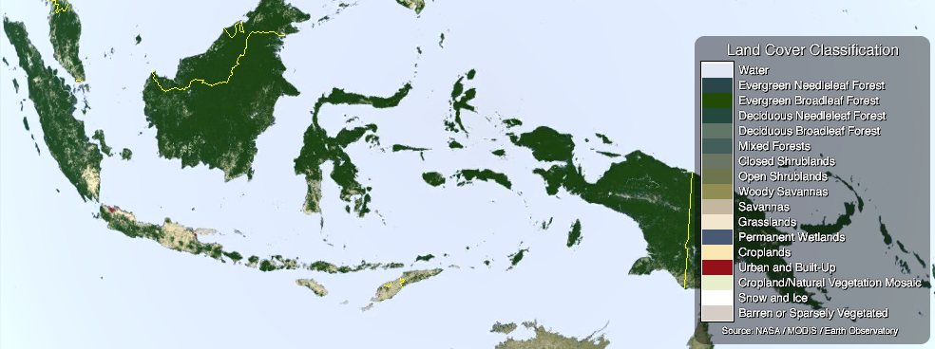
Figure 1. MODIS Land Cover Classification (LCC) product. Green colors represent different types of forests and tan colors represent grasslands/croplands.

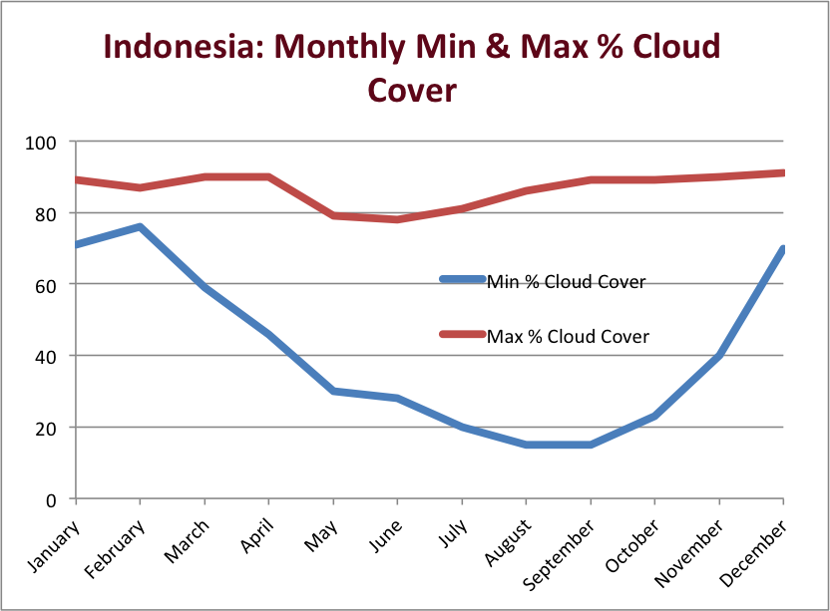

Figure 2. Monthly Minimum and Maximum Cloud Cover. Data from the NASA International Satellite Cloud Climatology Project (ISCCP) dataset (D2 product, 25 years, 280-km pixels, 3-hour sampling, monthly averages).

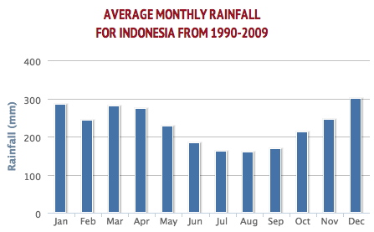

Figure 3. Average Monthly Rainfall. Data from the World Bank website (http://data.worldbank.org).

Section 2: Landsat Data Acquisition Background Information

Indonesia
Landsat WRS-2 and Data Summary
Pass | Duration (min) | Path | Row(s) | Scenes | Data Volume (GB)
1 | 0.76 | 131 | 56-58 | 2 | 0.9
2 | 1.13 | 130 | 56-58 | 3 | 1.4
3 | 1.51 | 129 | 57-60 | 4 | 1.9
4 | 1.89 | 128 | 58-61 | 5 | 2.3
5 | 2.27 | 127 | 59-62 | 6 | 2.8
6 | 2.64 | 126 | 59-62 | 7 | 3.3
7 | 3.02 | 125 | 60-64 | 8 | 3.7
8 | 3.40 | 124 | 60-64 | 9 | 4.2
9 | 3.78 | 123 | 61-65 | 10 | 4.7
10 | 4.16 | 122 | 59-65 | 11 | 5.1
11 | 4.53 | 121 | 59-65 | 12 | 5.6
12 | 4.91 | 120 | 59-65 | 13 | 6.0
13 | 5.29 | 119 | 59-66 | 14 | 6.5
14 | 5.67 | 118 | 57-66 | 15 | 7.0
15 | 6.04 | 117 | 57-66 | 16 | 7.4
16 | 6.42 | 116 | 58-66 | 17 | 7.9
17 | 6.80 | 115 | 59-66 | 18 | 8.4
18 | 7.18 | 114 | 59-67 | 19 | 8.8
19 | 7.55 | 113 | 59-67 | 20 | 9.3
20 | 7.93 | 112 | 59-67 | 21 | 9.8
21 | 8.31 | 111 | 57-68 | 22 | 10.2
22 | 8.69 | 110 | 58-67 | 23 | 10.7
23 | 9.07 | 109 | 58-66 | 24 | 11.2
24 | 9.44 | 108 | 60-66 | 25 | 11.6
25 | 9.82 | 107 | 60-66 | 26 | 12.1
26 | 10.20 | 106 | 60-66 | 27 | 12.6
27 | 10.58 | 105 | 61-64 | 28 | 13.0
28 | 10.95 | 104 | 61-65 | 29 | 13.5
29 | 11.33 | 103 | 61-63 | 30 | 14.0
30 | 11.71 | 102 | 61-66 | 31 | 14.4
31 | 12.09 | 101 | 62-66 | 32 | 14.9
32 | 12.47 | 100 | 63-66 | 33 | 15.3
 | 211.53 |  |  | 560 | 260.4

Table 1. Landsat WRS-2 Path-Row Summary Table (Pass 1 = West, Pass 5 = East)

The Landsat scene area is 183km x 170km, or 31,110 km². Data volume was based on the number of scenes and an average scene size of 465 MB. Refer to Figures 5-8 for scene borders in Google Earth.

The minimum number of Landsat scenes required to cover the total area of a country was determined by visual inspection of COVE (www.ceos-cove.org) instrument ground tracks. Each country only has one mission swath per day. Complete coverage of a country takes the entire revisit period (16 days), since orbits are typically designed for global coverage over this repeat period.
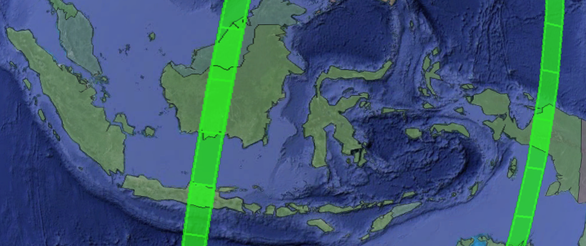

Figure 4. COVE Tool visualization of the Landsat 8 swath over a region on October 10, 2014.

Section 3: Landsat Historical Coverage Summary

Tables 2-3. Landsat 7 and 8 Historical Coverage Over Region.

Path | Row | Landsat 7 (2012) |  |  |  | Landsat 7 (2013) |  |  |  | Landsat 8 (2013)
 |  | Avg. Cloud Cover | Total # scenes acquired | # scenes <10% | # scenes <60% | Avg. Cloud Cover | Total # scenes acquired | # scenes <10% | # scenes <60% | Avg. Cloud Cover | Total # scenes acquired | # scenes <10% | # scenes <60%
100 | 63 | 63% | 17 | 0 | 7 | 71% | 10 | 0 | 4 | 65% | 6 | 0 | 2
100 | 64 | 78% | 22 | 0 | 5 | 75% | 13 | 0 | 2 | 82% | 6 | 0 | 0
100 | 65 | 79% | 22 | 0 | 3 | 69% | 13 | 0 | 3 | 84% | 6 | 0 | 1
100 | 66 | 63% | 22 | 2 | 8 | 60% | 13 | 0 | 7 | 71% | 6 | 0 | 1
101 | 62 | 63% | 12 | 0 | 5 | 65% | 13 | 0 | 4 | 70% | 6 | 0 | 1
101 | 63 | 75% | 16 | 0 | 4 | 65% | 13 | 0 | 7 | 66% | 6 | 0 | 1
101 | 64 | 71% | 15 | 0 | 6 | 74% | 14 | 0 | 4 | 72% | 6 | 0 | 1
101 | 65 | 63% | 22 | 1 | 10 | 83% | 14 | 0 | 1 | 55% | 6 | 0 | 3
101 | 66 | 50% | 22 | 2 | 12 | 66% | 14 | 0 | 5 | 52% | 5 | 1 | 2
102 | 61 | 49% | 10 | 2 | 6 | 63% | 8 | 1 | 4 | 53% | 3 | 0 | 2
102 | 62 | 68% | 22 | 0 | 9 | 79% | 11 | 0 | 1 | 72% | 4 | 0 | 1
102 | 63 | 68% | 20 | 0 | 7 | 77% | 12 | 0 | 1 | 78% | 4 | 0 | 0
102 | 64 | 69% | 23 | 1 | 8 | 66% | 13 | 0 | 5 | 78% | 4 | 0 | 0
102 | 65 | 56% | 23 | 1 | 12 | 55% | 13 | 0 | 5 | 57% | 4 | 0 | 2
102 | 66 | 48% | 23 | 1 | 15 | 50% | 13 | 1 | 8 | 44% | 3 | 0 | 3
103 | 61 | 50% | 13 | 0 | 9 | 52% | 11 | 2 | 6 | 50% | 6 | 0 | 4
103 | 62 | 67% | 22 | 0 | 10 | 67% | 13 | 0 | 4 | 44% | 6 | 0 | 4
Path | Row | Landsat 7 (2012) |  |  |  | Landsat 7 (2013) |  |  |  | Landsat 8 (2013)
 |  | Avg. Cloud Cover | Total # scenes acquired | # scenes <10% | # scenes <60% | Avg. Cloud Cover | Total # scenes acquired | # scenes <10% | # scenes <60% | Avg. Cloud Cover | Total # scenes acquired | # scenes <10% | # scenes <60%
103 | 63 | 68% | 22 | 0 | 8 | 73% | 13 | 0 | 3 | 47% | 6 | 1 | 3
104 | 61 | 63% | 18 | 0 | 10 | 64% | 12 | 1 | 4 | 51% | 7 | 1 | 3
104 | 62 | 61% | 21 | 1 | 8 | 60% | 12 | 1 | 5 | 45% | 7 | 1 | 5
104 | 63 | 59% | 23 | 0 | 15 | 66% | 13 | 0 | 5 | 43% | 7 | 1 | 4
104 | 64 | 65% | 23 | 0 | 10 | 63% | 13 | 0 | 5 | 48% | 7 | 1 | 5
104 | 65 | 47% | 23 | 1 | 15 | 54% | 13 | 2 | 7 | 37% | 6 | 1 | 5
105 | 61 | 62% | 19 | 0 | 10 | 58% | 12 | 1 | 5 | 70% | 7 | 0 | 1
105 | 62 | 64% | 17 | 0 | 8 | 64% | 12 | 0 | 5 | 68% | 7 | 0 | 1
105 | 63 | 64% | 23 | 0 | 9 | 59% | 13 | 1 | 7 | 62% | 7 | 0 | 2
105 | 64 | 51% | 23 | 3 | 12 | 62% | 13 | 1 | 5 | 54% | 6 | 1 | 3
106 | 60 | 61% | 12 | 2 | 5 | 58% | 12 | 0 | 7 | 27% | 6 | 2 | 5
106 | 61 | 49% | 13 | 0 | 8 | 69% | 13 | 0 | 5 | 46% | 6 | 0 | 5
106 | 62 | 54% | 14 | 0 | 9 | 73% | 13 | 0 | 3 | 36% | 6 | 1 | 5
106 | 63 | 53% | 23 | 2 | 14 | 64% | 13 | 1 | 6 | 33% | 6 | 0 | 5
106 | 64 | 48% | 23 | 2 | 16 | 55% | 13 | 2 | 7 | 35% | 6 | 0 | 6
106 | 65 | 39% | 23 | 5 | 15 | 45% | 13 | 2 | 8 | 33% | 6 | 1 | 5
106 | 66 | 31% | 23 | 5 | 19 | 49% | 13 | 0 | 7 | 36% | 5 | 1 | 5
107 | 60 | 29% | 7 | 2 | 6 | 35% | 12 | 1 | 10 | 40% | 6 | 1 | 5
107 | 61 | 49% | 12 | 0 | 7 | 34% | 12 | 1 | 11 | 45% | 6 | 0 | 6
107 | 62 | 62% | 16 | 0 | 6 | 39% | 12 | 2 | 10 | 54% | 6 | 0 | 4
107 | 63 | 51% | 23 | 1 | 13 | 34% | 13 | 3 | 11 | 55% | 5 | 0 | 2
107 | 64 | 44% | 23 | 3 | 15 | 33% | 13 | 3 | 11 | 81% | 1 | 0 | 0
107 | 65 | 32% | 23 | 6 | 20 | 44% | 13 | 3 | 7 | 58% | 2 | 0 | 1
107 | 66 | 24% | 23 | 7 | 21 | 55% | 13 | 4 | 6 | 17% | 2 | 0 | 2
108 | 60 | 43% | 11 | 1 | 7 | 39% | 8 | 2 | 7 | 61% | 4 | 0 | 1
108 | 61 | 56% | 18 | 0 | 11 | 53% | 10 | 1 | 5 | 57% | 4 | 0 | 2
108 | 62 | 52% | 15 | 1 | 9 | 63% | 11 | 0 | 3 | 43% | 4 | 1 | 3
108 | 63 | 52% | 23 | 3 | 14 | 58% | 14 | 1 | 6 | 15% | 3 | 1 | 3
108 | 64 | 44% | 23 | 4 | 16 | 55% | 14 | 4 | 7 | 9% | 1 | 1 | 1
108 | 65 | 37% | 23 | 10 | 18 | 46% | 14 | 3 | 9 | 12% | 1 | 0 | 1
108 | 66 | 28% | 23 | 7 | 20 | 38% | 14 | 4 | 10 | 54% | 1 | 0 | 1
109 | 58 | 32% | 9 | 3 | 7 | 47% | 8 | 1 | 5 | 47% | 5 | 1 | 4
109 | 59 | 35% | 12 | 2 | 11 | 43% | 9 | 1 | 6 | 48% | 5 | 1 | 4
109 | 60 | 43% | 15 | 3 | 9 | 45% | 10 | 1 | 7 | 45% | 5 | 1 | 3
109 | 61 | 35% | 15 | 2 | 12 | 44% | 10 | 1 | 6 | 47% | 5 | 0 | 4
109 | 62 | 33% | 15 | 2 | 13 | 41% | 12 | 2 | 7 | 52% | 4 | 0 | 2
109 | 63 | 40% | 23 | 6 | 16 | 37% | 13 | 2 | 9 | 63% | 3 | 0 | 1
109 | 65 | 34% | 23 | 8 | 18 | 47% | 13 | 3 | 8 | 41% | 1 | 0 | 1
109 | 66 | 33% | 23 | 7 | 19 | 49% | 13 | 2 | 7 | 21% | 1 | 0 | 1
110 | 58 | 20% | 6 | 2 | 6 | 30% | 5 | 1 | 4 | 26% | 5 | 2 | 4
110 | 59 | 19% | 8 | 3 | 8 | 46% | 8 | 0 | 5 | 36% | 5 | 2 | 3
110 | 60 | 12% | 7 | 2 | 7 | 51% | 8 | 1 | 5 | 40% | 5 | 2 | 4
110 | 61 | 24% | 8 | 1 | 8 | 47% | 7 | 1 | 4 | 32% | 5 | 1 | 4
110 | 62 | 38% | 12 | 2 | 9 | 51% | 9 | 0 | 7 | 37% | 5 | 1 | 3
110 | 63 | 39% | 14 | 4 | 10 | 52% | 9 | 0 | 6 | 71% | 2 | 0 | 0

Path | Row | Landsat 7 (2012) |  |  |  | Landsat 7 (2013) |  |  |  | Landsat 8 (2013)
 |  | Avg. Cloud Cover | Total # scenes acquired | # scenes <10% | # scenes <60% | Avg. Cloud Cover | Total # scenes acquired | # scenes <10% | # scenes <60% | Avg. Cloud Cover | Total # scenes acquired | # scenes <10% | # scenes <60%
110 | 65 | 32% | 22 | 7 | 17 | 52% | 14 | 2 | 8 | 15% | 5 | 3 | 5
110 | 66 | 28% | 22 | 7 | 20 | 51% | 14 | 2 | 9 | 12% | 5 | 3 | 5
110 | 67 | 31% | 22 | 7 | 18 | 51% | 14 | 2 | 8 | 16% | 5 | 2 | 5
111 | 57 | 39% | 6 | 2 | 4 | 53% | 7 | 2 | 4 | 20% | 1 | 0 | 1
111 | 58 | 36% | 6 | 2 | 5 | 56% | 8 | 1 | 5 | 22% | 1 | 0 | 1
111 | 59 | 37% | 7 | 1 | 5 | 34% | 8 | 1 | 7 | 42% | 5 | 0 | 3
111 | 61 | 19% | 7 | 3 | 7 | 26% | 8 | 2 | 8 | 47% | 5 | 1 | 3
111 | 64 | 42% | 23 | 3 | 17 | 37% | 13 | 3 | 10 | 27% | 1 | 0 | 1
111 | 66 | 28% | 23 | 7 | 20 | 34% | 13 | 5 | 11 | 14% | 5 | 2 | 5
111 | 67 | 26% | 23 | 11 | 20 | 36% | 13 | 3 | 8 | 18% | 4 | 3 | 4
111 | 68 | 26% | 23 | 10 | 19 | 27% | 13 | 7 | 10 | 20% | 4 | 2 | 4
112 | 59 | 63% | 9 | 1 | 4 | 45% | 10 | 0 | 7 | 31% | 6 | 1 | 5
112 | 60 | 51% | 12 | 1 | 8 | 35% | 10 | 0 | 8 | 47% | 6 | 0 | 4
112 | 61 | 39% | 9 | 0 | 6 | 41% | 11 | 1 | 8 | 62% | 6 | 0 | 3
112 | 62 | 43% | 12 | 0 | 9 | 48% | 11 | 1 | 7 | 46% | 5 | 0 | 4
112 | 63 | 42% | 12 | 0 | 9 | 47% | 11 | 1 | 6 | 47% | 4 | 0 | 2
112 | 64 | 41% | 23 | 4 | 16 | 46% | 13 | 1 | 8 | 56% | 5 | 0 | 3
112 | 65 | 27% | 23 | 6 | 20 | 44% | 13 | 3 | 8 | 32% | 5 | 1 | 5
112 | 66 | 24% | 23 | 9 | 20 | 40% | 13 | 4 | 9 | 24% | 5 | 1 | 5
112 | 67 | 20% | 23 | 14 | 21 | 39% | 13 | 3 | 10 | 26% | 5 | 3 | 4
113 | 59 | 45% | 12 | 0 | 9 | 51% | 11 | 1 | 5 | 26% | 7 | 2 | 7
113 | 60 | 50% | 12 | 0 | 8 | 57% | 11 | 1 | 7 | 43% | 7 | 0 | 5
113 | 61 | 51% | 13 | 0 | 9 | 54% | 10 | 0 | 5 | 43% | 7 | 1 | 5
113 | 62 | 46% | 15 | 0 | 11 | 60% | 11 | 0 | 6 | 35% | 7 | 1 | 5
113 | 63 | 40% | 13 | 2 | 9 | 68% | 11 | 0 | 4 | 33% | 7 | 2 | 6
113 | 64 | 36% | 23 | 5 | 17 | 52% | 13 | 1 | 9 | 26% | 7 | 1 | 7
113 | 65 | 30% | 23 | 8 | 19 | 45% | 13 | 0 | 9 | 17% | 7 | 3 | 7
113 | 66 | 32% | 23 | 7 | 19 | 39% | 13 | 3 | 10 | 16% | 7 | 3 | 7
113 | 67 | 34% | 23 | 3 | 20 | 39% | 13 | 3 | 10 | 20% | 7 | 2 | 7
114 | 59 | 40% | 10 | 2 | 7 | 31% | 12 | 3 | 10 | 63% | 5 | 0 | 2
114 | 60 | 49% | 11 | 1 | 7 | 49% | 12 | 1 | 8 | 64% | 6 | 0 | 2
114 | 61 | 51% | 16 | 0 | 10 | 55% | 12 | 0 | 7 | 68% | 6 | 0 | 3
114 | 62 | 50% | 15 | 0 | 11 | 60% | 13 | 1 | 6 | 65% | 5 | 0 | 1
114 | 63 | 42% | 12 | 1 | 10 | 54% | 13 | 0 | 7 | 57% | 5 | 0 | 3
114 | 64 | 28% | 10 | 3 | 9 | 44% | 13 | 2 | 9 | 61% | 5 | 1 | 1
114 | 65 | 19% | 9 | 3 | 9 | 34% | 13 | 2 | 10 | 54% | 5 | 1 | 3
114 | 66 | 28% | 23 | 10 | 20 | 21% | 13 | 3 | 12 | 29% | 5 | 2 | 4
114 | 67 | 25% | 23 | 12 | 18 | 23% | 13 | 5 | 12 | 13% | 5 | 2 | 5
115 | 59 | 42% | 11 | 1 | 8 | 55% | 10 | 1 | 4 | 23% | 4 | 1 | 4
115 | 60 | 51% | 15 | 1 | 10 | 67% | 10 | 0 | 3 | 23% | 4 | 1 | 4
115 | 61 | 56% | 17 | 1 | 8 | 71% | 11 | 0 | 3 | 34% | 4 | 1 | 3
115 | 62 | 46% | 14 | 1 | 9 | 62% | 12 | 2 | 5 | 28% | 4 | 2 | 3
115 | 64 | 30% | 9 | 3 | 8 | 50% | 11 | 2 | 6 | 4% | 1 | 1 | 1
115 | 65 | 21% | 13 | 7 | 12 | 36% | 12 | 3 | 10 | 28% | 5 | 2 | 4
115 | 66 | 33% | 23 | 5 | 19 | 37% | 14 | 3 | 9 | 29% | 4 | 1 | 4

Path | Row | Landsat 7 (2012) |  |  |  | Landsat 7 (2013) |  |  |  | Landsat 8 (2013)
 |  | Avg. Cloud Cover | Total # scenes acquired | # scenes <10% | # scenes <60% | Avg. Cloud Cover | Total # scenes acquired | # scenes <10% | # scenes <60% | Avg. Cloud Cover | Total # scenes acquired | # scenes <10% | # scenes <60%
116 | 58 | 49% | 16 | 0 | 9 | 41% | 10 | 0 | 8 | 60% | 6 | 0 | 3
116 | 59 | 50% | 15 | 1 | 10 | 54% | 11 | 0 | 5 | 70% | 6 | 0 | 1
116 | 60 | 54% | 17 | 1 | 9 | 61% | 13 | 1 | 5 | 55% | 6 | 0 | 3
116 | 61 | 47% | 19 | 1 | 13 | 54% | 13 | 2 | 8 | 45% | 7 | 0 | 6
116 | 62 | 40% | 21 | 4 | 14 | 49% | 12 | 3 | 7 | 53% | 7 | 0 | 5
116 | 63 | 44% | 17 | 3 | 12 | 46% | 12 | 2 | 7 | 52% | 7 | 0 | 4
116 | 65 | 21% | 12 | 7 | 10 | 37% | 11 | 3 | 7 | 18% | 5 | 2 | 5
116 | 66 | 27% | 12 | 4 | 9 | 33% | 11 | 0 | 9 | 25% | 5 | 1 | 5
117 | 57 | 56% | 14 | 0 | 9 | 79% | 13 | 0 | 3 | 38% | 6 | 0 | 5
117 | 58 | 61% | 18 | 0 | 8 | 80% | 13 | 0 | 1 | 51% | 6 | 0 | 4
117 | 59 | 68% | 17 | 0 | 7 | 71% | 14 | 0 | 3 | 51% | 6 | 0 | 4
117 | 60 | 70% | 17 | 0 | 4 | 64% | 14 | 0 | 7 | 45% | 5 | 0 | 4
117 | 61 | 60% | 16 | 1 | 8 | 73% | 13 | 0 | 3 | 37% | 4 | 0 | 3
117 | 62 | 43% | 14 | 2 | 9 | 63% | 12 | 0 | 5 | 21% | 4 | 1 | 4
117 | 63 | 25% | 11 | 4 | 10 | 53% | 12 | 1 | 7 | 20% | 5 | 2 | 5
117 | 64 | 27% | 8 | 2 | 7 | 55% | 12 | 2 | 6 | 13% | 5 | 2 | 5
117 | 65 | 28% | 12 | 4 | 10 | 52% | 13 | 2 | 7 | 35% | 5 | 2 | 4
117 | 66 | 29% | 11 | 1 | 11 | 52% | 13 | 1 | 6 | 47% | 4 | 0 | 3
118 | 57 | 59% | 23 | 1 | 11 | 63% | 13 | 0 | 5 | 60% | 6 | 0 | 3
118 | 58 | 64% | 21 | 1 | 6 | 68% | 12 | 0 | 5 | 57% | 6 | 0 | 3
118 | 59 | 65% | 20 | 0 | 7 | 73% | 12 | 0 | 3 | 60% | 6 | 0 | 2
118 | 60 | 70% | 21 | 0 | 6 | 67% | 13 | 0 | 5 | 54% | 6 | 0 | 4
118 | 61 | 61% | 21 | 0 | 13 | 67% | 13 | 0 | 6 | 38% | 6 | 0 | 5
118 | 62 | 52% | 21 | 1 | 14 | 58% | 12 | 1 | 5 | 34% | 5 | 0 | 5
118 | 63 | 58% | 8 | 1 | 4 | 48% | 11 | 1 | 5 | 30% | 2 | 1 | 2
118 | 64 | 47% | 10 | 2 | 7 | 48% | 11 | 0 | 6 | 33% | 2 | 0 | 2
118 | 65 | 38% | 18 | 5 | 14 | 45% | 12 | 0 | 10 | 40% | 6 | 1 | 4
118 | 66 | 42% | 14 | 1 | 11 | 46% | 10 | 0 | 7 | 32% | 6 | 1 | 6
119 | 59 | 54% | 18 | 0 | 11 | 72% | 12 | 0 | 3 | 40% | 6 | 0 | 5
119 | 60 | 63% | 18 | 0 | 8 | 71% | 12 | 0 | 3 | 39% | 6 | 1 | 4
119 | 61 | 69% | 19 | 0 | 5 | 65% | 12 | 0 | 5 | 49% | 6 | 0 | 4
119 | 62 | 66% | 20 | 0 | 7 | 61% | 12 | 0 | 7 | 34% | 6 | 0 | 6
119 | 64 | 32% | 13 | 2 | 10 | 53% | 12 | 2 | 5 | 39% | 5 | 0 | 5
119 | 65 | 28% | 16 | 5 | 15 | 55% | 12 | 2 | 6 | 47% | 6 | 0 | 4
119 | 66 | 29% | 19 | 3 | 17 | 42% | 12 | 3 | 10 | 58% | 6 | 0 | 3
120 | 59 | 59% | 20 | 0 | 10 | 65% | 13 | 1 | 6 | 48% | 6 | 1 | 3
120 | 60 | 63% | 21 | 0 | 9 | 58% | 13 | 1 | 6 | 47% | 6 | 2 | 3
120 | 61 | 60% | 19 | 1 | 9 | 52% | 13 | 1 | 8 | 44% | 6 | 2 | 4
120 | 62 | 58% | 19 | 0 | 9 | 53% | 13 | 0 | 7 | 48% | 5 | 1 | 3
120 | 64 | 33% | 16 | 4 | 14 | 53% | 13 | 0 | 8 | 49% | 5 | 1 | 2
120 | 65 | 38% | 18 | 3 | 14 | 54% | 11 | 0 | 8 | 53% | 5 | 1 | 4
121 | 59 | 66% | 21 | 0 | 9 | 49% | 12 | 3 | 7 | 34% | 6 | 2 | 4
121 | 60 | 60% | 18 | 0 | 8 | 56% | 13 | 2 | 7 | 22% | 6 | 2 | 6
121 | 61 | 40% | 16 | 1 | 13 | 58% | 12 | 2 | 7 | 18% | 6 | 2 | 6
121 | 62 | 40% | 16 | 1 | 12 | 54% | 11 | 1 | 5 | 31% | 6 | 2 | 5

Path | Row | Landsat 7 (2012) |  |  |  | Landsat 7 (2013) |  |  |  | Landsat 8 (2013)
 |  | Avg. Cloud Cover | Total # scenes acquired | # scenes <10% | # scenes <60% | Avg. Cloud Cover | Total # scenes acquired | # scenes <10% | # scenes <60% | Avg. Cloud Cover | Total # scenes acquired | # scenes <10% | # scenes <60%
121 | 64 | 32% | 18 | 8 | 14 | 43% | 10 | 1 | 7 | 36% | 5 | 1 | 4
121 | 65 | 42% | 21 | 0 | 16 | 41% | 12 | 1 | 9 | 38% | 5 | 0 | 5
122 | 59 | 43% | 17 | 3 | 11 | 58% | 9 | 1 | 5 | 15% | 6 | 4 | 6
122 | 60 | 39% | 18 | 7 | 13 | 43% | 10 | 1 | 7 | 23% | 6 | 2 | 5
122 | 61 | 42% | 16 | 4 | 12 | 51% | 10 | 1 | 5 | 26% | 6 | 1 | 5
122 | 62 | 38% | 17 | 5 | 13 | 51% | 10 | 0 | 7 | 23% | 6 | 2 | 6
122 | 64 | 40% | 16 | 4 | 11 | 65% | 13 | 0 | 5 | 37% | 5 | 1 | 4
122 | 65 | 33% | 14 | 5 | 10 | 53% | 12 | 0 | 7 | 26% | 5 | 0 | 5
123 | 61 | 40% | 10 | 2 | 7 | 36% | 9 | 1 | 7 | 31% | 5 | 1 | 5
123 | 62 | 55% | 10 | 0 | 5 | 47% | 11 | 0 | 7 | 44% | 5 | 0 | 5
123 | 63 | 55% | 15 | 0 | 8 | 53% | 11 | 3 | 6 | 62% | 6 | 0 | 3
123 | 64 | 47% | 19 | 1 | 13 | 47% | 11 | 0 | 7 | 75% | 7 | 0 | 1
123 | 65 | 33% | 13 | 1 | 12 | 48% | 10 | 1 | 7 | 55% | 7 | 1 | 3
124 | 60 | 52% | 11 | 1 | 6 | 50% | 8 | 0 | 5 | 48% | 7 | 2 | 3
124 | 61 | 50% | 14 | 2 | 8 | 62% | 9 | 0 | 5 | 32% | 7 | 1 | 7
124 | 62 | 53% | 19 | 0 | 11 | 60% | 12 | 0 | 7 | 30% | 7 | 2 | 7
124 | 63 | 48% | 20 | 1 | 12 | 66% | 13 | 0 | 5 | 36% | 7 | 1 | 5
124 | 64 | 45% | 16 | 0 | 12 | 60% | 12 | 0 | 5 | 37% | 7 | 0 | 6
125 | 60 | 50% | 18 | 1 | 11 | 62% | 11 | 1 | 5 | 40% | 6 | 0 | 5
125 | 61 | 63% | 19 | 1 | 8 | 65% | 12 | 1 | 4 | 66% | 6 | 0 | 1
125 | 62 | 57% | 20 | 0 | 11 | 63% | 12 | 1 | 6 | 61% | 6 | 0 | 2
125 | 63 | 50% | 18 | 2 | 10 | 64% | 12 | 0 | 5 | 60% | 6 | 1 | 3
125 | 64 | 50% | 15 | 1 | 9 | 68% | 11 | 0 | 4 | 50% | 6 | 0 | 4
126 | 59 | 54% | 15 | 2 | 7 | 59% | 11 | 0 | 5 | 30% | 5 | 0 | 4
126 | 60 | 61% | 16 | 1 | 6 | 66% | 12 | 0 | 4 | 31% | 6 | 1 | 6
126 | 61 | 60% | 16 | 1 | 7 | 66% | 12 | 0 | 5 | 40% | 7 | 1 | 5
126 | 62 | 50% | 14 | 0 | 10 | 55% | 12 | 1 | 7 | 46% | 7 | 1 | 5
127 | 59 | 61% | 20 | 0 | 8 | 73% | 10 | 0 | 3 | 67% | 6 | 0 | 2
127 | 60 | 58% | 16 | 1 | 8 | 63% | 10 | 0 | 5 | 56% | 6 | 0 | 3
127 | 61 | 49% | 16 | 1 | 8 | 62% | 9 | 1 | 4 | 32% | 6 | 1 | 5
127 | 62 | 38% | 13 | 3 | 10 | 57% | 7 | 0 | 4 | 21% | 6 | 1 | 6
128 | 58 | 65% | 18 | 0 | 7 | 54% | 9 | 0 | 6 | 43% | 7 | 1 | 6
128 | 59 | 52% | 13 | 0 | 7 | 51% | 9 | 0 | 6 | 45% | 7 | 1 | 5
128 | 60 | 52% | 16 | 1 | 9 | 53% | 9 | 1 | 4 | 39% | 6 | 1 | 4
128 | 61 | 45% | 11 | 0 | 8 | 54% | 9 | 2 | 5 | 59% | 3 | 0 | 1
129 | 57 | 71% | 9 | 1 | 3 | 59% | 7 | 0 | 4 | 40% | 7 | 0 | 4
129 | 58 | 55% | 13 | 0 | 6 | 43% | 6 | 2 | 3 | 42% | 6 | 1 | 4
129 | 59 | 53% | 11 | 0 | 7 | 42% | 6 | 2 | 4 | 48% | 6 | 1 | 5
129 | 60 | 54% | 10 | 3 | 4 | 38% | 5 | 1 | 4 | 50% | 4 | 0 | 2
130 | 56 | 44% | 12 | 2 | 9 | 50% | 5 | 1 | 3 | 54% | 5 | 1 | 3
130 | 57 | 57% | 15 | 0 | 7 | 61% | 9 | 1 | 4 | 52% | 4 | 0 | 3
130 | 58 | 47% | 15 | 2 | 11 | 40% | 9 | 0 | 6 | 59% | 4 | 1 | 2
131 | 56 | 58% | 8 | 1 | 4 | 62% | 6 | 0 | 3 | 59% | 5 | 0 | 2
131 | 57 | 40% | 8 | 1 | 6 | 62% | 6 | 0 | 2 | 56% | 5 | 0 | 2
131 | 58 | 32% | 11 | 3 | 8 | 53% | 5 | 1 | 2 | 30% | 5 | 0 | 4

Path | Row | Landsat 7 (2014) |  |  |  | Landsat 8 (2014)
 |  | Avg. Cloud Cover | Total # scenes acquired | # scenes <10% | # scenes <60% | Avg. Cloud Cover | Total # scenes acquired | # scenes <10% | # scenes <60%
100 | 63 | 63% | 15 | 0 | 6 | 63% | 15 | 0 | 8
100 | 64 | 73% | 15 | 0 | 4 | 70% | 15 | 0 | 4
100 | 65 | 70% | 15 | 0 | 5 | 62% | 15 | 0 | 6
100 | 66 | 55% | 15 | 0 | 8 | 47% | 12 | 1 | 8
101 | 62 | 60% | 15 | 0 | 6 | 54% | 14 | 0 | 9
101 | 63 | 67% | 15 | 0 | 5 | 65% | 15 | 0 | 5
101 | 64 | 65% | 15 | 1 | 5 | 64% | 15 | 1 | 6
101 | 65 | 67% | 15 | 0 | 6 | 60% | 14 | 0 | 6
101 | 66 | 54% | 15 | 0 | 9 | 54% | 13 | 0 | 6
102 | 61 | 49% | 12 | 3 | 6 | 45% | 11 | 2 | 7
102 | 62 | 62% | 15 | 0 | 5 | 59% | 15 | 1 | 7
102 | 63 | 61% | 15 | 0 | 7 | 57% | 14 | 0 | 8
102 | 64 | 70% | 15 | 0 | 6 | 65% | 14 | 1 | 5
102 | 65 | 63% | 15 | 1 | 6 | 58% | 13 | 0 | 6
102 | 66 | 52% | 15 | 2 | 10 | 46% | 10 | 0 | 7
103 | 61 | 56% | 14 | 1 | 7 | 43% | 14 | 0 | 9
103 | 62 | 56% | 16 | 0 | 9 | 46% | 14 | 0 | 11
103 | 63 | 71% | 15 | 0 | 3 | 57% | 14 | 0 | 6
104 | 61 | 61% | 15 | 0 | 7 | 53% | 15 | 1 | 8
104 | 62 | 56% | 15 | 1 | 8 | 59% | 15 | 0 | 7
104 | 63 | 70% | 15 | 0 | 5 | 59% | 15 | 0 | 7
104 | 64 | 69% | 14 | 0 | 5 | 66% | 15 | 0 | 4
104 | 65 | 45% | 15 | 1 | 11 | 62% | 13 | 0 | 5
105 | 61 | 64% | 16 | 0 | 7 | 48% | 14 | 1 | 9
105 | 62 | 63% | 16 | 0 | 6 | 63% | 14 | 1 | 4
105 | 63 | 55% | 16 | 1 | 11 | 63% | 14 | 1 | 4
105 | 64 | 50% | 16 | 0 | 11 | 48% | 14 | 0 | 10
106 | 60 | 46% | 13 | 2 | 9 | 23% | 14 | 5 | 14
106 | 61 | 67% | 15 | 0 | 5 | 43% | 14 | 0 | 11
106 | 62 | 60% | 15 | 0 | 9 | 46% | 14 | 0 | 11
106 | 63 | 49% | 15 | 0 | 11 | 38% | 14 | 0 | 13
106 | 64 | 36% | 15 | 3 | 12 | 35% | 15 | 5 | 12
106 | 65 | 32% | 15 | 3 | 15 | 35% | 14 | 0 | 10
106 | 66 | 25% | 15 | 3 | 14 | 36% | 13 | 4 | 10
107 | 60 | 48% | 15 | 0 | 10 | 40% | 15 | 1 | 10
107 | 61 | 51% | 15 | 0 | 9 | 46% | 15 | 0 | 11
107 | 62 | 48% | 15 | 1 | 11 | 50% | 15 | 0 | 10
107 | 63 | 42% | 15 | 3 | 10 | 46% | 15 | 2 | 11
107 | 64 | 40% | 15 | 3 | 11 | 45% | 14 | 2 | 9
107 | 65 | 43% | 15 | 2 | 10 | 40% | 13 | 3 | 9
107 | 66 | 34% | 15 | 5 | 11 | 32% | 14 | 3 | 13
108 | 60 | 49% | 15 | 1 | 10 | 28% | 14 | 5 | 12
108 | 61 | 50% | 15 | 0 | 8 | 37% | 15 | 1 | 12
108 | 62 | 54% | 15 | 0 | 9 | 40% | 14 | 0 | 11
108 | 63 | 43% | 15 | 3 | 10 | 38% | 13 | 1 | 10

Path | Row | Landsat 7 (2014) |  |  |  | Landsat 8 (2014)
 |  | Avg. Cloud Cover | Total # scenes acquired | # scenes <10% | # scenes <60% | Avg. Cloud Cover | Total # scenes acquired | # scenes <10% | # scenes <60%
108 | 64 | 50% | 15 | 3 | 8 | 30% | 13 | 3 | 12
108 | 65 | 43% | 15 | 4 | 10 | 37% | 14 | 3 | 9
108 | 66 | 33% | 15 | 3 | 12 | 36% | 14 | 4 | 11
109 | 58 | 34% | 8 | 2 | 7 | 23% | 13 | 6 | 12
109 | 59 | 32% | 9 | 3 | 8 | 42% | 15 | 1 | 10
109 | 60 | 28% | 9 | 2 | 8 | 31% | 15 | 3 | 14
109 | 61 | 35% | 11 | 4 | 9 | 33% | 15 | 1 | 13
109 | 62 | 43% | 11 | 2 | 7 | 41% | 15 | 0 | 11
109 | 63 | 49% | 15 | 2 | 8 | 43% | 15 | 4 | 11
109 | 65 | 42% | 15 | 3 | 11 | 31% | 15 | 5 | 12
109 | 66 | 38% | 15 | 2 | 11 | 29% | 12 | 5 | 10
110 | 58 | 27% | 8 | 1 | 7 | 37% | 15 | 2 | 11
110 | 59 | 46% | 13 | 0 | 9 | 44% | 15 | 3 | 11
110 | 60 | 46% | 13 | 3 | 9 | 44% | 15 | 1 | 12
110 | 61 | 28% | 14 | 3 | 13 | 41% | 15 | 2 | 10
110 | 62 | 37% | 14 | 3 | 10 | 39% | 15 | 5 | 10
110 | 63 | 50% | 14 | 1 | 9 | 39% | 14 | 2 | 11
110 | 65 | 24% | 14 | 3 | 13 | 26% | 14 | 7 | 13
110 | 66 | 29% | 14 | 1 | 12 | 21% | 14 | 6 | 12
110 | 67 | 31% | 14 | 5 | 12 | 23% | 13 | 4 | 12
111 | 57 | 28% | 6 | 2 | 5 | 41% | 15 | 4 | 11
111 | 58 | 21% | 8 | 4 | 8 | 27% | 16 | 6 | 12
111 | 59 | 28% | 12 | 3 | 10 | 32% | 14 | 4 | 12
111 | 61 | 54% | 10 | 0 | 5 | 38% | 13 | 2 | 9
111 | 64 | 31% | 15 | 2 | 13 | 34% | 14 | 4 | 11
111 | 66 | 22% | 15 | 6 | 14 | 22% | 15 | 8 | 13
111 | 67 | 20% | 15 | 5 | 14 | 28% | 15 | 7 | 12
111 | 68 | 17% | 15 | 10 | 14 | 22% | 15 | 7 | 14
112 | 59 | 40% | 16 | 4 | 13 | 33% | 15 | 5 | 11
112 | 60 | 43% | 16 | 4 | 12 | 33% | 15 | 2 | 13
112 | 61 | 56% | 16 | 2 | 9 | 34% | 15 | 3 | 12
112 | 62 | 50% | 16 | 0 | 10 | 43% | 15 | 0 | 11
112 | 63 | 43% | 16 | 0 | 12 | 36% | 15 | 1 | 13
112 | 64 | 35% | 16 | 4 | 13 | 31% | 15 | 2 | 14
112 | 65 | 30% | 16 | 6 | 12 | 24% | 15 | 5 | 14
112 | 66 | 30% | 16 | 9 | 11 | 17% | 15 | 9 | 14
112 | 67 | 24% | 16 | 7 | 14 | 11% | 12 | 7 | 12
113 | 59 | 46% | 12 | 0 | 9 | 32% | 13 | 4 | 11
113 | 60 | 52% | 15 | 0 | 9 | 41% | 15 | 1 | 10
113 | 61 | 61% | 15 | 1 | 6 | 57% | 15 | 0 | 10
113 | 62 | 64% | 15 | 0 | 5 | 58% | 15 | 0 | 8
113 | 63 | 46% | 15 | 1 | 13 | 49% | 15 | 1 | 10
113 | 64 | 41% | 15 | 3 | 9 | 42% | 15 | 4 | 10
113 | 65 | 26% | 15 | 5 | 14 | 40% | 15 | 3 | 12
113 | 66 | 28% | 15 | 6 | 13 | 36% | 15 | 6 | 11

Path | Row | Landsat 7 (2014) |  |  |  | Landsat 8 (2014)
 |  | Avg. Cloud Cover | Total # scenes acquired | # scenes <10% | # scenes <60% | Avg. Cloud Cover | Total # scenes acquired | # scenes <10% | # scenes <60%
113 | 67 | 25% | 15 | 4 | 13 | 21% | 13 | 5 | 12
114 | 59 | 35% | 9 | 2 | 7 | 42% | 12 | 4 | 9
114 | 60 | 46% | 15 | 2 | 10 | 48% | 13 | 1 | 9
114 | 61 | 52% | 15 | 0 | 9 | 51% | 12 | 0 | 8
114 | 62 | 54% | 15 | 0 | 11 | 50% | 13 | 0 | 8
114 | 63 | 51% | 15 | 0 | 8 | 50% | 13 | 0 | 8
114 | 64 | 34% | 15 | 4 | 12 | 35% | 13 | 1 | 11
114 | 65 | 33% | 15 | 5 | 12 | 33% | 14 | 2 | 11
114 | 66 | 32% | 15 | 4 | 12 | 19% | 14 | 6 | 13
114 | 67 | 15% | 15 | 9 | 15 | 18% | 14 | 9 | 13
115 | 59 | 41% | 13 | 1 | 10 | 25% | 15 | 5 | 13
115 | 60 | 55% | 15 | 1 | 7 | 34% | 15 | 3 | 12
115 | 61 | 59% | 15 | 0 | 8 | 39% | 13 | 4 | 8
115 | 62 | 55% | 15 | 0 | 8 | 32% | 13 | 2 | 11
115 | 64 | 35% | 15 | 4 | 13 | 32% | 14 | 5 | 12
115 | 65 | 28% | 15 | 5 | 13 | 33% | 15 | 6 | 11
115 | 66 | 32% | 15 | 3 | 12 | 28% | 11 | 7 | 7
116 | 58 | 52% | 15 | 1 | 9 | 49% | 15 | 1 | 10
116 | 59 | 62% | 15 | 0 | 7 | 48% | 15 | 0 | 10
116 | 60 | 62% | 15 | 0 | 6 | 49% | 15 | 1 | 11
116 | 61 | 71% | 15 | 0 | 4 | 48% | 15 | 0 | 11
116 | 62 | 63% | 15 | 0 | 8 | 47% | 15 | 0 | 11
116 | 63 | 53% | 15 | 1 | 7 | 44% | 14 | 0 | 11
116 | 65 | 26% | 14 | 6 | 12 | 33% | 14 | 3 | 11
116 | 66 | 32% | 14 | 4 | 11 | 29% | 15 | 4 | 13
117 | 57 | 58% | 15 | 1 | 7 | 46% | 15 | 1 | 11
117 | 58 | 64% | 15 | 0 | 5 | 46% | 15 | 0 | 10
117 | 59 | 61% | 15 | 1 | 7 | 53% | 15 | 0 | 9
117 | 60 | 67% | 15 | 1 | 6 | 58% | 14 | 0 | 7
117 | 61 | 56% | 15 | 0 | 7 | 50% | 14 | 1 | 10
117 | 62 | 54% | 15 | 0 | 9 | 44% | 14 | 1 | 11
117 | 63 | 52% | 15 | 1 | 9 | 32% | 15 | 4 | 12
117 | 64 | 38% | 14 | 6 | 10 | 28% | 15 | 4 | 14
117 | 65 | 31% | 14 | 4 | 11 | 17% | 14 | 7 | 14
117 | 66 | 42% | 12 | 1 | 8 | 21% | 14 | 5 | 13
118 | 57 | 54% | 15 | 0 | 9 | 51% | 15 | 0 | 12
118 | 58 | 54% | 15 | 0 | 9 | 63% | 15 | 0 | 6
118 | 59 | 57% | 15 | 0 | 8 | 65% | 15 | 0 | 5
118 | 60 | 59% | 15 | 0 | 9 | 61% | 15 | 0 | 6
118 | 61 | 49% | 15 | 0 | 13 | 55% | 15 | 2 | 7
118 | 62 | 44% | 15 | 0 | 10 | 43% | 15 | 1 | 12
118 | 63 | 34% | 13 | 4 | 11 | 29% | 15 | 5 | 12
118 | 64 | 26% | 13 | 4 | 10 | 35% | 15 | 4 | 12
118 | 65 | 35% | 12 | 0 | 10 | 33% | 15 | 3 | 12
118 | 66 | 24% | 11 | 0 | 11 | 22% | 13 | 3 | 13

Path | Row | Landsat 7 (2014) |  |  |  | Landsat 8 (2014)
 |  | Avg. Cloud Cover | Total # scenes acquired | # scenes <10% | # scenes <60% | Avg. Cloud Cover | Total # scenes acquired | # scenes <10% | # scenes <60%
119 | 59 | 68% | 16 | 0 | 6 | 61% | 15 | 0 | 7
119 | 60 | 62% | 16 | 0 | 7 | 56% | 14 | 0 | 6
119 | 61 | 54% | 16 | 2 | 8 | 60% | 14 | 1 | 5
119 | 62 | 47% | 16 | 0 | 11 | 52% | 15 | 1 | 10
119 | 64 | 41% | 16 | 3 | 10 | 32% | 15 | 3 | 13
119 | 65 | 40% | 16 | 2 | 11 | 32% | 15 | 3 | 13
119 | 66 | 33% | 12 | 2 | 10 | 21% | 14 | 3 | 14
120 | 59 | 66% | 15 | 0 | 6 | 55% | 15 | 0 | 8
120 | 60 | 72% | 15 | 0 | 4 | 60% | 15 | 0 | 6
120 | 61 | 76% | 15 | 0 | 3 | 50% | 15 | 0 | 9
120 | 62 | 58% | 15 | 0 | 8 | 42% | 14 | 1 | 13
120 | 64 | 38% | 15 | 3 | 12 | 44% | 15 | 1 | 9
120 | 65 | 42% | 15 | 3 | 10 | 44% | 15 | 2 | 10
121 | 59 | 51% | 16 | 0 | 11 | 43% | 15 | 0 | 11
121 | 60 | 55% | 16 | 0 | 10 | 28% | 15 | 2 | 14
121 | 61 | 42% | 16 | 0 | 11 | 22% | 15 | 1 | 15
121 | 62 | 41% | 15 | 3 | 11 | 25% | 15 | 4 | 14
121 | 64 | 40% | 14 | 2 | 11 | 40% | 15 | 1 | 12
121 | 65 | 57% | 14 | 1 | 7 | 36% | 15 | 2 | 12
122 | 59 | 43% | 14 | 0 | 10 | 48% | 15 | 1 | 9
122 | 60 | 37% | 14 | 0 | 12 | 39% | 15 | 4 | 10
122 | 61 | 33% | 14 | 3 | 12 | 42% | 15 | 0 | 12
122 | 62 | 34% | 15 | 2 | 12 | 46% | 15 | 1 | 11
122 | 64 | 41% | 15 | 1 | 10 | 45% | 15 | 2 | 9
122 | 65 | 40% | 15 | 1 | 10 | 37% | 15 | 2 | 14
123 | 61 | 45% | 13 | 0 | 10 | 28% | 14 | 1 | 14
123 | 62 | 51% | 13 | 0 | 9 | 47% | 15 | 0 | 10
123 | 63 | 59% | 15 | 0 | 8 | 50% | 15 | 1 | 10
123 | 64 | 50% | 15 | 0 | 11 | 38% | 15 | 1 | 11
123 | 65 | 41% | 12 | 2 | 9 | 32% | 15 | 3 | 15
124 | 60 | 39% | 9 | 1 | 7 | 26% | 15 | 5 | 14
124 | 61 | 47% | 15 | 0 | 10 | 34% | 15 | 5 | 12
124 | 62 | 53% | 15 | 1 | 10 | 44% | 15 | 1 | 11
124 | 63 | 60% | 15 | 1 | 7 | 42% | 14 | 1 | 9
124 | 64 | 46% | 15 | 2 | 10 | 35% | 14 | 2 | 12
125 | 60 | 47% | 15 | 0 | 12 | 47% | 14 | 0 | 10
125 | 61 | 60% | 15 | 0 | 8 | 62% | 14 | 0 | 5
125 | 62 | 62% | 15 | 0 | 7 | 65% | 15 | 0 | 6
125 | 63 | 43% | 13 | 2 | 9 | 44% | 15 | 1 | 12
125 | 64 | 41% | 13 | 1 | 10 | 47% | 14 | 0 | 10
126 | 59 | 54% | 4 | 0 | 3 | 57% | 15 | 1 | 7
126 | 60 | 65% | 5 | 0 | 2 | 67% | 15 | 1 | 4
126 | 61 | 69% | 5 | 0 | 2 | 69% | 15 | 1 | 6
126 | 62 | 57% | 5 | 1 | 2 | 50% | 15 | 2 | 10
127 | 59 | 63% | 15 | 1 | 7 | 54% | 16 | 1 | 9

Path | Row | Landsat 7 (2014) |  |  |  | Landsat 8 (2014)
 |  | Avg. Cloud Cover | Total # scenes acquired | # scenes <10% | # scenes <60% | Avg. Cloud Cover | Total # scenes acquired | # scenes <10% | # scenes <60%
127 | 60 | 62% | 15 | 0 | 7 | 51% | 16 | 0 | 11
127 | 61 | 52% | 14 | 0 | 9 | 41% | 16 | 1 | 12
127 | 62 | 33% | 9 | 2 | 7 | 47% | 16 | 1 | 10
128 | 58 | 61% | 14 | 0 | 7 | 57% | 15 | 0 | 7
128 | 59 | 62% | 15 | 0 | 9 | 59% | 15 | 0 | 9
128 | 60 | 53% | 13 | 2 | 6 | 51% | 15 | 2 | 8
128 | 61 | 48% | 13 | 3 | 8 | 58% | 14 | 1 | 6
129 | 57 | 43% | 8 | 0 | 5 | 48% | 16 | 1 | 9
129 | 58 | 32% | 7 | 1 | 5 | 50% | 16 | 0 | 11
129 | 59 | 29% | 7 | 2 | 6 | 43% | 16 | 2 | 11
129 | 60 | 37% | 7 | 2 | 5 | 39% | 16 | 3 | 11
130 | 56 | 29% | 10 | 3 | 10 | 48% | 14 | 1 | 9
130 | 57 | 35% | 11 | 3 | 9 | 45% | 14 | 0 | 10
130 | 58 | 28% | 11 | 4 | 8 | 47% | 14 | 0 | 9
131 | 56 | 6% | 1 | 1 | 1 | 49% | 14 | 0 | 7
131 | 57 | 5% | 1 | 1 | 1 | 50% | 14 | 2 | 9
131 | 58 | 0% | 0 | 0 | 0 | 47% | 13 | 1 | 7

A detailed analysis (Tables 2 and 3) was completed for Indonesia to summarize Landsat 7 and Landsat 8 historical acquisitions for years 2012-2014. This information will help users understand the expected availability of core data and to assess alternatives to ensure core data coverage over very cloudy regions.

Tables 2 and 3 show the average cloud cover for all acquired scenes, the total number of scenes acquired, the number of nearly cloud-free scenes (<10% cloud cover) and the number of scenes where pixel mining (mosaics) may be feasible (<60% cloud cover). The maximum theoretical number of acquired scenes for any single path-row location in a full year is 23, considering a 16-day mission repeat cycle and only one of the Landsat missions. In the case of Landsat 8 in 2014, the duration of acquisitions is January 1, 2014 through September 30, 2014 (9 months) with a maximum number of acquired scenes of 17. RED text in Tables 2 and 3 indicates there were NO clear-sky (<10% cloudy) scenes acquired for a given path/row that year. Since the minimum requirement for GFOI is one clear-sky scene per year, these highlighted locations will require more Landsat acquisitions, supplemental acquisitions by similar missions, pixel mining of scenes with <60% cloud cover to create cloud-free mosaics, or supplemental radar measurements to penetrate cloud cover. An assessment of these results is found in Section 4 of this document.

The current Landsat Long-Term Acquisition Plan (LTAP) for Landsat-7 and -8 acquires constant data over the U.S. but only acquires a minimum of one scene per Path-Row region over other areas of the world. In addition, the Landsat-7 instrument had a scan line corrector error in 2003 that introduces a 22% data loss in imagery such that additional swaths are required to achieve complete coverage of an area. In general, Landsat 8 is acquiring more scenes than Landsat 7 over the world, but the combination of these two missions often acquires more than one cloud-free scene of a given area of the world.
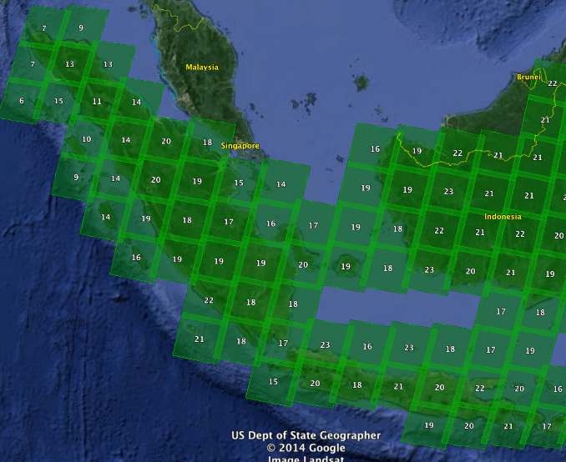

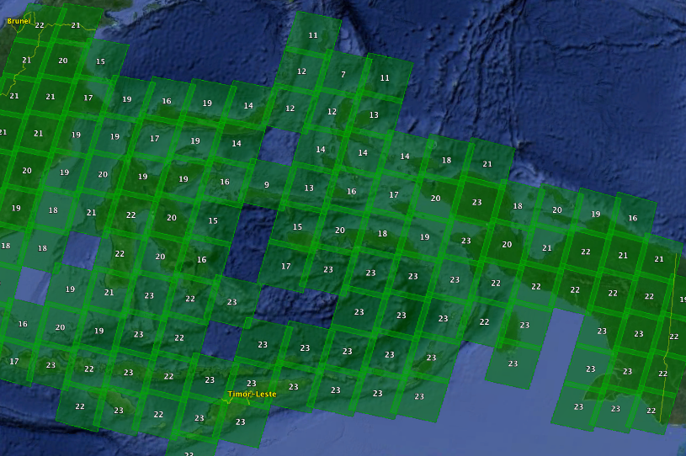

Figure 5. Total number of scenes acquired by Landsat 7 in 2013. The maximum number of scenes that can be acquired in any location is 23 per year.
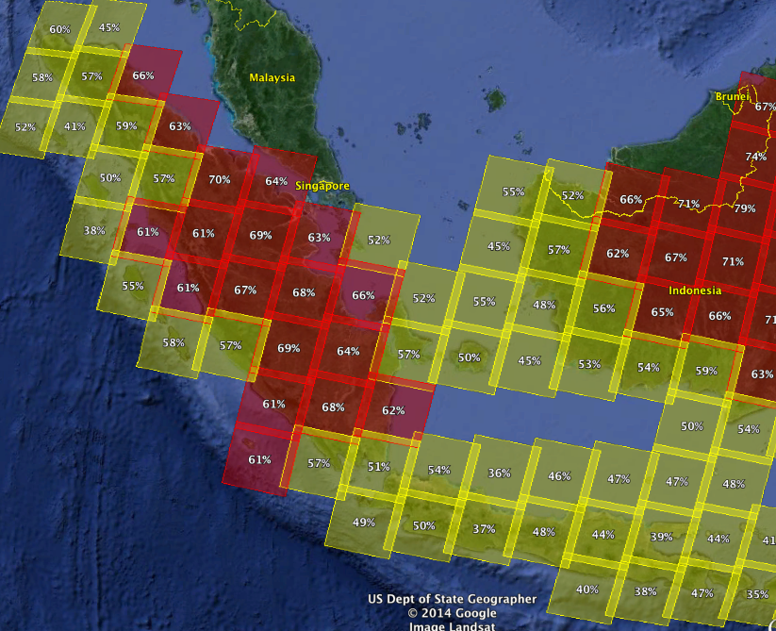

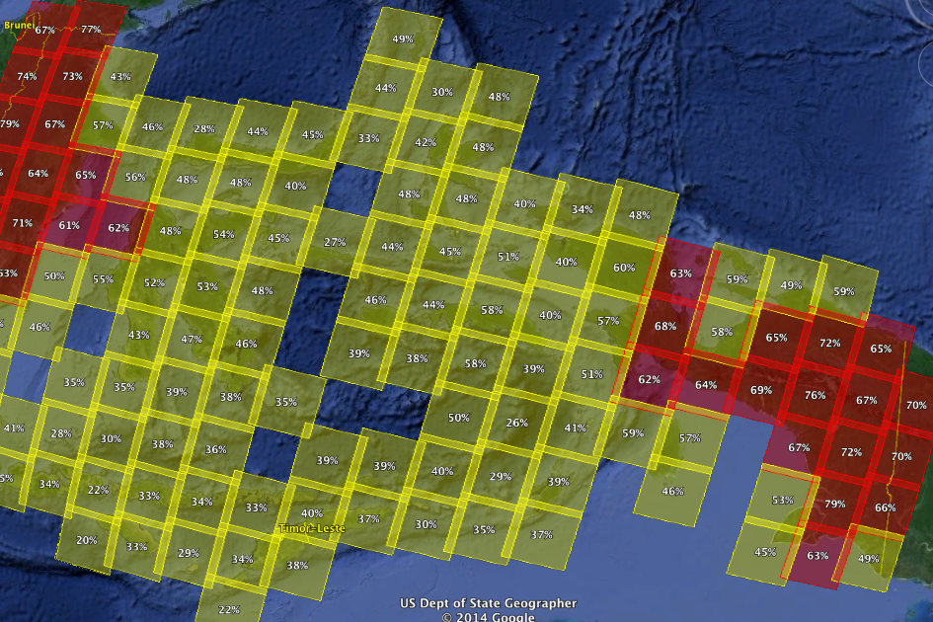

Figure 6. Average Cloud Cover for all acquired Landsat 7 scenes in 2013
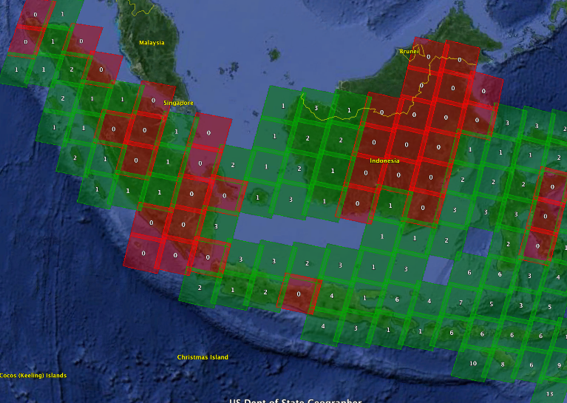

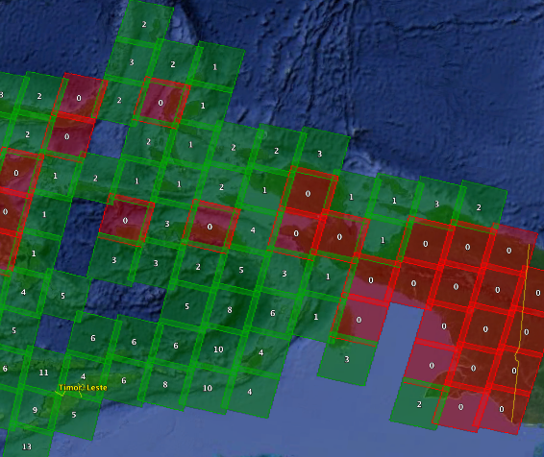
Figure 7. Number of nearly clear-sky scenes (<10% cloud cover) acquired by Landsat 7 in 2013
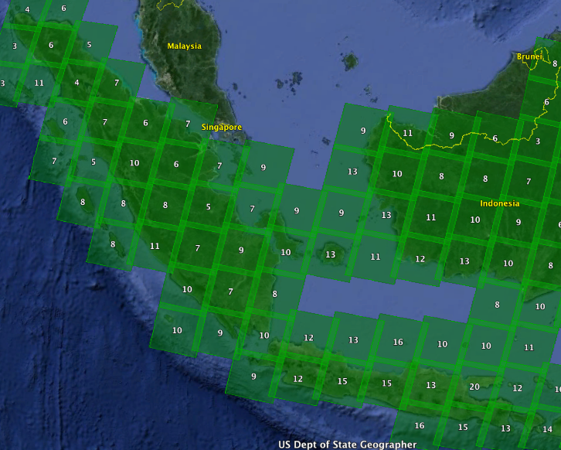

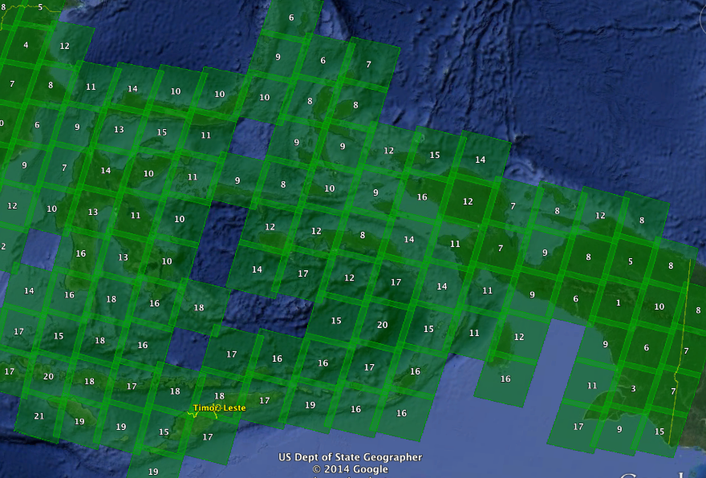
Figure 8. Number of scenes <60% cloud cover acquired by Landsat 7 in 2013
Section 4: Analyses and Conclusions

Path-Row scenes for Indonesia were evaluated based on the criteria defined below. These evaluations are completed in ascending order (1,2,3) using the criteria below to determine the recommendation for handling Landsat scenes over specific regions to meet the GFOI requirements.

1. Acceptable: There is a minimum requirement of ONE clear-sky scene per year for baseline assessments and a goal of AT LEAST TWO clear-sky scenes per year for improved classification and change detection. For these analyses, it is assumed that ONE clear-sky scene per year is acceptable. If the archive data had ONE clear-sky scene in each year, the location is considered “acceptable” for GFOI.

2. Pixel Mining: These locations have a sufficient number (≥ 5 per year) of existing archived scenes with less than 60% cloud cover that could be used for pixel mining (e.g.. via Web-Enabled Landsat Data, WELD) to produce at least ONE or more clear-sky composited or mosaic scenes.

3. Extreme Cloudiness. These locations do not have a sufficient number (< 5 per year) of existing archived scenes with less than 60% cloud cover for pixel mining. Due to persistent cloudiness, these locations should pursue alternative optical or non-optical measurements for cloud penetration.

Conclusions:

Indonesia has cloud problems in many regions of the country, but some locations do meet the minimum acceptable requirement of one nearly cloud-free scene (<10%) per year. The table below highlights the recommendations for each path-row region. While Landsat coverage is acceptable for generating an annual cloud-free mosaic from acquired scenes, many regions (73 total) would require Pixel Mining to generate a cloud-free mosaic. In addition, there are 7 regions that show Extreme Cloudiness and will likely need to consider alternative measurement options, such as SAR imagery to penetrate clouds.

Path | Row | Recommendations |  | Path | Row | Recommendations |  | Path | Row | Recommendations
100 | 63 | Pixel Mining |  | 108 | 65 | Acceptable |  | 114 | 60 | Acceptable
100 | 64 | Acceptable |  | 108 | 66 | Acceptable |  | 114 | 61 | Pixel Mining
100 | 65 | Extreme Cloudiness |  | 109 | 58 | Acceptable |  | 114 | 62 | Pixel Mining
100 | 66 | Pixel Mining |  | 109 | 59 | Acceptable |  | 114 | 63 | Pixel Mining
101 | 62 | Pixel Mining |  | 109 | 60 | Acceptable |  | 114 | 64 | Acceptable
101 | 63 | Extreme Cloudiness |  | 109 | 61 | Acceptable |  | 114 | 65 | Acceptable
101 | 64 | Pixel Mining |  | 109 | 62 | Acceptable |  | 114 | 66 | Acceptable
101 | 65 | Extreme Cloudiness |  | 109 | 63 | Acceptable |  | 114 | 67 | Acceptable
101 | 66 | Pixel Mining |  | 109 | 65 | Acceptable |  | 115 | 59 | Acceptable
102 | 61 | Acceptable |  | 109 | 66 | Acceptable |  | 115 | 60 | Acceptable
102 | 62 | Extreme Cloudiness |  | 110 | 58 | Acceptable |  | 115 | 61 | Acceptable
102 | 63 | Extreme Cloudiness |  | 110 | 59 | Acceptable |  | 115 | 62 | Acceptable
102 | 64 | Pixel Mining |  | 110 | 60 | Acceptable |  | 115 | 64 | Acceptable
102 | 65 | Pixel Mining |  | 110 | 61 | Acceptable |  | 115 | 65 | Acceptable
102 | 66 | Acceptable |  | 110 | 62 | Acceptable |  | 115 | 66 | Acceptable
103 | 61 | Pixel Mining |  | 110 | 63 | Pixel Mining |  | 116 | 58 | Pixel Mining
103 | 62 | Pixel Mining |  | 110 | 65 | Acceptable |  | 116 | 59 | Pixel Mining
103 | 63 | Pixel Mining |  | 110 | 66 | Acceptable |  | 116 | 60 | Acceptable
104 | 61 | Pixel Mining |  | 110 | 67 | Acceptable |  | 116 | 61 | Acceptable
104 | 62 | Acceptable |  | 111 | 57 | Acceptable |  | 116 | 62 | Acceptable
104 | 63 | Pixel Mining |  | 111 | 58 | Acceptable |  | 116 | 63 | Acceptable
104 | 64 | Pixel Mining |  | 111 | 59 | Acceptable |  | 116 | 65 | Acceptable
104 | 65 | Acceptable |  | 111 | 61 | Acceptable |  | 116 | 66 | Acceptable
105 | 61 | Pixel Mining |  | 111 | 64 | Acceptable |  | 117 | 57 | Pixel Mining
105 | 62 | Pixel Mining |  | 111 | 66 | Acceptable |  | 117 | 58 | Pixel Mining
105 | 63 | Pixel Mining |  | 111 | 67 | Acceptable |  | 117 | 59 | Pixel Mining
105 | 64 | Acceptable |  | 111 | 68 | Acceptable |  | 117 | 60 | Extreme Cloudiness
106 | 60 | Acceptable |  | 112 | 59 | Acceptable |  | 117 | 61 | Pixel Mining
106 | 61 | Pixel Mining |  | 112 | 60 | Pixel Mining |  | 117 | 62 | Acceptable
106 | 62 | Pixel Mining |  | 112 | 61 | Pixel Mining |  | 117 | 63 | Acceptable
106 | 63 | Acceptable |  | 112 | 62 | Pixel Mining |  | 117 | 64 | Acceptable
106 | 64 | Acceptable |  | 112 | 63 | Pixel Mining |  | 117 | 65 | Acceptable
106 | 65 | Acceptable |  | 112 | 64 | Acceptable |  | 117 | 66 | Acceptable
106 | 66 | Acceptable |  | 112 | 65 | Acceptable |  | 118 | 57 | Pixel Mining
107 | 60 | Acceptable |  | 112 | 66 | Acceptable |  | 118 | 58 | Pixel Mining
107 | 61 | Pixel Mining |  | 112 | 67 | Acceptable |  | 118 | 59 | Pixel Mining
107 | 62 | Pixel Mining |  | 113 | 59 | Acceptable |  | 118 | 60 | Pixel Mining
107 | 63 | Acceptable |  | 113 | 60 | Pixel Mining |  | 118 | 61 | Pixel Mining
107 | 64 | Acceptable |  | 113 | 61 | Pixel Mining |  | 118 | 62 | Acceptable
107 | 65 | Acceptable |  | 113 | 62 | Pixel Mining |  | 118 | 63 | Acceptable
107 | 66 | Acceptable |  | 113 | 63 | Acceptable |  | 118 | 64 | Pixel Mining
108 | 60 | Acceptable |  | 113 | 64 | Acceptable |  | 118 | 65 | Acceptable
108 | 61 | Pixel Mining |  | 113 | 65 | Acceptable |  | 118 | 66 | Acceptable
108 | 62 | Acceptable |  | 113 | 66 | Acceptable |  | 119 | 59 | Pixel Mining
108 | 63 | Acceptable |  | 113 | 67 | Acceptable |  | 119 | 60 | Pixel Mining
108 | 64 | Acceptable |  | 114 | 59 | Acceptable |  | 119 | 61 | Pixel Mining

Table 4. Landsat Path-Row coverage analysis results.
Path | Row | Recommendations |  | Path | Row | Recommendations
119 | 62 | Pixel Mining |  | 128 | 59 | Pixel Mining
119 | 64 | Acceptable |  | 128 | 60 | Acceptable
119 | 65 | Acceptable |  | 128 | 61 | Pixel Mining
119 | 66 | Acceptable |  | 129 | 57 | Pixel Mining
120 | 59 | Pixel Mining |  | 129 | 58 | Pixel Mining
120 | 60 | Pixel Mining |  | 129 | 59 | Pixel Mining
120 | 61 | Acceptable |  | 129 | 60 | Acceptable
120 | 62 | Pixel Mining |  | 130 | 56 | Acceptable
120 | 64 | Acceptable |  | 130 | 57 | Pixel Mining
120 | 65 | Acceptable |  | 130 | 58 | Acceptable
121 | 59 | Pixel Mining |  | 131 | 56 | Pixel Mining
121 | 60 | Pixel Mining |  | 131 | 57 | Extreme Cloudiness
121 | 61 | Acceptable |  | 131 | 58 | Acceptable
121 | 62 | Acceptable
121 | 64 | Acceptable
121 | 65 | Pixel Mining
122 | 59 | Acceptable
122 | 60 | Acceptable
122 | 61 | Acceptable
122 | 62 | Acceptable
122 | 64 | Acceptable
122 | 65 | Pixel Mining
123 | 61 | Acceptable
123 | 62 | Pixel Mining
123 | 63 | Pixel Mining
123 | 64 | Acceptable
123 | 65 | Acceptable
124 | 60 | Acceptable
124 | 61 | Acceptable
124 | 62 | Pixel Mining
124 | 63 | Acceptable
124 | 64 | Pixel Mining
125 | 60 | Acceptable
125 | 61 | Acceptable
125 | 62 | Pixel Mining
125 | 63 | Acceptable
125 | 64 | Pixel Mining
126 | 59 | Pixel Mining
126 | 60 | Acceptable
126 | 61 | Acceptable
126 | 62 | Pixel Mining
127 | 59 | Pixel Mining
127 | 60 | Pixel Mining
127 | 61 | Acceptable
127 | 62 | Acceptable
128 | 58 | Pixel Mining

Table 4. Landsat Path-Row coverage analysis results (continued).

