Committee on Earth Observations (CEOS)
Ad-hoc Space Data Coordination Group (SDCG)

Global Data Flow Study for
the Global Forest Observations Initiative (GFOI)

Version 0.16
15 February 2016

1 Introduction 3
1.1 Overview 3
1.2 Purpose 4
1.3 Context 4
1.4 Contents 5
2 Global Forest Observation Scenarios 6
2.1 Scenario components 7
2.2 Analysis Ready Data 7
2.3 Scenarios 9
3 Scenario Architecture Description 11
3.1 Data Transmission 11
3.2 Data Storage 12
3.3 Data Services 13
3.4 Data Processing 13
3.5 Forest Map Production 13
3.6 Costs 14
4 Evaluation Criteria 15
5 Evaluation 16
6 Recommendations 17
6.1 Recommendations for Space Agencies 18
6.2 Capacity Building Implications 18
6.3 Benefits for Country and Donor Agencies 18

1 Introduction

1.1 Overview
This document evaluates alternate solutions for reducing barriers to effective use of satellite data in implementing measurement, reporting and verification (MRV) methodologies within national forest monitoring systems (NFMS) in support of REDD+. The launch of Landsat 8, Sentinel-1A, and Sentinel-2A, and resulting access to extremely large volumes of data at no cost to the user changes the environment within which REDD+ countries can access and analyze data. However in those countries capacity is often lacking to handle and process large amounts of data, and the acceptance of higher level global products is often low within government organisations. These rapid changes in data availability provide both opportunities and challenges for significant advances in MRV methodologies including:
- Opportunity: The increased number of satellites provide a dense time series to improve change detection and classification of global forest cover
- Opportunity: Access to Optical and SAR core data flows provide alternate solutions for complex problems, landforms and persistently cloudy regions
- Challenge: Higher data volume increases storage and delivery costs
- Challenge: Additional choices adds complexity to data discovery and selection
- Challenge: Multiple sensors make georegistration and cross calibration more complicated
- Challenge: New methodologies are needed to benefit from increased data volumes and increased sensor complexity
- Challenge: Acceptance and take-up by country’s authorities and agencies
The Space Data Coordination Group (SDCG) needs to consider a coordinated phased approach with GFOI Capacity Building partners that meets countries immediate needs whilst also working toward long-term solutions. The following approaches are evaluated in this document:
- Provide tools for use in maintaining local databases through incremental updates as new data, that meet specified agency criteria, become available
- Provide improved discovery and selection tools needed to assist countries in more effectively identifying required data before attempting downloads.
- Work with space agencies and partners to reduce the burden of data preprocessing on forest management organizations
- Work with space agencies and partners to implement new preprocessing, change detection and classification methodologies
- Acknowledge that simple and more appropriate solutions may exist that do not require an investment in expensive infrastructure
A fundamental premise of this study is the shared objective to reduce barriers and increase efficiencies to the production of national Forest Product Maps. This may involve new data intensive methodologies or more efficient selection, discovery and access tools. An underlying premise is the vested interest in the donor community to ensure that Forest Product Maps meet strict quality and content guidelines as efficiently and cost effective as possible.

1.2 Purpose
It is acknowledged that with vastly increased volumes of data from missions providing continuous global coverage to users at no cost (e.g. the Landsat and Sentinel series), and new methodologies requiring long and dense time series, the movement of such data around the world is becoming increasingly unsustainable. The current business model of uncoordinated delivery of minimally processed data on media is not an effective mechanism for maintaining a national archive - neither at facilities within a country, nor in the “cloud.” This is due in part, but not entirely, to limitations of national internet and high performance computing infrastructure. Even in countries with access to high-speed networks, the construction and maintenance of these large datasets is a time consuming and costly exercise.
More efficient mechanisms are needed for the discovery and maintenance of large national databases. Computing infrastructure must be scoped to meet national requirements and budgets. Among infrastructure that needs to be considered are cloud-based solutions, regional solutions, national solutions and solutions using global archives at CEOS space agencies and commercial partners.
The objective of this study is to explore practical scenarios building on multi-year collections of Landsat and Sentinel-2 data. Other data, such as Sentinel-1, CBERS-4, ASTER, SPOT, ALOS-1 will be discussed as they pertain to the study. Although the focus of the study is on freely available core data streams, unique characteristics of commercial and other restricted distribution data will be addressed. The study is scoped to address the pros and cons of different architectures, technical elements, and implementation of data storage, handling, and processing tools to support the range of requirements of all GFOI countries. Capacity building partners, including FAO, SilvaCarbon, and Australia’s Department of the Environment (DOTE), are central to the success of any global data flows study. Capacity building partners bridge the gap between the REDD+ donor and national forest monitoring communities.
While the focus of this document is on supporting GFOI and REDD+ countries, the conclusions have broader relevance for consideration by CEOS and its agencies in the context of next generation data architecture design, national data requirements, data volumes, bandwidth, processing capacity, “analysis ready” data products, data cube storage architectures, national infrastructure, costs and technical capacity.

1.3 Context
This study report is cast within the framework of the 3-Year Work Plan of the CEOS Space Data Coordination Group (SDCG) for the Global Forest Observations Initiative. Outcome 2 of the 3 Year Work Plan is the identification and implementation of “efficient and effective global flows of data to accommodate in-country development of GFOI recommended Forest Map products.”
The study builds on activities at the space agencies and FAO. The Australian Geoscience Data Cube (AGDC) methodology under development by Geoscience Australia (GA), the Commonwealth Scientific and Industrial Research Organization (CSIRO) and the Australia National Computational Infrastructure (NCI), is central to development efforts implemented by the CEOS Systems Engineering Office (SEO) and at USGS. The SEO is working with the AGDC to implement the Data Cube locally, regionally and in the “cloud”, and USGS is implementing the Data Cube methodology in its Land Change, Monitoring and Prediction (LCMAP) system. ESA’s Thematic Exploitation Platform and Big Data projects are investigating similar methodologies. SEPAL, FAO’s scene-based operational data management tool for forest monitoring can leverage lessons learned from the global data flow study to advance its implementation. The CEOS Land Surface Imaging Virtual Constellation (LSI-VC) will use the outcome of the study as the foundation for more general land surface applications.
The primary purpose of the CEOS Global Baseline Data Acquisition Strategy for GFOI is to assure the acquisition of the minimum required satellite data for countries to participate in reporting forest-related greenhouse gas emissions and national forest carbon stocks to UNFCCC under the REDD+ provisions. This study aims to shift the emphasis from data acquisition to data and information access.

1.4 Contents
This study compares the main parameters and costs associated with a ‘business as usual’ data architecture with alternate architectures and draws conclusions as to the pros and cons and lessons for future data architectures of the main data suppliers and of global initiatives such as GFOI. A sense of how the global data flows operate under alternate future scenarios is provided. The need for efficient data selection and database maintenance mechanism will also be addressed. The study takes into account practical considerations identified from the pilot work underway with Kenya and Colombia, and identifies areas for further consideration by CEOS through the ad hoc team on future data architectures established at the 29th CEOS Plenary (November 2015). Recommendations specific to GFOI will help inform and update the SDCG 3-Year Work Plan, as well as the data segment plans of core data stream providers like USGS and ESA/EC.
The study is framed as follows:
Chapter 2 provides reference points defined as a set of scenarios.
Chapter 3 describes system architecture alternatives available for implementation.
Chapter 4 specifies the evaluation criteria for assessing benefits comparing business as usual scenarios to cloud-based analysis ready data models.
Chapter 5 presents the evaluation of the alternate scenarios.
Chapter 6 summarizes the analysis and presents recommendations for efficient and cost effective global data flows for forest monitoring.

2 Global Forest Observation Scenarios
Three current and proposed global data flow scenarios (see Figure 1) are evaluated. The Business As Usual (BAU) scenario describes the unstructured global data flow of scene-based Top-of-Atmosphere (TOA) products. Alternate scenarios (Option 1 and Option 2) are proposed to provide cost savings, higher efficiencies and improved forest resource analysis and monitoring capabilities in the future. Option 1 describes the flow of Analysis Ready Data (ARD) products to country agencies for the local production of Forest Map products. Option 2 describes the flow of data to a computing cloud or data hub, where country agencies remotely produce national forest products, which are then downloaded to country agencies for further analysis. The country agency controls the selection of the source data, process and the results. Restricted distribution and access data will be delivered to the in country agency or to a capacity building partner under an agreement including the data provider and the capacity building partner.
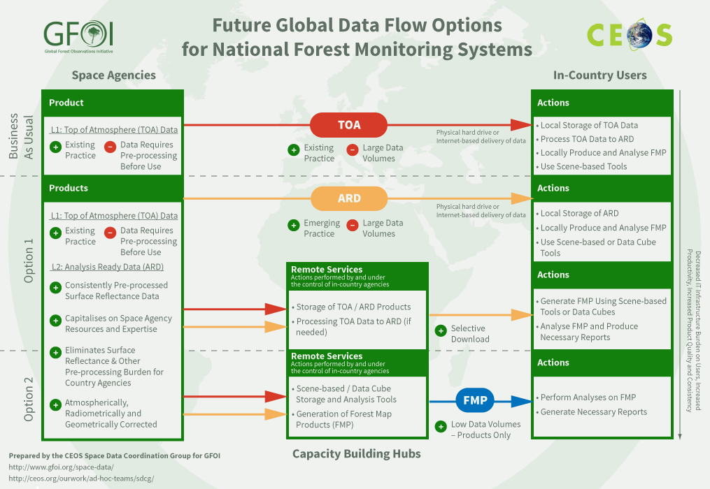
Figure 1. Three general data flow scenarios are evaluated. The difference between these scenarios depends on where the data processing is performed, where the data is stored and where the forest map product is created.
TOA products are often called “level-1 data” and the ARD is often called “level-2 data”. TOA data are radiometrically calibrated and geometrically corrected. ARD is produced from TOA using atmospheric correction to yield a surface reflectance product and has explicit requirements for geolocational accuracy. Existing forest maps serve an important function as baseline forest products and as “bootstrap” products for new forest maps.
Each scenario includes functional components that are implemented using system architectures consisting of storage and computational infrastructure linked by transmission infrastructure. The functional components are outlined in Section 2.1 and the architectural alternatives are outlined in Section 3.
The scenarios are designed with components that are globally relevant. The criteria for success need to meet “typical” country requirements For GFOI, these criteria which are designed to meet donor specified REDD+ requirements, rather than the requirements of a specific country. However, individual countries may have other requirements that would benefit by more general solutions.
National agency users control the data flow to meet their forest monitoring requirements. Capacity building partners, such as FAO, or SilvaCarbon, and technology partners such as the CEOS SEO, Google or Amazon Web Services, can facilitate the delivery and processing of data to meet the requirements established by the national agency and donors. The end-to-end example is focused on Kenya’s forest monitoring system requirements. Application to other countries will require scaling of data volumes, user skills, local infrastructure and budget. Important component studies lie along the analysis path. At each step alternates may exist that are relevant for specific national requirements.

2.1 Scenario components
In 2016, data acquisitions of the core optical data sets will provide repeat global coverage. Data limitations will increasingly shift to country specific challenges. Data access and the establishment of infrastructures to accommodate emerging methodologies that utilize the large volumes of newly available satellite data including SAR and high resolution data will become key focus areas. Managing the flow of the vast amount of new satellite data will become increasingly complicated - made even more complex by the need to make multiple data flows compatible across satellite sources. The infrastructure needed to move, store and analyse these data becomes increasingly difficult in the BAU model. In fact, these models will not be sustainable in the future and are only marginally effective now. Emerging monitoring methodologies increasingly depend on access to dense multiyear temporal cross-calibrated and geo-registered satellite databases.
For countries with limited access, storage or computational infrastructure, the delivery of ‘Analysis Ready Data’ may represent significant savings. In addition, the use of intermediate storage options (e.g. cloud computing, data hubs) will reduce the dependency on internet bandwidth and also reduce long-term costs, as shown in Section 3.6.

2.2 Analysis Ready Data
The definition of “Analysis Ready Data” (ARD), in large part, depends on national infrastructure and requirements. The intent of ARD is to shift the burden of preparing space data for analysis from data users to data providers. Capacity building and technology partners can assist in the shift as space agencies transition to the delivery of ARD and as national infrastructure evolves.
The transition to ARD has two components. The first is the creation of scene based radiometrically and geometrically corrected products that include terrain, atmospheric and viewing angle corrections (Table 1). The second is the reorganization of the data into data cubes to optimize time series analysis. Whether scene-based or data cubes are preferred depends on national agency requirements.

Table 1. Analysis Ready Data
Optical | Radiometry | Absolute calibration
 |  | Cross calibration
 |  | Band difference adjustment
 |  | Viewing angle correction
 |  | Solar illumination angle correction
 |  | Atmospheric correction
 | Geometry | Systematic correction
 |  | Orthorectification
 |  | Projection
 |  | Image to image registration
 | Mosaics | Cloud free
 | Pixel level metadata | No data  Clouds  Shadows  Water
Radar | Radiometry | Absolute calibration
 |  | Radiometric correction for topography
 |  | Normalization of cross track (near-far range) incidence angle variation
 |  | Rain attenuation
 | Geometry | Systematic correction
 |  | Orthorectification
 |  | Projection
 |  | Image to image registration
 | Mosaics | Void free
 | Pixel level metadata | No Data  Water  Layover  Shadow  Land
DEM | Elevation data are need to correct Optical and Radar data and for forest monitoring
Global Forest Products | Global forest maps are useful as “bootstrap” classifications and validation
Surface reflectance data registered to within a third of a pixel are the foundational Analysis Ready Data product for optical sensors. Different paths exist to reach this requirement. Most space agencies produce Top of Atmosphere (TOA), also called “at sensor”, radiance or reflectance data products, while some produce higher level products:
- USGS produces on-demand ARD Surface Reflectance (SR) products, also called top of canopy;
- ESA provides a toolbox to convert TOA products to calculate ARD SR products (systematic provision of SR products is currently under investigation within the Copernicus ground segment); and
- JAXA provides ortho-rectified SAR products.
The current trend is toward the distribution of tiled ARD Data Cubes by the space agencies. No agency currently distributes their ARD as Data Cubes. The data cubes for the Kenyan and Colombian pilot studies are created using open source ingest algorithms developed by the NASA SEO, GA and CSIRO teams. Data Cube applications are currently in research and development and may not be appropriate for GFOI operational applications
GFOI’s MGD and R&D teams in partnership with capacity building partners and countries can define higher-level ARD products specifically designed to meet the goals of GFOI. Example derived products include greenness, wetness, bareness indices and products derived from algorithms such as the continuous change detection and classification of land cover. Existing forest maps also serve as de facto ARD input for the production of new forest products. All scenarios are based on the assumption that national agencies have the access and processing infrastructure required to produce the final national forest products.

2.3 Scenarios
Three scenarios are evaluated. The first is the Business As Usual (BAU) scenario representing how data have typically been processed and delivered to countries. Within the scope of national forest monitoring systems (NFMS) the two alternate scenarios have a common thread: they both rely on the automation of the data processing and reformatting of the satellite data to create ARD. Countries can use either scene-based or tiled data (e.g. Data Cubes) to reduce computational load in analysis tools. The alternate scenarios (Option 1 and Option 2) consider differences in the location of data processing, data storage and data analysis. The key to success is building on shared methodologies, such as those defined within the Methods and Guidance Document (MGD) and a database maintenance organization supporting sustainable and comparable forest mapping practices. The analysis recognizes that real world implementations will find a balance between these options based on data availability, skills, infrastructure and cost.

2.3.1 Business As Usual Scenario
The BAU scenario (shown below) sets the baseline for comparison. This scenario represents the state of satellite data flows in 2014-2015, when Landsat was the primary core data flow with Landsat 8 data just becoming available. At that time the broad usage of SAR data was very limited for forest applications.
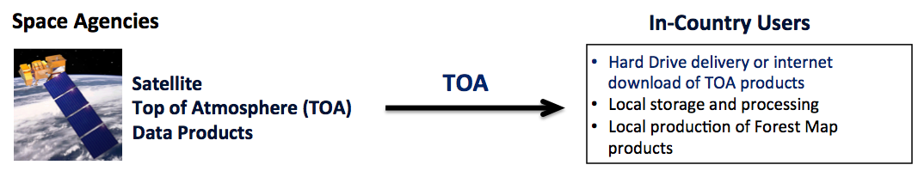
Prior to Landsat 8, most core data products could be delivered on hard media or over the internet with the assumption that countries had access to sufficient storage and processing infrastructure. Space satellite data were delivered to the country and then ingested, processed and analysed to create the forest products using methodologies implemented in each NFMS. Most analysis tools used scene-based TOA radiance products. In large part this is the current model although the community is in transition to SR products.
The defining limitation of BAU scenarios is the lack of an organized data flow, methodologies and maintenance structure leading toward comparable forest products that can evolve to meet future requirements at known and controllable costs and quality. Many current assessments are treated as independent events. New data are acquired and new analyses are performed with little inheritance from past data and practices to new forest maps.
An alternative BAU scenario is the delivery of a forest map by a research institute, NGO or commercial partner – with or without country participation. Although the maps are frequently of high quality, the provenance and source of the data needed for comparison to new forest maps is often lacking.

2.3.2 Option 1: Delivery of analysis ready data to a country agency

The current trend among space agencies is to shift toward the distribution of ARD. Option 1 (shown below) represents a national agency solution where Space agencies provide access to the satellite data and capacity building partners may serve as intermediaries as space agencies transition to the distribution of ARD. These data will be delivered to the country agency via the internet or disk drive (see Section 2.2). These data will be scene-based, but tile-based solutions (e.g. Data Cubes) are expected to follow. Technology partners such as the CEOS SEO, Google or Amazon Web Services may provide access to infrastructure as needed. National information products will be created in the country NFMS, by national agency staff and used for further analysis. New data will be added to the national image database by national agency staff using automated algorithms. Option 1 may represent a long-term solution for national agencies with sufficient processing, storage and internet infrastructure, as well as the expertise to support national requirements and a need for a national image database to meet broader requirements. Option 1 removes the burden of producing ARD, while providing maximum flexibility for the country users.
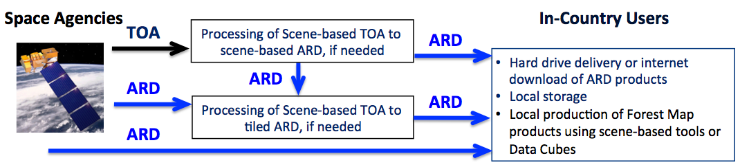

2.3.3 Option 2: Delivery of data to a cloud or data hub for country agency access and analysis
Option 2 (shown below) represents a cloud computing or data hub solution where the data exists at a partner agency (FAO or other regional partner) hub or in the commercial cloud. Space agency data is downloaded to the hub or cloud where processing can then take place, if needed. The hub may exist on a commercial cloud or at a partner agency, such as FAO or other regional partner. The data hub infrastructure is maintained by the partner. National agency access to the hub is a requirement. National agency staff implement the forest application analyses and download the forest map results once complete.
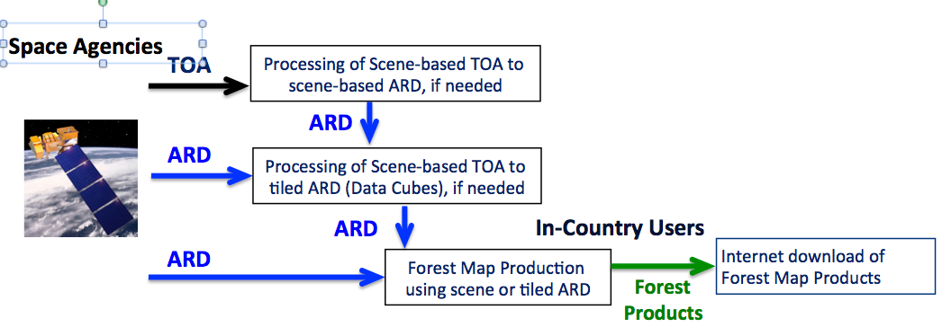
The space data (TOA or SR) are pulled from space agencies to the data hub. If the data are delivered as TOA data they need to be converted to Surface Reflectance (SR). The preference is that the TOA-SR step is performed by space agencies, but if that is not possible, then open source or commercial processing tools can be installed on the cloud or data hub to create ARD products. At this point, further application analyses are possible with scene-based tools. If desired, the SR data can be further reformatted to the specification of the national grid for Data Cube analysis. National information products will be created at the data hub using MGD algorithms, by national agency staff. Information products are downloaded by the national agency for further analysis, reporting and decision making.
Option 2 may represent a long-term solution for national agencies who cannot, or do not, see the need to invest in national infrastructure. An alternative is to implement operational solutions at partner agencies, such as FAO, regional partners, or NGOs.

3 Scenario Architecture Description
Each of the scenarios defined in Section 2 differ in their requirements for data transmission, data storage, data processing, technical capacity, and cost. The variation in technical capacity (e.g., storage, computing, internet) of GFOI countries must be considered in the assessment of any solution scenario. In addition, these technical capacities may change over time. The solution scenarios should be flexible to accommodate a wide variety of country resources and allow those scenarios to change as countries gain capacity. This section describes these requirements in detail such that an evaluation can be conducted to understand the trade-offs and assess the preferred options for the future.

3.1 Data Transmission
It is assumed that “data transmission” is the transfer of data to a given country over the internet. A study was conducted by the CEOS SEO to evaluate internet download rates for 70 GFOI countries that are part of various REDD+ groups. Internet speeds were sourced from Akamai’s State of the Internet website (https://www.stateoftheinternet.com). As of early 2015, the report suggests that internet download speeds above 10 Mbps are considered “fast” and the global average speed was 5 Mbps. The fastest region of the world is Southeast Asia, with average speeds just over 20 Mbps. The box-and-whisker figure below shows the range of data transmission rates for the 70 GFOI countries in the study. As the figure shows, 50% of the countries have download speeds between 4.9 and 9 Mbps. For comparison, the average rates of Australia (7.4) and USA (11.5) are shown. The lowest rates for GFOI countries are Benin (1.6) and Sudan (2.3). The highest rates for GFOI countries are Vietnam (17.9) and Thailand (20.2). If one were to consider an average annual data load of 1TB of data (around 500 Landsat 8 scenes), the transmission time at the average global download rate of 5.0 Mbps would be ~19 days.
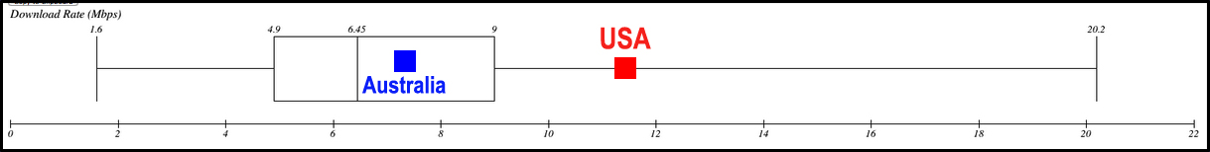

3.2 Data Storage
The SEO study noted in Section 3.1 also calculated the annual data volume for the 70 GFOI countries assuming each country received complete coverage from the Landsat-7, Landsat-8 and Sentinel-2A missions. The CEOS COVE coverage analyzer tool (http://www.ceos-cove.org/) was used to calculate the number of scenes for each mission. The TOA file sizes are on average 500 MB (Landsat 7), 1.8 TB (Landsat 8) and 600 MB (Sentinel-2A subscene). Many of the GFOI countries are rather small (e.g., Bhutan, Jamaica, Vanuatu), but several are quite large (e.g., DRC, Argentina, Brazil) and will generate a large amount of annual data if all 3 missions are utilized. The box-and-whisker figure below shows the range of required storage for the 70 GFOI countries in the study. The figure shows that 50% of the countries have a required annual data volume of 0.6 to 3.35 TB. The mean volume is 2.8 TB and the median volume is 1.2 TB. For comparison, the data volume for USA (20.5 TB) and Australia (20.8 TB) is shown. It should be noted that data from other missions and prior years can be scaled and added to these results to assess total data storage requirements for a given country.
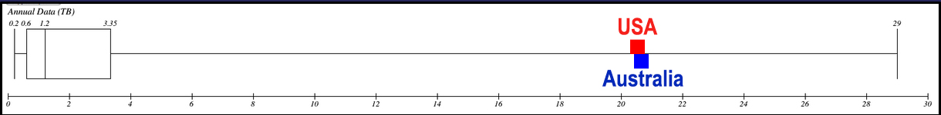

3.3 Data Services
Tools are needed to allow agencies to search and discover data to meet forest mapping requirements and to manage databases once assembled. To minimize costs, only data to produce the forest map product should be acquired and maintained. Setting database scope to match requirements results in fewer images to download and update. The goal is to create an appropriate database that may contain a richer set of source data including SAR and high resolution data to meet specific landform, climate and accuracy criteria. CEOS, through the Systems Engineering Office (SEO), the Space Data Coordination Group (SDCG) for GFOI and the Working Group on Information Systems and Services (WGISS) is continually working on new search and discovery tools and enhancements to existing tools. The goal is to provide countries with a CEOS multi-mission portal where they can easily search and discover past (archive) data as well as understand future acquisition plans. Regardless of the data flow scenario chosen for a country (i.e., BAU, Option 1, Option 2), any country will be able to identify required datasets, obtain those datasets in the format desired and perform forest application analyses now and in the future.

3.4 Data Processing
The scenarios presented in Section 2 depend on the creation of an analysis ready data (ARD) product. At some point in the data flow, processing will be needed. This processing can be done at the Space Agency (Option 1), on a data hub (Option 2), or in a country with the necessary resources (BAU). In many cases, countries prefer to manage their own processing (e.g., Australia) in order to apply their own processing algorithms (e.g. local atmospheric correction, local DEM). It is believed that most of the GFOI countries will desire ARD and prefer to receive these data from Space Agencies (Option 1) or via a data hub (Option 2). In the latter case (regional or cloud computing hub), the country will need a reasonable internet download speed (>5 Mbps) to adequately connect to the data hub resources and download resulting analysis products.

3.5 Forest Map Production
Methodologies needed to perform forest application analyses and produce forest map products are coordinated by the Capacity Building teams at the partner agencies (e.g. FAO, SilvaCarbon, Australia Department of the Environment) and are aligned with the intentions of the Methods and Guidance Document (MGD). These analyses can be conducted using traditional scene-based approaches or newer Data Cube approaches, depending on the desires and technical capabilities of a country. Until now, partner agencies have only utilized accepted tools (e.g. OpenForis Toolset, SEPAL) or tools desired by individual countries to perform analyses and produce forest maps. As technologies advance and data volumes increase, it is believed that more countries will desire to utilize a Data Cube infrastructure for enhanced analyses and time series studies. The CEOS SEO is leading a prototype project in Kenya to test the implementation of a data cube system in parallel to their existing scene-based analyses. Lessons learned from this project will be used to expand the capabilities of the data cube system and ultimately evaluate its potential to be the baseline approach for future forest analyses.

3.6 Costs
Costs can be estimated for each of the solution scenarios: BAU, country-based data management (Option 1) and cloud computing or data hubs (Option 2). In order to make a reasonable comparison, the costs will assume an average annual data volume of 1 TB, and a past data volume of 5 TB (5 times the annual volume). This is reasonable assumption, based on Landsat 7 data, which was the only baseline dataset available until mid-2015.
It is important to make the distinction of how these costs are spread among various entities. For example, the BAU costs are entirely covered by capacity building partners and therefore operationally unsustainable. The increased costs to implement Data Cubes should not be directly compared to BAU costs, since these costs are covered by a variety of groups, such as space agencies, individual countries (local deployment or cloud-based deployment), other partners (e.g. Google partnership with FAO, CEOS SEO partnership with Amazon) or stakeholders (e.g., regional data hubs, GFOI, FAO). In the end, the future cost of delivering large amounts of data cannot be covered by space agencies but must be shared by the users, partners and stakeholders.
Business as Usual (BAU): The estimated cost to deliver 1 TB of data annually from the Space Agencies (USGS and EC/ESA) to all 127 GFOI countries is >$500,000 U.S. These costs are dominated by the requirements of smaller developing nations (~50%), as one would assume they do not have adequate internet and can only support hard drive delivery of data. Such delivery requires annual space agency costs for management and preparation (e.g., one dedicated person, per space agency, per year), hard drives, shipping and possibly travel for capacity building and training. It is assumed that no cost is needed to distribute data from space agency servers to larger and developed countries (~50%) over the internet, as this is already part of the basic program plan for these agencies. Surely these costs are not sustainable and sensible for the future though the requirement exists to supply functional data to all of the GFOI countries.
Country-based Data Management (Option 1): Countries will need a reasonable local computer to run Data Cube algorithms (if desired), store large volumes of data and perform forest application analyses. The baseline system (e.g., Titan Workstation) requires a Linux operating system with a 6-core CPU, 3.7 GHz processer, 64 GB RAM, and 12 TB RAID storage. The cost estimate for this system is $5,000 U.S. In addition, it is assumed the country can provide the necessary system administration and accommodate expansion for the future.
Cloud Computing or Data Hubs (Option 2): Costs for regional data hubs and/or cloud-computing hubs can be estimated from recent Amazon Web Services (AWS) costs incurred by the CEOS SEO to support the Kenyan Data Cube project. A reasonable assumption is a total data storage of 10 TB and sufficient processing (EC2, shared 8 cores, 64 GB RAM) for creating ARD, creating data cubes, and running MGD algorithms. This cost estimate is $10,000 U.S. per year per country and applies primarily to the cloud computing option. In the case of a regional data hub (e.g. SERVIR) it may be possible for countries to obtain free data services, as many of these hubs are funded by external philanthropic organizations. Regardless of the data hub choice, there are still some costs associated with space agency management and preparation of data to populate the hubs, but those costs are significantly less than the BAU scenario.

4 Evaluation Criteria
The functional requirement is to position countries to establish operational measurement, reporting and verification (MRV) methodologies within national forest monitoring systems (NFMS) for the next 15 years. As NFMS mature and as space agency products mature, the systems will evolve. The solution now will be different from the solution that is possible and needed fifteen years from now. Donor agencies must be able to use the recommendations to constrain costs and to ensure quality.
The qualitative functional criteria that summarize the overall scenario and the quantitative component criteria that estimate costs and performance of the components are outlined below. Each of the scenarios will be evaluated using these criteria. When necessary, scenario variants are discussed to capture analysis alternatives, examples include the incorporation of commercial or regional data.
Component criteria discussed in Section 3 and assessed in Section 5 are:

- Data transmission (access) — Speed and reliability
- Data storage — Reliability, performance, sustainability
- Data services — Discovery and selection, management and update
- Data processing — Adaptability, performance
- Forest map production — Quality assurance, data provenance, reproducibility and comparability of results
- Costs

Functional criteria discussed in Section 6 include:
- Does the option lead to an operational solution with opportunities for growth that can be sustained by the country and space agencies?
- Does the solution readily expand to include other data sources such as SAR, high resolution, commercial, or other data sources that may have restricted access?
- Does the solution support collaborative relationships with other partners and capacity building needs?
- Is the option implementable? (maturity of system, set up costs, maintenance costs)

5 Evaluation
The evaluation is organized by responsible party and scenario. Capacity building and technology partners serve as intermediaries between space agencies and countries. Capacity building partners will also advance technology and technology partners will provide capacity building. The function option references scenario components. The technical and cost references the component evaluation criteria described in Section 3.
Responsible Group | Functional Option | GDF Scenario | Technical Impact | Cost Impact
 |  |  |  | Space agency | partner | country
Space Agency (Data Provider) | Process and deliver TOA (level 1) data over internet to country or partner agency | BAU  Option 1/2 | Typical space agency function. May require partner agency assistance to create ARD. Requires reasonable country internet access, storage and processing. | Low | High | High
 | Process and deliver scene-based ARD (level 2) over internet to country or partner agency | Option 1/2 | Not operational product for all space agencies. Requires reasonable country internet access, storage and processing. | Medium | Medium | Medium
 | Process and deliver data cube ARD (level 2) over internet to country or partner agency | Option 1 | Currently not operational product at any space agency. Requires substantial space agency commitment. Optimized for time series analysis. Requires reasonable country internet access, storage and processing. | High | Low | Low
Capacity Building Partner | Process, as needed, and store scene-based and data cube ARD on a temporary basis | Option 1/2 | Requires hosting Data Cube software for on-demand Data Cube formation | Low | High | Low
 | Deliver scene based or data cube ARD to countries over the internet or on media | Option 1 | Requires reasonable partner and country storage and transmission infrastructure. Requires funding for media and shipping. Countries need storage for data. | Low | Medium | Medium
 | Temporarily host services for the production of forest products by country agencies | Option 2 | Requires hosting Data Cube software for on-demand Data Cube formation and open source tools for Forest Product creation | Low | High | Medium
Technology Partner | Create and deliver Data Cube open source software to GitHub for country and partner use | Option 1/2 | Sustained maintenance of GitHub and open source tools by CEOS | High | High | Low
 | Create, store and maintain data cubes for technology demonstration | BAU  Option 1/2 | Partner investment in creation, storage and maintenance of Data Cubes for countries | Low | High | Low
 | Deliver mini-cubes to countries to support CB partners for technology demonstration | Option 1/2 | Partner investment in mini-cube creation and delivery and sustained investment in capacity building/training by partners | Low | High | Low
 | Store global or regional collections of TOA or ARD on mirror sites | Option 1 | Maintained and funded by external partners (e.g. Amazon, Google, SERVIR) or sibling space agency. Authoritative data source remains the originating space agency | High | Low | Low
GFOI Country (User) | Download scene based or Data Cube ARD from space agency and produce forest products | Option 1 | Requires internet capacity to download ARD. Country processes ARD locally to produce forest products. | Low | Medium | Medium
 | Download ARD from storage and processing hub supported by CB or technology partner and produce forest products | Option 1 | Requires investment in storage and processing hub. Requires internet capacity to download scene ARD. Country processes ARD locally to produce forest products. | Low | Medium | Medium
 | Use free/open tools and storage in the cloud or at a partner’s hub to produce forest products | Option 2 | Requires capacity building and training for countries to utilize hub. Requires investment in hub. | Low | High | Low
 | Download TOA data in scene-based format and use local storage and processing | BAU | Country is responsible for download of TOA, processing to SR, local storage, and creation of forest products. | Low | Low | High

The total cost is reflected as a function of all costs. The country costs reflect the end goal. The minimization of country costs may require high donor and space agency commitments. These high space agency costs assumed by space agencies can be justified by amortization across a very large data volume and the production of improved data product that also benefits the national interests of the space agency. Investment in high partners costs should result in a better and more efficiently produced forest product that will meet the REDD+ donor requirements for many countries. The goal is to minimize country agency costs, while also minimizing per instance partner and space agency costs.

6 Recommendations
The recommendations build on how well the alternative data flows satisfy the fundamental premises of:
- reducing barriers in the production of national forest products by countries; and
- meeting the strict quality and content guidelines set by the donors as efficiently and cost effectively as possible.
Opportunities and challenges exist for space agencies, capacity building partners, technology partners, country agencies, and donors.

6.1 Recommendations for Space Agencies
- Evolve ARD products to meet current requirements for scene-based and future requirements for Data Cubes.
- Support the development of methodologies to use Data Cubes.
- Increase coordination among space agencies for cross calibration of products.
- Improve access to data directly from space agencies and through external partners.
- Increase access to older data sets for time series analysis and baseline classifications.

6.2 Capacity Building Implications
How do the options provide opportunities for capacity building and for supporting MGD type development?
- Technology partners
  - Coordinate with capacity building partners to prototype applications for access and production of forest maps
  - Coordinate with space agencies to develop prototype tools and access mechanisms
  - Improve multi sensor access and selection tools
- Capacity building partners
  - Coordinate with technology partners to adapt and implement prototype tools in operational environments
  - Coordinate with other capacity building partners and countries to optimize practical and integrated solutions
  - Investigate and evaluate multiple data flows to meet country and donor requirements
  - Provide country access to storage and processing needed to generated ARD products

6.3 Benefits for Country and Donor Agencies
How are we able to improve the ability of countries to perform GFOI requirements and how do countries benefit beyond this narrowly defined criteria? Does this study provide a framework within which Donor agencies can support the implementation of requirements?
- Determine national infrastructure requirements
  - If an in-country storage and processing infrastructure is not required, the forest product can be procured from an external partner. Minimal storage and internet infrastructure is required
  - If there is no requirement for in-country storage and processing infrastructure, but national forest resource assessment expertise is available, an option 2 solution where the processing is performed by national staff via the internet may be satisfactory. Reasonable storage, processing and internet infrastructure is required.
  - If there is a requirement for in-country storage and processing infrastructure, an option 1 solution, where ARD data are delivered to countries may be preferred. Substantial storage, processing and internet access is required.
  - Country agencies with excellent storage, processing and internet access can assess future data cube methodologies for forest monitoring – option 1 with data cubes.
- Evaluate opportunities for growth
  - Capacity building partners can assist countries assess national and donor requirements and technology partner solutions.
  - Capacity building and technology partners can provide guidance to evolve processing systems to meet current and future requirements.
  - Country authority and agency acceptance depends on the demonstration of clear national benefits.
- Evaluate sustainability of solutions
  - What are the implementation costs of the solutions?
  - Can new solutions be maintained?
  - What specialized expertise needs to be sustained? Technology, Remote sensing, GIS, Forest management?
  - Sustainable solutions are key to acceptance by donors and country authorities.

