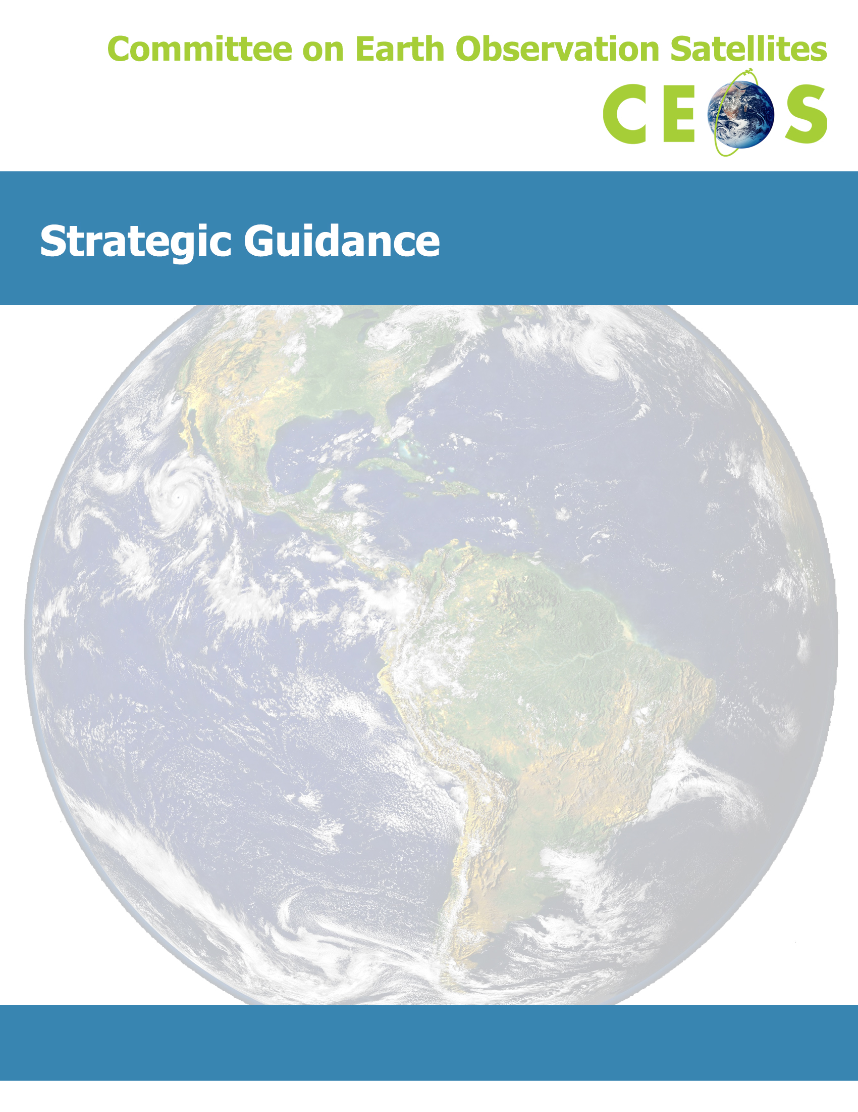
Version: July 16, 2013
Version: November 2013

Contents
1 Introduction and Background 3
2 CEOS Mission and Objectives 4
3 Goals 5
4 Value to Stakeholders 6
5 Approach 6
6 Definition and Measures of Success 7
7 Challenges, Opportunities, and Strategic Direction 8

Introduction and Background
The Committee on Earth Observation Satellites (CEOS) was established in September 1984 in response to a recommendation from a Panel of Experts on Remote Sensing from Space that was set up under the aegis of the G7 Economic Summit of Industrial Nations Working Group on Growth, Technology and Employment. This panel recognized the multidisciplinary nature of space-based Earth observations and the value of coordinating international Earth observation efforts to benefit society. Accordingly, the original function of CEOS was to coordinate and harmonize Earth observations to make it easier for the user community to access and utilize data. CEOS initially focused on interoperability, common data formats, the intercalibration of instruments, and common validation and intercomparison of products.
Since the inception of CEOS, the circumstances surrounding the collection and use of space-based Earth observations have changed. The number of Earth-observing satellites has vastly increased. Onboard instruments are more complex, and are capable of collecting new types of data in ever-growing volumes. The user community has expanded and become more diverse, as different data types become available and new applications for Earth observations are developed. Users have become more organized, forming several international bodies that coordinate and levy Earth observation requirements. In response to this changing environment, CEOS has also evolved, becoming more complex, and expanding the number and scope of its activities. In addition to its original charge, CEOS now focuses on validated requirements levied by external organizations, works closely with other satellite coordinating bodies (e.g., the Coordination Group for Meteorological Satellites [CGMS]), and continues its role as the primary forum for international coordination of space-based Earth observations.
Over the past three decades, CEOS has significantly contributed to the advancement of space-based Earth observation community efforts. CEOS Plenary sessions provide a regular opportunity for CEOS Agencies to communicate, collaborate, and exchange information on Earth observation efforts. Such international coordination has spurred useful partnerships such as the Integrated Global Observing Strategy (IGOS), and CEOS played an influential role in the establishment and ongoing development of the Group on Earth Observations (GEO) and the Global Earth Observation System of Systems (GEOSS). Indeed, CEOS coordinates the GEOSS space segment. CEOS Agencies are working together to launch multi-agency collaborative missions, and such cooperative efforts have become the primary approach to Earth observation mission development. CEOS also provides an established means of communicating with external organizations, enabling CEOS to understand and then act upon these organizations’ Earth observation needs and requirements.
To ensure it remains a vital and relevant organization, CEOS initiated a self-study in 2011 to revisit its mission and international role in light of the evolving nature of Earth observation initiatives and the changing needs of the Earth observation user community. As a result of this self-study, CEOS now employs three documents to guide and conduct its work: this CEOS Strategic Guidance document, which articulates the overarching long-term (7-10 years) purpose and goals of CEOS; a CEOS Governance and Processes document, which provides updated guidelines with regard to CEOS’s structure and operations, and the processes CEOS employs to achieve its goals; and a three-year rolling CEOS Work Plan, which sets forth near-term actions to achieve the goals outlined in the CEOS Strategic Guidance document. The following CEOS Strategic Guidance document describes the overarching purpose of the organization and the value CEOS provides to its stakeholders and the global community. It defines broad goals for the organization, and outlines a general approach to achieve those goals, as well as methods to maximize success. The guidance herein addresses the path forward for CEOS, including various strategies CEOS can employ both to respond to anticipated challenges and capitalize on upcoming opportunities.

CEOS Mission and Objectives
CEOS Mission Statement:
CEOS ensures international coordination of civil space-based Earth observation programs and promotes exchange of data to optimize societal benefit and inform decision making for securing a prosperous and sustainable future for humankind.

CEOS is an international body uniquely capable of coordinating the broad spectrum of space-based Earth observation activities. CEOS participants include government organizations that develop and operate civil Earth observation satellites (Members) and other coordinating groups and scientific or governmental organizations that support CEOS’s mission (Associates). Since CEOS’s inception, the number of Members and Associates, collectively referred to as CEOS “Agencies,” has grown to include nearly all civil space-based Earth observation agencies, together with associated key user organizations. CEOS operates on a best-effort basis using consensus-based decision-making processes, and its Agencies possess varying capabilities, areas of expertise, and resource levels. CEOS Agencies are mindful of the CEOS scope and desire to provide and share high-quality data, as well as information tools, to an expanding global user community on a full and open basis, and in accordance with the principles of Data Democracy as enunciated by CEOS at its 2010 Plenary in Rio de Janeiro. Satellite data requirements relating to societal benefits, global climate change, and sustainable development are collected and conveyed in connection with relationships established with CEOS by key user groups including, but not limited to: GEO, the Global Climate Observing System (GCOS), the United Nations Framework Convention on Climate Change (UNFCCC), and the United Nations International Strategy for Disaster Reduction (UNISDR). CEOS, through its internal mechanisms including Working Groups and Virtual Constellations, works to achieve compatibility and complementarity of data products, services, applications and policies.
CEOS has three primary objectives:
- To optimize the benefits of space-based Earth observation through cooperation of CEOS Agencies in mission planning and in the development of compatible data products, formats, services, applications and policies
- To aid both CEOS Agencies and the international user community by, among other things, serving as the focal point for international coordination of space-based Earth observation activities, including the Group on Earth Observations and entities related to global change
- To exchange policy and technical information to encourage complementarity and compatibility among space-based Earth observation systems currently in service or development, and the data received from them, as well as address issues of common interest across the spectrum of Earth observation satellite missions

Goals
To ensure that CEOS fulfills its mission and purpose and remains sustainable, viable, and relevant, CEOS will work to:
- Close important observational gaps. CEOS must identify key future observational gaps by gathering validated observational requirements from stakeholders and comparing them against the capabilities and capacity to be provided by upcoming Earth observation systems. Having targeted specific observational challenges, CEOS will promote solutions to reduce gaps and duplication through partnerships, membership growth and coordination, new launches, and leverage of existing member assets.
- Achieve better integration across the full range of Earth observations. CEOS must reach out to form working partnerships with organizations responsible for space-based, airborne, ground-based, and in situ data. For example, CEOS must continue to coordinate with GEO to accomplish the successful development of a GEOSS that integrates this full range of Earth observations.
- Promote Data Democracy by improving access to and use of CEOS Agency data. To facilitate open and easy access to Agency data, CEOS must improve discovery, provide interoperability arrangements, coordinate data access portals in specific topical areas, and promote the use of open-source tools for data handling. Not only will CEOS Agencies need to coordinate and incorporate standard data discovery and access mechanisms, they will also need to adapt these mechanisms to the tools employed by the user community. CEOS must also work to stimulate capacity-building initiatives—both human and technological—to maximize the societal benefits derived from CEOS Agency data.
- Remain responsive to Earth observation users’ needs globally. CEOS must continue to forge partnerships with the increasingly diverse Earth observation user community. To aid this dialogue, CEOS must demonstrate that the Earth observation systems coordinated, developed, and operated by CEOS Agencies have provided real societal and/or scientific benefits with clear identification of the end users. This work needs to be implemented in full partnership with the CEOS Associates and stakeholders such as GEO’s Communities of Practice (CoP). CEOS must understand and manage internal and external constraints to optimize its outputs and must remain flexible and forward-thinking to respond to the emerging needs of its stakeholders and the global community.
The work documented in the CEOS Work Plan shall be consistent with these goals and in consideration of the capacity and resources of CEOS Agencies. These goals will serve to reinforce CEOS’s role as the unique forum for international coordination of space-based Earth observations to meet societal and scientific needs.

Value to Stakeholders
An improved understanding of the Earth system—weather, climate, oceans, land, geology, natural resources, ecosystems, and natural and human-induced hazards—is essential to better predict, adapt to, and mitigate the expected global changes and their impacts on society. Understanding a planet as complex as Earth, however, clearly requires a global effort since no single country can monitor Earth by itself. CEOS endeavors to provide the Earth observation data and derived information required to further our understanding of Earth and inform the decisions made by government and other leaders.
Bringing space-based sensors, ground-based data analysis systems, and skilled experts together requires a well-coordinated international effort and a strong commitment from space agencies. CEOS is dedicated to international collaboration among space systems and Earth observation missions, and provides the multilateral coordination that enables achievement of CEOS Agency goals and addresses the needs of the global community. CEOS Agencies strive to address critical scientific questions and to develop national satellite programs with common standards and systems that can provide data to the international community, while not unnecessarily overlapping satellite missions of other Agencies. CEOS ensures technical coordination among Agencies on issues concerning the usability of Earth observation data acquired by diverse systems, including coordinated access to data, intercalibration of multiple sensors, and coordination of multi-mission blended products.
CEOS also provides a forum where Agencies can identify partnership opportunities through which they can share development and operational costs and gain government support through CEOS endorsement of targeted initiatives.
The value of CEOS is also highly dependent upon strong external stakeholder engagement. The external stakeholders of Earth observations are a broad range of users including: national, regional and local decision makers; organizations responsible for the implementation of international conventions and treaties; business, industry, and service sectors; scientists, researchers, and educators; and ultimately, every inhabitant of Earth.
The sustained investment by CEOS Agencies will ensure the provision of information of unique value in both public and commercial spheres, derived from the measurements of a diverse range of geophysical parameters and phenomena.

Approach
To achieve its purpose, CEOS predominantly relies on coordination of the capabilities and assets of individual CEOS Agencies. The guiding principle behind all such coordination activities is the demonstration of the feasibility and added value of sustained space-based Earth observations, particularly in the context of responding to stakeholder requirements. More specifically, the scope of the coordination encompasses both current and future satellite observation systems, with the aim of ensuring their complementarity and completeness with respect to the stakeholder requirements.
Internal coordination is implemented through a variety of CEOS mechanisms. At the working level, this coordination is generally achieved using a combination of Working Groups (for the coordination of infrastructure and cross-cutting issues) and Virtual Constellations (for the coordination of thematic/topical-based areas). In addition, and depending on the context, these permanent, working-level CEOS mechanisms may be augmented by ad hoc arrangements for specific, shorter-term activities, as deemed appropriate by the CEOS Plenary. Internal coordination at a higher level, often based on inputs from the working level, is generally carried out via a combination of the CEOS Secretariat, the Strategic Implementation Team (SIT) and the CEOS Plenary—the ultimate CEOS decision-making forum.
External coordination (e.g., with CEOS stakeholders such as GEO, GCOS, UNFCCC, and UNISDR) generally mirrors the internal coordination approach, with the nature of the issue determining the coordination mechanism to be applied. However, formal coordination with external entities is always undertaken by the CEOS Chair, except for areas which have been specifically delegated to the SIT Chair.

Definition and Measures of Success
CEOS defines success as the achievement of its goals (see section 3) as indicated by measurable results for its stakeholders, or, in cases where results cannot be measured directly, CEOS success may be attained when the stakeholders involved perceive that desired results are obtained. For instance, an example of directly measurable results would be the elimination of observational gaps for key parameters requested by Earth observation users. A less quantifiable, but still important result would be a successful effort to motivate a group of agencies to contribute to a specific CEOS project. Such cooperation might not be directly measurable, but could be perceived as a valued success by the parties involved.
To be successful, CEOS must also be sustainable. It is essential that CEOS build and maintain a strong organization where the majority of CEOS Agencies are significantly engaged in CEOS activities. For many of its goals and associated projects, CEOS directly evaluates success with respect to a list of milestones and deliverables or compared to a set of pre-defined criteria. Indicators of this type of organizational success, however, might be less tangible. For example, participation by a broad set of diverse agencies in CEOS leadership positions is evidence of the organization’s perceived value and usefulness.
CEOS should evaluate its activities regularly during the entire life cycle of each project, including an analysis at the end of the project. Projects that are productive, result in important outcomes, and for which CEOS Agencies have committed sufficient financial and human resources are potential candidates for continuation. Activities that have accomplished their objectives should be discontinued, but follow-on activities might be defined if deemed necessary. Projects that do not demonstrate progress against milestones, do not provide valuable outcomes, or that lack Agency interest or committed resources should be refocused or discontinued. CEOS should not evaluate the success of its activities in isolation, however, but rather as part of the overall CEOS portfolio.
The CEOS lead(s) for each activity should report project status to the proper forum such as the CEOS Plenary or the CEOS Secretariat meetings. Plenary sessions also allow the organization to gather feedback from CEOS Agencies regarding the effectiveness of CEOS efforts. CEOS should make sure that external stakeholders understand that CEOS desires their regular feedback, and should invite them to report at CEOS events such as SIT meetings and CEOS Plenary meetings. Such external feedback may facilitate a subjective evaluation of CEOS success not based on directly measured results.
To measure success for a given project or activity, CEOS should identify the following elements:
- Initial project needs and requirements at a sufficient level of detail, so that the participating agencies can better define the tasks to be undertaken and assess the level of resources to be allocated
- Milestones, schedule (including activity end date), deliverables, and success criteria specific to each individual project (e.g., long-term, ongoing activities will require different criteria than short-term projects), and key participating agencies and resources required for the duration of the project
- The appropriate level of project management and the channels by which to communicate project status, so that CEOS can adequately monitor progress against the list of project milestones, deliverables, and criteria

Challenges, Opportunities, and Strategic Direction
Knowledge of CEOS contributions to the international community and an understanding of the resources needed to accomplish its mission are integrally tied to the CEOS identity as the unique forum for international coordination of the broad spectrum of space-based Earth observation activities and products. As such, CEOS will be presented with a number of challenges and opportunities while it continues to maintain its strategic focus.
Challenge: Engage Stakeholders to Optimize Relevance - Sustainability and success for CEOS require that it engage stakeholders, both internal and external, to continuously optimize the relevance and delivery of its products and societal benefit contributions. To this end, CEOS leadership will actively promote the participation of all CEOS Agencies, partners, and new stakeholders in its mission and functions. CEOS will build and maintain partnerships to expand and complement its capacity and resources to deliver Earth observation measurement products, datasets, and a high standard of satellite and Earth observation mission coordination. To ensure efficiency, CEOS will examine the prioritization of its activities and commitments annually, informed by its strategic guidance documents, leadership, and governance mechanisms.
Challenge: Maintain Leadership Continuity and Participation - CEOS recognizes that continuity of leadership and maintaining broad participation in its work are important to its efficacy and sustainability. CEOS Agencies, which have varying capabilities, expertise, and resources, will be empowered to identify existing and future activities that can benefit from and be improved by their technical and other contributions. Addressing both of these critical success factors in the near and long term must be a strategic objective for CEOS leadership.
Challenge: Manage Cyclic and Scarce Resources - CEOS also recognizes that the resources available to CEOS Agencies can be cyclical, resulting in interruptions and diminished progress for the implementation of near-term and long-term endeavors. As a best-effort organization, CEOS remains vulnerable to underutilizing some Agencies and overburdening others. Successfully tying awareness of this reality to expectations of decision makers worldwide is important for CEOS, its stakeholders, and the global community. Future CEOS leaders and Plenaries must continue to focus attention and efforts in this area.
Opportunity: Build Capacity for Earth Observation Products - With urgency for CEOS Earth observation data products increasing more quickly than the capacity for use, CEOS will actively promote availability of civil Earth observation data and endeavor to build capacity to use the resulting products. Broader geographic representation will remain a strategic and capacity-building priority for CEOS with respect to both the end user community and the Earth observation data providers.
Opportunity: Identify Gaps and Promote Complementarity - CEOS will remain a leader in the Earth observation community through the guidance and complementarity it achieves with others to accomplish its mission. CEOS will continue to fill a critical need in the global community to reduce unnecessary duplication and to identify gaps to be bridged so that resources can be put to best use.
Strategic Direction: Optimize the Societal Benefit of Space-based Earth Observation - CEOS will actively identify specific avenues through which its contributions for global societal benefit are showcased and communicated at Ministerial and other global forums. Guided by its founding principles and mission, CEOS will remain a forward-thinking and adaptive participant in the Earth observing community and intergovernmental forums. To further facilitate the accomplishment of its mission and maximize the societal benefits it delivers, CEOS will explore avenues for engagement with Earth observation communities of practice and other contributors to space-based activities.
Strategic Direction: Remain the Focal Point for International Coordination of Space-based Earth Observations - Now and in the future, the global community will continue to study the Earth system using space-based and in situ observations for the benefit of the planet. As the unique international forum coordinating the full spectrum of civil space-based Earth observing systems, CEOS reaffirms its commitment to lead as a catalyst for change by fostering new technologies, measurement capabilities, improved data access strategies, innovative and integrated approaches to satellite data, and mission coordination for the global community.

This CEOS Strategic Guidance document can be amended or modified only after review and careful consideration by the CEOS Agencies. This review should also examine other CEOS guiding documents that will be affected by the amendment or modification to ensure that all of the guiding documents are consistent and mutually supporting. The specific amendments or modifications must be reviewed at a CEOS SIT Meeting and approved at the subsequent CEOS Plenary.

As of November 2013, CEOS Agencies operate 107 space missions. For the latest count of missions and instruments sponsored by CEOS Agencies, visit the CEOS website (www.ceos.org).

