MINUTES OF THE 2017 CEOS PLENARY
19-20 October 2017
Rapid City, South Dakota, USA

Executive Summary

- Reviewed the various CEOS climate activities, including the Space Agency Response to the GCOS IP, CEOS Statement to SBSTA 47, COP-23 CEOS/CGMS Presence, and the Essential Climate Variables (ECVs) Inventory (Inventory 2.0 has been published and gap analyses are ongoing).
- Assessed progress of CEOS carbon efforts, including the AC-VC Greenhouse Gas Constellation paper and CEOS input to the 2019 IPCC Guidelines for National Greenhouse Gas Inventories and NIES Guidebook.
- CEOS undertook to try and identify new Co-Leads for the SDCG for GFOI and potential contributions to SDCG secretariat funding or in-kind support.
- Confirmed the 2018 CEOS Chair’s plan to lay the foundation for an international CO₂ and GHG monitoring system: facilitate the completion and follow-on activities of the AC-VC white paper on defining an optimum constellation for CO₂ and GHG monitoring; place the space segment in the broader context of a fully sustained system for CO₂ monitoring; advance the relationship with CGMS for an operationally implemented and sustained observation capability.
- CEOS’ strategic partnerships, including with UN agencies, and international financing institutions such as the development banks; and the effective functioning of GEO, and CEOS within it, are high priorities. The proposed CEOS Statement on EO and ODA was endorsed, and ESA will lead conclusion of the ODA communications document reflecting comments and inputs from CEOS Agencies.
- CEOS will proceed with a “Water from Space” observations strategy workshop in Q2 2018. The proposed workshop aims to clarify and progress space agency coordination.
- The 2018 continuation of the FDA-AHT will continue to center around five themes: CEOS Analysis Ready Data (ARD); Interoperable Free and Open Tools; Data, Processing, and Architecture Interface Standards; Analytical Processing Capabilities; and User Metrics.
- CEOS Plenary renewed, for another year, the mandate of the SDG-AHT. It is anticipated that a permanent CEOS Working Group on the SDGs will be proposed for decision at the 2018 CEOS Plenary.
- The risk to the current and continued PMW constellation for SST was noted again (need for a redundant capability of PMW at 7 GHz). A CEOS Work Plan task will be established to track the issue.
- CEOS Plenary confirmed the following appointments: WGClimate Vice-Chair: John Dwyer (USGS); WGISS Vice-Chair: Rob Woodcock (CSIRO); WGDisasters Vice-Chair: David Green (NASA); WGCapD Vice-Chair: Nancy Searby (NASA); CEOS Lead for GFOI: Osamu Ochiai (JAXA); SDCG Co-Chair: TBA (UKSA).
- CEOS Plenary renewed for another year the mandates of the following ad-hoc teams: Space Data Coordination Group (SDCG) for GFOI; Ad-hoc WG on GEOGLAM; Ad-hoc Team on the Sustainable Development Goals; Ad-hoc Team on Future Data Access and Analysis Architectures.
- NOAA assumed the role of SIT Chair. CEOS Plenary endorsed CSIRO-GA as SIT Vice-Chair (2018-2019) and subsequently SIT Chair (2020-2021).
- Steven Hosford (ESA/CNES) was welcomed as CEOS Executive Officer (CEO) for the next two years.
- The European Commission assumed the role of CEOS Chair for 2018. CEOS Plenary confirmed VAST as CEOS Chair for 2019 and ISRO as CEOS Chair for 2020.
Thursday October 19th
Session 1: Core Business
Steve Allender, the Mayor of Rapid City, welcomed CEOS delegates to the Plenary and to Rapid City.
CEOS Chair Introduction
Frank Kelly (USGS, CEOS Chair) welcomed everyone to the Plenary and to Rapid City and initiated a tour de table.
Frank reviewed the agenda and summarised the objectives of the 31st CEOS Plenary:
- to review the various CEOS climate activities and provide direction and endorsement where required;
- to assess progress of, and provide direction on, CEOS carbon efforts;
- to review progress of, and provide direction on, the CEOS thematic acquisition strategies;
- to establish broader understanding of the various activities related to water observations, and achieve clarity on the priorities and way forward for CEOS in relation to GEOGLOWS, COVERAGE, AquaWatch, and GEO Blue Planet;
- to review status of and way forward on CEOS Future Data Architectures (FDA) activities;
- to evaluate and provide direction for the CEOS Virtual Constellations and Working Groups and their activities;
- to review progress of, and provide guidance on, CEOS efforts related to the United Nations Sustainable Development Goals (SDGs);
- to discuss the topic of a coordinated CEOS strategy for engagement with International Financial Institutions (IFIs) and to potentially endorse the proposed one-page statement on EO and Overseas Development Aid (ODA), and confirm the further actions needed on the statement.
30th CEOS Plenary Actions Status
Jonathon Ross (GA, CEO) reviewed the status of the actions from the 2016 CEOS Plenary. Jonathon suggested that action 30-2 be closed until the relevant document is provided to CEOS by GEOGLAM. Actions 30-10, 30-11, and 30-12 will be addressed during the Plenary. All other actions have been completed.
Jonathon invited EUMETSAT to respond to action 30-11. Paul Counet (EUMETSAT) noted that CGMS had agreed to foster the coordinated development of novel products and applications of the new generation of geostationary imagers, initially for the areas of fire, aerosols and flood-mapping. A corresponding activity has been included in the CGMS rolling Work Plan. Alex Held (CSIRO) noted that CSIRO is still engaged with JAXA on the Non-Meteorological Applications activity and both agencies still hope to progress this including in cooperation with NOAA SIT Chair activities.
Actions 30-2, 30-10, and 30-11 were formally closed.
CEOS 3-Year Work Plan Annual Review and Update Schedule & CEOS Work Plan Action Status Overview
Jonathon Ross (GA, CEO) reviewed the purpose and functions of the CEOS 3-Year Work Plan. Jonathon noted that a majority of Work Plan activities have a duration of one year. He suggested that contributors keep in mind that this is a 3-Year Work Plan, and this timeframe should be reflected in task due dates. Jonathon presented a summary of the status of Work Plan tasks, noting in particular:
- there are 87 objectives/deliverables in the CEOS 2017-2019 Work Plan;
- the Work Plan has increasingly been at the heart of CEOS Plenary discussions;
- 19 actions have been completed, 49 are on-track, 14 are classified as ‘material delay’, and 5 have not been started;
- updates to Working Group terms of reference (action ORG-07, opened in 2014) will now need to be a focus for the next CEO.
Jonathon noted that while this summary was based on his knowledge and analysis of the status of actions, it broadly reflects the current situation.
Jonathon recalled the process for updating the CEOS Work Plan. He added that the ceos-deliverables.org website should also be updated regularly. The CEO Team is available to upload updates on behalf of CEOS entities.
Frank Kelly (USGS, CEOS Chair) thanked everyone for their efforts on the Work Plan tasks, and encouraged everyone to keep up the good work.
Session 2: Climate
WGClimate
Pascal Lecomte (ESA, WGClimate Chair) and Jörg Schulz (EUMETSAT, WGClimate Vice-Chair) reported as follows:
Space Agency Response to the GCOS IP
- the Response was sent on October 16th to UNFCCC secretariat, GCOS, CEOS and CGMS secretariats;
- WGClimate warmly thanks the writing team and agencies that contributed to its content and development;
- a technical supplement will be produced by Spring 2018 to include detailed responses;
CEOS Statement to SBSTA 47
- The document has been submitted to UNFCCC SEC after CEOS review;
COP-23 CEOS/CGMS Presence
- a GEO side event has been proposed (see GEO presentation);
- two side events have been proposed by GCOS and WMO (have been merged into one event);
- an informal strategy meeting between the SBSTA Chair and the Earth observation community is organised on Friday 10th November; GCOS, ESA, EC, EUMETSAT have been invited;
- WGClimate plans to present the Space Agency Response to the GCOS IP in the context of one of these side events in coordination with GCOS;
Essential Climate Variables (ECVs) Inventory
  - the ECV Inventory 2.0 has been published;
  - it fully describes current and planned implementation arrangements (ECV-by-ECV) within the Architecture;
  - there are now more than 4 times more data records in the ECV inventory (913 versus ~210) compared to the first version in 2015;
  - the content is fully verified for the first time;
  - the gap analysis capability has been demonstrated; all ECV Products without corresponding CDRs have been identified, and compliance of CDRs to GCOS requirements has been analyzed, and the capability to analyze missing missions established (ECVI/MIM/OSCAR harmonisation is on-going);
  - a gap analysis on a limited number of ECV products including mission availability and suitability (with the selection of these ECV products based on the relevance of the variable to current discussions and/or known issues with past and future missions remains to be done (to be completed by SIT-33 in April 2018);
  - Jörg gratefully acknowledged the financial support of the European Commission for the Inventory development;
  - lessons learned from the second ECV Inventory cycle include: EC Funding of the inventory activities made a big difference; engagement with agency focal points and data set experts was key; the verification process is absolutely critical to ensure that the inventory is a reliable source of information; commitment level for future components of the inventory needs to be reconsidered; global data record development is more dynamic than first thought – suggest incremental (annual) updates;
WGClimate Vice-Chair Nomination
- John Dwyer (USGS) has been proposed following the required procedure.
Mark Dowell (COM) supported John Dwyer’s nomination as Vice-Chair, noting John’s exceptional contribution to the Working Group over the years. CEOS Plenary welcomed and endorsed the nomination. Jörg Schulz thanked Pascal on behalf of CEOS and WGClimate for his dedicated leadership and commitment to the WGClimate over the last few years.
Mike Freilich (NASA) stated that NASA fully endorses the Statement to SBSTA 47, noting however that the final submission was slightly different to the text that was previously endorsed. He cautioned that care should be taken in the future to avoid updating text, even in a minor way, once endorsed.
Steve Volz (NOAA) asked that the ECV gap analysis be framed in terms of missing measurements and not necessarily missing missions. Ivan Petiteville (ESA, SIT Chair Team) asked how the gap analyses to be undertaken have been selected. Jörg noted that selections are influenced by both identified needs (e.g., the SST PMW issue noted by SST-VC, Salinity, key components of the carbon cycle, land biomass). The energy cycle and water cycle could be foci in the future.
Josef Aschbacher (ESA) thanked WGClimate for their excellent work and highlighted the effective partnership with CGMS.
Alain Ratier (EUMETSAT) asked about the reference to ‘low use of FCDRs’. Jörg noted that around 60% of survey respondents did not answer the question related to FCDR use. Jörg suspects this is due to the large amount of effort and expertise required to work from the FCDRs. Mike Freilich (NASA) noted that some FCDRs are extremely well documented and we should highlight these as examples for others to follow.
Mark Dowell (COM) hoped that the ECV Inventory will be used far beyond the CEOS community as a valuable resource.
Global Climate Observing System (GCOS)
Carolin Richter (GCOS) presented some background on the work of GCOS (noting in particular the GCOS contribution to the 2015 Paris Agreement) and noted the 2016 update of the GCOS Implementation Plan (IP). The new IP has five elements: Adaptation & Mitigation; Water, Energy and Carbon cycles; Additional Essential Climate Variables; Emphasis on more help for networks in developing countries; and Climate Indicators. Closing the global climate cycles is the target/priority for this new IP and the additional ECVs. In 2017, CEOS-CGMS WGClimate prepared the Space Agency Response to the GCOS IP.
Josef Aschbacher (ESA) asked if there is a consolidated statement of contributions from space agencies to each of the Paris Agreement Articles. Stephen Briggs (ESA) supported the idea, and suggested that WGClimate prepare a summary and statement along these lines.
CEOS-31-01 | WGClimate to explore development of a brief, consolidated statement of space agency contributions in support of each Article of the Paris Agreement. | 32nd CEOS Plenary

Session 3: Carbon
CEOS Carbon Strategy Action Status
Mark Dowell (COM) recalled the heritage and drivers behind the CEOS Strategy for Carbon Observations from Space Report (endorsed by CEOS in 2014), its recommendations and subsequent actions, including the outcomes of COP in Paris, and the CEOS Response to the GCOS IP. He recalled the subset of carbon actions from this 2014 CEOS Carbon Strategy that have been the initial focus:
- AC-VC: white paper on a GHG constellation (refer to item 3.2);
- LSI-VC: adopt GEOGLAM requirement process & gap analysis;
- WGClimate: focus gap analysis work on carbon-specific ECVs;
- WGISS: on a carbon data portal to facilitate the discoverability and accessibility of ECV products and space-borne CDRs relevant for the carbon actions;
- NASA-ESA: cal/val and production of biomass products from CEOS missions – based on previous bi-lateral NASA/ESA initiative;
- WGCV: Summarize current list of validated land data products relevant to Carbon Strategy, document a validation framework, online platform for intercomparisons;
- JAXA: on the opportunity to engage with IPCC TFI guideline process, promoting satellite EO (refer to item 3.3).
Mark stressed the importance of the Satellite Greenhouse Gas report being undertaken by AC-VC with a 2018 CEOS Plenary target. He also noted the possible value of a common requirements process in the context of the Carbon Strategy. WGClimate is active on the definition of carbon-related ECVs. WGISS will begin facilitating discoverability and accessibility of ECV Products and space-born CDRs relevant for the CEOS Carbon Actions via WGISS Interoperability Systems & Standards.
CEOS WGCV LPV has completed a listing of 11 carbon-focused variables, totaling 138 land products from 11 CEOS Agencies (https://lpvs.gsfc.nasa.gov/ ). 9 of these product categories are listed as GCOS Essential Climate Variables (ECVs). 2 of these product categories are listed as GEOBON Essential Biodiversity Variables (EBVs). CEOS LPV has established a framework with the aim of independent validation and consistent uncertainty reporting across products as its main output. At WGCV-42, LPV announced the launch of the Land Product Characterization System (LPCS) – designed to facilitate intercomparison of higher-level, satellite-derived, global land products.
The NASA-GEDI Science Team is compiling a global dataset of coincident field and airborne LIDAR. The reference archive includes ~4,000 plots (0.0625-0.25 ha), and 18,500 simulated footprints (25m) over ~100 corresponding field sites. The CEOS-LPV Biomass team (NASA/ESA) will work to determine which GEDI reference sites can fill the needs of all missions (including data access) (Q2 2018).
AC-VC Greenhouse Gas Constellation
The primary focus of the AC-VC Greenhouse Gas (GHG) effort since the CEOS SIT-32 meeting has been the development of the GHG White Paper. Space-based measurements of CO₂ and CH₄ are needed to:
- reduce uncertainty in fossil fuel emission inventories and their time evolution (review origin, content, and limitations of present GHG inventories; new requirements from the 2015 Paris Agreement (e.g., “global stocktaking”); summarize challenges of discriminating and quantifying anthropogenic emissions in the context of the natural carbon cycle); and,
- monitoring and predicting changes in the natural carbon cycle associated with climate change and human activities.
Most existing and planned GHG missions are science missions, designed to identify optimal methods for measuring CO₂ and CH₄, not operational missions designed to deliver policy relevant GHG products focused on anthropogenic emissions. GOSAT and OCO-2 have provided significant lessons for future missions.
Mark presented an overview of the key points from chapters of the draft white paper, around: integrating near-term missions into a Virtual Constellation, candidate GHG constellation architectures and specifications, and moving forward from scientific to operational GHG missions.
In conclusion, Mark noted:
- data from a future, coordinated GHG constellation that combines LEO, GEO, and HEO vantage points could meet the measurement accuracy, precision, resolution, and coverage requirements;
- to provide reliable, verifiable constraints on GHG inventories as well as the response of the natural carbon cycle to climate change, advances are needed in:
- laboratory measurements of gas absorption cross sections;
- pre-launch and on-orbit calibration capabilities;
- GHG retrieval algorithms;
- flux inversion algorithms;
- GHG concentration and flux validation techniques;
- open data policies that encourage the cross-calibration of sensors, the cross validation and free exchange of space-based data products will accelerate the development of these capabilities and the acceptance of their results by scientists and policy makers;
- AC-VC is targeting an end-to-end draft of the white paper by the end of calendar year 2017, and the due date for the publication is the 2018 CEOS SIT-33 meeting.
Mauro Facchini (COM) noted that completion of this white paper is one of the priorities for the European Commission’s 2018 CEOS Chair term.
Alain Ratier (EUMETSAT) noted that for the LEO constellation both sunlight and coverage of the large continents is needed, and asked: i) how the constellation will reflect these needs/considerations, and ii) whether the principal measurements would be from active or passive sensors, since clouds and night-time will prevent measurement by passive sensors. David Crisp (NASA, remotely) noted that with polar satellites one cannot be "everywhere all the time" and that cloud will obscure observations. Overlapping coverage is needed to mitigate cloud effects. Most missions considered in the white paper are passive and will make measurements on the daylight side of the planet. Without active sensors, models will be relied upon heavily for areas that are consistently cloudy or for night-time, and active sensors, particularly Lidar, are being considered in the white paper to constrain these models.
2019 IPCC Guidelines for National Greenhouse Gas Inventories
Akiko Suzuki (JAXA) recalled the heritage of this issue around the Japanese government’s efforts to connect with the update of the IPCC guidelines on National Greenhouse Gas Inventories, including to assure proper representation of satellite capabilities. NIES has been preparing a draft methodology document for the application of satellite data in their nationally determined contributions reporting.
JAXA has been undertaking broad outreach for this initiative, including with space agencies, WMO and GEO. The SIT TW side meeting discussion was very helpful in progressing understanding of the schedule:
- the first order draft will be released by end of November 2017, with expert review of the draft December 2017 – January 2018;
- NIES will publish the GHG Guidebook by March 2018 and the draft will be open to the public in late 2017; CEOS AC-VC to review the Guidebook in November 2017.
- CEOS AC-VC Greenhouse Gas white paper could also be input to IPCC authors. The draft will be available by end of 2017.
Akiko presented a new JAXA promotional video on GHG monitoring from space and the GOSAT series.
Osamu Ochiai (JAXA) presented the next steps and timeline for the IPCC Guidelines revision:
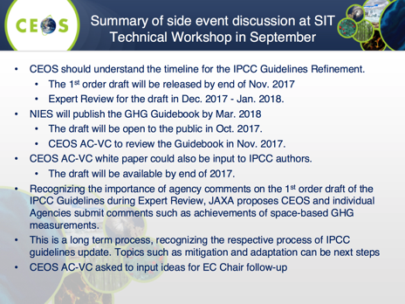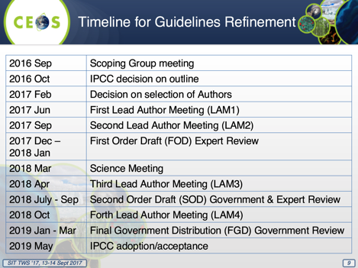
Mark Dowell (COM) stressed that the December to January First Order Draft (FOD) Expert Review is, in fact, an open review, and this is a critical window for CEOS feedback.
Ivan Petiteville (ESA, SIT Chair Team) encouraged CEOS to be proactive in contacting key IPCC people. Mark noted that Simon Eggleston (GCOS) is a lead author and in direct contact with CEOS regarding the matter. Ivan asked whether we should make further connections. Stephen Ward (CEOS Chair Team) noted that around 12 members of the GFOI Methods and Guidance Documentation Advisory Group are also contributing to the revision of the guidelines.
Jonathon Ross (GA, CEO) asked if we could be more specific about what is required of agencies during the critical December to January review. Mark and Osamu noted that the NIES guidebook should be the basis for feedback. Comments during the review window should be consistent with what appears in the NIES guidebook.
GFOI/SDCG Report
Gene Fosnight (USGS, SDCG Co-Chair) noted that 2017 was a significant milestone for CEOS support to GFOI and for operational forest monitoring from space – with the coverage provided henceforth for all countries that wish to report on forest cover (e.g., for UNFCCC, REDD+, market incentives). SDCG is confident in annual wall-to-wall coverage for all countries through next decade and beyond. Press releases have been issued by CEOS, GEO, GFOI, ESA and USGS. This is the major CEOS WP outcome for GFOI in 2017. SDCG must update its own 3-year Work Plan to reflect the changes in motion for Phase 2 of GFOI – this will be undertaken in 2018.
Stephen Ward (CEOS Alternate Lead for GFOI) reported that Phase 2 has a strong country emphasis – reflecting the development aid finance nature of funding. ESA (R&D support), UK and German governments have all been invited to serve on the expanded Leads group and are all understood to be accepting.
Other changes include:
- Re-establishment of the MGD Advisory Group, with Ake Rosenqvist (JAXA) the CEOS technical representative; the role and use of REDDcompass continues to grow rapidly;
- SilvaCarbon continuing to implement a full work plan until September 30, 2018. Assumption of same level USAid funding for next FY with significant uncertainty (broadly);
- ESA will finance the GOFC-GOLD office including GFOI R&D Coordination for the next 3 years (open ITT in autumn 2017);
The implications for space data in Phase 2 include:
- emphasis turns to data uptake and application; pilot activities are ongoing – Data Cube for Colombia and now Vietnam;
- SDCG EXEC is pursuing inclusion of Early Warning as a GFOI activity – as a possible basis for the long-promised cooperation with WRI/Global Forest Watch;
- all Element-3 agencies actively contributing to R&D activities;
- SDCG awaits further definition of a new Data User Advisory Group proposed by Leads to further narrow the gap between EO data suppliers and user country agencies.
SDCG sees significant opportunities to deepen the benefits that CEOS and agencies get from this thematic coordination initiative. We are now closer than ever to users and their implementing partners, including IFI funding, with strong policy foundations (UNFCCC, IPCC, REDD+, SDG methodologies) and a productive proving ground for our FDA ambitions.
There are some significant changes in leadership and capacity of SDCG for attention of Plenary and Principals:
- USGS Co-Chair (Gene Fosnight) is retiring and no prospect of replacement;
- GFOI Lead has appealed for new Co-Chairs and UKSA has volunteered (name is TBA);
- CEOS GFOI Lead has changed from Masanobu Shimada to Osamu Ochiai, with JAXA still willing to support;
- SDCG SEC funding from the Australian Government has ended; JAXA has volunteered travel funds to cover existing SEC attendance at GFOI Plenary in March 2018;
- Further Co-Chairs and capacity for SDCG SEC (existing or new) remains welcome and needed.
Per the conclusions from the Joint LSI/GFOI/GEOGLAM meeting in September, SDCG notes the ongoing requirement for a CEOS group dedicated to the GFOI interface so long as CEOS is engaged in the flagships (GFOI, GEOGLAM).
Stephen thanked Gene Fosnight for his significant contribution to SDCG and GFOI. Josef Aschbacher (ESA) added thanks to Gene for his service to GFOI and expressed concern about the lack of co-leads and SEC support for SDCG. He noted that Frank-Martin Seifert (ESA) will be the sole co-chair of the SDCG after Plenary.
Klaus Schmidt (DLR) recalled his proposal during last CEOS Plenary as to whether SDCG governance might migrate under GFOI if no resources are found in CEOS. Stephen Ward noted recent efforts around LSI/SDCG/GEOGLAM rationalisation – to be reported tomorrow.
Senthil Kumar (ISRO) asked about the inclusion of ISRO data sets in GFOI, and the support available to aid the development of GFOI geophysical products from ISRO sensor products. Stephen noted that SDCG would be happy to chat with ISRO about getting their datasets represented.
Mike Freilich (NASA) responded to the DLR point and suggested that CEOS agencies might best respond to a written proposal for Principal consideration. He then suggested Plenary try to resolve the pressing matter to move SDCG forward over the next year at least – with leadership and a strong secretariat. He remarked that CEOS agencies should collectively be able to come up with the relatively small amount of resources to continue funding the SDCG secretariat.
Stephen Briggs (ESA) suggested that shifting space data coordination efforts for GFOI into the GFOI Office was a logical mistake. GFOI represents the users, with the office based at FAO, and could not sensibly address both data supplier and data user aspects. This would fall always to the provider agencies, as best coordinated by CEOS. It was agreed to defer further discussion on that point until the next day and to define actions on the issue of leadership and SEC capacity. Action CEOS-31-02 below reflects the discussion in Session 12.
CEOS-31-02 | CEOS Chair and SIT Chair to send a written appeal to CEOS principals for Co-Leads for the SDCG for GFOI and for potential contributions to SDCG secretariat funding or in-kind support. | October 2017
Synthesis of Carbon Observations Discussions in CGMS
Jörg Schulz (EUMETSAT) reviewed the process through which CGMS Plenary agreed to contribute to the CEOS AC-VC Greenhouse Gas White Paper and agreed upon the specific contributions CGMS can provide to a future carbon monitoring system. CGMS have recommended having a reference to the target architecture for GHG and carbon monitoring from space in the WMO WIGOS Vision 2040. CGMS have suggested that a mechanism to ensure that coordination is strengthened between CGMS and CEOS on this matter, and this should be discussed. One idea that has been floated is a joint CEOS-CGMS Working Group on Carbon, and it has been suggested that this be discussed as part of the European Commission’s CEOS Chair term.
Kerry Sawyer (NOAA, SIT Vice-Chair Team) asked whether a new joint WG on Carbon is being proposed, or whether this could be undertaken by the existing joint CEOS-CGMS WGClimate. Jörg reported that the course of action has not been prescribed.
Broader Coordination of Carbon Observations
Mark Dowell (EC) provided a broad perspective on the CEOS Carbon actions and their policy context and drivers:
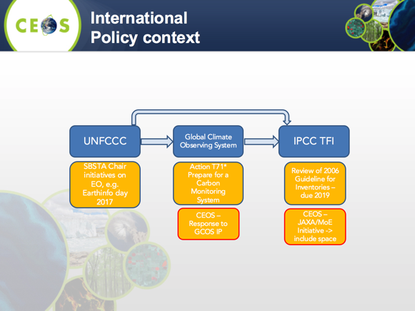
Mark postulated the following conceptual framework with CEOS within the space data segment and GEO within the in-situ data coordination.
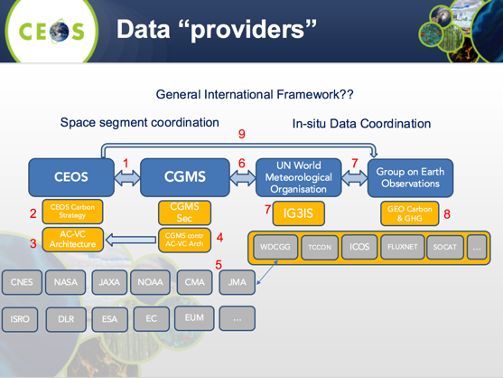

The GEO Carbon and GHG initiative was accepted as a GEO Initiative at the 3rd GEO Programme Board in 2016; it provides cross integration and coordination of the interfaces (between: atmosphere, ocean and terrestrial domains; space-based, air-borne and in-situ monitoring systems) and builds on existing strategies, initiatives, networks and infrastructures, and integrates them with the missing pieces to obtain a comprehensive globally coordinated GHG observation and analysis system. Key elements are:
- Task 1: User needs and policy interface (policy and science requirements);
- Task 2: Data access and availability (CEOS);
- Task 3: Optimization of observational networks (CEOS);
- Task 4: Budget calculation consistency (global, regional, sub-regional, national, local) (CEOS Carbon Strategy).
The CEOS POC and member of the Executive Committee is Stephen Plummer of ESA.
As CEOS Chair for 2018, COM will prioritize laying the foundation for an international CO₂ and GHG monitoring system, progressed through three initiatives:
- Facilitate the completion and follow-on activities of the AC-VC white paper on defining an optimum constellation for CO₂ and GHG monitoring, including the joint competences of CEOS and CGMS, and in the general framework of the continued implementation of the CEOS Carbon Strategy.
- Place the space segment in the broader context of a fully sustained system for CO₂ monitoring. Individual CEOS Agencies have counterparts in their individual countries/regions who have responsibility for Inventories, the required modelling, in-situ infrastructure and the ground segment elements.
- Advance the relationship with CGMS for an operationally implemented and sustained observation capability. Consider establishing a formal working relationship between CEOS and CGMS as with the successful ongoing relationship on Systematic Observations of ECVs in support of UNFCCC.
A workshop is planned for June 2018 in Italy.
Mark suggested that CEOS review the modus operandi for cooperation with CGMS as a priority in this area, and provided some possible paths:
- continue ad-hoc collaboration in the context of the CEOS Carbon Strategy Actions, e.g., as in joint efforts on the AC-VC white paper;
- establish a sub-group (with dedicated resources) in an existing standing WG, i.e., Joint WG on Climate;
- establish a dedicated joint WG specifically on Carbon/GHG observations.
Further discussion is needed within CEOS and with CGMS. Space agency coordination is probably a first priority for action by the 2018 CEOS Chair, supplemented by continued dialogue with CEOS Associate members (GCOS, GEO, WMO). The broader coordination framework is still in “definition” and the next 12-24 months will be critical.
Josef Aschbacher (ESA) suggested we clarify the scope and terminology as we go forward (GHG vs Carbon vs climate). Mark noted that the CEOS Carbon Strategy is broad, however the focus here is atmospheric GHG. Mark agreed on the need to be clear and specific. In response to a question, Mark confirmed that he hopes to continue in his role coordinating the Carbon activities for CEOS.
Pascal Lecomte (ESA, WGClimate Chair) reiterated that WGClimate is not in a position to take on these specific tasks on GHG and carbon. Pascal is of the opinion that a joint WG on carbon and GHG is needed.
Stephen Briggs (ESA, SIT Chair) noted the magnitude of the issues in front of CEOS and the need to establish a clear understanding of the broad context for carbon observations and modelling across many communities. But CEOS can and should only focus on the space data aspects and perhaps focus first on our relationship with CGMS for that purpose.
Alain Ratier (EUMETSAT) agreed with Stephen’s statement, noting that the problem is very complex and not simple to address. Whatever mechanism is established it needs to have a link to WGClimate as its work will be related to ECVs. Alain supported the establishment of a new WG on Carbon, provided it is sufficiently linked with WGClimate and its ECV work.
Session 4: Agency and Partner Updates
GEO Update
Stephen Briggs (ESA, SIT Chair) reported on behalf of Barbara Ryan (GEO Secretariat Director):
- GEO has realigned its work programme to focus on a few priority topics;
- the first of these is the 2030 Agenda for Sustainable Development and the Sustainable Development Goals (the SDGs);
- GEO has been active in the development of methodologies for the SDGs (e.g., 15.3.1: Proportion of degraded land over total land area); GEO representatives have been extensively involved with UNCCD and FAO in their efforts to develop methodologies for monitoring degraded land through use of EO techniques;
- the 2015 Paris Agreement on Climate is a further priority for GEO. Stephen reviewed the Articles of the Paris Agreement that will benefit from the increased availability of geospatial data. GEO will have a strong presence at the upcoming COP-23, and is collaborating on events with GCOS and CEOS;
- GEO has been considering how best to direct its Carbon and GHG Initiative and this remains under discussion;
- GEO also prioritizes disaster resilience, including The Sendai Framework for Disaster Risk Reduction, and assessing how geospatial agencies can respond to the needs identified therein; GEO has been making progress on its engagement with other stakeholders, in particular the UN, around the use of geospatial data for DRR.
GEO Programme Board (PB) Report
Jonathon Ross (GA, CEO) reviewed the GEO PB report. Readers are directed to the full report on the CEOS website. Jonathon reported that:
- the Board is maintaining good momentum;
- developing country representation could be improved;
- the CEOS representative on the PB and observer to ExCom will remain for two more years;
- one of the tasks for the PB in 2017 was managing incremental changes to the three-year GEO Work Programme, which is a living document.
- more targeted symposia have been suggested as a way to increase participation, with gaps existing in the areas of climate and transport. However, the convening power of past symposia have been a key benefit, bringing together a wide group of participants;
- there is also now recognition within the PB that its ‘startup phase’ is over. The PB needs to now be more proactive at stewarding the Work Programme;
- CEOS PB representatives have made the point that some of the 'global' initiatives that are bubbling up may lack the comprehensive engagement from key global actors that they require to be successful, even if the technical content may be good;
- the recognized focus of the PB has mostly been the SDGs, and it was agreed by the Board that the Paris Agreement and Sendai Framework focus should now be increased, with SDG efforts up and running;
- efforts to restructure the Work Programme document itself have delivered significant improvements to readability;
- overall, the sense of the 2017 CEOS representatives to the PB is that the PB itself, and the CEOS
engagement in it, are going well and we are confident that the transition to the next set of CEOS
representatives will be smooth;
- Kerry Sawyer (NOAA) will represent CEOS on the GEO PB going forward, as a member of the next SIT Chair Team.
Mark Dowell (COM) asked how the GEO PB links its priorities to ongoing community activities. Stephen Briggs (ESA, SIT Chair) noted that the role of the PB was to take top-down priorities and link them to bottom-up activities already underway. Carolin Richter (GCOS) hoped that CEOS, as a PB member, might aid in connecting GCOS back to the GEO system.
GEO-XIV Plenary Preparations and Inputs
Jonathon Ross (GA, CEO) reviewed CEOS representation at GEO-XIV Plenary, including: the delegation (led by Mauro Facchini (COM)); CEOS input on the panel sessions; the CEOS Statement to GEO-XIV (for endorsement); the CEOS exhibition booth; and participation in the four Data Cube workshops. Alex Held (CSIRO) will represent CEOS at the 41st and 42nd ExCom meetings – as SIT Vice-Chair at the time (pending endorsement).
A number of panel themes are foreseen. The panel on public sector decision-makers will cover: agriculture, forests, fisheries; land and water; national statistical offices; local environmental initiatives. The commercial sector panel will span software, reinsurance, and farming. The international development panel will cover development banks and national development agencies. The fourth panel is on national Earth observations.
Brian Killough (NASA, SEO) thanked USGS for their contribution to the booth costs. Alex Held (CSIRO) reported that CEOS will also be participating in a panel organized by the EO4SDG group.
Jonathon displayed the draft CEOS Statement to GEO-XIV and noted that it has been available for some time for comments. The Statement was endorsed by CEOS Plenary.
Decision 01 | The CEOS Statement to GEO-XIV was endorsed.
GEO Executive Committee Report
Stephen Briggs (ESA, SIT Chair) reported the following on the GEO Executive Committee (ExCom):
- R-J Smits took on the role of Co-Chair in June 2016; June-September 2016 saw important changes to ExCom’s role, behavior, and achievements;
- ExCom is much more focused on outcomes; less on process;
- creation of the Programme Board in 2016, and its renewal in 2017, with attendance of Co-Chairs at ExCom and with three observers from among the PB Participating Organizations (including CEOS) improved many aspects of GEO operations; Steve Volz (NOAA) will take over as Lead Chair of GEO in fall 2017;
- there is improved delineation of the roles of ExCom/PB/Secretariat;
- the GEO Engagement Strategy and the subsequent Implementation Plan are important documents developed in 2016/17;
- GEO engagement with financial institutions and the commercial sector is a priority approved by ExCom;
- the ExCom selected a new GEO Secretariat Director in September 2017 – to be announced/confirmed at GEO Plenary;
- CEOS future attendance at ExCom is proposed to be led by the CEOS SIT Vice-Chair (CSIRO) (due to the conflict of roles of Steve Volz) – supported by the CEO and SIT Chair staff;
- overall, there has been a vast improvement in GEO operations resulting from the ExCom’s direction; CEOS has been seminally involved;
- there are excellent reports of meetings (summaries and detailed discussions) to be found on the GEO website.
Steve Volz (NOAA) stressed that CEOS has helped GEOSEC recognize that they do not need technical experts in every SBA.

International Financial Institutions (IFIs)
Stephen Briggs (ESA, SIT Chair) recalled the SIT Chair Team’s theme on maintaining and improving the effectiveness of CEOS’ strategic partnerships, including with UN agencies, and international financing institutions such as the development banks; the effective functioning of GEO, and CEOS within it, is a high priority.
Stephen noted that GEO has recognized IFIs as a critical partner, evidenced by a special panel session at the upcoming GEO Plenary. CEOS and GEO need coherent and consistent approaches to engaging with IFIs. The 2017 SIT Technical Workshop resulted in actions to prepare a compelling set of materials to promote the value of EO for ODA:
- a one page statement of the CEOS commitment to support the expanded use of EO in Development, highlighting the role and benefits that EO can deliver; and,
- a supporting document (10-12 pages) consisting of key summary information (based on the white paper, 3-4 pages) to substantiate the Statement, followed by examples (8-10 pages) that illustrate the benefits and use of EO drawn from across the CEOS agencies.
CEOS Plenary was asked to:
- consider endorsement of the Statement on EO and ODA; and,
- discuss and agree the CEOS approach to IFIs.
The written materials will be used (by CEOS, GEO, individual agencies) to engage IFIs at the highest levels. The target for completion of the supporting document is the end of 2017.
Joost Carpay (NSO) asked how CEOS will avoid this appearing as a technology push. Stephen acknowledged this risk, and noted that this is why we will not be employing a strategy of approaching/pushing the Statement, but rather using the Statement at key fora (where the IFIs are also present). CSIRO, NASA, SANSA, and JAXA all volunteered to assist with the supporting document.
Decision 02 | The proposed CEOS Statement on EO and ODA was endorsed.
CEOS-31-03 | ESA to lead conclusion of the ODA communications document reflecting comments and inputs from CEOS Agencies. | End 2017
Agency Updates
A number of CEOS agencies provided programmatic updates, including the following highlights:
- Roscosmos: significant increases in EO data planned in the Russian space plan; 22 satellites are on the planning slate;
- NOAA: GOES-R is almost fully operational; GOES-S will launch in March; JPSS-1 will launch on November 10;
- NASA: NASA leads or co-leads 47 of the 87 CEOS objectives/deliverables; recent launches include SAGE-III, and ICECube; TSIS-1 will launch in the next 2-4 months; GRACE-FO in March 2018; and ICESat-2 in September 2018; EO-1 & GRACE have both ended; funding for five missions (of approximately 20 NASA Earth research missions in development for launch before 2023) is in question pending final budget decisions by the Congress;
- EUMETSAT: preparing for Metop-C launch, 3-satellite Metop constellation expected from 2019-2022; EPS-SG progressing toward launch; EUMETCast and big data pathfinder projects underway; contributions to Copernicus progressing as planned; preparing for Sentinel-7 GHG/Carbon mission with ESA and COM.
- UKSA: the UK is developing a new civil space plan, with EO prominent; seeking to continue cooperation on Copernicus post-Brexit; ODA is important to UK Government and UKSA is closely involved; NovaSAR will launch in the next few months;
- Australia: CSIRO is establishing a central coordination body for all its space activities, which will include EO; joined NovaSAR programme with UKSA, CSIRO has secured 10% tasking rights; Digital Earth Australia Data Cube programme supported by Australian Government for 3 years; the Data Cube technology is now open source under the Open Data Cube banner (opendatacube.org); Australian Government has announced the establishment of an Australian space agency;
- COM: Sentinel-5P just launched, Sentinel-3B next; establishing the Data Information and Access Services (DIAS) platform, which will provide access to all Copernicus data and big data analytics capabilities.
- ESA: 27 satellites under development, 12 in operation (across science, Copernicus, and meteorology); 35.61 PB of data downloaded from the Open Access Data Hub; Earth Explorer 9 is in competition now;
- USGS: Landsat 7 EOL expected around July 2021, overlapping with Landsat 9 (launch end 2020); Landsat CONUS ARD available to the public in early November, global data with Collection 2 release; Landsat-Sentinel-2 interoperability is a priority;
- NSMC-CMA: FY-4A is the first next generation geostationary satellite of China, launched in 2016, similar sensor to GOES-16 and Himawari-8; TanSat carbon monitoring satellite also launched; GF-4 50m geostationary satellite also now active;
- ASI: 10 years of COSMO-SkyMed, second generation under development; China Seismo-Electromagnetic Satellite (CSES) in development by ASI and CNSA to study correlation between seismic events and electromagnetic properties of the Earth;
- JAXA: GCOM-C and SLATS missions highlighted; Japan has a new EO data distribution plan, with significant changes to data policy toward more free-and-open distribution;
- ISRO: Many satellites, in both LEO and GEO, are in operation for resource management, weather monitoring, and climate and ocean studies. Various satellites, such as Cartosat-3, HRSAT-1, Oceansat-3/3A, RISAT-1A, Resourcesat-3/3A, GISAT-1, and NISAR are under development. Also highlighted the availability of operational products and applications of Scatsat-1 and INSAT-3DR;
- CNES: Venus launched August 1, 2017; Microcarb phase C/D decision, target launch end-2020; CFOSAT launch expected summer 2018; significant involvement in climate activities since COP-21;
- CSA: Éric Laliberté reported that an extension to the SCISAT-I mission has been approved. Éric thanked ESA and NASA for their support.
Session 5: Agriculture
GEOGLAM
Bradley Doorn (NASA, Co-Lead of the CEOS ad-hoc Working Group on GEOGLAM presented an update on GEOGLAM and CEOS support to the initiative. GEOGLAM was recently re-endorsed by the G20, signaling ever greater support and a strengthened political mandate, which is timely given GEOGLAM’s potential contributions to numerous UN SDGs. GEOGLAM has selected a new Programme Director: Ian Jarvis, Agriculture and Agri-Food Canada. Ian replaces Michel Deshayes (MinAg France), who served as Coordinator from 2013-2017 (retired September 2017).
Brad presented some select examples of CEOS Agency support to GEOGLAM:
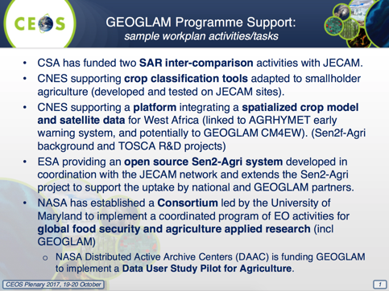
In 2011, at GEOGLAM’s inception, acquisition of data at appropriate resolutions was the constraint – now, in 2017, we are in a “big data” world, constrained by access and use (computational environments). In the short-term, the priority is to make the most of all of the data available, namely through dense optical and SAR time series exploitation. Analysis-ready time series (cloud & cloud shadow screening, high co-registration accuracy between sensors, harmonized surface reflectance) at moderate (10-100m) resolution are central to this objective, and availability in near-real-time on cloud computing infrastructures is key. Specifically for SAR, having interferometric coherence at daily-weekly intervals and a Digital Terrain Model (potentially TerraSAR-X) available on cloud computing infrastructure is desirable.
Given the evolution of science and operational monitoring systems, GEOGLAM is currently undertaking an ‘EO Requirements Refresh’. The requirements scope will be increased to 13 variables, and the observation types considered will be increased to include both in situ and agrometeorology. The objectives of the refresh are to:
- Update based on R&D results, considering satellite and in situ data needs;
- Support GEOGLAM’s Compendium of Best Practices;
- Provide insight in future mission planning and current acquisition planning;
- Better understand “proximal user” data needs (ARD, FDA); and,
- Achieve consistency with JECAM’s “Minimum Datasets” principle.
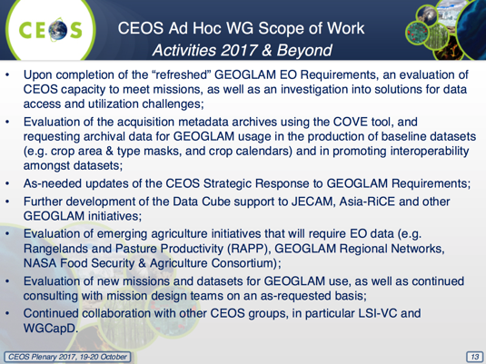
Asia-RiCE
Brad presented the following update on Asia-RiCE:
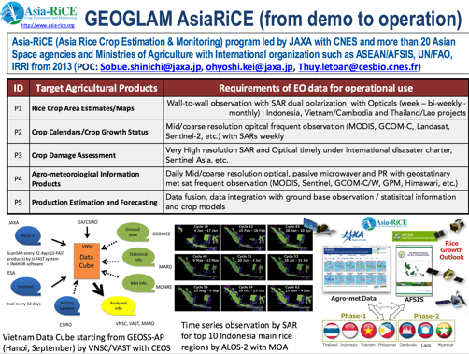
GEOGLAM Rangelands And Pasture Productivity (RAPP)
GEOGLAM RAPP brings together space agencies, existing associated institutional frameworks, in-situ networks, rangeland ecologists, and the pasture productivity modelling community, to establish a dedicated global system for observing the condition of pastures and rangeland status, and ultimately to also estimate biomass dynamics and productivity.
GEOGLAM RAPP recently welcomed a new co-lead, Clement Adjorlolo (SANSA), and held a RAPP workshop (>30 participants) at ESA ESRIN. The current priorities for GEOGLAM RAPP are:
- Continued development of the RAPP Map (http://map.geo-rapp.org);
- Moderate resolution (L8, S2) coverage over RAPP pilot sites (interest in implementing this data via Data Cube);
- Development of an early warning system for rangelands; and,
- Supporting/engaging in the UN SDG process.
CEOS Plenary was asked to consider the CEOS Ad-hoc Working Group on GEOGLAM Scope of Work Document, and to decide whether to renew, for another year, the mandate of the CEOS Ad-hoc Working Group on GEOGLAM.
Session 6: Disasters
WGDisasters
Stephane Chalifoux (CSA, WGDisasters) presented an update on the WG’s activity areas: GEO Geohazard Supersites and National Laboratories (GSNL, DIS-10); Recovery Observatory (DIS-12); Floods, Seismic Hazards, Volcanoes Pilots and Landslide Pilot (DIS-13).
GEO Geohazard Supersites and National Laboratories
Established Supersites undergo periodic CEOS review. The biennial reports for the New Zealand and Ecuadorian Volcanoes Supersites were provided ahead of the Plenary, and are available on the meeting website.
Stephane also presented two new Supersite proposals:
- Southern Andes: The region of interest extends over 220 km along an arc in a swath of 50 km in width in Chile and Argentina.
- Virunga Volcanoes: Fifteen years after the Nyiragongo 2002 destructive eruption, the Goma Volcano Observatory remains under-equipped and with few qualified scientists. All studies which will contribute to improved assessment and the understanding of geohazards in the Virunga and Lake Kivu basin are critical for Disaster Risk Reduction in this highly populated region of very vulnerable population.
Recovery Observatory (RO)
The RO aims to offer free-and-open access to data and information useful in planning and monitoring disaster recovery, but also to serve as a forum of exchange and collaboration on recovery related issues to foster resilience at the community level. A number of CEOS Agencies have committed resources to the RO.
CEOS Plenary was asked to approve the Recovery Observatory Operational Plan.
Floods, Seismic Hazards, Volcanoes Pilots
Three thematic pilots (Floods, Seismic Hazards and Volcanoes) have all concluded successfully. The objectives were met in almost all cases. For the Flood Pilot, the feasibility of the global flood dashboard was demonstrated, but no permanent home was identified due to a lack of funding. For the Volcano Pilot, Objective C (intensive monitoring of a single major event) was not implemented as no appropriate event occurred during the pilot period.
Sustainability strategies covering implementation beyond CEOS have been identified for each pilot, as pilots move to become Demonstrators. Each Demonstrator proposed is preparing an Implementation Plan for review by SIT-33. Wherever possible, Demonstrators are linking to existing activities such as GEO-DARMA.
CEOS Plenary was asked to approve the final reports of the Floods, Seismic Hazards, and Volcanoes Pilots.
Landslide Pilot
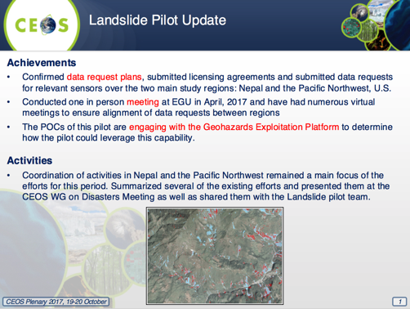
Geohazards Lab Implementation Plan
Stephane introduced the Geohazards Lab – a platform with federated resources to access, process, and publish satellite EO data and derived products; providing data access and a processing and e-collaboration environment for the exploitation of EO data for assessing geohazards and their impact. The Lab aims to address the priorities of the Sendai Framework for Disaster Risk Reduction 2015-2030 using satellite EO and supports and complements other CEOS WGDisasters activities.
CEOS Plenary was asked to approve the Geohazards Lab Implementation Plan.
Closing
Stephane noted the CEOS Disasters Brochure, which was presented at the Disaster Risk Reduction Across the Americas Summit and will also be available at the GEO-XIV Plenary CEOS exhibition booth.
Stephane’s term as WGDisasters Chair comes to an end at CEOS Plenary 2017. He thanked CSA and CEOS for the opportunity, as well as the members of WGDisasters for their support. Simona Zoffoli (ASI) will now take on the role of WGDisasters Chair.
CEOS Plenary was asked to endorse a new Vice-Chair: David Green (NASA).
Decision 03 | CEOS Plenary endorsed a number of WGDisasters documents: Ecuador and New Zealand Supersites Biennial Reports; the Southern Andes and Virunga Volcanoes Supersites proposals; the Recovery Observatory Operational Plan; the final reports of the Floods, Seismic Hazards, and Volcanoes Pilots; the Geohazards Lab Implementation Plan.
Laura Candela (ASI) on behalf of Roberto Battiston (ASI) thanked Stephane for his efforts as WGDisasters Chair and confirmed support for the WGDisasters endorsements and future activities.
Jonathon Ross (GA, CEO) suggested that DIS-13b is very much aligned with FDA, and the lessons learned should feed into the work of the FDA-AHT going forward.
Mark Dowell (COM) confirmed that the European Commission will host the next WGDisasters meeting in Brussels.
Raj Kumar (ISRO) confirmed that ISRO is willing to support the RO with data from its missions, where available.
GEO-DARMA
Ivan Petiteville (ESA, Lead Coordinator for GEO-DARMA) presented the latest status of GEO-DARMA, which aims to address priorities of the Sendai Framework for Disaster Risk Reduction 2015-2030 using EO. GEO-DARMA brings together numerous partners, grouped on a regional basis. For each region, the types of hazards, DRR issues to be solved, initial countries, and prototype projects are identified.
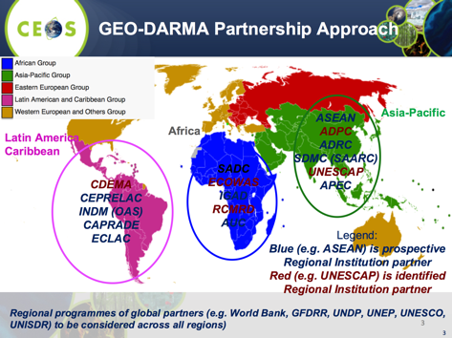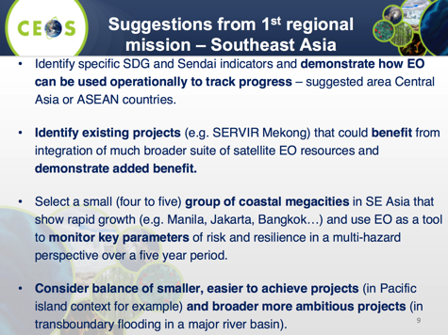
A number of meetings have been held throughout 2017, including the 1st Steering Committee (SC) meeting and Concept Workshop (at the 2017 UN Global Platform for DRR, Cancun, 25 May 2017), which: introduced SC members to the GEO-DARMA concept and forged a collective approach on the way forward; reviewed the role and schedule for the SC; reviewed the high-level GEO-DARMA approach and refined the schedule and timeline as functions of the objectives; discussed Sendai Framework priorities and the SDGs; and initiated discussions on regional priorities. Ivan highlighted that the membership of the SC is composed primarily of high-level representatives of UN agencies, banks, and national disaster and resources agencies playing a key role in disaster risk reduction; the SC includes only one member from the EO space community (ESA).
The current status and next steps are reflected in the CEOS Work Plan (DIS-15):
- regional Assessment Template agreed by the SC and distributed to regional organizations.
- regional organizations to develop short reports on their vision for regional priorities (ongoing).
- review of regional assessments by SC (Q1 2018).
- conclusion of the concept phase and initiation of first projects for the prototyping phase (Q2 2018).
Friday October 20th
Session 7: Water
Overview of Ongoing Efforts in the Water/Ocean Space
Kerry Sawyer (NOAA, SIT Vice-Chair Team) gave a short review of the different water-related institutions and activities of interest to CEOS, including:
- the history of the IGOS Theme Reports;
- the GEO Water Strategy and the CEOS response;
- Blue Planet, AquaWatch, and GEOGLOWS;
- the relevance of GEOGLOWS to the CEOS Work Plan was shown:
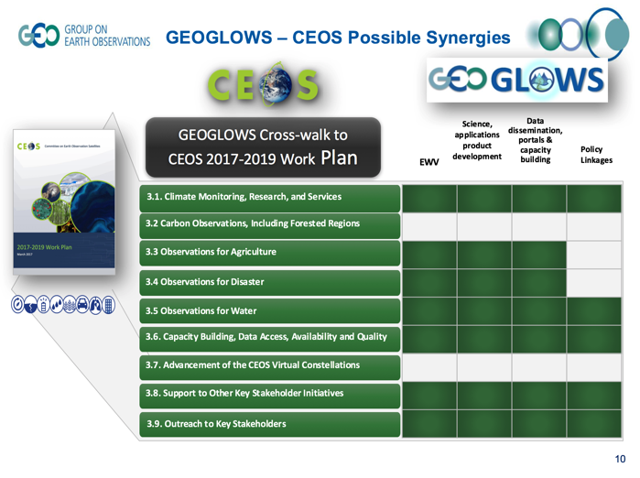
- AquaWatch (www.geoaquawatch.org) focuses on coastal and inland water and was previously the GEO Water Quality CoP;
- Blue Planet’s focus is on oceans and coastal waters;
- water quality is a recurring theme;
- CEOS endorsed the COVERAGE initiative at SIT-32 (April 2017, Paris) as a 3-year pilot project;
- COVERAGE is a collaborative effort within CEOS with the 4 Ocean Virtual Constellations (SST, OST, OCR, OSVW) and GEO projects (MBON, Blue Planet) to enable more widespread use of ocean satellite data in support of applications;
- COVERAGE phasing includes: A. Scoping (6mo). B. Prototype Development/Evaluation (1yr). C: Full system development (1yr). D: Testing/Evaluation & transition to operations (6mo); this is reflected in COVERAGE inputs to the CEOS 2017-2019 Work Plan;
- the main challenge is to find better coordination among these water-related activities; their proliferation is confusing to external partners.
Feasibility Study on Satellite Missions/Instruments Focused on Water Quality Measurements
Tom Cecere (USGS) presented on behalf of the writing team. The Study has been prepared in response to action C.10 of the CEOS Water Strategy, and is expected to be released for CEOS review before the end of the month.
Three activities were defined in the feasibility study:
- An assessment of the benefits and technological difficulties of designing a global satellite mission focused on inland, estuarine, deltaic and near coastal waters;
- To examine threshold and baseline observation requirements for sensors suitable for aquatic ecosystems;
- That the GEO Water community define inland and near-coastal water quality and benthic habitat essential variables.
Jenn Lacey (USGS) confirmed that LSI-VC will plan to undertake a review of the Study, and she suggested that Tom join an upcoming LSI-VC teleconference to brief the team.
Alex Held (CSIRO) noted the significance of the Study. Alex suggested the review timeline be condensed, such that a printed report might be produced before SIT-33.
Joost Carpay (NSO) would like to see some feedback from the potential user community. Jonathon Ross (GA, CEO) suggested an action for VCs to report out (at SIT-33) on how they will take the report into account in their work going forward.
CEOS-31-04 | SIT Chair to coordinate feedback from the Virtual Constellations on how they will take the Feasibility Study on Satellite Missions/Instruments Focused on Water Quality Measurements into account in their work going forward. | SIT-33
Way Forward
Stephen Briggs (ESA, SIT Chair) presented a proposed way forward for the ‘Water from Space’ Workshop. He noted that the scope is on freshwater observations. Stephen recalled the JAXA-led Water Constellation Feasibility Study from 2016. The proposed workshop aims to clarify and progress space agency coordination. The suggested target date is Q2 of 2018. We should seek a user community co-Chair as part of a small planning committee.
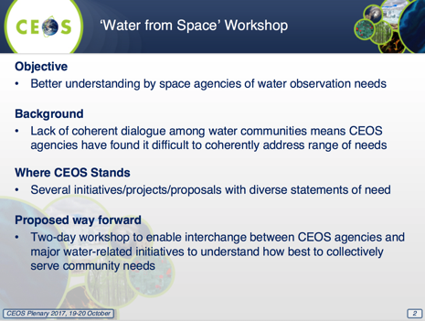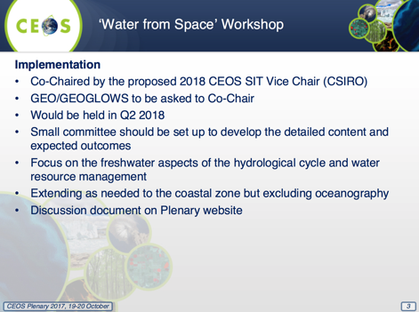
Given that the proposed “Water from Space” workshop appeared to focus only on freshwater to the exclusion of the oceans, Mike Freilich (NASA) questioned whether CEOS wishes to continue with the COVERAGE initiative. Raj Kumar (ISRO) also asked for clarification on the scope of the proposed workshop and made the comment that inclusion of oceans in the workshop may not dilute the scope. Alex Held (CSIRO) acknowledged the need to better define the scope, and indicated that he is happy to support the formulation of the proposed workshop. Joost Carpay (NSO) supported the proposed workshop, and suggested that the workshop include substantial user community participation. Steve Volz (NOAA) suggested that the focus be reconciliation and coordination of activities, rather than a technical workshop. Josef Aschbacher (ESA) also supported the workshop proposal, noting the relevance of inland water to many other SBAs.
Stephen Briggs (ESA, SIT Chair) noted that this proposal does not detract from importance of non-freshwater initiatives (such as COVERAGE), but intended to address a manageable scope. Mike Freilich (NASA) acknowledged this and expressed support for the proposed workshop. Alain Ratier (EUMETSAT) also noted the ambiguity in the scope of the workshop and stressed that this must be clearly defined so as not to appear to downgrade CEOS interest in ocean observations.
CEOS-31-05 | SIT Vice-Chair to coordinate establishment of a steering committee to determine the focus, scope, and arrangements of a CEOS “Water from Space” observations strategy workshop in Q2 2018. The matter of inclusion of the ocean component needs to be answered, with consideration being given to renaming the workshop if it will be excluded entirely, or if only coastal water will be included. | Q2 2018
Decision 04 | CEOS will proceed with the freshwater coordination workshop in the first half of 2018.
Session 8: Earth Observation (EO) Data Access, Delivery, and Interoperability
Future Data Architectures (FDA) Strategy
Steve Labahn (USGS, FDA-AHT Co-Chair) reported on the year’s effort:
- he thanked Alex Held (CSIRO) and Nick Hanowski (ESA) for serving as Co-Chairs and to the whole team for their contributions;
- Steve noted the interconnections between CARD4L, MRI, and FDA;
- the work is driven by: the rapid increase in the volume, velocity and variety of data; the changing user community; and their expectations for data to be easy to access and use;
- the FDA strategic discussion paper covers five key themes and outcomes: CEOS Analysis Ready Data (ARD); Interoperable Free and Open Tools; Data, Processing, and Architecture Interface Standards; Analytical Processing Capabilities; and User Metrics;
A short FDA strategy video was shown to the meeting to summarise these five themes and their intentions. Nick Hanowski (ESA) thanked the other co-Leads and the FDA-AHT members for their work over the past year. He emphasized that ARD, Data Cube, open source tools, standardization of interfaces, and the inclusion of improved data are all an expression of a single ambition: to open up new user communities. It is important that the impacts are assessed and understood.
CEOS Data Cube (CDC) + FDA Pilot Outcomes
Brian Killough (NASA, SEO) reviewed the concept of the Data Cube (a time-series multi-dimensional (space, time, data type) stack of spatially aligned pixels ready for analysis) and clarified the difference between the Open Data Cube and CEOS Data Cube:
Open Data Cube (ODC): An open-source technology established by GA and CSIRO (previously the Australian Geoscience Data Cube), and currently overseen by the ODC Partners Forum (GA, CSIRO, SEO, AMA, USGS, UK Catapult) and technical Steering Council (GA, CSIRO, AMA, USGS). https://opendatacube.org
CEOS Data Cube (CDC): A specific implementation of the ODC technology, run by the SEO, with a focus on building global capacity to utilize satellite data and contribute to global initiatives (e.g., SDGs, GFOI, GEOGLAM) through the use of Data Cubes. Amazon (AWS) Demo Portal: http://tinyurl.com/datacubeui
Digital Earth Australia (DEA) and the USGS Land Change Monitoring, Assessment, and Projection (LCMAP) are other ODC implementations.
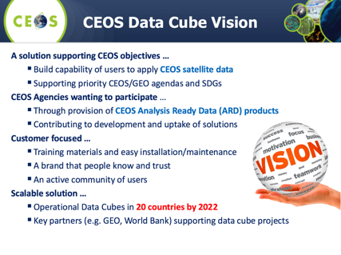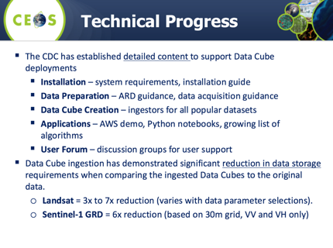
The CEOS Data Cube addresses several CEOS Work Plan FDA actions. Brian reported that FDA-03 (CEOS Data Cube Governance), FDA-04 (CEOS Data Cube Pilots), and FDA-05 (Promote Awareness of the CEOS Data Cube) have all been completed; FDA-02 (Collaborative Development of CEOS Data Cube) is ongoing. The CEOS Data Cube is also central to CEOS WP actions AGRI-08 (Vietnam Data Services Prototype), AGRI-09 (RAPP Data Cube Demo and Application Testing), and CARB-18 (Colombia Data Cube Prototype) – all are ongoing.
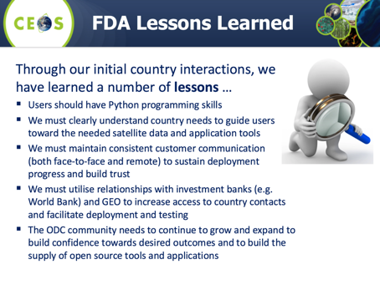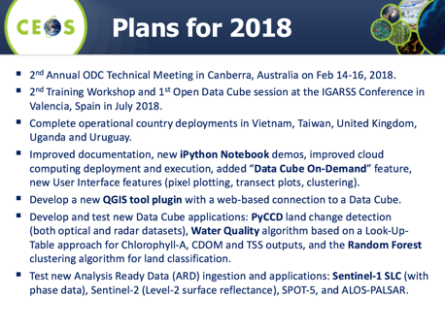
Senthil Kumar (ISRO) suggested connecting to NGOs and universities. Brian noted prior work with universities, and the potential of ‘Data Cube on Demand’ for university student use.
Pham Anh Tuan (VAST) noted Vietnam’s Data Cube, which was established with support from CSIRO and the SEO.
Ivan Petiteville (ESA) asked how the SEO deals with datasets that are not ARD (e.g., Sentinel-1 SLC). He also asked how other agencies can best contribute. Brian noted that the SEO is coming up with their own S1 ARD candidate for land on a trial basis and will evolve the standards as feedback dictates. In terms of what other agencies can contribute, the SEO would welcome a Data Cube on Demand solution placed at agency data hubs. It would also be valuable to have support in application algorithms – converting existing tools for Python/Data Cube compatibility. Adam Lewis (GA) added that the Data Cube work is helping to discover the required form for CEOS ARD.
Alex Held (CSIRO) stressed the need to make sure that FDA networks are interoperable. Also, access to data must be maintained and data supply for FDAs could be improved.
Jonathon Ross (GA, CEO) noted the need to give countries choice regarding platform and hosting location – the more flexibility, the better.
CEOS Analysis Ready Data for Land (CARD4L) Status
Adam Lewis (GA, LSI-VC Co-Chair) reported:
- Bianca Hoersch (ESA) has stepped down as a Co-Chair of the LSI-VC following a change in role at ESA, and has been replaced by Susanne Mecklenburg (ESA, Sentinel-3 Mission Manager);
- one of the main priorities of LSI-VC has been the concept of CEOS Analysis-Ready Data for Land (CARD4L), including its definition and Product Family Specifications (PFS);
- attention now turns to the CARD4L Assessment Framework – the process by which data providers can assess their products as CARD4L;
- Product Family Specifications (PFS) have been developed for: surface reflectance; radar backscatter; land surface temperature; and detailed input to the drafts was received from multiple sources; more input is needed with a further round of technical teleconferences to be convened by Geoscience Australia (Andreia Siqueira); Other PFS will probably emerge, e.g., radar phase data, water leaving radiance;
- very strong support for CARD4L is indicated by a range of experiences and activities (UK, ESA, USGS, NASA, Canada, GA, CNES, MRI, FDA, etc.);
- the Journal of Remote Sensing has recently announced a special issue, anticipated for mid-2018, on analysis-ready Landsat data;
- the FDA-AHT is recommending that LSI-VC promote the benefits of CARD4L to providers and that a broader strategy for CEOS ARD be explored (discussed at SIT TW);
- the CARD4L activity in LSI-VC now moves into an ‘implementation phase’, comprising: ‘road-testing’ the PFS, developing the process for datasets to be assessed as CARD4L (Assessment Framework), identifying data products that are on-track to become CARD4L, and monitoring and communicating progress of individual products toward CARD4L;
- the Product Family Specifications will continue to evolve as the LSI-VC gathers feedback in the alignment assessments;
- LSI-VC plans to engage with user communities (e.g., through GFOI and GEOGLAM) to capture and communicate user experiences of ARD / MRI and promote the CARD4L Framework to data providers;
- discussion at SIT Technical Workshop noted that oceanographic and atmospheric approaches that provide grids of variables such as sea surface temperature (which in turn enable products such as the NOAA Coral Reef Watch Alert System) are exemplars and have provided guidance for CARD4L; nonetheless, the CARD4L Framework offers a general formalization that might be of value to other VC communities;
- LSI-VC plans to provide CEOS VCs with a package of CARD4L materials for them to provide feedback on the Framework and to consider the applicability to oceans and atmosphere;
Josef Aschbacher (ESA) noted that ESA experts have been solicited on the PFS, and ESA is happy to contribute and to provide leadership on radar-related PFS.
CEOS-31-06 | LSI-VC to provide CEOS VCs with a CARD4L package to stimulate their feedback on the Framework and to allow the VCs to assess the applicability to their work. LSI-VC will utilize feedback to inform their recommendations for a broader ARD strategy. | End 2017

FDA Way Forward in the CEOS Structure / Work Plan
Steve Labahn (USGS, FDA-AHT Co-Chair) started the discussion on the way forward:
- Steve noted areas where CEOS agencies can contribute to the FDA five themes;
- WGISS will need additional resources in some areas to contribute effectively, in particular on: data, processing, and architecture interface standards; and analytical processing capabilities;
- provide agency computing resources for prototype testing of application algorithms to take advantage of locally stored data or to utilize web-based protocols (e.g., WCS, APIs) for data interaction;
- the proposed 2018 continuation of the FDA-AHT will continue to center around the five themes;
Josef Aschbacher (ESA) expressed his support for the continuation of the FDA-AHT, and offered the continued co-leadership of Nick Hanowski (ESA).
Ivan Petiteville (ESA) asked whether WGISS has the correct expertise to undertake the assessment of user uptake and use of ARD. Andy Mitchell (NASA, WGISS Chair) acknowledged the need for assistance with some aspects. Jonathon Ross (GA, CEO) stressed the importance of capturing user metrics – as a communication tool and for the justification of agency resources.
Alex Held (CSIRO) noted the strong demand from users for radar ARD. Mauro Facchini (COM) noted increasing demand from the agricultural community for both optical and radar ARD.
Frank Kelly (USGS, CEOS Chair) noted the Plenary support for the five FDA themes going forward.
Moderate Resolution Sensor Interoperability (MRI) Initiative
Gene Fosnight (USGS) introduced the Moderate Resolution Sensor Interoperability (MRI) Initiative, which he has led throughout 2017. He noted that this initiative addresses the CEOS strategic objective to encourage complementarity and comparability among the increasing number of Earth observing systems in the moderate resolution class for both optical and SAR sensors and the data received from them. The initiative had the following objectives in 2017:
- A framework paper for moderate (10-100m) resolution interoperability to facilitate the creation and use of multi-sensor data streams. The framework draws upon:
  - The Harmonized Landsat Sentinel-2 (HLS) case study, which identifies and summarizes lessons learned through the production of the HLS data product;
  - The vegetation dynamics monitoring use case study with HLS data, which explores the relationship between spatial resolution, temporal resolution and vegetation type;
- The MRI Survey, which sought to identify other examples of multi-sensor analysis in the user community.
The MRI Framework outlines current good practices (thresholds) and proposed next steps (targets) for general metadata, per-pixel metadata, measurements and corrections applied using metadata and data models, and geolocation and corrections for image to image registration.
Gene outlined where MRI fits in the CARD4L and FDA landscape, and presented the way forward for the initiative:
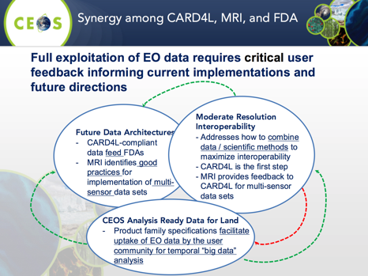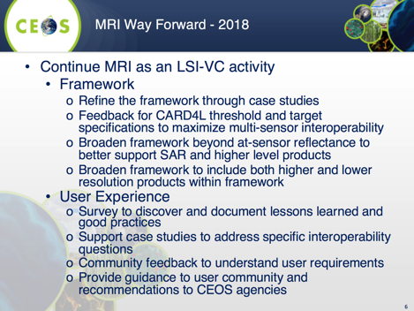
Jenn Lacey (USGS) reported that Steve Labahn (USGS) will take over the leadership of the MRI initiative within LSI-VC. Jenn also noted that Jeff Masek (NASA) will continue his involvement. Josef Aschbacher (ESA) offered the support of Ferran Gascon (ESA) to the continued MRI initiative. Astrid-Christina Koch (COM) congratulated the MRI team and offered the continued support of Amanda Regan (COM). Mauro Facchini (COM) asked whether there are any future plans for operational coordination of the satellites under consideration – in addition to data product interoperability. Jenn noted that this is one of the original priorities of the renewed LSI-VC, however due to competing priorities, this hasn’t been followed up. Stephen Ward (CEOS Chair Team) noted that this is being done in a thematic way, highlighting the work of the SDCG for GFOI.
Session 9: UN Sustainable Development Goals (SDGs)
SDG-AHT
Alex Held (CSIRO, SDG-AHT Co-Lead) provided an update on the activities of the team, which was established following the 2016 CEOS Plenary to (in coordination with GEO and other stakeholders):
- take stock of the UN processes in place for SDG implementation and of the existing SDG stakeholders; and,
- focus CEOS activities around the unique role that CEOS should play, as a coordination body of the space community, to support the integration of satellite EO in support to the full realization of the SDGs.
The SDG-AHT has now prepared its Implementation Plan, with the following key elements:
- Compile and maintain a compendium of CEOS Agencies’ engagement on SDGs (all Agencies are still invited to input on the circulated survey);
- Define a coherent, flexible, and adaptive CEOS engagement plan on SDGs;
- Coordinate CEOS support to GEO-led SDG activities;
- Review and assess the contribution of EO to the SDG Targets and Indicators;
- Demonstrate, showcase, and foster the added-value of EO in the SDG monitoring and reporting process;
- Facilitate uptake of EO by SDG stakeholders (e.g., for national statistics); and,
- Develop impactful communication and outreach materials on EO for SDGs.
Alex reviewed each of these components in detail, summarising the objectives, work to date, and plans for the future. Please see the presentation slides for details.
CEOS Plenary was asked to consider renewing, for another year, the mandate of the SDG-AHT. It is anticipated that a permanent CEOS Working Group on the SDGs will be proposed for decision at the 2018 CEOS Plenary. CEOS Agencies are encouraged to provide team representatives if not already represented.
Mauro Facchini (COM) queried whether national agencies may be resistant to the introduction of new technology such as space data. Alex confirmed this is the case in a number of countries. He noted that CSIRO has been working with the UN to develop a guidance manual for such countries.
Session 10: Working Groups and Virtual Constellations
WGISS
Andy Mitchell (NASA, WGISS Chair) presented updates on the WGISS actions from the CEOS Work Plan, broken down by subgroup/topic: Interoperability Interest Group, Technology Exploration Interest Group, Data Stewardship Interest Group, and GEO Interactions.
Interoperability Interest Group | DATA-8 (Improve WGISS Interoperability Standards Architecture) is an ongoing task for WGISS. The WGISS webpage has a current list of the data collections accessible from IDN, FedEO, and CWIC. Clients accessing data via WGISS Connected Data Assets include: GEOSS Evolve – Data Access Broker (DAB), GEO Portal, AMERIGEOSS Data and Services Portal, ESA FedEO Portal, and COVE.  DATA-9 (ECVs/CDRs Discovery and Access through WGISS Systems) is being addressed using the results of the WGClimate ECV Inventory questionnaire to identify relevant data records already discoverable/accessible through WGISS systems. WGISS is working this action with support from WGClimate.  CARB-15 (Carbon Data Portal): WGISS is working with Mark Dowell (CEOS Carbon Lead) and Stephen Plummer (WGClimate) to define a preliminary set of requirements for a future Carbon Portal. The CEOS Carbon Portal currently allows collection and granule searches (using keywords with auto-completion with IDN science keywords), region of interest searches, and searches by special topics or interest area (using predefined, topic-filtered inputs) and returns records from both CWIC and FedEO.
Technology Exploration Interest Group | The Technology Exploration Interest Group is advancing DATA-11 (Technology Exploration Webinars and Workshops) and FDA-6 (Technical Best Practices Relating to Future Data Architectures Opportunities).  WGISS will contribute to the following FDA themes (FDA-6): Data, Processing, and Architecture Interface Standards; Analytical Processing Capabilities; and User Metrics.
Data Stewardship Interest Group | The Data Stewardship Interest Group has three focus areas:  - Data Purge Alert Procedure & White Paper (Complete/Operational)  - DATA-10: Reference Model for Data Stewardship (Complete)  - WGISS EO Data Stewardship Maturity Matrix (in review, being submitted to GEOSS Evolve Data Management Principle Group)
GEO Interactions | In the 2017-2019 GEO Work Programme, the GEO Foundational Task GD-07 has transitioned to a GEO Initiative titled ‘GEOSS EVOLVE’. WGISS has representation in the following GEOSS EVOLVE Work Packages: Evolving GEOSS Architecture, Functionality Testing, Data Management Principles, Demonstration Projects, and Community Portals.  DATA-12 (CEOS Data Holdings Reported in GEO) is an ongoing task. WGISS continues to provide support for the incremental harvesting of CEOS metadata from the IDN, in response to the requests of the GEODAB team.  WGISS is also represented on the NextGEOSS Advisory Board and is working with NextGEOSS on federated authentication technology solutions.
Andy announced Dr. Robert Woodcock of CSIRO as the candidate for the incoming WGISS Vice-Chair position. Andy’s term as WGISS Chair comes to an end as of the 31st CEOS Plenary, and Mirko Albani (ESA) will assume the role of WGISS Chair for the coming two years, having served as Vice-Chair in 2016 and 2017.
Alex Held (CSIRO) confirmed CSIRO’s support for Rob Woodcock to take on the Vice-Chair role – an official nomination letter will be sent. It was noted that it would be the responsibility of CSIRO to organise secretariat support for the agency’s term as WGISS Chair. Pascal Lecomte (ESA) recalled that the nomination letter should be written in terms of the agency’s nomination, rather than as a personal nomination.
WGCV
Kurt Thome (NASA, WGCV Chair) reported that all of WGCV’s CARB actions have a path toward completion with specific actions being addressed in preparation for WGCV-43. He noted CARB-19 in particular, which calls on WGCV to summarise the current list of validated land data products relevant to the CEOS Carbon Strategy. CARB-19 is undertaken by the WGCV LPV subgroup, which has established a framework with the aim of facilitating independent validation and consistent uncertainty reporting across products, as well as an online platform for intercomparison of terrestrial carbon products (OnLine Validation Exercise, OLIVE). The results of the LPV subgroup’s work will be formalized to allow the closure of CARB-19.
WGCV is a key partner in the Atmospheric Correction Intercomparison eXercise (ACIX), which addresses CEOS WP action CV-13 (Intercomparison of atmospheric correction models). ACIX is providing a better understanding of the different uncertainty contributors in AC processors. An inter-comparison protocol was initiated at the first ACIX workshop. Once the protocol was in place, participants applied their AC schemes to test sites while keeping processing parameters constant. ACIX coordinators processed the results submitted by all participants in early 2017, and the results were presented during the 2nd ACIX workshop in April 2017. Lessons were learned around how to improve atmospheric correction schemes, and the results pointed to the importance of per-pixel quality flags for ensuring accurate atmospheric correction.
Work on RadCalNet – a network of instrumented sites dedicated to the radiometric calibration of EO optical sensors – continues in the IVOS subgroup. RadCalNet is in beta testing and is scheduled to open its website to the public in early 2018. WGCV is in the process of developing a procedure for the acceptance of new test sites into RadCalNet.
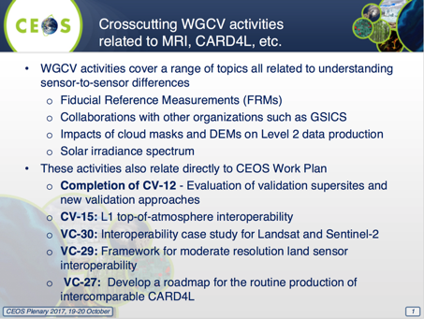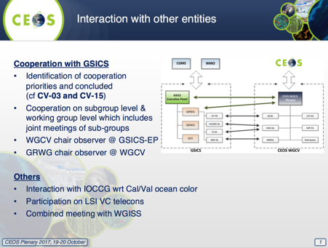
Kurt also reviewed ongoing WGCV activities around the GSICS/WGCV IVOS solar irradiance spectrum (CV-16), fiducial reference measurements, and SI-traceability and good practices – which directly relate to CEOS WP action CV-15 (defining Level 1 top-of-atmosphere interoperability). WGCV also continues to move forward on a DEM Task Group.
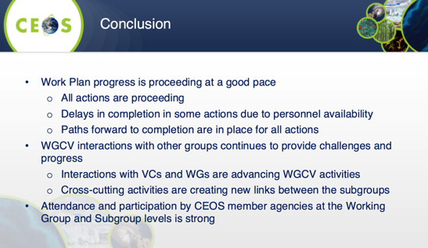
Alex Held (CSIRO) confirmed CSIRO’s continued support for WGCV, including Cindy Ong’s (CSIRO) term as WGCV Vice-Chair (and subsequent WGCV Chair term). Adam Lewis (GA) thanked WGCV for their support to the work of the LSI-VC, and their participation in LSI-VC meetings and teleconferences.

WGCapD
Phila Sibandze (SANSA, WGCapD Chair) reviewed the activities and achievements of the Working Group in 2016 and 2017:
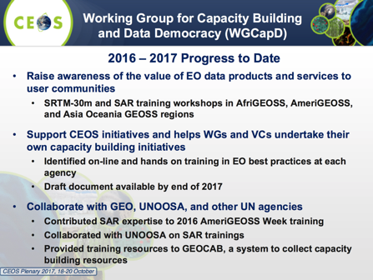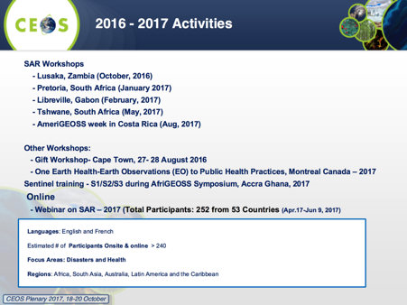
Phila noted that effort is being made to record and archive all teaching materials generated. A Digital Knowledge Repository (free-and-open, Creative Commons licensed) has been established at: http://learningcenter.obt.inpe.br/ Lessons Learned reports from WGCapD capacity building initiatives are also available on the CEOS website, and a document on training methods and best practices is being compiled.
From the 31st CEOS Plenary, Senthil Kumar (ISRO) will become the WGCapD Chair. Phila represented SANSA as WGCapD Chair following the departure of Jane Olwoch. CEOS Plenary thanked Phila for taking on the role.
Senthil Kumar (ISRO, WGCapD Vice-Chair) announced that NASA have nominated Nancy Searby as the next WGCapD Vice-Chair (and subsequent Chair).
Virtual Constellation Issues, Discussions, Decisions
Jean-Louis Fellous (SIT Chair Team) presented an overview of the CEOS Virtual Constellations (VCs), noting that overall the VCs are in good shape, and fulfill the purpose for which they have been established: to help improve international coordination and measurement coverage, anticipate and remedy potential gaps, reduce redundancy, favor intercomparison, etc.
CEOS Work Plan VC Action Status
Jean-Louis presented an overview of the status of CEOS Work Plan VC-related actions (available in the presentation slides). Overall, the actions are on-track. In the following slides, he highlighted the few identified issues.
OSVW-VC – Building a Strong Case for Operation Continuity (VC-14)
Jean-Louis presented the current status of the OSVW-VC:
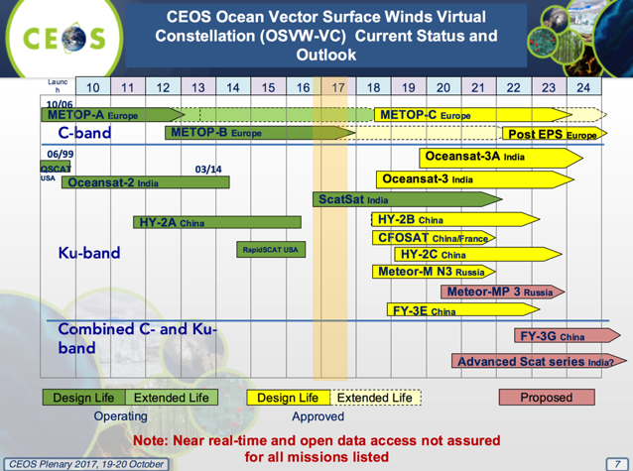
The 2015 IOVWST meeting recommended the following as the optimum (minimum) OSVW-VC:
- At least 3 scatterometers in orbits designed to roughly meet WMO requirements (observations every 6 hours);
- One instrument in a non-sun-synchronous orbit for sampling of the diurnal cycle, better mid-latitude sampling, and to provide data for inter-calibration.
Jean-Louis presented the following questions from the 2017 OSVW-VC meeting:
- Is the “business” case for satellite OSVW strong enough?
- Satellite SSH, SST (IR), rain/TPW, visible/IR imagery, and microwave soundings appear to be considered core measurement capabilities, but is this also the case for satellite OSVW?
- What needs to be done to improve the chances of realizing the optimum (minimum) satellite OSVW constellation?
SST-VC – Passive Microwave Radiometer Continuity
Jean-Louis once again highlighted the risk to the current and continued PMW constellation for SST, and flagged the need for a redundant capability of PMW at 7 GHz. He presented some slides demonstrating the importance of these measurements for high-latitude areas, high-aerosol regions, and persistently cloudy locations. Jean-Louis presented promising mission updates from JAXA and CMA, which are summarised below along with the overall PMW SST situation:
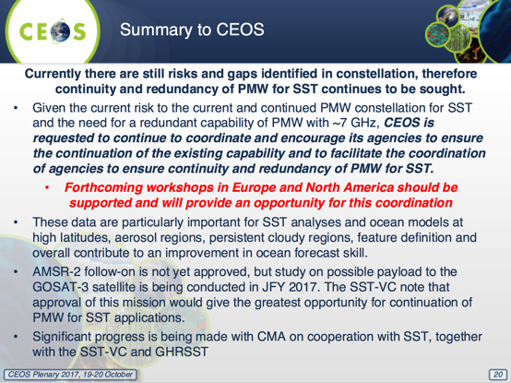
AC-VC Issues – Data Access, Unmet Measurement Goals, Joint AQ/GHG Constellation
Jean-Louis presented one request, and two recommendations on behalf of the AC-VC:
- AC-VC requests that CEOS actively engage (or continue) conversations with appropriate agencies in Republic of Korea and China to facilitate open sharing of satellite data between all partner space agencies. Enabling the Air Quality (AQ) constellation objectives for open data exchange (refer to the CEOS-endorsed AQ Constellation Position Paper, 2011) now relies on data access policies for the Asian missions to be established by their organizations.
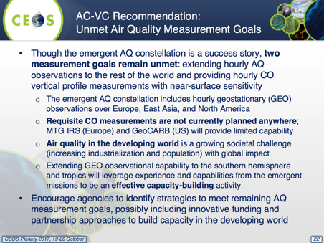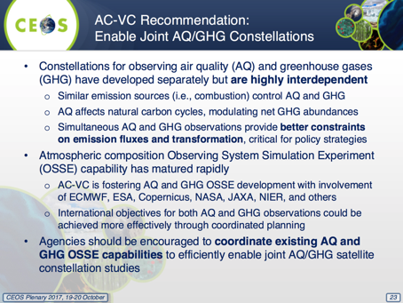
Jean-Louis thanked CEOS and his many colleagues for their friendship and collaboration over the many years prior to this, his last CEOS Plenary. Frank Kelly (USGS, CEOS Chair) thanked Jean-Louis on behalf of CEOS and all its Agencies for his many years and incarnations of support to CEOS.
Jonathon Ross (GA, CEO) asked how CEOS should go about tracking the SST PMW continuity issue going forward. Jean-Louis suggested that a CEOS Work Plan task be established. CEOS Plenary action 30-12 can be closed. Jean-Louis encouraged all agencies to support the forthcoming workshops on this matter in North America and Europe.
CEOS-31-07 | CEO to establish a CEOS Work Plan task to track the sea surface temperature passive microwave radiometer continuity issue, and encourage all agencies to support the forthcoming workshops on this matter in North America and Europe. | End 2017
Alex Held (CSIRO) highlighted the potential of new generation geostationary satellites for the issues highlighted by the VCs.
Raj Kumar (ISRO) informed that ISRO have upcoming missions related to SST and OSVW. Mauro Facchini (COM) noted that SST PMWs are on the radar for the planning of future Copernicus missions.
LSI-VC / SDCG / GEOGLAM Coordination Recommendations
Stephen Ward (SIT Chair Team) reported the outcomes from the trial joint meeting of the LSI-VC, SDCG-GFOI, and the GEOGLAM ad-hoc Working Group – which was first proposed at the 2016 CEOS Plenary as a way to improve representation/travel efficiency and coordination among related groups. The trial meeting consisted of both individual and joint sessions. Stephen summarised the outcomes and lessons learned:
- the meetings were extremely productive;
- ARD, MRI, FDA Data Cube pilots, user requirements, and mission updates all present significant overlap and interest across groups;
- agreed to have thematic communities formally engaged in the CARD4L Product Family Specifications and their review;
- with benefits comes some compromise, however this is manageable (e.g., more people and more rooms reduces the number of potential hosts);
- it was agreed to have fewer parallel sessions next time.
Stephen presented some notes and discussion points regarding the way forward:
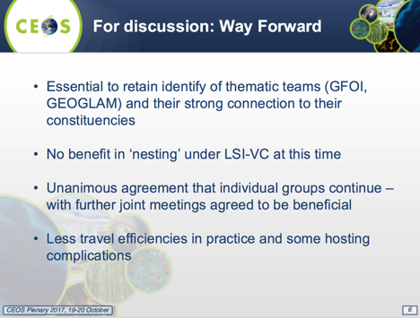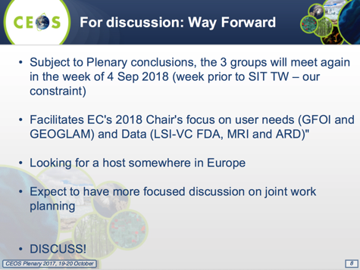
Adam Lewis (GA, LSI-VC Co-Chair) agreed that the joint meeting was very productive and will be the start of a process that will help evolve the requirements for ARD and others. It was agreed that a joint LSI/SDCG-GFOI/GEOGLAM meeting should proceed in 2018 as proposed.
Decision 05 | Plenary endorsed that LSI-VC, SDCG for GFOI, and the GEOGLAM ad-hoc Working Group proceed with a 2nd joint meeting in 2018.
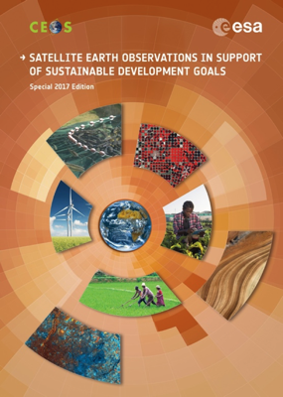
Session 11: Other CEOS Business
Missions, Instruments, and Measurements (MIM) Database Report
Ivan Petiteville (ESA) reported on the three main activities undertaken by the CEOS MIM Database and Earth Observation Handbook team in the last year: the annual update of the MIM Database, maintenance and enhancements to the MIM DB and its online portal, and the EO Handbook being prepared for UNISPACE+50 (focused on the SDGs).
The EO Handbook for UNISPACE+50 on satellite EO support of the SDGs is currently being drafted and is drawing upon inputs from across CEOS and non-CEOS agencies. The foreword will be supplied by the Chair of the UN Statistical Commission (UNSC) and a co-Chair of UN-GGIM. The CEOS message will be co-signed by ESA (Josef Aschbacher) and the 2018 CEOS Chair (Philippe Brunet). Printing will be completed by early 2018 for the 49th session of the United Nations Statistical Commission (March 2018) and for UNISPACE+50 in June. Calls for distribution list inputs and agency mailing contacts should be expected in the near future.
The annual update of the CEOS MIM DB has now been completed, and the changes are reflected online at: database.eohandbook.com. Responses were received from 28 CEOS agencies. 14 new mission records were added, while 226 existing records were updated. The survey also resulted in 19 new instrument records being added, with 132 existing records updated. The MIM DB currently features 322 Earth observing satellite missions and 913 instruments that are operating or planned for launch in the next 15 years.
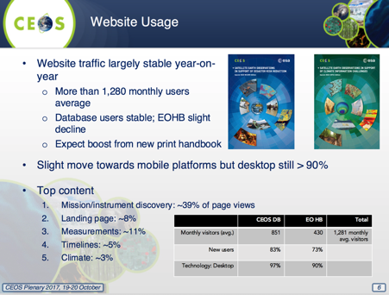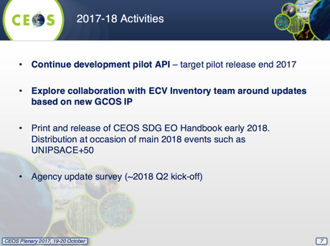
Jonathon Ross (GA, CEO) asked about the strategies being employed to make key POCs aware of the EO Handbook, and to encourage them to read it. Ivan noted the work being done to identify key POCs ahead of time and directly mailing them a copy of the report. The team has also worked to include articles by diverse communities, aiming to stimulate interest from further agencies in these communities. Jonathon suggested that the letters sent to POCs along with the directly mailed Handbook could highlight articles of interest.
Systems Engineering Office (SEO) Report
Brian Killough (NASA, SEO) provided an overview of the 2017 achievements of the SEO. On the technical side, the CEOS Data Cube has been the top priority. The SEO is a member of the Open Data Cube (ODC) Partners Forum and the SEO’s technical contractor Analytical Mechanical Associates (AMA) participates in the ODC Steering Council. The SEO has made a number of significant code contributions (e.g., user interface, applications, data ingestion) to the ODC and led many of the country pilot projects.
The SEO technical team has also contributed to the LSI-VC (CARD4L definition, gap analysis process), SDCG for GFOI and GEOGLAM (data acquisition planning), the maintenance of existing CEOS tools (COVE: www.ceos-cove.org, Data Policy Portal), and the CEOS website.
Kim Holloway (NASA, SEO) has provided communications support to the SDG-AHT and WGCapD, managed CEOS web and social media content, continued producing the “Faces of CEOS” video series, provided meeting logistics support across many CEOS entities, developed new outreach materials, and maintained the mailing lists.
Brian reviewed the SEO’s plans for 2018:
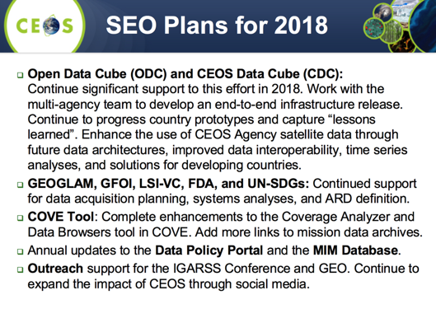
The CEOS website and social media accounts are key outreach tools. In the last year, the CEOS website received 47,000 visits. CEOS leadership, WG, and VC Leads were asked to review relevant web pages and send updates; and everyone was asked to send short summaries of newsworthy CEOS activities/accomplishments (to Kim Holloway) and to remember the availability of meeting registration capabilities and the Document Management System.
Brian estimated that around 8000 USD plus 3 people’s time are needed per conference that CEOS is represented at (IGARSS, GEO Plenary). Mark Dowell (COM) asked whether CEOS has been present at IAC in the past; Brian confirmed no, but it is something that could be considered in the future. Jonathon Ross (GA, CEO) suggested that CEOS materials could be integrated into country/agency exhibitions at conferences such as IAC.
Frank Kelly (USGS, CEOS Chair) stressed how the SEO’s existence has revolutionized the ability of CEOS to address different work, including implementation and CEOS promotion. The Plenary warmly congratulated the SEO on their 10-year anniversary.
Session 12: Closing Business
WG Leadership Succession and Recap of Decisions on One-Year Extensions of the CEOS Ad-Hoc Teams
Steve Labahn (USGS, CEOS Chair Team) recapped the appointments raised in the course of Plenary and these were recorded as confirmed by Plenary.
Decision 06 | CEOS Plenary confirmed the following appointments:  WGClimate Vice-Chair: John Dwyer (USGS)  WGISS Vice-Chair: Rob Woodcock (CSIRO)  WGDisasters Vice-Chair: David Green (NASA)  WGCapD Vice-Chair: Nancy Searby (NASA)  CEOS Lead for GFOI: Osamu Ochiai (JAXA)  SDCG Co-Chair: TBA (UKSA)
It was noted that an agency letter is due on the nomination for WGISS Vice Chair. Alex Held of CSIRO confirmed that a letter will be provided.
Steve handed over to the Ad-hoc Teams to present the case for renewal of their mandates for another year:
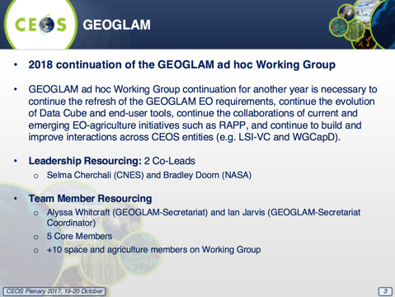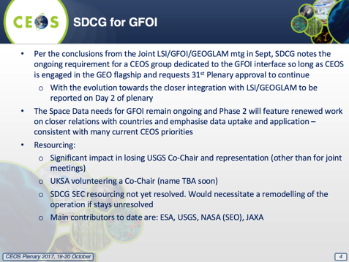
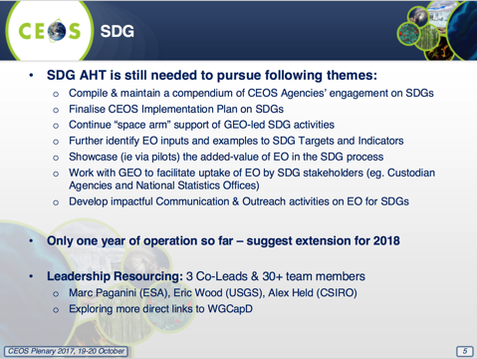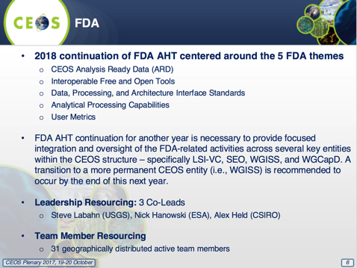
Mike Freilich (NASA) strongly urged CEOS Principals to each consider pledging a small amount of funding for the SDCG Secretariat – with the total estimated cost at ~ $US70,000 per year. JAXA has already confirmed $US10,000 in support. Chris McQuire (UKSA) hoped that UKSA could make a modest contribution financially, and also noted the intention to provide a new SDCG Co-Chair. Alex Held (CSIRO) supported the continuation of the SDCG for GFOI for another year. No one was opposed. Mike suggested the new CEOS Chair and SIT Chair to send a written appeal to principals for SDCG resources. Recall CEOS-31-02:
CEOS-31-02 | CEOS Chair and SIT Chair to send an appeal to CEOS agencies for Co-Leads for the SDCG for GFOI and for potential contributions to SDCG SEC funding or personnel capacity. | October 2017
Decision 07 | CEOS Plenary renewed for another year the mandates of the following ad-hoc teams: Space Data Coordination Group (SDCG) for GFOI; Ad-hoc WG on GEOGLAM; Ad-hoc Team on the Sustainable Development Goals; Ad-hoc Team on Future Data Access and Analysis Architectures
SIT Chair Handover
Outgoing SIT Chair’s Presentation
Stephen Briggs (ESA, SIT Chair) reviewed the landscape at the time when ESA took on the SIT Chair role, noting in particular changes related to data availability and technology. He recalled the ESA SIT Chair priorities for 2016-2017:
- Ensure successful advancement of ongoing CEOS commitments and deliverables;
- Ensure full access to, and exploitation of, Copernicus Sentinel data;
- Further develop the relationships with IPCC and UNFCCC to support observation of climate indicators in the post-COP-21 context;
- Maintain and improve our strategic partnerships (e.g., UN agencies, Development Banks, international programmes and agencies);
- Ensure effective functioning of GEO, and CEOS within GEO, with its new strategic goals and a new governance model for the coming decade;
- Support initiatives proposed and advanced by the CEOS Chairs in 2016 (CSIRO) and 2017 (USGS).
Stephen reviewed CEOS support to GEO over the period 2016-2017, in the areas of climate (The Paris Agreement); disasters (The Sendai Framework); and the Sustainable Development Goals. In addition to the support of these themes, CEOS has also contributed greatly to GEO itself, in particular through participation in the GEO Programme Board and as an observer to the GEO Executive Committee.
Incoming SIT Chair’s Presentation
Steve Volz (NOAA, SIT Vice-Chair) reviewed NOAA’s priorities as SIT Chair for 2018-2019:
- Ensure the efficient execution of existing SIT responsibilities as described in the SIT Terms of Reference, including addressing Working Group and Virtual Constellation continuity, sustainability, and outputs;
- Enhance the utility of observations from new generation geostationary satellites and exploring development of GEO-LEO combination products and data processing capabilities;
- Improve and clarify CEOS relationships with CGMS, GEO, and to a lesser degree WMO, by identifying coordinated activities and, where appropriate, holistic interaction among CEOS, CGMS, GEO, and WMO, emphasizing the unique values of each.
- Support initiatives undertaken by CEOS Chairs in 2018 and 2019.
NOAA will begin by reaching out to the VCs and WGs to get a sense of current status and needs via a questionnaire. Bi-annual WG/VC tag-up teleconferences will be maintained. The CEOS Work Plan will be a key focus for NOAA, and it will be updated based on the results of the questionnaire.
Steve reviewed the meeting plans for 2018/2019:
- SIT-33: April 23-26, 2018; Boulder, Colorado, USA;
- 2018 SIT Technical Workshop: September 10-14, 2018; Darmstadt, Germany;
- SIT-34: March/April 2019, National Water Center, Tuscaloosa, Alabama (TBC);
- 2019 SIT Technical Workshop: September 2019, Location TBD;
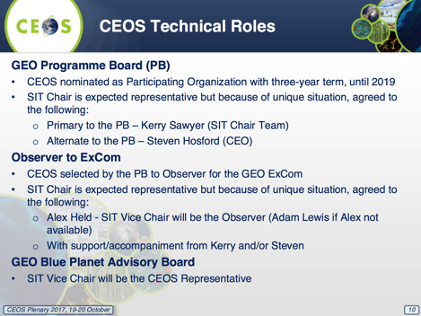
SIT Vice-Chair Nomination
Alex Held (CSIRO) confirmed the nomination of CSIRO-GA as SIT Vice-Chair. There may be some influence of the new Australian space agency on the representation. Adam Lewis (GA) noted that GA will support CSIRO in this.
Decision 08 | CEOS Plenary endorsed CSIRO-GA as SIT Vice-Chair (2018-2019) and subsequently SIT Chair (2020-2021).
CEO Handover
Jonathon Ross (GA, CEO) thanked CEOS for the opportunity to serve as CEO. He also expressed his gratitude to previous CEOS Chairs, SIT Chairs, CEOs, and Geoscience Australia for their support.
Steven Hosford (ESA/CNES) thanked CEOS for the opportunity; he is looking forward to the next two years as CEO.
Future CEOS Chairs
Frank Kelly (USGS, CEOS Chair) summarized the position with respect to offers for future CEOS Chairmanship.
Raj Kumar (ISRO) confirmed that ISRO is ready to serve as CEOS Chair for 2020. Pham Anh Tuan (VAST-VNSC) is looking forward to serving as 2019 CEOS Chair after the European Commission.
Decision 09 | CEOS Plenary confirmed VAST as CEOS Chair for 2019 and ISRO as CEOS Chair for 2020.
CEOS Chair Handover
Frank Kelly (USGS, 2017 CEOS Chair) and Mauro Facchini (COM, 2018 CEOS Chair Representative) exchanged the CEOS flag and gavel, signifying the transfer of the CEOS Chair position from USGS to the European Commission. Mauro thanked CEOS, on behalf of the European Commission and Philippe Brunet (COM, 2018 CEOS Chair), for the opportunity to serve as CEOS Chair in 2018.
2018 CEOS Chair Presentation
Mauro Facchini (COM) presented the European Commission’s CEOS Chair priorities for 2018:
- to ensure continuity and coherence of CEOS activities, the European Commission will first aim to ensure that the priorities and themes identified by the 2017 Chair, USGS, are supported and further developed. The European Commission will work with USGS, ESA, NOAA, and relevant stakeholders to ensure substantive and timely continuity of:
  - the study of future data access and analysis architectures;
  - the Moderate Resolution Sensor Interoperability initiative;
- consideration of future partnerships and priorities for CEOS, notably with GEO, the UN System, development banks, and "big data" companies; and,
- expediting existing CEOS thematic acquisition strategies – in relation to forests, agriculture, disasters, climate, carbon, and water;
- continued support of the SDG-AHT’s activities, which include increased engagement with national statistics agencies and analyzing the mainstreaming of efforts into policies;
- rationalization of the many ongoing CEOS activities in the area of land surface imaging and its applications;
- continue the practice of periodically examining existing CEOS groups, including some that could, potentially be integrated into existing CEOS entities, such as the Working Groups and Virtual Constellations.
All of these priorities build upon CEOS collective efforts over a number of years and attempt to evidence the specific added value the European Commission can bring in its year as CEOS Chair.
In consideration of these past efforts, and without prejudging the outcome of these processes, the European Commission proposes to pursue two additional priority initiatives during its chairmanship:
- Lay the foundation for an international GHG monitoring system; and,
- Bring the benefits of Future Data Architectures to the present and identify new targets.
Mark Dowell (COM) referred participants to the paper on the Plenary website for full details of these initiatives.
Mauro outlined the European Commission’s CEOS Chair team for 2018, and showed a short video on the 2018 CEOS Plenary (16-18 October 2018; Palais des Congrés, Brussels, Belgium).

2017 CEOS Plenary Decisions and Actions Recap
Stephen Ward (2017 CEOS Chair Team) reviewed the decisions and actions. No interventions were made. Stephen asked for any edits/feedback to be emailed and/or input during the review cycle of the minutes.
Closing Remarks
Mauro Facchini (COM, 2018 CEOS Chair Representative) thanked USGS and Frank for the exceptional year of chairing and for a wonderful 31st CEOS Plenary. Frank thanked the team who worked hard for the whole year – with the results clear in the productive plenary.

APPENDIX A
Attendees

Organization | Name | Organization | Name
ASI | Laura Giulia Maria Candela | NASA | Christine Bognar
ASI | Simona Zoffoli | NASA | David Jarrett
CNES | Juliette Lambin | NASA | Kurt Thome
COM | Astrid-Christina Koch | NASA | Matthew Koeppe
COM | Mark Dowell | NASA | Michael Freilich
COM | Mauro Facchini | NASA | Nancy Searby
COM | Michael Berger | NASA | Richard Eckman
CONAE | Laura Frulla | NASA | Wenying Su
CSA | Eric Laliberte | NOAA | Charles Wooldridge
CSA | Marie-Josée Bourassa | NOAA | Kerry Sawyer
CSA | Stephane Chalifoux | NOAA | Stephen Volz
CSIRO | Alex Held | NSMC/CMA | Jinlong Fan
CSIRO | Cindy Ong | NSMC/CMA | Jun Yang
CSIRO | Flora Kerblat | NSMC/CMA | Shihao Tang
DLR | Klaus Schmidt | NSMC/CMA | Xiang Fang
ESA | Ivan Petiteville | NSMC/CMA | Xiuqing Hu
ESA | Jean-Louis Fellous | NSO | Joost Carpay
ESA | Josef Aschbacher | Roscosmos | Tamara Ganina
ESA | Michael Rast | SANSA | Paida Mangara
ESA | Mirko Albani | SANSA | Phila Sibandze
ESA | Nick Hanowski | U.S. State Department | Fernando Echavarria
ESA | Pascal Lecomte | UKSA | Catherine Mealing-Jones
ESA | Simonetta Cheli | UKSA | Christopher McQuire
ESA | Stephen Briggs | USGS | Brenda Jones
ESA/CNES | Steven Hosford | USGS | Eric Wood
EUMETSAT | Alain Ratier | USGS | Eugene Fosnight
EUMETSAT | Jörg Schulz | USGS | Frank Kelly
EUMETSAT | Paul Counet | USGS | Jenn Lacey
EUMETSAT | Remko Scharroo | USGS | Karen Reiser
GA | Adam Lewis | USGS | Matthew Steventon
GA | Jonathon Ross | USGS | Pete Doucette
GCOS | Carolin Richter | USGS | Stephen Ward
GEO SEC | Barbara Ryan | USGS | Steve Labahn
ISRO | Harikrishnan Gopalakrishnannair | USGS | Thomas Cecere
ISRO | Raj Kumar | USGS | Tim Stryker
ISRO | Senthil Kumar Arumugam | USGS/SGT | Howard Hedger
JAXA | Akiko Suzuki | USGS/SGT | Jerad Shaw
JAXA | Osamu Ochiai | USGS/SGT | Laura Nemec
JAXA/RESTEC | Koji Akiyama | USGS/SGT | Todd Taylor
KMA | Jae-Dong Jang | VAST | Viet Tien Dang
KMA | Ki-Hong Park | VAST/VNSC | Anh Tuan Pham
NASA | Andrew Mitchell | VAST/VNSC | Huong Hanh Vu
NASA | Bradley Doorn | VAST/VNSC | Ngoc Phuong Linh Phan
NASA | Brian Killough

APPENDIX B
Actions and Decisions Record

No. | Action | Due Date
CEOS-31-01 | WGClimate to explore development of a brief, consolidated statement of space agency contributions in support of each Article of the Paris Agreement. | 32nd CEOS Plenary
CEOS-31-02 | CEOS Chair and SIT Chair to send a written appeal to CEOS principals for Co-Leads for the SDCG for GFOI and for potential contributions to SDCG secretariat funding or in-kind support. | October 2017
CEOS-31-03 | ESA to lead conclusion of the ODA communications document reflecting comments and inputs from CEOS Agencies. | End 2017
CEOS-31-04 | SIT Chair to coordinate feedback from the Virtual Constellations on how they will take the Feasibility Study on Satellite Missions/Instruments Focused on Water Quality Measurements into account in their work going forward. | SIT-33
CEOS-31-05 | SIT Vice-Chair to coordinate establishment of a steering committee to determine the focus, scope, and arrangements of a CEOS “Water from Space” observations strategy workshop in Q2 2018. The matter of inclusion of the ocean component needs to be answered, with consideration being given to renaming the workshop if it will be excluded entirely, or if only coastal water will be included. | Q2 2018
CEOS-31-06 | LSI-VC to provide CEOS VCs with a CARD4L package to stimulate their feedback on the Framework and to allow the VCs to assess the applicability to their work. LSI-VC will utilize feedback to inform their recommendations for a broader ARD strategy. | End 2017
CEOS-31-07 | CEO to establish a CEOS Work Plan task to track the sea surface temperature passive microwave radiometer continuity issue, and encourage all agencies to support the forthcoming workshops on this matter in North America and Europe. | End 2017

Decision 01 | The CEOS Statement to GEO-XIV was endorsed.
Decision 02 | The proposed CEOS Statement on EO and ODA was endorsed.
Decision 03 | CEOS Plenary endorsed a number of WGDisasters documents: Ecuador and New Zealand Supersites Biennial Reports; the Southern Andes and Virunga Volcanoes Supersites proposals; the Recovery Observatory Operational Plan; the final reports of the Floods, Seismic Hazards, and Volcanoes Pilots; the Geohazards Lab Implementation Plan.
Decision 04 | CEOS will proceed with the freshwater coordination workshop in the first half of 2018.
Decision 05 | Plenary endorsed that LSI-VC, SDCG for GFOI, and the GEOGLAM ad-hoc Working Group proceed with a 2nd joint meeting in 2018.
Decision 06 | CEOS Plenary confirmed the following appointments:  WGClimate Vice-Chair: John Dwyer (USGS)  WGISS Vice-Chair: Rob Woodcock (CSIRO)  WGDisasters Vice-Chair: David Green (NASA)  WGCapD Vice-Chair: Nancy Searby (NASA)  CEOS Lead for GFOI: Osamu Ochiai (JAXA)  SDCG Co-Chair: TBA (UKSA)
Decision 07 | CEOS Plenary renewed for another year the mandates of the following ad-hoc teams: Space Data Coordination Group (SDCG) for GFOI; Ad-hoc WG on GEOGLAM; Ad-hoc Team on the Sustainable Development Goals; Ad-hoc Team on Future Data Access and Analysis Architectures
Decision 08 | CEOS Plenary endorsed CSIRO-GA as SIT Vice-Chair (2018-2019) and subsequently SIT Chair (2020-2021).
Decision 09 | CEOS Plenary confirmed VAST as CEOS Chair for 2019 and ISRO as CEOS Chair for 2020.

