Earth Observations in Public Policy, Tuesday 25 Oct (10:45 – 12:30):
Description:
The Earth Observations in Public Policy Panel will bring together government officials, both at country and city levels to highlight the role of open data in providing insight for their day-to-day decisions, policies and programmes. The discussion outcome will inform GEO’s Members’ approaches for engaging the public sector to further support efforts promoting sustainable development, and building resilient communities.
Moderator: John Firth
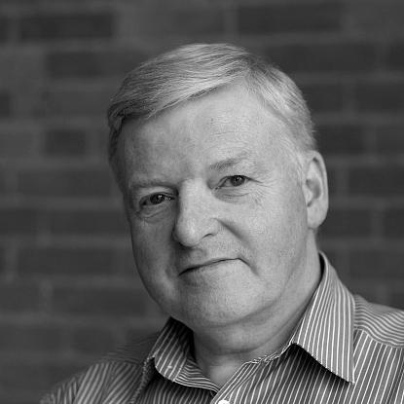
John has over 25 years’ experience in assessing the impacts of climate change. Prior to Acclimatise he worked in the UK water sector for Severn Trent Water, where he led their strategic business planning team, with responsibilities for water resource, water supply and wastewater planning, and environmental consenting.
John co-founded Acclimatise with Dr Richenda Connell in 2004. Acclimatise has now worked on nearly 400 adaptation and resilience projects in 70 countries, for both the public and private sectors. He has extensive experience of integrating climate change into business decision-making and risk management processes. He has a particular expertise in the impacts of climate change on SMEs, multi-national corporates and their supply-chains and the financial services sectors. John is also interested in the legal implications for business, disclosure of information to investors, the mobilisation of private-sector finance, climate funding in developing countries, and the integration of adaptation/resilience into national policy making.
Panelists :
Ann Bartuska is Vice President for Land, Water, and Nature in the organization Resources for the Future (RFF). She was previously Deputy Under Secretary for Research, Education and Economics within the United States Department of Agriculture. | 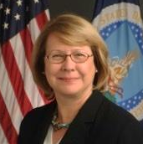
Saboto Caesar is Minister, Agriculture, Forestry and fisheries and Rural Transformation in Saint Vincent and Grenadines. A lawyer by training, he has garnered a wide range of professional experience as a lawyer, community worker, Senator and Minister. | 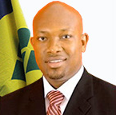
Carlos Felipe Prada Lombo is an economist with the Department of National Statistics in Colombia. He holds the degree of Master in Economics from Universidad Javeriana. | 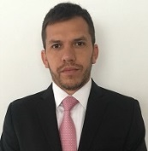
Eli Yewdall is Senior Programme Officer with the International Council for Local Environmental Initiatives (ICLEI), based in the United States. His focus is on developing resources to help local governments measure, manage and reduce greenhouse gas emissions. | 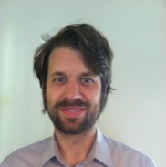
Earth Observations in the Commercial Sector, Tuesday 25 Oct (13:45 – 15:30)
Description:
The Earth Observations in the Commercial Sector Panel will highlight current uses of Earth observations by commercial companies to assess and manage risks, thereby optimizing their investments. With panellists ranging from a local farmer from Australia to multi-national companies, we will explore the current impact and potential of open data and services for the commercial sector. Discussion outcomes will inform how GEO will best engage with business communities to promote and advance the further utilization of Earth observation data.
Moderator: John Firth
John has over 25 years’ experience in assessing the impacts of climate change. Prior to Acclimatise he worked in the UK water sector for Severn Trent Water, where he led their strategic business planning team, with responsibilities for water resource, water supply and wastewater planning, and environmental consenting.
Panellists :
Jack Dangermond is President of Environmental Systems Research Institute (Esri). A landscape architect by training, he founded Esri in 1969 with a vision that computer mapping and analysis could help us design a better future. | 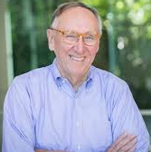
Jon Davis is Chief Meteorologist with Riskpulse/Earthrisk. Based in Chicago, USA, Jon Davis brings over 30 years of experience and is widely considered one of the foremost experts on the impact of weather and climate on global commodities.
Franklin Nutter is President of the Reinsurance Association of America. Mr. Nutter currently serves on the Advisory Board of the OECD’s International Network for the Financial Management of Large Scale Disasters, the RAND Center on Catastrophic Risk Management and Compensation, and the Carl H. Lindner III Center for Insurance and Risk Management Board of Directors. | 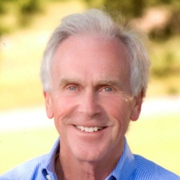
Kenji Wakamatsu is Director of NTT DATA’s Earth observation business, based in Tokyo, Japan. He has participated in numerous projects related not only to remote sensing but also to GIS and sensor networks, using these tools for disaster management, asset management and more. | 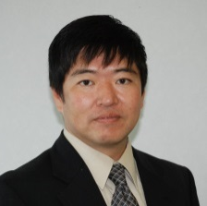
Brad Wooldridge is a farmer from Western Australia. In 2000, he began using Landgate’s satellite remote sensing to measure pasture growth and production, and developed their own systems analysis with management and benchmarking of productivity through analysis of remote sensing imagery data. | 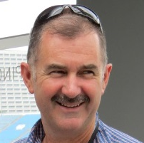

Earth Observations in International Development Tuesday 25 Oct (16:00-17:30)
Description:
The next Panel, Earth Observations in International Development, will comprise development banks and foundations discussing their role and interest in increasing the world's Earth observation capacity, and how this is incorporated in their own policies and programmes. The objective of this Panel is to promote a dialogue among major funders and recipients working on projects to increase the socio-economic benefit of Earth observations for sustainable development.
Moderator: Jennifer Morris
Prior to her work as President of Conservation International, Jennifer Morris led the organization’s conservation investment and business engagement initiatives as Executive Vice President for Ecosystem Finance and Markets, managing five diverse funds, with US$330 million under management, as well as CI’s Center for Environmental Leadership in Business.
Panelists:
Haishan Fu is Director of Development Data Group, World Bank. She oversees the World Bank’s global development monitoring and open data initiative, surveys and other technical advisory services, and global statistical programs such as the International Comparison Program. | 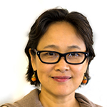
Ryosuke Nakata is Chief Representative of the Japanese International Cooperation Agency (JICA) USA Office. He assumed this position in October 2016, and also previously served as a Senior Representative of the JICA USA Office from 2006 until 2010. | 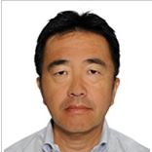
Carrie Stokes is Chief Geographer and Geocentre Director with the US Global Development Lab in the United States Agency for International Development. She has used mapping and satellite imagery to help the government decide more effectively where and how to provide aid and humanitarian assistance.

National Earth Observations, Wednesday 26 Oct 14:00-15:30
Description:
Finally the National Earth Observations Panel will showcase examples of best practices in assessing and developing national Earth observation portfolios, with examples from large countries deploying extensive Earth observation systems as well as smaller nations just stepping up to exploit the available observing capabilities. Panelists will discuss best practices in applied methodologies, and demonstrate how national GEO mechanisms can both leverage national efforts, and better support the international community.
Moderator: Philip Thigo
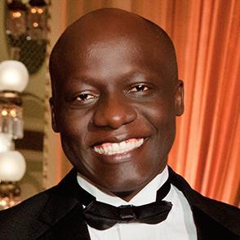
Philip Thigo is a Technology & governance expert. He doubles is the Senior Advisor on Data and Innovation at the Office of the Deputy President and Advisor on Data and Communication for the Cabinet Secretary - Agriculture, Livestock, Fisheries, Government of Kenya.
He has previously held executive positions, notably Infonet Africa and Foundation El Taller with experience spanning across Asia, Africa, Arab World and Latin America. Over the years, he has co-created unique technology driven initiatives such as Apps4Africa together with the US State Department, Uchaguzi to monitor Election, Budget Tracking Tool for citizen engagement, Sauti Yetu (Huduma) on public service delivery monitoring and The State House Summit where high level government officials engage with citizens through online media.
Panelists:
Xingfa Gu is the Executive Acting Director of Institute of Remote Sensing and Digital Earth in the Chinese Academy of Sciences. | 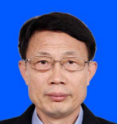
Frances Blair is a Senior Manager at the National Environment and Planning Agency (NEPA) in Jamaica. | 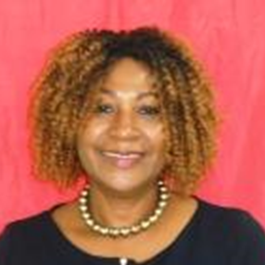
Iain Williams is the Deputy Chief Scientific Adviser in the Department for Environment, Food and Rural Affairs (Defra) in the United Kingdom. | 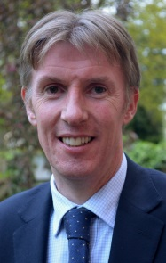
Tim Newman is the Program Coordinator for the United States Geological Survey's Land Remote Sensing Program, which operates the Landsat satellites and provides the portal to one of the largest archives of remotely sensed land data in the world.
Pham Anh Tuan is the Director General of Vietnam National Space Center (VNSC) of the Vietnam Academy of Science and Technology (VAST), Hanoi, Vietnam. | 