For Endorsement by the 2018 CEOS Plenary

CEOS Working Group on Capacity Building and Data Democracy (WCapD)

TRAINING CALENDAR IMPLEMENTATION PLAN
Version 2.0, 03 October 2018

Introduction

This implementation plan has been prepared to support endorsement by the October 2018 CEOS Plenary of a training calendar by WGCapD and participating agencies. The implementation plan to encourages sharing of training events and plans across agencies, with GEO, with other training networks engaged in building skills to use Earth observations for informed decision making and societal benefit. The benefit to both CEOS members as well as the collective CEOS WGCapD will be that our training activities will be available on a standardized calendar with consistent information, allowing training participants to more easily find, participate, and learn from our training activities to use Earth observations for their needs.

This implementation plan includes using the approach developed by EUMETSAT and in use for their own training activities, as well as by the WMO/CGMS VLab training network and by WMO’s on-line learning platform WMO Learn. The acceptance of the EUMETSAT calendar approach and format was based on its history of use, a reasonable amount of information to be included, and general acceptance by the training community of this tool. WGCapD plans to implement this same approach.

This plan summarizes the current status of training calendars by individual agencies and WGCapD, and details the approach and plan to implement a standardized training calendar. This plan provides a general estimate of resources that might be expected to be needed, and requests buy-in and commitment from CEOS through endorsement of this implementation plan.

Current state of training calendars used by WGCapD and participating agencies

Currently, WGCapD announces upcoming trainings through the CEOS WGCapD website and through a growing CEOS WGCapD-World distribution list that includes past training participants. Active WGCapD agencies use their own approaches and provide different information to advertise upcoming training events. For example, DLR advertises trainings associated with specific projects on project websites, has developed a centralized SAREdu website with SAR training materials, and is transferring SAREdu to a more general EOCollege website. ISRO has a Beta ISRO Digital Knowledge Repository. ESA has a web page that announces upcoming training events. NASA’s ARSET program advertises trainings on its website and with its own distribution list. Each agency has its own approach and provides different information about their upcoming training events. While reaching intended training audiences, a more standardized and similar approach to that used across the broader training community should allow easier discovery and more access to our training events.

Review of other training calendar options

GEOCab is a portal of capacity building information to further the use of EO in economic and social benefit areas developed for the GEO community, and includes links to training information. Those links lead to the various training calendars when available at the linked websites. Unfortunately, the GEOCab portal is offline and for the present, is unavailable for linking WGCapD training information; the resources have not been available to maintain the site and hence many of the links have broken as websites undergo inevitable change and upgrades, and projects end as do the maintenance of their websites. WGCapD has its website, as well as the training material repository, housed at INPE’s learning center linked to GEOCab. If GEOCab is revived, as is possible, we will continue to link to this site. In addition, we will separately link our WGCapD training calendar with the EUMETSAT, WMO/CGMS VLab, and WMO Learn calendars as appropriate, as well as advocate that the GEO community and other related training networks adopt the same training calendar approach.

WMO and CGMS also have training calendars. As the WMO Global campus has been developed, the developers explored different calendar options. In the end, they settled on the EUMATSAT-provided VLab calendar due to the history of use, a reasonable amount of information to be included, and general acceptance by the training community of this tool. WGCapD plans to implement this same approach.

Basic concept and design of the EUMETSAT/VLab/WMO Learn training calendar

The training calendar design includes a centralized database with fixed fields of information describing the training event and certain characteristics (see Figure 1 below).

Figure 1: Current data fields in database:

An API pulls selected information into a “front end” that can be designed with the users of that training calendar in mind. The Training Database API and REST Requests Examples are described in EUM/USC/TEN/16/878826 V1A Draft, 1 March 2017. EUMETSAT is improving the data entry features and ability to pull reports, and the revised calendar toolkit is expected to be available by the end of 2018. The calendar toolkit, including API source code, database structure, and front end code for a website will be placed on GitHub (gitlab.eumetsat.int/training-calendar).

Current calendars are shown below. As can be seen by the varying look of the calendars, the front end can be tailored based on the needs of the training community and the provider.

EUMETSAT: http://trainingevents.eumetsat.int/

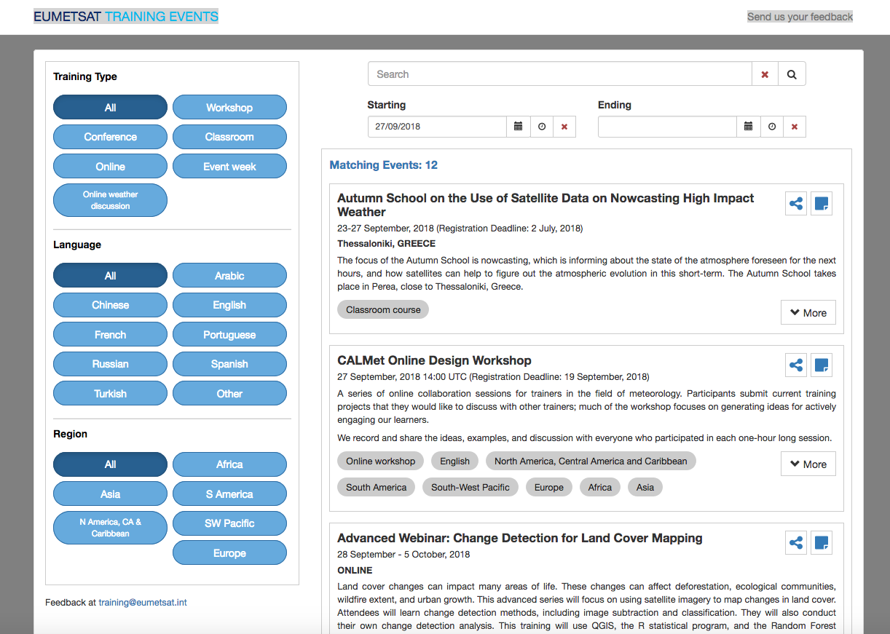

VLab: https://www.wmo-sat.info/vlab/calendar-of-events/

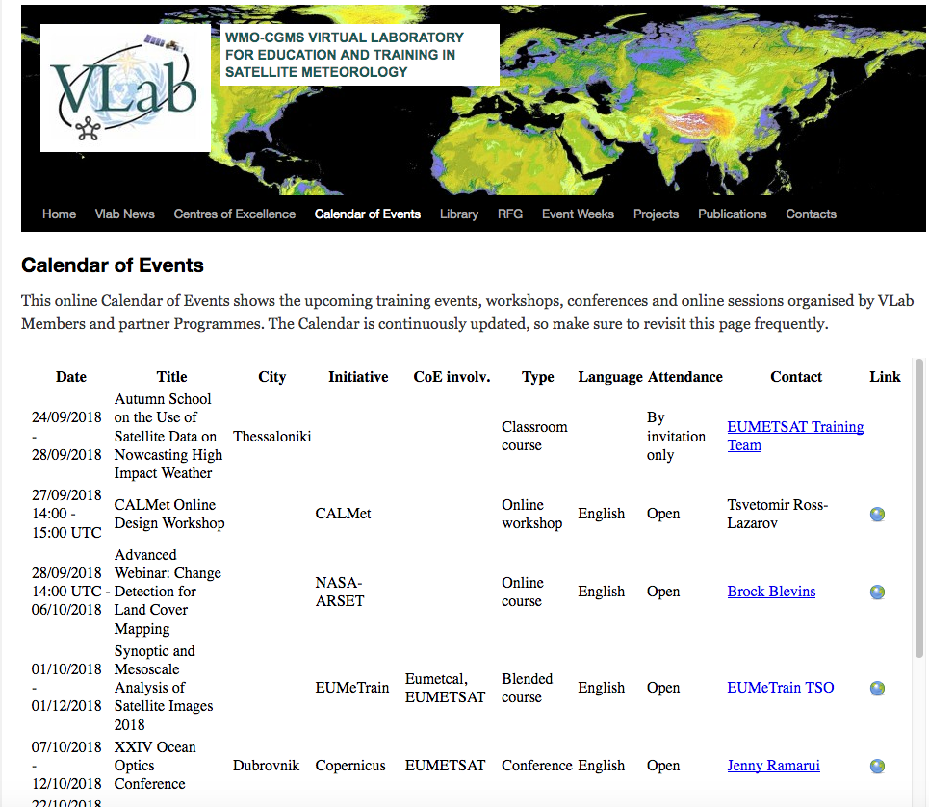

WMO Learn: http://learningevents.wmo.int/#/events

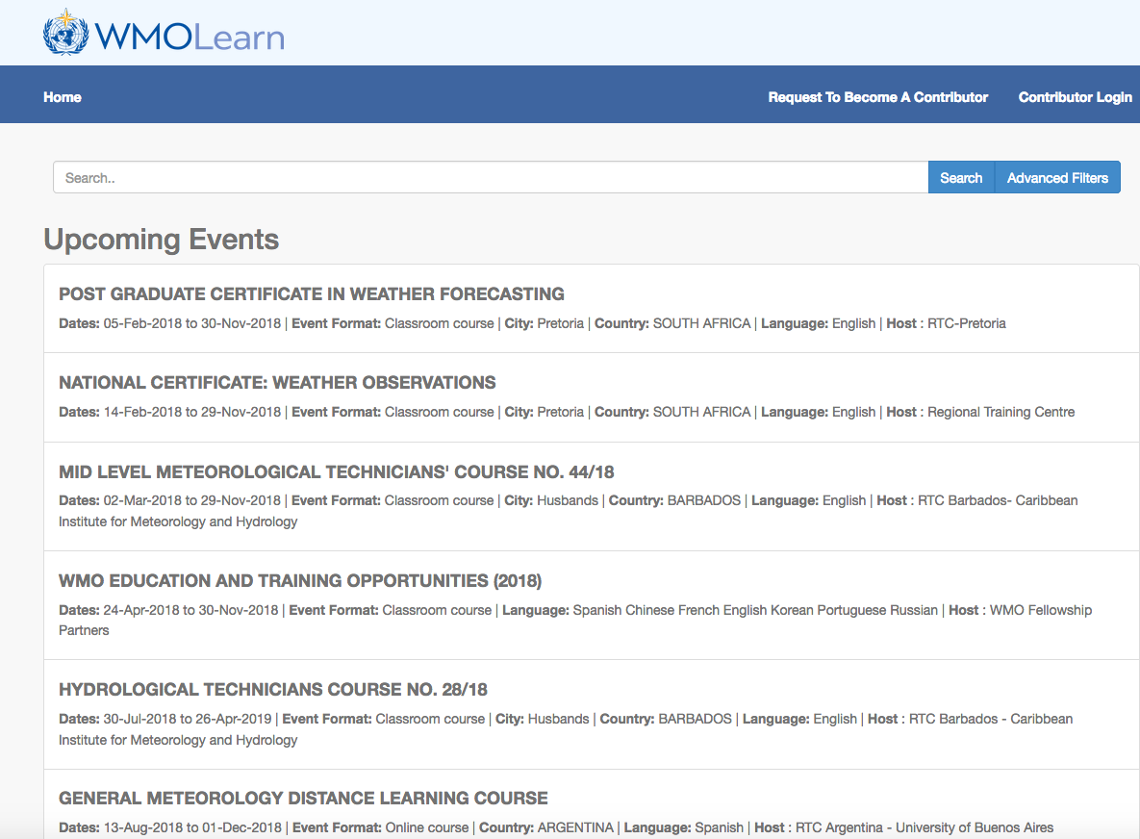

WGCapD training calendar implementation plan

In order to implement the training calendar, we will use a three-pronged approach:
- NASA will implement the training calendar for its capacity building program to advertise trainings offered by ARSET and by SERVIR.
- DLR will implement the training calendar through EOCollege.
- CEOS SEO will implement the training calendar for WGCapD.

These three pilot efforts will work together to:
- Evaluate the centralized database to see if additional fields might be needed. For example, the current data fields do not include different thematic societal benefit areas, since the 3 calendars mentioned are focused on the meteorological community. Different user types, e.g. geosciences community vs applied user, may warrant an additional field.
- Determine if the results from 1 above suggest entering data into the existing database or whether a new one is needed with additional fields, to be hosted by the CEOS SEO.
- Work with EUMETSAT as they revise the API and provide feedback. EUMETSAT has agreed to train someone in how to use and maintain the calendar. The three pilot leads will identify who should be trained, and arrange for that training.
- Each pilot will define their “front end” based on their understanding of user needs independently. The three pilots will then compare their approaches, and together agree on the approach that should be recommended for implementation for the WGCapD calendar.
- Finalize plans for where to host the calendar and its component parts.
- A Concept of Operations will be developed to explain how the calendar(s) will be operated, e.g. how to enter information, relationships between calendars, and permisssions.
- The WGCapD calendar design will be provided to the WGCapD participating agencies for final review, and then will be implemented.

WGCapD training calendar implementation timeline and milestones

The timeline for implementation is as follows:

Task | Q1 2019 | Q2 2019 | Q3 2019 | Q4 2019 | Q1 2020 | Q2 2020 | Q3 2020 | Q4 2020
Evaluate database | X
API training | X
Front end design |  | X
Hosting plan |  | X
Calendar concept of operations |  |  | X
Implement calendar |  |  | X

Estimate of resources

Resources required by each Agency and CEOS SEO will vary depending on the Agency’s current website and training calendar approach. The pilot groups will expend the resources to accomplish the steps above, and may be expected to spend roughly 3 months of labor based on an initial rough order of magnitude estimate. Other Agencies implementing the results of the pilot groups’ calendar and employ the Concept of Operations would be expected to need less resources, depending on their current website approach. Ongoing entry of training event information by the individual Agencies will require a low but consistent level of effort depending on the number of training events each Agency offers.

Request for Endorsement by the October 2018 CEOS Plenary

WGCapD participating agencies are requested to endorse this approach, to provide information on training events based on the planned Training Calendar Concept of Operations, and plan to implement the Calendar as appropriate at their Agency website and/or contribute to the WGCapD calendar. The 2018 CEOS Plenary is requested to endorse this implementation plan as a step towards making training events more discoverable and accessible, thereby improving use of CEOS Agency space assets.

