2019 CEOS Plenary Objectives
October 14th – 16th, 2019
Hanoi, Vietnam

** ATTENDANCE AS PART OF OFFICIAL CEOS AGENCY DELEGATION ONLY **

CEOS Plenary focuses on decisions to be made by Principals to advance and direct the various initiatives underway within the numerous subsidiary groups that are active in support of CEOS objectives. The Plenary agenda is dictated by the priority business underway in these groups and is informed by the outcomes and discussions of the September 2019 CEOS SIT Technical Workshop.
Specific objectives of the 33rd CEOS Plenary include:
- Present the achievements of the 2019 CEOS Chair Initiative; which integrated a number of ongoing CEOS activities, data, algorithms, and training/capacity building in support of forest and rice crop monitoring for the Mekong Delta region; and detail the next steps and evolution of this sustained platform.
- Review the various CEOS climate activities and provide direction where required. Several topics are anticipated:
- The definition and implementation of an integrated global carbon observing system including a targeted observing system for monitoring the column concentrations of CO₂, CH₄ and other greenhouse gases from space. The implementation roadmap and staff resource requirements will be presented for consideration.
- Consideration of the Convention Engagement Paper and way forward for a workshop on convention engagement spanning greenhouse gases, land use, and forestry.
- Other CEOS Carbon Strategy actions that have been taken forward by various CEOS groups.
- Consider endorsement of new CEOS Carbon Strategy activities for inclusion in the 2020-2022 CEOS Work Plan.
- Version 3.0 of the ECV Inventory Gap Analysis Report and Coordinated Action Plan, including the preservation, discovery and access of Climate Data Records (CDRs) and Essential Climate Variables (ECVs).
- Consider endorsement of the space agency statement to SBSTA 51.
- Consideration of possible CEOS activities in relation to biomass mission coordination.
- Consider endorsement of the “Air Quality Constellation Validation Needs” document and its recommendations for implementation.
- Chart the next steps for CEOS Analysis Ready Data through consideration (for endorsement) of the comprehensive CEOS Analysis Ready Data Strategy prepared by the SIT Vice Chair Team.
- Consider endorsement of the GEOGLAM Ad Hoc Working Group’s response to the updated GEOGLAM observational requirements.
- Evaluate and provide direction for the CEOS Virtual Constellations and Working Groups and their activities, and in particular consider new Working Group Vice-Chairs and refreshed Terms of Reference, where necessary. Topics anticipated include:
  - Consider endorsement of an updated Terms of Reference for the Working Group on Disasters.
- Provide guidance on CEOS support to other key stakeholder initiatives where required, such as the United Nations Sustainable Development Goals (SDGs) – and the way forward organisationally within CEOS.
- Consider CEOS organisational matters as necessary:
  - CEOS Executive Officer contingency plan (if no nominees).
  - The proposals for a new Working Group and a merged Virtual Constellation for the ocean domain.
  - Way forward for current Ad Hoc Teams (GEOGLAM, SDCG, SDG).
  - The Virtual Constellation leadership rotation proposal.
  - Proposed Ad Hoc Team (AHT) initiation cycle.
Week at a Glance
Monday October 14 | Tuesday October 15 | Wednesday October 16
Side Meetings  (see below) | CEOS Core Business  Climate & Carbon  Agency & Partner Updates | EO Data Access, Delivery, and Interoperability  Working Groups, Virtual Constellations and Ad Hoc Teams
Monday, October 14th – Side Meeting Schedule
Time | Room
 | West Lake | Da Nang | Pacifica Buffet
8:00 – 9:00
9:00 – 10:00 | CEOS SEC-256
10:00 – 11:00
11:00 – 12:00 | SIT Chair 2020-21 Prospectus Town Hall
12:00 – 13:00 |  |  | Lunch Buffet Open
13:00 – 14:00 | 2020 CEOS Chair Priorities
14:00 – 15:00 |  | GEO-LEO-SAR Flood Pilot
15:00 – 16:00 | CEOS European Coordination Meeting
16:00 – 17:00
Note: CEOS Agency bilateral meetings are not shown here.
18:00-20:00: Icebreaker at Turtle Lake Brewing Company
Agenda
Tuesday, October 15th
Plenary Day 1, Room: Pacific Ballroom
08:00 — Registration
Session 1: CEOS Core Business
1.1 | 09:00 | CEOS Chair Introduction  - Welcome and Opening Remarks  - Tour de Table  - Membership Requests (None) | P. A. Tuan  CEOS Chair
1.2 | 09:15 | Vietnam Academy of Science and Technology (VAST) Welcome | Prof. Tran Tuan Anh
1.3 | 09:20 | Review of the Status of Actions (For Information)  - 32nd CEOS Plenary (Oct. 2018)  - 2019 SIT Technical Workshop (Sept. 2019)  - SIT-34 (Apr. 2019) | S. Hosford  CEOS Executive Officer
1.4 | 09:35 | CEOS Three-Year Work Plan (CEOS 2019-2021 WP) (For Information)  - Schedule and Deadlines for the Annual Update  - CEOS Work Plan Progress Report [Document] | S. Hosford  CEOS Executive Officer
1.5 | 09:50 | Contingency Plan in the Absence of a New CEOS Executive Officer (For Information) | Incoming CEOS Chair
1.6 | 10:05 | 2019 CEOS Chair Initiative (For Information)  - Achievements  - Societal Benefits for the Region  - Next Steps and Evolution | P. A. Tuan  CEOS Chair
10:20 — Break & Photo

Session 2: Climate & Carbon
2.1 | 10:50 | Update: Global Climate Observing System (GCOS) (For Information) [Presentation]  - 4th Assessment Cycle  - Status Report and Implementation Plan Update  - CEOS Engagement/Inputs | C. Richter  WMO/GCOS
2.2 | 11:05 | CEOS/CGMS Joint Working Group on Climate [Presentation]  - Version 3.0 of the ECV Inventory Gap Analysis Report and Coordinated Action Plan (Preparation for Virtual Endorsement After CEOS Plenary)  - Space Agency Statement to SBSTA 51 (For Endorsement) [Document] | J. Schulz  Joint CEOS/CGMS WGClimate
2.3 | 11:30 | CEOS Carbon Strategy  - Action Status (For Information)  - Proposed New Activities (For Endorsement) | M. Dowell  COM
2.4 | 11:50 | Architecture for Monitoring Carbon Dioxide and Methane from Space [Presentation]  - WGClimate Greenhouse Gas Roadmap (For information) [Document]  - Greenhouse Gas Team Staff Resource Requirements (For Information)  - Paper: Improved Synergies on CEOS Engagement with UNFCCC/SBSTA: Support to the Convention on Aspects Relating to Systematic Observations, Greenhouse Gas Monitoring, and Support to Agriculture, Forestry and Other Land Use (For Information) | A. v. Bargen /  D. Crisp /  M. Dowell /  J. Schulz
2.5 | 12:15 | 2019 Refinement of the IPCC Guidelines for GHG Inventories (For Information) | K. Tachi  JAXA
2.6 | 12:30 | Update on CEOS Contributions to Forest Carbon Monitoring (GFOI/SDCG) (For Information)  - Possible CEOS Activities in Relation to Biomass Mission Coordination  - SDCG Continuity | O. Ochiai /  S. Ward  SDCG
12:45 — Lunch
Room: Pacifica Buffet

Session 3: Agency & Partner Updates
3.1 | 13:45 | Update: Group on Earth Observations (For Information) | G. Camara  GEO Secretariat
3.2 | 14:00 | Continuity of CEOS Representation on the GEO Programme Board and ExCom (For Information) | K. Sawyer  SIT Chair Team
3.3 | 14:10 | GEO Programme Board Report (For Information) | K. Sawyer  SIT Chair Team
3.4 | 14:20 | GEO ExCom Report (For Information) | A. Held  SIT Vice Chair
3.5 | 14:30 | CEOS Statement to the GEO-XVI Plenary (For Information) [Document] | S. Hosford  CEOS Executive Officer
3.6 | 14:40 | Agency and Partner Updates (5-10 Minutes Each, For Information)  - NOAA (C. Wooldridge)  - ESA (S. Cheli) [Presentation]  - USGS (J. Lacey) [Presentation]  - EUMETSAT (P. Counet)  - Roshydromet (Z. Andreeva) [Presentation]  - JAXA (K. Tachi)
15:40 — Break
3.7 | 16:00 | Agency and Partner Updates (Continued…)  - UKSA (B. Archer)  - NASA (S. Cauffman)  - NIER [Presentation]  - KMA [Presentation]  - VNSC  - GA (T. Dhu)  - CNES (S. Cherchali)  - Roscosmos (A. Kuklin) [Presentation]  - ISRO (PG Diwakar) [Presentation]  - SANSA (A. Mlisa)  - WMO (C. Richter) [Presentation]
18:00 — Adjournment

Wednesday, October 16th
Plenary Day 2, Room: Pacific Ballroom

Session 4: EO Data Access, Delivery, and Interoperability
4.1 | 09:00 | Report: WGISS  - Handover to the New WGISS Chair  - WGISS Vice Chair Nomination (For Endorsement) | M. Albani  WGISS Chair
4.2 | 09:15 | Status Report: CEOS Analysis Ready Data for Land (CARD4L) (For Information) | S. Labahn  LSI-VC
4.3 | 09:30 | A Broader CEOS ARD Strategy (For Endorsement) [Document] | A. Lewis  SIT Vice Chair
10:00 — Break

Session 5: Working Groups, Virtual Constellations and Ad Hoc Teams
5.1 | 10:30 | Report: WGCV (For Information) [Presentation] | C. Ong  WGCV Chair
5.2 | 10:45 | Report: WGCapD [Presentation]  - Handover to the New WGCapD Chair  - WGCapD Vice Chair Nomination (For Endorsement) | P. Chauhan WGCapD Chair
5.3 | 11:00 | Report: WGDisasters [Presentation]  - Updated Terms of Reference (For Endorsement) [Document]  - WGDisasters Vice Chair Nomination (For Endorsement) | S. Zoffoli  WGDisasters Chair
5.4 | 11:15 | Report: CEOS Ad Hoc Working Group on GEOGLAM [Presentation]  - Response to the Updated GEOGLAM Observational Requirements (For Endorsement) [Document]  - Ad Hoc Working Group Continuity (For Information) | I. Jarvis
5.5 | 11:30 | Report: Sustainable Development Goals (SDG) Ad Hoc Team (For Information) [Presentation]  - SDG-AHT Continuity  [Information Note] [Work Plan on SDGs] | A. Held  SDG-AHT Co-Lead
5.6 | 11:45 | AC-VC Air Quality Constellation Validation Needs and Recommendations for Implementation (For Endorsement) [Document] [Presentation] | D. Crisp
12:00 — Lunch
Room: Pacifica Buffet
5.7 | 13:00 | Virtual Constellations  - Productivity, Activities, Accomplishments (For Information)  - Issues, Discussion Points, and Decision Processes (For Information)  - Leadership Changes (For Information)  - Approach for Coastal Observations and Applications Study Team (COAST) (For Decision) [Document]  - Leadership Succession Proposal (For Endorsement) [Document] [Track-changed Version] [Summary Document] | S. Volz  SIT Chair
5.8 | 13:30 | Results of Study Teams Considering a New Working Group and a Merged Virtual Constellation for the Oceans (For Decision)  - Study Team Findings and Outcomes from SIT Technical Workshop  [WGST Document] [OVCMST Document] | S. Volz  SIT Chair
5.9 | 14:00 | Ad Hoc Team Initiation Cycle (For Endorsement) [Document] [Track-changed Version] [Summary Document] | S. Volz  SIT Chair
5.10 | 14:15 | Ad Hoc Team Continuity Decisions (For Decision)  - SDCG-GFOI  - Ad Hoc Working Group on GEOGLAM  - SDG Ad Hoc Team | S. Hosford  CEOS Executive Officer

Session 6: Other CEOS Business
6.1 | 14:30 | Report: CEOS Missions, Instruments, and Measurements (MIM) Database (For Information) | I. Petiteville  ESA
6.2 | 14:45 | Report: CEOS Systems Engineering Office (SEO) (For Information) | B. Killough  SEO

Session 7: Closing Business
7.1 | 15:00 | Overview of CEOS Leadership (For Information)  - Future CEOS Chairs  - CEOS Executive Officer (CEO)  - CEOS Deputy Executive Officer (DCEO) | P. A. Tuan  CEOS Chair
15:20 — Break
7.2 | 15:45 | SIT Chair Handover | S. Volz  SIT Chair  A. Held & A. Lewis  SIT Vice Chairs
7.3 | 15:50 | CSIRO/GA SIT Chair 2020-2021 Prospectus (For Information) | A. Held  SIT Chair
7.4 | 16:05 | CEOS Chair Handover | 2019 & 2020 CEOS Chairs
7.5 | 16:10 | Presentation by the 2020 CEOS Chair, ISRO  - 2020 CEOS Chair Priorities & CEOS Agency Contribution Opportunities (For Information) | 2020 CEOS Chair
7.6 | 16:25 | Review: 2019 CEOS Plenary Decisions & Actions | 2019 CEOS Chair Team
7.7 | 16:45 | Closing Remarks | 2019 CEOS Chair
17:00 — Adjournment

Meetings Open Only to the CEOS Secretariat and CEOS Troika Members
Room: Pacific Ballroom
17:15 | 257th CEOS Secretariat Meeting (SEC-257) | Led by the  2020 CEOS Chair
17:45 | CEOS Troika | Led by the  2020 CEOS Chair
18:15 — Adjournment

Thursday, October 17th
Ha Long Bay Tour – Tentative Schedule

08:30 Pick-up at Pan Pacific Hotel.
11:30 Arrive at Tuan Chau, Ha Long tourism harbour.
12:00 Start cruise to Ha Long Bay. Lunch will be served during the cruise.
13:15 Visit Thien Cung Grotto.
16:15 Return to Ha Long tourist wharf and catch the bus back to Hanoi.
19:30 Arrive at Pan Pacific Hotel.

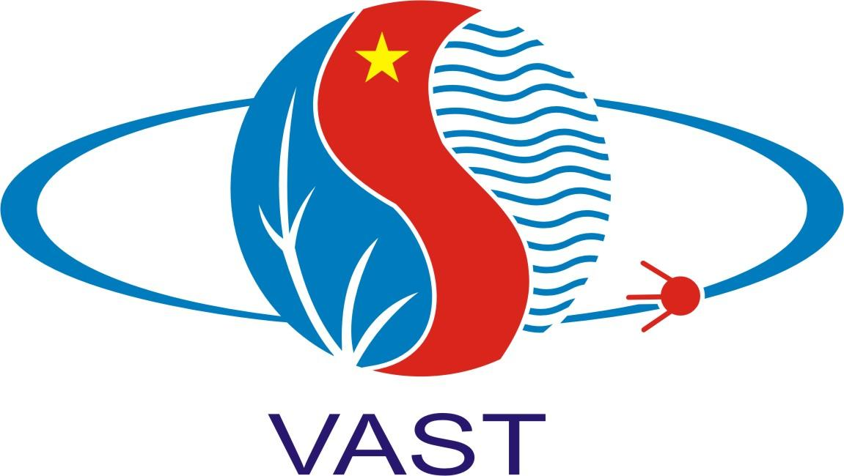

2019 CEOS Plenary
Teleconference Connection

https://www.gotomeet.me/CEOS

United States: +1 (224) 501-3217  Australia: +61 2 9087 3605  Austria: +43 7 2088 1403  Canada: +1 (647) 497-9351  Finland: +358 942 41 5780  France: +33 182 880 459  Germany: +49 692 5736 7210 | Italy: +39 0 553 98 95 67  Norway: +47 21 03 58 98  Spain: +34 955 32 0845  Sweden: +46 853 527 836  Switzerland: +41 435 0167 09  United Kingdom: +44 330 221 0086

Access Code: 294-644-221
Audio PIN: Shown after joining the meeting
Meeting ID: 294 644 221

Join from a video-conferencing room or system.
Dial in or type: 67.217.95.2 or inroomlink.goto.com
Meeting ID: 294 644 221
Or dial directly: 294644221@67.217.95.2 or 67.217.95.2##294644221

