**ROADMAP FOR IMPLEMENTATION OF A CONSTELLATION ARCHITECTURE FOR MONITORING CARBON DIOXIDE AND METHANE FROM SPACE**

1 Scope and Objectives 3

2 Context 4

3 Roadmap Objectives and Approach 7

3.1 Refine Requirements: 7

3.2 Develop a Prototype System to Support the 2023 Stocktake 8

3.3 Implement an Operational CO2/CH4 Constellation to Support Future Stocktakes 8

3.4 Implementation Approach 9

4 CEOS and CGMS Implementation Entities and Roles 10

4.1 Role of WGClimate and the GHG Task Team 11

4.2 Role of Atmospheric Composition – Virtual Constellation 12

4.3 Role of WGCV/ACSG and GSICS 13

4.4 Role of other CEOS and CGMS Entities 14

5 Roadmap actions to 2021 and 2025 14

5.1 Actions for WGClimate GHG Task Team 14

5.2 Actions for Atmospheric Composition – Virtual Constellation 15

5.3 Actions for WGCV/ACSG and GSICS 15

6 Expected Outcomes 16

7 Resource Implications 17

8 High-level Timeline 18

# Scope and Objectives

The 2017 CEOS Chair commissioned the CEOS Atmospheric Composition Virtual Constellation (AC-VC) to write a Whitepaper that defines the key characteristics of a global architecture for monitoring atmospheric CO2 and CH4 concentrations and their natural and anthropogenic fluxes from instruments on space-based platforms to:

* reduce uncertainty of national emission inventory reporting;
* identify additional emission reduction opportunities;
* provide nations with timely and quantified guidance on progress towards their emission reduction strategies and pledges (Nationally Determined Contributions, NDCs); and
* track changes in the natural carbon cycle caused by human activities (deforestation, degradation of ecosystems, fire) and climate change.

The CEOS AC-VC greenhouse gas (GHG) Whitepaper was finalised in 2018. That document explains how estimates of XCO2 and XCH4 from space-based sensors can be integrated into a global carbon monitoring system and summarizes the state of the art in the space-based measurements and the modeling tools needed to retrieve CO2 and CH4 fluxes from these data. It then describes existing and planned space-based CO2 and CH4 sensor types and performance, observing strategies, launch dates and operational timelines. It reviews the lessons learned from SCIAMACHY, GOSAT, and OCO-2 missions and summarizes the steps needed to transition from a series of scientific experiments to an operational constellation that can support an integrated global carbon observing system. To illustrate this transition, it documents the approach adopted by the European Commission Copernicus Programme to define the requirements for a future operational constellation of CO2 Sentinels. Finally, it proposes an architecture of a future greenhouse gas constellation designed to address the objectives listed above and recommends a three-step plan to implement this architecture:

1) Link the atmospheric GHG measurement and modeling communities and stakeholders in the national inventory and policy communities through UNFCCC/SBSTA[1], to refine requirements;

2) Exploit the capabilities of the CEOS member agencies, Coordination Group on Meteorological Satellites (CGMS) and the World Meteorological Organization (WMO) Integrated Global Greenhouse Gas Information System (IG3IS) to integrate surface and airborne measurements of CO2 and CH4 with those from available and planned space-based sensors to develop a prototype, global atmospheric CO2 and CH4 flux product in time to support inventory builders in their development of GHG emission inventories for the 2023 global stocktake; and

3) Use the lessons learned from this prototype product to facilitate the implementation of a complete, operational, space-based constellation architecture with the capabilities needed to quantify atmospheric CO2 and CH4 concentrations that can serve as a complementary system for estimating NDCs in time to support the 2028 global stocktake.

To meet these goals on this ambitious timeline, the Way Forward section of the report recommends a series of 16 specific actions by CEOS and its partners.

The Whitepaper was endorsed by the CEOS agencies at the 32nd Plenary in Brussels (October 2018). However, at that point the three-step plan to implement the architecture as well as the identified activities in the Way Forward were interpreted as recommendations to CEOS Agencies, for their consideration:

|  |  |
| --- | --- |
| **Decision 04** | CEOS Plenary endorsed the report *'A Constellation Architecture for Monitoring Carbon Dioxide and Methane from Space.’* It is emphasised that the three-step plan to implement the architecture contained in the paper, as well as the identified activities in the way forward, should be interpreted as recommendations to CEOS Agencies, for their consideration. |

Decision 04 from the 2018 CEOS Plenary.

To make further progress toward the actions proposed in the Whitepaper, the CEOS Plenary directed the Joint CEOS/CGMS Working Group on Climate (WGClimate) to form a dedicated task group on greenhouse gases, and to work with the CEOS Working Group on Calibration and Validation (WGCV) and the AC-VC to develop a comprehensive roadmap for GHG activities. The products of that effort are documented in this report.

In addition, CGMS approved the Whitepaper during the 47th plenary in Sochi (2019). CEOS and CGMS can therefore combine their efforts to address the tasks described in the Way Forward through the Joint CEOS/CGMS WGClimate.

# Context

The United Nations Framework Convention on Climate Change (UNFCCC) was established in 1994 to stabilize “greenhouse gas concentrations in the atmosphere at a level that would prevent dangerous anthropogenic interference in the climate system.” To limit the increase in the globally average temperatures to less than 2 °C above pre-industrial levels, the 21st session of the Conference of the Parties (COP21) of the UNFCCC implemented the Paris Agreement, an ambitious global effort to reduce GHG emission. Parties to the 2015 Paris Agreement defined nationally determined contributions (NDCs) to a global GHG emissions reduction effort. Each party agreed to report their anthropogenic GHG emissions and removals to the UNFCCC, which would evaluate their progress toward their NDCs at 5-year intervals through a “global stocktake”, the first of which is scheduled for 2023.

To track their progress toward their NDCs and the global GHG emission reduction targets, each Party agreed to provide a national inventory report of anthropogenic emissions by sources and removals by sinks of GHGs, prepared using best-practice methodologies accepted by the Intergovernmental Panel on Climate Change (IPCC). These methods are based on “bottom-up” emission inventories, compiled from a statistical analysis of emissions reported from sources in specific sectors and categories. To ensure the effectiveness of this approach, the Agreement (Article 13) defines the implementation of an enhanced “Transparency Framework” to promote the transparency, accuracy, completeness, consistency, comparability, and environmental integrity of the stocktake.

Measurements of the atmospheric concentrations CO2 and CH4 and their changes over space and time also provide valuable information about their emissions and removals. While bottom-up inventories provide specific information about known emission sources, “top-down” methods based on atmospheric measurements provide an integrated constraint on the net amount of each gas that is exchanged between the surface and the atmosphere by natural and anthropogenic processes. Accurate, spatially- and temporally-resolved atmospheric CO2 and CH4 measurements can therefore provide additional information for bottom-up inventories as well as a complementary approach for assessing NDCs.

At global scales, atmospheric concentrations of CO2, CH4 and other well-mixed greenhouse gases (GHGs) are well characterized by precise, systematic, ground-based in situ measurements from a network of ~145 surface stations that are coordinated by WMO Global Atmospheric Watch (GAW) program. However, this network still does not provide the spatial resolution and coverage needed to identify or quantify the sources emitting CO2 and CH4 into the atmosphere on the scale of individual nations, or to localize or quantify the natural sinks that remove these gases. A dramatic expansion of the GAW GHG network would be needed to identify emission “hot spots” missed by the inventories or to assess the effectiveness of national carbon emission management strategies.

Recent advances in space-based remote sensing methods are providing new opportunities to augment the spatial and temporal resolution and coverage of the ground-based network. Measurements collected by space-based sensors can be analyzed to estimate the column-averaged dry air mole fractions of CO2 and CH4 (hereinafter XCO2 and XCH4, respectively). These space-based concentration estimates are as accurate as those obtained from the ground-based and airborne sensors, but they can provide much greater resolution and coverage of the globe, including areas that are too geographically or politically inaccessible to support ground-based stations. A global GHG monitoring system that integrates accurate airborne and ground-based measurements with spatially dense space-borne estimates of XCO2 and XCH4 could therefore yield atmospheric CO2 and CH4 inventories that complement the bottom-up inventory statistical inventories used to track progress toward GHG emission reduction targets.

Space agencies responded to these challenges by supporting pioneering space-based experiments designed to retrieve spatially resolved estimates of atmospheric CO2 and CH4 concentrations from high spectral resolution observations of reflected sunlight. The first of these included the combined German-Dutch-Belgian contribution in kind SCanning Imaging Absorption spectroMeter for Atmospheric CartograpHY (SCIAMACHY) onboard the European Space Agency (ESA) Environmental Satellite (ENVISAT), Japan’s Greenhouse gases Observing SATellite (GOSAT) Thermal and Near Infrared Sensor for Carbon Observation-Fourier Transform Spectrometer (TANSO-FTS), and the National Aeronautics and Space Administration (NASA) Orbiting Carbon Observaotry-2 (OCO-2) mission. The free and open distribution of the data from these missions has fostered rapid progress in the development of a new generation of remote sensing retrieval algorithms optimized to retrieve XCO2 and XCH4 from space-based spectroscopic measurements.

Recognizing the need for a coordinated global system to monitor the carbon cycle’s response to both human activities and the changing climate, the Group on Earth Observations (GEO) commissioned the GEO Carbon Strategy (Ciais et al. 2010). This report called for an Integrated Global Carbon Observing system (IGCO) within GEO and the Global Climate Observing System (GCOS) that would incorporate advanced ground- and space-based observations to meet the increasingly pressing needs for policy-relevant scientific information. The Committee on Earth Observation Satellites (CEOS) responded to the GEO Carbon Strategy report by convening a Carbon Task Force (CTF), which compiled the CEOS Strategy for Carbon Observations from Space (Wickland et al. 2014; hereinafter, CEOS Carbon Strategy). The CEOS Carbon Strategy report documents the state of knowledge and measurement requirements for the atmospheric, oceanic, and terrestrial domains and their interfaces, and identifies several actions to be completed by its member agencies.

Given the recent progress with SCIAMACHY, GOSAT, and OCO-2, the CEOS Chair recognized that high-quality observations of atmospheric CO2 and CH4 could be an essential component of an integrated global carbon observing system (Figure 1), such as that advocated by the WMO IG3IS. In such systems, the space-based XCO2 and XCH4 estimates complement the spatial resolution and coverage of the ground-based and airborne in situ measurements. If the ground- based, airborne, and space-based datasets can be harmonized, they can be assimilated into atmospheric inverse systems to yield top-down global inventories of CO2 and CH4 fluxes with the accuracy, precision, resolution and coverage needed to serve as a complementary system for estimating NDCs, as proposed in the 2016 New Delhi Declaration. In addition, if these atmospheric data products were distributed freely and openly, in compliance with the CEOS data policy, they could support the Transparency Framework.

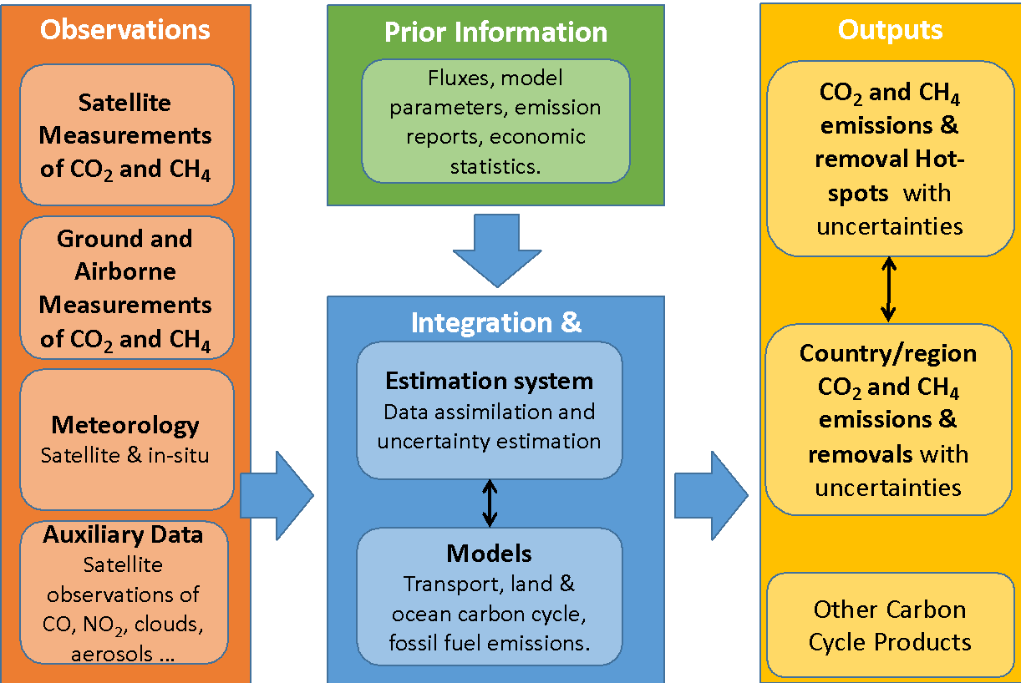

*Figure 1: System functional overview. Adapted following JRC GHG Workshop 2018 [REF]*

To advance these goals, the CEOS Chair commissioned the Atmospheric Composition Virtual Constellation (AC-VC) to define the key characteristics of a global architecture for monitoring atmospheric CO2 and CH4 concentrations and their natural and anthropogenic fluxes from instruments on space-based platforms to:

* reduce uncertainty of national emission inventory reporting, identify additional emission reduction opportunities and provide nations with timely and quantified guidance on progress towards their emission reduction strategies and pledges (NDCs); and
* track changes in the natural carbon cycle caused by human activities and climate change.

The resulting CEOS AC-VC GHG Whitepaper is a 166-page document with contributions from 88 authors representing 47 organizations. It consists of a 2-page executive summary followed by a 75-page body, summarizing the science requirements, existing and planned measurement and modeling capabilities, and proposing a constellation implementation architecture and the 3-step implementation plan described in section 1. The final chapter of this section proposes way forward, consisting of a series of specific actions. These actions and the proposed implementation approach are summarized below in the following section.

# Roadmap Objectives and Approach

To produce space-based atmospheric CO2 and CH4 inventories that meet the goals described above, the CEOS AC-VC GHG Whitepaper proposes a series of specific actions for CEOS and its member agencies. Here, specific recommendations mentioned in the Whitepaper and collected in the   
“Way Forward” chapter have been summarized and grouped under the three high-level goals that they support. The final subsection summarizes the approach adopted address these recommendations.

## Refine Requirements:

Link the atmospheric GHG measurement and modeling communities and stakeholders in the national inventory and policy communities (through UNFCCC/SBSTA), to refine requirements;

To ensure that the space agencies are working together and building the necessary partnerships with the relevant stakeholders (i.e. UNFCCC/SBSTA) to address the overall system implementation goals, they should work through CEOS and CGMS to strengthen the ties to these stakeholders (Rec#6).

CEOS and CGMS have complementary viewpoints that are essential for advancing the implementation of system that incorporates both research and operational elements. A continued engagement by both entities is required and some formalisation of the relationship would be advantageous. The joint CEOS/CGMS Working Group on Climate (WGClimate) could lead this effort (Rec#4).

A broad system approach is required to develop a top-down atmospheric inventory approach that complements the bottom-up inventories. This system integrates the satellite observations, in situ (surface, aircraft, and balloon) measurements, modelling components (retrieval, inversion, biogeochemical processes and transport), prior information and ancillary data (Rec#5).

The Whitepaper adopts the GCOS (2016) accuracy, resolution and coverage requirements as the baseline requirements for the space-based elements of CO2/CH4 management system. However, these requirements predated the Paris Agreement. Further analysis of these requirements is needed to address this new focus. The CEOS and CGMS agencies should work with GCOS and other partner organizations and stakeholders to revise those requirements (Rec#7).

To meet these goals within a decade, individual research and operational space agencies work within CEOS, CGMS and other international coordination bodies (i.e. WMO IG3IS, GCOS) to define a roadmap with specific programmatic milestones for developing virtual and then dedicated constellations that can deliver harmonized, space-based climate data records for CO2 and CH4 (Rec#3).

To ensure that the initial operational constellation and associated atmospheric CO2 and CH4 monitoring system can meet the sustained operational needs, a system engineering effort should be undertaken early in the implementation. This effort is needed to ensure that the requirement-reliability-traceability-fitness-for-purpose cycle is adequately planned and that the user uptake, user support and training and capability building elements are defined and prototyped. The CEOS and CGMS agencies and their partners at WMO have the necessary competences to start addressing these requirements and can help to assess the scope of these activities at the different levels of the implementation (Rec#16).

CEOS, CGMS and their partners should continue to support the necessary OSSE experiments to refine the detailed requirements of the space-based elements of the constellation (sensor precision, accuracy, and resolution, orbit and mission coordination). The near-term objective is to develop a prioritized list of the required OSSE experiments and end-to-end system simulations to optimize the overall system design, resolve system-level uncertainties, and facilitate the coordination of activities among the CEOS and CGMS agencies. The output from these experiments should be made available to the CEOS and CGMS Principals periodically, in a format conducive to discussions with their mission and orbit planning organizations (Rec#8).

## Develop a Prototype System to Support the 2023 Stocktake

Exploit the capabilities of the CEOS and CGMS member agencies and the WMO IG3IS to integrate surface and airborne measurements of CO2 and CH4 with those from available and planned space-based sensors to develop a prototype, global high resolution atmospheric CO2 and CH4 flux product in time to support inventory builders in their development of GHG emission inventories for the 2023 global stocktake (Rec#1). To support this stocktake, the initial global atmospheric CO2 and CH4 flux products must be available by 2021.

* Identify and foster the methods needed to cross-calibrate and cross-validate products from a diverse range of space-based sensors and observational vantage points to produce harmonized, interoperable atmospheric CO2 and CH4 concentration products. A coordinated effort among the CEOS AC-VC, the CEOS Working Group on Calibration and Validation (WGCV) and the WMO Global Space-based Inter-Calibration System (GSICS) would facilitate this effort.
* Improved coordination among the atmospheric CO2 and CH4 remote sensing and flux inversion modelling communities is needed to produce a global atmospheric flux product by 2021, so that it can be used to support the 2023 stocktake. This ambitious goal will benefit from recent efforts such as the ESA Climate Change Initiative (CCI) and the NASA Carbon Monitoring System (CMS) and ongoing efforts such by the Copernicus Atmosphere Monitoring Service (CAMS), and the European Horizon 2020 (H2020) CO2 Human Emission (CHE) and VERIFY projects to establish harmonised long-term satellite-based GHG Essential Climate Variables.
* Develop an atmospheric GHG inventory product that will foster the active engagement of the atmospheric inventory community with the national inventory agencies in the development of 2023 stocktake.
* Establish a baseline for use in future comparisons of top-down atmospheric and bottom-up inventory products.
* Foster the development of end-to-end atmospheric data analysis systems designed to yield policy-relevant atmospheric inventory products, like the one advocated by WMO IG3IS.

## Implement an Operational CO2/CH4 Constellation to Support Future Stocktakes

The initial operational system should exploit the lessons learned from the development and use of the prototype product as well as new space-based measurement and modelling capabilities to produce space-based CO2 and CH4 flux products in time to support the second global stocktake in 2028 (Rec#2).

The Whitepaper summarizes the lessons learned from the SCIAMACHY, GOSAT, and OCO-2 experiments. In the short-term, these lessons represent best practices that should be generalised by the CEOS Working Group on Calibration and Validation (WGCV) and the Global Space-based Inter-calibration System (GSICS) so that they are available as Cal-Val strategy "protocols" for space agencies that are now considering missions (Rec#9).

* Measurements collected by the GOSAT and OCO-2 instruments were cross-calibrated using common standards, including observations of the Sun, Moon, and surface vicarious calibration sites, such as Railroad Valley, Nevada, U.S.A. Additional effort by WGCV and GSICS is needed to maintain and improve the quality of these standards to better address the calibration needs of space-based CO2 and CH4 sensors (Rec#10).
* TCCON has provided the primary transfer standard to relate space-based XCO2 and XCH4 estimates to the ground-based in situ standards maintained by the WMO GAW network. Teh Whitepaper recommends that TCCON be maintained and augmented with portable, ground-based remote sensing instruments (e.g. EM27/SUN), in situ sensors on fixed-wing aircraft (commercial aircraft, such as CONTRAIL, IAGOS) and balloons (AirCore), and airborne remote sensing instruments (MAMAP, CHARM-F etc.) to provide a more robust and accurate operational validation approach. CEOS and CGMS should strongly encourage their member agencies to develop a more accurate, coordinated and sustainable operational validation approach (Rec#11).

Ancillary measurements are needed both to improve the accuracy of the XCO2 and XCH4 retrievals (i.e. coincident observations of clouds and aerosols) and to facilitate their interpretation within the context of the anthropogenic and natural carbon cycle (i.e. SIF, NO2 and CO). Here, the proposed atmospheric CO2 and CH4 monitoring system could substantially benefit from the full scope of carbon cycle observations included in the CEOS Carbon Strategy. The CEOS partner agencies should therefore continue to support that strategy (Rec#15).

CGMS and CEOS should work with their member agencies to identify and promote standards in product specification, formats, pre-processing etc. and product inter- comparisons should be routinely undertaken and supported on a sustained basis to produce seamless, interoperable datasets for use in the broader system implementation (Rec#12).

CEOS and CGMS agencies should consider a [centralized or possibly geographically distributed] repository for hosting quality-controlled CO2 and CH4 products, with internal capability for product inter-comparison (Rec#13).

The UNFCCC and the Parties to the Convention require GHG monitoring capabilities that are beyond the state-of-the-art for existing space-based measurement technologies.

* CEOS and CGMS agencies should therefore continue to pursue technology development for both sensors (e.g. wide swath passive CO2 and CH4 imagers, active lidar) and mission designs (e.g. GEO, HEO vantage points) to better meet these needs. These technology development efforts should be coordinated and reported to the CEOS and CGMS Principals along with additional capabilities needed for future mission opportunities (Rec#14).
* CEOS and CGMS should encourage its member agencies to support remote sensing retrieval algorithm developments and inter-comparison efforts, and should encourage the free exchange of gas and aerosol optical properties and other types of input and validation data.
* To inform anthropogenic emission inventories with space-based measurements, CEOS should continue to encourage its member agencies to support the development of advanced atmospheric inversion systems. These efforts should span all scales of interest, from global models, to mesoscale models, to urban scale and point source models, and should encourage the use of data from the broadest range of space-based and ground-based sources. They should also encourage the development and testing of innovative ways to validate atmospheric inversion products.

## Implementation Approach

The implementation approach proposed here is driven by the delivery schedule and performance requirements needed to achieve the three major objectives listed in the introduction of this document (i.e. refined atmospheric inventory requirements, prototype atmosphere inventory, and operational constellation performance specifications). To meet each objective, the following are needed:

* An overall architecture that meets the specified goals of each product to be delivered;
* A list of the potential contributors to the implementation of the architecture;
* A list of open points/challenges that need to be solved, the proposed approach to resolving each issue (including as appropriate actions identified ... e.g. prototyping etc.), potential impact of issue on the system outputs, if unresolved, etc.;
* Decision logic for clarifying the product architecture where open issues exist;
* Apportionment of requirements to components of the system (as needed to system elements) in order to meet the end-to-end requirements (including system output requirements); and
* A schedule leading to the delivery of each product with activity dependencies between versions clearly identified in a top-level schedule.

To meet the tight delivery schedule dictated by the Global stocktakes, the implementation approach follows an initial phase of planning for a semi-parallel approach that addresses the three objectives. A versioning approach underlies each objective, allowing a clear assignment of updates based on two different streams:

* *System version development,* which includes the version design, development, testing, and delivery; and
* *User consultation and preparation,* encompassing the refinement of user requirements uptake and the user preparation by outreach and training.

These two streams will be supplemented by:

* *System engineering support,* including the apportionment of requirements, planning (tasks, V&V, development etc.);
* *Operational governance,* accommodating the management approach, data policy, and provisional user support; and
* *System performance measures and optimization.*

The starting point will be the prototype system with the goal to achieve more detailed functional building blocks for the operational implementation, which may be updated gradually in a version process that incorporates user feedback, lessons learned, and a requirements refinement loop. Those loops will be initiated in parallel to the development of the prototype system.

# CEOS and CGMS Implementation Entities and Roles

The 32nd CEOS Plenary requested that WGClimate coordinate the joint effort between CEOS and CGMS to monitor GHGs. WGClimate was directed to form a GHG Monitoring Task Team to coordinate the CEOS Carbon Strategy and develop a GHG monitoring roadmap based on activities proposed in the AC-VC GHG Whitepaper. This included establishing appropriate links and cross-representation with AC-VC, the WGCV Atmospheric Composition subgroup (ACSG) and other CEOS and CGMS entities and identifying the resourced needed to execute the actions identified in this roadmap. The 32nd Plenary also endorsed the revision of the Terms of Reference of the WGClimate to accommodate these changes (Figure 2).

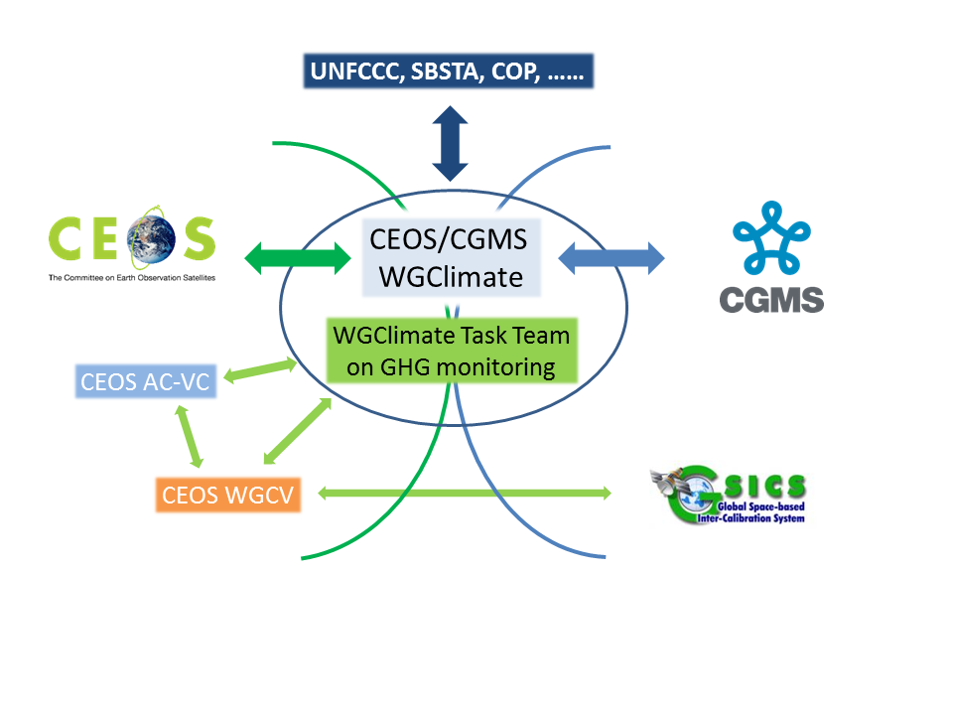

*Figure 2: CEOS and CGMS entities currently included in the task team. At a later stage, additional entities may contribute.*

## Role of WGClimate and the GHG Task Team

As mentioned above, WGClimate was identified by CEOS and CGMS as the coordination link for the GHG monitoring activities. Based on its experience as joint working group, direct links were established for reporting and approval and also for integrating and balancing the work plans of both CEOS and CGMS. A key component is the interaction with UNFCCC, SBSTA, and the COP of behalf of CEOS and CGMS, providing insight to the space agencies’ activities to the primary user communities.

Exploiting the existence of joint working group and its links to UNFCCC, SBSTA, and GCOS, a dedicated task team was formulated within WGClimate at its 11th meeting, with a leader and a deputy with nominal 2-year terms. The WGClimate Chair selects the leader, while the deputy will always be the Vice Chair of the WGClimate to assure the coordination with the WG Chair. . The Vice Chair would never become the Task Team leader. Representation of CEOS and CGMS bodies is achieved by identifying Points of Contact (PoCs) for tasks to be executed by the contributing CEOS and CGMS bodies (AC-VC, WGCV/ACSG, GSICS/UVWG, etc.). The meetings of the Task Team will optimally be side-by-side with a WGClimate meeting, allowing CEOS and CGMS agencies to participate in both, and offering a transparent insight into the progress of the initiative and its activities.

The approach was adopted by WGClimate and endorsed by CEOS and CGMS. The current composition of the Task Team is given in annex. The lead update of the task team will be in 2021.

The principal responsibility of the task team is the coordination of all CEOS and CGMS efforts with respect to the implementation of the recommendations of the GHG white paper outlined in three major milestones:

* support for the first UNFCCC stocktake in 2023 with a prototype system available in 2021/22;
* support for the second UNFCCC stocktake in 2028 with an advanced GHG system available in 2026/27; and
* design a fully operational system available after 2030.

To support this effort, WGClimate shall:

* Develop and maintain the roadmap within the GHG Task Team defining the overall distributed work plan;
* Coordinate CEOS and CGMS bodies in executing the distributed work plan;
* Provide links to UNFCCC, GCOS, WCRP, (GEO), IG3IS and perform communication of results;
* Maintain an active interface with the national carbon inventory community; and
* Oversee the implementation of the CEOS carbon strategy.

The Task Team was organized to execute the coordination activities while ensuring balanced representation of the involved entities. To avoid duplication of structures and activities of the contributing bodies, the roadmap development effort was initiated using the existing individual work plans of the different contributing bodies. The work plan was then divided into clearly defined work packages with milestones identifying the responsible lead.

This coordination activity is expected to require some additional effort by WGClimate, WGCV, AC-VC and other CEOS and CGMS entities. The resources needed for this effort are outlined in Section 7 of this roadmap and will be further defined in the work plan.

## Role of Atmospheric Composition – Virtual Constellation

The CEOS AC-VC role is to support the implementation of the CO2/CH4 focus within WGClimate. In this role, AC-VC will continue to support GHG constellation development and synergistic GHG and atmospheric composition observations and modelling efforts:

1. Space borne GHG sensor development

* Contribute to the implementation of a prototype system that incorporates products from a virtual constellation of sensors by 2021 (Rec#1);
* Contribute to the definition of the requirement records for an operational system or dedicated constellations of space-based sensors (Rec#2);
* Define best practices and facilitate exchange and harmonization of approaches for instrument cross-calibration in coordination with CEOS WGCV and GSICS (Rec#10);
* Facilitate exchange of expertise and support in defining mission requirements (Rec#7);
* Coordinate discussion on auxiliary observations enhancing data quality (e.g., aerosol properties for light path correction) (Rec#15);
* Track implementation and operations of space-based GHG sensors and identify and propose solutions for observational gaps (Rec#14).

1. GHG product (L1&2) development

* Document the performance of existing and near term L1 and L2 products and their ability to meet WGClimate needs for ECV and FCDRs;
* Establish product accuracy, precision, resolution, and coverage requirements needed to meet the flux requirements on various scales;
* Coordinate between national and international development efforts to identify best practices and develop a prototype product;
* Pursue consistency in product content, format, units, variable names, etc. to facilitate interoperability;
* Pursue traceability of data quality;
* Coordinate algorithm inter-comparisons to improve accuracy and speed of retrieval algorithms;
* Facilitate exchange and harmonization of approaches to calibration and retrieval challenges;
* Follow and provide recommendations on development of laboratory spectroscopy needs; and
* Define types of data (calibration, L1, L2) that must be exchanged to enable the integration of space-based systems into a constellation.

1. GHG Flux inversion model Development

* Identify accuracy and precision requirements sufficient for policy applications;
* Coordinate research on flux estimation (local to national scale; Level-4 products) (Rec#3);
* Coordinate between CAMS/C3S and NASA OCO-2/CMS/GMAO efforts (Rec#12);
* Coordinate OSSE studies dedicated to flux estimation (Rec#8);
* Identify synergies between observation strategies for GHGs and air quality gases and aerosols;
* Consolidate mission requirements for auxiliary observations (e.g. plume tracers like NO2) (Rec#14);
* Pursue consistency in the product content (Rec#12);
* Insure traceability of data quality (Rec#12, 13); and
* Define types of data that must be exchanged to derive and validate fluxes from a constellation of space-based sensors to facilitate open data access (Rec#11).

## Role of WGCV/ACSG and GSICS

The high levels of accuracy needed for GHG measurements place significant demands on the calibration of individual sensors, the inter-calibration of sensors across the constellation and the cross-validation of the products retrieved from their measurements. These capabilities shall be addressed through two existing (but re-enforced) groups covering both research and operational elements of space-based sensor calibration and validation. These are the CEOS Working Group on Calibration and Validation (WGCV) through the Atmospheric Composition Subgroup (ACSG) and the Global Space-based Intercalibration System (GSICS), under its newly re-established Reflective Solar Spectrometers Subgroup (UVSG). GSICS is an international collaborative effort initiated in 2005 by the WMO and CGMS to improve and to harmonize the quality of observations from operational weather and environmental satellites of the Global Observing System (GOS). GSICS aims to ensure consistent accuracy among space-based observations worldwide for climate monitoring, weather forecasting, and environmental applications. This is achieved through a comprehensive calibration strategy, which involves:

* Monitoring instrument performance;
* Operational inter-calibration of satellite instruments;
* Tying the measurements to absolute references and standards; and
* Recalibration of archived data.

GSICS contributes to the integration of satellite data within the WMO Integrated Global Observing Systems (WIGOS) and within the Global Earth Observation System of Systems (GEOSS) of the Group on Earth Observations (GEO) through the subgroup addressing spectrometers operating in the UV –SWIR range, with the following focus areas:

* Pre-launch calibration and characterisation for all sensors, but particularly for GHG missions;
* Solar calibration including interactions with the solar community which have already been initiated;
* Lunar calibration where the focus will be on UV and spectrally resolved data, contributing to other lunar calibration activities;
* Polarization (also for lunar calibration where possible); and
* Inter-calibration and development of common methods for use of pseudo-invariant targets & vicarious calibration sites (with a homogeneous surface over a sufficiently large area) will be further developed with an intensified focus is on atmospheric absorption.

## Role of other CEOS and CGMS Entities

Other CEOS and CGMS organizations could make significant contributions to the GHG roadmap. For example, involvement of CGMS Working Group-1 could help to ensure that the implementation of the GHG roadmap addresses the objectives of the WMO Integrated Global Observing System (WIGOS) vision. Interactions with CGMS WG-II could facilitate the definition and application of standards for operational GHG constellation products and operational aspects of the satellite data production systems at international level. CGMS WG-IV could address operational access and end user support for GHG constellation products in cooperation with WGISS. Finally, close collaboration with CEOS WGCapD and CGMS and WMO Virtual Lab would facilitate the engagement in necessary capacity building activities related to the usage of GHG inventory products.

# Roadmap actions to 2021 and 2025

## Actions for WGClimate GHG Task Team

Actions for the Task Team are mostly derived from its coordination and liaison responsibility. Some of those actions are continuous or recurrent items to facilitate the coordination:

* Establish a mechanism to track the implementation of the actions defined in this document;
* Develop a detailed work plan to execute the roadmap objectives and actions including a coordination frame (first version end of 2019 including work packages, schedule, and timelines);
* Establish progress review meetings on a regular basis, ideally side-by-side with WGClimate meetings;
* Continuously track the schedule and progress between progress review meetings;
* Report progress to CEOS and CGMS principals based on the progress reviews and the input of the contributing bodies; a two years progress report is recommended;
* Identify development risks and recommend mitigation or adaptation actions;
* Exploit the WGClimate interface with UNFCCC, SBSTA and COP to foster interactions with stakeholders;
* Include other CEOS or CGMS bodies, where appropriate to meet the objectives of the work plan, if needed; and
* Ensure consistency and sustainability between the prototype and operational development approaches.

In close cooperation with the WGClimate lead, as the CEOS PoC to UNFCCC, SBSTA, and COP, the Task Team will support outreach activities during COP and Earth Information Days (EID), increasing awareness and establishing contacts with the national GHG inventory communities. To actively engage its user communities and bridge the gap between satellite products and national statistical GHG inventories, the Task Team will interact with the national inventory community and the modelling communities by:

* Seeking an annually exchange with the inventory and modelling communities;
* Supporting feedback utilization from user community on product development. A first meeting is envisaged in Q4 / 2019 aside the annual GEIA meeting;
* Planning a workshop with modelling community ideally in combination with WMO IG3IS/TRANSCOM (Q2 / 2021), detailed planning for further regular workshops/meetings;

In addition, the Task Team will also initialize the establishment of system engineering support and the inclusion of training and outreach aspects in its work plan.

## Actions for Atmospheric Composition – Virtual Constellation

Deliverables needed by 2021 to demonstrate that satellites can support the 2023 stocktake (WP-Rec#1)

* Catalog the virtual constellation consisting of the GHG satellite sensors that will be operating prior to 2021;
* Work with partner agencies to coordinate the development of a prototype atmospheric CO2 and CH4 inventory product (spanning 2009-2021) from this virtual constellation, with traceable consistency and data quality; and
* Document the quality of the atmospheric CO2 and CH4 flux estimates derived from the prototype product on spatial and temporal scales spanning large urban areas to continental scales and at monthly to annual intervals.

Deliverables needed by ~2021 to prepare a future purpose-built, operational constellation to support future stocktakes (WP-Rec#2)

* Compile observational requirements for a future GHG constellation;
* Work with CEOS and CGMS agencies to coordinate research and development plans and activities for GHG retrieval and flux estimation schemes (Rec#4); and
* Develop a plan to cross-calibrate and cross-validate GHG products aiming at traceable consistency and data quality across the existing and planned GHG constellation in cooperation with CEOS WGCV and GSICS.

## Actions for WGCV/ACSG and GSICS

Ongoing efforts by theGSICS Reflective Solar Spectrometers Subgroup (UVSG)will be complemented by an enhanced effort in WGCV/ACSG to address the following short-term activities:

1. Address existing CEOS Action by Q1 2020 on “Greenhouse gas reference standards for interoperability”: Develop a list of reference standards for CO2 and CH4 products that are suitable for use in inter-comparison of multiple missions.
2. Identify the current shortcomings/gaps/sustainability in GHG calibration and validation capabilities, and formulate recommendations on the medium- to long-term way forward, that is with a specific focus on GHG Fiducial Reference Measurement (FRM).

On the medium to long-term,

1. Address improvements/gaps in the inter-calibration of sensors (cooperation with GSICS) and the level-2 validation infrastructures (ground-based algorithm inter-comparisons and geographical/geophysical gaps for FRM).
2. Identify long-term validation needs (at horizon 2025-on) and potential process study needs.
3. Work towards an operational reporting on the quality of space-borne GHG measurements and the underlying calibration and validation infrastructure.

# Expected Outcomes

The expected outcomes are related to the functional delivery of the systems, the prototype, an first version of an operational, and an advanced operational systems. Having in mind that CEOS and CGMS is based on best effort and rely on the resources of its members; we recall that the physical implementation of a system is an effort by one member or multiple members. Because of the importance of the added value of satellite data products and the layout of such an integrated system for the derivation of GHG emissions for the Global stock-take, it is fundamental that the user or stakeholder which shall be later rely on such a system, won’t be worried by eventually different outputs from different system implementations because of system-immanent biases, under- or over-estimations. For thus, it is an absolute need that *best practices* are provided as output for those parts of the system which can be served by CEOS or CGMS agencies (or its partners). In addition, in the context of CEOS and CGMS several parts of the system can be studied as a research but also as a operational endeavor.

From that, the expected outcome shall be for the prototype system in 2021/2023

* A maintained and updated catalogue of GHG satellite systems which may contribute to a virtual constellation in 2021/2023 timeframe including a future system estimate (CEOS AC-VC);
* A most complete listing of consistent and harmonized data sets from satellite observations existing at date (2021/2023) which can serve as input with given uncertainties and documentation about their impact on the flux estimates with traceable consistency and data quality (CEOS AC-VC);
* An observation requirements repository based on the 2021/2023 GHG virtual constellation maintained for future constellations (CEOS-AC-VC);
* Quality-monitoring means and continuously validation by well-characterized means, especially in operational modes (see cross-calibration and validation plan for inclusion);
* Inventory of reference standards suitable for inter-comparison of GHG data products from multiple missions (CEOS WGCV, GSICS);
* Report about GHG calibration and validation capabilities including shortcoming, gaps, sustainability and opportunities with mid- and long-term recommendations. This report shall also include the improvement/gaps of the inter-calibration of GHG sensors, the Level 2 validation infrastructure, and the identification of long-term needs. A first draft of an operational reporting about data quality shall be included (CEOS WGCV, GSICS);
* Draft of a cross-calibration and validation plan of GHG products for a virtual constellation (CEOS AC-VC, CEOS WGCV, GSICS);
* Progress report on the GHG task team developments (2021, task team leads)
* Risk register including mitigation means (Task team)

The expected outcomes shall be augmented by a report about the usage of satellite observation based flux estimates for the derivation of GHG emission estimates in cooperation with various inventory stakeholders (Task team in cooperation with CEOS AC-VC).

The output for the operational system (2025) may maintain and sustain the above documents and reports in terms of amendments and consolidation. In addition, the operational system approach does need an appropriate system engineering approach which describes not only the functional part of the system but also the product tree, the data flow, and interfaces based on consolidated requirements. A more detailed description about those parts will be presented together with the detailed work plan. Most emphasis will be taken to the sustained definition of interfaces between the different functional sub-systems and formats used therein allowing the comparability of different implementation instances.

# Resource Implications

A preliminary estimate of the resource needs was compiled based on the scope of activities based on the scope of the effort described above and earlier experience with these types of coordination and product delivery efforts. We anticipate that these resource estimates will evolve somewhat as the detailed task plan is developed and as we gain experience from the first rounds of product prototyping. This should provide CEOS and CGMS Agencies with an overview of both the types and amounts of contributions that are anticipated so that their individual agencies can assess where they feel best suited to make contributions.

We anticipate that contributions will be needed both from the agencies that are planning to launch satellites contributing the envisaged GHG monitoring constellation, as well as those that plan to contribute to other aspects of the overall system architecture. This includes agencies with competences/interests in the necessary cal/val infrastructure, ancillary in-situ observations, modelling capability, interface to the user/inventory communities and application development, as well as agencies with the system engineering experience to ensure the longer-tern transition to a fully integrated end-to-end global data-assimilation framework. Within CEOS and CGMS, there are many additional agencies with these complimentary competences and it is hoped that they will contribute to this endeavor.

Three broad categories of resources are envisaged and requested for consideration by Agencies:

1. Human resources from CEOS members and external experts supported through Agency programmes & grants. These resources are described in greater detail below.
2. Support for travel and hosting of workshops and networking activities. This will be critical in the first phase of this effort to develop the necessary interfaces with the national inventory community, the atmospheric GHG measurement and modelling communities, and stakeholders (e.g. UNFCCC/SBSTA).
3. On longer time scales, additional, more substantial requests for resources will be addressed by individual agencies through internal funding mechanisms supporting research, development and infrastructure for priorities identified by GHG Task Team and Roadmap implementation. The GHG Task Team will provide periodic and prioritized assessments to Agencies highlighting areas where research and infrastructure investments are required to ensure adequate implementation and evolution of the system.

Dedicated human resources are required from both Agency staff and experts that Agencies support on research funding and grants.

* Agencies are asked to continue, and in some cases increase support to the GHG relevant staff (time & travel) contributing to the technical implementation tasks in AC-VC and WGCV.
* For the WGClimate GHG Task Team, the following specific “profiles” are required:
  + Core team ensuring linkages to internal CEOS/CGMS entities (i.e. WGClimate, AC-VC , WGCV )
  + Agency staff representing GHG missions/programmes
  + Agency staff from “operational” agencies to ensure operational transition
  + Agency Staff/Experts with links to Inventory Community
  + Agency Staff/Experts involved in modelling aspects

We envisage that the GHG Task Team would include ~12 members, with each member typically dedicating one person-month of effort each year. Those leading specific activities will need to dedicate closer to 2 person months per year. Support should include necessary travel budgets for attending meetings/workshops.

# High-level Timeline

The high-level timeline is driven by the overarching goal to provide a GHG constellation architecture for the Global stocktake in 2023, 2028 and so on. This leads to a “governed-by due-date” schedule which can be displayed as such.

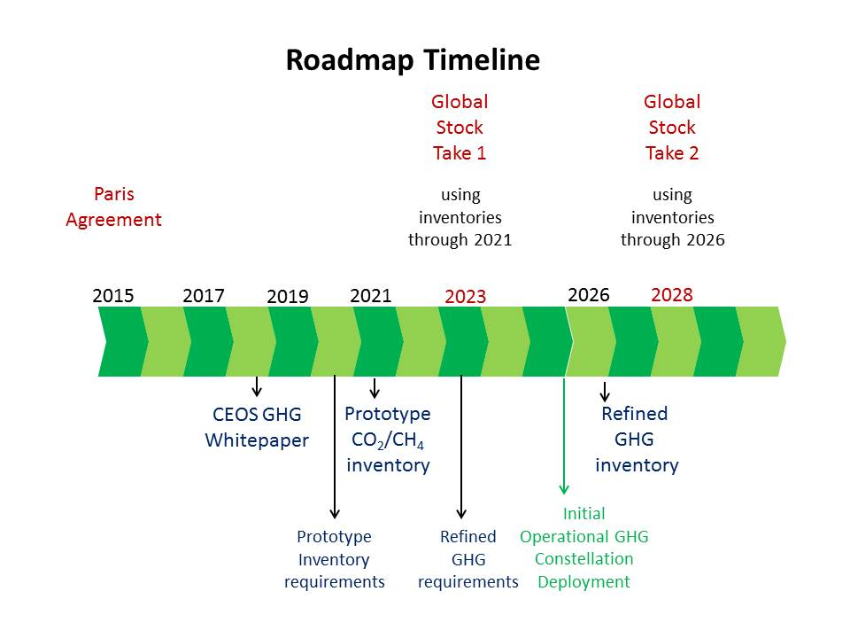

Figure 3: Roadmap timeline underlining the target dates as boundary conditions

However, the timeline can be detailed into four streams reflecting also the above mentioned due dates and the allocated actions:

1. *User Interaction / Requirements refinement*  
   includes the interaction with the envisaged user community and the overall user requirements refinement or update
2. *Step 1: Prototype System*  
   includes the single steps to proceed to the prototype system with a pre-development phase needed also for the later implementation of the operational system(s)
3. *Step 2: Initial Operational System*  
   includes roughly the typical system engineering steps for the implementation of the operational system
4. *Management packages*  
   includes all review and progress reporting items and the risk register as well.



Please note that the current timeline is a guideline for the work plan implementation and will be substituted when a more detailed work plan will be in place.

**Annex**

WGClimate Task Team membership

* Mark Dowell (EU, WGClimate, Task Team lead)
* Albrecht von Bargen (DLR, WGClimate Vice-chair, deputy Task Team lead ex officio)
* Bojan Bojkov (EUMETSAT, CEOS WGCV)
* David Crisp (NASA, CEOS AC-VC)
* Akihiko Kuze (JAXA, CEOS WGCV)
* Rüdiger Lang (EUMETSAT)
* Ben Veihelmann (ESA, CEOS AC-VC)
* N.N. (agency representative*)
* N.N. (agency representative*)
* N.N. (GSICS)

*Representatives shall be chosen from agencies not being represented in the current membership

1. UNFCCC/SBSTA: United Nations Framework Convention on Climate Change / Subsidiary Body for Scientific and Technology Advice