MINUTES OF THE 2015 CEOS SIT TECHNICAL WORKSHOP
17th-18th September 2015
EUMETSAT
Darmstadt, Germany

Main SIT Workshop Discussion Points, Outcomes and Actions
- The activities of the Working Groups and Virtual Constellations were reviewed in detail during a dedicated VC and WG day prior to the Workshop. Progress was reported during the Workshop.
- CEOS capacity building activities should work to become more ‘demand driven’.
- The potential exists for CEOS oceans-related VCs to engage further on integrated ocean products, with the Blue Planet community, and to consider joint activities with CGMS. One of the topics of interest may be applications of next generation geostationary instruments.
- The question of whether a Sea Ice-related Virtual Constellation, possibly linked with the Polar Space Task Group, should be considered was raised and a follow-up action was agreed.
- The draft revised Terms of Reference and Implementation Plan for the LSI-VC were reviewed, and it was agreed they should be presented to Plenary for endorsement.
- Revitalisation of a CEOS dataset purge alert procedure proposed by WGISS is to be discussed at SEC 205, and information provided to Plenary.
- The CEOS response to the GEO Carbon Strategy was reviewed, and the status of selected actions was reviewed. It was agreed that achievable steps with a 1-year time horizon should be identified for consideration at SIT-31.
- The triggering procedure for the Recovery Observatory, the creation of a new multi-hazard Pilot on Landslides, and three new Supersites were reviewed and it was agreed they should be presented to Plenary for endorsement.
- CEOS is seeking a new Lead for GFOI effective February 2016.
- The CEOS Response to the GEOSS Water Strategy Recommendations was discussed, and it was agreed to adjust the language in light of the need to assess resource availability for implementation. It was also agreed that that the CEOS response needs to be timely in order to be relevant.
- The scope of CEOS support to GEOGLAM, and the Strategy document were reviewed, and a possible eventual transition of the activity to LSI-VC was discussed.
- The GEO Strategic Plan 2016 – 2026, implementation, and implications for CEOS were reviewed, and it was agreed to consider proposing the formation of a task force to Plenary to formulate CEOS strategy in response.
- CEOS communication strategy at COP21 was reviewed, and a small working team was formed to propose follow-up actions.
- Potential CEOS engagement and support to the UN Sustainable Development Goals was reviewed.
- The 2016 CEOS Chair themes were presented, including next generation data architectures (e.g. Data Cubes), and new geostationary applications.
- The CEOS Social Media strategy was reviewed and it was agreed it should be presented to Plenary for endorsement.

Welcome and Opening Remarks
Alain Ratier (EUMETSAT) and Pascale Ultré-Guérard (SIT Chair) welcomed all participants attending the 2015 SIT Technical Workshop in person and via web-conferencing. Alain gave a brief update on activities at EUMETSAT, noting that the 4th Meteosat Second Generation satellite was launched in July 2015 and is undergoing commissioning. He also noted that EUMETSAT recently secured funding approval for their contribution to the joint Jason-CS mission which will secure continuity for global sea level observations.
Pascale reviewed the objectives of the SIT Workshop, noting that this meeting focuses on detailed discussion of the progress of the virtual constellations and working groups, and preparing key CEOS Plenary discussion points:
- Advancement of the CEOS Virtual Constellations (VCs) and Working Groups (WGs).
- Review progress and status across key thematic areas of the Expected Outcomes, in particular items due for decision or action at Plenary, and with respect to the CEOS Work Plan.
- Support to other key Stakeholder initiatives and outreach to key Stakeholders.
- Discussion of any CEOS organizational issues that require coordination prior to CEOS Plenary.
- Identification of main discussion points and anticipated outcomes of the 29th CEOS Plenary (e.g. preview of prospective Kyoto Statement).
The participants of the meeting introduced themselves in a Tour de Table.

Review of Open Action Items
George Dyke (SIT Chair Team) reviewed the open actions from the 28th CEOS Plenary and SIT-30. An updated SIT-30 and 28th CEOS Plenary action status table is included as an appendix to these minutes.

29th CEOS Plenary Priorities
Nobuyoshi Fujimoto (JAXA) presented a summary of the priorities and expected outcomes from CEOS Plenary.
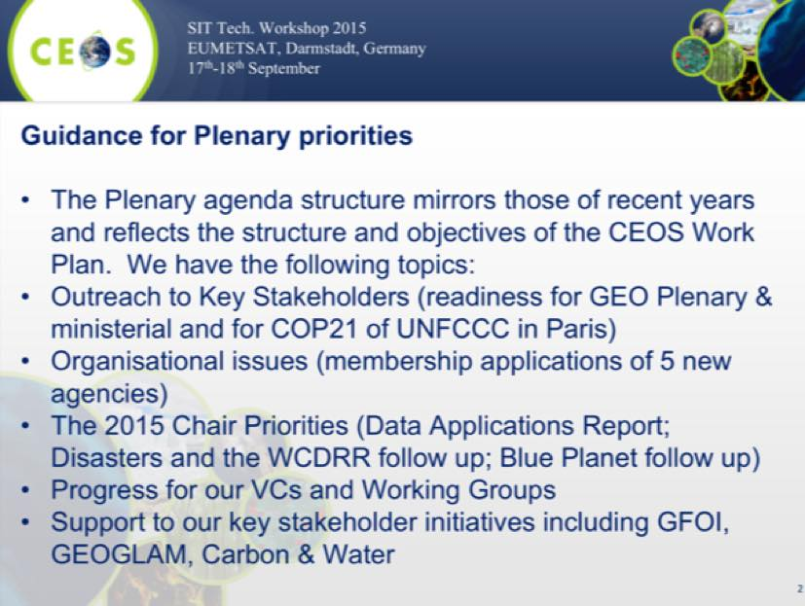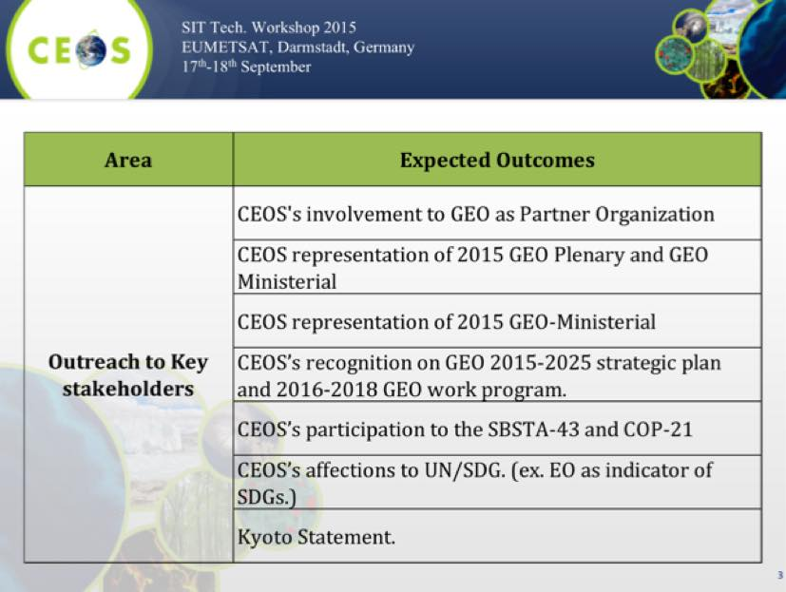
He noted that there are applications for CEOS Associate status from the Malaysian National Space Agency (ANGKASA), the Gabonese National Space Agency (AGEOS), the EU Satellite Centre, the Australian Bureau of Meteorology, and the Mexican Space Agency (AEM).
He also noted that Plenary will also address the 2015 CEOS Chair priorities including: the data applications report, results from the 3rd World Conference on Disaster Risk Reduction (WCDRR), and results of the GEO Blue Planet Symposium. In addition, support to CEOS priority activities, GFOI, GEOGLAM, Carbon, and Water will be key topics.

Synthesis Session: Report from the Virtual Constellation and Working Groups Day
Introduction
Jean-Louis Fellous (SIT Chair Team) reviewed the objectives from the Synthesis Session, including:
- review the VC/WG Day outcomes and main discussion points;
- assess the progress in reinstating the LSI-VC; and,
- review WG’s issues and topics for Plenary Preparation.
Four topics from the VC/WG Day discussion were selected to be presented in detail (three in this session, plus carbon action coordination in a later session). In addition, the presentation on possible coordination between CGMS and the CEOS Virtual Constellations dealing with Ocean parameters was discussed.
CGMS-CEOS coordination: Mikael Rattenborg on behalf of the CGMS Secretariat presented ways to encourage interaction between CGMS and the ocean-related CEOS VCs. Highlighting the increasing role of space-based ocean observations in the meteorological domain, CEOS VCs and CGMS have mutual interest in multiple areas including coordination of observing systems and protection of assets; data dissemination, direct read out services and contribution to the WMO Information System (WIS) Products development; enhancing the quality of satellite-derived data and Products; and outreach and training activities. Further discussions between CGMS and CEOS in this area is to be encouraged potentially going as far as “joint oversight” of Ocean-related VCs.
Training Activities Eric Wood (USGS) introduced the topic, and Steven Neeck (NASA) gave an overview of potential P-VC training activities, and noted the importance of increasing the profile of training as a recognised CEOS contribution to the community.
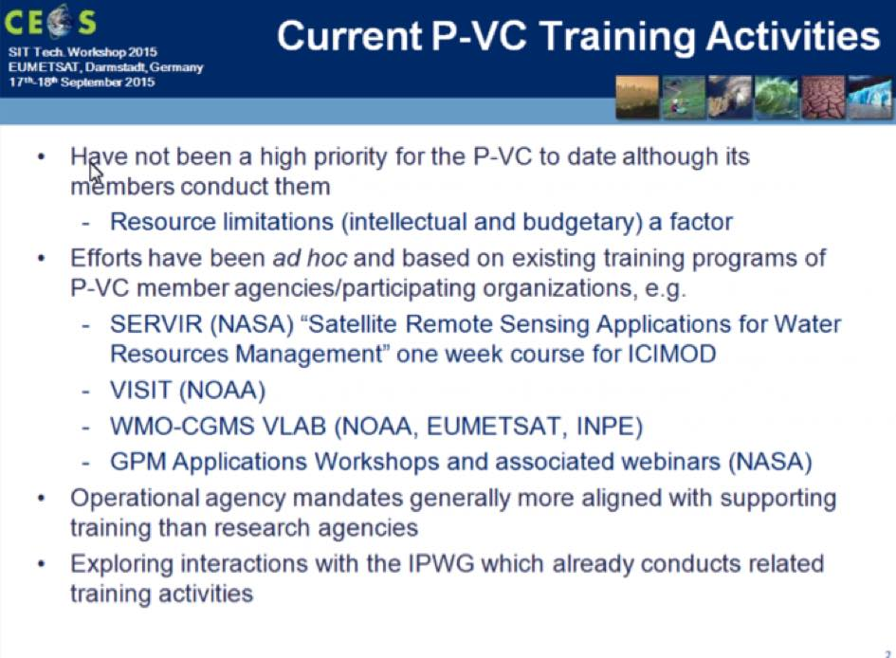
Eric reviewed the history of WGCapD, noting that they are working to reach more people, better meet the needs of CEOS, and to promote Data Democracy. He summarised some of WGCapD’s 2014/2015 activities in response to the discussion at last year’s VC/WG day. Some of the lessons learned from these activities were also reviewed.
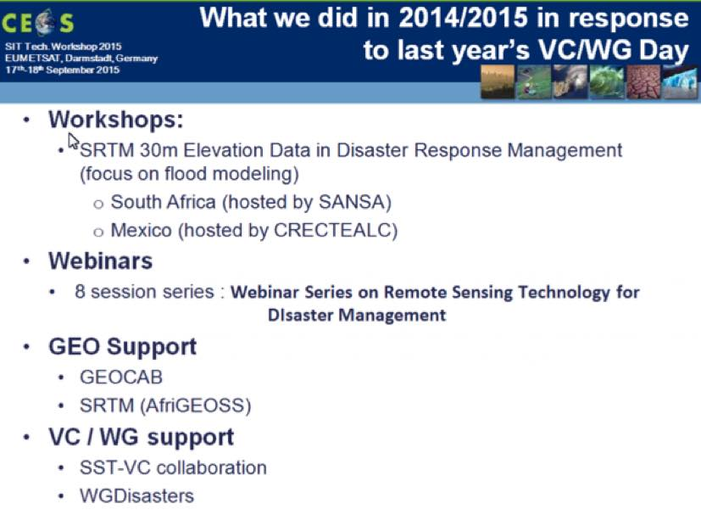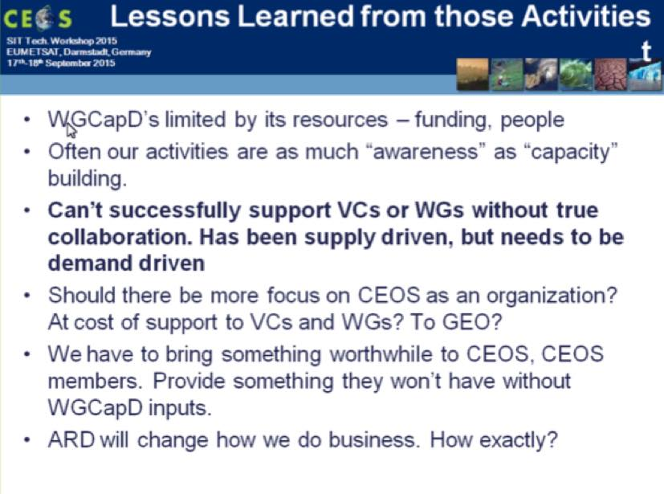
Eric noted that WGCapD is looking at a restructuring, and summarised the preliminary goals of this, including:
- to better focus on building awareness of new CEOS missions and datasets, and how to use the latter within the context of existing datasets or in support of CEOS/GEO projects;
- to increase the ability of the WGs/VCs to provide their own capacity building (vs WGCapD doing it for them);
- to improve communications and coordination between member agency and WG/VC/WGCapD capacity building and education activities as well as related international activities/practitioners; and,
- to continue to increase access to data, products, and tools, and the ability to use them (data democracy).
Eric reviewed some examples of their planned work for 2015/2016, including:
- highlighting CEOS contributions (e.g. SRTM, GEO Plenary, ESA/DLR webinar series);
- support to CEOS VCs and WGs;
- collaboration with CEOS agency CB activities; and,
- Data Democracy (e.g. AfriGEOSS, AmeriGEOSS, final SRTM workshops, and directed webinar series).
He also summarised the way forward for WGCapD.
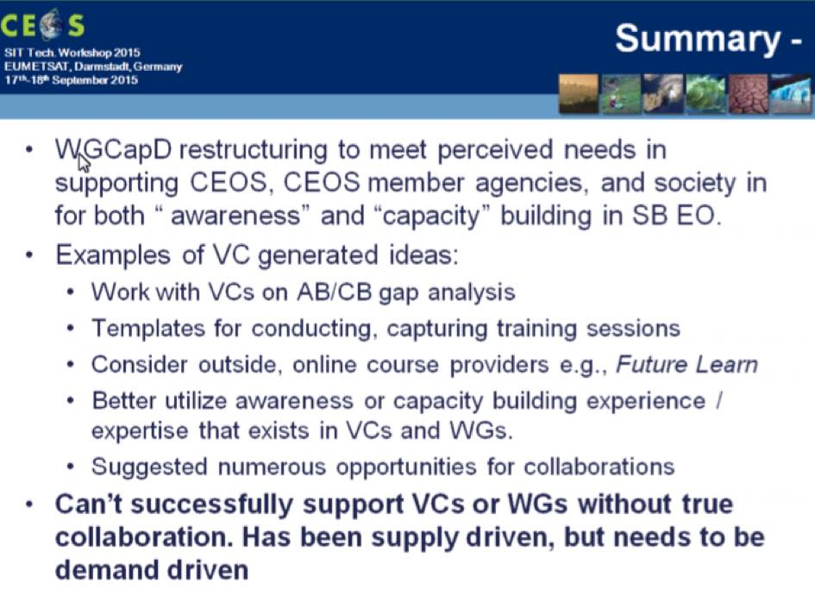
A brief discussion followed:
- Steven Hosford (CNES) asked about the role of the SEO in outreach, in particular with reference to the CEOS website. Eric noted that the SEO team is engaged with WGCapD, and has been involved in a number of their activities. Brian Killough (SEO) noted that the SEO will likely host a WGCapD meeting in 2016.
- Astrid Koch (EC) noted that Copernicus is starting to use Social Media for outreach, and that this channel can attract interest from outside the community. Brian noted that Kim Holloway has developed a draft Social Media strategy for CEOS which was scheduled for discussion.
- Pascale Ultré-Guérard (SIT Chair) asked about the plan for webinars, and Eric noted that a number of concepts were being considered with a focus on generating short-format (7-10 minutes) video content. Hilcéa Ferreira from INPE has been involved in the scoping of these concepts.
Interaction between the Disasters WG and VCs – focus on hydrometerologicial disasters. Ivan Petiteville (ESA) reviewed the context, noting that a large percentage of disasters are related to hydrometerologicial hazards. He reviewed the status of CEOS single and multi-hazard pilot projects.
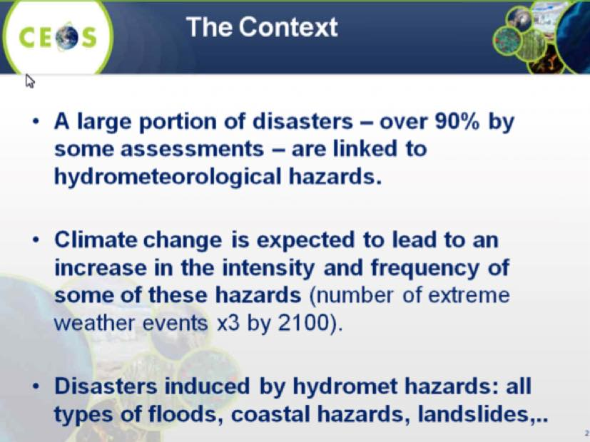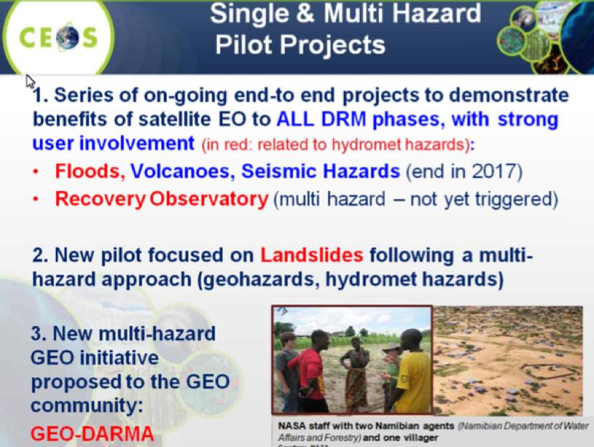
Ivan reviewed the objectives of these pilots noting that the overall goal is to demonstrate effective application of EO to the full cycle of flood management at all scales by:
- Objective A: Integrating information from existing NRT global flood monitoring / modeling systems into a Global Flood Dashboard;
- Objective B: Delivering EO-based flood mitigation, warning, and response products and services through regional end-to-end pilots in: Caribbean/Central America (focus on Haiti); Southern Africa (including Namibia, South Africa, Zambia, Zimbabwe, Mozambique, and Malawi); and Southeast Asia (focus on lower Mekong Basin and Java); and,
- Objective C: Encouraging at least base-level in-country capacity to access EO and integrate it into their operational systems and flood management practices.
Ivan noted that the issues of data acquisition (e.g. commercial conflict) and access (e.g. licencing issues) were significant barriers. He noted that there is cooperation on these issues with WGCapD and WGISS, but not currently with any of the VCs, though potential engagement was discussed with VC leads at the VC/WG Day.
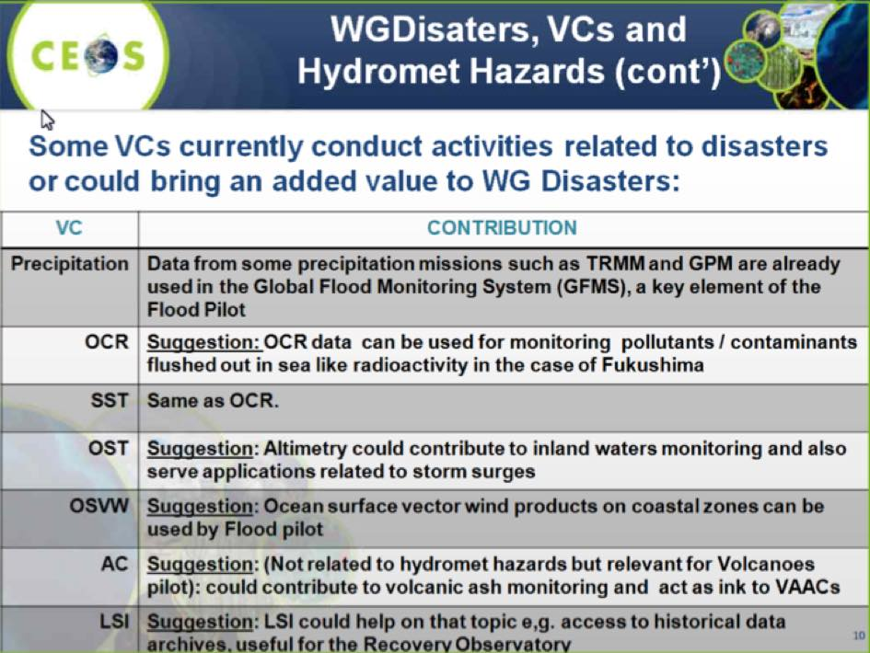
Ivan reviewed the next steps following the VC/WG Day:
- WG Disasters co-leads will be informed about the outcomes of this session;
- the Flood co-leads (Stuart Frye, NASA and Bob Kuligowski, NOAA) will contact the VC co-leads to further assess / define opportunities of cooperation with individual VCs; and,
- similar follow-up with Volcanoes pilots for the AC-VC for volcanic ash monitoring.
A brief discussion followed:
- Julia Figa Saldana (EUMETSAT) suggested that making contact with Craig Donlon (ESA) on the topic of prediction of storm surge might be useful.
- Marie-Josée Bourassa (CEO) noted that GEO is treating Capacity Building as a cross-cutting activity now, and asked if this was the case for the WGDisasters pilots. Ivan noted that there are Capacity Building activities included in the pilots, but this does not exclude contributions from experienced groups like WGCapD.
- Marie-Josée asked if CEOS should consider including a Capacity Building component in every new activity it puts forward. Pascale noted that there are many outreach initiatives that CEOS agencies conduct that are not a formal part of CEOS, and these could and should be better linked to WGCapD.
- Kerry Sawyer (NOAA) noted that WGCapD’s push to become more demand driven, rather than supply driven, is important. She suggested that WGCapD could provide guidance based on their experience to support demand for new Capacity Building activities.
- Alex Held (CSIRO) noted that there are Capacity Building activities in a number of GEO tasks (e.g. SilvaCarbon as a US contribution to GFOI), and suggested that links between these activities and WGCapD could be valuable. CEOS may be able to contribute expertise into Capacity Building for these key tasks.
- Eric noted that WGCapD is working with GEO on Capacity Building, who is currently modifying its Capacity Building structure. He noted that the GEO Flagships have not required WGCapD support to date, but they are looking for opportunities. For example, they have reached out to AfriGEOSS but a clear role for WGCapD isn’t yet apparent.
Integrated Ocean Products Julia Figa Saldana (EUMETSAT) presented a summary of the VC/WG Day discussion on the meaning of integrated ocean products, and potential roles and linkages. During the VC/WG Day, several topics for discussion were identified:
- VC’s role and links to application-based groups;
- VC’s and WG-CV links to the science teams;
- missing VC or WG topics; and,
- links to the modelling community.
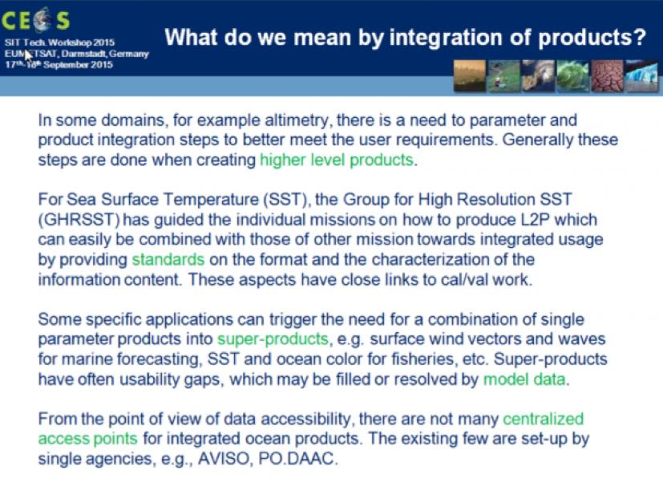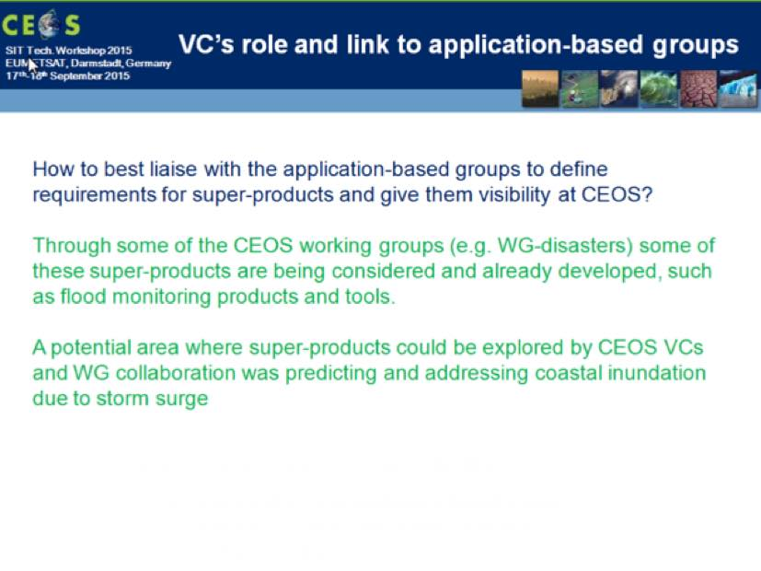
Julia raised the question of whether there is a need for a Sea Ice VC. She noted that sea ice is an already established variable, but the satellite missions supporting it (e.g. SAR) are not addressed specifically within any of the VCs.
A brief discussion followed:
- On the issue of Sea Ice identified as a “missing parameter” in the VC context, Stephen Briggs (ESA) noted that duplication with the Polar Space Task Group (convened by WMO) should be avoided. He suggested that this point be discussed with the PSTG leadership to ensure good coordination.
- The SIT team indicated that a VC process paper exists to guide the proposal of a Virtual Constellation if required.
- Tom Cecere (USGS) noted that if the LSI-VC plans are approved by Plenary, then the inclusion of coordination on radar data is being considered, and this may be another forum for the coordination of polar imaging activities.
SITWS-2015-01 | SIT Chair | Contact WMO about the Polar Space Task Group (PSTG) activity in relation to the question raised concerning Sea Ice in the context of CEOS VCs | CEOS Plenary

Coordination of CEOS Land Surface Imaging Activities
Tom Cecere (USGS) presented a summary of recent developments related to LSI-VC, reviewing the Terms of Reference (ToR):
The Land Surface Imaging Virtual Constellation exists to maximize the value derived from CEOS agency land surface imaging assets and activities by providing an overarching coordination role.
The responsibility of the LSI-VC is to facilitate coordinated and optimized land surface imaging contributions from CEOS agencies to enable access to fundamental measurement products in support of confirmed/validated requirements linked to adopted CEOS priorities. These priorities are typically derived from key stakeholders, such as UN agencies/programs and GEO.
Tom reviewed the Implementation Plan (IP), including the three- and five-year implementation horizon for the Space and Ground Segments, as well as the Products and Services. He noted that the only recent change was the five year plans for the Ground Segment.
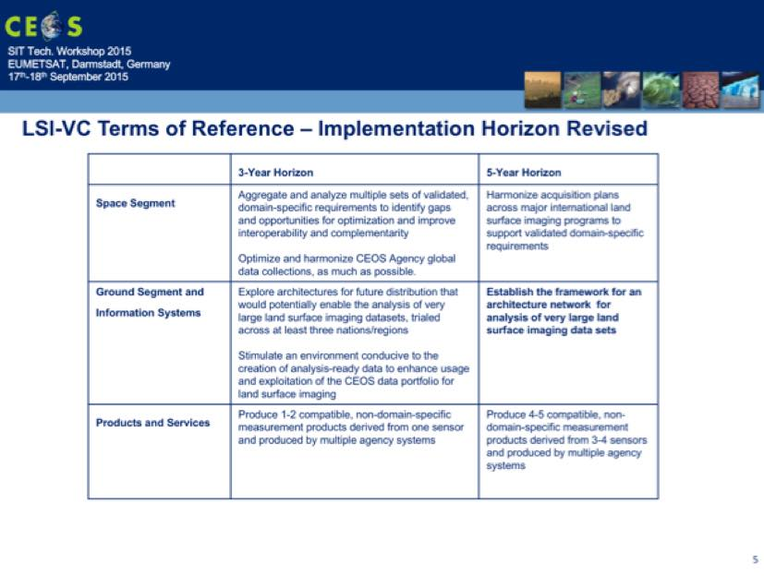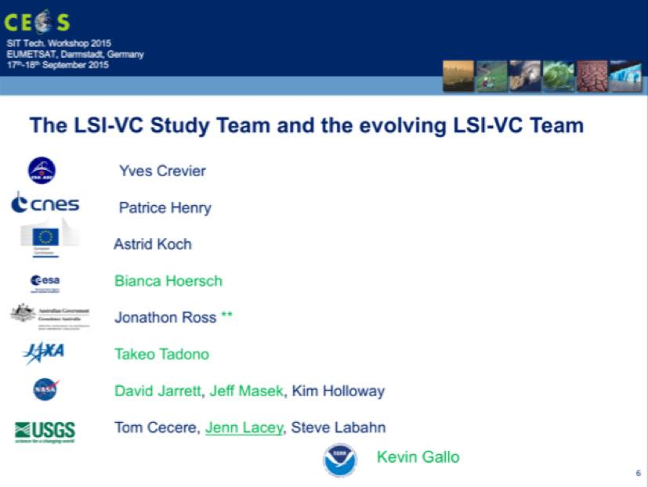
Tom reviewed the membership of the study team, and called for further membership nominations (including for co-leadership of the group) to join as the LSI-VC is re-established. He also reviewed some of the proposed initial focuses for the LSI-VC, including a focus on analysis ready data and the handling of large data sets (e.g. Data Cubes).
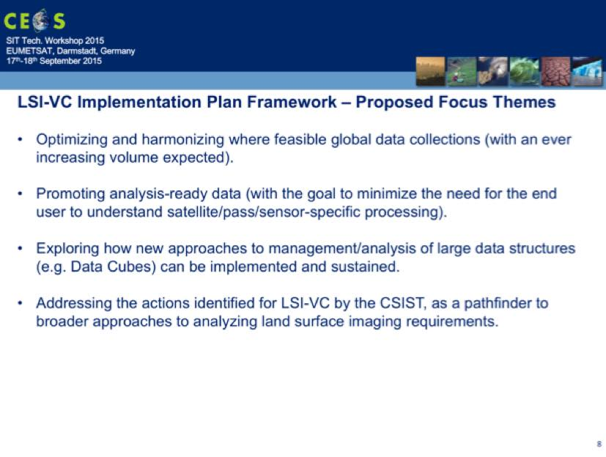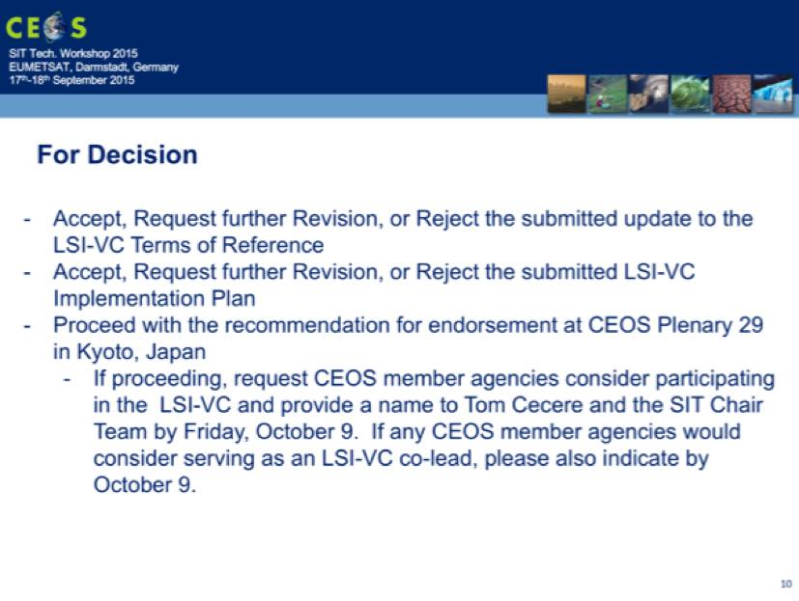
Tom reviewed the items for decision at Plenary, and a brief discussion followed:
- Kerry Sawyer (NOAA) asked at what point the Data Cube activities might transition from groups like SDCG to the LSI-VC. Jonathon Ross (GA) noted that there is a lot of complementarity between the Data Cube development (e.g. Kenya, supported by the SEO), and what is envisioned for the LSI-VC, and so the transition should be natural.
- Brian Killough (SEO) noted that the Kenya activity will likely be followed next year by a Colombia Data Cube, and that there is a great opportunity for CEOS to scale globally, informed by the current pilot activities. Brian sees the LSI-VC providing a cross-cutting capability, in support of the definition and implementation of key components like analysis ready data. He also noted that LSI-VC could play a role in integrated data products (e.g. Landsat-Sentinel-2 combined datasets).
- Astrid Koch (EC) thanked the team members, noting that she is currently looking for a European Commission representative with land expertise to participate in the LSI-VC, and hopes to be able to confirm a participant shortly.
- Chu Ishida (JAXA) noted that he was pleased to see both optical and SAR data being covered, and stressed the importance of the LSI-VC, given the increasing number of missions to coordinate and growing user demand.
Jean-Louis asked for comments on the ToR and IP, and none were raised. He asked if there were any objections to proceeding to Plenary with the request for endorsement of the ToR and the IP, and none were raised. It was agreed that these documents would be put forward at Plenary for endorsement.
SITWS-2015-02 | CEOS Agencies | Provide final nominations to Tom Cecere for representatives to the reformulated LSI-VC, including as Co-Lead | 9 October 2015

Working Group Issues and Topics for Plenary Preparation
WGISS Chair Richard Moreno (CNES) provided an update on a number of WGISS activities, including the status of the Recovery Observatory (addressing CEOS Work Plan action DATA-04). He also reviewed the status of the CEOS International Directory Network (IDN) service.
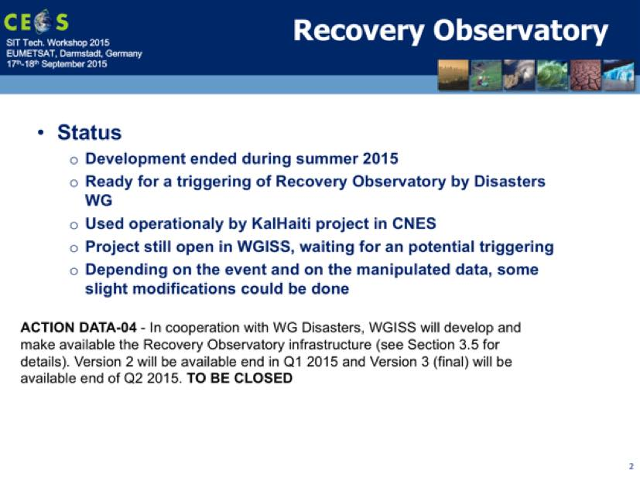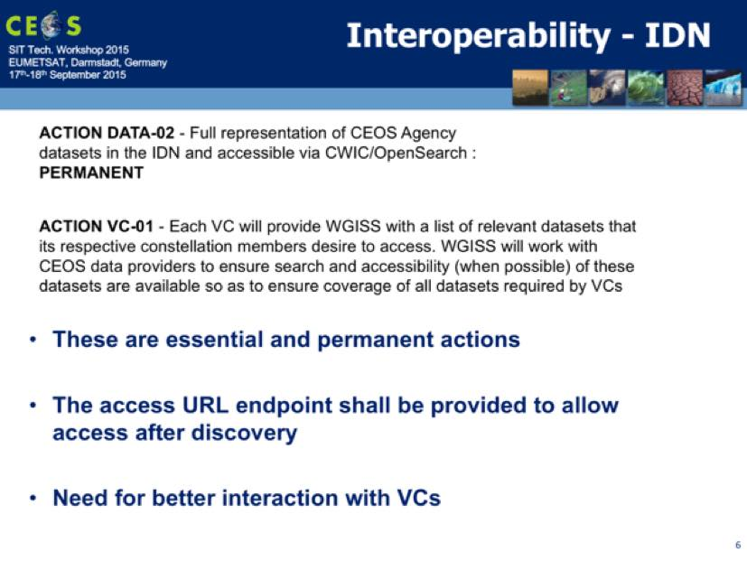
Richard noted the importance of data stewardship, and in particular the development of a procedure for purge alerts for datasets that are about to be irrecoverably and permanently deleted. He asked whether CEOS Plenary should be asked to endorse any proposed procedure, and Steven Hosford (CNES) indicated that this should be further discussed offline and that the CEOS Principal level (i.e. CEOS Plenary) is not likely the appropriate forum for the decision but that informing Plenary that this mechanism has be restored would be useful. It was agreed that this should be discussed at the next SEC meeting.
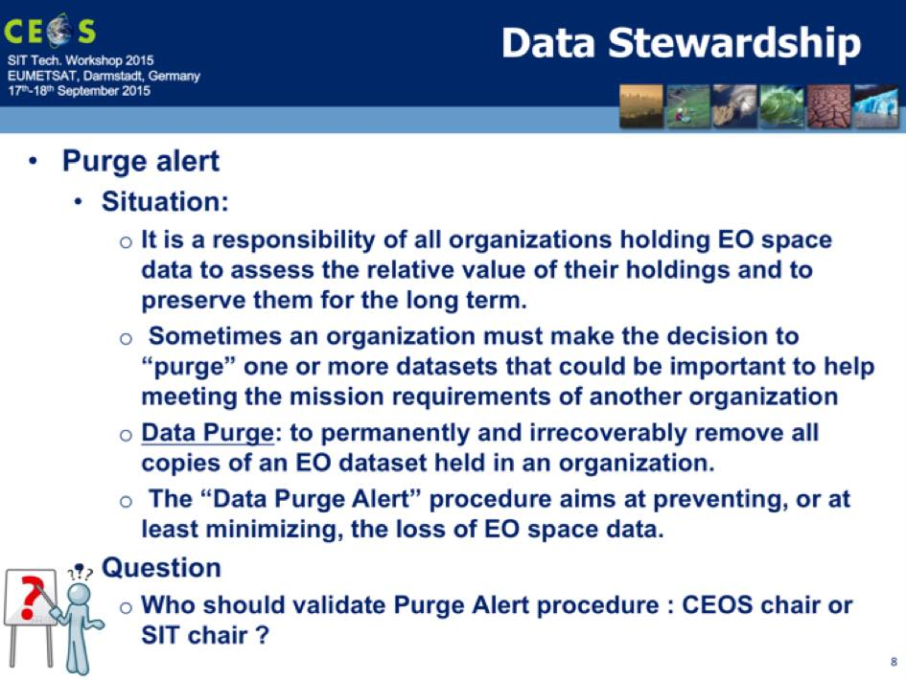
SITWS-2015-03 | WGISS Chair and SIT Chair | Coordinate a discussion item on archive purge alert procedures at CEOS SEC 205. (Depending on the outcome, a short discussion led by WGISS at Plenary may be required.) | CEOS SEC 205
Main Plenary issue: information on the dataset purge alert procedure.
WGCV Chair Albrecht von Bargen (DLR) provided an update on a number of WGCV activities, including updates on the structure of the group, outcomes from the most recent meeting in May 2015, the status of deliverables, and future events and outlook.
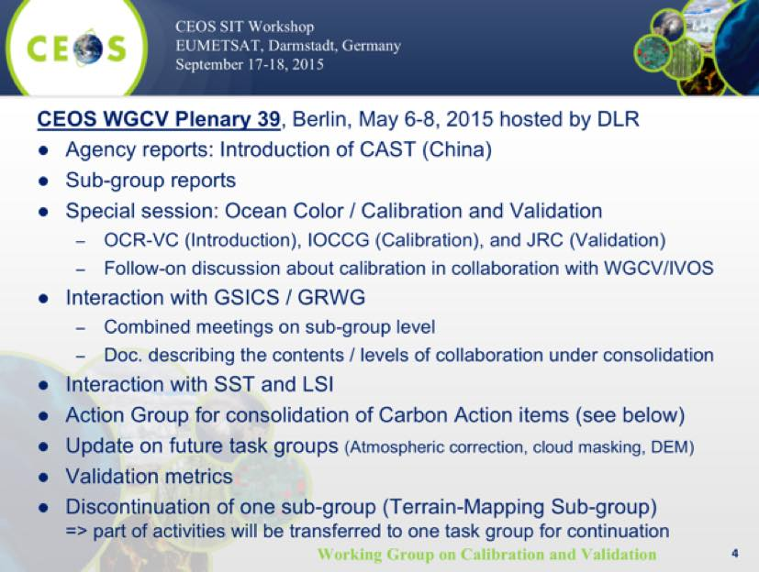
Albrecht reviewed the status of deliverables, including:
- carbon action items, where some were deemed to be sub-group specific and some cross cutting, and where follow-up is being identified by the sub-groups including next steps and milestones; and,
- a number of CEOS deliverables have been closed (CV-02, CV-06, CV-07, CV-08, CV-11), partially completed (CV-05 GSICS cooperation, CV-10 TanDEM-X product check, CV-12 Sentinel-2 validation sites), and some remain open (CV-01 new outreach concept, CV-03 characterisation workshop, CV-04 self-analysis).
Upcoming WGCV events include:
- CEOS SAR Cal/Val workshop, October 2015, hosted by ESA/ESTEC;
- GSICS / WGCV ACSG workshop, October 2015, hosted by NOAA;
- WGCV IVOS workshop, November 2015, hosted by ONERA;
- WGCV # 40, March 14-18, 2016 in Canberra (AUS), hosted by GEOSCIENCE Australia and CSIRO; and,
- WGCV # 41, September 2016, hosted by JAXA.
Albrecht noted that WGCV is entering a consolidation phase during which it will setup a work plan taking CEOS activities into account, work to establish systematic collaboration with other CEOS entities where mutually beneficial, and intensify cooperation with GSICS.
It was noted that there aren’t currently any issues that require Plenary attention. A brief discussion followed:
- Pascale Ultré-Guérard (CNES) asked about the collaboration with GSICS, and whether any CEOS Plenary decision is required on this collaboration. Albrecht noted that there are two ways to handle this – either a working level collaboration (which does not require Plenary endorsement), or a more formal arrangement which may require endorsement.
Main Plenary issue: approach to increased GSICS cooperation.
WGCapD Chair Eric Wood (USGS) provided an update on a number of WGCapD activities, including progress towards WGCapD CEOS Work Plan actions.

Activity | Progress/Status | Future Activity
CB-1: Conduct a series of Digital Elevation Model (DEM) regional workshops | First workshop completed (March 2015). Second completed (May 2015)  (Q2 2016) | Workshops in Asia and W. Africa to follow
CB-2: Provide practical EO education for students and teachers | CEOS WGCapD endorses but does not support K-12 EO education activities  (Q4 2017) | Proposal between SANSA, DLR, ESA to combine forces in future is being discussed.
CB-3: Develop a long term Capacity Building Strategy | First discussions were during undertaken at the Group Annual Meeting #4 in Pretoria. | To be presented prior to SIT 31
CB-4: Collaborate with GEO in the development and implementation of the GEOCAB Portal | CEOS Capacity Activities have been added. Established.  (Q4 2017) | Sustainability of the Portal still not defined but there are internal discussions in WGCapD and GEO.
CB-5: Implement the TanDEM-X Edu Project | Not started due to unavailability of Data | DLR /SANSA are still interested but need to wait until the required data is processed to be utilized for CB activities
CB-6: Capacity Building for Disaster Management - Pilot Course | INPE and ISRO in charge  Webinar Series: from 7 April to 26 May | There is already an announcement on CEOS Website
CB-7: Release of web-based newsletters and other outreach materials | Not yet started | WGCapD will significantly increase its communication through key channels such as its newsletter and list-serves, including promotion of appropriate material and activity of other CEOS Entities.
CB-8: Web based archiving and distribution of CEOS EO webinars | Not yet started | A series of webinars will be developed, drawing on presentations and materials already under development by other CEOS Entities. These webinars will be made easily available through the CEOS website
CB-9: Strengthening AfriGEOSS | Communicating with GEO and ID-02. | Work with GEO to determine the capacity building activities necessary to strengthen AfriGEOSS, as well as, assist in establishing the capacity building component of AfriGEOSS itself.
Eric noted that there will be a CEOS booth at the GEO Plenary, which will provide an opportunity to again highlight CEOS’s work as an organisation.
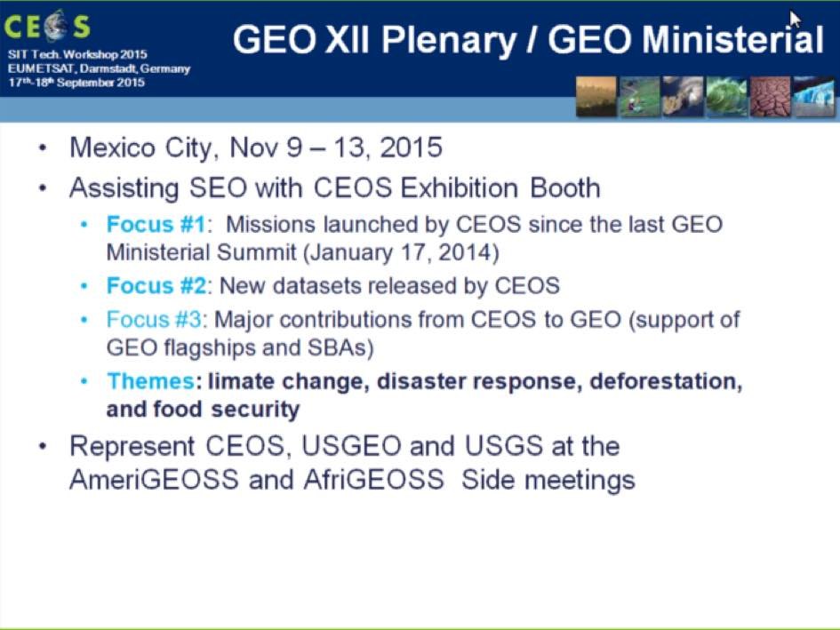
The 4th WGCapD meeting was held in Pretoria in March 2015, and the next meeting will be hosted by the SEO at NASA Langley.
Eric noted that he will be completing his tenure as WGCapD Chair at Plenary, and Jane Olwoch from SANSA will take over as Chair. Senthil Kumar (ISRO/IIRS), from ISRO’s principal Capacity Building institute, has been nominated as the incoming Vice Chair.
Main Plenary issue: information on plans for WGCapD to become more demand driven.
WGClimate Vice Chair Pascal Lecomte (ESA) provided an update on the status of the WGCV CEOS Work Plan actions.
Objective/Deliverable | Projected Completion Date | Status and Comments
CMRS-2: Gap analysis (first version) | Q2 2015 | Complete for high-definition gap analysis of few selected ECVs spanning the Atmospheric, Oceanic, and Terrestrial GCOS domains.  Two documents (A Questionnaire Guideline and a Gap Analysis) are under review and will be released by plenary.
CMRS-3: Action plan (first version) | Q3 2015 | At this stage, there is not enough results to derive a complete Action Plan.  Nevertheless, some preliminary indications have been included in the Gap Analysis document to be released.
CMRS-4: Case studies linking CDRs to societal applications and informed policy decisions | Q1 2015 | Complete. Final typeset version to be released in September.
CMRS-7: CEOS Response to the GCOS IP and Satellite Supplement for submission (via GCOS) to COP-21 | Q2 2015 | Complete and delivered to GCOS.  GCOS acknowledged receipt and results have been used in draft GCOS 2015 status report.
CMRS-10 : CEOS-CGMS Report on Progress to SBSTA-43 | Q3 2015 | Draft complete and comments received from WGClimate members.  Revised draft to be sent to CEOS SEC for review in late September.  Final report due to SBSTA by end of October.
CMRS-8: Incorporation of in situ data holdings within the ECV inventory | Q4 2015 | Questionnaire complete and handed off to WCRP Data Advisory Council.
CMRS-9: Update of ECV inventory, gap analysis and action plan (Version 2) | Q2 2015 to Q4 2016 | Will be covered by the four years WGClimate activity Plan that will be presented at plenary.
CMRS-11: Analysis report on implications of new climate change treaty | Q1 2017 to Q4 2018 | Will be covered by the four years WGClimate activity Plan that will be presented at plenary.
Pascal shared some ideas for the future direction and implementation of the ECV Inventory.
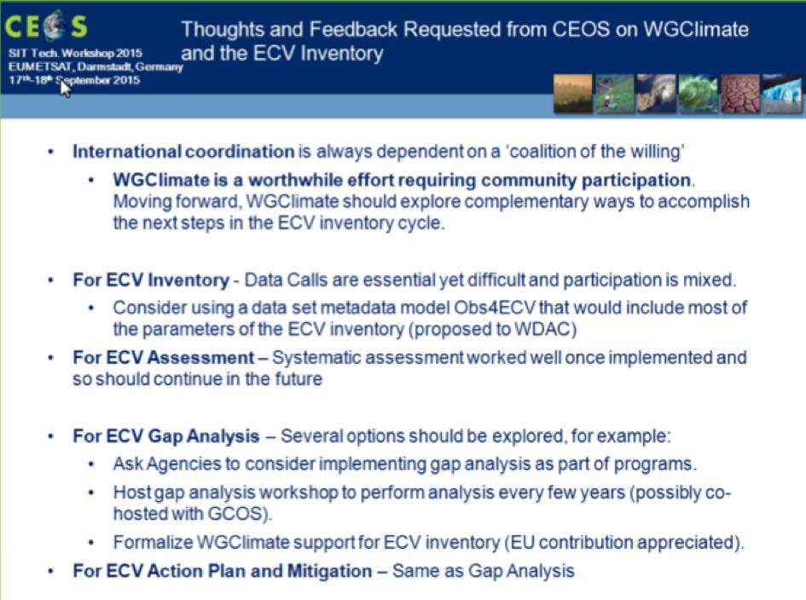
Pascal noted that WGClimate actions SIT-30-2 (COP21 inputs) and SIT-30-3 (COP21 EO Handbook) have been completed. A brief discussion followed:
- Chu Ishida (JAXA) asked about the next update cycle for the ECV Inventory gap analysis, and Pascal noted that the coming cycle will likely require a couple of years to incorporate lessons learned, and further cycles could be expected to be faster.
Main Plenary issue: future implementation and applications of the ECV Inventory.
WGDisasters Chair Ivan Petiteville (ESA) provided an update on WGDisasters activities, covering the pilot projects including the Recovery Observatory (RO). It was noted that an updated RO triggering procedure will be put forward for endorsement at Plenary.
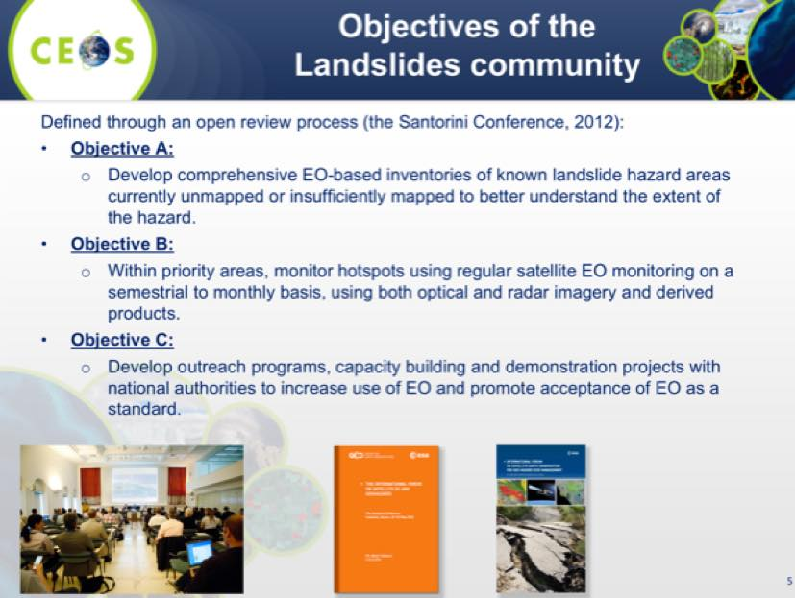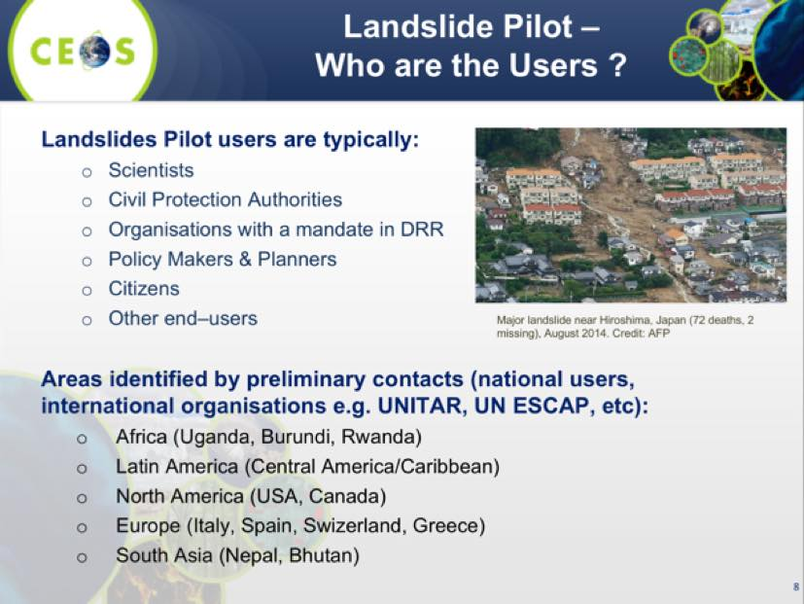
Ivan noted that the Landslides project proposal will be refined and the creation of a landslide pilot presented to CEOS Plenary for endorsement. He reviewed the status of the Recovery Observatory, and noted a number of lessons learned had been generated from a trial activation during the March 2015 Vanuatu cyclone. He also noted new activities in Chile on volcanic eruptions, and a new regional site in Texas for floods.
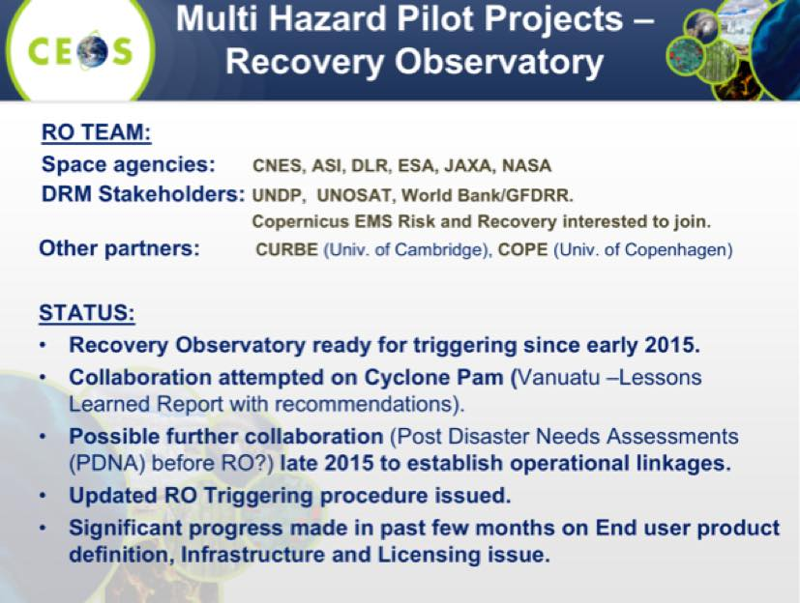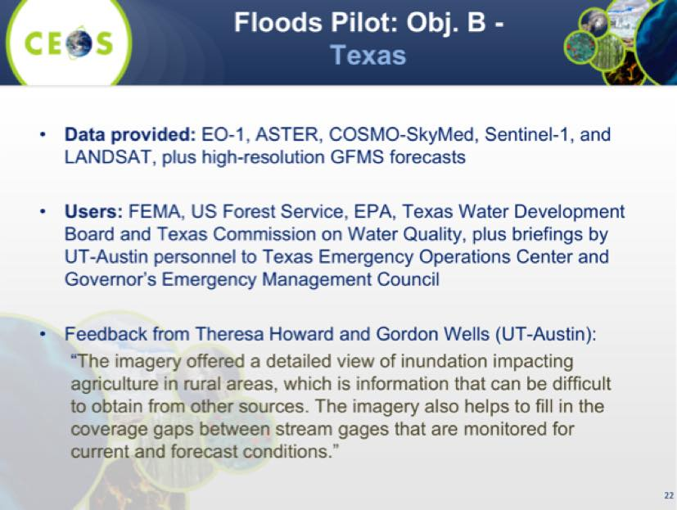
Ivan reviewed the WG Disasters tasks in the CEOS Work plan. No issues preventing progress were identified.
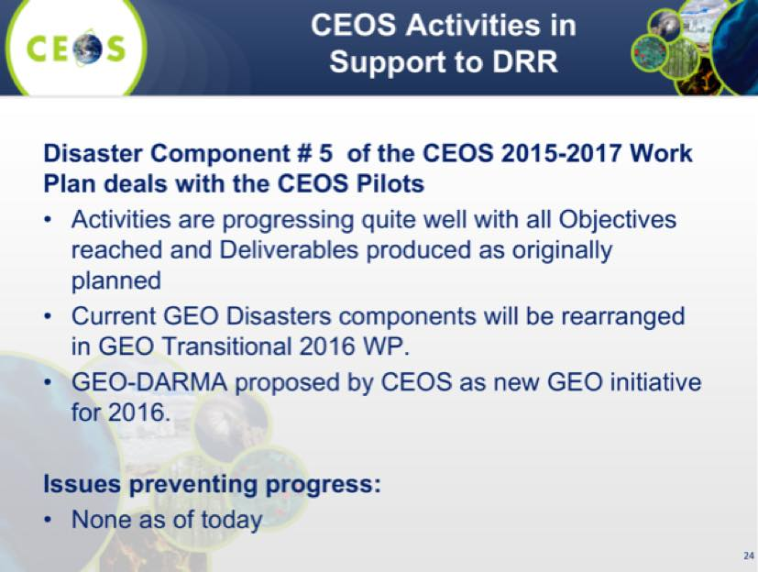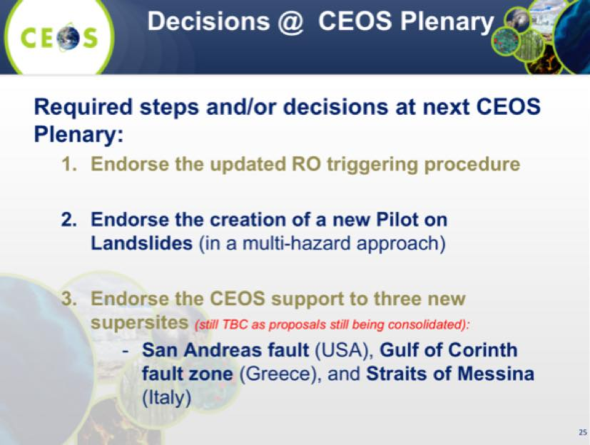
Ivan noted that there will be three items from WGDisasters for decision at Plenary:
- Endorsement of the updated RO triggering procedure
- Endorsement of the creation of a new multi-hazard Pilot focused on landslides
- Endorsement of CEOS Support to three new supersites – pending finalised Supersite proposals (San Andreas Fault, Gulf of Corinth, Straits of Messina)
Ivan noted that this will be his last Plenary as the Chair, and Stéphane Chalifoux (CSA) will take over as Chair, with Simona Zoffoli (ASI) anticipated to assume the Vice Chair role.
A brief discussion followed:
- Steven Neeck (NASA) noted that he can help facilitate the support of Dahlia Kirschbaum of NASA if required.
Main Plenary issue: endorsement of updated RO triggering procedure, creation of a landslide pilot and 1 or more new supersites.
Jean-Louis noted that no objections were raised to the three items Ivan raised for decision at Plenary.
VCs and WGs Session Wrap-up
Jean-Louis Fellous (SIT Chair Team) closed the VC and WG session by reviewing the main outcomes and actions. He noted that he will request Plenary inputs from the VCs - 1-2 slides covering major issues, the status of each VCs CEOS Work Plan actions (max 1 slide), and upcoming meetings (max 1 slide).

Update on CEOS Support to the Global Forest Observations Initiative (GFOI)
Stephen Briggs (CEOS GFOI Lead, ESA) provided a brief update on implementation of the CEOS Strategy for Space Data Coverage and Continuity in Support of GFOI, starting with an overview of the GFOI components. He noted that the GFOI Office was relocated from the GEO Secretariat earlier this year – on an interim basis furnished by Australia, but in the long term transitioned to FAO in Rome. Stephen noted that the plan for Plenary includes:
- presentation of the 2014 Global Baseline Data Acquisition Strategy Implementation Report;
- presentation of the updated SDCG 3-Year Work Plan [in response to SIT 30-16]; and,
- to seek an extension of the SDCG mandate.
Stephen noted two main issues for attention, shown below.
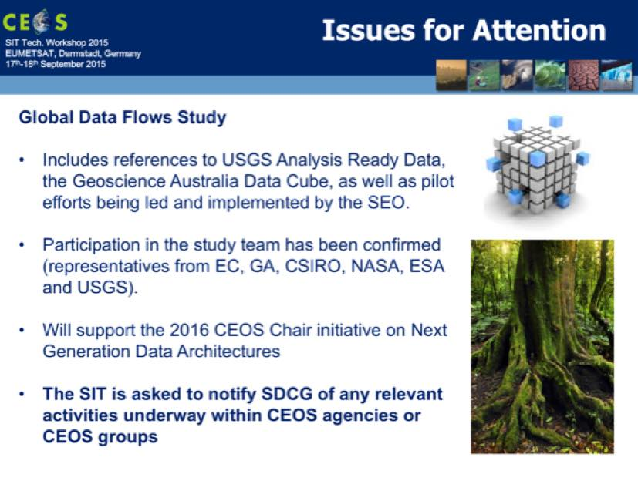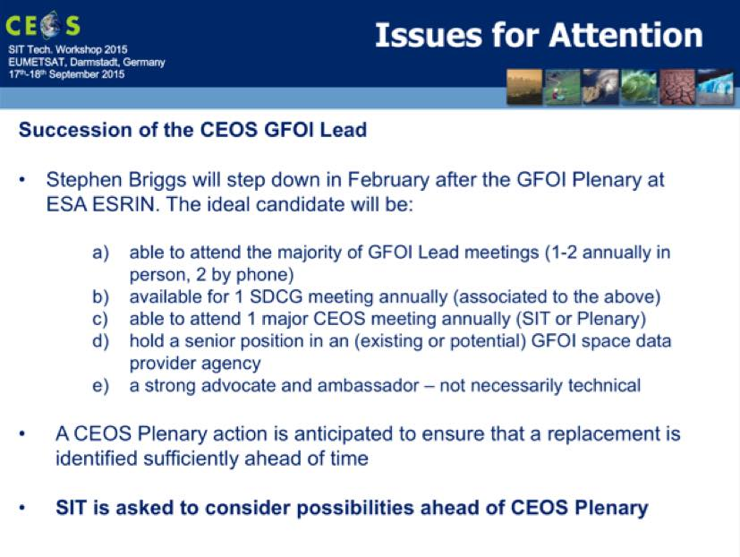
Stephen reviewed the status of the SDCG actions in the CEOS Work Plan.
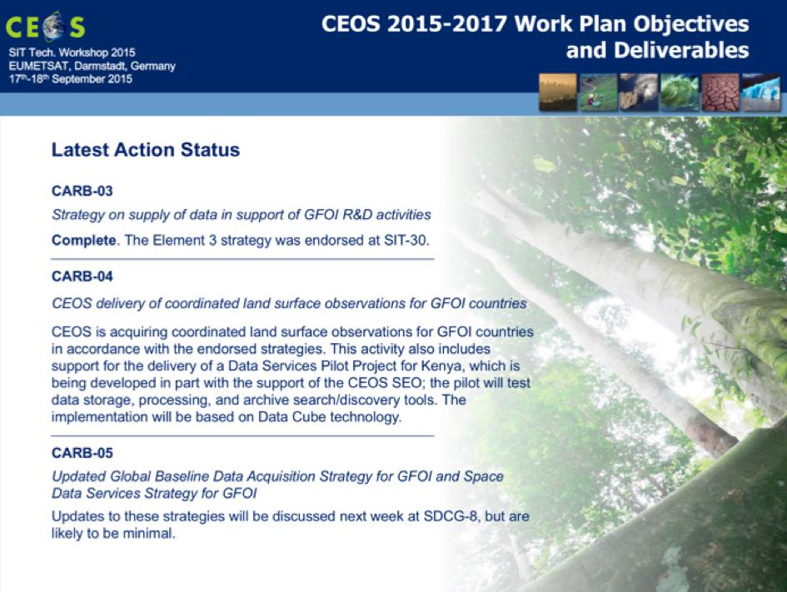
Stephen Ward (GFOI Office) noted that SDCG is participating in the International Conference on "MRV of REDD", hosted by GIZ in Bonn on Monday-Tuesday 21st/22nd September, followed by SDCG-8 hosted by DLR on Wednesday to Friday of the same week. He noted that experience has shown that countries with lower capacity have trouble handling the data CEOS is offering, and that trying to do so consumes all their resources. One way of addressing this is the “Data Cube” approach and is the major motivation behind the Global Data Flows study being conducted by the SDCG.
SITWS-2015-04 | CEOS Agencies | Provide nominations for the new CEOS Lead for GFOI (from Feb 2016) – with reference to the criteria outlined in the SIT Workshop presentation | CEOS Plenary
Main Plenary issue: identify a new CEOS lead for GFOI.

Carbon Strategy Implementation
Stephen Briggs (ESA) reviewed the context for the implementation of the CEOS Strategy for Carbon Observations.
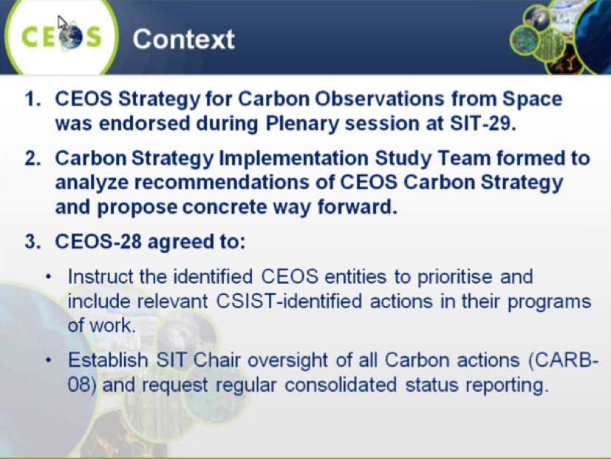
Stephen noted that a dedicated working session on the Carbon Strategy actions was held during the VC/WG Day – overall progress is inconsistent, with progress in some areas and others yet to initiate action.
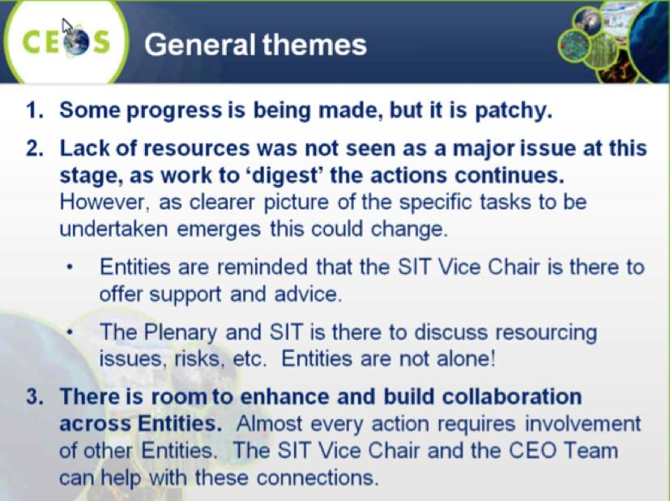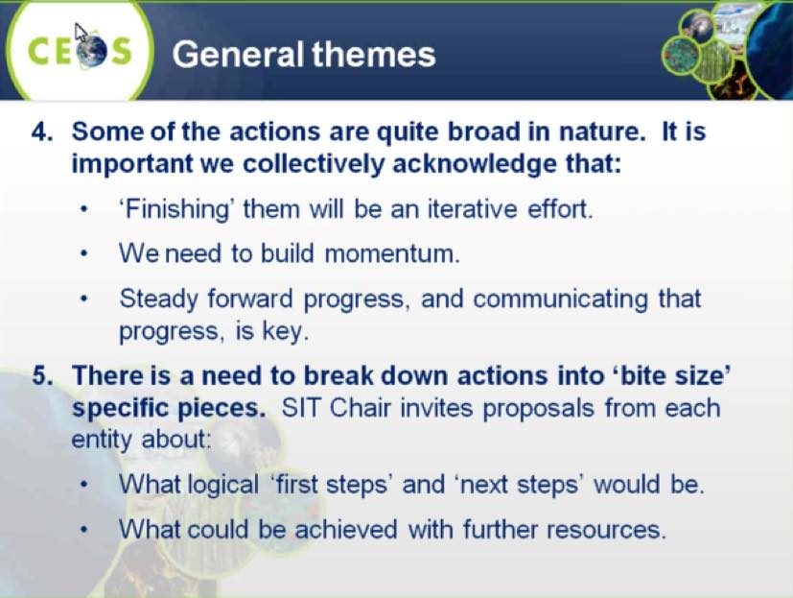
Stephen suggested that the actions should be further broken down into smaller elements which can be addressed in shorter timeframes in order promote gradual progress. This was identified as an action on all Carbon Strategy actionees with a deadline of January 2016.
A brief discussion followed:
- The actionees on the Carbon Strategy implementation items were asked whether additional resources or the assistance of Principals was required, and they indicated this was not currently required.
- Chu Ishida (JAXA) noted JAXA’s investment in GOSAT, and expressed his appreciation of the framework that the CEOS Strategy for Carbon Observations presents for this mission.
SITWS-2015-05 | Carbon Strategy actionees (VCs and WGs) | Propose concrete achievable next steps with a 1-year time horizon, for consideration at SIT-31 | January 2016

Water Strategy Implementation Study Team
Chu Ishida (JAXA) presented a summary of the status of the action WAT-1 (Development of a CEOS response to the GEOSS Water Strategy). He noted that following the SIT Workshop side meeting, the CEOS Response to the GEOSS Water Strategy Recommendations is being revised, and an updated draft should be available soon.
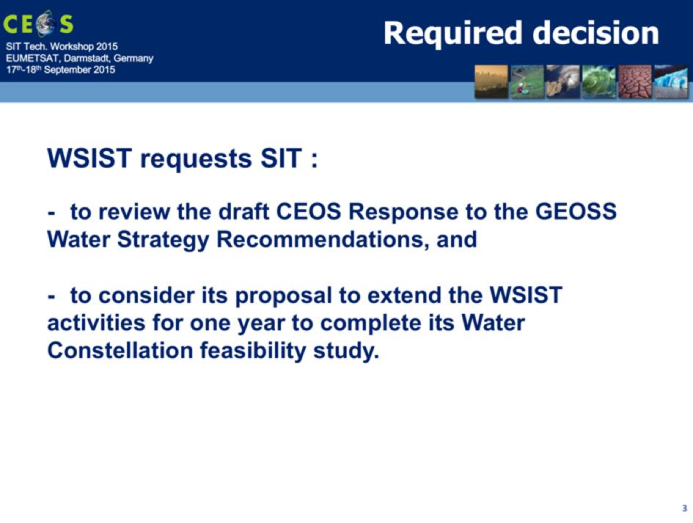
Chu reviewed the recommendations related to the priority areas in the Report, noting GEOSS Strategy contains 58 recommendations, 22 of which have been identified as being relevant for CEOS and 10 of which CEOS would be the most appropriate lead entity.
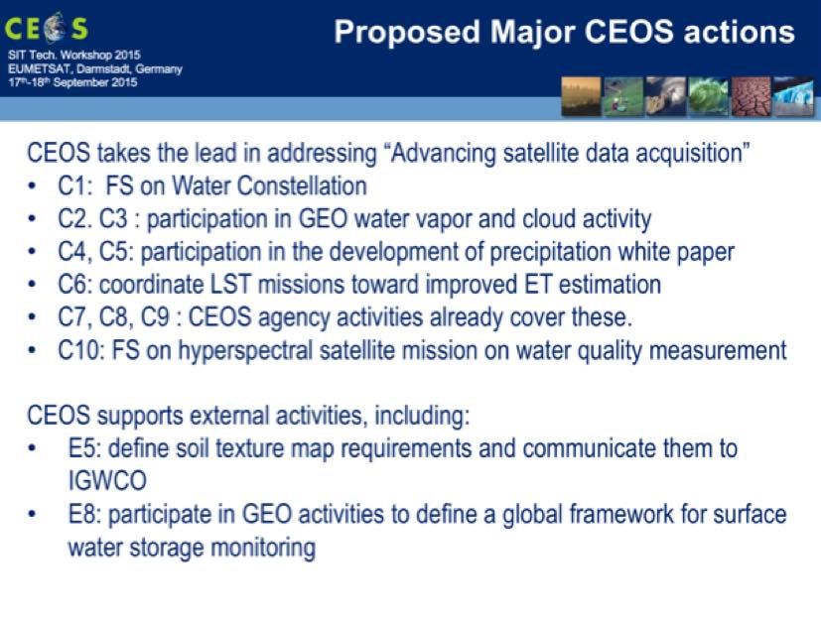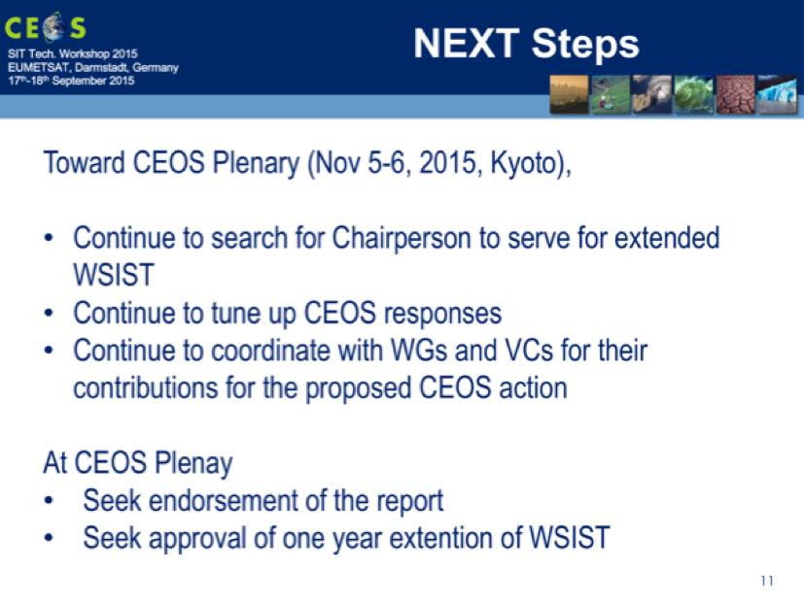
A brief discussion followed:
- Pascale Ultré-Guérard (SIT Chair) suggested a comment window of two weeks on the revised CEOS Response to the GEOSS Water Strategy Recommendations.
- Brian Killough (NASA) noted that the CEOS Response contains a large number of actions, and endorsement by Plenary might be seen to imply that CEOS can address them all. He suggested that the language could be clarified to refer to potential CEOS contributions, and that they would become formal CEOS actions (as for the Carbon Actions) once specific appropriate resources are identified by CEOS Agencies.
- Pascale agreed, noting that the extension of the WSIST is in part to allow more time to address the question of resources.
- Tom Cecere (USGS) also agreed, noting that the timing is tight to get the updated document finalised and reviewed by Principals before Plenary.
- Chu agreed to the softening of the language to read ‘potential CEOS contributions’.
- Kerry Sawyer (NOAA) noted that the WSIST has looked at the CEOS Response for almost a year now, and a lot of the work around language has been done. Brian noted that a number of NASA resources are implicated by the actions, and it is not clear that NASA will be able to endorse the Response as it stands. He suggested preparing for a discussion at SEC-205.
- Jonathon Ross (DCEO) noted that the question of whether resources will ever be available to address the CEOS tasks needs to be addressed – otherwise there’s a risk that even after a further year of coordination, no action will result. Paul DiGiacomo (NOAA) agreed that the question is whether CEOS does this or not, and that there is a risk that if the CEOS Response is too sluggish it may be less relevant.
- Pascale suggested if it might be possible to define a different approach / wording for each action based on resource requirements.
It was agreed that Chu would circulate the revised document in a week, and that it would be discussed at SEC-205.
SITWS-2015-06 | CEOS Agencies | Provide review comments on the updated Water Strategy Implementation Study Team (WSIST) report to JAXA. JAXA will issue a revision using language consistent with previous CEOS strategy document | Report expected early October. Comments within 2 weeks to support Plenary endorsement.
SITWS-2015-07 | CEOS Agencies | Provide nominations for individuals to serve as Chair of an extended Water Strategy Implementation Study Team, pending approval by Plenary at CEOS-29 | CEOS Plenary
Main Plenary issue: endorsement of updated WSIST report; extension of WSIST and nominations for chair of this ad hoc team.

CEOS Acquisition Strategy for GEO Global Agricultural Monitoring Initiative (GEOGLAM)
Brian Killough (NASA) presented an update on the activities of the CEOS ad hoc Working Group on GEOGLAM, summarising changes since SIT-30.
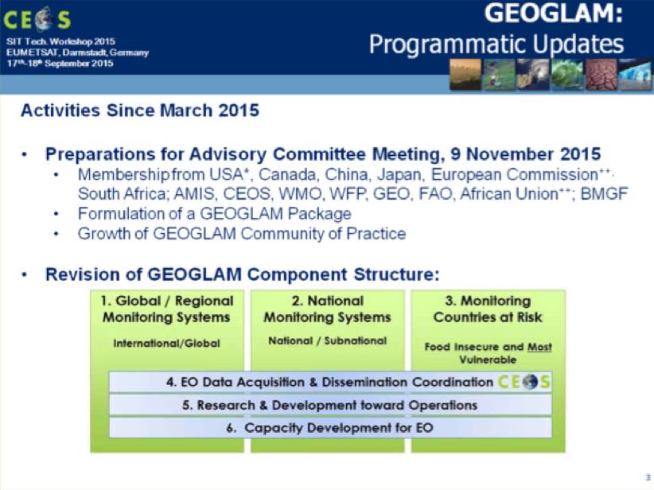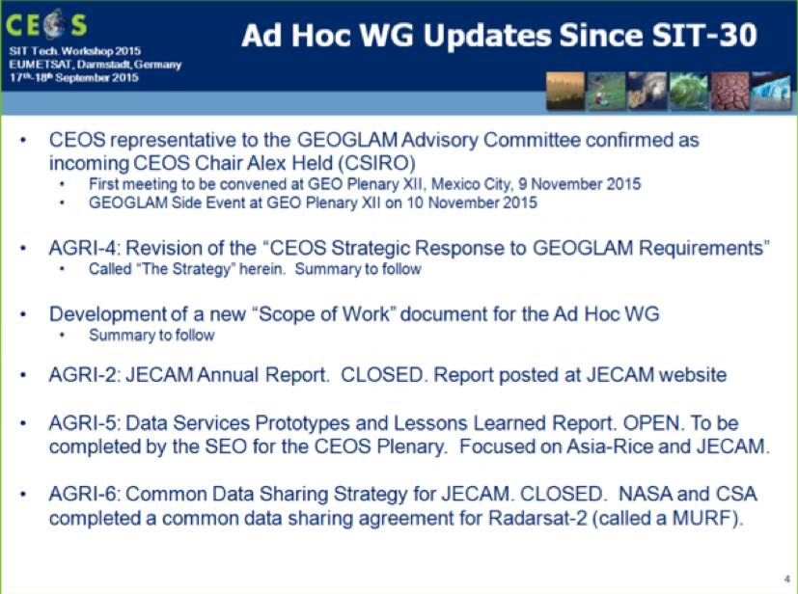
Brian reviewed a draft document which aims to briefly (two pages) define the scope of CEOS support to GEOGLAM, and is intended to complement the GEOGLAM Strategy document. The scoping document also addresses the criteria that would need to be met for the ad hoc group to be considered to have achieved its goal, and therefore be disbanded with key tasks transitioned to the LSI-VC.
A brief discussion followed:
- Ivan Petiteville (ESA) asked about the transition to LSI-VC, and whether this would mean there would need to be specialist members in the LSI-VC to maintain the GEOGLAM-related tasks. Brian confirmed that GEOGLAM would appoint a point of contact to participate in the LSI-VC – as of today this would likely be Alyssa Whitcraft.
- Astrid Koch (EC) asked about the European Commission (EC) representation on the GEOGLAM Advisory Committee, and it was noted this was likely related to EC funded activities related to agriculture.
- Steven Hosford (CNES) asked about the transition to LSI-VC, and Brian noted that the suggestion for the transition is that it would take place once the major coordination effort is completed, and large-scale meetings are no longer required. Tom Cecere (USGS) noted that as the LSI-VC re-forms and grows, participation from GEOGLAM will be considered.
Main Plenary issue: feedback on potential transition of GEOGLAM support to LSI-VC.

GEO 2016 - 2025
André Obrégon (GEO Secretariat) presented a summery of recent GEO activities, noting that there have been a number of developments related to the GEO Strategic Plan 2016 - 2025. He reviewed the Strategic Plan.
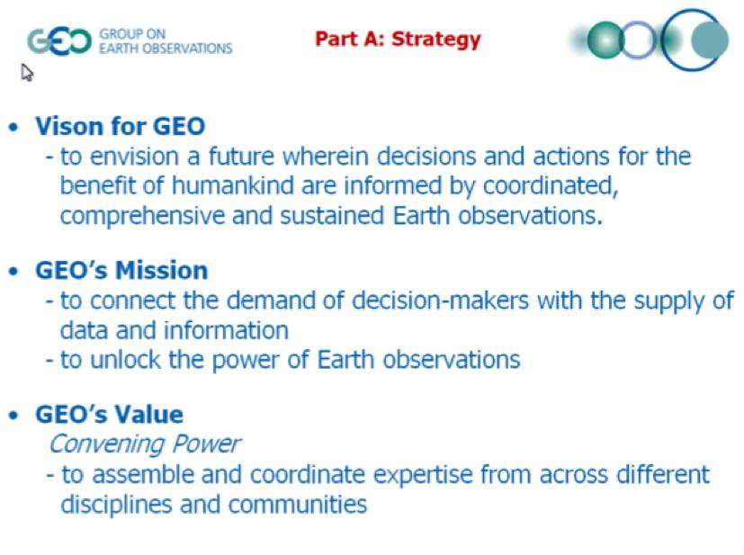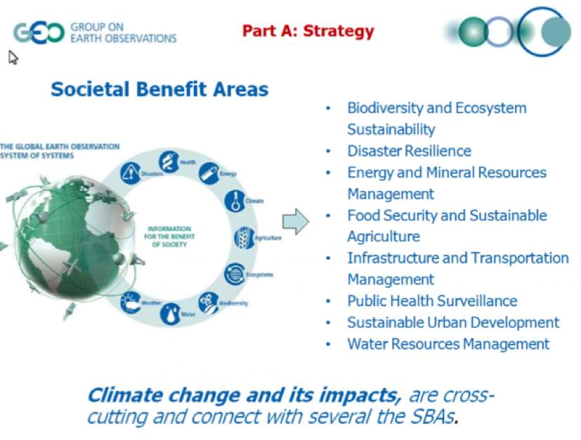
André reviewed the plans for implementation of the Strategic Plan, as well as the GEO Work Programme, which was developed in parallel with the Strategic Plan.
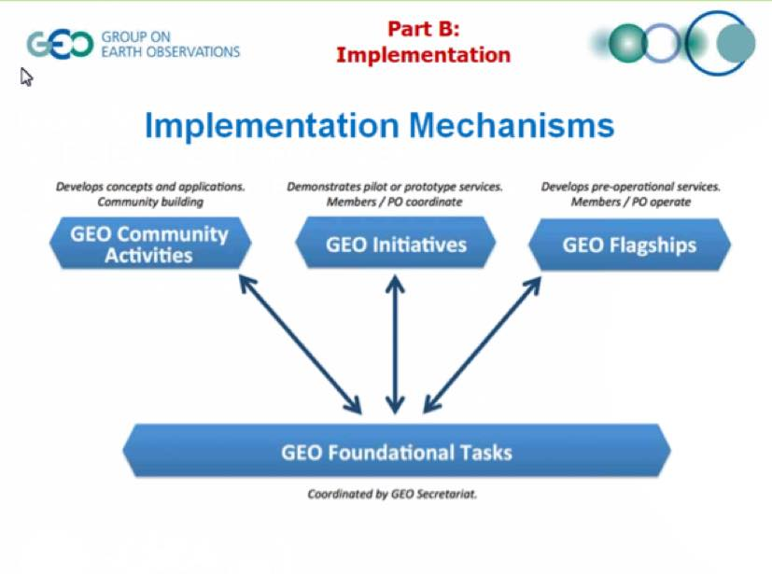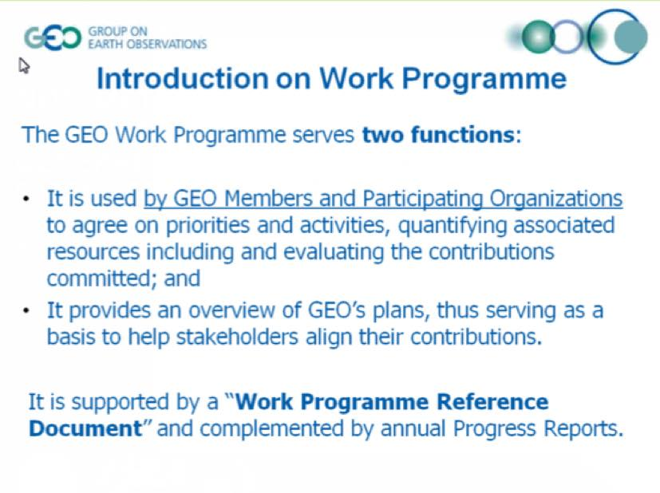
Preparations for the GEO Ministerial Summit are underway, and the third Ministerial Working Group meeting is taking place 17-18 September in Washington D.C.
A brief discussion followed:
- Astrid Koch (EC) asked about the activities at the GEO Summit, and suggested that the event be advertised as ‘GEO Week’, rather than just the Plenary and Ministerial – this may help delegates justify their participation for the full week, and will help to showcase the holistic view of all the initiatives in GEO.

Implications of the GEO Strategic Plan 2016 - 2026 for CEOS
Jonathon Ross (DCEO) presented a summary of the implications of the GEO Strategic Plan for CEOS. He summarised the Strategic Plan, noting that André Obrégon covered that well in his presentation (previous item).
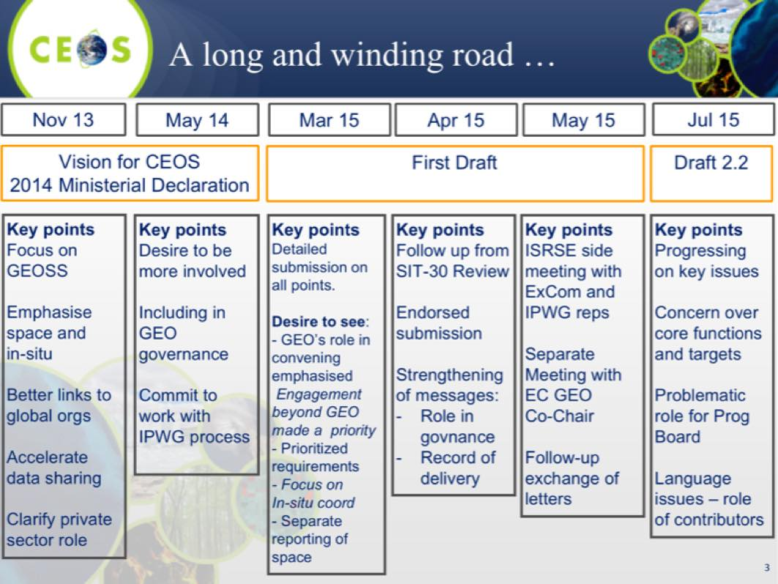
He noted that CEOS is committed to strengthening its role in GEO and the GEOSS, and while progress is being made, some concerns remain, in particular around the ‘modalities’ on how intent might be translated to action, and ensuring that momentum is not lost in the ‘rewrite’. He reviewed some of the potential future features of the overall landscape.
- Big focus on delivering impact into big global and regional agendas – in particular the Sustainable Development Goals.
- Focus on developing stronger and more explicit links with UN institutions and programmes.
- Focus on mobilizing resources (i.e. funds) from ‘outside GEO’. Private sector, development banks, philanthropic organizations.
- Emphasis on defining and prioritizing requirements by SBA. Deeper end-user engagement – hopefully fewer ‘wish lists’.
- Strong focus on in situ coordination and space/in situ integration.
- POs in top-level governance – observers on ExCom, key Programme Board role.
A brief discussion followed:
- Ivan Petiteville (ESA) noted that CEOS should consider the structures and resources that might be required to realistically respond to the requirements coming from the 2016 – 2025 Strategic Plan. He suggested that CEOS should start considering how to address these requirements now, even while GEO’s plans have not been finalised, and prepare for a substantive discussion at CEOS Plenary 2016.
- Paul DiGiacomo (NOAA) noted that in the case of water quality, implementation is already underway, and unless CEOS can identify how to engage (i.e. resources) then CEOS risks being left behind. He also noted that requirements evolve, and that part of the dialogue with GEO is to show users what is possible which means there’s an iterative process involved in defining requirements.
- Stephen Ward (JAXA) noted that CEOS and GEO need to address the issue of how to work with, or around, UN agencies. Ideally a true partnership with UN agencies could be established, but this may not be possible.
- Alex Held (CSIRO) suggested that CEOS should look at the calendar of meetings for 2016, and determine which of those CEOS needs to support to truly engage. GEO and perhaps the UN agencies see CEOS as a service, rather than a partner.
- Stephen Briggs (ESA) noted that CEOS has been a major force for the changes in GEO to date. He recognised the convening power of GEO to bring groups together, citing GFOI as an example. He suggested that CEOS should respond based on what is agreed at GEO Plenary, and should think strategically and develop a coherent response in time for the CEOS and GEO Plenaries in 2016. CEOS should overall be pleased with how GEO is developing, as it is responding to CEOS’ needs, and that CEOS, in turn, should engage positively.
- Stephen noted that CEOS is not only on the data side, but is also engaged in defining requirements. For example, there was strong CEOS support to the development of the GEO Carbon Strategy, and this example can give CEOS some confidence in the recommendations and requirements that might emerge in other areas.
- Ivan suggested that, like the GCOS Satellite Supplement, CEOS could participate in the GEO processes proactively, coordinated by a small response group within CEOS.
- Stephen noted that many of the requirements coming from the SBAs in the future will be satisfied by a single suite of land cover observations and that the requirements will likely not be as complicated as what has come from GCOS in the past.
- Chu Ishida (JAXA) noted that strong governmental support is key to effective engagement with both GEO, and the UN system.
- Doug Cripe (GEO Secretariat) noted that it is likely that GEO will begin to change immediately after the GEO Plenary 2015, most notably by the addition of the Programme Board and with CEOS as an observer on the Executive Committee.
- Jonathon agreed with Doug, noting that there will be a lot of work within CEOS adjusting, but from a working level CEOS members shouldn’t expect a sudden change at the close of GEO Plenary.
- Brent Smith (NOAA) noted that CEOS is now well positioned within GEO to have an influence, but that there is much more going on outside of GEO (i.e. in the UN system), and CEOS needs to consider broader engagement in these forums. There is a need to look at a model like the UN Sustainable Development Goals, which in many ways has more influence than something like the GEO Ministerial Declaration.
It was agreed that a proposal to Plenary be considered to form a task force, lead by SIT Chair and CEOS Chair, to formulate CEOS strategy in response to the GEO Strategy 2016 – 2025 through to GEO Plenary 2016.

CEOS Linkages to the Future GEO Work Programme
Jonathon Ross (DCEO) noted that Brian Killough has led the GEO IN-01 (Earth Observations) task for CEOS since 2009, and will continue until the end of 2015. Currently the IN-01 task is progressing well, and there are no IN-01-C2 “space-based observation” issues. CEOS is currently operating 135 missions, with no significant gaps, though data access remains a topic for discussion. He noted that in the 2016 GEO Work Programme, the ‘space task’ will become a top level task (GD-05), which is a significant achievement.
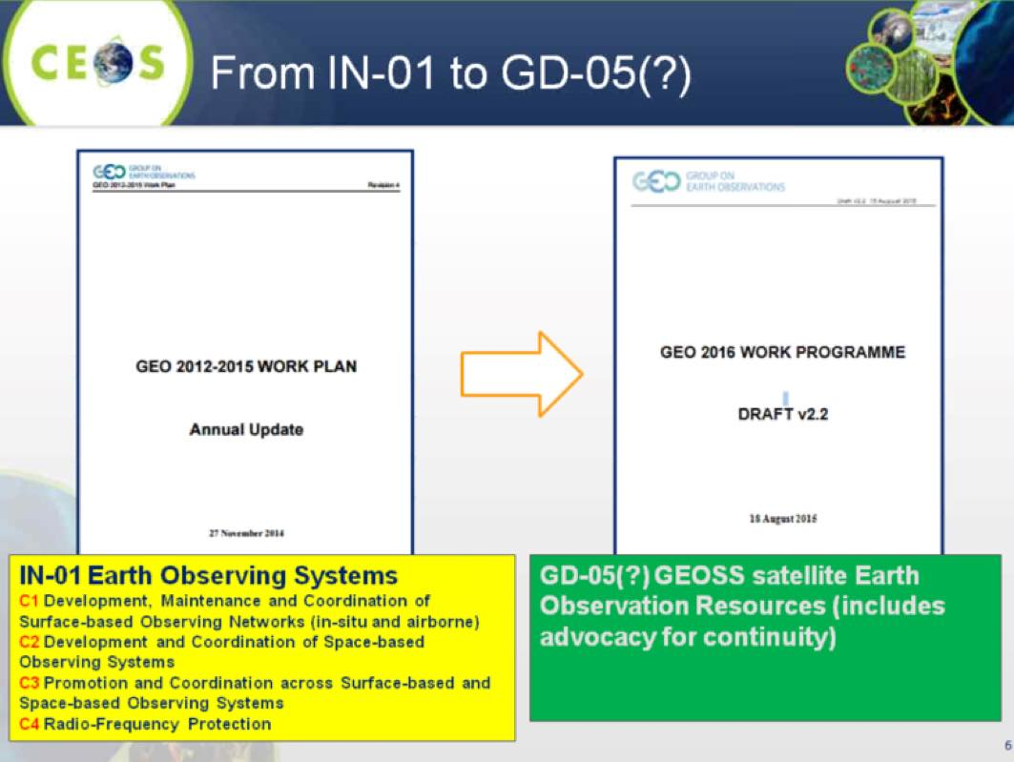
Jonathon summarised the content of GD-05, noting that it is basically “CEOS core business”, and includes:
- coordinate space missions to provide new observations;
- support sustained production of fundamental variable sets as defined by authoritative user communities;
- develop new technologies/approaches to enhance space data access;
- support the provision of satellite data;
- provide evidence of the unique, and complementary, value of satellite data
- provide information on gaps and opportunities to national governments and the private sector;
- coordinate increased interoperability among space datasets; and,
- support GEO community efforts to increase interoperability between space and in-situ datasets.
Stephen Briggs (ESA) emphasised that IN-01 was really a task to deliver all data to GEO (including in situ), and that this has been addressed with the advent of GD-05 (and a parallel in situ task GD-04).
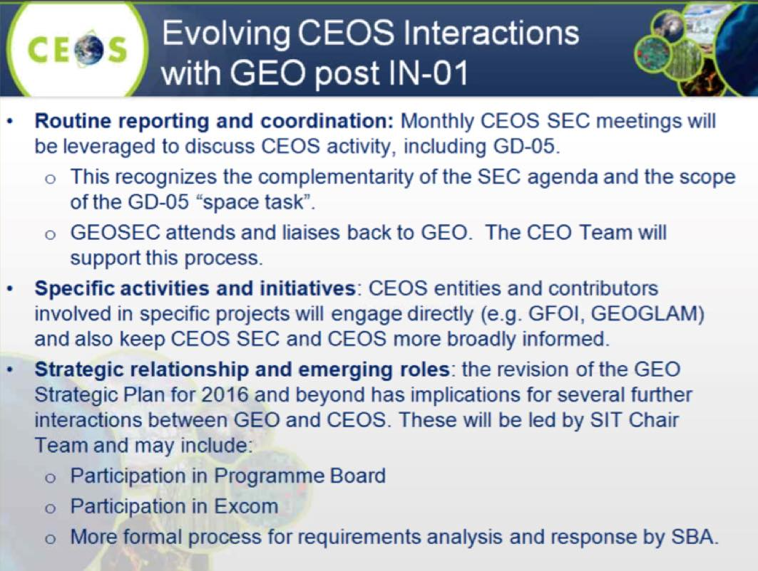
Stephen noted the GEO Strategic Plan is adopting many of the suggestions that CEOS has made in the past, and CEOS may be more directly involved in the management process after GEO Plenary (i.e. Programme Board, Executive Committee). Though there may be changes to this structure as things are finalised prior to GEO Plenary.
A brief discussion followed:
- Albrecht von Bargen (DLR) noted that CEOS participation in the Programme Board and the Executive Committee is important, but that DLR does not see the added value of CEOS having its ‘own task’ (i.e. GD-05) given that CEOS manages its own work and activities. The GD-05 task builds in a stronger dependence on GEO which DLR does not support.
- Stephen Briggs noted that the GD-05 task has been defined by CEOS, but it could be done by a group other than CEOS, though it is not clear how it would be beneficial to CEOS for someone other than CEOS to do this task. If there is an overall task within GEO to coordinate space data acquisitions, then it should be lead by CEOS. He also stressed that CEOS is free to have activities outside of those defined in GD-05.
SITWS-2015-08 | CEOS Chair | Add a Plenary slot led by SIT Vice Chair to discuss internal organization of CEOS approach to strategic issues arising from GEO Strategic Plan 2016-2025 | CEOS SEC 205

CEOS in the GEO Ministerial and GEO-XII Plenary
Alex Held (CSIRO) reviewed CEOS plans for support to the GEO Ministerial and Plenary.
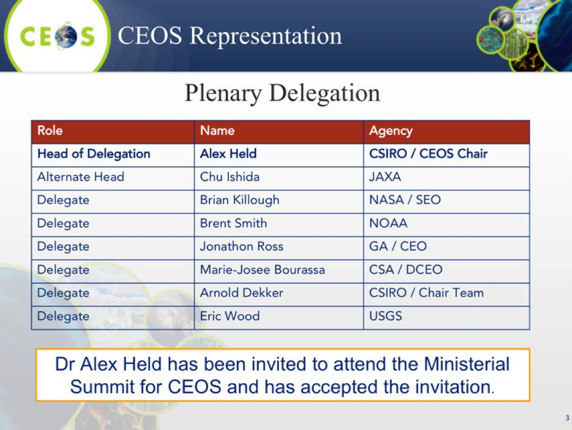
Alex noted that the Ministerial Declaration establishes the political mandate required for GEO, and GEO participants (CEOS and Agencies) to achieve the GEO Strategic Plan goals, and that CEOS has been active in providing detailed input to draft declaration text. The most recent inputs focussed on need to ensure:
- the goals and expectations Ministers establish by adopting the Declaration (and Strategic Plan);
- that they are matched by the commitments they make: ensuring participants (e.g. CEOS) can deliver what they ask for; and,
- that areas where these commitments are key: relationships with UN institutions and agencies, data sharing, and sustainability of observing systems.
Brent Smith (NOAA) noted that on the second day of the GEO Ministerial Working Group meeting (today), work on the Declaration was proceeding but there are still issues to be resolved. He noted that 13 ministers have confirmed, including ministers from the four GEO Co-Chairs. He also confirmed that the changes to the GEO Strategic Plan appear to be consistent with what André Obrégon reported.
Alex encouraged CEOS Agencies to connect within national structures to promote Ministerial awareness of invitations, and advise national GEO representatives of CEOS discussions and key messages. He also noted that CEOS will support a side event led by GEO Secretariat focussed on promoting the role of EO in monitoring UN Sustainable Development Goals, and a CEOS booth managed and staffed by Brian Killough (SEO) and Eric Wood (USGS), funded by the SEO and CSIRO.

UNFCCC & UN Sustainable Development Goals
Pascale Ultré-Guérard (SIT Chair) presented a summary of CEOS activities in support of COP21:
- a roundtable of CEOS principals including Mike Frielich, Alain Ratier, Shizuo Yamamoto, Volker Liebig was organised to promote climate from space during the Paris Airshow at Le Bourget;
- a space data focused session was organised during the Climate Conference in Paris in July where a presentation was given and CEOS materials were distributed;
- the role of space in climate monitoring will be further promoted during an exhibition at the Grand Palais in Paris during COP21 organised jointly by CNES and ESA open to the general public; and,
- a text advocating the role of satellites in climate monitoring is being developed under the umbrella of IAA and will be finalised at the Head of delegations summit in Mexico (17/09/2015). SIT Chair committed to circulate the final version once it has been released.
Kerry Sawyer (NOAA) summarised the existing CEOS documentation related to climate.
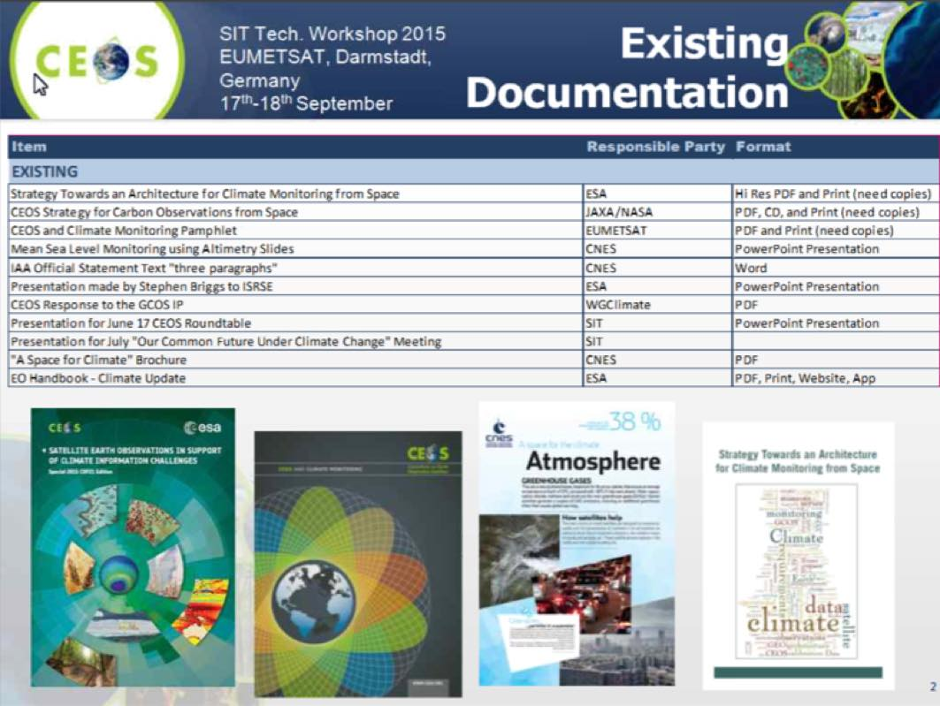
She noted that COP21 will be electronic only for publications, and so CEOS will need to adjust accordingly – for example by putting materials onto memory sticks. A brief discussion followed:
- Andrew Mitchell (NASA) noted that the IT policies of several agencies do not allow USB sticks to be used with agency equipment.
- Stephen Ward (JAXA) noted that a tablet (iPad and Android) version of the COP21 EO Handbook is being developed.
- Pascal Lecomte (ESA) noted that ESA is preparing a set of materials describing the ESA Climate Change Initiative (CCI) – though they are currently in a paper format. He noted that ESA are also creating an electronic handbook on the CCI which will be available for COP21. He noted that the CEOS website could feature a link to all available electronic COP21 materials.
- Stephen Ward (JAXA) noted that for the WCDRR EO Handbook, the focus was on developing a good mailing list so materials can be sent out in advance. Ivan Petiteville (ESA) noted that this has the added advantage of pre-informing participants.
- Steven Hosford (CNES) suggested developing a specific CEOS COP21 website or webpage might help, or perhaps a feature COP21 front page for the CEOS webpage.
- Kerry asked if any additional materials need to be prepared, and it was suggested that a two-pager summary of what CEOS is (which we have had in the past) could be valuable.
Pascal presented a summary of the EO Handbook, noting that two versions were produced in 2015, focused on informing decision makers on current and potential roles of satellites.
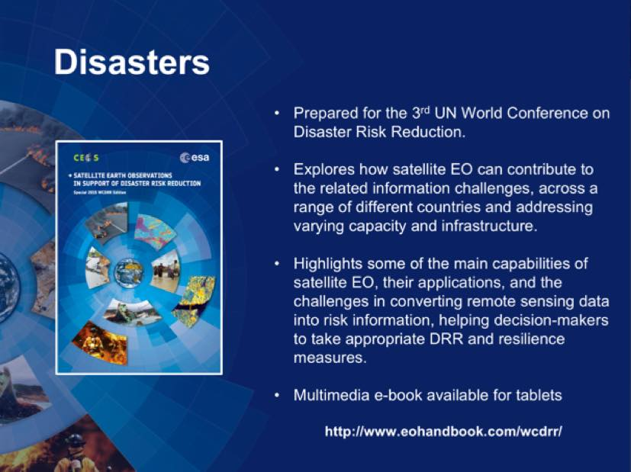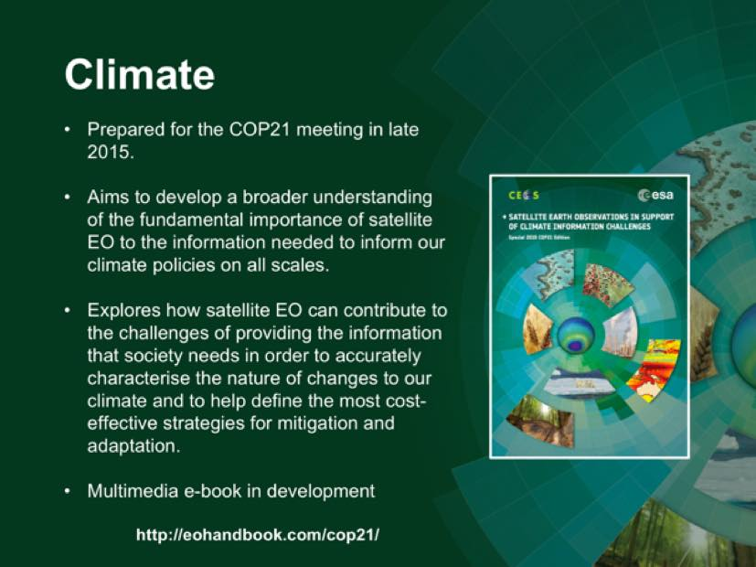
It was agreed to have a dedicated meeting ASAP between CEO/DCEO, Kerry Sawyer, WGClimate, SIT Chair and Vice Chair and CEOS Chair to coordinate on the plans for COP21 publications.
Marie-Josée Bourassa (CEO) presented a status updated on the UN Sustainable Development Goals (SDG). There are 17 goals, and 169 targets, with a number of targets having more than one indicator.
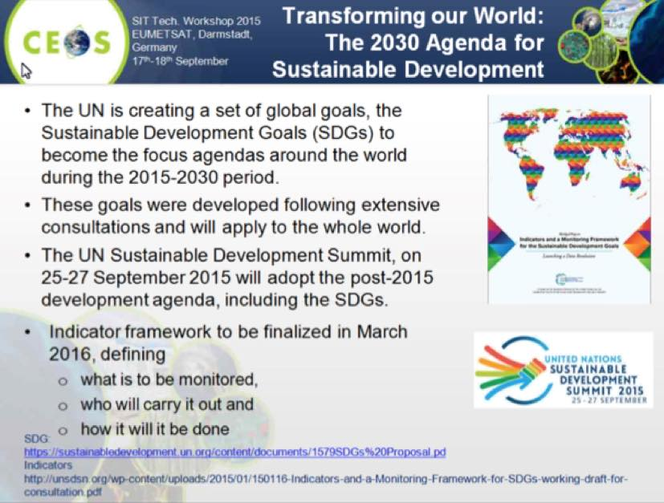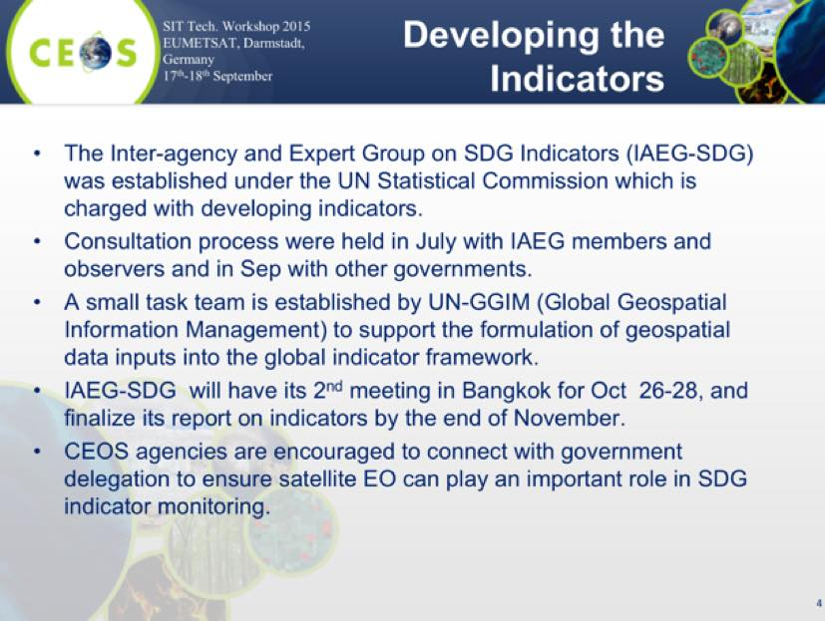
She noted that there will be an SDG side event at GEO Plenary with a number of sessions, including an overview of the goals, targets and indicators, perspectives from national governments, natural capital accounting, perspectives from Development Banks and the UN, and the GEO Initiatives on the SDG.
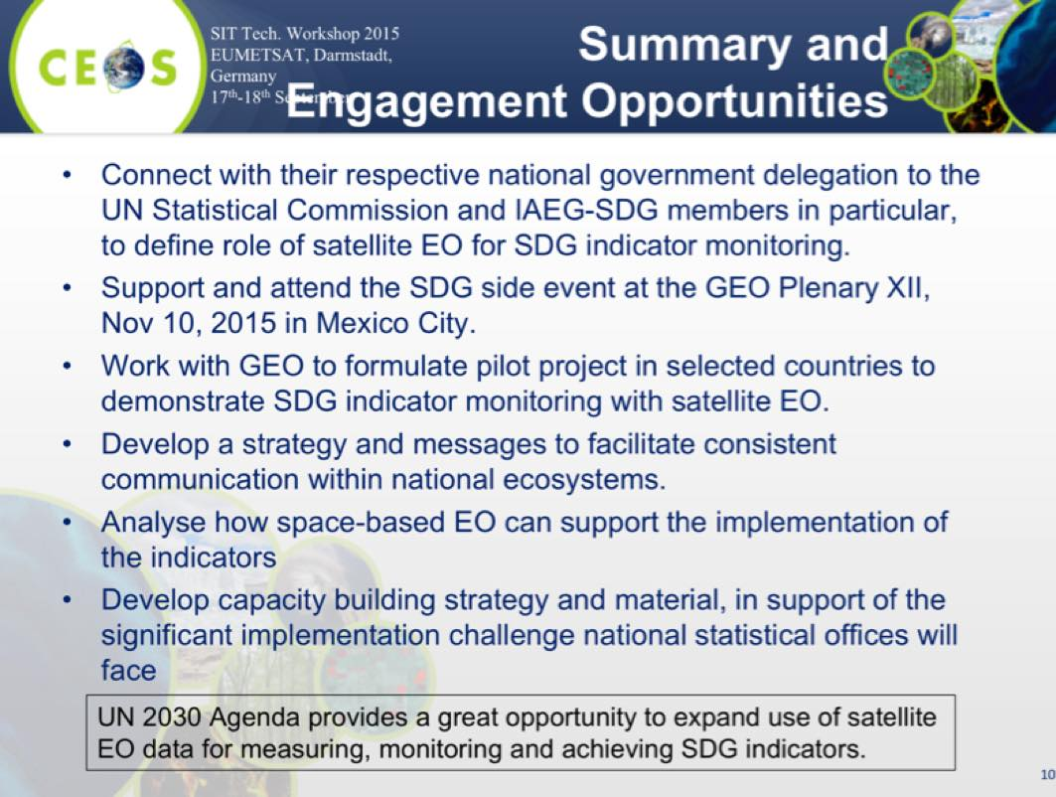
A brief discussion followed:
- Eric Wood (USGS) asked if it would be possible to get a more detailed version of the table on SDG Goals and Geospatial Data, and Marie-Josée agreed to follow-up.
- Ivan Petiteville (ESA) noted that CEOS should be cautious about engaging on the SDG, given that CEOS is a best efforts organisation and resources are a concern. Chu confirmed is this a concern, and it is not currently clear what is required – though the statistical community would expect a stable and reliable contribution, and so expectations need to be understood and managed.
- Chu noted that the SDG are clearly linked to different data types, and that CEOS may be able to contribute with a clear land cover product.
SITWS-2015-09 | SIT Chair | Organise a discussion of the climate material coordinator, SIT Chair and Vice Chair, CEOS Chair, SEO, CEO team, WGClimate Vice Chair to develop the CEOS COP21 communications strategy (in light of the announcement that COP-21 is a “paper free” event) | CEOS SEC 205
SITWS-2015-10 | CEOS Agencies | Volunteer experts to the Sustainable Development Goals UN-GGIM (Global Geospatial Information Management) Expert Task Group | ASAP before CEOS SEC 205

CEOS Office Holder Updates
CEOS Chair 2017 Chu Ishida (JAXA) noted that this issue has been discussed by the CEOS Secretariat for some time, and a letter was circulated calling for nominations – to which USGS has responded. A formal announcement is expected at Plenary.
CEOS SIT Vice Chair 2016-2017 Stephen Briggs (ESA) confirmed that ESA will assume the SIT Chair role as of Plenary, and will be seeking nominations for SIT Vice Chair 2016-2017 who will, in turn, assume the SIT Chair role for the period 2018-2019.
CEOS Executive Officer (CEO) and Deputy CEO (DCEO) arrangements 2015-2016 Marie-Joseé Bourassa confirmed that she will become the DCEO as of CEOS Plenary, Jonathon Ross will assume the CEO role, and that this arrangement will be in place until CEOS Plenary 2016.
SITWS-2015-11 | CEOS Agencies | Consider volunteering for the role of incoming SIT Vice Chair | CEOS Plenary

CEOS Three-Year Work Plan Status Update and Priorities for 2015
Marie-Josée Bourassa presented a summary of the status of the CEOS Work Plan 2015-2017, as well as the plan for the 2016 - 2018 update, noting that the objective is to complete the process at the end of February 2016 prior to SIT-31.
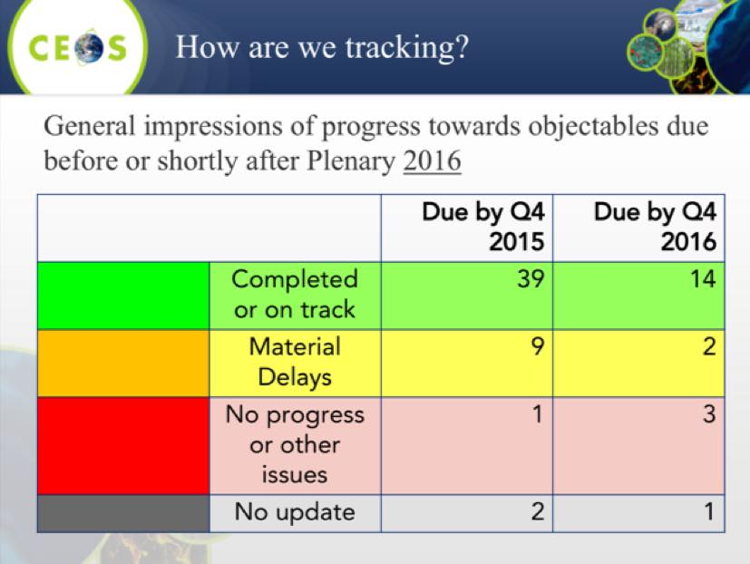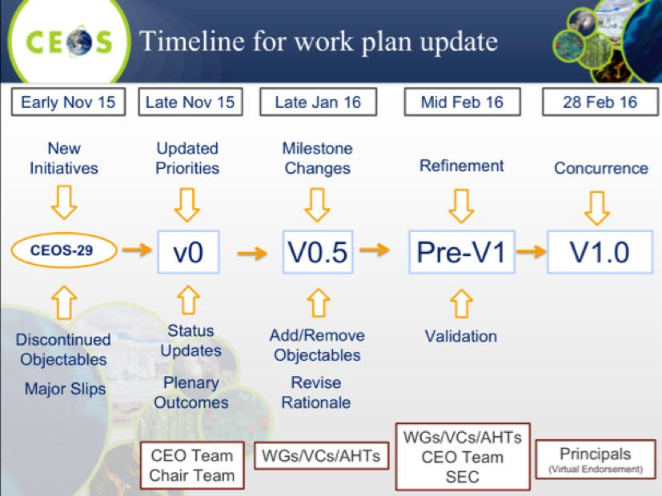
Marie-Josée noted that the CEO/DCEO team will reflected the outcomes of the SIT Workshop in the CEOS deliverables tracker.

CEOS Chair Themes for 2016
Alex Held (CSIRO) presented a summary of CSIRO’s themes for their upcoming CEOS Chair term. He noted that CSIRO plans to promote continuity of existing and ongoing activities, while promoting its own priorities.
The two main priorities are exploration of next generation data architectures, and the formulation of non-meteorological products from next generation geostationary satellites. These activities will draw upon expertise and capacity from existing CEOS Working Groups and Virtual Constellations, as well as member agency experts wishing to participate. He noted that the incoming CSIRO Chair team has circulated two papers on these priorities, and would welcome feedback from the CEOS community.
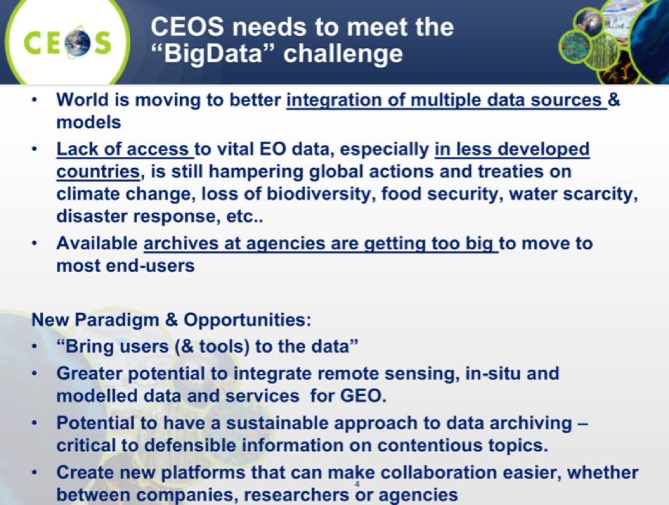
Alex noted that the new paradigm being considered in the new data architectures can play a powerful role in enabling users – including those without massive infrastructure, or expertise in data preparation and synthesis - to leverage complex large EO datasets. It can also present a solution to manage and exploit the dense time series of data that are being generated by an increasing number of data streams.
Alex also gave an overview of the potential for non-meteorological applications of geostationary satellites. These applications are being enabled by advances in spatial, spectral, and temporal resolution in these platforms – and a number of new products covering oceans and coastal waters, atmosphere, and land.
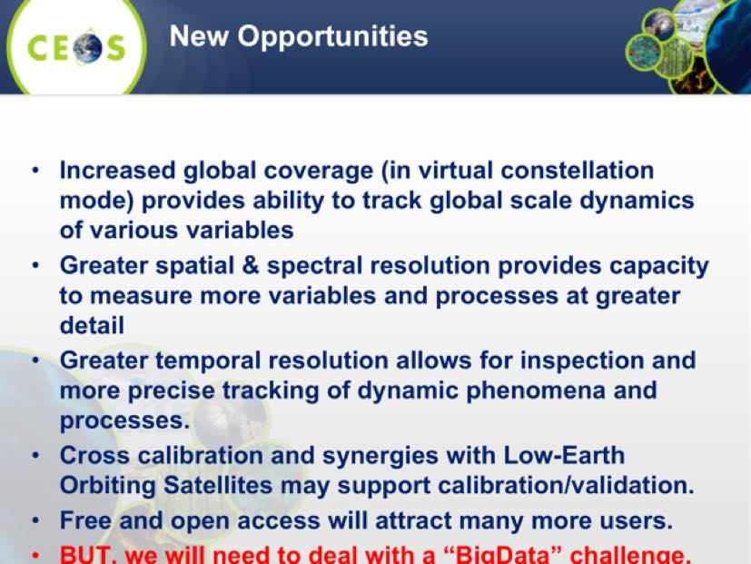
A brief discussion followed:
- Chu Ishida (JAXA) noted that JAXA was grateful for the opportunity to have back-to-back CEOS Chair terms by agencies from the Asia-Pacific region.
- Paul Counet (EUMETSAT) noted that the meteorological community is also working on next generation non-meteorological applications, a lot of work is on going, and that additional satellites are expected to be added completing the geostationary ring globally over Europe/Africa, North/South America, and Asia. Alex noted that this is one of the areas where CGMS and CEOS can work together on things, and he would be pleased to see these collaborations established.
- Paul DiGiacomo (NOAA) noted that there are opportunities to link these new geostationary applications to the Blue Planet initiative. He noted the GEOS-R team is working on terrestrial applications, and offered to make a connection.
SITWS-2015-12 | SIT Chair | Seek a CEOS representative to serve on the planning committee for the 3rd Blue Planet Symposium to be held September 2016 in Monterey, California | CEOS Plenary

29th Plenary Preparations
Nobuyoshi Fujimoto (JAXA) presented a summary of JAXA’s preparations for CEOS Plenary, as well as the Symposium planned for Tokyo prior to CEOS Plenary. He reviewed the key outcomes and decisions expected from Plenary.
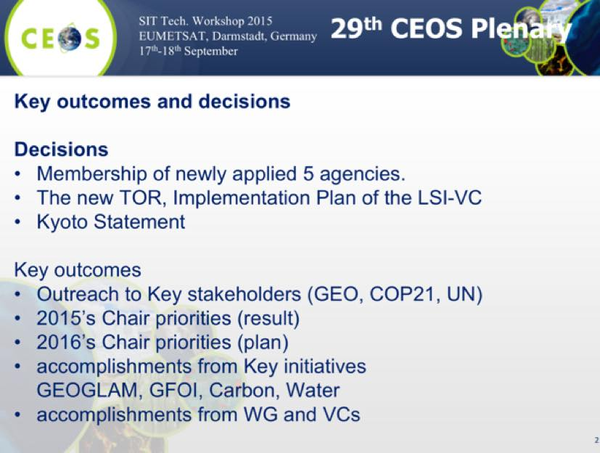
He noted that there are currently more than 70 registrations for Plenary.
Nobuyoshi reported on the Data Applications Report (DAR), noting that JAXA will be requesting a final review in October. He also outlined some post-DAR activities being considered:
- JAXA is considering how to apply findings from DAR in order to improve its data application activities;
- they are considering selecting representative data application cases, conducting value chain analysis to find areas of improvement, proposing possible improvements, and implementing where possible; and,
- JAXA hopes to report on the outcome of this post-DAR activities at 2016 CEOS Plenary in Australia.

SIT Workshop Action Item Confirmation
George Dyke (SIT Chair Team) presented a summary of the actions agreed at the Workshop. The actions table is embedded as an appendix to these minutes.

CEOS Information Management
Kim Holloway (SEO) presented a summary of CEOS information management activities, including on the CEOS website and the document management system. She also summarised the CEOS Social Media Strategy.
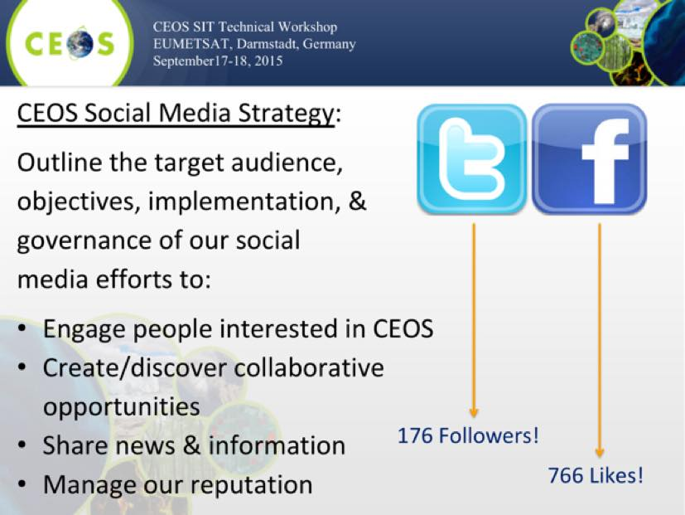
She asked for feedback on the social media strategy, which she will reflect in the final version to be submitted for for endorsement at CEOS Plenary. She reviewed the plans for the CEOS booth at the GEO Summit, which will feature CEOS promotional content displayed on a screen.

Closing Remarks
SIT Vice Chair
Stephen Briggs presented a summary of the SIT Vice Chair views on their coming SIT Chair term.
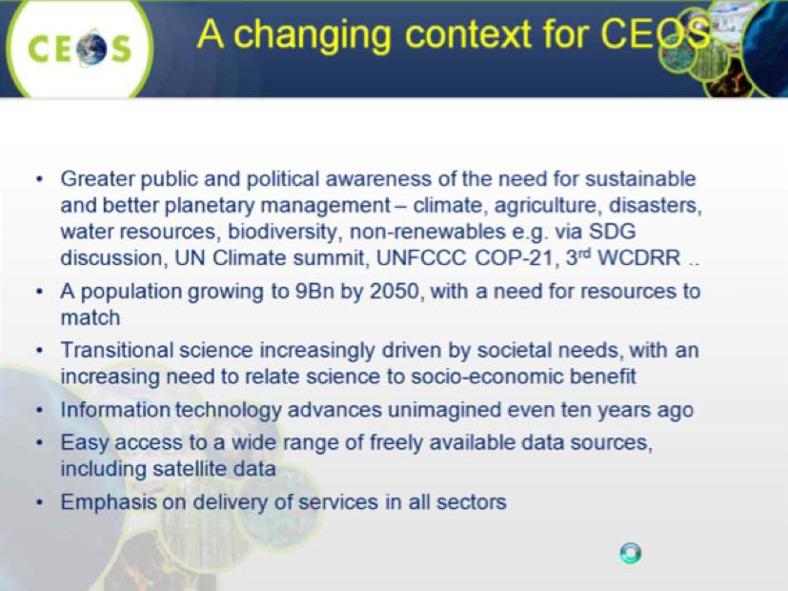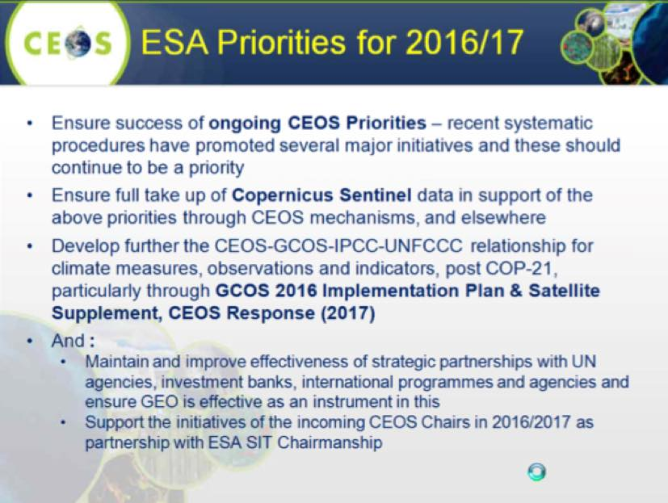
Stephen outlined his vision for the role of the three major meetings in the CEOS calendar:
- Plenary (Oct/Nov) setting the strategic direction for CEOS, setting priorities and giving targets;
- Strategic Implementation Team (SIT), meeting once per year (March/April) and setting strategic direction of implementation of CEOS Priorities set by Plenary; and,
- SIT workshop (September), a technical meeting to track progress against objectives in advance of Plenary, to identify any specific resource constraints for attention of Principals, and generally to prepare Plenary.
SIT Chair
Steven Hosford (CNES) presented a summary of plans for the proposed SIT operations survey, which has the objective of reviewing how SIT has been operating over the last two years, and providing inputs to the incoming SIT Chair Team. The survey will cover:
- main functions of the SIT Chair;
- CNES objectives presented prior to Plenary 2013; and,
- general comments.
The electronic survey will be opened on 1 October (after a brief CEOS Secretariat review), close on 20 October, and the results will be reviewed during a brief side meeting at Plenary. He asked that everyone take a few minutes to provide their feedback. Examples of the questions to be addressed include:
- how do you evaluate steering of activities?
- how do you evaluate SIT Chair interaction with VCs and WGs?
- how do you evaluate SIT & SIT WS meetings?
- how do you evaluate the interface between SIT Chair and other CEOS entities?
- how do you evaluate the interactions/supports with/to External Stakeholders?
Paul DiGiacomo (NOAA), Chu Ishida (JAXA), Christine Bognar and Andrew Mitchell (NASA), and a number of others expressed their thanks to SIT Chair Team for their leadership.
Pascale Ultré-Guérard (SIT Chair) provided some closing remarks, noting that the meeting including the day spent focusing specifically on VC and WG issues was productive and set CEOS up for a well organised and efficient Plenary meeting. She thanked all who prepared materials, and thanked the EUMETSAT team for their generous hosting of the meeting. She also thanked the SIT Chair Team including Steven, Mireille and Danielle, as well as the CEO Marie-Joseé and the DCEO Jono.

2015 SIT Technical Workshop Participants
Organisation | Participant | Organisation | Participant
ASI | Anna Rita Pisani | GGOS | Alisson Craddock
CGMS | Mikael Rattenborg | GA/DCEO | Jonathon Ross
CNES | Pascale Ultré-Guérard | JAXA | Chu Ishida
CNES | Jean-Louis Fellous | JAXA | Fujimoto Nobuyoshi
CNES | Steven Hosford | JAXA/RESTEC | Masatoshi Kamei
CNES | Richard Moreno | JAXA | Stephen Ward
CNES | Juliette Lambin | NASA | Christine Bognar
CNES | Patrice Henry | NASA | Steven Neeck
CNES | Mireille Paulin | NASA | Yonsook Enloe
CNES | Danielle Barrere | NASA | Andrew Mitchell
CNES | George Dyke | NASA | Kurtis Thome
CSA/CEO | Marie-Josée Bourassa | NASA | David Jarrett
CSIRO | Alex Held | NASA/SEO | Brian Killough
CSIRO | Flora Kerblat | NASA/SEO | Kim Holloway (WebEx)
DLR | Albrecht von Bargen | NOAA | Kerry Sawyer
EC | Astrid-Christina Koch | NOAA | Kenneth S. Casey
ESA | Stephen Briggs | NOAA | Paul DiGiacomo
ESA | Pascal Lecomte | NOAA | Gu Heng
ESA | Ivan Petiteville | NOAA | John Bates (WebEx)
ESA | Claus Zehner | NOAA | Brent Smith (WebEx)
EUMETSAT | Hans Bonekamp | SANSA | Jane Olwoch
EUMETSAT | Paul Counet | USGS | Steven Labahn
EUMETSAT | Julia Figa Saldana | USGS | Tom Cecere
EUMETSAT | Anna Ocarroll | USGS | Jenn Lacey
EUMETSAT | Carina Movitz (WebEx) | USGS | Eric Wood
EUMETSAT | Robert Husband (WebEx) | USGS | John Hana
GEO Secretariat | André Obrégon
GEO Secretariat | Gary Geller (WebEx)
GEO Secretariat | Dominique Berod (WebEx)
GEO Secretariat | Douglas Cripe (WebEx)
(WebEx) indicates remote participation via WebEx.

2015 SIT Workshop Actions

V0.0
No. | Actionee | Action | Due date
SITWS-2015-01 | SIT Chair | Contact WMO about the Polar Space Task Group (PSTG) activity in relation to the question raised concerning Sea Ice in the context of CEOS VCs | CEOS Plenary
SITWS-2015-02 | CEOS Agencies | Provide final nominations to Tom Cecere for representatives to the reformulated LSI-VC, including as Co-Lead | 9 October 2015
SITWS-2015-03 | WGISS Chair and SIT Chair | Coordinate a discussion item on archive purge alert procedures at CEOS SEC 205. (Depending on the outcome, a short discussion led by WGISS at Plenary may be required.) | CEOS SEC 205
SITWS-2015-04 | CEOS Agencies | Provide nominations for the new CEOS Lead for GFOI (from Feb 2016) – with reference to the criteria outlined in the SIT Workshop presentation | CEOS Plenary
SITWS-2015-05 | Carbon Strategy actionees (VCs and WGs) | Propose concrete achievable next steps with a 1-year time horizon, for consideration at SIT-31 | January 2016
SITWS-2015-06 | CEOS Agencies | Provide review comments on the updated Water Strategy Implementation Study Team (WSIST) report to JAXA. JAXA will issue a revision using language consistent with previous CEOS strategy document | Report expected early October. Comments within 2 weeks to support Plenary endorsement.
SITWS-2015-07 | CEOS Agencies | Provide nominations for the Chair of the proposed extension for the Water Strategy Implementation Study Team | CEOS Plenary
SITWS-2015-08 | CEOS Chair | Add a Plenary slot led by SIT Vice Chair to discuss internal organization of CEOS approach to strategic issues arising from GEO Strategic Plan 2016-2025 | CEOS SEC 205
SITWS-2015-09 | SIT Chair | Organise a discussion of the climate material coordinator, SIT Chair and Vice Chair, CEOS Chair, SEO, CEO team, WGClimate Vice Chair to develop the CEOS COP21 communications strategy (in light of the announcement that COP-21 is a “paper free” event) | CEOS SEC 205
SITWS-2015-10 | CEOS Agencies | Volunteer experts to the Sustainable Development Goals UN-GGIM (Global Geospatial Information Management) Expert Task Group | ASAP before CEOS SEC 205
SITWS-2015-11 | CEOS Agencies | Consider volunteering for the role of incoming SIT Vice Chair | CEOS Plenary
SITWS-2015-12 | SIT Chair | Seek a CEOS representative to serve on the planning committee for the 3rd Blue Planet Symposium to be held September 2016 in Monterey, California | CEOS Plenary

SIT-30 Action Item Status
No. | Action | Due date
SIT 30-1 | CEOS Work Plan responsible entities to provide an initial status update for their CEOS 3-Year Work Plan outcomes and deliverables using the new ceos-deliverables.org site and thereafter to update the action status at least quarterly | May 2015  COMPLETE – updates now on an ongoing basis
SIT 30-2 | SIT Chair to work with WGClimate Chair and CEOS SEC to refine the strategic messages within a text for COP21 and to distribute for review by CEOS Principals | COMPLETE
SIT 30-3 | ESA to plan & develop an EO Handbook with a climate focus for COP21, in consultation with SIT Chair, WGClimate and GCOS, planning circulation in advance to key stakeholders | COP21  COMPLETE – Handbook copies printed
SIT 30-4 | WGClimate Chair to work with SIT Chair to identify a coordinator to bring together climate material in preparation of COP21 | April 2015  COMPLETE NOAA nominates Kerry Sawyer
SIT 30-5 | SIT Chair and CEO Team to work with WGClimate to develop a process and timetable for review of the CEOS inputs to SBSTA/COP21 | April 2015  COMPLETE
SIT 30-6 | SIT Chair Team to circulate additional details about the COP21 event being prepared for the Grand Palais, Paris, referenced by Nicolas Bériot | May 2015  Update to be provided by SIT Chair under Workshop Item #18
SIT 30-7 | CEOS Agencies, Working Groups, Virtual Constellations and Ad-Hoc Teams to provide SIT Chair team with 1 or 2 compelling climate case study examples for use in the Climate Conference in Paris (July 2015) | 25 May 2015  Conference COMPLETE
SIT 30-8 | CEOS Agencies to ensure the GEO Principal(s) in their national governments, and the relevant Ministers and Departments, are aware of the forthcoming Information Note and invitation to the GEO Ministerial | 25 May 2015  COMPLETE
SIT 30-9 | CEOS Principals to convey CEOS strategic messages to their national GEO ExCom member (where relevant), emphasising the desire for CEOS to be represented on ExCom | May 2015  COMPLETE
SIT 30-10 | SIT Chair to coordinate with CEO Team and CEOS SEC to conclude the refined CEOS submission to GEO on their draft Post-2015 Strategy, reflecting agreements reached at SIT-30 | COMPLETE
SIT 30-11 | SIT Chair to send a letter to CEOS Principals whose agencies operate ocean colour missions requesting them to consider distribution of ocean colour radiometry satellite Level 0 or Level 1A, stressing the importance of validation across all agencies and why validation as well as calibration should be built into all ocean colour radiometry missions. SIT Chair will also echo these requests in the report to CEOS Plenary. | May 2015  COMPLETE
SIT 30-12 | SIT Chair Team to connect CMA to the VC Leads and WG Chairs and to help them explore their participation in the various groups | COMPLETE
SIT 30-13 | VCs & WGs to develop poster displays and a short presentation of their activities highlighting the most recent mission (for VCs) or major project (for WGs) within their purview to stimulate discussion at the VC/WG Working Day | COMPLETE
SIT 30-14 | Craig Donlon, on behalf of and in consultation with VC Leads and WG Chairs, to propose an agenda to SIT Chair for the VC/WG Day at SIT Technical Workshop | 25 May 2015  COMPLETE
SIT 30-15 | LSI-VC Team to submit an LSI Implementation Plan for distribution by SIT Chair and review by CEOS Agencies, for review at SIT Technical Workshop, and endorsement at CEOS Plenary. | 30 June 2015  COMPLETE
SIT 30-16 | SDCG Exec to work with DLR to ensure that the SDCG 3-Year Work Plan reflects the discussion at SIT-30 regarding the scope of CEOS efforts for GFOI and the eventual transition to operational entities. The amended Plan will be submitted to CEOS Plenary for information. | CEOS-29  Draft text agreed between DLR and SDCG to be presented for discussion at SIT WS – update under Workshop Item #9
SIT 30-17 | Core and contributing data stream providers to work with SDCG to implement the 3 Elements of the Space Data Strategy for GFOI in 2015 | End 2015  Update under Workshop Item #9
SIT 30-18 | WSIST to propose a consolidated CEOS response to GEO Water Strategy; and VCs and WGs requested to provide support | End August (for SIT Tech Workshop)  Update under Workshop Item #11
SIT 30-19 | SIT Chair to work with the co-leads of the CEOS Ad-hoc Working Group on GEOGLAM to identify a CEOS representative to the GEOGLAM Advisory Committee | End April  COMPLETE

28th CEOS Plenary Action Item Status
No. | Action | Due date
28-01 | CEOS SIT Chair to discuss with the GEO Secretariat the need to ensure that the very successful CEOS contributions to GEO Task IN-01 are accurately reflected in the GEOSS evaluation process that GEO communicates to ministers and national policy-makers at its Plenary. | GEO-XI  COMPLETE
28-02 | CEO, in consultation with the CEOS Chair and CEOS Agencies, to develop written and verbal interventions for the GEO-XI Plenary that will:  - Emphasise the overarching role of CEOS in coordinating international cooperation on space-based Earth observing systems for GEO;  - Reaffirm the very successful CEOS contributions to GEO to date, based on the sustained investments of CEOS Agencies;  - Emphasise the need for a formalised level of CEOS participation in the GEO Governance framework that reflects its unique role and the scale of its contributions; and  - Underscore the CEOS position that any revised SBA structure accurately reflects the full range of global community needs, and provide a vehicle for the structured and coherent collection of GEOSS requirements. | GEO-XI  COMPLETE
28-03 | CEOS Chair to send a letter to CEOS Agencies inviting nominations for participation in the LSI VC, and including a description of the preparatory activities to reconstitute the LSI VC (see Plenary Action 28-04), with a due date for receipt of nominations of 15th November 2015. | 5th November 2015  COMPLETE
28-04 | The LSI-VC, led by Tom Cecere (USGS), to prepare a draft Implementation Plan, based on the "Space Segment Coordination" option and including a proposed update to the LSI-VC ToRs, for review prior to, and discussion at, SIT-30. | SIT-30  IN PROGRESS  To be discussed under SIT WS agenda item #6
28-05 | CEOS Chair to send a letter to CEOS Agencies seeking nominations for the upcoming vacant position of Co-Chair of the SDCG for GFOI | 15th November 2014  COMPLETE
28-06 | SIT Chair in conjunction with the relevant WGs and VCs, to determine by SIT-30 whether appropriate implementation arrangements are in place for all actions associated with the CEOS Strategy for Carbon Observations from Space | SIT-30  IN PROGRESS  To be discussed under SIT WS agenda item #10
28-07 | CEOS Chair to inform the GEO IGWCO Chair that: i) CEOS considers that the GEO Water Strategy is a relevant guidance document for CEOS activities, ii) based on the first expression of interest of CEOS Agencies, CEOS is establishing a Water Strategy Implementation Study Team to define its potential contribution to the implementation of the Strategy | 15th November 2014  COMPLETE
28-08 | CEOS Chair, with the support of the CEO, to develop Terms of Reference for a Water Strategy Implementation Study Team and, once available, write to CEOS Agencies to solicit nominations for participation in this Study Team | 2nd December 2014  COMPLETE
28-09 | CEOS Chair to deliver the draft structure of the planned CEOS Data Applications Report to CEOS Agencies | 5th November 2014  COMPLETE
28-10 | CEOS Agencies to deliver abstracts for contributions to the planned CEOS Data Applications Report to the CEOS Chair, together with nominations for participation in the editorial team | 30th November 2014  COMPLETE

