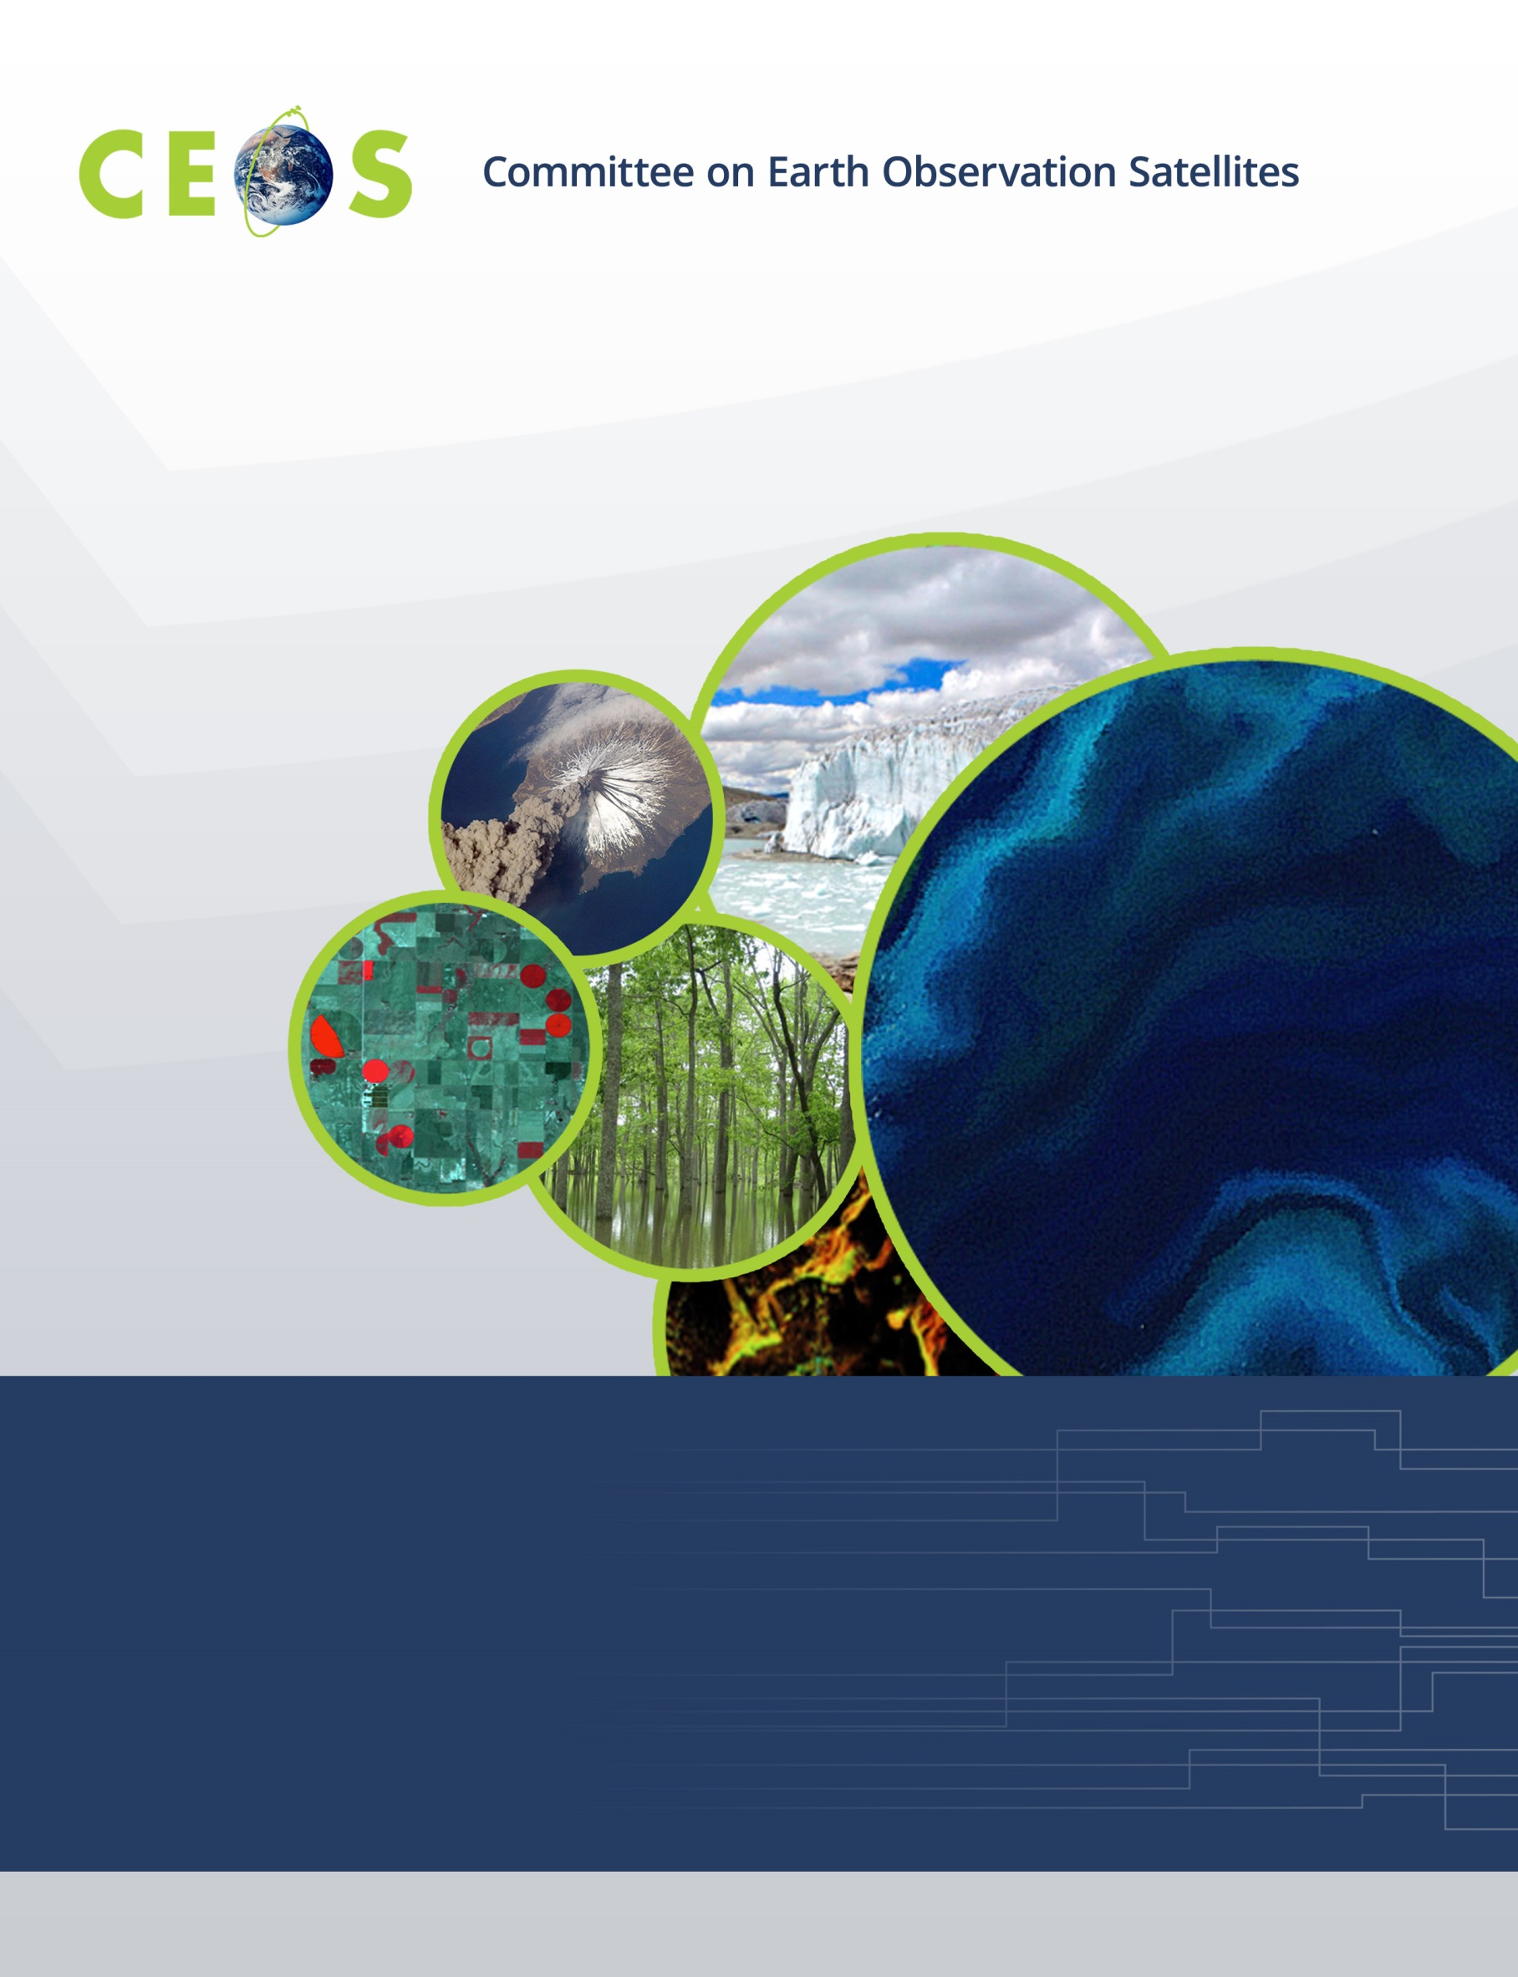

CEOS Social Media Strategy

July 20, 2015 Draft

Before the digital age, people accessed news and information from the same limited resources, and communication typically occurred via mail or telephone. Now that our media consumption and communication efforts are largely digital, we rely on the internet to both consume and communicate.
According to recent research by the Pew Research Center, 74% of the world’s internet users are using social media. While social media was originally intended for person-to-person interactions, it is now very often the place where we find and share news and information from and about organizations. In fact, not only do we learn about all kinds of businesses, organizations, and brands on social media, but we actually engage with them—learning who they are, what they’re about, and why we should (or shouldn’t) care.

Social media allows us to inform and interact with anyone who might benefit from an improved understanding of the Earth system—weather, climate, oceans, land, geology, natural resources, ecosystems, and natural and human-induced hazards. Since improving this understanding is the foundation of our work and essential to better predict, adapt to, and mitigate expected global changes and their impacts on society, our social media content has the potential to ultimately benefit every inhabitant of Earth.

As the world’s thought leader in satellite Earth observations, we will use social media to:

- reach out and engage with people interested in our work
- create and discover opportunities for collaboration
- share news and information, and
- manage our reputation.

This Social Media Strategy outlines the target audience, objectives, implementation, and governance of our organizational social media engagement efforts.

Target Audience

Our target audience on social media includes a broad range of satellite Earth observation stakeholders and users including:

- people representing government agencies, coordinating groups, and scientific/governmental organizations that develop, operate, or benefit from civil Earth observation satellites
- national, regional, and local decision makers
- people from organizations responsible for the implementation of international conventions and treaties
- people working in the business, industry, and service sectors
- current and future scientists, researchers, and educators

As we engage with our target audience, our content will gain more visibility and extend the reach of our impact on society.

Social Media Objectives

The CEOS Social Media Objectives:

- To increase global awareness about CEOS, the value and benefits of satellite Earth observations, and available resources by:

- posting original content about available CEOS Agency data, tools, and resources and our current activities
- engaging with and sharing relevant content from others
- assessing what types of content generate the most engagement
- redefining our strategy as necessary

- To drive more traffic to our website for more detailed information by:

- sharing original CEOS website content
- assessing how much web traffic we get from social media
- redefining our strategy as necessary.

Social Media Tactics

To accomplish our social media Objectives, we will:

- Create and maintain an editorial calendar that defines the types of content to be posted each week of the upcoming quarter (topics, news items, relevant content from others, educational materials, data/tools/resources) on each of the social media channels: Facebook, Twitter, YouTube, and LinkedIn.
- Invite people from throughout CEOS to create/share content about their work on CEOS social media channels.
- Monitor social media interactions on a daily basis and respond to interactions from others within 48 hours.
- Reference CEOS social media channels on all print media (i.e. Like us on Facebook! or Follow us on Twitter!)

Measurement Strategy

To track whether or not we are reaching our social media objectives, we will record the following metrics on a monthly basis and analyze overall outcomes each quarter to guide decisions on any strategy adjustments:

- Number of new likes/followers/subscribers on each channel (i.e. engagement); note any engagement with thought leaders in our field
- Number of two-way interactions with thought leaders in our field
- Number of visitors to the website and how many from social media (using Google Analytics)

Organizational Format

The CEOS Systems Engineering Office (SEO) Communications Lead will develop the quarterly editorial calendar and implement the CEOS social media strategy. She will invite others from the CEOS community to write articles or inform posts about current CEOS activities, based on the editorial calendar. She will also give posting privileges to social media people throughout the CEOS community (along with posting guidelines).

Internal Social Media Guidelines

- Avoid any negative reference to other people, organizations, competitors, clients, or coworkers. If you wouldn’t say it at a business event or social gathering, don't share it on a social media posting.

- Social media engagement is about educating and generating discussion, not the direct selling of any kind of event or service. Try to stimulate interest in a topic, idea, or article that you read. Make sure that the way you introduce content is funny, meaningful, or valuable – not just empty phrases like, “Great article!” (which can actually annoy followers instead of entice them).

- Don’t discuss or share information about CEOS or your organization that isn’t approved for sharing with the public. If you aren’t sure, don’t post it.

- You can always share or discuss information from blogs, videos, marketing communications, or press releases, but try to make sure you aren’t duplicating someone else’s posts when you do so.

- Be proud to be involved with CEOS, but on social media, be a person, not an organization. People want to engage with people (you), not “brands”.

- Use your subject matter expertise to engage people in discussions – it’s your expertise that generates interest in CEOS.

- When posting content to multiple channels, make sure you tailor it for that channel. Some of your followers may be on both, so you don’t want to be copy and pasting. You are a person, creating discussion in different “rooms” with different “audiences”, so don’t act like a robot reading a script. Change up the language and try different approaches.

- Make sure the way you mention CEOS and our activities aligns with our style guidelines for grammar, spelling, style, and tone. Take the time to be error-free, so that your errors are not shared and retweeted all over the world. Be professional, but fun, enthusiastic, and friendly at the same time.

- Post content about CEOS, CEOS-relevant topics, and CEOS activities, not about your personal life or the personal lives of anyone else affiliated with CEOS.

- Posting about relevant, current events that are receiving plenty of media attention can sometimes be a good way to generate more visibility and engagement on our social media channels. However, make sure to be sensitive to and respectful of the perspectives of everyone else in the world. When lives are at stake or there has been a major tragedy, it is appropriate to express our support and concern. It is not appropriate to try and benefit from or make light of others’ tragedies. Consider whether what you are posting about any topic might generate controversy or upset others who will see the post. Always lean toward being sensitive, considerate, and compassionate. If there is any question about the appropriateness of a post at all, please consult the SEO Communications Lead (or don’t post it at all).

- Bottom-line: Engage in social media channels as you would at a business meeting, industry event, or social gathering. It’s all about how you show up and what you share. Always be respectful, responsive, helpful, and kind.

Mostly – Be creative and have fun! CEOS is your organization. If you aren’t sure if something will fly, discuss it with your colleagues or management. See if others have done something like it. Social media success requires a little experimentation, so don’t be afraid to try something new and see if it flies or flops. We will all learn from each other’s successes and failures. Just make sure you stick to these general guidelines.

Social Media Governance Policies

CEOS ensures international coordination of civil space-based Earth observation programs and promotes exchange of data to optimize societal benefit and inform decision making for securing a prosperous and sustainable future for humankind.

Ultimately, we believe satellite Earth observation data can give us all a brighter future, and we rely on effective international coordination and access to data for that to happen. Our Social Media Strategy allows us to build and strengthen our relationships with other organizations and the general public so that our clear, powerful, and unified voice moves them to partake in our Mission.

Our social media presence and impact is the responsibility of every person involved in CEOS. For that reason, we should all familiarize ourselves with these Social Media Governance Policies and feel free to discuss possible updates/improvements based on how it’s working and how it affects our ability to creatively/happily represent CEOS on social media.

Internal

- We (we = anyone involved with or representing CEOS on social media) will only communicate/participate on CEOS social media channels or about CEOS as authorized to do so.

- We should only post articles and videos we have fully watched and read to ensure they align with CEOS values, voice, and strategy. We should never use hashtags or trending phrases without first researching the actual meaning of those hashtags or phrases. We should assume to know nothing until we’ve done our research.

- We will not post any complaints or negative opinions about CEOS to other people or organizations on any social media channel, including on our own personal social media accounts.

- We will not instigate or participate in any behaviors/ communications/activities online or on any social media channel that could be considered/misconstrued/legally defined as harassment/discrimination/ retaliation. It is our responsibility to learn what these prohibited behaviors/communications/ activities might include by requesting guidance from the SEO Communications Lead. We are all fully liable to be prosecuted as individuals for any damage caused by engaging in these prohibited behaviors/communications/ activities.

- We will document all complaints or negative comments made about/related to CEOS via social media by notifying the SEO Communications Lead immediately.

Any person that does not adhere to CEOS social media policies will be blocked from participating in CEOS social media interactions as decided by the SEO Communications Lead with the concurrence of the CEOS chair and/or CEO Team.

External

CEOS engages with other organizations/people in the social media world on Facebook, Twitter, YouTube, and LinkedIn. To give our online community a good idea of how to engage with us on social media, we’ve developed the following guidelines:

- Don’t do anything that breaks the law.

- Be polite and courteous, even if you disagree. Excessive name calling, profanity, fighting words, discriminatory epithets, sexual harassment, bullying, gruesome language or the like, will not be tolerated.

- Stay on topic. Keep the conversation relevant to the community and contribute to the dialogue. We reserve the right to remove content that is off-topic, out of context, spam, promotional, or links to third party sites. Please support any claims with links to information sources whenever possible. We love opinions; we love them even more when you back them up with facts.

- Keep it real. All wall postings should come from a real person and Facebook profile. Postings from fake or anonymous profiles will be deleted when discovered.

- There is a place for customer service-related questions, complaints, concerns or ideas from customers. If you are a customer and have a customer service comment, complaint, concern or idea, we encourage you to contact us via the CEOS website to ensure that we can respond in a timely manner. Please note that any customer service posts published on social media by customers will be removed when discovered. As always, if you would like to comment about customer service or any other issue, you can visit our website.

- We strive to respond to as many relevant questions and comments as possible, but we reserve the right to use our judgment in selecting the messages we respond to.

- None of our interactions with any other social media accounts constitute an endorsement, even if we repost, “like”, or “favorite” their content. The posting and presence of content on any CEOS social media channel or CEOS website does not necessarily mean that CEOS agrees with the content, ensures its accuracy, or otherwise approves of it. It also does not constitute a binding representation, agreement, or endorsement on the part of CEOS.

What to Post

Here are a few examples of what to post on CEOS social media channels:

Post | Description
We help protect our world’s forests by sharing and coordinating satellite data. [Link to article about SDCG/GFOI on CEOS.org + Cool image]. | This post uses active voice and uses plain, simple language that can be meaningful to our entire audience, regardless of background or affiliation. It also makes a strong point and includes an eye-catching, relevant, high-impact image or links to an article on our website for more information.
Our hearts are with everyone in #‎Nepal, and our Agencies are actively providing satellite data in an effort to support #‎NepalEarthquake recovery.  The U.S. Geological Survey (USGS) is hosting high resolution data from Planet Labs and Digital Globe. The ESA - European Space Agency- has tasked the Sentinel-1A satellite to acquire radar data over the region. French, Italian, and German Agencies (CNES, Deutsches Zentrum für Luft- und Raumfahrt (DLR), ASI) are providing satellite data too!  The International Charter for Space & Major Disasters is another major way that Agencies are sharing satellite data to support recovery efforts.  We are with you, Nepal! | This post is a bit lengthy, but it accomplishes several things.  First, it speaks to a current event of high importance and demonstrates that we are a caring, compassionate, actively involved organization who jumps up to make a difference when it counts. But it’s not just about us, it’s about letting Nepal know we care during such a tragic and difficult time for them. Not only do we care, but we are here to help.  The length of the post comes from tagging the CEOS Agencies involved in contributing satellite data to Nepal recovery efforts, but it’s worthwhile to include these tags, because they deserve a high five for sharing data, and because we also benefit from being seen by the thousands of followers of these Agencies on social media.  Note that the focus is on showing compassion and support for Nepal and celebrating others who are also showing compassion and support. In no way does this post make light of the tragic situation or attempt to benefit from it – doing so would be inappropriate and callous.
Happy Earth Day! It's an honor to share this beautiful planet with all of you as we continue our work to understand and protect it.  #‎EarthDay #‎CEOS  [Shared link from EUMETSAT of view of Earth from space] | Another current event! Everything doesn’t have to be technical and serious. Sometimes, it’s good to just share our follower’s appreciation for our beautiful planet or really cool news about space.  While we’re at it, though, we may as well do it while sharing a gorgeous image of Earth from space posted by our Facebook friend, EUMETSAT. This broadens the reach of their post and gets us seen by their followers too. It’s always good to share quality content from other CEOS Agencies.
Congratulations to the Japan Aerospace Exploration Agency (JAXA) on becoming the 2015 CEOS Chair. [Link to Chair Priorities Document on the CEOS Website] | This is a bit of an internal happening, but our Agencies (and their employees and citizens) are part of our audience, and they like receiving due recognition for their involvement.

What Not to Post

Here are a few examples of what not to post on CEOS social media channels:

Post | Description
The CEOS Ad Hoc Team for SDCG for GFOI, which coordinates data acquisition to assess global deforestation & forest degradation, began in 2011. | Avoid the use of jargon and acronyms that are only internally useful. Instead use plain, simple language that makes a strong point and include relevant, high-impact images or links to articles on our website for more information. Keep facts currently relevant and interesting – a social media snippet is not the best place to tell people about your organizational history (unless it’s a landmark anniversary).
The XLTN Mission fails again. | Avoid posting anything that might embarrass whoever the post is about. If a mission fails, we can share an article from that Agency about what happened, but it’s better if our language is more neutral: “Recent news about the XLTN launch: [link to article]”
Cool article!  [Link to article.] | Make your words count. Rather than posting vague comments about the content you’re sharing, say something substantive or quote from the article. For example, “Satellite data expected to reduce the lost of lives and property by 50% in 2016.” will get a lot more clicks than “Cool article!”
SPAM | Don’t try to sell irrelevant products or programs via the CEOS social media channels. People will un-follow us for this quickly.
Had a great birthday party yesterday! Thanks to everyone who showed up! | Keep your personal information on your personal social media channels. It can be easy to accidentally post on the CEOS page when you actually meant to post on your personal page, so be mindful and please pay attention.

Adopted from Maximize Your Social by Neal Schaffer
Adopted from Maximize Your Social by Neal Schaffer
Adopted from Wal-Mart’s Social Media Guidelines

