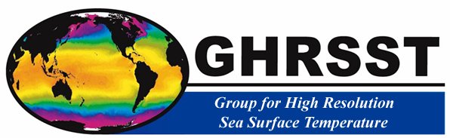

A CEOS Constellation for Sea Surface Temperature (SST-VC)

Implementation Plan (IP): March 2012

Document Management
Reference: | CEOS-SST-VC-IP-Iss-1-Rev-6-final.docx
Version: | 1 | Document Revision: | 6 | Status: | FINAL
Last Save date: | 03/03/2012 11:43:00
Date of issue: | 3rd March 2012
Document type: | Microsoft Word 2012 (docx)
Book Captain: | Craig Donlon (craig.donlon@esa.int) and Kenneth S. Casey (kenneth.casey@noaa.gov)
Author: | Craig Donlon, Kenneth S. Casey, K Misako, A. Bingham, H. Bonekamp, A Kaiser Weiss, P. Minnett
Master File Location: | URL to location of online resource:  Approved version: https://www.ghrsst.org/documents/q/category/ceos-sea-surface-temperature-virtual-constellation/

Please reference this document as:
Donlon, C. J., K. S. Casey, M. Kachi, A. Bingham, H. Bonekamp, A. Kaiser-Weiss and P. Minnett, 2012, Implementation Plan (2012) for the CEOS Virtual Constellation for Sea Surface Temperature (SST-VC), available from the GHRSST International Project Office, http://www.ghrsst.org

Change Log
Reason for change |  | Issue |  | Revision |  | Date
 | Draft based on full proposal plus inputs and comments from CEOS SIT (Teleconference 14/02/2012) |  | 1 |  | 1 | 14th February 2012
 | Revisions based on inputs from K Misako, A. Bingham, K. Casey, H. Bonekamp, A., O’Caroll, S. Ward, C Donlon, K Sawyer, |  | 1 |  | 2 | 23rd February 2012
 | Revisions by K. Casey, A Kaiser Weiss, |  | 1 |  | 3 | 25th February 2012
 | Final edits and revisions including comments from all members |  | 1 |  | 4 | 1st March 2012
 | Additional corrections from C Donlon, I. Petiteville, A Kaiser-Weiss, M. Kachi, K Casey |  | 1 |  | 5 | 2nd March 2012
 | P. Minnett added ISSI Science Team workshop details |  | 1 |  | 6 | 3rd March 2012

The CEOS Constellation for Sea Surface Temperature (SST-VC)

Implementation Plan (2012): March 2012
Executive Summary
This document is the 2012 Implementation Plan (IP) of the CEOS Sea Surface Temperature Virtual Constellation (SST-VC), designed to further optimize SST observation and data production.

The CEOS SST-VC Membership 2012
Kenneth S Casey | NOAA, USA
Craig J Donlon | European Space Agency, The Netherlands
Misako Kachi | Japan Aerospace Exploration Agency (JAXA), Japan
Andrew Bingham | NASA
Hans Bonekamp | EUMETSAT
TBD | ISRO
TBD | CONAE
TBD | NRSCC
TBD | NSMC/CMA
TBD | Roskosmos
TBD | KARI
TBD | UKSA
Carolin Richter | GCOS
 | GOOS
A Kaiser Weiss | GHRSST Project Office (ex officio)
P.J Minnett | GHRSST Science Team Chair (ex officio)

Table of Contents

Document Management 2
Change Log 2
The CEOS SST-VC Membership 2012 3
Table of Contents 4
1. Reference Documents 5
2. Introduction 5
3. SST-VC Terms of Reference 6
3.1. Membership 6
3.2. Meetings 7
4. Implementation of the SST-VC: 2012 Work-plan 7
4.1. Long-term Implementation strategy 7
4.2. Key Actions and Activities for 2012 9
4.3. Relevance to GEO Implementation plan 17
4.4. Schedule 18
5. Resourcing and Staffing issues 21
6. VC representation 22
7. Alignment of the SST-VC with CEOS working groups. 22
8. Conclusions 22

Reference Documents
[RD-1] A CEOS Constellation for Sea Surface Temperature (SST-VC), CEOS-SST-VC-Full-Proposal-Iss-1-Rev-3-FINAL.docx, Full Proposal, September 2011
[RD-2] SIT-27 Special Session on CEOS Virtual Constellations and Working Groups, Discussion Paper on Scope and Approach, V0.3 February 3, 2012
[RD-3] GHRST Terms of Reference, Agreed at the 9th GHRSST International Science Team Meeting, Perros Guirrec, France, June 2008, Available from the GHRSST Project Office (http://www.ghrsst.org)
[RD-4] “CEOS Constellation for GEO. Process paper”, dated 24 Sep. 2008.

Introduction
This document is the 2012 Implementation Plan (IP) for the CEOS Virtual Constellation for Sea Surface Temperature (SST-VC). It has been developed from a Full Proposal [RD-1] and is fully compliant with the CEOS paper on establishing new Virtual Constellations [RD-4]. The reader is referred to [RD-1] for a complete overview of the SST-VC. This IP recognises the strategic re-vectoring of CEOS through increased focus on Virtual Constellations (VC), led by CEOS SIT [RD-2], towards:

- Physical outputs and implementation
- Initial implementation targets
- Resourcing and staffing
- VC Representation
- Alignment with CEOS Working Groups (WG).

SST-VC IP activities for 2012 (and beyond) are linked to specific SST-VC Activities as set out in [RD-1]: these activities are strategically aligned with the priorities of the SST community and are fully in-line with those of the Group for High Resolution SST (GHRSST) that implements coordination through a wide variety of activities and projects. The expected outcomes of the SST-VC include:

- Continued support to an extensive user community with established and functional systems and services,
- Stronger CEOS Agency SST activities through better synergy and communication,
- Wider participation of CEOS Agencies in SST related activities,
- Better SST product and service interoperability building on the strengths of CEOS Agencies,
- Better data access and product applications by CEOS Agencies,
- Value for money to CEOS Agencies by capitalising on the already committed investments made to GHRSST,
- Reduced duplication of coordinating activities, and
- A stable and secure rapid spin up of SST-VC activities.

The CEOS SST-VC terms of reference (ToR) are presented in Section 3 followed by planned implementation activities for 2012 in Section 4. Section 5 discusses Resourcing and Staffing issues. Section 6 explains VC representation and section 7 the alignment of the SST-VC with CEOS working groups.

SST-VC Terms of Reference
The aim of the SST-VC is:

To foster the best quality sea surface temperature data for applications in short, medium, and decadal time scales in the most cost effective and efficient manner through international collaboration, scientific innovation, and rigor.

The SST-VC shall address the following strategic objectives to address this aim:

- Foster better engagement by Nations operating or preparing satellite SST sensors within the SST-VC and GHRSST frameworks,
- Maintain a strong and mutually supportive relationship with the GHRSST,
- Provide an interface to CEOS for GHRSST activities.
- Improve coordination, consolidation and development of the collective SST capability,
- Work to assure long-term continuity of passive microwave SST data,
- Develop the driving requirements to create, validate and sustain the development of an international ensemble of ECV SST measurements from space,
- Support outreach, education and development of new SST practitioners,
- Foster better use of reference sensors (e.g., ENVISAT AATSR and the Sentinel-3 SLSTR) within the Constellation,
- Provide advice and advocate to the international community the importance of SST,
- Enforce standards (e.g, definitions of SST, collection methods, algorithms, validation approaches, data management, product formats)
- Advocate and endorse future funding activities

Membership
The SST-VC shall appoint the following Executive Officers:

- Co-Chair selected from a CEOS Agency
- Co-Chair selected from a different CEOS Agency
- Secretary selected from a CEOS Agency
- SST-VC Members appointed by the representatives of CEOS Agencies and CEOS Affiliate Agencies
- The GHRSST Project Office Coordinator (ex officio)
- The GHRSST Science Team Chair (ex officio)

Notes:
- The Co-Chairs shall be responsible for the overall management of the CEOS SST-VC supported by the Secretary and SST-VC members.
- Co-chairs shall be elected by the SST-VC members on a 3 year renewable term following candidate proposal by a CEOS Agency member. Election shall be by majority vote.
- In order to maintain continuity, only one co-chair shall be replaced on a single occasion with at least 1 year between successive replacements where feasible.
- As a principle, Co-Chairs shall rotate throughout CEOS Agencies with SST capability.
- SST-VC members shall be proposed by CEOS principals.

Meetings
The SST-VC shall:
- Meet in plenary at least once per calendar year in conjunction with the annual GHRSST Science Team Meeting
- Conduct as much of its business as possible by teleconference, web-conference and video-conference

Implementation of the SST-VC: 2012 Work-plan

Long-term Implementation strategy
The CEOS SST-VC shall support the coordination consolidation and further development of satellite SST capability, products, user feedback and education/outreach activities using the recognized and well established GHRSST as the prime implementation mechanism.
Figure 1 presents a mapping between CEOS activities and those implemented by GHRSST [RD-3]. GHRSST functions internationally based on national and Agency support that today amounts to in excess of $25M over a period of nearly 11 years. GHRSST processes and services, implemented via many CEOS Agencies and National infrastructures, support on a daily basis, in near real time, the continued development and management of critical SST datasets and have attained a significant level of operational maturity. The extensive user community that depends on GHRSST includes operational agencies and scientific institutions, climate groups and media services. The level of maturity leads naturally to a formal implementation relationship with CEOS SST-VC, which coordinates the activities of Agencies for the sustained cost-effective collection of the satellite measurements on which GHRSST bases its work.
The purpose of the CEOS SST-VC is not to duplicate or to replace the activities of GHRSST but rather, to ensure formal communication and coordination between CEOS Agencies and GHRSST. The long-standing GHRSST Technical Advisory Groups (TAG) and ad hoc Working Groups (WG) are typically at the “cutting edge” of international SST activities delivering real coordination in space-based Earth observations for societal benefit. Co-ordination between the SST-VC and GHRSST will take place through the GHRSST Science Team Chair and the International Project Office coordinator that sit on the SST-VC (representing the GHRSST Science Team) and interactions with the various working groups of GHRSST and CEOS. Through this configuration, the SST-VC will provide an essential conduit for formal dialog between CEOS Agencies and GHRSST.
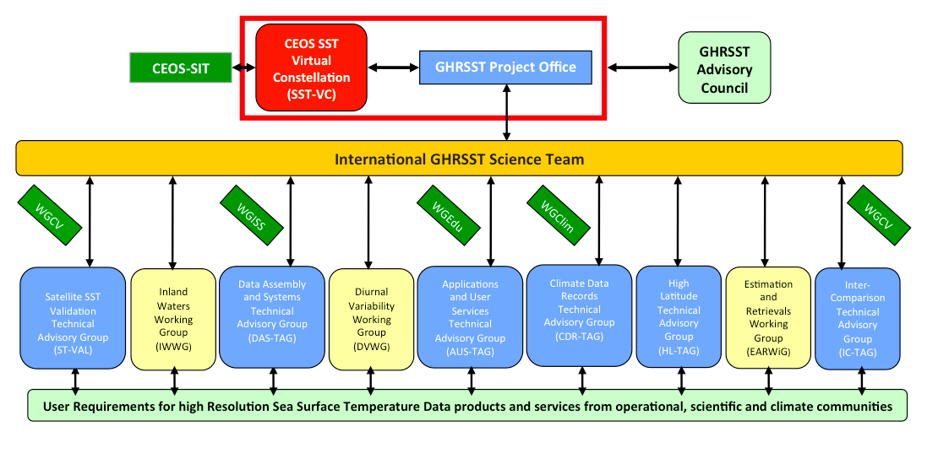
Figure 1. The mapping of interfaces for improved interaction between the SST-VC and the GHRSST Standing Technical Advisory Groups (TAG) and task oriented Working Groups (WG). CEOS Agencies will benefit from better connectivity to the long-standing international activities embodied within the GHRSST teams and their associated processes.

Key Actions and Activities for 2012
The twelve key actions and activities described in the SST-VC CEOS endorsed Full Proposal [RD-1] provide the backbone of the SST-VC implementation framework. These are described in Table 1 together with specific target activities for 2012 and long-term strategic targets (2-5 year horizon). For each action a specific measure is defined that shall be used to monitor the progress of the SST-VC. All activities will be reviewed and consolidated at the first SST-VC meeting planned in June 2012.
Table 1 Planned activities for the SST-VC in 2012
ID | Action | Activity | Measure | Milestone | Responsibility | Resources in place? | Output status  Year 1 = 2012
1 | Implement and Manage the CEOS SST-VC | 1.1 Select and appoint SST-VC Members and officers | Officers and members appointed | June 2012 | SST-VC Chairs and Members | From CEOS Agencies | Year 1:  - Co-Chairs appointed.  - Membership to be completed in coming months  Year 2+:  - Maintain commitments
 |  | 1.2 Hold annual SST-VC plenary | Meeting held | June 2012 | SST-VC Chairs and Members | Support from JAXA for 2012 meeting | Year 1:  - Meeting Arranged and invitations sent out  Year 2+:  - To be planned at 1st meeting
 |  | 1.3 Develop a CEOS SST-VC Portal (in line with other CEOS VC). | Implement Portal | V1 Portal ready by May 2012 | SST-VC members | Plan to use GHRSST (ESA funded) and CEOS web pages | Year 1:  - V1 web presence to be set up on GHRSST and CEOS  - Web contend incrementally added  - Close action
 |  |  | Regular update of web content | End 2012+ | SST-VC members | Yes (members time) | Year 1:  - Web contend incrementally added  Year 2+:  - Web contend incrementally added
 |  | 1.4 Maintain a close dialogue between GHRSST and CEOS agencies by reporting GHRSST, GEO and CEOS activities regularly to CEOS-SIT. | Report to SIT-27 La Jolla, California on March 27 and 28 2012. | March 24-26th 2012 | SST-VC Chairs | Travel funds not in place. | Issue: Co-Chairs not likely to attend the meeting in person. Alternates shall be appointed.
 |  |  | Report to CEOS Plenary | 2012 | SST-VC-Chairs | Travel funds not in place. | Issue: Discussions on funding options to attend meetings on-going
 |  | 1.5 Solicit and arrange adequate resources to execute the CEOS SST-VC | Resources for travel, meeting and implementation secured | 2012 | SST-VC members | Not all resources are available (travel costs are particularly difficult) | Year 1 and 2+:  Funding of member activities on a case-by-case basis
 |  | 1.6 Appoint SST-VC members to monitor and participate in CEOS WG as appropriate | Nominate reps. For WGCV, WGClimate, WGEdu, WGISS | 2012 | SST-VC members | Not all resources are available (travel costs are particularly difficult) | Year 1:  - Appoint members to represent SST-VC  - Attend meetings and circulate results to SST-VC members  Year 2+  - Attend meetings  - Review SST-VC appointments circulate results to SST-VC members
 |  | 1.7 Review annually SST-VC IP status | Conduct review and issue report to SST-VC members | 2012 | SST-VC Chairs and Secretary | Yes (members’ time) | Year 1 and 2+:  - Conduct reviews as defined by teleconference
 |  | 1.8 Ensure that each CEOS Agency having an SST capability (on-orbit or planned) has a representative member on the SST-VC | SST-VC Membership includes all SST capable Agencies | June 2012 | SST-VC Chairs and Secretary | Not all Agencies have committed yet | Year 1:  - Solicit Agency member appointments and invite representatives to 1st meeting in 2012  Year 2+:  - Review SST-VC appointments
 |  | 1.9 Maintain list of SST missions | Review and revise annually the CEOS MIM | 2012 | SST-VC members | Yes (members’ time) | Year 1:  - Review the MIM content and feedback to CEOS  Year 2+:  - Review the MIM content and feedback to CEOS
 |  | 1.10 Respond to outcomes of the CEOS Self Study (CSS) | Asses and implement CSS recommendations applicable to the SST-VC | 2012 | SST-VC members | Yes (members’ time) | Year 1:  - Review the CSS recommendations  - Plan activities to address CSS  Year 2+:  - Monitor and implement CSS outcomes within the SST-VC
2 | Minimise duplication of existing activities.  Act as a conduit for feedback between CEOS and the international SST science and operational community at all levels by formal reporting of SST-VC activities to CEOS SIT. | 2.1 Participation on Annual GHRSST Science Team meetings. | SST-VC membership participation on GHRSST ST annual meetings. | GHRSST XII June 2012 | SST-VC members | Travel funds not secured | Year 1:  - Joint SST-VC and GHRSST meeting planned in tokyo  Year 2+:  - Continue to work with GHRSST for co-located meetings
 |  | 2.2 Agree representation and feedback mechanisms between GHRSST and SST-VC | Appoint members of SST-VC to appropriate working groups within GHRSST and have overlap of membership to facilitate feedback and communication between CEOS and GHRSST. | GHRSST XIII, June 2012 | All SST-VC members  GHRSST | Yes (members’ time)  Travel funds not secured | Year 1:  - Agree cross representation at 1st SST-VC/GHRSST meeting  - Participate in GHRSST activities as required  Year 2+:  - Review SST-VC appointments  - Participate in GHRSST activities as required
3 | Development and optimization of the SST constellation  Advocate and promote the development and optimization (reduced redundancy and improved continuity and overlap among missions) of a virtual constellation of satellites (defined in Table 2) that satisfy key on-going GEOSS and GCOS requirements for SST measurements based on international consensus that shall build on the strengths of each CEOS Agency to sustain an effective constellation | 3.1 Develop a paper describing an optimised constellation for SST building on the feedback from the GHRSST Regional/Global task Sharing (R/GTS), Users and Agencies. | Peer reviewed journal paper prepared | Draft paper submitted to journal by end of 2013 | All SST-VC members | Members’ time secured  Publication costs not secured | Year 1 and 2:  - Build on the SST/GHRSST Ocean Obs 09 White Paper.  - Finish draft and circulate for review  - Submit to Journal  - Arrange publication costs if any  - Close action
 |  | 3.2 Contribute to the CEOS response to the 2010 GCOS Implementation Plan. | Prepare response to GCOS IP in collaboration with CEOS | Provide inputs to WGClimate as required. | All SST-VC members | Members’ time | Year 1:  - Work with CEOS bodies  - Work with GHRSST CDR-TAG  Year 2+:  - Continue to provide inputs
4 | Develop and implement metrics for SST services, products and users.  Develop and implement processes, based on an agreed set of metrics, that ensure the SST Constellation will satisfy the relevant community needs making full use of existing statements of requirements. | 4.1 Monitor International SST User Requirements | Provide CEOS inputs to the GHRSST URD. | Annual review conducted for 2012 | All SST-VC members  GHRSST | Members’ time | Year 1:  - Obtain new inputs for URD from CEOS  Year 2+:  - Continue to monitor SST User Requirements  - Annual review of SST User requirements
 |  | 4.2 Establish a process paper for defining appropriate metrics for an SST constellation | Develop a draft process paper together with GHRSST | End of 2012 | All SST-VC members  GHRSST | Members’ time | Year 1:  - Develop a list of metrics together with GHRSST  - Develop draft working paper  Year 2+:  - Deploy metrics to GHRSST web site and begin reporting to CEOS
5 | Coordinate consensus SST reference documents. | 5.1 Review and endorse the GHRSST GDS documentation for the benefit of CEOS agencies. | Conduct review following established GHRSST revision cycles. | Annual review conducted for 2012. | All SST-VC members  GHRSST | Members’ time | Year 1 and 2+:  - Obtain new inputs for GDS from SST-VC members  - Conduct annual review of GHRSST GDS  - Pass feedback to GHRSST  - Endorse GDS for CEOS agencies
 |  | 5.2 Coordinate and provide CEOS SST requirements to the GHRSST community. | Document and deliver CEOS requirements to GHRSST. | Complete as part of annual review process | All SST-VC members | Members’ time | Year 1 and 2+:  - Complete relevant SST-VC actions and provide CEOS requirements to GHRSST
6 | Encourage timely access to products.  Foster and encourage timely access to CEOS agency satellite SST data products. | 6.1 Foster better participation of CEOS Agencies within GHRSST activities. | Help develop new collaborations with CEOS agencies under the GHRSST R/GTS | Develop a Brochure explaining how the GHRSST R/GTS works and circulate to CEOS members | All SST-VC members  GHRSST | Members’ time  Travel resources are not secured. | Year 1 and 2+:  - Provide CEOS requirements to GHRSST working in partnership with GHRSST ST Chair, GPO, TAG and WG  - Complete brochure  - Monitor collaborations
 |  | 6.2 Identify current barriers to product access and application. | Develop recommendations to CEOS Agencies to address current barriers | Report to CEOS SIT | All SST-VC members  GHRSST | Members’ time  Travel resources are not secured. | Year 1 and 2+:  - Complete review of barriers to product access and applications  - Report to CEOS-SIT
7 | Develop and improve satellite SST Essential Climate Variable.  Foster the development, improvement, production and wide application of CEOS agency satellite SST Essential Climate Variable (ECV) satellite data products for climate applications and services. | 7.1 Develop requirements for producing, maintaining/sustaining and managing an ensemble of SST ECVs. (e.g. WG-Climate, NOAA, NASA, JAXA, EUMETSAT and ESA CCI, activities, GCOS SST/SI Working group, GOOS, OOPC and Essential Ocean Variable concept) to minimise duplication and maximise international partnerships. | Work with GHRSST and other relevant groups to develop the SST ECV Data Processing Framework (DPF) | Conduct survey of SST climate activities | All SST-VC members  GHRSST | Members’ time | Year 1 and 2+:  - Solicit requirements form CEOS WG-Climate  - Work with GHRSST and WG-Climate to define the most appropriate implementation framework.  - Collect a list of relevant SST climate activities at the ISSI sponsored Science Team workshop “Generation of Climate Data Records of Sea-Surface Temperature from current and future satellite radiometers”  - Work with the GCOS SST/SI WG  - Work with the ESA SST_cci project  - Work with the NASA “Converting NASA Satellite Datasets for the CMIP5/IPCC Assessment” activity
 |  | 7.2 Coordinate CEOS implementation actions through GCOS Action O7 [IP-04 O9]: “provision of best possible SST fields”. | Monitor SST-CDR activities with WG-Climate | Catalogue of SST-CDR activities | All SST-VC members and GHRSST | Members’ time. Other activities not secured. | Year 1 and 2+:  - Ensure CEOS requirements are properly articulated  - Liaise with GHRSST for implementation  - Work with Agency activities (e.g. SST_cci)  - Produce a catalogue of SST CDR activities.
 |  | 7.3 Work closely with CEOS WG-Climate as a demonstration CEOS VC | Work towards implementation of CEOS WG-Climate framework | Provide input to WG-Climate | SST-VC representation to WG-Climate | Travel not secured | Year 1 and 2+:  - Coordinate with WG-Climate and other groups  - Work with GHRSST CDR-TAG and other relevant groups to develop the SST ECV Data Processing Framework (DPF)
8 | Improve SST calibration, inter-calibration and validation. | 8.1 Work with GHRSST and the CEOS WGCV to educate and inform the GHRSST community on the benefits of the QA4EO process. | Improve QA4EO processes into GHRSST R/GTS and products. | Review QA4EO processes within GHRSST and ensure GDS is linked to QA4EO | SST-VC members and GHRSST | Resources to travel not in place | Year 1:  - Review QA4EO expectations  - Develop SST requirements to implement QA4 EO  - Develop strategy and plan to address QA4EO requirements  - Initiate discussions with GHRSST to review QA4EO issues and implementation  Year 2+:  - Implement QA4EO within SST activities.  - Review status of QA4EO implementation
 |  | 8.2 Work with WGCV-IVOS to maintain in situ validation reference measurements of climate quality | Organise and run an in situ radiometer and reference black-body round-robin inter-comparison | Organise inter-comparison exercise | SST-VC and GHRSST | ISSI sponsored Science Team workshop “Generation of Climate Data Records of Sea-Surface Temperature from current and future satellite radiometers” | Year 1:  - Plan inter-comparison activity at ISSI workshop in April 2012  Year2+:  - Run inter-comparison activity
9 | Improve user feedback to CEOS Agencies.  In partnership with data providers, coordinate SST user feedback for the benefit of CEOS Agencies | 9.1 Actively seek user feedback and report to CEOS | Conduct an annual user assessment for SST products at the GHRSST Science Team Meeting and prepare report on user feedback to SST-VC | GHRSST XIII | SST-VC members and GHRSST | Funds to travel to GHRSST not secured | Year 1:  - SST-VC and GHRSST meeting are co-located  - Write short report to CEOS  Year2+:  - Maintain SST-VC attendance at GHRSST meetings
10 | Develop training activities for satellite SST practitioners.  Develop and implement specific development and training activities to foster a next generation of satellite SST practitioners | 10.1 Document existing training materials and identify gaps | Working together with GHRSST, develop training materials inventory and publish on SST-VC/GHRSST web pages | Review and update annually | SST-VC members and GHRSST | Members’ time | Year 1:  - Review and catalogue available training resources on SST-VC web pages  - Identify gaps and define requirements to fill training gaps  Year 2+:  - Perform annual review of training resources and update web pages
 |  | 10.2 Develop training materials to fill identified gaps | Develop any required training materials and publish to SST-VC/GHRSST web pages | As required | SST-VC members and GHRSST | Members’ time | Year 1:  - Draft materials published  Year 2+:  - Materials finalized and updated annually as required
 |  | 10.3 Support training in satellite SST | Support international workshops (e.g., ESA Summer schools, GHRSST training workshop) using existing tools and products to promote a new generation of SST practitioners | As required | SST-VC members and GHRSST | Various resources and funds in place. E.g. ESA LearnEO! Project and others | Year 1 and 2+:  - Support SST training activities
11 | Liaise with the other Virtual Constellations  Liaise with the other Virtual Constellations (e.g., Ocean Vector Winds, Ocean Surface Topography, Ocean Colour Radiometry) to enable cross-fertilization among the communities and to create synergy | 11.1 Attend relevant VC meetings to better coordinate activities and synergies | Establish collaborations as appropriate | Attend relevant CEOS VC meetings in 2012 | SST-VC members | Funding to attend meetings not secured | Year 1 and 2+:  - Attend other VC meetings as required
 |  | 11.2 Inform other VC of SST-VC activities | Circulate SST-VC full proposal, SST-VC IP and solicit feedback and comments on mutually beneficial collaborations | 2012 (When IP has been accepted by SIT) | SST-VC members | Members’ time | Year 1:  - Circulate SST-VC material to other VC  - Solicit and document feedback from other VC  - Update SST-VC workplan as required.
12 | Prepare an Implementation Plan, to be approved by CEOS. | 12.1 Prepare IP, review plan with GHRSST community and submit to CEOS | Submit IP to CEOS SIT for approval. | SIT-27, March 27-28th 2012 | SST-VC members | Members time | Year 1:  - Prepare SST-VC Work plan  Year 2+:  - Review and update SST-VC work-plan on an annual basis

Relevance to GEO Implementation plan
The CEOS SST-VC is relevant to many areas within the GEO Implementation plan and through the implementation activities of GHRSST, the SST-VC and GHRSST partnership can be viewed as a demonstration of GEOSS in action. Rather than single out individual links to the proposed activities of the SST-VC, a list of specific activities within GEO is presented below.

INFRASTRUCTURE
In-1 Earth Observation
- C2 Development and Coordination of Space-based Observing Systems
- C3 C3 Promotion and Coordination across Surface-based and Space-based Observing Systems
IN-02 Earth Data Sets
- C1 Advances in Life-cycle Data Management

INFORMATION FOR SOCIETAL BENEFITS
SB-01 Oceans and Society: Blue Planet
- C2 Operational Systems for Monitoring of Marine and Coastal Ecosystems
- C3 A Global Operational Ocean Forecasting Network

CLIMATE
Understanding, assessing, predicting, mitigating, and adapting to climate variability and change
CL-01 Climate Information for Adaptation
- C1 Extension and Improvement of the Climate Record
- C2 Accelerated Implementation of the Global Climate Observing System
- C4 Easy Access to, and Use of, Climate Information

WATER
Improving water-resource management through better understanding of the water cycle
WA-01 Integrated Water Information (incl. Floods and Droughts)
- C3 Information Service for Cold Regions
- C4 Global Water Quality Products and Services

WEATHER
Improving weather information, forecasting and warning
WE-01 High-Impact Weather Prediction and Information

ECOSYSTEMS
Improving the management and protection of terrestrial, coastal and marine resources
EC-01 Global Ecosystem Monitoring
- C1 Global Standardized Ecosystem Classification, Map and Inventory
- C2 Operational Monitoring of Key Ecosystems and Related Services

BIODIVERSITY
Understanding, monitoring and conserving biodiversity
BI-01 Global Biodiversity Observation (GEO BON)
- C1 Global Biodiversity Observation Network (GEO BON)

Schedule
A draft schedule for SST-VC activities linked to the Major Actions in Section 4 is presented below. This is to be agreed by the SST-VC members.
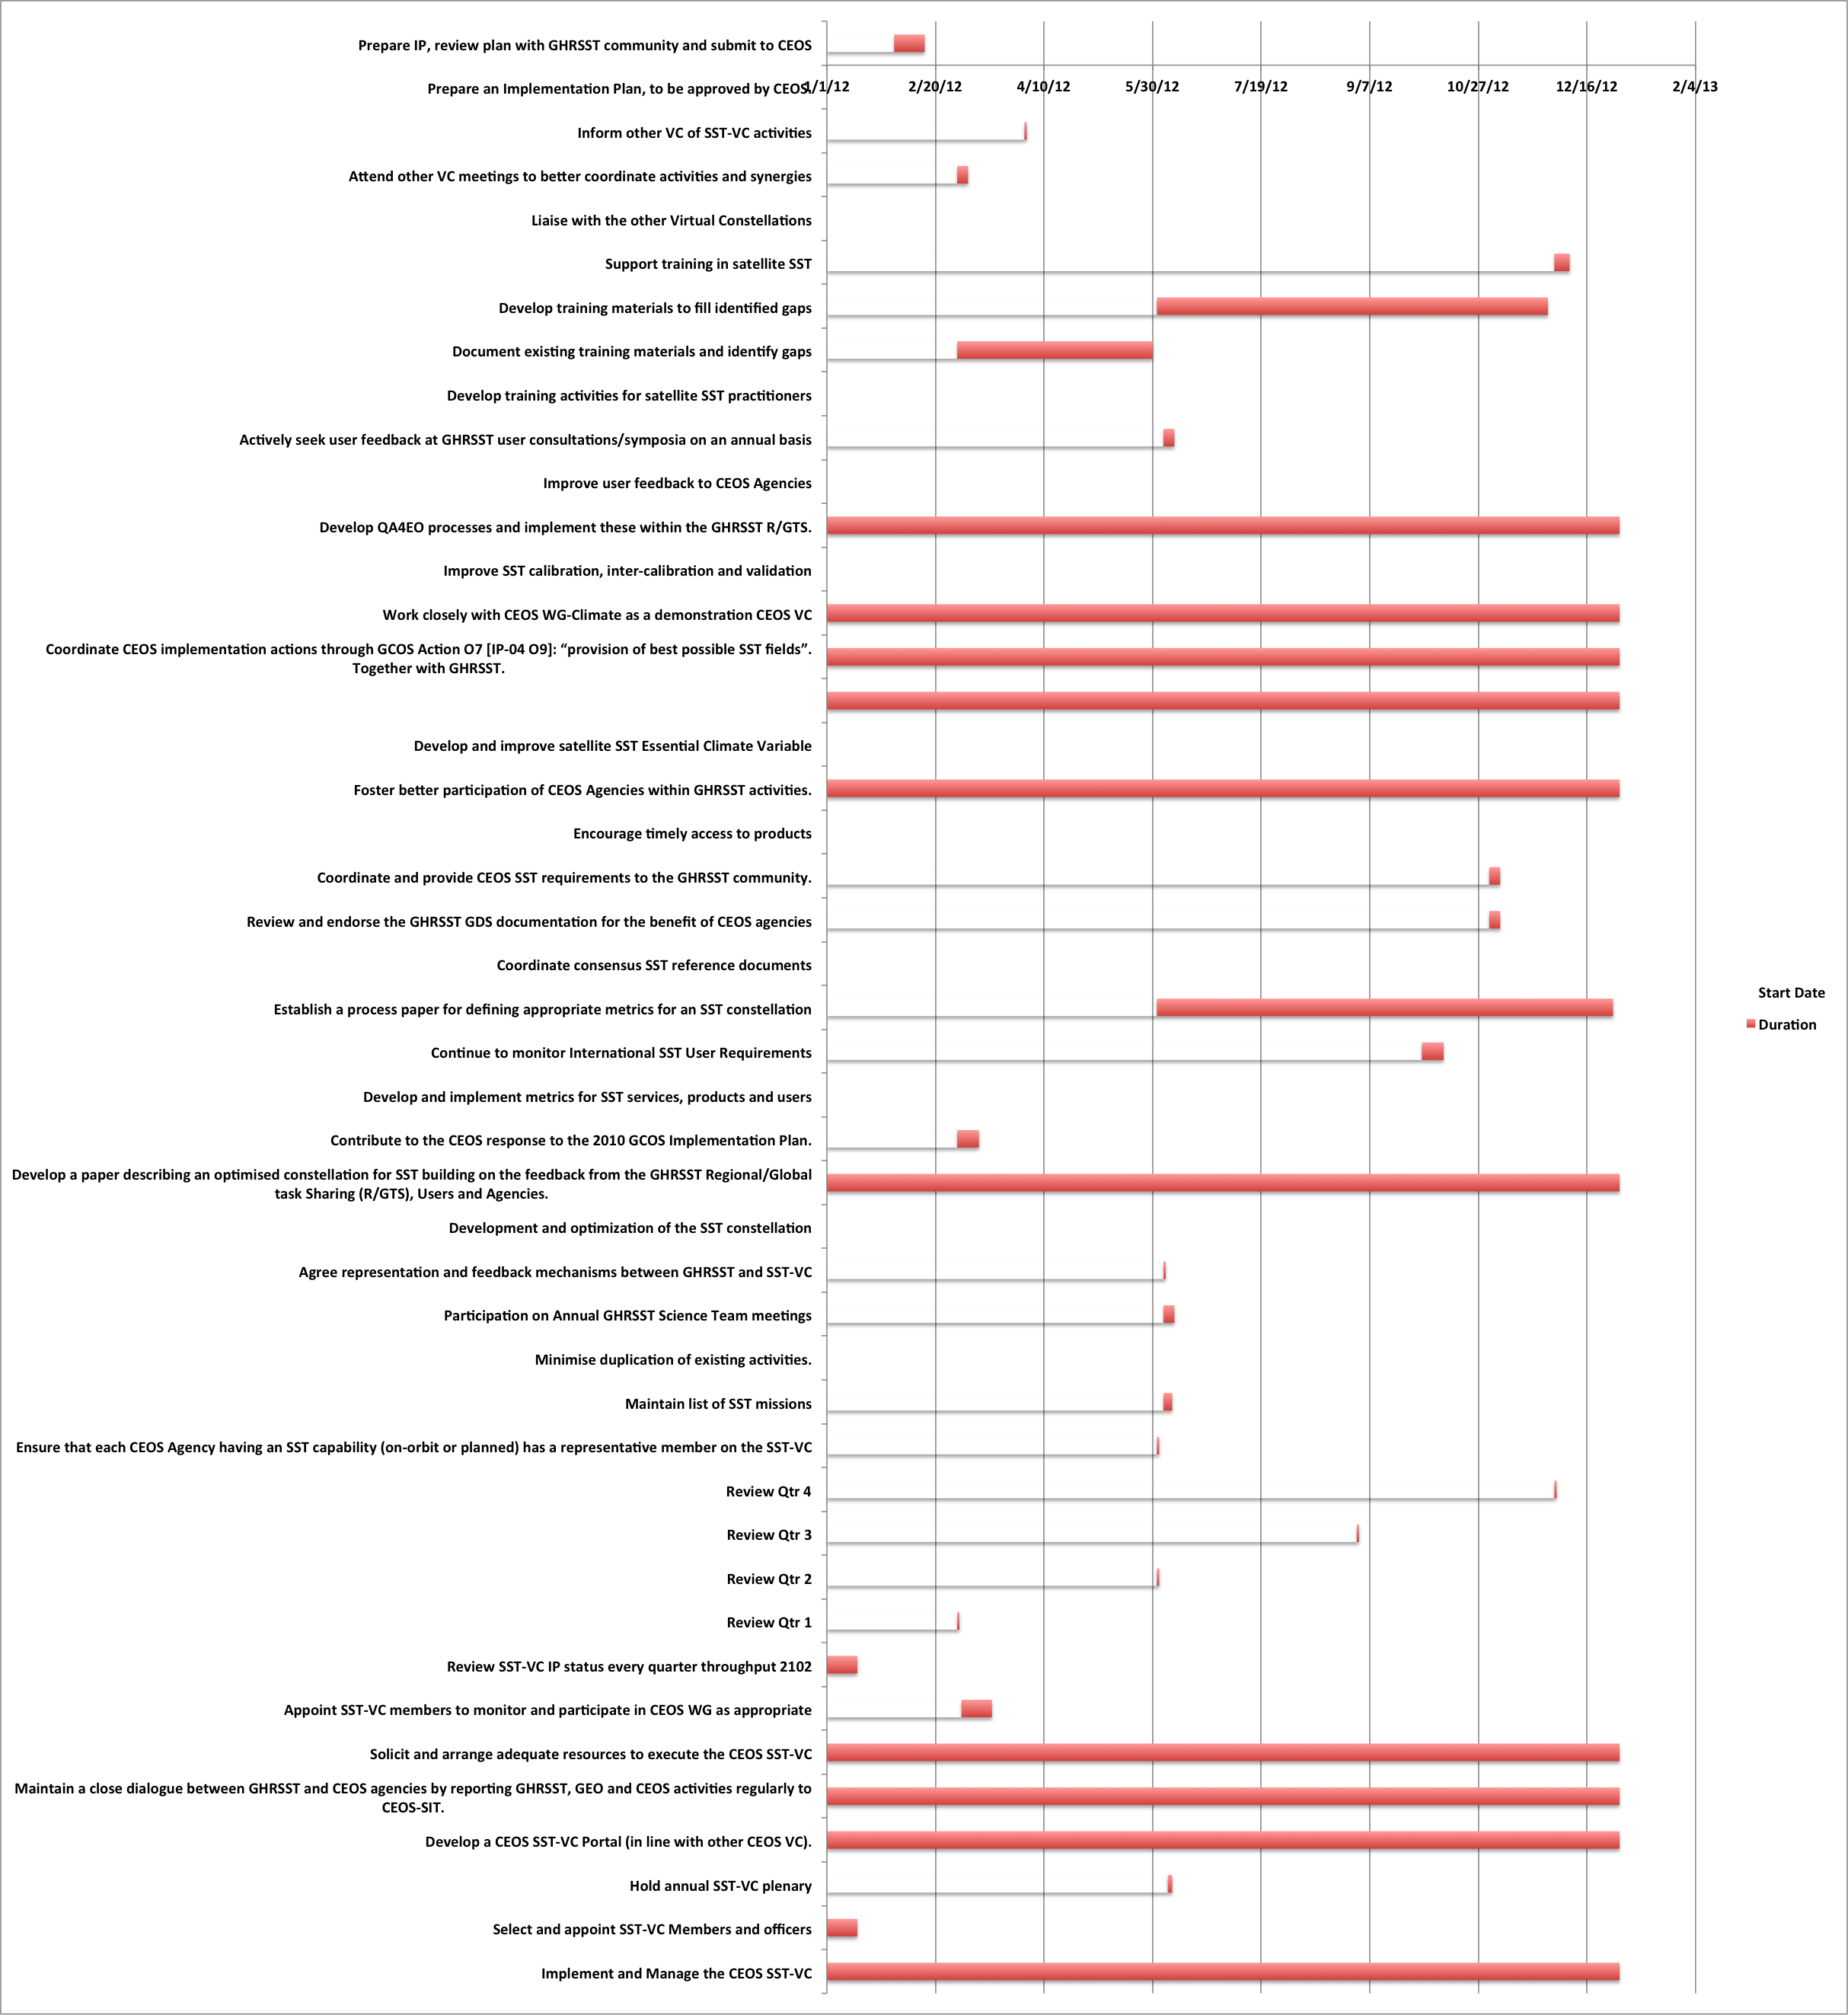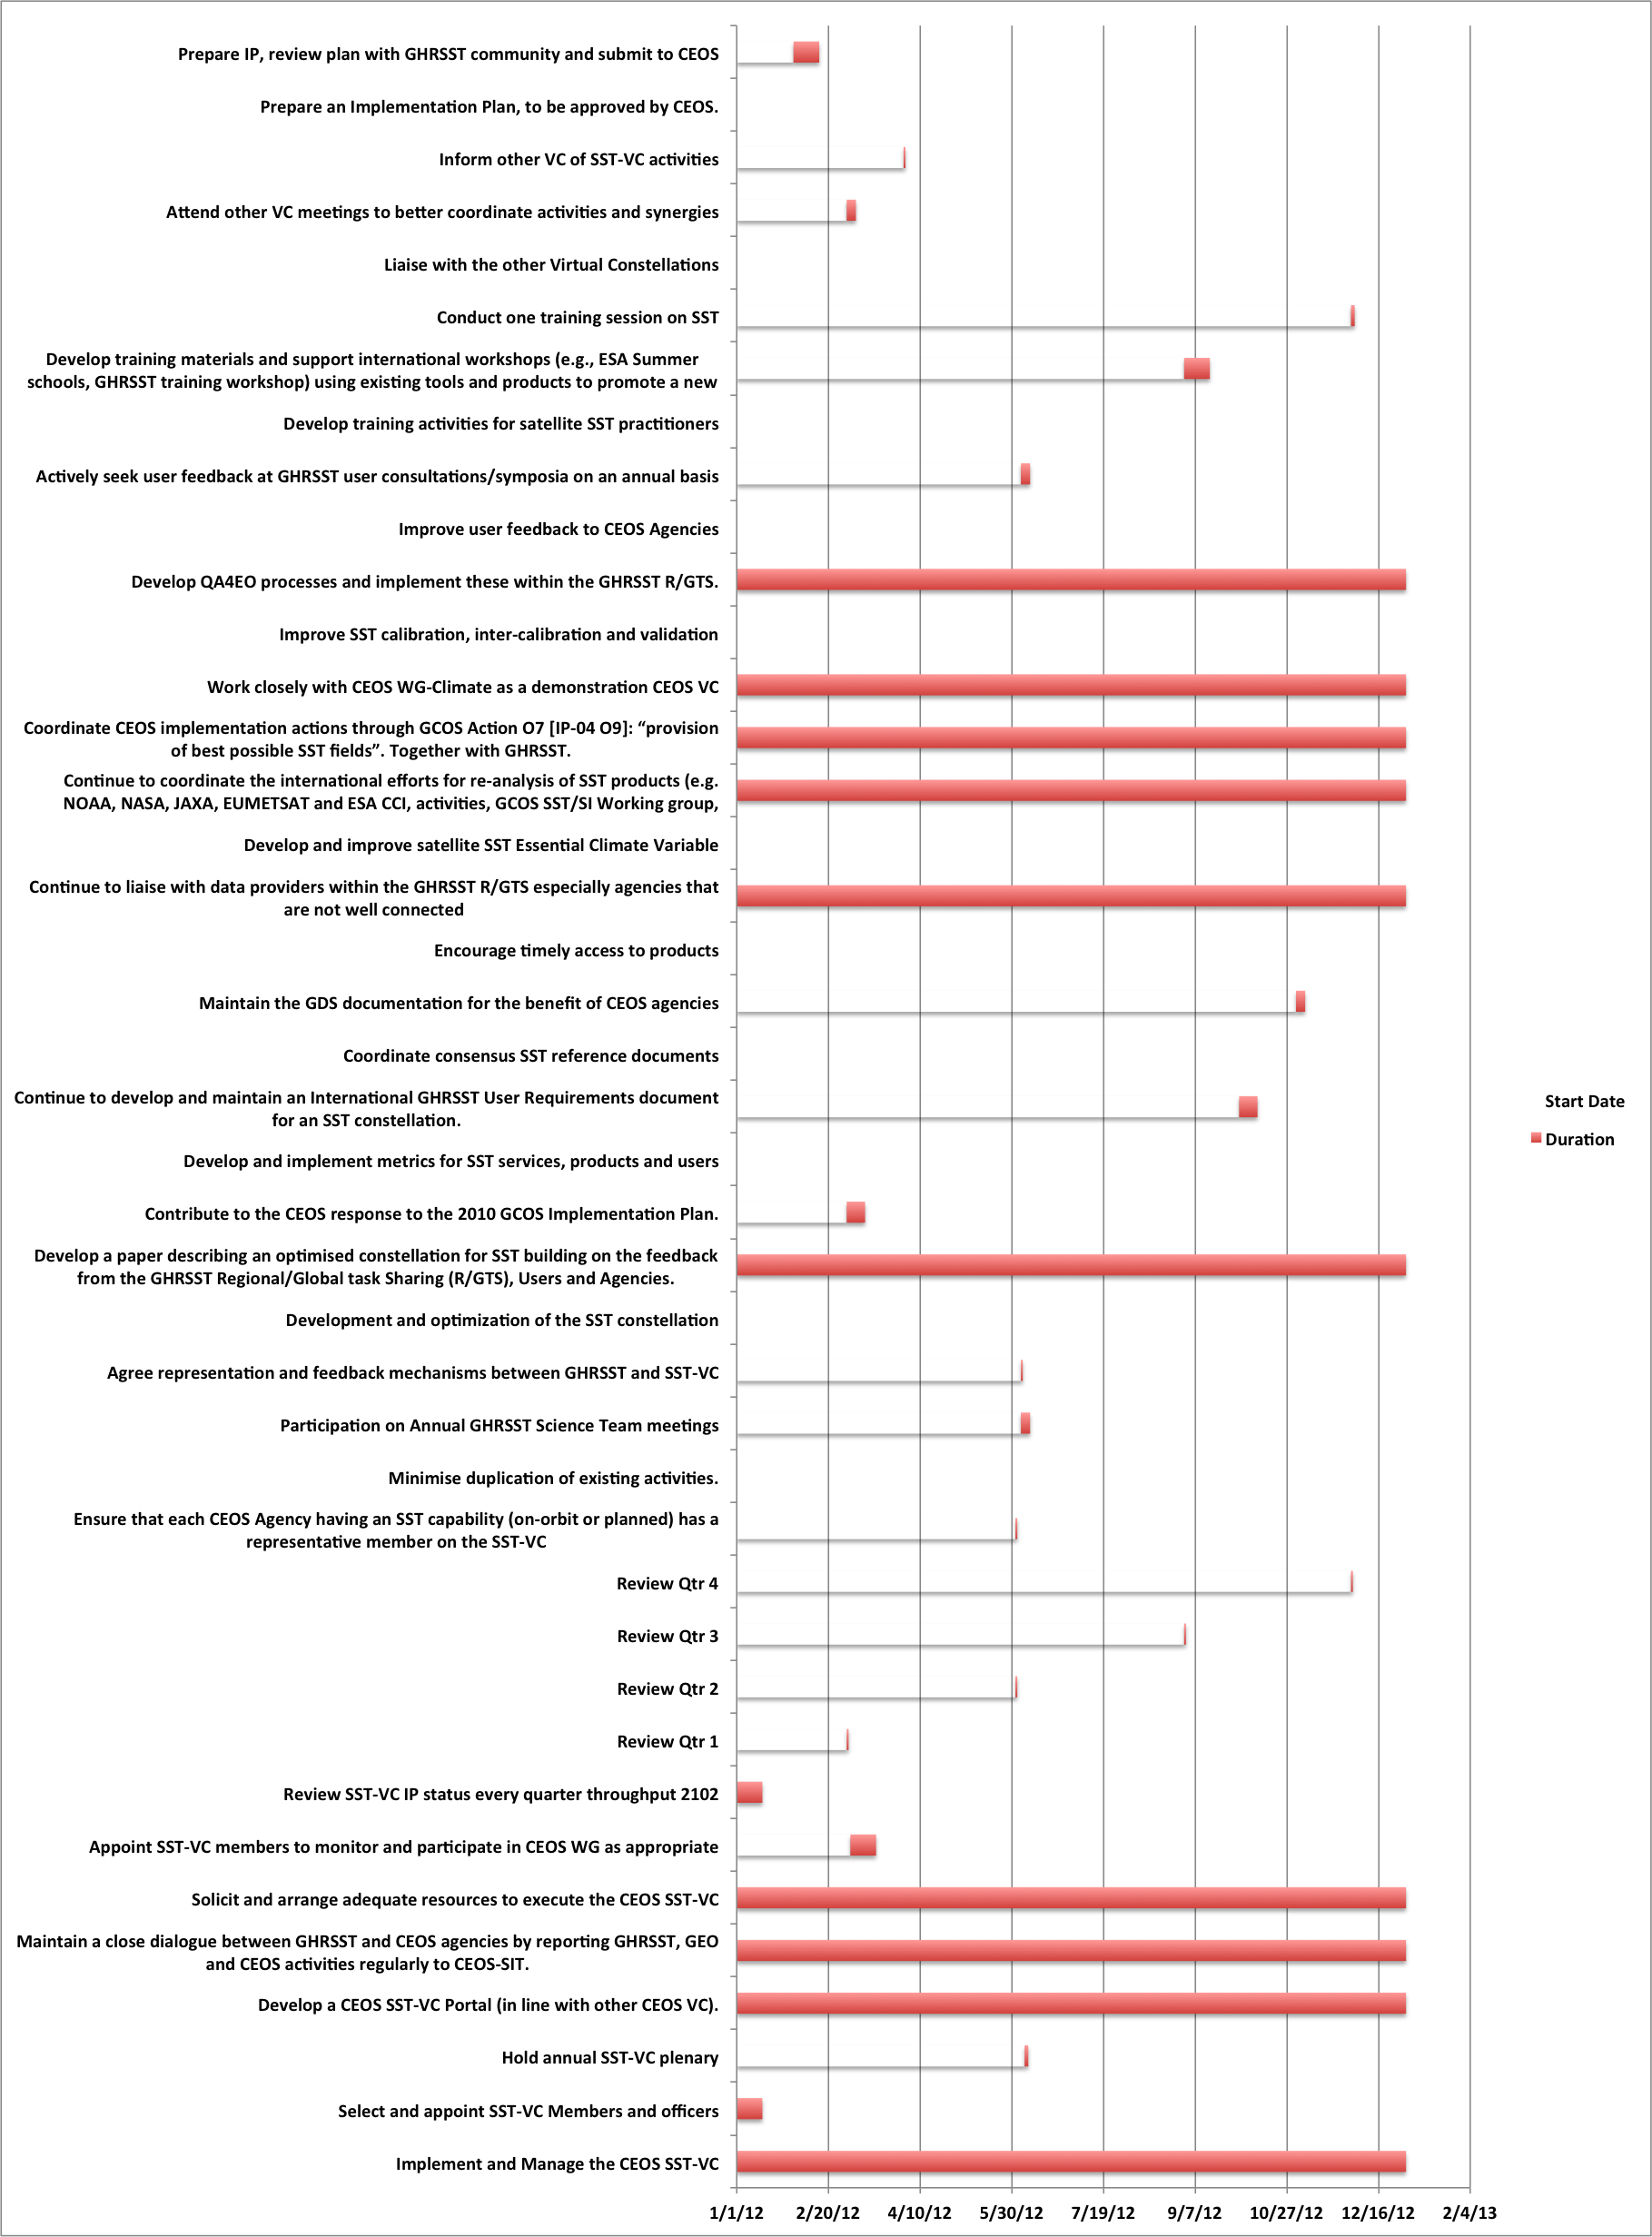

Resourcing and Staffing issues
It must be recognised that the CEOS virtual constellations function on a volunteerism basis and that currently, funding for substantive activities and travel remains a challenge. However, the cost of establishing the SST-VC is minimal given the intimate relationship to GHRSST and the commitments already made to GHRSST (approximately $25M over a period of nearly 10 years). In terms of executing the SST-VC (through this implementation plan) the following resources are in hand:

- ESA funds production of SST from ENVISAT, production of SST climate data records in support of the SST-ECV and the GHRSST International Project Office;
- NASA funds the GDAC and NASA SST-Science Team activities,
- NOAA funds operational production of SST, the GHRSST LTSRF and operational production of GHRSST data from GOES platforms, and the application of GHRSST data by Regional Associations of the US Integrated Ocean Observing System
- EUMETSAT funds operational production of SST data from GEO and LEO platforms and funds the OSI-SAF contributions to GHRSST,
- JAXA funds their activities within GHRSST,
- Additional funds contribute from National agencies supporting the activities of the SST-VC (via GHRSST),
- GHRSST international Science Team meetings provide an obvious annual focal point for the SST-VC. Traditionally, costs associated with hosting the GHRSST meetings are met by sponsorship with travel and subsistence costs covered at National level (except for students where sponsorship is required).

CEOS SIT will help to ensure that CEOS Agencies are fully cognisant of their commitment and responsibility to fund the activities of the SST-VC at an appropriate level. This mechanism is through the endorsement of the SST-VC IP at SIT-27. In terms of developing the SST-VC, additional CEOS Agency support will be required to support specific SST-VC activities including: development and publication of promotional and educational materials (web pages, course materials); organization and hosting of SST-VC training workshops; attendance of CEOS meetings and other specific meetings as required by the activities of the SST-VC.

The SST-VC will be de-facto implemented and maintained using a volunteerism approach that is challenging yet has the benefit of ensuring that activities have a “real” foundation (otherwise they would not be funded). The new order envisioned for the VCs by SIT is likely much more relevant to budgets available for dataset and product development within space agencies (and other bodies) and CEOS must identify how to leverage these budgets and engage the relevant staff skills if we are to be successful. ESA has established its Climate Change Initiative precisely for this purpose and SIT must explore how to leverage this and its equivalents elsewhere in order to find ‘new’ sources of funds for these collective ambitions expressed through CEOS [RD-3].

For example, the way in which the SST-VC has sought to ‘design in’ the expertise and funding to allow it to undertake ECV assessment and development together with GHRSST and other groups may provide a template for evolution of the other VCs. The SST-VC has engaged relevant experts with funding from various funded ECV/CDR development activities, such as the SST ECV program within ESA’s CCI (and others within NASA and NOAA). Linkage with leading science groups such as GHRSST also guarantees access to the necessary expertise to deliver good coordination based on sound scientific and operational advice.

VC representation
The CEOS Chair and SIT Chair have already taken steps to address ideal participation in the various VCs by CEOS space agencies. The SST-VC Co-chairs recognise the need to have proper representation of Agencies within the VC and, together with CEOS SIT, will ensure that representatives from CEOS Agencies with an SST measurement capability (either on-orbit, in the future or in the historical context) are part of the SST-VC activities.

Alignment of the SST-VC with CEOS working groups.
It is clearly evident that while much has been achieved through the activities of GHRSST, there is more to do in order to optimize and take full advantage of the SST virtual constellation to further benefits to society. An important aspect of the SST-VC will be climate SST, working with GCOS and CEOS WGClimate. Using the leverage of international collaboration, a common purpose and consensus documentation to secure domestic budgets underpinning GHRSST activities is evidently successful. Continuing this philosophy we expect the SST-VC/GHRSST partnership, working with WGClimate, to emerge as a key instrument in the space segment of the climate architecture, and a mechanism for delivery of coordinated SST ECV products and services. For example: the GHRSST Climate Data Records Technical Advisory Group (CDR-TAG) is coordinating with the GCOS SST/SI WG and many members are actively involved in ECVs; an SST- ECV framework is being developed to address the inputs a requirements of many organisations; a reanalysis activity and inter-comparison work is underway at LTSRF; a concerted effort is being made to federate the SST user/producers and deliver consensus recommendations to CEOS and GCOS.
We propose a lean and efficient approach, consistent with the view of CEOS, that builds on existing activities and services in order to maintain coordination of SST activities and provide value for money. Currently ESA, NASA, NOAA, CSIRO, JAXA and EUMETSAT play prominent roles in the SST-VC: we prioritise the inclusion of other “SST Agencies” in SST-VC activities.

Conclusions
This Implementation Plan sets out the priorities and proposed activities to be implemented by the CEOS SST-VC working with GHRSST in 2012. The Terms of Reference for the SST-VC are presented and the officers for the SST-VC are defined. A plan of implementation activities is presented linked to strategic targets, milestones and metrics. Resourcing and Staff issues are explained and risk mitigation approaches identified. The SST-VC alignment with CEOS Working Groups is defined and a schedule of activities is provided.

END OF DOCUMENT

Donlon, C. J., K. S Casey, C. Gentemann, P. LeBorgne, I. S. Robinson, R. W Reynolds, C. Merchant, D. Llewellyn-Jones, P. J. Minnett, J. F. Piolle, P. Cornillon, N. Rayner, T. Brandon, J. Vazquez, E. Armstrong, H. Beggs, I. Barton, G. Wick, S. Castro, J. Hoeyer, D. May, O. Arino, D. J. Poulter, R. Evans, C. T. Mutlow, A. W. Bingham and A. Harris, Successes and Challenges for the Modern Sea Surface Temperature Observing System, in Proceedings of OceanObs’09: Sustained Ocean Observations and Information for Society (Vol. 1), Venice, Italy, 21-25 September 2009, Hall, J., Harrison, D.E. & Stammer, D., Eds., ESA Publication WPP-306. White paper available from http://www.ghrsst.org/modules/documents/documents/OO-ModernEraSST-v3.0.pdf and http://www.oceanobs09.net/blog/?p=227

