MINUTES
32nd CEOS STRATEGIC IMPLEMENTATION TEAM MEETING (SIT-32)
DRAFT v1.0 26-27 April 2017
ESA Headquarters, Paris, France
Main discussion points and outcomes from the 32nd CEOS SIT meeting
Summary: Discussions demonstrated the range of issues CEOS is addressing today, including efforts to improve access to and use of Earth observation (EO) satellite data; CO₂ monitoring from space; support for the Paris Accord and the Sendai Framework for Disaster Risk Reduction; support for UN Sustainable Development Goals (SDGs); further enhancing coordination of Earth observations; the partnership with GEO and support for its initiatives. The breadth of CEOS activities continues to expand, accentuating the challenge of optimising the contributions of teams, VCs and WGs, and the importance of CEOS leadership continuity across a broad remit. The partnership exercised through CEOS is an invaluable asset, and care should be taken to manage resources in support of the many societal areas which are critically dependent on EO satellite data.
Partners and Partnerships:
- Follow-up at the SIT Technical Workshop on the potential for space agencies to collectively engage with development finance institutions was agreed.
- CEOS approach to GEO activity advisory boards remains unchanged, though resources should be focused on GEO 3-Year Work Programme activities, Initiatives, and Flagships.
- UNISPACE-50 will take place in 2018 and will provide space agencies with an opportunity to showcase their capabilities, including possibly via a print EO Handbook.
Water and Oceans:
- COVERAGE was endorsed as a new CEOS activity during a dedicated Plenary session.
- CEOS agreed that activities in support to the GEO Water Strategy will conclude with the delivery of the Hyperspectral Water Quality Report (item C.10).
- CEOS welcomes the opportunity to re-focus its water thematic observation support on user requirements, via GEOGLOWS, Blue Planet, COVERAGE, and AquaWatch.
Climate:
- CEOS’s response to GCOS Implementation Plan (GCOS-200) will be completed by October 2017. The updated ECV Inventory is expected to be released in June 2017.
- An update on the seven CEOS Carbon Strategy activities will be given at CEOS Plenary.
- JAXA is pursuing an increased profile for satellites in the IPCC Task Force on National Greenhouse Gas Inventories guidelines focusing on greenhouse gas monitoring, and CEOS will provide input via the AC-VC in the 2017 timeframe.
- LSI-VC will identify potential additional land use inputs to the IPCC guidelines.
- Incoming CEOS Chair to outline a proposal for broader coordination of carbon observations addressing all observation types and GEO and CEOS coordination
Virtual Constellations, Working Groups, Thematic Groups, and Ad-Hoc Teams:
- Terms of Reference of SDG ad-hoc Team were agreed, and the CEOS approach to the SDGs via GEO Programme Board activities and GEO’s EO4SDG activities was confirmed.
- Objectives of the FDA ad-hoc Team were endorsed, with implementation details (i.e. how, when) to be developed and reported on at the SIT Technical Workshop.
- Plans for the joint LSI-VC, SDCG for GFOI, GEOGLAM ad-hoc Working Group trial meeting in September were reviewed and agreed.
- The need to identify co-leads of OSVC-VC and OST-VC was discussed and follow-up agreed.
- The Geohazard Natural Laboratory Concept, and Geohazard Supersites and Natural Laboratory activities (Hawaii, San Andres Fault) were endorsed.

1. Welcome and Opening Remarks
Stephen Briggs (SIT Chair) welcomed participants to the 32nd meeting of the CEOS Strategic Implementation Team (SIT) and to the European Space Agency’s Paris Headquarters on behalf of Josef Aschbacher and the ESA Earth Observation Programmes Directorate. He reviewed the outcomes of the recent ESA ministerial meeting, noting that budgetary support for EO from ESA Member States is the strongest it has ever been.
Participants introduced themselves in a tour de table.

SIT Chair Term Themes and SIT-32 Objectives
Stephen reviewed the SIT Chair Priorities for 2016-2017, noting that these priorities were first presented at the SIT Technical Workshop in 2015. Stephen noted the very busy agenda and the importance the topics, indicating the increasing significance of EO data in society.
The topics covered in the agenda represent the themes and priorities for two year ESA’s SIT Chair term:
- Ensure successful advancement of ongoing CEOS commitments and deliverables, finding solutions for issues and obstacles facing existing priority initiatives.
- Ensure full access to, and exploitation of Copernicus Sentinel data.
- Further develop the relationships with IPCC and UNFCCC to support observation of climate indicators in the context of the new global Paris Agreement on climate change.
- Maintain and strengthen strategic partnerships with key actors, in particular UN agencies, development banks, international programmes and agencies.
- Support GEO as it moves into its next decade, using the substantial contributions of CEOS within GEO to support improvements in GEO’s effectiveness and governance.
- Support initiatives proposed by the CEOS Chairs in 2016 and 2017.

2. CEOS Plenary Session
Frank Kelly (CEOS Chair) introduced the brief Plenary session. He noted that the CEOS Executive Officer (CEO) position will be vacant as of the end of this calendar year, that the Deputy CEO (DCEO) position is currently vacant, and encouraged agencies to consider nominating candidates. He also noted that the SIT Vice-Chair role will be vacant as of CEOS Plenary on October.
CEOS Ocean Variables Enabling Research and Applications for GEO (COVERAGE) – Building an Ocean VC Data Product
Frank introduced the COVERAGE topic as a potential initiative for CEOS, noting that it had been presented at the September 2016 SIT Technical Workshop and referred for decision at SIT-32.
Vardis Tsontos (NASA) presented an overview of the COVERAGE initiative, which aims to provide a coherent set of data products from the four Ocean VCs through a dedicated portal. This platform will provide access to an online catalogue of EO and in-situ products, access to the products themselves, and provide tools and services allowing the data user to run predefined processing functions. He reviewed the history of the initiative, noting that over the past seven months the team had been consulting across the CEOS community in the formulation of this effort. He noted that SIT-32 is the decision point for the COVERAGE initiative.
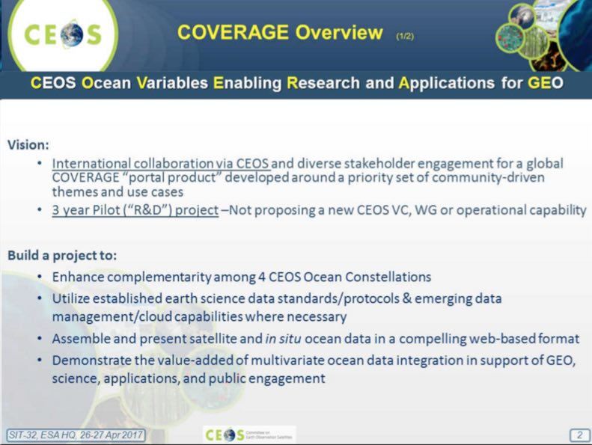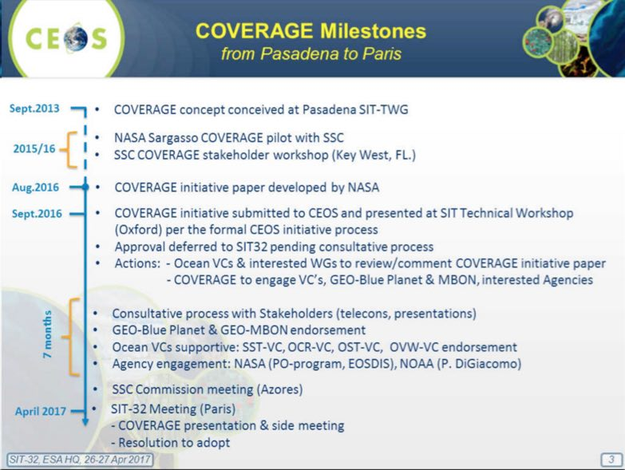
COVERAGE is a response to the need for:
- improved, unified access to data from the four CEOS ocean Virtual Constellations (VCs) for GEO (OCR, OST, OSVW, and SST, but also potentially SSS and Ocean Currents); and,
- improved access/integration of multivariate, multi-platform ocean observations, thematically organised and in a common frame (including those from the Ocean VCs), available in near real-time where possible in support of GEO-Blue Planet & MBON initiatives in particular.
It is intended to be a ‘low footprint’ pilot project, with no new VC or WG being proposed, aiming to provide a coherent, focal-point activity and mechanism promoting the advancement of the needs, consistent with CEOS programmatic objectives. Several collaborative opportunities are anticipated around data sharing and technical exchange, and they invite interest and participation of other CEOS Agencies in this effort. Overall COVERAGE has been welcomed by the CEOS Oceans VCs and ocean-related projects.
Vardis highlighted COVERAGE’s connection to the CEOS mission and objectives, specifically around achieving better integration across the full range of Earth observations, and facilitating open and easy access to CEOS Agency data for societal benefit, promoting use of open-source tools. Linkage to other tasks in the CEOS Work Plan are being put in place, including to the Future Data Architecture (FDA) initiative and Blue Planet and GEOBON. He reviewed the outcomes from yesterday’s side meeting on COVERAGE and the draft implementation approach.
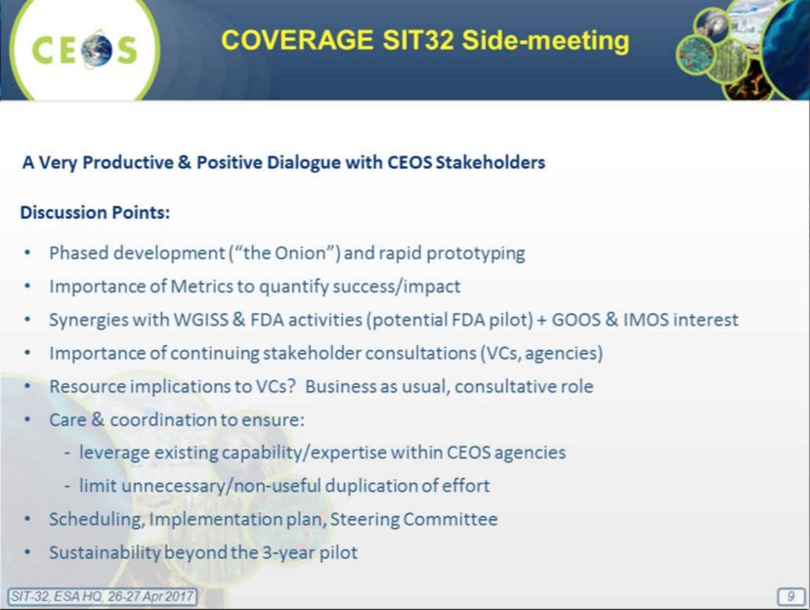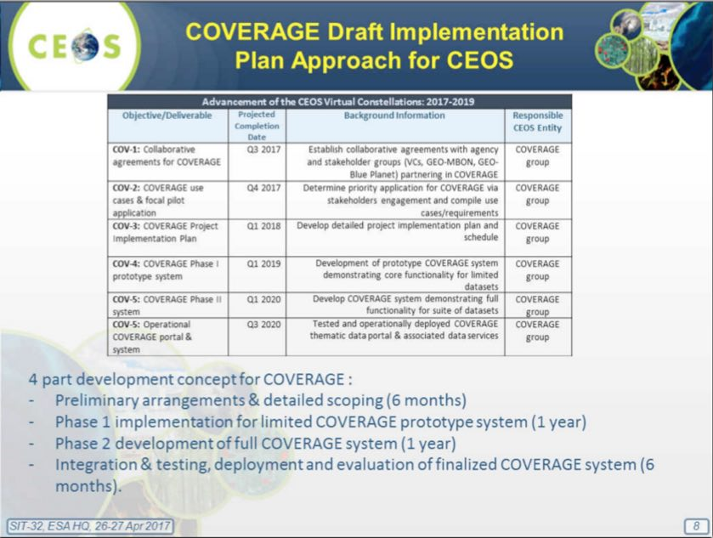
Frank introduced the discussion on the proposition to adopt COVERAGE as a CEOS initiative, and a brief discussion followed:
- Barbara Ryan (GEO Secretariat Director) welcomed this effort from CEOS, and recognised that the technical depth of GEO comes from its member agencies. She welcomed the linkages to Blue Planet and GEOBON, and suggested stronger linkages to the GCI.
- Pascale Ultre-Guerard (CNES) noted that CNES is very interested in the COVERAGE initiative, and is building a data centre called Odatis (http://www.odatis-ocean.fr/en/) which appears to align well. She asked about the sharing of tools to existing and new data centres, and the potential to create a network of datacentres in this way. Vardis confirmed that a lot of the technologies and tools being developed will be open source and released to the broader science community.
- Alain Ratier (EUMETSAT) noted that there are several ocean-related platforms being developed, and encouraged COVERAGE to be developed in an interoperable way.
- Albert Fischer (UNESCO, GOOS) supported the proposal, noting that potential for the integration with in-situ observations and tools development is welcomed.
- Astrid-Christina Koch (COM) noted that they would like to ensure the tools from the Copernicus Marine Environment Monitoring Service are considered in the development of COVERAGE. Mark Dowell (COM-JRC) suggested COVERAGE could help ensure the cumulative contribution of the CEOS oceans VCs is reflected in the next Global Ocean Assessment.
- Steve Volz (SIT Vice Chair, NOAA) noted he was encouraged by the outreach to operational applications and asked about the expectations for participation of each VC in the COVERAGE activity. He asked about the Execution Team and Oversight Board referred to in the Plan and whether these would be new groups or are already internally existing within COVERAGE. Vardis noted that VC engagement would be welcomed, and that the proposed governance structures would be established once the initiative is approved. Steve ended by stating that NOAA is supportive of COVERAGE.
- Alex Held (CSIRO) expressed interest in the application of COVERAGE outputs for Pacific Island applications. He suggested that this would be a good case to extend the LSI-VC work on Analysis Ready Data (ARD) for Land to the Ocean domains.
- Paidamwoyo Mangara (SANSA) noted that they are developing a similar oceans-focused centre which could contribute. SANSA was in favour of the initiative and expressed interest in participating.
- Tapan Misra (ISRO) supported the proposal, and noted that ISRO has implemented an oceans-focused centre which may be complementary.
Frank noted that, hearing no objections, COVERAGE was adopted as a limited three-year pilot initiative. Jonathon Ross (CEO) noted that an update of the CEOS Work Plan will be issued to reflect the inclusion of COVERAGE.
Decision 1 | CEOS Plenary session at SIT-32 agreed to adopt COVERAGE as an initiative in the CEOS 2017-2019 Work Plan as a three-year pilot project. The Work Plan will be updated promptly to reflect this.

3. Strategic Directions and Partnerships
Stephen Briggs (SIT Chair) recalled the SIT Chair Theme on maintaining and improving the effectiveness of our strategic partnerships, including with UN agencies, Development Banks, international programmes and agencies - and emphasising our GEO relationship. The SIT Chair Team has been preparing material for this discussion looking at a sustainable and structured alignment of roles and resources between space agencies and Development/Aid Finance organisations. He recalled the partnership trends and features that were raised at SIT-31.
- UN agencies have strong presence and country interface role in many of the thematic areas of active CEOS interest;
- ‘Internet giants’ have changed expectations around ease of data access and application and are ‘stages’ for vast amounts of CEOS agency data. They also increasingly provide both conventional and machine learning processing capability;
- Development finance (from International Financial Institutions (IFIs) and national Aid agencies) sustainable and structured alignment of resources which do not finance space programs directly, but support through their own financing, activities, and competencies (e.g., capacity-building activities) in areas where EO already, or should, play a major role.
George Dyke (SIT Chair Team) reported on the survey work undertaken in preparation for this topic. He reviewed the proposition that alignment with development finance is an essential ingredient in ensuring sustained success for CEOS/GEO programmes which engage countries in the uptake and application of EO satellite data. CEOS should aim to increase understanding within International Financial Institutions (IFIs) about how better to manage their projects using EO starting during design and implementation. CEOS, through GEO, could engage more effectively with IFIs, and agencies could learn from each other. Many GEO projects have implicit links to funding from IFIs in the target countries which are not visible. In addition to establishing a formal link with IFIs, GEO should also engage at working level of IFI staff in GEO projects.
George reviewed the example of the UK’s International Partnerships Programme:
- UK Govt increased its aid budget and UKSA/DFID cooperated in the definition of the programme to utilise UK space capabilities in support of development goals; and
- IPSP: $US 46Mn over 2 years; IPP: $US 220Mn over 5 years.
This programme involved partnering with developing countries and using space solutions to solve specific challenges and increase their capacity to respond to challenges.
George also explained the example of the NASA-SERVIR joint venture with USAID since 2003, with hubs in Amazonia, Africa, and Asia. He also noted that GFOI is built and runs on development finance from Norway, Australia, and USA.
George reported on the main findings of the short survey which asked CEOS Agencies about their relationships with IFIs, including the main application areas. He noted some of the conclusions from the interview with Stephen Coulson of ESA:
- IFIs are likely to be more open to 'alignment of resources' and support through (e.g.) financing capacity-building activities;
- Default sentiment within the development finance community is against spending money on technologies outside countries that will benefit;
- Loans and finances intended to achieve economic growth in country, and tech can be seen to distract from this;
- Main need that satellites address differentially is consistent and transparent environmental monitoring of projects; and,
- CEOS and GEO should consider making the case for ‘mainstreaming’ EO in support of development bank activities and investments.
Stephen Briggs stressed this last point and the opportunity for EO data to provide objective evidence to justify the efficacy of development finance.
ESA International Financial Institutions Partnerships
Stephen Coulson (ESA) presented some of ESA’s practical experience, noting they have focused on sustainable development and working with truly international Institutions (as opposed to national or even pan-European institutions). They have focused on carrying out small-scale demonstration projects, consulting with users and helping to devise information-based solutions for their problems. In parallel, they have been working on establishing higher-level partnerships with the Banks, with a secondee currently at the World Bank, and currently working to place a secondee at the Asian Development Bank (ADB). He reviewed some of the information drivers and users, such as working with client states to demonstrate that there is a need and value in including satellite information in loan operations.
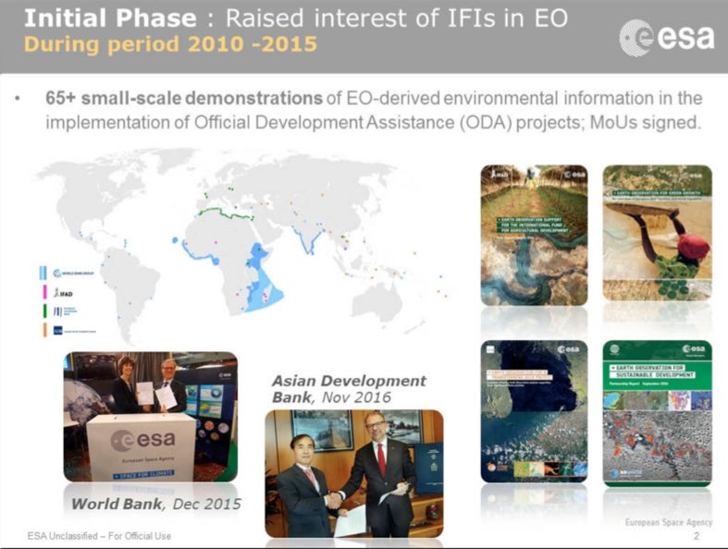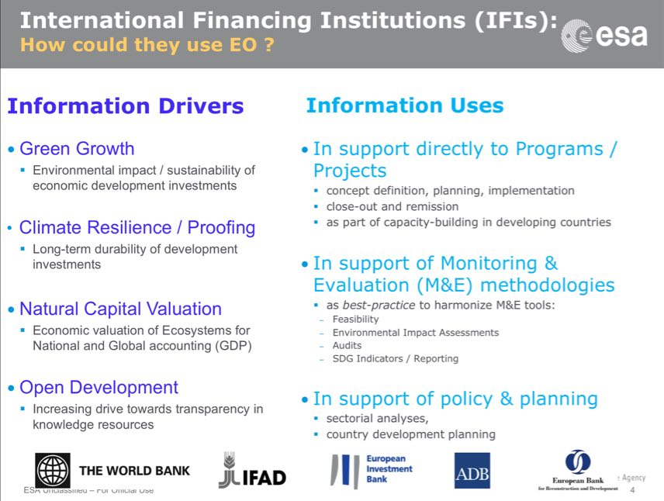
There is no a priori insistence with the banks that EO data needs to be included, but instead seeking to demonstrate the benefits. ESA conducted an analysis of actual planned projects of the main IFIs where a geospatial information requirement was identified, and applied some simple planning rules to try and assess the benefit that satellite EO might have on these projects if systematically incorporated. The assessed benefit was:
- 40-50 M€/yr for the project preparation phase (0.1%); and,
- 140-280 M€/yr for the project implementation phase (1-2%).
This analysis persuaded ESA to increase its investment in this area. Stephen Coulson reviewed the longer-term vision for the next 8-years.
- Phase 1 (25 M€, 3 years, in EOEP-5): Consolidate Requirements, Engage Stakeholders (IFIs & Client States) via regional demonstrations of EO for 10 specific thematic areas.
- Phase 2 (65 M€, 5 years, EW element, C-MIN19): Mainstream & Transfer EO into operational working processes & financing of ODA as ‘best-practice’ source of environmental information in Environmental Safeguards Systems (ESS) and Monitoring & Evaluation methodologies, SDGs of highly relevant.
Stephen Coulson noted ESA are currently putting significantly more of their own resources into capacity building, and having the client states able to see the value in, and use the information operationally themselves, is very important to long-term viability. He summarised the take-home messages as follows:
- Official Development Assistance (ODA) is a sector of significant and long-term economic activity with increasing attention on environmental sustainability (green growth) and climate change (resilience, proofing) of the (mainly large infrastructure) investment projects to promote economic growth in developing countries;
- Earth observation (EO) can deliver key environmental information that supports the definition, planning, implementation, monitoring and assessment of many (not all) major projects and programmes; and,
- Europe has world-leading capabilities in Earth Observation (both ESA and national EO missions) and a highly skilled and experienced EO information services industry. The World Bank and ADB recently signed long-term, strategic cooperation agreements with ESA.
He noted there may be a significant opportunity to take EO to a new, highly relevant user community; CEOS and GEO can be key.
Stephen Briggs initiated a discussion on the topic.
- Mike Freilich (NASA) asked if it might be useful to devote time to a discussion on what might be common CEOS objectives for these interactions; for SIT-32 to consider if some of these objectives can be accomplished with or through GEO; and, if agencies should engage independently.
- Stephen Briggs replied that agencies have been working in this area for some time with the ambition of demonstrating the value of their agency’s data, and this will likely continue. But in addition, this may be an opportunity to share experiences and identify specific areas to work together. In more general terms, we see the work of space agencies in the context of GEO, and GEO may be able to broker the discussions amongst these agencies with the Banks. Stephen hazarded that a large percentage of GEO projects are relevant to bank funding, or directly funded through the IFIs, but in many cases these projects don’t have the knowledge or expertise to take advantage of the capabilities EO can offer. The problem should be approached both top-down with the Development Banks, and also with the relevant project managers and programme managers in the respective Bank programmes.
- Barbara Ryan (GEO Secretariat Director) noted that GEO has gone into the World Bank, and other Banks, and it would be helpful if CEOS could refer to GEO during its interactions, and vice-versa. The GEO message to the Banks has been that they could be a game changer in terms of the utilisation geospatial information given their investments, and noted that CEOS could help the push for more open data policies in the conditions of the finance. She suggested that CEOS could help support analysis across the various pilot projects, and that there should be coordination between ESA and JAXA on ESA’s ADB secondee. She also observed that in general within national governments, space agencies aren’t communicating with their national aid agencies.
- Stephen Coulson noted that in front of the Banks he is promoting space-derived information in general (with a focus on ESA missions), but there is a job to be done for all agencies to coordinate on the message, and that the IFIs hope to see better coordination among agencies. He stressed that loan agencies and recipients need to realise the benefits, and that he hopes to see increased interaction between COM’s DG-GROW and DG-DEVCO as an opportunity to emphasize this point.
- Mike Freilich said he hoped CEOS would focus on common ground, for example, improved coordination between space agencies and the IFIs.
- Adam Lewis (GA) stressed the importance of a consistent message from CEOS to the Banks including the value of EO, the need for Analysis Ready Data, and the promotion of free and open licensing. Showing that this can be translated into a better return on investment from the Bank’s funds, and embedding it in their culture are important to sustainability.
- John Remedios (UKSA) observed that international investment agencies, and national governments would like a consistent picture of what satellite EO can do, and that it is important to feed the wider understanding of what satellite EO can do rather than promote particular systems.
- Luc St-Pierre (UNOOSA) noted that several specialised agencies of the UN have substantial resources and the regional and national level, and suggested this topic could be revisited at UNISPACE-50. This event will deal with both space technology, as well as capacity building in support of the 2030 agenda. There is a need to develop regional, national, and global resources and capacity. He suggested that the insurance and reinsurance companies could be involved, in particular for agriculture, disaster management, and infrastructure development.
- Marie-Josée Bourassa (CSA) noted that Canada is developing a new space strategy, and that the international development is included but with a focus on economic growth in Canada. CSA welcomes these discussions, and agreed that there could be benefit from sharing experiences and helping to build the case for space agencies, but CSA will not be able to be a disinterested party in the discussions.
- Paidamwoyo Mangara (SANSA) noted that working to quantify the value of EO could help to make the case, and suggested a linkage to work place within GEO VALUE group.
- Brian Killough (SEO) noted any follow-up by CEOS should focus on the goal of having the Banks recognise the value of EO data, and recognise CEOS as a key resource in getting information and data.
Stephen Briggs summarised possible next steps, noting the agency, CEOS, and GEO threads should be considered:
- Within GEO, we operate as CEOS to support the work of GEO in an integrated capacity to deliver satellite data to their activities, including the eco assessment of the value of EO;
- As a group of space agencies, trying to put forward the integrated capacity of space agencies to deliver data, including demonstrating the capacity and interoperability of data and the value of an integrated product, quality control, ensuring data access and usability, and that this work is ongoing within the CEOS Work Plan;
- How we should work within CEOS to see whether there are principles and best practice to help work together to take a more coherent approach within some agencies, and indeed to go together as a group of space agencies to the IFI agencies. He suggested assessing this integrated approach, and develop a proposed approach, between now and the SIT Technical Workshop; and,
- National aid agencies are extremely important customers for this information, and may be less complicated than larger Banks, though challenges remain around national coordination. It may be possible to work on this challenge via GEO country representatives on the linkage between their national space and overseas development agencies (ODA).
Some additional discussion points were raised:
- Barbara stressed the importance of the open data in any CEOS-GEO collaboration in this area.
- Mark Dowell (COM-JRC) suggested that a slightly different track for the national and international development bodies may be required.
- Tapan Misra (ISRO) noted they have been promoting the of space technology over the last two years, encouraging its inclusion in project governance and transparency.
- Stephen Briggs agreed that transparency and objective measurement of outcomes is one of the key points to consider.
- Mike asked who will develop the way forward, and Stephen Briggs suggested that the SIT Chair proposes (via a white paper for comment) some activities around the Workshop in September.
SIT-32-01 | SIT Chair | Develop, in consultation with CEOS SEC and Principals, a proposal for a way forward on CEOS agency coordination in engaging the international finance institutions (IFIs), for discussion at a dedicated session at SIT Technical Workshop in September 2017 | SIT TW 2017
 | Rationale: The discussion on CEOS agency coordination on IFIs at SIT-32 was intended to be a conversation starter. Based on interest expressed, a more detailed follow-up discussion (half-to-one full day prior to SIT TW 2017) should be framed and planned. Any agreement on substantive action would need to be further considered after the SIT TW at a CEOS Principal-level meeting or meetings.

4. Future Data Access and Analysis Architectures
Future Data Architectures (FDA) Ad-Hoc Team (AHT) Update
Steve Labahn (USGS) revisited the objectives of the FDA AHT, noting that FDA has been raised in relation to several CEOS initiatives.
- CEOS FDA AHT was initiated at the 2015 CEOS Plenary meeting and was tasked with developing a report on the status of data supply, access, processing, and delivery to provide guidance to CEOS on the potential that new high-performance, cloud-computing technologies can provide;
- In 2016 FDA AHT assessed the potential of new technologies and approaches to bridge the gap between the enormous volumes of Earth Observation (EO) data and the users developing applications to tackle key environmental, economic, and social challenges; and,
- In 2017 FDA AHT continuing the 2016 work by pursuing pilot architectures, obtaining end user feedback / best practices / lessons learned, generating CARD4L products, and addressing strategic questions.
He highlighted some of the changes and opportunities that the FDA AHT is seeing.
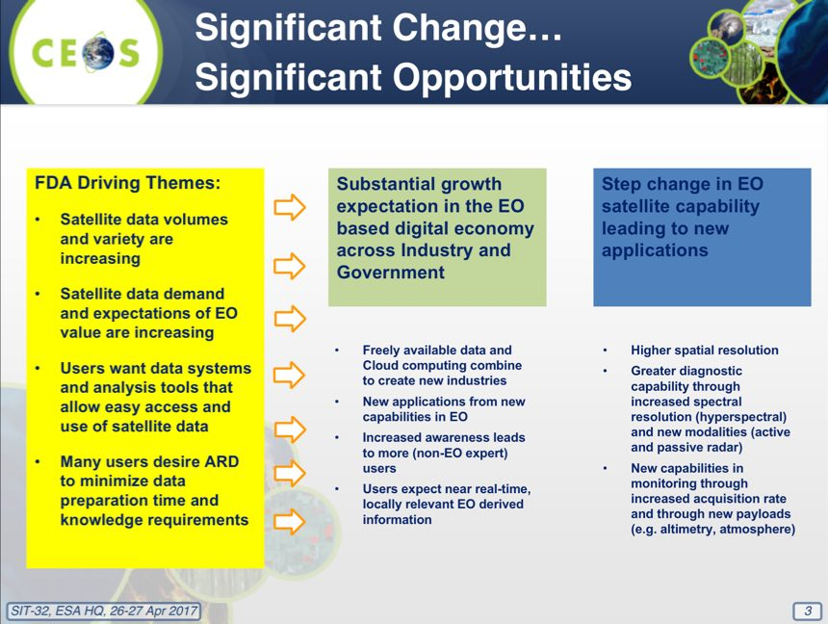
The FDA AHT performed a strategic assessment to try and identify actions and what agencies can do together, and what barriers exist. Nicolaus Hanowski (ESA) reviewed the ‘what’ items that SIT-32 is being asked to endorse.
- Pursue CARD4L interoperability by proceeding with systematic generation of CARD4L-compliant products for optical data (e.g., S2, L8), developing examples of CARD4L-compliant SAR products reflecting user demand, and exploring further development of ARD-on-the-fly production through data handling tools;
- Develop interoperable Open Source tools to stimulate satellite data use enabling exploitation of EO data and to build local, national, regional, and global capabilities;
- Capture user feedback and user statistics on FDA implementations in a structured way which allows analyses and extraction of lessons learned;
- Ensure availability and promote uptake of data and processing standards when appropriate and implement standardization when necessary; and,
- Adapt the potential FDA solutions to the profile of diverse users accommodating analytical processing capabilities.
Nicolaus gave an overview of the FDA architectures, and reviewed the criteria for success.
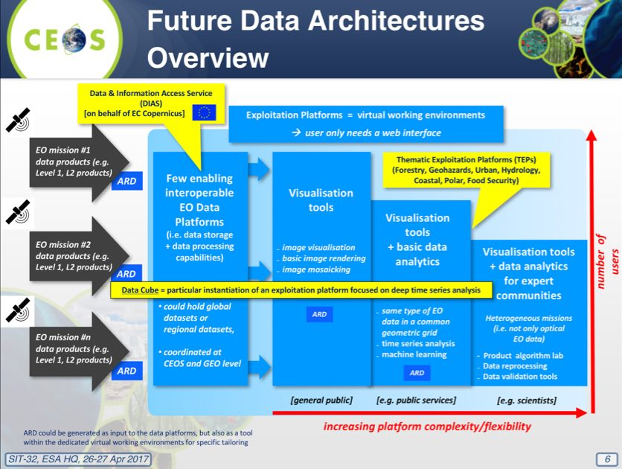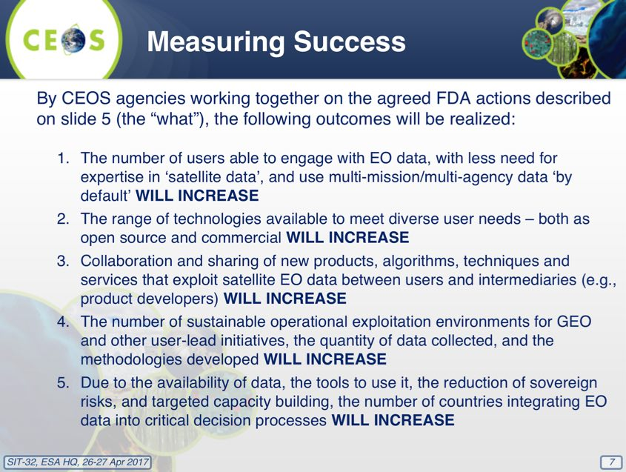
Adam Lewis (GA) introduced the CARD4L background and definition:
- The Land Surface Imaging Virtual Constellation (LSI-VC) was tasked (Nov 2015) to “Define intercomparable Analysis-Ready Data (ARD) products within the context of land surface imaging”;
- CEOS Analysis Ready Data for Land (CARD4L) are satellite data that have been processed to a minimum set of requirements and organized into a form that allows immediate analysis with a minimum of additional user effort, and, interoperability both through time and with other datasets; and,
- CARD4L is intended to lower barriers to use and engage new communities of users. CARD4L will underpin many CEOS activities including Data Cubes and other future data distribution architectures.
Adam reviewed the CARD4L Framework, which is intended to promote and assure consistency with the CARD4L specifications.
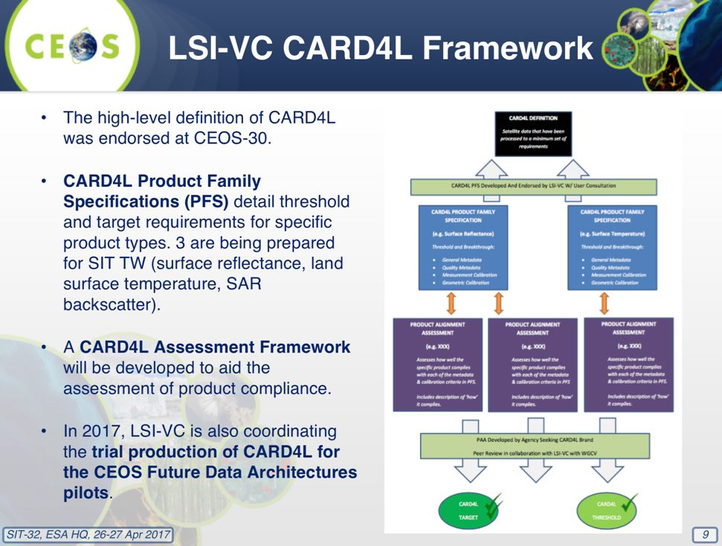
Alex Held (CSIRO) reviewed several pilot projects, including around CEOS Open Data Cube, and reviewed the next steps.
- With CEOS SIT-32 concurrence on the ‘What’, the FDA AHT will work on the ‘How’ and ‘When’ next steps from the Strategic Assessment to be proposed and refined at 2017 CEOS SIT TW, and finalised and briefed at 2017 CEOS Plenary;
- Continue working with CEOS space agencies on provisioning of CARD4L-compliant products, supporting the pilot projects, and explore other VC’s interest in participating beyond just land (e.g. marine, atmosphere); and,
- Engage user community on pilot projects and obtain feedback and documenting lessons learned and develop best practices.
A discussion followed:
- Ivan Petiteville (ESA) noted the need to ensure that people outside CEOS don’t feel ARD is a technology push, but is being done in support of applications and addressing specific problems and user needs. He noted a rough cost-benefit analysis could also be helpful, highlighting what we can do with the FDA tools that we could not do without.
- Kerry Sawyer (NOAA) suggested that FDA look at other disciplines and noted that COVERAGE could be a ‘CARD4O’ (Oceans), and hopes the FDA efforts are well coordinated with COVERAGE. Alex agreed, noting that water leaving radiance could be one of the products.
- Jonathon Ross (CEO) noted that in the past a lot of effort has been spent on compiling download statistics, but these don’t give you a clear indication of what happened with the data once downloaded. He noted that the evidence of stakeholder engagement that agencies could gain from these new approaches may be significant.
- Steven Hosford (CNES) noted they are very supportive of the initiative in general, and that the land data centre in France is processing Sentinel-2 to L2A using an open source algorithm that can be downloaded by anyone (‘MAIA’), and they would like to ensure the work is being done within this context is brought into line with CARD4L.
- Astrid-Christina Koch (COM) confirmed that they would like implementation of the FDA AHT priorities to be progressed during their 2018 CEOS Chair term.
- Mark Dowell (COM-JRC) noted that for water, offshore ocean ARD is not the only priority, but that inland and coastal waters could also be considered. He noted that typically L2 processing over land are not adequate for inland and coastal waters, and that there has been significant interest in Sentinel-2 data within the inland and coastal communities. He also noted that the Copernicus Global Land Service will likely propose a global Sentinel-2 surface reflectance product in 2018.
- Adam noted the value to be demonstrated through multiple ARD implementations, and agreed that COVERAGE may be an opportunity to take CARD4L beyond land.
- Barbara Ryan (GEO Secretariat Director) supported these efforts, noting there will be lessons that come out of the meteorological community that ought to be considered. She noted that continental and eventually global scale frameworks would help support GEO’s efforts across many projects. She suggested that branding be given early consideration needed, and noted and suggested a linkage to the OS-GEO initiative as they are not currently engaged.
- Paidamwoyo Mangara (SANSA) noted that for South Africa this is not just relevant to EO, but also other areas, and cited the example of lessons learned from the Square Kilometre Array radio telescope.
- Shizu Yabe (JAXA) noted that ALOS-2 ScanSAR data could potentially be contributed. She also noted that the new Remote Sensing Act in Japan had no restrictions for ALOS series data provision, though data processing and distribution resources need to be identified. They also anticipate completing processing of an AVNIR-2 global data product in the coming months.
- Brian Killough (SEO) noted that they are now referring to the Open Data Cube, removing reference to CEOS, and trying to attract contributions from other non-CEOS entities.
Stephen Briggs (SIT Chair) noted that this was a useful progress report, and noted that no objections to the proposed ‘what’ and way forward proposed were raised, and so these are considered endorsed by SIT-32.
Decision 2 | The Future Data Architectures (FDA) Initiative way forward proposed by the Co-Chairs (‘the what’) was agreed, and the FDA team will report back on ‘the how & when’ at the SIT Technical Workshop.

SIT-32-02 | Future Data Architectures Ad Hoc Team | Report back on ‘the how and when’ the substance of the CEOS FDA strategy will be implemented within the CEOS structure and Work Plan | SIT TW 2017
 | Rationale: The main ‘what’ items for the FDA way forward were endorsed at SIT-32, and so the FDA AHT’s attention will now focus on the ‘how and when’. A progress update should be given at the SIT TW 2017.
CEOS Chair Moderate Resolution Interoperability Initiative (MRI)
Jennifer Lacey (USGS) presented the objectives of the CEOS MRI activity, and the 2017 deliverables expected.
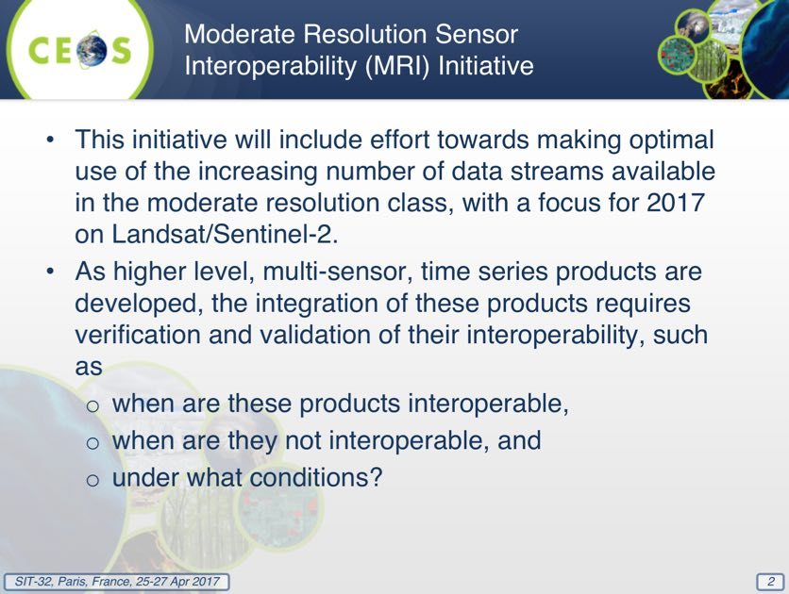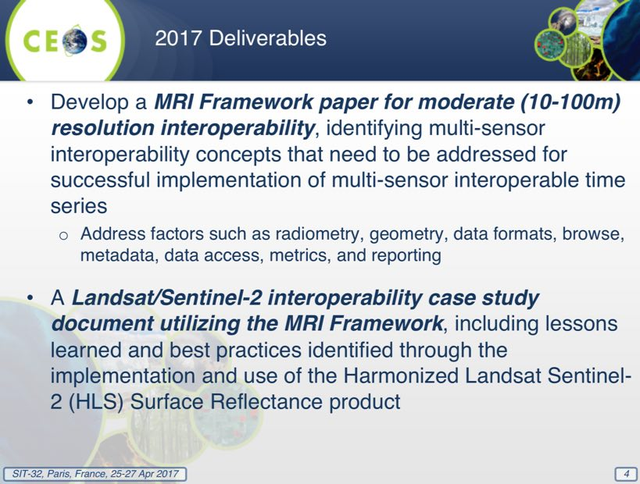
Jennifer noted the NASA Harmonized Landsat 8 - Sentinel-2 (HLS) product generation activity, which addresses many of the interoperability issues laid out in the MRI Framework. She stated that merging Sentinel-2 and Landsat-8 could provide 2 to 3 day repeat coverage globally. She noted that the case study evaluation will utilize the MRI Framework and address multi-sensor interoperability concepts. Beyond HLS, agencies and users will be surveyed to obtain a more comprehensive list of ongoing efforts to use Landsat and Sentinel-2 data together, and these projects can provide a basis for understanding “lessons learned” and best practices.
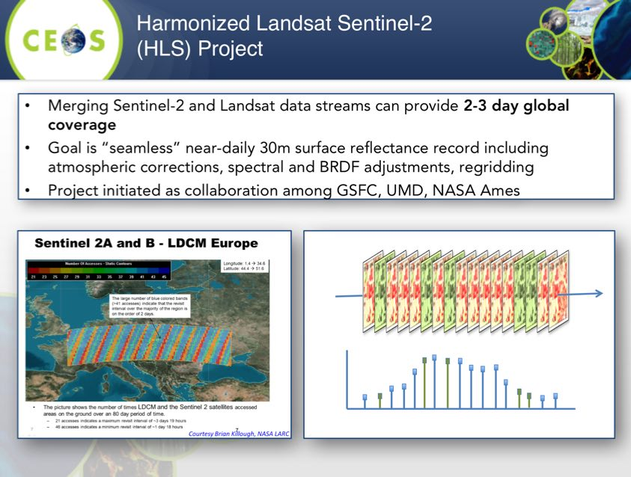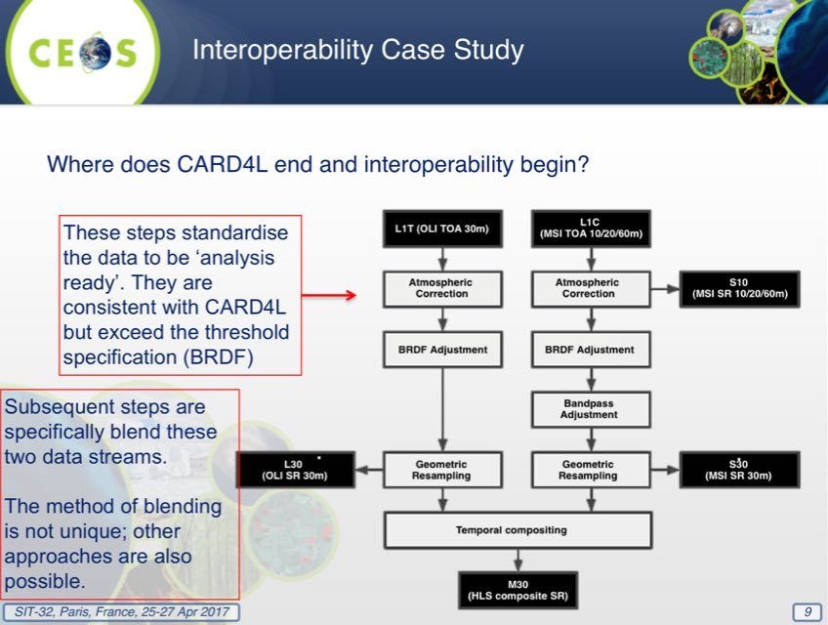
Jennifer reviewed the roadmap of the way forward, noting that the process will proceed iteratively, with the presentation of initial case study results at LSI-VC-4 and SIT TW (September 2017), presentation of final MRI Framework, case study results, and a proposed way forward at CEOS Plenary (October 2017).
A brief discussion followed:
- Mark noted the LSI-VC discussions on the DEM and the Global Reference Grid issues should be addressed as they have broad implications for interoperability, and Jennifer confirmed these issues are being considered.
- Tapan Misra (ISRO) noted that interoperability between Landsat and RESOURCESAT-2 is also an important consideration. Past discussions have addressed the planned release of ANVIR-2 data, and the exploration of further release of data holdings.

5. GEO and GEO Initiatives
GEO Framework Update and Outlook
Barbara Ryan (GEO Secretariat Director) presented an update on GEO, including an update on membership (104) and Participating Agencies (PO, 109). Barbara reviewed GEO support to the 2030 Agenda for Sustainable Development, and noted the recent report (including case studies) was prepared to highlight the potential contribution of Earth observations.
Barbara noted the EO contributions to a number of the SDGs, including Goal 2 (Agricultural Monitor), Goal 6 (The Ramsar Convention), Goals 11 & 13 (aerosol data), Goal 15 (GFOI). She also noted significant support to The Paris Agreement.
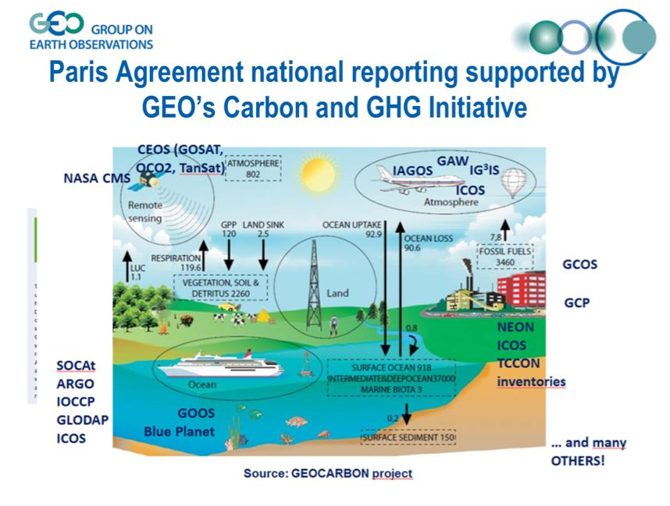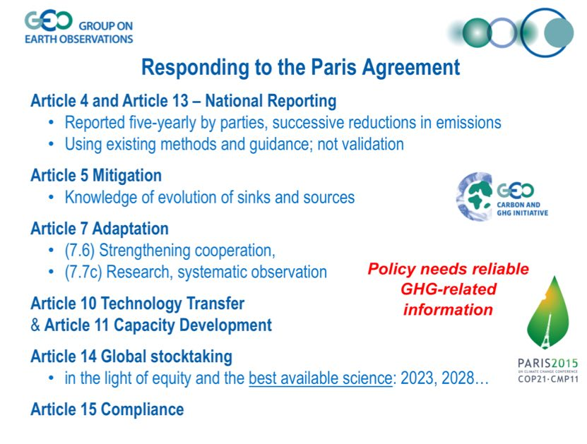
Barbara reviewed the status of the GEOSS Common Infrastructure (GCI), and thanked ESA for its ongoing contribution in operating it. She reviewed a number of challenges that GEO is facing including data access (broad, open data policies are needed for global monitoring and transparency), interoperability (data discoverability and access through federated systems), and downstream services (applications and information are needed to make data useful for decision-makers). She noted the strong economic arguments for open data policies, referencing the annual global benefits of Landsat’s open data policy amounting to more than $2 billion.
She thanked Osamu Ochiai and JAXA for their support to the GEO Secretariat as Osamu’s secondment there comes to an end, and noted that GEO Secretariat is seeking a secondee for the disasters portfolio, and that applications for the next GEOSEC Director are open for another two weeks.
CEOS View on GEO Developments and Outlook
Stephen Briggs (SIT Chair) summarised the CEOS view on recent developments at GEO, including the prospects for requirements development and thematic coordination activities in GEO. He recalled the three challenges for GEO, noting they are similar to those being aired by a number of CEOS Agencies. He noted major changes to operations at GEO over the last year or so, the new emphasis on the Paris and Sendai Agreements, and SDGs (Agenda 2030), and that these changes were reflected at the St. Petersburg Plenary.
As a part of the reorganisation, GEO created a Programme Board. The SIT Chair represents CEOS on the Board until 2019. The GEO ExCom has three seats for POs, and this will include CEOS again until 2019.
A brief discussion followed:
- Adam Lewis (GA) noted the importance of the statistical agencies in the SDGs, and that in Australia, GA has a strong relationship in support of the national agency. He noted it is unclear how this relationship is developing internationally, and whether there is a role for CEOS and GEO.
- Marc Paganini (ESA) noted that GEOBON is a new flagship within GEO, and its two main activities are to develop a biodiversity conservation network, and the Essential Biodiversity Variables (EBVs). He noted that space agencies have been involved from the outset, and that eventually they would like to discuss CEOS engagement on the EBVs
- Jonathon Ross (CEO) asked about how support to the various steering committees and advisory groups being created through GEO’s focus on governance can be sustained. He asked how GEO Secretariat could support CEOS in ensuring support for groups who would like our input. Barbara noted that their push towards more structured governance of initiatives has included a focus on users, not data providers.
- Kerry Sawyer (NOAA) noted that GEO has 22 initiatives, all of which are creating boards and inviting members, and there is a need for CEOS to understand if and how it can address this requirement. Stephen suggested that if there is a significant space element, then it would be appropriate for CEOS to consider a representative. There is a need to understand the size of the need, though Barbara stressed that GEO Secretariat is unable to provide an estimate. She noted that GEO is driven by the community’s activities, and not from GEO Secretariat. She noted that GEO’s move to a three-year work plan was an attempt to manage the cadence of new requests. She also noted that an initiative is not promoted to Flagship status without Programme Board endorsement, and that Flagships are required to have a specific policy driver and linkage.
- Stephen agreed the flagships should be driven by the information service users, but governance boards should include representation from those who have a substantial resource commitment to enabling those initiatives. Barbara noted that the intention was not to exclude data providers, but that in the past discussions on have become too detailed and this has led to policy people disengaging from the discussion.
- Steve Volz (SIT Vice Chair) agreed that the ultimate objective is to have the receiving agencies take delivery and ownership of the data, but there is a need to have the space agencies involved. He also agreed that participation needs to be at an appropriate level, and to listen to the user needs rather than direct them.
- Emily Smail (GEO Blue Planet) noted that Blue Planet is putting together an advisory board consisting of data providers and users at a high level, and then a steering committee to support implementation. She noted that some users are not aware of what’s possible with EO data, and this is where the space agencies can contribute.
- Ian Jarvis (GEOGLAM) noted that in the case of GEOGLAM, the CEOS ad-hoc Working Group is very active, and that Alex Held represents CEOS on the Advisory Group.
- Mark Dowell (COM-JRC) asked about the GEO systematic requirements definition process (formally GEO Task GD-08), noting that it is an important task for CEOS agencies. Barbara noted this is not currently progressing due to lack of staff, and that the Programme Board is attempting to look across issues. Mark suggested this could be addressed via a ‘requirement Sherpa’ rather than having a detached SEC function, but Barbara noted that even this process would require a coordination function.
- Stephen noted that for 10 years CEOS encouraged GEO to define requirements based on SBAs, but the lack of progress makes it clear this is not going to happen, and this approach is no longer being pursued. He noted there are alternatives to that process, and that addressing requirements for the three major GEO priorities for GEO (UN 2030 Agenda for Sustainable Development, Paris Climate Agreement, and Sendai Framework for Disaster Risk Reduction) would be a good step forward.
- Mark noted that the Paris Agreement gives a lot of attention to mitigation, but perhaps GEO can help with the contribution on adaptation. He also noted a concern that, without requirements, the stimulation of the evolution of observations is a challenge.
- Mark asked about how the mainstreaming of climate activities (e.g., adaptation) is proceeding within GEO without a dedicated SBA. Barbara remarked that the lack of an SBA has strengthened work across the GEO Work Programme.
- Stephen suggested a focus on the Paris Agreement and assessing what needs to be done, and then to understand whether the current GEO activities can address those needs. He agreed that adaptation is an area where GEO has a unique capacity to support the Paris Agreement, with the potential to support access to a wide range of data, including local information.
- Mark asked about the relationship between SDG oversight on the Programme Board and GEO’s EO4SDG project.
- Albert Fischer (UNESCO) noted that the Programme Board has been reluctant to push requirements, but more focused on demonstrations and the thinking about how those demonstrations can be extended to operations.
- Ivan Petiteville (ESA) noted that in GEODARMA, there is a process to collect user needs at a regional level.
- Adam noted that in the last few years we’ve seen an order of magnitude increase in systematic observations, and suggested that GEO should focus more in these observations rather than non-systematic ones.
- Barbara noted the GCOS approach to ‘essential variables’ (e.g., extended to biodiversity, oceans) as an approach to defining requirements.
- Carolin Richter (GCOS) asked why GEOSS and the system-of-systems approach has been less visible, and that this may help with requirements management.
- Barbara noted that the next GEO Work Programme Symposium will be held in concert with ISRSE in Pretoria, South Africa, the week of 8-12 May. She noted that the GEO Plenary will take place the week after the CEOS Plenary in Washington D.C.
GFOI Status and Issues
Stephen Ward (SDCG Secretariat) presented as the alternate CEOS Lead for GFOI, representing Masanobu Shimada of JAXA. He reviewed recent changes in the GFOI coordination and management.
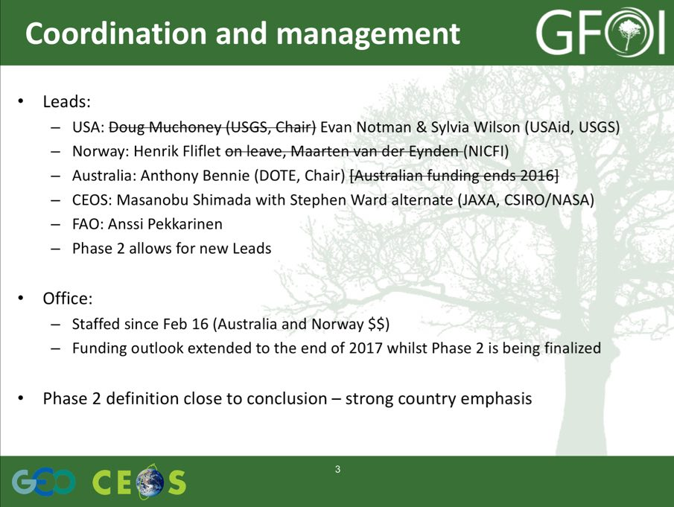
Stephen Ward noted that the necessary space data supply for GFOI is currently in place with multiple core data streams in operation, and the issue has turned to how to distribute the data. The SDCG Global Data Flows study looked at the volume, velocity and variety of data, which presents a major challenge. Based on countries’ requests, SDCG is also pursuing inclusion of Early Warning as GFOI activity, possibly on the basis for the long-promised cooperation with Global Forest Watch (GFW).
Stephen Ward noted that the SDCG R&D (Element-3) is development support by JAXA, and that all SDCG agencies now actively contributing EO data to GFOI R&D Programme. The SDCG Element-3 Strategy has been updated (CEOS.org/SDCG), and the GFOI R&D Programme Technical Report released (available at GFOI.org/RD). Discussion with the European Commission are ongoing to address GFOI R&D (coordination and specific actions) in a future call of the Horizon 2020 Initiative.
He noted that the MGD is the ‘structural bridge’ between the forest observations and the policy structures aimed to support them. CEOS Agencies are encouraged to promote the GFOI MGD within their government programs related to forest monitoring.
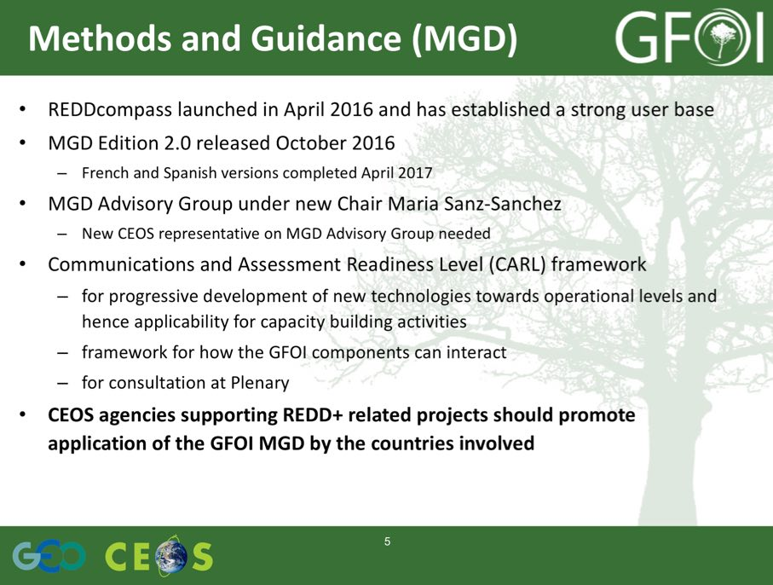
At present, there are risks within GFOI Capacity Building around anticipated reductions in funding from Norway and USAID (which funds SilvaCarbon).
Stephen Ward reviewed the key points for CEOS, noting that GFOI Plenary was recently held and there was strong involvement from a number user countries (30-40). The next GFOI Plenary is planned for Colombia Q1 2018, and this will likely bring the agenda back towards space data with Colombia being a strong user of space data.
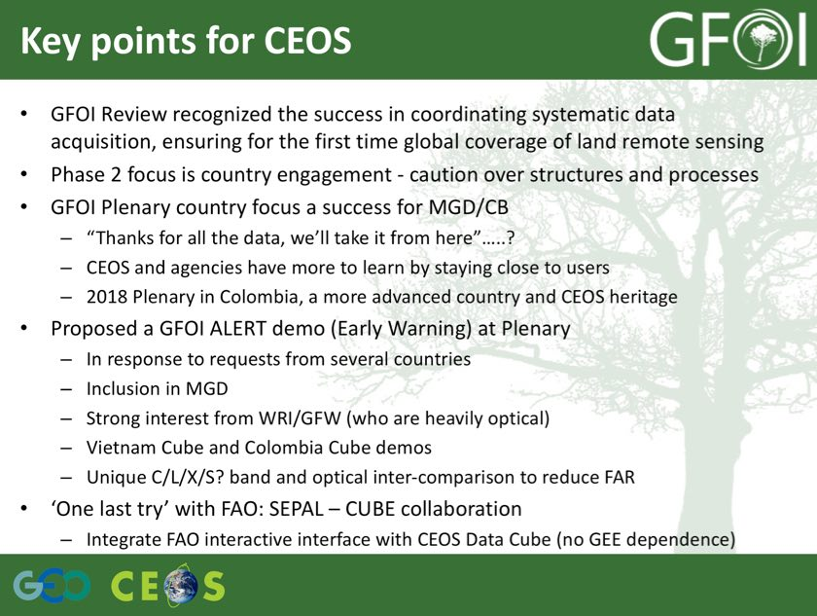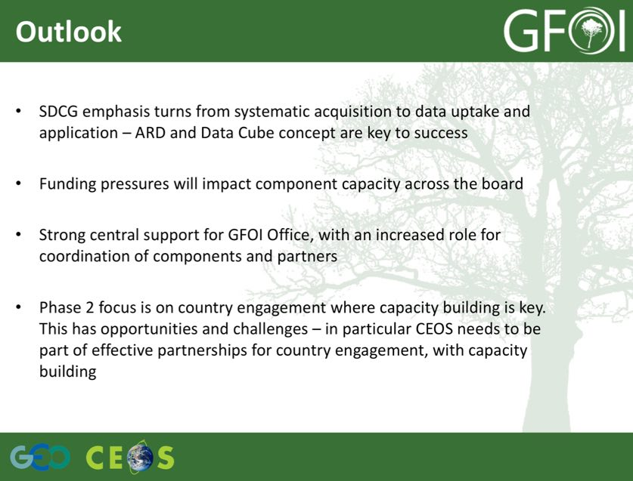
A brief discussion followed:
- Steve commented that the lessons learned from initiatives like GFOI could be applied to new application areas. Stephen Ward noted that GFOI was designed by understanding and balancing across the application landscape. Stephen Briggs agreed, noting that while some generic issues could be extracted, one of the lessons learned is that sometimes the largest issues (and strong solutions) are caused by individuals within the program.
- Paidamwoyo Mangara (SANSA) noted that they are receiving CBERS for Africa data, and would like to be able to contribute it, in particular for southern Africa.
SIT-32-03 | SDCG | Develop, in discussion with SIT Chair and Vice-Chair, a lessons learned paper on the CEOS engagement with GFOI and how these lessons might shape future engagement decisions by CEOS | SIT TWS 2017
 | Rationale: Lessons learned from mature CEOS initiatives like the SDCG for GFOI may be applicable to the development of new application areas.
GEOGLAM Status and Issues
Selma Cherchali (CNES) presented a summary of GEOGLAM updates, and reviewed the activities from three key GEOGLAM components supported by CEOS.
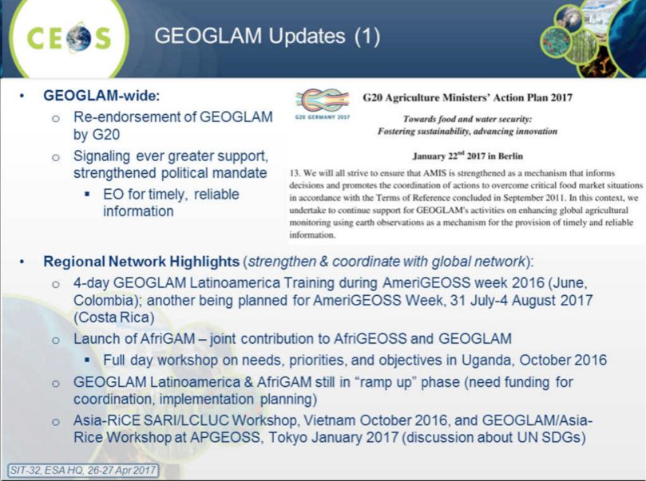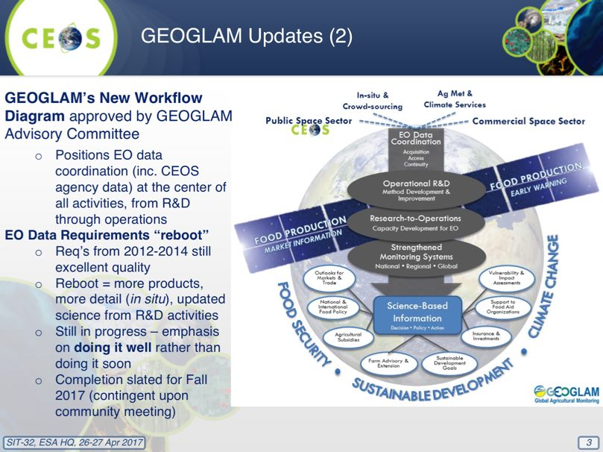
Asia-RiCE
- Upcoming Asia-RiCE related meeting (15 May 2017) focused on pre-operational data use (wall-to-wall) in Indonesia and Vietnam with Data Cube discussion and ALOS-2 ScanSAR data on-line access; and,
- GEORICE contributing a Sentinel-1 Module to the Vietnam Mekong Delta Data Cube.
RAPP
- Upcoming workshop at ESRIN (16-17 May) focused on integrating Sentinel-1 and -2 data for biomass estimation on rangelands; and,
- RAPP Map (global monitoring system) officially launched (http://map.geo-rapp.org/) In-country validation work ongoing with RAPP partners (Argentina, Brazil, South Africa, Namibia, Mongolia).
JECAM
- SAR Inter-comparison experiment;
- Agreement achieved between AAFC and CS, imminent start, with details to-be-discussed 28 June at Sen2Agri/SIGMA/JECAM meeting in Rome;
- Nearly 6000 km2 of VHR optical data (Pleiades) provided (Nov 2016).
Selma noted that GEOGLAM is currently considering how it can support the SDGs Goal 2 on Sufficient, reliable food availability, access, utilization as population increases. Selma noted that support to this goal is strongly linked to water resources and utilisation.
Selma noted that GEOGLAM has had good interactions with several components of CEOS including the LSI-VC (on requirements development and evaluation process and ARD), and WGapD (including GEOGLAM representation at WGCapD annual meeting in March 2017). She noted GEOGLAM will be participating in the joint meeting with LSI-VC and SDCG in September.
Stephen Briggs noted this is another nice example of GEO addressing a specific thematic area of need.
Blue Planet Update
Emily Smail (GEO Blue Planet) reviewed the mission of Blue Planet:
- to advance and exploit synergies among the many observational programmes devoted to ocean and coastal waters;
- to improve engagement with a variety of users for enhancing the timeliness, quality and range of services delivered; and
- to raise awareness of the societal benefits of ocean observations at the public and policy levels.
She reviewed the components and themes of Blue Planet, and noted the group is populating a new Advisory Board and expanded the Steering Committee, and planning a Blue Planet symposium in College Park, MD 31 May - 2 June 2017. Paul DiGiacomo will represent CEOS at this meeting.
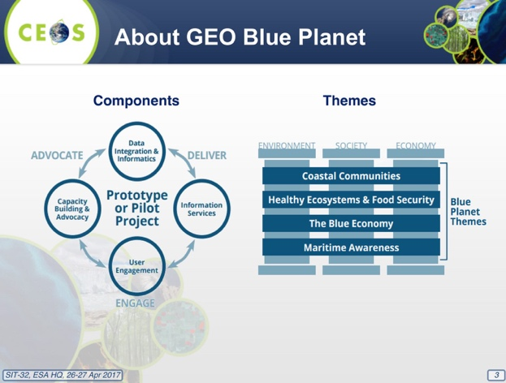
She reviewed the Multipurpose Marine Monitoring Mechanism (4M) project concept (for implementation in Barbados and Grenada) currently being developed by UNDP Barbados.
GEO Blue Planet is formulating a contribution to the SDGs, and recently contributed to side event on ocean observing at the February preparatory meeting UN Oceans Conference. Members of the GEO Blue Planet network will participate in the UN Oceans Conference in June. GEO Blue Planet is working on a proposal to NASA to fund a workshop in the Caribbean titled: “Implementing and Monitoring the Sustainable Development Goals in the Caribbean: The Role of the Ocean”.
Emily reviewed some of the objectives for 2017 – 2019:
- Build and engage working groups;
- Secure funding for implementation of 4M;
- Identify and begin work on additional prototype/pilot projects.
- Work to increase engagement and begin capacity building activities; and,
- Advocate for sustained ocean and coastal observations.
A brief discussion followed:
- Katherine Hill (GOOS) noted it was great to see this initiative evolving in this direction, and noted the potential for a very strong collaboration between GOOS and Blue Planet. Stephen Briggs noted this potential linkage was important, and also noted potential links to COVERAGE.
- Steve Volz noted he accepted a role on the Blue Planet Advisory Board because of his CEOS role, and because Oceans are of significant interest to NOAA. He noted that meeting four times of year is likely too frequent for a strategic advice body.
Other CEOS Actions in the GEO Work Plan
Jonathon Ross (CEO) presented a summary of CEOS Actions in GEO Work Plan, noting CEOS has contributions to 20% of the community activities, 40% of the initiatives, and 3 of the 4 current flagships, and as well several Flagship candidates. The roles and contributions have been varied, including in governance structures, leadership and management roles, and providing expertise.
He noted that there was a review of the foundational tasks last year, and a number are now managed and delivered by the community. He stressed that the GEO Programme Board helps GEOSEC with priority setting, but not in day-to-day activity. The in-situ task has been restructured and hopefully can now progress. The GEO three-year Work Programme 2017-2019 has been updated by Plenary, and is revised annually.
Report on World Cover 2017 Meeting
Stephen Briggs reviewed the conclusions of the World Cover 2017 meeting which took place at ESRIN March 14-16. The meeting agreed:
- to a wider collaborative initiative bringing together worldwide expertise desirable, with the potential that GEO could play a role;
- to retain also individual initiatives, including those delivering single-issue thematic maps (water, tree cover, urban, …);
- on the need for land cover classification schemes to be relevant to specific problem areas: no single scheme will satisfy all needs;
- but a generic classification could be of use to a wide range of service areas in societal areas such as SDGs;
- on the need for consistency in approach, some near real time mapping capacity, more penetrating analysis of accuracy assessment than simple comparisons;
- that generic land cover clearly important for biodiversity and ecosystem analysis, but care needed to ensure correct typology of classification schemes;
- that transparency of results and validation, sharing of validation data is important;
- to be wary of crowd-sourced validation data;
- the commercial sector capable and willing to deliver, in particular, tailored services on land cover and analysis; and,
- there is a need for careful dialogue with users to understand their information needs and potential to satisfy them.
Stephen Briggs noted that since the decline of GTOS, there has been a gap in the coordination of terrestrial observations, and that in parallel with the World Cover symposium a meeting among interested parties was convened by GEO and generated a few ideas to take the dialogue forward.
The draft outcomes of the meeting included:
Acquisition Goals:
- Shared sites and co-location of observations (e.g., integrated site system)
- Shared site database and/or meta-database
- Identify and fill gaps
- Eliminate overlaps (or extract more value from them)
- Coordinated observing methods and protocols (standards)
Delivery Goals:
- Harmonized parameter formats and units (standards)
- Harmonized systems with increased interoperability
- Improved data discovery and access of related cross-theme and cross-system observations
General approaches for consideration:
- Agree on an overall framework within which terrestrial observation systems collectively operate (e.g., analogous to the Framework for Ocean Observations)
Specific approaches for consideration:
- Create thematic working groups for within-theme discussion
- Focused workshops, online forums, discussions
- Clear identification of benefits to users (how does coordination help them fulfil their mission)
- Create cross-theme discussion mechanisms
A brief discussion followed.
- Frank Kelly (CEOS Chair) noted that USGS was involved in this conference, and LCMAP is closely tracking what is going on here as it moves forward into the Land Cover arena.
- Jennifer Lacey (USGS) noted that there may be a role for LSI-VC to follow-up on some of the actions arising.
- Barbara noted that the focus could be less on maps, and more on algorithms that are applied across data holdings.

6. UN Initiatives
Stephen Briggs (SIT Chair) noted that the UN Sustainable Development Goals (SDGs) have been identified as the number one priority for GEO, and CEOS has been following their formulation closely.
UN-SDGs
Barbara Ryan (GEO SEC Director) presented a summary of the GEO approach to SDGs, reviewing the history and noting the challenges of getting Earth observations recognised in the process. She stressed the importance of engagement with statistical agencies (national and UN) in establishing the case.
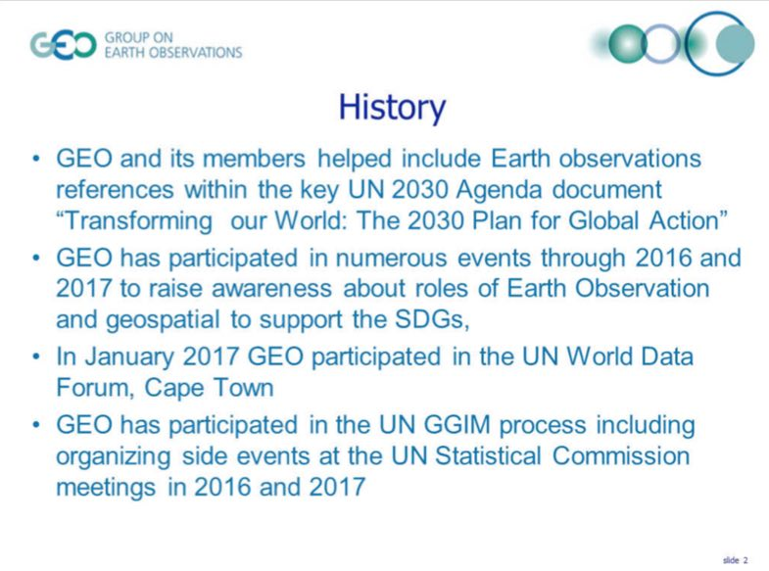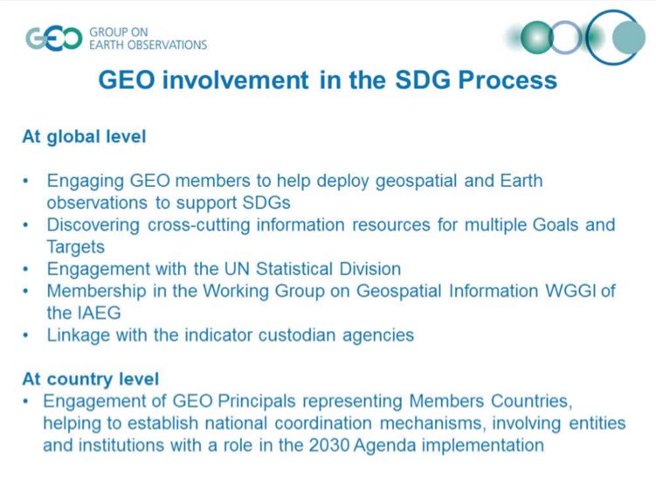
Barbara noted that lot of the discussion and coordination efforts have been via custodian agencies like: Sustainable Development Solutions Network, UN Committee of Experts on Global Geospatial Information Management, Global Partnership for Sustainable Development Data, and International Institute for Sustainable Development. She summarised the alignment of Earth observations and GEO to the goals, targets, and indicators.
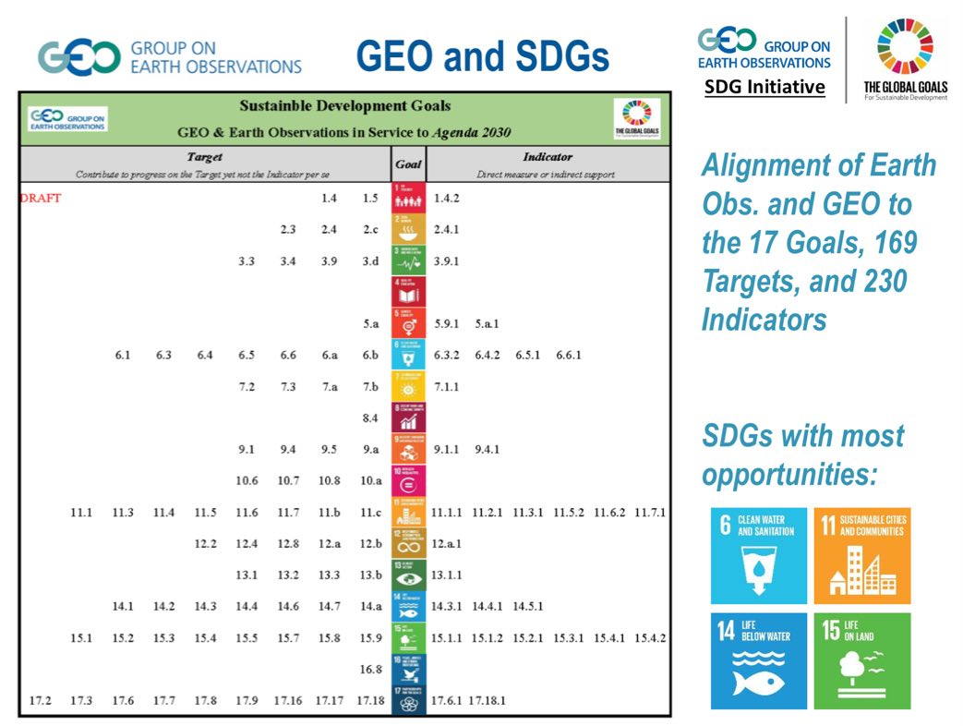
The GEO Programme Board (PB) has initiated an activity to coordinate GEO activities in support of SDG.
Lawrence Friedl (NASA) addressed the difference between the PB SDG activity and the GEO EO4SDG activity. He noted the PB activity is strategic and focused on the Work Programme, where the EO4SDG activity is more about how to navigate the UN process and engage with the UN structures and entities, in particular how do we maintain those conversations with the statistical agencies. When the time comes for a GEO initiative or Flagship to take over an SDG, then it’s time for the EO4SDG group to step away.
Barbara noted there is a need to align expectations with GEO’s and its member capabilities, and that acceptance by statistical agencies will take some time.
SDG Process
Marc Paganini (ESA) presented a summary of how the CEOS agencies are involved in the SDGs, and how CEOS can help to coordinate. He noted that the UN landscape is complex, and constantly evolving. He highlighted the work of the WGGI, noting their mandate is to identify the data gaps and methodological issues in relation to geospatial information. Where the engagement with the rest of the system is to communicate on-activity, rather than accomplishing the main work required.
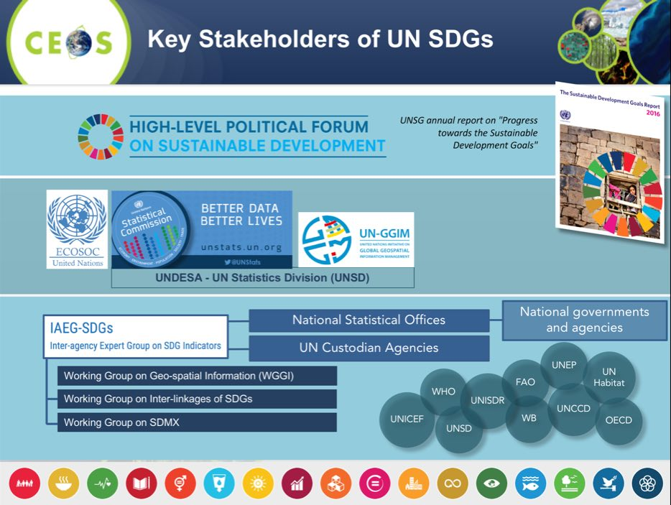
Marc noted the Report on “EO in support of the SDGs” co-written with CEOS and distributed at the 48th UN Statistical Commission (available on CEOS page under SDGs), and which identifies areas where Earth observations can support implementation.
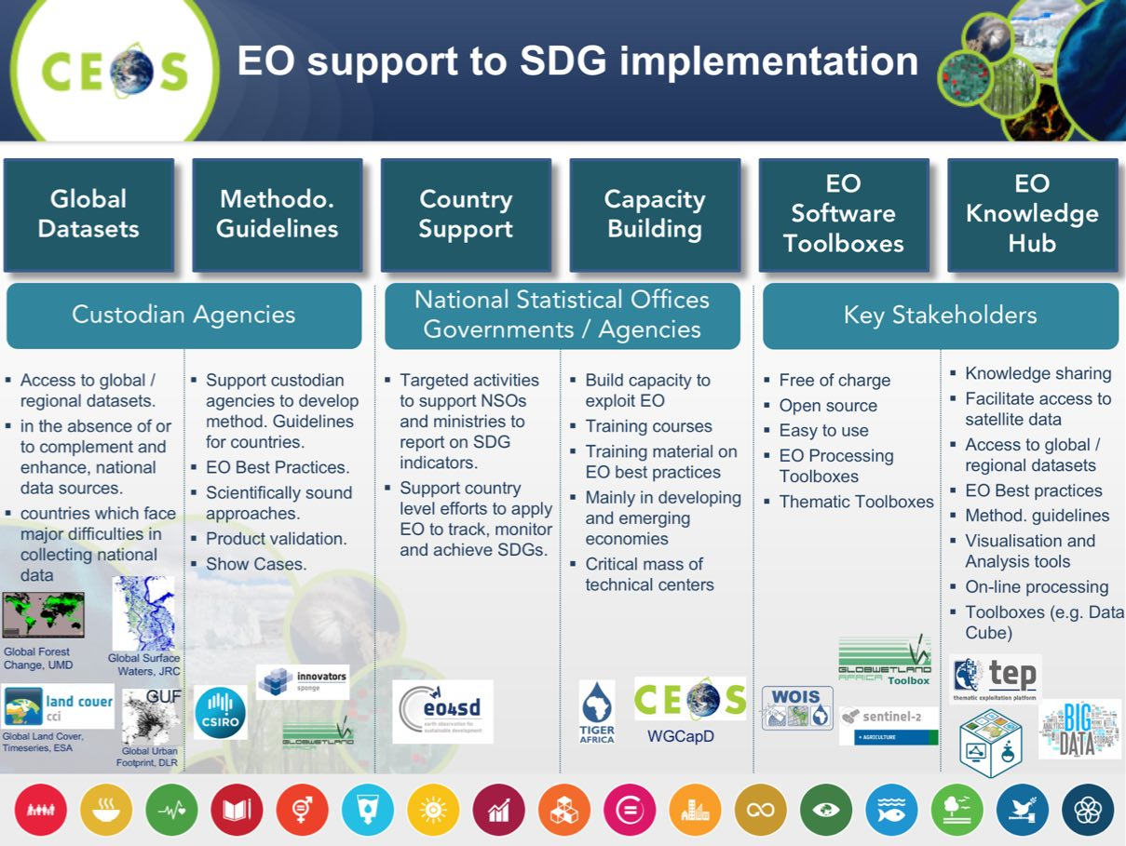
Marc reviewed the Terms of Reference (ToR) for the CEOS SDG Ad-Hoc Team (AHT), and stressed that in the complex and evolving environment, the SDG AHT must take stock of the UN processes in place for implementation and of the existing participants and stakeholders. CEOS should focus its activities around the unique role that it can play as a coordination body of the space community efforts. He reviewed the detailed ToR:
- Coordinate the efforts of CEOS agencies and communicate CEOS support to the SDG processes (use cases, communication materials, etc.).
- Provide a forum for sharing/communicating EO best practices in support to the SDGs.
- Analyse new opportunities for satellite-based EO to support SDGs Targets and Indicators.
- Engage with relevant authoritative SDG stakeholders inside (IAEG-SDGs, WGGI, UN Custodians) and outside the UN system (GPSDD, IISD, WBG, Foundations, etc.).
- Use CEOS assets and bodies (WGCapD, AHT FDA, etc.) to build and strengthen EO capacities at all levels of the UN SDGs implementation.
Marc recalled that the High Level Political Forum for Sustainable Development takes place every year, in the June-July timeframe. ECOSOC is officially in charge of the definition of the goals, targets and indicators and the UN Agencies are responsible for the implementation of the indicators, interfacing the governments and national statistical offices. WGGI looks for data gaps and methodical issues. Marc stressed the need for space agencies to participate in the major relevant meetings in order to increase the awareness of the various communities.
Marc noted that the SDG AHT had its first meeting in Washington DC, 8-9 March, where the group identified key elements of an Implementation Plan, building on ongoing key activities:
- Support to GEO and its EO4SDG initiative;
- Direct discussions with stakeholders especially Custodian Agencies and National Statistical Offices (bilateral);
- Communications and Capacity Building activities; and,
- Ongoing case studies and initiatives at agency-level.
The next steps until CEOS Plenary include:
- Finalize a compendium of existing CEOS Agencies engagement and activities in the SDG framework;
- Organize a discussion at SIT TW to review CEOS current engagement and identify gaps and opportunities; and,
- Identify key components of an implementation plan to present at CEOS 31 Plenary.
A brief discussion followed:
- Klaus Schmidt (DLR) noted that DLR has not been in a position to engage due to a lack of Terms of Reference for the SDG ad hoc Team. Jonathon Ross (CEO) noted that the AHT was agreed at Plenary with a set of short-term objectives, and the ToR are more for the group. Klaus asked that a DLR point of contact is added to the mailing list, and noted that and implementation plan would help.
- Stephen noted that when the group was formed in October 2016, it was asked to define what they would to this year, and then follow-up with a three-year work plan at this coming CEOS Plenary.
SIT-32-04 | Sustainable DevelopmentGoals Ad Hoc Team | CEOS Ad-Hoc Team for the SDGs will ensure DLR is added to the group’s mailing list | COMPLETE
 | Rationale: DLR would like to stay up to date with the latest status of the CEOS AHT for SDGs.
UN-WCDRR - Process Update and CEOS Way Forward
Ivan Petiteville (ESA) presented on GEO-DARMA, noting that after the Sendai meetings there was a growing awareness among decision makers and key stakeholders on the need to use all data sources (e.g. in-situ, remote sensing, socio-economic, models, etc.) for taking better- informed disaster risk reduction decision and resilience measures. There is a need for sustained end-to-end solutions with involvement of all relevant actors from data and information providers to final end users. Following Sendai, CEOS and GEO were asked by UNISDR (organiser of the Sendai Conference) to propose a concrete action plan, and the CEOS WGDisasters and GEO SEC developed GEO-DARMA in direct response to the Sendai Framework.
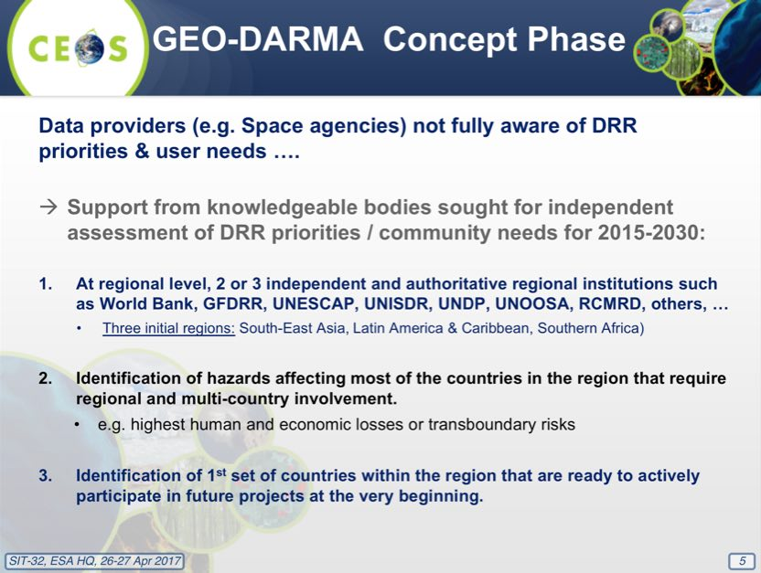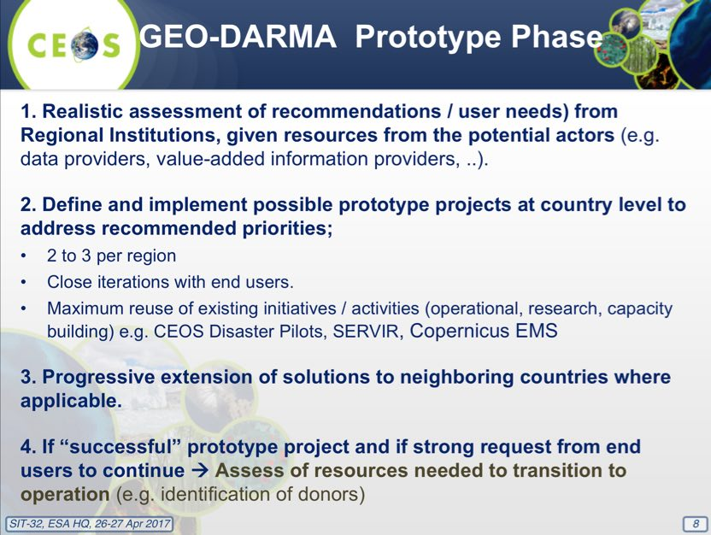
Ivan reviewed the status of GEO-DARMA.
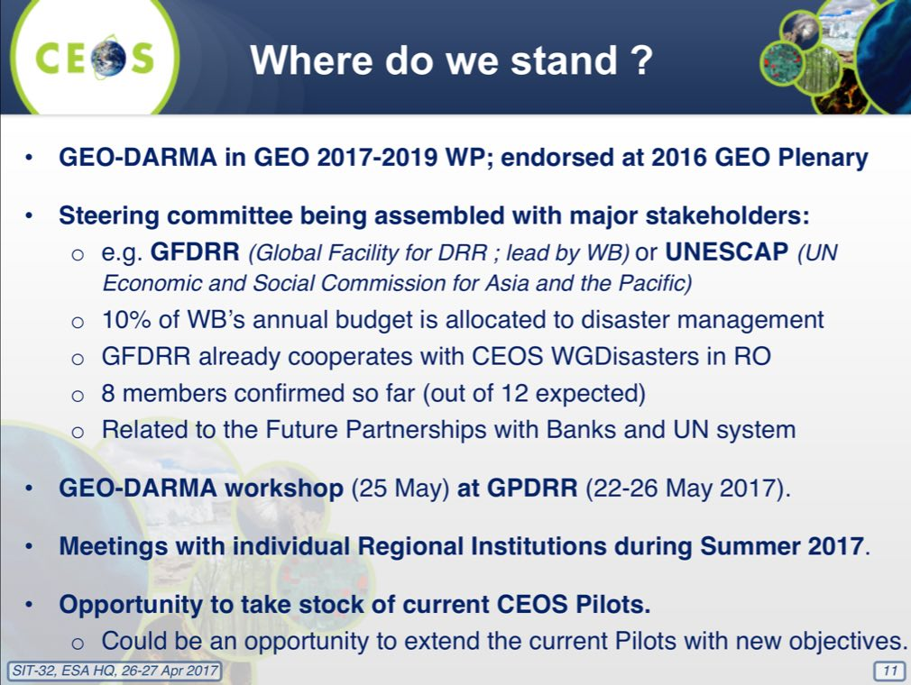
The 2017 Global Platform for Disaster Risk Reduction (GPDRR, 22-26 May, 2017) is the most important international forum dedicated to the disaster risk reduction agenda, and is held every 2 years, and more than 5000 participants are expected. This will be the first opportunity for international community to review global progress on the implementation of the 2015 Sendai Framework for Disaster Risk Reduction.
CEOS Support to the Sendai Framework for Disaster Risk Reduction
Stéphane Chalifoux (CSA) presented a summary of CEOS support to the Sendai Framework, including major earthquakes struck central Italy, the Haiti Recovery Observatory (RO), and GP-STAR contribution. He noted that following the Italian earthquake in August 2016, seismic pilot Objective C was triggered to generate rapid science products in support of response, including an assessment of residual movements after the occurrence of a slope failure, and the identification of safe areas for relocation.
Following Hurricane Matthew (October 2016), the RO was triggered by CEOS Chair in consultation with CEOS Principals. Support was also provided under Sendai Framework Priority #4 “Enhancing disaster preparedness for effective response, and to support recovery, rehabilitation, and reconstruction. Stéphane reviewed the GP-STAR initiative.
The potential overlap with radiant.earth was noted during a brief discussion.
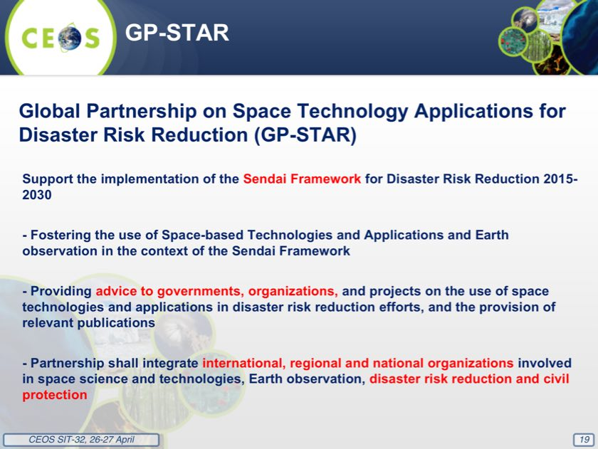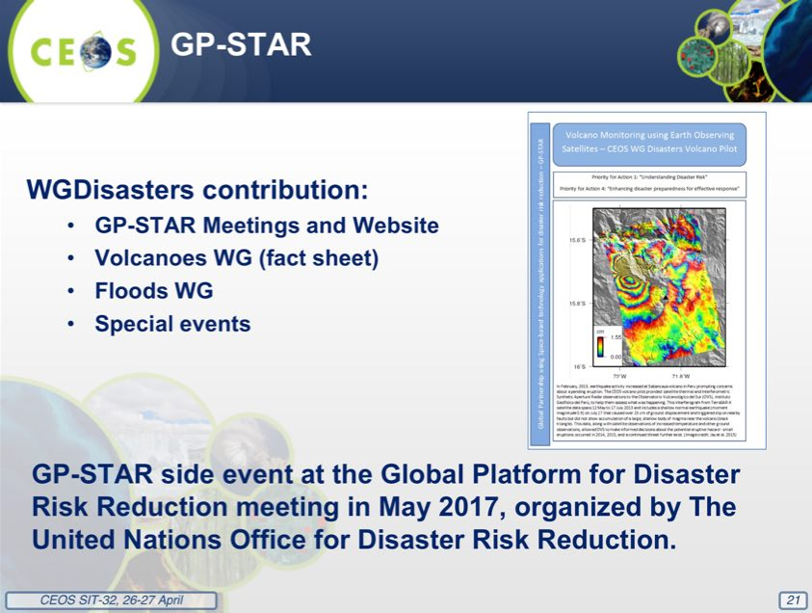
Stephen stressed the importance of the programmatic frameworks for these issues, and we will revisit the points for endorsement tomorrow.

7. Thematic Observing Strategies
GEOGLOWS
Barbara Ryan (GEO SEC Director) presented a summary of GEOGLOWS, noting the context for this activity comes from the GEO Water Strategy. The objectives of GEOGLOWS are:
- Engage end users and boundary organizations to understand needs by region and decision making process and prioritize activities based on vulnerability analyses;
- Strengthen capacity to understand water data needs and develop user-driven applications products from EO data and applications;
- Strengthen capacity to use water EO and science effectively across spatial and temporal scales;
- Coordinate and leverage GEOGLOWS partners to more effectively provide information and expertise to stakeholder and end user communities; and,
- Contribute to the assessments of impacts of climate change with population and economic growth on water resources and their availability, and to inform planning and adaptation activities.
Barbara noted that a GEOGLOWS/IGWCO business meeting will take place 16 to 19 May 2017, at the National Water Centre in Tuscaloosa, and will be focused on developing GEOGLOWS as an international initiative. It will include four Working Groups (science, applications, product development and testing; Essential Water Variables (EWVs) and observational issues; data dissemination, community portals, capacity building and user engagement; and, socio-Economic issues of the water crisis and Policy linkages). Paul DiGiacomo will represent CEOS at this meeting.
A brief discussion followed:
- Stephen Briggs (SIT Chair) noted that while water is clearly important, it hasn’t been clear in the past what we should be responding to, but GEOGLOWS represents an important opportunity to potentially re-focus the activity.
- Barbara noted that a recent consolidation in GEO’s water-related activities, and that GEOGLOWS is aiming to provide that focus. Kerry Sawyer (NOAA) noted that GEOGLOWS was the catalyst for this discussion was first discussed within CEOS at SIT-31.
GEO AquaWatch
Emily Smail (GEO AquaWatch) presented an update on AquaWatch, noting that it was previously referred to as the GEO Water Quality Community of Practice or the GEO Inland and Near-Coastal Water Quality Working Group, and emerged from a 2007 GEO Inland and Nearshore Coastal Water Quality Remote Sensing Workshop. In 2015, the group drafted a 10-year strategic plan for developing water quality assessment data and information products. In 2016, GEO AquaWatch established a Secretariat, formally established working groups and identified near-term projects and priorities.
The AquaWatch Mission is to improve water quality in coastal and inland waters through more effective monitoring, management and decision making, and the goal is to develop and build the global capacity and utility of Earth Observation-derived water quality data, products and information to support water resources management and decision making.
Emily reviewed the objectives, as well as the current activities of AquaWatch.
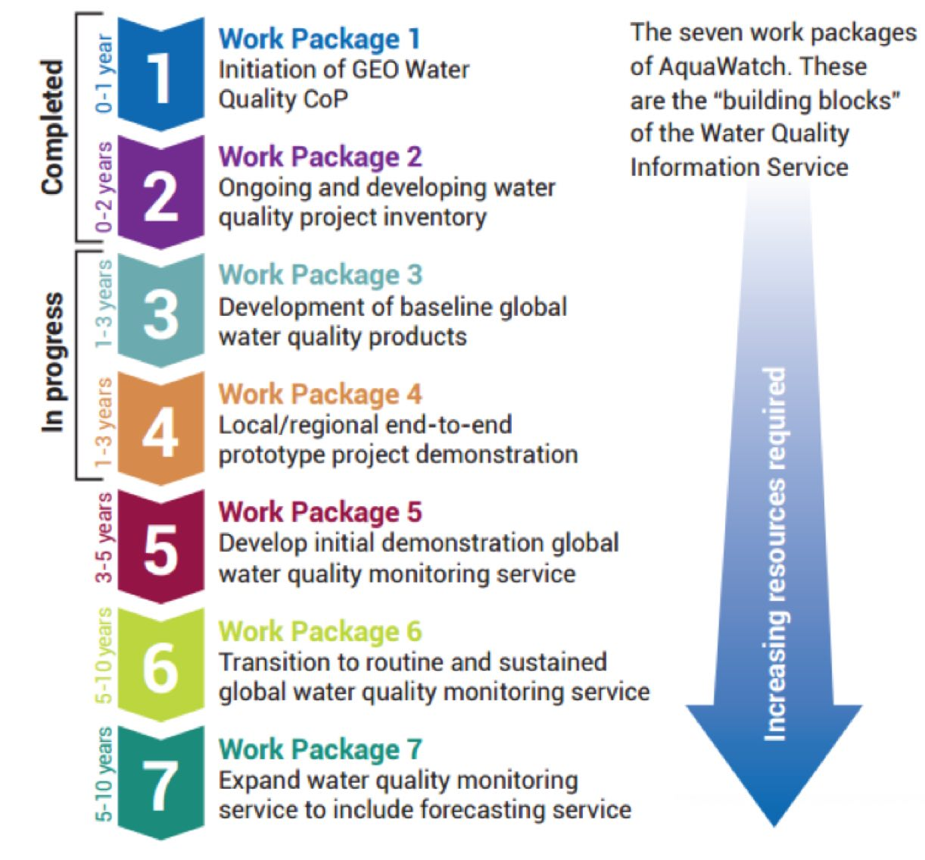
She reviewed the medium-term activities for 2017 – 2019, including:
- Support and collaborate with other GEO groups on water quality project needs (GEOGLOWS, EO4SDGS, GEO Blue Planet, GEO Wetlands, GEO BON, Regional GEO groups);
- Continue to build on work package 3 and 4, initiate 5 and 6;
- Populate formal Steering Committee and build Working Groups; and,
- Work to increase engagement and begin capacity building activities.
Emily noted that the work of the CEOS Virtual Constellations (especially the Ocean Colour Radiometry Virtual Constellation, OCR-VC) and Working Groups has provided support to the work of AquaWatch, and that CEOS tools and services, including the CEOS Water Portal, will likely be utilized and integrated into future AquaWatch products.
Hyperspectral Water Quality Report C.10
Alex Held (CSIRO) presented the final item in response to the CEOS Water Strategy (action C.10), noting that this summarises work led by Arnold Dekker with support from other CEOS agencies. He reviewed the optimal spatial resolution recommended by the study for inland waters:
- The minimum spatial resolution requirement for inland water bodies can be categorized in two bins;
- A GSD of 300 m can observe the majority of the world’s lake surface area (but is a small fraction of the total number of lakes);
- A sensor with a minimum GSD of 15-17 m would enable observations for ~25% of global river reaches and 90 to 100% of lakes 0.2 ha or larger;
- The Sentinel-3 series of satellites has 22 spectral bands, high SNR and a GSD of 300m and is thus adequate for large lakes adequately; and,
- The focus for new sensors should be around 5 to 8 nm spectral bands and a GSD of about 17 m, whilst a GSD of 30 m could be a compromise between costs and S:N.
Alex reviewed the main outcomes of the study.
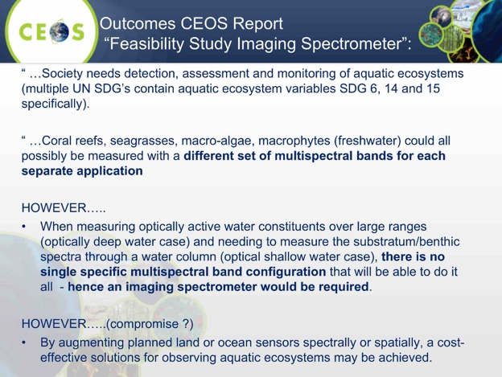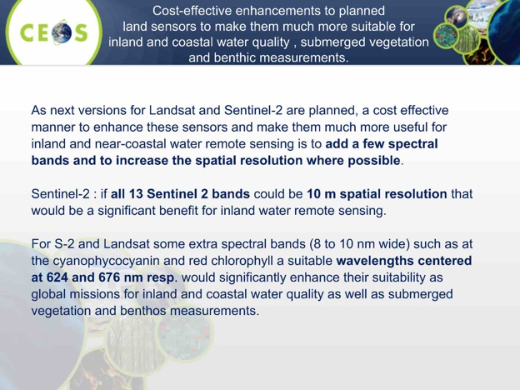
A brief discussion followed:
- Stephen noted that reports like these are the foundation stone for future mission requirements.
- Adam Lewis (GA) asked about the extent to which AquaWatch is implementing existing algorithms vs developing new algorithms, and Emily noted that for the prototype they are using existing algorithms, but that in future this could be expanded.
- Mark Dowell (COM-JRC) noted he attended an AquaWatch meeting last year, and that there was a healthy balance of the research and industrial SME community in making tailored water quality products in different agencies. He felt AquaWatch represented both the oceans and inland water communities, and this is one of the reasons it remains independent.
- Kerry Sawyer (NOAA) noted that AquaWatch is a community activity within GEO, but there is a concern that CEOS didn’t really know about this until Paul DiGiacomo raised it at the 2016 SIT Technical Workshop. She stressed that securing CEOS buy-in is key to being able to proceed.
- It was noted that NOAA’s OneStop portal, which captures significant water-related information, has been made ‘semi-operational’, and is available at https://www.ncdc.noaa.gov/onestop/.
- Stephen noted that both COVERAGE and AquaWatch appear to lack a policy driver, and that most involved appeared to be on the product delivery side, rather than on the user or demand side. In order to improve CEOS support to water monitoring, we need to understand the user needs addressed, rather than listing what we can address. He noted that GEOGLOWS appears to be trying to promote demand side rather than supply side information needs. He suggested that at the SIT Technical Workshop (in preparation for Plenary), we come back with greater engagement with the demand side for space agencies, and then try to understand what the actual call for resources will be.
- Emily noted that the AquaWatch Steering Committee is going work to bring in the user perspective. She noted that GEOGLOWS and GEO appear to be focused on fresh water as a Societal Benefit Area, and so this partially why AquaWatch hesitated to join.
- Barbara noted that to reach Flagship status, the GEO water activities will have to identify a clear policy mandate.
- Stephen welcomed both proposals, noting that this has been a difficult area for GEO and that both have great promise, and both could be strengthened by greater policy and demand side linkages.
Rationalising CEOS Land Imaging Activities
Stephen Ward (SIT Chair Team) presented a summary of the plans for September’s joint meeting between LSI-VC, SDCG for GFOI, and the GEOGLAM ad-hoc Working Group, and called for SIT concurrence with the plan. The overall objective is to achieve more consistency and structure within CEOS for land surface issues.
He noted that a side meeting was held at the 2016 CEOS Plenary in Brisbane, and it was agreed that a trial meeting should be organised as the next step in the way forward (website). A discussion paper followed, and there was a leadership telecon of the three groups in February which agreed to proceed with the trial meeting. The objectives are to take a more holistic approach to overall requirements and observing strategy, and to explore efficiencies in travel and representation. The trial meeting is proposed for 6th – 8th September at ESRIN, with SDCG (at least) also meeting on the 5th.
It was agreed that it is very important for SDCG and GEOGLAM to maintain their thematic linkages, and that it would be a failure if the work of these groups became internally focused on space agency business. For GFOI purposes, it was agreed best to keep ‘SDCG’ name at least for external purposes, regardless of how CEOS identifies it internally. SDCG could, potentially, become a permanent group under LSI, which would mean it was no longer ad-hoc, though permanence could be achieved via several different approaches, and SDCG is open minded on this.
Stephen Ward stressed that SDCG asks all core agencies remained engaged as GFOI is entering Phase 2, which will make continuity quite important.
No objections to the proposed joint meeting were raised.
A brief discussion followed.
- Mike Freilich (NASA) stressed that with the focus on efficiency, there should be a suitable focus on robustness, and that if CEOS doesn’t sufficiently resource the effort, it will be efficient for some time, and then risk becoming dysfunctional.
- Stephen Briggs noted having a clear indication of how CEOS groups presented their outward facing (e.g. to SDGs, Banks, GEO Initiative) is important, as are the linkages back to the internal workings of CEOS (e.g. ARD, FDA, Data Cube, etc.).

8. Coordination of Climate Observations
GCOS Status and Outlook
Carolin Richter (GCOS) presented as summary of recent GCOS activities, reviewing the development of the 2016 update of the GCOS Implementation Plan (IP, GCOS-200). She reviewed the role of the GCOS Science Panels, and noted where the work of CEOS-CGMS WGClimate is reflected. She mentioned that the objective is to update the GCOS IP in 2021 (target date).
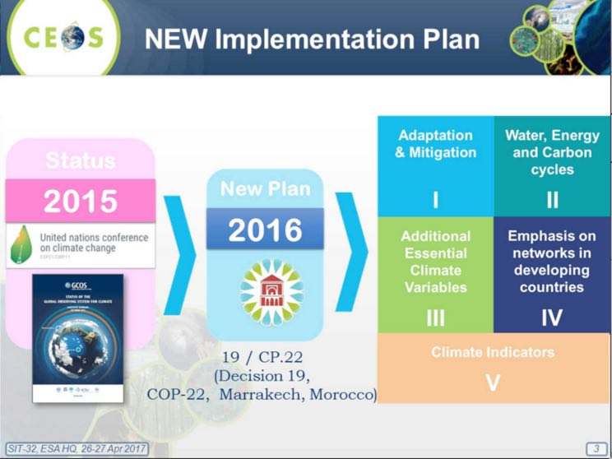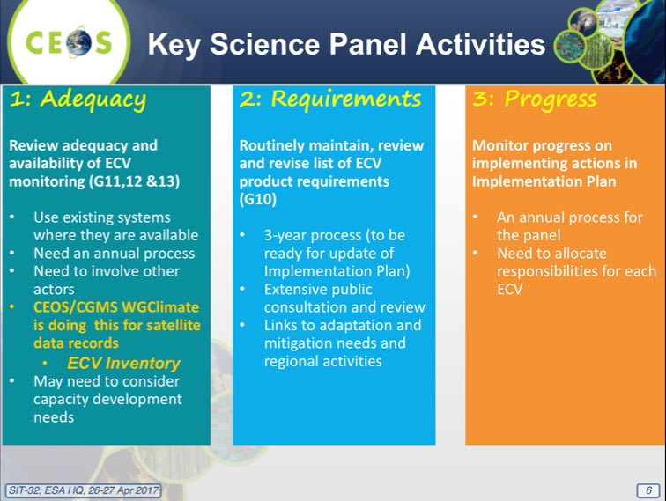
Carolin noted several recent thematic discussions on future potential ECVS:
- Atmospheric Observation Panel for Climate (AOPC-22): radiosondes, clouds, and lightning.
- Ocean Observations Panel for Climate (OOPC-20): Sea Surface Temperature, Sea Ice, Ocean Surface Stress, Heat Fluxes, Boundary Currents/Shelf Interactions, and Ocean Change detection.
- Terrestrial Observation Panel for Climate (TOPC-19): Evaporation from land should be an ECV, Satellite observations may help fill large gaps in reporting in-situ observations of rivers and lakes, Consistency between ECV products (e.g. Albedo, LAI, FAPAR, Land surface temperature) needs to be assured, 4 Copernicus will deliver many ECVs on a guaranteed long-term basis, and GCOS Surface Reference Network.
A brief discussion followed.
- Pascale Ultré-Guérard (CNES) asked if the updated GCOS-200 (i.e. “2016 GCOS Implementation Plan”) recognise the importance of upstream information, or complementary data (e.g. gravity variation measurements). Carolin confirmed that there was some discussion around ancillary measurements like gravity. Stephen Briggs (SIT Chair) noted the addition of ancillary observations that are fundamental but are not ECVs in this update, for example gravity measurements or the need for orbit restoration data.
- Mark noted that the report includes a specific mention of satellite-based reference information and satellite calibration missions.
- John Remedios (UKSA) asked about the linkage between IPCC WG1 and the key indicators, and also about the treatment of polar variables. Carolin noted they have invited the IPCC Secretariat and experts, and GCOS has reviewed the WG1 outcomes and they have been part of the discussion. She noted on cryosphere that they have been in contact with Cryosphere Watch and the Global Climate Programme, and that Antarctic Sea Ice is a specified ECV.
- Carolin Richter (GCOS) noted the potential connection between the work being done on Data Cubes, land surface work, and historical climate indicators.
CEOS Climate Coordination Update
Pascal Lecomte (ESA) presented on WGClimate and the CEOS-CGMS Response to GCOS-200. They are planning a smaller response (20-30 pages), and he reviewed the outline of the response, noting that 6-9 pages will be included to address detailed implementation. The writing team includes more than 20 people, with broad representation from COM, WMO, UKSA, USGS, CNES, NASA, DLR, INPE, DWD, NOAA, EUMETSAT, JAXA and ESA. The draft response will be sent to SBSTA in October 2017.
Pascal reviewed the contents of the ECV Inventory, noting the strong support provided by EUMETSAT. The Inventory contains 893 entries (435 existing data records + 458 planned data records) spanning across 27 of the 29 ECVs in GCOS-154. ~80% of the listed physical quantities, 74% Atmosphere, 15% Land, and 11% Ocean. A verification process on-going, with 80% finalised, 20% being iterated with Responders. More than 90% have been “Verified” for Gap Analysis Process. He noted that from GCOS-154 (2011), 27/29, or ~93% of the ECVs are covered. For GCOS-200, 30/35, or ~86% of the ECVs are covered. He noted that there will always be some inherent uncertainty around the contents of the Inventory, and reviewed the gap analysis roles and actors.
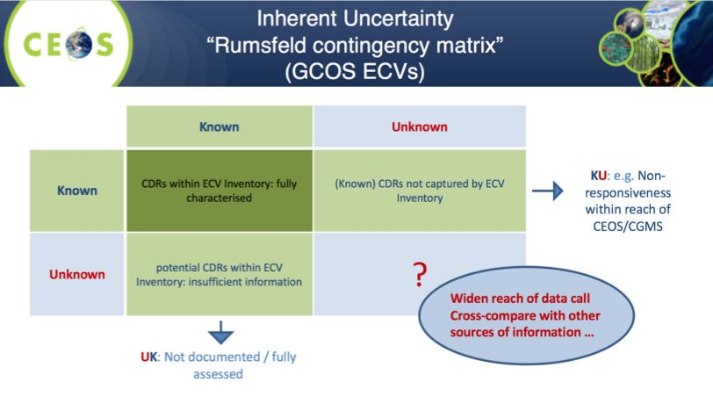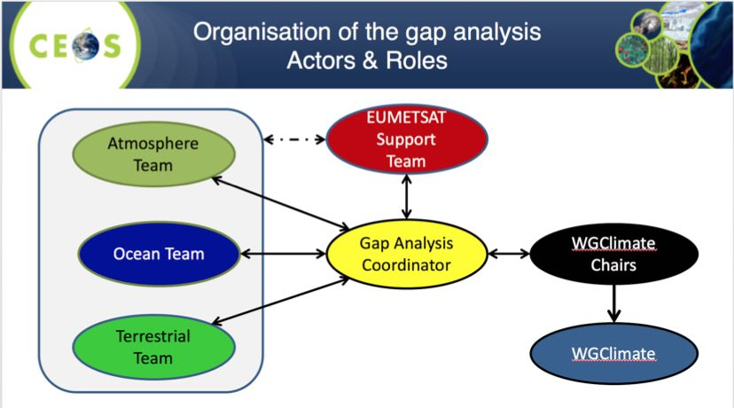
Pascal noted that the first brush through the Inventory shows how many ECVs, ECV products and physical quantities are addressed by space agencies. The coordination of a gap analysis has started, and there is a need to complete the domain teams. There is also a need to address in the gap analysis report the inherent uncertainty of the gap analysis, and develop tools for the verification process.
Pascal reviewed the planned schedule:
- ECV Inventory release: 05/06/2017
- Gap Analysis Report final draft: 31/08/2017 (First Draft: 31/07/2017)
- Coordinated Action Plan: 15/09/2017 (First Draft: 15/08/2017)
- Space Agency Response to the GCOS IP: 06/10/2017 (First Draft: 11/09/2017)
A brief discussion followed:
- Stephen asked about the 35 ECVs and whether those are the ones addressed by space, and Pascal confirmed they were. Stephen also noted that land surface temperature is a new ECV.
- Ivan Petiteville (ESA) asked about the maintenance of the Inventory, and Pascal noted that for cycle 3, EUMETSAT is committed to support. He noted that if USGS is confirmed by CGMS and CEOS Plenary, they are expected to take the work on for cycle 4. The location of the database needs to be discussed, and Paul Counet (EUMETSAT) confirmed that so long as the support of the EC Copernicus Climate Change service remains in place, EUMETSAT is happy to host and maintain and host the ECV Inventory.
- Mark asked how we are going to deal with endorsement of the Space Agency Response to the GCOS IP, with COP starting 10 days after CEOS Plenary. Stephen suggested we have a first draft of the response in time for the SIT Technical Workshop, and plan for a virtual concurrence later in September, with a two-week review/endorsement cycle before submission to SBSTA on 6th October.
- Steve Labahn noted that there is a CEOS SEC meeting between the Workshop and Plenary that could help in the process of endorsement.
SIT-32-05 | WGClimate | Coordinate with CEOS SEC to develop a timetable for the production and review of the CEOS statements to be delivered at COP-23 | May 2017
 | Rationale: Because of the short time between CEOS Plenary and COP-23, and the need to submit materials before CEOS Plenary, a CEOS endorsement process that does not rely on a face-to-face meeting will have to be agreed.
IPCC Task Force on National Greenhouse Gas Inventories (TFI) Engagement Status
Shizu Yabe (JAXA) noted that the 2006 IPCC Guidelines for National Greenhouse Gas Inventories will be refined in 2019 and this is an opportunity to have optimal representation of EO satellite data in the guidelines provided to countries by IPCC. The guidelines provide methodologies for estimating national inventories of anthropogenic emissions by sources and removals by GHG sinks. JAXA and their Ministry of Environment (MOE) wish to focus on the inclusion of atmospheric GHG measurements from satellites, where the current guidelines indicate that each country should use independent data to verify GHG inventories.
The MOE/JAXA effort is focused on Volume 1 (General Guidance and Reporting), Chapter 6 (Quality Assurance/Quality Control and Verification). Since the existing Volume 1 Chapter 6 is outdated and expected to be updated, MOE aims to have the refined IPCC GHG Inventory Guidelines refer to satellite-based GHG data to enable all countries to utilise the data for national reports on GHG emissions, and will:
- develop a methodology to estimate anthropogenic GHG emissions with satellites;
- promote training of practitioners engaged in GHG inventories in developing countries with the methodology; and,
- collaborate with other countries for monitoring GHG emissions.
MOE would appreciate a CEOS review of the draft methodology document as an input to IPCC/TFI guidelines in September 2017. The schedule of the IPCC process was shown:
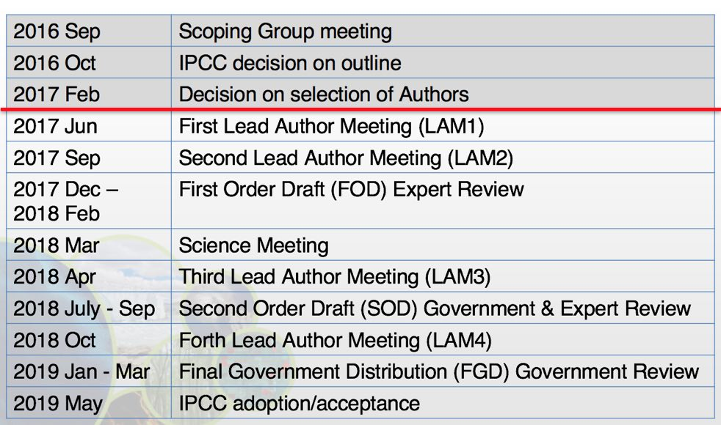
Quality control is essential for the IPCC Guidelines, and JAXA will propose a standard methodology for calibration of the relevant datasets to WGCV for quality control of observed data. JAXA will organise side events at COP-23 (e.g. a session at Earth Info Day), and will look for co-organisers.
Stephen summarised the SIT-32 side meeting discussion, noting the timeline allows for opportunities to contribute before the guidelines are finalised in 2019. The first opportunity to contribute comes in June (LAM1). This is an opportunity for CEOS, and despite the difficult timeline, CEOS should work to formulate a submission to make the case for satellites to contribute. He referred to the challenge of integrating the knowledge of the space agencies into the submission and process by the Japanese MOE.
Stephen noted that the one mature reference to satellite data in the IPCC guidelines is emissions due to changes in land use, and wondered if there are others in the terrestrial area that could be added.
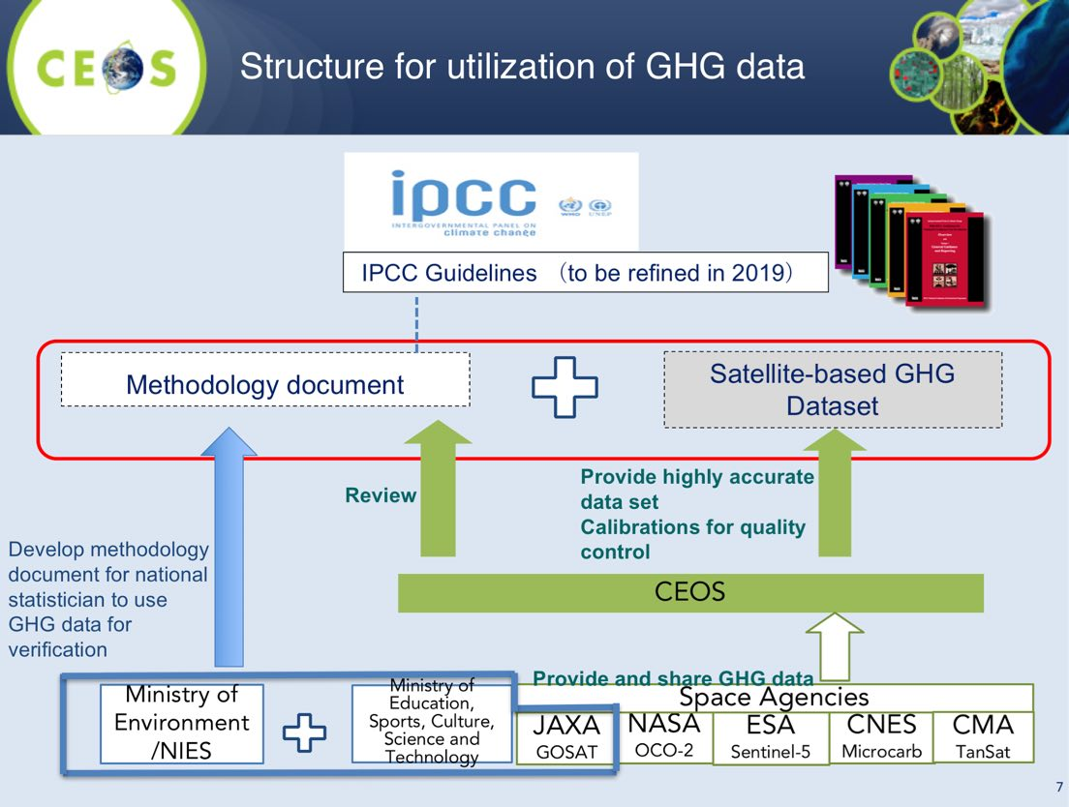
CEOS Carbon Strategy Implementation Update
Mark presented a summary of the status of seven the VC/WG initiatives on carbon, reviewing the process to date. He noted that this process started with the GEO Carbon Strategy in 2010, and then the CEOS response in 2014. 42 actions were identified in the report for specific response, and were first discussed at SIT Technical Workshop in 2013. Since these strategies were formulated, the Paris Agreement and the GCOS response to that have been completed. In addition, several parallel space agency efforts have been underway to try and address carbon observations on a national and regional level.
Mark noted this may be the most cross-cutting activity within CEOS do date, with the lead CEOS “Entities” for each action as follows:
- Atmospheric Chemistry-VC: 6 Actions
- Land Surface Imaging-VC: 4 Actions
- Working Group Climate: 7 Actions
- Working Group Calibration/Validation: 11 Actions
- Strategic Implementation Team: 7 Actions
- N/A: 2 Actions
- Many other WGs and VCs named as contributing
Mark reviewed several of the activities underway, noting that CEOS Plenary had agreed on the overall approach (i.e. a smaller number of dedicated activity addressing multiple Actions), and that an update would be provided at Plenary 2017, process to be reviewed at Plenary 2018. Additional initiatives could be added if critical mass and resources available.
- ACC: white paper on a GHG constellation;
- LSI-VC: adopt GEOGLAM requirement process & gap analysis;
- WGClimate: focus gap analysis work on carbon-specific ECVs;
- WGISS: on a carbon data portal to facilitate the discoverability and accessibility of ECV products and space-borne CDRs relevant for the carbon actions;
- NASA-ESA: cal/val and production of biomass products from CEOS missions – based on previous bi-lateral NASA/ESA initiative;
- WGCV: Shorter term activities - Summarize current list of validated land data products relevant to Carbon Strategy; and,
- JAXA: engagement with IPCC TFI guideline process, promoting satellite EO.
Mark noted there are strong links to the GEO Carbon and GHG Initiative, which was accepted as a GEO Initiative at 3rd GEO Programme Board 2016. In the long run, these activities could be a potential integrator for global in-situ networks. He noted that European Commission is proposing a priority addressing some of the carbon/GHG issues during its period as Chair.
David Crisp (NASA JPL) reviewed the variety of missions planned for launch in the coming years. He stressed that this impressive collection of satellites are focused in their own ways on conducting the science to learn how to make this GHG observations from space, and CEOS could make large and unique contributions to their coordination.
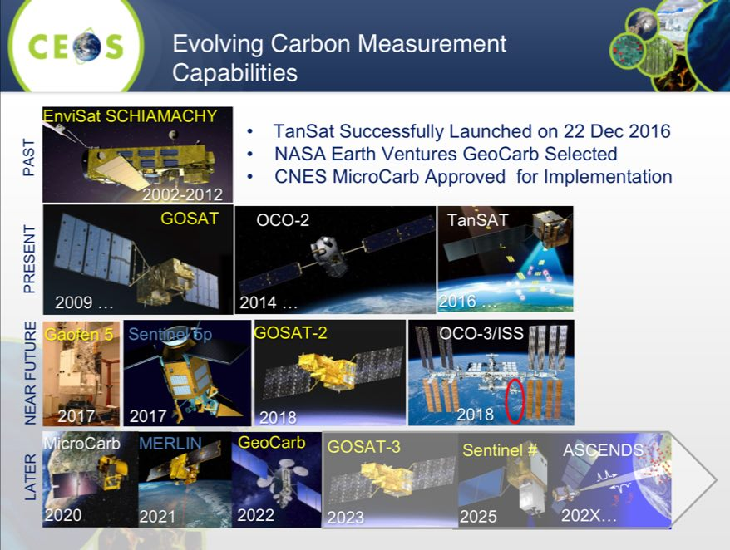
Stephen noted that there are many measurements required to map the global carbon cycle - not just from satellites, but from many sources. He asked about how to make a timely submission to the IPCC Inventories process, and proposed asking David’s group within the AC-VC to support, and David agreed.
Stephen noted there is a broader question on how to formulate a global coordination effort (perhaps based on the joint CEOS/CGMS activity already ongoing), taking advantage of the excellent progress made by the COM task forces on Carbon (which already have representation from outside Europe) and this action could be addressed in part by the COM during their CEOS Chair term.
A brief discussion followed.
- Barbara Ryan (GEO Secretariat Director) asked about the requirements process, and Mark noted that there is some risk of losing the heritage from the rigorous IGOS-P processes.
- John Remedios asked if short-term actions for agencies could be identified in anticipation of questions coming back from the IPCC Inventories process. Mark noted that an ancillary activity discussed at the 2016 SIT Technical Workshop as would be to compile a list of agency-level efforts that were currently addressing actions in the CEOS carbon strategy with the objective of informing other agencies, and to identifying possible gaps where efforts still required. He suggested he could call for inputs from initiatives for areas to be addressed.
- Stephen noted this is clearly a task that this group of agencies (i.e. CEOS) needs to take on, and despite the organisational and schedule challenges, these drivers which cannot be ignored. A lot of groups have an interest in having this happen, but none has taken the lead, and so there is an opportunity for CEOS.
SIT-32-06 | AC-VC | AC-VC Satellite Carbon Report initiative to work with JAXA to coordinate the CEOS review and input to their atmospheric GHG methodology input to the IPCC guidelines update process | 2017
 | Rationale: JAXA (with Japanese MOE) are developing inputs to the IPCC guidelines update process, and have requested CEOS support in reviewing in 2017. AC-VC has confirmed they are willing to provide a review.

SIT-32-07 | LSI-VC & Mark Dowell | LSI-VC to work with Mark Dowell to define the opportunity for CEOS agencies to provide input to Vol 4 (AFOLU) of the IPCC GHG guidelines update process | Jun 2017
 | Rationale: Currently land use is the only specific reference to satellite information the IPCC GHG guidelines, and other areas should be considered and flagged if suitable. Input to global land assessments is an important role for CEOS to maximise the uptake an application of CEOS data, and, to be in a position to influence the development of improved guidelines that make better use of satellite capabilities.

SIT-32-08 | European Commission (COM) as Incoming CEOS Chair | Outline a proposal for discussion on the need for broader coordination on carbon observations, addressing both satellite and other (e.g., in-situ) observations, and activities within GEO, CEOS, and CEOS agencies. | SIT TW 2017
 | Rationale: There is a need to consider the broader coordination of carbon observations, in particular within the CEOS and GEO communities. A proposal should be formulated for discussion at the SIT Technical Workshop, with a view to having it endorsed by CEOS agencies, and with implementation to be initiated during COM’s CEOS Chair Term.

9. VC Leads and WG Chairs Issue Reports
Jean-Louis Fellous (SIT Chair Team) presented a synthesis report of VC and WG achievements and plans, covering the period since the 2016 CEOS Plenary.
WGCV
- CARB-19: to be completed by Q4 2017, related to listing of land product validations by summarizing current list of validated land data products relevant to Carbon Strategy, documenting validation framework and protocols, and providing guidance for online platform for inter-comparison of terrestrial carbon products;
- LPV has taken the lead on CARB-19, and completion will lead to recommending that Carbon Action #8 would be closed and significant progress on five other Carbon Actions;
- CV-1 and CV-9: Completion dates for CV-1 (Update of WGCV web site); CV-3 (Preflight calibration workshop); CV-9 (RadCalNet) have been modified and there are no issues expected in completing actions;
- CV-13 and CV-14: Progress continues on CV-13 related to ACIX and CV-14 related to cloud masking
- CV-15 and CV-16: WGCV provided two new actions: CV-15: L1 top-of-atmosphere interoperability – due Q4 2017; and, CV-16: Report on outcomes from GSICS/CEOS reference Solar Spectrum evaluation.
WGISS
- In the 2017-2019 GEO Work Plan, the GEO Foundational Task GD-07 (GCI Development) is transitioning to a GEO Initiative titled ‘GEOSS EVOLVE’. WGISS has been reviewing and providing feedback to the various GEOSS Evolve work packages related to CEOS data system and access activities. As a GEOSS data provider, WGISS has been assigned to test functionalities of the GCI, the GEOSS data providers and the GEOSS community portals needed to support the requirements;
- In support of the Future Data Architecture ad-hoc group, WGISS is proposing discussing broader interoperable network infrastructure (including Data Cubes, etc.). This can include items like authentication, metadata models and product formats;
- WGISS is co-leading the Moderate Resolution Sensor Interoperability (MRI) Metadata and Information System interoperability Initiative. WGISS will concentrate on the development of the metadata sections of the MRI Framework document and lessons learned at CEOS agencies represented at WGISS including metadata standards, and search and discovery; and,
- WGISS is awaiting response from a CEOS Agency that expressed interest in putting forward a nominee. They are considering the four-year commitment which becomes effective in November 2017.
WGCapD
- Three training workshops (ALOS and Sentinel-1 SAR data) were held in the past few months (October 2016, Zambia, onSentinel-1 data, January 2017 in cooperation with Japan on L-band ALOS data, and mid-February 2017, Gabon);
- WGCapD members to support populating GEO Capacity Building Portal to increase the awareness of Capacity Building Inventory across CEOS & GEO;
- It continues to pursue webinars; it has announced a training webinar on SAR Processing and Applications in April – June 2017;
- WGCapD support to AfriGEOSS, to AmeriGEOSS and engagement with Asia-Oceania (AO) GEOSS initiative; and,
- WGCapD intends to collaborate with WGCV to develop training materials to promote e.g. QA4EO, LandNet, optical and SAR calibration/validation.
OSVW-VC
- ISRO recently launched SCATSAT-1 (26 September 2016);
- There is an on-going need for CEOS to continue to advocate for open and timely data access commitments from China and Russia for their OSVW missions; and,
- Julia Figa (EUMETSAT) recently resigned from her former role as co-chair of the OSVW-VC and informed of the inability of EUMETSAT to designate a replacement at this point in time.
SIT-32-09 | CEOS Agencies | CEOS Agencies asked to make use of all opportunities to advocate for open and timely data access commitments from China and Russia for their OSVW missions | May 2017
 | Rationale: To maximise the benefits of international coordination and the data streams available from partners around the world, and in alignment with GEO’s Open Data Policy, CEOS Agencies should advocate for open and timely data access.
OST-VC
- It was the second time in a row that the OST-VC was not able to report on their activities, though the constellation undoubtedly represents a very active community with new, exciting perspectives.
- The OST-VC is facing an issue of leadership that is put to the attention of SIT-32 for rapid resolution.
SIT-32-10 | CNES and EUMETSAT | Advise on leadership succession for their outgoing co-chairs for OST-VC and OSVW-VC | May 2017
 | Rationale: Leadership is currently vacant, and suitable replacements need to be identified. Both CNES and EUMETSAT agreed to seek new nominees.
LSI-VC
- In just 12 months, the LSI-VC has confirmed agency leads and members (12 agencies), held three successful team meetings, and advanced several key areas that cross-cut many CEOS activities;
- Most LSI-VC topics already covered on this agenda (Analysis-Ready Data for Land (CARD4L), Requirements analysis and Thematic Acquisition Strategies, Moderate Resolution Sensor Interoperability Framework);
- The recent LSI-VC-3 outcomes included Progressed the revision of the LSI-VC Implementation Plan, ensuring that it is consistent with current CEOS activities, priorities, and the CEOS Work Plan 2017-2019, Confirmed the next steps for the LSI requirements analysis process, including its application in support of the CEOS Strategy for Carbon Observations from Space, and Provided input to the Moderate Resolution Sensor Interoperability (MRI) CEOS Chair Initiative, including via participation in its dedicated meeting the day following LSI-VC-3; and,
- LSI-VC-4 and the Joint LSI-VC–GEOGLAM–SDCG-GFOI Meeting will take place 6th-8th September 2017, at ESA ESRIN.
SST-VC
- Data Stewardship Maturity Model (DSMM) Assessments was completed on all GHRSST datasets at LTSRF (84 data sets currently);
- The SST-VC White paper (Documented plan for the SST Virtual Constellation) has been the main focus for some time. It is now in progress and chapters will be distributed to the VC members soon. The new members of CMA and KMA are important to include in this activity. The aim is to deliver a final version by end of July for an ultimate review. This version could be presented to the SIT Technical workshop; and,
- Anne O'Carroll will provide a detailed presentation on the PMW Radiometer Continuity issue at the SIT Technical workshop in September.
P-VC
- WAT-5: In the context of developments within GEO (AquaWatch, GEOGLOWS, etc.), it is not clear whether this action remains relevant. (Response to precipitation-related aspects of CEOS Strategy for Water Observations from Space (Recommendations C2, C3, C4, C5).)
- VC-17: The GPM satellite constellation has been stable in its observational capabilities, meeting or exceeding (e.g. in data latency) requirements, with the GPM Core Observatory observing its third year launch anniversary. GPM’s prime mission ends in May. The next scheduled additions are JPSS-1 with its launch scheduled for September 2017 and Metop-C with its launch scheduled for October 2018. GOES-16 (formerly GOES-R) was launched in November and is completing post-launch testing. The high spatial and radiometric performance Advanced Baseline Imager (ABI) and Global Lightning Mapper (GLM) will provide useful precipitation-related data
- The NASA PPS/JAXA MOS continued to produce and distribute all GPM Standard Data Products and specialized NRT products (IMERG-Early, GSMaP_NOW) to public users
- The GPM Ground Validation (GV) team planning for participation (KMA is lead) for the International Collaborative Experiment – PyeongChang Olympics Paralympics (ICE-POP) Snow Experiment 2018;
- The JAXA GSMaP RIKEN nowcast (GSMaP_RNC) product will be released in April;
- The P-VC continues to support the WGDisasters in the Landslide and the Flood Pilots;
- The GPM Applied Sciences element continues to conduct expert education/training including at a World Bank World Water Day workshop on March 22, 2017;
- Concerns remain regarding microwave imager continuity (GCOM-W2/W3, DMSP FO) and precipitation radar measurements following GPM Core. The Government of Japan’s commitment to study an AMSR-2 successor in JFY2017 is a positive development; and,
- NASA TROPICS PMW 12 nanosat constellation mission (2019) and RainCube Ka band Precipitation Radar 6U and TEMPEST-D mm wave 6U CubeSat technology demonstrations (both 2018) potentially enable longer term solutions to microwave radiometer and precipitation radar continuity concerns.
ACC-VC
- VC-2: “Total ozone dataset validation and harmonization” with projected completion Q4 2017;
- VC-3: “Air quality constellation coordination” with projected completion Q2 2017 of a geophysical validation needs white paper;
- CARB-12: “Greenhouse gas constellation coordination” with projected completion Q3 2018 of a white paper on coordinated detailed planning/preparation of a constellation of instruments to measure CO2 and CH4 from space; and,
- Republic of Korea’s National Institute of Environmental Research (NIER) would like to apply for CEOS Associate membership. AC-VC will assist and heartily endorses their application. NIER is the agency responsible for Korea’s geostationary air quality mission GEMS.
OCR-VC
- INSITU-OCR is moving forward nicely, following a modular approach, several agencies are offering resources. The IOCCG is providing a coordinating officer;
- OCR-VC Cal/Val activities continue to progress, including funded vicarious calibration projects by NASA, ESA and other partners, like BOUSSOLE or MOBY;
- Some work is going on to use Sentinel-2A L2 adjusted data for ocean color purposes;
- Sentinel-3B launch is slated for launch by end-2017. Plans are being developed to expedite the commissioning phase. The satellite will be placed in tandem with Sentinel-3A (30 seconds behind on the same orbit), then both satellites will fly with a phase separation of 140° (instead of the initial separation of 180°) that will address the concerns expressed by the altimetry community and the needs of the Copernicus Marine Environment Monitoring Service; and,
- The IOCCG leadership is evolving, with Cara Wilson (NOAA/NMFS) to replace Stewart Bernard (CSIR) as IOCCG Chair. Stephen Briggs (SIT Chair) expressed his thanks to Stuart Bernard (CSIR) for his service to IOCCG.
Decision 3 | CEOS thanked outgoing OCR-VC Co-Chair Stewart Bernard (CSIR) for his service as the IOCCG Chair.
WGDisasters
Stéphane Chalifoux (CSA) presented a reviewed three items for endorsement:
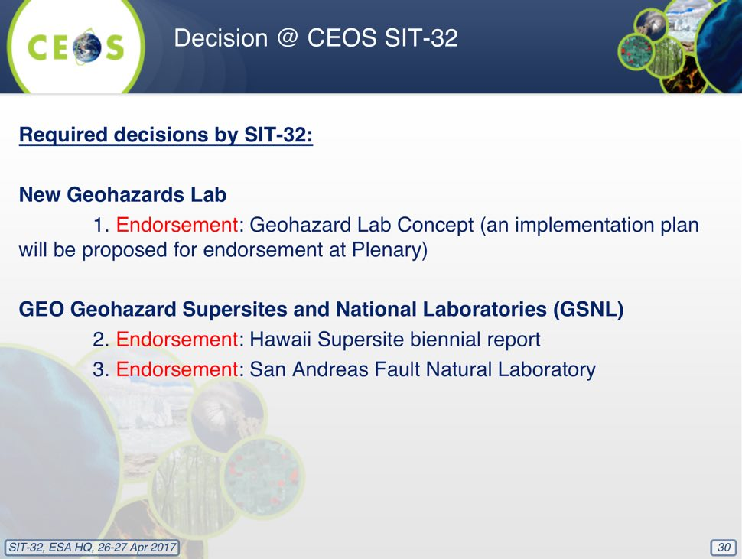
SIT endorsed these activities as proposed.

Decision 4 | SIT endorsed the Geohazard Natural Laboratory Concept (and an implementation plan will be proposed for endorsement at Plenary).

Decision 5 | SIT endorsed Geohazard Supersites and Natural Laboratories (GSNL) activities: GNSL Hawaii Supersite Biennial Report; and the San Andreas Fault Natural Laboratory.
A brief discussion followed:
- Pascale Ultré-Guérard (CNES) confirmed that CNES will nominate a replacement for Phillipe Escudier in the OST-VC leadership.
- Paul Counet (EUMETSAT) confirmed EUMETSAT will nominate a replacement for the OSVW-VC Co-Chair. It was noted that Paul Chang of NOAA will continue as OSVW-VC Co-Chair.
- Katherine Hill (GOOS) asked about the SST MW radiometer continuity issue, and Mark Dowell (COM-JRC) noted that a more substantial discussion will take place at the SIT Technical Workshop on this topic.
- Stephen Briggs (SIT Chair) welcomed the news on the AMSR-2 follow-on mission, and Shizu Yabe (JAXA) thanked Stephen and GOOS for their support. She noted that the Japanese government has approved seed money for the AMSR-2 follow-up on mission, and is also considering adding an AMSR-2 FO sensor on GOSAT-3 which will be launched in 2022. Stephen noted this is a potential solution to a long-term problem.
- Kerry Sawyer (NOAA) noted the references (where they appeared) to the CEOS Work Plan in the reporting from the VCs and WGs, and stressed the importance of these connections. It was agreed these connections should be emphasised in the formulation of future CEOS meetings. Jonathon Ross (CEO) noted that there wasn’t a formal Work Plan presentation at SIT-32, but thanked all who contributed to the plan.
- Kerry noted that the WATER-6 action in the CEOS Work Plan indicates NOAA as the CEOS lead for AquaWatch, confirming that CEOS has indeed endorsed support for AquaWatch by virtue of endorsing the Work Plan; further evidence of the importance all should place on having a working knowledge of the CEOS Work Plan. Paul DiGiacomo is currently NOAA’s representative in this role.
Decision 6 | Noting the value SIT members saw in understanding linkages between progress being reported and the CEOS Work Plan, future reports on CEOS Working Group and Virtual Constellation activity should identify the relevant linkages to the CEOS Work Plan.

SIT-32-11 | CEOS Agencies | Ensure familiarity with the CEOS Work Plan to inform discussions at the 2017 CEOS SIT Technical Workshop and Plenary | Sep 2017
 | Rationale: Making linkages back to the CEOS Work Plan in the formulation and operation of CEOS meetings is key to ensuring relevant tasks are being completely addressed.

SIT-32-12 | CEOS Entities | Once updates to the CEOS Deliverable Tracking Tool to reflect the CEOS Work Plan 2017-2019 are complete, CEOS Entities to provide an update on the status of each objective/deliverable in advance of the pre-2017 SIT Technical Workshop tag-ups with the SIT Chair. | Aug 2017
 | Rationale: The CEOS Work Plan 2017-2019 is being reflected in the CEOS deliverables tracking tool (http://www.ceos-deliverables.org/task_manager/tasks), and once this is complete, task leads are asked to update the current status.

10. Copernicus Sentinel Data Uptake and Application

Sentinels Space and Ground Segment Status
Ivan Petiteville (ESA) provided an overview of the Copernicus Sentinel missions, reviewing some of the utilisation numbers, highlighting that more than 24 PB of data have been downloaded, and that each data product is downloaded an average of 10 times. With this vastly increased data volume, the focus has moved from data supply to data exploitation.
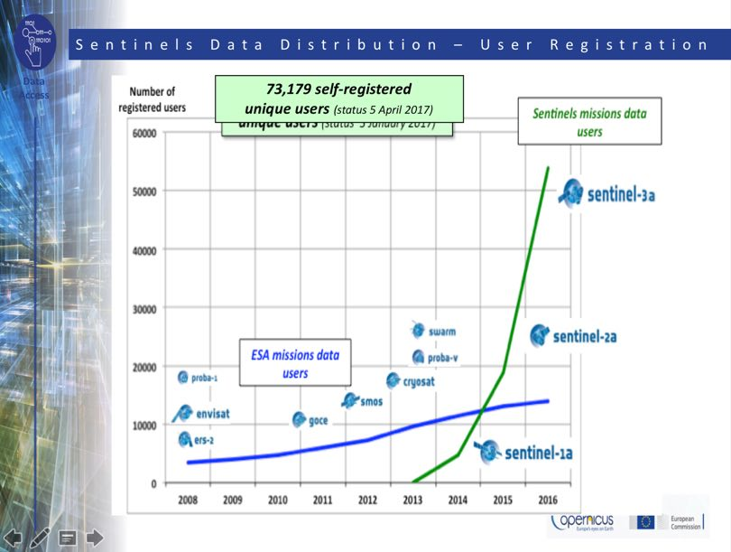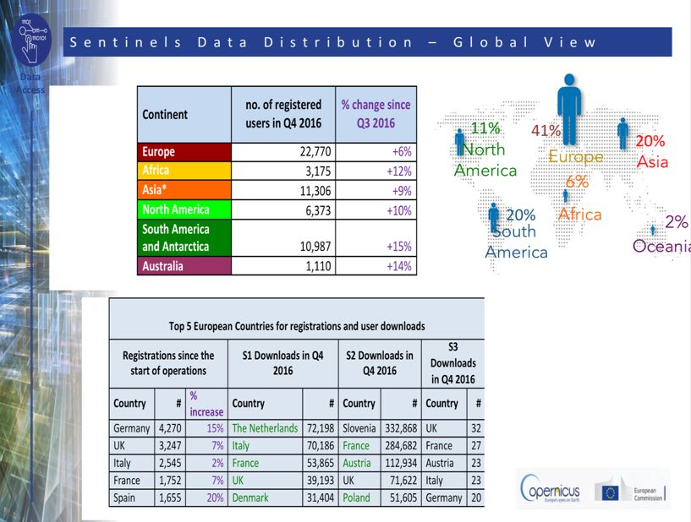
Copernicus Services are providing higher level products and information to a community of more than 10,000 users (as of Q1-2017), and almost 1000 user licences have been signed.
The Sentinel-1 A&B constellation now generates 10 TB of products daily (formal specification was 3 TB), and this is expected to be further increased with the operational use of EDRS for Sentinel-1B and the 4th core X-band station.
Sentinel-2B was launched 6 March 2017, and in-orbit commissioning phase proceeding nominally. Reprocessing of data acquired during Sentinel-2A commissioning phase and entire Sentinel-2 archive into new tile format, and the release of sample Level-2A products is planned as part of feasibility study, and pre-operational Level-2A production over Europe.
Paul Counet (EUMETSAT) summarised EUMETSAT data access mechanisms which delivery the Copernicus Sentinel-3 data.
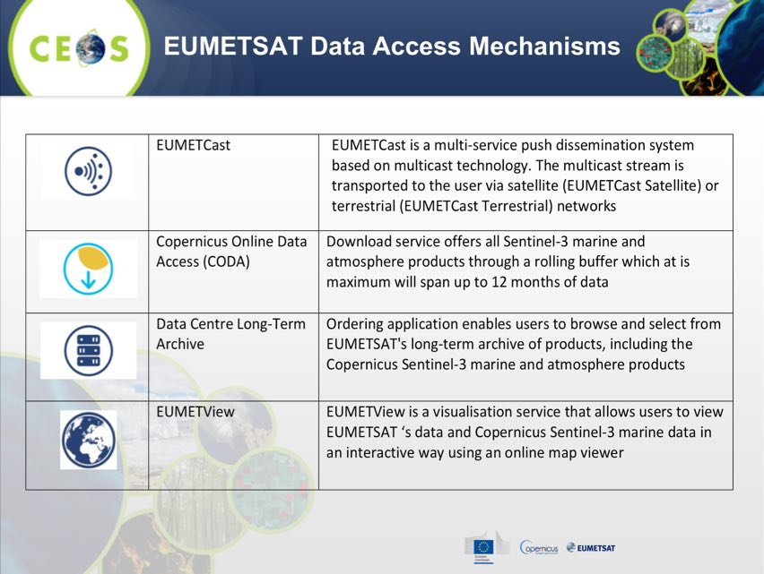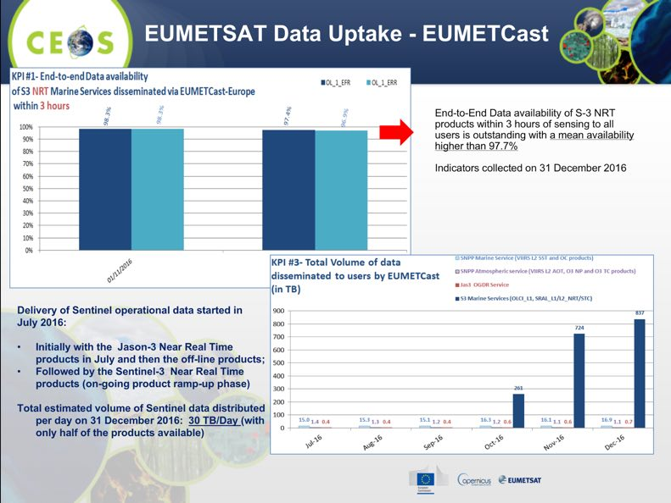
Adam Lewis (GA) noted that the Australian Copernicus Data Hub, which covers Australian and a significant portion of the region, has been in operation since mid-2016. One of the main rationales is to try to reduce the burden on the European data centres, and to provide reliable access to users in Australia and the region. He noted that some Australian users are accessing the data via other sources like Amazon Web Services.
Space Strategy for Europe
Astrid-Christina Koch (COM) provided a short overview of the Space Strategy for Europe (SS4E) published in October 2016. She noted the EU will invest over 12 B€ between 2014-2020 in the ownership and operation of the Copernicus for Earth Observation and Galileo/EGNOS satellite systems. With 18 satellite currently in-orbit and more than 30 planned in next 10-15 years, the EU is already the largest institutional customer for launcher services in Europe. She reviewed the strategic objectives of the strategy.
- Maximising the benefits of space for society and the EU economy;
- Fostering a globally competitive, innovative European space sector;
- Reinforcing Europe's autonomy in accessing & using space; and,
- Strengthening Europe's role as a global actor.
SS4E makes specific reference to support to the Committee on Earth Observation Satellites (CEOS) and the Group on Earth Observation (GEO). A brief discussion followed:
- Carolin Richter (GCOS) asked about how the European thinking will be extended globally, and also about the linkage between in-situ and space. Astrid noted that in-situ is referenced by SS4E, and is a key component for the evolution of Copernicus, but no detail is provided in the document. She also noted that agreements (e.g., Australia) also cover the provision of in-situ data.

Inputs from CEOS Initiatives
George Dyke (SIT Chair Team) noted that CEOS Agencies had been asked for their input on their experience with Copernicus data for this session. He noted that several ‘highlighted inputs’ would be presented, and that the detailed response information had been made available to the mission management.
Brian Killough (SEO) reviewed some of the SEO’s experience in the utilisation of Copernicus data.
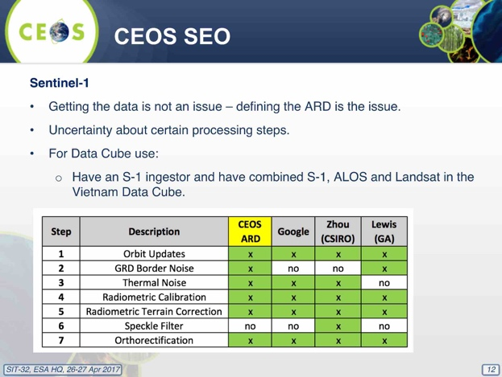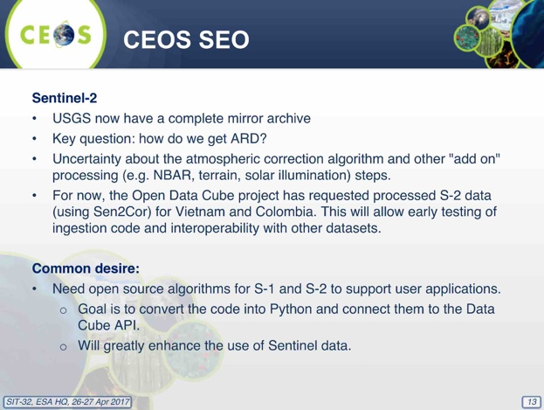
Jennifer Lacey (USGS) reported that the USGS Archive has caught up on downloads, and currently holds 653,846 scenes (345.15 TB). They currently have 15,000 users of the data. She also noted that Landsat Collection 2 in 2018 will use the Sentinel-2-derived Global Reference Image (GRI) once completed.
Adam noted that discussing changes to the necessary processing would be a useful, noting that a number of users are now applying BRDF corrections. If an objective test to determine the feasibility and utility of those corrections would be helpful. Stephen Briggs noted that applying additional corrections has the potential to represent a step-function increase in the amount of effort required.
Stephen Ward (SDCG SEC) reviewed some of the key issues identified during GFOI satellite data support, including continue to report difficulty with downloads from the OpenHub, the request for ARD and the provision of Sentinel ARD for the CEOS FDA Pilots, the need for SAR ARD definitions and data provision, Sentinel data as a support for Early Warning capability for GFOI, and Landsat-Sentinel-2 interchangeable utilisation.
Astrid noted COM is very happy about the uptake of the Copernicus data globally and the efforts made to showcase the value to society, and they are working to support their partners, making data useful to the users, and improve the user experience.

11. SIT-32 AOB, Action Item Review, and Closing
Closing Items and Any Other Business (AOB)
Luc St-Pierre (UNOOSA) reported that UNISPACE-50 will be held in 2018, and noted that developing national space capacities is one of the priorities that will be discussed. As a part of the preparations, they will be developing a space solutions compendium, which will help to document the capabilities of space. The proposed Compendium being far reaching and wide in scope, UNOOSA proposes that a full range of solutions be documented and made available through complementary partnerships in line with the needs and priorities individual governments will identify. (i.e. working to develop a process to develop tools at national level in support of SDGs, climate change, and disasters.)
CEOS Information Systems Survey Follow up
Ivan Petiteville (ESA) presented a summary of the 2016 CEOS Information Systems Survey outcomes, reviewing the top three requests from the survey.
- Explicit Linkages to Mission / Instrument Data Archives;
- Direct Linkages to COVE Coverage Assessments; and,
- API to Enable CEOS Database Information Access.
He noted that based on this feedback, and as a part of the usual update cycle, the CEOS database team has the following work plan for the remainder for 2017.
- May-June: Annual database survey cycle to be initiated;
- May-June: Assess implementation options for ‘top three’ priorities, in addition to the regular annual cycle of minor enhancements;
- June-July: Implement trial CEOS DB API based on approach agreed with SEO and WGISS;
- Q3/Q4: API feedback and evaluation; and,
- September-October: Regular cycle of database update release as well as release of enhancements implemented.
Stephen Briggs (SIT Chair) noted that with the 2015 handbooks focused on Disaster Risk Management (Sendai), and Climate (COP-21), a third focused on the UN SDGs would complete the set of the top three GEO priorities.
31st CEOS Plenary
Frank Kelly (CEOS Chair) presented a summary of plans for this year’s CEOS Plenary, noting that preliminary meetings will take place Wednesday 18th October, and Plenary itself will take place 19th-20th Thursday and Friday. There will be an optional side visit to EROS (home of the Landsat archive) for those who wish to come to Sioux Falls early that week, and then they will rent transport to drive across the state to Rapid City where Plenary will be held. On the Saturday after the Plenary (21st), there are two different excursions: one to Mt. Rushmore, and then later in that day to Deadwood.
2018-2019 CEOS SIT Chair Proposed Priorities
Steve Volz (SIT Vice Chair) reviewed the proposed priorities for NOAA’s SIT Chair term, noting that in the past couple of years, there is an increasing recognition of the value and work that CEOS agencies do which is a good validation of our efforts, but does present additional workload.
- Ensure the efficient execution of existing SIT responsibilities as described in the SIT Terms of Reference, including addressing Working Group and Virtual Constellation (VC) continuity, sustainability, and outputs.
- Enhance the utility of new observations from next generation of geostationary satellites and exploring development of LEO/GEO combination products and data processing capabilities.
- Improve and clarify CEOS relationships with CGMS, GEO, and to a lesser degree WMO, by identifying coordinated activities and, where appropriate, holistic interaction among CEOS, CGMS, GEO, and WMO, emphasizing the unique values of each.
- Support initiatives undertaken by CEOS Chairs in 2018 and 2019.
Future CEOS Chair Initiatives
Astrid-Christina Koch (COM) introduced the membership of the COM CEOS Chair team for 2018, noting that key support will be provided by Mark Dowell, Michael Berger (seconded from ESA), and Robert Husband. The team will focus on continuation and development of existing initiatives, as well as rationalization of on-going activities.
Mark Dowell (COM-JRC) reviewed the Chair initiative looking at laying the foundation for an international CO₂ and greenhouse gas (GHG) emission monitoring system, which focuses on making a fundamental contribution to monitoring globally using the CEOS Carbon Strategy, as well as specific targeted activities started in 2017 (i.e. the AC-VC whitepaper), as well as ongoing discussions on mutual interests between CEOS and CGMS on these issues.
Three specific activities are foreseen for advancing this effort in 2017:
- Facilitate the completion of the AC-VC whitepaper on defining an optimum constellation for CO2 and GHG emission monitoring;
- Place the space segment in the broader context of a fully sustained system for CO2 emission monitoring; and,
- Advance the relationship with CGMS for an operationally implemented and sustained observation capability. Consider establishing a formal working relationship between CEOS and CGMS as with the successful ongoing relationship on Systematic Observations of ECVs in support of UNFCCC.
The COM proposes to organise a dedicated discussion workshop to bring together different stakeholders to define best practices and synergies, and exploring possibilities for common approaches to some of the system development.
Astrid reviewed 2018 Chair on data, which will involve concluding the initial study of Future Data access and analysis Architectures (FDA) with recommendations for a "Generation 2020" of operational systems and their global interoperability, and consider a follow-on within WIGISS. They will also introduce the new Copernicus DIAS as an enabling element for operational implementation of services, CEOS pilot projects and other Small-scale demonstrators, and continue to support and expand the efforts related to exploitation environments based on ARD, including for CEOS Open Data Cube and links to non EO domains, and Earth System Data Cube methodologies. This will build on the achievements of the LSI-VC, CARD4L and ARD, the work done by CEOS agencies and the WMO to initiate the definition of necessary ARD products for marine and ocean applications, and draw up a CEOS service inventory and promote the consideration of existing services (e.g. Copernicus services) in the ARD context.
They also propose four dedicated workshops during their Chair term on:
- Access to Copernicus data and information, and additional data, in a flexible tool environment for data exploitation – introducing Copernicus DIAS for CEOS;
- Consolidation and prioritisation of user needs – proposing a shortlist for a CEOS coordinated response;
- Land observation and data to support the CEOS Carbon Observation from space; and,
- Innovative integration of SAR data/products in CEOS; exploiting the full potential of interferometry.
SIT-32-13 | Incoming CEOS Chair (COM) | Propose plans for a workshop on their Chair priority on an international CO₂ and GHG emission monitoring system | SIT TW 2017
 | Rationale: The COM as incoming CEOS Chair has proposed this be one of their priorities. Such a workshop supports well SIT Chair objectives, and a number of CEOS Agencies will likely to be interested in planning their participation.
Review of Actions
Stephen Ward reviewed the draft actions from the meeting. He noted the proposal to have a half day meeting focused on the development finance topic the day before the SIT Technical Workshop, and Jean-Louis Fellous (SIT Chair Team) noted that his will need to be balanced with the VC/WG Day. Mike Freilich (NASA) agreed that the meeting to discuss engagement with development finance institutions is necessary, and suggested it may not need to be a face-to-face meeting. It could be separated by a couple of days from the Workshop, and it could be conducted via telecon.
Mike asked whether the SIT Technical Workshop will be decisional (and therefore require Principal-level participation), and Stephen Briggs (SIT Chair Team) that the attendance would likely be focused on addressing tasks in progress, as in the intended process for the SIT Technical Workshop as opposed to the full SIT meeting.
SIT-32 Closing Remarks
Stephen Briggs closed the meeting, noted it was a good meeting which covered the things we needed to, and the understanding generated around the table is very valuable.

List of Participants
Organization | Participant | Organization | Participant
COM | Astrid-Christina Koch | JAXA | Akiko Suzuki
COM/JRC | Mark Dowell | JAXA | Shizu Yabe
CNES | Pascale Ultré-Guérard | JAXA | Koji Akiyama
CNES | Selma Cherchali | JAXA/RESTEC | Masatoshi Kamei
CNES | Steven Hosford | NASA | Mike Freilich
CSA | Marie-Josée Bourassa | NASA | Christine Bognar
CSA | Stéphane Chalifoux | NASA | Lawrence Friedl
CSIRO | Alex Held | NASA | Steven Neeck
CSIRO | Flora Kerblat | NASA | David Crisp
DLR | Klaus Schmidt | NASA | Kurtis Thome
ESA | Stephen Briggs | NASA | Matthew Koeppe
ESA | Simonetta Cheli | NASA | Andrew Mitchell
ESA | Ivan Petiteville | NASA | David Jarrett
ESA | Michael Rast | NASA | Vardis Tsontos
ESA | Michael Berger | NASA | Jorge Vazquez
ESA | Pascal Lecomte | NASA | Wenying Su
ESA | Jean-Louis Fellous | NASA | Kevin Turpie
ESA | Marc Paganini | NASA/CEOS SEO | Brian Killough
ESA | Stephen Coulson | NOAA | Steve Volz
ESA | Bianca Hoersch | NOAA | Kerry Sawyer
ESA | Nicolaus Hanowski | NOAA | Chuck Wooldridge
ESA | Henri Laur | GEO Blue Planet/AquaWatch | Emily Smail
ESA | Mirko Albani | NSC | Einar-Arne Herland
ESA | Carmen Comparetto | NSMC/CMA | Weiying Cai
ESA | Stephen Ward | NSMC/CMA | Jinlong Fan
ESA | George Dyke | SANSA | Paidamwoyo Mangara
EUMETSAT | Alain Ratier | SANSA | Valanathan Munsami
EUMETSAT | Paul Counet | UKSA | John Remedios
EUMETSAT | Robert Husband | UKSA
GA | Adam Lewis | UNESCO/GOOS | Albert Fischer
GA/CEO | Jonathon Ross | UNOOSA | Luc St-Pierre
GCOS | Carolin Richter | US Dep. of State | Fernando Echavarria
GEO Secretariat | Barbara Ryan | USGS | Frank Kelly
GEO Secretariat | Osamu Ochiai | USGS | Jennifer Lacey
GEOGLAM | Ian Jarvis | USGS | Steve Labahn
GOOS | Katherine Hill | WMO Space | Toshiyuki Kurino
ISRO | Tapan Misra

Record of Actions and Decisions from CEOS SIT-32
No. | Actionee | Action | Due date
SIT-32-01 | SIT Chair | Develop, in consultation with CEOS SEC and Principals, a proposal for a way forward on CEOS agency coordination in engaging the international finance institutions (IFIs), for discussion at a dedicated session at SIT Technical Workshop in September 2017 | SIT TW 2017
 | Rationale: The discussion on CEOS agency coordination on IFIs at SIT-32 was intended to be a conversation starter. Based on interest expressed, a more detailed follow-up discussion (half-to-one full day prior to SIT TW 2017) should be framed and planned. Any agreement on substantive action would need to be further considered after the SIT TW at a CEOS Principal-level meeting or meetings.
SIT-32-02 | Future Data Architectures Ad Hoc Team | Report back on ‘the how and when’ the substance of the CEOS FDA strategy will be implemented within the CEOS structure and Work Plan | SIT TW 2017
 | Rationale: The main ‘what’ items for the FDA way forward were endorsed at SIT-32, and so the FDA AHT’s attention will now focus on the ‘how and when’. A progress update should be given at the SIT TW 2017.
SIT-32-03 | SDCG | Develop, in discussion with SIT Chair and Vice-Chair, a lessons learned paper on the CEOS engagement with GFOI and how these lessons might shape future engagement decisions by CEOS | SIT TW 2017
 | Rationale: Lessons learned from mature CEOS initiatives like the SDCG for GFOI may be applicable to the development of new application areas.
SIT-32-04 | Sustainable DevelopmentGoals Ad Hoc Team | CEOS Ad-Hoc Team for the SDGs will ensure DLR is added to the group’s mailing list | COMPLETE
 | Rationale: DLR would like to stay up to date with the latest status of the CEOS AHT for SDGs.
SIT-32-05 | WGClimate | Coordinate with CEOS SEC to develop a timetable for the production and review of the CEOS statements to be delivered at COP-23 | May 2017
 | Rationale: Because of the short time between CEOS Plenary and COP-23, and the need to submit materials before CEOS Plenary, a CEOS endorsement process that does not rely on a face-to-face meeting will have to be agreed.
SIT-32-06 | AC-VC | AC-VC Satellite Carbon Report initiative to work with JAXA to coordinate the CEOS review and input to their atmospheric GHG methodology input to the IPCC guidelines update process | 2017
 | Rationale: JAXA (with Japanese MOE) are developing inputs to the IPCC guidelines update process, and have requested CEOS support in reviewing in 2017. AC-VC has confirmed they are willing to provide a review.
SIT-32-07 | LSI-VC & Mark Dowell | LSI-VC to work with Mark Dowell to define the opportunity for CEOS agencies to provide input to Vol2 (AFOLU) of the IPCC GHG guidelines update process | Jun 2017
 | Rationale: Currently land use is the only specific reference to satellite information the IPCC GHG guidelines, and other areas should be considered and flagged if suitable. Input to global land assessments is an important role for CEOS to maximise the uptake an application of CEOS data, and, to be in a position to influence the development of improved guidelines that make better use of satellite capabilities.
SIT-32-08 | European Commission (COM) as Incoming CEOS Chair | Outline a proposal for discussion on the need for broader coordination on carbon observations, addressing both satellite and other (e.g., in-situ) observations, and activities within GEO, CEOS, and CEOS agencies. | SIT TW 2017
 | Rationale: There is a need to consider the broader coordination of carbon observations, in particular within the CEOS and GEO communities. A proposal should be formulated for discussion at the SIT Technical Workshop, with a view to having it endorsed by CEOS agencies, and with implementation to be initiated during COM’s CEOS Chair Term.
SIT-32-09 | CEOS Agencies | CEOS Agencies asked to make use of all opportunities to advocate for open and timely data access commitments from China and Russia for their OSVW missions | 2017
 | Rationale: To maximise the benefits of international coordination and the data streams available from partners around the world, and in alignment with GEO’s Open Data Policy, CEOS Agencies should advocate for open and timely data access.
SIT-32-10 | CNES and EUMETSAT | Advise on leadership succession for their outgoing co-chairs for OST-VC and OSVW-VC | May 2017
 | Rationale: Leadership is currently vacant, and suitable replacements need to be identified. Both CNES and EUMETSAT agreed to seek new nominees.
SIT-32-11 | CEOS Agencies | Ensure familiarity with the CEOS Work Plan to inform discussions at the 2017 CEOS SIT Technical Workshop and Plenary | Sep 2017
 | Rationale: Making linkages back to the CEOS Work Plan in the formulation and operation of CEOS meetings is key to ensuring relevant tasks are being completely addressed.
SIT-32-12 | CEOS Entities | Once updates to the CEOS Deliverable Tracking Tool to reflect the CEOS Work Plan 2017-2019 are complete, CEOS Entities to provide an update on the status of each objective/deliverable in advance of the pre-2017 SIT Technical Workshop tag-ups with the SIT Chair. | Aug 2017
 | Rationale: The CEOS Work Plan 2017-2019 is being reflected in the CEOS deliverables tracking tool (http://www.ceos-deliverables.org/task_manager/tasks), and once this is complete, task leads are asked to update the current status.
SIT-32-13 | Incoming CEOS Chair (COM) | Propose plans for a workshop on their Chair priority on an international CO₂ and GHG emission monitoring system | SIT TW 2017
 | Rationale: The COM as incoming CEOS Chair has proposed this be one of their priorities. Such a workshop supports well SIT Chair objectives, and a number of CEOS Agencies will likely to be interested in planning their participation.

Decision 1 | CEOS Plenary session at SIT-32 agreed to adopt COVERAGE as an initiative in the CEOS 2017-2019 Work Plan as a three-year pilot project. The Work Plan will be updated promptly to reflect this.
Decision 2 | The Future Data Architectures (FDA) Initiative way forward proposed by the Co-Chairs (‘the what’) was agreed, and the FDA team will report back on ‘the how & when’ at the SIT Technical Workshop.
Decision 3 | CEOS thanked outgoing OCR-VC Co-Chair Stewart Bernard (CSIRO) for his service as the IOCCG Chair.
Decision 4 | SIT endorsed the Geohazard Natural Laboratory Concept (and an implementation plan will be proposed for endorsement at Plenary)
Decision 5 | SIT endorsed Geohazard Supersites and Natural Laboratories (GSNL) activities: GNSL Hawaii Supersite Biennial Report; and the San Andreas Fault Natural Laboratory
Decision 6 | Noting the value SIT members saw in understanding linkages between progress being reported and the CEOS Work Plan, future reports on CEOS Working Group and Virtual Constellation activity should identify the relevant linkages to the CEOS Work Plan.

