MINUTES/ACTIONS/DECISIONS
33rd CEOS STRATEGIC IMPLEMENTATION TEAM MEETING (SIT-33)
FINAL v1.0
24-25 April 2018, Boulder, CO, USA
Main discussion points and outcomes from the 33rd CEOS SIT meeting
The meeting started with a discussion on future mission planning in an effort to understand the background for potential CEOS contributions to individual agency efforts.
CEOS Work Planning
- CEOS governing documents were reviewed, with an action to consider whether revisions to the Governance and Processes are needed. ^{[33-01]}
- CEOS Work Plan 2018-2020 was presented, along with suggested improvements to the development process to improve timeliness and consistency.
- 2017-2019 GEO Work Programme was reviewed and mapped to the CEOS Work Plan.
Virtual Constellations (VCs) and Working Groups (WGs)
- Key points from the VC and WG questionnaire responses and telecons were reviewed, with a view to identifying actions to help ensure VC and WG continuity and sustainability.
- The VCs and WGs summarized their current activities, tangible outcomes, support to CEOS Agency planning, and opportunities for synergy across groups.
- Proposals for a Volcano and Seismic Hazard Demonstrators, and the 1st GEODARMA pilot project were endorsed. ^{[D1, D2, D3]} Potential links to CEOS Data Cube to be explored. ^{[33-03]}
- Introduction of CEOS materials to COP-24 will be ensured by WGClimate and VNSC. ^{[33-04]}
- Preparation for the SIT Technical Workshop (TW) will include an analysis of possible process improvements, Work Plan contributions, and sustainment of VCs and WGs. ^{[33-05]}
Emerging and On-Going Activities
- CEOS Chair will write a letter to the Landsat Advisory Group advocating continuity of the free and open data policy for Landsat, noting its importance to users and its role in encouraging other nations to adopt similar policies. ^{[33-06]}
- Initial follow-up on freshwater measurements from space was agreed. ^{[33-08][33-09]}
- SIT agreed to keep a watching brief as the Space Climate Observatory progresses. ^{[33-07]}
- JAXA continues to lead CEOS efforts to reflect space agency inputs in the 2019 update of the IPCC Inventory Guidelines, including significant inputs from AC-VC.
Ad Hoc Teams (AHTs)
- The SDG AHT will explore a CEOS expression of interest for participation in the GEO Land Degradation Neutrality (LDN) activity. ^{[33-02]}
- SDCG is working with GFOI and Agencies to define the CEOS role for GFOI Phase 2 ^{[33-10]}
- Lifecycle plans for the AHTs will be the subject of a follow-up item at the SIT TW. ^{[33-11]}
Partnerships
- Advancing carbon observations from space requires coordination across the community (CEOS, CGMS, WMO). CEOS Chair will hold a related workshop (June) to progress. ^{[33-12]}
- CEOS representation to the GEO Carbon Steering Committee was confirmed. ^{[D4][33-13]}
- GEO-LEO activities may be advanced via CARD4L ^{[33-14]}, and with CGMS ^{[33-15][33-16]}
- Potential CEOS-CGMS collaboration on climate observations is explored in a draft concept paper provided for SIT information.
Plenary Session and Plenary Planning
- The WGCapD and WGClimate Terms of Reference were endorsed. ^{[D5][D6]}
- WGClimate Gap Analysis and Action Plan to be submitted for virtual endorsement. ^{[33-17]}
- The need for follow-up on identifying the next CEOS Executive Officer (CEO) beginning in 2019 was raised. ^{[33-18]}

1. Welcome and Opening Remarks
Steve Volz (SIT Chair, NOAA) welcomed participants to the 33rd meeting of the CEOS Strategic Implementation Team (SIT) and to Boulder, on behalf of NOAA and of the Cooperative Institute for Research in Environmental Sciences (CIRES) as host.
Participants introduced themselves, their affiliations and CEOS roles in a tour de table.

SIT Chair Term Priorities
Steve reviewed the SIT Chair Priorities for 2018-2019, to which SIT-33 will contribute:
- Ensure the efficient execution of existing SIT responsibilities addressing Working Group (WG) and Virtual Constellation (VC) continuity, sustainability, and outputs, including:
  - Undertaking gap analyses for each VC, to support ongoing and likely upcoming strategic Agency observatory decisions;
  - Seeking observations from VCs and WGs on best practices and possible modifications to existing practices; and
  - Supporting the activities of the CEOS ad hoc Team on Sustainable Development Goals by identifying targets and indicators relevant to each VC.
Specifically address the outcomes of the VC and WG Questionnaires that were shared with the current and one-generation removed leaders of the VCs and WGs in January.
- Enhance the utility of new observations from next generation of geostationary satellites and exploring development of LEO/GEO combination products and data processing capabilities.
- Improve and clarify the CEOS relationships with CGMS, GEO, and WMO by identifying coordinated activities and, where appropriate, holistic interaction emphasizing the unique values of each organization.
- Address a mapping of CEOS priorities with the 2017-2019 GEO Work Programme, identifying areas where support and commitment from CEOS Agencies is requested, as well as how those activities are captured in the CEOS 2018-2020 Work Plan, which will also be endorsed at SIT-33.
- Support the initiatives undertaken by CEOS Chairs in 2018 and 2019.
Steve reviewed the structure of the agenda, with Day 1 focused on the transfer of information, communicating Agency near-term and long-term future plans, emerging activities, and building common understanding of implementation activities across CEOS through the Virtual Constellations and Working Groups. Day 2 focused on broader strategic discussions, linkages across CEOS work, mapping the work of CEOS to other partners (e.g., GEO), and concluding CEOS business.
Mauro Facchini (CEOS Chair, COM) thanked NOAA for the significant preparation for SIT-33, noting that the discussions here will set the stage for the next 6 months of work leading up to the CEOS Plenary in October. He noted that both the CEOS Chair and SIT Chair Agencies in 2018 have responsibility for operational programs and bring that perspective to the discussion. He noted that for Copernicus, ‘operational’ does not imply relevant missions are not state-of-the-art, and stressed there is a fundamental and complementary role for agencies with both research and operational mandates in ensuring that the best technologies are provided to operational programs.
Mauro noted the first broad objective of SIT-33 is to ensure that we have effective and efficient conditions for VCs and WGs to undertake their work, and that they have the necessary guidance and direction from CEOS Principals. CEOS must not assume that it can address many of the topics we are dealing with in isolation; operational and research synergies can be further reinforced through building strong external partnerships where appropriate. The relationship with CGMS is an obvious demonstration of this, both through the existing/successful collaboration in the context of the Joint Working Group on Climate as well as ongoing discussions on collaboration for Greenhouse Gas (GHG) Monitoring. Also of importance are the partnerships with WMO and GEO, particularly in areas that require satellite-in situ synergies and integration. Addressing this broad range of partnership issues represents the second priority for SIT-33.
This combination of analysis and discussion - addressing both internal and external efficiencies and synergies combined - provides a solid basis for the development of thematic priorities such as those being pursued in the context the 2018 CEOS Chair priorities.

2. Future Mission Planning
U.S. Decadal Survey
Graeme Stephens (NASA/JPL) provided a summary of the recommendations in the Decadal Survey, released in January 2018. The Survey addressed 35 key science/applications questions from amongst hundreds that were proposed by the science community. It recommends augmenting the Program of Record with eight priority observables; five that are specified to be implemented (Aerosols, Clouds, Convection, and Precipitation, Mass Change, Surface Biology and Geology, and Surface Deformation and Change), and three others to be selected competitively from among an additional seven candidate observables.
The survey team was asked to assess progress from 2007, develop a prioritized list of top-level science and application objectives for 2017-2027, identify gaps and opportunities in the programs of record at NASA, NOAA, and USGS, and recommend approaches to facilitate the development of a robust, resilient, and appropriately balanced U.S. program of Earth observations from space. Increased recognition of the important role of international partners was identified as an essential element of implementation of the Survey.
The Survey team included five disciplinary panels: Global Hydrological Cycles and Water Resources, Weather and Air Quality, Marine and Terrestrial Ecosystems and Natural Resource Management, Climate Variability and Change, and Earth Surface and Interior.
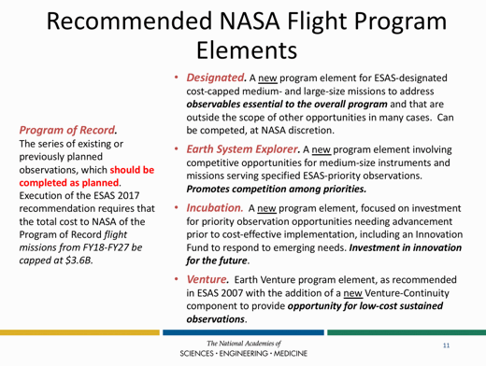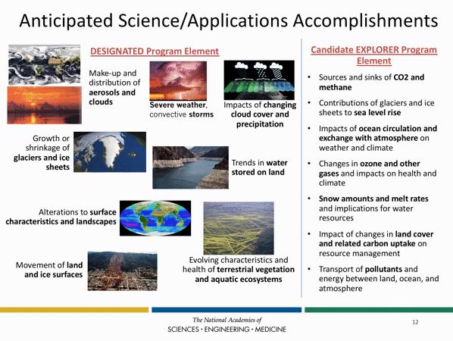
Three target observables were prioritized in an ‘incubation study’ to try to accelerate progress within the next decade: atmospheric winds, planetary boundary layer, and surface topography and vegetation. Partnerships were considered important by the Survey team. The evolving capability of geostationary satellites was also considered in the findings.

A brief discussion followed:
- Ivan Petiteville (ESA) asked about the Earth System Explorers and whether there is any guarantee that GHG monitoring will be addressed. Graeme noted that this will be considered competitively alongside the other Explorer concepts presented. The selection process remains to be determined, and the Survey did not provide guidance on implementation. There will be funding for three Explorer mission opportunities, and some proposals may address more than one of the Explorer concepts.
- Mike Freilich (NASA) noted that the Decadal Survey is a set of independent recommendations to NASA, USGS, and NOAA, and is not an implementation plan. He also noted that the Program of Record is the foundation for the Survey recommendations, that it includes international missions, and is in Appendix A of the Survey.
- Terry Nakajima (JAXA) asked about the process for reconciling the capabilities of next generation geostationary observing systems, and Graeme noted that this was considered in the Survey but a specific mechanism was not defined.
- Stephen Briggs (GCOS) asked about the consideration of measurement of winds with 3D Lidar, noting that there are instruments being launched within the next year that should help clarify capability and affordability of these systems. Graeme noted that the intention was to study these current activities before an Explorer proposal would be considered.
- Mauro Facchini (CEOS Chair, COM) noted that the Copernicus program is following a similar process, and this helps in identify opportunities for synergies and collaboration.
- Barbara Ryan (GEO Secretariat Director) asked about references to in situ observations, and Graeme noted that coupling of in situ to space observations was considered (e.g., ARGO), though the emphasis was on space observations, with a recognition that in situ observations are essential. Mike noted that the Survey team was asked to focus on space observations.
- Graeme noted that the belief that more integrated observations are required (e.g., constellations), and this integration comes from partnerships. Mike suggested that all collaborations are ultimately bilateral (i.e. agency-to-agency), and what CEOS provides is the forum for identifying and initiating discussions that lead to collaboration.
- Arthur Charo (National Academy of Sciences) noted that USGS was also one of the parties that invested in the Survey process.
Discussion on Future Mission Planning
Steve Volz (SIT Chair, NOAA) introduced the discussion on future mission planning, noting that the session is an opportunity to advertise what mid- to long-range mission and measurement investment decisions each speaker’s Agency is facing in planning missions over the next 5 to 15 years. The expected outcome of this session was to provide background for later discussion in the VC and WG sessions, aimed at helping to determine where CEOS entities can provide value to Agencies.
Copernicus Evolution
Mauro presented background on Copernicus - the EU Earth Observation and monitoring program driven by treaties, policies and user needs and managed by the EC with a well-established partnership of the EC, ESA and EUMETSAT. Planning processes envision:
- Sentinel Expansion with additional observation capabilities in support of emerging needs
- Sentinel Next Generation for enhanced continuity of current (and expanded) observation capabilities to meet user requirements
The Copernicus Space Component is co-funded by the EU and ESA with complementary roles. Proper funding through program subscriptions by ESA Member States and by the EU within the next Multiannual Financial Framework (MFF) is a requisite for a successful implementation of the evolution scenario.
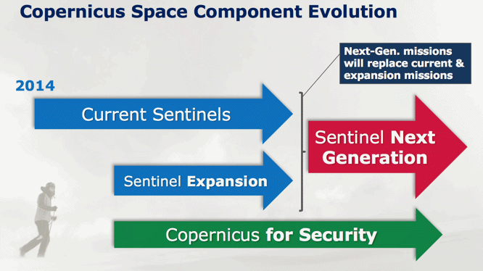
Top priority in the planning process is the stability of the program and long-term commitment to continuity of current data and services and to full, open and free data policy for the environmental domain. Additional services will be considered to meet emerging needs:
- climate change and sustainable development
- monitoring CO₂ and other GHG emissions
- changes in the Arctic
- land use and forestry
- security and defense: Improving the EU's capacity (border controls and maritime surveillance)
Major gaps identified are:
- CO2 measurements to estimate anthropogenic emissions (top priority)
- high-resolution thermal observations
- L-band SAR observations
- monitoring of sea ice and ice sheets in the polar region (PMR Imaging, Altimeter)
- hyper-spectral measurements
Studies are planned on these and the results will serve as input to iterate further the long-term strategy, but do not represent commitment by the Commission at this stage. The next Copernicus Regulation will frame the implementation of the Copernicus Space Component in the next program period and set out the missions to be included in the future program.
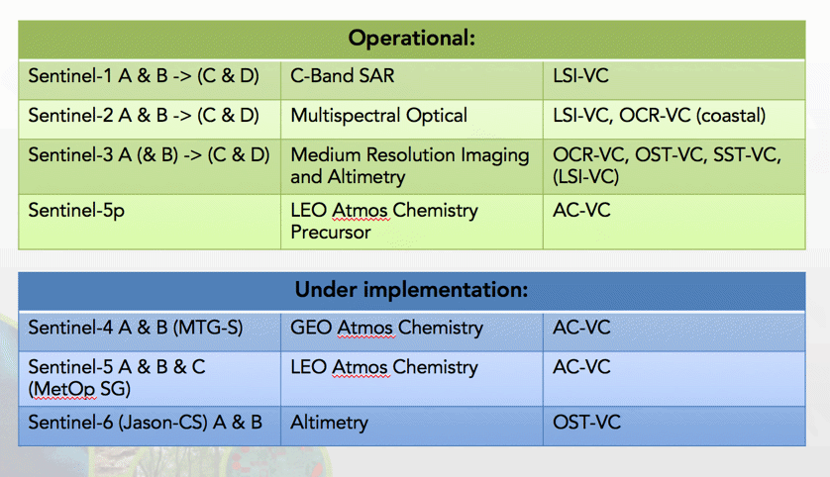
Current Sentinels relevance for CEOS VCs
JAXA Global EO Contributions
Terry Nakajima (JAXA) presented a summary of JAXA’s current EO program, and future considerations, noting the December 2017 launch of GCOM-C. Beyond current activities, and ALOS follow-on missions, there is some uncertainty in the program. He noted that orbit options for GOSAT-3 and AMSR-2 F-O are currently being studied; noting that they have concluded the best choice for AMSR2 follow-on is entering into the A-Train constellation. (Same as that of GCOM-W.) The GOSAT-3 orbit is now under consideration, and CEOS Agency opinions are welcome.
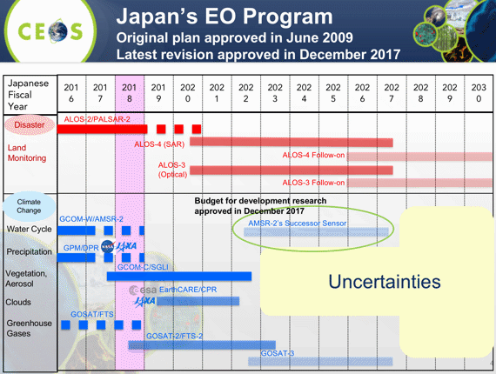
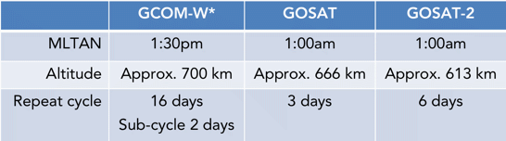
Terry noted that there is a focus by JAXA on understanding Climate Change processes, and for this, they are looking at a wide range of observations across the Earth system.
Terry noted that there are some uncertainties in government support for future EO programs. He stressed that JAXA is willing to continue its contribution in response to the global agenda as a part of the EO community. The Science Council of Japan made recommendations for Japan’s EO programs in 2017 and in response to the recommendations, the Remote Sensing Society Task Force Community (TF) proposed construction of an Earth Observation Grand Design. Both international cooperation and private sector engagement are important drivers for Japan’s space policy, and future plans are informed in part by the activities summarized in this session around Copernicus, the US Decadal Survey, the Chinese and Indian programs, and also application groups such as the CEOS VCs, WGs, and ad hoc Teams, WIGOS, and GCOS.
Terry would like to propose that CEOS collaborate on a visualization of an overarching EO Space-based System of Systems, taking into account contributions to the SDGs, Climate Change, and Disaster Risk Reduction, and mapping CEOS VCs/WGs and the similar efforts made by national programs, WMO/WIGOS 2040, CGMS, GCOS IP and others. This may help in identifying gaps that could be filled by potential future Japanese missions for space agency consideration. JAXA could use this kind of information in support of Japan’s domestic EO mission planning.
Klaus Schmidt (DLR) asked about the prospects for continuity for AMSR, and Terry noted that AMSR-2 and GOSAT-3 appear secure at present, but beyond this is uncertain.

NOAA Satellite Observing System Architecture (NSOSA)
Steve Volz (SIT Chair, NOAA) explained that the NOAA Satellite Observing Systems Architecture (NSOSA) study is examining NOAA’s future space segment architecture decisions, addressing NOAA operational needs, from defined requirements.
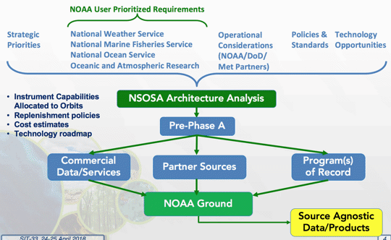
The study is organized into three major lines of effort built around three major design cycles: Value Model, Instrument Catalogue, and Constellation Synthesis. Each design cycle looks at complete, end-to-end designs of multiple alternative architectures, with scoring based on how well NOAA mission needs are met.
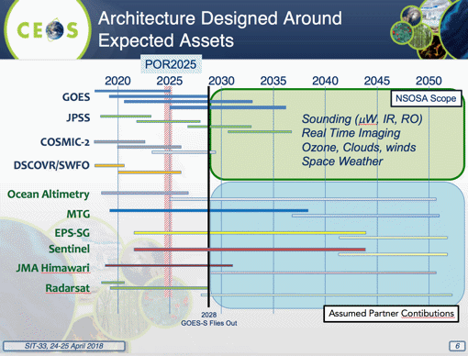
The architecture will be designed around expected assets and the analysis will: identify discriminating choices and opportunities about the next generation constellation architecture for NOAA systems; support NOAA development of a clear vision/roadmap for the next generation, including actionable trade studies and demonstrations; and, establish a robust analytical capability to evaluate and iterate opportunities.

NASA Future Missions/Architecture
Mike Freilich presented a brief update on NASA future mission planning, reviewing the current Earth Science Missions and Decadal Program of Record.
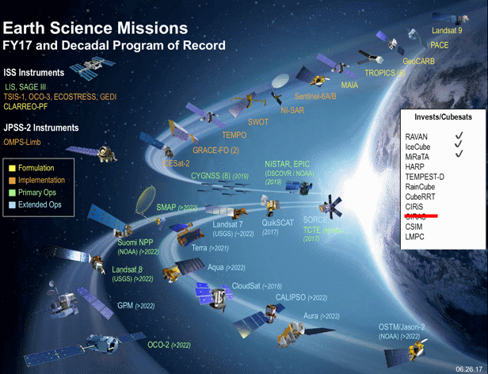
Mike reviewed the wide range of missions, including spacecraft flown in formation (e.g., A-Train), and constellations of smaller spacecraft to enable greater spatial and temporal coverage. He emphasized that free and open data exchange underpins all future NASA mission plans. NASA is exploring how to interact with the private sector (e.g., hosted payloads, data buys), with the hope that any lessons learned may benefit the whole community.
The NASA response to the Decadal Survey will include a “Continuity Measurement” demonstration strand ($150M full mission cost constraint) for the existing Venture-class program, the first of which will be radiation budget to mitigate RBI cancellation. Approximately three will be expected to be initiated within the decade.
A brief discussion followed.
- Stephen Briggs noted that there are public sector bodies outside space agencies that are considering designing and launching missions (e.g., EDF) and suggested that CEOS may need to consider how to be open and proactive in engaging these kinds of organizations.
- Barbara Ryan (GEO Secretariat Director) noted that based on their discussions with providers such as Planet, they have been open to broad data distribution for public data buys. Mike noted that they are exploring requirements around these data buys on a case-by-case basis and expect to learn more as things move forward.
Australian National Space Agency
Alex Held (CSIRO) summarized the current status of the development of an Australian national space agency, noting that the bureaucratic process is taking longer than anticipated, though the aspiration remains to have the new agency initiated on 1 July with a long ramp-up anticipated. A number of studies are informing the process with a focus on industry development. It is expected that the ongoing relationships among Australian agencies and CEOS will remain the same, and the hope is that in the future, Australia may be able to co-invest in missions.

3. Work Planning
Kerry Sawyer (SIT Chair Team, NOAA) introduced the session by reviewing existing Work Plans, noting that these are a part of core CEOS business and mission and in support of CEOS contributions to GEO. Another objective of this session was to try to identify opportunities for coordination and optimization.
The key questions for this session are:
- How do SIT-33 discussions relate to the CEOS Work Plan and GEO Work Programme?
- What areas can CEOS be expected to contribute in the future and how do these relate to the CEOS Work Plan?
Return to First Principles
Kerry gave a refresher on the CEOS mission and strategic goals and objectives, recalling the governing documents of CEOS:
- CEOS Terms of Reference that define the mission and scope of CEOS activities. (November 2013).
- The CEOS Governance and Processes document provides guidelines on the structure, operations, and processes CEOS employs to achieve its goals (~5 years) (November 2013) – it’s an open question as to whether CEOS should, over the next 6 months, assess and make a determination at SIT Technical Workshop and Plenary if we need to update Governance and Processes Document.
- The CEOS Work Plan (3-year rolling) sets forth near-term actions to achieve the goals outlined in the CEOS Strategic Guidance document. (March 2018).
- Other governing documents define the roles, responsibilities, and plans of the various CEOS leadership positions and organizational entities. These include: Terms of Reference – CEOS Chair, Strategic Implementation Team (SIT) Chair, CEOS Secretariat, CEOS Executive Officer (CEO), CEOS Systems Engineering Office (SEO); and Process Papers – Working Group, Virtual Constellations, and New Initiatives.
SIT-33-01 | SIT Chair | Assess whether the CEOS Governance and Processes Document should be updated. Report to SIT Technical Workshop including (if required) a recommendation to be presented for decision at CEOS Plenary. | CEOS Plenary 2018
 | Rationale: The document is now five years old, and we should consider if we need updates to CEOS structure, operations, and processes in order to address the evolving goals of the organization.
CEOS Work Plan 2018-2020
Steven Hosford (CEO, ESA/CNES) reviewed the 2018-2020 CEOS Work Plan, and the usual annual update cycle for the Plan.
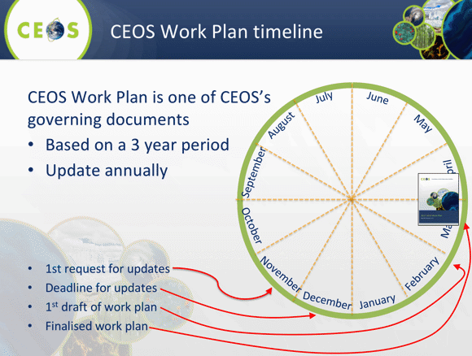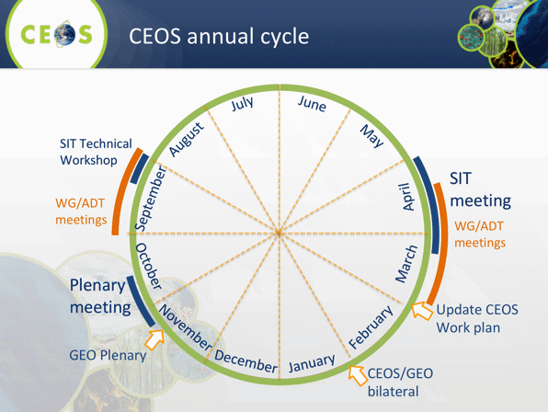
Steven reported that in this year’s Work Plan, there are 91 open deliverables across nine thematic and four cross-cutting areas. Of these, 29 are new deliverables. This increases slightly the number of open deliverables as compared to last year’s Work Plan as only 26 deliverables were closed in 2017 of the 55 deliverables that were scheduled to be closed. More than half of these newly created deliverables are scheduled to be completed during 2018. The total number of deliverables that should be closed in 2018 remains similar to 2017 at around 55.
Steven provided some feedback on the process of developing the 2018-2020 Work Plan. This is a long process, which this year, involved sending individual nominative emails to each CEOS entity lead with details of the current CEOS deliverables for which they were responsible. Despite this individual approach, the time for an initial response from CEOS entities varied widely from several weeks to four months. Steven suggested that to reduce this reaction time a call to each CEOS entity lead appropriately scheduled (before 15th Dec) could spur a more prompt reaction. Other approaches would be more frequent email contact (more than 1 reminder per month) or reporting progress to SEC.
In general, if the CEOS community wishes to increase the use of the CEOS Work Plan as a management tool then WG/VC meetings could be scheduled in block at least one month ahead of SIT and more focused put on the Work Plan during major meetings with a specific WP session.
Mark Dowell (CEOS Chair Team, COM) suggested that these calls with task leads could be combined with the regular SIT Chair calls with VCs and WGs. Kerry Sawyer (SIT Chair Team, NOAA) noted this topic was an agenda item in the recently held VC and WG calls but there was limited time for discussion as priority of the calls was on questionnaires. Additionally, the scheduling of the SIT Chair calls is not necessarily compatible with the schedule for updating the CEOS Work Plan.
CEOS Priorities and the 2017-2019 GEO Work Programme
Kerry presented, noting:
- The 2017-2019 GEO Work Programme was endorsed at GEO-XIV Plenary but a final version not yet released by GEO; proposals for new initiatives and flagships are due 15 July 2018; new proposals for Community Activities are due 1 September 2018.
- The CEOS connections and contributions to the GEO WP were summarized.
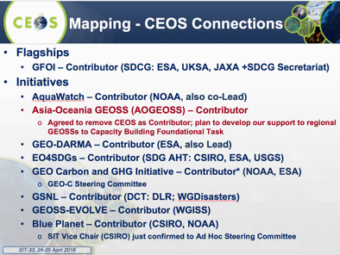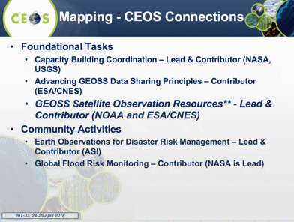
- There are challenges with CEOS recognition in the GEO WP arising from attribution of contributions to funding agencies, which understate the role of CEOS.
- At the 8th GEO Programme Board (PB) Meeting, the Land Degradation Neutrality (LDN) Initiative was accepted as a Community Activity being led by UNCCD and there is now a proposal to the PB for the LDN to become a GEO Initiative.
- Analysis of the 2018-2020 CEOS Work Plan provides 162 citations of GEO, including GEOSS, GEOGLAM, AmeriGEOSS, GSNL, GEO-DARMA, GEOBON, GEO Blue Planet, AfriGEOSS, AOGEOSS, etc.
A brief discussion followed.
- Mike Freilich (NASA) asked for clarity on what a CEOS commitment to the GEO LDN task would look like, and Kerry clarified that it can be as specific as desired. Mauro Facchini (CEOS Chair, COM) asked about the process for expression of support by CEOS. Alex Held (CSIRO) noted that CSIRO would be willing to nominate someone to contribute to (or lead) a CEOS LDN activity.
- Ivan Petiteville (ESA) noted that ESA fully supports the LDN activity with expertise and data, and that ESA intends to continue to ‘support’.
- Astrid Koch (CEOS Chair Team, COM) suggested that ‘support’ is a more appropriate wording to capture agency intentions. Kerry noted that they worked hard to remove the word ‘commitment’ but Bill Sontag was insistent that firm commitments were offered.
- Barbara Ryan (GEO Secretariat Director) noted a shift in approach for UNCCD to come via GEO to get coordinated contributions.
- Mike raised the issue of CEOS vs individual agencies receiving ‘credit’ from GEO for its contributions, noting that this will influence how CEOS interacts with individual members. Mike remarked that it is ‘disruptive’ for GEO to only assign credit to individual agencies - if CEOS is not given credit, then only the big agencies will get credit for anything CEOS does, which may discourage smaller agency engagement. Stephen Briggs (GCOS) noted that only ESA and EUMETSAT are officially GEO Participating Organizations and that presumably all other agencies should only be cited as part of their respective government’s association with GEO, or as part of CEOS.
- NASA and SANSA both confirmed that they would be happy for their contribution to any subsequent LDN activity to be characterized as being through CEOS.
- Steve Volz (SIT Chair, NOAA) asked if we were looking at a CEOS endorsement of the LDN activity, noting that seemed to be the general consensus.
- Jonathon Ross (SIT Vice Chair Team, GA) asked if other agencies who have expressed support for the LDN activity whether they would be willing to contribute through a CEOS activity. Ivan noted that ESA would be happy with this arrangement, perhaps through the SDG team. NASA, DLR, SANSA, CSIRO, EC, and JAXA also confirmed. CNES later confirmed their support to LDN.
- Barbara thanked CEOS for all their contributions to the GEO Work Programme. She noted that the role of POs has been changing over time, and she has been asking other POs if they would like to take up other GEO thematic arms (e.g., geologic arm, training arm).
SIT-33-02 | SDG AHT | Explore a CEOS expression of interest for participation in the GEO Land Degradation Neutrality (LDN) activity and provide language to the LDN Initiative Team Leads that can be included in the Initiative proposal expressing CEOS Agency interest and support. | May 2018
 | Rationale: CEOS has been asked to commit to the GEO LDN activity. SIT recognized that LDN is the first time a UN institution reached out to GEO for assistance on the SDGs.

4. Virtual Constellations
Session Introduction
Steve Volz (SIT Chair, NOAA) noted the objective of the session is to support tangible and sustainable outcomes from CEOS Virtual Constellations by providing an opportunity to air key issues, identify barriers to progress, and discuss ways to overcome those barriers.
Key questions that the SIT Chair Team has been studying are:
- How does CEOS best ensure continuity and sustainability of its VCs?
- What outputs are the VCs delivering? What additional outputs are needed, or could they deliver?
- What are the gaps within and between VCs that need to be addressed? How can they be addressed?
- What obstacles are being raised by the VCs? And can they be resolved? If so, how?
- Can, and how can, the work of the VCs be mapped to future CEOS Agency mission planning processes?
The process so far has involved: an updated status of each group in 2018 with assessments from leadership; VC and WG telecons with SIT Chair Team; a dedicated questionnaire to VCs and WGs and Former VC and WG Leadership; an analysis of 2018-2020 CEOS Work Plan for tangible outputs; and, defining a corresponding reporting template for SIT-33.
Steve reviewed some of the key themes arising from the Virtual Constellation questionnaire, with highlights including: resource constraints around best efforts engagement; the visibility that VCs bring within organizations; difficulty in connecting to the broader themes of CEOS; the importance of rigorous gap analysis in agency planning processes; optimization of operations, sustaining and enhancing satellite EO; the desire for increased participation from Chinese CEOS Members; and challenges around travel and sustaining face-to-face engagement.
The SIT Chair team did an assessment of the health and viability of the groups, and noted a few issues that need to be considered:
- distinct operation of OST-VC and OSVW-VC, other than in related science teams to be clarified
- P-VC activity beyond NASA-JAXA leads and meeting attendance unknown
- meeting cadence and scheduling need to be deconflicted
The VC/WG outputs cited in 2018-2020 CEOS Work Plan were assessed, noting that not all deliverables are of equal scale and proportion. A few main points were noted:
- WGs have well established Deliverables within CEOS WP
- Ocean VCs have noticeably fewer Deliverables (none for OST)
- the COVERAGE initiative has four Work Plan Deliverables that span Ocean VCs
- Ocean VCs also cited in Blue Planet Deliverables
- for comparison, ad hoc teams like GFOI and SDGs have ~3 Deliverables each in the Work Plan
Mark Dowell (CEOS Chair Team, COM) noted that, in the past, the interaction of VCs with related science teams was seen as a good thing, enabling collaboration with the science community. In the case of China, he noted that there may be opportunities to engage through CGMS.
SST-VC: Sea Surface Ken Casey (SST-VC Co-Lead, NOAA)
Ken noted that the SST-VC experience has been consistent with the key points that Steve Volz included in his introduction. He presented the status of SST VC’s CEOS actions.
CEOS-31-06: Complete. Comments provided during SIT Tech Workshop 2017 on complementarity between CARD4L and SST-VC/GHRSST Regional-Global Task Sharing Framework (R/GTS) and GHRSST Data Specification (GDS). Written response provided to A. Siqueira (GA) last week to close action.
CEOS-31-07: Complete. “VC-35: Passive microwave radiometer continuity” CEOS 2018-2020 Work Plan item created.
SITTWS-2017-19: No progress. Meeting not scheduled to our knowledge. Possibly discussion at upcoming CGMS-46 meeting.
VC-19: Complete draft to be circulated in early May 2018 for review prior to SST-VC meeting in Darmstadt in June. On schedule for issue in Q3 2018.
VC-35: Presentation to ECMWF/ESA workshop on using low frequency PMW in research & operations. See: www.ecmwf.int/en/learning/workshops. AMSR-2 follow-on mission discussion. Copernicus High Priority Candidate Missions (HPCM): ESA coordinating mission requirements for the Polar Ice and Snow Copernicus Imaging Microwave Radiometer (CIMR). Two parallel Phase A/B1 contracts are now being negotiated; first CIMR MAG has met; Consolidated MRD by kick-off of industrial contracts expected in May.
Ken reviewed the outputs of the SST-VC, noting that Sea Surface Temperature is a designated Essential Climate Variable (ECV). There are currently ~90 GHRSST-compliant products in the SST-VC catalogue and CWIC, with numerous data discovery standards (CSW, OpenSearch, schema.org), and access standards (OPeNDAP, TDS, WCS, WMS). Six of the GHRSST datasets are considered climate data records (four AVHRR Pathfinder products at Levels 2 and 3, and two Level 4 Daily OISST products), and extend back into the early 1980s. In the next year, there are several items planned: an SST constellation white paper, GHRSST XIX and SST-VC-7, and a workshop on understanding SSTs Over and Around Reefs (SOAR).
For the SST-VC, natural synergies exist with WGISS, WG-Climate, and the other ocean VCs, as well as with other VCs interested in PMW radiometry, like the Precipitation-VC. Ken noted SST-VC believes there could be more synergies and commonalities around data format standards and data content standards, to achieve greater interoperability across VCs and relevant applications. (e.g., CARD4L to link GHRSST data, cross-VC standards with WGISS, COVERAGE).
Participation levels and intensities vary based on the topics being addressed, but the SST-VC has a healthy set of agencies engaged. They meet in person once each year, collocated with GHRSST Science Team meetings, and hold ad hoc teleconferences as needed.
OSVW-VC: Ocean Surface Vector Wind Eric Lindstrom (NASA)
Eric presented on behalf of the OSVW-VC leads, who were unable to attend SIT-33. Eric summarized the current status and outlook for OSVW-VC-related missions.
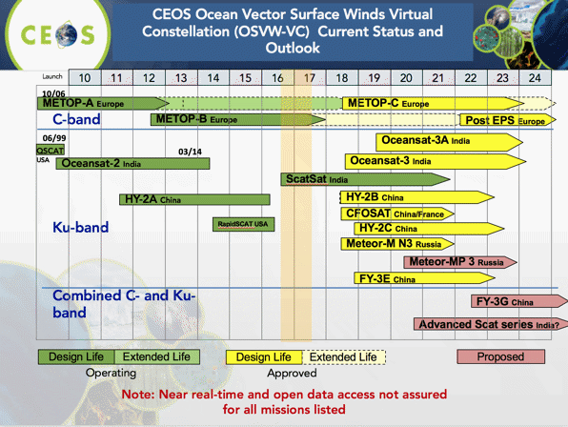
On tangible outputs from the VC, the following were highlighted:
- OSVW Standards and Metrics (VC-15): Calibration/validation methodology standards via the International Ocean Vector Winds Science Team (IOVWST) working groups; High wind speed validation.
- Outreach, training and advocacy: EUMETSAT-NOAA supporting EUMETSAT-led satellite wind/wave training workshops for marine forecasters.
- Optimum OSVW constellation white paper (VC-14): describe and justify the oceanography and climate requirements for the satellite OSVW observing system constellation.
On synergies, the OSVW-VC primarily engages the IOVWST for subject matter expertise. However, the CEOS Ocean Variables Enabling Research and Applications for GEO (COVERAGE) initiative provides a framework for potentially working with other VC’s toward a common goal.
The main obstacle is lack of resources. In terms of sustainable commitment, NOAA, EUMETSAT, ISRO, and NASA are the primary active agencies in the OSVW-VC. EUMETSAT and ISRO provide the anchor missions to the OSVW-VC observing system, and NASA supports the IOVWST. It would be beneficial if China would more fully engage given their plans for OSVW missions. The OSVW-VC meets once per year coincident with the IOWVST annual meeting. COVERAGE hopes to hold a workshop in connection with SIT Technical Workshop.
OCR-VC: Ocean Colour Radiometry Ewa Kwiatkowska (EUMETSAT, remote presentation)
Ewa presented a summary of the CEOS Work Plan linkages for OCR-VC.
3.1 Climate Monitoring, Research and Services – sample actions for OCR-VC
3.2 Carbon Observations, Including Forested Regions – inclusion of aquatic? IOCCG discussed “Aquatic Carbon from Space” special journal issue
3.5 Strategy for Observations of Water from Space – OCR-VC includes open ocean, lakes, rivers, coasts, etc. with different observational requirements
3.7 Plans for annual Summer Lecture Series in Villefranche-sur-Mer, France; Ocean Colour online primer; discussions on Copernicus training Asia/Africa
3.10 Outreach – EOV update provided to GOOS mid-March 2018
The OCR-VC has a number of current and planned outputs, including an IOCCG Water Quality report, Essential Ocean Variable submission to GOOS, modular implementation of Ocean Color Radiometry-Implementation Team (OCR-IT, formerly INSITU-OCR), draft IOCCG/VC White Paper on polarization requirements, and IOCCG Summer Lecture series. Future work may include lake ECVs (under development), an economic valuation of OC data, IOCS-2019 development (underway), and an Aquatic Carbon from Space special journal issue.
Synergies identified include with WGClimate, Carbon Strategy implementation, COVERAGE, and WGCV. The VC is exploring moving beyond passive radiometry and examining advantages of LiDAR and polarimetry in ocean biological, biogeochemical, and ecological retrievals, specifically looking for observational and mission requirements, and science harmonization with atmospheric groups (plankton LiDAR with aerosol and cloud communities). The VC is also looking at adapting different agency plans (INSITU-OCR/OCR-IT white paper requirements) for joint agency implementation.
OST-VC: Ocean Surface Topography Juliette Lambin (CNES)
Juliette presented, on behalf of the OST-VC Co-leads, who were not able to attend, noting that OST-VC acts as a link between wider satellite altimetry and CEOS, and presenting the current OST-VC mission timeline.
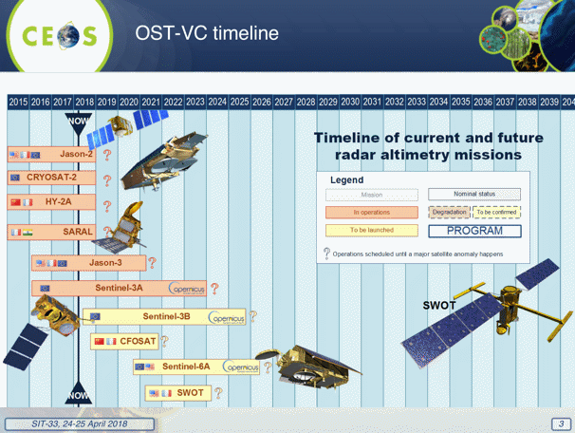
Juliette noted that one of their main objectives for 2018-2019 is to prepare a new User Requirements Document. Main topics addressed will be:
- analysis of user needs: systematic + exploratory
- swath altimetry + nadir altimetry: combined
- recommendation for an operational constellation (targets: Copernicus NG, China)
- recommendation for additional science missions in complement
- links with other observables
An objective may be covering all OST signals at 50 km/5 day resolution. There may also be an important role for auxiliary information (e.g., tides, gravity field).
SITTWS-2017-16: Complete. Amaury Larue de Tournemine has been formally identified as the CNES co-lead of OST-VC.
P-VC: Precipitation Steve Neeck, P-VC Co-Chair (NASA, remote participation)
Steve Neeck noted the CEOS WP deliverables for P-VC:
- VC-17 - Support to ECV precipitation parameter
- VC-18 - Programs for improvement of global precipitation products
Highlights of the tangibles achieved over the last 5 years include:
- deployment and operationalization of GPM constellation
- precipitation ECV support through response to GCOS IP Action A8
- support to the enhancement of precipitation measurement and uniformly calibrated multi-satellite products
- the PMW Imager Availability Study and promotion of MWI on EPS-SG
- inter-agency scientific dialog on GPM Follow-On and Cloud and Precipitation Processes Mission (CaPPM) concepts
- development of the P-VC Data Portal and its lessons learned
- additional space/ground segment, products and services deliverables as identified in the P-VC Terms of Reference (ToR)
Steve highlighted several current synergies:
- WGDisasters: Landslide Pilot (Co-lead), Flood Pilot (support through Global Flood Monitoring System)
- WGClimate: ECV inventory, precipitation support to GCOS IP response
- SST-VC: PMW Radiometer Continuity
- GEOGLAM: use of P-VC data through the JASMIN system (contribution to Asia-RICE)
There are potential synergies with FDA, WGCV, WGCapD, and SDG.
In terms of sustainable commitment, the active agencies are NASA, JAXA, NOAA, and EUMETSAT. Less active are CSA, EC, INPE, ISRO, and CNES/CNRS. ESA, DLR, ROSHYDROMET, and NSMC/CMA are inactive. Meetings are annually although travel funding and team availability has constrained some participation.
AC-VC: Atmospheric Composition Jay Al-Saadi, AC-VC Co-Chair (NASA)
Jay highlighted the linkages between the AC-VC and the CEOS Work Plan.
SITTWS-2017-15: In Progress. Korea NIER is in active discussion with SEC re CEOS membership request for 2018 Plenary; open data sharing is one criterion. China National Satellite Meteorological Center has started posting TANSAT data (only L1b so far, can access from NASA networks).
CARB-12: Carbon observation constellation white paper [Q3 2018] is on track, further update in Carbon session at SIT-33.
VC-2: Ozone dataset validation and harmonization [Q4 2020] there will be discussion in AC-VC-14 next week to possibly identify specific O₃ profile and/or tropospheric O₃ deliverable within this timeframe.
VC-3: Air quality constellation coordination [Q4 2018] is on track, “Validation Needs” white paper discussion and update in AC-VC-14 meeting next week.
Major past achievements of the VC include the volcanic ash advisory prototype, vision and advocacy for air quality constellation architecture, and long-term monthly gridded pole-to-pole total O₃ data. There are planned future outputs around validation standards for geostationary AQ data products, an architecture recommendation for GHG constellation, and O₃ profile and/or tropospheric O₃ standardization activity. There are also potential coordination/advocacy efforts, which will be discussed around air quality, associated with aerosol, synergies of joint AQ/GHG measurements, a potential update to the atmospheric composition measurements gap analyses, and harmonized data access for users.
The VC holds annual in-person meetings, with the next coming in May (100 registered participants), and there is confidence in the commitments of agencies for members to continue work currently identified. As the group continues to evolve from definition and advocacy of observing strategies to implementation, agency resource commitments will likely grow and become ever more critical determinants for accomplishing VC objectives.
Existing synergies have been identified with WGCV and WGClimate, and potential synergies with LSI-VC and GEOGLAM, and WGCV and WGISS. Jay feels that ad hoc interactions with other groups (e.g., Working Groups) have not been effective in the past, and a more structured approach may help address these issues.
Jay noted that the systematic dissemination of ground-based Cal-Val observations for GHGs would likely benefit from increased coordination.
Barbara Ryan (GEO Secretariat Director) asked about data sharing with Korea, and Jay noted that there is a discussion within their government about how this can be enabled. Membership in CEOS is seen as a possible way to encourage this data sharing.
Mark asked how the AC-VC sees the synergies around GHGs identified evolving, and Jay suggested that initially this may focus on modelling. The hope would be that these findings would make their way into future mission requirements.

LSI-VC: Land Surface Imaging Jenn Lacey (LSI-VC Co-Chair, USGS)
Jenn reported on LSI-VC:
- The VC has an active team and tasks are viable given participation: leads are USGS, GA, ESA, with active participation from CEOS SEO, EC, NASA, NOAA, JAXA, UKSA, CNES, CSA; LSI saw new participation from ISRO at LSI-VC-5; the group meets physically twice per year – one of these is in a joint setting with SDCG for GFOI and GEOGLAM.
- LSI outcomes for the CEOS WP include:
- CEOS Analysis-Ready Data for Land (CARD4L): maintain the CARD4L Product Family Specifications (PFS) [VC-33]; CARD4L Product Assessment Framework; [VC-32]; CARD4L Engagement Strategy. [VC-34]; evaluate CARD4L with target user communities, starting with GEOGLAM and GFOI. [VC-31]
- Gap and Requirements Analysis: to identify potential modifications to existing CEOS information tools that can be made to help improve their value for gap analyses. [VC-37]
- Moderate Resolution Interoperability (MRI): interoperability case study for Landsat and Sentinel-2. [VC-30]; monitoring MRI implementation examples [VC-36]
- In terms of potential LSI-VC contribution to the global observing architecture and national/agency planning, the group will pursue standardization for improved interoperability and ease of use, leveraging the data streams of each CEOS Agency and hoping to contribute to competitiveness of public EO programs.
- Opportunities for synergies: WGCV support is requested for the definition of the CARD4L Product Assessment Framework and the assessment of specific products; LSI-VC experience with CARD4L may serve as a pathfinder for analysis ready data in other domains (e.g., CARD4Ocean, CARD4Atmosphere) – if there is utility/user pull for such products in other domains, LSI-VC could support.
- LSI-VC work on CEOS Information System tool enhancements can support architecture planning and gap analysis; national planning processes are invited to lodge feature requests with the SEO and MIM teams; possible synergies are with WGClimate on ECV Inventory gap analysis and with WGISS on data access gaps.
- The Moderate Resolution Interoperability (MRI) activity can support interoperability between existing CEOS Agency sensors and improved temporal resolution for CEOS priority applications.

5. Working Groups
Steve Volz (SIT Chair, NOAA) and Mark Dowell (CEOS Chair Team, COM) introduced the session. Steve reviewed the Working Group (WG) questionnaire process and outcomes, and the priorities for WGs and VCs. The process sought to support discussion of tangible and sustainable outcomes from CEOS WGs by providing an opportunity to air key issues, identify barriers to progress, and discuss ways to overcome those barriers.
Key questions from the WG questionnaires and telecons included:
- How does CEOS best ensure continuity and sustainability of its WGs?
- What outputs are the WGs delivering? What additional outputs are needed, or could they deliver?
- What obstacles are being raised by the WGs? And can they be resolved? If so, how?
- Can and how can, the work of the WGs support the VCs, as well as current and future CEOS Work Plan and GEO Work Programme items?
Key statements from the WGs noted that they are motivated to integrate their agency assets in order that better decisions can be made more efficiently with EO, in particular by promoting collaboration in the development of systems. There was a view that it has been difficult to get a broader connection between the membership and what is happening at the SIT and Plenary levels. There was a suggestion that it may be valuable if a member of CEOS Leadership participated in a WG meeting in order to provide an “external” point of view.
Mark noted that the main interface for CEOS to the ‘external’ audience is often the WGs. He noted the important role they play in progressing cross-cutting activities in CEOS. He also noted that, where appropriate, synergies amongst and between the WGs and the VCs may support better outcomes.
WGCapD: Working Group on Capacity Building and Data Democracy Nancy Searby (WGCapD Vice Chair, NASA)
Nancy presented, noting that WGCapD has no open SIT or Plenary actions, but does have 11 activities referenced in the CEOS Work Plan. The major past achievements of the group include:
- Capacity Building Best Practices document
- Training resources posted on INPE-provided Learning Center, which is linked to GEOCab Portal and CEOS WGCapD website
- Many regional trainings, e.g., in SRTM 30-m data, SAR
- Many webinars on EO and applications
- WGCapD World distribution list provides CEOS outreach to all trained
Planned future outputs are being considered around gaps in agency activities, increased engagement with GEO regional activities, e-learning activities, awareness of future missions, data sets, and applications, and increased engagement of CEOS Agencies in Capacity Building and Data Democracy.
One of the key obstacles identified by WGCapD is the inability to plan more than one year in advance. Increased engagement with capacity building activities from other CEOS agencies would also help the group to thrive.
The scope of Working Group was queried, and Nancy noted that when the WG was reorganized, ‘education’ (i.e., school age) was reduced in priority (although it is still supported). The greater focus has been on working professionals and academics.
Barbara Ryan (GEO Secretariat Director) noted that ITC is about to do a virtual secondment into the GEO Secretariat which may help to increase capacity.
WGCV: Working Group on Calibration and Validation Kurt Thome (WGCV Chair, NASA)
Kurt presented, noting:
- Recent major achievements include: RadCalNet (CV-9), ACIX (CV-13), Solar Irradiance Model (CV-16), LPV SuperSites (CV-12, CARB-19).
- Near-term planned activities include: CARD4L assessment (CV-17); GSICS Level 1 interoperability (CV-15); carbon actions including GHGs (CV-18); and biomass (CV-19).
- Synergies among teams include:
- CV-14: Report on application of approaches for cloud masking will involve understanding impacts on CARD4L (LSI-VC)
- CV-17: Surface reflectance validation also will prompt interactions on CARD4L
- CV-18: GHG reference standards for interoperability will lead to work with AC-VC
- CV-19: Biomass validation protocols will involve WGClimate
- WGCV has always had a close collaboration with GSICS continuing with L1 top-of-atmosphere interoperability (CV-15) and pre-launch workshop (CV-03).
- WGCV meets three times per two-year term of each WGCV Chair, with strong meeting participation (notably from BELSPO, CNES, CSIRO, DLR, ESA, GA, ISRO, JAXA, NASA, NSSC, UKSA, USGS - generally agencies with subgroup chairs and vice chairs).
WGDisasters: Working Group on Disasters Simona Zoffoli (WGDisasters Chair, ASI)
Simona presented, noting that there are three items for decision at SIT-33:
- proposal for a CEOS Volcano Demonstrator
- proposal for a CEOS Seismic Hazard Demonstrator
- CEOS support for the 1st GEO-DARMA pilot project
She reviewed major past achievements:
- Sendai Framework for Disaster Risk Reduction 2015-2030 - showcased the value of EO derived information for DRR
- validation of methodology for new products generation
- generation of advanced science products for emergency response
- facilitated data access and processing
- collaboration with mission operators to optimize EO coverage
And planned future outputs:
- fill gaps where satellite observations are not being fully exploited
- awareness raising and Capacity Building
- 2019: results from landslide pilot and Recovery Observatory (RO)
Simona noted that there are potential synergies with WGCapD and WGISS. She also noted that many agencies are contributing to the WG, and there are also relationships with a wide range of relevant non-CEOS actors (e.g., research institutes, volcanic observatories, World Bank, GFDRR, UNDP, Red Cross, European Commission/Copernicus and others).
The WG has no open actions (SIT and Plenary) but does have five deliverables in the CEOS Work Plan 2018-2020 (DIS-10, DIS-12, DIS-15, DIS-16, and DIS-17).
Simona introduced the CEOS Volcano Demonstrator proposal, reviewing the 2014–2017 CEOS Volcano Pilot goals and achievements, and outlining how the Pilot is expected to evolve into a Demonstrator. She reviewed the areas of focus, implementation strategy, and the implementation timeline.
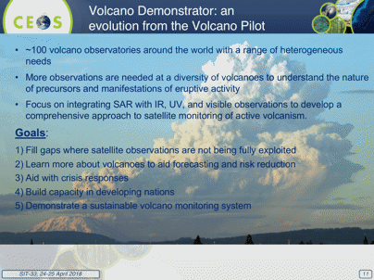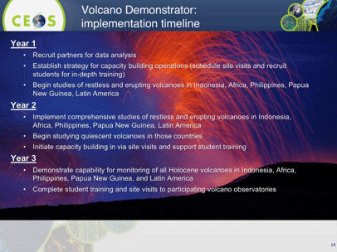
The proposed data volumes for this Demonstrator are as follows.
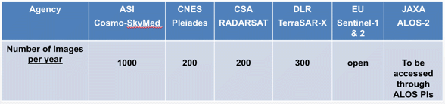
A brief discussion followed:
- The increased data volume was noted, and there was a question about the reason for this increase. Simona noted that the intention is to expand coverage globally.
- Kerry Sawyer (SIT Chair Team, NOAA) asked if the agencies listed as providing scenes have been consulted, and Simona noted that ASI, DLR, and JAXA confirmed.
- Klaus Schmidt (DLR) confirmed DLR support. CNES confirmed support for the project, but the details remain to be coordinated. Osamu Ochiai (JAXA) confirmed that JAXA is in support, and this is part of normal process. Marie-Josée noted that CSA supports the project, but the details remain to be coordinated. Ivan Petiteville (ESA) confirmed that ESA support the project.
- It was noted during the discussion that the agency representatives to the WGDisasters may not have formally authorized to commit data from their respective space agencies. With this being the case, the WG was advised to confirm agency commitments for data at the WG level.
- Simona confirmed that based on the endorsement, WGDisasters will confer with the data provider agencies on data supply arrangements.
Steve asked if there were any objections, and none were raised so the Volcano Demonstrator was endorsed.
Simona introduced the CEOS Seismic Hazard Demonstrator proposal, reviewing the 2014–2017 Pilot objectives and achievements. She reviewed the way forward, noting the intention to expand the precursor Seismic Hazards pilot activities through expand coverage (e.g., larger Areas of Interest, response to a higher number of events), and expanding the user base. It will also include the development of a collaborative framework with geoscience centers to achieve adoption of new EO approaches by decision makers, and support to capacity building.
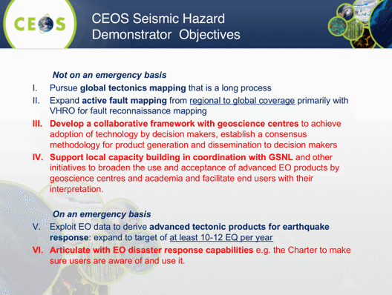
The proposed data volumes for this Demonstrator are as follows.
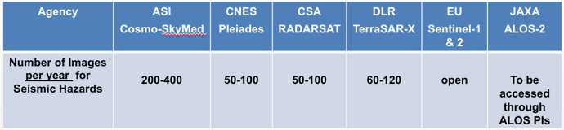
Steve asked if there were any objections, and none were raised so the Seismic Hazard Demonstrator was endorsed.
Simona introduced the first GEO-DARMA SERVIR Mekong Pilot proposal focused on developing a collaborative tool for flood monitoring in Myanmar. She reviewed the background and rationale for the pilot.
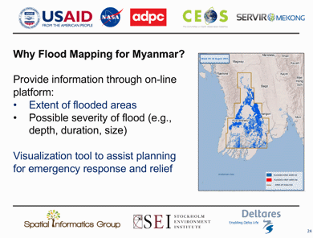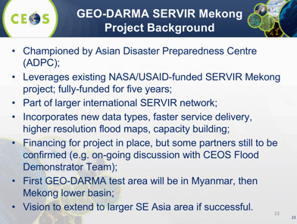
She reviewed the types of data, as well as the data volumes required for 2018.
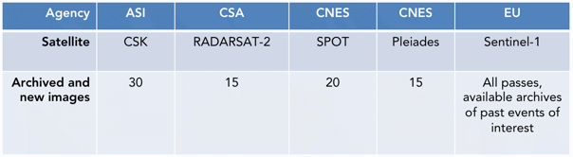
A brief discussion followed:
- Jonathon Ross (GA) noted the CEOS Data Cube is supporting the Vietnamese government to establish a Mekong Data Cube. The project has contributions from the Vietnamese government (including 2019 CEOS Chair VNSC), CSIRO, NASA and USGS.
- Pham Anh Tuan (VNSC) noted that the Vietnamese Government will be tabling the Mekong Data Cube project at the Mekong River Commission, the intergovernmental body that brings together Cambodia, Lao PDR, Thailand and Viet Nam to discuss management of the river.
- Jonathon noted that as the GEO-DARMA project intends to explore expansion to include the lower Mekong delta, it will be important that all CEOS activities in the area are coordinated and capitalize on the ability of the 2018 Chair VNSC to ensure engagement with the other lower Mekong governments.
- Nancy welcomed this activity, noting that may fit well with other activities within WGCapD.
- Ivan noted that as the GEO-DARMA co-Lead, he observed that the proposed data supply was clearly welcomed as an improvement by the SERVIR team and suggested going forward with the proposal as is.
SIT agreed that the first stage of the project focused on Myanmar be endorsed, and requested that WGDisasters, the CEOS Data Cube and VNSC discuss how to align the activities in preparation for a potential expansion to include the Lower Mekong, and to present the results of these discussions at the SIT Tech Workshop 2018.
Steve asked if there were any objections, and none were raised so CEOS support for the first GEO-DARMA pilot (GEO-DARMA SERVIR Mekong Pilot) was endorsed as presented.
SIT-33-03 | WGDisasters and VNSC | WGDisasters, VNSC, SEO, and CSIRO to discuss how to align the activities with the CEOS Data Cube efforts (led by the CEOS SEO) in preparation for a potential expansion of the first GEO-DARMA flood Pilot to include the Lower Mekong. | SIT TW 2018
 | Rationale: Explore potential overlaps and synergies between the WGClimate GEO-DARMA SERVIR Mekong Pilot, and VNSC’s Vietnam Data Cube.

Decision 1 | SIT endorsed the initiation of the CEOS Volcano Demonstrator.
Decision 2 | SIT endorsed the initiation of the CEOS Seismic Hazard Demonstrator.
Decision 3 | SIT endorsed the initiation of the first GEO-DARMA pilot (SERVIR Mekong) focused on developing a collaborative tool for flood monitoring in Myanmar.

WGISS: Working Group on Information Systems and Services Mirko Albani (WGISS Chair, ESA)
Mirko presented the WGISS structure and activities.
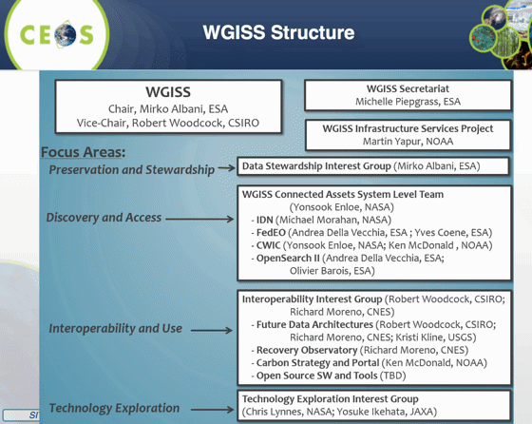
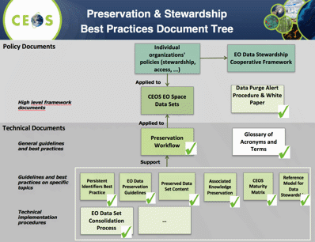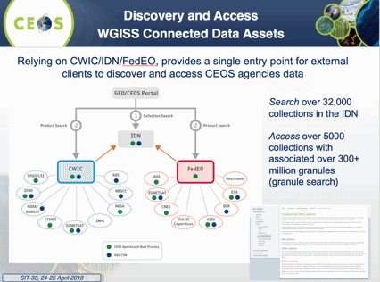
- WGISS Connected Data Assets Systems (IDN, CWIC, FedEO) are maintained and evolved in coordination among different agencies represented in the System Level Team. The WGISS Connected Data Assets is supporting the CEOS OpenSearch Best Practice specification defined by WGISS. The OpeanSearch Best Practice provides a standardized way for GEO (GEOPortal) and other user portals to discover and access CEOS Agencies data.
- WGISS is implementing six and contributing to one of the deliverables identified by the FDA AHT;
- WGISS has arranged a series of Technology Exploration Webinars.
- WGISS has 13 identified CEOS Work Plan deliverables.
- Cooperation with other groups includes the Carbon Portal prototype, review of the ECV Inventory to ensure access to CDRs through WGISS Connected Data Assets Infrastructure, and discussion with WGDisasters related to their demonstrators.
- WGISS has healthy participation and meeting engagement.
WGClimate: CEOS/CGMS Working Group on Climate Jörg Schulz (WGClimate Chair, EUMETSAT)
Jörg presented the recent achievements of the WG, with highlights including the publication of the Essential Climate Variable (ECV) Inventory 2.0 in October 2017 and the preparation of the first gap analysis report and coordinated action plan.
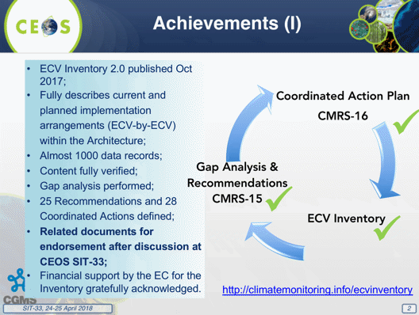
The recommendations and coordinated actions address:
- improved link of GCOS ECV user requirements to climate applications to ensure a more complete understanding of the intended usage, information chain, and potential impacts on decision-making
- improved understanding on CDR quality evaluation and uncertainty characterization
- production of specific ECV climate data records
- continuation of and new measurements for specific ECVs providing input to future coordination efforts by CEOS and mission planning activities of its agencies
- harmonization of measurement data bases CEOS-MIM and WMO-OSCAR
- improvement of the ECV Inventory
In addition, the WG has completed a small update of Space Agency Response to GCOS-IP 2016 to version 2.2.1 instead of providing a Technical Annex (CMRS-19).
Jörg reported that SBSTA-47 noted with appreciation the space agency response to the GCOS-IP and recognized the progress made in the development of the ECV Inventory (with explicit link in the conclusions). Then Jörg summarized the WG deliverables planned for 2018 and 2019.
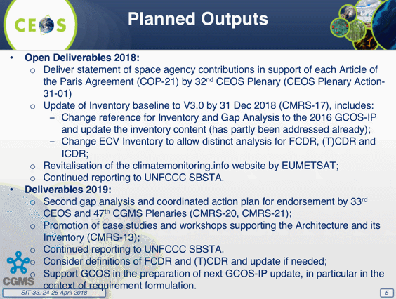
WGClimate has not had much interaction with other CEOS WGs and VCs so far, but with the Coordinated Action Plan, this should change in the near future. Interactions envisaged from the coordinated actions are:
- with WGCV on quality evaluation of CDRs, e.g., establishment and use of long term fiducial reference measurements
- with WGISS on access to CDRs in ECV Inventory
- with AC-VC on Carbon, Methane CDRs and new measurements
- with P-VC, CGMS-IPWG, and WMO SCOPE-CM to develop a plan for providing an optimal set of precipitation CDRs
- with SST-VC on future utilization of additional past measurements for SST data records and continuation of measurements, e.g., C-band microwave
- with LSI-VC on LST, LAI and Biomass data products and measurements
- with CEOS MIM team on improvement of the MIM database
- with OCR-VC on their contribution to relevant VCs
Jörg noted that the contributions of CEOS and CGMS Agencies to the ECV Inventory, and the two-step gap analysis has been very strong. He noted that engagement with other WGClimate activities needs to be improved, in particular from agencies in Asia (where WGClimate plans to hold one of its next two meetings) and also as the WG looks at the full architecture, i.e., towards the enhancement of CDR usage in applications.
A discussion followed:
- Mike Freilich (NASA) asked if there will be both CEOS and CGMS branding on webpages where the climate info will be posted once it is updated (climatemonitoring.info website), and Jörg confirmed this will continue.
- Mark noted the amount of work that has gone into the updated space agency response to the GCOS IP, and that this shows how much work has also gone into the ECV Inventory. Jörg noted that there is also interest in the ECV Inventory from the research community, and there has been a productive exchange on its content and development during the joint meeting of the WG with the World Climate Research Programme (WCRP) Data Advisory Council (DAC).
- Mark added that we need to start thinking about the package of material for COP-24 (first two weeks of December).
- Stephen Briggs (GCOS) expressed appreciation for all the climate-related work of CEOS agencies. With regards to the next GCOS IP update, it is hoped that the process could become more of a continuous evolution than an intensive update process.
SIT-33-04 | WGClimate and VNSC | Confer on the CEOS delegation to COP-24 and the process for ensuring a national delegate from Vietnam can introduce CEOS material. | June 2018
 | Rationale: UNFCCC COP is one of the first roles for incoming CEOS Chairs and WGClimate will work with VNSC to manage expectations and ensure solid arrangements.

6. Virtual Constellations and Working Groups Wrap-up Discussion
Steve Volz (SIT Chair, NOAA) noted the breadth of work by the VCs and WGs makes it challenging to summarize. He reviewed the discussion seeds shown earlier:
- For each entity, what action is necessary to ensure the necessary leadership, engagement and connection to the CEOS objectives?
- Should we (can we) achieve greater specificity in tangible outcomes from each entity (as appropriate)?
- Is more direction required to maximize the value of VC/WG outputs for CEOS objectives and in support of individual CEOS Agency objectives (like planning processes)?
- How realistic are these ambitions given operating realities – and what further support would be needed in each case?
Steve noted the scale of deliverables in the CEOS WP for WGs is considerably more than imposed on the VCs. He suggested that we could consider more directed interaction between VCs and WGs, e.g., on Cal-Val. He would like to encourage discussion of this interaction at the coming SIT Technical Workshop (TW).
A discussion followed:
- Osamu Ochiai (JAXA) reiterated JAXA’s desire to have a ‘system of systems’ view of EO mission planning, with a draft for discussion at the SIT TW.
- Mike Freilich (NASA) seconded the comment on the differences between the VCs and WGs. He noted that it is possible for a couple of agencies to drive a WG (Chair and Vice Chair of the WG), whereas the activities of a VC cannot and should not be driven by a couple of agencies. We should think about how we can incentivize multiple contributors to VCs.
- Stephen Briggs (GCOS) noted that space agencies are driven by their own individual sets of priorities, often beyond their control, and this is a barrier to the harmonization of upstream mission planning activities. In the last decade, space agencies have shown they can coordinate efficiently if they work together on activities that focus on downstream applications. We should also be cognizant that there are currently two types of WGs in CEOS - three that look at how we work together, and two that focus on applications.
- Steve noted that you do not force partnerships, you converge over common objectives, and this can happen in a number of cross-cutting ways across the VCs and WGs by asking VCs and WGs to define an outcome together.
- Juliette Lambin (CNES) noted the individual presentations by each VC and WG were not complemented by an overview of cooperation amongst them.
- Jay Al-Saadi (NASA) suggested that the VCs may benefit from a ‘maturity model’, which reflects where they are along their development pathway. Once they reach an ‘operational’ maturity, they could be expected to increase their border interactions with other CEOS entities.
- Eric Lindstrom (NASA) noted his COVERAGE proposal, and the challenge he has faced in getting response from the Oceans VCs. He suggested that if there were more shared project staff across these VCs, this might promote interaction. However, this would require additional resources.
- Ken Casey (NOAA) noted that some of the VCs are quite different in their relationship to CEOS than the WGs. SST-VC sees itself as a bridge between the community outside CEOS and the CEOS community, which is the embodiment of the space agencies.
- Jenn Lacey (USGS) noted that LSI-VC is focused on land observations, and works with thematic groups (e.g., SDCG, GEOGLAM) on the user interface, and at times, they have felt LSI-VC is more like a WG than a VC. She noted the VC is working well in this mode.
- Barbara Ryan (GEO Secretariat Director) noted that GFOI, GEO-DARMA, and GEOGLAM reference GEO Flagships, and asked about linkages to other GEO Flagships (e.g., Blue Planet). She also asked if there was any feedback on the Flagship process.
- Stephen Briggs noted that each of the Ocean VCs had a pre-standing science team, and out of that grew a requirement for a better partnership with the space agencies. The other three VCs do not have this counterpart and are therefore somewhat different in scope, composition, and function.
- Steve Neeck (NASA) looks forward to the future work with P-VC referenced by WGClimate. He also noted that there is an active international precipitation science team, and this is a key element in P-VC.
- Mark Dowell (CEOS Chair Team, COM) noted that an interesting common objective across the VCs would be to look at ECVs and CDRs. He raised the idea of the VCs revising their ToR to explicitly address CDR generation and ECV requirements.
Steve Volz summarized the discussion, noting that there is no ‘one size fits all’ for VCs and WGs, and that focusing on a common set of objectives and outcomes may be the best approach to go forward. He suggested making this a focus of the TW in September, and the SIT Chair Team will work towards formulating that discussion.
SIT-33-05 | SIT Chair | Provide an analysis of possible measures to: improve consistency in processes across CEOS entities; identify whether further tangible contributions to the CEOS Work Plan are possible; ensure sustainment of resources across the groups. | SIT TW 2018 VC/WG Day
 | Rationale: SIT Chair has challenged CEOS to identify whether top-down contributions to the CEOS WP are required and possible in addition to the bottom-up population of the WP.
Day 1 Summary
Steve Volz summarized the outcomes of Day 1.
- LDN: SDG AHT will propose a way forward.
- VC/WG: action for VC/WG to review their ToR to see if they need to be updated.
- CEOS Work Plan: for next year’s iteration, try to have some consistent activities for the VCs (e.g., constellation updates, gap analysis).
- It was agreed that the SIT Chair Team would develop a short set of recommendations that identify changes to the governance documents to make procedures more consistent across the organization. The SIT Chair Team will also assess the feasibility of proposing a formal VC Co-Lead Rotation scenario.
- The SIT Chair Team will canvass the community for suggestions on topics for the VC/WG Day in May/June.
Steve also encouraged VCs to work with SEO on their gap analyses, with Mike noting that NASA funds the SEO in service to CEOS Leadership.
Steve noted the review of Landsat data policy announced in recent days. Tim Stryker (USGS) noted that the Landsat Advisory Group of the National Geospatial Advisory Committee was engaged following a request from the Department of Interior to look at cost recovery for Landsat data. He noted that the Group has expertise and a good understanding of the benefits and value of free and open data, and suggested that CEOS Chair might write to the Group to advocate for continuity of the current Landsat data policy. Mike noted that this issue was raised within NASA during the transition last year, and after some education of incoming officials, the Landsat program remains in the NASA budget.
SIT-33-06 | CEOS Chair | Write to the Landsat Advisory Group of the National Geospatial Advisory Committee advocating for continuity for the free and open data policy for Landsat data. | May 2018
 | Rationale: Many CEOS coordination activities are predicated on the continued free and open availability of EO data. Consistent with CEOS support to GEO’s GEOSS Data Sharing Principles.

7. Emerging and On-going Activities
Steve Volz (SIT Chair, NOAA) introduced the session, noting that the objective is to review several emerging opportunities for CEOS engagement from the GEO Work Programme, as well as across the community. The key questions for the session include:
- What are the requirements of new and emerging activities around aquatic ecosystems and freshwater observations from space? Can these be addressed by CEOS capabilities, and if so, should they? How?
- What are the next steps that CEOS can be taking in support of the Paris Declaration?
- How is CEOS engaging with the IPCC Inventories process?
- What, if any, new CEOS resources and Partnerships may be required to support engagement in these emerging activities?
Feasibility Study for Aquatic and Freshwater from Space
Alex Held (CSIRO) presented a summary of the Feasibility Study on Satellite Missions/Instruments Focused on Water Quality Measurements. The study addresses science and applications driving sensor specifications, platform requirements and mission design, and aquatic ecosystem activities enabled by Earth observations. The SIT-33 acknowledged the hard work of the authors and contributors who prepared this Study.
Alex reviewed recent discussions on the CEOS Freshwater from Space Observation Strategy, noting that a planned workshop on this topic has been postponed until Q4 2018. The plan is to follow lessons and processes used to build the CEOS Carbon Strategy. An initial draft plan will be prepared with output from the first workshop, to be presented to CEOS in early 2019 (TBC) and with links to GEO. A second consultation workshop will be held in mid-2019, with a final strategy document ready for CEOS Plenary 2019 (Vietnam).
CEOS-31-04: Complete. Feedback was received from OCR-VC and SST-VC.
CEOS-31-05: In Progress. Due date changed to Q4 2018.
Steve asked if there were any issues to raise, and none were flagged.
Space Climate Observatory
Selma Cherchali (CNES) reported, noting that some of the heads of the world’s space agencies have proposed the creation of a Space Climate Observatory (SCO) to act as a hub between space agencies and the international scientific community. The key principles for the SCO are:
- building on the existing capabilities and programs
- being inclusive
- international coordination is mandatory
- complementary to the existing programs/initiatives
- open and free access
Linkages to the SDG framework will be taken into account with the aim of working towards the provision of information to policy makers. Selma reviewed the scope and context of the SCO.
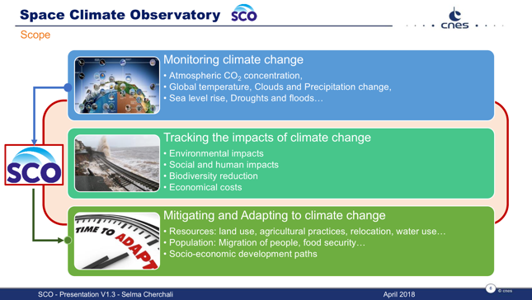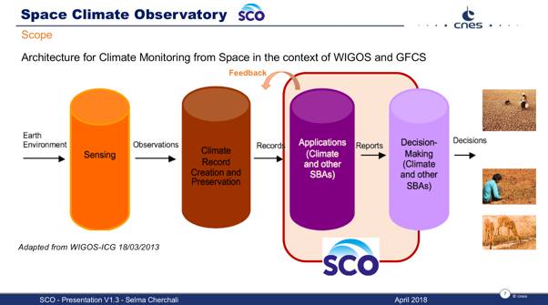
Climate change impacts are worldwide but there are also specific impacts at national, sub-national and territory levels, and there is a need to implement attenuation and adaptation policies, which the SCO seeks to support by providing information for decision-making. Selma reviewed the SCO objectives, data access, products and services, and schedule.
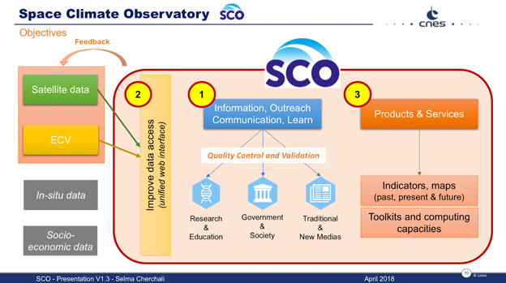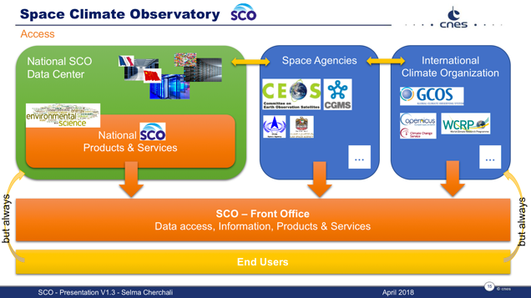
CEOS Way Forward on the Paris Declaration
Jörg Schulz (EUMETSAT) reviewed the discussion at the recent WGClimate #9 meeting on the CEOS way forward with the Paris Declaration (“Towards a Space Climate Observatory”).
He noted that WGClimate had been presented details of SCO and recognized that this is a response to high-level political pressures. The CEOS Chair commended CNES in trying to take positive advantage of this opportunity and to reach out collaboratively. WGClimate emphasized the importance of its ‘badgeless’ culture which is fundamental to the truly collaborative nature of the WG, and it is important this is preserved as the SCO develops. There is also a need to ensure SCO does not duplicate existing structures. In particular, the coordinated voice of space agencies to UNFCCC/SBSTA and GCOS (as represented by the CEOS-CGMS WGClimate) should not be compromised

Further points arising from the WGClimate discussion were:
- The SCO concept is new and the precise scope is still being clarified which means its incorporation into the existing CEOS coordination structures is premature.
- It might be advantageous if SCO were to address pillars 3 and 4 of the architecture, in order to enhance the uptake of CDRs into applications.
- WMO confirmed the finding from the WMO/EC earlier case studies that satellite data fulfils only part of what is needed for applications. These original case studies done in 2013 should be seen as very embryonic, and maybe the SCO could develop further and more detailed case studies of satellite applications for climate research/services.
- WGClimate identified that the nomenclature used is very sensitive. It was suggested to be explicit about what is meant by a climate data record in the context of the SCO, and what is supporting information.
- More time is needed to understand the implications of the implementation of the SCO. The evolving concept and its implementation should be accompanied by a review of its usefulness for CEOS.
- The stated aim to provide services from local to national climate impacts is relevant, but different to what was subscribed to in December 2017 as the purpose of the SCO; more detailed documentation would be useful, e.g., addressing the expected additional value that the SCO would bring to the development and implementation of the architecture. It is currently not visible what role the partners that participated in the original declaration will play in the SCO.

From the perspective of WGClimate, the SCO could be useful if it were to: focus on impact studies and the tailoring of the associated inputs, with a particular emphasis on the illustration/promotion of the use of CDRs; provide inputs as appropriate to GCOS on observational requirements for particular applications/services; adhere to the ‘badgeless’ approach of WGClimate where contributions are made under the umbrella of CEOS/CGMS.
Discussion
- Paul Counet (EUMETSAT) reported that CNES had consulted with EUMETSAT. EUMETSAT’s opinion is very close to the WGClimate comments. He noted that while the efforts should be coordinated and international, SCO shall rely on and not duplicate existing mechanisms, and there should be a clear recognition of where the data has come from and that contributions from all national parties be made visible.
- Jonathon Ross (GA) noted that SCO goes beyond the scope of GCOS. He noted there is no reference to GEO in the materials. Selma noted that the intent is to promote the SCO under the GEO banner. Selma also acknowledged that the SCO purpose described goes beyond the scope intended by the name.
- Stephen Briggs (GCOS) suggested that this is not a CEOS response to the Paris Declaration but a program proposal from CNES. Significant amount of further information is needed to understand the intent.
- John Remedios (UKSA) suggested we need clarity on where gaps are and where CEOS could and should contribute to such an initiative to try to narrow the scope.
- Barbara Ryan (GEO Secretariat Director) noted the strong support from the French government and that we should seek to capitalize on that. She welcomed the use of the climate architecture pillars representation.
- Mark Dowell (CEOS Chair Team, COM) noted the potential for confusion in UNFCCC and SBSTA about their interface to the space community (via the CEOS-CGMS WGClimate). CEOS should define a clear communication strategy to help mitigate the potential for confusion.
- Juliette Lambin (CNES) welcomed the comments and messages of support and assured the group that details, perhaps including the name, may evolve with discussions.
Steve noted that CEOS is not necessarily endorsing the SCO at this point but can agree to provide a point of contact (WGClimate), and that this should be included in the list of topics for CEOS Plenary.
SIT-33-07 | WGClimate | Serve as Point of Contact for CEOS and keep track of the Space Climate Observatory (SCO) progress. Report to CEOS SEC monthly telecons, and provide updates at SIT TW and CEOS Plenary. | Through to 2018 Plenary
 | Rationale: CNES has asked for CEOS engagement in SCO.
IPCC Engagement Update
Akiko Suzuki (JAXA) presented an update on progress towards reflecting space agency inputs in the updated IPCC guidelines, reviewing the activities to date.
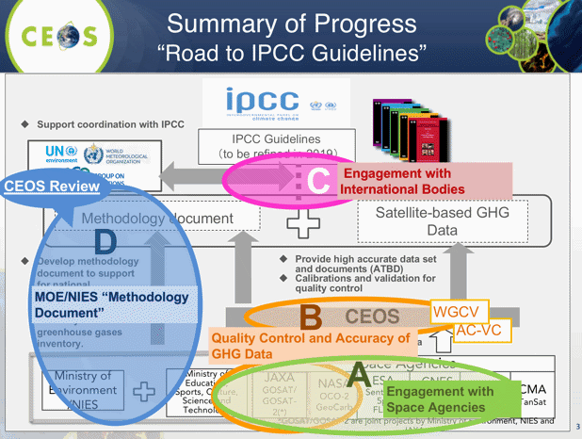
Recent activities have included: sharing the technical and scientific advancements of satellite monitoring at UNFCCC/COP23; the conclusion of a JAXA/NIES GHG agreements with ESA, CNES and DLR, development by NIES of a GHG guidebook and CEOS reviewed the draft (1st Edition can be downloaded from http://www.nies.go.jp/soc/en/documents/); and, JAXA, in support of CEOS Chair and AC-VC, submitted expert comments to the first order draft (FOD) of IPCC guidelines. An inter-comparison between GOSAT and OCO-2 has been completed as a part of assessing reliability of CO₂ observations and providing uniform data.
Akiko noted that JAXA will nominate Dr. Kuze as a candidate for vice chair of WGCV. He has experience with GOSAT and GOSAT-OCO-2 calibration and validation activities.
JAXA has submitted several comments to the expert review on First Order Draft (FOD) of 2019 Refinement to the 2006 IPCC Guidelines for National GHG Inventories during the comment window (December 4, 2017 – February 11, 2018). They were:
- There are a series of GHG monitoring satellites on orbit in operation, that their observations and results available openly and freely with future mission continuity into the next decade.
- The importance of high quality GHG information integrated with ground-based measurements and models in supporting a monitoring and verification system for NDCs and stocktaking, and CEOS and CGMS started activity to define an optimum constellation of satellites to meet requirements of a monitoring and verification system.
- Further engagement of partnerships/collaboration: CEOS/CGMS for the space component aspects; GEO/WMO on the broader framework; GCOS, UNFCCC and IPCC in better defining the role for space-based observation in the inventory guidelines process.
SITTWS-2017-06: Complete. CEOS Agencies, separately and via JAXA, engaged in the IPCC review process.
Akiko reviewed the planned activities from April 2018 to March 2019:
- continue Cal/Val to enhance reliability of data
- literature cut-off date in 25 June 2018, and the second order draft (SOD) of IPCC Guidelines in July to September (Relevant papers should be issued before the cut-off date, and CEOS should submit expert comments to SOD, e.g., AC-VC White Paper)
- UNFCCC/COP24@Katowice in December: intensify engagement for the final review of IPCC Guidelines
- IPCC Plenary in Japan in May 2019 (Adoption of the refined IPCC Guidelines)
Akiko stressed the need for engagement with in situ observations and modelling, as well as the importance of supporting mitigation and adaptation, in addition to monitoring.
Way Forward on New Activities
Steve initiated discussion around the seed questions:
- What are the requirements of new and emerging activities around aquatic ecosystems and freshwater observations from space? Can these be addressed by CEOS capabilities, and if so, should they? How?
- What are the next steps that CEOS can be taking in support of the Paris Declaration?
- How is CEOS engaging with the IPCC Inventories process?
- What, if any, new CEOS resources and Partnerships may be required to support engagement in these emerging activities?
Steve asked that the OCR-VC and LSI-VC review the report of the Feasibility Study on Satellite Missions/Instruments Focused on Water Quality Measurements and advise SIT TW on any implications for their work.
SIT-33-08 | OCR-VC and LSI-VC | Review the CEOS Feasibility Study on Satellite Missions/Instruments Focused on Water Quality Measurements and report to SIT TW on any implications for their work, including opportunities to address the recommendations that may be on the horizon. | SIT TW 2018
 | Rationale: Measurements identified in the study are of direct relevance to OCR-VC and LSI-VC data coordination.
SIT-33-09 | SIT Vice Chair | Consult with the community to reschedule the Freshwater from Space Workshop in the late November/early December 2018 period. Feedback is invited on the provisional Freshwater from Space Workshop agenda published on the SIT-33 website. | SEC-237
 | Rationale: Stakeholder availability has dictated re-scheduling of the workshop.

8. Ad Hoc Teams
Steve Volz (SIT Chair, NOAA) introduced the session on the ad hoc Teams and their activities, noting the objective is to review progress and key issues being faced by the Teams.
The key questions for the session include:
- What concrete steps can be taken in support of FDA activities? And how does this relate to existing Work Plans? What is required to promote and systematically generate ARD?
- What are the next steps for CEOS in supporting the advancement of the SDGs?
- How does CEOS sustain and progress its commitments to GEO Flagships such as GFOI (via SDCG), and GEOGLAM (via the AHT)? What resources and actions are required?
Steve asked that the Teams consider their group trajectory and lifecycle in relation to the thematic initiatives that they support and help develop a clear understanding for SIT as to the outlook and evolution of those initiatives, including, if appropriate, long-term, sustained operations and the expectation for CEOS and CEOS Member Agency participation. Kerry Sawyer (SIT Chair Team, NOAA) noted the action SIT TW Action 2017-21 for the AHTs to explore a path for their future evolution.
Mauro Facchini (CEOS Chair, COM) noted the activity and work of the VCs and WGs reported during this meeting and suggested that these groups consider how their work can be integrated into the broader work of CEOS in the short term whilst also addressing longer-term issue of sustainability and integration of the AHTs into WGs and VCs. He noted that we should concentrate on activities that are progressing well.
Future Data Architectures
Nick Hanowski (ESA, FDA Co-Chair) reported, noting that currently work on Future Data Architectures is focused on three main areas: Analysis Ready Data, Interoperable Free and Open Tools (including the DataCube), and User Metrics. Nick described the areas in which effort has been invested in FDA over the past 6 months and described the progress made:
- Analysis Ready Data. Among work on the general theme of Analysis Ready Data, the CEOS Analysis Ready Data for Land (CARD4L) led by LSI-VC has progressed significantly with a consolidated effort to identify potential CARD4L products from the three Product Families. New Synthetic Aperture Radar (SAR) Product Family Specifications (PFS) are under definition and the process for granting the “CARD4L stamp” including “test running” the proposed self-assessment process are underway. In addition, a USGS-ESA pilot study is underway led by a recently established bilateral working group, which will aim, in a stepwise approach, first to ensure interoperable ARD products from S2 and Landsat 8, before looking at possible harmonized products. This would involve adopting common processing approaches and reference datasets.
- Interoperable Free and Open Tools (including the data cube). The CEOS Data Cube project has evolved into the Open Data Cube community to ensure the possibility of wider involvement and appeal including involvement by private entities. In addition, the inventory of free and open tools (such as open toolboxes like SNAP, Orfeo etc.) begun by WGISS several years ago will be finalized this year.
- User Metrics. The User Metrics theme was identified early by the FDA’s group as of strategic interest in order to characterize the different EO resources (platforms, data exploitation environments, data cubes etc.) in this burgeoning new sector. However, it is only in the last few months that progress has begun on documenting and analyzing the ways in which CEOS Agencies “measure” their users. The FDA workshop organized during WGISS was very successful in progressing this discussion and WGISS will be generating a best practice document this year. These will include user metrics, but also other metrics, which provide an indication of the use of these resources (e.g., data flows into the resource, storage, computing power). The scope of this inventory is worldwide and the aim is to build a broad picture of the different EO Resources available. CEOS Agencies will be solicited to contribute their knowledge of the “EO Resource” sector.
One of the outcomes from the FDA workshop organized by WGISS and WGCV was the necessity to have common terminology when discussing the EO Resources (platforms, data exploitation environments, data cubes etc.). The FDA AHT intends to propose a common description of these “functional blocks” (CEOS WP deliverable FDA-8) before the end of 2018. This WGISS/WGCV FDA workshop reinforced the common issues faced by all publicly funded space agencies in facing the challenges of promoting EO is the rapidly evolving “digital” sector. This theme is expected to be to the forefront in the FDA Big Data Workshop organized immediately after SIT-33.
A short discussion followed, with Barb Ryan indicating that the FDA theme established by CEOS has given significant food-for-thought to GEO including on the major issue of identifying the appropriate interface between public and private. This single issue is of significant strategic, if not existential, importance for public sector agencies in EO. Ivan Petiteville also stated that the FDA has not been dormant, as was presented, that 6-7 ESA persons have been actively working on this activity, and there have been a number of telecons with USGS, CSIRO, and ESA.
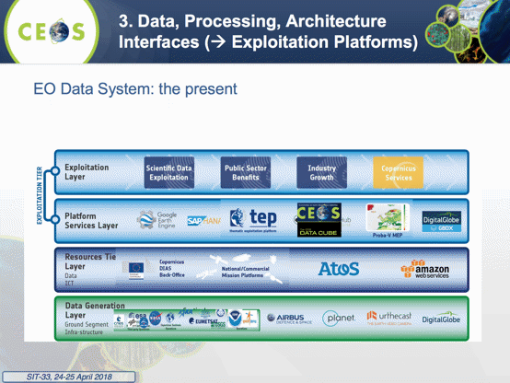
SDG: Ad Hoc Team on Sustainable Development Goals
Alex Held (CSIRO) presented a summary of the SDG AHT, noting that it was created at CEOS Plenary 2016 (Brisbane). He reviewed the implementation plan, and tangible outputs since last Plenary.
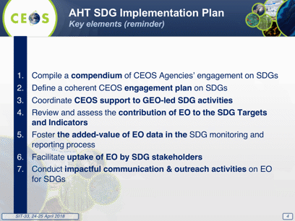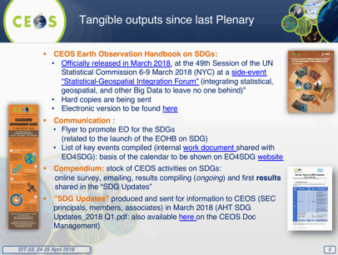

Alex reviewed the options discussed for the future of the SDG AHT:
Option 1: Continue as an AHT, requesting renewal for another year at Plenary, and continue to use Agencies’ best efforts to support UN and GEO mainstreaming EO in the SDG processes (new co-leads?);
Option 2: Continue as an AHT to ONLY act as a CEOS point of contact for external users, without undertaking new activities, and forward all specific requests to VC;
Option 3: ‘Graduate’ and become a CEOS Working Group with a more formal work plan, governance system and reporting mechanisms, and therefore more sustained efforts and support (= commitment) from CEOS and WG members to implement the work plan;
Option 4: Consider what the AHT SDG achieved, and still needs to be done from a CEOS perspective, and phase out the AHT with transfer of all AHT activities to GEO EO4SDG (including CEOS Agencies support)
Option 5: Transform the AHT into an “SDG Strategy” (given its cross-cutting essence, following the “Carbon Strategy” path), with a solid work plan and coordination body to map SDG activities to existing CEOS resources (VC, WG, etc.) and continue being the “SDG space arm” focal point for GEO
The proposal from the SDG AHT is to continue as AHT for 2018-2019 with following key ‘achievables’:
- Refine role of CEOS SDG activity vis-à-vis GEO EO4SDG activities and roles.
- Support further showcasing and examples of role of EO in national SDG reporting.
- If the option is given, prepare case for transition from AHT to CEOS Working Group on SDGs from late 2019, based on more tightly defined roles.
- Form a sub-team to support UNCCD request to GEO for support for “Land Degradation Neutrality” EO-based monitoring methodology implementation and testing (co-leads to be confirmed).
SITTWS-2017-21: In Progress. No option was selected from those presented. Need to readdress at SIT TW in September. Change due date to SIT 2018 Technical Workshop.
Alex noted that with the CEOS umbrella, SDG AHT will interact with LDN and UNCCD.
A brief discussion followed.
- Juliette Lambin (CNES) noted that Alex’s presentation was consistent with CNES’ goals, and they intend to support the LDN and SDG AHT.
- Mark Dowell (CEOS Chair Team, COM) noted that the SDG report was circulated internally in the Commission, in particular to policy experts, and it was well received with encouraging feedback from the Secretary General of the Commission.
Barbara Ryan (GEO Secretariat Director) presented on how GEO is interacting with UNOOSA. She noted that UNOOSA used to join CEOS meetings and is an Associate Member, and while GEO is happy to report on their relationship with UN bodies, CEOS probably needs to consider these relationships directly.
A brief discussion followed.
- Nancy Searby (NASA) noted that WGCapD is trying to engage with agencies such as UNOOSA in support of their capacity building objectives, most recently at a meeting in Pakistan.
- Gunter Schreier (DLR) noted that there is a recent trend towards these groups going directly to data commercial providers to get the data they are looking for quickly.
- Jonathon Ross (GA) noted that the engagement between the UN system and GEO may have meant that fewer UN agencies are represented at CEOS.
- Barbara noted that GEO will not be signing an MOU UNOOSA, and feels that their status as a PO will be sufficient to cover the necessary engagement.
SDCG: Ad Hoc Space Data Coordination Group for the Global Forest Observations Initiative (SDCG for GFOI)
Osamu Ochiai (GFOI Lead for CEOS, JAXA) reported, noting that GFOI has defined and started to implement its Phase 2, featuring:
- joint assessments of country needs and collaboration to address them
- complementary and consistent Capacity Building activities
- IPCC- and UNFCCC-compliant country guidance for REDD+ reporting (MGD)
- expanded data support to put more emphasis on access, uptake and application and the relevant tools (where CEOS comes in)
- coordinated R&D activities to support above
- expanded participation and leadership (WB, ESA and UK as new leads)
A letter was sent from the GFOI leads to the CEOS SIT Chair on April 12th recognizing the vital contribution CEOS has made to improve forest monitoring capabilities globally and specifically for the benefit of developing countries, and highlighting the desire for strengthening the relationship with CEOS to include ongoing advocacy for free and open availability of core satellite data, and also the accessibility and capacity to use satellite data for forest monitoring purposes. As countries move from readiness to implementation of their climate change policies and programs, the GFOI will take an increased focus on the implementation of forest monitoring systems - which will result in the further uptake and increased sophistication in the use of satellite data.
SDCG Secretariat reached out to SDCG agencies to gather their views on GFOI Phase 2 plans and prospects – responses from ASI, CNES, CONAE, CSA, DLR, INPE and USGS indicate continued strong support for engagement in GFOI.
On the ad hoc team lifecycle, SDCG approaches its 7th birthday. GFOI Phase 1 has made significant progress with strong contribution by SDCG. This success made GFOI a GEO Flagship, and the GFOI Office moved to FAO as an operational activity. Forests are still a vital theme for many CEOS Members and many new missions are planned (optical, LiDARs, P/L/S/C/X-band SAR). SDCG is defining its second 3-Year Work Plan. The 2016-17 joint discussions amongst SDCG, GEOGLAM, and LSI-VC concluded continued need for individual groups – but with an annual joint meeting (just before SIT TW)
The SDCG Work Plan is being updated to address GFOI Phase 2 design with key elements of: data component tools and systems support to countries; forest community CARD4L reference group feedback; biomass measurements global acquisition strategy; work with R&D Component on focused, funded R&D activity; and, an Early Warning program (e.g., detect illegal logging).
SDCG is not focused on ad hoc or permanent status but recognizes the need for cleaner logic within CEOS. The group is seeking clarity on the context of the SDCG role in Phase 2 among other contributions to the Data Component.
Ad hoc Teams might benefit from more systematic contact (e.g., with SIT Chair) as do the VCs and WGs. Ad hoc Teams could be reviewed at three years of age to debate whether they might be made standing entities and reviewed three-yearly thereafter. The SDCG Co-Chairs are undertaking resourcing study tasked by Plenary/SEC – starting with investigating support from Chair agencies.

A brief discussion followed.
- Alex noted that CSIRO is offering some support for SDCG SEC to sustain their work in 2018.
- Jonathon asked about the timing of the broadening of the scope of the Data Component to include in situ data, and Stephen Ward (SDCG Sec) noted that the roles beyond space data in the broadened scope are still not clear with no new actors immediately evident.
- Steve referred to the recent letter encouraging CEOS and ARD. He noted that the activities that GFOI expects from CEOS for Phase 2 appear to be part of ongoing agency business, and it was not clear in the letter what additional CEOS commitment was being requested. Osamu noted that biomass data coordination is a new area for Phase 2, as is the interaction with commercial data providers. Stephen Ward noted that the intent of the exchange of letters is to reiterate space agency support to the GFOI community for Phase 2.
- Selma Cherchali (CNES) noted ESA CCI support and other agency activities around biomass data and products.
Steve noted that the SIT Chair Team will draft a letter in response to the GFOI Leads letter and will confer with CEOS leadership.
SIT-33-10 | SIT Chair | Draft a response to the GFOI letter on CEOS/SDCG support to Phase 2 of GFOI. | May 2018
 | Rationale: CEOS Lead for GFOI has initiated an exchange of information to update the expectations between CEOS and GFOI as GFOI moves into a new Phase.

GEOGLAM: Ad Hoc Working Group on the Group on Earth Observations (GEO) Global Agricultural Monitoring (GEOGLAM) Initiative
Brad Doorn (GEOGLAM AHT Co-Lead, NASA) presented, noting that GEOGLAM is now a well-supported GEO Flagship with a strong policy mandate and support from the G20. He noted that the GEOGLAM Project Office is supported within GEO Secretariat for at least 2-3 years (sources growing: Germany, Canada, China, U.S.).
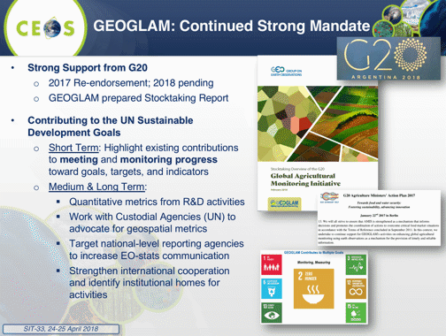
Brad noted that EO is central to GEOGLAM, and that the first CEOS Strategic Response (2012) was constrained by acquisition of data at appropriate resolutions. The current AHWG deliverable (AGRI-4) is a “refresh” of the 2012 Strategic Response, and the scope is expected to expand to cover data access and use (e.g., computational environments, capacity, communication, interoperability, multi-sensor solutions, in situ agriculture validation data are a constraint to EO adoption). He noted the growth in numbers and diversity of membership of the GEOGLAM requirements group, with approximately 40 participants taking part in last week’s Operational Requirements Workshop. Brad reviewed the outcomes of the Workshop and flagged some potential issues for CEOS to consider.
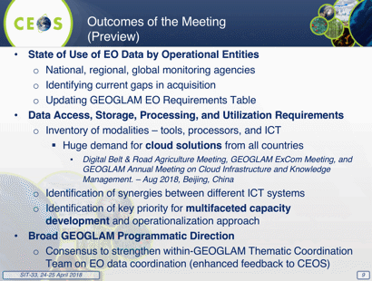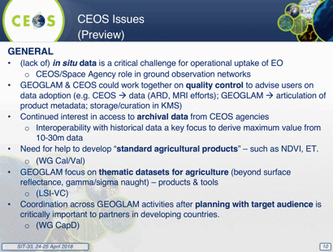
Brad reviewed the next steps towards the AGRI-4 deliverable:
- continue collecting survey responses (opportunity to expand CEOS-curated questions on ARD, MRI, etc.)
- integrate JRC Workshop presentations, survey responses, and breakout group summaries
- generate Final Requirements Document
- present summary to CEOS at Plenary 2018
Brad summarized the group’s views on the question of ad hoc Teams and their lifecycle within CEOS, noting that CEOS needs a responsive capability to address emerging topics, which may not require permanent / structural support. One option could be to more closely link the lifecycle to the CEOS Work Plan horizon, i.e., three-year initial lifespan with three-yearly reviews. He noted that the AHWG is currently seeking expanded membership and more comprehensive engagement with CEOS Agency activities, and permanent status/presence may help with attracting CEOS contributions to Agriculture research and applications.
The AHWG prefers to focus on maintaining and improving outcomes, with support to agriculture as a priority for many space agencies. The group seeks to better connect the agriculture community in EO activities, and better connect space data provider activities to agriculture community. The AHWG is coordinating with LSI-VC at joint meetings, with the next one planned for September, and expects continued and increased coordination and representation with other CEOS activities (e.g., WGCapD, SDG AHWG, and others).
A discussion followed.
- Steve noted the example Brad cited of the GEOGLAM ad hoc Team considering working with LSI-VC.
- Mauro noted that each group should look at how to interact with the existing VCs and WGs and suggested there appears to be options for both SDCG and the GEOGLAM group to make these linkages.
- Mauro returned to the proposal of creating a WG on SDGs and suggested this would be in line with the GEO priorities and complete the set of three WGs (along with climate and disasters) aligned with these priorities.
- Barbara noted the efforts that CEOS has put into these activities have put both CEOS and GEO on the map with the likes of the World Bank. She suggested that these activities could leverage both the climate architecture from space and FDA activities. The climate architecture approach could be replicated for other activities. She also noted that the FDA framework is applicable across a number of domains - SDCG was first, but there are many others that have or will follow.
- Steve noted the transition plans and asked the groups to consider the ‘option space’ approach used by the SDG group. He suggested that a collaborative WG on SDGs and Sustainable Observations could help address these issues, but there would have to be an appetite from agencies to support this.
- Mike Freilich (NASA) remarked that any such discussion on what a new WG would do should include a similar level of attention to the matter of how it will be sustained.
- Brian Killough (NASA) noted that the SDG team is driven by a very different set of requirements than the GFOI and GEOGLAM activities. He noted the LSI-VC may be another option, and there is more overlap with GFOI and GEOGLAM with their land focus. He noted that efficiencies are already being realized by holding joint meetings (i.e., with LSI-VC, SDCG, and GEOGLAM).
- Jenn Lacey (USGS) noted joint meetings can be efficient but would need to look at the governance and reporting structure. For example, if these groups were moved behind the LSI-VC, the reporting bandwidth for all groups would go down.
- Stephen Ward noted that the connection to the thematic constituencies is key and needs to be addressed in any way forward.
- Mike noted that the 2017 CEOS Plenary agreed that our GFOI and GEOGLAM groups should not merge into LSI-VC and should continue with their joint meetings.
- Barbara advocated a mapping exercise to try to identify boundaries for CEOS. She noted that the connections to companies like Descartes Labs and Development Seed are not being made, and there are clear links between these groups and the FDA work.
- Mike cautioned that as more activities are accepted by CEOS, this may diminish resources CEOS has to address other priorities.
Steve suggested that the SIT Chair Team come back to TW with a proposal around the onboarding and life cycle of ad hoc groups for now and the next five years. The SIT Chair Team will develop a mapping of resources, to include hours, resources, travel, etc. and support from the existing WGs and AHTs and investigate possible restructuring of entities by the TW.
SIT-33-11 | SIT Chair | Include CEOS Ad hoc Team lifecycle and processes as an agenda item on 2018 SIT Technical Workshop. | SIT TW 2018
 | Rationale: SIT Chair has proposed that CEOS address inconsistencies in the operation of different types of groups across the structure.

9. Partnerships
Steve Volz (SIT Chair, NOAA) introduced the session, noting the key question is how CEOS should be developing its partnerships, in particular with CGMS, GEO, and GCOS, to advance and reinforce common interests. The key questions for the session are:
- How does CEOS effectively and efficiently take its carbon actions forward?
- Could GEO-LEO combined products be promoted within CGMS?
- What is the joint CEOS-GCMS way forward on GHG monitoring?
- How does CEOS support GEO and its various sub-entities? Are there improvements to be made in this support?

Carbon
Mark Dowell (CEOS Chair Team, COM) presented, noting that the CEOS Chair has a specific initiative to lay the foundation for an international CO₂ and GHG monitoring system. Three specific activities are foreseen for advancing this effort in 2017-2018:
- Facilitate the completion and follow-on activities of the AC-VC white paper on defining an optimum constellation for CO₂ and GHG monitoring, including the joint competences of CEOS and CGMS, and in the general framework of the continued implementation of the CEOS Carbon Strategy.
- Advance the relationship with CGMS for an operationally implemented and sustained observation capability. Consider establishing a formal working relationship between CEOS and CGMS as with the successful ongoing relationship on Systematic Observations of ECVs in support of UNFCCC.
- Place the space segment in the broader context of a fully sustained system for CO₂ monitoring. Individual CEOS Agencies have counterparts in their individual countries/regions who have responsibility for Inventories, the required modelling, in situ infrastructure and the ground segment elements.
Mark noted the action in GCOS IP 2016 (GCOS-200) for space agencies to prepare a carbon monitoring system, and that the definition of an architecture of space component elements to address the requirements of a CO₂ and GHG monitoring system, which will provide a global holistic perspective, takes into account both existing and planned space segment assets as well as an optimum global constellation.
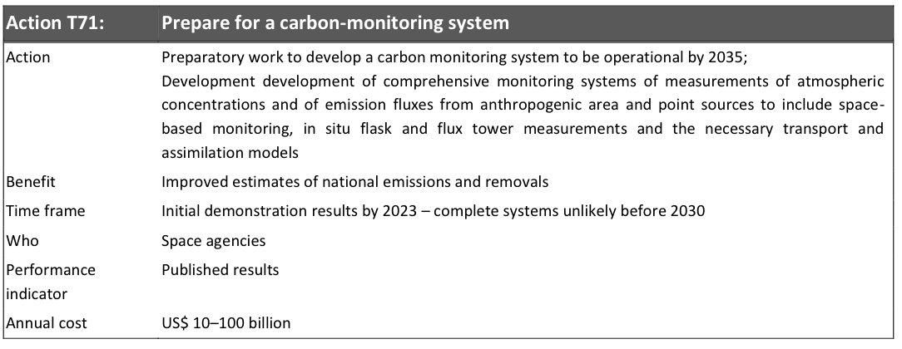
Mark referenced the conclusions from COP-23/SBSTA-47 and called out conclusion #12, which took tremendous support from the Japanese and EU delegations to ensure this accurately represented the capabilities of the space agencies.
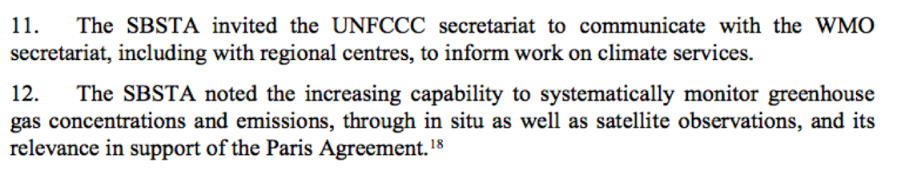
Mark provided an overview of the core elements of the monitoring capacity.
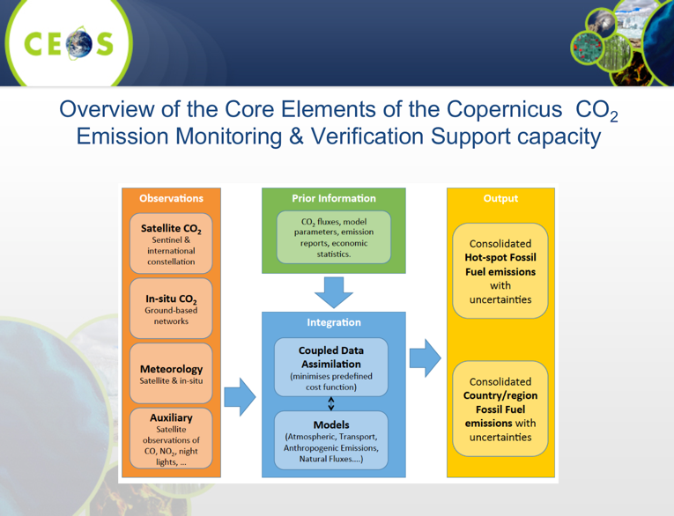
He reviewed the objectives of the June CEOS Chair GHG Workshop and provided an overview of the agenda and topics:
- bringing together these different stakeholders to define best practices and synergies
- exploring possibilities for common approaches to some of the system development
This will require the strong engagement of CGMS as well as CEOS Associate members such as the WMO.
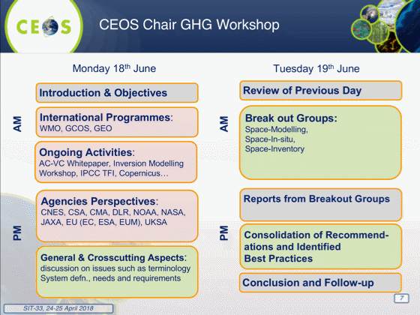
David Crisp (NASA) provided an overview of the GHG White Paper.
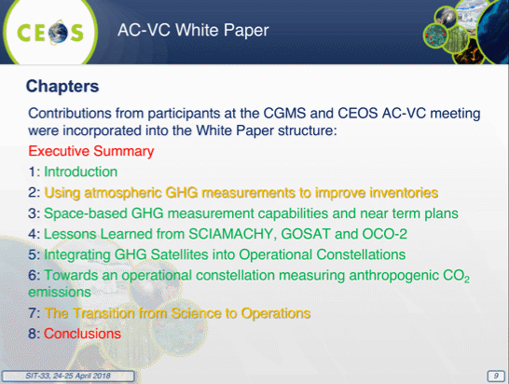
David noted that Chapter 2 was added to provide information on how these data streams can be applied to national inventory activities. He reviewed the GHG mission timeline, and highlighted plans for two future GHG monitoring constellations (Copernicus Sentinel CO₂ (2025+), and a TanSat-2 Constellation).
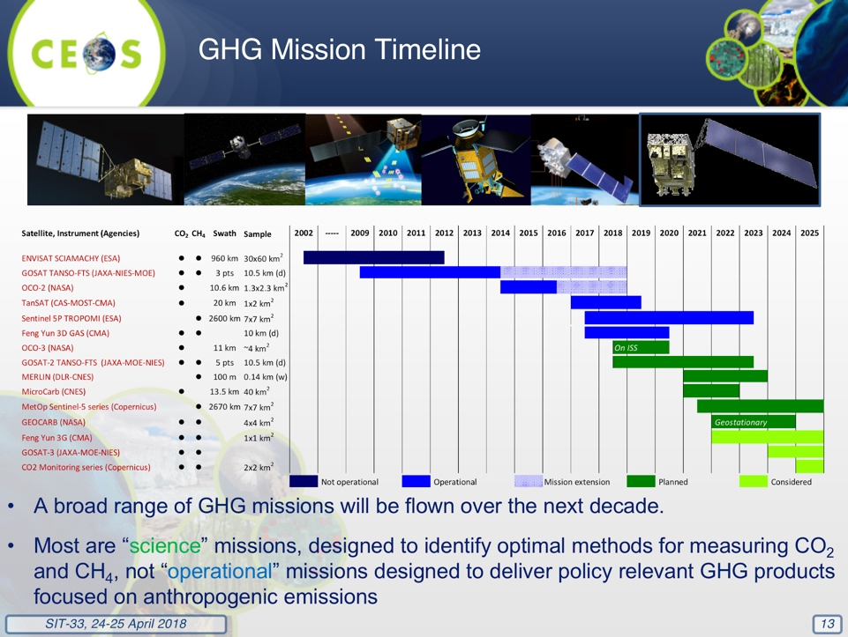
He noted that the CO₂ and CH₄ measurement requirements in the 2011 update for the Global Climate Observing System (GCOS) Systematic Observation Requirements for Satellite-Based Data Products for Climate (GCOS, 2011) and GCOS 2016 Implementation Plan (GCOS, 2016) were adopted as targets for a future GHG constellation. David reviewed a Candidate GHG Constellation Architecture, which could achieve the coverage, resolution, and precision requirements.
- A constellation of 3 (or more) satellites in LEO with:
- A broad (> 200) km swath with a mean footprint size < 4 km²
- A single sounding random error near 0.5 ppm, and vanishing small regional scale bias (< 0.1 ppm) over > 80% of the sunlit hemisphere
- One (or more) satellites carrying ancillary sensors (CO, NO2, CO2 and/or CH4 Lidar)
- A constellation with 3 (or more) GEO satellites:
- Monitor diurnally varying processes (e.g., rush hours, diurnal variations in the biosphere)
- Stationed over Europe/Africa, North/South America, and East Asia
This constellation could be augmented with one or more HEO satellites to monitor carbon cycle changes in the high arctic.
David highlighted a number of issues that will need to be addressed to merge the science-based efforts of the current set of GHG missions with operations. Because of the unprecedented requirements for precision and accuracy, the space-based elements of an operational GHG constellation architecture must be accompanied by rigorous pre-launch and on-orbit measurement calibration and product validation methods that evolve to meet emerging needs, and continuous refinements in remote sensing retrieval and flux inversion modelling methods that improve the products over time. CEOS could play an essential role in coordinating these activities among its partner agencies. Any operational architecture will also have to address orbit and mission coordination, data distribution, data exchange, and data format requirements, as well as training and capacity building and public outreach will be needed to fully exploit the value of the space based GHG measurements. CEOS should collaborate with CGMS and other operational organizations to foster the development of these capabilities. Timely inputs to policy makers are required, with capacity needed by the mid-2020’s.
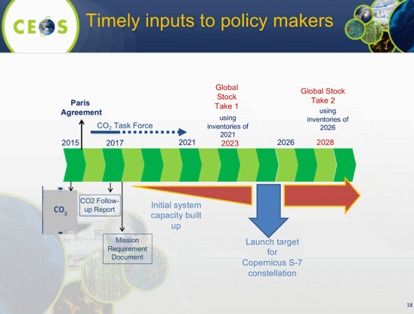
Mark reviewed four CEOS CGMS Coordination on GHG monitoring options, and the pros and cons of options 3 and 4 were reviewed, and the timeline and outline of an options paper presented.
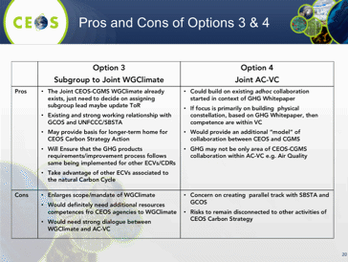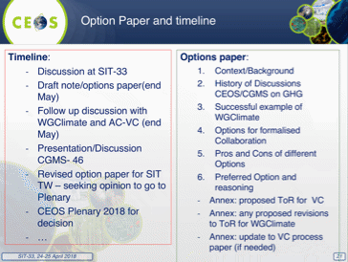
SIT-33-12 | Mark Dowell | To draft a paper exploring options for CEOS and CGMS coordination of GHG observation planning. | SIT TW 2018
 | Rationale: The paper seeks to progress this open question on GHG coordination structures.
Mark reviewed the GEO Carbon (GEO-C) Initiative, and the key outcomes of 1st GEO-C Steering Committee Meeting.
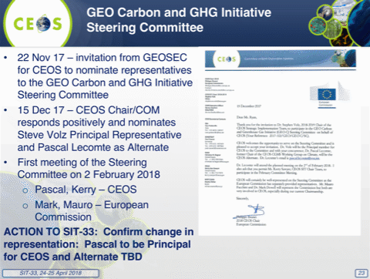
SITTWS-2017-05: Complete.
SITTWS-2017-08: In progress. Change due date to end of May
SITTWS-2017-17: In progress. Change due date to SIT 2018 Technical Workshop and reword to state that the AC-VC will produce a recommended strategy on unmet Air Quality measurement goals.
SITTWS-2017-18: In progress. Change due date to SIT 2018 Technical Workshop
A discussion followed.
- Steve asked when the draft of the AC-VC will be available, and David noted that they are close to having an end-to-end draft circulating amongst the writing team. The conclusions and recommendations have not yet been drafted, but the hope is to have the complete draft by the end of May. The ‘transition to operations’ chapter will require inputs to reflect experience across the community. The draft will be available before CGMS.
- Osamu Ochiai (JAXA) noted that the cut-off for the IPCC Inventories process is 25 June, and David noted that it is unlikely to be able to be published by then, but a near-final draft should be available.
Steve noted that Pascal Lecomte (ESA) has been nominated as the principal representative to the GEO-C Steering Committed for CEOS, and this was confirmed. Kerry Sawyer (SIT Chair Team, NOAA) noted that an alternate would be nice to have.
Decision 4 | Pascal Lecomte (ESA) identified as the new CEOS representative to the GEO Carbon Steering Committee.

SIT-33-13 | SIT Chair | Invite nominations for an alternate CEOS representative to the GEO Carbon Steering Committee - in support of Pascal Lecomte (ESA) as the CEOS Principal representative. | May 2018
 | Rationale: An alternate representative is proposed to guarantee coverage of meetings etc.

GCOS Update
Stephen Briggs (GCOS) provided an update on the Global Climate Observing System (GCOS) status and plans, noting that the new GCOS Implementation Plan aims to improve monitoring of Global Climate Cycles.
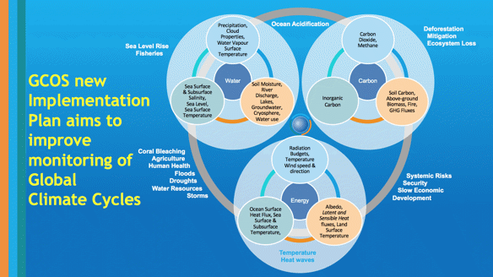
- The Paris agreement implies a need for significant improvement of observations in many areas, including on adaptation and risk.
- GCOS is developing a document with UNFCCC on where GCOS-supported observations can assist UNFCCC SEC; a bottom up approach to where contributions can be made would be helpful.
- Climate aspects are relevant for around 12-13 of the SDGs.
- GCOS is creating an updated strategy and principles document for its sponsors for discussion at WMO Executive Council in June.
- The GCOS schedule for the coming years was shown:
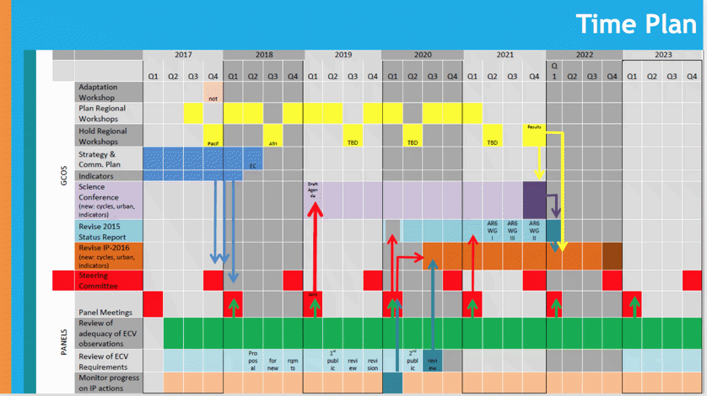
John Remedios (UKSA) asked about analysis of the linkage between the SDG goals and EO, and Stephen Briggs replied that at the top level you could probably say that all the goals are supported by EO, but a more detailed analysis is possible at the target and indicator level.
GEO/LEO Combined Products
Dan Lindsey (NOAA) outlined the SIT Chair priority related to enhancing the utility of new observations from the next generation of geostationary satellites and exploring development of GEO/LEO combination products and data processing capabilities. This topic was a nominated theme for the CSIRO CEOS Chairmanship in 2016 – culminating in a report presented to the CEOS Plenary in Brisbane. CGMS Working Group II reinforced the importance of GEO/LEO integration, and three Pilot Projects were proposed at the 2017 CGMS Plenary: Aerosol/Dust Observations; Fire Observations; and Flood Observations.
Dan demonstrated some existing product efforts underway in the USA in these application areas. He noted that NOAA and CMA are planning a flooding product pilot project. This project represents a nice opportunity to fulfil goals of both CGMS and CEOS SIT Chair.
CEOS Analysis-Ready Data for Land (CARD4L) provides geophysical quantities such as surface reflectance, temperature, or backscatter amplitude facilitating the use of observations from multiple platforms and sensors. Some LEO products are planned for development within the LSI-VC, and matching GEO products could be added as well. GEO products must be made available in the Analysis Ready Data (ARD) format to facilitate inter-comparisons and integrated product development - we could consider starting with Surface Reflectance and Land Surface Temperature.
SIT Chair Team proposes that CEOS should follow up on several years of effort on Land Surface Imaging using data from both GEO and LEO. This might:
- select a case study and bring in multiple datasets from multiple platforms (Landsat, Sentinel, GOES, Himawari, JPSS, etc.)
- coordinate across appropriate CEOS Virtual Constellations and Working Groups
- coordinate with users/customers
- make both LEO and GEO data available over a single location in the same format (ARD)
Dan reviewed GEO/LEO recommendations for CEOS-SIT:
- CEOS should follow up on several years of effort on Land Surface Imaging using data from both GEO and LEO.
- Coordinate with CGMS on development of combined GEO/LEO products for Fire, Flood, and Aerosol Monitoring.
Jörg Schulz (EUMETSAT) offered to make contact with Jan-Peter Muller (UCL), leader of the land section of the EU QA4ECV project that has developed a GEO/LEO combined time series of surface albedo.
SIT-33-14 | NOAA and CSIRO | Develop a proposal with appropriate CEOS entities for a GEO-LEO application case study using CARD4L and multiple datasets. | SIT TW 2018
 | Rationale: SIT Chair has challenged CEOS to identify productive avenues of collaboration to build on the GEO-LEO initiative started in 2016 by CSIRO and JAXA.
SIT-33-15 | SIT Chair | Identify CEOS Agency participants for the GEO-LEO flood mapping inter-comparison studies with CGMS. | June 2018
 | Rationale: CGMS has proposed to take forward a number of pilot activities from the CEOS GEO-LEO report and interested CEOS agencies are sought.
International Financial Institutions and Overseas Development Aid Action Item Closure
Ivan Petiteville (ESA) presented on behalf of Stephen Coulson (ESA), noting that this item originated as an ESA SIT Chair Team Theme priority, and recognized some recent trends.
- EO and SDGs growing in importance and visibility (e.g., one of 3 GEO top priorities, UNISpace+50 high-level event June 2018 …);
- New Partners/Operators (e.g., Digital Globe, Planet, Gates Foundation, Radiant Earth ….) turning more attention to philanthropic initiatives for societal benefits/challenges;
- Key IFIs (WB, ADB, IFAD) starting internal developments to promote the use of geospatial information in development operations; and,
- National Aid Agencies and OECD all showing increased interest in using EO-based environmental information in support of Development Aid financed activities.
Ivan noted that the last CEOS Plenary (Oct 2017) endorsed a one-page statement of the CEOS commitment to support the expanded use of EO in Development, highlighting the role and benefits that EO can deliver. Plenary also requested a supporting document (10-12 pages) consisting of key summary information (based on the White Paper, 3-4 pages) to substantiate the Statement, followed by examples (8-10 pages) that illustrate the benefits and use of EO drawn from across the CEOS agencies. He reviewed the proposed way forward for discussion.
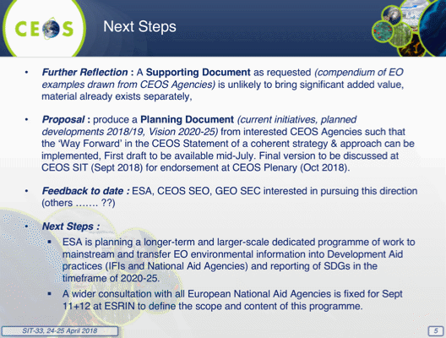
SITTWS-2017-23: Complete. Decision to let ESA and interested agencies pursue separately from CEOS.
CEOS-31-03: Complete. Decision to let ESA and interested agencies pursue separately from CEOS.
A brief discussion followed.
- Mike Freilich (NASA) noted that efforts to accomplish consensus on a CEOS-wide approach with respect to International Finance Institutions (IFIs) have been slow, while at the same time, some CEOS agencies have developed their individual approaches. He suggested that this means a CEOS-wide approach is not supported and suggested putting the matter aside.
- Steve Volz agreed, noting that without a common strategic objective and vision, it is difficult to continue without sustained input from CEOS Agencies.
- Paul Counet (EUMETSAT) noted that they have not engaged because they are focused largely on their efforts in Africa, which are quite intensive and focus on, amongst other things, building trust with their partners.
- Ivan Petiteville proposed that at future CEOS meetings, an opportunity be provided for agencies to present on their activities. Steve confirmed these items should be included in future CEOS meeting agendas.
- Barbara Ryan (GEO Secretariat Director) noted that there may be a marketing opportunity in the agency representatives placed in Development Banks (e.g., ESA at the World Bank and ADB) to advocate more broadly on behalf of other agencies by highlighting CEOS contributions and capabilities that can support their activities.
GEO Update
Barbara presented:
- GEO remains focused on its engagement priorities of the 2030 Agenda for Sustainable Development (SDGs), the Paris Climate Agreement, and the Sendai Framework on disasters.
- UNCCD has reached out to GEO Community for Land Degradation Neutrality (LDN) assistance; GPSDD partners join CEOS & GEO on African Regional Data Cube.
- UNFCCC endorses greater participation from GEO at COP-23; GEO has established a Steering Committee for GEO Carbon to bridge current partners and programs for more holistic approach.
- UNISDR facilitates greater involvement for GEO, including Global Forum on Science & Technology (Japan and JICA) Risk Modelling Workshop (GSNL & NASA); GEO Secretariat Director was invited to join Advisory Committee for next Global Assessment Report (GAR).
- On GEOGLAM, a Stocktaking Report was submitted to G20 and presentation made to the G20 Deputy Ministers of Agriculture to show progress and strengthen support.
- A number of regional GEOSS events are scheduled for 2018.
- Commercial sector engagement is increasing in GEO.
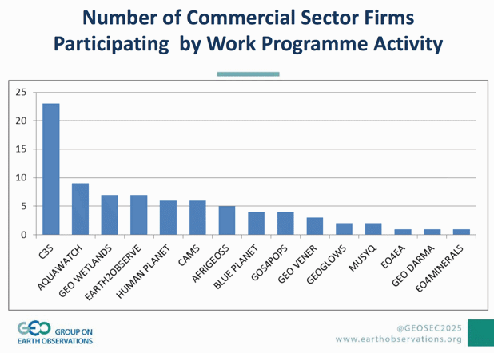
- The GEOSS platform continues to grow; WMO WIS is the biggest user of the GEOSS platform.
- The GEO Data Providers Workshop is next week in Frascati.
- The GEO Symposium will take place 11-12 June 2018, Geneva, Switzerland, and GEO-XV Plenary will take place Oct 29-Nov 2, 2018 in Kyoto, Japan.
Support to GEO
Steve referred to an update on CEOS support to GEO, which is available on the SIT-33 meeting website (here). Kerry noted that CEOS Agencies should consider nominating a representative to the GEO Programme Board Subgroup on Sustainable Observations.
Potential CEOS-CGMS Collaboration
Werner Balogh (WMO) provided an overview of the architecture for climate observations from space, noting that a logical view was developed several years ago, and proposing the next step would be to build a physical view based on that logical view. A concept paper has been provided to SIT-33 as information. It is based on the CEOS Virtual Constellation concept and suggests that CGMS considers the development of further Constellations in addition to those operated by CEOS. The paper is out for comment and will be discussed at the upcoming CGMS-46 and WMO Executive Council 70 meetings in June.
Jörg Schulz noted the emphasis on Pillars 1 and 2 of the architecture, and that the paper is more relevant to CGMS, which has not yet identified Virtual Constellations of the variety that CEOS coordinates. WGClimate noted that the work with VCs and WGs in CEOS and CMS on the implementation of the actions from the coordinated action plan is just starting and that it would be more appropriate to consider the need for new groups at a stage where no actionees could be found in the existing coordination structure. He added that SCOPE-CM was not referenced in the paper and WGClimate saw this an oversight. Kerry asked if there would be updates to the paper and Werner noted that no significant update to the paper is planned prior to CGMS.
CEOS-CGMS WGClimate is monitoring this proposal, and will ensure that any structures proposed do not duplicate or expand bodies prematurely, without thoughtful consideration of existing mechanisms.
Discussion
- Mark hoped to progress discussion on the GHG Coordination at SIT TW and CEOS Plenary based on an options paper also to be discussed at coming CGMS.
- Steve noted that NOAA will bring the proposal for the way forward between CEOS and CGMS on the GEO-LEO activity to the CGMS meeting also.
- Per the SIT-33 action, SIT Chair and CEOS Chair will look at the organizational structure and look for the efficiencies and structural improvements discussed during the meeting. Mark recalled the comments of Mike Freilich and encouraged consideration of the resources needed and being applied to be part of that study. This could be supported by a request to the CEOS groups as to resourcing information.
- Jonathon Ross (GA) noted the expanded GFOI Data Component may mean the CEOS Lead for GFOI is an appropriate nominee for the GEO Programme Board Subgroup on Sustainable Observations. He also noted that he would be willing to do it for CEOS if no other nominees step forward but he would be performing the duties dual-hatted as he is already the identify Australia representative.
SIT-33-16 | SIT Chair | Report CEOS update on GEO-LEO activities and proposals to the CGMS Plenary in Bangalore and explore a coordinated way ahead with CGMS. | June 2018
 | Rationale: Both CEOS and CGMS have identified interests around the GEO-LEO activity.

10. CEOS Plenary
Plenary Business Items
Mauro Facchini (CEOS Chair, COM) reviewed the items for Plenary discussion and endorsement.
Endorsement of WGCapD Terms of Reference: no comments or objections were raised, and so these Terms of Reference (ToR) are endorsed.
Endorsement of Joint CEOS-CGMS WGClimate Terms of Reference: Jörg mentioned that he was informed by Kerry Sawyer that the ToR were not endorsed when the group was formed in 2013, and the ToR being endorsed today are materially unchanged from that time. No comments or objections were raised, and so these Terms of Reference are endorsed.
WGClimate Gap Analysis and Action Plan: the complete version is now available but not completed in time for a review by CEOS entities so will be circulated by the CEO for virtual endorsement via the established virtual endorsement process. A ten-day review period will be allowed.
Planning for CEOS Plenary
Steve Volz (SIT Chair, NOAA) reviewed the decisions that need to be brought to Plenary, as follows:
- review the operating principles and practices of VCs and WGs, to improve consistency, efficiency, etc.
- improvements to the annual CEOS Work Plan update process
- the way forward for CEOS and CGMS coordination on GHG observations; Mark Dowell (CEOS Chair Team, COM) suggested readiness of this topic will depend on the CGMS and SIT TW discussions; the options paper should be ready in May
- we may be asked to make a decision on CEOS engagement on the SCO
Mauro would prefer that the Plenary focus on decisions rather than discussion, which should take place at the SIT TW. He would also like to allow time for agencies to speak about their activities. Astrid Koch (CEOS Chair Team, COM) suggested that if opportunities to streamline ad hoc activities are identified, these may be topics for decision at Plenary.
Kerry Sawyer (SIT Chair Team, NOAA) asked about the WMO Concept Paper and whether Plenary may be asked to endorse the proposal for a joint Virtual Constellation. Werner Balogh (WMO) stated that the Concept Paper will be presented to CGMS and again to WGClimate and based on comments received, an updated paper will be prepared before CEOS Plenary.
NIER (The National Institute of Environmental Research) of Korea has expressed interest in applying for full CEOS Members. Alex Held (CSIRO) noted past efforts to contact agencies asking them to re-engage and suggested we might do this again, including with INPE, Chinese Agencies, and ISRO. Jonathon Ross (GA) suggested some targeted calls would help.
SIT-33-17 | CEO | Manage a virtual endorsement of the WGClimate ECV Inventory Gap Analysis Report and Coordinated Action Plan. | May 2018
 | Rationale: WGClimate documents arrived too late for endorsement at the SIT-33 meeting.

Decision 5 | Updated WGCapD Terms of Reference were endorsed in a Plenary Session
Decision 6 | The Joint CEOS-CGMS WGClimate Terms of Reference were endorsed in a Plenary Session

11. Review of Main Points and Closing
CEOS Leadership Status/Issues
Steven Hosford (CEO, ESA/CNES) presented. All CEOS leadership positions are covered for the coming two years (except WGCV as described below) with nominations now required for the following periods:
- CEOS Chair nominations for 2021.
- SIT Vice Chair for 2020-2021.
- WGs WGCapD, WGClimate, WGDisasters, WGISS: Vice-Chair from 2020;
- WGCV Vice-Chair from 2019 (at least one candidate has been identified, decision at WGCV-44 in August).
VCs no issues with currently identified VC leadership.
Mike Freilich (NASA) suggested noting agency names first for WGs (followed by the names of individuals), and individual names first for the VCs (followed by their agency) to more accurately present the nature and scope of the participation and commitments of CEOS agencies versus individuals. There was no discussion on whether this was a widely held perspective.
Jonathon Ross (GA) raised the issue of the CEO role continuity. Steven’s CEO term ends in 2019. Mike suggested that CEOS could form a recruiting committee. While this has not been previously done in CEOS, it is something that could be considered.
Steve Volz (SIT Chair, NOAA) noted that we should include the AHT leadership in role summary, and Mike noted that the AHTs are by definition, temporary, with one-year terms and are endorsed at Plenary with the leadership in place. Kerry Sawyer (SIT Chair Team, NOAA) noted that per CEOS Governance and Processes document, AHT lifetimes are defined when the team is created at Plenary and therefore could be a multi-year activity. However, each AHT is reviewed annually at Plenary to determine if AHT will continue, transition, or be terminated. Steve noted the intention would be to understand current CEOS resource allocation.
SIT-33-18 | CEOS Chair | Manage a recruitment committee-type process to secure the next CEO (from 2019). | CEOS Plenary 2018
 | Rationale: No volunteers identified as yet for the next cycle of CEO.
Purpose and Objectives of the Big Data Workshop
Martin Ditter (CEOS Chair Team, COM) presented, noting that the Workshop aims to share experience and best practices among CEOS Agency on their interactions with the increasingly influential and powerful actors from the digital economy. This includes the major players in the data economy such as Google, Amazon and Microsoft who are downloading and making available huge quantities of EO data. The workshop will aim to address questions such as:
- How are such these initiatives integrated into the overall service offering of CEOS agencies?
- Are they effective in serving our user communities and facilitating development of value-added services?
- What benefit can be drawn in the domain of user uptake?
- What ARD products and features are needed in this context?
- How do we maintain and develop links to current and future user communities?
Review of SIT-33 Actions
Steve reviewed the draft action table.
Akiko Suzuki (JAXA) noted that the 50th CEOS Newsletter will soon be released.
SIT Chair Closing Remarks
Steve closed the meeting, thanking participants for sharing their activities and thoughts. He noted that the 2018 SIT Technical Workshop will take place September 11-14, 2018, hosted by EUMETSAT in Darmstadt, Germany.
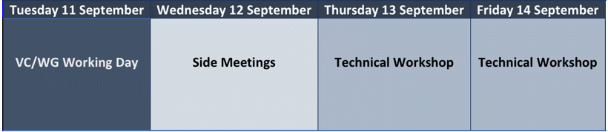

List of Participants
Organization | Participant | Organization | Participant
ASI | Simona Zoffoli | NASA | Brad Doorn
CNES | Juliette Lambin | NASA | David Jarrett
CNES | Selma Cherchali | NASA | Jay Al-Saadi
European Commission | Mauro Facchini | NASA | Eric Lindstrom
European Commission | Astrid-Christina Koch | NASA | Brian Tisdale
European Commission | Mark Dowell | NASA | Nancy Searby
European Commission | Michael Berger | NASA | David Green
European Commission | Martin Ditter | NASA | Argyro Kavvada
CONAE | Laura Frulla | NASA | Yonsook Enloe
CSA | Marie-Josée Bourassa | NASA | David Borges
CSA | Paul Briand | NASA | Georgina Crepps
CSIRO | Alex Held | NASA | Jeffrey Masek*
CSIRO | Flora Kerblat | NASA | Lauren Childs-Gleason
DLR | Klaus Schmidt | NASA/CEOS SEO | Brian Killough
DLR | Gunter Schreier | NOAA | Steve Volz
ESA | Ivan Petiteville | NOAA | Kerry Sawyer
ESA | Nicolaus Hanowski | NOAA | Chuck Wooldridge
ESA | Mirko Albani | NOAA | Ken Casey
ESA/CNES/CEO | Steven Hosford | NOAA | Dan Lindsey
EUMETSAT | Paul Counet | NOAA | Kevin Gallo*
EUMETSAT | Robert Husband | NOAA | Albert DeGarmo
EUMETSAT | Jörg Schulz | NOAA | Jeff Privette
EUMETSAT | Ewa Kwiatkowska* | NOAA | Stephen Ward
GA | Trevor Dhu | NOAA | George Dyke
GA | Jonathon Ross | NSC | Per-Erik Skrovseth
GCOS | Stephen Briggs | SANSA | Asanda Ntisana
GEO Secretariat | Barbara Ryan | SANSA | Andiswa Mlisa
GEOGLAM | Alyssa Whitcraft | SANSA | Paida Mangara
JAXA | Teruyuki (Terry) Nakajima | UKSA/NCEO | John Remedios
JAXA | Akiko Suzuki | UKSA | Chris McQuire
JAXA | Osamu Ochiai | UNOOSA | Lorant Czaran*
JAXA/RESTEC | Koji Akiyama | USGS | Jennifer Lacey
JPL | Graeme Stephens | USGS | Steve Labahn
NAS | Arthur Charo | USGS | Tim Stryker
NASA | Mike Freilich | USGS | Eric Wood
NASA | Christine Bognar | USGS | John Dwyer
NASA | Lawrence Friedl | VNSC | Pham Anh Tuan
NASA | Steven Neeck* | VNSC | Sean Lam
NASA | David Crisp | WMO | Werner Balogh
NASA | Kurtis Thome | US Dept of State | Fernando Echavarria
NASA | Matthew Koeppe
* - joined via GoToMeeting
*

Record of Actions and Decisions from CEOS SIT-33
No. | Actionee | Action | Due date
SIT-33-01 | SIT Chair | Assess whether the CEOS Governance and Processes Document should be updated. Report to SIT Technical Workshop including (if required) a recommendation to be presented for decision at CEOS Plenary. | CEOS Plenary 2018
 | Rationale: The document is now five years old, and we should consider if we need updates to CEOS structure, operations, and processes in order to address the evolving goals of the organization.
SIT-33-02 | SDG AHT | Explore a CEOS expression of interest for participation in the GEO Land Degradation Neutrality (LDN) activity and provide language to the LDN Initiative Team Leads that can be included in the Initiative proposal expressing CEOS Agency interest and support. | May 2018
 | Rationale: CEOS has been asked to commit to the GEO LDN activity. SIT recognized that LDN is the first time a UN institution reached out to GEO for assistance on the SDGs.
SIT-33-03 | WGDisasters and VNSC | WGDisasters, VNSC, SEO, and CSIRO to discuss how to align the activities with the CEOS Data Cube efforts (led by the CEOS SEO) in preparation for a potential expansion of the first GEO-DARMA flood pilot to include the Lower Mekong. | SIT TW 2018
 | Rationale: Explore potential overlaps and synergies between the WGClimate GEO-DARMA SERVIR Mekong Pilot, and VNSC’s Vietnam Data Cube.
SIT-33-04 | WGClimate and VNSC | Confer on the CEOS delegation to COP-24 and the process for ensuring a national delegate from Vietnam can introduce CEOS material. | June 2018
 | Rationale: UNFCCC COP is one of the first roles for incoming CEOS Chairs and WGClimate will work with VNSC to manage expectations and ensure solid arrangements.
SIT-33-05 | SIT Chair | Provide an analysis of possible measures to: improve consistency in processes across CEOS entities; identify whether further tangible contributions to the CEOS Work Plan are possible; ensure sustainment of resources across the groups. | SIT TW 2018 VC/WG Day
 | Rationale: SIT Chair has challenged CEOS to identify whether top-down contributions to the CEOS WP are required and possible in addition to the bottom-up population of the WP.
SIT-33-06 | CEOS Chair | Write to the Landsat Advisory Group of the National Geospatial Advisory Committee advocating for continuity for the free and open data policy for Landsat data. | May 2018
 | Rationale: Many CEOS coordination activities are predicated on the continued free and open availability of EO data. Consistent with CEOS support to GEO’s GEOSS Data Sharing Principles.
SIT-33-07 | WGClimate | Serve as Point of Contact for CEOS and keep track of the Space Climate Observatory (SCO) progress. Report to CEOS SEC monthly telecons, and provide updates at SIT TW and CEOS Plenary. | Through to 2018 Plenary
 | Rationale: CNES has asked for CEOS engagement in SCO.
SIT-33-08 | OCR-VC and LSI-VC | Review the CEOS Feasibility Study on Satellite Missions/Instruments Focused on Water Quality Measurements and report to SIT TW on any implications for their work, including opportunities to address the recommendations that may be on the horizon. | SIT TW 2018
 | Rationale: Measurements identified in the study are of direct relevance to OCR-VC and LSI-VC data coordination.
SIT-33-09 | SIT Vice Chair | Consult with the community to reschedule the Freshwater from Space Workshop in the late November/early December 2018 period. Feedback is invited on the provisional Freshwater from Space Workshop agenda published on the SIT-33 website. | SEC-237
 | Rationale: Stakeholder availability has dictated re-scheduling of the workshop.
SIT-33-10 | SIT Chair | Draft a response to the GFOI letter on CEOS/SDCG support to Phase 2 of GFOI. | May 2018
 | Rationale: CEOS Lead for GFOI has initiated an exchange of information to update the expectations between CEOS and GFOI as GFOI moves into a new Phase.
SIT-33-11 | SIT Chair | Include CEOS Ad hoc Team lifecycle and processes as an agenda item on 2018 SIT Technical Workshop. | SIT TW 2018
 | Rationale: SIT Chair has proposed that CEOS address inconsistencies in the operation of different types of groups across the structure.
SIT-33-12 | Mark Dowell | To draft a paper exploring options for CEOS and CGMS coordination of GHG observation planning. | SIT TW 2018
 | Rationale: The paper seeks to progress this open question on GHG coordination structures.
SIT-33-13 | SIT Chair | Invite nominations for an alternate CEOS representative to the GEO Carbon Steering Committee - in support of Pascal Lecomte (ESA) as the CEOS Principal representative. | May 2018
 | Rationale: An alternate representative is required to guarantee coverage of meetings etc.
SIT-33-14 | NOAA and CSIRO | Develop a proposal with appropriate CEOS entities for a GEO-LEO application case study using CARD4L and multiple datasets. | SIT TW 2018
 | Rationale: SIT Chair has challenged CEOS to identify productive avenues of collaboration to build on the GEO-LEO initiative started in 2016 by CSIRO and JAXA.
SIT-33-15 | SIT Chair | Identify CEOS Agency participants for the GEO-LEO flood mapping inter-comparison studies with CGMS. | June 2018
 | Rationale: CGMS has proposed to take forward a number of pilot activities from the CEOS GEO-LEO report and interested CEOS agencies are sought.
SIT-33-16 | SIT Chair | Report CEOS update on GEO-LEO activities and proposals to the CGMS Plenary in Bangalore and explore a coordinated way ahead with CGMS. | June 2018
 | Rationale: Both CEOS and CGMS have identified interests around the GEO-LEO activity.
SIT-33-17 | CEO | Manage a virtual endorsement of the WGClimate ECV Inventory Gap Analysis Report and Coordinated Action Plan. | May 2018
 | Rationale: WGClimate documents arrived too late for endorsement at the SIT-33 meeting.
SIT-33-18 | CEOS Chair | Manage a recruitment committee-type process to secure the next CEO (from 2019). | CEOS Plenary 2018
 | Rationale: No volunteers identified as yet for the next cycle of CEO.

Decision 1 | SIT endorsed the initiation of the CEOS Volcano Demonstrator.
Decision 2 | SIT endorsed the initiation of the CEOS Seismic Hazard Demonstrator.
Decision 3 | SIT endorsed the initiation of the first GEO-DARMA pilot (SERVIR Mekong) focused on developing a collaborative tool for flood monitoring in Myanmar.
Decision 4 | Pascal Lecomte (ESA) identified as the new CEOS representative to the GEO Carbon Steering Committee.
Decision 5 | Updated WGCapD Terms of Reference were endorsed in a Plenary Session
Decision 6 | The Joint CEOS-CGMS WGClimate Terms of Reference were endorsed in a Plenary Session

