MINUTES OF THE SECOND CEOS
LSI-VC / SDCG / GEOGLAM JOINT MEETING

6-7 September 2018
Ispra, Italy

Key Outcomes

- There are key overlaps between SDCG, GEOGLAM, and LSI-VC on CARD4L pilots and establishing links to user communities (for feedback, promotion, etc.). These will be priority areas for collaboration.

- CEOS Work Plan objective/deliverable VC-31 (Evaluate CARD4L among target user communities) will be modified to add two specific dot points for joint pilot activities and continuation of the CARD4L survey.

- Merging SDCG and CEOS-GEOGLAM into LSI-VC was agreed as the most sensible solution to the issue of continuity of these CEOS ad hoc teams.

- It was agreed to take the proposed solution from (3) forward to SIT Technical Workshop and CEOS Plenary, with the goal of reaching a conclusion in 2019. The ad hoc teams will need to be extended for one further year in this scenario.

Thursday September 6th

Session 1: Welcome, Introductions, Agency Reports

Welcome and Introductions

Ivan Kulis (EC/JRC) welcomed everyone and encouraged us to embrace the opportunity of this joint face to face meeting for collaboration and innovation.
Brad Doorn (NASA) welcomed everyone and introduced his new co-Lead of the CEOS-GEOGLAM AHWG Philippe Maisongrande (CNES), who is replacing Selma Cherchali (CNES) in the role.
Frank Martin Seifert (ESA) also introduced himself and noted that Joanne Nightingale (UKSA) the other co-Lead of SDCG had to return home today and is unable to attend this meeting. Osamu Ochiai (JAXA, CEOS representative to GFOI) is also unable to attend due to a conflicting GEO meeting. Frank Martin noted the past achievements of the SDCG, including increased coverage for forest monitoring, dual polarisation SAR acquisitions for Sentinel-1, etc. SDCG is now focused on its contribution to GFOI Phase 2, which places emphasis on support to end users.
Jenn Lacey (USGS, LSI-VC co-Lead) praised the first joint meeting, noting that it was very useful for the LSI-VC team. The joint meetings are also a good opportunity to prepare for the SIT Technical Workshop next week. Jenn noted that this will be her last LSI-VC meeting as a co-Lead, as she is stepping down from the role, replaced by Steve Labahn (USGS). Adam Lewis (GA, LSI-VC co-Lead) noted the excellent progress that has been made on the CARD4L specifications, and the great opportunity for thematic community feedback afforded by having close engagement with the SDCG for GFOI and CEOS-GEOGLAM teams.

Overall CEOS Context for the Joint Meetings and LSI/SDCG/GEOGLAM Work
Steven Hosford (ESA/CNES, CEO) presented:
- Some background on the 2018 CEOS Chair’s priorities, Working Group leadership changes, upcoming CEOS meetings, etc.
- The CEOS Future Data Architectures AHT is expected to be disbanded at the 2018 CEOS Plenary. Responsibilities for the FDA-AHT tasks from the CEOS Work Plan will be delegated to various groups throughout CEOS.
- CEOS Work Plan progress updates are due by the end of September. For the new CEOS Work Plan, task descriptions will be requested by December 14. The release of the 2019-21 Work Plan is targeted for the 22nd of February. Steven added that tasks for next year will be expected to have explicit links to the GEO Work Programme.
- Some history of the LSI-VC (from 2007/08). He noted that LSI-VC received its first thematic requests in 2008/09, after which the thematic groups of SDCG and GEOGLAM were eventually spun off. CEOS has now come full circle, with the discussions around perhaps incorporating these thematic groups into LSI-VC. Stephen Ward recalled that LSI-VC was inactive at the time of the SDCG spin off, but LSI-VC was always seen as the logical home for these thematic groups.
- The ceos-deliverables.org database and its CEOS Work Plan analysis/search capabilities were noted.

Agency Updates

USGS
Jenn Lacey (USGS) presented:
- An overview of Landsat-7 and 8 operations and status. Landsat-7 is planned to last until the end of 2020, after which it will be replaced by Landsat-9. There is still the possibility of a Landsat-7 refueling mission by NASA.
- An overview of Landsat-9. She noted that the mission will use the same MOC as Landsat-8, and the great opportunity of flying both missions with the same equipment at the same time.
- The Sustainable Land Imaging (SLI) activity being progressed with NASA, which will execute a study for the design and implementation approach of a spaceborne system to provide global, continuous, Landsat-quality multispectral and thermal infrared measurements for approximately a ten-year period starting in 2026.
Steve Labahn (USGS) presented an overview of the Landsat ground network and also the effort to recover all historical archive data through the Landsat Global Archive Consolidation (LGAC) activity. He also noted that Landsat Collection 1 is now complete, and further processing is limited to Landsat-7 and 8 forward processing, as well as new LGAC data. Collection 2 product details were also presented. USGS are looking at doing all Collection processing in the cloud in the future.

JAXA
Takeo Tadono (JAXA) presented:
- An overview of JAXA’s EO programme. He showed the updated schedule for the data reprocessing and opening of the ALOS and ALOS-2 archives:
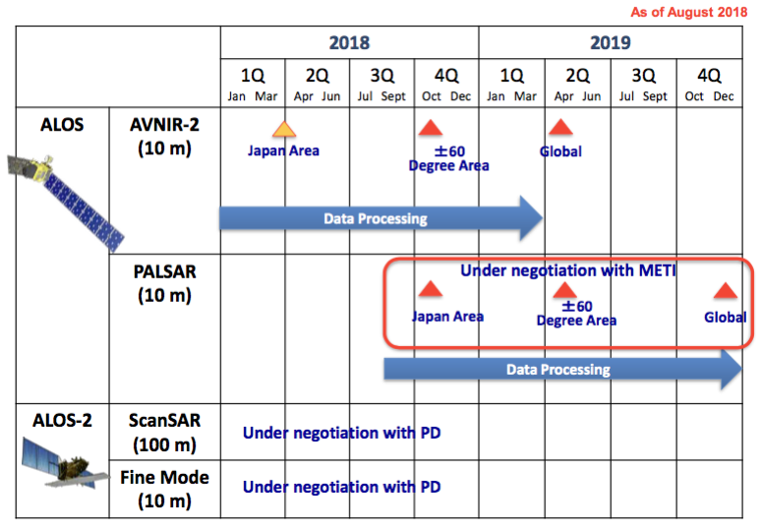
- Takeo also spoke about ALOS-3 (optical) and ALOS-4 (SAR) showing the specifications and objectives. He noted that efforts are being made to ensure that forestry is one of the priority applications for ALOS-4.
- IGARSS 2019 will be held in Yokohama, Japan, and a CARD4L session is being planned.

Geoscience Australia
Medhavy Thankappan (GA) presented:
- A number of GA’s activities, including Digital Earth Australia and Terria-Cube.
- GA/DEA’s approach to the validation of ARD products, which is focused on quantifying uncertainty. There is a team at GA dedicated to ARD production, and they are undertaking a continental-scale validation of surface reflectance products.
- The plan for operational processing of Sentinel-1 SAR ARD in Australia through a DEA InSAR project.
- Assessment of GA’s ARD products against the CARD4L specifications is expected in the near future. GA will contribute their self-assessments to the LSI-VC’s effort to define the assessment process.
- An ARD session is planned for the ESA Living Planet Symposium, 13-17 May 2019 in Milan. Fifteen abstracts are needed for a viable session. A similar session is planned for IGARSS 2019 a few months later.
Brian Killough (NASA, SEO) asked whether GA is using a proprietary surface reflectance product for Australia, or the one from USGS. Medhavy confirmed that they are using a GA product for the uncertainty analyses. A key question for GA is which products should be used (self-generated or provider agency-generated). Brian requested the results of the comparison of the USGS and GA surface reflectance products.
JM-01 | Medhavy Thankappan to share the results of the comparison of the USGS and GA surface reflectance products with Brian Killough. | ASAP

NASA
Jeff Masek (NASA) presented:
- A NISAR update, noting that its CDR is in October 2018, with launch planned for late 2021. He showed the acquisition plan, and reported that products will be distributed free and open. The standard products are yet to be defined, and this could be a good opportunity to have a SAR CARD4L product generated from the outset of the mission. Bruce Chapman (NASA/JPL) is on the CARD4L SAR Definition Team.
- A Landsat-9 status report. Landsat-9 is on target for a December 2020 launch. The OLI-2 instrument is undergoing Integration and Test (I&T) at Ball, and TIRS-2 is being integrated at GSFC. The spacecraft is under development at NGIS, and a successful CDR was held in February 2018. The ground system is being developed by USGS, and its CDR is to be held in September 2018.
Dave Jarrett (NASA) presented (slides 11-18) on NASA’s Earth Science 2017 Decadal Survey Planning:
- The Decadal Survey recommended four new items: Earth Venture Continuity, Designated Observables, Earth System Explorers, and an Incubation Program. The Designated Observables are considered foundational elements of the next decade’s observations, and cover aerosols; clouds, convection, and precipitation; mass change; surface biology and geology; and surface deformation and change.

Session 2: CEOS Analysis Ready Data for Land (CARD4L)

Overall CARD4L Status Report
Andreia Siqueira (GA) reported the background and motivation of CARD4L. She reviewed the planned process for assessing a dataset as CARD4L, including the connection to WGCV. WGCV have defined their role, as presented during LSI-VC-6 by Kurt Thome (NASA, WGCV Chair):
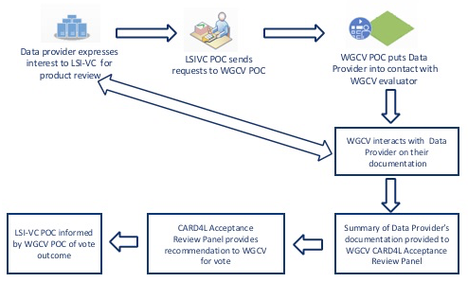
Andreia also presented the proposed timeline for the annual revision of the CARD4L PFS:
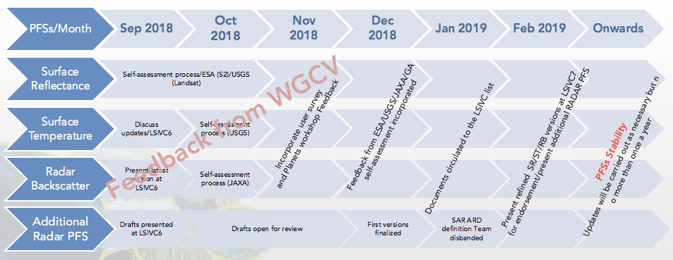
Yves Crevier (CSA) asked why Planet was seemingly prioritised in the feedback process. Adam clarified that this is not the case, it’s just that they convened the recent ARD workshop which brought together many commercial players, and this is expected to be an ongoing forum.

Broader CEOS ARD Strategy
Stephen Ward reported:
- The SIT Vice Chair (CSIRO/GA) has flagged the development of a broad CEOS ARD strategy as a flagship theme for their leadership term. The following are the objectives for a broader CEOS ARD strategy:
  - to ensure continued relevance of public EO programme data and information, leveraging the availability of all relevant CEOS agency missions to meet user needs for information;
  - to meet the changing expectations of the user base, which is increasingly non-technical and more accustomed to simplicity in geospatial data sourcing, integration and application;
  - to establish a broad understanding of, and participation in, CEOS efforts to define, produce, and apply ARD in support of societal needs;
  - to ensure effective engagement of the three key stakeholder groups: EO data providers (both public and private); Big Data hosts and aggregators who stage increasing amounts of CEOS agency free and open data; and data users;
  - to manage expectations of all stakeholders as to the status and outlook for ARD availability – so that all might plan and invest with confidence in capabilities to best exploit the CEOS agency ARD;
  - to establish priorities for which products and applications might follow on from the current CARD4L PFS;
  - to ensure appropriate organisational responsibilities across the CEOS structure for the definition and execution of the way forward on ARD.
- A number of activities foreseen in a comprehensive and successful strategy on ARD for CEOS:
  - Thematic product families – of which CARD4L is the first;
  - ARD stocktake and outlook (for user investment confidence);
  - Technical specification development and maintenance;
  - Pilots and feedback;
  - Promotion.
- A broad strategy is beyond the scope of LSI-VC alone. The SIT Vice Chair undertakes to further develop the discussion paper as a channel for community consultation.
JM-02 | All to provide feedback on the draft CARD4L information notes.  Justification: these notes will form the basis of the CARD4L communication package. A thorough review is needed before they are released online and distributed to identified targets. | September 27

Status of Engagement with CEOS and non-CEOS Data Providers
ARD Stocktake
Matt Steventon (LSI-VC Sec) presented the ARD stocktake. He requested permission to start publishing some limited CARD4L rows on the CEOS ARD website.
It was agreed that we need to avoid issues around publishing other providers’ datasets as ARD, and so we should restrict the information published publically to CARD4L, as this is the domain we have control over.
Steve Labahn (USGS) and Adam Lewis (GA) agreed to work with Matt to get some information online regarding ‘in progress’ CARD4L datasets – to initiate the register. The entries will be ARD datasets that are expected to be branded as CARD4L once the assessment process is finalised, and they will be identified as such.
JM-03 | Matt to work with USGS and GA to start adding some early CARD4L product information to the CEOS ARD website (a subset of the ARD stocktake information). These datasets will be clearly marked as being ‘in progress’ towards acceptance as CARD4L. | ASAP
Satellite Data Interoperability Workshop
Steven Hosford (ESA/CNES, CEO) presented an overview of the recent Satellite Data Interoperability Workshop organised by Planet and Radiant.Earth. He noted the following key takeaways:
- There is substantial interest and energy being put into simple, interoperable satellite data by the private and non-profit sectors. They have different motivations, but there is broad interest.
- There is the potential for cal/val and data quality collaboration with a bootstrapping approach. Space agencies should work to ensure the private sector benefits from their forty years of cal/val experience.
- Need to ensure the relevance of cal/val and ARD approaches for the small/nano satellite community (e.g., RadCalNet, ACIX, etc.) and investigate exercises between institutional and private constellation operators.
- A growing commercial land surface imaging sector is good for space agencies.
- ARD is a game changer for the application of large-scale machine learning approaches to satellite imagery.
Jeff Masek (NASA) also attended. He agreed with Steven’s point regarding there being a lot of enthusiasm around using government systems for the cal/val of new commercial systems. Jeff also noted the emphasis on the cloud processing environment and ARD ‘recipes’ for the generation of products. Steven added that it is clear the community is looking to understand the current extent of ‘recipes’ out there, and this is something CEOS might want to consider contributing toward.
Adam Lewis (GA) asked about our main messages back to the rest of CEOS and the Principals. Steven suggested some messages that need to go to Principals (e.g., the cal/val aspects) should be floated with WGCV first.

Landsat – Sentinel-2 Harmonisation Progress
NASA Harmonized Landsat Sentinel-2 (HLS)
Jeff Masek (NASA) presented an overview of NASA’s Harmonized Landsat Sentinel-2 (HLS) activity.
Brian Killough (NASA, SEO) asked whether the HLS product is available via an AWS S3 bucket, and Jeff confirmed that it is. Brian suggested the Tanzania Data Cube would be a good test case.
JM-04 | Brian to follow up with Jeff regarding AWS-hosted HLS data for the Tanzania Data Cube. | ASAP
Adam Lewis asked whether having the raw data used for the HLS process in an ARD format would accelerate or ease the HLS process. Jeff confirmed that geodetic accuracy increases would certainly help, as the HLS process currently starts earlier in the processing chain than desired due to these accuracy inadequacies. Jeff confirmed that the same processing chain is used for both Sentinel-2 and Landsat, with slight variations due to band differences.
ESA-USGS Bilateral
Steve Labahn (USGS) spoke about the increased collaboration between ESA and USGS in the domain of ARD and harmonisation. Several working group meetings have been held covering topics such as:
- The parallel CARD4L self-assessments underway on Landsat and Sentinel-2 products, and comparing the two ARD specifications being defined by the two agencies.
- Terminology/Definitions – including ARD, Interoperability, harmonized products.
- The interoperability and harmonisation of Landsat and Sentinel-2 ARD products, and steps that can be taken to ease their combination.
- ESA DEM procurement. USGS have flagged the possibility of contributing to gap-filling a global DEM if it is an improvement over what they are using today.
- USGS adoption of the Sentinel-2 GRI into the next Landsat collection. The GRI is needed soon, otherwise this could hold up Collection 2 processing.
- Various algorithm and methodology comparisons (e.g., atmospheric correction strategies, pixel reference orientation, geometric issues, etc.)
ESA Sen2Like
Steven Hosford (ESA/CNES) presented:
- The goal of the Sen2Like project is to provide Sentinel-2 like surface reflectances with daily periodicity, by using data from both Landsat-8 and Sentinel-2.
- Steven showed the Sen2Like approach. Harmonisation includes: consistent atmospheric correction, geometric resampling, spectral adjustments, and BRDF adjustments:
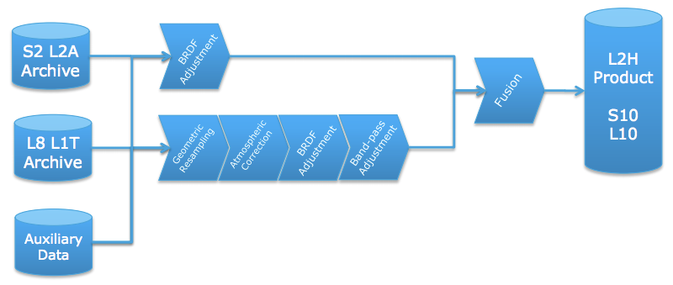
- Products will be generated and distributed using cloud infrastructure (e.g., DIAS) and the processor will be made freely available via the Sentinel Application Platform (SNAP).
- Sen2Like remains very high-level at the moment, and further work is underway. More details and progress are expected to be available around October.
- Expansion to include Sentinel-3 is planned in the future.

CARD4L Survey
Matt Steventon (LSI-VC Sec) reported the results from the CARD4L survey and presented the following conclusion and questions/discussion points:
- We plan to continue the survey, however is it more effective to wait and survey users once they have sample products?
- The survey has dual purpose, both feedback and promotion.
- LSI-VC has agreed that new groups should be targeted (e.g., commercial sector)
- How could we improving the survey completion rate?
Ake Rosenqvist (JAXA) suggested tailoring questions to the interest of the respondents (e.g., by using branching paths) as a possible way to increase the survey completion rate.

CEOS/Open Data Cube Pilots
Brian Killough (NASA, SEO) presented an update on the various Data Cube activities. He provided the following thoughts on ARD from this perspective:
- ARD is no longer a desire of global users, but is now becoming a requirement and an expectation.
- The Data Cube pilots are an ideal way to prove the benefits of ARD, as every pilot is using ARD. Most global users (not scientists or commercial groups) do not desire, or feel comfortable, making their own ARD, but want it provided.
- There is a growing interest in radar data, but few users understand its benefits or know how to use this data. Data Cube pilots are a great place to demonstrate open source radar algorithms on ARD. Having ALOS data in the Data Cube has been a great example of the power of SAR ARD.
- CEOS needs to make it easier for global users to get ARD. Landsat is easiest. ALOS is a bit harder, but JAXA has been providing great support to generate mosaics over any location. Sentinel-1 is even harder, as few users (outside Europe) understand the choices in the Sentinel-1 Toolbox and lack algorithms. The hardest is Sentinel-2, as few users (outside Europe) understand how to apply the Sen2Cor algorithm for pre-processing and do not have application algorithms in-hand.
Michael Bock (DLR) asked how Data Cubes are kept up to date with new data. Brian noted that this is a manual process at the moment, however he would like to see this be automated in future, however this requires a stable and up-to-date source of ARD that can be accessed readily and quickly.
Michael also asked about the interoperability of data in the Data Cube. Brian noted that the goal has been to avoid reprocessing data, as this is computationally intensive. Instead, native data sets are Cubed, and these are then reprojected etc. in the analysis phase.
Brian reported that approaches for connecting multiple Data Cubes together still need to be considered.
Brian closed by noting that Open Data Cube is not going to be the only solution for the analysis of EO data, however it is one approach to engaging new and non-traditional users into the EO community. It also provides an open source alternative to the likes of Google Earth Engine, with an increased number of datasets.

Discussion
Adam Lewis (GA) welcomed the SDCG and GEOGLAM communities to provide further feedback on CARD4L.
Brian Killough (NASA, SEO) expressed his concern that he is unsure whether CEOS Agency Principals are aware of the potential of CARD4L and ready and willing to step up to fund production, etc. Adam doesn’t think it will be difficult to achieve a high-level agreement on the importance of ARD, but thinks we need to increase efforts to rally agencies’ ARD efforts around CARD4L.
It was noted that there are commitments from an agency level to produce ARD, evidenced by the USGS and ESA efforts, however a broader base of participating agencies is desirable. Michael Berger (EC/ESA) noted that lower level ARD is more agreeable on the European side; higher level ARD can cause issues.
Brad Doorn (NASA) noted that NASA is generally on board with the concept of ARD also. He suggested that pressure from external user groups will be the most effective means for encouraging agencies to commit to the concept and start producing CARD4L systematically. Identifying proactive users that can play this role and also provide word-of-mouth promotion to other user groups should be a priority.
Ake Rosenqvist (JAXA) noted that new missions, particularly those that don’t yet have a fully-defined ground segment, are a great opportunity to get CARD4L adopted as a standard product. He noted the upcoming NovaSAR mission, for which CSIRO has made a commitment to produce a CARD4L compliant product as one of its standard offerings. NISAR is another good opportunity, among many others. Jenn Lacey (USGS) noted that CARD4L-SR will be a standard product for Landsat-9.
Steve Labahn (USGS) suggested that there is a lot more traction than might be apparent. He is aware of CEOS agencies that are producing ARD, but which are not represented in LSI-VC.

Session 3: CEOS Information Tools

Current Capabilities and Planned/Underway Developments
Brian presented an overview of COVE, including the main functionality which includes coverage analysis and archive data browsing. He reviewed some of the status and future plans including improvements to security and enhanced operating performance. Links to archive databases are a constant issue, as things change on the data provider side, and this takes time and effort to resolve.
They are planning to add a custom mission capability to support future mission concept studies, coverage and revisit performance calculation capabilities, cloud cover overlays derived from Landsat historical metadata (13 in total, 1 raw average, 12 monthly average files), and coincident calculations for both future predictions and historical archive data.
Shaun Deacon (SEO) confirmed that the current annual usage for COVE is approximately 5000 users, and this number has remained pretty consistent. It appears that a number of the core user base are revisit users, and further analytics are planned.
George presented a summary of recent developments in the CEOS Database (MIM), focusing on the development of a beta version of an API. The objective of the API is enabling machine-to-machine access to the Database, and enabling the content to be leveraged by external developers. Initial testing is being done with the CEOS SEO (on gap analysis), and the objective is to open the API for test users by the end of 2018.
The first task that the API is being built for is to support gap analysis, and this capability could be packaged as an ‘LSI Toolkit’ which could include a targeted set of Python notebooks that support the basic functions of land cover gap analysis (could be extended to other domains, but the first focus could be LSI). The concept of including ‘data products’ in the Database has also been considered, and CARD4L products could be a useful first set to be included.
Jenn Lacey (USGS) welcomed the suggestions related to gap analyses, noting it is within the mandate of LSI-VC, but nothing has been done yet. Adam Lewis (GA) suggested targeting LSI-VC-7 for a revisit of the gap analysis and LSI Toolkit idea. In the big picture, the idea behind this proposal would be to add another potential work stream for LSI-VC (noting the cancellation of the LSI-VC carbon requirements work stream).
JM-05 | SEO and LSI-VC SEC to provide a CEOS Information Systems update as input to scoping a potential ‘LSI Toolkit’ supporting gap analyses. | LSI-VC-7

Session 4: GEOGLAM Update on Requirements

Holistic GEOGLAM Satellite Data Requirements & Application Ready Data (ARD+)
Alyssa Whitcraft (GEOGLAM) presented the background of the GEOGLAM requirements, which have been in development since 2012, and are currently undergoing a reboot process. The survey portion of the requirements gathering effort asked users about ARD and the best forms for their specific target applications. NDVI time series are clearly the leading product used by the agriculture community, closely followed by ‘raw or pre-processed satellite data’. This NDVI time series could be called “Application Ready Data” (ARD+), as it is a step beyond ARD and fits the space data user agricultural monitoring community’s needs well.
There is also a push for ‘Essential Agricultural Variables’, which include parameters such as crop mask, crop type map/planted area, yield estimation (end of season), yield forecast, etc.
There is good potential for collaboration between LSI-VC and GEOGLAM on ARD, ARD+, and EAVs (task force within GEOGLAM established; concept still under development).
Regarding observation requirements, Alyssa noted the ideal scenario for agricultural monitoring:
- Daily global 10m VIS + Red Edge + SWIR (+ cloud screening bands) and 10-20m C-band SAR dual polarisation every 2-4 days (for cloudy areas/times);
- Increased SAR coverage over very cloudy areas during peak of growing seasons;
- 30-100m thermal observations every 1-3 days.
She presented some options to achieve (by 2035) a historical time series of 7-10 day global cloud-free observations (see slides 16-18).
Select points in summary:
- There is a need for common definitions (e.g., interoperability, ARD).
- SAR is a huge area of interest for agricultural users.
- Huge demand across the board for dense, high resolution optical time series. To realise this, interoperability in the moderate resolution domain is critical.
- There is a need for some level of ‘guarantee’ of long-term observation availability of EO products.
- Implementation of the ‘GEOGLAM Cloud Infrastructure’ requires federated systems and datasets. Data feeding into these systems must be analysis-ready (machine learning practically requires it).
- As compute capacity (and ability to process in real-time) increases, data timeliness is key for continuous agricultural monitoring. ARD+ in this context requires low latency (including acquisition, orthorectification, atmospheric correction, product generation, and delivery).

Discussion
Zoltan Szantoi (EC/JRC) pointed out the Sentinel cloud-free global mosaics offered by the Copernicus Global Land Service as a potentially useful agriculture product. Users can select a time period, area of interest, etc. and then generate a product on the fly.
JM-06 | Zolti to communicate the CARD4L concept to the Copernicus Global Land Service.  Justification: the cloud-free global mosaics could potentially be assessed as CARD4L products. | COMPLETE
Jenn Lacey (USGS) noted that data latency is being investigated on the Landsat side. She said that having latency requirements for specific applications would be helpful in justifying USGS efforts in this direction. Alyssa and Jenn have initiated some offline discussions about this and will work together to help articulate this justification.
Jeff Masek (NASA) asked if MODIS-level measurements would still be relevant as we move toward daily moderate resolution coverage. Alyssa reported that latency is the driving factor – should moderate resolution products be available with the necessary latency and coverage (alongside the computational capacity to utilize it, and intercomparability with historic observations from at least MODIS, if not AVHRR and SPOT-Veg), then this would make the low resolution products marginal. For example, Defourny’s proposed future “coarse resolution observatory” (~100m) proposes that the moderate resolution observatory’s (~10m) imagery be resampled on board to ~100m to create the historical time series of weekly global cloud-free observation:
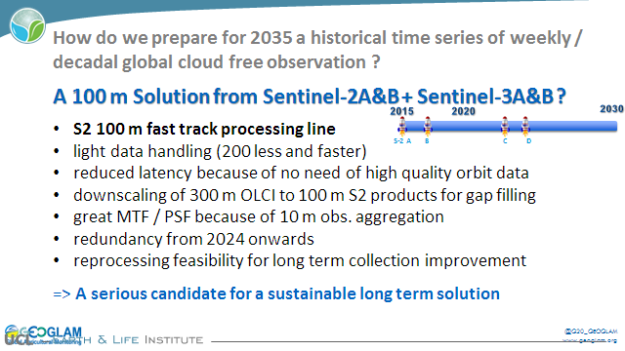
Michael Berger (EC/ESA) asked about the distinction between ARD, ARD+, and EAVs. Alyssa noted that ARD is the foundation (e.g., surface reflectance), ARD+ is “applications ready data” – a product built from ARD that fits a specific application (e.g., NDVI time series, per the survey), and that EAVs would further utilize that ARD+ for creating baseline products routinely used for agricultural monitoring. The systematic generation of both ARD+ and EAVs would serve a substantial community of agricultural monitoring users, with applications intersecting with national monitoring mandates as well as global policy drivers (G20, SDGs, Disasters, and Climate Change). A first cut from GEOGLAM on EAVs was briefly displayed by Ian Jarvis (GEOGLAM Secretariat Director), although further iteration is required within GEOGLAM:
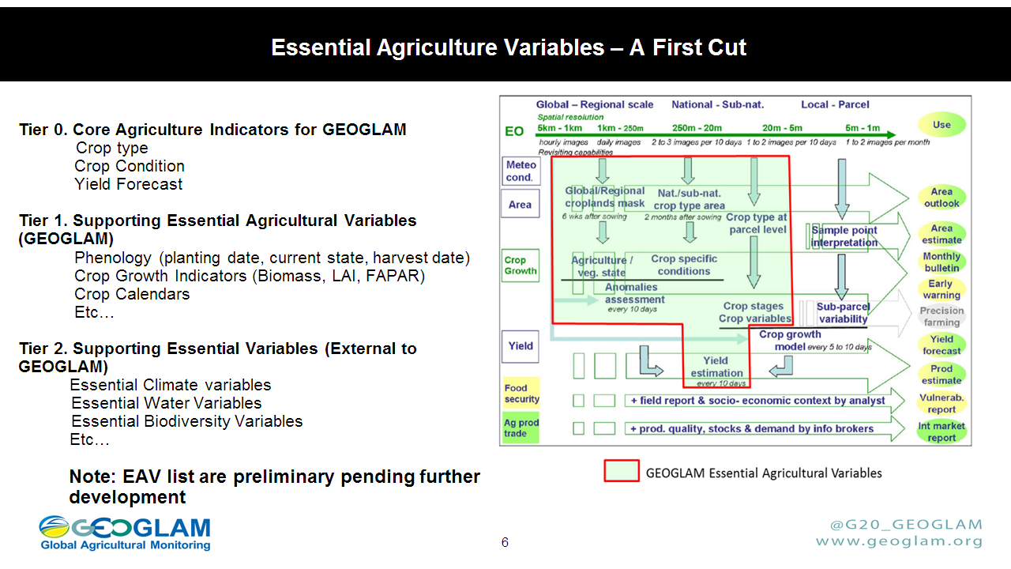

Session 5: Future Work Plans & Closing

ESA Agency Report
Susanne Mecklenburg (ESA) presented the ESA agency report, covering: Sentinel-2/3 mission status, in particular the tandem phase of Sentinel-3A and 3B (a close formation flight of the two units, which is driven by the GCOS satellite climate monitoring principles); the FLEX mission; and Copernicus DEM, data download statistics, evolution, and Data and Information Access Services (DIAS – a cloud platform offering data and analysis capabilities).
Susanne noted that ESA asked the DIAS contractors to establish a Data Cube generator/builder on their platforms. Results and updates are expected in October.
Susanne reported on ESA’s current and future sources of ARD:
Current: Sentinel-2 Surface Reflectance, Sentinel-3 Land Surface Temperature, Synergy products, GlobTemperature, Proba-V Surface Reflectance.
Future: Sentinel-1 SAR, Sentinel-2/Landsat ARD prototype products (Level-3 HS2L8), Sentinel-2/Sentinel-3 ARD prototype products (Level-3 HS2S3).
Susanne also summarised ESA’s contributions on ARD:
- Pilot CARD4L assessments show that ESA Sentinel-2/3 products are ‘quasi’ compliant with CARD4L.
- DOI is planned for product type (e.g., LST) and in future, also algorithms (e.g., LST retrieval).
- The ARD/CARD4L Stocktake.
- Lead on defining the process for CARD4L product alignment assessments with WGCV.
- Prototype land products being developed.
- An ESA study to develop and consolidate SAR ARD demonstrators and definitions.
- ARD on Demand (see slides 31-32)
- DIAS Data Cube instantiation service.
- ITT for Copernicus global DEM (will close on 18 September 2018).

Brief Review of Individual Work Plans for 2019-21

LSI-VC
Matt Steventon (LSI-VC Sec) presented the expected LSI-VC tasks in the 2019-21 CEOS Work Plan.
There was a discussion around reporting to Plenary, during which it was noted that Virtual Constellations do not report directly to Plenary, but ad hoc teams do. Steven Hosford (ESA/CNES, CEO) suggested that the LSI-VC Leads be engaged in the process of the Plenary agenda development to try and ensure the necessary exposure to CEOS Plenary and leadership.

SDCG-GFOI
Stephen Ward (SDCG Sec) reported:
- GFOI is now entering Phase 2, during which more emphasis is being put on end users. For SDCG, helping countries make use of data is the priority.
- The CEOS Space Data Strategy for GFOI will be maintained.
- SDCG is pursuing a biomass focus, and SDCG plans to engage people from new biomass mission teams.
- Additionally, SDCG is supporting the GFOI Early Warning activity, after pushing for its establishment.
- There are plenty of potential overlaps with LSI-VC and its CARD4L work around pilots and engagement with the user community (e.g., for feedback)
Frank Martin Seifert (ESA, SDCG Co-Chair) noted that a revamp of the GFOI R&D Component is planned.
Adam Lewis (GA) noted the need for consistent strategic communications around CARD4L/ARD. Stephen suggested this should be captured by the CEOS ARD Strategy.

CEOS-GEOGLAM
- Alyssa Whitcraft (GEOGLAM) presented a brief summary of the CEOS-GEOGLAM 2018-20 Work Plan tasks, which cover: the strategic response to the GEOGLAM requirements, ARD+, and the EAVs.
Discussion
Brian Killough (NASA) presented on the ongoing challenge of how ad hoc teams should evolve and graduate within the CEOS structure. These groups are supporting GEO Flagships, so their work is clearly important. There may be efficiencies to be realised in coordination and secretariat functions as well. Brian presented the following proposal:
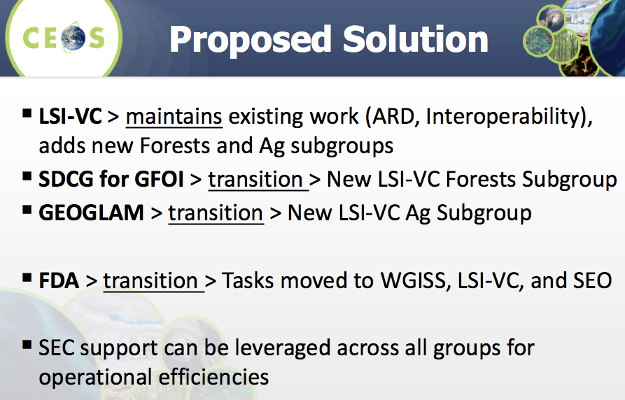
This proposal allows the groups to continue as-is, but also allows CEOS to move ahead with the ongoing discussions around the evolution of these ad hoc teams.
The topical groups would continue to have their own meetings as they currently do, including this joint meeting. The Forest and Agriculture sub-groups could report out on their support to GEO’s Flagships during a GEO session of CEOS Plenary.
There are discussions between Brian/SEO and Frank Martin Seifert/ESA around support for a secretariat for the group, which is required to keep the group moving forward and support the identification of synergies between, and coordination across, the groups.
Regarding the disbanding of the CEOS FDA-AHT, Steve Labahn (USGS) noted that the Leads will propose primary ownership of FDA tasks within WGISS, though there will be tasks in the LSI-VC group and others.
Brad Doorn (NASA) thinks Brian’s proposal is logical, but there is a need to discuss the details, which may take more time than we have available here. The key for GEOGLAM is having the connection with the space agencies. He asked if there is a reason that we need to get a decision at this Plenary, and Stephen Ward noted that we are trying to be proactive in providing a solution to CEOS leadership. Jenn Lacey (USGS) added that the CEOS SIT Chair has put this on the agenda for SIT Technical Workshop as they would like to get it resolved. She also stressed that we should make it clear that organisation should not get in the way of the work being done.
Brian suggested that the solution could also be presented with a plan for the agriculture group to join later, if this helps organisationally. Jenn would like to have a discussion around how this might proceed.
Steven Hosford (ESA/CNES, CEO) noted that the proposal is likely what the SIT Chair is seeking at this stage, and implementation need not be rushed.
Brad suggested that the response could be more thorough and extensible to address other activities (e.g., biodiversity, polar), and time could be taken to develop broader options.
Frank Martin will raise this issue within SDCG.
Jenn would like to see more opportunity for LSI-VC reporting at CEOS leadership level. Stephen Ward thinks this is what the SIT Chair would like to achieve with the organisational clean up. Adam Lewis (GA) noted that this lack of visibility and reporting is a broader problem.

Friday September 7th
Discussion continued…
In summary, there are three options for SDCG and CEOS-GEOGLAM going forward: AHTs continue as per usual, establish a new WG or VC, merge into LSI-VC.
Merging into LSI-VC was agreed as the most sensible solution.
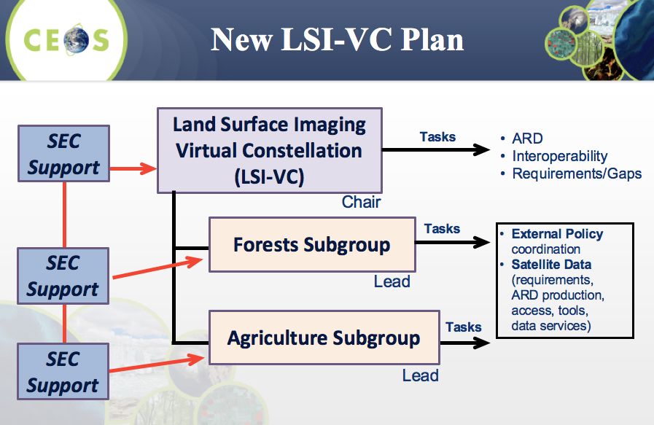
No increases would be expected with regards to funding, etc. as nothing new is being established. Mark Dowell (COM, CEOS Chair Team) noted that the LSI-VC Terms of Reference would need to be updated accordingly. It is also unclear whether the ‘Virtual Constellation’ umbrella/term would still be relevant with this integration.
It was agreed to take the proposed solution forward to SIT Technical Workshop and CEOS Plenary, with the goal of reaching a conclusion in 2019. The AHTs will need to be extended in this scenario.
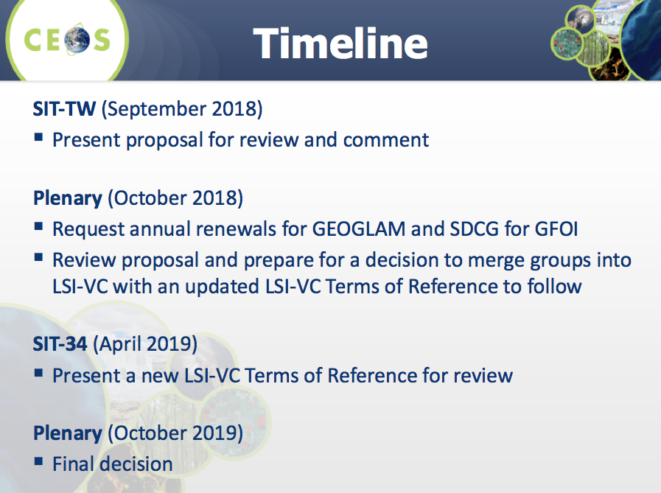
Mark suggested flagging additional benefits to CEOS, which could be useful for securing support. It was suggested that this new structure could provide further/increased support for GEO Flagships.

Closing

The LSI-VC, SDCG, and CEOS-GEOGLAM Leads thanked everyone for attending and closed the meeting.

APPENDIX A
Attendees
Organisation | Name
CNES | Philippe Maisongrande
CSA | Paul Briand
DLR | Michael Bock
EC/JRC | Ivan Kulis
EC/JRC | Zoltan Szantoi
ESA | Espen Volden
ESA | Frank Martin Seifert
ESA | Michael Berger
ESA | Susanne Mecklenburg
ESA/CNES | Steven Hosford
ESA | Stephen Ward
ESA | Matt Steventon
GA | Adam Lewis
GA | Andreia Siqueira
GA | Medhavy Thankappan
GEOGLAM | Alyssa Whitcraft
GEOGLAM | Ian Jarvis
JAXA | Takeo Tadono
JAXA | Ake Rosenqvist
NASA | Brad Doorn
NASA | Dave Jarrett
NASA | Jeff Masek
NASA/SEO | Brian Killough
NASA/SEO | George Dyke
NASA/SEO | Sanjay Gowda
NASA/SEO | Shaun Deacon
NASA/SEO | Syed Rizvi
USGS | Jenn Lacey
USGS | Steve Labahn

APPENDIX B
Actions Record

JM-01 | Medhavy Thankappan to share the results of the comparison of the USGS and GA surface reflectance products with Brian Killough. | ASAP
JM-02 | All to provide feedback on the draft CARD4L information notes.  Justification: these notes will form the basis of the CARD4L communication package. A thorough review is needed before they are released online and distributed to identified targets. | September 28
JM-03 | Matt to work with USGS and GA to start adding some early CARD4L product information to the CEOS ARD website (a subset of the ARD stocktake information). These datasets will be clearly marked as being ‘in progress’ towards acceptance as CARD4L. | ASAP
JM-04 | Brian to follow up with Jeff regarding AWS-hosted HLS data for the Tanzania Data Cube. | ASAP
JM-05 | SEO and LSI-VC SEC to provide a CEOS Information Systems update as input to scoping a potential ‘LSI Toolkit’ supporting gap analyses. | LSI-VC-7
JM-06 | Zolti to communicate the CARD4L concept to the Copernicus Global Land Service.  Justification: the cloud-free global mosaics could potentially be assessed as CARD4L products. | COMPLETE

