MINUTES OF THE
5th MEETING OF THE CEOS
LAND SURFACE IMAGING VIRTUAL CONSTELLATION (LSI-VC)

21-23 February 2018
Tokyo, Japan

Key Outcomes

- Progressed the CEOS Analysis-Ready Data for Land (CARD4L) assessment process, and agreed actions to establish a SAR subgroup to finalise the backscatter Product Family Specification (PFS) and investigate new SAR PFS. Agreed to engage WGCV in the assessment process.
- Agreed that annual updates of the CARD4L PFS are not necessary, however the documents will be updated as needed; stability of the PFS is preferred.
- The European ARD stocktake was well received, and actions were agreed to broaden this assessment.
- Actions agreed to proceed with a CEOS ARD Strategy and Notes to appeal to data users, providers, and hosts.
- The carbon requirements task will be discontinued in favour of focusing on progressing CEOS tools and information systems in support of gap analyses.
- Identified a way forward for the Moderate Resolution Interoperability (MRI) initiative, and identified three specific tasks to take forward and include in the 2018-2020 CEOS Work Plan.
- Actions agreed regarding GFOI and GEOGLAM input on the utility of CARD4L products, as a pathfinder for further feedback gathering.

Wednesday February 21st
Session 1:​ Opening
Welcome
Takeo Tadono welcomed everyone to Japan and the RESTEC office.
Jenn Lacey welcomed everyone to the meeting, and noted that this is a good time to take stock of the work we’ve done, and where we’re going next. Jenn welcomed Susanne Mecklenburg to her first LSI-VC meeting as a Lead. Susanne thanked Jenn and reported that she is looking forward to her first meeting as a Lead. Andreia Siqueira spoke on behalf of Adam Lewis/GA, noting that she is looking forward to the meeting. Jonathon Ross is here to represent the SIT Vice Chair Team, which has identified LSI-VC support as one of its priorities.
A tour de table followed. A record of the meeting attendance is attached in Appendix A.
LSI-VC CEOS Work Plan Tasks/Deliverables and LSI-VC Implementation Plan
Jenn reviewed the LSI-VC Mission Statement:
The Land Surface Imaging Virtual Constellation exists to maximize the value derived from CEOS Agency land surface imaging assets and activities by providing an overarching coordination role;
and noted that we are now at the 3-year horizon of the original LSI-VC ToR (2015). Jenn reviewed each of the work areas:
Space Segment
Jenn suggested that we might need to revisit the first point under ‘aggregating and analysing multiple sets of data’. Dave Jarrett noted that this will become very important for post Landsat 9 studies. Ake Rosenqvist noted the potential of systematic acquisition plans for SAR missions from agencies including CONAE, CSA, and UKSA – this could be a very helpful contribution. Jonathon noted that new missions from Copernicus and JAXA would benefit from such gap/capability analysis work. Dave noted the online survey for Copernicus requirements assessment.
Susanne asked what harmonizing acquisition plans means in practice. Jenn noted that this is open for debate, but this is mostly applicable to SAR given the current state of medium resolution optical acquisitions. With that said it would still be useful to assess what might be needed in the future – for communication to agencies as inputs for their acquisition planning processes. We had success in the past with Sentinel-2 (Bianca was able to add new S-2 acquisitions in response to discussions within LSI-VC).
Brian Killough noted that ‘harmonizing’ is a troublesome word, and he suggests changing it to ‘optimization’. He added that there has been good progress on optimizing radar acquisitions in SDCG/GFOI in support of specific goals. Ake noted that some missions don’t have defined acquisition plans, and so the opportunity exists for acquisition optimization. Brian noted the example of Radarsat-2, which has acquisitions planned in response to demand.
Jenn presented the LSI-VC Implementation Plan and noted how it relates to the CEOS Work Plan.

Ground Segment and Information Systems
Jenn is unclear about the breakdown of responsibilities for this item across WGISS, CEOS SEO, LSI-VC, etc., and would welcome a discussion on this.
Products and Services
There has been good progress here, and we will discuss implementation later today and tomorrow.
CEOS Work Plan Updates
Jenn reviewed the updates to the CEOS Work Plan for LSI-VC. Items were closed, modified, and created based on progress to date. The closing of CARB-13 was noted in particular. There has been no engagement from the CEOS carbon community, so this action will not be carried forward. The lack of engagement raises questions around the benefits of the task.
Jenn would like to identify responsible parties for all of the LSI-VC tasks/deliverables in the CEOS Work Plan. She suggests targeting an update of the LSI-VC Implementation Plan for September.
Steven Hosford reviewed the CEOS Work Plan purpose and process. The schedule for updating the Work Plan was presented and it was noted that CEOS entity meeting schedules are not always compatible with using the CEOS Work Plan as a tool for managing the work of the entities. Steven indicated that the SIT Chair was keen to encourage a more rigorous use of the CEOS Work Plan to manage CEOS’ activities. Concerning the question of whether CARD4L deliverables should be named FDA-XX actions or LSI-XX actions, Steven suggested that it was not critically important, however it would be better to have a coherent approach with respect to all of the CEOS entities contributing to FDA.
CEOS Overview
Steven Hosford reviewed CEOS’ organisational structure, governing documents, etc. He noted the priorities of the 2018 CEOS Chair (EC): a CO₂ and GHG emission monitoring system, and on "Data" including continuation of CEOS’ work on FDA.
LSI-VC is a unique VC due to the breadth of its activities – covering many observing technologies, resolutions, parameters of interest, and implementation approaches. This breadth has caused significant organisational challenges, but LSI-VC's recent focus on a subset of this scope has enabled progress on specific tasks (e.g., CARD4L, MRI, Data Cube support).
Session 2:​ Agency Reports
USGS
- Jenn noted USGS’ fundamental goal of ensuring the public availability of a primary data record about the current state and historical condition of the Earth.
- Landsat 7 has performed its last manoeuvre given its current fuel level. It is yet to be seen if Restore-L takes place and whether its target remains Landsat 7.
- Landsat 9 (launching late 2020) will have a joint Mission Operation Centre with Landsat 8, given the missions’ similarity.
- Everything remains on the table for Landsat 10 and the Sustainable Land Imaging (SLI) process.
- ARD will be the standard for Landsat data in the future.
- Funding remains a problem; working together is key in times of budget constraints.
Jonathon asked how it was agreed that ARD would be the standard Landsat product in future. Jenn noted that the main drivers were from the Landsat Science Team and user community demand. Jenn confirmed that Level 1 products will continue to be available. Brian noted that this ARD is basically the current SR product, but with improved atmospheric corrections, etc. Jonathon noted that USGS is still doing work around projections – recalling Steve Labahn’s email seeking feedback from LSI-VC.
Geoscience Australia
Andreia presented an update on behalf of GA:
- Coordinating a paper to be presented at the IGARSS conference in July. The paper (Observations and Recommendations for the Calibration of Landsat 8 OLI & Sentinel-2 MSI for Improved Data Interoperability) is led by Dennis Helder and other authors including Geoscience Australia (Adam Lewis).
- GA’s surface reflectance validation program at a continental scale: the main objective is to validate ARD products (starting with surface reflectance) based on in situ field data. This is a collaboration between GA, CSIRO, and AusCover partner-nodes. Data is being acquired across different sites to establish quantitative accuracy results on Digital Earth Australia’s surface reflectance products. The results, tools, and data will be open access and shared with the community. This program is using a much more comprehensive set of sites compared to past efforts. The project agreement between GA and CSIRO was signed in early February.
- GA has initiated an abstract for the Journal of Remote Sensing’s Special Issue on the Science of Landsat ARD (led by Adam Lewis). Andreia asked all LSI-VC members to consider contributing to the paper.
LSI-VC-5-01 | All to get in contact with Adam Lewis/Andreia to be involved in the ARD papers for IGARSS or the Journal of Remote Sensing. | Mid-March
- The 2nd annual Open Data Cube Conference was held in Canberra last week. There were 45 participants from many countries and organisations. The main message was that the ODC community sees themselves as users of analysis-ready data products. One of the community’s objectives for 2018 is a comprehensive stocktake of ARD status and outlook, to support user expectations.
Stephen Ward noted that the ODC community wishes to communicate to CEOS, via LSI-VC, that ARD is vital to the progress of the initiative.
JAXA
Takeo Tadono covered JAXA’s current mission portfolio and data distribution status:
- GCOM-C was launched in December 2017.
- JAXA are hoping to work with the NASA GEDI team in the future to resurrect the Multi-footprint Observation Lidar and Imager (MOLI) mission.
- JAXA is moving to a more open model for ALOS data:
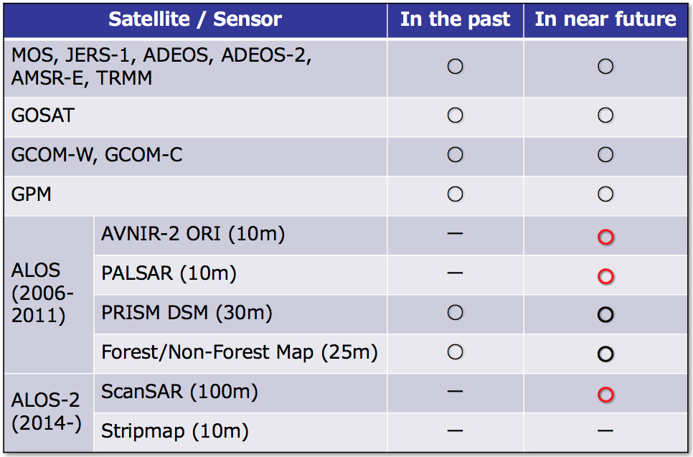
- Tadono-san attributed the release of AVNIR-2 data to the LSI-VC and its follow up after LSI-VC-3. He shared an overview of the AVNIR-2 products and noted that the data distribution website is under development. Release is expected in JFY18.
- ALOS-3 (optical) and ALOS-4 (L-band SAR) are under development, and are planned to launch in 2020. Tadono-san shared some details of the missions.
The LSI-VC Leads congratulated JAXA and the LSI-VC regarding the AVNIR-2 data availability.
Ake Rosenqvist noted that ALOS-1 PALSAR ScanSAR should also appear in the above table.
It was noted that distribution of ScanSAR data is dependent on processing and finding the budget necessary to do this. Stephen Ward suggested exploring solutions to get around the JAXA processing bottleneck and budget restrictions. Others (e.g., the commercial sector, Google, Amazon, the Copernicus Australia Hub, Alaska Satellite Facility, etc.) might be willing to take on this processing.
LSI-VC-5-02 | Shin-ichi Sobue, Stephen Ward, Jonathon Ross, and Brian Killough to explore alternative options for ALOS and ALOS-2 data processing. | LSI-VC-6
Toshio Okumura (JAXA/RESTEC) gave an overview of ALOS-2 PALSAR-2 ARD, which is provided by JAXA through the JJ-FAST system. The JJ-FAST product is an ARD dataset (compatible with the CARD4L PFS), and differs from the standard JAXA ALOS dataset. The data are ScanSAR, dual polarization, 1 degree tiles, ortho-rectified and slope corrected, gamma-0. There are four files for each data product: backscatter coefficients for each polarization (HH and HV), the local incidence angle, processing mask information, and a catalogue file (metadata). JAXA is trialling JJ-FAST data distribution to Vietnam and Indonesia for their Data Cube projects.
Brian commended JAXA on the JJ-FAST product, noting that it is high quality and very useful for the Data Cube and other applications. He encouraged JAXA to continue with this effort and welcomed an expanded scope of data availability.
Other types of SAR ARD is a topic of discussion and will be covered later in the meeting. Ake suggests that there could be many CARD4L SAR products (e.g., InSAR, polarimetric). Ake also noted that the already available annual 25m global FB mosaics, as well as the new ScanSAR mosaics from JAXA are compliant with the current CARD4L backscatter PFS.
ESA
Susanne presented the following Sentinel mission data updates:
- Acquisition plans are updated on a frequent (6-12 month) basis. The next round of updates is ongoing now.
- Sentinel-2: Coverage of Europe is available now. It’s expected that by mid-2018, the Level-2A product will be available with global coverage.
Brian asked whether there is any indication from ESA’s partners that they will mirror this global data. He noted that cloud providers offer the most power for expanding and populating Data Cubes. Susanne confirmed that the UK and CNES are already mirroring the data, and the global production will use Sen2Cor.
- Sentinel-3: routine operations are ongoing. All Level-1 and -2 land and marine core data products have been released. New product definition and implementation is ongoing, and some further fire products will be available in Q1/Q2 2018.
ESA FDA Activities
- DIAS: contracts have been signed with 4 providers (December 2017). Start of operations are planned for June 2018.
- A number of ESA ARD data products are available/planned:
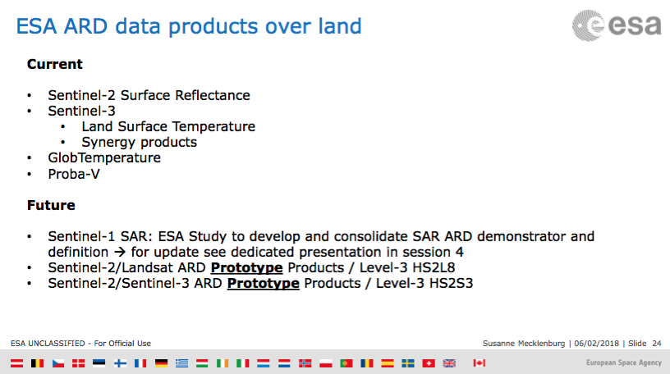
- Sen2Cor v2.5 was recently released and includes multiple fixes.
- A harmonized Sentinel-2/Landsat ARD prototype product is in the works, and ESA is considering systematic production of this Level-3 product. It is being developed in parallel with NASA’s HLS, and there seems to be an exchange of information between the two groups.
- ESA is also looking at combining S-2 and S-3 data. Susanne expects to have the first results in time for LSI-VC-6.
- There are a number of ‘quasi-compliant’ Sentinel CARD4L datasets – see the presentation for details.
- Ferran Gascon will serve as ESA’s POC for the MRI Initiative (to be discussed later in the meeting).
European Commission
Zoltan Szantoi reviewed the Copernicus data download statistics. He also noted that a global Sentinel-2 mosaic should be available by Q4 2018. The product is a seamless surface reflectance mosaic built using ESA data. Users have the ability to choose how the aggregation is done, and the product is generated on request. Users can also choose areas of interest for the mosaic, and this will impact processing time. Ake noted that it would be very helpful to have a Sentinel-1 mosaic capability also.
European ARD Progress
Steven Hosford presented an initial stocktake of ARD activities in Europe:
- CNES, DLR, ESA, UKSA, and VITO are the key surface reflectance ARD producers in Europe.
- CNES are using MAJA for their atmospheric correction. They currently produce SR data over France and French territories, Spain, Italy, Belgium, Netherlands, Scotland and many spot sites across the world. They are extending their geographical coverage to North Africa shortly. theia.cnes.fr
- DLR has partnered with CNES and are doing their own production of S-2 L-2A data over Germany using MAJA. On-demand production using Sen2Cor is also possible on www.code-de.org.
- DLR provided comments on the CARD4L PFS from the perspective of EnMAP.
- Systematic S-2 surface reflectance products for the UK have been generated up to July 2017 through a project led by the UK Satellite Applications Catapult. This has come through a prototype development project, and may be continued for access to UK government users.
- VITO are providing derived S-2 products for Belgium via Terrascope. There is a proposal to expand their geographical scope to Europe and Africa. Water products are also available.
Steven noted a general issue for discussion: the CARD4L registration accuracy requirement of half a pixel seems too ambitious for Sentinel-2 at 10m resolution.
Stephen Ward thanked Steven for his effort on this European stocktake. He noted that the Open Data Cube team has an action to do a global stocktake, and this will serve as a great basis.
Steven Hosford pointed out that there is not a lot of diversity in the approaches (mostly MAJA or Sen2Cor). Jonathon would be interested to know how many of these activities are ultimately funded by the EC.
NASA
Dave Jarrett reported:
- NISAR (launching 2021) product specifications are yet to be decided, but there will be a push for ARD generation in line with the CARD4L PFS.
- ASTER, MODIS, and VIIRS are already producing products that are compliant with the CARD4L PFS.
- Web-Enabled Landsat Data (WELD) and HLS are research products that advance ARD capabilities.
CEOS SEO
Brian Killough showed the COVE coverage analyser tool, and presented results on the relationship between temporal coverage using a single mission and combinations of data sources. His team has investigated different combinations of missions (including optical and SAR), and looked at the number of potential acquisitions per year and the occurrence of coincident coverages. There are three times a year when Landsat 8, Sentinel-2, and Sentinel-1 are coincident. There is great potential here, presenting lots of cal-val and interoperability opportunities. These results demonstrate that by combining data from multiple missions, observation gaps can be reduced to an average of 2-3 days.
Brian noted that there are two approaches to interoperability: merging data sources (e.g., the HLS approach) or combining the end products of separate analyses.
ISRO
Bimal Bhattacharya presented an overview of ISRO’s EO program. He also covered some upcoming collaborative missions including TRISHNA (with CNES) and NISAR (with NASA).
Bimal noted the SACRS2 scheme for atmospheric correction of RS2-AWiFS data. The software package, SACRS2-AWiFS, is open for all at http://mosdac.gov.in/data/tools/SACRS2_Package.rar.
Bimal reviewed the agricultural work being undertaken at ISRO. SAR is a key dataset due to cloud cover, and ISRO are exploring the integration of GEO and LEO products for high frequency agricultural monitoring.
ISRO are looking for assistance with integrating all the components necessary for an operational ARD production pipeline, and would welcome LSI-VC’s assistance. Bimal also noted that AWiFS lacks some bands, which makes AC more difficult.
LSI-VC-5-03 | Bimal to connect with ISRO colleagues doing Data Cube work. | Mid-March
LSI-VC-5-04 | GA (Jono/Andreia/Adam) to reach out to ISRO regarding assistance with an operational ARD production pipeline.  Dave to connect Bimal and Jeff Masek regarding the AROP (Automated Registration and Orthorectification Package) used for the HLS project. | August
Noting the issue of missing bands, Jono suggested an LSI-VC IP task around writing recommendations for agencies for the mission design phase – i.e., how to design an instrument to make it conducive to ARD production. Knowing how the specification of the majority of agency missions are developed incorporating months (if not years) of work interacting with users and tailoring the instrument design to their needs through Mission Specification teams, Steven and Susanne were not convinced of the impact of such a report.

Ake Rosenqvist noted there is no joint L- and S-Band acquisition plan for NISAR. Ake has an action from SDCG to write to NASA and ISRO asking them to consider an acquisition plan that would facilitate coincident acquisitions and therefore intercomparison exercises.
Session 3a:​ CEOS Analysis-Ready Data for Land (CARD4L) Overview
Status Report on Analysis-Ready Data Usage
Brian reviewed the status of Analysis-Ready Data usage. He noted that Google is currently the best source for Sentinel-1 ARD, given that they have pre-processed GRD data to ARD (gamma-0 intensity). The CEOS SEO has recently developed a script (with support from Google) that will generate a Data Cube directly from these data holdings. This is currently the fastest method to prepare S-1 Data Cubes – and is essentially free if you have a Google research grant which provides free access to Google Cloud storage and compute.
Stephen recalled the ODC action to do a stocktake of ARD availability and access options.
Data provenance is key, and this means that agencies are the preferred source of data, however reliability and access options need to be improved to entice users.
Zolti noted Google’s choice of projection, which is not the best for many applications; their products are certainly not the be-all, end-all for ARD.
ESA WGCV SAR Subgroup Interaction and SAR ARD Study
Susanne presented the outcomes from the SAR ARD session at the WGCV SAR subgroup meeting:
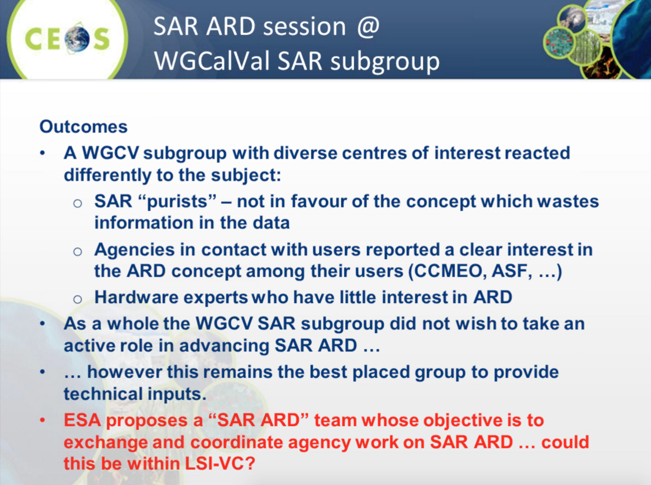
Stephen noted that he has been discussing SAR ARD with JAXA, and is encouraging them to take a lead on the SAR PFS, including any new ones that might emerge.
The constituency of the proposed SAR ARD team needs to be correct. A group of SAR purists will likely not be effective. We need a group that is well aware of the intended use case, that is, users that are not usually using SAR products (supplementary users, Data Cubes, etc.). We need to be clear that we are not proposing that raw products be replaced. A SAR backscatter intensity product is very useful for basic use cases.
LSI-VC-5-05 | ESA (Nuno Miranda) and JAXA (Takeo Tadono, Ake Rosenqvist) to establish a group to further the SAR ARD work, including expansion to other PFS. NASA will provide additional support, and the group should involve other SAR agencies such as CSA, DLR, etc. ISRO expressed interest in participating. | March
Susanne also presented the outcomes from ESA’s SAR ARD study:
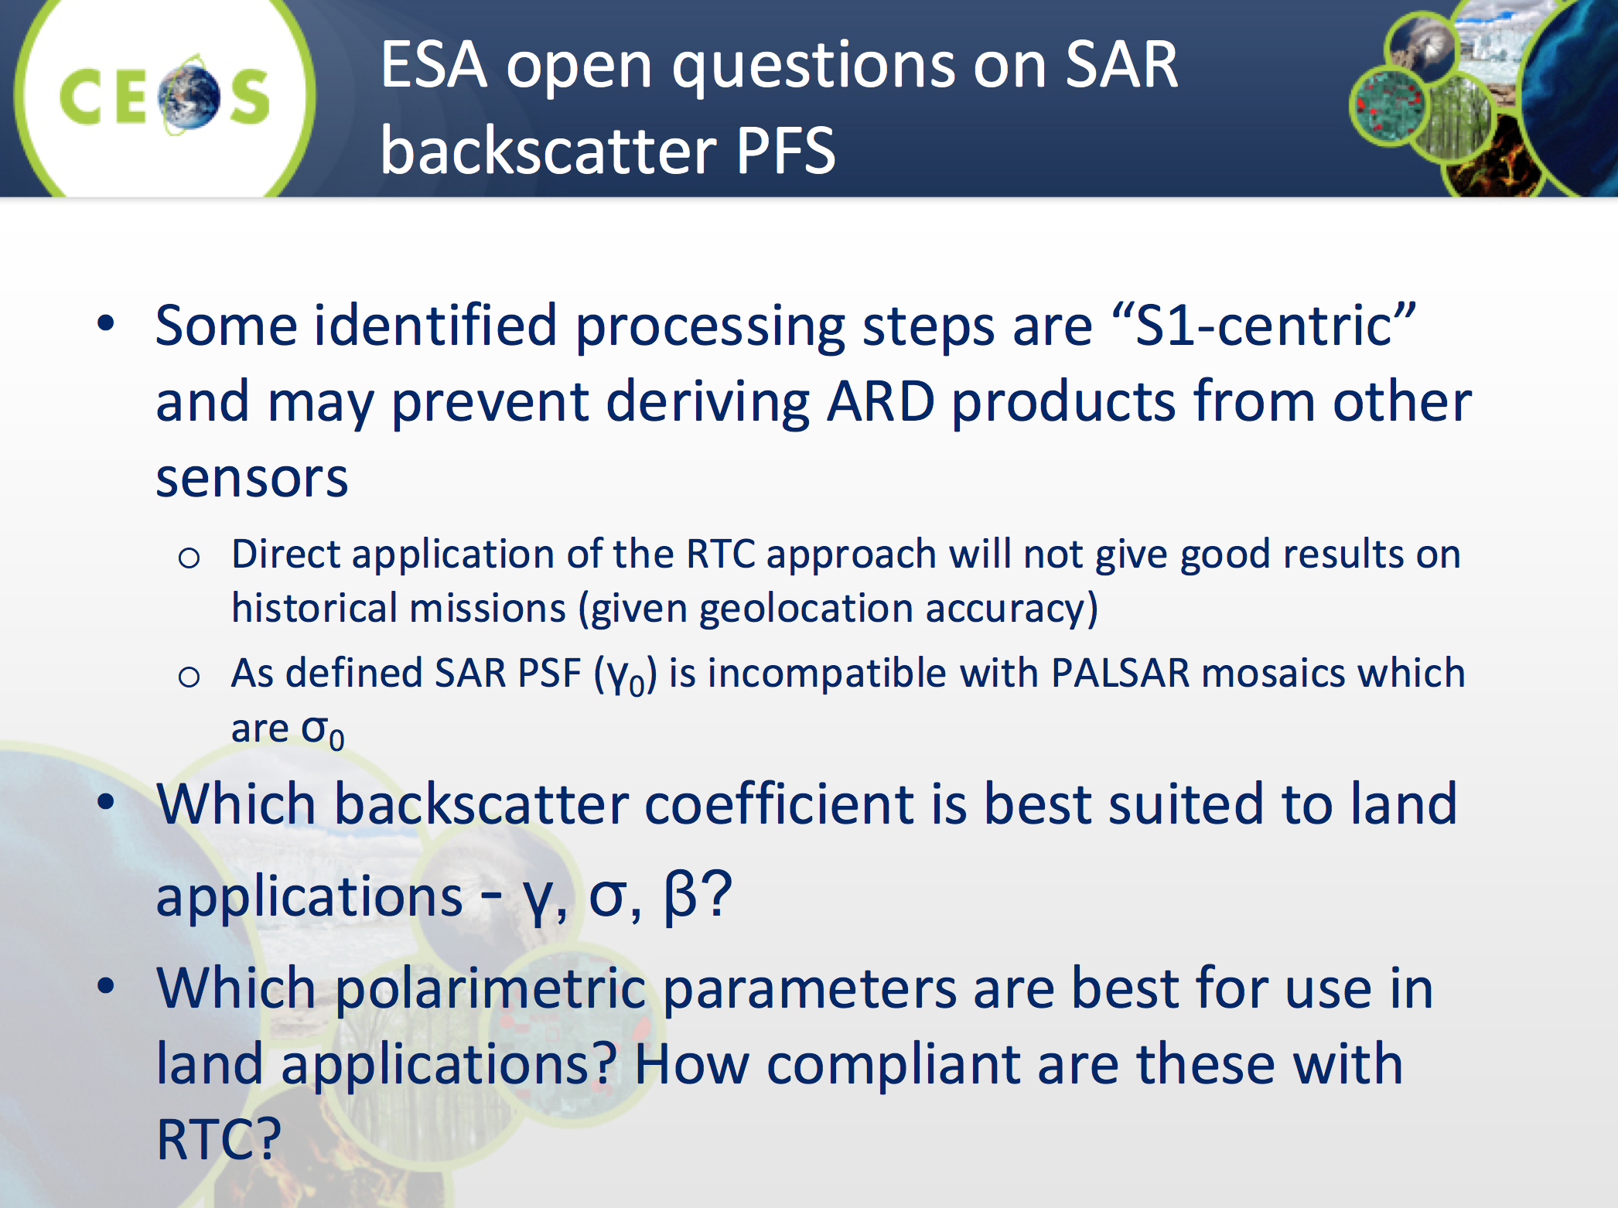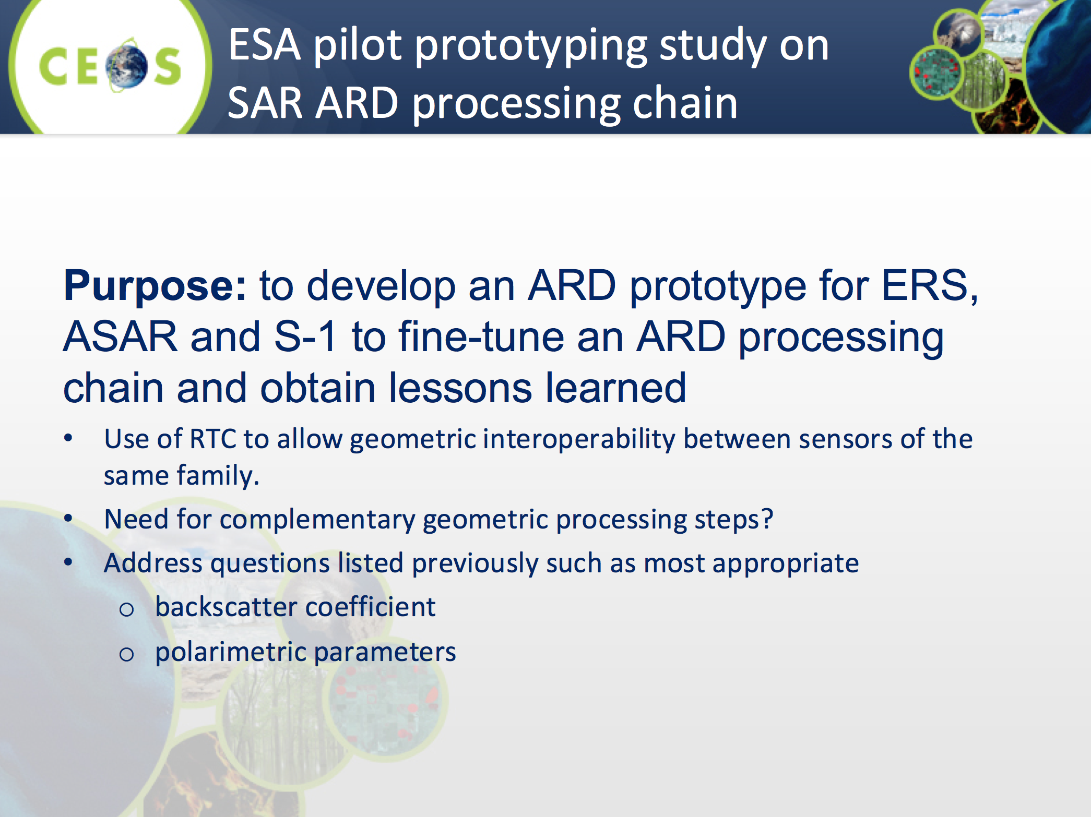
CEOS Analysis-Ready Data for Land (CARD4L) Framework Recap
Andreia reviewed the CARD4L framework work to date.
Thursday February 22nd
Session 3b:​ CARD4L Implementation Phase #1
Product Family Specifications (PFS)
Andreia Siqueira (GA) presented the background of the development of the CARD4L PFS. 20+ people participated in each of the PFS review teleconferences, and there was good engagement from a variety of communities. A number of different changes have been applied to each document. However, some changes were the same to all three documents, such as: the inclusion of a chapter for the definitions and acronyms used in the text (e.g., LST, SBT, ancillary data); changed words under the guidance section to say that the products will be resampled onto a common geometric grid (for a given product) and would provide baseline data for further interoperability both through time and with other datasets. Two major suggestions came out of the teleconferences: splitting the land surface temperature PFS into two components (surface temperature, brightness temperature) and the development of more radar PFS (e.g., interferometric SAR). All discussions, feedback, dates, actions, etc., are being captured in an Excel table. The updated PFS documents as well as the Excel table are kept in the Google Drive.
Jonathon Ross (GA) asked whether we should be prioritising the implementation phase before looking at modifying the existing PFS. He added that PFS instability could hamper uptake by data providers.
Referring to the planned further revisions of the PFS, Steven Hosford (ESA/CNES) stressed that we need to be aware that not all of CEOS is ‘operational’, and we should be considerate of the amount of resources available for this work.
Susanne Mecklenburg (ESA) asked whether an update of all PFS is necessary at this stage, suggesting that we instead focus on SAR. Ake Rosenqvist (JAXA) agreed, suggesting that updates should only take place as needed; excessive changes will be a drag on resources and make implementation more difficult for data providers.
It was agreed that the planned annual updates of the PFS are unnecessary, however we remain open to making minor incremental changes whenever necessary. PFS stability is the priority.
WGCV’s role in the CARD4L assessment process was discussed. Jonathon Ross (GA) suggested: calling the current PFS ‘pre-final’; asking LSI-VC agencies to do practice assessments for candidate products, recording their process; and then using these inputs to prepare a first draft of the CARD4L Assessment Framework. WGCV can then be engaged for their feedback.
It was agreed that WGCV should be engaged in the assessment process.
Stephen Ward stressed the importance of having a clear ARD strategy to inform data users, providers, and intermediaries (especially the ‘Big Data’ hosts), to make them aware of where we’re at, where we’re going, and persuading them that they should be using/producing/hosting CARD4L products. The ARD strategy should cover these points, as well as PR and outreach topics.
Summary
- No comprehensive updates to the PFS on an annual basis – we want stability in the specifications.
- The Surface Reflectance and Surface Temperature PFS are considered baselined; minor clarifications are possible later this year after the first agencies go through the assessment process.
- Looking for LSI-VC agencies to start piloting the assessment and production process over the coming months (e.g., JAXA on SAR, ESA on Surface Reflectance, USGS on Surface Temperature). Aim for results by the joint meeting in September. Use these experiences to draft an official assessment process to share with WGCV for review.
It was agreed that a sub-group, led by JAXA (Takeo Tadono, Ake Rosenqvist) and ESA (Nuno Miranda) should be established (see action below) to see that this is completed.
The SAR Backscatter PFS will be baselined by the SAR sub-group before SIT-33. The sub-group will also examine whether other SAR PFS (polarimetric and InSAR) should be proposed.
LSI-VC-5-06 | LSI-VC agencies (working with WGCV) to start piloting the CARD4L assessment and production process over the coming months (JAXA (Takeo Tadono, Ake Rosenqvist) on SAR, ESA (Ferran Gascon) on Surface Reflectance, USGS (Steve Labahn, Greg Stensaas) & ESA (S-3 LST teams, Susanne Mecklenburg) on Surface Temperature).  The above delegations are not exclusive; other agencies are also encouraged to test-run their products. | LSI-VC-6
LSI-VC-5-07 | Andreia Siqueira, Takeo Tadono and Ake Rosenqvist to engage Nuno Miranda, and work together to complete a baseline SAR Backscatter CARD4L PFS for SIT-33. | SIT-33
LSI-VC-5-08 | ESA (Susanne Mecklenburg, Nuno Miranda) and JAXA (Takeo Tadono, Ake Rosenqvist) to lead a SAR ARD subgroup tasked with discussing additional SAR PFS (e.g., polarimetry, InSAR) and make recommendations to LSI-VC-6. | LSI-VC-6
Ake noted the still outstanding question of where to draw the line with the PFS – there is a balance between general and specific utility. He highlighted prior discussions around whether the SAR backscatter PFS should be a gamma-0 or sigma-0 product, and he asked whether these should be two separate CARD4L products (as they serve different purposes) or should users be expected to perform the transformation between the two products? This will be discussed further by the SAR sub-group.
Open Data Cube, GFOI, and ARD Stocktake
Stephen Ward presented on the relationship between CARD4L and the Open Data Cube (ODC) and GFOI communities:
- CARD4L is perhaps the most significant standardisation activity for space agency programmes to remain competitive, meet user expectations, and address FDA challenges and opportunities – including ODC.
- ODC would like to convey – through LSI-VC, to SIT-33 – a request that CEOS and its agencies recognise the importance of ARD standards and production and take measures to resource and expedite the relevant CEOS initiatives. There will be agenda items on ARD and FDA at SIT-33 – led by Alex Held (CSIRO, SIT Vice Chair).
- ODC plans a comprehensive stocktake of ARD status, availability, and outlook.
- There was a formal action from the first joint meeting to have GEOGLAM and GFOI undertake formal feedback and pilot work to ensure CARD4L is fit for purpose for those user communities.
- SDCG plans to submit a survey to GFOI countries next month in Colombia. SDCG will request that LSI-VC review the survey. SDCG will also distribute PR materials to inform a short presentation to GFOI countries on ARD (and Data Cube). These materials can be reused for other communities (e.g., GEOGLAM)
- A core task is proposed for the next version of the SDCG 3-Year Work Plan, which implies close cooperation with LSI-VC.
LSI-VC-5-09 | Stephen Ward will work with the ODC Partners Forum to organise for a letter to be sent to CEOS/LSI-VC/SIT Chair acknowledging LSI-VC’s efforts on CARD4L, and encouraging expansion of the CARD4L initiative and a move to production of CARD4L data by agencies so that FDA platforms can flourish. | March 16
LSI-VC-5-10 | LSI-VC SEC to coordinate the drafting of a comprehensive stocktake of ARD status, outlook, and connection to CARD4L PFS – building on the work of Steven Hosford/ESA. The stocktake will be used to inform short ARD strategy notes for internal and external outreach with ARD providers, hosts, and user communities (ref: LSI-VC-5-17). | LSI-VC-6
LSI-VC-5-11 | LSI-VC contacts to review the GFOI/SDCG draft survey seeking feedback from GFOI countries on the utility of CARD4L for forest monitoring applications. | Once received
LSI-VC-5-12 | CEOS SEO to set up www.ceos.org/ard. LSI-VC SEC to migrate the existing CARD4L website to this location. | March 16
LSI-VC-5-13 | LSI-VC SEC to work with the SIT Chair Team to ensure the SIT Technical Workshop agenda includes an item on CARD4L outreach to communities beyond GFOI and GEOGLAM (including SDGs and other GEO priorities). | Before SIT Technical Workshop
CARD4L Product Assessment Framework
Jonathon Ross (GA) reviewed the draft process presented by Adam Lewis (GA) last year:
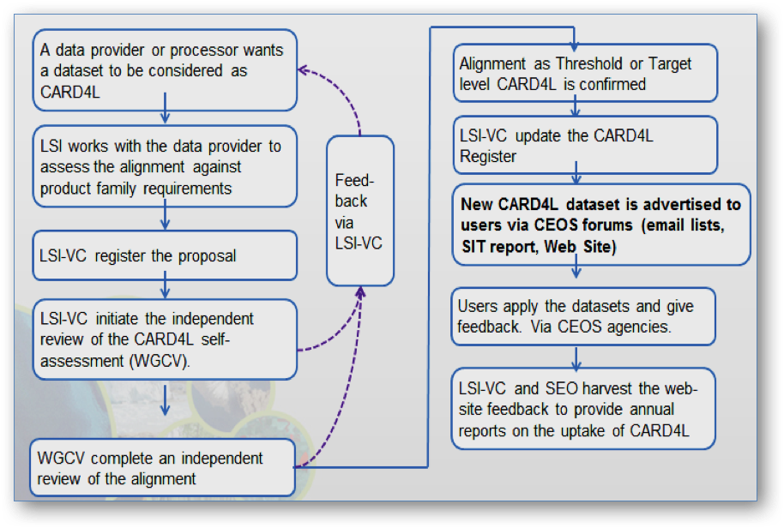
It’s felt that there is a role for WGCV around confirming the self-assessments done by the data producers. If we want a rigorous process that gives users confidence in the data, WGCV should be involved in the CARD4L ‘stamping’ procedure. LSI-VC provides the strategic layer, as well as an initial check, however the technical expertise of the WGCV team is required to completely verify the self-assessments.
LSI-VC-5-14 | Andreia to contact the WGCV Chair and Vice-Chair regarding WGCV’s potential role in CARD4L product assessments.  Chair: kurtis.thome@nasa.gov  Vice-Chair: cindy.ong@csiro.au | Before SIT-33
Susanne Mecklenburg (ESA) suggested that LSI-VC might need to establish a separate multilateral, operational activity (along the lines of ACIX) to handle the assessment process. Jenn Lacey (USGS) noted that we should avoid duplicating any efforts that are already ongoing (e.g., USGS has many related activities). Susanne suggested leveraging others’ work as much as possible, e.g., work completed for QA4EO.
After some discussion, the following were agreed as the high-level steps for CARD4L product assessments:
- LSI-VC is approached by a data provider that wishes for their dataset to be considered CARD4L.
- LSI-VC SEC to connect the data provider with a POC within LSI-VC (product-specific).
- LSI-VC SEC monitors the process, keeping a registry of proposals (in confidence) and carries out a general liaison role.
- The data provider self-assesses their product using the template against the PFS (which will be a product of LSI-VC’s pilot assessments; ref: LSI-VC-5-07).
- The LSI-VC POC reviews the data provider’s self-assessment.
- Provided all is in order, WGCV would then be engaged for a technical review (TBC with WGCV). WGCV will either approve the self-assessment or ask for further information/work.
- Once confirmed as meeting the requirements of CARD4L, the dataset will be added to the www.ceos.org/ard website along with access instructions by the LSI-VC SEC.
LSI-VC-5-15 | Jonathon Ross to update the CARD4L assessment process diagram, and to propose consistent CEOS WP/LSI-VC IP tasks. Both should be consistent with the steps agreed during the meeting. | March 23
LSI-VC-5-16 | Jenn Lacey to rename the CEOS Work Plan task on the CARD4L ‘Implementation Strategy’ to ‘Engagement Strategy’. | Before Next LSI-VC Teleconference
LSI-VC-5-17 | LSI-VC SEC to draft ‘ARD strategy notes’ that cover how to approach data providers, data hosts, and data users. These are separate to the Engagement Strategy, and are intended to inspire users and convince data providers and data hosts to adopt CARD4L. | LSI-VC-6
LSI-VC-5-18 | Andreia to plan the outreach and promotion aspects of the CARD4L Engagement Strategy (covering meetings, conferences, etc.). | LSI-VC-6
Requirements Session Ideas
Rather than pursuing the idea of broad requirements and gap analyses, Brian would like to focus on improving and enhancing tools and resources that would be valuable for all people undertaking their own analyses (e.g., COVE, MIM, etc.). Brian is certain that a polished process for the existing CEOS WP action VC-26 does not exist.
Jonathon thinks that we should at least still be looking at gap analyses for ancillary data requirements, noting the emergence of many small, independent satellites. He suggested that LSI-VC do a short guide for these new data providers on sources of information for atmospheric correction, geometry, etc.
Stephen Ward suggested that LSI-VC could help unlock the full power of the MIM database. Feedback on improvements to the MIM that would be helpful for gap analyses would be very useful. LSI-VC could also possibly serve as a pilot user of the new API (in development).
Alyssa noted that there are really two distinct gap analyses – around both acquisition and use. The latter is now a key focus for GEOGLAM, and they are looking at tools and processes for identifying whether data acquired is actually being used.
Engaging Data Providers
The following were identified as the criteria necessary for data providers to engage with the CARD4L concept:
- They know what to do;
- They know how to do it (i.e., product generation);
- They want to do it (a key point is how to convince them – providing example metrics, etc. (e.g., via USGS/Landsat) is crucial);
- Achieve buy-in from leadership (via CEOS and GEO and their initiatives).
Steven Hosford noted that early discussions between ESA and the commercial sector suggest that commercial providers would be very interested in ‘stamping’ their products as CARD4L, as it would give them a level of legitimacy.
Brian noted that it might be difficult to get metrics of data usage from commercial providers.
Ake noted the need for a strategy to engage other CEOS agencies that aren’t closely involved with LSI-VC at this stage (e.g., CNES, DLR, ASI, CONAE, China). We cannot simply present at SIT-33 and hope to get traction.
LSI-VC-5-19 | Jonathon Ross to follow up with Dave Hudson regarding identification of a Chinese LSI-VC contact. | March
Moderate Resolution Interoperability (MRI)
Jenn Lacey recapped the progress to date on MRI. The objective of this initiative was to increase the complementarity and comparability among the increasing number of moderate resolution Earth observing systems – helping users take advantage of all available space assets. She asked how we should take what was done last year, and combine this with everything else being done on FDA and CARD4L. The focus and goals for MRI are still unclear, and we hope to make some headway at LSI-VC-5.
Discussion on Product Interoperability and the Distinction Between CARD4L and MRI
Two main barriers to interoperability were identified: geometry and sensor compatibility. The former can be addressed by specifying common references and DEMs, while the latter requires similarity at the sensor level.
Ake noted that GFOI define data interoperability as being the ability to replace one sensor with another (as opposed to sensor complementarity where sensors, such as e.g. C- and L-band SAR, provide complementary information).
There is still no clarity around the meaning of MRI in this context. However, it is agreed that CARD4L doesn’t guarantee interoperability.
Susanne confirmed that Ferran Gascon will lead the MRI activity as well as the effort to create a merged LS-S2 product within ESA.
FDA Context
Steven Hosford presented an overview of CEOS’ FDA work to date. He noted that in past years, FDA has overseen tasks (FDA-XX) that have been assigned to the CEOS entities which complete the work. This is to continue for several FDA tasks assigned to WGISS, for example. It is unclear whether the ARD tasks to be conducted under FDA should be assigned as FDA or LSI tasks. The LSI-VC Leads prefer that the ARD tasks become LSI tasks.
The current set of FDA tasks for the 2018-2020 CEOS WP defined by the various CEOS entities implementing FDA and the FDA ad-hoc team were presented. It was felt by LSI-VC-5 participants that some of these tasks did not reflect the high-level, strategic function expected of the FDA-AHT. Steven agreed to pass these comments on to the FDA-AHT co-Chairs and iterate with them on the tasks identified. Despite the lack of reporting by the FDA-AHT, overall progress has been made on several FDA subjects including the critical need to better frame FDA to take a "big picture" approach, ensuring that a broad set of technology solutions is included in the framework, making it relevant and applicable to all space agencies.
MRI Way Forward
Michael Berger presented on the overall MRI objectives, principles and long-term roadmap. He suggested the following as the objectives of the MRI initiative:
- Providing clear recommendations to space agencies for the implementation of the MRI framework under consideration of widest possible use and the specific mandate of space agencies;
- Providing good practices and guidance for user communities in adapting and using multiple sensor products within single data streams, including related software tools and reference data sets;
and presented the following MRI implementation roadmap:
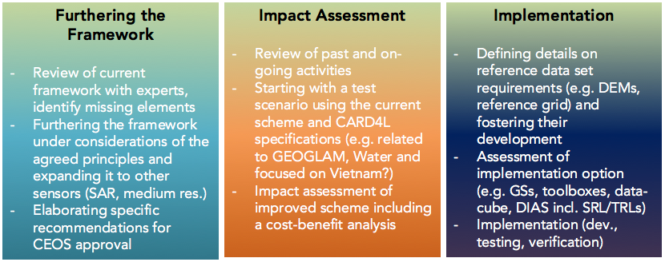
The following were suggested as the specific tasks for 2018:
- Furthering the framework under consideration of the agreed principles and expanding it to other sensors with a focus on moderate resolution SAR.
- Analysing various past/ongoing implementations (NASA HLS, ESA HLS, etc.) for MRI framework compliance.
- Initiating detailed assessments of various implementation options (common grid, spectral and temporal adjustments).
LSI-VC-5-20 | Jenn to ensure Michael Berger agrees with the MRI tasks currently proposed for the CEOS WP. | Next LSI-VC Call
Harmonized Landsat Sentinel-2 (HLS)
David Jarrett briefly presented on NASA’s Harmonized Landsat Sentinel-2 products/project.
- It was noted that the HLS products would themselves be considered a CARD4L product.
- A dialogue has been established with NASA HQ around long-term stewardship of HLS processing, which would facilitate the ‘spinning-up’ of HLS Data Cubes.
LSI-VC-5-21 | Brian to follow up with Jeff Masek regarding the specifics of the HLS dataset interpolation. | March
Friday February 23rd
Session 5:​ Requirements Assessment
GEOGLAM Requirements Overview
Alyssa Whitcraft (GEOGLAM) presented an overview of the GEOGLAM requirements work to date, its evolution, and the two-day operational user requirements workshop planned for April. The workshop will not only look at gaps in what has been acquired (increasingly few), but also look at gaps in user uptake. The workshop will look at how users are using data, and how this can be made easier and more impactful using new approaches (e.g., Data Cube, CARD4L).
Alyssa supported Brian Killough’s suggestion to focus on improving the utility of CEOS information tools to make gap analyses more systematic and straightforward.
Brian noted the African Regional Data Cube (ARDC) and its potential for GEOGLAM. The ARDC will be showcased at the GEOGLAM meeting.
The GEOGLAM community’s feedback on CARD4L was discussed. In a couple of weeks, the GFOI community will be asked for their feedback on CARD4L through a survey. Alyssa requested a copy of the survey; she will review it and assess how it might be incorporated into a survey going out ahead of the April GEOGLAM workshop.
LSI-VC-5-22 | Stephen/Brian to discuss with Alyssa: integration of the GFOI CARD4L survey questions into the GEOGLAM April workshop survey. | March
LSI-VC-5-23 | Alyssa and Brian to explore possibilities around testing HLS data with the GEOGLAM community – as a new MRI case study. | April
Carbon Requirements
LSI-VC reached out to the CEOS carbon community multiple times, with little result and infrequent interactions. It was agreed that there is not much we can do in a one-way fashion – LSI-VC needs inputs and feedback from the thematic side. Brian Killough (NASA, SEO) suggested that, at this point, we should hold off on any further action around carbon. Alyssa Whitcraft (GEOGLAM) agreed, noting that there needs to be a strong pull from the thematic side/a demand for this analysis to be done.
Also, while broad, generalised gap analyses do not look feasible, there are still tasks that LSI-VC could progress in support of gap analysis activities. Specifically, LSI-VC and the SEO can work together to improve the utility of existing CEOS tools (COVE, MIM) to improve their usefulness for specific gap analyses that might arise in the future.
Stephen Ward (ESA, MIM DB Team) noted that there is work ongoing within the MIM DB team on improvements to the database that will aid gap analyses, in particular the development of an API, migration to machine-readable fields, etc. This is jointly funded by the CEOS SEO and ESA. Stephen welcomed LSI-VC inputs on desired features and other improvements, and he will share more details with LSI-VC members.
LSI-VC-5-24 | Alyssa and Brian to discuss improvements to COVE that would aid gap analyses. | April
LSI-VC-5-25 | Jenn to delete the CEOS Work Plan task on requirements, and work with Brian (COVE), Stephen (MIM), and Alyssa (GEOGLAM) to write new tasks around gathering CARD4L feedback via GEOGLAM and GFOI, and updating CEOS information tools to improve their value for gap analyses. | March
LSI-VC-5-26 | CEOS MIM Database Team to share the plans for the MIM API and other database updates. | ASAP
Regarding the carbon gap analysis, Jenn Lacey (USGS) noted the potentially new linkage to WGClimate via John Dwyer (USGS). Jenn also suggested that a gap analysis focused on CARD4L datasets could be useful.
Summary
The outcomes of Session 5 can be summarised as follows:
- Seek feedback on CARD4L from the GFOI and GEOGLAM communities, including via a questionnaire.
- Suspend the carbon requirements work until a sufficient dialogue is established.
- Another thematic area for gap analyses will not be sought.

Session 6:​ Upcoming Meetings
LSI-VC-6 / SDCG-14 / GEOGLAM Joint Meetings
Following the last joint meeting, Alyssa Whitcraft (GEOGLAM) and Brad Doorn (NASA) expressed concern about the overlaps between meetings (particularly LSI-VC and GEOGLAM). A possible solution is to move GEOGLAM earlier in the week. Stephen Ward noted that we are still working out how to best structure the week. ARD, Data Cubes, and interoperability are all common concerns for the three groups, and these topics should be addressed together. It was agreed that feedback on CARD4L is a perfect topic for a joint session. It’s felt that four days should be sufficient, and the aim will be to minimise overlap and maximise common sessions.
LSI-VC-7
Dave Jarrett (NASA) has offered to investigate the possibility of holding LSI-VC-7 (February/March 2019) in the United States, perhaps in Florida at Kennedy Space Center.
Session 7:​ Closing
Closing Remarks
Jenn Lacey (USGS) thanked everyone for attending, and thanked Takeo Tadono (JAXA) in particular for hosting the meeting at JAXA/RESTEC.
Susanne Mecklenburg (ESA) thanked everyone for their inputs to the meeting. She noted that it was very useful in getting up to speed on the work of LSI-VC, since taking over the ESA co-Lead role. She was especially happy to see some tangible outcomes and clear next steps on CARD4L.
Jonathon Ross (GA) acknowledged the significant progress made by the team since the reboot of the LSI-VC at the 2015 CEOS Plenary. He commended the team’s focus and high profile work.
Andreia Siqueira (GA) thanked everyone for their support as a newcomer to the team. Andreia hopes to be involved going forward.
Takeo Tadono (JAXA) thanked everyone for coming, and hopes that everyone enjoyed their stay in Japan. JAXA will remain closely engaged in LSI-VC, in particular through their leading role in the SAR CARD4L work.
Zoltan Szantoi (EC/JRC) noted that JRC will host the next LSI-VC meeting in Ispra, Italy. He looks forward to welcoming everyone in September. The meeting will be joint with the SDCG-GFOI and GEOGLAM groups.
Bimal Bhattacharya (ISRO) thanked LSI-VC for engaging ISRO in the meeting. He stated that there is plenty of work to do around ISRO’s data, and he will take back the lessons learned from this week and promote progress in India. He looks forward to updating us in the near future.

APPENDIX A
Attendees

Organisation | Name
EC/JRC | Zoltan Szantoi
ESA | Michael Berger (remote)
ESA | Susanne Mecklenburg
ESA/CNES | Steven Hosford
ESA | Stephen Ward
ESA | Matt Steventon
GA | Andreia Siqueira
GA | Jonathon Ross
GEOGLAM | Alyssa Whitcraft (remote)
ISRO | Bimal Bhattacharya
JAXA | Takeo Tadono
JAXA | Osamu Ochiai
JAXA | Ake Rosenqvist
JAXA/RESTEC | Toshio Okumura
NASA | Dave Jarrett
NASA/SEO | Brian Killough
USGS | Jenn Lacey

APPENDIX B
Actions Record

No. | Action | Due Date
LSI-VC-5-01 | All to get in contact with Adam Lewis/Andreia to be involved in the ARD papers for IGARSS or the Journal of Remote Sensing. | Mid-March
LSI-VC-5-02 | Shin-ichi Sobue, Stephen Ward, Jonathon Ross, and Brian Killough to explore alternative options for ALOS and ALOS-2 data processing. | LSI-VC-6
LSI-VC-5-03 | Bimal to connect with ISRO colleagues doing Data Cube work. | Mid-March
LSI-VC-5-04 | GA (Jono/Andreia/Adam) to reach out to ISRO regarding assistance with an operational ARD production pipeline.  Dave to connect Bimal and Jeff Masek regarding the AROP (Automated Registration and Orthorectification Package) used for the HLS project. | August
LSI-VC-5-05 | ESA (Nuno Miranda) and JAXA (Takeo Tadono, Ake Rosenqvist) to establish a group to further the SAR ARD work, including expansion to other PFS. NASA will provide additional support, and the group should involve other SAR agencies such as CSA, DLR, etc. ISRO expressed interest in participating. | March
LSI-VC-5-06 | LSI-VC agencies (working with WGCV) to start piloting the CARD4L assessment and production process over the coming months (JAXA (Takeo Tadono, Ake Rosenqvist) on SAR, ESA (Ferran Gascon) on Surface Reflectance, USGS (Steve Labahn, Greg Stensaas) & ESA (S-3 LST teams, Susanne Mecklenburg) on Surface Temperature).  The above delegations are not exclusive; other agencies are also encouraged to test-run their products. | LSI-VC-6
LSI-VC-5-07 | Andreia Siqueira, Takeo Tadono and Ake Rosenqvist to engage Nuno Miranda, and work together to complete a baseline SAR Backscatter CARD4L PFS for SIT-33. | SIT-33
LSI-VC-5-08 | ESA (Susanne Mecklenburg, Nuno Miranda) and JAXA (Takeo Tadono, Ake Rosenqvist) to lead a SAR ARD subgroup tasked with discussing additional SAR PFS (e.g., polarimetry, InSAR) and make recommendations to LSI-VC-6. | LSI-VC-6
LSI-VC-5-09 | Stephen Ward will work with the ODC Partners Forum to organise for a letter to be sent to CEOS/LSI-VC/SIT Chair acknowledging LSI-VC’s efforts on CARD4L, and encouraging expansion of the CARD4L initiative and a move to production of CARD4L data by agencies so that FDA platforms can flourish. | March 16
LSI-VC-5-10 | LSI-VC SEC to coordinate the drafting of a comprehensive stocktake of ARD status, outlook, and connection to CARD4L PFS – building on the work of Steven Hosford/ESA. The stocktake will be used to inform short ARD strategy notes for internal and external outreach with ARD providers, hosts, and user communities (ref: LSI-VC-5-17). | LSI-VC-6
LSI-VC-5-11 | LSI-VC contacts to review the GFOI/SDCG draft survey seeking feedback from GFOI countries on the utility of CARD4L for forest monitoring applications. | Once received
LSI-VC-5-12 | CEOS SEO to set up www.ceos.org/ard. LSI-VC SEC to migrate the existing CARD4L website to this location. | March 16
LSI-VC-5-13 | LSI-VC SEC to work with the SIT Chair Team to ensure the SIT Technical Workshop agenda includes an item on CARD4L outreach to communities beyond GFOI and GEOGLAM (including SDGs and other GEO priorities). | Before SIT Technical Workshop
LSI-VC-5-14 | Andreia to contact the WGCV Chair and Vice-Chair regarding WGCV’s potential role in CARD4L product assessments.  Chair: kurtis.thome@nasa.gov  Vice-Chair: cindy.ong@csiro.au | Before SIT-33
LSI-VC-5-15 | Jonathon Ross to update the CARD4L assessment process diagram, and to propose consistent CEOS WP/LSI-VC IP tasks. Both should be consistent with the steps agreed during the meeting. | March 23
LSI-VC-5-16 | Jenn Lacey to rename the CEOS Work Plan task on the CARD4L ‘Implementation Strategy’ to ‘Engagement Strategy’. | Before Next LSI-VC Teleconference
LSI-VC-5-17 | LSI-VC SEC to draft ‘ARD strategy notes’ that cover how to approach data providers, data hosts, and data users. These are separate to the Engagement Strategy, and are intended to inspire users and convince data providers and data hosts to adopt CARD4L. | LSI-VC-6
LSI-VC-5-18 | Andreia to plan the outreach and promotion aspects of the CARD4L Engagement Strategy (covering meetings, conferences, etc.). | LSI-VC-6
LSI-VC-5-19 | Jonathon Ross to follow up with Dave Hudson regarding identification of a Chinese LSI-VC contact. | March
LSI-VC-5-20 | Jenn to ensure Michael Berger agrees with the MRI tasks currently proposed for the CEOS WP. | Next LSI-VC Call
LSI-VC-5-21 | Brian to follow up with Jeff Masek regarding the specifics of the HLS dataset interpolation. | March
LSI-VC-5-22 | Stephen/Brian to discuss with Alyssa: integration of the GFOI CARD4L survey questions into the GEOGLAM April workshop survey. | March
LSI-VC-5-23 | Alyssa and Brian to explore possibilities around testing HLS data with the GEOGLAM community – as a new MRI case study. | April
LSI-VC-5-24 | Alyssa and Brian to discuss improvements to COVE that would aid gap analyses. | April
LSI-VC-5-25 | Jenn to delete the CEOS Work Plan task on requirements, and work with Brian (COVE), Stephen (MIM), and Alyssa (GEOGLAM) to write new tasks around gathering CARD4L feedback via GEOGLAM and GFOI, and updating CEOS information tools to improve their value for gap analyses. | March
LSI-VC-5-26 | CEOS MIM Database Team to share the plans for the MIM API and other database updates. | ASAP

