CEOS Response to GEOGLAM Requirements 2019

# 0. Executive Summary

This report lays out the GEOGLAM Requirements as of 2019, as well as the 2019 CEOS Strategic Response to them. It begins with the context and methodology for GEOGLAM’s “requirements reboot” and follows with a high-level review of GEOGLAM consensus data acquisition, access, and use requirements. It identifies GEOGLAM activities which align or impact CEOS and constituent agency activities, identifying collaborative areas for expanding EO data adoption and sustained use. In parallel to these GEOGLAM findings and recommendations are inset boxes which contain CEOS responses to these GEOGLAM objectives. Bold-face font identifies key points to CEOS, as well as section headers. This document satisfied AGRI-04 from the CEOS Work Plan 2019-2021.

CEOS is a critical partner within the GEOGLAM program. Together our communities have effectively delivered and surpassed the original G20 policy mandate on market volatility. Today at the global level our Crop Monitors help stabilize food commodity markets and provide early warning for food security response. This work has evolved to support at the national level where timely EO informed policies and programs are proactively improving response to food emergencies, saving lives, while reducing the cost of response. As we look to the future there is much more we can do together, and the 2019 requirements revision is an important step along the way to further refine and define the relationship between our communities.

The GEOGLAM requirements are continuously evolving as the science, technology and mission evolves, and so too must the CEOS requirements continue to evolve to reflect these changes. GEOGLAM community needs are evolving to address priorities around Paris Accord, the Sendai Framework and SDG’s that have all come about since the original G20 mandate in 2011. The client needs associated with the evolution are driving requirements for greater quantification of agricultural state and change variables over multiple time scales (within season to decadal). In response GEOGLAM has begun the process of defining Essential Agricultural Variables (EAVs) to address GEOGLAM well into the future (Section 3). The EAVs will drive a revised set of requirements for EO data, ARD, and computing infrastructure post-2020. Consequently, it should be emphasized that GEOGLAM requirements are ever-evolving (although with the changes anticipated to be minor adjustments as the state of missions, science, and practice evolve).

# Context, Background, and Sources of Information

## 1.1 Original Requirements Assessment & CEOS-GEOGLAM Relationship

****Since 2011, the Group on Earth Observations Global Agricultural Monitoring (GEOGLAM) Initiative has had as a core activity the coordination of Earth observations data for those undertaking cropland and rangeland monitoring at national, regional, and global scales. Critical to this has been a partnership with the Committee on Earth Observation Satellites (CEOS), which has maintained an Ad Hoc Working Group on GEOGLAM since 2012, tasked with evaluating and assisting with the implementation of GEOGLAM data requirements and requests for acquisition. In 2012, this CEOS Ad Hoc Working Group on GEOGLAM convened for the first time, at the Canadian Space Agency, and concretely characterized satellite data requirements for a variety of agricultural information products in tabular format (Figure 1). This was an evolution of a previous GEO Agricultural Community of Practice effort to characterize monitoring requirements in a sensor-agnostic manner (via the “Defourny Diagram”).

Figure 1: Version 1 of the GEOGLAM Satellite Observation Requirements (2012-2014)

## 1.2 The Evolving Need for Requirements Reboot

Between 2016 and 2017, GEOGLAM undertook a refreshment of these requirements from a “state of the science” perspective – accomplished through survey of participants in the Joint Experiment on Crop Assessment and Monitoring (JECAM) and Asia-RiCE networks. It was agreed upon – through consultation with the CEOS Ad Hoc WG on GEOGLAM during their annual meeting in September 2017 – that this R&D perspective should be complemented by an assessment of the data and service requirements from the operational user perspective. From this, the concept of an “end-to-end” or “holistic” assessment of operational EO data use and requirements was born, and in 2018, GEOGLAM undertook the final step in the “requirements reboot” initiated in 2016. By launching an advance survey on operational needs and then convening an in-person meeting of stakeholders (hosted by EC JRC in Ispra, Italy, 17-18 April 2018), we traced information needs to product needs to data needs, and along the way consider computational, connectivity, technical, institutional, and human capacity requirements in order to fulfill the requirements.

Figure 2: A diagram showing the flow from information needs through product needs and eventually data needs, as well as associated capacity requirements. This describes the holistic approach to requirements taken by this workshop, and GEOGLAM in general.

# State of Acquisition, Access, and Use of EO Data by Operational Entities

The following points of contact provided specific feedbacks on their national and regional systems’ perspectives on priorities, challenges, and requirements for (using) EO data for decision making in the context of this requirements gathering activity:

|  |  |
| --- | --- |
| **National Users** | **Regional & Global Users** |
| AAFC Canada – Catherine Champagne | EC JRC – Bettina Baruth |
| INTA Argentina – Carlos di Bella | USDA FAS – Bob Tetrault |
| Mahalanobis NCFC India – Shalini Saxena | China CropWatch – Xin Zhang |
| Conab Brazil – Candice Santos | RAPP – Juan Pablo Guerschman (CSIRO) |
| NASU-SSAU Ukraine – Nataliia Kussul | Copernicus – Michel Massart (EC DG GROW) |
| OPM Uganda – Martin Owor | SERVIR – Lee Ellenberg (NASA) |
| ARC South Africa – Terry Newby | Asia-RiCE – Thuy LeToan & Shinichi Sobue (co-leads) |
| MALF Tanzania – Marystella Mtalo |  |

Common themes across many presentations were:

* While there is a wide range in level of EO data usage across programs, all systems clearly communicated the **importance of products, methods, and information “ownership” by their own organizations**
* *In situ* data are inconsistently available, expensive to collect, and rarely shared, yet these data are absolutely essential to making EO-datasets valuable and actionable. **A revolution in ground data collection** is needed to push forward operational adoption of EO data sets.
* **Institutional, communication, and political barriers** were among the most commonly articulated challenges for EO adoption, but insufficient methods, technical capacity, and computational capacity were also common.
* **Continuity:** There was an expressed need for assurance of long-term observations to promote institutional investment in EO-based methods, as well as higher readiness to use in terms of cloud filtering and atmospheric adjustment.
* **Dataset QA/QC**: A consensus emerged around the need for improved communication about product and dataset quality and veracity to help users decide what datasets and products are best suited for their information needs.
* **SAR-based agricultural monitoring** is a high priority, with the proliferation of available SAR (e.g. Sentinel-1, ALOS-PALSAR, TerraSar-X, TanDEM-X, SAOCOM, etc.) and upcoming missions (Radarsat Constellation Mission, NISAR) – however **best practices require improvement and capacity development is critical.**
* **Capacity development:** Long-term knowledge/technology transfer relationships (both inter- and intra-nationally) are critical for developing trust and ensuring sustained transition of methods to operations

Generally, these presentations echoed survey response. Respondents who self-identified remote sensing technicians were asked to evaluate a number of statements related to their and their organization’s use of EO (Figure 3). Although confidence in individual level usage of EO products is high, **there is also a consensus that more training and technical support are needed both at the individual and institutional level (Statements 1-4)**. This highlights the need for approaches tailored to institutional needs and situations, even if certain commonalities can be found across types of organizations. Also notable **is the general preference for at least some preprocessing of EO data to be done before delivery (Statements 6&7).**

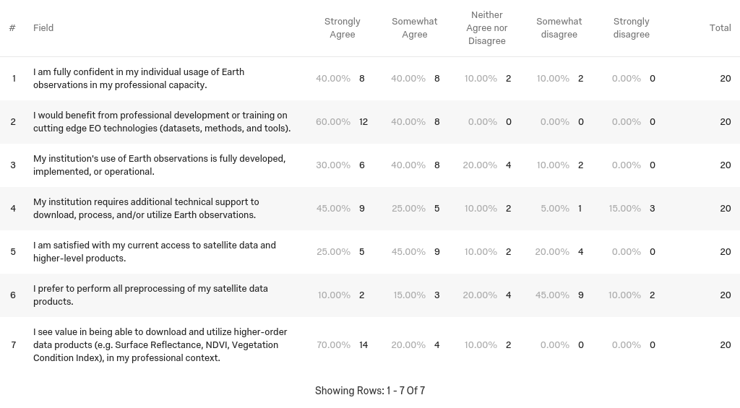

Figure 3: Responses to the GEOGLAM Holistic User Requirements Survey from self-identified remote sensing technicians (those who download, preprocess, analyze, or validate EO data or data products) (Whitcraft et al.).

Similarly, respondents who self-identified as individuals who use EO to produce higher-order information products for non-geospatial audiences were asked to evaluate a number of statements about EO usage in their organizations (Figure 4). Notably, while many articulated that they had a clear understanding of how EO could be used in their organizations (Statement 13), most agreed or strongly agreed that their **organization would benefit from increased use of EO** (Statement 10). While not particularly strong, the responses also indicated that **communication between EO producers and information users about the applicability and value of EO are needed** (Statements 1-3&7).

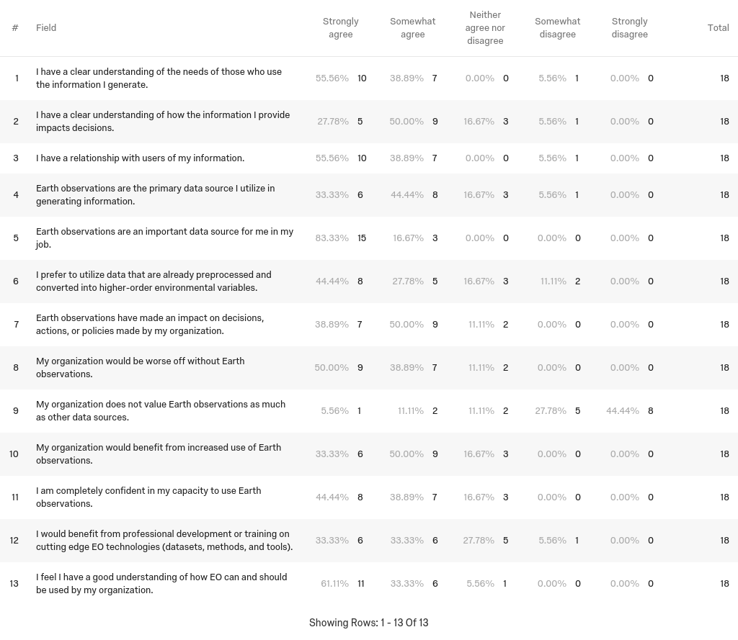

Figure 4: Responses to the GEOGLAM Holistic User Requirements Survey from self-identified information product generators (those who utilize EO to develop higher-order information products for a non-geospatial audience) (Whitcraft et al.).

This perspective was complemented by brief presentations on data services, platform, or tool, describing its objectives, usership, data sources, cost structure, and implementation status:

|  |  |
| --- | --- |
| **ICT System** | **Presenter/Affiliation** |
| ESA Thematic Exploitation Platform | Espen Volden (ESA) |
| COPERNICUS DIAS | Daniel Quintart (European Commission) |
| Copernicus Data in German Agriculture | Holger Lilienthal (Julius Kuhn-Institut) |
| CAP monitoring in the EU with Copernicus | Guido Lemoine (EC JRC) |
| Digital Belt and Road (DBAR): Big Earth Data | Xin Zhang (RADI-CAS) |
| CEOS Open Data Cube | Brian Killough (CEOS SEO) |
| IKI VEGA | Sergei Bartalev (IKI) |
| Sen2Agri | Pierre Defourny (UCL) |

The core takeaways from this portion of the requirements collection were:

1. It is desirable from the producer and user side to connect the different proliferating ICT platforms, to minimize duplication of effort, streamline lessons-learned, and minimize confusion to users.
2. GEOTIFFs were a vastly preferred data source for operational use – HDFs had very high scientific value but complementary production of GEOTIFF was viewed as more user friendly.

# GEOGLAM’s Role as Curator of Data, Products, Knowledge, and Technology

The agricultural monitoring communities view that GEOGLAM’s core function is as a “curator” of data, products, knowledge, and technology was reaffirmed and strengthened through this requirements gathering exercise. Particularly relevant to CEOS are the following GEOGLAM roles, which will be expanded upon in Section 4:

1. **Gathering and communicating data requirements to CEOS:** EO data coordination has been a core activity for GEOGLAM since its inception, and CEOS plays a critical role in ensuring agricultural observation requirements are addressed by current and planned missions. Specific recommendations related to this relationship are in Section 4, but let this point serve as an **affirmation of the value of the CEOS-GEOGLAM relationship** in assuring the provision of timely and sufficient data for downstream uses in the agricultural and food security monitoring community.
2. **GEOGLAM Endorsement of Products and Services:** One survey respondent – an end user of information – noted, *“There are more and more end user near real time EO products on the market and it is difficult to be constantly updated and have a good idea about the quality of the products.”* GEOGLAM can add significant value by developing an approach to endorsing data products and services to help users parse through their recent proliferation. This will ensure the consistency and credibility of GEOGLAM outputs, while increasing EO adoption and improving the usability of EO-based information by end user communities. Out of this has grown a community interest in developing Essential Agricultural Variables for GEOGLAM.This activity and how it relates to CEOS are articulated in Section 4.
3. **Capacity Development Coordination:** Even those who articulated that they were confident in their usage of EO still noted that they would benefit from professional development or training on cutting edge EO technologies. This is true in both the case of individual and institutional capacity. Regardless of the level of technical capacity, those on the receiving end of knowledge transfer and training activities clearly articulated the need for coordination across those on the delivering end. This not only ensures that end user priorities are the driving force, but also serves to maximize the efficiency and impact of activities within and outside the GEOGLAM community. In this vein, the GEOGLAM ExCom formally launched the GEOGLAM Thematic Coordination Team on Capacity Development (“CapDev Team”) in May 2019.

# Feedback to CEOS: Acquisition, Access, Adoption, and Sustained Use

The relationship with CEOS around data acquisition has been effective. EO data coordination for GEOGLAM through CEOS has principally been executed in the context of the JECAM and Asia-RiCE experimental activities, allowing the state of the science to evolve at a rapid pace. Despite marked increases in data acquisition and coverage by moderate spatial resolution satellites since the CEOS Ad Hoc Working Group on GEOGLAM’s (AHWG) 2012 launch, the challenge of scaling coordination to support national, regional, and global scale operational implementation persists. Where we were data limited, we are now largely constrained by issues related to data access and utilization. GEOGLAM’s efforts to identify these access and utilization requirements is timely, as CEOS space agencies have increased their efforts around data services during recent months and years.

**Developing a relationship around access and utilization are new frontiers in the evolution of the CEOS-GEOGLAM relationship.** Specifically, there were four recommendations for interaction between CEOS and GEOGLAM:

1. **GEOGLAM-CEOS Coordination on Data Quality Control & Assessment:** In light of the recent proliferation of data streams and associated products from CEOS agency missions, many users expressed uncertainty about which products were appropriate for their applications as well as how to gain access to them. A potential joint effort on data documentation and data quality standards would be of enormous benefit to the both the space and GEOGLAM data user communities.

* **Interoperability** between sensors was consistently referenced as of utmost importance.
* In the near-term, with existing missions, this might be achieved through consistent atmospheric adjustment, band pass adjustments/articulation of spectral response function, and/or **GEOGLAM-CEOS piloting of “Analysis Ready Data” as well as “Application Ready Data”**
* In the longer term, it was suggested that GEOGLAM should articulate “standard agricultural monitoring spectral bands” to be considered in future mission planning.

**CEOS Response:** CEOS is already pushing forward on Analysis Ready Data (e.g. CARD4L within LSI-VC) and has made progress on the Moderate Resolution Interoperability Initiative (within LSI-VC). GEOGLAM will present sensor intercalibration needs to WGCV LPV, after which CEOS will revisit the previously proposed “AGRI-12” action (2019-2021) to scope out the level of effort required to characterize requirements for interoperability across multiple land areas.

1. **Analysis Ready Data (ARD):** the CEOS Analysis Ready Data for Land (CARD4L) is useful to highly-trained remote sensing technicians with adequate computational infrastructure or access to cloud-based data processing modalities (e.g. CEOS Data Cube). There was agreement with the rapidly expanding volumes of data from new missions, increased attention to data access, continuity, and quality is needed. The breakout group discussing CARD4L emphasized the following priorities of high value to the agriculture community:

* Consistent atmospheric adjustment; excellent cloud, snow, and shadow masking
* Documentation on bandwidth impacts on interoperability, and how to adjust
* Making 10-30m time series coherent with historical 100+m resolution
* A thermal infrared product family specification
* Beyond this technical discussion, many users expressed a need for services which capitalize upon ARD to promote accessibility, such as NDVI anomaly or long-term vegetation index time series, in order for facilitate application and sustained use. For this, access to archival datasets is critical, and still an interest area for GEOGLAM. It is anticipated that future definition of EAVs (see below) will drive out further requirements for ARD products moving forward.

1. **Essential Agricultural Variables for GEOGLAM:** Due to the proliferation of EO-based data products, the demand for policy-relevant, actionable information is only increasing. This evolving demand is coming from the perspective of market information; early warning and forecasting; Paris Accords (climate change); Sustainable Development Goals (SDGs); and Sendai Framework (disaster risk reduction). All require a more quantified approach to agricultural monitoring, as well as the ability to go beyond in-season metrics and look at state and change between season and longer term. As such, the group identified a need for **consistently validated, standard agricultural products that can be leveraged alongside other data sources**. Development of requirements for a set of GEOGLAM “Essential Agriculture Variables (EAVs)” would leverage and complement other community efforts to define their thematic “essential variables.” Due to the fundamental nature of these variables they would support not only Paris Climate Accord metrics (adaptation, loss & damage, stocktaking) but also SDGs and the Sendai Framework for Disaster Risk Reduction. These EAVs sit within a data-decision cycle (Figure 5), which articulates the pathway between observations and eventual sustainable decisions that impact policy. A new GEOGLAM EAV Working Group has been established under the GEOGLAM Thematic Coordination Team on EO Data Coordination, with a first draft of EAVs already articulated. This group will meet for an in-depth workshop 23-24 October 2019 to advance this effort, and GEOGLAM expects that a succinct set of EAVs will be articulated later in 2019 and into 2020. These will define future requirements for space based EO, ARD and computing infrastructures beyond what is identified in this 2019 requirements document, necessitating a further revision post 2020.

**CEOS Response:** CEOS will iteratively respond to GEOGLAM EO Data Coordination team’s definitions of “Essential Agricultural Variables for GEOGLAM” through the CEOS mechanism dedicated to liaise with GEOGLAM and the agricultural monitoring community (at present, the CEOS Ad Hoc WG on GEOGLAM).In 2020, mechanisms for collaboration between CEOS constituent agencies, CEOS groups, and GEOGLAM WG on EAVs will be defined (AGRI-13).

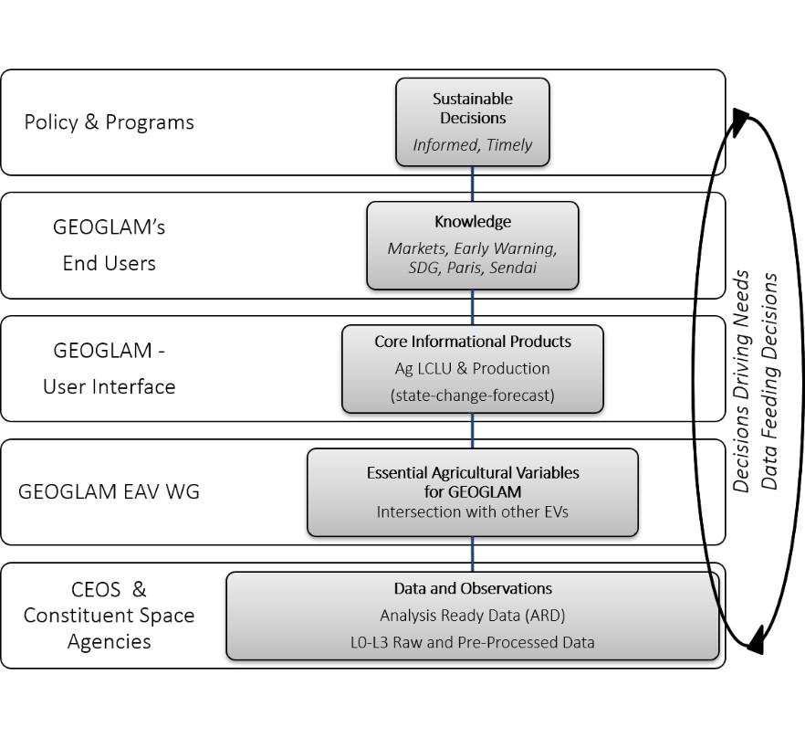

Figure 5: Data-Decisions Cycle that Underpins GEOGLAM, with responsible or liaising communities at left.

1. **Data Continuity and Observation Priorities:** The following data sets, products, or data characteristics were articulated as of high priority, with operational priorities occupying slots a-d (except sub-bullet “c”), and research e-g:
2. For all agricultural systems, 10-30m time series product, coherent with historical 100m+ observations
3. For smallholder systems, <10m data with high temporal resolution (cloud-free weekly to biweekly, which generally indicates a revisit of 5 days or less)
4. ~50m thermal observations every 2-3 days
   * Note: further research is indicated by the GEOGLAM community to confirm value of 2x daily thermal observations (morning and afternoon)
5. Passive microwave continuity
6. In addition to Sentinel 1, access to multi-frequency SAR systems (including X and L), as well as access to upcoming C-band SAR systems (e.g. Radarsat Constellation Mission)
7. Missions with bandwidths at 1.9, 2.0, 2.1 microns to target soil quality and organic content monitoring, for implications in tillage monitoring
8. Hyperspectral data has potential for agricultural assessment, but many research questions remain related to spatial, temporal, and radiometric resolution, as well as operational uses.

**CEOS Response:** These observations priorities (as well as those in Table 1) are accepted into the record by CEOS, with no further action requested at this time.

1. **Coordination on Capacity Development Activities:** It is essential to coordinate efforts by multiple actors working in the same countries and regions – and to have those efforts driven by end-user needs – in order to respect national processes and priorities while maximizing the impact of training investments. Essentially our experience to date has indicated that at sub-global scales, unless there is in country or region ownership of the information development, uptake by the policy community is generally poor. Consequently **GEOGLAM sees value in ensuring our newly-launched GEOGLAM CapDev Team is calibrated and coordinated with the CEOS Working Group on Capacity Development.**

**CEOS Response:** The CEOS WGCapD has invited GEOGLAM CapDev Team leadership to attend their coordination calls and meetings. Communication has been established between WGCapD Vice Chair and GEOGLAM CapDev Team and will be maintained to ensure coordination of resources.

1. **The *in situ* data challenge:** the lack of continuous open access to *in situ* data is perhaps the largest challenge for operational uptake of Earth observations. It was noted that while it is not specifically the role of CEOS, of its constituent space agencies, or of GEOGLAM to coordinate ground observation networks, it will require a concerted GEO community wide effort and this challenge should be brought to forward as it is core to to achieving space agency objectives of enhanced and sustained use of Earth observation in decision making.

**CEOS Response:** CEOS notes this message as relevant to its constituent agency membership, but no further action is required by CEOS.

# New GEOGLAM Observation Requirements Table

In addition to the holistic perspective on GEOGLAM data (access, use) requirements articulated in Sections 3 & 4, GEOGLAM also revisited and refined its observation requirements table (building off of the framework and format seen in Figure 1). It includes expanded articulation of target products (now identified as “Core Information Products” and “Essential Agricultural Variables for GEOGLAM,” in keeping with the Data-Decisions Cycle (Figure 5).

Table 1: GEOGLAM satellite data (right columns) requirements for community information needs (“target products” along top row), updated in 2018 in response to multiple sources including community survey, workshops, literature review, and research site information. This builds upon the methods and efforts described in Whitcraft et al. (2015), and shows continued value for coarse resolution observations, but a clear community movement into the moderate resolution domain. Requirements are characterized by spatial & spectral range, frequency with which reasonably cloud-free data are required, geographic extent of satellite acquisition, as well as the target product for which the measurements are suitable. Specific target product requirements are further refined by the field sizes for which a certain measurement would be useful. These appear on the right side of the table, where “L” refers to “Large fields” (defined as >15 ha), “M” refers to “Medium fields” (defined as 1.5–15 ha), and “S” refers to “small fields” (<1.5 ha). The symbol “x” indicates that these data are useful for that product’s generation for all field sizes. “VIS” indicates spectral coverage in the visible range (wavelength = ~400-700 nm), “Red Edge” indicates the same for ~680-750 nm, NIR is “near infrared” (~750-1300 nm), SWIR is “shortwave infrared” (~1300-3000 nm), thermal is “thermal infrared” (~3000-14000 nm), passive microwave (frequency = 1-200 GHz; wavelength = 0.15-30 cm), and SAR is “synthetic aperture radar” with multiple frequencies in the 1-5.5 GHz range (3-25 cm wavelength).



**CEOS Response:** CEOS notes these observation priorities and requirements and accepts them into the record. GEOGLAM has made no specific request at this time, and as such, no further CEOS action is necessary.

# Looking Ahead

GEOGLAM recognizes that as the state of science and operational use advances, so too will the observation requirements. As new sensors and capabilities come online, so too will the state of practice change. The continued communication between GEOGLAM and CEOS – via the CEOS Ad Hoc Working Group on GEOGLAM or whatever future form that co-community takes (the CEOS AHWG on GEOGLAM has proposed to move under LSI-VC as the SubGroup on GEOGLAM) – will be essential to both ensuring that the agricultural community’s requirements are clearly stated to the space agencies who design instruments and collect and distribute the data, but also that the value of the use of EO to agriculture and food security has a systematic means to be clearly articulated to the CEOS principals.

**CEOS Response:** CEOS agrees that the relationship with GEOGLAM has been successful and helped demonstrate the relevance of CEOS satellite data and tools for broad societal benefit. Continued engagement that is mutually beneficial to both GEOGLAM and CEOS as the space arm of GEO will be assured whatever the final home of the GEOGLAM-CEOS relationship.

# Notes & Appendix

Document prepared by Alyssa Whitcraft (GEOGLAM Secretariat), with text drawn from a prior report she generated with support from Ian Jarvis (GEOGLAM Secretariat), Felix Rembold (EC JRC), and Bettina Baruth (EC JRC). Further edits from Ian Jarvis, Brian Killough (CEOS SEO), and Bradley Doorn (NASA HQ) have been incorporated.

Inputs into the requirements reboot came principally from the following actors at an April 2018 meeting hosted by EC JRC in Ispra, Italy.

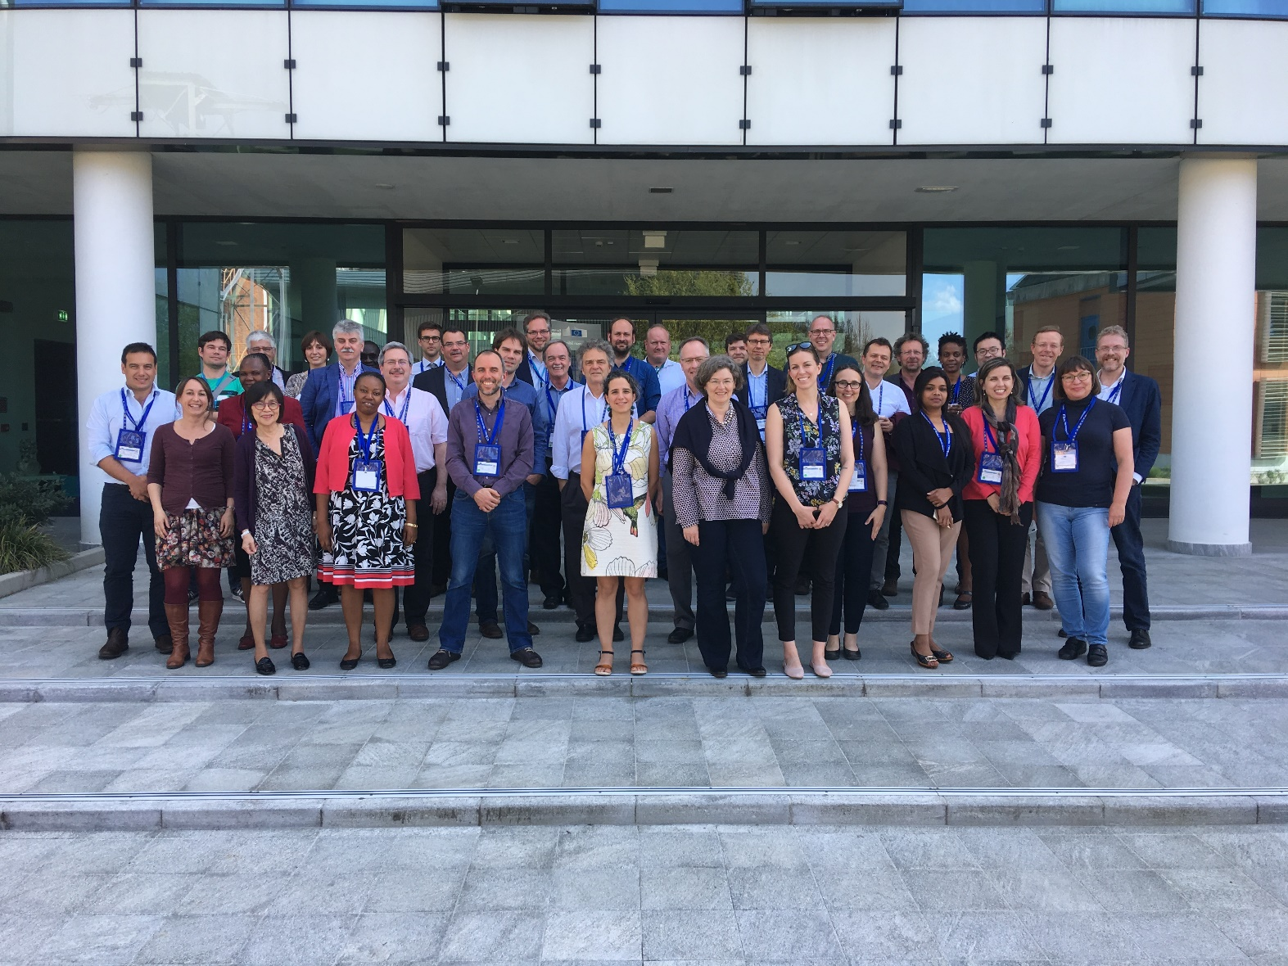

Participants in the GEOGLAM Workshop on Data and Systems Requirements for Operational Agricultural Monitoring  
17-18 April 2018 in Ispra, Italy

|  |  |  |
| --- | --- | --- |
| **Table 1: Participants and Affiliations** | | |
| **First Name** | **Last Name** | **Organisation** |
| Catherine | AHIMBISIBWE | Office of the Prime Minister- Uganda |
| Sergey | BARTALEV | Space Research Institute- Russian Academy of Sciences |
| Bettina | BARUTH | European Commission - Joint Research Centre |
| Inbal | BECKER-RESHEF | GEO Global Agricultural Monitoring (GEOGLAM) Secretariat & Harvest -University of Maryland |
| SOPHIE | BONTEMPS | UC Louvain-Geomatics |
| Catherine | CHAMPAGNE | Agriculture and Agri-Food Canada |
| Andrew | DAVIDSON | Agriculture and Agri-Food Canada |
| Gérard | DEDIEU | CESBIO |
| Pierre | DEFOURNY | UC Louvain-Geomatics |
| Carlos | DI BELLA | INTA |
| Bradley | DOORN | National Aeronautics and Space Administration |
| Lee | ELLENBURG | NASA – SERVIR |
| Steffen | FRITZ | International Institute for Applied Systems Analysis (IIASA) |
| Sven | GILLIAMS | VITO |
| Juan | GUERSCHMAN | CSIRO |
| Ian | JARVIS | GEO Global Agricultural Monitoring (GEOGLAM) Secretariat |
| Christopher | JUSTICE | Harvest – University of Maryland |
| Brian | KILLOUGH | CEOS Systems Engineering Office [Remote Participation] |
| Benjamin | KOETZ | European Space Agency |
| Nataliia | KUSSUL | Space Research Institute NASU-SSAU |
| Barthelemy | LANOS | European Commission- DG AGRI |
| Thuy | LE TOAN | Centre d'Etudes Spatiales de la Biosphere (CESBIO) |
| Guido | LEMOINE | European Commission Joint Research Centre |
| Holger | LILIENTHAL | Julius Kühn-Institut |
| Michel | MASSART | European Commission - DG GROW |
| Candice | SANTOS | CONAB – Brazil |
| Marystella | MTALO | Ministry of Agriculture – Tanzania |
| Catherine | NAKALEMBE | University of Maryland |
| Andy | NELSON | University of Twente - Faculty ITC |
| Terry | NEWBY | Agricultural Research Council - South Africa |
| John Martin | OWOR | Ministry of Agriculture - Uganda |
| Milena | PLANELLS | CNES-CESBIO |
| Felix | REMBOLD | European Commission Joint Research Centre |
| Shalini | SAXENA | Mahalanobis National Crop Forecast Centre MNCFC |
| Robert | TETRAULT | USDA Foreign Agricultural Service |
| Espen | VOLDEN | ESA – ESRIN |
| Alyssa | WHITCRAFT | GEO Global Agricultural Monitoring (GEOGLAM) Secretariat & Harvest University of Maryland |
| Xin | ZHANG | The Institute of Remote Sensing and Digital Earth (RADI) - the Chinese Academy of Sciences (CAS) |