Minutes of the 45th Meeting of the CEOS
Working Group on Calibration & Validation (WGCV)
16-19 July 2019
Perth, Australia

Key Outcomes
- The concept for a new Australian supersite to support multi-mission SAR calibration was presented and discussed. An action was taken to scope out exact requirements, plan, timelines, etc. for discussion at the SAR subgroup meeting in November.
- The Guideline for Ground Surface Reflectance Validation Measurements and Uncertainty Quantification was presented. WGCV will do a review of the document, submit it to close CEOS Work Plan Task CV-17 and then take this forward within WGCV and create some more specific and global protocols for CEOS to endorse.
- The WGCV CARD4L peer review process presented was agreed. An initial pool of reviewers were also identified. WGCV is now in a position to peer review the CARD4L self-assessments.
- WGCV will be proactive in engaging in the GHG Roadmap development. The WGCV Vice Chair will connect with the AC-VC and WGClimate GHG Task Team to ensure that the cal/val requirements in the GHG Roadmap are developed in coordination with IVOS to ensure the requirements are suitable and actionable.
- The new Cal/Val Portal will be made live at the end of October.
- The Terrain Mapping Subgroup (TMSG) was renewed with Peter Strobl/EC as the lead. The first task will be to develop a detailed plan for the DEMIX (DEM intercomparison) task that was proposed during the meeting.
- WGCV-46 is targeted for March 23-27 at Caltech. WGCV-47 is proposed to be joint with WGISS, and ROSCOSMOS offered to host (14-18 September 2020, Sochi).

Tuesday July 16th

Session 1:​ WGCV Business and Meeting Introduction

Chair/Vice Chair Welcome and Opening
Cindy Ong (CSIRO, WGCV Chair) and Akihiko Kuze (JAXA, WGCV Vice Chair) welcomed everyone to Perth and the 45th meeting of the CEOS Working Group on Calibration & Validation (WGCV-45).

Acknowledgement of Country
Ian Lau (CSIRO) communicated the traditional welcome message.

Tour de Table
Cindy Ong (CSIRO, WGCV Chair) initiated a tour de table of introductions. The complete attendance list is in Appendix A.

Welcome from CSIRO and Overview of EO in CSIRO
Alex Held (CSIRO) presented an overview of CSIRO, the Centre for Earth Observation, GEO Week 2019, NovaSAR, CSIROSat-1, Open Data Cube, and the CSIRO/GA priorities for their 2020-21 SIT Chair term, which are:
- CEOS Analysis Ready Data;
- Carbon and Biomass; and,
- UN Sustainable Development Goals.
He also presented a summary of Australia’s cal/val infrastructure and capabilities, as well as the AusCalVal initiative (proposed as a National Facility), which seeks to provide a top-down coordination and management layer to the numerous cal/val sites in operation throughout the country. The aim is to establish an all-in-one source and POC for cal/val as a national capability.

Astronomy and Space Science in Western Australia
Kevin Ferguson (CSIRO) presented an overview of CSIRO Astronomy and Space Science (CASS) and the various dish facilities spread across NSW and WA, in particular the Australian Square Kilometre Array Pathfinder (ASKAP).

Meeting Overview, Goals, and Agenda Approval
Cindy Ong (CSIRO, WGCV Chair) reviewed the main goals for the meeting. Maintaining and progressing the WGCV CEOS Work Plan Tasks/Deliverables is a key point, along with consolidating/solidifying WGCV’s collaborative efforts with other entities such as LSI-VC (ARD), WGISS, and AC-VC/WGClimate (GHG initiative). New CEOS Work Plan Tasks/Deliverables are also expected to be proposed and discussed.
The meeting agenda was reviewed and approved.
Greg Stensaas (USGS) pointed out the need for a new WGCV Vice Chair next year. He suggested that it would be worth starting the process of finding a candidate as soon as possible. WGCV leadership roles follow a geographic rotation and the next in line is Europe, but this is not a strict requirement. The nominations need to be presented at WGCV-46 and then finalised at WGCV-47. Cindy recalled the requirements regarding meeting travel, secretariat support, etc.
WGCV-45-01 | Everyone to consider nominating for the WGCV Vice Chair role that will become vacant in 2020.

Medhavy Thankappan (GA) asked whether there is an opportunity on the agenda to discuss the approved solar radiance tables and the recently noted issue with the SWIR component. Nigel Fox (UKSA) reported that in IVOS there is an ongoing debate about anomalies in the SWIR part of the spectrum. IVOS will convene a teleconference with GSICS people, WGCV members and the solar community to try and resolve the issue. The result will likely be a modification of the already approved tables. Further discussion cannot be held at WGCV-level until after the teleconference.

WGCV Chair’s Report
Cindy Ong (CSIRO, WGCV Chair) reported on recent meetings and CEOS SEC representation. Cindy reviewed the headline outcomes from the 32nd CEOS Plenary (available here) and SIT-34 (here). She also briefly presented her slides from SIT-34 (here).
Following Cindy’s review of SIT-34, there were concerns raised regarding the proposal to merge the CEOS ocean VCs. Alex Held (CSIRO) noted that this is still an ongoing discussion and nothing is finalised. He suggested any concerns be communicated through the current VC leads and CEOS Agency Contacts/Principals.

CEOS Executive Officer (CEO) Report
Steven Hosford (ESA/CNES, CEO) presented a general update on CEOS and the 2019-21 CEOS Work Plan:
- VAST-VNSC is the current CEOS Chair, and their main priority has been the Vietnam Data Cube;
- ISRO will be the CEOS Chair for 2020, with their priorities yet to be finalised;
- CSIRO/GA will be SIT Chair for 2020-21;
- The CEO position will be vacant from October, and nominations are urgently needed;
- The endorsed CEOS Work Plan 2019-21 is available here;
- CEOS Work Plan Task/Deliverable updates will be due by the end of September, ahead of CEOS Plenary;
- The next revision of the CEOS Work Plan will commence in the November timeframe;
- A new CEOS Deliverables Database is being established to help improve tracking, reporting, and accountability.
Cindy Ong (CSIRO, WGCV Chair) asked Steven to explain the suggestion to incorporate RADCALNET under the CEOS Services section of the CEOS Work Plan. Steven reported that the thinking was that while these kinds of activities are often spun up on a project basis, some are of greater utility to the broader community. Because CEOS is opening up to much broader operators of these kinds of missions, the idea was that space agencies have a quality assurance role and that CEOS Agencies could perhaps help other operators ensure their missions stack up to the ‘gold-standard’ missions of CEOS Agencies. Cindy’s feeling is that by branding RADCALNET as a ‘CEOS Service’ it implies some sort of continuity of support. Steven clarified that this is not the intent – it remains, as with all CEOS activities, ‘best efforts’ only. Nigel Fox (UKSA) noted that RADCALNET was established with a ‘service’ structure in mind, so this categorisation doesn’t cause any issues. Kurt Thome (NASA) noted that by including RADCALNET under ‘CEOS Services’, the ongoing work retains visibility at the CEOS management level.
Greg Stensaas (USGS) noted a broader need to maintain visibility for long-term ongoing/operational work, and suggested that there are a few other initiatives that might need to be included in the ‘CEOS Services’ section of the Work Plan, along with further promotion via the CEOS website, etc.
WGCV-45-02 | Greg Stensaas to follow up with the CEO regarding visibility at the CEOS management level for long-term ongoing/operational work.

WGCV Deliverables for the CEOS 2019-2021 Work Plan
Cindy Ong (CSIRO, WGCV Chair) reviewed the ten WGCV Tasks/Deliverables in the CEOS 2019-21 Work Plan. Nine of these are due by the end of 2019. She called on those responsible for each of the tasks to clearly summarise in their presentations to WGCV-45 how we are tracking towards completion of each of the tasks.
Cindy suggested that in the future WGCV should consider migrating some of its ongoing work (e.g., LPV Supersites) to the ‘CEOS Services’ section of the Work Plan as a means of making ongoing/operational work more visible.

Session 2:​ Australian Calibration and Validation Activities

Terrestrial Ecosystem Research Network Supersites
Mirko Karan (TERN) presented an overview of the Australian Terrestrial Ecosystem Research Network and the various sites they operate. TERN is Australia’s land ecosystem observatory. TERN observes, records and measures critical terrestrial ecosystem parameters and conditions for Australia over time from continental scale to field sites at hundreds of representative locations. This information is standardised, integrated and transformed into model-ready data, enabling researchers to discern and interpret changes in land ecosystems.
WGCV-45-03 | Fernando Camacho to connect with Mirko Karan regarding linking the WGCV Portal to the various TERN resources.

Australian Soil Moisture and Salinity Calibration and Validation Network (CosmOz)
Cindy Ong (CSIRO, WGCV Chair) presented on behalf of David McJannet (CSIRO). Cosmic-ray soil moisture sensors measure neutrons above the soil surface. The more soil moisture the fewer fast neutrons present. There are currently 15 sensors installed across Australia, in addition to mobile vehicle-based sensors for surveys. CosmOz contributes to the collaborative International Soil Moisture Network.

Australian Ocean Colour Calibration/Validation
David Antoine (Curtin University) presented on Australia’s current activities related to ocean colour radiometry calibration and validation, including the Lucinda Jetty Coastal Observatory and the Curtin University facilities on the Australian west coast (Rottnest Island) and a recent voyage of the CSIRO Investigator (Marine National Facility).
David also noted the Integrated Marine Observing System (IMOS) Radiometry Task Team (RTT), which has been established to improve consistency across the various activities taking place in the marine radiometry domain. The RTT is running a series of experiments to improve the consistency of radiometric measurements.

Australian Satellite Altimetry
Benoit Legresy (CSIRO) presented on IMOS satellite altimetry work in support of Sentinel-3, Sentinel-6 and SWOT.

SAR Supersite
Medhavy Thankappan (GA) presented the concept for a new Australian supersite to support multi-mission SAR calibration. The existing AGOS Corner Reflectors (CRs) are currently supporting routine calibration of X and C-band SAR missions, however the emergence of many longer wavelength SAR missions will necessitate larger CRs (2.5m; for SAOCOM, TanDEM-L, NISAR, ALOS-4, BIOMASS). NASA and ISRO have approached Australia (GA) regarding calibration options and the possibility of co-investment.
The proposal at this stage is:
- GA would potentially manage the project and have oversight.
- NASA contributes funds.
- Consortium fund GA management of the facility.
- Seeking Australian Space Agency link.
- Looking for further collaboration and co-investment.
Key outcomes from the Monday group discussion on this topic were:
- The value of global supersites for multi-mission SAR calibration, cross-calibration, and interoperability studies was reiterated.
- SAR supersites need to cater to multiple calibration and observation needs (CRs, transponders, PARCs, left/right looking missions, etc.).
- A defined set of criteria/requirements and characteristics would provide shared understanding for establishing SAR supersites (similar to RADCALNET).
- Sustainability of operations and co-investment are critical.
- A task plan to define the activity (with timelines) will be prepared by the SAR subgroup for discussion at their November 2019 meeting in Frascati.
Nigel Fox (UKSA) questioned the use of the term ‘supersite’ noting that this is to be used in cases where there are multiple parameters. Medhavy noted that this hasn’t been considered yet as it is still very early in the proposal process, but this will certainly be kept in mind.

AEROSPAN Network
Ian Lau (CSIRO) presented a quick overview of the AEROSPAN network, which is Australia’s contribution to AERONET.
Kurt Thome (NASA) asked where the sensors are calibrated. Ian confirmed this is done at GSFC, but the AEROSPAN team is looking to establish capacity to do this internally.
WGCV-45-04 | Anyone using AEROSPAN data is requested to contact Ian Lau with feedback to aid future budget discussions.

A Guideline for Ground Surface Reflectance Validation Measurements and Uncertainty Quantification
Tim Malthus (CSIRO) presented on the Digital Earth Australia surface reflectance validation project. The report detailing the methods used is proposed to be used as the basis for the response to WGCV’s CEOS Work Plan Task CV-17 (Continental-scale surface reflectance validation: Provide guidance for the development of methodologies to validate the results of the recent ACIX work leading to protocols for determining uncertainties for interoperable reflectance products).
The handbook will be shared with the WGCV community (in particular the IVOS and LPV subgroups) for review and feedback, before submission to close out CV-17 (while also noting that more specific protocols will be a follow-on CEOS Work Plan Task/Deliverable).
Panel tilt was found to be the most significant source of errors, and the guidelines present a number of recommendations for minimising these, among other things. Tim presented some of these recommendations:
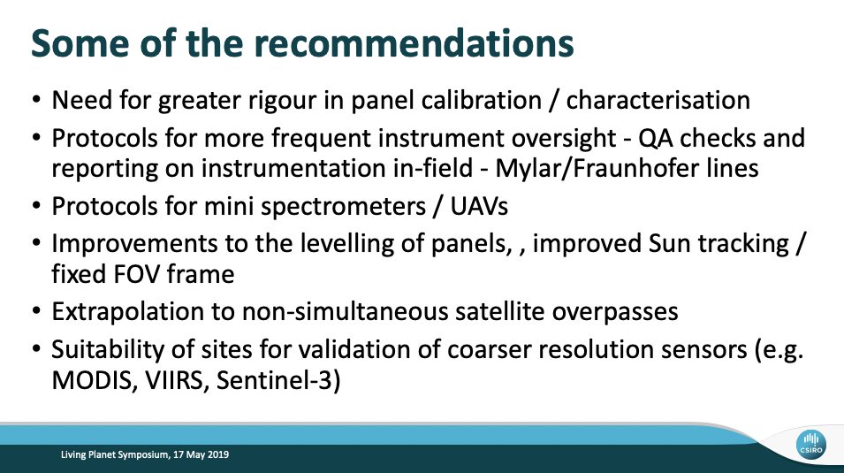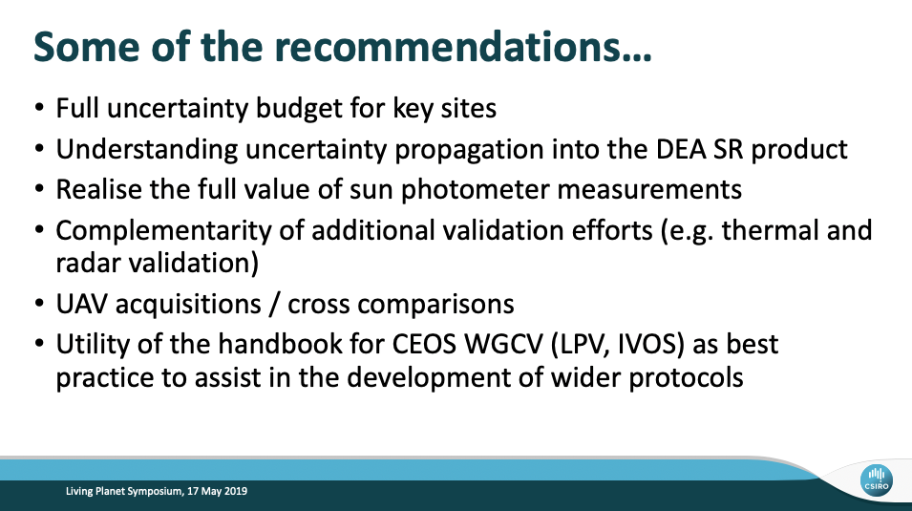

Session 3:​ Subgroup Reporting

IVOS Subgroup Report
Nigel Fox (UKSA) reported the latest on IVOS, including recent meetings, the subgroup’s terms of reference, membership, specific/cross-cutting projects (e.g., RADCALNET, MTF, PICSCAR), and IVOS-31 (all meeting materials are available on the cal/val portal). He noted some key actions and conclusions:
- ARD: the consensus of IVOS is to accept the CARD4L ‘Threshold’ specifications with the hope that these will evolve over time. IVOS is prepared to help assess compliance.
- Cal/Val Portal and Test Site Naming Convention: IVOS is keen to make use of the portal and to encourage its use with links made to it via presentations/papers, etc. IVOS is broadly happy with the test site naming convention proposed.
- Further Review Solar Spectral Irradiance: IVOS will initiate a teleconference with GSICS.
- IVOS encourages agencies (particularly those with hyperspectral sensors) to collect and provide data over CEOS radiometric sites (PICS).
- Support to GHG Roadmap: If helpful, IVOS could look at:
  - How to collate information to optimise pre-flight calibration of sensor requirements and methods (noting the opportunity of the pre-flight calibration workshop).
  - How to collate sites suitable for vicarious radiometric cal/val post-launch.
- Thermal IR: IVOS will consider holding a workshop on thermal IR at its next meeting and potentially prepare for the next comparison activity.
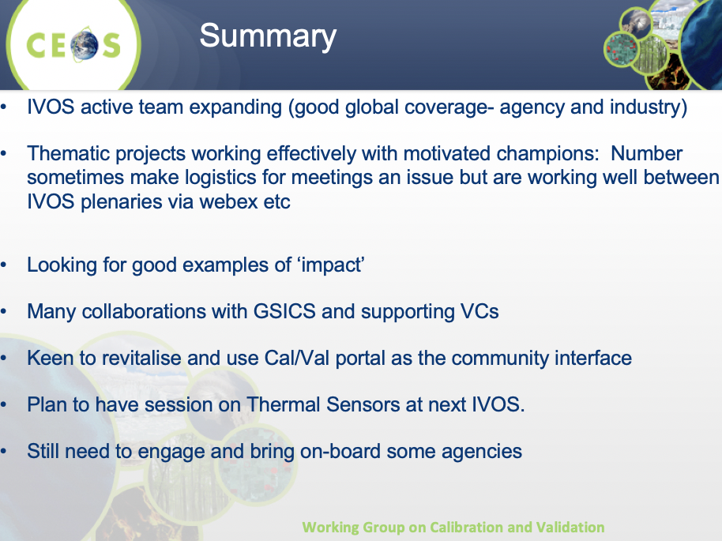

LPV Subgroup Report
Fernando Camacho (EOLAB/Parc Cientific Universitat de Valencia) reported:
- The LPV Vice Chair position is currently vacant.
- The FAPAR and LAI focus areas of LPV were recently merged due to them having similar ground data collection, product algorithms, and validation.
- The LPV validation framework ensures consistency in the guidance provided to data users.
- CARB-16-2018-2: Cal/val and production of biomass products from CEOS missions. The background paper on biomass protocols has been published.
- CARB-16-2018-3/CV-19: Biomass Validation Protocol. The protocol will be presented tomorrow in more detail.
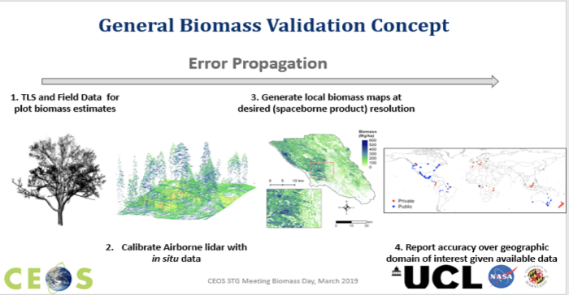
- CARB-16-2018-5: Establishment of biomass validation supersites:
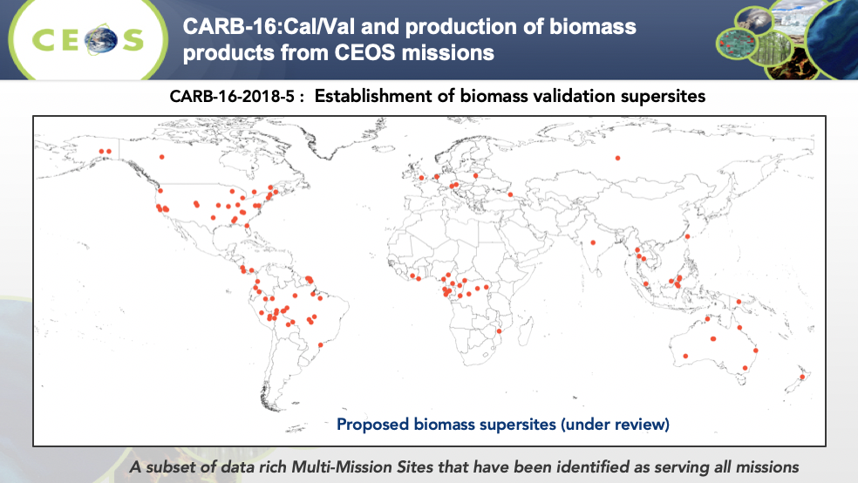
- The Surface Albedo Product Validation Protocol (the third protocol published after LAI and LST) was completed in 2019.
- CEOS LPV Supersite Network – Towards a European Network of Land Product Supersites: Currently being progressed. The sites will be super-characterised (canopy structure and bio-geophysical variables) that follow well-established protocols useful for the validation of (at least 3) satellite land products and for radiative transfer modeling approaches. The sites will be active, long-term, supported by appropriate funding and infrastructural capacity, and supported by airborne LiDAR and hyperspectral acquisitions (desirable).
- LPV contributed to the validation requirements for terrestrial ECVs for the GCOS Surface Reference Network.
- Completed MODIS, VIIRS, and ECOSTRESS LST validation.
- LPV will be working with the CEOS-GEOGLAM AHWG on CEOS Work Plan Task AGRI-13 and will produce a Land Cover Validation Protocol.
Fernando’s strategy for LPV 2019-2022 is based on four components:
- Continuous development of good practices.
- Improving ground references.
- Promoting validation and intercomparison exercises.
- Improving LPV focus area communication with stakeholders.
The LPV Action Plan 2019-2022 can be found on the LPV website. Fernando reviewed some of the recommendations from the LPV May 2019 meeting (see slide 26).

MW Subgroup Report
Xiaolong Dong (NRSCC, MWSG Chair) reported:
- The current focus of the subgroup is supporting CDRs from microwave instruments and supporting the CEOS VCs.
- At WGCV-44 the calibration requirements for radar scatterometers were confirmed for OSVW-VC. A focus group was established with the following objectives:
  - Develop guidelines for the calibration of radar scatterometers for OSVW-VC.
  - Develop and validate algorithms and methods for radar scatterometer calibration with global ocean NWP data.
- The next steps for the focus group are further confirmation of requirements with OSVW-VC, draft guidelines, summarising and reviewing past practices, identifying requirements and the availability of data for calibration, and organising a group for future collaboration on cal/val.
- Outlined the CFOSAT scatterometer calibration work.
- The guidelines for calibration of passive microwave sensors was promoted by the Standardization Administration of China to ISO.
- Still discussing potential collaborations with the Microwave Sub-Group of the GSICS Research Working Group.
Two recommendations were presented to WGCV-45:
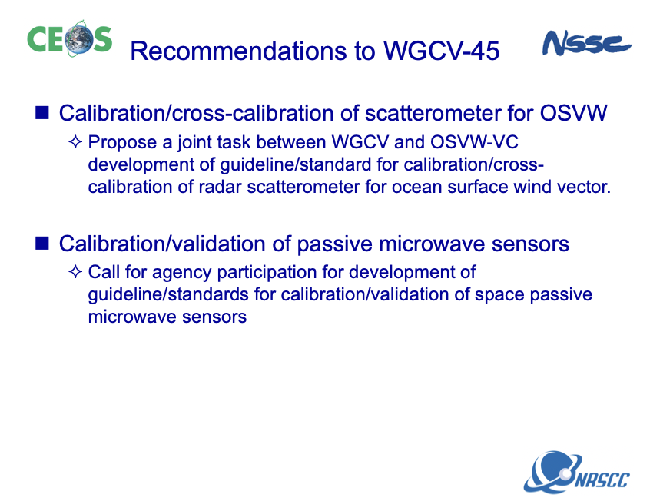
WGCV-45-05 | WGCV Chair to consider the addition of a new joint CEOS Work Plan Task/Deliverable with OSVW-VC on the development of guidelines/standards for calibration/cross-calibration of radar scatterometers for ocean surface vector winds.
WGCV-45-06 | All to consider nominating for a group to develop guidelines/standards for calibration/validation of space passive microwave sensors.
Cindy Ong (CSIRO, WGCV Chair) asked about the pre-launch calibration work done by MWSG. It was confirmed that this is not included in the scope of the pre-flight calibration workshop being planned, as it focuses only on optical data.
Cindy also asked about the status of the ISO standard on calibration of passive microwave sensors. Xiaolong confirmed that the standards are still about 2-3 years away from completion. Cindy urged everyone to get involved in the process to ensure the ISO standard is suitable, noting issues in the past with optical standards. Agencies can input through country representatives.
WGCV-45-07 | All to consider potential inputs to the development of an ISO standard on calibration of passive microwave sensors and communicate these via national channels.

SAR Subgroup Report
Medhavy Thankappan (GA) reported for Bruce Chapman (NASA/JPL):
- Reviewed the 2019 25th SAR subgroup workshop. The main topics discussed at the meeting were CARD4L for SAR and joint investment in cal/val supersites. The discussion on SAR CARD4L focused on the additional SAR Product Family Specifications under development and peer review of the Normalised Radar Backscatter self-assessments.
- The next SAR subgroup workshop will be held in Frascati, Italy, hosted by Nuno Miranda (ESA) of ESRIN, simultaneously with the VH-RODA meeting, in the week of November 18th, 2019.
- Discussions are continuing around updating the SAR Cal/Val CEOS website pages.
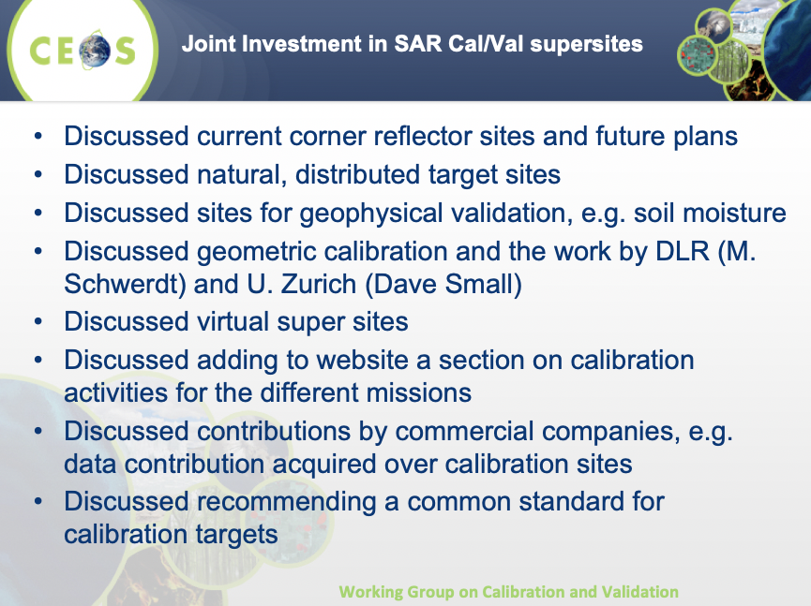

Wednesday July 17th

Day 1 Summary
Cindy Ong (CSIRO, WGCV Chair) reviewed the actions from the first day of WGCV-45. All were agreed, and the following action was added:
WGCV-45-08 | Everyone who is non-EU to consider  nominating for the LPV Vice Chair role that has  become vacant.

Session 4:​ WGCV Interactions With Other CEOS Groups

LSI-VC & CARD4L
Matt Steventon (LSI-VC Secretariat) presented background information on the CEOS LSI-VC, CARD4L, and the 2020-21 CSIRO/GA SIT Chair priorities – in particular the CEOS ARD Strategy.
Patrice Henry (CNES) asked how CARD4L compliance and versioning will work. What will happen when a dataset meets the CARD4L Specifications for one version, but then the requirements are made more stringent in future versions?
Cindy Ong (CSIRO, WGCV Chair) noted the need to connect the interoperability terminology work highlighted in the CEOS ARD Strategy with that being undertaken in IVOS.
WGCV-45-09 | Matt Steventon to ensure that the WGCV IVOS subgroup is consulted/added to the CEOS ARD Strategy task on interoperability terminology, noting the ongoing IVOS work on the topic and the need to ensure consistency.
Peter Strobl (EC/JRC) suggested that CEOS progress discussions with standards bodies regarding ARD sooner rather than later, noting that there are numerous efforts to define ARD already ongoing in OGC, etc.
Medhavy Thankappan (GA) presented the proposed WGCV CARD4L Peer Review Process (summary below, more details in the slides). The goal for WGCV-45 is to have the process agreed and a panel in place for the first assessments that are expected soon (surface reflectance).
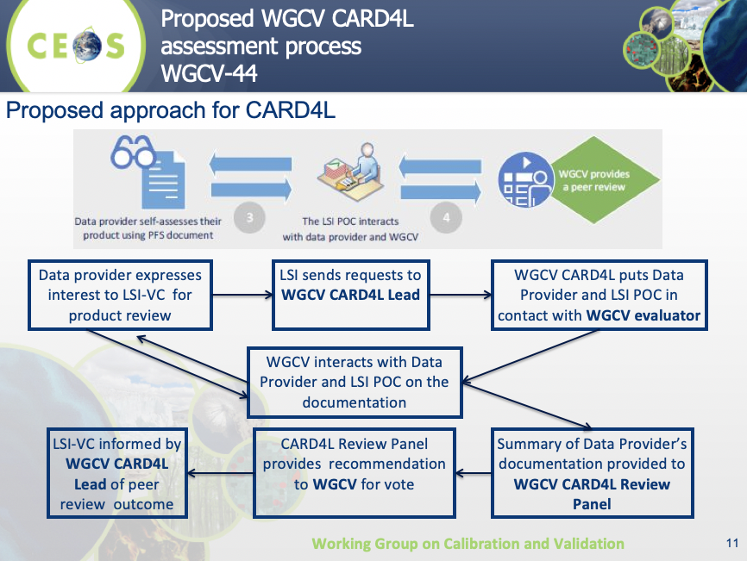
Kurt Thome (NASA) clarified that the data provider can bypass the Evaluation Lead’s decision/objections and push forward to the Review Panel if they so wish.
Decision 01 | The WGCV CARD4L peer review process presented was agreed.

WGCV-45-10 | Medhavy Thankappan and Kurt Thome to establish an initial pool of candidates for the CARD4L peer review panel (10-20) and choose an initial five people from this pool for the first peer review (expected to be for surface reflectance). | COMPLETE

AC-VC
David Crisp (NASA/JPL) reported on the AC-VC GHG White Paper (Architecture for Monitoring Carbon Dioxide and Methane from Space) and the role of space-based measurements in an atmospheric GHG inventory system. He noted the evolving/growing fleet of space agency GHG missions that would make up a GHG constellation. He presented the candidate operational CO₂/CH₄ constellation architecture to meet the GCOS requirements (three LEO and three GEO missions, augmented with Lidar and HEO missions (for the polar regions)).
The CEOS AC-VC GHG White Paper recommends the following approach:
- Refine requirements and implementation plans for atmospheric flux inventories.
- Produce a prototype atmospheric CO₂ and CH₄ flux inventory that is available in time to inform the bottom-up inventories for the 2023 global stocktake.
- Use the lessons learned from this prototype flux product to refine the requirements for a future, purpose-built, operational, atmospheric inventory system in time to support the 2028 global stocktake.
A WGClimate task group has been established to address the actions identified in the White Paper. WGCV was enlisted to support the definition of the calibration and validation needs. AC-VC was enlisted to support GHG constellation development and synergistic GHG and atmospheric composition observations and modelling efforts.
The first step in this process is to write a comprehensive Roadmap for the GHG activities to be conducted by WGClimate, WGCV, and AC-VC. A dedicated GHG Roadmap Meeting was held in Nakano, Tokyo, on 9 June 2019 to initiate the Roadmap. Endorsement of the Roadmap is targeted for CEOS Plenary 2019.
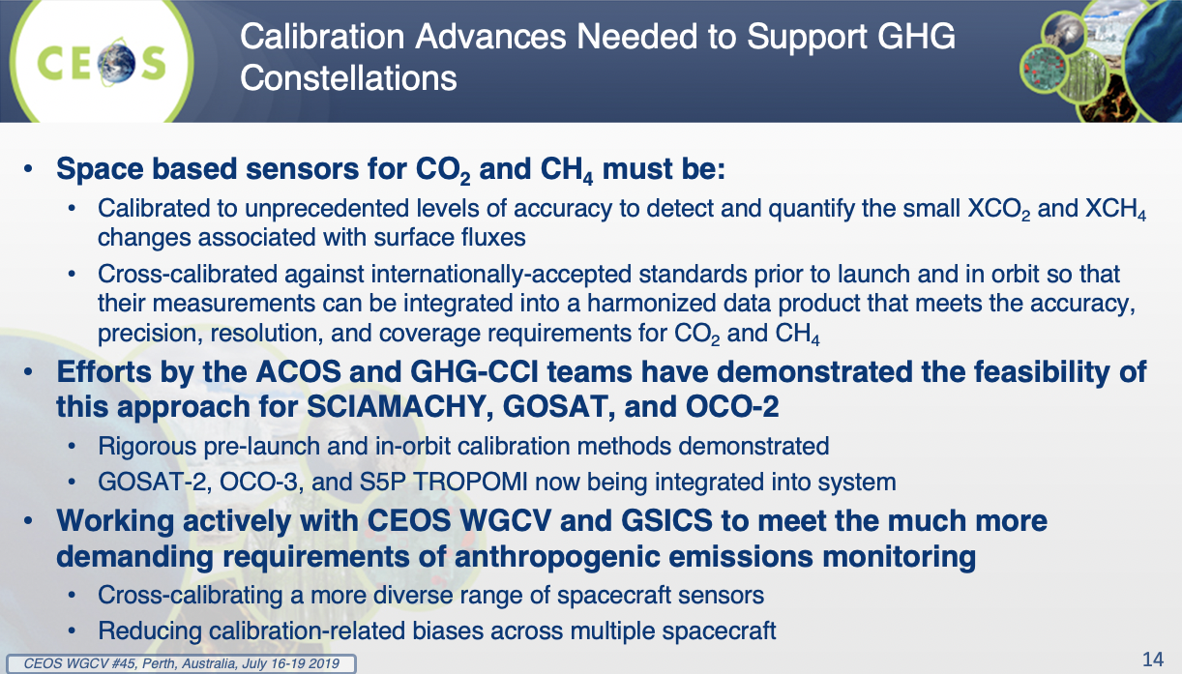
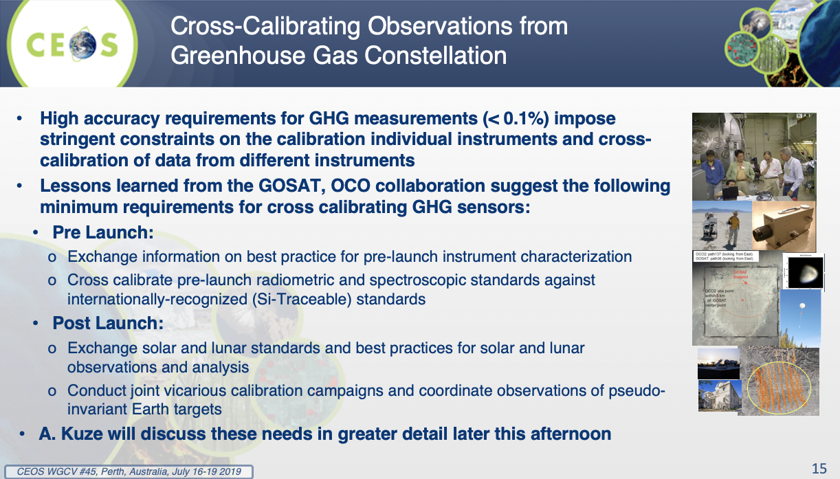
Session 5:​ Subgroup Reporting

AC Subgroup Report & GHG Reference Standards for Interoperability
Akihiko Kuze (JAXA) reported on behalf of Bojan Bojkov (EUMETSAT):
- The Working Meeting on Defining the Roadmap for Space Agency Coordination on Greenhouse Gas Monitoring in Tokyo was attended by the ACSG Chair and the Vice Chair of WGCV.
- The ACSG Chair and the Vice Chair of WGClimate are now in the process of planning the logistics of the ACSG meeting on Level 2 GHG calibration (October 2019).
- CEOS Work Plan Task CV-18 calls on ACSG to develop a list of reference standards for CO₂ and CH₄ products that are suitable for use in the intercomparison of multiple missions. A WGCV/ACSG expert meeting dedicated to the GHG FRMs is planned for October (invitation to be sent out shortly). The plan is to close CV-18 by mid-2020.
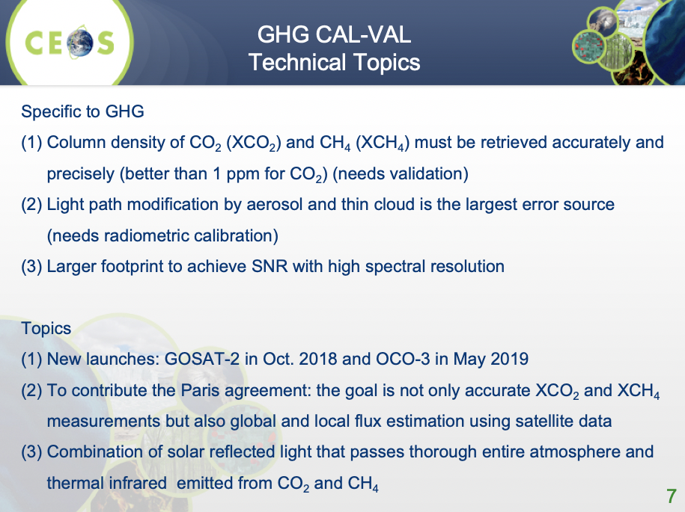
- Kuze-san reported on the recent RRV 2019 vicarious calibration and cross-calibration campaign for OCO-2/3, GOSAT-1/2 and TROPOMI. Intercomparisons were made very difficult by changing sky and cloud conditions. New in 2019 were intercomparisons with TCCON, vertical SNAAX spiral flights, and automobile surveys to confirm horizontal uniformity within the footprint.
Nigel Fox (UKSA) asked whether input is needed from IVOS on the GHG Roadmap. He stressed that any request should come through ACSG to avoid possible duplication of effort. Cindy Ong (CSIRO, WGCV Chair) noted that specific requirements are unclear until the Roadmap is developed. Nigel urged the ACSG/WGCV to be closely involved in the development of the Roadmap to ensure the requirements are suitable and actionable.
WGCV-45-11 | WGCV Chair and Vice Chair to connect with the AC-VC and WGClimate GHG Task Team to ensure that the cal/val requirements in the GHG Roadmap are developed in coordination with IVOS to ensure the requirements are suitable and actionable.

Session 6:​ Updates on Progress and Status of 2019-2021 Work Plan

CARB-16: Cal/Val and Production of Biomass Products from CEOS Missions
Fernando Camacho (EOLAB/Parc Cientific Universitat de Valencia) presented the background and components of the LPV Biomass Validation Protocol, which is currently being reviewed and edited internally. An external review is expected in early Fall, with finalisation by the end of the year.
The protocol will be implemented in two parts:
- CEOS LPV-led independent validation of products using biomass in situ supersites;
- User-led validation using a wide range of available in situ data.
A multi-mission biomass cal/val group (including GEDI, ICESat-2, BIOMASS, and NISAR mission teams) hold monthly teleconferences to work on data sharing and data collection coordination. The team is also undertaking a pilot with high spatial and temporal resolution Planet data to assess its utility for rapid identification of disturbances in reference plots. Validation tools/portal options are also under consideration for a multi-mission analysis and algorithm platform.
WGCV-45-12 | Philippe Goryl and Fernando Camacho to prepare a BRIX2 CEOS Work Plan Task/Deliverable for the next iteration of the CEOS Work Plan. | September 2019

Proposal: Solar Radiation Validation Protocol
Ian Grant (Australian Bureau of Meteorology) presented a proposal that LPV prepare a solar radiation validation protocol, justifying it by noting that Downwelling Surface Solar Radiation (DSSR) is:
- a key environmental variable – it drives weather, climate, evapotranspiration, plant growth, and solar energy;
- a GCOS ECV;
- produced by CEOS Agencies;
- ‘fuel’ for solar energy generation.
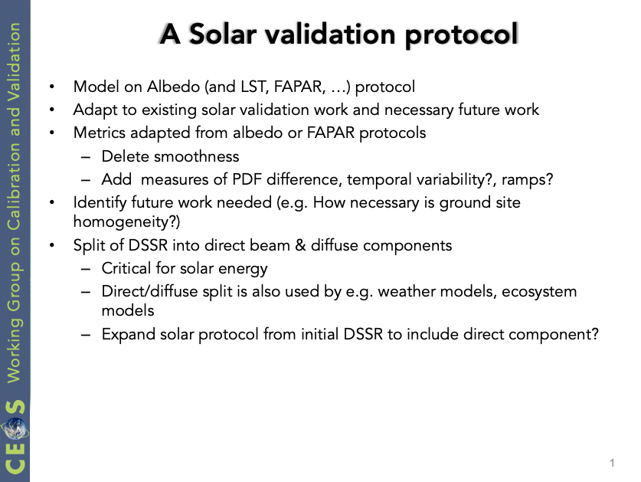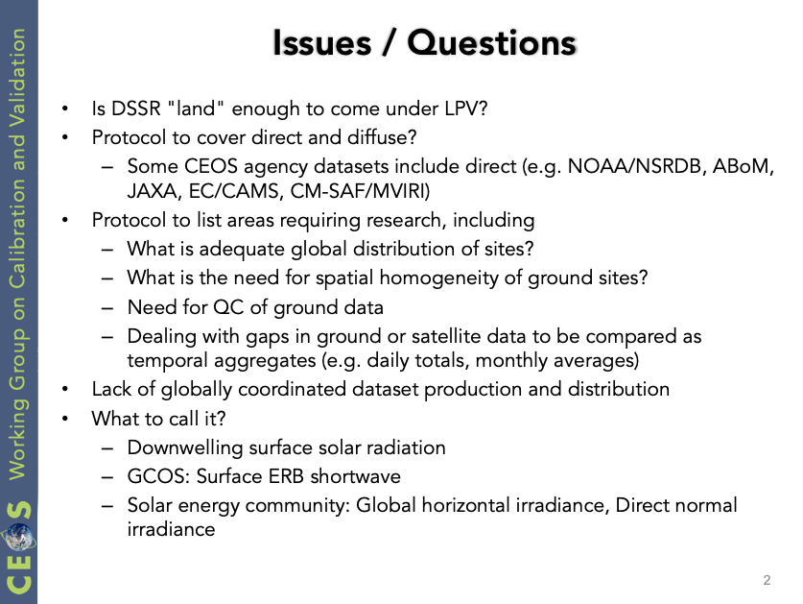
Nigel Fox (UKSA) suggested talking to WMO and PMOD regarding this proposal before progressing any further. Greg Stensaas (USGS) noted that NOAA has used SURFRAD sites to validate up/down-welling radiation. Input from PIs that have already done assessments with various satellite products would be helpful.
Ian clarified that Bilinear Surface Regression Models (BSRM) already provide ground data, but then there are no standard procedures for using this data with satellite products for validation. Satellites provide high spatial and temporal coverage, but need to be validated, and there are many open questions around how to do this (e.g., How to stratify comparisons? Geographic spread based on vegetation/atmosphere type?). There is a need to review the existing work of agencies in comparing satellite estimates of solar data with measurements from the ground. It was also clarified that this proposal is not looking to duplicate the work of the BSRMs.

CV-3: Workshop on State of the Art for Pre-flight Calibration Techniques
Nigel Fox (UKSA) presented the latest on the planning for this workshop (proposed to be jointly hosted by GSICS), which is now expected to take place in Q1 2020, with a focus on optical imagers.
WGCV-45-13 | WGCV Chair to follow up again with Mitch Goldberg for GSICS sign-off on the pre-flight calibration workshop plan and flyer, noting the mention of the workshop in recent GSICS Executive Panel minutes. | COMPLETE
WGCV-45-14 | Nigel Fox to share the latest flyer and strawman for the pre-flight calibration workshop with Cindy after revising it to include GHG in the scope. | July 26

Patrice Henry (CNES) noted the proposed CNES/Toulouse location for the workshop and indicated the need for at least a year’s lead time to prepare for the meeting.
Cindy Ong (CSIRO) noted she has raised this with Mitch Goldberg (NOAA, GSICS) in the past, and he needs the approval of the GSICS Executive Board before signing off on the workshop. She asked what the implications are if GSICS is dropped as a co-organiser. Nigel said there are no implications.
Kurt Thome (NASA) suggested revisiting the scope of the workshop and making it more IVOS-internal again if GSICS is dropped as a co-organiser.
WGCV-45-15 | Nigel Fox to push ahead with the next steps on the pre-flight calibration workshop, starting with an email to those involved to propose a planning teleconference in September. | Before End August

Steven Hosford (ESA/CNES, CEO) suggested the NOAA SIT Chair (Steve Volz) might be able to help with the GSICS response. He also confirmed there is no issue with the completion date of CV-3 being pushed back, provided a sufficient update and evidence of activity is provided.

Kurt suggested that GHG aspects could be considered in the scope of the workshop, given the shift in date.

CV-14: Report on the Application of Approaches for Cloud Masking
Philippe Goryl (ESA) reviewed the ACIX II (ACIX-Land) and CMIX activities. The intercomparison results are expected to be presented at the 2nd ACIX Workshop in November, with final publication targeted for February 2020 (consistent with the current due date of Q2 2020).

CV-15: Level 1 Top-of-Atmosphere Interoperability
Nigel Fox (UKSA) presented. Nigel confirmed that the report is expected by Q4 2019. It will be an initial report showing the state of play and what might be needed going forward. CV-15 will close with the completion of this preliminary report, but other CEOS Work Plan Tasks/Deliverables are expected to follow on. Kurt Thome (NASA) suggested that two of those follow on activities could be quantifying uncertainties in interoperability and moving toward Level 2.

CV-17: Continental-Scale Surface Reflectance Validation
Medhavy Thankappan (GA) presented on the Geoscience Australia-funded Digital Earth Australia (DEA) activity to undertake continental-scale validation of surface reflectance products and compile community protocols for the validation of surface reflectance data. The DEA report will be shared with WGCV for review and comments, after which it will be submitted to CEOS to close CV-17. The protocols developed could be adapted to global protocols under a future WGCV task.
Medhavy also covered the sensitivity analysis work done for the DEA surface reflectance products (variables were: AOD, water vapour, solar angle, and BRDF). DEA is now moving to Phase 2 which will increase automation and drone measurements, and will explore further crossovers with new LPV and IVOS initiatives.
WGCV-45-16 | Tim Malthus to share the DEA continental-scale surface reflectance validation protocol with the WGCV community for feedback and edits before the document is finalised to complete CEOS Work Plan Task CV-17. | COMPLETE

FDA-12: Inventory of Space Data Product Formats used by CEOS Agencies
Kurt Thome (NASA) presented on this task, which aims to identify recommendations that will facilitate interoperability between CEOS Agency datasets. There are overlaps with other joint WGCV-WGISS tasks on data formats and interoperability in the framework of FDA and quality indicators in discovery metadata. The proposed way forward was presented:
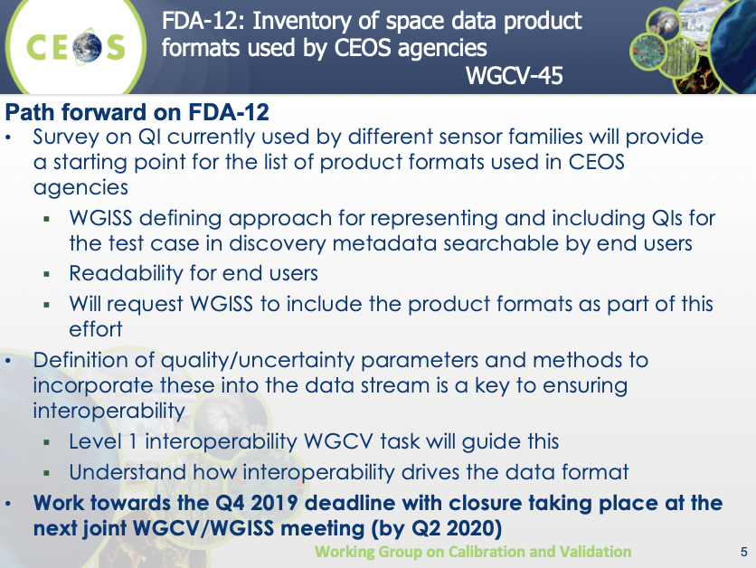
WGCV-45-17 | Cindy Ong to follow up with Bruce Chapman regarding WGCV-46 dates (target is spring break at JPL, March 19-29). | COMPLETE

CV-09: Radiometric Calibration Network (RADCALNET)
Nigel Fox (UKSA) presented an update on the Radiometric Calibration Network (RADCALNET). He reported that RADCALNET has moved to a ‘collections’ model, where data is updated once a year to address issues identified in the past year. The 2020 collection will include improved uncertainties for sea level sites; reduce the bandwidth from 20nm to 10nm; and correct minor problems with uploaded data (improved quality control, etc.). Usage statistics reveal that RADCALNET has around 314 users from 36 countries.
Kurt Thome (NASA) noted that a peer reviewed paper on RADCALNET will be published soon.
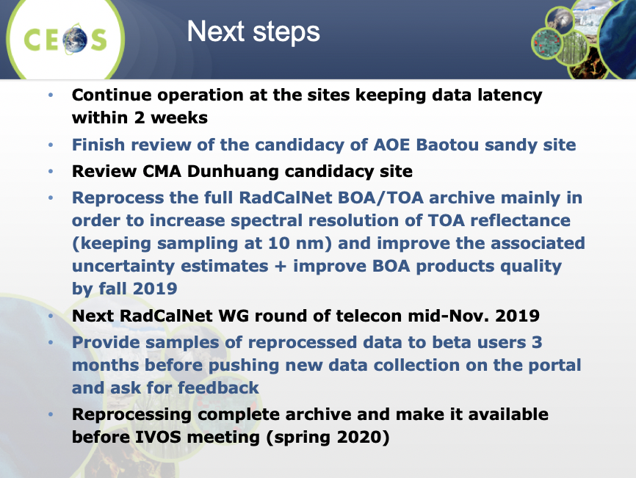

Session 7:​ Agency Reports

Indian Space Research Organisation
Arundhati Misra (ISRO) presented. A discussion followed the presentation:
- Medhavy Thankappan (GA) asked if ISRO is planning on dedicated infrastructure for the calibration of the S-band instrument on NISAR. Arundhati confirmed that yes they are (2 metre corner reflectors).
- Nigel Fox (UKSA) asked whether the IMGEOS cal/val facility might be able to become part of RADCALNET.
- Nigel also asked whether hyperspectral data from HySIS could be shared for some of the sites being used for CEOS (e.g., PICS sites). It would be very helpful if this data were available. Arundhati might be able to say more next year.
WGCV-45-18 | Arundhati Misra (ISRO) to follow up the possibility of ISRO contributions to RADCALNET and hyperspectral measurements over PICS sites with Nigel Fox (via teleconference, looping in other ISRO colleagues).

Centre National d'études Spatiales
Patrice Henry (CNES) reported. He covered the CO3D mission, MAJA (atmospheric correction processor for high revisit sensors; open source, running on Theia and PEPS), and some other THEIA processors, among other topics. A discussion followed the presentation:
- Maintaining the full PEPS archive is expensive and it is unclear if this will continue into the future. The DIAS for example will not have access to a full archive of Sentinel data.
- There was a long discussion on the properties of CARD4L, with some noting that there is a risk of over-selling the ARD concept. It was stressed that ARD is only aiming to satisfy the non-expert user base. It was also noted that CARD4L is not prescriptive, it just calls on data providers to document their approach.

European Space Agency
Philippe Goryl (ESA) presented an overview of ESA missions including the Earth Explorers and Copernicus Sentinels (there are six candidates for the second phase). Philippe presented EDAP (ESA Data Assessment Pilot) – a project to assess the quality of data from NewSpace companies and also to establish dialogues with the various mission providers in order to improve the overall coherence of the EO system. He noted the VHR-RODA CEOS WGCV SAR workshop planned for November 2019 and the Eradiate Community Workshop 2019 at JRC, also in November. Philippe also reported that ESA is a full member of GSICS since March 2019.

United Kingdom Space Agency
Nigel Fox (UKSA) presented an overview of TRUTHS – proposed by the UK as a new potential element of the European Earth Watch Programme, with the aim of creating a space-based climate and calibration observatory (ideally as a constellation with NASA’s CLARREO and possibly a similar Chinese mission). It will measure incoming and reflected solar radiation ten times more accurately than done previously, providing a more accurate assessment of the energy entering and leaving Earth’s climate system. Being primarily a climate mission, climate parameters drive the requirements. The mission will have a lifetime of 5-7 years and is planned for launch in the 2026-2028 timeframe. Repeated missions are needed to detect long-term changes.

Thursday July 18th

Session 8:​ Agency Reports (Continued)

National Aeronautics and Space Administration
Kurt Thome (NASA) reviewed NASA’s Earth science mission portfolio, the selection process for the Earth Venture missions, and the Decadal Survey. He reviewed CLARREO Pathfinder (2022-2023 launch), which will provide on-orbit (ISS), high accuracy, SI-traceable calibration. There is the ability to transfer this calibration to operational sensors with coincident observations. CLARREO Pathfinder will be a one-year mission to demonstrate the utility and learn lessons for follow-ons. A follow-on for CLARREO Pathfinder was rated highly in the Decadal Survey.

United States Geological Survey
Greg Stensaas (USGS) presented:
- The EROS Cal/Val Centre of Excellence (ECCOE) aims to improve data quality across all systems. EROS have received additional funding for ECCOE, and as such will be increasing staff by 7-10 FTE. An ECCOE workshop is planned for September 23, with GEO-LEO as a focus.
- The status of Landsat 7, 8, and 9, including radiometric stability statistics for Landsat 8.
- Landsat Collection 2 (Level-2 surface reflectance and surface temperature).
- The 3rd Lunar Calibration Workshop (late 2019).
- EROS is in discussions to take over the NASA Harmonized Landsat-Sentinel project (currently coordinated by Jeff Masek, NASA).
- The Land Product Characterisation System (LPCS) joint effort of NOAA and USGS (facilitates the characterisation and validation of higher-level scientific data products).
- The USGS approach to surface reflectance validation.
WGCV-45-19 | Greg Stensaas to follow up regarding linking LPCS and other USGS tools to the cal/val portal.

Japan Aerospace Exploration Agency
Akihiko Kuze (JAXA) reviewed JAXA’s EO mission portfolio. He noted that JAXA missions are currently contributing to 23 of the 50 ECVs. Kuze-san presented on GCOM-W and noted the 10th anniversary of GOSAT observations (January 23, 2018). He also presented on new GOSAT products that have been generated since 2009. Future JAXA EO missions include ALOS-3(optical)/4(radar) (2020-2021), EarthCARE (2022), GOSAT-2 Follow-on/AMSR-3 (2022-2023).

Australian Bureau of Meteorology
Ian Grant (Australian Bureau of Meteorology) presented an overview of the Bureau and its measurement products.
The Bureau's Dobson, ozonesonde and MAX-DOAS ozone observations are now collected and available through the ESA Validation Data Centre and are being used for TROPOMI validation. The Dobson and MAX-DOAS observations are also submitted in near-real-time to the Copernicus Atmospheric Monitoring Service. The Bureau supplies a large fraction of southern mid-latitude ozone observations.
Ian presented some new atmospheric composition instruments being deployed by the Bureau: MAX-DOAS, SAOZ, and Pandora.
The Bureau produces and validates sea surface temperature datasets from AVHRR, VIIRS, and Himawari-8 under the GHRSST framework. It also produces various satellite solar data products, which are bias corrected using surface data from a network of stations around the country.

Geoscience Australia
Medhavy Thankappan (GA) reported on the following GA activities:
- Continental surface reflectance validation.
- Digital Earth Australia/GA Landsat Collection 3 (uses USGS Collection 1 Level 1 as a baseline). Sample products were released July 19, 2019. GA’s Landsat Collection 2 will be decommissioned in June 2020.
- Digital Earth Africa – a sovereign operational and analytical capability for Africa, with in-country expertise in EO data analysis and management.
- Updates to the AGOS and Yarragadee corner reflector sites.
- Operational ARD processing for Sentinel-1 and contributions to the LSI-VC SAR ARD definition process.
- Independent Landsat surface brightness temperature validation using GA’s products and field data.

European Commission
Peter Strobl (EC/JRC) reviewed the Copernicus programme, the DIAS (Data and Information Access Services; combine data with a cloud-based architecture of services to bring users closer to the data), and Copernicus Evolution. Sentinel expansion missions are planned to start phasing in around 2025, and in the 2030-2032 timeframe the new generation Sentinels are expected to be operating. Peter also presented some Copernicus Global Land Monitoring Service examples including the global land cover layers and the Global Mosaics service which strongly relate to CEOS ARD and Data Cube topics.

National Space Science Center, Chinese Academy of Sciences
Yongmei Wang (NSSC, CAS) presented some of the remote sensing activities taking place at NSSC, covering both the ocean and atmosphere domains. She reviewed missions to which NSSC contribute, CFOSAT and its scatterometer, the on-orbit calibration of FY-3, and various upcoming missions.

Academy of Opto-Electronics, Chinese Academy of Sciences
Ning Wang (AOE, CAS) reviewed the Baotou cal/val site capabilities and activities (supports high resolution satellite missions of China), and presented on the airborne transfer calibration campaign, advances in spaceborne radiometric transfer calibration research, consideration of an atmospheric and eco-environment comprehensive monitoring scientific platform, and future plans. More information is available in the slides here.

National Oceanic and Atmospheric Administration
TaeYoung Choi (NOAA) presented an overview of NOAA’s polar and geostationary programmes and presented an assessment of the VIIRS Reflective Solar Band, Thermal Emissive Band, and Day-Night Bands and their updates. GOES-17’s radiance quality and major VNIR update were also addressed.
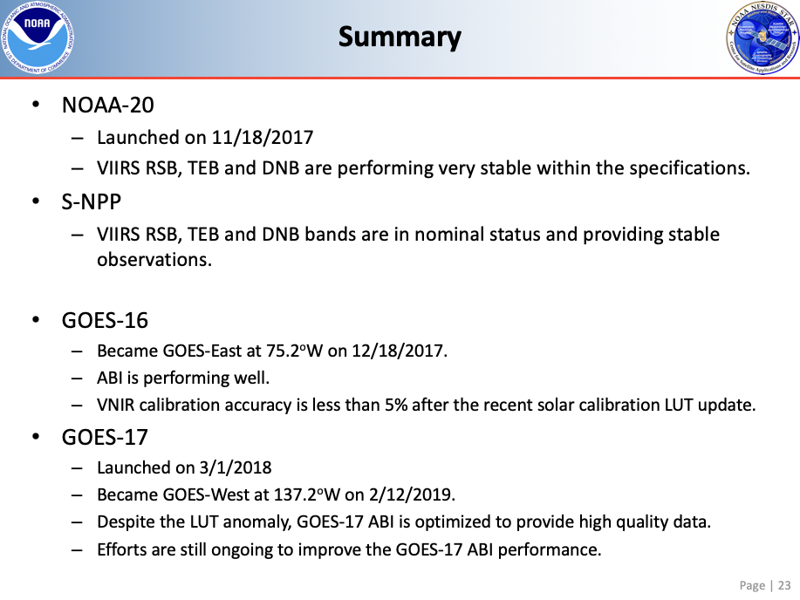
Greg Stensaas (USGS) asked whether the JPSS follow-on sensors are the same as those flown previously. TaeYoung confirmed that they are, however with small fixes to address stray light issues.

Session 9:​ WGCV Open Task Updates, Progress and Status

Cal/Val Portal Update
Philippe Goryl (ESA) reported on behalf of Paolo Castracane. He reviewed the new Cal/Val Portal that is currently under development and noted that inputs are needed from everyone to flesh out the content. Paolo requires assistance regarding what information users will be interested in. Ensuring there is a robust and harmonised set of tagging terminology is also critical.
Input is particularly needed on the ‘Sites’ page, which aims to present all CEOS-endorsed test sites and networks, sorted by subgroup domain. An interactive map was suggested for this page in addition to the existing list. It was suggested that the top layer of ‘CEOS Supersites’ be removed and to also include links to other networks, e.g., AERONET.
Submissions are also needed for the ‘Projects’ page. Greg Stensaas (USGS) noted the need for ‘Validation Teams’ in addition to ‘Projects’, and he suggested that activities should be categorised.
A Twitter account/feed specific to cal/val was agreed as a good idea. This feed will be embedded on the Cal/Val Portal pages.
The audience for the Cal/Val Portal was agreed to be people that are unfamiliar with the content, however the first step is having something that is useful to WGCV itself, to help justify the maintenance and hosting.
Dedicated Cal/Val Portal teleconferences were proposed to avoid overcrowding the monthly WGCV teleconference.
WGCV-45-20 | WGCV Chair and Philippe Goryl to set up standing monthly teleconferences dedicated to cal/val portal development and content curation. | Once the new cal/val portal is made live at the end of October
WGCV-45-21 | WGCV Chair and Philippe Goryl to re-send all details related to the new cal/val portal website along with a call for feedback, updates, content, etc. | COMPLETE

Decision 02 | A standing side meeting (around 2 hours) on cal/val portal development will be added to the agenda for face-to-face WGCV meetings going forward.
Decision 03 | The new cal/val portal will be made live at the end of October.

DEM Related Topics
Kurt Thome (NASA) reviewed past work on DEM topics and actions. WGCV Actions 39-18, 41-02, and 42-11 were all recommended to be closed. WGCV Action 39-19 is still open, awaiting the redesign of the Cal/Val Portal. He presented slides from WGCV-44 regarding the DEM Task Team, the possibility of a DEM Intercomparison exercise (DEMIX) and the Terrain Mapping Subgroup. The outcome from the discussion at WGCV-44 was that the DEM Task Team concept should continue to be explored. Two actions also emerged from WGCV-44:
- WGCV-44-01: Survey recent results from Surface Reflectance ARD efforts within LSI-VC to determine current DEMs being used and provide a list of DEMs and their resolutions and uncertainties.
- WGCV-44-02: Draft an approach that could quantify the geometric and radiometric uncertainties from DEMs of varying spatial postings and vertical resolutions.
Kurt reported that a presentation planned for this Friday should close WGCV-44-02. Greg Stensaas (USGS) will send inputs for WGCV-44-01 to Cindy Ong (CSIRO, WGCV Chair) and Kurt now so the action can be closed tomorrow.

Terminology (WGCV-40-2)
Nigel Fox (UKSA) presented on Action CV-40-2. A task group has been established under IVOS to:
- Compile a dictionary/thesaurus of “correct enough” definitions for different words (e.g., accuracy, resolution, interoperability, harmonisation).
- Prepare tutorial materials to help communicate these definitions to the broader community.
A list of candidate terms has been compiled. Nigel presented a few questions as an example of the types of points that need consideration, including around accuracy, resolution, interoperability, and harmonisation. He noted that multiple definitions are acceptable (due to different communities, uses, etc.).
Peter Strobl (EC/JRC) suggested looping the OGC community into the task. Cindy Ong (CSIRO, WGCV Chair) suggested consulting IEEE standards people also.
The following action from yesterday was recalled (WGCV-45-09) and a new action was recorded regarding sharing the LSI-VC document on interoperability terminology as a potential input to the work of IVOS. Maintaining consistency between these similar efforts is critical.
It was agreed that a wiki should be established on the new Cal/Val Portal to consider, discuss and iterate on the definitions.
WGCV-45-09 | Matt Steventon to ensure that the WGCV IVOS subgroup is consulted/added to the CEOS ARD Strategy task on interoperability terminology, noting the ongoing IVOS work on the topic and the need to ensure consistency.
WGCV-45-22 | Steven Hosford to share the LSI-VC document on interoperability terminology. | COMPLETE

IVOS Spatial Quality Task Group Updates (WGCV-42-05, 42-06)
Nigel Fox (UKSA) presented the status of the IVOS Spatial Quality Task Group and their effort to define a framework/recommendations for in-flight Modulation Transfer Function (MTF) measurement methods to ensure good geospatial quality. Actions that came out of this framework were: a field methods survey, compilation of a database of ‘standard’ imagery for PSF/MTF estimation, and compilation of a database of ‘standard’ estimation methods.
Dennis Helder led the field methods survey. A catalogue of targets suited for MTF measurement was prepared. This has now also been migrated to the Cal/Val Portal. The catalogue was agreed on Monday this week to be an exhaustive list of checkerboards and bridges. Maintenance of sites will be the first requirement to be a CEOS-recommended site; other criteria are to be developed. The inclusion of further test sites (e.g., stars, moon, urban sites) also needs to be considered.
In 2018, a paper was published in Optics Express and a reference dataset created for the comparison of MTF measurements using the edge method.

Outreach (WGCV-43-03, 05)
Kurt Thome (NASA) reviewed progress on WGCV Actions 43-03 and 43-05:
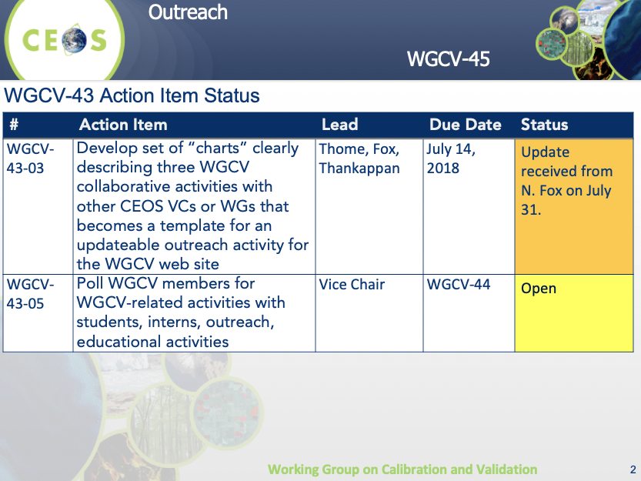
Kurt hopes to have both of these actions closed by WGCV-46.

Supersite Definition (WGCV-43-06)
Kurt Thome (NASA) reported that Action WGCV-43-06 (definitions of validation Supersites across WGCV subgroups need to be defined in a consistent fashion to allow ease of communication through the WGCV website) is closed.

Session 10:​ CARD4L Peer Reviews

CARD4L Review Panel Member Brainstorming
A discussion was held to identify an initial pool of potential reviewers for the CARD4L peer review process. Nigel Fox (UKSA) volunteered himself as a WGCV-level representative, and will follow up with possible representatives from the IVOS subgroup. Medhavy Thankappan (GA), as the WGCV LSI-VC POC will also be on the panel as the Evaluation Lead. The summary of possible candidates is as follows:
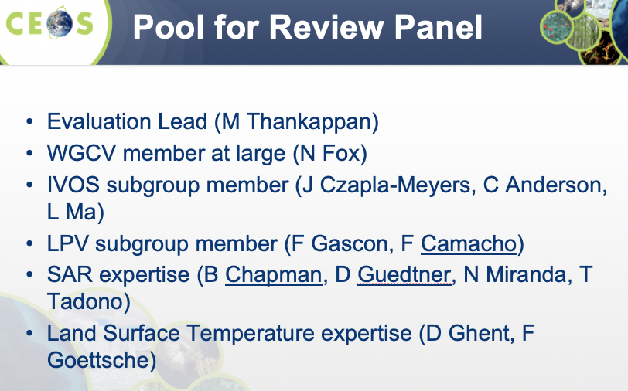
Kurt Thome (NASA) suggested prioritising people from the subgroups, as this increases the scope of participation beyond space agencies. Cindy Ong (CSIRO) suggested CSIRO could volunteer additional people for SAR-related peer reviews when needed. Geographic spread of the panel members was also suggested as a good idea.
WGCV-45-23 | Nigel Fox and Fernando Camacho to confirm the identified potential volunteers from IVOS and LPV (respectively) for the CARD4L peer review panel pool. | ASAP
WGCV-45-24 | Medhavy Thankappan to follow up with all identified potential candidates for the CARD4L peer review panel pool to confirm willingness. | ASAP
WGCV-45-25 | Medhavy Thankappan to report back to LSI-VC on the progress made on the WGCV CARD4L peer review process and selection of the peer review panel. | LSI-VC-8 (4-6 September)

Session 11:​ Collaborative Efforts

WGClimate
Albrecht von Bargen (DLR, WGClimate Vice Chair) presented. He covered the latest on WGClimate’s interactions with GCOS and WCRP, the GHG monitoring system roadmap development (a dedicated task team has been established under WGClimate), the ECV Inventory and 2019 gap analysis, and reporting to UNFCCC/SBSTA.

WGISS
Mirko Albani (ESA, WGISS Chair) presented an overview of the four WGCV-WGISS joint tasks. The presentation includes the detailed status of each activity, and these tasks will be covered in more detail in the following agenda items.
WGCV-45-26 | Philippe Goryl to get the latest version of the WGISS Maturity Matrix from Iolanda Maggio. | COMPLETE  The latest version of the WGISS maturity matrix can be obtained here.
WGCV-45-27 | Nigel Fox, Philippe Goryl, and Greg Stensaas to review the Maturity Matrix from WGISS (WGCV-45-26) and work to understand what adjustments are necessary from a data quality perspective. | End September

Data Formats and Interoperability in the Framework of FDA
Medhavy Thankappan (GA) presented the status of this WGCV-WGISS joint task:
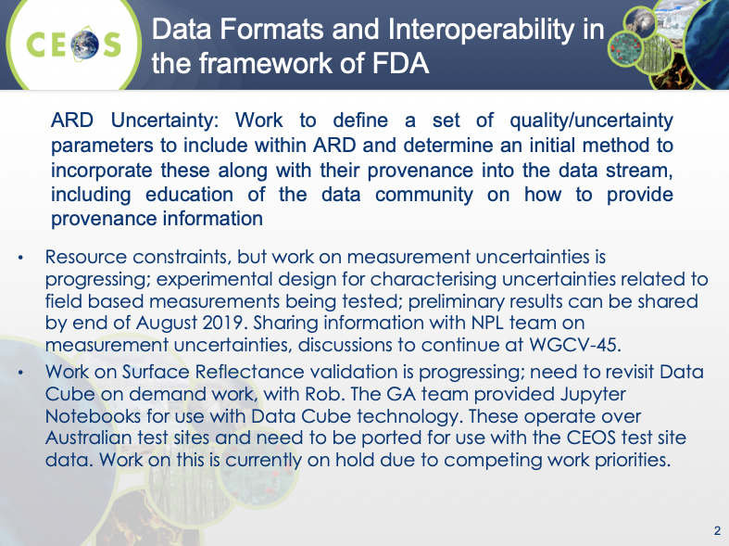
Medhavy reported that there is some uncertainty around the scope of the task. He has been operating under the assumption that the focus is on uncertainty of the field validation data only. An action was recorded for Medhavy to work with Rob Woodcock (CSIRO, WGISS Vice Chair) to clarify the scope, including whether the focus is on per-pixel uncertainty or a broader metric.
WGCV-45-28 | Medhavy Thankappan to work with Rob Woodcock to clarify the scope of the “Data Formats and Interoperability in the Framework of FDA” task (uncertainty of field measurements – not the end product). | Mid August

Quality Indicators in Discovery Metadata
Nigel Fox (UKSA) presented on the collaboration between WGCV and WGISS on ensuring that quality and uncertainty information is available for users in discovery metadata. He presented the approach used for global SST products as an example of Quality Indicator (QI) development.
GHRSST-compliant L2 and L3 SST products contain a simple QI plus an error estimate (L4 contain just the latter). They are generated based on knowledge of the sensor and SST algorithm. A new generation of pixel-level uncertainties is being trialled, which allow both the SST and its uncertainty to be independently validated.
Nigel noted that the SST example will be documented to close out this task. In addition, the following steps will be taken:
- Circulate a link to the GHRSST definitions.
- Arrange a teleconference with GHRSST and WGISS to discuss what can be done to document the QI process and to automate a method for establishing Sensor Specific Error Estimates (SSEs).
- Arrange a teleconference with WGISS to discuss how measurement equations can be incorporated into metadata.

CEOS Data Cubes & Test Site Data Access
Andrea Della Vecchia (ESA) presented on the ESA PDGS Data Cube and its trial application in support of some select WGCV activities (RadCalNet and ACIX). For RadCalNet it was used to support post-launch TOA radiometric calibration and validation of optical EO data. For ACIX it was used for the inter-comparison of BOA radiometric calibration processors. These demonstrations sought to determine whether WGISS could assist WGCV with better access to both space and ground data and whether the Data Cube can facilitate and ease data processing for activities like ACIX and RadCalNet.
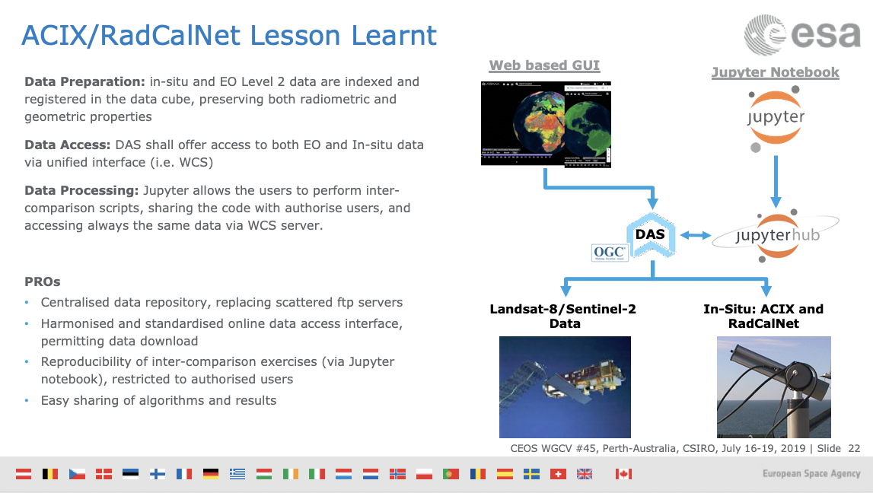
Further collaborations between WGISS and WGCV on the application of Data Cubes are TBD, but could involve ACIX II, LPV Supersites, or others. Andrea welcomed any ideas from WGCV.

Standardisation and Best Practices
Cindy Ong (CSIRO, WGCV Chair) reviewed the status of WGCV’s tasks regarding standardisation and best practices. WGCV inputs to ISO standards 19159-3 and 19157 were discussed in particular. An action was recorded for Cindy to follow up the status of WGCV input to ISO 19159-3 and Greg Stensaas (USGS) will submit his name as a reviewer for 19157 before the deadline (July 21) to ensure WGCV is involved in that review process.
WGCV-45-29 | Cindy Ong to follow up ISO 19159-3 with Bruce Chapman to see whether WGCV is actively involved or whether a connection needs to be made.
Another discussion was also held on terminology definition, in particular around interoperability. Cindy noted that the terminology action being undertaken in IVOS needs to be linked to the similar work ongoing in WGISS (as well as with that in LSI-VC and the 2020-2021 SIT Chair’s CEOS ARD Strategy).
WGCV-45-30 | Nigel Fox to connect with Michael Morahan regarding terminology work undertaken in WGISS and to ensure this is linked to the IVOS terminology task.

Friday July 19th

Session 12: New Tasks and Work Plan Activities​

Proposal for a SAR Supersite
Medhavy Thankappan (GA) presented again the proposal to establish a SAR Supersite for multi-mission calibration. He reviewed GA’s plan, which was initially driven by an approach from NISAR mission management. The proposal presented by Medhavy is to expand upon this plan and establish a new Australia-based supersite that supports multiple missions, in particular the numerous longer wavelength missions (SAOCOM, TanDEM-L, NISAR, ALOS-2, BIOMASS). There is the potential for co-investment from CEOS/WGCV Agencies. Medhavy presented the key outcomes from the discussion held earlier this week:
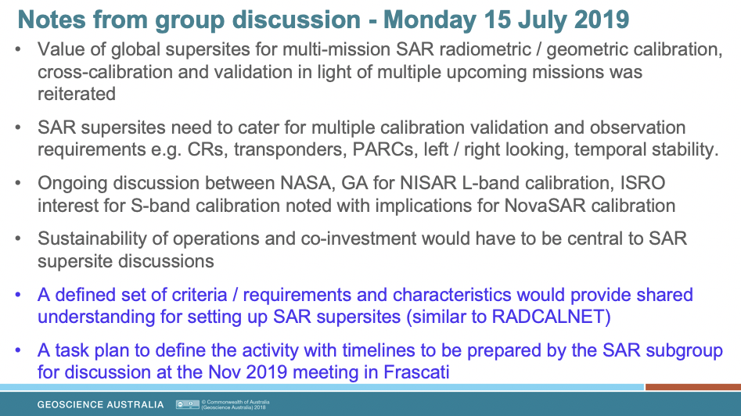
Cindy Ong (CSIRO, WGCV Chair) noted the call for co-investment is different to the typical CEOS model and asked Medhavy how he sees this working. Medhavy is unsure at the moment; the first step will simply be to establish a CEOS WGCV task to work on the criteria/requirements, with discussions around co-investment to come later, likely more bilaterally rather than via WGCV. GA and NASA will be continuing their discussions as a start, but GA will be looking beyond NISAR to justify the investment from their side.
Medhavy noted that sites in other geographic locations could also be part of the ‘supersite’. It was also noted that the term ‘supersite’ specifically means that multiple parameters/missions are involved.
WGCV-45-31 | Medhavy Thankappan to lead the preparation of a set of criteria/requirements and characteristics for the proposed new SAR supersite. | Due for discussion at the SAR subgroup meeting in November 2019

CARD4L Peer Reviews
Medhavy Thankappan (GA) confirmed again the CARD4L peer review process and initial pool of review panelists. The related actions and decisions were also re-confirmed. He clarified that the pool of review panelists is not final; subgroup leads will continue to seek volunteers and representation is expected to change and evolve over time.

Proposal for a New IVOS/LPV Surface Reflectance Task
Fernando Camacho (EOLAB/Parc Cientific Universitat de Valencia) reviewed some background on the importance of field-based validation in ensuring consistency in the generation of ARD products such as Surface Reflectance (SR) from multiple sensors. Surface reflectance is an input for many terrestrial land products, so understanding uncertainty in both field and satellite products is essential. He noted that community consensus protocols on SR are still yet to be written. There are several ongoing activities (GA Digital Earth Australia SR validation task (CV-17), ESA FRM4Veg) that present a window of opportunity to agree SR validation protocols, before starting a global SR validation exercise.
Fernando recalled the following recommendation from the 2019 meeting of the LPV subgroup:
LPV R-2019-4: In collaboration with IVOS, propose a new CEOS WGCV surface reflectance validation and intercomparison exercise lead by ESA and NPL (UK) in the framework of FRM4Veg.
In response the following proposal was presented for WGCV discussion and approval:
Field Surface Reflectance “Round Robin” Inter-Comparison Exercise & Development of Community-Endorsed Surface Reflectance Validation Protocols
Lead Agency: ESA (FRM4Veg Project) with funding support from ESA Earthnet.
Support: IVOS (calibration/traceability of field radiometry), LPV (consensus global validation protocols for SR)
Objectives:
- Agree fiducial reference measurement protocols with full traceability for surface reflectance (SR) characterisation (using inputs from the GA/DEA task, FRM4Veg, etc.).
- Develop protocols for global SR validation (field radiometry, airborne, models).
- Perform a round robin intercomparison of SR validation approaches and use the lessons learned to refine FRM protocols.
- Organise two workshops before and after the round robin to discuss the protocols, field experiments and outcomes.
- Publish round robin intercomparison results.
Outcome: Endorse FRM4Veg SR protocols under CEOS WGCV (LPV-IVOS).
Period: 2020-2021 (round robin exercise in June-July 2021, Europe).
On the horizon: Validation of SR products using community-endorsed protocols.
The activity was discussed and approved in principle. The LPV Chair and IVOS Chair were assigned an action to confirm the specifics of the task (including a formal CEOS Work Plan Task/Deliverable) for review and endorsement by WGCV via email.
WGCV-45-32 | LPV Chair and IVOS Chair to convene a group (including Tim Malthus as a third co-lead) to confirm the specifics of the new surface reflectance validation protocol task (including a formal CEOS Work Plan Task/Deliverable) for review and endorsement by WGCV via email. | End September

Proposal for DEMIX Task
Peter Strobl (EC/JRC) presented some background on DEMs and the Copernicus-DEM procurement process. Part of this process included a JRC workshop on global DEM benchmarking (January 16-19, 2019), which resulted in the following recommendations:
- Revival of the CEOS TMSG
  - Link with geomorphometry.org
  - Work towards a ‘DEMIX’
- Guidelines for shoreline bathymetry
- Guidelines for DEM-Fusion
- Create a DEM user communication platform
There are various outstanding questions such as: What is the consistency or coherence of a DEM? What is a ‘good’ DEM? Which is the ‘better’ DEM? To answer these questions, among others, Peter proposed a DEM Intercomparison eXercise (DEMIX):
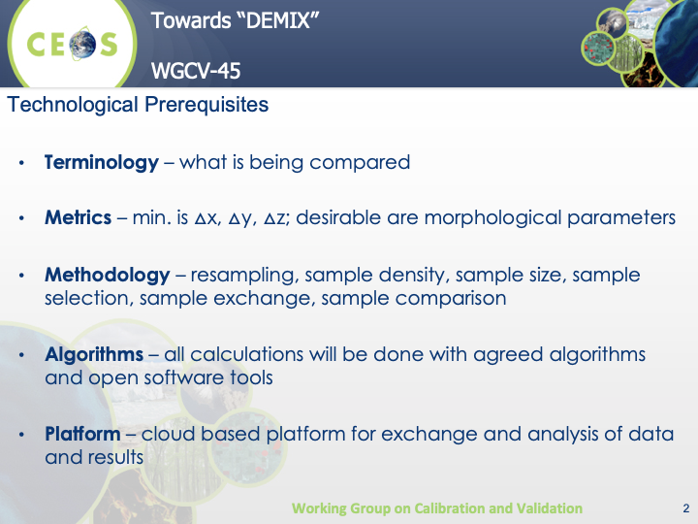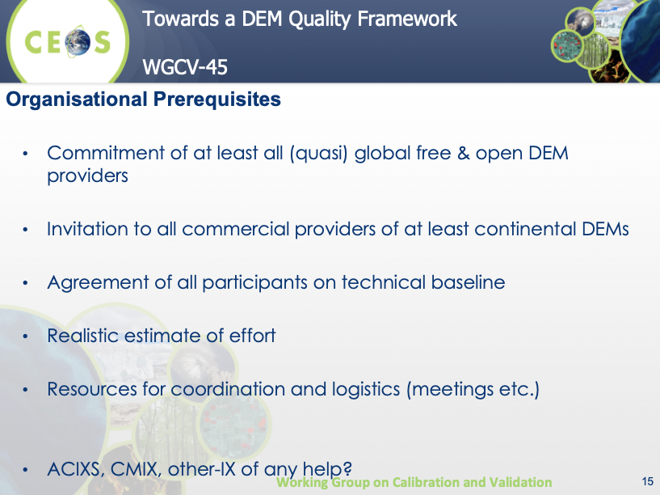
Proposed approach:
- Call for expressions of interest to all CEOS partners (plus industry?);
- Select one global DEM as a reference (by consensus, majority?);
- Determine a suitable sub-tiling of the reference DEM;
- Perform (correlation?) matching between the reference DEM and the S2-GRI (using shaded relief technique) and analyse eventual co-registration issues;
- Calculate the agreed comparison metrics for each candidate with the reference;
- Publish results.
The proposal was opened for discussion, including on whether this is a task that fits under the work of WGCV.
Kurt Thome (NASA) noted that there is no CEOS-endorsed DEM, but there was in the past a WGCV task to pursue this, but it stalled.
It was agreed that this task is in line with WGCV priorities, specifically under the Terrain Mapping Subgroup (TMSG).
Peter confirmed there is the potential for himself/EC to chair a renewed TMSG.
Greg Stensaas (USGS) noted that USGS has two people that can participate in the TMSG to support this task. Patrice Henry (CNES) confirmed CNES will also find someone to participate. JAXA and DLR have also indicated an interest in participating.
Decision 04 | Renewed the Terrain Mapping Subgroup (TMSG) with Peter Strobl/EC as a lead.

WGCV-45-33 | TMSG lead and Greg Stensaas to confirm team members and co-leads of the renewed TMSG (seeking confirmation from USGS, JAXA, DLR, CNES, others).
WGCV-45-34 | Greg Stensaas to share with Peter Strobl the last compiled list of past TMSG members.
WGCV-45-35 | TMSG lead to develop a detailed plan for the DEMIX task, based on the proposal presented during WGCV-45, for the review of WGCV. This needs to include a formal CEOS Work Plan Task/Deliverable. | End October
WGCV-45-36 | WGCV Chair to communicate to SIT Technical Workshop that the TMSG has been renewed (with EC as a lead) and that additional team members are sought. | SIT Technical Workshop

Session 13: Closing

Meeting Summary
Matt Steventon reviewed the actions and decisions; a number of edits were made. These changes are all reflected in the final actions and decisions summary (Appendix B).

Future Directions and Meetings
Cindy Ong (CSIRO, WGCV Chair) summarised the tentative schedule of upcoming meetings:
- WGCV-46: March 23-27, Caltech, Pasadena, California, USA.
- WGCV-47: Joint with WGISS hosted by ROSCOSMOS in Sochi, Russia (14-18 September 2020)

Meeting Close
Cindy Ong (CSIRO, WGCV Chair) thanked everyone for attending and closed the meeting.

APPENDIX A
Attendees
Organisation | Name
AOE, CAS | Ning Wang*
Australian Bureau of Meteorology | Ian Grant
CNES | Patrice Henry
CSIRO | Alex Held
CSIRO | Benoit Legresy
CSIRO | Cindy Ong
CSIRO | Ian Lau
CSIRO | Kevin Ferguson
CSIRO | Matthew Steventon
CSIRO | Tim Malthus
CSIRO | Zheng-Shu Zhou
Curtin University | David Antoine
DLR, WGClimate Vice Chair | Albrecht von Bargen*
EC/JRC | Peter Strobl
EOLAB/Parc Cientific Universitat de Valencia | Fernando Camacho
ESA | Andrea Della Vecchia*
ESA | Philippe Goryl
ESA, WGISS Chair | Mirko Albani*
ESA/CNES, CEO | Steven Hosford*
GA | Mark Broomhall
GA | Medhavy Thankappan
ISRO | Arundhati Misra*
JAXA | Akihiko Kuze
NASA | Kurt Thome
NASA/JPL | David Crisp
NOAA | TaeYoung Choi
NRSCC | Xiaolong Dong*
NSSC | Yongmei Wang
TERN | Mirko Karan
UKSA | Nigel Fox
USGS | Greg Stensaas
* indicates remote attendance

APPENDIX B
Actions & Decisions Record

WGCV-45-01 | Everyone to consider nominating for the WGCV Vice Chair role that will become vacant in 2020.
WGCV-45-02 | Greg Stensaas to follow up with the CEO regarding visibility at the CEOS management level for long-term ongoing/operational work.
WGCV-45-03 | Fernando Camacho to connect with Mirko Karan regarding linking the WGCV Portal to the various TERN resources.
WGCV-45-04 | Anyone using AEROSPAN data is requested to contact Ian Lau with feedback to aid future budget discussions.
WGCV-45-05 | WGCV Chair to consider the addition of a new joint CEOS Work Plan Task/Deliverable with OSVW-VC on the development of guidelines/standards for calibration/cross-calibration of radar scatterometers for ocean surface vector winds.
WGCV-45-06 | All to consider nominating for a group to develop guidelines/standards for calibration/validation of space passive microwave sensors.
WGCV-45-07 | All to consider potential inputs to the development of an ISO standard on calibration of passive microwave sensors and communicate these via national channels.
WGCV-45-08 | Everyone who is non-EU to consider nominating for the LPV Vice Chair role that has become vacant.
WGCV-45-09 | Matt Steventon to ensure that the WGCV IVOS subgroup is consulted/added to the CEOS ARD Strategy task on interoperability terminology, noting the ongoing IVOS work on the topic and the need to ensure consistency.
WGCV-45-10 | Medhavy Thankappan and Kurt Thome to establish an initial pool of candidates for the CARD4L peer review panel (10-20) and choose an initial five people from this pool for the first peer review (expected to be for surface reflectance). | COMPLETE
WGCV-45-11 | WGCV Chair and Vice Chair to connect with the AC-VC and WGClimate GHG Task Team to ensure that the cal/val requirements in the GHG Roadmap are developed in coordination with IVOS to ensure the requirements are suitable and actionable.
WGCV-45-12 | Philippe Goryl and Fernando Camacho to prepare a BRIX2 CEOS Work Plan Task/Deliverable for the next iteration of the CEOS Work Plan. | September 2019
WGCV-45-13 | WGCV Chair to follow up again with Mitch Goldberg for GSICS sign-off on the pre-flight calibration workshop plan and flyer, noting the mention of the workshop in recent GSICS Executive Panel minutes. | COMPLETE
WGCV-45-14 | Nigel Fox to share the latest flyer and strawman for the pre-flight calibration workshop with Cindy after revising it to include GHG in the scope. | July 26
WGCV-45-15 | Nigel Fox to push ahead with the next steps on the pre-flight calibration workshop, starting with an email to those involved to propose a planning teleconference in September. | Before End August
WGCV-45-16 | Tim Malthus to share the DEA continental-scale surface reflectance validation protocol with the WGCV community for feedback and edits before the document is finalised to complete CEOS Work Plan Task CV-17. | COMPLETE
WGCV-45-17 | Cindy Ong to follow up with Bruce Chapman regarding WGCV-46 dates (target is spring break at JPL, March 19-29). | COMPLETE
WGCV-45-18 | Arundhati Misra to follow up the possibility of ISRO contributions to RADCALNET and hyperspectral measurements over PICS sites with Nigel Fox (via teleconference, looping in other ISRO colleagues).
WGCV-45-19 | Greg Stensaas to follow up regarding linking LPCS and other USGS tools to the cal/val portal.
WGCV-45-20 | WGCV Chair and Philippe Goryl to set up standing monthly teleconferences dedicated to cal/val portal development and content curation. | Once the new cal/val portal is made live at the end of October
WGCV-45-21 | WGCV Chair and Philippe Goryl to re-send all details related to the new cal/val portal website along with a call for feedback, updates, content, etc. | COMPLETE
WGCV-45-22 | Steven Hosford to share the LSI-VC document on interoperability terminology. | COMPLETE
WGCV-45-23 | Nigel Fox and Fernando Camacho to confirm the identified potential volunteers from IVOS and LPV (respectively) for the CARD4L peer review panel pool. | ASAP
WGCV-45-24 | Medhavy Thankappan to follow up with all identified potential candidates for the CARD4L peer review panel pool to confirm willingness. | ASAP
WGCV-45-25 | Medhavy Thankappan to report back to LSI-VC on the progress made on the WGCV CARD4L peer review process and selection of the peer review panel. | LSI-VC-8 (4-6 September)
WGCV-45-26 | Philippe Goryl to get the latest version of the WGISS Maturity Matrix from Iolanda Maggio. | COMPLETE  The latest version of the WGISS maturity matrix can be obtained here.
WGCV-45-27 | Nigel Fox, Philippe Goryl, and Greg Stensaas to review the Maturity Matrix from WGISS (WGCV-45-26) and work to understand what adjustments are necessary from a data quality perspective. | End September
WGCV-45-28 | Medhavy Thankappan to work with Rob Woodcock to clarify the scope of the “Data Formats and Interoperability in the Framework of FDA” task (uncertainty of field measurements – not the end product). | Mid August
WGCV-45-29 | Cindy Ong to follow up ISO 19159-3 with Bruce Chapman to see whether WGCV is actively involved or whether a connection needs to be made.
WGCV-45-30 | Nigel Fox to connect with Michael Morahan regarding terminology work undertaken in WGISS and to ensure this is linked to the IVOS terminology task.
WGCV-45-31 | Medhavy Thankappan to lead the preparation of a set of criteria/requirements and characteristics for the proposed new SAR supersite. | Due for discussion at the SAR subgroup meeting in November 2019
WGCV-45-32 | LPV Chair and IVOS Chair to convene a group (including Tim Malthus as a third co-lead) to confirm the specifics of the new surface reflectance validation protocol task (including a formal CEOS Work Plan Task/Deliverable) for review and endorsement by WGCV via email. | End September
WGCV-45-33 | TMSG lead and Greg Stensaas to confirm team members and co-leads of the renewed TMSG (seeking confirmation from USGS, JAXA, DLR, CNES, others).
WGCV-45-34 | Greg Stensaas to share with Peter Strobl the last compiled list of past TMSG members.
WGCV-45-35 | TMSG lead to develop a detailed plan for the DEMIX task, based on the proposal presented during WGCV-45, for the review of WGCV. This needs to include a formal CEOS Work Plan Task/Deliverable. | End October
WGCV-45-36 | WGCV Chair to communicate to SIT Technical Workshop that the TMSG has been renewed (with EC as a lead) and that additional team members are sought. | SIT Technical Workshop

Decision 01 | The WGCV CARD4L peer review process presented was agreed.
Decision 02 | A standing side meeting (around 2 hours) on cal/val portal development will be added to the agenda for face-to-face WGCV meetings going forward.
Decision 03 | The new cal/val portal will be made live at the end of October.
Decision 04 | Renewed the Terrain Mapping Subgroup (TMSG) with Peter Strobl/EC as a lead.

