Minutes v1.0
WGCV-48
28 October 2020

Outgoing Chair Report [Slides]
Presenter: Cindy Ong (CSIRO)
Main points:
- Cindy reported primarily on the CARD4L assessments and RadCalNet progress at the 2020 CEOS Plenary. Plenary was happy to hear about the expansion of RadCalNet with a new site and 500 active users.
- The Biomass Validation Protocol was mostly covered separately by Laura Duncanson, and had a substantial amount of time on the agenda to cover both the protocol and the implementation plan, as well as the Forest Biomass Reference Network.
- The LPV Biomass Validation Protocol is open for review and will now seek endorsement at SIT-36 in March, 2021. WGCV endorsement will be required before this.
- A number of other CEOS Work Plan Deliverables will likely need to be postponed, mostly due to COVID-19. Five new CEOS Work Plan tasks were added for WGCV in 2020.
- Albrecht von Bargen (DLR) noted that there are a number of other LPV protocols. He asked why the Biomass Protocol is seeking endorsement, where the others didn’t. Cindy noted that there is a special interest in this protocol given the SIT Chair Team’s priorities, so it has been elevated to the CEOS Plenary/SIT level.
- Albrecht noted that a date has been tentatively chosen for an in-person pre-flight calibration workshop (May 2021). A virtual workshop is not ideal and will be avoided if possible.
- The Greenhouse Gas Task Team under WGClimate is progressing and there are several items that require WGCV attention. Kuze-san’s role and experience with GOSAT will be very beneficial.
Incoming Chair Report [Slides]
Presenter: Akihiko Kuze
Main points:
- Kuze-san welcomed everyone to the meeting – the first of his term as WGCV Chair. Matt Steventon will be supporting Kuze-san as WGCV Secretariat.
- Kuze-san thanked Cindy Ong (CSIRO) for her leadership of WGCV over the past two years.
- Special interests for Kuze-san during his Chair term are: Carbon and biomass to contribute to the Paris Agreement (validation of retrieved products and fluxes), CEOS Analysis Ready Data (in particular for atmospheric and ocean missions, as well as industry’s role), and the Cal/Val Portal.
- Tentative upcoming meeting plans are as follows:
  - WGCV-49: July 2021 (virtual)
  - WGCV-50: Early 2022 (Tokyo, Japan)
  - WGCV-51: 2022 (joint with WGISS)
Incoming Vice Chair Report [Slides]
Presenter: Philippe Goryl
Main points:
- Philippe thanked Cindy for her leadership of WGCV over the past two years.
- Special interests for Philippe’s Vice Chair term: give special attention to the intercomparison exercises and their continuity; the LPV surface reflectance task; increasing the provision and use of WGCV reference sources for validation, following the meteorological model (FRM, for New Space, and perhaps SDG-related activities); and, communication (including through GSICS).
- Cindy has encouraged the leads and others to engage with ISO on their new TC 211 about a new standard on EO-derived products. Nigel Fox (UKSA) noted that the challenge is when the standard becomes overly prescriptive – WGCV should avoid this by keeping to a higher level.
WGCV-48-01 | Cindy to share details of the POC for the ISO TC 211 with Philippe. | COMPLETE
Land Product Validation (LPV) [Slides]
Presenter: Fernando Camacho
Main points:
- WGCV LPV has decided to extend the time period for public review of the Biomass Validation Protocol until December 15, 2020, and will present it for potential endorsement at CEOS SIT-36. It needs to be endorsed/approved beforehand by WGCV.
- Implementation of the Biomass Validation Protocol requires updated reference datasets and validation tools (MAAP platform). In support, a business case for the CEOS Forest Biomass Reference Network of 100 core sites (+210 additional) has been proposed and put to CEOS Agencies for consideration of possible contributions. Contributions will be sought from other entities and the network could also leverage established systems.
- The Soil Moisture Product Validation Good Practices Protocol has passed its review and is now in the final publication process (DOI in progress). A digital copy will be sent for endorsement by email.
- LPV’s progress continues moving toward an operational validation capability.
- Philippe noted that the FRM for Soil Moisture project will kick-off in January.
Infrared and Visible Optical Sensors (IVOS)
Presenter: Nigel Fox
Main points:
- The next round of sea surface temperature comparisons will kick-off soon. These are held approximately every 5 years, and this will be the fifth instance. Nigel asked WGCV to consider whether a standardised naming convention should be started. ESA has agreed to fund the next comparison. The target is Q2 2022 and initial discussions have started with previous and potential participants from the US, Europe, and Australia. Seeking to have a one week laboratory program and one week sea viewing from a coastal pier. Invitations to participate will go out in 2021.
- The commercial sector is keen to have an ‘analysis-ready’ standard to facilitate transparency with customers, and there is interest in using CARD4L as a basis. An IVOS sub-team is working on a strawman of an evolved CARD4L that fits the demands of IVOS’s industry contacts. This will be shared with the broader community for comment. The main potential additions identified so far are related to high resolution RGB applications and the inclusion of an intermediate between the threshold and target levels. A number of other potential changes identified to date are detailed in the slides. Nigel plans to present the idea at the ARD20 Workshop next week. One of the key goals is to add clarity regarding the types of applications that would typically require certain parameters detailed in the PFS. The process being followed should be transferable to other PFS as well. Adding granularity to the PFS is the overall goal. Not yet socialised with the LSI-VC. The work to date has been led by Planet and Maxar with contacts from USGS and ESA.
- Matt Steventon suggested that the work on analysis-ready data be socialised with the LSI-VC Leads before the ARD20 Workshop.
WGCV-48-02 | Matt to connect Nigel, Cody and Medhavy with the LSI-VC Leads regarding the representation of CEOS ARD at the ARD20 Workshop. | COMPLETE
Terrain Mapping (TMSG) [Slides]
Presenter: Peter Strobl
Main points:
- TMSG restarted as of late 2019. Around 60 participants so far, with about 50% coming from a CEOS background.
- The DEMIX exercise is the focus of the TMSG. The first kick-off teleconference was held in June, and there are around 30 active participants. There are three subgroups: terminology and analytical basis; algorithms and software; and, platforms and processing. There has been good progress in the terminology team, with revised definitions being agreed.
- Challenges include maintaining the group and enhancing visibility; accommodating new high resolution datasets (Copernicus 1” global DEM, GLO-30); finding suitable test areas and reference data; and allocation of platform resources (e.g., ESA-Visioterra, CEOS EAIL).
- The DEMIX schedule has slipped by about three months due to the unusual year.
- Santhi Sree (ISRO) suggested ISRO can validate GLO-30 data over Indian terrain. Peter welcomed ISRO participation in the TMSG and DEMIX.
WGCV-48-03 | Peter to check on the GLO-30 release date with Ferran Gascon. | COMPLETE  Publicly available to all users with a free & open licence
Microwave Sensors (MSSG)
Presenter: Xiaolong Dong
Main points:
- Xiaolong shared progress on CEOS Work Plan Task CV-20-05. A large number of datasets have been contributed. There are four sub-tasks: development and validation of algorithms and methods for calibration of Sigma 0; evaluation and assessment; development of guidelines/standards for validation of ocean surface winds (L2B data) by radar scatterometer data; and, identifying and organising collocation data.
- IGARSS 2021 has invited a technical session on this topic. Xiaolong presented the proposed topics.
- Soil moisture and snow water equivalent by active and passive microwave products are being discussed.
FDA-18-05 Report [Slides]
Presenter: Kurt Thome
Main points:
- This CEOS Work Plan Task is on the compilation of an inventory of space data product formats used by CEOS Agencies. This was previously FDA-12. The goal is to present recommendations to facilitate interoperability. Originally planned for completion in late 2019, WGCV needs to decide how to close this action (the new deadline is one year from now). Kurt presented various options for how to make progress on and close FDA-18-05 and then summarised what he sees as the paths forward. His preferred option is some combination of points one and three below. It will be up to the WGCV Chair and Vice Chair to decide the way forward.
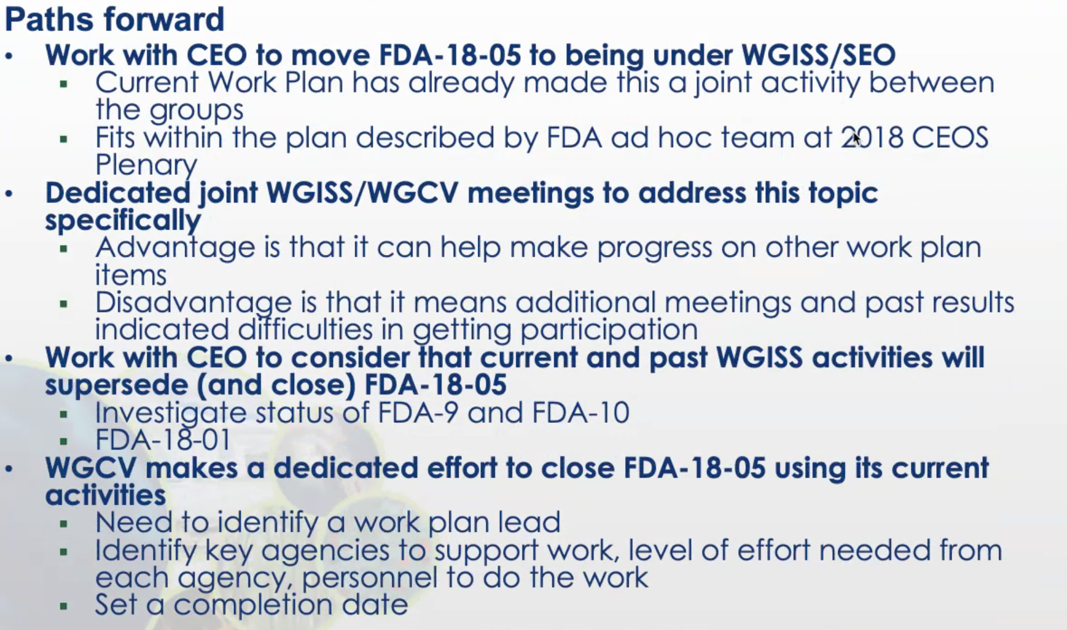
- Cindy agreed with some combination of one and three. Number two is not feasible under the current circumstances.
WGCV-48-04 | Akihiko Kuze to explore the possibility of transferring action FDA-18-05 to WGISS with the WGISS Vice Chair, Makoto Natsuisaka (JAXA) and WGISS Chair, Rob Woodcock (CSIRO). | ASAP
CARD4L Assessments
Presenter: Medhavy Thankappan
Main points:
- WGCV provides the peer review function for CARD4L assessments. Medhavy reviewed the steps in the assessment process, for which he is the POC between LSI-VC and WGCV.
- Landsat Collection 2 Surface Reflectance and Surface Temperature products were the first officially confirmed CARD4L datasets. An update of these assessments are currently in progress against the new version 5.0 PFS. The ESA Sentinel-2 Surface Reflectance assessment (at Threshold level) and a self-assessment from Element84 (Sentinel-2; different process to ESA; contracted by Digital Earth Africa) are in progress.
WGCV-48-05 | Ferran Gascon (ESA) to follow up the ESA Sentinel-2 Surface Reflectance CARD4L self-assessment with Valentina Boccia (ESA). | ASAP
- Medhavy presented some questions for WGCV consideration:
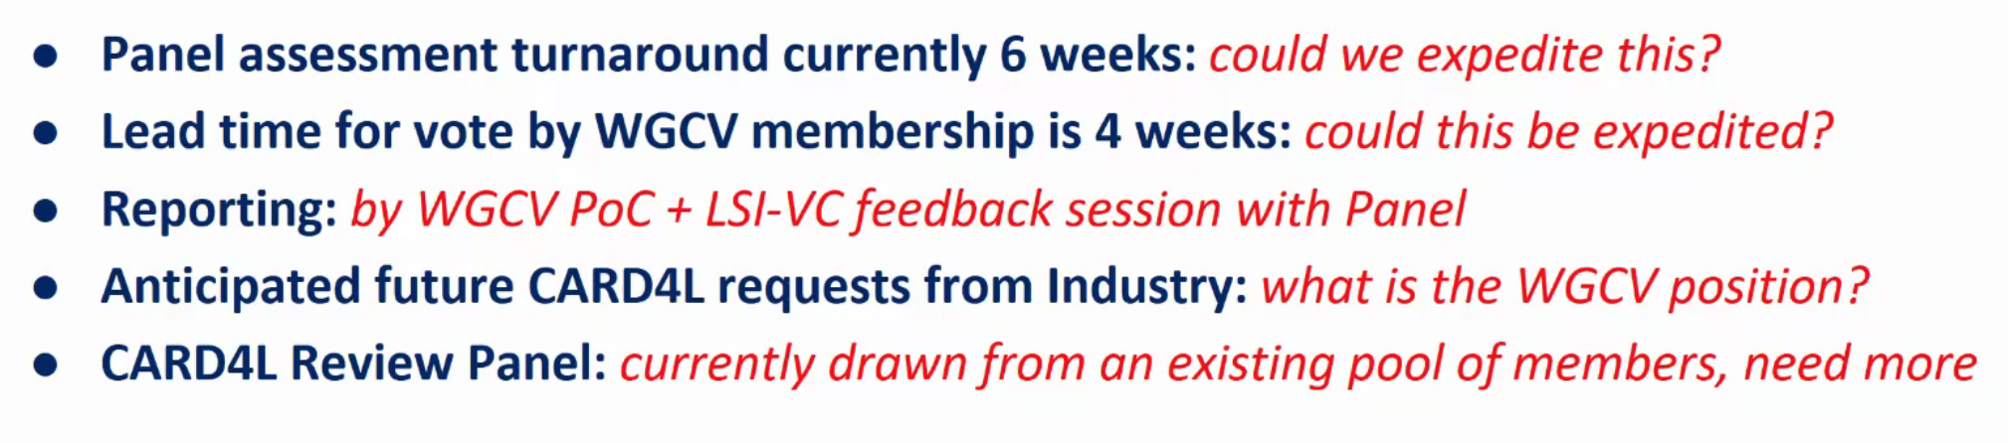
- Medhavy welcomed additional members for the CARD4L Review Panel from TMSG.
Geoscience Australia Report
Presenter: Medhavy Thankappan
Main points:
- Presented a wrap up on the Continental Surface Reflectance Validation Project. A Phase 1 Technical Summary Report is close to publication. Phase 2 aims to use sites that are more difficult to access, and drones will be employed as a result. A new compact LIDAR will also be used.
- GA continues to support the ESA Pandora instruments (for FRM4AC) and the Australian SAR Corner Reflector Array. The array has been updated with some new positions that have led to improved results for Sentinel-1. These new positions will be published on the Cal/Val Portal.
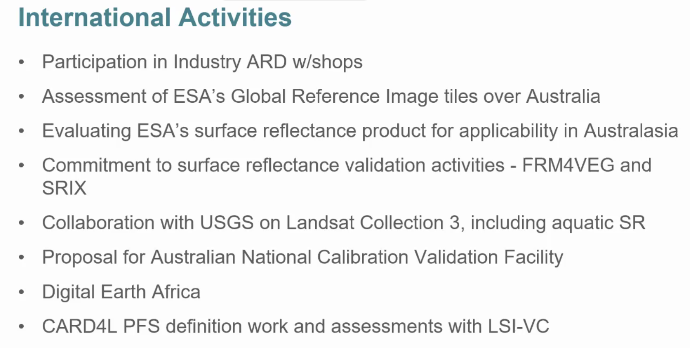
JACIE & ARD20
Presenter: Greg Stensaas
Main points:
- The 19th JACIE Civil Commercial Imagery Evaluation Workshop will be held November 17-19, 2020 (virtual workshop). Further information and registration: https://www.usgs.gov/land-resources/eros/calval/jacie
- 2nd Annual – 2020 Joint Agency Commercial Imagery Evaluation (JACIE) - Land Remote Sensing Satellite Compendium: https://pubs.er.usgs.gov/publication/cir1468 USGS will seek WGCV IVOS review after the JACIE team review.
- ARD20 Third ARD Workshop on Remote Sensing Data Interoperability, November 2-6, 2020 (virtual workshop). Registration: https://forms.gle/vQGJgpTGdB412b8N8
- Philippe Goryl (ESA) noted that VH-RODA will likely be held virtually on April 20, and will be coordinated with JACIE.
Next Meeting, Adjourn
Main points:
- Kuze-san recalled that WGCV-49 will be held in the July 2021 timeframe and will be a virtual meeting. He thanked everyone for joining and closed the meeting.

