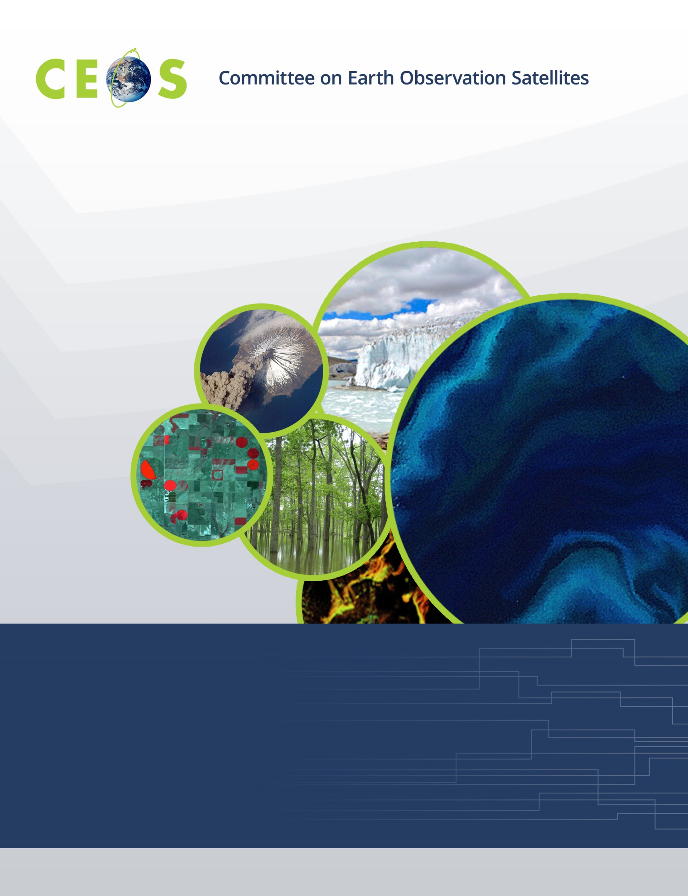

Monday, September 19, 2016
Agenda
CEOS WGISS-42 Frascati, Italy
Hosted by the European Space Agency (ESA)
September 19 – September 22, 2016
Version 1.0 September 18, 2016
*Indicates remote presentation

08:30 Registration – passport required

WGISS PLENARY Andrew Mitchell
09:00 Host Welcome Logistics Information Mirko Albani
09:10 Welcome and Introductions, Adoption of Agenda Andrew Mitchell
09:20 ESA Welcome Address Nicolaus Hanowski,
Henri Laur
09:40 WISP Report Anne Kennerley
09:50 WGISS Chair Report Andrew Mitchell

10:30 Break
10:45 Review of WGISS-41 Actions Andrew Mitchell
11:15 CEO Report Jonathon Ross*
11:45 GEO Report Osamu Ochiai*
12:00 SEO Report Brian Killough*
12:15 Review of CEOS and GEO Actions Andy Mitchell

12:30 Lunch
Data USE
13:30 Future Data Architecture Andy Mitchell
14:30 Data Cubes Activities at ESA Guenther Landgraf
Pierre Philippe Mathieu
15:00 Data Cubes Activities at INPE Lubia Vinhas

15:15 Break
15:30 Agency/Liaison Reports
NASA Dawn Lowe
JAXA Masumi Matsunaga
ISRO Nitant Dube
GSDI Gabor Remetey-Fülöpp
NOAA Martin Yapur
USGS Kristi Kline
Geoscience Australia Simon Oliver
INPE Lubia Vinhas
16:45 Summary and Discussion All

17:00 Adjourn

Tuesday, September 20, 2016

09:00 Convene
Technology Exploration Workshop on CLOUD COMPUTING Satoko Miura
09:00 Introduction and Overview Satoko Miura
09:05 GS evolution and EO Innovation Europe Henri Laur,
Mirko Albani
09:35 Thematic Exploitation Platforms and Cloud Computing Activities at ESA Sveinung Loekken
10:05 Cloud Computing and Security Julien Airaud

10:35 Break
10:50 JAXA Approach on Virtualization and Cloud Computing Satoko Miura
11:20 ISRO - EO Data Processing Cloud: Requirements and Research Issues Nitant Dube
11:50 Computing in the Cloud at Geoscience Australia Simon Oliver

12:20 Group Photo

12:30 Lunch
13:30 NOAA Martin Yapur
13:50 USGS Kristi Kline
14:10 NASA: Assessing Applications of Cloud Computing to NASA’s Earth Chris Lynnes*
Observing System Data and Information System (EOSDIS)
14:40 CEOS Data Cube use of Cloud Computing Brian Killough*
15:00 Cloud Computing Discussion All
15:30 Future Webinar Discussion Shinichi Sekioka

16:00 Adjourn

16:00 Transportation to Rome for free time and no-host dinner

22:30 Transportation to Frascati

Wednesday, September 21, 2016

09:00 Convene
Data ACCESS
09:00 IDN Michael Morahan
09:45 OpenSearch II Yves Coen

10:30 Break
10:45 OpenSearch for EO Standard Olivier Barois
11:00 FedEO Yves Coen
11:30 CWIC Yonsook Enloe*,
Ken McDonald
CWIC Report Yonsook Enloe*

12:30 Lunch
13:30 CWIC, continued
EUMETSAT Report Uwe Voges
ISRO Report Nitant Dube
INPE Report Lubia Vinhas
NOAA report Ken McDonald,
Martin Yapur
14:15 Future Work on CEOS, WIGOS, and CGMS Interoperable Metadata Yonsook Enloe*
14:45 WGISS Connected Data Assets Yonsook Enloe*
15:15 Data Access Discussion All
15:40 Minutes and Action Items review Michelle Piepgrass
16:00 Future Meetings Mirko Albani

17:00 Adjourn

Thursday, September 22, 2016

09:00 Convene
Data PRESERVATION Mirko Albani
09:00 Data Stewardship Interest Group Overview and Updates Mirko Albani
09:30 Preservation of Associated Knowledge Best Practices Mirko Albani,
Iolanda Maggio
10:00 Maturity Matrix/Model for Harmonization Mirko Albani,
Iolanda Maggio
10:30 Report on Agency Stewardship Activities Mirko Albani
ESA - Heritage Data & Knowledge Preservation

11:00 Break
11:15 Report on Agency Stewardship Activities
NASA Dawn Lowe
12:00 Data Preservation Discussion All
Thesaurus, Landing Page and DOI for knowledge, Glossary Extension

12:30 Lunch
WGISS PLENARY Andrew Mitchell
13:30 WGISS Summary Andrew Mitchell
14:45 Action Items Michelle Piepgrass
15:45 Concluding Remarks Andrew Mitchell

16:00 Adjourn

16:00 ESRIN Facility Tour

