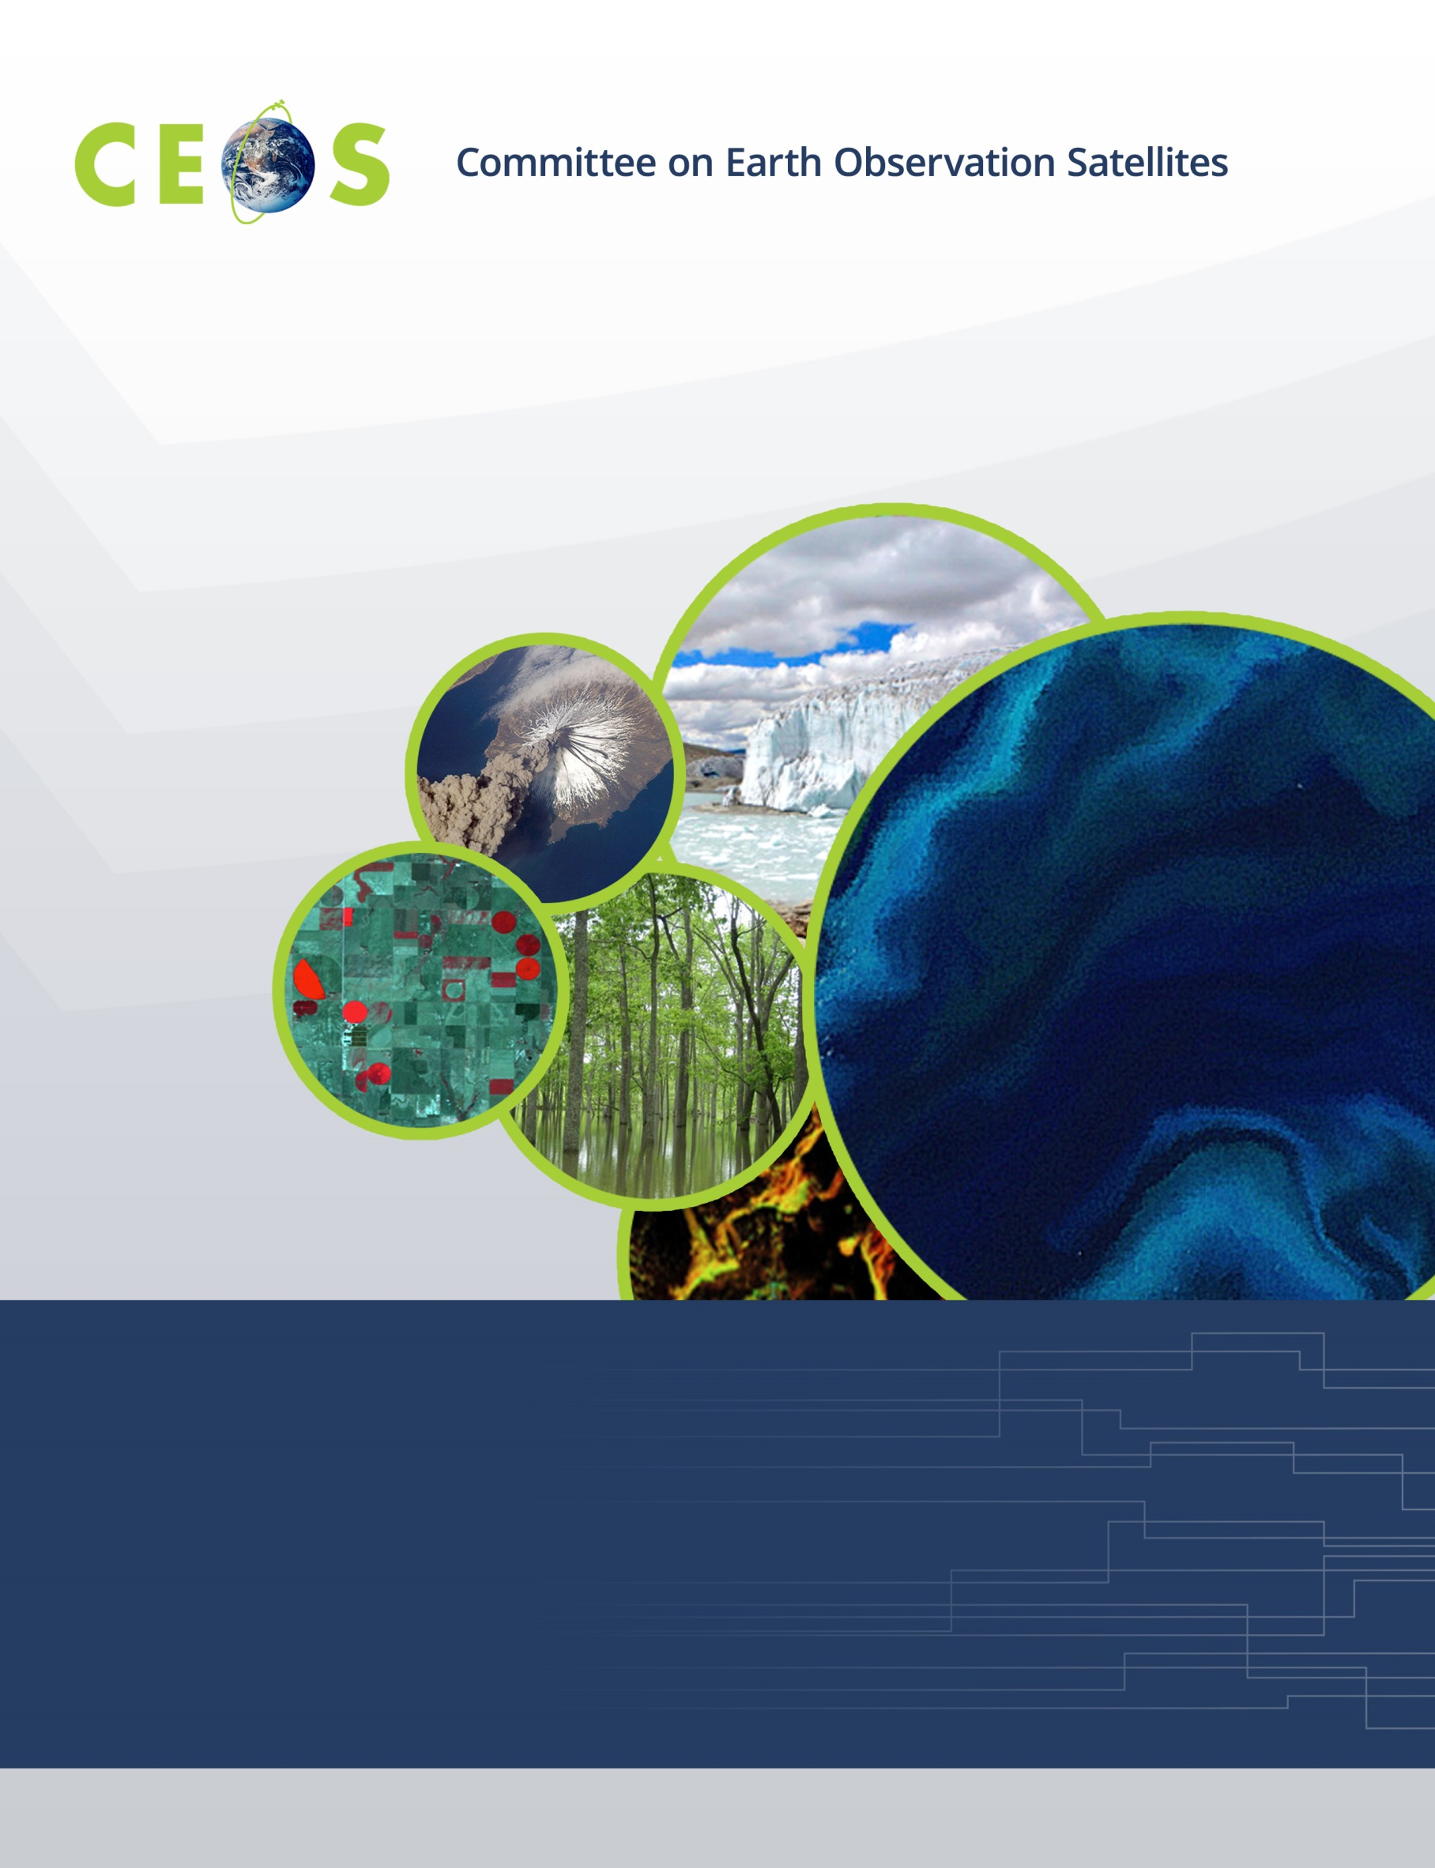

Monday, April 3, 2017
Agenda
CEOS WGISS-43 Annapolis, MD, USA
Hosted by the National Aeronautic Space Administration (NASA)
April 3 – April 6, 2017
Version 1.0 April 2, 2017
*Indicates remote presentation

08:30 Registration, Continental Breakfast

09:00 Convene

WGISS PLENARY Andrew Mitchell
09:00 Host Welcome Logistics Information Andrew Mitchell
09:10 Welcome and Introductions, Adoption of Agenda Andrew Mitchell
09:20 NASA Welcome Address Kevin Murphy,
NASA HQ Program Executive
09:40 WISP Report Anne Kennerley
09:50 WGISS Chair Report Andrew Mitchell

10:15 Break
10:30 Review of WGISS-42 Actions Andrew Mitchell
11:15 Review of CEOS and GEO Actions Andrew Mitchell

12:00 Lunch
CEOS Activities
13:30 CEO Report Andrew Mitchell
13:45 SEO Report Brian Killough
14:15 SEO Outreach Activities Kim Holloway*
14:30 WGISS Brochure Andrew Mitchell

15:00 Break
15:15 WGISS Support for MIM and Service Registry Andrew Mitchell
15:30 ISO TC 211 Liping Di
16:00 Agency/Liaison Reports
GA /CSIRO Robert Woodcock
GSDI Gabor Remetey*
16:45 Minutes and Action Items review Michelle Piepgrass

17:00 Adjourn

Tuesday, April 4, 2017

08:30 Continental Breakfast

09:00 Convene
Technology Exploration Workshop
Future Data Access and Analysis Architectures
09:00 Overview Robert Woodcock
10:00 Federated User Management
ESA Albrecht Schmidt*
NASA Brett McLaughlin*

10:30 Break
10:45 Future Data Access and Analysis Prototype Systems, continued
NASA EOSDIS Cloud Prototype Systems Chris Lynnes
CNES Data Cube Erwann Poupart*
GEOHazards Exploitation Platform Pilot Project Sveinung Loekken*

12:15 Group Photo

12:30 Lunch
14:00 Future Data Access and Analysis Prototype Systems, continued
INPE Data Cube Lubia Vinhas
USGS Data Cube Brian Sauer*
Colombia Data Cube Brian Killough

15:30 Break
15:45 MRI (Moderate Resolution Sensor Interoperability) Eugene Fosnight*
16:15 Cloud Computing and Future Data Access and All
Analysis Architectures Collaboration Session
Discussion on Cloud Computing from WGISS-42 All
Cloud Computing Lessons Learned/Best Practices All

17:00 Adjourn

18:30 No-Host Group Dinner - Metropolitan Kitchen Lounge

Wednesday, April 5, 2017

08:30 Continental Breakfast

09:00 Convene
GEOSS-WGISS Interoperability Workshop
09:00 GEO Report Osamu Ochiai*
09:30 GEOSS
GEOSS Evolve Osamu Ochiai*
NextGEOSS Bente Lilja Bye*
GEOSS Service Registry Liping Di

10:30 Break
10:45 GEOSS, continued…
GEODAB Stefano Nativi*,
Mattia Santoro*
USGEO Common Framework Jeff de la Beaujardiere*
AmeriGEOSS Angelica Gutierrez,
Rich Frazier
GEOSS Portal Joost Van Bemmelen*,
Guido Colangeli*

12:00 Lunch
13:30 Capacity Building Discussion Nancy Searby
14:15 CEOS WGISS Connected Data Assets
Introduction Yonsook Enloe
IDN Michael Morahan
FedEO Mirko Albani

15:00 Break
15:15 CEOS WGISS Connected Data Assets, continued…
CWIC Yonsook Enloe,
Ken McDonald
CEOS OpenSearch Update and Status Olivier Barois
CEOS OS BP Conformance testing Doug Newman
GEO-JSON Encoding Olivier Barois
OGC TB13 EO Cloud Thread Cristiano Lopes

17:00 Adjourn

Thursday, April 6, 2017

08:30 Continental Breakfast

09:00 Convene
Data Preservation Interest Group
09:00 Data Stewardship Interest Group Overview and Updates Mirko Albani
09:30 CEOS Core Document Status Mirko Albani
10:00 DMP IG as a Maturity Matrix Iolanda Maggio*

10:45 Break
11:00 Report on Agency Stewardship Activities Introduction Mirko Albani
11:10 Long Term Archive: Infrastructure and Processes All
INPE Archive Lubia Vinhas
ESA Archives Daniele Iozzino*
11:50 Transcription Chains All

12:00 Lunch
Agency/Liaison Reports, continued…
13:30 Academy of Opto-Electronics Guangyu Liu
CAS Lizhe Wang
CNES Richard Moreno
ESA Mirko Albani
European Commission Astrid Koch
ISRO Kalpana Tanguturu
JAXA Masumi Matsunaga
NASA Andrew Mitchell
NOAA Martin Yapur
USGS Kristi Kline
15:00 Future Meetings Mirko Albani

15:30 Break
15:45 WGISS Summary Andrew Mitchell
16:00 WGISS-43 Action Items Michelle Piepgrass
16:30 Concluding Remarks Andrew Mitchell

17:00 Adjourn

