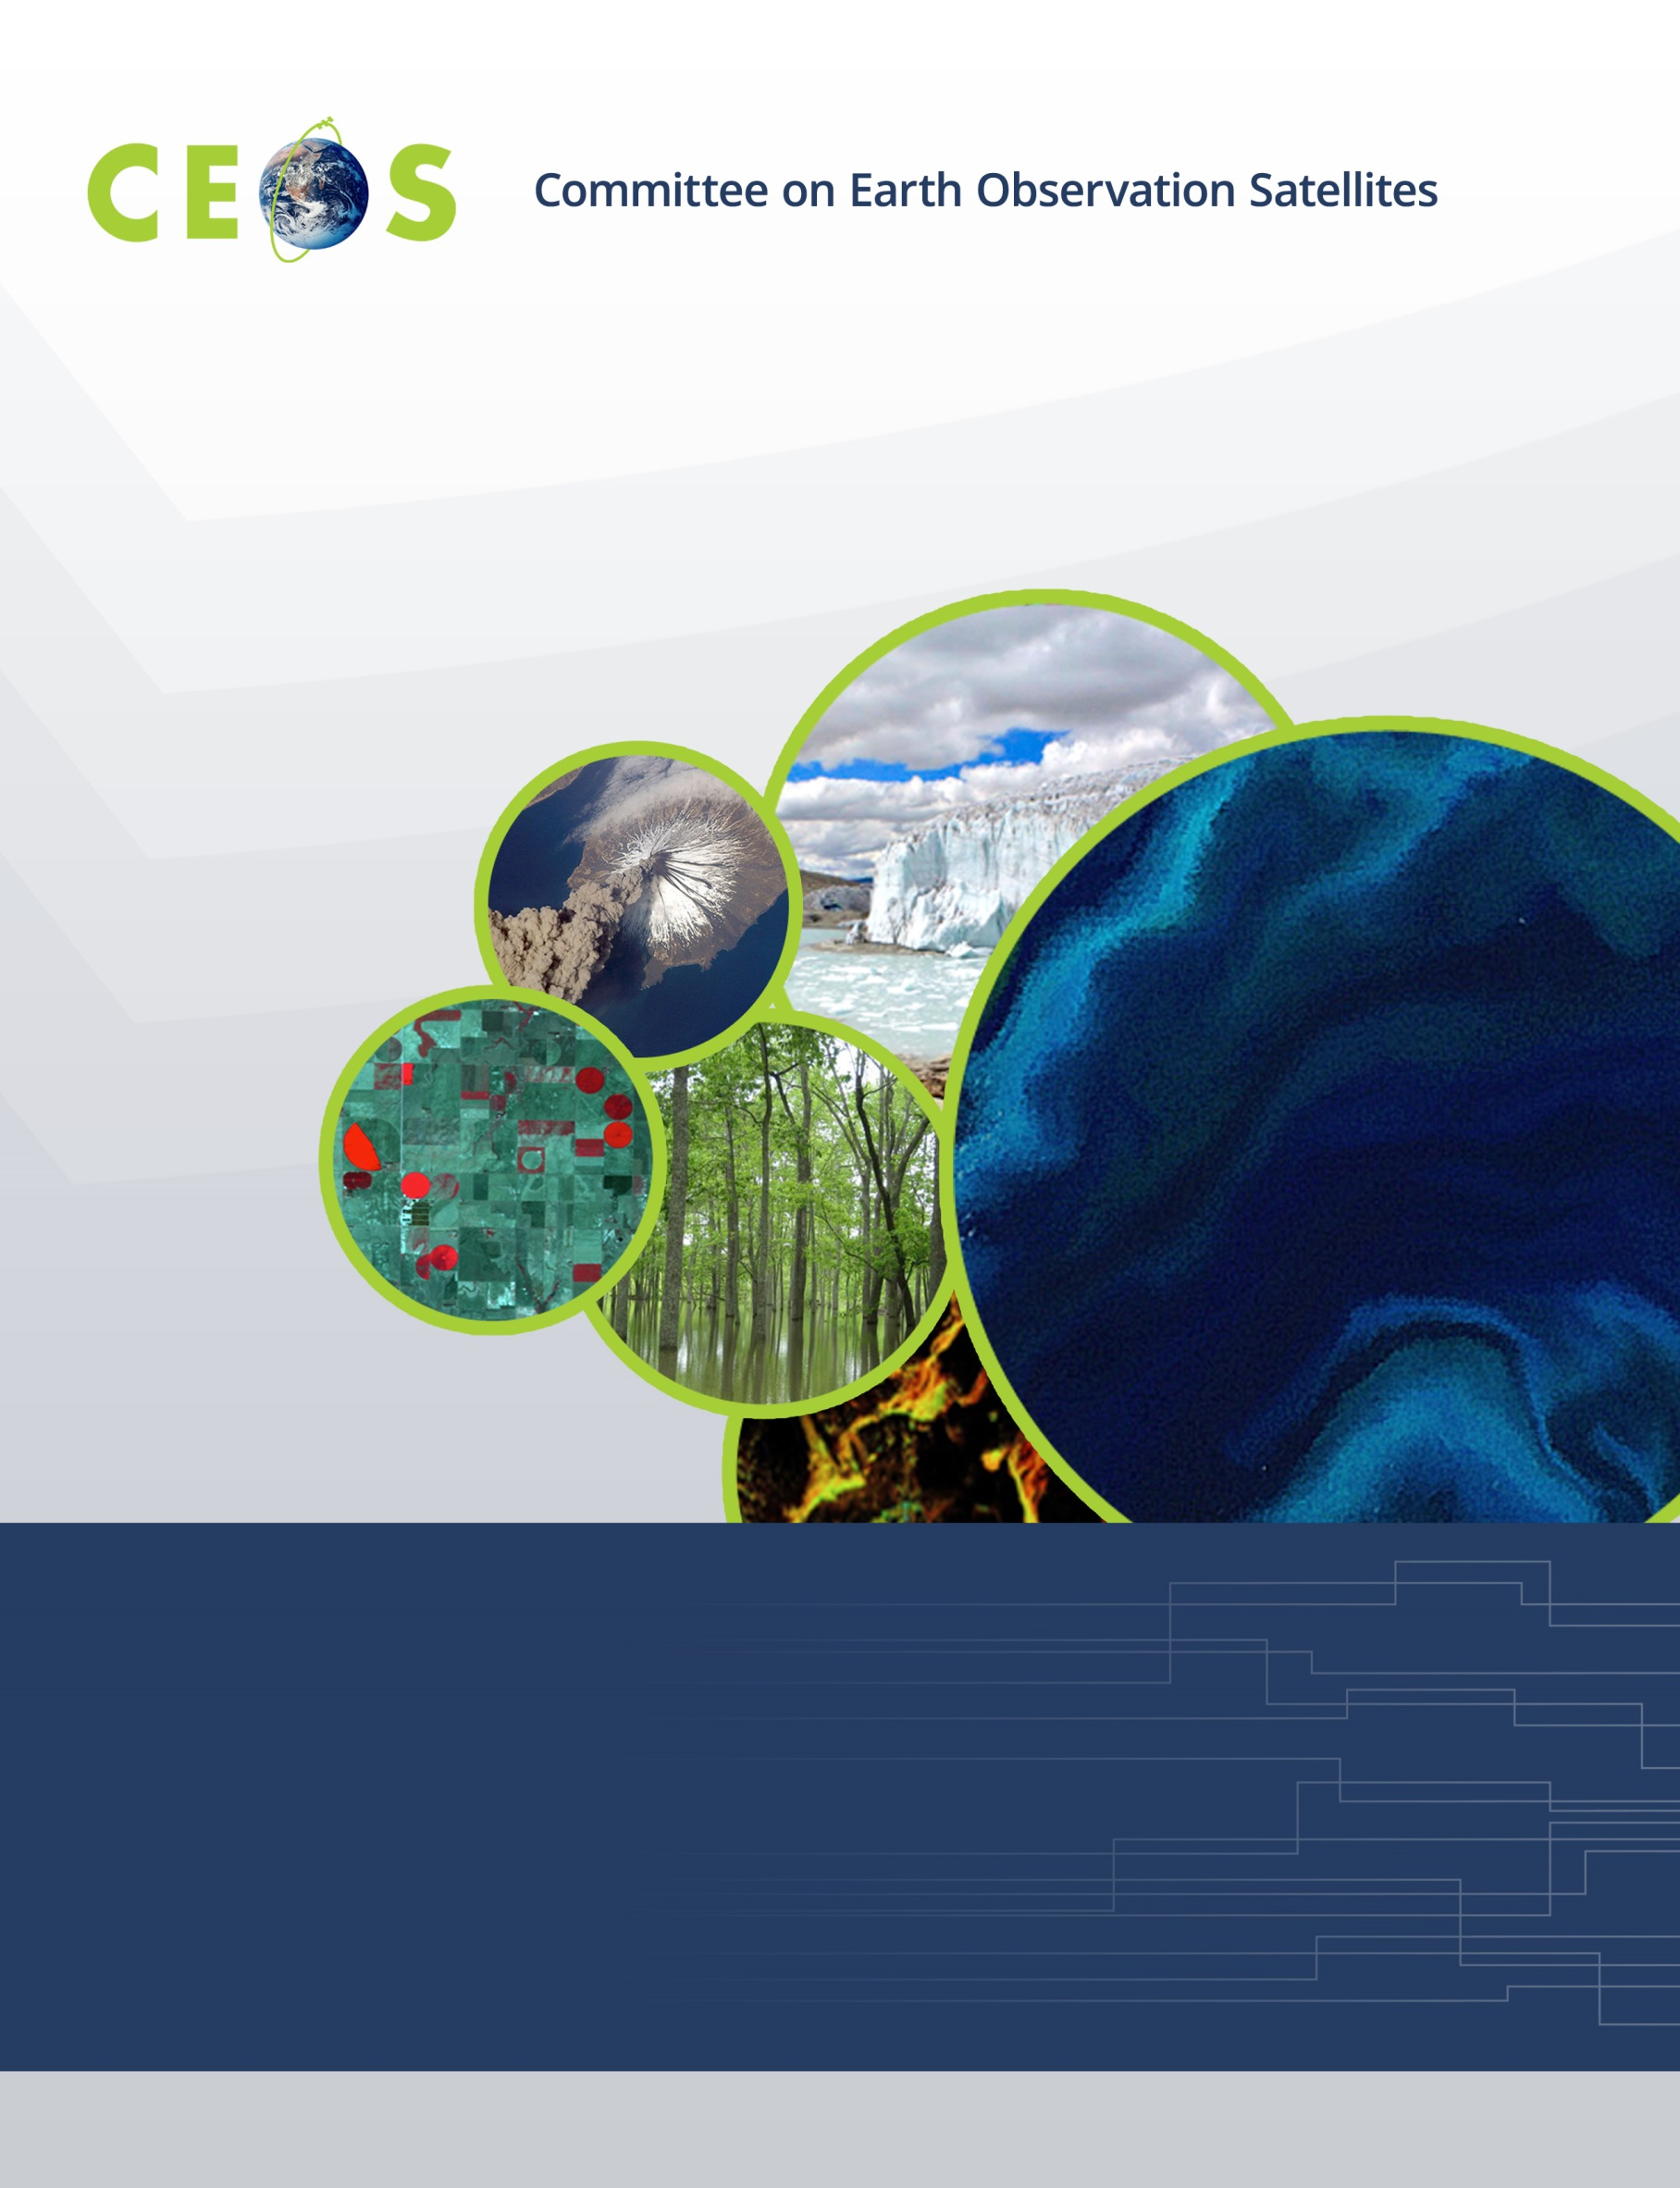

Sunday, April 8, 2018
Agenda
CEOS WGISS-45
April 9-12, 2018 - São José dos Campos, SP, Brazil
Hosted by the Instituto Nacional de Pesquisas Espaciais (INPE)
Version 1.0 April 8, 2018
*Indicates remote presentation

18:00 WGISS-Exec Meeting Ema Palace Hotel Lobby

Monday, April 9, 2018

08:15 Meet in Hotel Lobby for Transportation to Meeting

08:30 Registration

09:00 Convene

WGISS PLENARY Mirko Albani
09:00 Host Welcome and Logistics Information Lubia Vinhas
09:10 Welcome and Introductions, Adoption of Agenda Mirko Albani
09:20 WISP Report Michelle Piepgrass
09:30 WGISS Chair Report Mirko Albani
09:50 WGISS 2018-2020 Work Plan Mirko Albani

10:30 Break
10:50 WGISS Brochure Yonsook Enloe
Data PRESERVATION and STEWARDSHIP
10:10 Data Stewardship Interest Group Session Mirko Albani
11:40 DSIG Standards status and Way Forward Iolanda Maggio
12:00 Data Management and Stewardship Maturity Matrix Lessons Learned
ESA Iolanda Maggio
IGSNRR/CAS Liu Chuang

12:30 Lunch
Data DISCOVERY and ACCESS
13:30 Introduction Yonsook Enloe
WGISS Connected Data Assets Yonsook Enloe
IDN and ECV Status Michael Morahan
FedEO Status Andrea Della Vecchia
CWIC Status Yonsook Enloe
China (NRSCC) and China GEO Status Eugene Yu*

15:00 Break
15:20 Carbon Portal and Strategy, Kenneth McDonald*,
Demonstration Liping Di*
15:40 OGC Documents Spec Status - OGC 17-003 and OGC 13-026r9 Andrea Della Vecchia
16:00 CEOS OpenSearch Project Report Andrea Della Vecchia
Conformance Test Document and OGC document review
16:20 Data Asset Enhancement — Synergies with FDA Rob Woodcock
16:40 Minutes and Action Items review Michelle Piepgrass

17:00 Adjourn

Tuesday, April 10, 2018

08:15 Meet in Hotel Lobby for Transportation to Meeting

09:00 Convene
Joint Session with WGCV
09:00 Welcome and Introductions, adoption of Joint Plenary agenda Mirko Albani,
Kurtis Thome
09:10 Host Welcome Opening Address Dr. Ricardo Galvao,
INPE Director
09:40 CEOS Executive Officer Report Steven Hosford
10:10 CEOS 2018-2020 Work Plan Steven Hosford

10:30 Break
Joint Session with WGCV, continued
10:50 GEO Secretariat Report Paola de Salvo*
11:10 CEOS Systems Engineering Office Report Brian Killough*
11:30 WGISS Overview Mirko Albani
11:45 WGCV Overview Kurtis Thome
12:00 Overview of WGISS/WGCV Joint Effort; Past Achievements & Discussion Mirko Albani,
Kurtis Thome

12:30 Lunch
Joint Session with WGCV, continued
13:30 Data Formats and Interoperability in the framework of FDA Robert Woodcock,
Medhavy Thankappan
14:00 Quality Indicators in Discovery Metadata Michael Morahan,
Nigel Fox
14:30 CEOS Data Cubes and CEOS Test Sites Data Access in support Robert Woodcock,
of WGCV Activities Greg Stensaas

15:00 Group Photo

15:10 Break
15:30 Standardization and Best Practices (e.g. ISO 19159-3) Richard Moreno,
Cindy Ong
16:00 Summary on Joint Interaction and Additional Opportunities; Mirko Albani,
Joint Recommendations to CEOS and GEO Kurtis Thome
16:30 Minutes and Action Items review Michelle Piepgrass,
Jamie Nickeson

17:00 Adjourn

19:00 No-host Dinner

Wednesday, April 11, 2018

08:00 Meet in Hotel Lobby for Transportation to Meeting

08:45 Convene
Workshop on Future Data Architectures (FDA) and Introduction of Copernicus
Data and Information Access System (DIAS)
FDA Platforms and Elements Landscape
08:45 Introduction Mirko Albani
08:50 FDA Context Steven Hosford
09:10 Exploitation Platforms and Common Reference Architecture Cristiano Lopes*
09:30 ESA Data Cubes Rosemarie Leone*,
Andrea Della Vecchia
09:50 Sentinel-2 ARD: Making the Process Operational Federica Moscato*
10:10 Open Data Cube in Uganda Simon Reid*

10:30 Break
FDA Platforms and Elements Landscape, continued
10:50 Horizontal Scalability for the Colombian Data Cube Pilar Lozano-Rivera,
Harold Castro*
11:10 Copernicus DIAS Martin Ditter
11:30 GeoHazards Exploitation Platform (GEP) and BIOMASS Jolanda Patruno*,
Missions Application Platform (MAP) Andrea Della Vecchia
11:50 Pipelines, Ingestion, on-Demand – EO Data Supply Chains in FDA Rob Woodcock
12:10 USGS Experiences With Cloud Kristi Kline*

12:30 Lunch
FDA Platforms and Elements Landscape, continued
13:30 CODE-DE Platform Albrecht von Bargen
13:50 NASA Cloud presentations
13:50 How Cloud Computing Can Help Scientists Chris Lynnes
14:10 Cumulus: Cloud-based Archive for NASA’s Earth Science Data Katie Baynes*
14:30 Best Practices for Cloud-Native Architectures Dan Pilone*
14:50 NASA’s Earthdata Cloud Analytics Framework Chris Lynnes

15:10 Break
15:30 Vietnam Data Cube Matt Paget
15:50 CNES FDA status Richard Moreno
16:10 INPE’s MODIS Data Cube: Architecture, Algorithms, and Results Lubia Vinhas
16:30 Minutes and Action Items review Michelle Piepgrass

17:00 Adjourn

Thursday, April 12, 2018

08:15 Meet in Hotel Lobby for Transportation to Meeting

09:00 Convene
Data INTEROPERABILITY and USE
09:00 Recovery Observatory Richard Moreno
09:20 Open Source Software discussion Iolanda Maggio
09:40 OGC Testbed 13 Outcomes and Information on the OGC Testbed 14 Cristiano Lopes*
10:00 User Metrics Introduction Iolanda Maggio
10:10 ESA User Metrics Mirko Albani

10:30 Break
10:50 DLR User Metrics Katrin Molch*
11:05 NASA User Metrics Chris Lynnes
11:20 ESA Single Sign On (SSO) and Federated Identity Management Marco Leonardi*
11:35 USGS User Management Kristi Kline*
11:50 NextGEOSS User Management Nuno Catarino,
Agency/Liaison Reports
12:10 CSIRO Robert Woodcock
12:20 CNES Richard Moreno

12:30 Lunch
13:30 CONAE Homero Lozza
13:40 INPE Lubia Vinhas
13:50 ESA Mirko Albani
14:00 Geoscience Australia Medhavy Thankappan
14:10 JAXA Makoto Natsuisaka
14:20 NASA Andrew Mitchell*
14:30 NRSCC Chuang Liu
14:40 UKSA Esther Conway
14:50 Future Meetings Robert Woodcock

15:00 Break
15:20 WGISS Summary Mirko Albani
16:00 WGISS-45 Action Items Michelle Piepgrass
16:45 Concluding Remarks Mirko Albani

17:00 Adjourn

