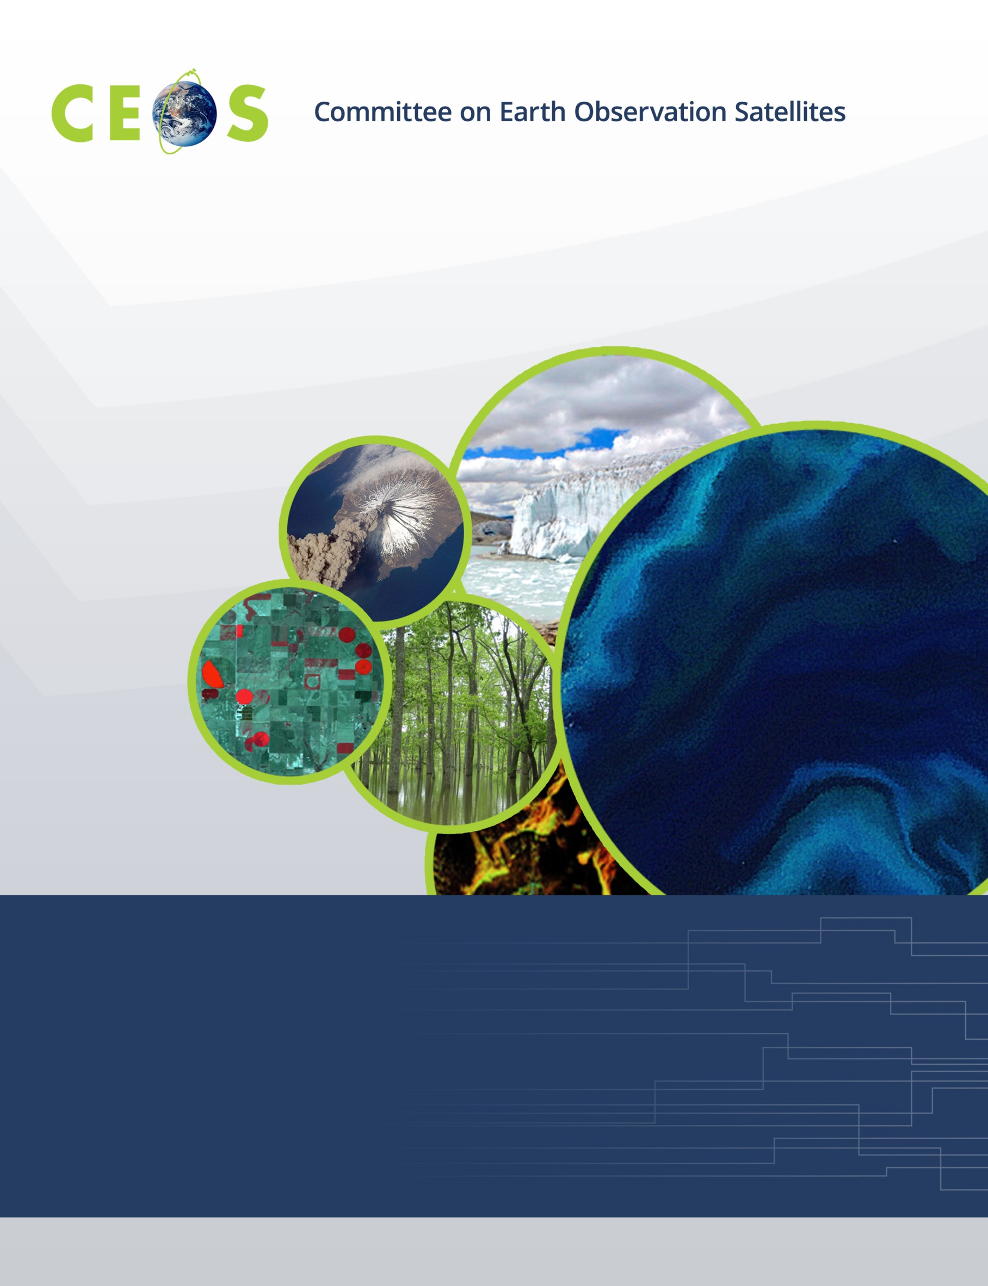

Sunday, April 28, 2019
CEOS WGISS-47, Agenda
Silver Spring, Maryland, USA, April 29-May 2, 2019
Hosted by the National Oceanic and Atmospheric Administration (NOAA)
Version 1.1 April 29, 2019
*Indicates remote presentation

18:00 WGISS-Exec Meeting

Courtyard by Marriott Silver Spring Downtown, meet in lobby
8506 Fenton St, Silver Spring, MD 20910

Monday, April 29, 2019

08:30 Registration

09:00 Convene

WGISS PLENARY Mirko Albani
09:00 Host Welcome Dr. Steve Volz,
Dr. Ed Kearns
10:00 Welcome and Introductions, Adoption of Agenda Mirko Albani
10:10 Introduction to NCEI Ken Casey
10:20 WISP Report Michelle Piepgrass
10:30 WGISS Chair Report Mirko Albani
10:45 GEO Secretariat Report Paola de Salvo*

11:00 Break
11:20 Future Meetings Robert Woodcock
11:30 CEOS Working Groups Reports and Progress on Cooperation with WGISS
WGCV Kurtis Thome
12:00 Review of CEOS 2019-21 Work Plan and WGISS 2018-2020 Work Plan Mirko Albani
12:10 Systems Engineering Office (SEO) Report Brian Killough

12:30 Lunch (on your own)
Future Data Architectures Elements Demonstration and Interoperability Workshop
13:50 Introduction and Scope Robert Woodcock
14:10 GEO AquaWatch with Demonstration Steven Greb
14:30 CEOS SEO Client Interfaces and Open Data Cube with Demonstration Brian Killough
14:50 FDA Common Architecture Whitepaper (FDA-08) Robert Woodcock
15:10 Inventory and Characterize Existing FDAs (FDA-09) Mirko Albani

15:20 Break
15:40 USGS Architecture for Services in the Cloud Kristi Kline
16:00 ESA PDGS Data Cube with Demonstration Andrea Della Vecchia
16:20 Discussion on 4i (interfaces, interoperability, implications and impact) Robert Woodcock

17:00 Adjourn

Tuesday, April 30, 2019

09:00 Convene
09:00 CEOS Executive Officer (CEO) Report Steven Hosford*
Future Data Architectures Elements Demonstration and Interoperability Workshop
09:20 Data Cube Service Cristiano Lopes
09:40 GEOhazard Thematic Exploitation Platform with Demonstration Francesco Barchetta*
10:00 Copernicus Data and Exploitation Platform – Deutschland (CODE-DE) with Demonstration Christian Strobl*,
Christoph Reck*
10:20 Food Security Thematic Exploitation Platform with Demonstration Antonio Romeo*

10:40 Break
11:00 Plateforme d'Exploitation des Produits Sentinel (PEPS) Richard Moreno,
Patrice Henri*
11:20 JASMIN Super Data Cluster Phil Kershaw*
11:40 Big Data Approaches Supporting Market Growth in EO at the Satellite Applications Catapult Rob Fletcher
12:00 Discussion: Concrete Next Steps for FDA Interoperability and Ecosystem Take-up;
Address actions from SIT-34 Robert Woodcock, All

12:30 Lunch (on your own)
Data DISCOVERY and ACCESS
13:40 Introduction Yonsook Enloe
13:45 WGISS Connected Data Assets Status Report Yonsook Enloe
14:00 IDN Update Michael Morahan
14:15 CWIC Update Yonsook Enloe
14:30 FedEO Evolution Andrea Della Vecchia
14:45 NOAA NCEI Rich Baldwin*
15:15 IDN Front End Portal, Branding and User Metrics (WGISS-46-17, 19) System Level Team, All

15:30 Break – 10 min walk towards NOAA Campus – 1315 East West Highway

15:50 Group Photo
16:00 “Science on a Sphere” NOAA

17:00 Adjourn

17:00 Reception at NOAA GATEWAY – 1325 East West Highway

19:00 No-Host Dinner Event, McGinty’s Public House, 911 Ellsworth Dr., Silver Spring, MD

Wednesday, May 1, 2019

09:00 Convene
09:00 CEOS Working Groups Reports and Progress on Cooperation with WGISS
09:00 WGCapD Nancy Searby*
Data INTEROPERABILITY and USE
09:20 Earth Observation Services Metadata Use Cases Valerie Dixon
ISRO Use Cases Nitant Dube*
NASA EOSDIS Valerie Dixon
09:50 Inventory of Software and Tools (Open Source) (FDA-10) Iolanda Maggio
10:10 Carbon Data Portal Prototype (CARB-15): status and way forward discussion Liping Di
10:30 White Paper on Single Sign-On (SSO) Authentication (DATA-14) Damiano Guerrucci

10:50 Break
11:00 Recovery Observatory Richard Moreno
11:20 GEO Knowledge Hub and WGISS Contribution – discussion Chris Lynnes, All

12:30 Lunch (on your own)
Data PRESERVATION and STEWARDSHIP
13:50 Solution for Long Term Preservation – Workshop outcomes Daniele Iozzino*
14:00 EO Ontologies Iolanda Maggio
14:10 NASA Michael Morahan
14:30 ESA Andrea Della Vecchia
14:50 CNES Richard Moreno
15:10 NOAA Nancy Ritchey

15:30 Break
15:50 WMO Stewardship Maturity Matrix for Climate Data (SMM-CD) Ge Peng*
16:10 WMO Expert Group Possible Collaboration Ge Peng*
16:30 RDA Possible Collaboration Iolanda Maggio
16:40 GEO DMP Proposal – Discussion Iolanda Maggio
16:50 PV2020 and Other Relevant Conferences Iolanda Maggio

17:00 Adjourn

Thursday, May 2, 2019

09:00 Convene
09:00 CEOS Working Groups Reports and Progress on Cooperation with WGISS
WGClimate Joerg Schultz*
Sustainable Development Goals Ad-hoc Team (SDG AHT) Marc Paganini*
TECHNOLOGY EXPLORATION
09:20 Data Services in the Cloud Chris Lynnes
09:25 Advanced Geospatial Techniques: Aiding Earth Observation Applications Nitant Dube*
09:45 OGC Testbed 14 and 15 Cristiano Lopes
10:05 CNES Activities and Services in the Cloud Pierre Lassalle
10:25 EOSDIS Architecture for Data Services in the Cloud Chris Lynnes

10:45 Break
11:05 Artificial Intelligence & Machine Learning Chris Lynnes
11:10 Workshop on Leveraging AI in the Exploitation of Satellite Sid Boukabara
EO and Numerical Weather Prediction
11:30 AI for EO and EO for AI Sveinung Loekken*
11:50 Machine Intelligence towards Tomorrow’s Earth Science Data Systems Manil Maskey*
12:10 A New Large-Scale Sentinel-2 Benchmark Archive to Begum Demir*
Drive Deep Learning Studies in Remote Sensing
12:30 Multi-task Deep Learning from Sentinel-1 SAR: Clement Dechesne*
Ship Detection, Classification and Length Estimation
12:50 CNES Initiatives on AI Pierre Lassalle
13:10 Discussion and Way Forward Chris Lynnes

13:20 Lunch (on your own)
Agency/Liaison Reports
14:20 CNES Richard Moreno
14:30 NASA Andrew Mitchell
14:40 HSO Gabor Remetey-Fülöpp
14:50 JAXA Makoto Natsuisaka
15:00 ISO TC211 Liping Di

15:10 Break
15:30 WGISS Summary Mirko Albani
15:50 Review of WGISS-46 Actions Michelle Piepgrass
16:00 WGISS-47 Actions Michelle Piepgrass
16:50 Concluding Remarks Mirko Albani

17:00 Adjourn

