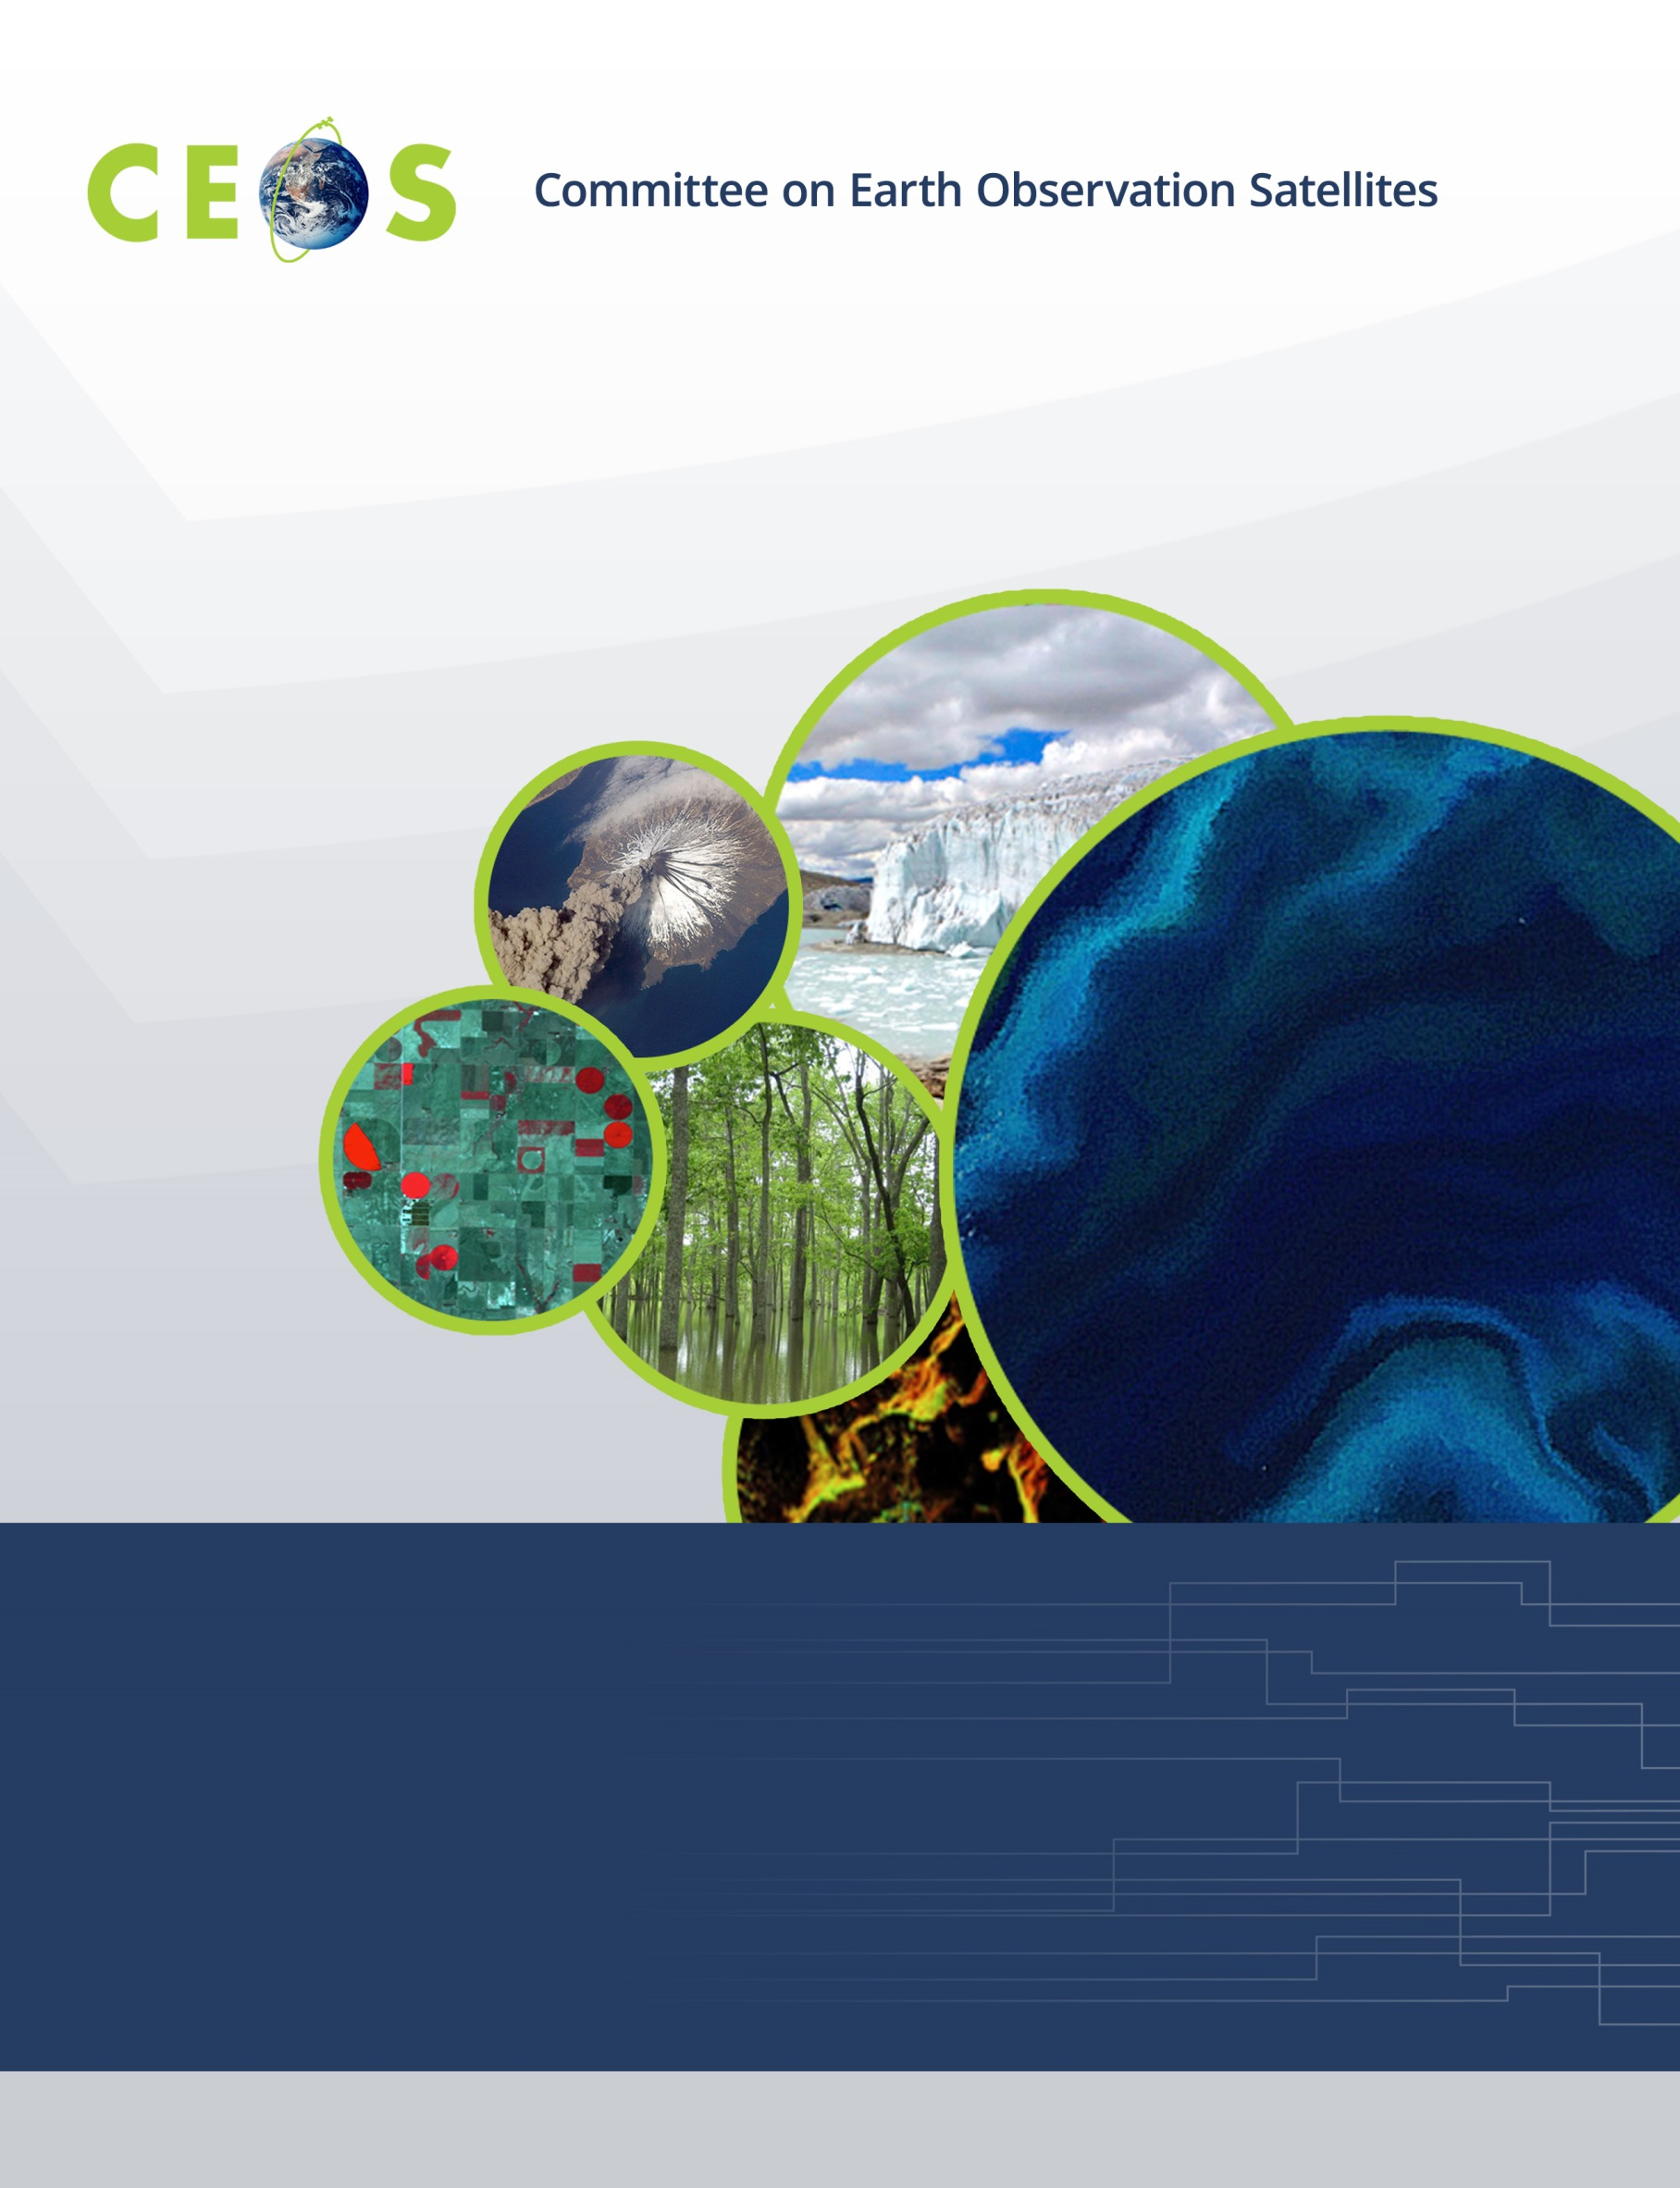

CEOS WGISS-49, Agenda
Virtual Meeting, April 21-23, 2020

All times are Universal Time (UTC), all presentations are remote
Version 1.0 April 16, 2020

Tuesday, April 21, 2020

11:00 Convene

WGISS PLENARY
11:00 Welcome and Introductions, Adoption of Agenda Robert Woodcock (CSIRO)
11:05 CEOS Executive Officer (CEO) Report Kerry Sawyer (NASA)
11:20 Systems Engineering Office (SEO) Report Brian Killough (NASA)
11:30 CEOS Working Groups Reports and Progress on Cooperation with WGISS
WGCapD Nancy Searby (NASA)
WGDisasters David Borges (NASA)
11:40 WGISS Plenary Discussion, Summary of Actions, Chair Report Highlights Robert Woodcock (CSIRO)
Data INTEROPERABILITY and USE (Part 1 of 2)
FDA – Cloud based EO Analytics architectures and deployment/operations
11:50 USGS Landsat processing Cloud architecture Kristi Kline (USGS)
12:05 Open Data Cube on Kubernetes Robert Woodcock (CSIRO)
12:20 ESA Pixel Based Access and Data cube initiatives Philippe Mougnaud (ESA),
Andrea Della Vecchia (ESA)
12:35 Status of the Brazil Data Cube Project Lubia Vinhas (INPE)

12:50 Break
13:10 Data Interoperability and use Discussion Robert Woodcock (CSIRO)
Data DISCOVERY and ACCESS
13:25 General Reports
13:45 STAC Overview Chris Holmes
14:00 Landsat and STAC Matt Hanson, Kristi Kline
(USGS)
14:15 ESA FedEO STAC Yves Coene (ESA)
14:30 Data Discovery and Access Discussion, Summary of Actions Damiano Guerrucci (ESA)

15:00 Adjourn

Wednesday, April 22, 2020

11:00 Convene
Data INTEROPERABILITY and USE (Part 2 of 2)
User Experience and Portals for EO Analytics and Use
11:00 Ghanaian Crop Modelling Jupyter Notebook and Data Cube Jose Gomez-Dans
(NCEO/UCL)
11:15 JASMIN Jupyter Notebook Service Challenges and Opportunities Phil Kershaw,
Mat Pryor (NCEO/CEDA)
11:35 Jupyter for CAPD – UK Overseas Development Aid, Agritech, etc. Esther Conway (UKSA),
Heiko Balzer (NCEO)
11:45 Discussion and Next Actions on Jupyter in EO Esther Conway (UKSA)
12:00 Carbon Portal Update – Links to the Open Data Cube Liping Di (NASA/NOAA)
12:15 CEOS COAST - Users Needs and Experience Paul DiGiacomo (NOAA)
Data Cube interoperability
12:30 openEO Matthias Schramm
(Vienna Univ. of Technology)
12:40 Data Interoperability and Use Discussion, Summary of Actions Robert Woodcock (CSIRO)

12:50 Break
13:15 WGCV-WGISS Joint Activities Cindy Ong (CSIRO)
TECHNOLOGY EXPLORATION
13:30 Cloud Native Data Formats Overview Chris Lynnes (NASA)
13:45 Pangeo Ecosystem; xarray and zarr Ryan Abernathey
Update on CEOS ARD Production, Strategy and Approaches
14:00 USGS Tom Sohre (USGS)
14:15 NOAA: CoastWatch and OceanWatch ARD Preparation and Product Interoperability Veronica Lance (NOAA)
14:30 LSI-VC update on CARD4L and ARD Strategy Steven Labahn (USGS)
14:45 ARD and Datacube for BIMSTEC D. Dhar (ISRO)

15:00 Adjourn

Thursday, April 23, 2020

11:00 Convene
Data PRESERVATION and STEWARDSHIP
11:00 Data Stewardship and Management Maturity Matrix Iolanda Maggio (ESA)
11:15 NOAA CoMET Tool and the Maturity Matrix Self-Assessment Tool Nancy Ritchey (NOAA)
11:30 Persistent Identifier Implementation at CEOS agencies
CEOS PID Best Practice Iolanda Maggio (ESA)
ESA Mirko Albani (ESA)
NASA Dawn Lowe (NASA)
NOAA Nancy Ritchey (NOAA)
JAXA Makoto Natsuisaka (JAXA)
CNES Richard Moreno (CNES)
ISRO Nitant Dube (ISRO)
12:30 Technical Content and Information Preservation Iolanda Maggio (ESA)
12:40 Discussion and Actions Review Mirko Albani (ESA)

12:50 Break
WGISS PLENARY, continued
13:10 Future Meetings Makoto Natsuisaka (JAXA)
13:15 Discussion Robert Woodcock (CSIRO)
13:45 WGISS Summary Robert Woodcock (CSIRO)
14:10 Review of WGISS-48 Actions Michelle Piepgrass (CSIRO)
14:30 WGISS-49 Actions Michelle Piepgrass (CSIRO)
14:50 Concluding Remarks Robert Woodcock (CSIRO)

15:00 Adjourn

