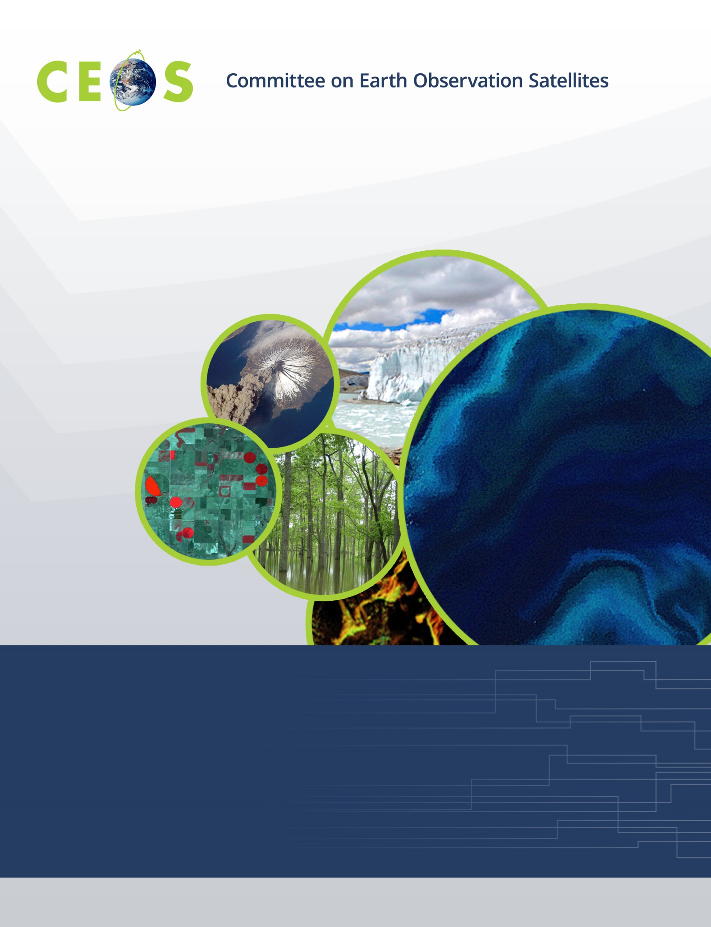

CEOS WGISS-50, Agenda
Virtual Meeting, September 22-24, 2020

All times are Universal Time (UTC), all presentations are remote
Version 1.0 September 21, 2020

WGISS 50 is being held as a virtual meeting; all presentations are pre-recorded and available here: http://ceos.org/meetings/wgiss-50/
To assist scheduling and to ensure your questions are answered please feel free to submit your questions in advance to the conference Q&A site <insert link> whilst you are viewing the video presentations.
Please review the video content at a time convenient to you prior to the main video conference as the material will not be presented in the main conference. The main conference will consist of a teleconference with Q&A with speakers and discussion.

Tuesday, September 22, 2020

11:00 Convene

WGISS PLENARY
11:00 Welcome and Introductions, Adoption of Agenda Robert Woodcock (CSIRO)
CEOS Executive Officer (CEO) Report Kerry Sawyer (NOAA)
Systems Engineering Office (SEO) Report (including ODC) Brian Killough (NASA)
Data DISCOVERY and ACCESS
General reports:
IDN Michael Morahan (NASA)
CWIC and CWIC Evolution Minnie Wong (NASA)
FedEO Y. Coene (Spacebel, ESA),
A. Della Vecchia (Randstad, ESA)
FedEO Catalogue API Evolution Y. Coene (Spacebel, ESA),
A. Della Vecchia (Randstad, ESA)
FedEO Metadata Editor Y. Coene (Spacebel, ESA),
A. Della Vecchia (Randstad, ESA)
STAC Community Sprint (web link) Chris Holmes (Planet Labs)
STAC CMR Valerie Dixon (NASA)
FedEO STAC API and STAC Browser Y. Coene (Spacebel, ESA),
A. Della Vecchia (Randstad, ESA)
TECHNOLOGY EXPLORATION
Future Webinars Planning Yousuke Ikehata (JAXA)
CEOS Branded Webinar Plans with WGCapD Nancy Searby (NASA)
Jupyter Notebooks Survey results; Developing a Best Practice Esther Conway (UKSA)

13:00 Adjourn

WGISS 50 is being held as a virtual meeting; all presentations are pre-recorded and available here: http://ceos.org/meetings/wgiss-50/
To assist scheduling and to ensure your questions are answered please feel free to submit your questions in advance to the conference Q&A site <insert link> whilst you are viewing the video presentations.
Please review the video content at a time convenient to you prior to the main video conference as the material will not be presented in the main conference. The main conference will consist of a teleconference with Q&A with speakers and Discussion.

Wednesday, September 23, 2020

11:00 Convene
Data INTEROPRABILITY and USE
11:00 CEOS Earth Analytics Interoperability Lab (EAIL): Rob Woodcock (CSIRO),
Brian Killough (NASA)
CEOS Rice Monitoring Community Shin-ichi Sobue (JAXA)
CEOS COAST Paul DiGiacomo (NOAA)
WGCV – DEMIX Peter Strobl (EC)
WGDisasters Flood Pilot Guy Schumann (NASA)
CEOS Interoperability Terminology Rob Woodcock (CSIRO)
Artificial Intelligence at the service of Geospatial Information Pierre-Marie Brunet (CNES)
Entwine Point Tiles (for point cloud data like ICESat-2) Dan Pilone (NASA),
Trevor Skaggs (Element 84)
Agency updates on FDA, ARD, Data Cubes, Best Practice
WGISS Best Practice for Cloud-based data formats Discussion, All
Accessing and Processing Brazilian EO Data Cubes with ODC Karine Ferreira (INPE)
CSIRO EASI Hub Data Pipelines Matt Paget (CSIRO)
CEOS Carbon Portal Liping Di (NOAA)
SAR2CUBE Alexander Jacob (EURAC)
EuroDataCube Gunnar Brandt (Brockmann Consult)

13:00 Adjourn

WGISS 50 is being held as a virtual meeting; all presentations are pre-recorded and available here: http://ceos.org/meetings/wgiss-50/
To assist scheduling and to ensure your questions are answered please feel free to submit your questions in advance to the conference Q&A site <insert link> whilst you are viewing the video presentations.
Please review the video content at a time convenient to you prior to the main video conference as the material will not be presented in the main conference. The main conference will consist of a teleconference with Q&A with speakers and Discussion.

Thursday, September 24, 2020

11:00 Convene
Data PRESERVATION and STEWARDSHIP Mirko Albani (ESA)
11:00 Persistent Identifier Best Practice
NASA Update Dawn Lowe (NASA)
NOAA Update Nancy Ritchey (NOAA)
ESA Update Iolanda Maggio (RHEA, ESA)
ISRO Update T. Sai Kalpana (ISRO)
Discussion Iolanda Maggio (RHEA, ESA)
Technical Content and Information Preservation
JAXA Experience
ESA Experience Iolanda Maggio (RHEA, ESA)
International Cooperation on AVHRR Data Mirko Albani (ESA),
Stefan Wunderle (U of Bern)
NOAA Update on Data Preservation and Stewardship Nancy Ritchey (NOAA)
WGISS PLENARY
12:00 Agency Reports
NASA Andy Mitchell (NASA)
NOAA Nancy Ritchey (NOAA)
JAXA Makoto Natsuisaka (JAXA)
HSO Gabor Remetey-Fulopp (HSO)
ISO Liping Di (NOAA)
ISRO Nitant Dube (ISRO)
12:10 Future Meetings Makoto Natsuisaka (JAXA)
12:20 WGISS Summary and Discussion Robert Woodcock (CSIRO)
12:40 Review of WGISS Actions Michelle Piepgrass (CSIRO)
13:00 Concluding Discussion and Remarks Robert Woodcock (CSIRO)

13:00 Adjourn

