Landslide China Pilot and Events

- Overview
China is one of the countries seriously affected by landslide hazards. According to the China Geological Survey, there are about 280,000 potential landslides in China and the hazards influence more than 10 million people and 200 billion property. As one of the regional study areas of CEOS Landslide Pilot, China Pilot was started in 2016.
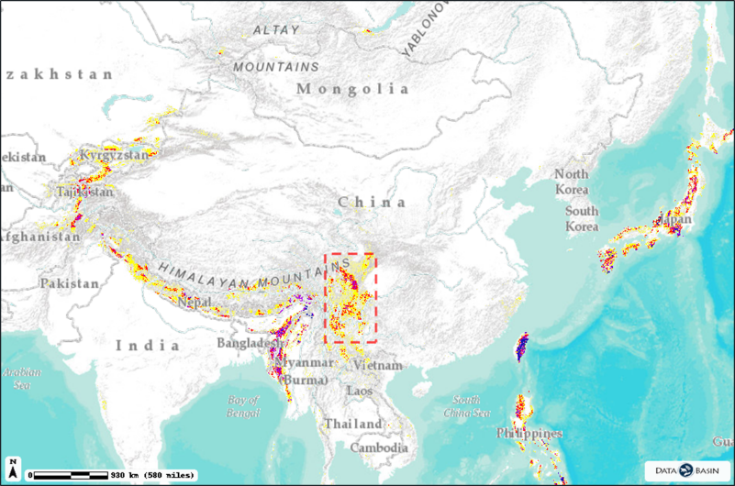
Chinese Landslide Hazards Distribution (Courtesy of CHRR, CIESIN, and NGI)
  - Region of Interest: SW China
The region of interest of Landslide China Pilot is southwest China. In this broad area, due to the movement of the Indian Plate pushing Tibet Plateau, big earthquakes occur every few years, and a large amount of landslides appear every year.
On August 8th 2017, a Ms7.0 earthquake struck Jiuzhaigou. On August 3rd, 2014, a Ms6.5 earthquake hit Ludian in this area, inducing more than 1000 landslides and thousands of people were killed by landslides. On May 12th 2008, a Ms8.0 magnitude earthquake hit Wenchuan, causing near 50,000 landslides.
  - Objectives
    - Develop more effective multi-temporal methods for merging multi-source optical satellite images to better detect historical landslides on a quarterly to monthly basis.
    - Develop Machine Learning-based methods for understanding patterns in images time series to rapidly detect new landslides in new available satellite images.
- Event: Landsat and GaoFen satellites reveal landslides in Ludian, China in years 2000-2015
  - Study Area
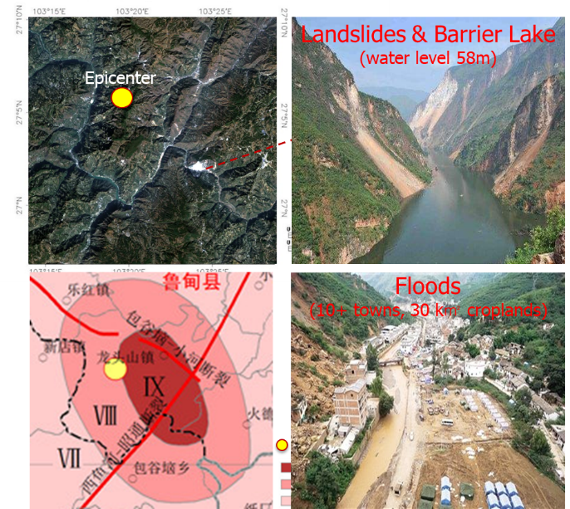
The 2014 Ms6.5 Ludian Earthquake and induced landslides and flood
The 2014 Ludian earthquake struck Ludian County, Yunnan, China, with a moment magnitude of 6.1(Ms 6.5, Mw6.1) on 3 August. The earthquake killed at least 617 people, injuring at least 2,400 others. The epicentral zone of that earthquake was selected for the study. In the area of earthquake intensity of nine, several huge landslides occurred along a river, causing a barrier lake with water level rising up to 58 meters following with big floods over tens of towns.
  - Earth Observation Satellite Data
To investigate the historical landslides that had appeared before this earthquake and the new landslides induced by the earthquake, a series of optical images from the Landsat-5/7/8, Chinese GaoFen-1 and HuanJing satellites were collected. The optical images time series consists of 332 images from 2000 to 2016.
  - Landslides in years of 2000-2015
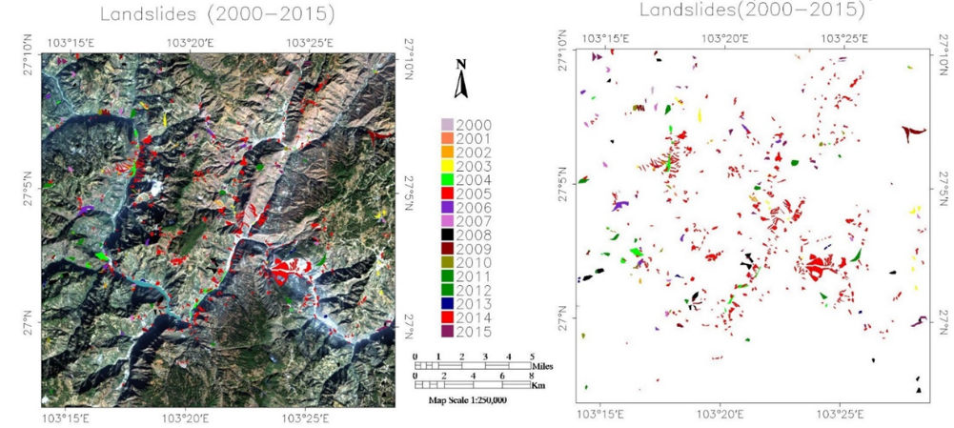
A map of the landslides in 2000-2015
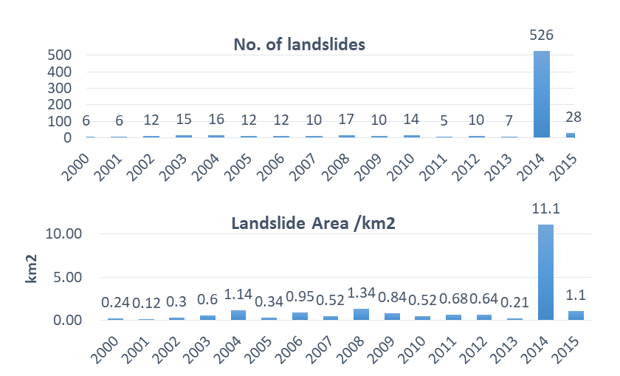
Numbers and areas of the landslides in 2000-2015
The landslides occurred in each year from 2000 to 2015 were visually interpreted. In this period, there are 700+ landslides > 90*120m², with a minimum of 5 landslides in 2011 and a maximum of 526 landslides in 2014 (year of the big earthquake).
An inventory map of those visually interpreted landslides in this study area illustrates that the landslides occurred every year, and a large amount of huge landslides were induced by the earthquake in 2014, with a total area of 11km².
- Co-Lead and PoC of the Landslide China Pilot
  - Co-Lead: Prof. Ziyang Li, Academy of Opto-Electronics (AOE), Chinese Academy of Sciences (CAS).
  - Point of Contact: Dr. Zeng-Guang Zhou, AOE CAS.

