 | CEOS-ARD Product  Self-Assessment  User Guide | Steps for Completing  Analysis Ready Data  Product Family Specification  Self-Assessments

Document History
Version | Date | Description of Change | Author
1.0 | 18/04/2023 | Initial draft | Peter Harrison
1.1 | 20/04/2023 | Edits to draft | Medhavy Thankappan
1.2 | 10/5/2023 | Edits to draft | PH & MT
1.3  1.4 | 5/6/2023  2/4/2024 | Edits to draft  Edits to match new Combined SAR PFS | PH & MT  PH & MT

Introduction
The CEOS Analysis Ready Data (CEOS-ARD) Product Family Specifications (PFSs) are the core component of the CEOS-ARD concept. They describe Analysis Ready Data specifications for particular remotely sensed measurement types. A PFS details specific requirements that a dataset must satisfy to be identified as CEOS-ARD compliant at either the minimal (Threshold) and/or desired (Goal) level. Each PFS has the following core requirement elements:
• General Metadata: allow the user to assess overall suitability of the dataset;
• Per-Pixel Metadata: allow users to choose which observations (e.g., pixels) to use or discard;
• Radiometric Corrections and Atmospheric Corrections: specify any corrections that must be made to the data to reach a measurement and accuracy requirements for the data to be analysis-ready;
• Geometric Corrections: specify geometric corrections that must be made and geometric accuracy required for the data to be analysis-ready.
Each PFS has the core elements mentioned above. However, the exact form of the Specification (i.e., which items / parameters appear in the PFS) differ among PFSs because the measurement, instrumentation, mode of observation, levels of maturity, expectation of the user community, etc., differ among product types.
The PFSs are intended to be self-contained documents, with both the requirements listed for each parameter as well as a location for the associated response from the self-assessor. This allows data providers to complete their self-assessments by including information detailing how their products meet the specifications as well as recording feedback on the specifications, if any. The PFS details requirements at two levels – 'Threshold' and 'Goal'. The Threshold level requirement is the minimum to meet the CEOS-ARD specification. The Goal level represents a higher level of specification and more stringent criteria to be met compared to the Threshold. Goal level requirements are intended to increase the quality of the product as well as interoperability with other datasets.
PFS self-assessment submissions at the Threshold level are evaluated through a simple Peer Review by nominated Points of Contact within the CEOS Working Group on Calibration and Validation (WGCV), facilitating a quick turnaround. PFS self-assessment submissions at the Goal level undergo a longer, more stringent review by a Panel of CEOS experts drawn from the WGCV.
A checklist is provided at the end of this document for data providers to use during the PFS self-assessment and to avoid incomplete or incorrect submissions. Once complete, self-assessments are submitted to the CEOS-ARD Oversight Group Secretariat for evaluation.

General Guidelines

Sample Data
When providing sample datasets, ensure that only the datasets and associated metadata to be evaluated for CEOS-ARD compliance are provided in a stand-alone directory for downloading via ftp or equivalent. To reduce file sizes, the samples can be zipped. This prevents assessments being carried out using incorrect datasets or documents being difficult to locate for evaluators. The sample dataset(s) are also to be made available to the public via the CEOS-ARD web page. This requires the link to be both maintained and accessible to the public.

Supporting Ancillary Data
Along with the sample datasets, relevant documentation required for the assessment must be provided. This may include Product User Manuals, Product Guides, Algorithm Description Documentation, etc.
If available on the web, a URL or Digital Object Identifier (DOI) is required as a minimum to access these documents and should be included in the self-assessment document. If not available via a web link, the documents are to be included as attachments in the submission email.

DOI Landing Page
Where there is a specific requirement, a DOI landing page must be provided. The page can be:
• live with active links;
• live with inactive links (documents to be provided as part of the sample data package); or
• a mock-up of how the page will look when it goes live, including any hyperlinks for accessing relevant information related to the evaluation.
A “mock-up” of the landing page or hyperlink to the landing page and DOI embedded in the metadata can be provided as shown in Figure 1.

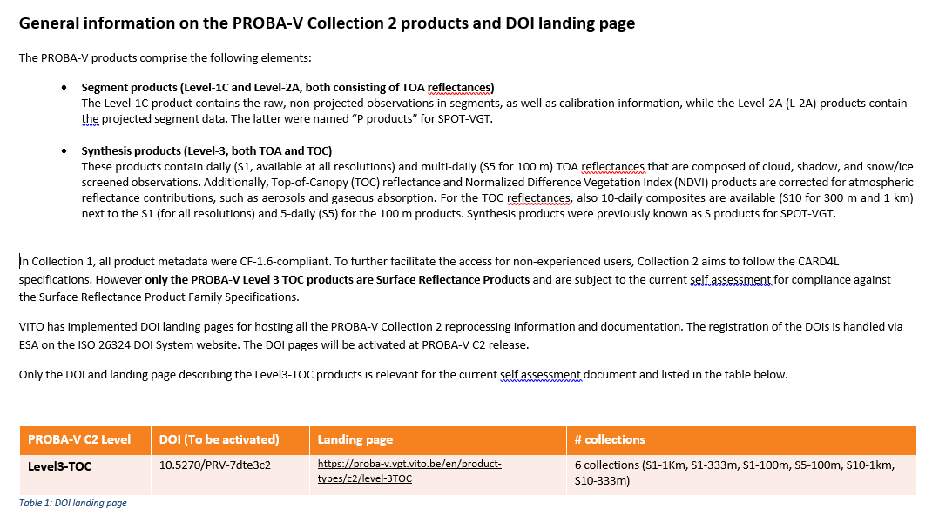

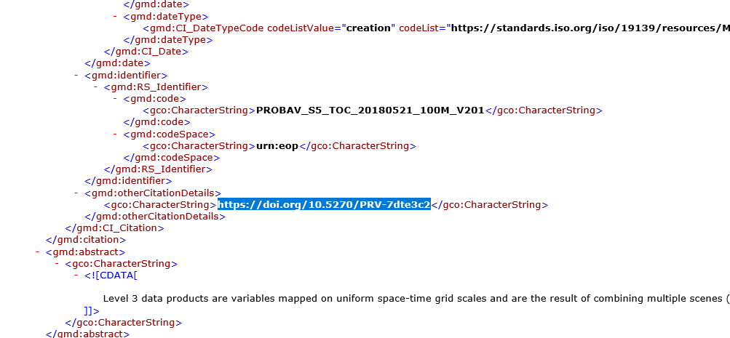
Figure 1. DOI Landing Page Examples

If multiple hyperlinks are being provided, highlight relevant sections on the page for evaluators to refer. Figure 2 shows an example of the DOI landing pages from the USGS Landsat Collection 2 datasets (Landsat Collection 2 | U.S. Geological Survey (usgs.gov)).

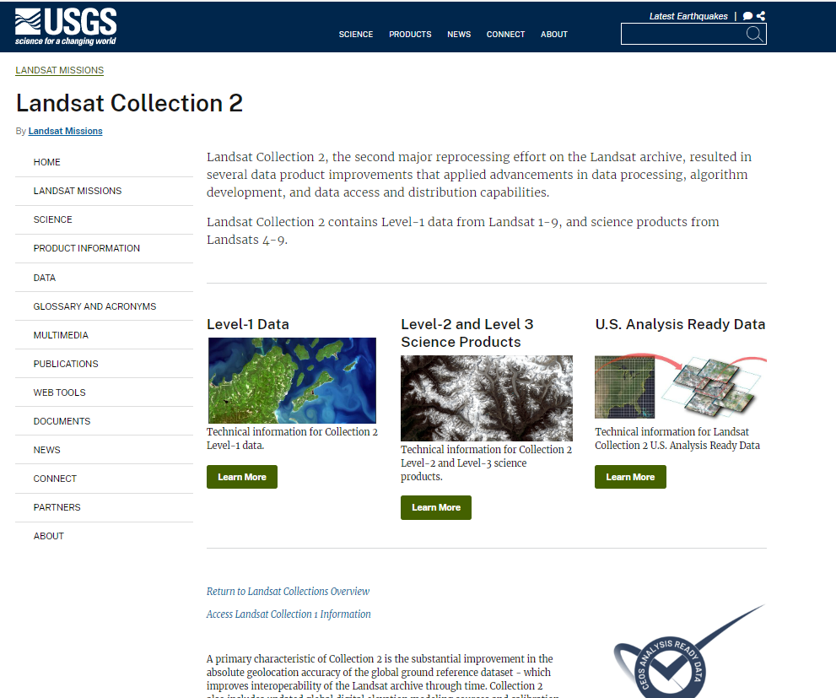
Figure 2 Landing Page for Landsat Missions
Various Landsat algorithm and auxiliary data landing pages can be found via the following link and are shown in Figure 3: Landsat 8-9 USGS EROS Archive - Landsat Archives - Landsat 8-9 OLI/TIRS Collection 2 Level-2 Science Products | U.S. Geological Survey

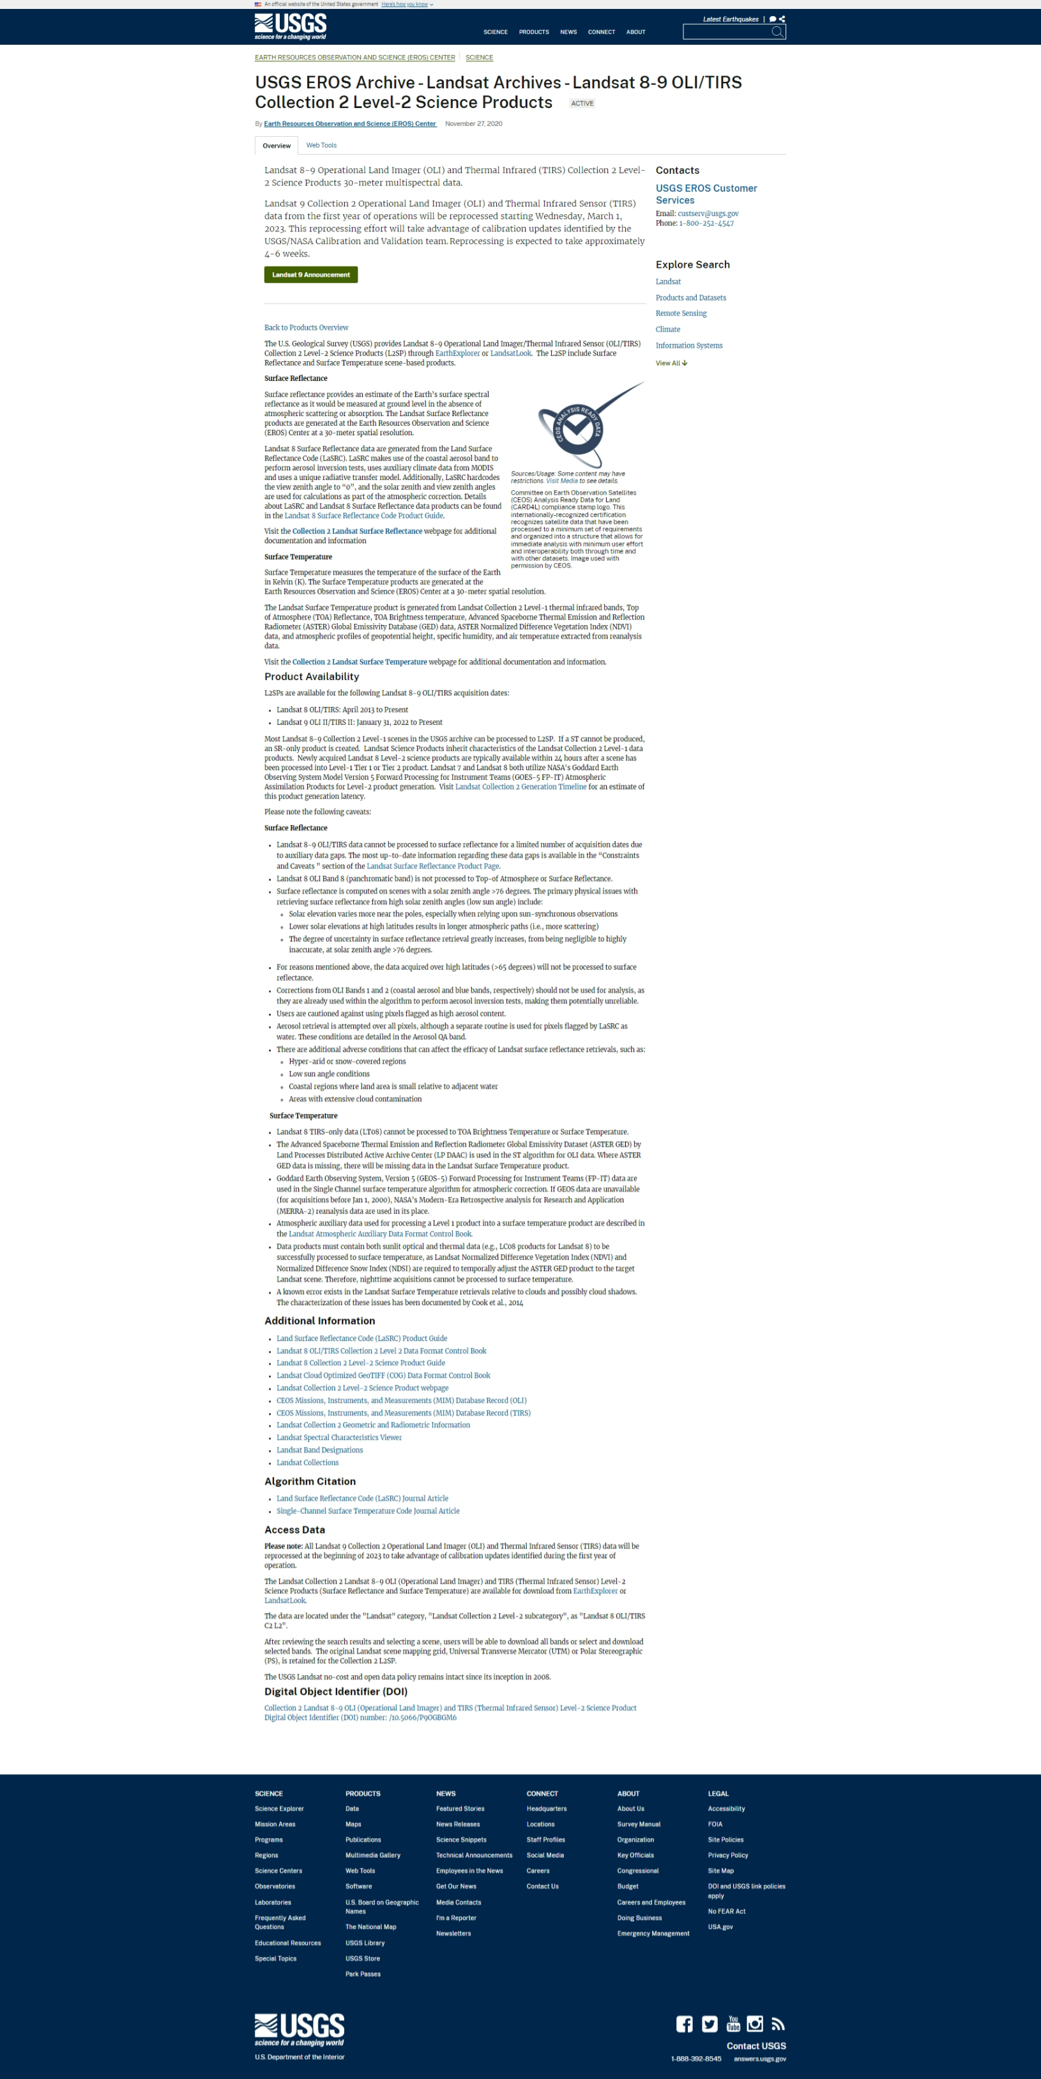
Download Site Link
Product Guide Link
Algorithm Papers Link
Geometry/Radiometric Link
Auxiliary Data Site Link
Figure 3 Landing Page for Landsat 8-9 Level-2 Products

Guidelines for Self-Assessment
View and download the latest version of the relevant self-assessment PFS document, which is available from the CEOS-ARD web page. The PFS can be found and downloaded from the “Current Product Family Specifications” links. For evaluators to note any feedback on the form, please complete the PFS self-assessment and submit in a Word format (.doc or .docx). A screenshot of the web page with links to the latest versions (as of April 2024) of all available PFS’s is shown in Figure 4.
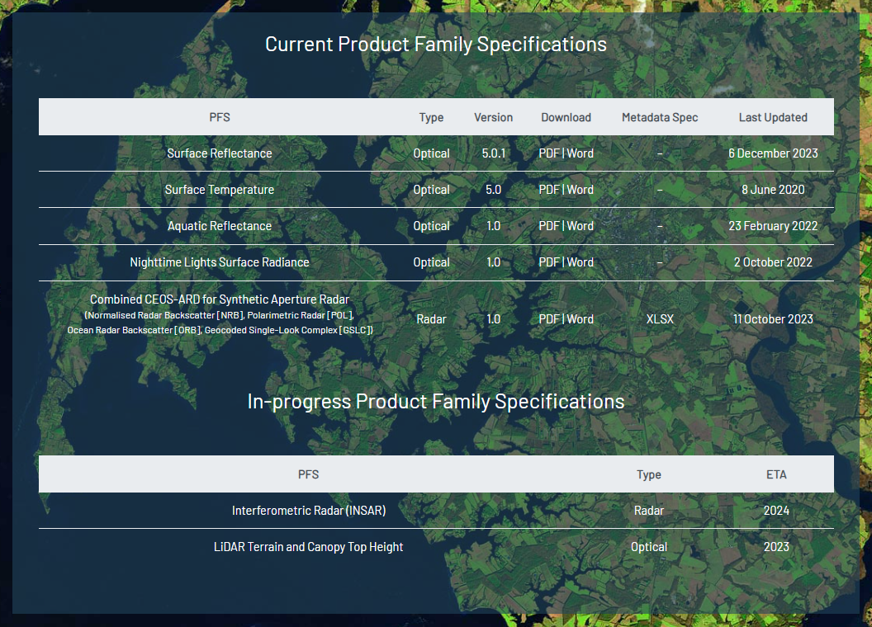
Figure 4 Screenshot of Web Page for PFS Documents
In October 2023, the 4 existing SAR PFS’s for Normalised Radar Backscatter (NRB), Polarimetric Radar (POL), Oceanic Radar Backscatter (ORB) and Geocoded Single-Look Complex (GSLC) were combined into a single PFS. Associated with the PFS is a Metadata Specification document (an excel table) which defines the XML tags to be used for the different parameters/items. Both documents are now available through the CEOS-ARD website.

The data provider is to complete a self-assessment of the product at the appropriate level for the peer review. Threshold level is the minimum, and it is up to the data provider to ensure that all requirements under the Threshold level are met before it is submitted for evaluation. Incomplete self-assessments with requirements that are not met should not be submitted for evaluation. At the Threshold level, not all items are required to be met and are clearly identified as such in the PFS. Any Goal level self-assessment items included at Threshold level will be ignored during the review.
If a self-assessment is carried out for Goal level requirements, the same conditions apply, whereby all requirements need to be assessed and justified / explained before it can be submitted for evaluation. A panel of experts drawn from the CEOS WGCV will be assembled for such a review, which will be an elaborate process. Self-assessment submissions at both levels need to cite the justification and evidence of how each requirement is met either as an extract from the metadata or reference to a document, a self-assessment note without justification and evidence is difficult to evaluate.
The self-assessment is carried out against a number of individual Items that are divided into four general metadata categories (with some nomenclature differences among PFS documents).
1. General Metadata
2. Per-Pixel Metadata
3. Radiometric and Atmospheric Corrections
4. Geometric Corrections

Item Requirements
Items are grouped into four general categories, with the requirements for each item being outlined in the CEOS-ARD PFS. Requirements are divided into Threshold (minimum) and Goal (Desired) requirements. Each PFS defines the parameters for each item required to meet the self-assessment at both levels for verification. While there are some commonalities, the parameters covered in each PFS will vary depending on the product type. Figures 5 and 6 show the generic template and how each item is to be self-assessed in a PFS for a reflectance product. Figures 7 and 8 show how items are to be self-assessed in the SAR PFS. Figure 9 shows the XML tags to be used for the associated SAR metadata file (obtained from the Metadata Specification spreadsheet). It is important to note that XML is case sensitive.

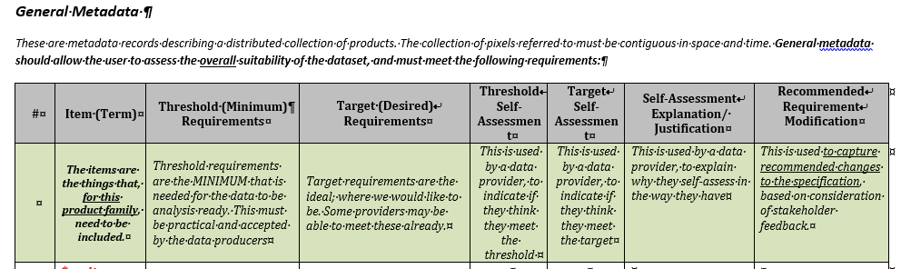

Figure 5 Item 1.8 Algorithms in the Surface Reflectance PFS with Threshold/Goal requirement descriptions NOTE: Target is now Goal.

Figure 6 Item 2.x Per-Pixel Metadata - Mask in the Surface Reflectance PFS with no Threshold requirements
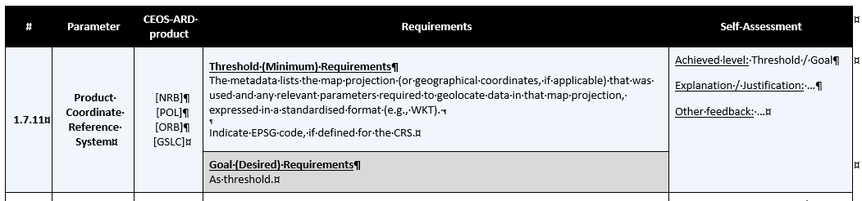
Figure 7 Item 1.7.11 Product Coordinate Reference System in the Combined SAR PFS with Threshold/Goal requirement descriptions (NOTE: Required for all SAR product types)
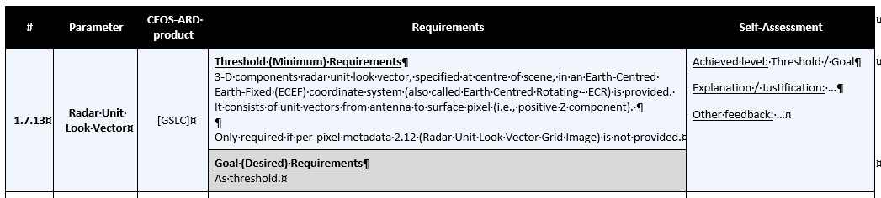
Figure 8 Item 1.7.13 Radar Unit Look Vectors in the Combined SAR PFS with Threshold/Goal requirement descriptions which is required for only the GSLC SAR product.
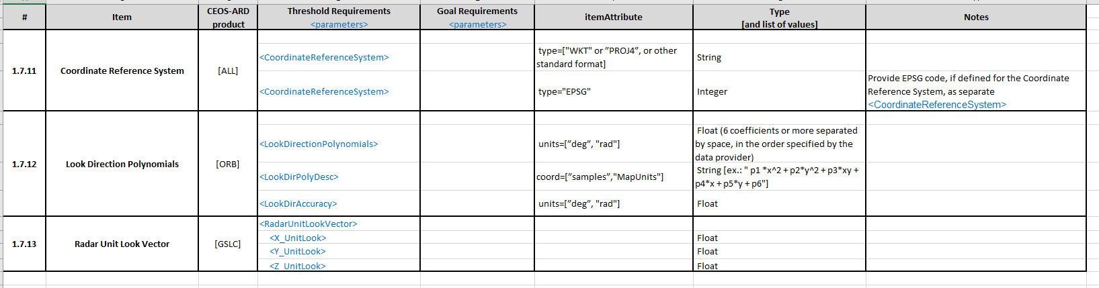
Figure 9 Combined SAR Metadata Specifications defining the XML tags and attributes for the metadata file.

Threshold Requirements
At the Threshold level, a number of items might not be required as part of the PFS self-assessment. These are identified in the relevant PFS document as “Not required”. When self-assessing items with no requirements, the Threshold level self-assessment column should be marked “Not required”. In these instances, a justification or explanation is not needed and can be left blank. In the Combined SAR PFS, some of the metadata parameters relate solely to a particular SAR Product type. If these are not required, these are identified in the self-assessment document as “Not Relevant” (Figure 10). In the Summary Self-Assessment Table, these parameters should not be removed and marked as “Not Relevant”.
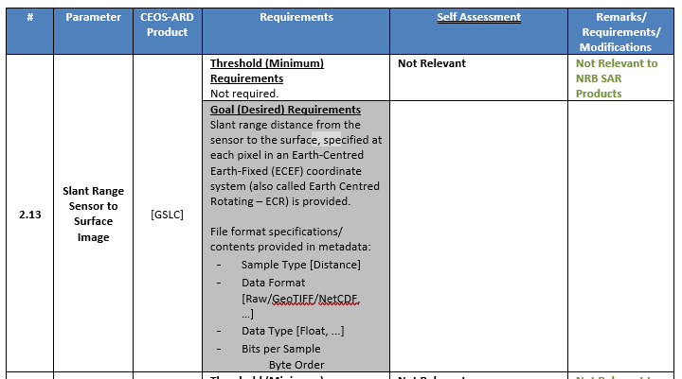

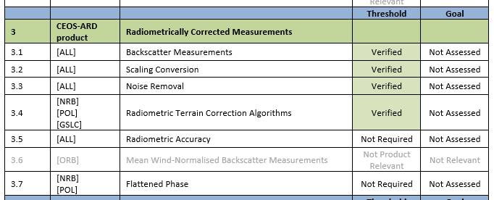
Figure 10. Combined SAR Self-Assessment for parameters not required for the product type (an example for an NRB product)

If an Item is required at Threshold level in the PFS and self-assessed as being met, then the Self-Assessment column for Threshold should be marked as ‘Requirement Met’. It is vital that items having assessed as meeting a requirement have a justification or explanation in the Self-Assessment Explanation/Justification column, with the appropriate evidence. An example of the justification and form of evidence is provided in Figure 11.
The explanation / justification is usually:
• an extract from the metadata file that corresponds to the item; or
• reference to a document, journal paper or a DOI / URL (section or page if possible).
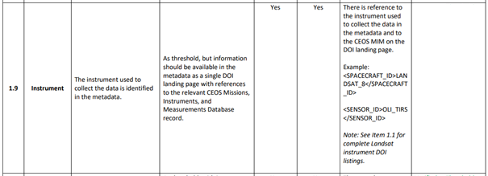
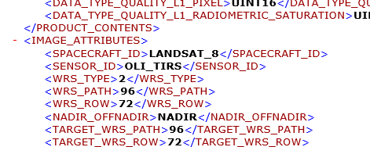
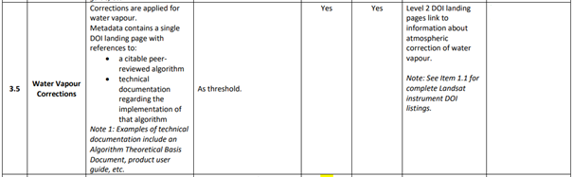
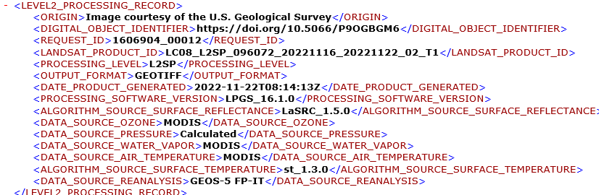
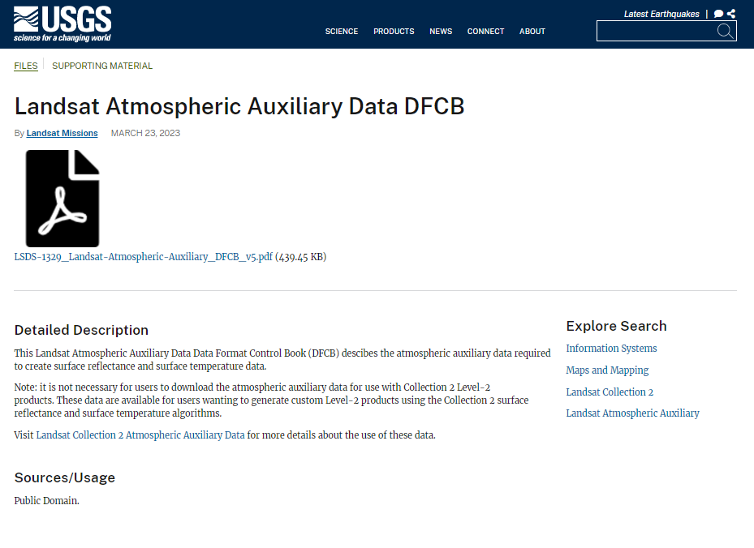

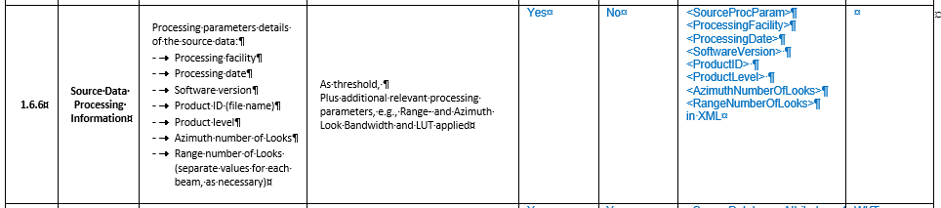
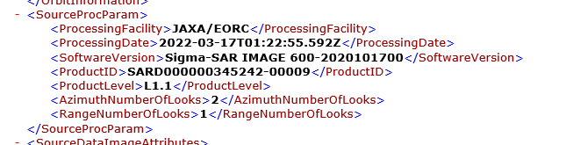
Figure 11. Examples of Justification and Form of Evidence
In the case where no explanation or justification is provided, the submission will be considered incomplete.
Examples of successful Threshold level self-assessments that have been peer evaluated and accepted can be found on the CEOS-ARD website datasets table, as shown in Figure 12. These should be used for reference.

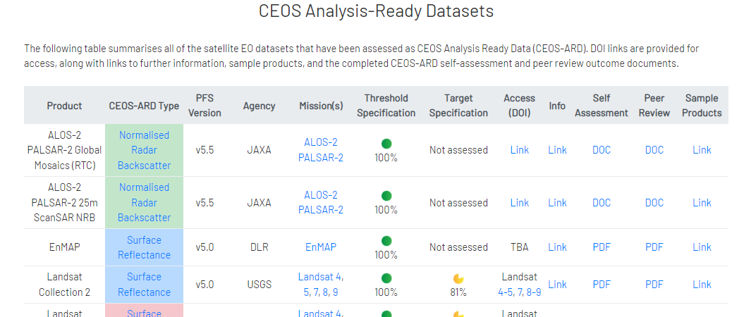
Figure 12. Sample Self-Assessments Available Online

The web page shown in Figure 8 also provides a summary of the product with ARD type and PFS versions with hyperlinks to landing pages and sample dataset(s) that could be used as guidance for submitting a self-assessed PFS.

Goal Level Requirements
On the 6th of December 2023, the term Target was replaced with Goal in the CEOS-ARD PFS documentation. For Goal level acceptance, all item Goal requirements need to be met prior to submission. Again, as per the Threshold level self-assessment, the Goal self-assessment column should be noted with “Requirement Met”. It is also important that a Self-Assessment Explanation/Justification is given as per Threshold self-assessment justifications – that is to say, either as a DOI or metadata extract (Figure 13).
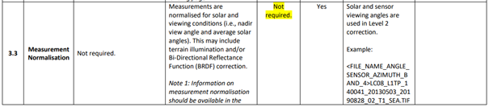
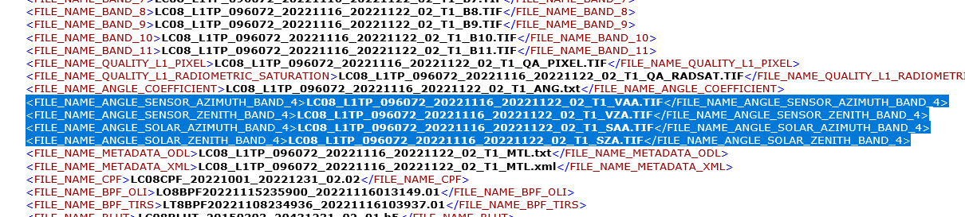

Figure 13 Example of Self-Assessed Item at Goal Level

Submission to CEOS-ARD
Once the self-assessment PFS has been completed, it needs to be formally submitted for review. This is done by email.
Email submissions are to be sent to ard@ceos.org and must contain all relevant attachments and links as required for the review.
For full details on attachments and content, refer to the Checklist on the next page.

Acceptance and Notification
Once all self-assessed items have been validated by the peer review process as meeting the specification, the product will be endorsed as compliant with CEOS-ARD by evaluators.
The self-assessment evaluation result will be communicated to the CEOS-ARD Oversight Group Secretariat, who then will notify the data provider of the outcome. The dataset will be listed on the CEOS-ARD website as part of the suite of compliant datasets.

CEOS-ARD Compliant Logo
Once a data provider’s product has been endorsed at the Threshold or Goal level, they are permitted to use the “CEOS-ARD” logo on webpages and other dataset promotional materials. Various configurations of the CEOS-ARD logo can be downloaded from the Logo and Branding web page.

Checklist
Complete
1. Version of the PFS template used for the self-assessment is current (check https://ceos.org/ard/)
2. Landing page with up to date/correct DOI links or a mock-up version provided
3. Sample dataset(s) with metadata provided
4. Ensure ALL requirements are assessed at Threshold or Goal level
5. Ensure ALL items assessed have a justification (metadata extract or reference)
6. Support documentation provided (if applicable)
6a. Product User Manual
6b. Algorithm Theoretical Basis Document
6c. Auxiliary/Ancillary Data Sources
6d. Journal Papers (Cited reference as a minimum)

