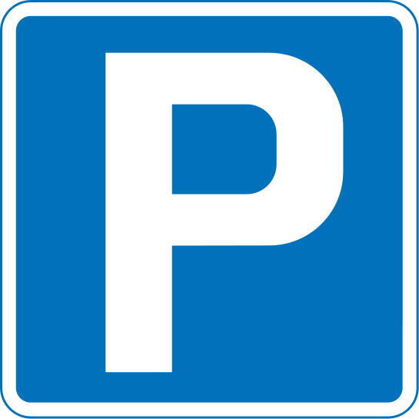

**Global Forest Observations initiative 2016**

**Event name: Global Forest observation initiative 2016**

**Valid: 6th – 10th September 2016**

**Delegate Parking Permit**

For use on day(s) of event only 6th – 10th September .

Please print off and leave in the window of your vehicle.

**Mobile number:**

(Should we need to contact you about your vehicle during the event)