MINUTES OF THE 10th SDCG MEETING (SDCG-10)
7th-9th September 2016
University of Reading, UK

Welcome and Introductions
Frank Martin Seifert (ESA) and Eugene (Gene) Fosnight (USGS) welcomed the participants to the meeting and reviewed the agenda. Participants introduced themselves around the table.
GFOI Status
Stephen Ward (SDCG SEC) presented an update on the status of GFOI, reviewing the latest governance and office arrangements as well as the status of the MGD.
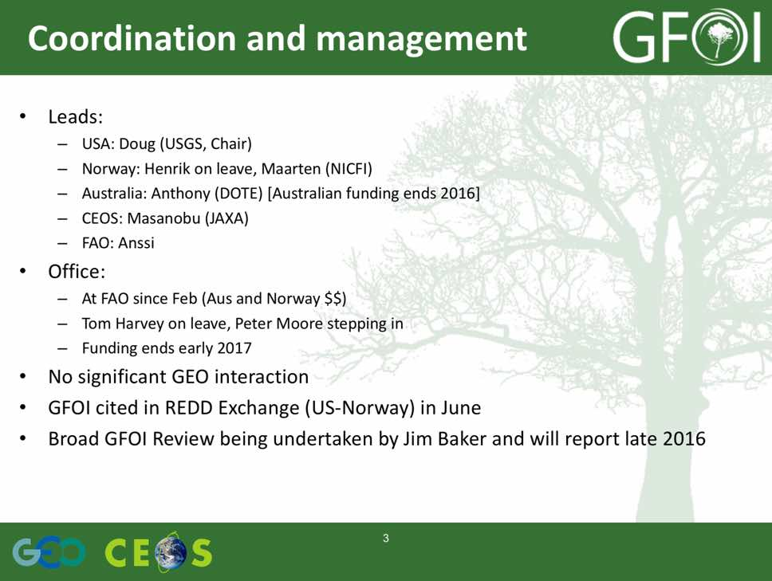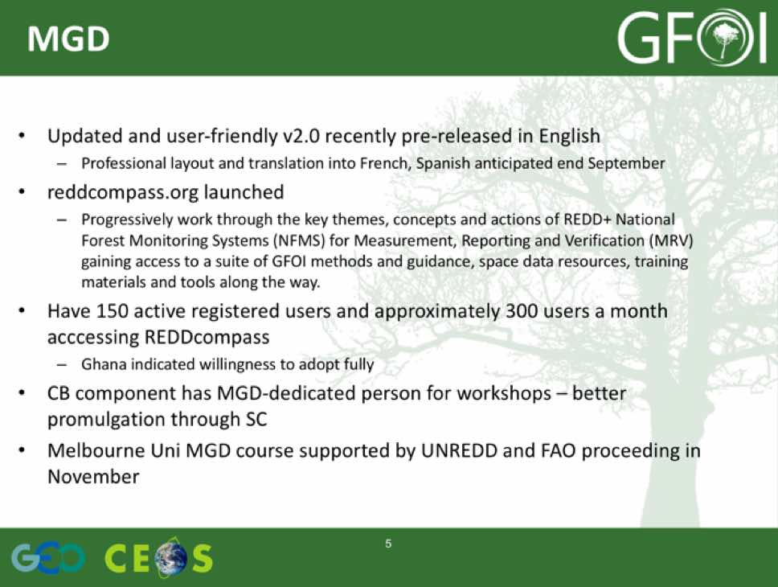
He summarized the overall status, noting that:
- 2016 is significant in terms of global space data coverage and availability of useable and updated MGD2.0 and web materials;
- Significant uncertainties due to loss of Australia funds and leadership, as well as R&D funding;
- Maturity of GFOI comes with component integration – SDCG continues to advocate strongly for end-to-end demo: support is claimed but need to see action beyond words; and,
- The reaction to and follow-up from the GFOI Review in progress will have a significant bearing on the way forward.
A brief discussion followed.
- Osamu Ochiai (GEOSEC) asked about the GFOI strategic review that Jim Baker is conducting, and Stephen noted that the review is being conducted independently, drafts are currently being reviewed by the Leads, and he confirmed that a report will be published once completed.
- Helmut Staudenrausch (DLR) raised the topic of using the GEO forum to raise the issue of sustainable funding for GFOI Space Data Coordination. Osamu noted that GEOSEC has been working with the GFOI Office to develop a statement of needs.
- Ake Rosenqvist (JAXA) asked about Norwegian funding commitments to GFOI, and it was noted this is also unclear and dependent on the outcome of the GFOI review.
- Doug Muchoney (USGS) confirmed that SilvaCarbon has support from the US Government through 2019.
2016-2018 Work Plan Outcomes Status Summary
George Dyke (SDCG SEC) summarised the status of the 2016-2018 Work Plan, noting significant accomplishments since SDCG-9 as well as the overall status of the Outcomes.
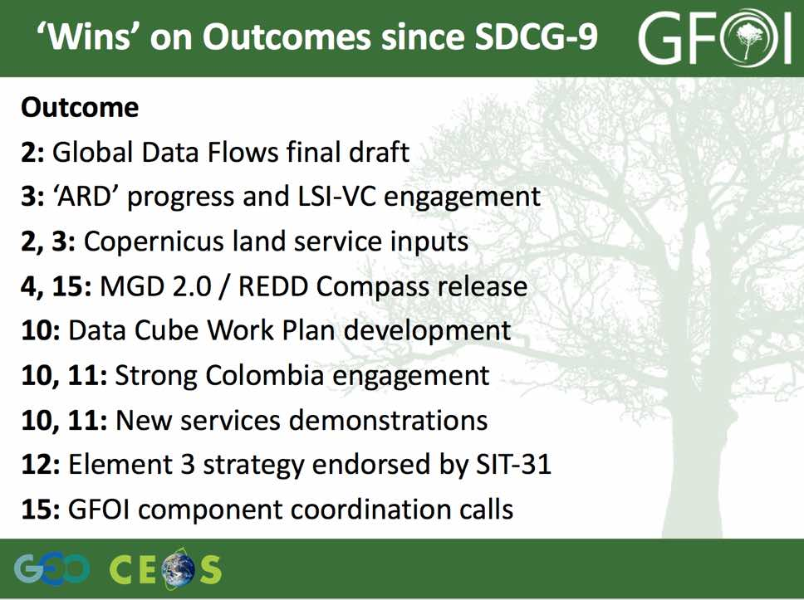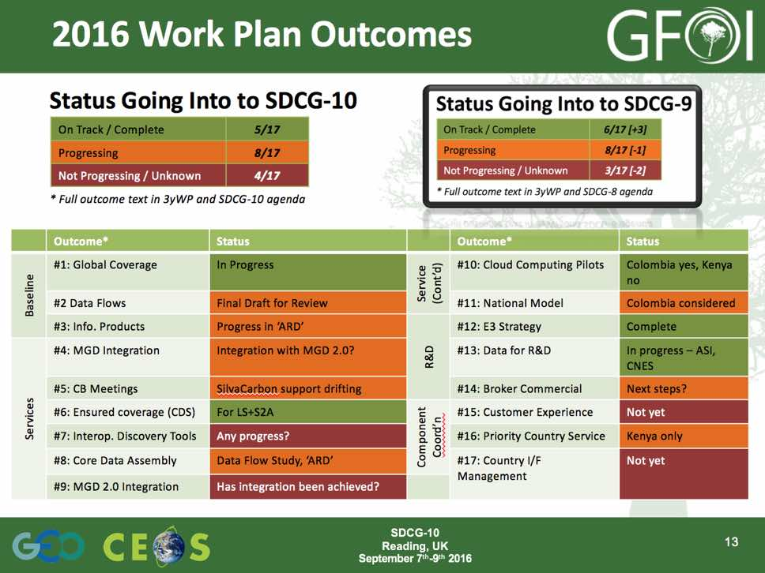
GEO/GEOSS Status
Osamu reviewed the history, governance, and Societal Benefit Areas (SBAs) of GEO, noting that there are a number of different kinds of GEO activities. He reviewed a number of aspects of GEO, noting that they are engaged in a number of areas, including developing a response to the UN Sustainable Development Goals (SDGs).
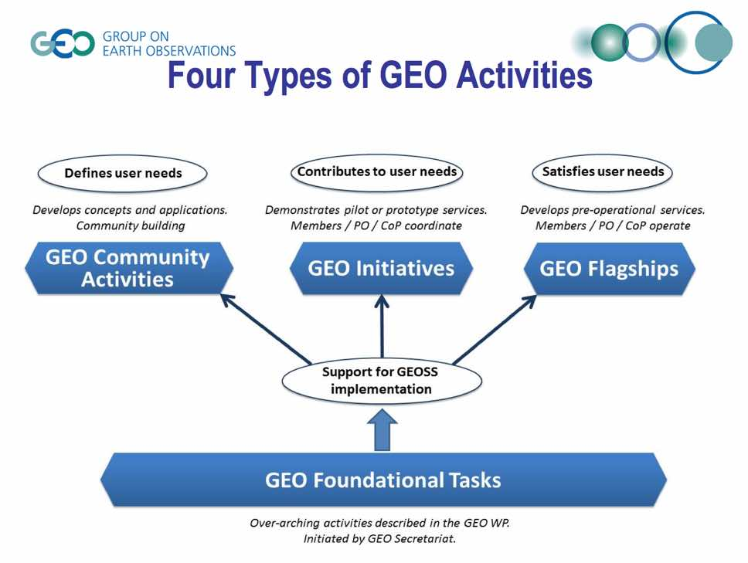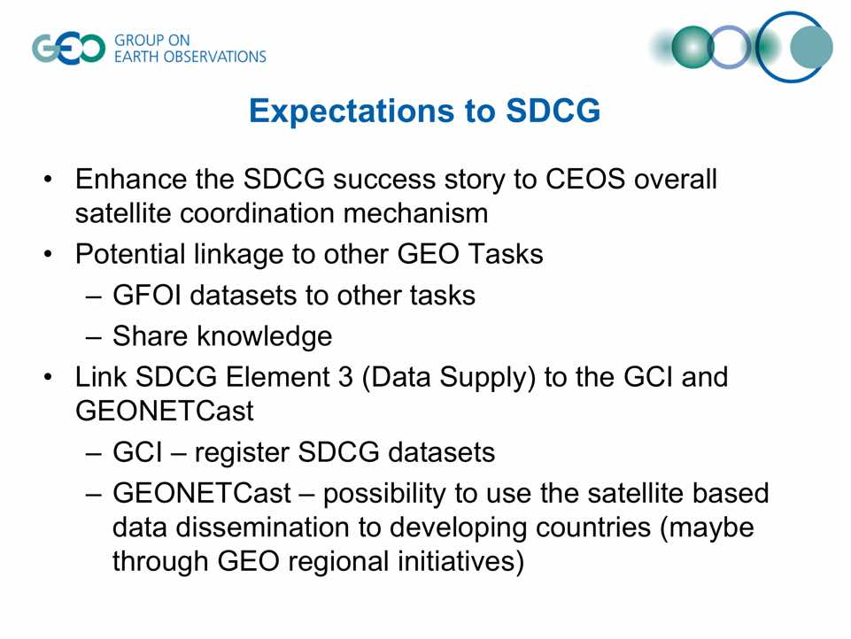
A brief discussion followed.
- Doug raised the issue if requests from the GEOSEC, noting that these requests taxed GFOI as a largely best efforts activity with a small office. Helmut noted that the request from GEO for a GFOI fact sheet came from the GEO member countries in an effort to try and secure additional resources for activities like GFOI, and that some level of reporting is going to be required. He noted that GEO has the potential to contribute to securing longer term support for GFOI.
SDCG-10-1 | SDCG SEC to follow-up with the GFOI Office on the GFOI fact sheet for GEO Secretariat | COMPLETE  GFOI Fact Sheet ("Opportunities to Help" in the GEO-XIII document) has been released
SDCG-10-2 | SDCG SEC to follow up with GFOI Leads on representation at GEO Plenary | COMPLETE  Doug Muchoney will not attend due to US travel constraints, Stephen Briggs will attend. Stephen Ward following-up on participation

Baseline Global Observation Scenario
Frank Martin introduced the session, noting that the baseline global observation coordination is one of the core GFOI activities.
Landsat Status
Gene presented a summary of the baseline global observation Outcomes, noting at the main activities are acquiring data (#1), distributing data (#2), and ensuring that the data formatting is optimised (#3, i.e. pre-processing).
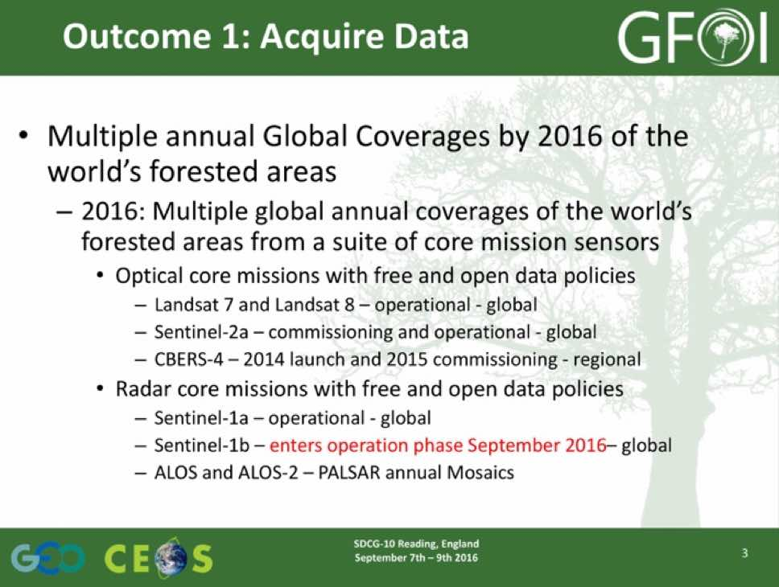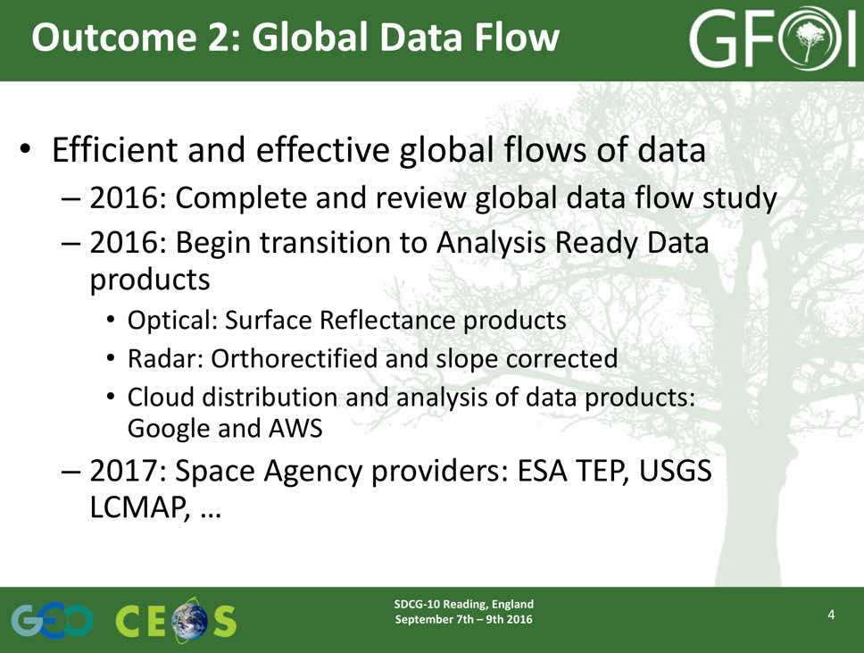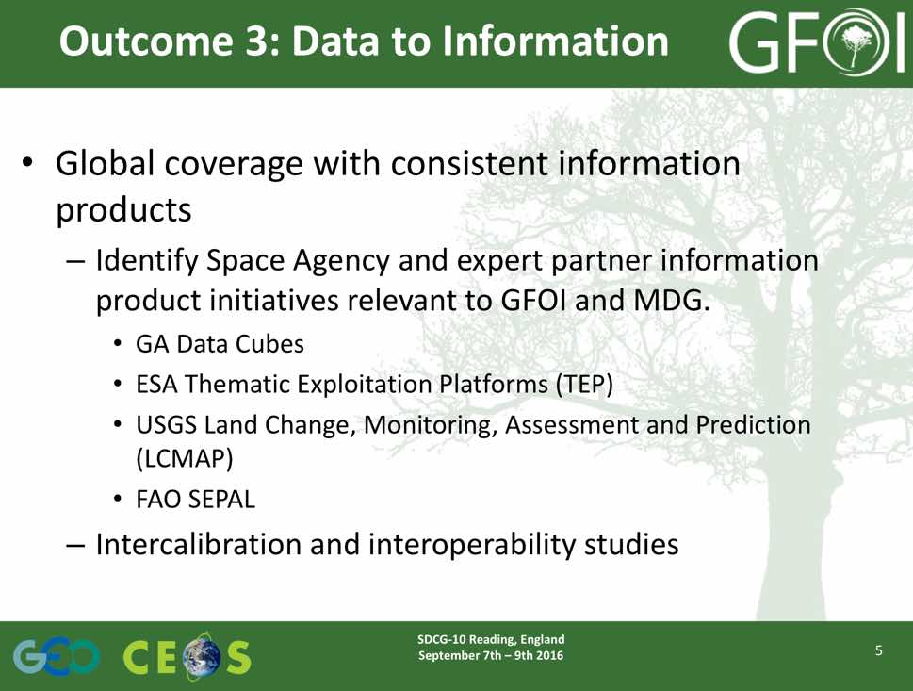
Gene reviewed the status of Landsat, noting that Landsat-7 is successfully implementing its ‘Continental mode’, acquiring only over continental land masses, and Landsat-8 is acquiring all data globally over land.
He noted that USGS is moving to a collections model for the Landsat archive, with three basic categories of products defined:
- NRT (Near-real time) products that are processed using ancillary data such as predicted ephemeris or bumper mode parameters that may be improved by reprocessing;
- Tier 1 products that meet the criteria for the collection definition (i.e. enable time-series stacking, <12m RMSE); and
- Tier 2 products that do not meet the criteria for the collection definition and have been processed using the best known ancillary data.
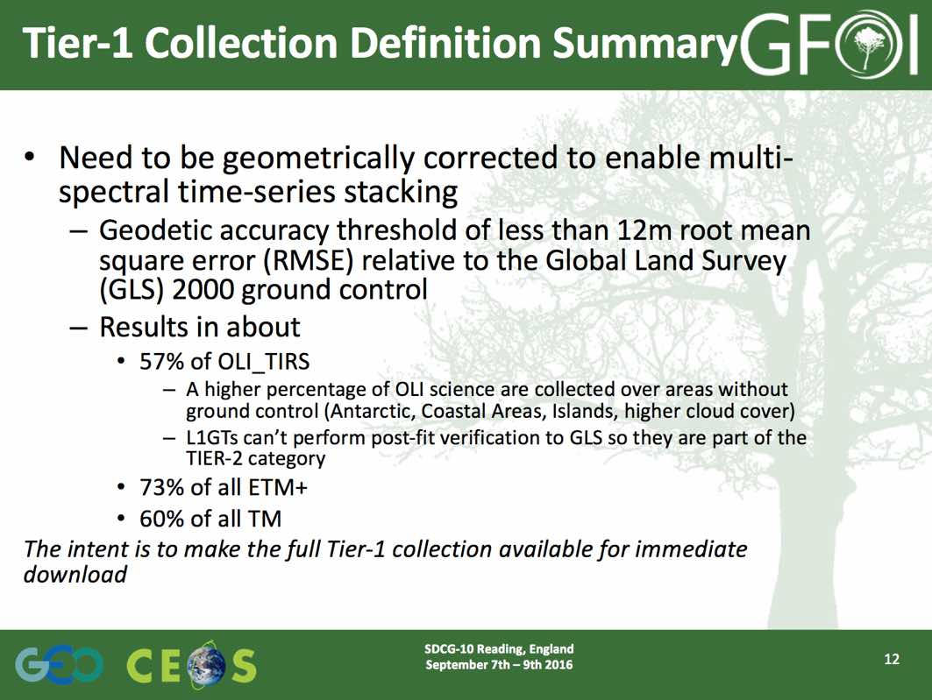
Frank Martin noted that the Sentinel-2 Global Reference Image (GRI) is expected to be completed late in 2017. At that point, the Landsat products will be reprocessed to the GRI, and there is good coordination between USGS and ESA in this area.
Gene noted that in persistently cloudy areas, users will likely need to look at both Tier 1 and Tier 2 collections to get the imagery they require. He also noted that repatriation international ground station data back to the Landsat Global Archive is ongoing, and this is expected to build the archive considerably (perhaps 3x) once complete. He reviewed the plans for Landsat-9 and Landsat-10.
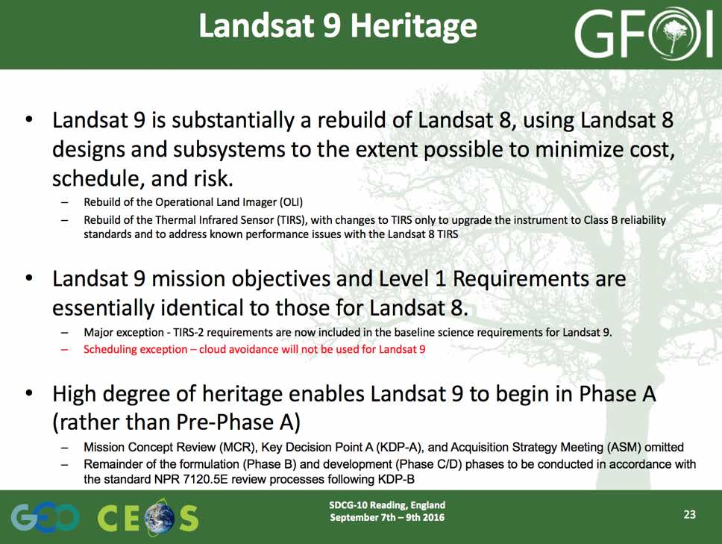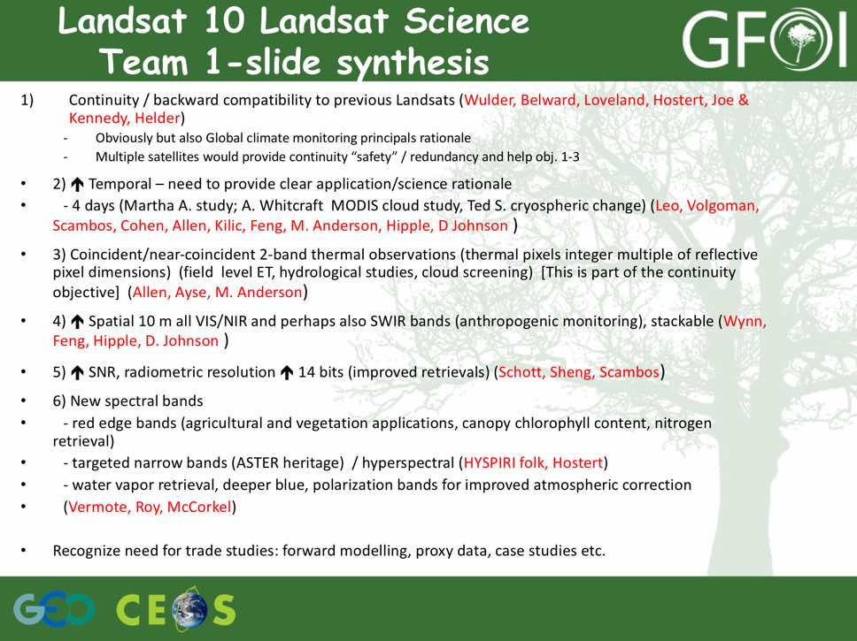
Gene noted that there will be an opportunity to provide user perspective feedback on Landsat-10, and that SDCG should consider how to contribute.
A brief discussion followed.
- Doug asked about the status of cooperation with Google Earth Engine (GEE) and Amazon Web Services (AWS), and Gene noted that as soon as new products hit the archive, they are being downloaded by GEE and AWS. He also noted that more Landsat data is distributed via GEE/AWS than via EROS.
- Yves Crevier (CSA) asked how ARD will impact on the collections, and Gene noted that as soon as ARD products are standard, they will be used for collections.
Sentinel-1 and Sentinel-2
Frank Martin presented a summary of the Sentinel missions, noting that Sentinel-1B commissioning is currently ongoing and is expected to be complete in early 2017.
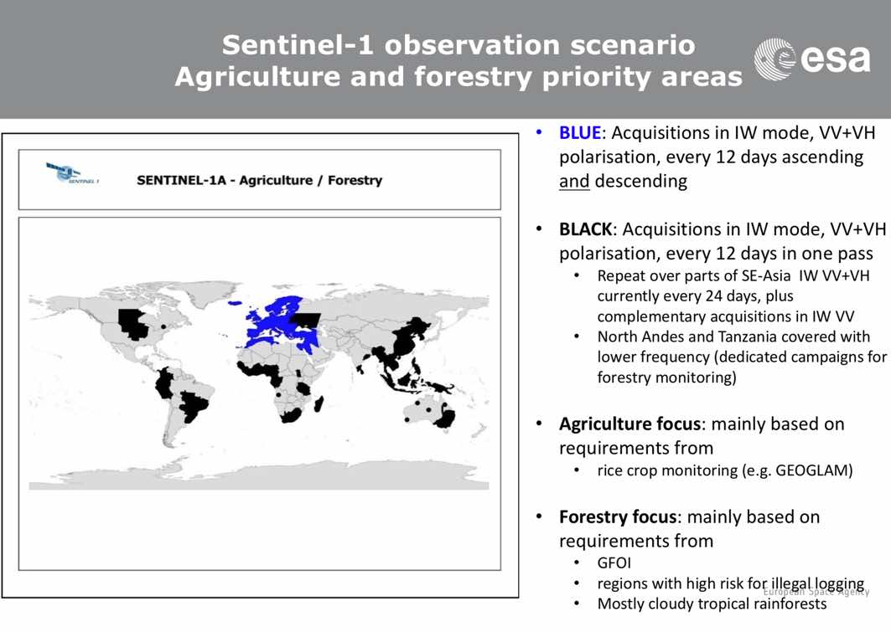
Frank Martin reviewed the main factors impacting on the Sentinel-1 acquisition planning, noting that once Sentinel-1B is in operation, there will be some coordination of observations between 1A and 1B.
Frank Martin summarised the initial performance of Sentinel-2A, and also summarised the mission outlook. He noted that the Scientific Data Hub data archive is no longer a rolling archive.
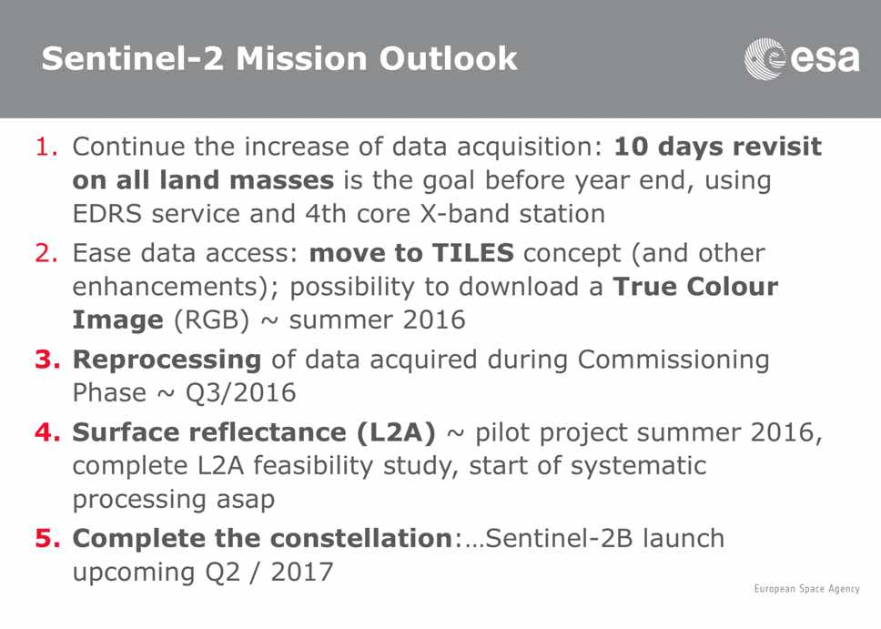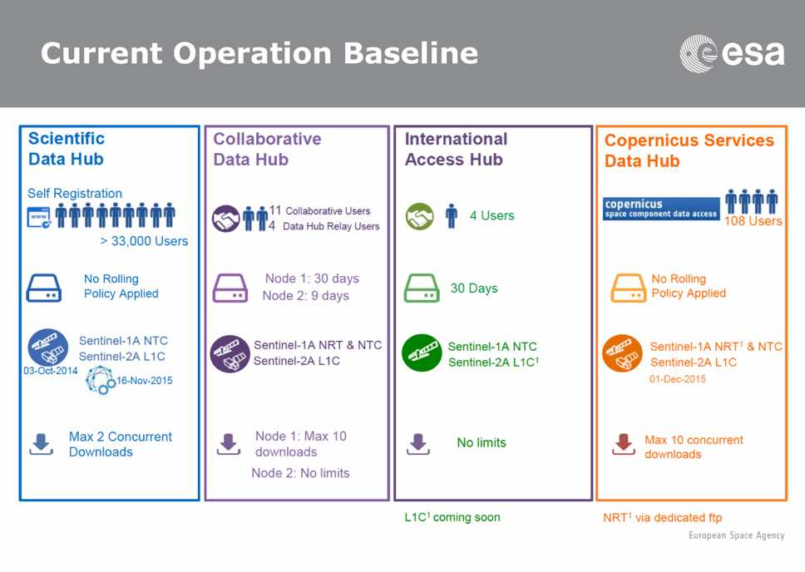
Helmut reviewed German activities in relation to Sentinel data access in particular CODE-DE, noting that the main objective is to increase the uptake of Sentinel data for commercial, research, and public applications. CODE-DE will become an element of the integrated Copernicus Ground Segment.
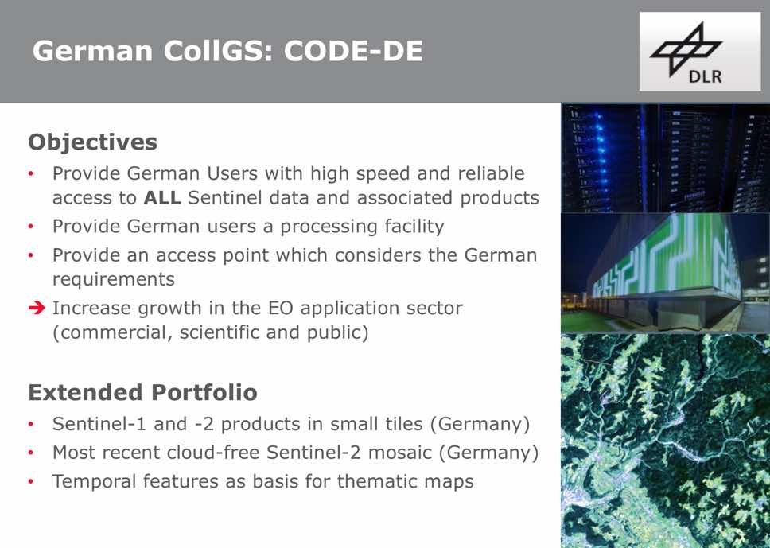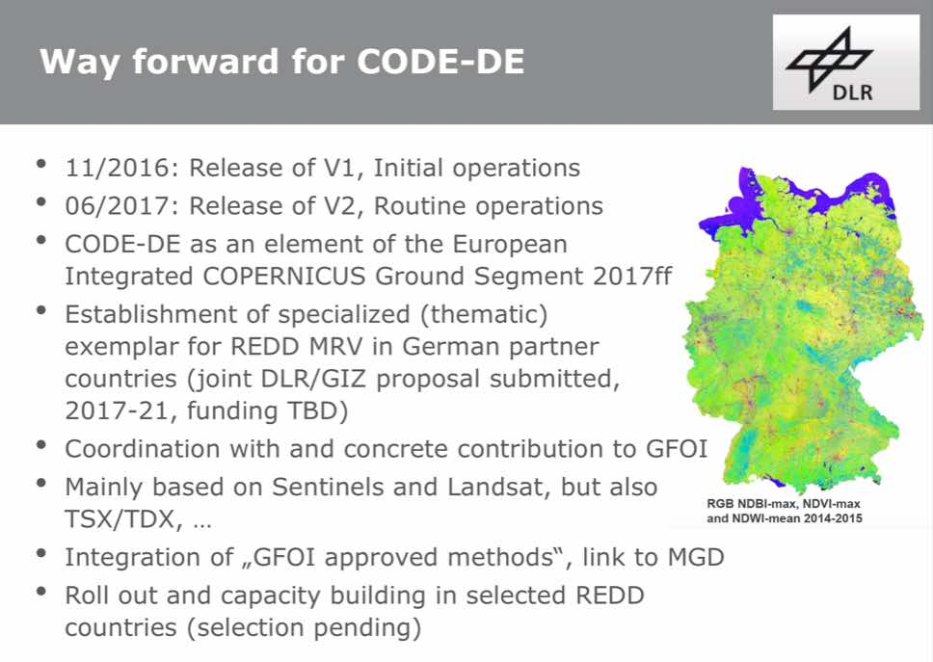
Frank Martin reviewed a similar French ground segment activity (PEPS), which will aim to distribute global Sentinel-1, -2, and -3 acquisitions for French users.
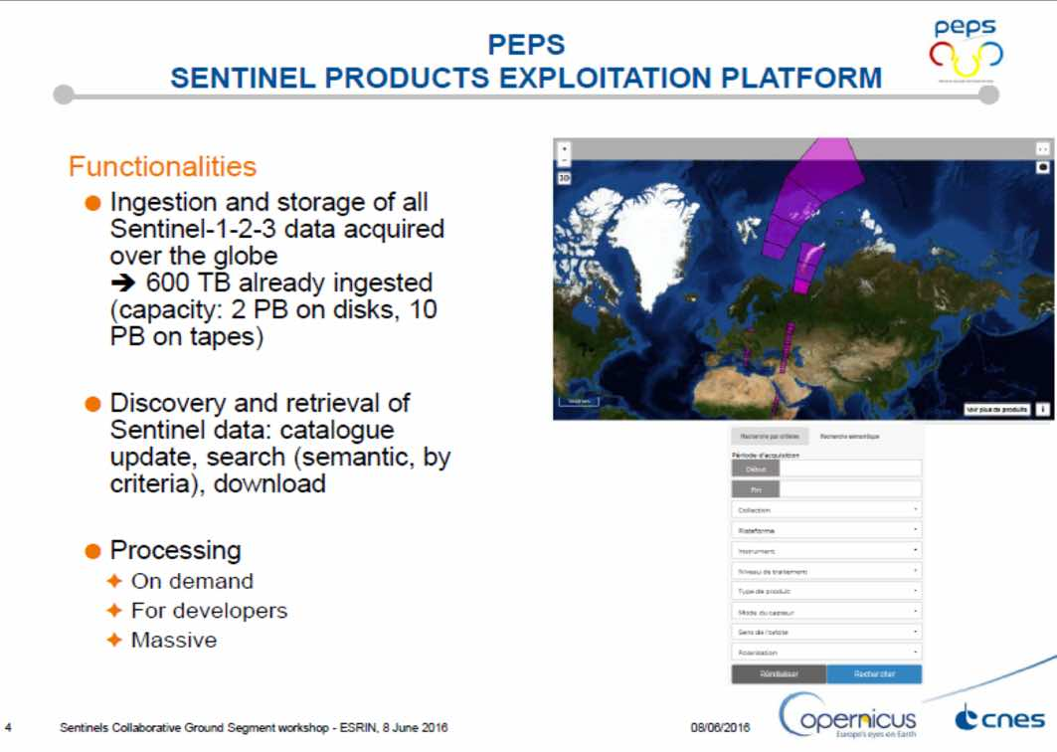
Frank Martin reviewed the current international coordination arrangements for Sentinel data access.
Countries | Institution | Summary
USA | NASA | NASA and ESA have signed a Cooperation Arrangement in February 2016. NASA intends to set-up a Sentinel data mirror site.
USA | NOOA | NOAA and ESA have signed a Cooperation Arrangement in March 2016. NOAA intends to use global Sentinel data for research purposes.
USA | USGS | USGS and ESA have signed a Cooperation Arrangement in February 2016. USGS will focus on Sentinel-2 products hosting and distribution.
Australia | Geoscience Australia | GA and ESA have signed a Cooperation Arrangement in March 2016. GA, in collaboration with partner entities, intends to establish a Regional Copernicus Data Access/Analysis Mirror Site ('GA Data Mirror Site') to improve access to, and exploitation of, Sentinel data in the Australian, South-East Asia and South Pacific Region.
Frank Martin reviewed the purpose and status of the Copernicus Land Cover Service for REDD+.
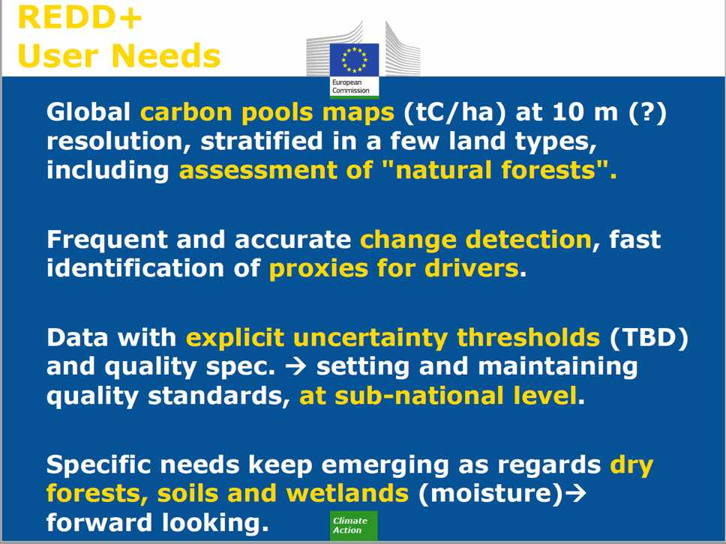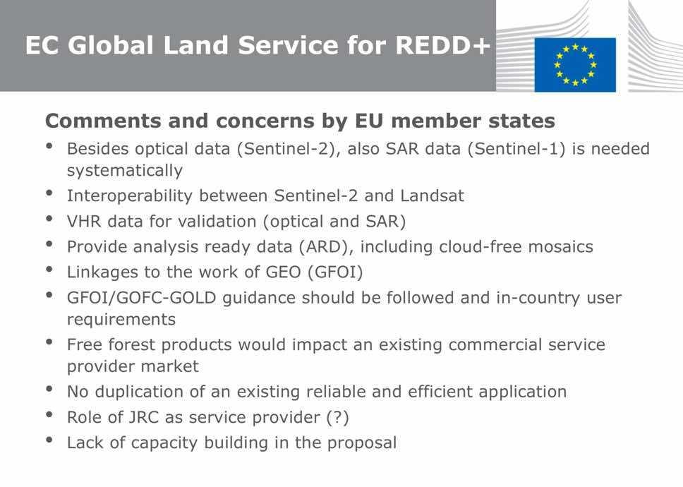
A brief discussion followed.
- Richard Tipper (Ecometrica) asked about the number and diversity of ground segments, and what are the advantages of national data hubs, and who is allowed to access them. Helmut noted that for example the German hub provides service in German (as well as English). It was also noted that these additional ground segments help to spread the load associated with data download.
ALOS-2 – Core Data Set
Shizu Yabe (JAXA) presented a summary of the ALOS-2 systematic observation strategy, reviewing the plans for continuity of the Baseline Observation Scenario (BOS) as well as the long term global archive, and confirming maintain the archive is a JAXA priority.
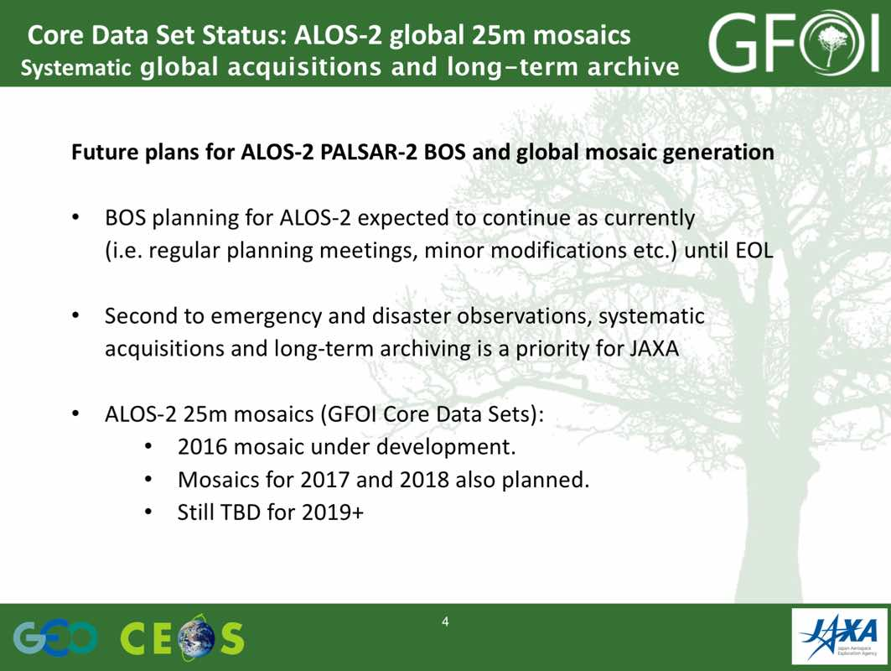
A number of discussion points were raised.
- Frank Martin noted that the 25m global mosaics from PALSAR are very valuable for the research community, including for biomass estimation. noted Shizu that this feedback is quite useful for JAXA, and Frank Martin agreed to send some additional detail on recent use cases he has seen.
- Ake stressed that both the systematic observations, as well as the global 25m mosaics are very important to promote the utilisation of L-band SAR. Frank Martin agreed, stressing the importance of continuity of systematic observations.
- Frank Martin noted that in general, all agencies should recognise the value of long term archives which are essential for a number of applications.
- Brian Killough (NASA) noted that the PALSAR 25m L-band mosaics are being looked in a Data Cube activity with Colombia, creating an aligned product along with Landsat and Sentinel data. Gene suggested that this could be a step towards ARD for radar, and Shizu confirmed that JAXA is interested in the definition of ARD for radar.
SDCG-10-3 | Frank Martin Seifert to send Shizu Yabe details of some examples of the use of the PALSAR 25m mosaics for biomass monitoring | September 2016
SDCG-10-4 | SDCG EXEC to confer on a communication to JAXA requesting that they maintain the long term continuity of systematic L-band SAR acquisitions | COMPLETE  Letter sent to JAXA 19 Oct 2016
CBERS-4 Global Background Mission Support
There was a brief discussion on the offer of support from INPE, and Ake suggested SDCG should provide a response with a potential focus on African acquisitions.
SDCG-10-5 | Ake Rosenqvist to draft a response to INPE’s offer to acquire over Africa for revision, comment and finalisation by SDCG EXEC | September 2016

Global Data Flow Study
Gene presented a summary of the Global Data Flow Study that has been conducted over the past number of months, and that the current focus is on the conclusions and recommendations. Gene noted that the focus of the study is on exploring the various user data access solutions and scenarios that are possible in the future, driven by increased data volumes and supported by emerging technologies. He highlighted the main draft conclusions of the study.
- Increase in satellite data volumes resulting from new capacity is outstripping the capacity of the national data handing infrastructure of GFOI many countries.
- BAU approach is considered unsustainable, and in general a move towards centralized data handling is viewed as a potential solution to make satellite-data support sustainable.
- Increased volumes and number of data sources require more effective data discovery and access tools.
- Cost/burden of pre-processing data needs to be minimized to foster uptake. Agency-backed ARD products and tools are steps in that direction.
- Mechanisms will vary, but quality of ARD products needs to be assured by agencies.
Gene reviewed the recommendations, noting they have been divided into three groupings - space data providers, capacity building partners, and users and countries. He noted that space agencies should be the stewards and publishers of standard products, and these can be picked up by partners (e.g. Google and AWS) and passed along to users.
- [1] Widely-accepted ARD descriptions and specifications are important to ensuring maximum benefit and interoperability for GFOI data streams and should be confirmed.
- [2] Improved data access and data discovery tools for multi-sensor search and ARD products should be developed.
- [3] CEOS should promote community uptake of ARD, in particular to emerging platforms from ‘data giants’ like Google and Amazon.
- [4] Interoperability between Landsat-8 and Sentinel-2 would be of significant value to GFOI countries and users and should be pursued.
- [5] Support pilot activities to exercise some of the fundamental and enabling elements of future data architectures which have the potential to address some issues raised.
- [5a] Include accommodation for tiled data and time series stacks, compatible with the CEOS Data Cube in their product development pathways.
- [5b] Support pilot activities initiated by SDCG to demonstrate the potential of these technologies.
- [5c] Other topics highlighted by the FDA report appear promising in support of the challenges facing GFOI.
- [6] Support the development of a model pilot end-to-end NFMS based on the GFOI components.
Gene noted it is important that we don’t make decisions that preclude the development of tiled data products, and also that the methodologies required to make use of these products are developed and communicated via the likes of the MGD.
A number of discussion points were raised.
- The group agreed that radar ARD is an area that should be addressed in future, and Brian noted that the ARD discussion within CEOS is still ongoing.
- The broader CEOS FDA study underway will likely make a series of short term recommendations this year, and to release medium and long term recommendations in 2017.
- There is a need to show that all the GFOI components are contributing, and that the MGD should be explicitly referenced.
- Doug noted that there is currently no way to work around for the bandwidth issues in some countries, and suggested that this bottleneck could be raised or addressed via GEO. The option of using GEONetcast to maintain data with new acquisition after a national archive / data cube is established was raised.
- A Data Cube provision services could be considered by the SEO in future. However, the user’s ability to take advantage of a data cube would need to be considered before these types of products are delivered.
- The alternatives presented in the study should be considered as ‘MGD 3.0’ is developed.
- Doug stressed that ancillary data outside of the space data should be considered, for example elevation data, climate data, and others.
- The role of Global Forest Watch (GFW) and global data products needs to be considered - these products are not a replacement for national efforts, but can play a very useful role. They are useful as communications tools and input products, but their limitations for reporting needs to be made clear. The ALOS PALSAR forest/non-forest products are another global product which could be considered.
- Offerings based on the likes of Landsat and Sentinel can be developed by all interested organisations (e.g. commercial, research).
- The space agencies are responsible for the core data supporting basic ARD, where GFOI is focused on the analysis required to generate core forest information products.
SDCG-10-6 | SDCG members to provide feedback on the Conclusions and Recommendations of the Global Data Flows study | 16th September 2016

UK Activities and Engagement
Frank Martin introduced the session, noting that GFOI has long sought to engage the UK community, and that the objective the session is to share experiences across both communities.
GFOI Overview
Doug provided an overview of GFOI and its components.
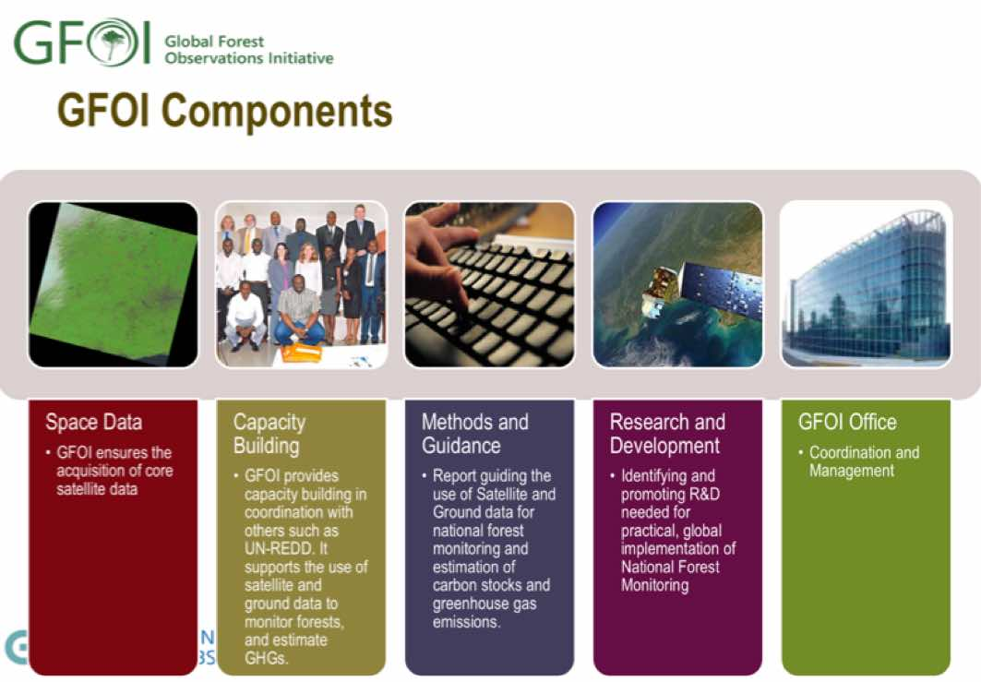
GFOI Space Data Strategy
Stephen introduced the GFOI Space Data Strategy, noting that the primary purpose is to make it clear that satellite data is available for the monitoring of forests in support of UN climate negotiations.
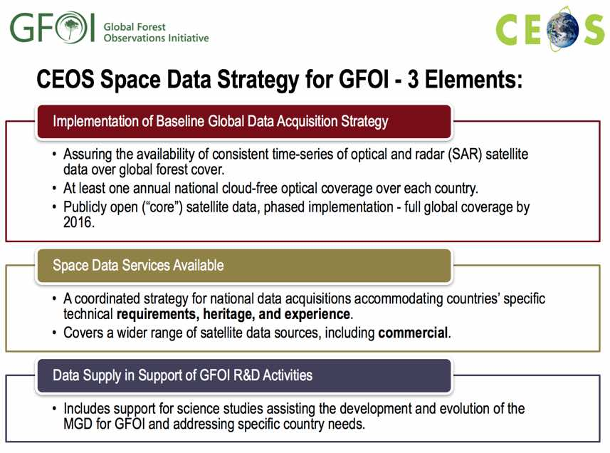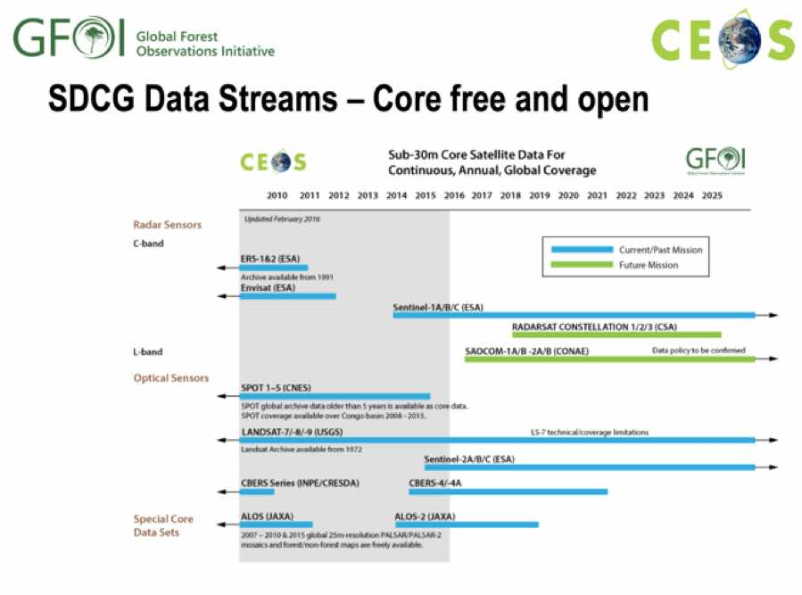
A brief discussion followed.
- The question of examples of past commercial data provider support provided by the SDCG was raised, and it was noted that a number of commercial data streams are being coordinated under the GFOI R&D programme.
GFOI Capacity Building
Sylvia Wilson (SilvaCarbon/USGS) presented a summary of SilvaCarbon, which represents the Capacity Building component of GFOI along with FAO. SilvaCarbon is funded by the US government, and is currently engaged in 21 countries across four regions.
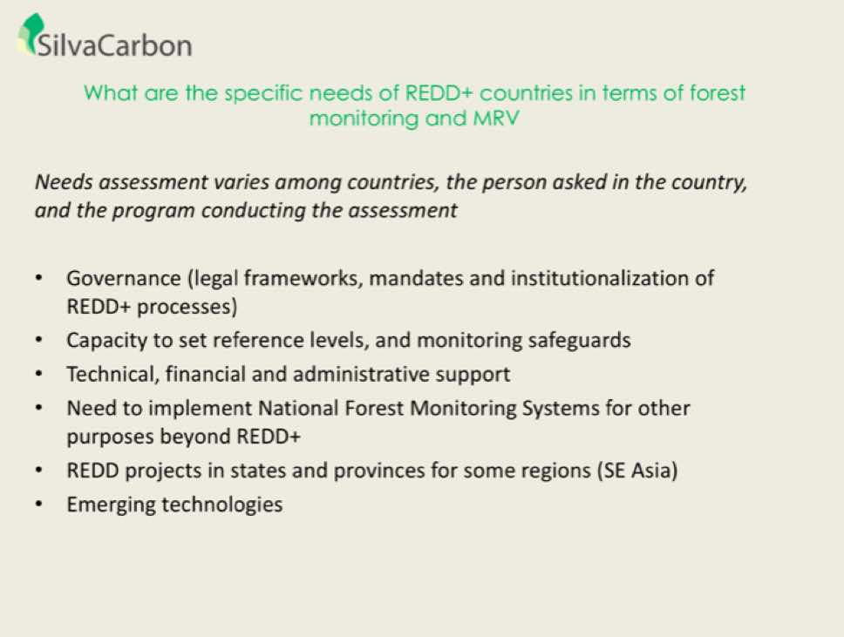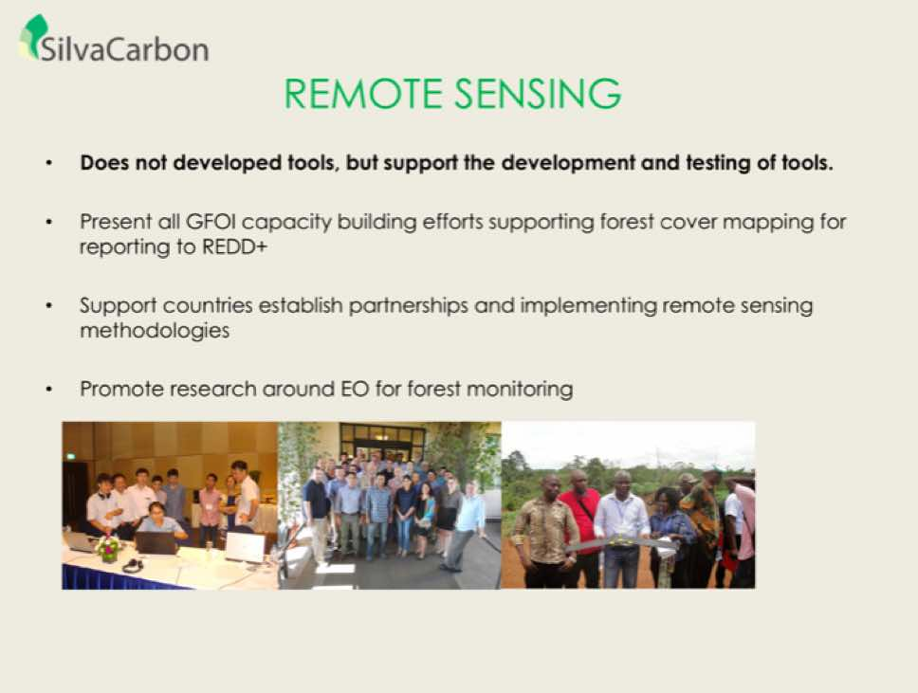
Sylvia reviewed the FY17-19 strategy for SilvaCarbon, including around engaging more countries as well as developing support in key technical areas.
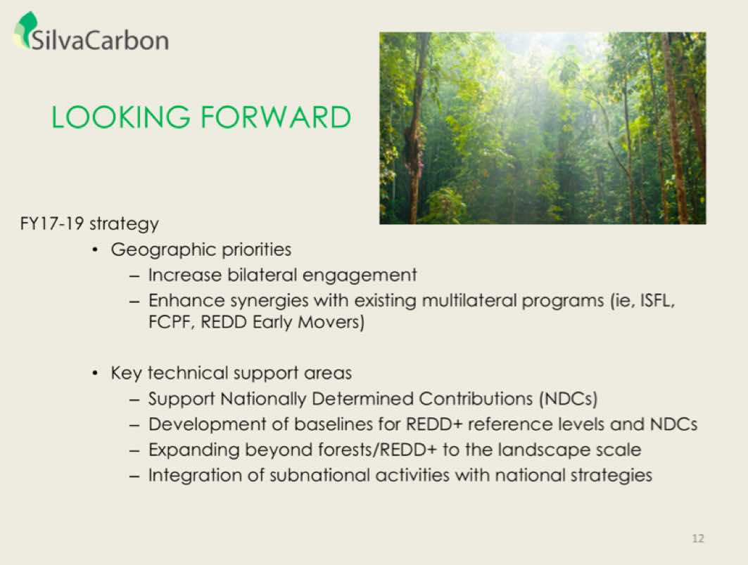
A number of discussion points were raised.
- Helmut asked about synergies with the REDD Earlier Movers Programme, and Sylvia noted that one of the mandates for SilvaCarbon is to reach out to countries. One of the targets is countries who are working to improve their monitoring in order to improve reporting and move towards receiving payments.
- Ake asked about the next SilvaCarbon research announcement, and Sylvia noted there will be a decision on future funding following a review of the outcomes of the current round in December.
- Mandar Trivedi (DECC/UK) asked about how GFOI is informing or effecting Colombia’s MRV roadmap. Sylvia noted that they have been working with Colombia for a number of years now, and has worked with them on the incorporation of carbon information in their national MRV system, provided them with enhanced tools, and supported the production of Colombia’s national forest/non-forest maps.
- John Remedios (UKSA) asked about the funding of SilvaCarbon, and Sylvia noted that it will be $US 4M annually for the next few years, but has been as high as $US 7M annually in the past.
- John asked about whether the starting points for country engagement comes via science or policy mandates, and Sylvia noted that their mandate is to work with the ministry that is responsible for implementing REDD+ policy. First contacts are generally made via USAID missions in countries, and they also via FAO.
Overview of UK Activities
John introduced the session yesterday, and summarised yesterday’s GFOI policy briefing to the UK government and with participants from Norway and Germany. He noted that during this session, good coordination amongst the UK community was also achieved.
Pedro Rodriguez (Uni. of Leicester) summarised work they are doing as a part of ESA’s DUE GlobBiomass initiative focused on:
- Improved quantitative biomass maps at regional and global scale;
- Provision of associated uncertainty maps;
- Validation including major user organisations and establishing common practices and standards;
- Contribution of new scientific results with respect to biomass stock and change estimation; and,
- Identification of the limitations of current data and methods to estimate biomass by historical, recent and future global Earth observation data (Sentinels, BIOMASS, SAOCOM, ALOS-2).
He also summarised a REDD+ monitoring services monitoring pilot project, as well as applications of Sentinel-1, and some work on going in Colombia.
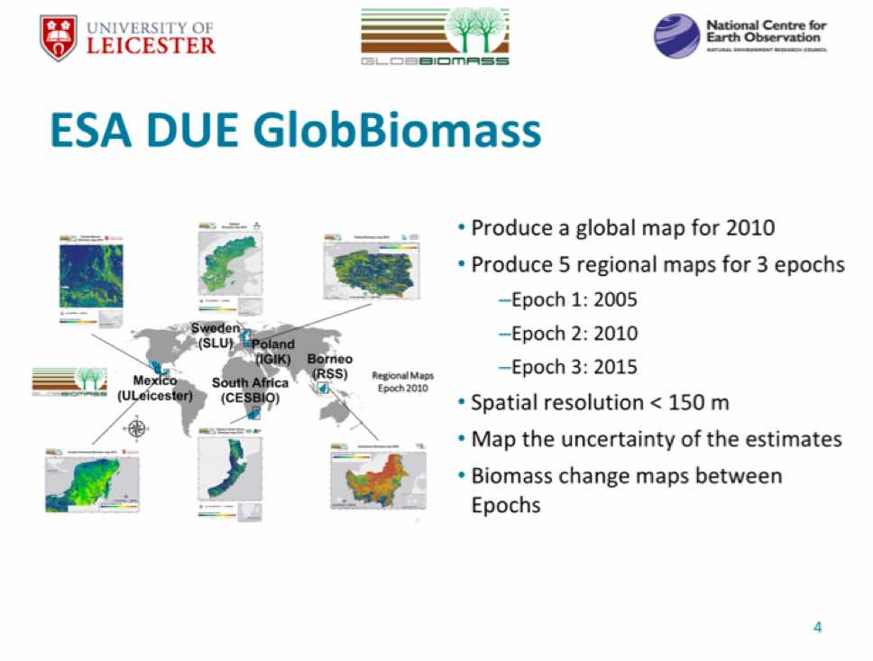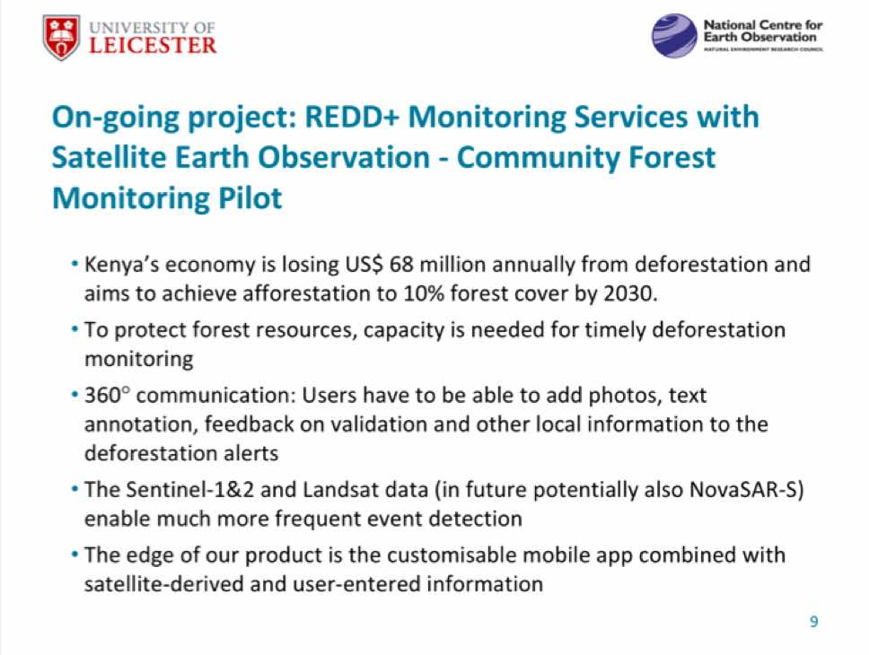
Pete Bunting (Aberystwyth Uni.) presented a summary of vegetation classification based on vegetation height and cover using ALOS PALSAR data.
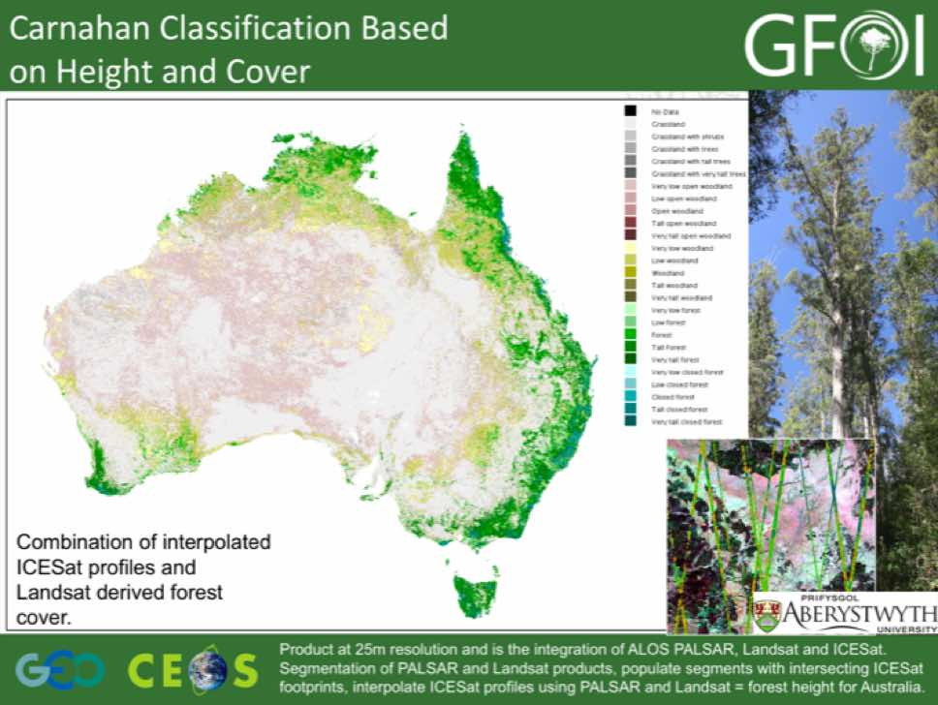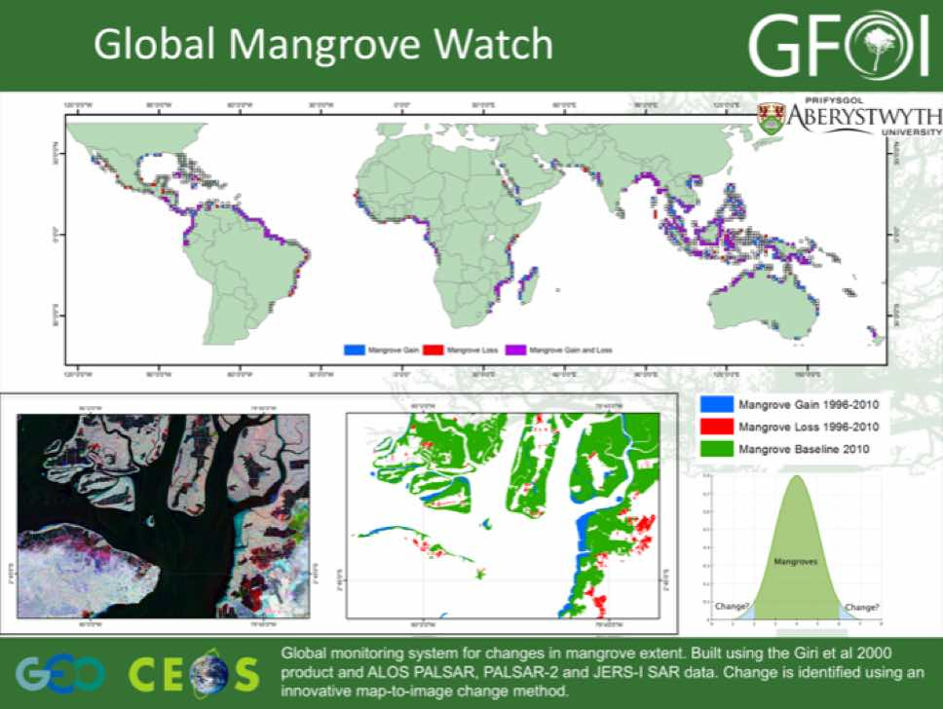
A brief discussion followed.
- Frank Martin asked which PALSAR data was being used, and Pete noted that both mosaic and strip map data were used.
NovaSAR
Caroline Slim (SSTL) provided an overview and status update on the NovaSAR programme, which is a demonstration S-band SAR mission. The objective of SSTL is to extend their product range from low cost optical in to SAR capabilities leveraging some available new technology.
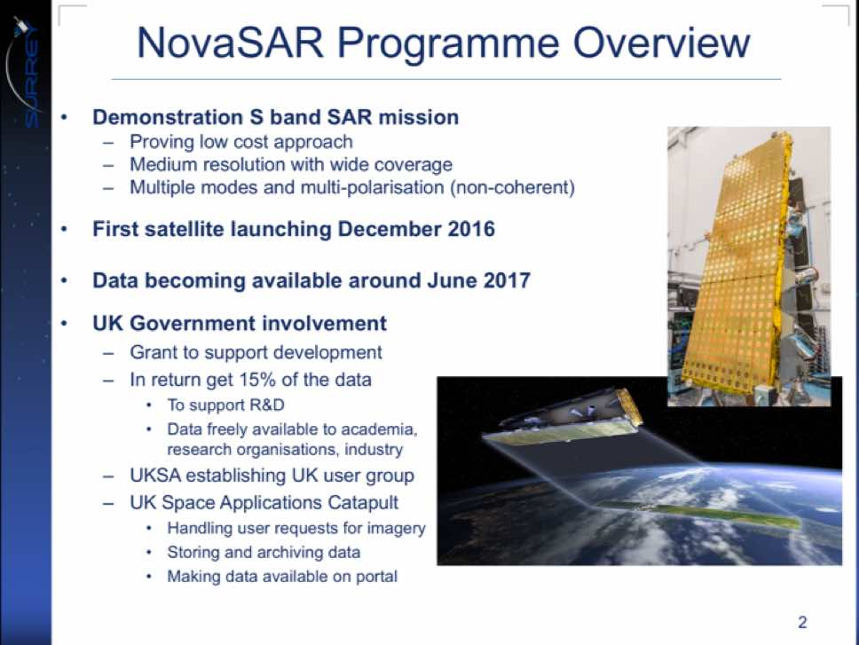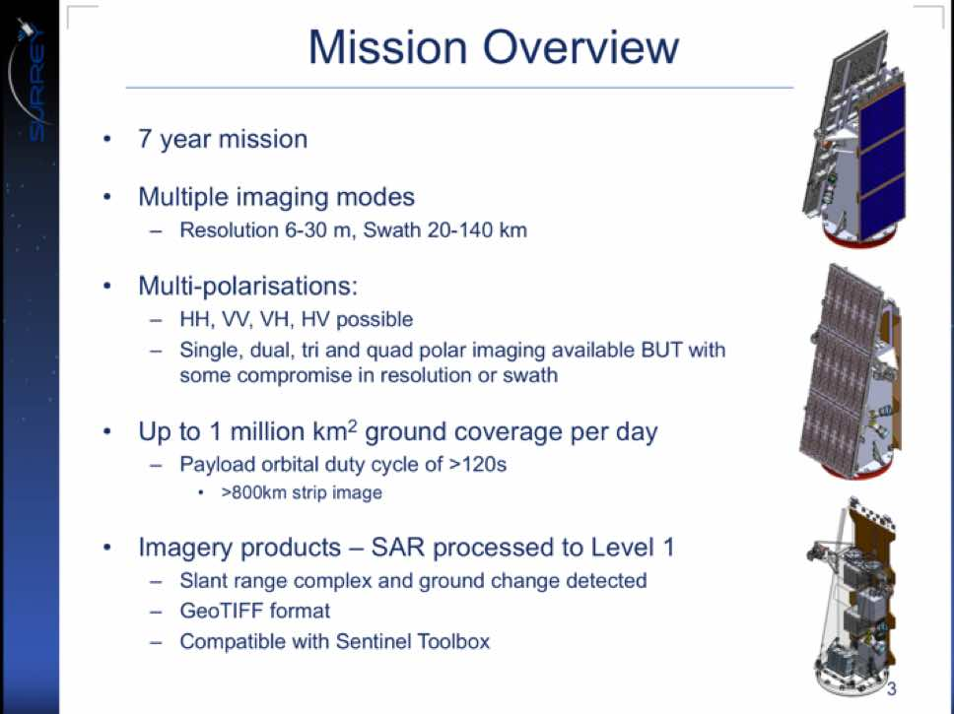
The first NovaSAR satellite is scheduled for launch in December 2016, and the data should become available around June 2017. In exchange for support from the UK government, 15% of the total capacity of the mission will be available on free and open terms.
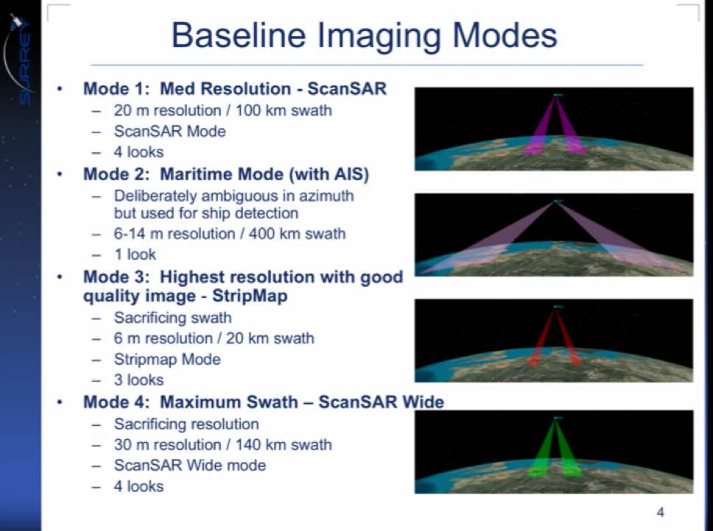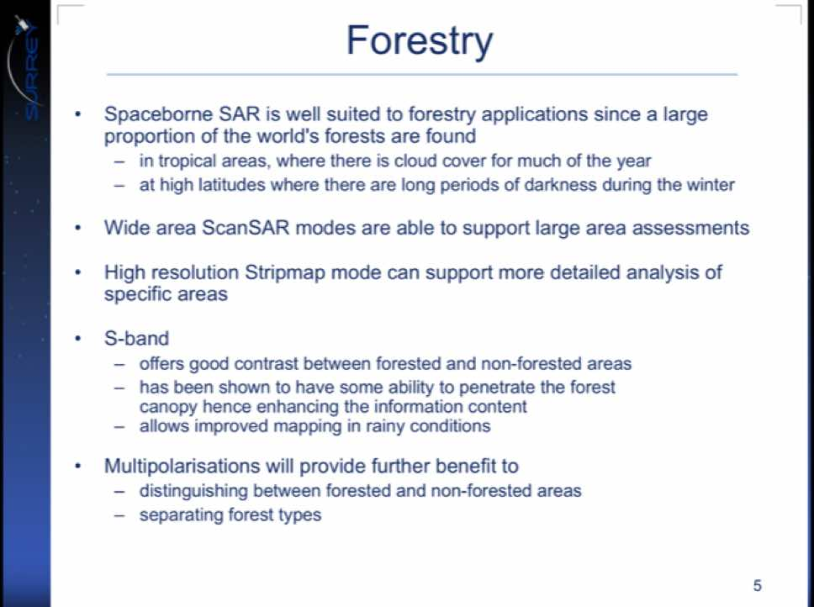
A number of discussion points were raised.
- A UKSA analysis of the 15% of free and open data suggests a primary interest in UK coverage, but also some interest globally. India is also receiving a 50% share of the data (in exchange for launch), and this coverage is focused on India. The UKSA share of data can be distributed to anyone via governmental links, ensuring that it is non-commercial.
- While the mission is being designed for 2% duty cycle, but 4-5% is believed to be feasible depending on solar conditions.
- The possibility of a Colombia R&D NovaSAR dataset was raised, and it was noted that if SDCG has a request on behalf of GFOI, it should consider submitting a proposal to UKSA.
SDCG-10-7 | SDCG Element 3 (lead by Ake) to work with the GFOI R&D component to coordinate on a potential NovaSAR request for areas of interest for GFOI R&D, and coordinate this with UK community and contacts (John Remedios, Caroline Slim, Beth Greenway) | SDCG-11
SDCG-10-8 | Ake Rosenqvist to send invitations for the GFOI/GOFC-GOLD Science meeting in The Hague, Netherlands (31st October 31 – 4th November 2016) to Caroline Slim and Erik Lindquist | COMPLETE  Ake has extended invitations to both Erik Lindquist and Caroline Slim
BIOMASS
Shaun Quegan (Uni. of Sheffield) presented a summary of the BIOMASS mission, including how it could potentially link with GFOI. He noted that there is a plan to generate a global map in the first 14 months, and then new maps every 7 months thereafter.
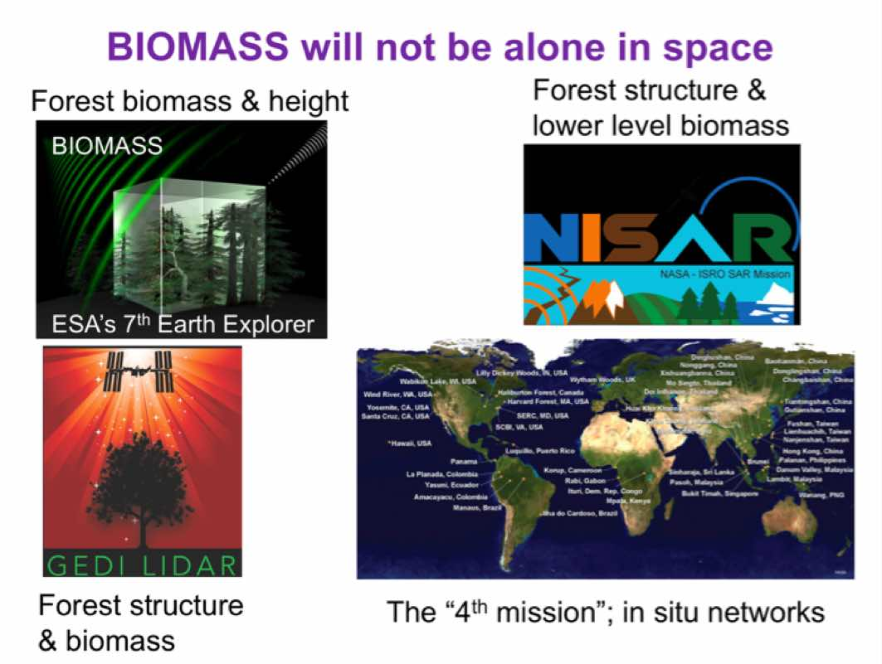
- Shaun outlined a number of areas where BIOMASS could benefit GFOI and vice versa.
- GFOI is very much based on IPCC principles; practical methods that can be implemented at country level and “as far as possible” yield unbiased estimates of forest change and the associated emissions
- In the GFOI MGD Earth Observation forms a core element in estimating forest area change.
- This needs to be converted into emissions and uptake using emissions factors at different levels of complexity
- The parameters needed to make this conversion are essentially based on in situ data.
- Change in biomass is a fundamental quantity in quantifying emissions and uptake.
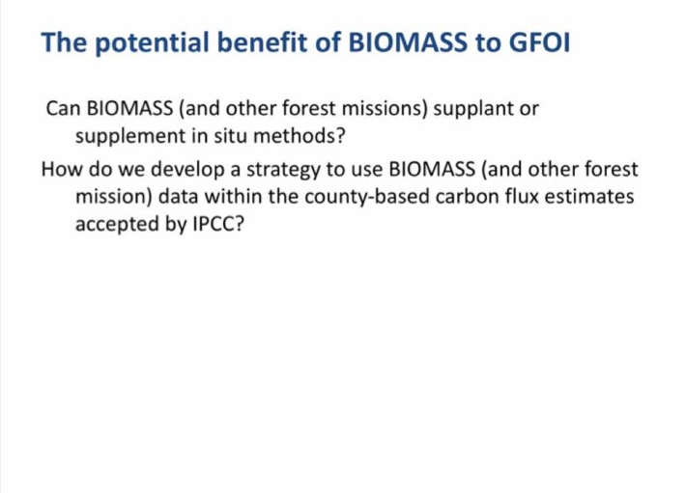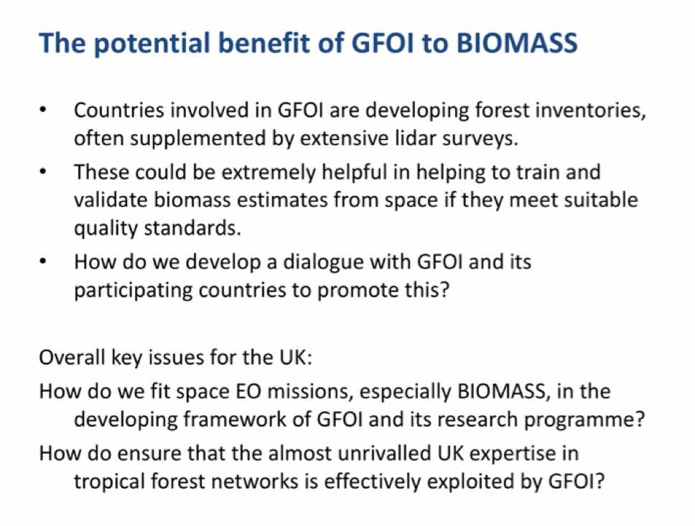
Airborne and Ground Support Missions
Pete presented a summary of activities around airborne and ground support missions, highlighting the role of Lidar in validation of forest cover products.
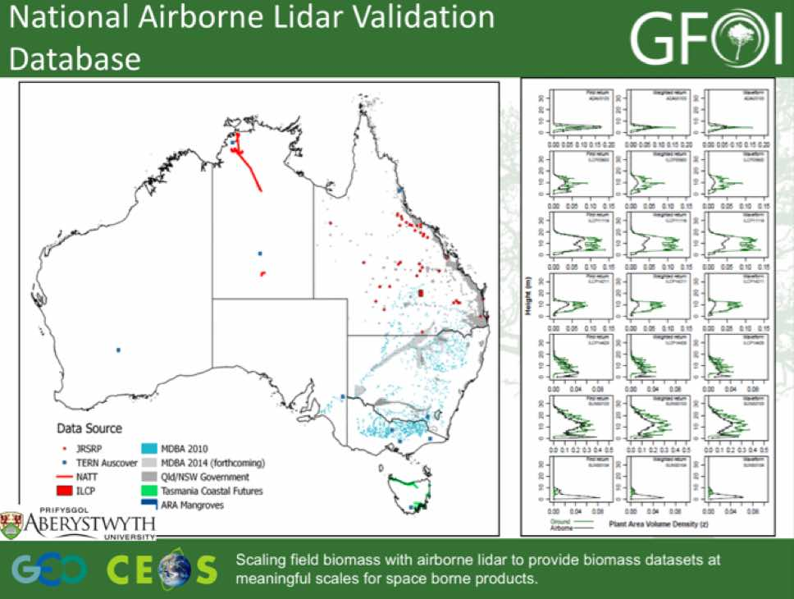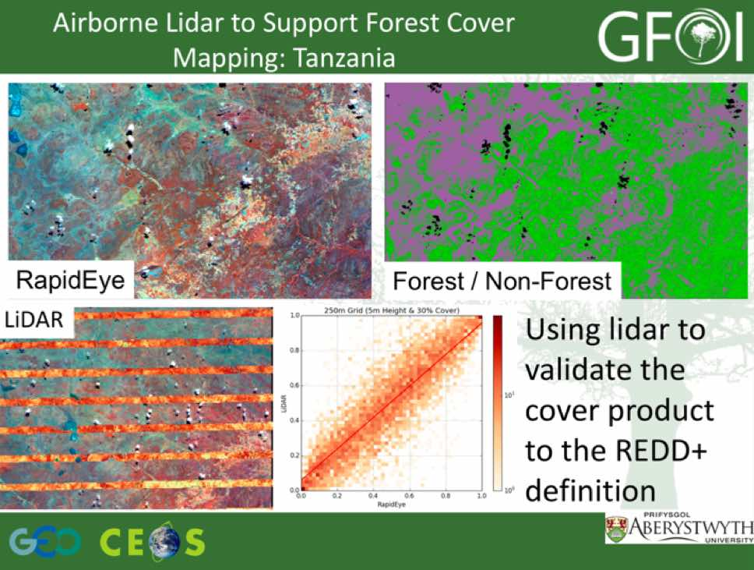
Iain Woodhouse (Carbonmap) reviewed the role of aircraft and UACs in carbon mapping for land use planning.
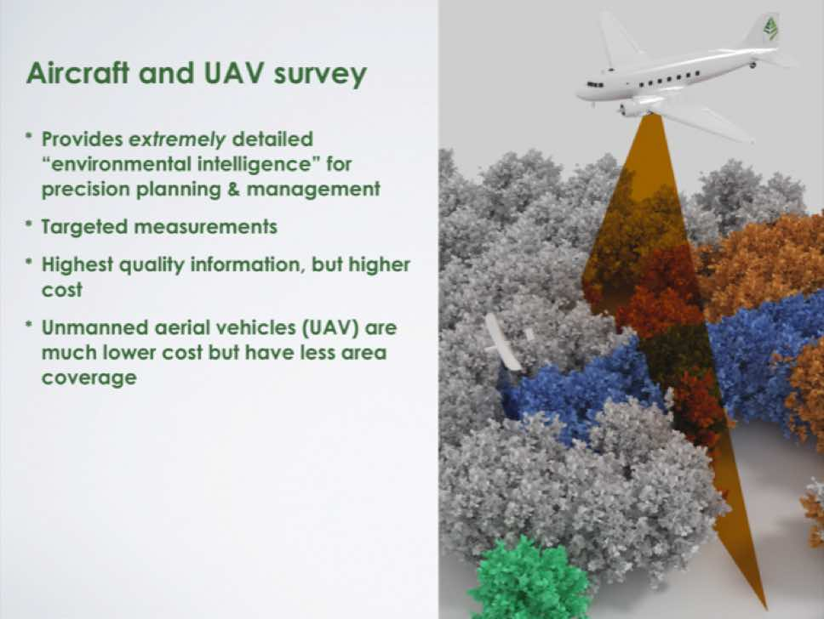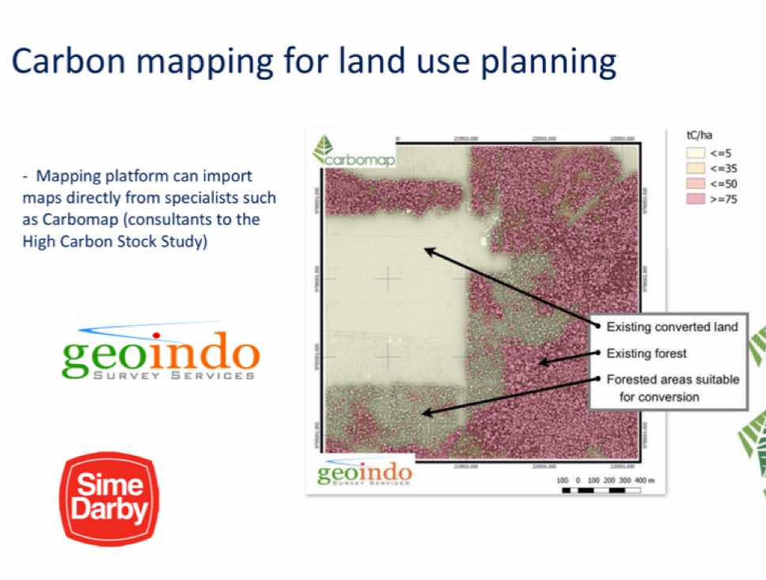
Estimating Forest Change and Loss for UK Development Aid
Richard presented a summary of UK Climate and Space Programmes and their potential to input into GFOI. He summarised the work of the UK’s International Climate Fund, as well as UKSA.
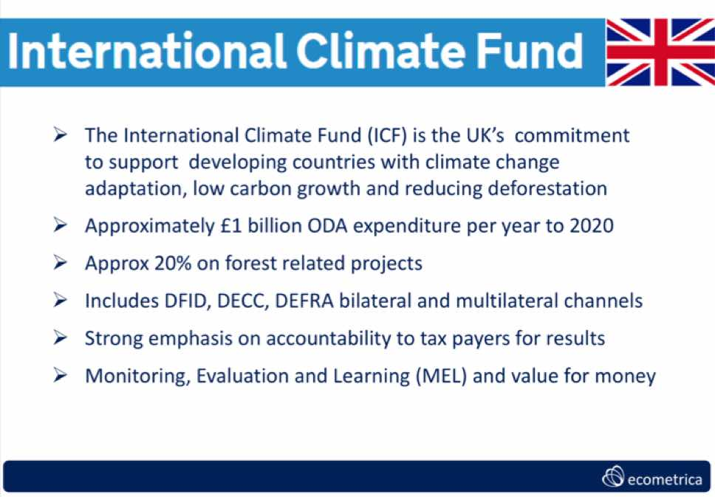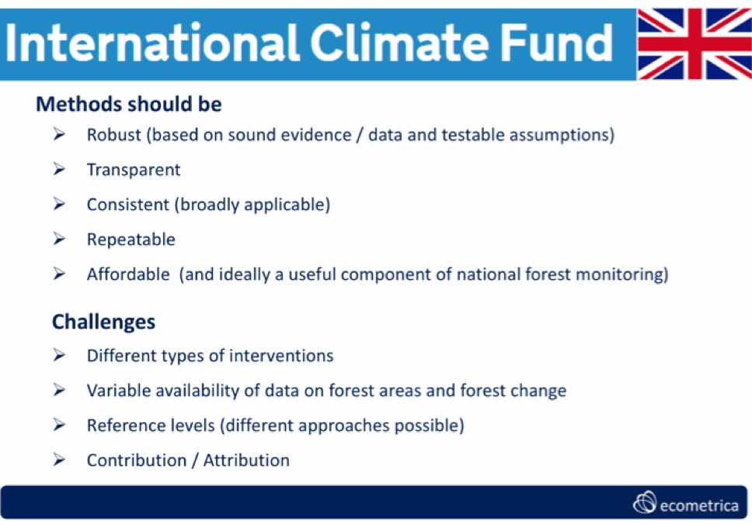
Richard reviewed the UK’s Forests 2020 program, and some potential links to GFOI.
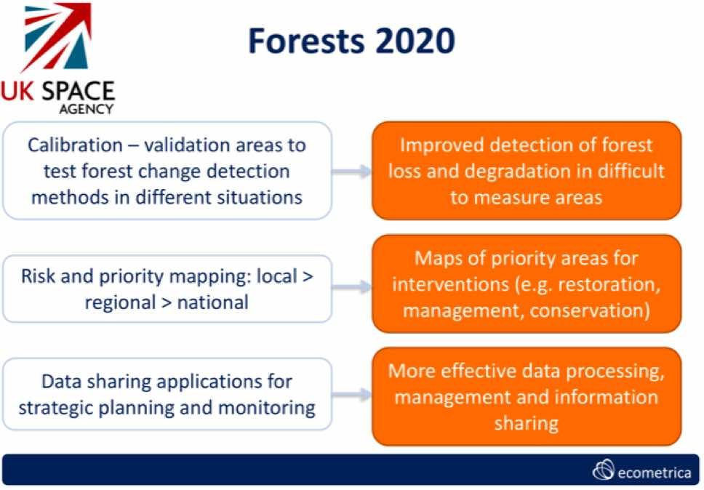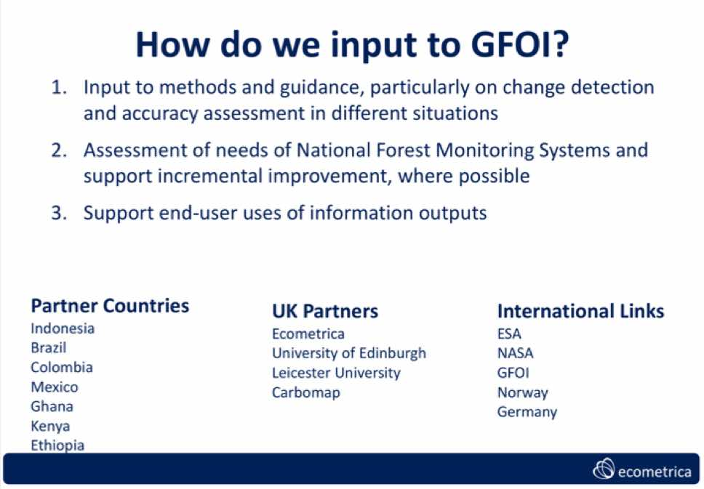
A number of general discussion points were raised.
- There was a discussion on how to leverage the UK capabilities in support of GFOI and vice versa. There is a lot of forest EO science in the UK, as well as a new satellite series (NovaSAR) which can contribute, as well as large funds flowing from the International Climate Fund to forest projects that this could all support.
- The suggestion is that the forest monitoring ambitions of the GNU (Germany, Norway, UK) block could be linked to GFOI, and that GFOI could be a recommended framework for GNU programs.
- Osamu raised the GEO Plenary perspective, and noted that GEO Plenary may be an opportunity to make a joint statement from the GNU governments.
- Mandar noted that the discussion of a GNU representative to GFOI was raised during the policy meeting in London. He noted that to release funds from forestry programs, governments will need some assurance that the carbon promised is delivered, and GFOI could be a framework. He noted that the GFOI evaluation will also be an important factor in drawing these connections. It is in the interest of the donor countries to look for simplicity and comparability in verification systems, and that they meet the IPCC guidelines
- Sylvia noted that there is often a disconnect between the work on the ground, and the policy level and GFOI may be a potential bridge between those two communities.
- Shaun suggested that there may be linkages to be drawn between the NovaSAR and BIOMASS missions, and the GFOI R&D component.
- It was agreed that there is a potential NovaSAR contribution to be discussed, and Ake has an action to follow-up from the R&D perspective. Links to commercial companies involved in the R&D was raised, and it was noted that the R&D activities involve mostly academic institutions, though a number of companies are represented in the R&D teams.
- It was noted that the development of Level 2 (atmospherically corrected) Sentinel-2 products are being developed by a number of countries (including the UK), and that USGS-ESA are also working closely on this topic. Helmut suggested there’s a need to coordinate in detail who does what and how to do this in the most effective way.
- It was agreed that the topic of involving UK research groups within GFOI R&D should be discussed, and John will circulate the invitation to the upcoming GFOI Science meeting.

Support to GFOI R&D
Ake introduced the R&D session, reviewing the session agenda and the status of the 2016-2018 Work Plan R&D outcomes.
#12 Development/Update of Element-3 Strategy: On schedule
- El-3 v2.0 endorsed by SIT-31
- Completion of v2.1 – including revised team descriptions (18 teams) – following SDCG-10 discussions
- Question: “Endorsement” or “for info” @SIT-32?
It was agreed that the Element 3 strategy should be presented at SIT-32 for endorsement.
#13: Providing Satellite Data to Progress R&D Topics: On schedule
  - SDCG agency selection of R&D teams to support clarified (El-3 Aug telecon)
  - Some agencies (ASI, CNES) already in contact with R&D teams
  - Remaining contacts expected by Sept/Oct 2016
  - (agency reporting next agenda item)
#14 Element-3 Strategy Ensures Engagement and Accountability Towards Advancement of Priority R&D Topics: On schedule
- Standard operating procedures (“El-3 governance”) – El-3 wording to be finalised post SDCG-10
- Migration of GFOI R&D projects into new framework (as defined @ SDCG-9). Completed in El-3 v2.1 update.
- Private sector engagement: AD&S (SPOT 6/7) – good progress; Planet (RapidEye + Doves) – TBC; and, SSLT (NovaSAR) – New! Contacts established @SDCG-10.
Ake reviewed the GFOI R&D coordination activities, as well as the refined data request table based on feedback from the R&D teams.
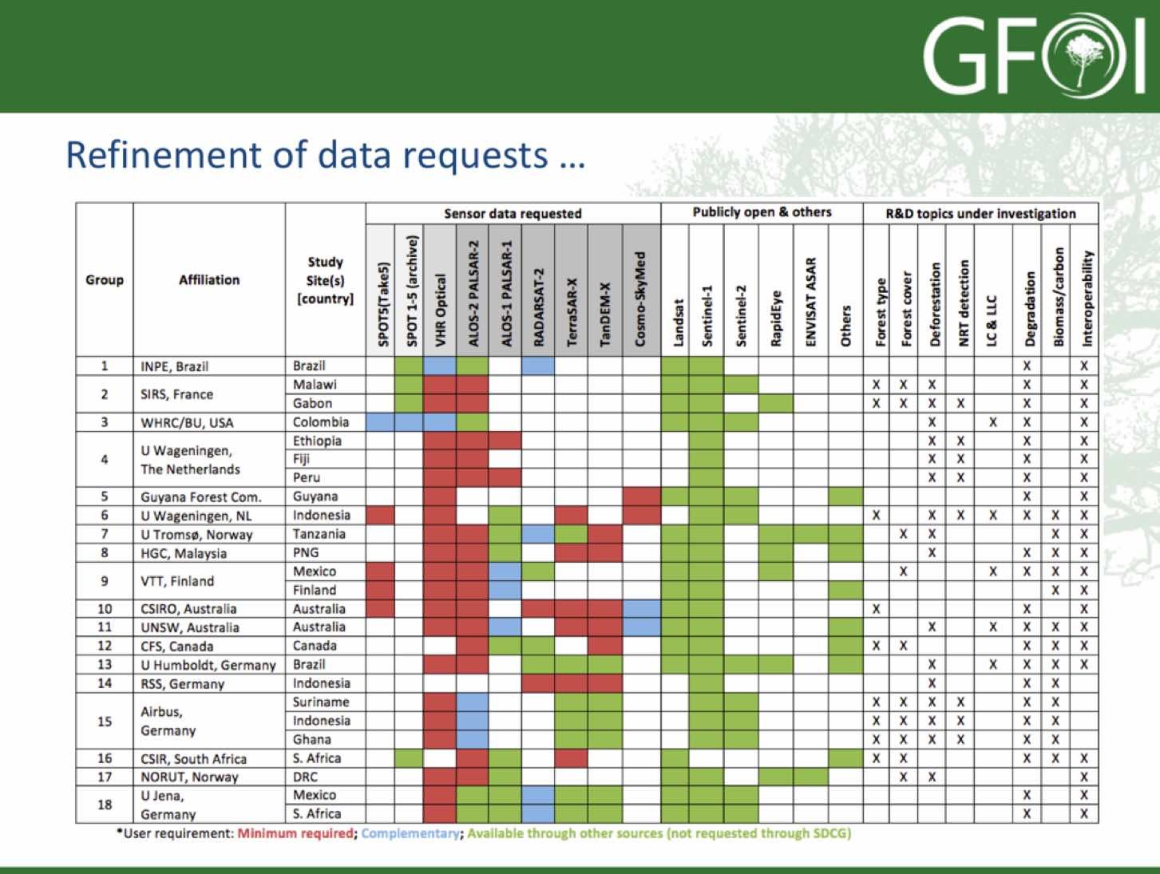
Yves noted that we can draw a couple of lessons from this table:
- L-band is perceived by R&D users to be essential, though it’s possible that C-band sources may be able to address some of these requirements and this is something that should be explored.
- High resolution optical has been identified as critical for research, but sources of this data are currently largely outside of the influence of SDCG agencies.
- Based on this table, coordination across data providers may be able to alleviate stress on a single supplier.
Ake noted that two of the main discussion topics for this session are governance roles and responsibilities in the Element-3 strategy, and the inclusion of new groups (e.g. from the UK). He introduced the agency-by-agency review of plans to agency Plans for Data Supply in Support of the Element-3 Strategy.
ASI
Anna Rita Pisani (ASI) reviewed the status of the ASI response to R&D groups requesting COSMO-SkyMed data.
Group 6: SUM-2 (Harapan, Indonesia) and BOR-3 (Mawas, Indonesia)
- Principal Investigator: Dirk Hoekman (Wageningen University)
- Agreed 80 scenes/year for one year, until February 2017; and
- Data provided: 12 images (6 asc on Mawas and 6 desc on Harapan) since March 19th, 2016.
GFOI Group 10: AU-3 (Warra, Australia) and AU-4 (Robson Creek, Australia)
- Principal Investigator: Neil Sims (CSIRO, Canberra, Australia);
- Co-Investigator: Melissa Fedrigo, Alex Held (CSIRO, Canberra, Australia); and
- Update February 29th, 2016: Process was stopped by the PI, we are waiting to be contacted again.
GFOI Group 11: AU-5 (Injune, Australia)
- Principal Investigator: Richard Lucas (UNSW, Sydney, Australia);
- Co-Investigator: Peter Bunting (Aberystwyth University), John Armston (University of Maryland), Peter Scarth (university of Queensland); and,
- update February 29th, 2016: Process waiting to be completed: some information are missing.
GFOI Group 5: GFC1 and GFC2 (Guyana)
- Principal Investigator: Pradeepa Bholanath (Guyana Forest Commission);
- Co-Investigator: Pete Watt (Indufor Asia-Pacific Ltd Auckland, New Zealand); and,
- Pending request: PI and co-PI have to be both institutional users.
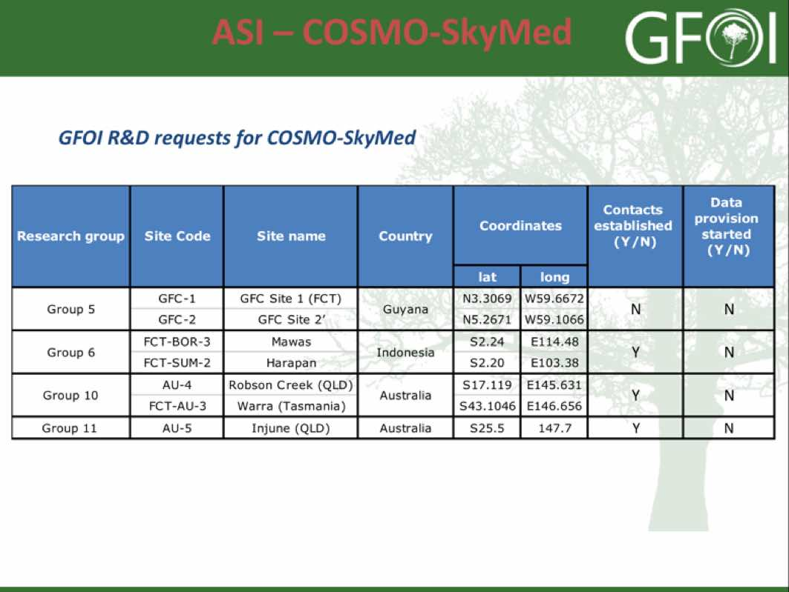
CNES
Ake reviewed the status of the CNES response to R&D groups requesting Pléiades data behalf of Steven Hosford.
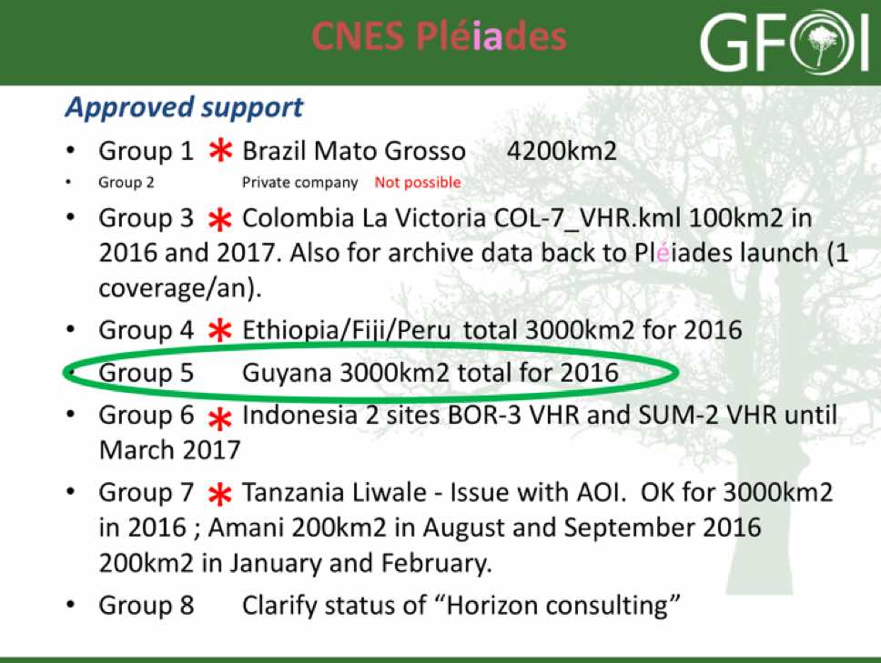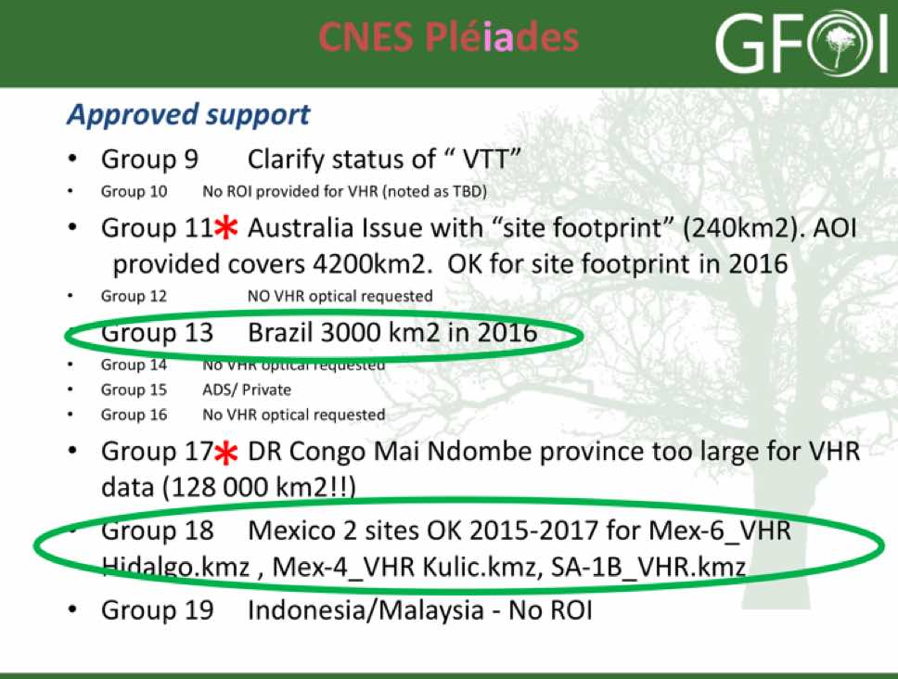
Ake noted that those approved circled on green have been approved, and summarised the status:
- Pléiades tasking activated for 2 request (5, 18), 2 being processed (13);
- 7 requests awaiting clarification feedback from science teams (1, 3, 4, 6, 7, 11, 17);
- 2 requests have not provided an ROI (10, 19);
- 2 private companies (Group 2 and Group 15). Awaiting feedback from Airbus;
- 2 clarifications of user status needed (8, 9); and,
- 3 requests contain no VHR (12, 14, 16).
Erik Lindqvist (FAO) noted that if there are restrictions on giving Pléiades data to Indufor for Guyana, perhaps FAO could be the data recipient.
CSA
Yves presented a summary of RADARSAT-2 data support to GFOI R&D.
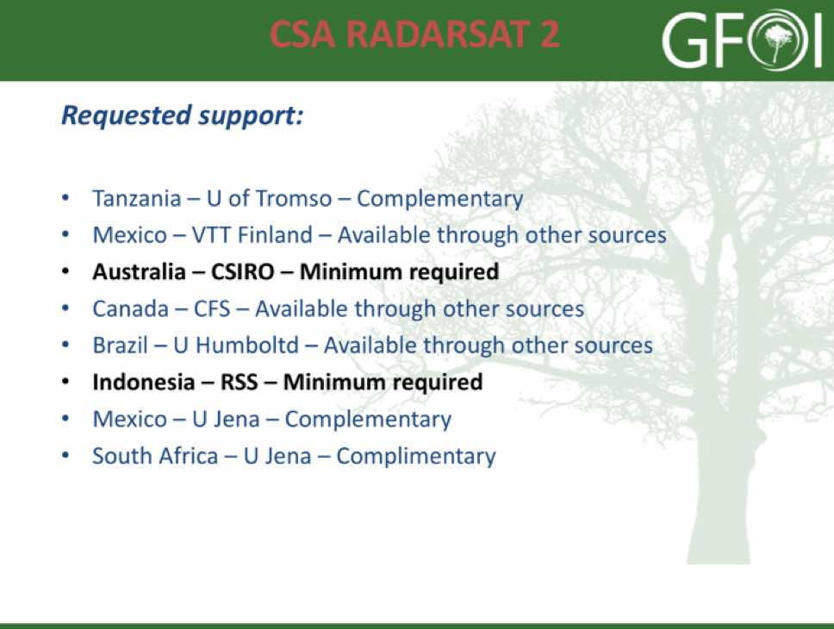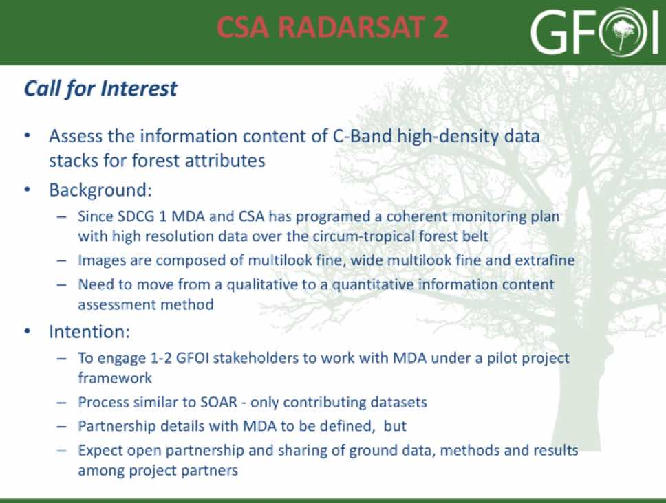
Yves also presented a call for interest in an activity which has the objective of assessing and establishing the value in extracting forest attributes from dense time series of C-band SAR. The announcement has not yet been released, but he would be interested in seeking 1-2 teams from the GFOI R&D programme.
A brief discussion followed.
- Helmut asked about the nature of the relationship with MDA, and Yves noted that MDA has an interest in being involved beyond the distribution of the data, though their exact role remains to be defined.
- Yves noted that Colombia is well covered by the archive, and there could be an opportunity to link this to Brian’s Data Cube activities.
- Erik noted that countries are inclined to use datasets and solutions that have a strong prospect of passing the UN-REDD review process, and so making that connection is important.
DLR
Michael Bock (DLR) presented a summary of the TerraSAR/TanDEM-X missions, as well as the data support DLR is able to provide to GFOI R&D teams.
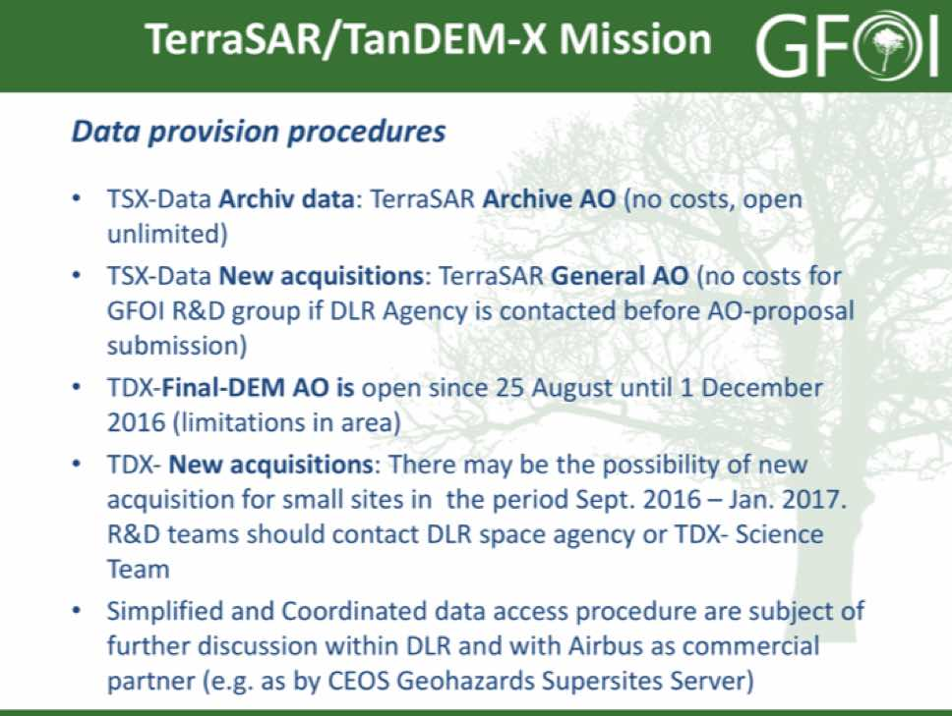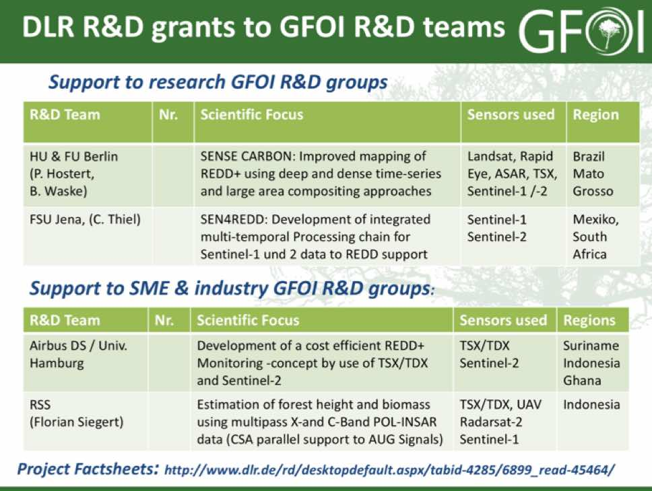
He also reviewed to additional activities that DLR is supporting which may be of interest to the GFOI R&D community – a science team meeting in 2016, as well as the AfriSAR campaign.
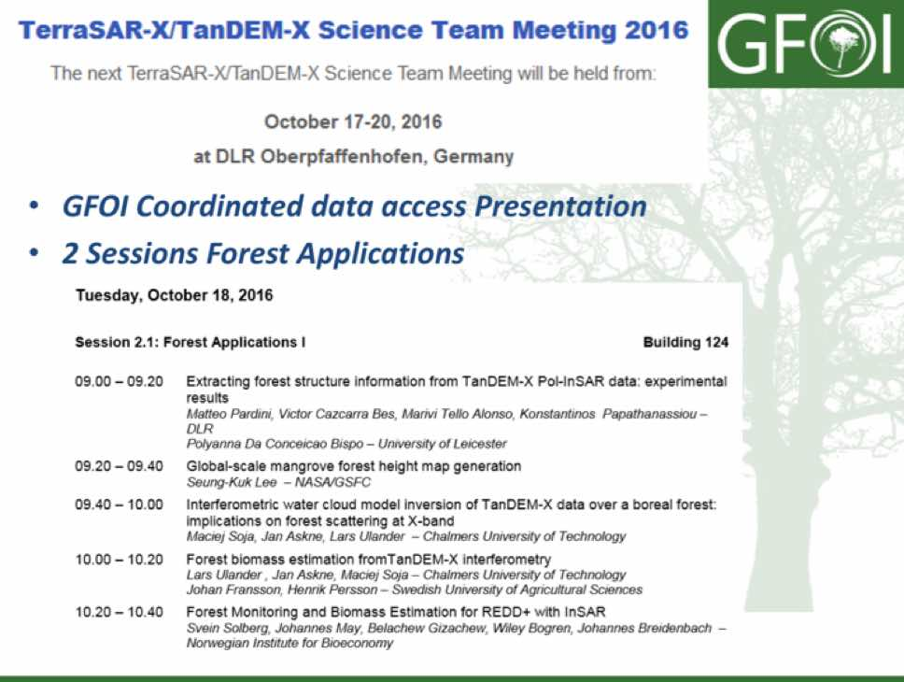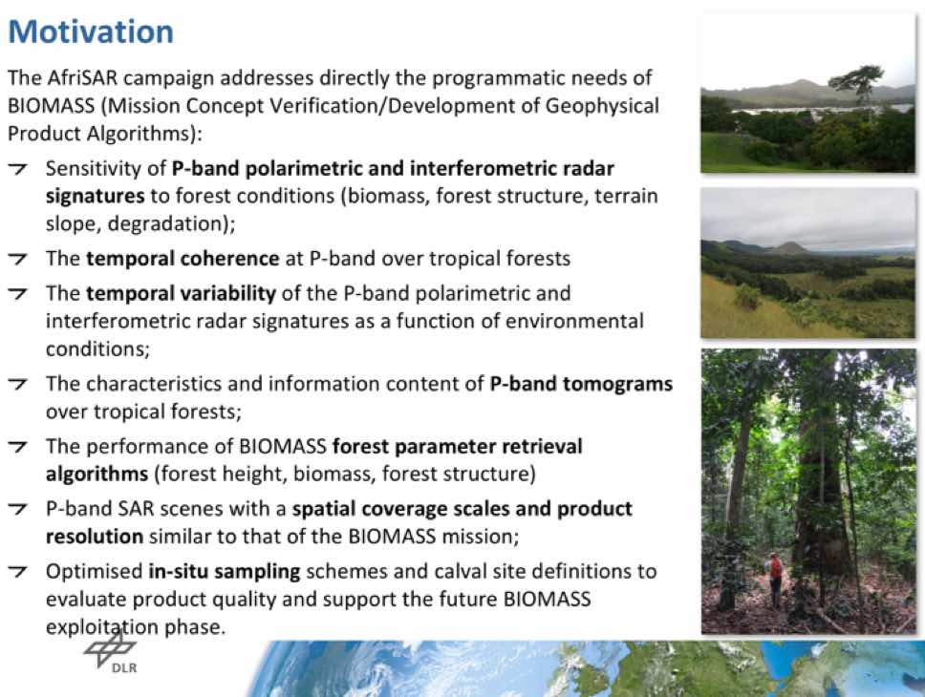
JAXA
Shizu presented a summary of ALOS PALSAR / ALOS-2 PALSAR-2 data supply to GFOI R&D.
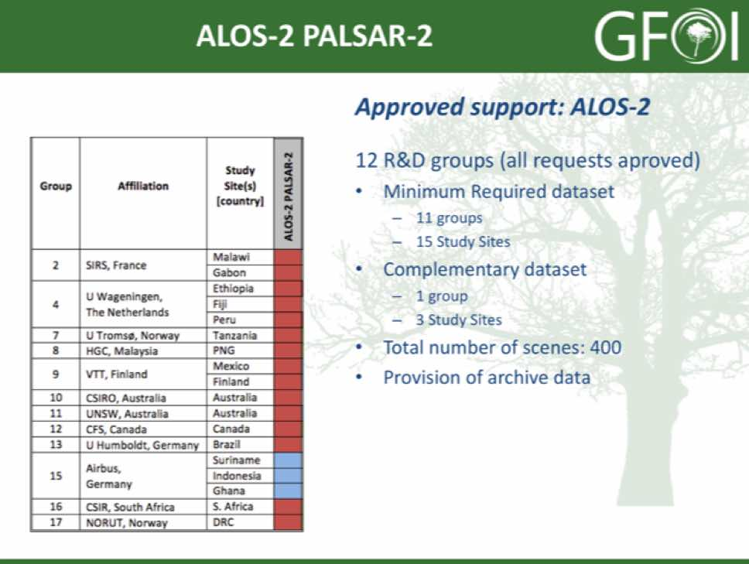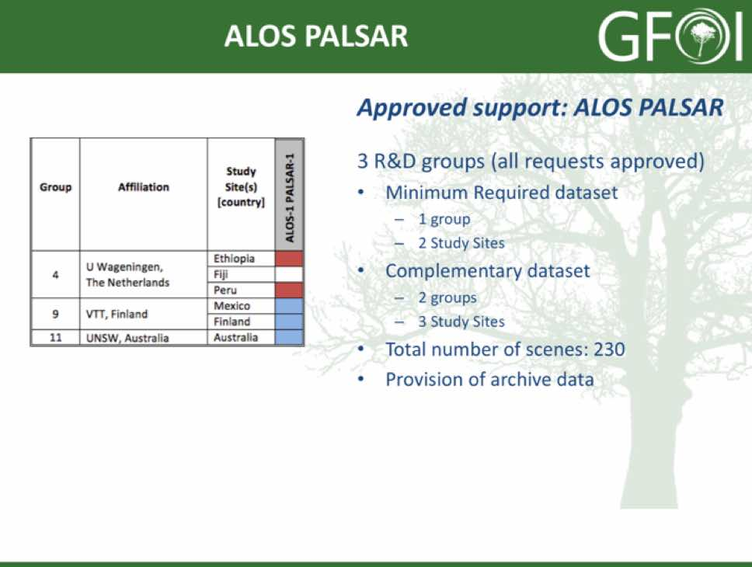
Ake noted that the approval from JAXA to provide L-band SAR data from PALSAR-2 to the GFOI R&D programme is a positive development.
ESA-CNES
Frank Martin reported on the Spot5Take5 initiative, noting that data was collected over 150 sites as a part of this joint ESA-CNES initiative. Part of the objective was to simulate the performance of Sentinel-2’s two satellite constellation. Data was captured between April to September 2015 every 5 days under constant viewing angles, and the time series are made available by ESA and CNES to the scientific community. Spot5Take5 data are distributed with a free and open policy via the joint ESA-CNES portal (https://spot-take5.org) for R&D purpose non-commercial use.
SDCG-10-9 | Brian Killough to send Erik Lindquist and Gene Fosnight the link to the SPOT-5 pre-processed data that Steven Hosford has provided | COMPLETE  https://theia.cnes.fr/rocket/#/search?collection=SpotWorldHeritage
SDCG-10-10 | SDCG EXEC to follow-up with Steven Hosford on the status of the SPOT-4 and SPOT-5 archive pre-processing activity | COMPLETE  ~100,000 scenes from the SPOT archive downloadable from the link below, including some images over Africa. Another ~100,000 are currently prcessed. An update on processing the rest of the archive should be available at SDCG-11. https://theia-landsat.cnes.fr/rocket/#/search?collection=SpotWorldHeritage
GFOI R&D governance Arrangements
Yves opened the discussion summarising the outcomes for the R&D component. He noted that the success of SDCG is in having a strong linkage to the GFOI R&D programme, which is currently in place.
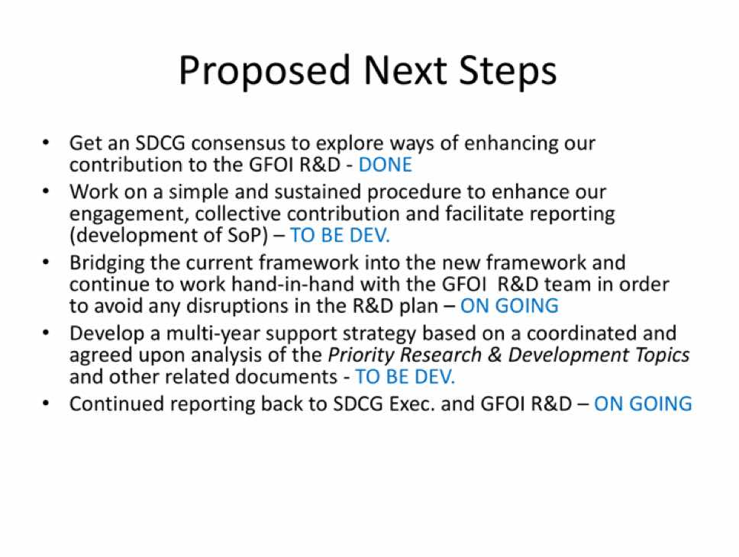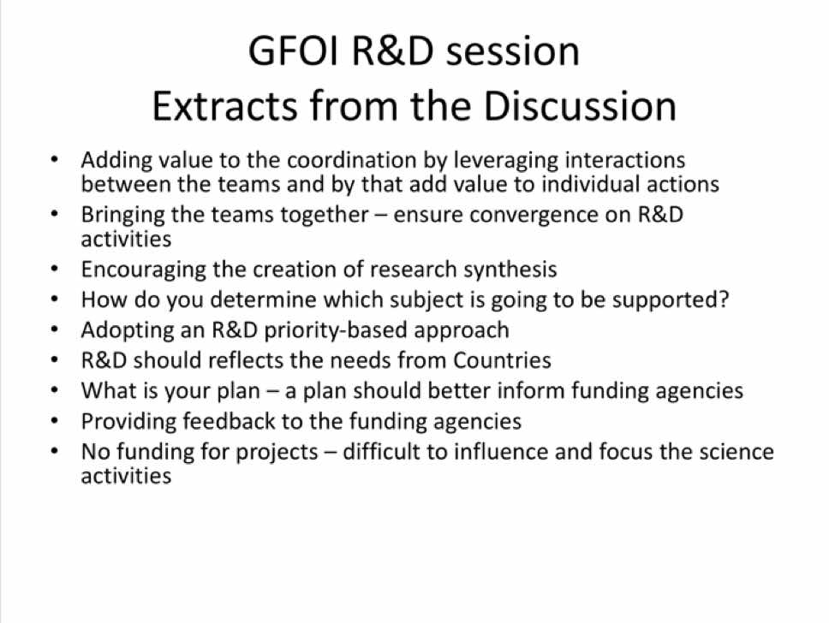
Three main aspects of support to GFOI R&D were discussed.
1. Encourage Horizontal Collaboration
Several discussion points were raised.
- Ake noted that it was a challenge to secure time on the GFOI science meeting agenda for the R&D teams, but one day was secured. It is hoped that in future, the emphasis will grow - however for this year, because teams are only just starting to receive data, one day will suffice.
- Yves asked if the science meetings should take place in the SDCG or GFOI framework, and Ake feels that they should be captured in the GFOI framework.
- While it may be difficult to compel collaboration across the R&D teams, SDCG and GFOI should not be hesitant to propose this to the groups.
2. Fast-Tracking Priorities
Several discussion points were raised.
- Yves would like to see the themes that are being addressed structured into priorities, including an assessment of complexity, and use this to scale efforts. Ake noted that all the items in the R&D plan are being treated with the same priority.
- It was agreed that the role of the SDCG is to deliver data based on priorities and requirements defined by the R&D teams.
3. Enhance Accountability
Several discussion points were raised.
- The issue of reaching out to commercial data providers was raised, and it was noted that GEOGLAM is facing a similar issue, and so there could be some synergies there. There was a discussion about whether it would be useful to have the commercial providers engage with the R&D component. Sylvia noted that R&D should be driven by country needs, and the inclusion of commercial data into R&D should be limited as this data could not be accessed sustainably by countries.
- The question of whether a better defined statement of data requirements for R&D would be useful, and it was agreed this would help support engagement.
Ake raised the question of how to respond to requests from new research groups that wish to join, and Yves suggested this should be managed by the GFOI R&D team. Ake noted that there is a finite amount of data that agencies can provide, and so adding new teams will stress data supply. Michael noted that the procedure is not currently clear, and also that data quotas may be adjusted, however the overall process is not currently clear. Ake noted that the process to date has been that the teams approach GFOI and they are considered on a case-by-case basis. It was noted that the question is not pressing as there are no new teams formally approaching at present.
Yves noted that this discussion highlighted some common issues for space data provision for R&D which can be addressed mutually amongst the group.
SDCG-10-11 | Yves Crevier to write a one page summary on the call for interest in the 2010-2016 tiled RADARSAT-2 archive | October 2016
SDCG-10-12 | Ake Rosenqvist to coordinate an email and telecon consultation within the R&D data providers on the content and approaches to enhanced accountability | October 2016
SDCG-10-13 | Ake Rosenqvist to work with the Element 3 agencies to finalise the Element 3 strategy document revision and have it uploaded to gfoi.org | October 2016

Space Data Services
Brian reviewed the status of four of the outcomes within the space data services work thread.
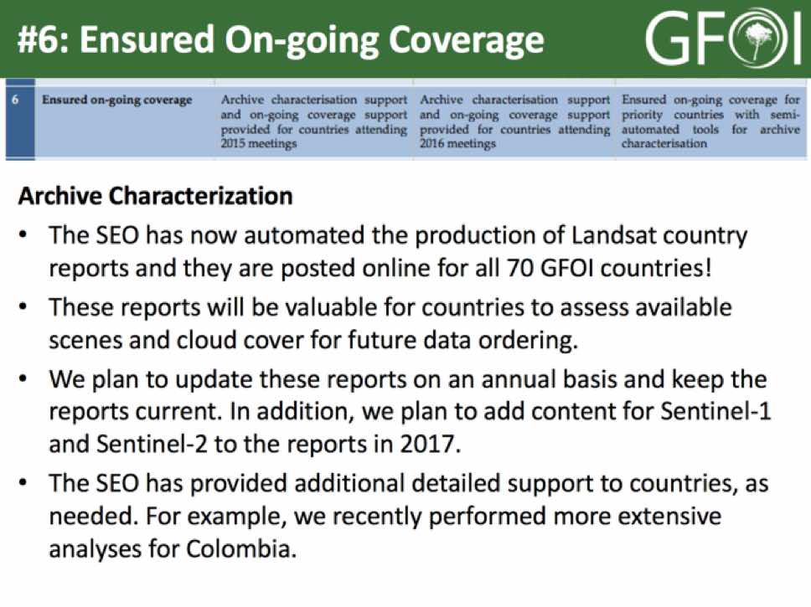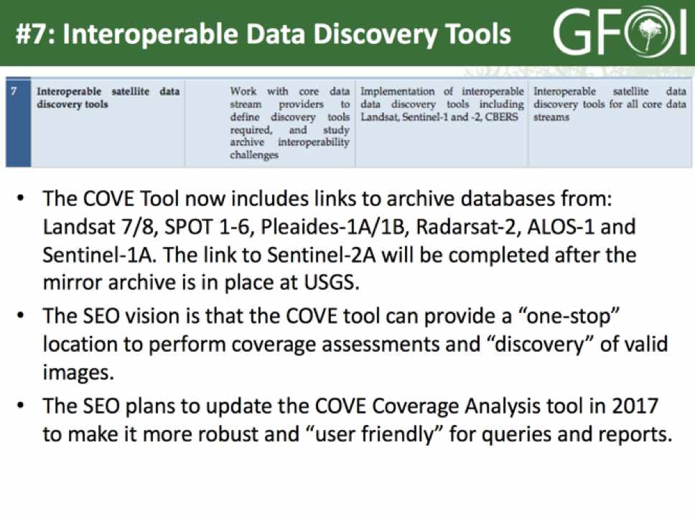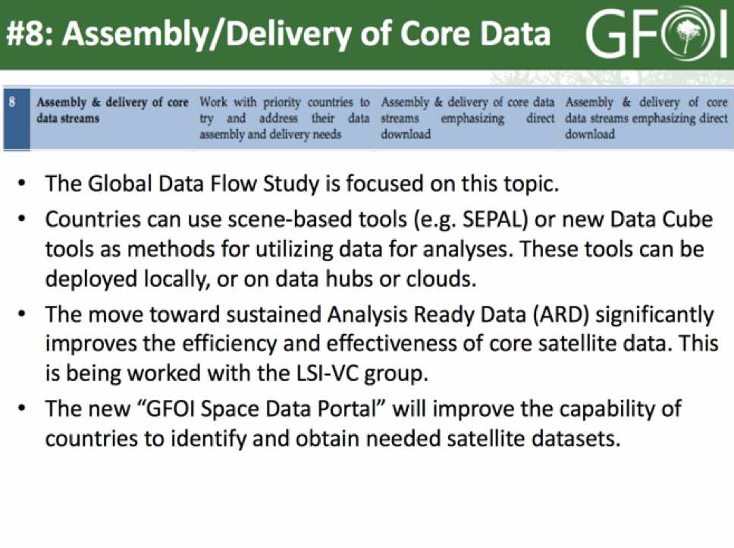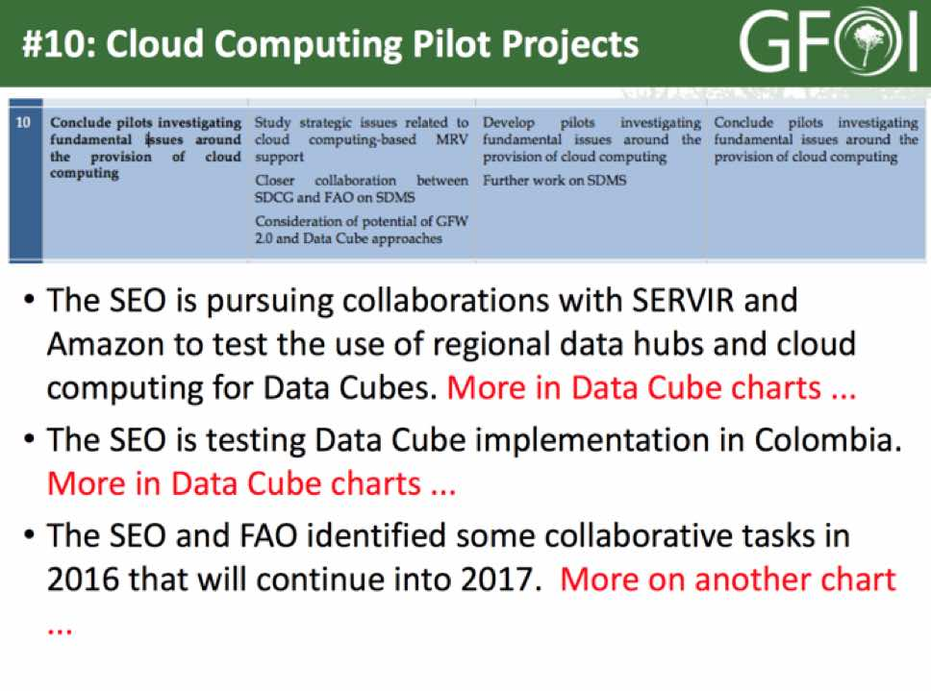
A brief discussion followed.
- Brian noted that the API call details for the USGS Sentinel-2 archive aren’t apparent, and Gene will follow-up and provide available details.
- Helmut asked why the TerraSAR/TanDEM-X archive is not linked to COVE, and Paul Kessler (CEOS SEO/NASA) confirmed that TerraSAR-X is linked, but the TanDEM-X archive has not yet been linked due to a lack of API.
- Ake asked about ALOS-2, and Paul believes they do have both ALOS and ALOS-2. Paul noted that the data is available in COVE as soon as it is available on the provider’s API, and the COVE metadata archive is updated daily. For Sentinel-1, COVE is currently pulling the metadata from the Alaska Science Facility mirror.
- Michel asked if a KML archival search is possible in COVE, and Paul noted this is not currently possible but is being considered for the new coverage analyser which is in work.
Brian reviewed the status of collaboration tasks between the SEO and FAO.
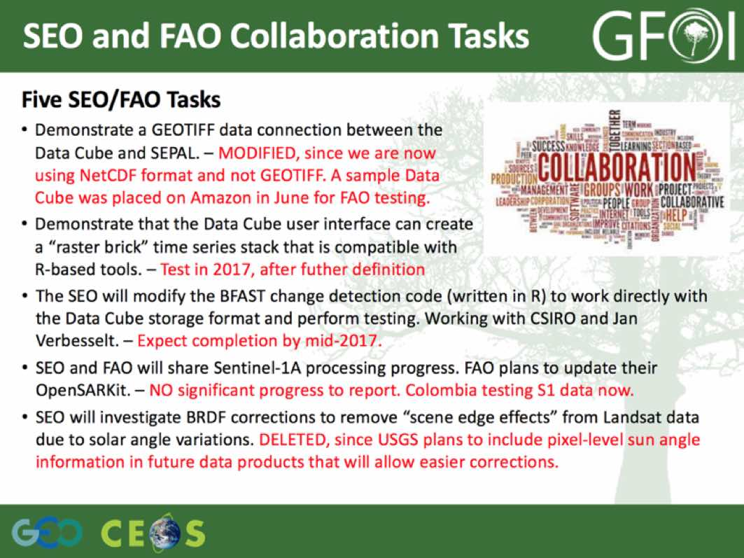
Erik noted that OpenSARKit now includes Sentinel-1, and a user manual will be released by the end of the year. Brian noted his team will likely wait until the end of the year, and then start to adapt and adopt this code.
Brian reviewed the status of the Data Cube and its architecture.
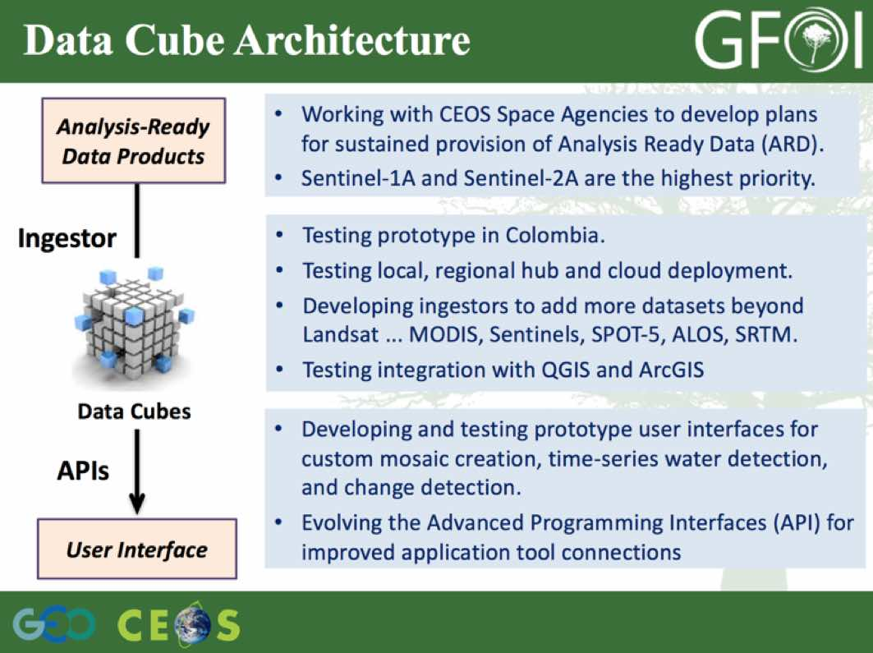
The latest GitHub release of the Data Cube took place in August, and includes:
- Modified v2 Data Cube core additions – flexible ingestion bounds (can create smaller cubes), ingest UTM projections, ability to add a specific datatype;
- New ingestion configuration and preparation scripts for Landsat SR product;
- New Data Access API “wrapper” for v2;
- Updated custom mosaic user interface – compatible with v2, improved; and,
- New Water Detection tool (based on WOFS from Australia) and Jupyter notebook.
Brian reviewed the status of the Data Cube prototypes, and the recently published Data Cube Work Plan.
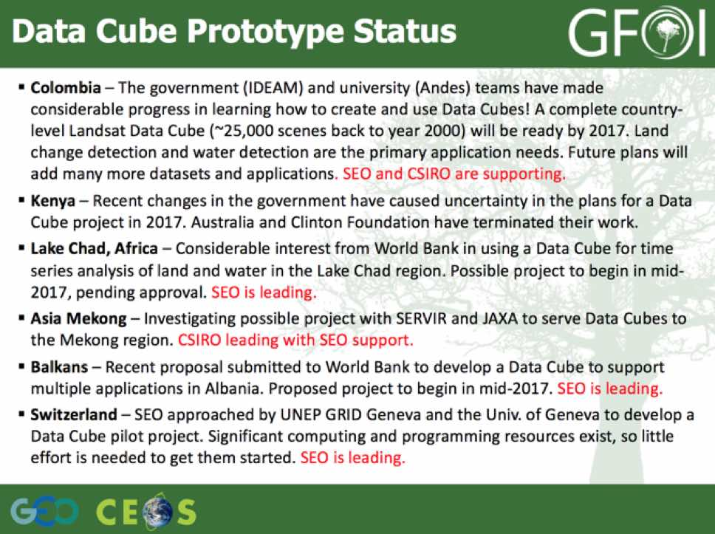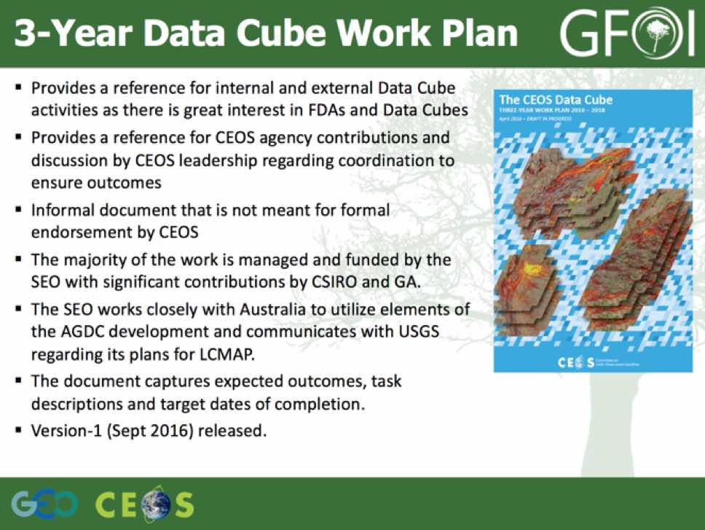
Brian noted that Kenya has become inactive on the Data Cube front, and appear to be continuing with scene based approaches. This is in contrast to Colombia who has expressed a lot of interest in the Data Cube, and he would like to see the continuation of this project include a demonstration of spatial alignment of multiple datasets.
Gene asked if the Data Cube is still on a research basis, or operational, and Brian noted that in the case of Colombia they are considering it for their operational system - though applications are still under development Brian noted that USGS has recently decided to work the implementation of their LCMAP utilising Data Cube approaches, which is good news.
Brian raised the topic of endorsement of the Data Cube Work Plan, and Stephen suggested that it should be endorsed as a broader piece of work including the development of ARD. Stephen also noted that the main question is what do we do next, suggesting that one key milestone would be the generation of ARD from several CEOS missions for a purpose with a user feedback loop.
Brian suggested that the World Bank could be a potential Data Cube partner who could also help in providing CEOS with feedback on how effective the implementation has been.
Gene stressed the importance of separating applications and implementation, and there needs to be a clear reason to drive the work, including an end user. He stressed that we need to ensure that we’re satisfying end user needs, and noted that some of the recommendations from the Global Data Flows study were overselling Data Cubes.
The potential of a blended optical and SAR product was discussed, though it’s clear that an end user is necessary to justify its development. Helmut added that activities like the ESA TEP, the French and German Sentinel mirror and application hubs may provide a conduit for these kinds of data products.
Osamu noted that GEO is interested in the potential of Data Cubes, and suggested possible engagement via AfriGEOSS to establish a user pull for Data Cubes. Osamu would also like to see GEONETCAST linked to providing updated data for the Data Cube. Brian noted that if there are unique problems GEO activities are encouraging that can be addressed with the dense time series, that would be welcome.
SDCG-10-14 | Gene Fosnight to provide Brian Killough with information on the API call to the USGS Sentinel-2 data archive | September 2016  In progress, appears Kristi Klein is the point of contact. The API interface used for Landsat is also used for Sentinel-2 data at EROS.
SDCG-10-15 | Brian Killough to assess ability to add ALOS-2 to the COVE metadata browser | October 2016
Forest Thematic Exploitation Platform
Frank Martin presented a summary of ESA’s Forest Thematic Exploitation Platform (F-TEP), noting that the objective is to move away from the classical model of data access via download. The F-TEP project has another year to run before implementation is complete.
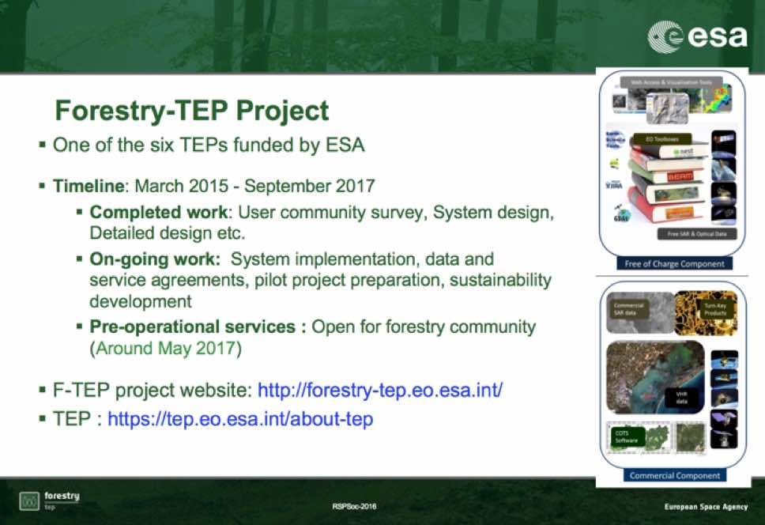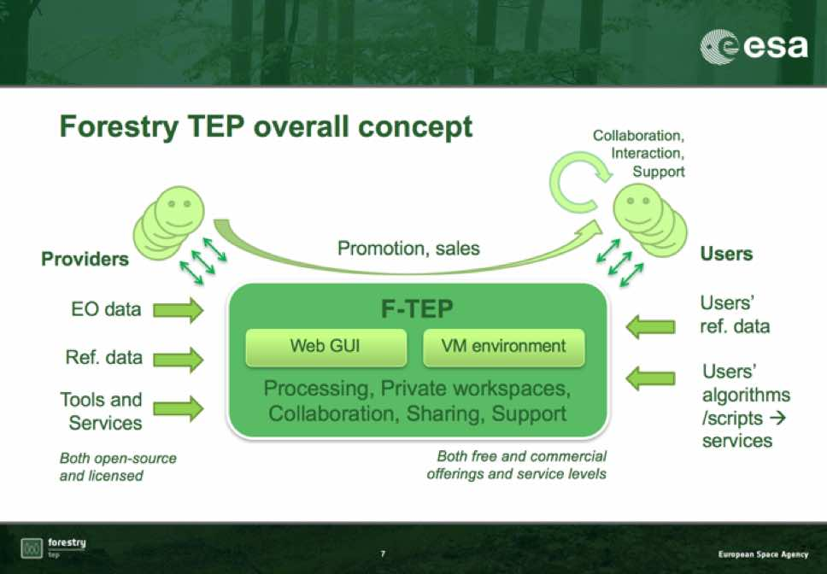
The F-TEP seeks to be a ‘one-stop shop’ for forestry remote sensing services.
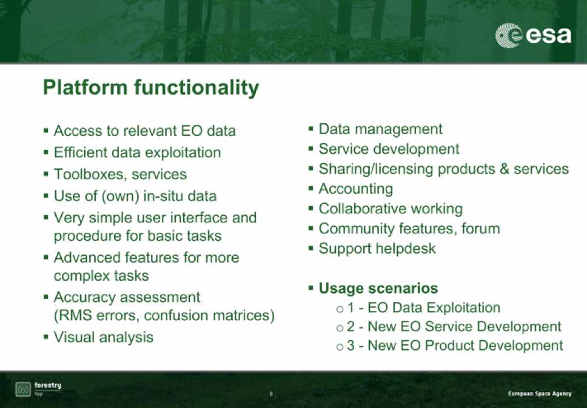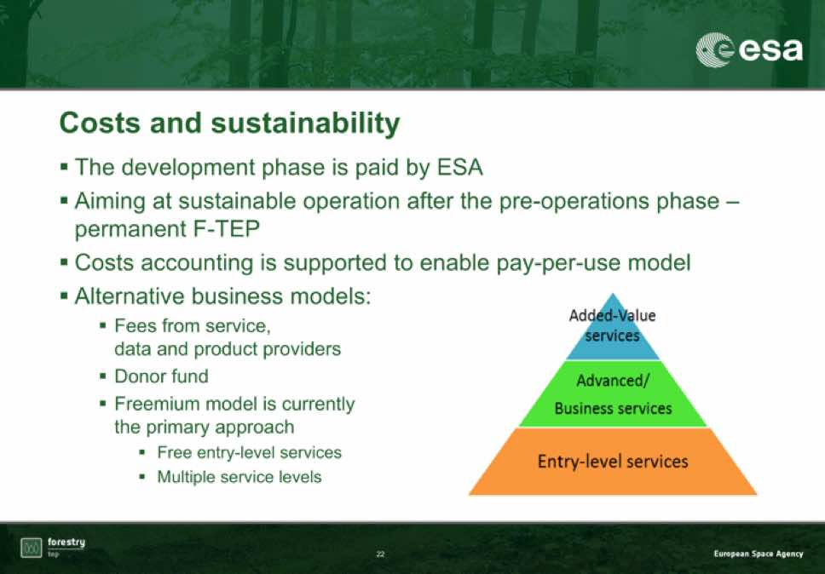
Frank Martin noted that a number of different business models are being discussed, including possibly a free entry level with fees for more enhanced offerings.
A number of discussion points were raised.
- Michael asked how open the F-TEP is to other service providers, and Frank Martin confirmed it will be open, though user fees are still being considered.
- Gene asked if there was a formal link to the German and French ground segments, and Frank Martin noted that at present the focus is on the implementation of the platform. Helmut noted that DLR is involved in an Urban-focused TEP, and the technology for that is related to German national data infrastructure.
- Frank Martin noted that the F-TEP is being sold as an evolution of the data and ground segment.
- Gene asked where the data will be stored, and Frank Martin noted that the approach being taken is more distributed.
SEPAL Update
Erik presented a summary of the work that FAO has been doing on data processing, in particular on SEPAL 2.0. A number of points were discussed:
- SEPAL 2.0 is currently running on the AWS cloud. All the source code is on GitHub, and the platform does not leverage any AWS proprietary services.
- Erik explained the functionality of SEPAL’s data discovery service, which enables spatial and temporal data search of Landsat data. Sentinel search will be developed, and it can be implemented for any data source.
- SEPAL has gone two routes with their implementation of data storage - it is currently running on the Earth Engine Python API, though the functionality exists to reference data outside of Earth Engine (e.g. Data Cube).
- Erik noted that they are using SEPAL driven by Earth Engine in country (e.g. from Kinshasa, DRC).
- SEPAL maintains the ability to run its command line tools.
- The AWS hosting of SEPAL costs $1600/mo, and most of that is storage. The compute cost is pretty small (from $US 0.03/hr up to $US 2.66/hr), but storage cost is higher. To block off storage is expensive, thoug there is some experimentation by AWS and Microsoft Azure with dynamic storage where you only pay what you use. SEPAL users can be assigned a budget for their processing work.
- A Data Cube stored and shared via AWS could be referenced by SEPAL.
- Erik noted that in some countries, there are policy and political considerations that cause countries to resist cloud computing technologies.
- Erik stressed that SEPAL has enabled him to ‘fail’ in much shorter cycles, which allows for much faster progress. It also allows the generation of results more quickly, while the data downloads on a slower channel.
SDCG-10-16 | Brian Killough to follow-up with Erik Lindquist on access to a demonstration account for the SEPAL system | Follow-up in October 2016 once the updated SEPAL system is released
SDCG-10-17 | Erik Lindquist to circulate the announcement of the release of SEPAL once completed | Follow-up October 2016  SEPAL release expected in the next few weeks

Colombia GFOI End-to-End Experience
Sylvia presented an overview of the Colombian activities session.
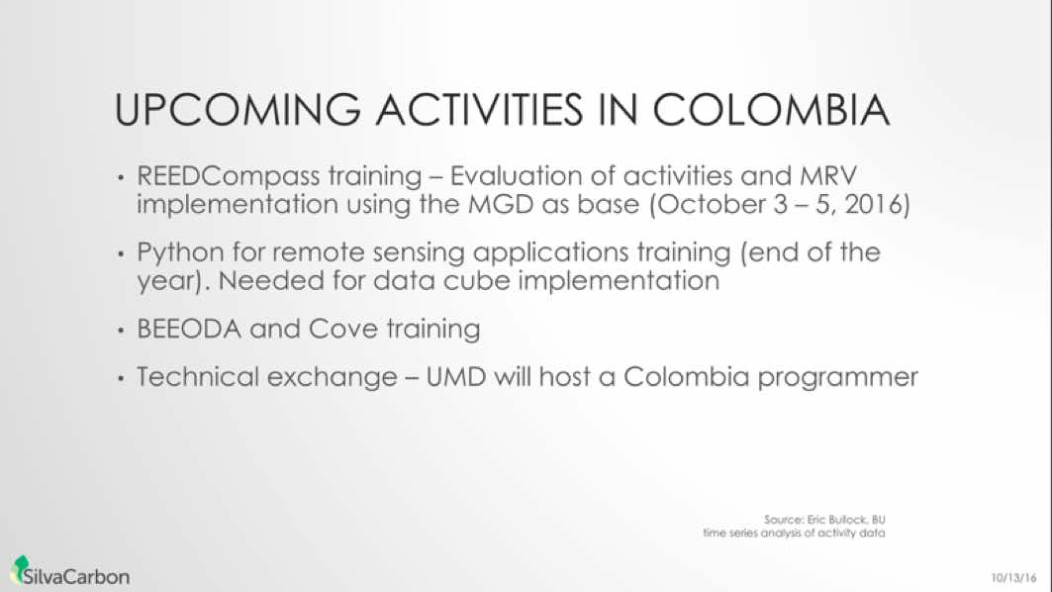
Stephen asked who the SilvaCarbon person will be at the REDDCompass training workshop in October, and Sylvia confirmed that the point of contact will be Jennifer Hewson.
Sylva reviewed the changes in Colombia’s processing capacity between 2009 and present day, where processing time for national mapping started at six months, and is now down to two hours. This reduction has been driven by a partnership with the University of the Andes and their increased computing capacity and expertise.
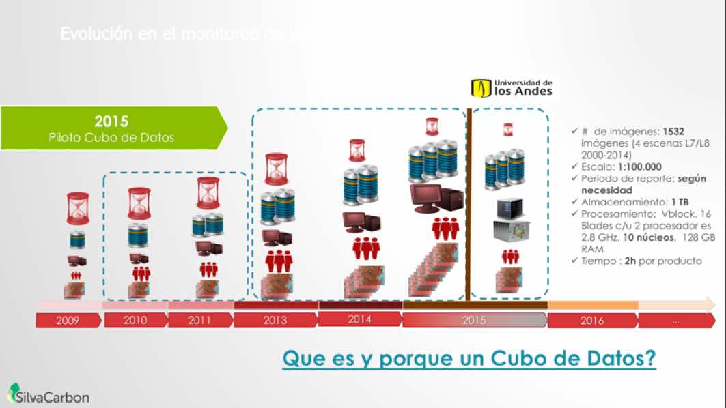
It was noted that the potential for SEPAL to be utilised by Colombia could be explored, and Erik noted that FAO is consulting with Colombia, but they are comparatively high capacity and are smart about how they assign personnel to capacity building events.
SDCG Support to Colombia
Brian presented a summary of the support SDCG is providing to Colombia.
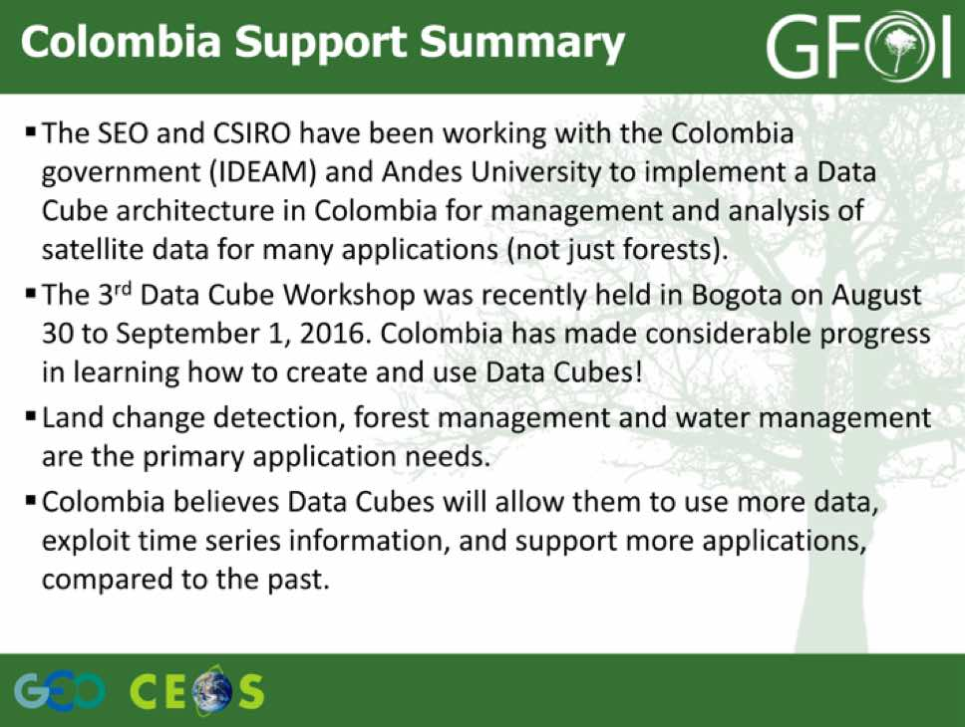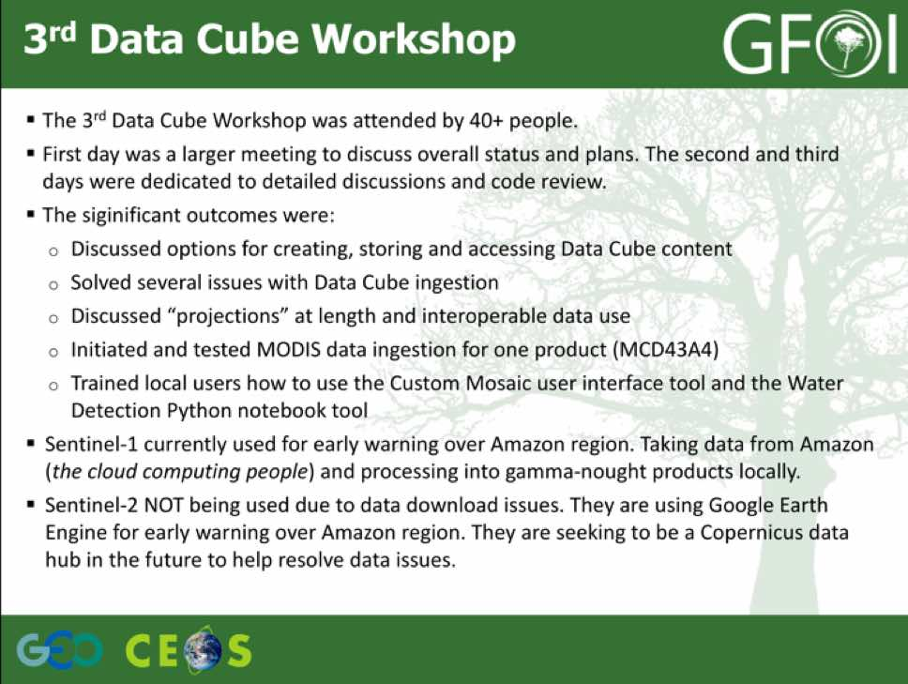
Brian reviewed a number of the needs he’s seeing for Colombia.
- Support with transition to version-2 and ingestion of a new country-wide Data Cube by the end of 2016. To date, they are testing a version-1 Data Cube with PCA change detection algorithms.
- Help with parallelization of ingestion and analysis processes to improve time.
- More ingestors to support MODIS (several products), SRTM, Sentinel-1, and Sentinel-2.
- Data Cube connections to ArcMap and QGIS.
- New and modified user interface tools to support user applications.
- Ability to modify an existing Data Cube by removing or adding data layers.
- Training and capacity building modules for other country organizations to use the Data Cube.
- Automation of new data identification, ordering, download, and ingestion into existing Data Cubes.
Peruvian Activities
Matt Hansen (UMD, presenting remotely) provided a summary of the work on monitoring of large area forest extent and change in Colombia. He stressed the importance of the systematic free and open acquisitions of Landsat as an enabling data stream for these applications, and Sentinel-2A is expected to provide a similar supply option.
Matt noted that for the Brazilian Amazon, which are the gold standard in terms of best practice, there were consistently cloud free periods in the July-August timeframe, and so they could work with cloud free scenes. However, when Matt went to apply similar approaches to areas of Africa, there were areas that never had cloud free periods, which drove the pixel based approach.
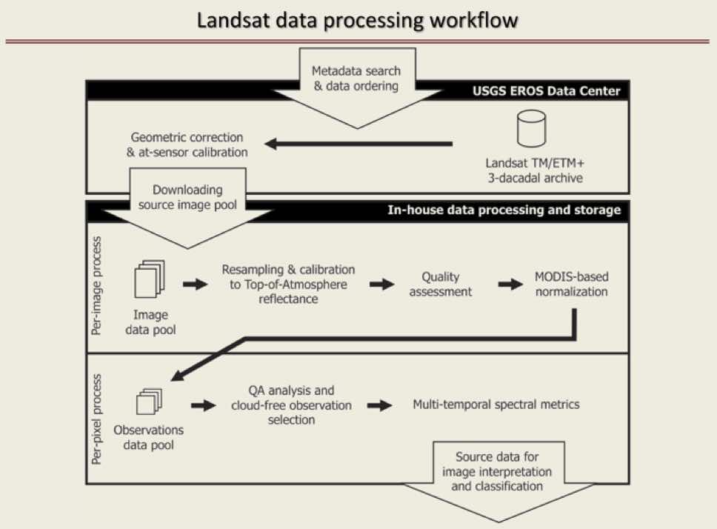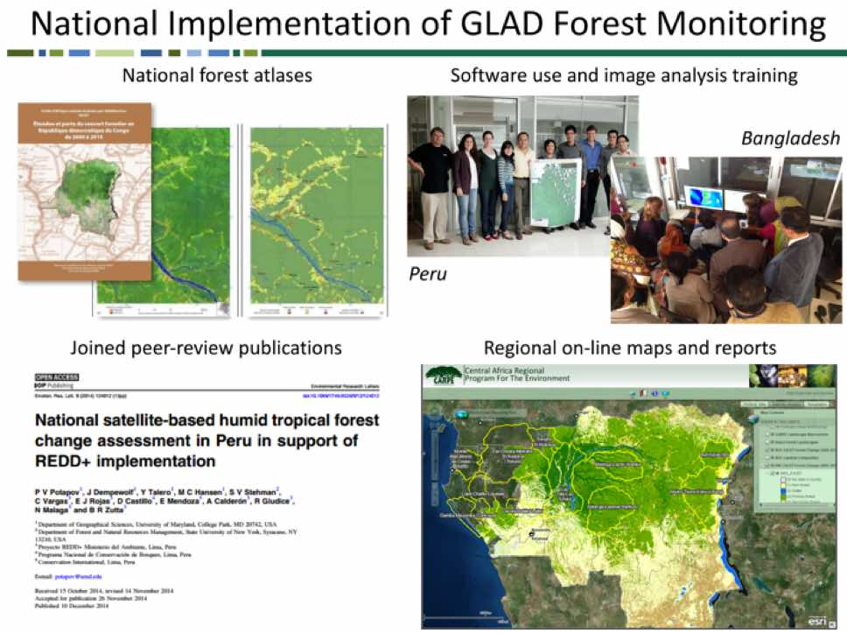
Matt reviewed an end-to-end case study for Vietnam.
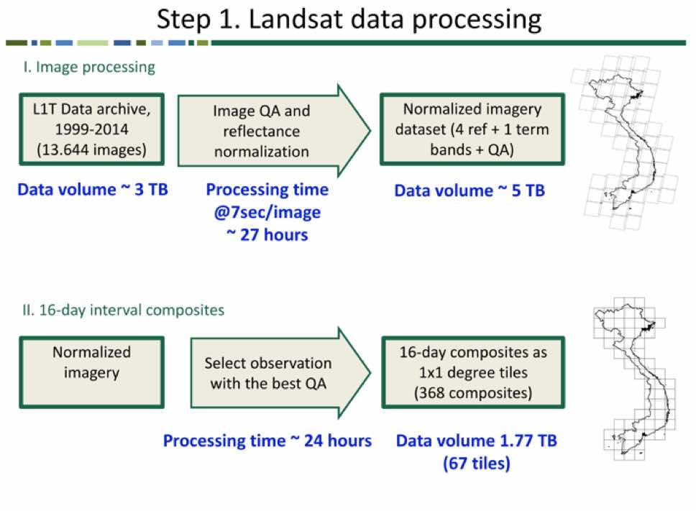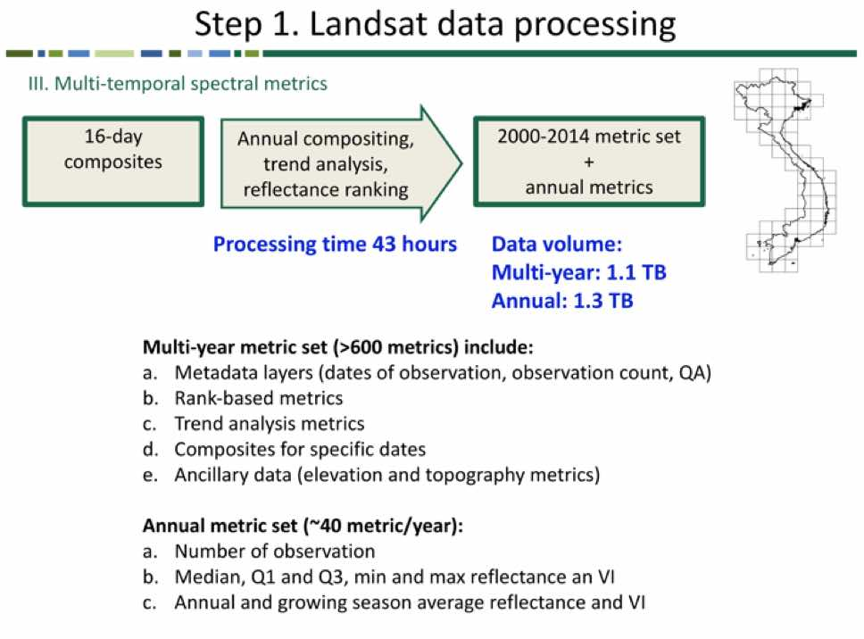
Matt reviewed the roles and ownership in the analysis process:
- The feature space is owned by UMD, and the user is not able to edit this;
- The local tuning parameters are managed by the end users; and,
- The algorithm is the least important element, and any can be used so long as it is distribution free.
Matt noted that validation currently takes about half of their effort. He noted that in the case of Indonesia, definitions played a significant part in divergence between the global products and the official governmental results.
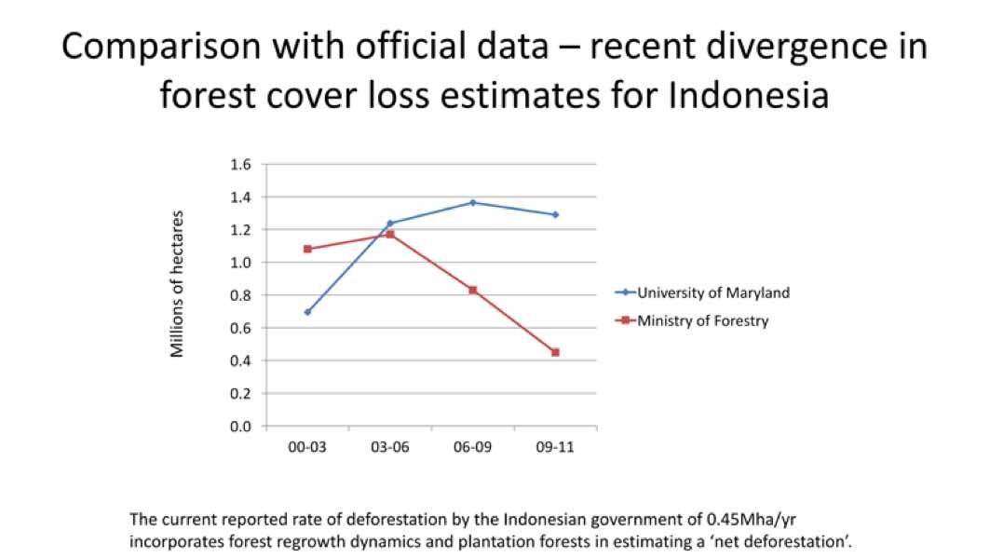
Matt noted they are working with Colombia on IPCC-like classifications.
He reviewed some data considerations, and summarised several key conclusions.
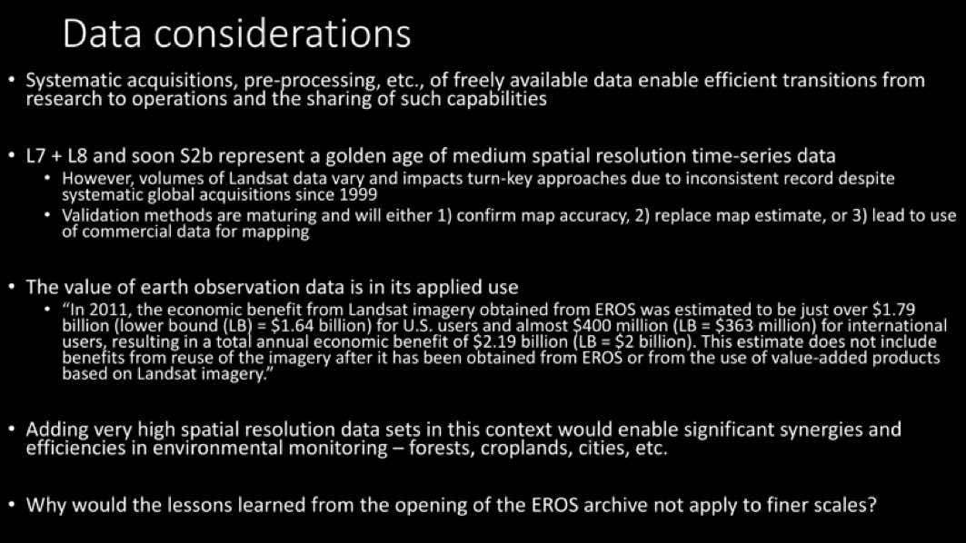
Key conclusions:
- Focus is on starting with forest maps, rather than satellite data handling and pre-processing;
- Need countries to make investments in operational systems;
- Making data user friendly is important;
- Making products in a timely manner is important;
- Brazil is the model - how do we replicate that?;
- Free and open data is key - constellations promising, but governments haven’t even confirmed they will pay for analysts much less data - commercial model not suitable; and,
- Commercial data should not be integrated with operational monitoring - it should be used for research, and also could be used for validation.
A number of discussion points were raised.
- Sylvia asked about plans to integrate Sentinel-2 in this analysis, and Matt noted the need to build quality assessment per pixel models as a first step, including bias and BRDF adjustment models, and then get the data into the processing queue. He noted they are going to try and integrate data products from Landsat and Sentinel-2 into the same data stream, though is going to take some time. The combined 10-day coverage would be an advantage.
- Sylvia asked about the Global Forest Watch (GFW), and the exclusion of 2015. Matt noted they are doing a reprocessing of the entire record, and hope to have 2015 complete in 2016, but they are taking the lessons learned from the initial product which is slowing the process.
- Stephen noted that Colombia has been put forward as a possible candidate for a model national GFOI system, and this would involve getting them to apply all parts of the GFOI process starting with the MGD, utilisation of space data, and the Capacity Building resources. Matt agreed that Colombia is a great place to try this, with a very advanced and self-reliant team in place. He contrasted this with the Republic of Congo where they deliver products and from there they are just mapped. He cautioned that Colombia is thinly spread they are, and the government asking more and more, which means they are straining somewhat under increased responsibility.
- Stephen asked about the potential for practical collaboration between GFOI and GFW. GFOI. Matt not that GFW is an outreach platform meant to spur action, and is not intended to be reference for reporting. He did suggest that if there is no capacity then you could use a global map off the shelf to do some sample based estimation. He noted that Columbia is advanced well beyond the level of the GFW products.
- Ake asked about the need to tweak algorithms when Sentinel-2 data is ingested, and Matt confirmed that this will need to be done, and the higher resolution should enable more information to be squeezed out of the data stream. A more labour intensive validation may be required, but over time they expect to integrate the data and that this will improve the products.
- Sylvia asked about the six IPCC classes being explored with Colombia, and whether this classification had been validated. Matt noted that this is not validated at present, and is pretty experimental. He noted the Colombia map is expected to be a stratifier.
Colombia session wrap-up discussion
It was noted that the main purpose of this session was to listen to Colombia, but without Edersson’s participation this was not possible. Several discussion points were raised.
- Sylvia noted that the interaction with Colombia should be lead by the GFOI Leads, and not the SDCG.
- Peter Moore (GFOI Office) noted that following and adhering to the MGD provides a level of certainty that the outcome will be IPCC compliant, and it can help a country organise its national MRV activities and help identify gaps. He suggested that Colombia could be a good place to use the MGD to optimise resource allocation, though the steps to achieve this are not clear and GFOI needs to form a plan for engagement.
- Brian noted that stepping through the MGD with Colombia would be a good next step, but it is not clear how to progress this dialogue. He noted the REDDCompass workshop may present an opportunity.
- Erik noted that the reason why Colombia was chosen was because they have most of the answers and the skill to test the data and the tools we have. They know the answer using their own system, and can use GFOI methods to as an independent results set.
- Brian noted he is going to continue to work with the Colombia team and expects them to be approaching independence.
- Frank Martin suggested that GFOI should look at 3-4 other countries to follow this process through, perhaps based on the discussion with the GNU block, and ensuring the target countries have existing and resourced activities.
- Osamu noted that Colombia are very active in GEO and are a member of the GEO Executive Committee, which could be helpful.
- Sylvia noted that in 2013 there were letters of cooperation exchanged with Colombia, and so there is a commitment in place.
SDCG-10-18 | SDCG EXEC to work with Sylvia Wilson and the GFOI Office to set up a meeting with Jenny Hewson on the upcoming REDDCompass training workshop in Colombia to discuss how to leverage the workshop to promote the GFOI end-to-end country demonstration | 22 September 2016

SDCG Business and Wrap-Up Discussions
Review of Main Discussion Points
Stephen Ward introduced a discussion session with the aim of checking the consensus on major outcomes for each session, and considering the implications and next steps for each Work Plan thread.
Baseline strategy
Stephen reviewed the main outcomes of the discussion on the global baseline strategy:
- Ongoing coverage from L-7, L-8 and S-1, S-2 (1B commissioning);
- S-2 GRI completion late 2017… Landsat data will be processed;
- Good pre-interoperability collaboration;
- L-9 essentially an L-8 clone;
- SDCG should input to the L-10 consultation process;
- German and French Copernicus data access points;
- Importance of L-band data stressed and resolve to write to JAXA to ensure continuity; and,
- Global Data Flows will be reported to CEOS SIT next week.
A number of discussion points were raised.
- At present the expectation is that SAOCOM will be free and open outside of the European area of interest, and the expectation is that the ALOS data policy will be reviewed in November 2017. It was agreed that we should follow-up with CONAE on the expected data policy for SAOCOM.
- Erik asked about the pre-processing of the historic SPOT archive, and Brian noted that he’s been in touch with Steven Hosford and this is nearing completion. Erik noted that the SPOT data from 1990 to the early 2000’s would be very valuable as it is the only validation data other than Landsat they have available.
SDCG-10-19 | SDCG EXEC to confer on a communication to CONAE requesting a status update on the anticipated data policy for SAOCOM | COMPLETE  Letter sent to CONAE 19 Oct 2016.
SDCG-10-20 | Frank Martin Seifert to check whether SAOCOM will be included in the ESA TPM programme | September 2016  In progress - SAOCOM is listed as a potential ESA TPM mission – Frank Martin will check with Bianca Hoersch to see if there have been any updates
UK session
Stephen reviewed the main outcomes of the UK session discussion:
- It was noted that the GNU block of countries has committed $5Bn in finance to national forest monitoring in support of REDD for 2015-2021;
- UK interested in exploring closer GFOI engagement;
- Inclusion of NovaSAR S-band data in the GFOI R&D programme, to help advance its application for forest applications;
- Specifically inclusion of NovaSAR data in the CEOS Data Cube to show its utility alongside better known data;
- Exchanging notes on the GFOI Capacity Building efforts with space data in countries; and,
- A number of detailed technical collaborations that popped up in discussions.
A number of discussion points were raised.
- Stephen noted that there may be an opportunity to help join the dots between the GNU’s interest in investing in national forest monitoring and the potential for NovaSAR to contribute as a monitoring satellite.
- In the short term, Peter Moore has already written to the GFOI Leads suggesting that there is a meeting in the UK on potential GFOI support to GNU’s forest monitoring ambitions before the end of the month. However, what will happen in the medium and long term - it is important that GFOI stats to show results in the next 18 months.
- Frank Martin noted that UK expertise in converting mapping to forest and carbon products should be stressed as this is an area where GFOI overall could use additional capacity.
R&D
Stephen reviewed the main discussion points from the R&D session:
- El-3 strategy will be updated for SIT-32 information;
- Refinement of GFOI R&D team data requirements;
- Agency reports on data provision;
- ASI and CNES: Supporting all groups without commercial provider requests; established contacts with the R&D groups;
- CSA: Will work to support groups with RADARSAT-2 requests;
- DLR and JAXA: Support all groups that requested data; data distribution still to be commenced;
- ESA: Data available at Spot5Take5.org; and
- ALOS-2 data approved for GFOI R&D.
It was noted that without L-band SAR supply, a number of the R&D data requests would have gone unfulfilled.
Space Data Services
Stephen reviewed the main discussion points during the space data services session:
- Latest news on SDCG tools, pilots and prototypes;
- Colombia moving apace, Kenya not;
- Way forward on SEO-FAO collaboration…?;
- Data Cube Work Plan should go to CEOS for information;
- Discussed way forward in 2017/18 for the CDC and ARD activities – with a possible GFOI application emphasis;
- Heard latest on F-TEP from ESA; and,
- And from FAO on SEPAL 2.0.
A number of discussion points were raised.
- Brian reviewed the two main next steps with the FAO relationship: sharing sample Data Cube; and accessing SEPAL demonstration user account once it is up and running.
- Erik noted that the cloud based services could be a good place to host some of the results derived from the R&D tasks.
- Brian asked whether SEPAL could be demonstrated at SilvaCarbon workshops, and Erik confirmed that they would be open to this approach, and is interested in showing utility. Sylvia noted that they are already doing this in country with their FAO counterparts.
- Osamu asked about the relationship to Google Earth Engine and Global Forest Watch, and it was noted that a lot of these discussions are ongoing in the background, and that SEPAL is currently leveraging Google Earth Engine as a data backend.
There was a discussion around the CEOS Data Cube.
- It was agreed that the Data Cube should be promoted as an example of a future data architecture (FDA).
- Erik noted that they will take the Data Cubes provided by Brian and assess how they interact with their current toolset.
- Kenya Data Cube is reasonably well advanced from a technical perspective, but the lack of an implementation counterpart means no progress is currently being made.
- Stephen suggested that we push for one of the CEOS demonstrations of the FDA be focused on GFOI and applying the CEOS Data Cube.
- Ake noted that it is important that JAXA continue produce the PALSAR mosaics as these represent ARD products for SAR. This mosaic exists for Colombia, and could be extracted to put into a Data Cube.
- Erik noted that they are using the PALSAR mosaics (e.g. in Zambia), combined with field data to generate biomass estimations. Ake noted that they are generated a global mosaic for 1996 from JERS-1, and thinks it could be a useful product. He also noted that all the JERS-1 scenes are already available online freely.
SDCG-10-21 | Pedro Rodriguez to report on his late-September visit to the Kenyan Forestry Ministry regarding the potential to leverage work Brian’s Data Cube has done for Kenya | COMPLETE  Pedro has sent Brian his report from Kenya
SDCG-10-22 | Ake Rosenqvist to follow-up with JAXA on the potential release for the JERS-1 1996 global mosaic, starting first Colombia (include in communication related to action SDCG-10-4) | COMPLETE  Letter sent to JAXA 19 Oct 2016
SDCG-10-23 | SDCG EXEC to follow-up on having first version of the radar guide that Brian Killough and Ake Rosenqvist have been preparing uploaded to the GFOI space data portal once complete | October 2016
Colombia Session
Stephen reviewed the topics raised during the Colombia session:
- It was noted that the bulk of discussion during this session has had to be delayed due to Edersson’s travel issues;
- Potential of REDDCompass Workshop in Colombia to be used to explore insertion points for GFOI MGD in country?;
- There is a need to re-establish dialogue with Edersson;
- There may be an opportunity as CEOS Data Cube demo in 2017-18?; and,
- Matt Hansen presented a summary of his work in the area.
A number of discussion points were raised.
- There needs to be a clear communication from the space data component to the GFOI Leads that a plan is needed on the end-to-end country demonstration. This could include the Leads seeking a top-down endorsement of the Colombian end-to-end demonstration via the GEO and the GEO ExCom. Sylvia agreed that we may be able to make other contacts in Colombia, and will also follow-up.
- The global forest products are not sufficient at the national level, and Matt Hansen suggested that improving these products at the national level from the bottom up should be a part of the way forward. The lesson that you can make a better map by incorporation these global products is a valuable message.
- Sylvia stressed that when they work with Matt Hansen, they do get an external validation done by Boston University, in particular because the global forest product algorithm.
There was a discussion around the SPOT archive.
- Gene stressed that getting access to the SPOT historical archive is very important, as Erik had suggested. He noted that much of the SPOT data resides at national ground stations, and the processing and algorithms are still being developed.
- Gene noted that the SPOT archive has the potential to fill a time period where the Landsat archive is quite weak. He also stressed that the archive is likely decaying at the ground station and is at risk.
- It was agreed that SPOT, JERS-1, and CONAE/SAOCOM data should be stressed.
SDCG-10-24 | SDCG EXEC to communicate with the GFOI Leads on the GFOI end-to-end demonstration to ensure there is a plan to take it forward. Include the suggestions of a top-down approach via the Colombian GEO ExCom member, and that the Leads consider other countries for future end-to-end demonstrations | September 2016
Updates to SDCG 3-Year Work Plan
George summarised the plans to update the SDCG 3-Year Work Plan, reviewing the major changes required.
- Global Data Flows moves from study to implementation;
- GFOI Component Coordination and Country Engagement contingent on GFOI Office continuity;
- Changes in services and Kenyan activities?;
- Add SEO support agenda with FAO?; and,
- Others?
There was a brief discussion.
- Stephen Briggs noted that a number of the threads around the space data and interactions with cloud service providers are very much being discussed.
- Stephen Briggs noted that GFOI has been confirmed as a GEO Flagship for the next three years, though there was some significant discussion around whether it should be a Flagship.
SDCG-10-25 | SDCG Work Plan thread leads (Frank Martin, Gene, Brian, Ake, Stephen, George) to provide revised outcomes for the 2017-2019 Work Plan | September 2016  Inputs being gathered.
SDCG-10-26 | SDCG SEC to finalise updated 2017-2019 SDCG Work Plan | Penultimate draft for CEOS Plenary  Finalise by end November 2016
SDCG Future Activities
Stephen Ward reviewed the history of SDCG, and some of the targets for the next three years. He noted that the emphasis is moving from data supply to how to bring the data acquired to users.
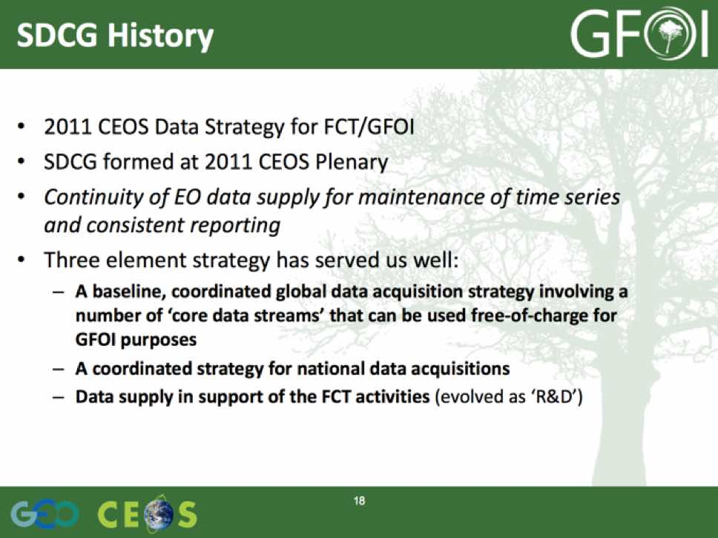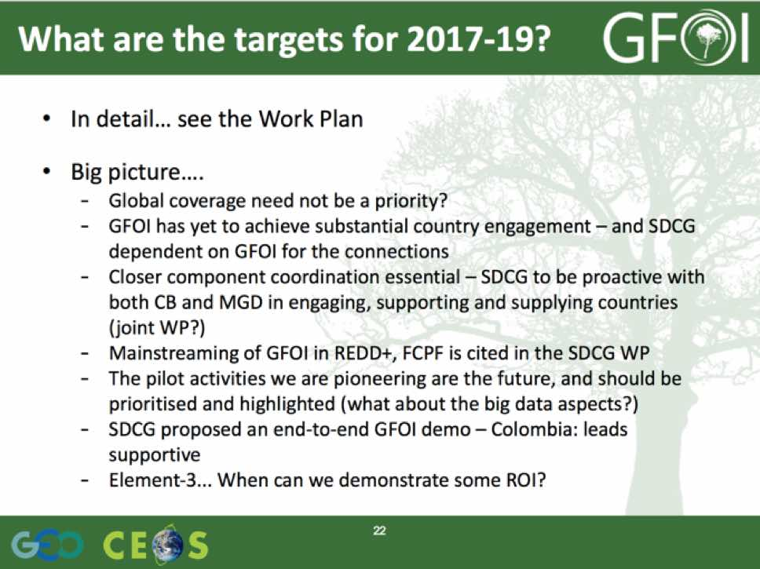
There was a brief discussion.
- Gene noted there is an opportunity for the baseline element to focus on historical archive data (e.g. the SPOT archive).
- In addition, there is an opportunity to reach out on SAOCOM data policy and coordination.
- Gene noted that users who are doing global modelling work are generally using Google Earth Engine, including much of the Landsat Science Team who is using this tool.
- There are discussions underway to include support for GFOI R&D in the EC’s Horizon 2020 Work Plan, and this could lead to a significant step up in funding for R&D.
- Ake clarified that the support for Element 3 is from JAXA, and the support for the GFOI R&D coordination is from ESA.
- There was a discussion about when we might be able to demonstrate some ROI on the space data contributions to the GFOI R&D component, and Ake noted that they would raise this at the GFOI Science Meeting and could potentially consider some special publication next year once the data now being supplied is processed into results.
Stephen reviewed the operations of SDCG, outlining the impact of the anticipated end of Australian support to GFOI, and specifically around the space data component coordination (e.g. SDCG Secretariat support). There is some prospect for some short term support to continue SDCG Secretariat work, but this is expected to be lower capacity, more limited, and only through the end of 2017. The potential meeting dates for next year were also reviewed.
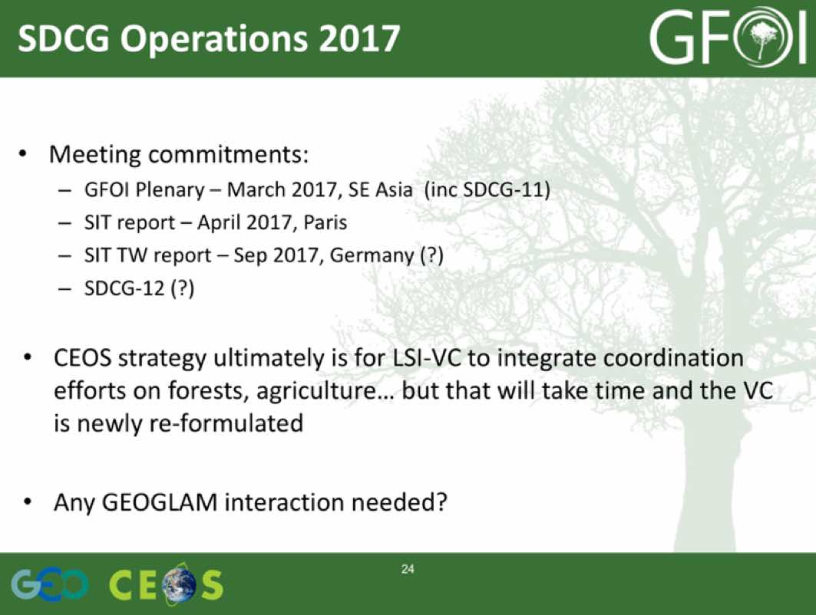
There was a brief discussion.
- Stephen Briggs noted that SDCG has provided a lot of GFOI baseline management support, and he will indicate this in his note to the GFOI Leads. He also noted that the future of SDCG impacts groups such as GEOGLAM.
- SDCG-11 will be attempted to be organised in conjunction with the GFOI Plenary, which is being considered for Asia (Thailand or Vietnam discussed) in March-April 2017.
- The SIT Technical Workshop 2017 will be in Europe, and could be a window for SDCG-12.
SDCG-10-27 | Stephen Ward to communicate the message to the GFOI Leads that the space data component, and the other GFOI components, are awaiting the result of the GFOI Review as a part of considering their future plans | September 2016
SDCG-10-28 | SDCG EXEC to follow-up with Stephen Briggs on his report from this week’s UK policy session and the GEO Programme Board to the GFOI Leads | September 2016
SDCG-10-29 | George to circulate a poll of SDCG-11 weeks to assess availability for feedback to the GFOI Leads | COMPLETE  http://doodle.com/poll/5q4avz9ykwn9b4dd
SDCG-10-30 | SDCG EXEC to follow-up with the GFOI Leads to get clarity around the future of funding of the GFOI Office, and the promotion of MGD uptake | September 2016
The topic of merging the efforts of SDCG with LSI-VC was discussed.
- Gene noted that the merger of SDCG and LSI-VC activities has been discussed within LSI-VC, including whether SDCG could be a subgroup of LSI-VC, or perhaps just the SDCG leads could attend LSI-VC, and the SDCG could continue to exist as a community.
- Stephen Briggs noted that the topic of land surface products will be discussed at next week’s SIT Technical Workshop.
- Frank Martin noted that LSI-VC has focused on optical data so far, and the interest in SAR data would need to be maintained in any future transition.
- Brian suggested that the best approach is to consider just the next couple of years, and wait to see if a longer term solution presents itself.
- The possibility of co-meetings with GEOGLAM was also raised in order to promote cross pollination.
Review of Actions
George briefly reviewed the actions from the meeting (included as an appendix to these minutes).
Closing Remarks
Frank Martin and Gene, the SDCG co-Leads, closed the meeting thanking all participants for their participation and valuable contributions.

SDCG-10 Attendees
Organisation | Participant | Organisation | Participant
Aberystwyth Uni. | Pete Bunting | FAO | Erik Lindquist
ASI | Anna Rita Pisani | GEOSEC | Osamu Ochiai
Carbonmap | Iain Woodhouse | GFOI Office | Peter Moore
CEOS SEO (NASA) | Brian Killough | GOFC-GOLD | Brice Mora
CEOS SEO (NASA) | Paul Kessler | JAXA | Shizu Yabe
CEOS SEO (NASA) | Kayla Fox | JAXA | Ake Rosenqvist
CEOS SEO (NASA) | Sanjay Gowda | NCEO | Zof Scott
CEOS SEO (NASA) | Andrew Cherry | UMD | Matt Hansen (phone)
CSA | Yves Crevier | Uni. of Leicester | Pedro Rodriguez
DECC/UK | Mandar Trivedi | Uni. of Sheffield | Shaun Quegan
DLR | Helmut Staudenrausch | SilvaCarbon | Sylvia Wilson
DLR | Michael Bock | SSTL | Caroline Slim
DOTE/Australia | Stephen Ward | UKSA | John Remedios
DOTE/Australia | George Dyke | UKSA | Beth Greenaway
Ecometrica | Richard Tipper | USGS/GFOI Leads | Doug Muchoney
ESA | Frank Martin Seifert | USGS | Eugene (Gene) Fosnight

SDCG-10 Actions (v1.0)
No. | Action | Due date
SDCG-10-1 | SDCG SEC to follow-up with the GFOI Office on the GFOI fact sheet for GEO Secretariat | COMPLETE  GFOI Fact Sheet ("Opportunities to Help" in the GEO-XIII document) has been released
SDCG-10-2 | SDCG SEC to follow up with GFOI Leads on representation at GEO Plenary | COMPLETE  Doug Muchoney will not attend due to US travel constraints, Stephen Briggs will attend. Stephen Ward following-up on participation
SDCG-10-3 | Frank Martin Seifert to send Shizu Yabe details of some examples of the use of the PALSAR 25m mosaics for biomass monitoring | September 2016
SDCG-10-4 | SDCG EXEC to confer on a communication to JAXA requesting that they maintain the long term continuity of systematic L-band SAR acquisitions | COMPLETE  Letter sent to JAXA 19 Oct 2016
SDCG-10-5 | Ake Rosenqvist to draft a response to INPE’s offer to acquire over Africa for revision, comment and finalisation by SDCG EXEC | September 2016
SDCG-10-6 | SDCG members to provide feedback on the Conclusions and Recommendations of the Global Data Flows study | 16th September 2016
SDCG-10-7 | SDCG Element 3 (lead by Ake) to work with the GFOI R&D component to coordinate on a potential NovaSAR request for areas of interest for GFOI R&D, and coordinate this with UK community and contacts (John Remedios, Caroline Slim, Beth Greenway) | SDCG-11
SDCG-10-8 | Ake Rosenqvist to send invitations for the GFOI/GOFC-GOLD Science meeting in The Hague, Netherlands (31st October 31 – 4th November 2016) to Caroline Slim and Erik Lindquist | COMPLETE  Ake has extended invitations to both Erik Lindquist and Caroline Slim
SDCG-10-9 | Brian Killough to send Erik Lindquist and Gene Fosnight the link to the SPOT-5 pre-processed data that Steven Hosford has provided | COMPLETE  https://theia.cnes.fr/rocket/#/search?collection=SpotWorldHeritage
SDCG-10-10 | SDCG EXEC to follow-up with Steven Hosford on the status of the SPOT-4 and SPOT-5 archive pre-processing activity | COMPLETE  ~100,000 scenes from the SPOT archive downloadable from the link below, including some images over Africa. Another ~100,000 are currently prcessed. An update on processing the rest of the archive should be available at SDCG-11. https://theia-landsat.cnes.fr/rocket/#/search?collection=SpotWorldHeritage
SDCG-10-11 | Yves Crevier to write a one page summary on the call for interest in the 2010-2016 tiled RADARSAT-2 archive | October 2016
SDCG-10-12 | Ake Rosenqvist to coordinate an email and telecon consultation within the R&D data providers on the content and approaches to enhanced accountability | October 2016
SDCG-10-13 | Ake Rosenqvist to work with the Element 3 agencies to finalise the Element 3 strategy document revision and have it uploaded to gfoi.org | October 2016
SDCG-10-14 | Gene Fosnight to provide Brian Killough with information on the API call to the USGS Sentinel-2 data archive | September 2016  In progress, appears Kristi Klein is the point of contact. The API interface used for Landsat is also used for Sentinel-2 data at EROS.
SDCG-10-15 | Brian Killough to assess ability to add ALOS-2 to the COVE metadata browser | October 2016
SDCG-10-16 | Brian Killough to follow-up with Erik Lindquist on access to a demonstration account for the SEPAL system | Follow-up in October 2016 once the updated SEPAL system is released
SDCG-10-17 | Erik Lindquist to circulate the announcement of the release of SEPAL once completed | Follow-up October 2016  SEPAL release expected in the next few weeks
SDCG-10-18 | SDCG EXEC to work with Sylvia Wilson and the GFOI Office to set up a meeting with Jenny Hewson on the upcoming REDDCompass training workshop in Colombia to discuss how to leverage the workshop to promote the GFOI end-to-end country demonstration | 22 September 2016
SDCG-10-19 | SDCG EXEC to confer on a communication to CONAE requesting a status update on the anticipated data policy for SAOCOM | COMPLETE  Letter sent to CONAE 19 Oct 2016.
SDCG-10-20 | Frank Martin Seifert to check whether SAOCOM will be included in the ESA TPM programme | September 2016  In progress - SAOCOM is listed as a potential ESA TPM mission – Frank Martin will check with Bianca Hoersch to see if there have been any updates
SDCG-10-21 | Pedro Rodriguez to report on his late-September visit to the Kenyan Forestry Ministry regarding the potential to leverage work Brian’s Data Cube has done for Kenya | COMPLETE  Pedro has sent Brian his report from Kenya
SDCG-10-22 | Ake Rosenqvist to follow-up with JAXA on the potential release for the JERS-1 1996 global mosaic, starting first Colombia (include in communication related to action SDCG-10-4) | COMPLETE  Letter sent to JAXA 19 Oct 2016
SDCG-10-23 | SDCG EXEC to follow-up on having first version of the radar guide that Brian Killough and Ake Rosenqvist have been preparing uploaded to the GFOI space data portal once complete | October 2016
SDCG-10-24 | SDCG EXEC to communicate with the GFOI Leads on the GFOI end-to-end demonstration to ensure there is a plan to take it forward. Include the suggestions of a top-down approach via the Colombian GEO ExCom member, and that the Leads consider other countries for future end-to-end demonstrations | September 2016  SW has asked Masonobu Shimada to add this to the GFOI Leads meeting
SDCG-10-25 | SDCG Work Plan thread leads (Frank Martin, Gene, Brian, Ake, Stephen, George) to provide revised outcomes for the 2017-2019 Work Plan | September 2016  Inputs being gathered.
SDCG-10-26 | SDCG SEC to finalise updated 2017-2019 SDCG Work Plan | Penultimate draft for CEOS Plenary  Finalise by end November 2016
SDCG-10-27 | Stephen Ward to communicate the message to the GFOI Leads that the space data component, and the other GFOI components, are awaiting the result of the GFOI Review as a part of considering their future plans | September 2016  SW has communicated this to the Leads
SDCG-10-28 | SDCG EXEC to follow-up with Stephen Briggs on his report from this week’s UK policy session and the GEO Programme Board to the GFOI Leads | September 2016  COMPLETE – Tom recently circulated a report from Peter Moore
SDCG-10-29 | George to circulate a poll of SDCG-11 weeks to assess availability for feedback to the GFOI Leads | COMPLETE  http://doodle.com/poll/5q4avz9ykwn9b4dd
SDCG-10-30 | SDCG EXEC to follow-up with the GFOI Leads to get clarity around the future of funding of the GFOI Office, and the promotion of MGD uptake | September 2016

