MINUTES OF THE
11th SPACE DATA COORDINATION GROUP for GFOI MEETING (SDCG-11)
9th-10th April 2017
Ho Chi Minh City, Vietnam

Welcome and Introductions
Frank Martin Seifert (ESA) welcomed the participants to the meeting and reviewed the agenda. He noted that it is good to be holding an SDCG meeting in a user country like Vietnam. He noted that ESA has recently confirmed it will be able to fund the GFOI R&D Coordination Component for a further three years via the GOFC-GOLD office.
Participants introduced themselves around the table.
GFOI Status Overview
Stephen Ward (SDCG SEC) presented an update on the status of GFOI, reviewing the upcoming developments and the latest Phase 2 arrangements. He reviewed the recent changes to GFOI coordination and management. He also reviewed the status of space data coordination issues, and how the expectations have changed as data flows have increased and the focus moves to exploitation.
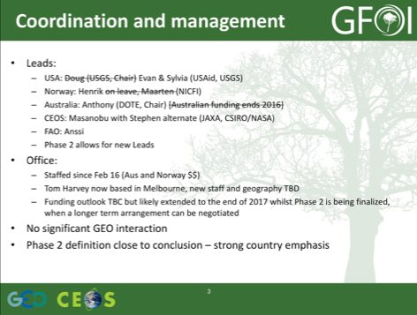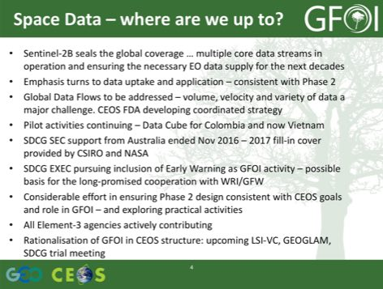
Stephen reviewed the main points from the other components.
- MGD: REDDcompass launched in April 2016 and has established a strong user base, with MGD Edition 2.0 released October 2016. The MGD Advisory Group being revitalised under new Chair Maria Sanz Sanchez, with linkages to the IPCC encouraging.
- Capacity Building: UN-REDD is now the REDD+ team within FAO (diversified funding), focusing on Norway’s 14 priority countries and less so the 64 UN-REDD countries, also more and more involved in The World Bank FCPF implementation.
- SilvaCarbon continuing to implement its full work plan through September 30 2018, though there is significant USAid funding uncertainty (broadly). They are partnering with other US government capacity building programs to leverage capacity and funds, for example SERVIR.
- R&D: Ake noted that there was a successful R&D summit held in November 2016 in The Hague (see report: http://www.gofcgold.wur.nl/sites/gofcgold-gfoi_sciencemeeting2016.php). He reported that a new R&D Coordination work plan for 2017-2019 prepared, with discussion with EC ongoing to address GFOI R&D (coordination and specific actions) in a future call of the Horizon 2020 Initiative.
Stephen concluded noting:
- Funding pressures will impact component capacity across the board;
- There appears to be strong central support for the GFOI Office and coordination;
- GFOI Phase 2 presents opportunities and challenges – CEOS needs to be part of effective partnerships for country engagement, with capacity building; and,
- GFOI Plenary is a new model and hopefully successful.
A brief discussion followed.
- Sanjay Gowda (NASA/AMA) asked if there are any metrics around the MGD user base, or whether something like that should be established. Nikki noted that based on web analytics there are 6000 who have used the MGD, and 3000 that appear to be regular users. The establishment of a more structured communications strategy (e.g. the way GOFC-GOLD registers Sourcebook users and provides them with updates via email) is planned.
- Helmut Staudenrausch (DLR) asked about how the Data Component will manage user engagement and Stephen suggested this may be done via the User Advisory Group.
- Yves Crevier (CSA) asked about the integration between LSI-VC, SDCG, and GEOGLAM and whether there would be time to discuss this, and Stephen confirmed this and GFOI Phase 2 features strongly on the agenda.
2017-2019 Work Plan Outcomes Status Summary
George Dyke (SDCG SEC) reported that a summary of the status of the 2017-2019 Work Plan outcomes since SDCG-10 is available on the SDCG-11 website.
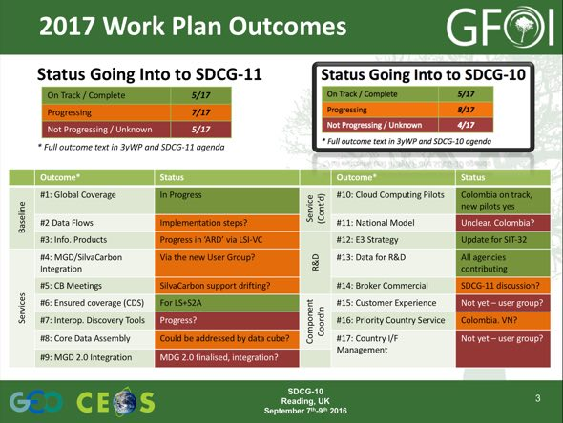

Baseline Global Observation Scenario
Frank Martin introduced the session, noting that the baseline global observation coordination is one of the core GFOI activities.
Sentinel-1 and Sentinel-2
Frank Martin reviewed the status of the Sentinel space segment, noting the recent successful launch of Sentinel-2B, effectively doubling the medium resolution optical capacity. This adds to the existing C-band SAR from Sentinel-1A and -1B, as well as optical from Sentinel-1B and Sentinel-3A (coarse). Frank Martin stressed that all this data is available on free and open terms, and this represents a significant achievement for the community.
Frank Martin reviewed the changes to the Sentinel-1 acquisition strategy to optimise the inclusion of Sentinel-1B. He noted that the are moving towards capturing global land areas with dual polarisation every 12 days. He noted that this includes good coverage of Vietnam, which is covered every 12 days dual-pol for the whole country, and every 6 days dual-pol for the Mekong Delta. He reviewed some work done by CESBIO (France) in Vietnam on near real time forestry monitoring and rice crop monitoring using Sentinel-1.
Commissioning of Sentinel-2B is currently underway, with operations being smooth, and the acquisition duty cycle ramping up. Sentinel-2 has stimulated many new applications, and has also showed that the community is increasingly interested in analysis ready surface reflectance products. He noted that Landsat currently produces surface reflectance products on an order basis, but is moving towards systematic production. It is expected that Sentinel-2 will move in this direction as well.
The CNES-DLR MAJA software is available freely for non-commercial use. Stephen asked about the longer-term plan towards Sentinel-2 surface reflectance products. Steven Hosford noted that ESA appears to be considering several algorithms to integrate into their ground segment, and that processed surface reflectance data is expected to be available. The Sentinel-2 mission manager (Bianca Hoersch) is pushing for EC support for the generation of surface reflectance products, but some work remains to secure funding and conclude algorithm choice.
Frank Martin reviewed plans for a Copernicus Global Land Service, noting that there is a Hot Spot project which could be an entry point in relation to UN-REDD services. There are efforts to push REDD services further, but the outcomes to date have been limited. Helmut noted that there was a tender from EC-JRC in relation to global Sentinel-2 mosaics. Stephen noted that there is some risk of divergence between the surface reflectance products from Sentinel-2, with parallel initiatives in different countries (e.g. UK), and efforts are being made to try and ensure good coordination.
Landsat Status
Stephen reviewed the slides that Eugene Fosnight prepared, noting that Landsat-7 and -8 are in good health with Landsat-7 now projected to last until 2021. Potential coordination between Landsat-7 and a future Landsat-9 orbits is being considered.
Both Landsat-7 and -8 acquisitions are strong, with Landsat-8 approaching ‘always on over land’ acquisitions. Monthly downloads for Landsat products continue to grow strongly.
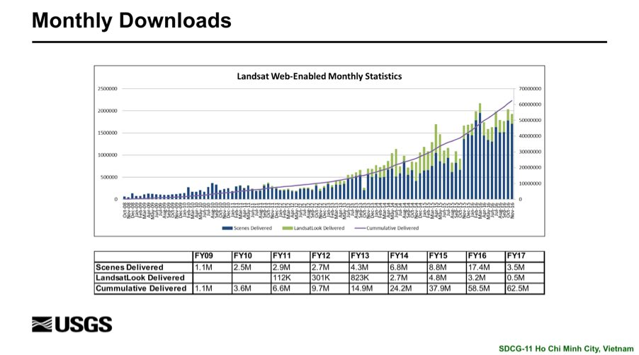
The Landsat Global Archive Consolidation activity continues to progress, though there is still a significant data outstanding. 4.07 million scenes have been ingested, representing approximately 62% complete, and approximately 71% of scenes are new to the archive. This is a very important activity to ensure the future utility of the global archive. Funding for Landsat-9 appears to be on track at this stage.
ALOS-2 PALSAR-2 – Core Data Set
Masanobu Shimada (JAXA) presented an activity focused on providing a core data set, free and open for GFOI, based on JERS and ALOS data. He noted that ALOS-3 has been approved for launch in 2020, with improved performance over ALOS-2 (4x imaging area), and includes a focus on forest monitoring in its mission objectives.
The core data set produced for GFOI by JAXA is at 25m, slope corrected and orthorectified, and covers the periods of JERS (1992-1998), and ALOS-1 and -2 (2007-2010, and 2014-2016). The 2016 dataset is targeted for release by the end of this month. Similar ALOS-3 datasets are also planned, and all datasets are available for free public download after a simple registration.
Several discussion points were raised.
- Frank Martin thanked JAXA for making these datasets available, and noted that having continuity of these products through ALOS-3 will be valuable.
- Ake Rosenqvist (JAXA) noted that JAXA is working to ensure seasonal consistent of acquisitions, without which there can be some striping in the products.
- Yves asked about the pixel values of the mosaics represent, and Masanobu noted the pixels were gamma_0, as well as metadata covering acquisition parameters. Phase information is not included.
- Masanobu noted that the process of generating ARD products from ALOS data is currently under discussion, with users indicating a desire for these products. Yves noted that they are undertaking a similar process within the Canadian community, but there is debate around the product definition. Ake noted that the desired product will depend on the application and end user sophistication.
CBERS-4 – Core Data Stream Status
Ake presented materials provided by Júlio Dalge on behalf of INPE on CBERS-4, noting that CBERS-4 was launched in 2014 and it is a joint initiative between Brazil and China. He reviewed the performance of CBERS-4, noting that spatial resolution ranged from ~20m to ~60m depending on the instrument. The mission doesn’t currently have a global acquisition strategy, but the mission could serve as a useful source of data over selected areas, including over South America where there are significant acquisitions and data supply. There are also significant acquisitions over western Africa.
CRESDA is currently working to expand acquisitions over the Congo Basin, through acquisitions over eastern central Africa, but this will require design of new operational procedures and data recorder utilisation.
Global Data Flows
Stephen reviewed the conclusions and highlights of the Global Data Flows study, stressing that there were some important lessons to draw from in this study and some of these are being taken up by the CEOS Future Data Architectures (FDA) activity. He reviewed the main conclusions:
- Increase in satellite data volumes resulting from new capacity is outstripping the capacity of the national data handling infrastructure of GFOI many countries.
- BAU approach is considered unsustainable, and in general a move towards centralised data handling is viewed as a potential solution to make satellite-data support sustainable.
- Increased volumes and number of data sources require more effective data discovery and access tools.
- Cost/burden of pre-processing data needs to be minimised to foster uptake. Agency-backed ARD products and tools are steps in that direction.
- Mechanisms will vary, but the quality of ARD products needs to be assured by agencies.
Stephen reviewed the recommendations of the report, which were grouped by Space Data Providers, Capacity Building Partners, and Users and Countries. He noted that there is ongoing discussion around the role of ‘internet giants’ in the staging and provision of governmental satellite data, and that this role is one that will probably expand. Stephen suggested a couple of ‘headline’ topics for discussion.
- SDCG continue to push the CEOS future data architectures and analysis ready data strategies.
- Is there an opportunity to pioneer new cooperation with big industry?
- Success on user aspects depends on successful design & execution of Phase 2 and capacity forthcoming from our partners in GFOI.
- How do we promote MGD utilisation within our national agencies?
A brief discussion followed.
- Jim Baker (GFOI Leads) asked if there will be a series of recommendations for private sector space data providers, and Stephen noted this is not currently in the plans.
- Helmut noted that there are Data Cube and analysis ready data-like efforts on going in several agencies, and is worried that we are too focused on certain solutions and how we reflect the diversity of efforts on going. Stephen suggested submitting information on these activities via the CEOS FDA ad hoc team.
- Steven Hosford (CNES) noted that the Global Flows Study may be written differently if it were done today, and this reflects the rapidly changing environment around the area of data uptake and exploitation.
- Yves asked what concrete outcomes might follow the FDA and ARD strategy, and in the extreme best case, sensor agnostic applications and ‘every pixel counts’ would be ideal.
- Yves stressed that the thematic component of CEOS land surface coordination needs to remain intact or else there is a risk if the group becomes too technically focused.
- George noted that the future contribution of machine learning and commercial providers (e.g. Descartes Labs) shaping development could be very important in the future.
SDCG-11-1 | Stephen to provide Helmut with the compilation of CEOS FDA ad hoc team inputs with a view to having DLR contribute if they feel their contributions are not well reflected. | COMPLETE
Baseline Session Close
Frank Martin closed the session, noted that the supply of global baseline data is currently strong, and the prospects are good.

GFOI Updates: MDG and GFOI Phase 2
MGD Update
Carley Green (MGD Component manager) presented a summary of the developments within the MGD, starting with a summary of the MGD objectives.
- To coordinate the development, and make available materials in support of REDD+ MRV.
- Maintain these materials as the foundation for consistent communication within GFOI.
- Publication of materials via REDDcompass.
- Engage partners in ensuring consistency with the MGD.
REDDcompass launched in April 2016, and the MGD Edition 2.0 was released in October 2016, and was made available in French and Spanish just this week. The MGD Advisory Group is now lead by Maria Sans Sanchez, who brings significant experience to the role (e.g. with the IPCC).
The country uptake has been strong, including via the integration of content by the likes of SilvaCarbon into the delivery of their programs and workshops. SilvaCarbon has a dedicated person (Jennifer Hewson) for the promotion and delivery of MGD content at their workshops. Carly also noted that a Masters level course delivered at the University of Melbourne in late 2016 to several Pacific island countries.
At present the MGD Advisory Group only includes four members, with objective of building that to 11 members (three four countries, five for experts, and the Chair). Carly reviewed the structure and themes of the MGD.
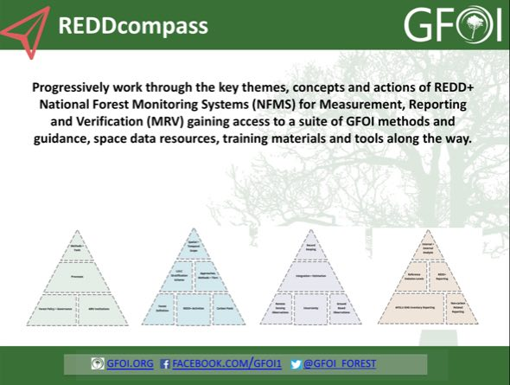
Since the launch in April 2016, there have been 3000 unique users from 101 different countries, and more than 3000 program details have been added to the system by registered users (though you do not have to register to access the materials).
The updated MGD incorporates experiences from country engagement and new developments (UNFCCC, methodological) including more visual material (flowcharts, decision trees), a consistent structure between MGD and REDDcompass (as they are one and the same), updates on institutional arrangements, strengthened guidance on integrated methods, more complete material on statistical inference (emission factors as well as area data) and uncertainties, including module material developed over the course of the year (global datasets, reference levels, statistical inference), updates from UNFCCC (Paris, reference level submissions), and updates to core data availability.
Carly reviewed the next steps for the MGD component.
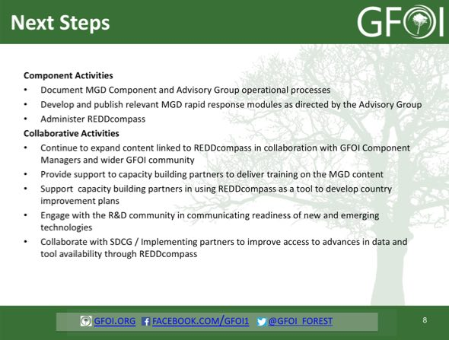
A brief discussion followed.
- Ake asked if there are opportunities to provide feedback, and Carly confirmed there are mechanisms in place on the website, but little written has been received to date. However, she noted they receive good input from face to face workshops.
- Helmut asked if a helpdesk is planned, and Carly confirmed this is planned for but current experience suggests it is not needed.
- Frank Martin asked about uptake of the MGD within The World Bank and their country interactions with the FCPF. Carly noted that she recently participated in a workshop on FCPF emissions review, and several opportunities to link the World Bank’s methodological framework were identified (e.g. indicator list), and the value of working through REDDcompass in identifying successes and challenges in that process.
- Jim asked about connecting MGD with the idea of the Early Warning systems being discussed, and Carly confirmed this topic is on the list of items to be discussed. She noted that GFOI Phase 2 does recognise the importance of other forest observation activities.
Support to Early Warning
Stephen presented a summary on some of the threads going on around early warning, and while the list isn’t comprehensive, SDCG has been engaged in a few related background threads which could be tied together.
- GFOI Leads long discussed possible cooperation with WRI/GFW.
- JJ-FAST system of JICA/JAXA trialled in South America and Africa, based on PALSAR-2.
- Brazil has an operational Early Warning system (DETER) run by INPE. Currently based on MODIS 250m data. (See http://www.obt.inpe.br/deter/.)
- CESBIO demonstrated an Early Warning approach based on Sentinel-1 data in Vietnam (12 days repeat).
- A Vietnam Data Cube was recently installed at VNSC, who are keen to encourage local agencies (like FIPI) to identify GFOI applications; Framework for GFOI EW pilot.
- JAXA willing to supply Vietnam-wide ScanSAR data approximately every 6 weeks from later in 2017.
A brief discussion followed.
- Ake noted that it is very important to have Early Warning included in GFOI, and noted that INPE’s operational DETER system should be included in the list. He also suggested that GFOI should be proactive in this area, noting that INPE hosted a GFOI/SilvaCarbon capacity building workshops in the past (January 2015) that may provide a useful model.
- Masanobu stressed that Early Warning systems are a good way to make use of several space data streams, and that if there is a clear requirement from the MGD they would be happy to produce a supporting ScanSAR product.
- Helmut asked if there was a suggestion to have a high-resolution component to support in response to alerts raised, and this is an area where DLR may be interested in contributing.
- Frank Martin noted that at the SDCG meeting in Pasadena countries expressed a clear need for Early Warning systems. GFOI was not focused on Early Warning at the time, but this may be the right time to pick up this topic again.
- Ake noted that Early Warning systems are not focused on reporting, and therefore accuracy requirements are more relaxed. INPE stressed that these systems should be focused on reducing false alarms (commission errors), while a certain amount of missed alarms (omission errors) can be accepted.
- Pedro Rodriguez Veiga (UK/Leicester) noted that they have been working on a prototype system with Kenya, and he will present something on this tomorrow.
- Yves noted that there are two critical components to an Early Warning system - the data assimilation system, and the data supply - and asked whether space agencies are structured to support such a system and is there any infrastructure currently in place.
Stephen noted that CEOS could champion this within GFOI, but there is a dependency on the other GFOI components. Carly confirmed that from the MGD side she sees value in presenting material on this topic, and the way in which the MGD would incorporate these kinds of inputs would be via the MGD Advisory Group. Establishing this process is part of their discussion at the MGD component meetings at this GFOI Plenary.
SDCG-11-2 | SDCG EXEC to follow-up with Carly Green on the correct approach to engage the MGD Advisory Group on the potential inclusion of Early Warning systems, following the discussions around the MGD Advisor Group process. | May 2017
SDCG-11-3 | SDCG EXEC to consider drafting a proposal for a ‘GFOI ALERT’ system addressing the potential for Early Warning systems, and potentially engaging existing activities such as JJ-FAST and GFW’s related activities | June 2017
GFOI Status and Phase 2 Overview
Anthony Bennie (GFOI Leads) presented an overview of GFOI Phase 2 process and discussions, noting that the draft Phase 1 review and Phase 2 documentation has been distributed widely. One of the conclusions of the review is that GFOI has been effective, and the Space Data component has successfully promoted the role of space data within GFOI. There is an increasing demand for the kind of support GFOI is providing, and we appear to be well positioned to support this demand in Phase 2.
The strengthening of coordination with countries, and the linkage of providing countries with usable data in support of their national MRV activities will be priorities in Phase 2.
A brief discussion followed.
- Frank Martin noted that GFOI is about not giving data only, but building capacity within a given country to make their own monitoring decisions on an informed basis. Anthony noted that countries are faced with difficult and potentially confusing decisions around data supply and tools, which also vary depending on the programs they want to participate in.
- Helmut noted he hears from the German donor perspective a requirement for GFOI Phase 2 to provide more means for consistency in data flows, and methodology and technical options. GFOI should work to promote a ‘validated set’ options during Phase 2.
- Anthony noted that there is strong potential for further engagement with Germany and the UK underpinning GFOI Phase 2, as well as increased linkages with the likes of the World Bank FCPF.
- Anthony noted that one of the challenges for GFOI Phase 2 will be converting the increased data supply into information for national MRV systems.
- Stephen noted that there is some risk of duplication of effort between the proposed User Group and the Capacity Building component, and that the User Group should be consistent with the existing GFOI framework. There are also challenges around staffing and support for Group. Anthony stressed that the focus is on trying to build the link between GFOI and users.
- Tom Harvey (GFOI Office) noted that to date, coordination across the GFOI Components has not been structured, and part of this effort is try and take a more structured approach.

Support to GFOI R&D
Ake introduced the R&D session, reviewing the session agenda and the status of the 2017-2019 Work Plan R&D outcomes.
#12 Development/Update of Element-3 Strategy: The Element-3 strategy is being updated, and will be submitted to SIT-32 for information.
#13: Providing Satellite Data to Progress R&D Topics and #14 Element-3 Strategy Ensures Engagement and Accountability Towards Advancement of Priority R&D Topics: All agencies have selected the GFOI projects they will support, and started to provide data. Support from the private sector has been secured for SPOT-6/-7, and SSTL (NovaSAR). Support from Planet (Rapid Eye + Doves) remains to be confirmed, but they have engaged with SDCG in the past.
Ake reviewed the revisions to the Element-3 strategy document.
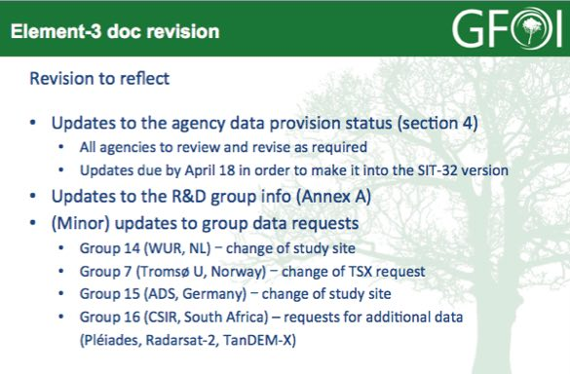
Ake referred to the GFOI R&D 2017 Technical Progress report, and noted that an R&D Component Coordination session later in the meeting to discuss the work of the groups. Helmut noted the need for DLR to get more feedback on progress and utilisation of their data in the GFOI R&D programme to be able to justify the continued supply of data, and Yves noted CSA has the same need.
ASI
Ake reviewed the status of the ASI response to R&D groups requesting COSMO-SkyMed data on behalf of Anna Rita Pisani. He noted that four R&D groups have registered for CSK data, and two of the groups are yet to contact ASI.
JAXA
Ake presented a summary of ALOS PALSAR / ALOS-2 PALSAR-2 data supply to GFOI R&D on behalf of Shizu Yabe from JAXA. A total of 12 groups have requested ALOS-2 PALSAR-2 data, and three groups have requested ALOS PALSAR data. JAXA has agreed to provide 400 ALOS-2 and 230 ALOS scenes. Once requested, processed scenes are generally available within a day or sooner. There will be a general research announcement for ALOS-2 in 2017/2018, and coordination with GFOI objectives is possible. Generally, 50 scenes a year are available under these announcements.
CNES
Steven reviewed the status of the CNES response to R&D groups requesting CNES data, including Pléiades. Steven noted that some requests have been deemed commercial and so haven’t been able to be granted, though this situation may change based on the evolving relationship with Airbus. Seven groups have requested almost 13,000 km², with images having been delivered to five groups. The data allocated is pooled, and so any of the data provided can be requested and processed by any of the teams. The teams started receiving data at the end of 2016 with utilisation currently ramping up. Steven noted that several of the teams who were allocated data haven’t responded to the request, which is surprising.
Stephen reported that a decision on the Spot World Heritage Programme (couple of week’s), and it is expected that the whole archive will be corrected to at least Level-1A (i.e. no geometric or atmospheric correction). The total archive is estimated to be approximately 50 million scenes, and is expected to be made available mid 2018 or early 2019.
There is no current update on SPOT-6/-7 acquisitions and data flow, though for the past year it has appeared there is interest in contributing data. A more targeted request may help to expedite the process.
A brief discussion followed.
- Ake asked about how the SPOT World Heritage Programme data would be made available, and Steven noted that no firm decisions around exploitation platforms and access have been made yet. The team is available of the discussion within CEOS around FDA and ARD, and will try and take these into account.
- Ake noted that he has assembled a report of the current R&D group status which can be downloaded.
SDCG-11-4 | Ake to circulate the link to the GFOI R&D group status report | COMPLETE  http://www.gfoi.org/gfoi-rd-progressreport_31mar2017/
SDCG-11-5 | Ake to work with Steven Hosford on ensuring that the potential requests for SPOT-6/-7 data are formulated and ready when the data becomes available. | May 2017
CSA
Yves presented a summary of RADARSAT-2 data support to GFOI R&D, noting that with the current supply of SAR data increasing, we are likely in the ‘golden age of SAR’. These datasets are complementary and interoperable with optical datasets. He noted that since SDCG-1 at CSA in 2012, they have been systematically acquiring C-band data over the entire circumtropical region, and this data can be used in conjunction with Sentinel-1. He noted that there is a need for good science and good feedback loops with the science teams to realise the full potential.
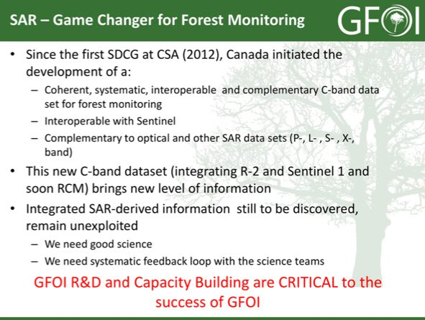
DLR
Helmut presented a summary of the TerraSAR/TanDEM-X missions, noting that Michael Bock is the DLR point of contact for SDCG Element 3 (R&D). The current expected lifetime of the satellites is 2020-2022, which should allow overlap with the follow-on mission (current name HRWS, High Resolution, Wide Swath).
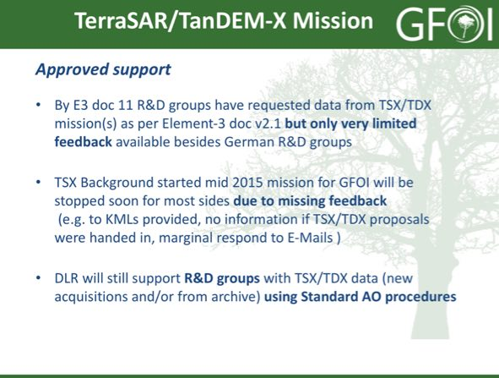
Helmut noted the limited feedback received from the GFOI R&D groups, and that the TSX background mission started in mid-2015 may be stopped due to a lack of feedback. He noted that there is a general agreement that the AO costs for GFOI R&D groups can be waived if DLR is contacted before the AO-proposal submission. He noted that two regional African capacity building workshops held in CEOS WGCapD cooperation and another planned for South Africa around ISRSE.
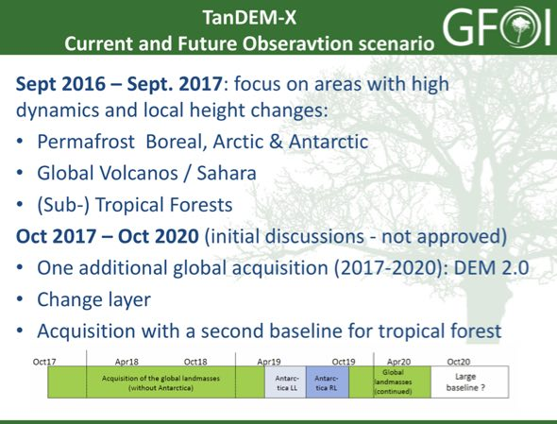
Helmut suggested that the GFOI R&D component have a large-scale demonstrator project to show added value on top of distributed research.
A brief discussion followed.
- Ake noted that because GFOI is not funding the R&D teams, it is difficult to direct them. However, the large-scale demonstrator project may be suitable to the Data Cube activity. The objective of such a demonstration would have to be clarified.
- Ake noted that he can try and help push the R&D groups to provide DLR with the required feedback.
SDCG-11-6 | Ake to follow-up with Michael Bock and Helmut on the required reporting on the R&D groups using the TSX background mission data in order to help ensure the coverage and data provision can continue | May 2017
Discussion - Involvement of Commercial Data Providers
Several discussion points were raised on the involvement of commercial data providers and overall GFOI R&D support.
- Jim asked if there was a forum where commercial data providers could gather requirements, and Ake noted that commercial providers have been engaged at past SDCG meetings. However this engagement hasn’t been sustained. Yves suggested ensuring that the commercial providers are engaged and invited to the next GFOI Science Forum.
- Ake noted it is important there is a forum where the R&D teams can present their work, and there was some resistance to including these kinds of presentations at the last meeting in The Hague in late 2016.
- Frank Martin noted that the meeting in The Hague was also focused on the political level and science issues identified within GOFC-GOLD and GFOI.
- Yves noted that there is a need to have interaction between the space agencies to assess performance on key scientific issues, and this is challenging with the diffuse set of GFOI R&D projects. It is difficult to address clear science questions in this framework, and there needs to be a dialogue between the space agencies and science teams. Ake noted this may require an additional meeting to enable this interaction.
- Masanobu noted that one of the purposes of R&D is to learn by trial and error, and asked how the outcomes and algorithms would be captured and progressed towards operations.
- Helmut again suggested that a large-scale demonstrator project could help pull some of these themes together.
- Ake suggested that the CARL framework that is a part of GFOI Phase 2 could be a useful mechanism, and Tom agreed that achieving line of sight to operational readiness is a key goal of GFOI Phase 2.
SDCG-11-7 | SDCG agencies asked to review the sections of v3.0 of the Element-3 document related to their missions | No later than 18 April 2017

Data Coordination Topics
Discussion: Space Agency Approach to GFOI Phase 2
Stephen introduced discussion on the space agency approach to GFOI Phase 2.
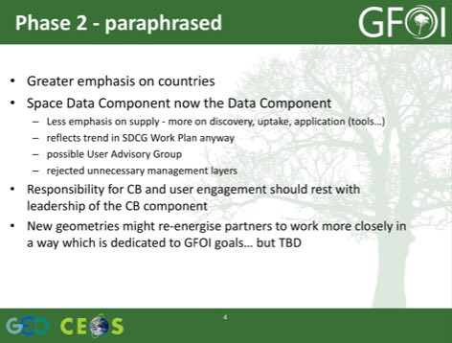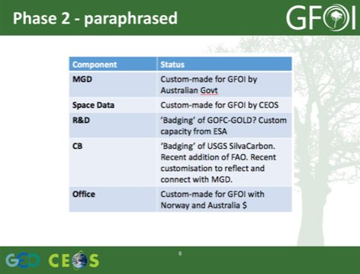
A number of discussion points were raised.
- Tom noted that SilvaCarbon was designed as an input to GFOI, and Stephen suggested he doesn’t see this reflected in the SilvaCarbon Work Plan.
- Carly asked about the specific Work Plan issues, and Stephen flagged the cross-component coordination. He suggested that if Phase 2 is going to live up to its headline, this will have to change. Carly noted that SilvaCarbon is responsive to country needs, rather than the other way around, and this has been effective for the MGD over the past 12-18 months.
- Helmut noted that the connection between the Space Data component and the R&D component is a cross-component coordination issue in that needs to be addressed, but it is not clear how this is addressed in the GFOI Phase 2 concept documents. Stephen agreed, noting that a practical demonstration would achieve the cross-component coordination topic.
- The Early Warning topic may represent an opportunity to exercise this cross-component coordination.
- Yves noted Tom’s comment on ensuring that there is transverse coordination across the GFOI components. The ultimate upside for space agencies is to see datasets and process included in the MGD, and ensuring that the approaches are being adopted MGD users. He noted that it is not clear what will happen to the SDCG group in the framework of the GFOI data component.
- Steven asked about the Data Component, and whether this change is intended to change the emphasis to in situ data streams. Stephen noted that it is not clear who would deal with the topic of broader datasets in the new data component, and it is not clear how this would work in the new framework.
- Tom noted that the initial purpose of SDCG was data availability, and now that there is data available, the challenge moves to how to get the data used. The intention of the change is to focus on data utilisation, expanding into accessibility and use.
- Anthony noted that there is still a specific focus on space data in the proposed data coordination group. There are variety of issues that other sectors (e.g. weather) have faced in the past that the forestry community hasn’t had to address, and so the hope is that some of the approaches being taken by other communities.
- Stephen noted that the focus of SDCG would continue to be space data and the uptake and utilisation of that data, and in situ data would not be in scope.
- Anthony noted that countries are already demonstrating by doing via their work to implement MRV for REDD+, and GFOI activities should be clearly linked to this objective.
- Frank Martin noted that space agencies are focused on acquisition, access, and distribution, and on tools to make data access easier. In relation to in situ data, there is no space agency mandate for this effort. Anthony noted that the intention is not to focus on the collection of in situ data, though the relevant tools will have to address the incorporation of in situ data.
- Frank Martin suggested that the User Advisory Group could be placed more broadly under the GFOI Leads. Anthony noted that a broader Group would become large and unmanageable. He suggested that the intention is to broaden the perspective of the data coordination component, and would include membership from developing countries and other issues.
- Stephen noted that there are significant questions and uncertainty around the User Group. The overall direction of GFOI Phase 2 is good, and reflects the directions that individual space agencies, and CEOS is pursing. Tom noted that the intention is to formalise what is already happening in an ad hoc manner.
- Anthony noted that he welcomes these views and comments. He asked Carly to describe how the MGD Advisory Group has been utilised in the work of the MGD.
- Carly noted that the MGD Advisory Group has evolved from the start of the MGD, and has enabled the MGD component to engage across the GFOI components. This includes the needs of the countries and limitations. The inclusion of the IPCC representation on the Advisory Group has been very important. Moving into Phase 2, the Advisory Group is much more focused on advising countries - helping to ensure that the countries are aware of the MGD materials - and also that the MGD reflects what the countries are actually doing.
- Carly noted that there isn’t a very large management overhead for the group, with one face-to-face meeting at GFOI Plenary annually, and regular telecons. The expansion of the membership to 11 will require this to become a little more structured.
- There is some risk around the proliferation of structure if each component has a User Advisory Group. There is an expectation that there will be cross-component representation on the various Advisory Groups (e.g. MGD Advisory Group, Data Advisory Group).
- Yves noted that the SDCG was created to ensure access and availability of data, and that the role of the space agencies engaged in the SDCG have resources to support each of the components, and this is how we should position ourselves within GFOI.
- Ake asked about the naming of the Data Component, which has the feel of being a little watered down and suggested persisting with the inclusion of ‘space’ in the title. Perhaps the ‘Space and Data Component’.
- Anthony noted that there is some benefit to having a form of Advisory Group, but the exact structure of this Group is less clear, including if and how this capacity could be duplicative. He suggested the terms of reference need to be drafted for discussion, and that with these unknowns it is difficult to discuss the way forward. Aid investment is focused on outcome, and in the case of GFOI on having countries achieve their REDD+ outcomes.
Approach to CEOS Thematic Coordination
Stephen introduced the discussion of the joint meeting with LSI-VC, and SDCG and GEOGLAM. He noted that a discussion paper has been prepared addressing the objectives and topics.
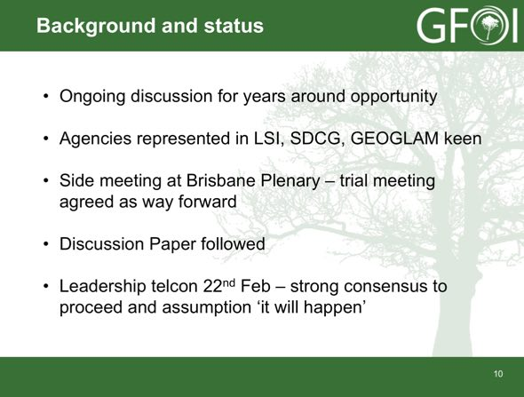
The objectives include a more holistic approach to overall requirements and observing strategy, and to try and capture some efficiencies in travel and representation. A trial meeting has been agreed for September at ESA/ESRIN.
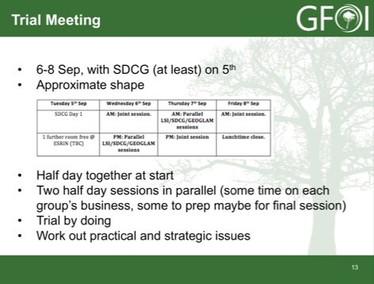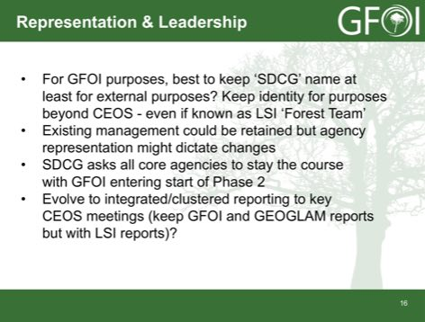
The plan is to have the joint meeting in September, and then assess the plan for 2018. If positive, the meeting cycle for 2018 would be:
- February/March 2018 SDCG meeting; and
- September 2018 integrated meeting (week before SIT TW USA?).
A brief discussion followed.
- Yves suggested that LSI-VC is focused on capacity and cross-cutting issues such as ARD, where the SDCG group is much more thematically focused on GFOI and forests. There is a need to continue these thematic forums not focused on mission management and infrastructure.
- Stephen agreed, and stressed that the draft agenda for September may help address some of these concerns. But it remains to be seen if this is true in practice. Yves agrees with the rationalisation objective, and the need to do more with less.
- Stephen noted that he looked at the reality of who’s coming to try and assess the travel efficiency, and it appears that approximately 1/3rd of the people may be common. Though the logistics, hosting, and agenda overlap/conflicts will become more complicated as the number of actors in the joint meetings increases.
- Frank Martin noted in the past LSI-VC has been focused on optical sensors, though recently at LSI-VC-3 he noted a radar component has been added. In the past LSI-VC had tended towards an academic and technical exercise, with no community being directly served by these activities.
- Ake noted that in general this proposal is a good thing, so long as the groups maintain their own identity going forward. It is important to ensure the individual Work Plan of SDCG should be maintained and assured.

Space Data Services
Status Overview of 3-Year Work Plan Tasks and Outcomes
Brian Killough presented a summary of the data services activities, and reviewed the status of the Work Plan outcomes.
#6: Ensured On-going Coverage
- The SEO has now automated the production of Landsat country reports and they are posted online for all 70 GFOI countries. We plan to update these reports on an annual basis and keep the reports current.
- Hard copy reports are available for Vietnam, Gabon, Guatemala, Mozambique, Nepal and Taiwan.
- We have now added Sentinel-1 to the report, and will work to include Sentinel-2 by the end of 2017.
- These reports will be valuable for countries to assess available scenes and cloud cover for future data ordering.
- The SEO has provided additional detailed support to countries, as needed.
#7: Interoperable Data Discovery Tools
- The COVE Tool now includes links to archive databases from: Landsat 7/8, SPOT 1-6, Pleaides-1A/1B, Radarsat-2, TSX, ALOS-1, Sentinel-1A/1B and Sentinel-2A (new). Following the WGISS meeting (last week), we have plans to add CBERS-3 and ResourceSat-2.
- The SEO vision is that the COVE tool can provide a “one-stop” location to perform coverage assessments and “discovery” of valid images. It also gives the user direct links to data ordering, when possible.
- The SEO plans to update the COVE Coverage Analysis tool in late 2017 to make it more robust and “user friendly” for queries and reports.
#8: Assembly and Delivery of Core Data
- Countries can use scene-based tools (e.g. SEPAL) or the new Data Cube tools as methods for data analysis. These tools can be deployed locally, or on data hubs or computing clouds.
- The move toward sustained Analysis Ready Data (ARD) significantly improves the efficiency and effectiveness of core satellite data. This is being worked within CEOS.
- The new “GFOI Space Data Portal” will improve the capability of countries to identify and obtain needed satellite datasets.
#10: Cloud-Computing Pilot Projects
- The SEO is pursuing collaborations with SERVIR and AWS to test the use of regional data hubs and cloud computing for Data Cubes.
- The SEO is testing a Data Cube implementation in Colombia.
- The SEO and FAO identified some collaborative tasks in 2016 that will continue into 2017.
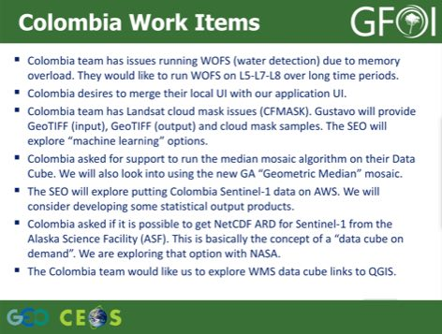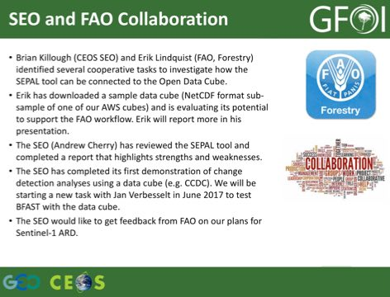
#11: Model National GFOI Data Services
- To date, we have not identified a “Model National GFOI Data Services” system.
- FAO is continuing to work on its SEPAL tool and the CEOS SEO is working on its Open Data Cube tools.
- As these two initiatives progress, the GFOI group should discuss the notion of a “model” system and what serves the community most effectively and efficiently.
A brief discussion followed.
- Steven raised the issue around Sentinel-1 ARD products, and how these products are defined. There are several proposals for SAR ARD, but no singular solution has been presented. It is likely that there will be multiple SAR ARDs, and Brian noted they are trying to devise a suggested ARD to address a common set of problems.
CEOS Data Cube
Brian presented an update on the CEOS Open Data Cube.
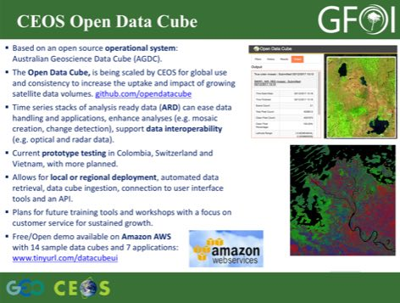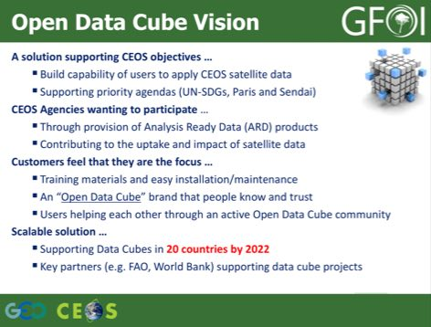
Brian reviewed the plan to reach 20 countries by 2022, noting that the strategy to expand is based around engaging partners in the process. He reviewed the plan for the Vietnam Cube, noting that the plan is to try stacking several different datasets (Landsat, Sentinel-1, ALOS) in this Cube. Yves noted that CSA would be quite interested in participating in this activity, and that they have an archive of RADARSAT data they could consider contributing.
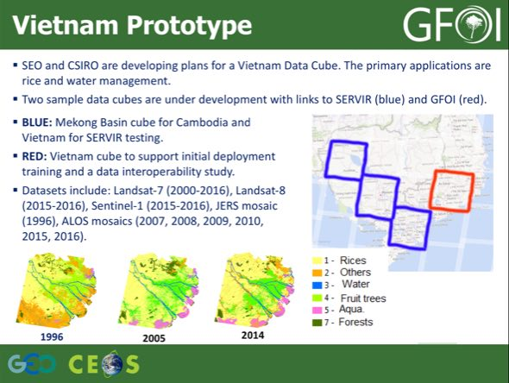
Brian reported on progress they have made on implementing the CCDC algorithm in the Data Cube, noting that it has recently been translated to Python by USGS. His team is currently working on working with CCDC in the Data Cube, assessing performance and the results generated by the system.
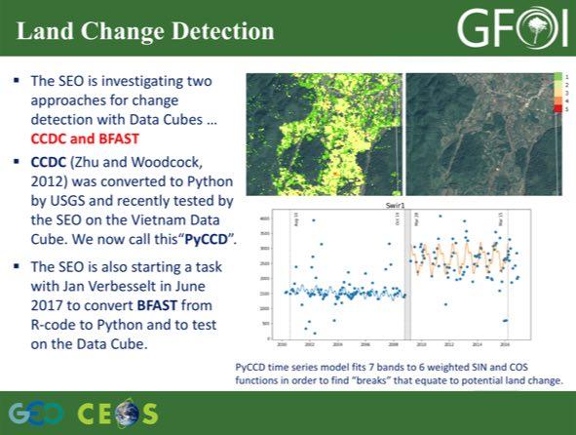
A brief discussion followed.
- Brad Reed (SilvaCarbon/USGS) noted that Curtis Woodcock and his group are using CCDC methods to observe degradation, and that could feed into the discussion we’ve been having on Early Warning applications.
- Yves asked about the plan to scale to 20 countries, and Brian suggested the way this is achieved will be a mix of direct support, as well as support by partners (e.g. Swiss Cube, Colombia, World Bank, SERVIR) helping other countries to become established.
SDCG-11-8 | Brian to follow-up with Yves on the potential to include RADARSAT data in the Vietnam Cube | May 2017
SEPAL
Erik Lindquist (FAO) presented a summary of the SEPAL tool which is part of FAO’s efforts to bring data and processing, ‘processing as a service’, and ‘REDD+ as a service’ in a transparent and repeatable way. SEPAL is open source and available on GitHub, and has a lot of parallels with the Data Cube approach. Erik provided an AWS-hosted demonstration, and noted that he can provide logins to anyone interested in the exploring the system.
He demonstrated the download of Landsat and Sentinel from SEPAL. They will be implementing change detection in the next couple of weeks, and will be adding time series analysis capabilities in the future. He noted that the system is highly scalable, enabling the rapid spinning up and down of infrastructure via AWS. Users are allocated a limited monthly budget which is provided by FAO.
Erik noted that the data is currently supplied via the Google Earth Engine Python API. They had old code that used to download data directly from USGS, and so it wouldn’t be a leap to connect the system to another data storage (e.g. Data Cube). User data is stored on AWS, and mosaics are also exported to AWS for processing.
Erik noted that they can import R functions into SEPAL, and make that functionality to all users. There is also a SAR Toolkit which allows ALOS and Sentinel-1 data to be used. He noted that this was important in the case of the Sentinel-1 and ALOS data, their system downloads directly from ESA and applies the corrections once it’s in the workspace as the product in Google Earth Engine is not in the correct format.
He noted that at present it would be difficult for a user to download the code base from GitHub and get their own instance running, but the goal is to progress the code base to the point where this would be possible. Brian suggested that if countries wanted to have a local Data Cube, and use SEPAL tools, then deploying SEPAL locally could be a useful functionality. If we can demonstrate the functionality that would be a useful step forward.
A brief discussion followed.
- Brian asked about the long-term plan for funding infrastructure. Erik noted that at present, FAO covers their worldwide operations on AWS for a cost of less than $2000/month, and that in the longer term this could be anticipated to be funded by the country’s REDD+ projects. At present, they have 200 registered users.
- Brian asked if any of the countries have had internet access problems, where the internet access has been a bottleneck. Erik noted that to date countries have been satisfied, and that this system has been the fastest way to get the results.
- Brian asked about the processing of Landsat data (e.g. BRDF and other corrections), and Erik noted for Landsat that this gets done in Google Earth Engine using code the FAO team wrote, and this code is on the SEPAL GitHub. For Sentinel-2, this processing is not available in Earth Engine, and so at present the Sentinel-2 data is TOA.
- Steven asked if countries could upload their own data (e.g. ground truth), and Erik confirmed this is possible. They are working on creating country and group permissions to enable shared resources to be accessed.
SDCG-11-9 | Brian to follow-up with Erik on the OpenForis BRDF and solar illumination algorithms they have implemented in Google Earth Engine | May 2017
ALOS-2 ScanSAR data provision
Stephen presented a summary of the ALOS-2 ScanSAR data provision on behalf of Shinichi Sobue from JAXA. He noted that ALOS-2 ScanSAR data is being provided already GEOGLAM and CEOS. Under GEOGLAM/Asia-RiCE and ALOS K&C project, JAXA provides ScanSAR data at technical demonstration sites (100km x 100km, i.e. approximately one province) to Asia-RiCE crop team members with ALOS-2 download system now. And under Asia Pacific Regional Space Agency Forum (APRSAF) framework with GEOGLAM/AsiaRiCE, JAXA provides scale up activity for Indonesia (Top 10 rice crop production provinces) and Vietnam (Mekong).
There is a new proposal from JAXA under cooperation with JICA and commercial data providers, JAXA will provide on-line access to intermediate JJ-FAST products, including ScanSar and/or ALOS-2 products to selected countries where JAXA, ADB and APRSAF countries have a cooperative agreement (Indonesia, LaoPDR, Thailand, Philippine, Vietnam) for governmental use. JAXA would like to propose the ScanSAR products as a potential CEOS ARD of SAR (1 degree mesh tiled data or path orth-slop corrected data).
Several potential country coordination activities are being considered.
- Vietnam VNSC and CSIRO/GA already prepare to implement CEOS Mekong data cube by the end of this year. VNSC and JAXA agreed to coordinate ALOS-2 ScanSAR data ingestion with rice crop area estimation software (INAHOR) to CEOS Mekong data cube.
- Indonesia LAPAN, MOA and JAXA agreed to coordinate ALOS-2 ScanSAR data ingestion to LAPAN data archive.
- Thailand JAXA already consulted to GISTDA and HAII about Thai interest of ALOS-2 ScanSAR data access.
For Vietnam, it may be possible to integrate other SAR data streams into these activities, including Sentinel-1, RADARSAT, and as suggested by Helmut even X-band data for detailed follow-up investigation.
A brief discussion followed.
- Masanobu noted that at present, only the HV data is available (better for forestry), but for rice crop monitoring HH would be better, and having both would maximise utility.
- It was agreed that there is a need to ensure the user perspective is reflected in the development of this system.
- Frank Martin provided a similar demonstration is available with Sentinel-1 data over the Mekong Delta, noting that for the Mekong coverage is completed every 6 days.
Brian summarised the Space Data Services session, noting that there was a thread around following-up on the RADARSAT data and incorporation into VN Cube. Ake noted that CCDC could be applied to Sentinel-1 and/or ALOS data. Brian also noted that we should follow-up with SEPAL on ways to connect or converge with Data Cube activities.
SDCG-11-10 | Brian to follow-up on the potential to apply PyCCDC to Sentinel-1 and/or ALOS data | June 2017
SDCG-11-11 | Brian to follow-up with Eric on a potential demonstration of a SEPAL connection to the data cube | SDCG-12

GFOI R&D Coordination Component
Session Overview and Objectives
Ake introduced the session, noting that the main topic for this session will be an update from the GFOI R&D Coordination Component.
Update on GFOI R&D Coordination Component
Martin Herold (GFOI R&D Component Coordinator) noted that he is the R&D Component Coordinator, with Brica Mora and Anthea Mitchell providing much of the support over the past 12-18 months in ensuring that the R&D Component is well integrated within GFOI. One of the main drivers for this coordination is to ensure that potential donors can understand how their contributions will support the outcomes of GFOI.
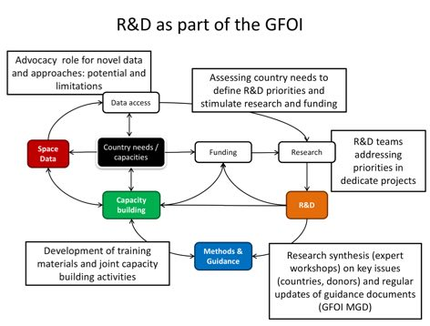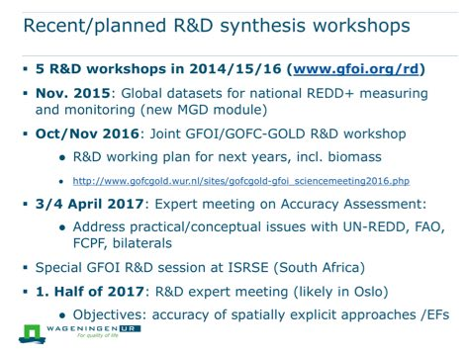
Martin noted that they are working to implement the CARL framework as a part of the approach to collaboration between the MGD and R&D components. He also noted that 14 REDD+ training modules have been developed built around the REDDcompass as the central Capacity Building element of GFOI.
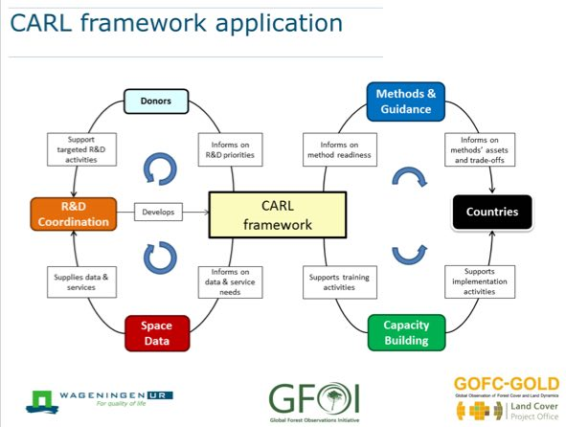
A brief discussion followed.
- Helmut noted DLR’s SAREdu initiative (https://saredu.dlr.de) could be integrated into the capacity building materials. Martin noted there is an increasing interest from countries in SAR applications, and that the work FAO is doing with countries (e.g. with SEPAL). SAREdu can play an important role with higher capacity countries.
- Helmut asked about the plans to improve communications with potential GFOI R&D donors to try and improve funding. Martin noted that one of their main approaches is to define priority areas which can be used by donors to support with confidence they are linked to country needs. He also noted the need to work with countries actively on the development of R&D priorities. Helmut agreed that working with countries would be a real value-add for funding R&D countries and agencies.
- Helmut asked about communication between R&D and the Space Data Component, and noted that this was raised as a critical issue yesterday to optimise the data supply for research purposes. There was an impression yesterday that this could be improved. Martin noted that there has been a lot of emphasis placed on ensuring good feedback into the R&D, but that the opportunity to feedback to the space data providers has been more limited.
- Yves agreed that there is a need to increase the communications between the GFOI R&D activities and the space agencies.
GFOI R&D group progress updates
Anthea Mitchell presented a summary of the progress of the GFOI R&D team, and reviewed the priority GFOI R&D topics including forest degradation and disturbance mapping. Ake noted that data provision from the CEOS agencies has only just started in the past six months, and further results could be expected in the coming 6-12 months.
Status report from Guyana Forest Commission R&D group
Santosh Bhandari (Indufor) reported on some work being done focused on Guyana. He noted that Guyana’s national MRV was established in approximately 2010. The objective was to try and detect forest degradation using satellite imagery, and at present they are just starting to receive satellite data from COSMO-SkyMed and Pleiades.
R&D Coordination component funding (ESA, Horizon2020 etc.)
Frank Martin presented a summary of funding opportunities related to the GFOI R&D component, noting that ESA has been supporting the lead of the R&D component via the GOFC-GOLD Office. This funding has ended, but a new tender for a further three years at a similar level (approximately 70-80k EUR / year) is now expected.
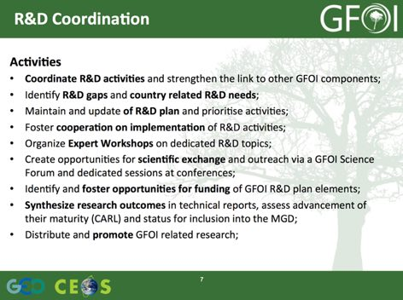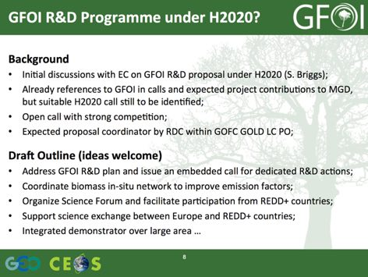
Frank Martin noted discussions around the potential for a GFOI R&D funding proposal to the EC’s Horizon 2020 program, and this could potentially provide a home for a GFOI R&D program. There is no current call, but the anticipated call would be 3-5M EURO over three years.
A brief discussion followed.
- Helmut noted that it may be good work with European national delegations participating in the Horizon 2020 call (e.g. Germany, France, Norway). He also noted the EuroGEOSS activity will be developed over the coming months, and this could be injected into the formulation of that activity. Martin agreed that support by the European member states could be critical to the success of the Horizon 2020 funding.
- Helmut suggested that the concept of a larger scale, more comprehensive, demonstration project could be included in the push towards Horizon 2020. Ake noted that the R&D teams have been encouraged to work on smaller areas, but are interested in working on larger areas. Helmut suggested that with the right concept, it may be possible for data providers to supply data for larger areas.
- Ake noted that in the past there have been larger scale GFOI and GEO-FCT science meetings which could provide a valuable coordination forum. He noted that this could foster the sense that there is a GFOI R&D program, rather than just an aggregation of existing groups under the GFOI umbrella.
- Stephen raised the issue of Horizon 2020 with Stephen Briggs and Brice Mora to ensure this thread is not lost, and asked how this could be specifically followed-up.
SDCG-11-12 | Ake to follow-up with the GFOI R&D Component Coordination Group to ensure follow-up and next steps on potential Horizon 2020 funding for GFOI R&D activities are defined | April 2017

UK Activities and Engagement
Follow-up to UK-Related Topics
Stephen introduced the topic of follow-up from the SDCG-10 discussions from the UK. He noted that the UK is interested to explore closer GFOI engagement, and topics of interest may include:
- Inclusion of NovaSAR S-band data in the GFOI R&D programme, to help advance its application for forest applications;
- specifically inclusion of NovaSAR data in the CEOS Data Cube to show its utility alongside better known data;
- exchanging notes on the GFOI Capacity Building efforts with space data in countries;
- a number of detailed technical collaborations that popped up in discussion; and
- Engaged in Phase 2 feedback and possible Lead role.
Forest 2020
Pedro presented a summary of UK forest activities and engagement, NCEO research, and the Forest 2020 initiative. He reviewed the aims of the Forest 2020 initiative.
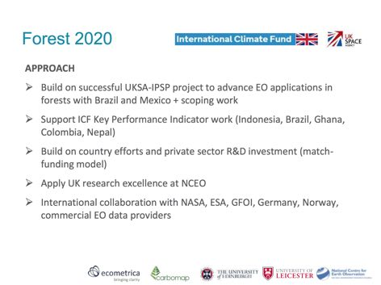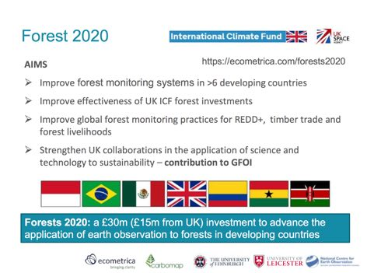
Pedro highlighted the potential linkages between Forest 2020 and GFOI.
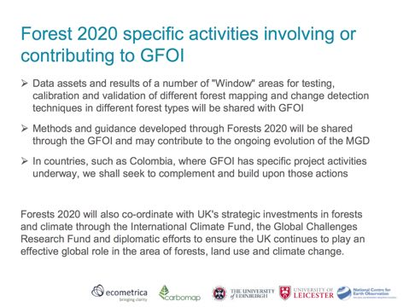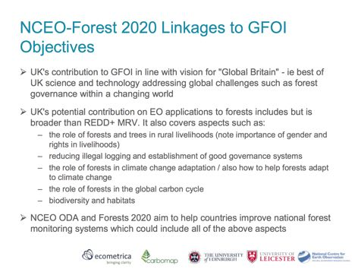
A brief discussion followed.
- Ake asked about the activities in Kenya, and linkages to the Kenya Data Cube prepared by Brian’s team. Pedro noted that people in Kenya know of the Data Cube, but not how to access it. Brian suggested that Nikki may know more as she was working on the ground with the SLEEK team. He also noted that the Kenyan Data Cube is one of the sample Cubes hosted on AWS. Fred Stolle noted that GFW has hired some of the staff from the SLEEK project, and so they still have a connection there.
SDCG-11-13 | Brian to provide Pedro with the details of the Kenya Cube hosted on AWS so Pedro can share it with his Forest 2020 UK and Kenya contacts | COMPLETE

Near Real Time Monitoring
JJ-FAST
Masanobu presented a summary of JJ-FAST developed jointly between JICA and JAXA, noting that the use radar data has allowed them to detect deforestation quite rapidly independent of cloud cover. In a 2007 study, the performance of PALSAR system was compared favourably with Brazil’s IBAMA system.
He reviewed some of the key features of JJ-FAST.
- It provides a web-based quick deforestation information system using the time series PALSAR-2 ScanSAR (English and Japanese) provides a deforestation polygon and timing, and it can be operated on lightweight computer clients (e.g. web-connected iPad).
- The observation frequency is every 42 days, with a product latency of 3 weeks (future goal 1 week).
- The system was launched in November 2016, and as of now covers 77 countries, including several tropical countries, and this will rise to 80 countries when the system becomes fully operational in November 2017.
- The spatial resolution is 50m, with a minimum detection size of the polygon of 5ha (1 ha in near future).
- Guidance documentation is available in English, French, and Spanish.
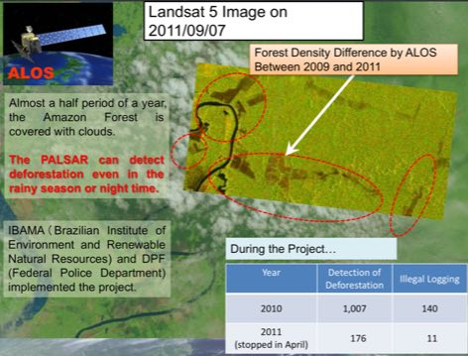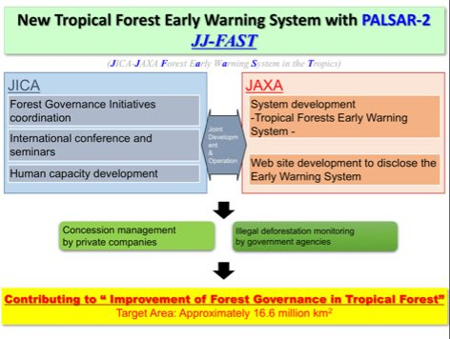
A brief discussion followed.
- Brian asked if the JJ-FAST product uses the same forest/non-forest mask as the ALOS global products, and Masanobu confirmed that at present they are currently very close.
- Brian asked whether the algorithm might be available for use, and Masanobu noted that currently only the output is available (a polygon, and a 16 bit TIFF image).
- Mari Miura (JICA) noted that improving data accuracy is one of the challenges, and they are setting up a user feedback system to try and improve via field feedback and ground truth. They are also trying to promote this system to be used by partner countries, and are holding a conference in Tokyo 24th-25th October. They will be inviting partner country officials and international agencies, with a focus on how partner countries can use JJ-FAST in their national forest monitoring efforts. They will also provide a training course in Japan, though the system is very easy to use.
- Frank Martin noted that there was a discussion on Early Warning systems during SDCG yesterday including to be included in the scope of the MGD
- Fred Stolle (WRI/GFW) asked if the data from JJ-FAST can be downloaded, and it was noted that the system uses an FTP server to share data.
Near Real Time Alerts
Fred presented a summary of WRI’s GFW near real time alerts, noting that they have three MODIS-derived alerts, and since January 2016 a 30m alert from Landsat-7/-8 (from Matt Hansen). He noted that the 500m alert had a lot of false positives, especially in river areas, and has been deactivated. There is an implication that the alerts will be less accurate because they are more timely, though the system includes both unconfirmed (flagged once) and confirmed (flagged again 7 days later) alerts. The product is released every 8 days for 17 countries, and at present the processing is very manual.
The usual users for the system are at the Ministry level, but more recently in Peru and Uganda they have started working with law enforcement agencies. Different users have different preferences around the alert trigger sensitivity, with some preferring a lower threshold, and some higher.
Performance of the system in cloudy areas is naturally constrained by the availability of acquisitions, and this is driving interest in radar-based systems (e.g. Sentinel-1). This effort is still nascent, focused on Malaysia and Indonesia, and is being carried out on collaboration with Wageningen University. If these development efforts are successful, they would like to scale the system up regionally, and then eventually globally.
A brief discussion followed.
- Yves asked if radar archive data of known areas of change would be of interest, and Fred confirmed this would likely be of interest to confirm results.
- Ake supported the idea of utilisation of multiple data streams, and Fred agreed that users don’t have a preference for the satellite data type but do want reliability and predictability.
- Helmut asked if there is any data on utilisation and impact of this system in countries, and Fred confirmed that it has been used by law enforcement in Peru and Uganda, but it is difficult to quantify what impact his is having on illegal logging.
SDCG-11-14 | Yves to follow-up with Fred Stolle on the potential to provide archive radar data in support of the development of GFW’s radar near real time alerts | May 2017

SDCG-11 Closing Discussions
Review of Main SDCG-11 Discussion Points and Outcomes
Stephen Ward reviewed the main points from SDCG-11.
CEOS Structure
- Points from slides.
- Some pressure to rationalise
- Trial LSI/SDCG/GEOGLAM meeting in Sept
- Some challenge to the rationale
- Consensus to maintain the thematic focus and engagement
- Desire to maintain existing name and leadership
- ‘Joint meetings’ the best characterisation?
- There are benefits to be had
GFOI-ALERT
- Practical country-focused demo (Vietnam Cube? + ….)
- Parallel development of GFOI MGD ‘Annex’
- Focus for the discussed GFOI-WRI cooperation
- Multiple data streams in world-leading system
- Data Cube platform
  - C-band SAR: Sentinel-1 A&B data every 6 days
  - L-band SAR: ALOS-2 SCANSAR data every 6 weeks
  - possibly S-band SAR: NovaSAR when launched
  - possibly X-band SAR: for hi-res cued investigations by TerraSAR-X (and in due course LotuSat-1 & -2)
  - JJ-FAST alert product of JICA/JAXA
  - WRI/GFW alert products (inc Landsat-8 day)
- Positive first discussions at SDCG-11
Global Data Flows
- Not all recommendations are going forward – though CEOS FDA has picked up many of the main thrusts.
- Engagement with data ‘stagers’ including on ARD standards remains outstanding (informal axis exists with George/Brian).
- Partnerships with donor bodies being developed by SIT/GEO.
- One axis that hasn’t really moved forward is on the relationship with ‘data stagers’ (e.g. AWS, Google), but they will likely have valuable views to explore and keep open.
Space Data Services
- GFOI website holds Landsat and Sentinel-1 country acquisition reports for 70 countries. Sentinel-2 to be added in 2017.
- Yves suggested Radarsat-1/2 historic data is available for the Vietnam cube for interoperability testing with other radar datasets.
- Data Cube pilot projects operational in Colombia and Switzerland. Vietnam pilot just beginning, but progress is good.
- Interest on recent change detection results from PyCCD. The SEO will continue to test and consider applying the same algorithm to radar data.
- SEPAL tool progressing well and operational in many countries. The SEO-FAO collaboration will consider connecting SEPAL to an AWS Data Cube to test mosaic creation.
- GFOI website updated with LS and S1 reports, S2 to be added.
- Pilot projects proceeding well.
Element-3
- Most R&D groups are just starting to receive data.
- Outcome 12 – El-3 doc. v.2.2 released in Oct 2016 (COES Plenary) v3.0 in the pipeline for SIT-32 (to be submitted “for info”). SDCG agencies asked to review the sections related to their missions BY APRIL 18.
- Outcome 13 – Data provision. All El-3 agencies (ASI, CNES, CSA, DLR, JAXA) have begun tasking and/or data provision to the selected R&D groups. Groups have only recently started to access/analyse the data.
- Outcome 14 – Private sector engagement. In contact with Airbus (SPOT-6/7), SSTL (NovaSAR-S), Planet (RapidEye, Doves). Verbal commitment but details still to be worked out.
- Better communications btw SDCG and R&D groups desired. Actions include improve reporting, science workshops, …
- Technical Progress report from R&D groups published on March 31, 2017. http://www.gfoi.org/gfoi-rd-progressreport_31mar2017/
Global Baseline
- Ongoing coverage from L-7,-8 and S-1,-2 (2B commissioning).
- The Sentinel-2 global reference image to be produced based in early 2018. This is eagerly awaited as will be used for reprocessing of Landsat data which will promote interoperability.
- There was a recent workshop on atmospheric correction and cloud detection at ESRIN this week, which is a key milestone.
- Good pre-interoperability collaboration (e.g. ACIX).
- CBERS regional available in South America and Western Africa.
- SAOCOM Launch foreseen in Q1/2018.
- Importance of L-band data stressed, and encourage JAXA to continue systematic observations with ALOS-2 and follow-on L-band, and encourage mosaics being provided to research community.
- Ake noted that the letter that was sent after SDCG-10 which was positively received by the JAXA manager, and this was followed by the release of the JERS-1 global mosaics and 2016 ALOS mosaic
- Golden Age of satellite data availability, with the new challenge being to provide easy access to users in REDD+ countries.
A brief discussion followed.
- Stephen noted that based on discussion in the Task Force, GFOI Phase 2 execution is not totally settled. There are concerns around duplication, unnecessary structure, etc., and there is a need to ensure this is consistent with what we want for CEOS.
- Erik Lindstrom asked whether the SPOT historic archive is available and if it can be used. Steven Hosford reported on this yesterday, and noted that CNES is now scoping what is required to do the processing in-house to generate products, and this should be decided in a couple of weeks time. There are 50 million scenes in the archive. They anticipate having a low-level product available by the end of this year, with full processing of the archive anticipated to take a year or so.
- Brian noted that he is working with Stuart Phinn (UQld/Australia) on processing the SPOT images to surface reflectance. Steven noted that it is not clear how the atmospheric correction could be applied, given that this requires knowledge of the state of the atmosphere at the time of observation.
Review of SDCG-11 Actions
George will circulate the SCDG-11 actions table for comment offline.
Closing Remarks
Frank Martin closed the meeting, thanking the team for their support, and noting that SDCG-12 will take place on conjunction with the joint LSI-VC and GEOGLAM meetings. SDCG-12 will run 5th-8th September at ESA/ESRIN.

Country and Capacity Building Coordination
Session Introduction and SilvaCarbon Support to Vietnam
Brad introduced the country information session, with the first part of the session focused on Vietnam and Colombia. He briefly reviewed the SilvaCarbon activities going on in Vietnam, including the background of SilvaCarbon activities.
Erik noted that FAO’s support to Vietnam is very similar. They have been working primarily with FIPI, and are currently focused on building a forest reference emission level to submit to the UNFCCC process based on the historical records, assessing the quality and accuracy of the records, improving where necessary, and then working to establish a baseline.
Space Data Coordination Overview
Frank Martin presented a summary of the SDCG and its Work Plan. He noted that the availability of satellite data is currently quite strong, and the focus is turning towards data exploitation (e.g. via Data Cubes, reducing processing burden for the user by providing analysis ready data).
Overview of Vietnam Forest Monitoring Activities
Nguyen Cao Tung (FIPI) presented an overview of Vietnam forest monitoring activities, including satellite and space data utilisation and capacity. He introduced the national forest monitoring system (NFIS), and explained their strategy to integrate satellite remote sensing data into the system. Data used by the system has included Landsat and SPOT, and the inventory has included four cycles starting in 1991. The fifth cycle is expected to start at the end of 2017.
The approach has evolved over time, from visual classification before 2005, and with pixel based approaches being employed from 2016 onwards. FIPI is currently in discussions with VNSC on the potential for resources to support the processing of satellite data, including the application of the Data Cube. There is significant consideration of new technologies such as cloud computing (e.g. AWS, Google Earth Engine), as well as new instruments (e.g. Lidar, UAV, mobile technology for field data collection).
A brief discussion followed.
- Erik clarified that there is no cost to Vietnam to run their SEPAL instance, and this will cover the cost for the whole country.
- Brian asked about collaboration with SERVIR/Mekong, and Nguyen confirmed that his colleagues are working with SERVIR/Mekong. Brian noted that this could be a possible data source for Vietnam.
- Brad asked about the number of forest classes being requested, noting that the 93 classes discussed cannot be supported by satellite data. He asked what the compromise position would be, and Nguyen suggested 10-20 will likely be sufficient.
- It was noted that to increase the frequency of updates to the NFIS system from five to one years, satellite data is required.
- George provided a brief update on the CSIRO-VNSC collaboration on the Data Cube, noting that a development version of the Cube was installed last week at VNSC’s offices in Hanoi, and a dialogue has been initiated between VNSC and FIPI on the potential to apply the Cube to forestry applications. One of the areas under consideration would be near real time monitoring.
SDCG-11-15 | Brian, in collaboration with Stephen and George to explore the potential to link Vietnam Data Cube activities to NASA/SERVIR via existing Vietnamese interfaces to SERVIR (e.g. VNSC, FIPI, other). Brian to follow-up with Dan Irwin on the Vietnamese national contact agencies and individuals for SERVIR. | May 2017
Update on Colombia Activities
Edersson Cabrera (IDEAM) presented a summary of the Colombian national forest monitoring system, noting that their forest cover monitoring system covers 25 years from 1990 - 2015. Since 2013, Colombia has released quarterly early warning reports which have most recently identified eight active areas of deforestation. Edersson reviewed several different applications of the Data Cube Colombia has developed, including forest monitoring but also diverse application areas such as water management, and disaster monitoring. Edersson stressed the importance of ensuring timely delivery of information products derived from satellite imagery to address societal needs.
A brief discussion followed.
- Ake asked about advice Colombia can offer to other countries trying to build capacity, and Edersson suggested the most important component is learning by doing. Continuity of personnel is also important to consolidate and underpin progress.
- Brian asked about the location of the recent landslides in Colombia as he would like to try and evaluate what the performance of the Data Cube landslide algorithm in this area.
- Brian noted the recent implementation of CCDC on the Data Cube, and would like to share the latest information to get some feedback from Colombia.
- Ake asked whether CBERS-4 data would be of use, and Edersson confirmed this may be of interest. Ake also asked about SAR data, and Edersson confirmed they were looking at the integration of Sentinel-1B, but it is difficult to integrate data which is not available freely wall-to-wall. Edersson also confirmed that they have been working with JAXA on the development of the JJ-FAST activity.
SDCG-11-16 | Brian to follow-up with Edersson on the location of the recent landslides in Colombia to look at the results the Data Cube landslides algorithm would generate | May 2017
SDCG-11-17 | Brian to follow-up with Edersson to share the recent development of the CCDC algorithm in order to get his feedback | May 2017
Country Reporting
Brad presented a summary of country inputs gathered in preparation for this session.
Gabon
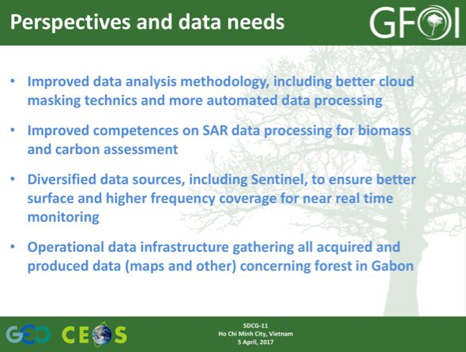
A brief discussion followed.
- Ghislain Moussavou (Gabon) noted that he welcomes the opportunity to learn from the other countries present, and that they are quite interested in capacity transfer and how to do the work themselves.
Guatemala
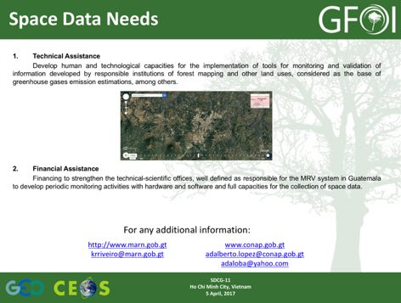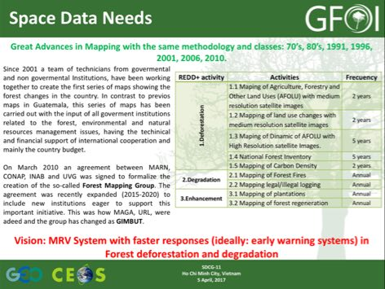
Mozambique
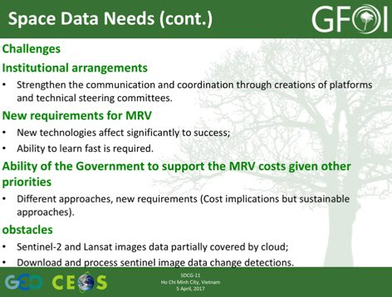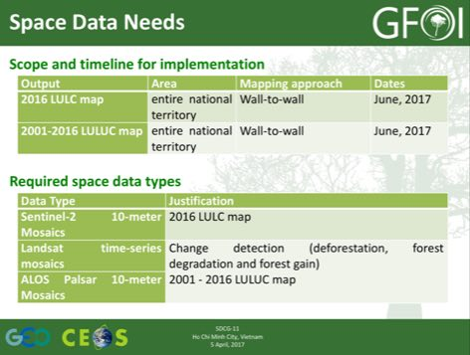
- Ake noted that there is a Mozambique member of the Kyoto and Carbon team, and Alismo Herculano (Mozambique) confirmed he knew that person.
- Frank Martin noted that ESA is providing support to Mozambique as well, including an offer to provide cloud computing support.
Taiwan
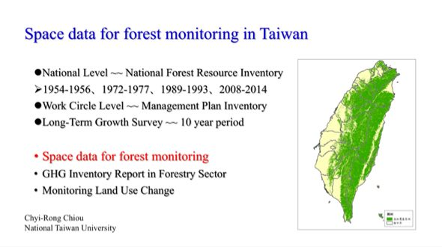
- Chiou Chyi-Rong (Taiwan) The primary deforestation mechanism in Taiwan are landslides, and there is very little logging.
- Chiou noted that in Taiwan they do not use satellite imagery for forest monitoring, but rather update their base map with airborne imagery.
- Chiou also noted he believes that the Data Cube approach is a good way to utilise and exploit satellite data.
Brad summarised the session, noting that several valuable topics were raised, and the ‘colleague to colleague’ discussion is encouraging. Ake noted that the sustained training support provided by SilvaCarbon over the years would have had a very positive impact on the progress over time.

SDCG-11 Attendees
Organisation | Participant | Organisation | Participant
CEOS SEO (NASA) | Brian Killough | JAXA | Ake Rosenqvist
CEOS SEO (NASA) | Sanjay Gowda | JICA | Mari Miura
CEOS SEO (NASA) | Alfredo de los Santos | JICA | Takahiro Endo
CEOS/JAXA | Masanobu Shimada | MGD Component | Carly Green
CNES | Steven Hosford | Mozambique | Alismo Herculano
CSA | Yves Crevier | NCEO UK | Pedro Rodriguez
DLR | Helmut Staudenrausch | RESTEC | Takahiro Endo
DOTE/Australia | Nikki Fitzgerald | SDCG SEC (CSIRO/NASA) | Stephen Ward
DOTE/Australia | Aran Hirsch | SDCG SEC (CSIRO/NASA) | George Dyke
DOTE/Australia | Anthony Bennie | SDCG SEC | Felix Lipkin
ESA | Frank Martin Seifert | Taiwan | Franz Ming-Chih Cheng
FAO | Erik Lindquist | Taiwan | Chiou Chyi-Rong
FIPI | Nguyen Cao Tung | USGS | Brad Reed
Gabon | Ghislain Moussavou | USGS | Sylvia Wilson
GFOI Office | Tom Harvey | VNSC | Lam Dao Nguyen
GFOI Office | Jim Baker | VNSC | Pham Thi Thanh
GFOI R&D | Martin Herold | VNSC | Nguyen Tien Cong
GFOI R&D | Anthea Mitchell | VNSC | Ngo Duc Anh
Guatemala | Adalberto Lopez | VNSC | Hoang Phi Phung
IDEAN | Edersson Cabrera | WRI/GFW | Fred Stoll
Indufor | Santosh Bhandari

SDCG-11 Actions (v1.0)
No. | Action | Due date
SDCG-11-1 | Stephen to provide Helmut with the compilation of CEOS FDA ad hoc team inputs with a view to having DLR contribute if they feel their contributions are not well reflected. | COMPLETE
SDCG-11-2 | SDCG EXEC to follow-up with Carly Green on the correct approach to engage the MGD Advisory Group on the potential inclusion of Early Warning systems, following the discussions around the MGD Advisor Group process. | May 2017
SDCG-11-3 | SDCG EXEC to consider drafting a proposal for a ‘GFOI ALERT’ system addressing the potential for Early Warning systems, and potentially engaging existing activities such as JJ-FAST and GFW’s related activities | June 2017
SDCG-11-4 | Ake to circulate the link to the GFOI R&D group status report | COMPLETE  http://www.gfoi.org/gfoi-rd-progressreport_31mar2017/
SDCG-11-5 | Ake to work with Steven Hosford on ensuring that the potential requests for SPOT-6/-7 data are formulated and ready when the data becomes available. | May 2017
SDCG-11-6 | Ake to follow-up with Michael Bock and Helmut on the required reporting on the R&D groups using the TSX background mission data in order to help ensure the coverage and data provision can continue | May 2017
SDCG-11-7 | SDCG agencies asked to review the sections of v3.0 of the Element-3 document related to their missions | No later than 18 April 2017
SDCG-11-8 | Brian to follow-up with Yves on the potential to include RADARSAT data in the Vietnam Cube | May 2017
SDCG-11-9 | Brian to follow-up with Erik on the OpenForis BRDF and solar illumination algorithms they have implemented in Google Earth Engine | May 2017
SDCG-11-10 | Brian to follow-up on the potential to apply PyCCDC to Sentinel-1 and/or ALOS data | June 2017
SDCG-11-11 | Brian to follow-up with Eric on a potential demonstration of a SEPAL connection to the data cube | SDCG-12
SDCG-11-12 | Ake to follow-up with the GFOI R&D Component Coordination Group to ensure follow-up and next steps on potential Horizon 2020 funding for GFOI R&D activities are defined | April 2017
SDCG-11-13 | Brian to provide Pedro with the details of the Kenya Cube hosted on AWS so Pedro may be able to share it with his Forests 2020 Kenya contacts | COMPLETE
SDCG-11-14 | Yves to follow-up with Fred Stolle on the potential to provide archive radar data in support of the development of GFW’s radar near real time alerts | May 2017
SDCG-11-15 | Brian, in collaboration with Stephen and George to explore the potential to link Vietnam Data Cube activities to NASA/SERVIR via existing Vietnamese interfaces to SERVIR (e.g. VNSC, FIPI, other). Brian to follow-up with Dan Irwin on the Vietnamese national contact agencies and individuals for SERVIR. | May 2017
SDCG-11-16 | Brian to follow-up with Edersson on the location of the recent landslides in Colombia to look at the results the Data Cube landslides algorithm would generate | May 2017
SDCG-11-17 | Brian to follow-up with Edersson to share the recent development of the CCDC algorithm in order to get his feedback | May 2017

