The CEOS Strategy for Space Data Coverage and Continuity in Support of the GEO Global Forest Observations Initiative (GFOI) and Forest Carbon Tracking (FCT) Task

V1.1
10th October 2011
Introduction & Rationale
The GEO initiated the Global Forest Observations Initiative (GFOI) as a coordinating framework for observation of the world’s forests. The mission of the GFOI is to:
- foster sustained availability of satellite and ground observations in support of national forest information systems; and
- support countries in the use of observations for their national forest information systems – respecting national choices of data and tools.
In addition, the GFOI is being defined to support long-term observation needs emerging from the discussions within the UNFCCC. To realise the mission of the GFOI, GEO will engage with other key users, in particular the FAO and the Intergovernmental Panel on Climate Change (IPCC).
GFOI extends the current GEO Forest Carbon Tracking (FCT) task, which has been underway since 2008. The FCT focuses on demonstrating coordinated data acquisitions, and methods and protocols through campaigns in several countries - the National Demonstrators. The operationally focussed GFOI will build on the FCT science and demonstration projects. A partnering approach with organisations and national governments aims to enable the development worldwide of national forest information and reporting systems. GFOI will initially focus on supporting the development and implementation of monitoring, reporting and verification (MRV) systems for REDD+, but future expansion will seek to broaden the coverage of forest related issues beyond climate policy. Governments in all forested countries will potentially benefit from the GFOI, depending on their choice to access the data or methods of the GFOI framework.
GEO undertook a concept development phase for the GFOI in 2010 to define the possible roles that GEO could play in forest monitoring. The concept considered how GEO would work with and augment the work of other global and national institutions, which have mandated roles in forest monitoring and reporting. The GFOI Concept Plan was prepared by an ad hoc Planning Group established after the 2009 GEO Plenary. The Concept Plan was accepted by the 2010 GEO Plenary, which ‘…supported the establishment of a GFOI Task Force… and recommended that the [Implementation] Plan for the Global Forest Observation Initiative be submitted to GEO VIII Plenary in 2011’.
The Implementation Plan, currently in development, envisions four key components for the GFOI:
- Support and capacity building for national governments: apply consistent and comparable methods to help governments build individually developed yet comparable national forest monitoring systems, and in collaboration with other providers such as the FAO to help with data utilisation.
- Observations and measurement: regular and routine (systematic) observations and measurements are essential for effective reporting. Data acquisitions need to include satellite, periodic ground, and other measurements. Continuity of data supply will be needed to ensure maintenance of time series and consistent reporting. Achieving interoperability between observations from different satellite sensors over time is crucial to ensuring time series consistency.
- Methods and protocols for data collection, processing and integration: GEO should promote and encourage the development of methods and protocols for data collection, processing and integration.
- Continuing research and development: GEO should promote coordinated research and development needed for continuous improvement of national forest information systems.
CEOS, having effectively coordinated acquisitions in support of FCT needs since 2009, has accepted responsibility for coordination of the satellite data contribution to the second GFOI component – the regular and routine (systematic) observations and measurements for effective reporting – ensuring continuity of data supply for maintenance of time series and consistent reporting. This document is intended to promote the discussions and agreements required among the relevant CEOS agencies to fulfil this responsibility. As such, it fulfils the actions defined at the 25th CEOS SIT meeting for that purpose:
25-10: CEOS FCT participants, supported by CEOS Chair, to develop a CEOS Strategy Report on continuity and coverage plans year by year for 2010 – 2015 using public good data sources and identifying the role for high-resolution data.
25-11: CEOS & SIT Chairs to initiate a short study among participating agencies to report to CEOS Plenary on the institutional arrangements for management of the CEOS role in supporting FCT future development and expansion.
Scope
CEOS membership comprises space agencies responsible for civil Earth observation programmes of governments. These programmes are funded and operated in a range of different ways – including fully governmental programmes and public-private partnerships. CEOS agencies operate a range of different data policies for these EO satellite missions, including: free of charge, or ‘public good’ policies open to all users for all uses; more complex arrangements which may incur a supply cost depending on the use or user (eg being commercial/non-commercial or research/non-research); full commercial data policy which requires payment for data for all uses. There are examples of missions of interest for the GFOI Data Strategy in each of these categories. Indeed, the capacity required to ensure sustained, annual, cloud-free wall-to-wall coverage of all forested areas globally (or the need for higher resolution data for validation studies), may necessitate the utilisation of many different satellite missions – including those which are fully commercial systems and funded and operated by industry.
So that CEOS stays within its mandate and maintains a neutral position with regards to the commercial opportunities which may exist with regards to the substantial data requirements associated with REDD+ etc, the proposed CEOS Data Strategy will - as a matter of principle – focus on the coordination of data which is being made available for GFOI purposes on a free of charge basis (whilst taking account of known plans for data which is not). This may be by virtue of the permanent free of charge data policy for a particular satellite mission, or by virtue of a more temporary donor arrangement by a CEOS agency (or commercial data provider) making a particular data available for GFOI purposes. This important principle ensures CEOS coordination efforts are not hampered by complications resulting from competing commercial interests.
Recognising the potentially important contribution of the commercial sector, CEOS will ensure that the sector is as informed as possible by: publishing the CEOS coordinated acquisition strategy annually; clearly identifying observational gaps and needs that might be served by industry or by data donors; engaging in dialogue with commercial data providers as appropriate – including taking note of commercial supply arrangements that may exist to satisfy the data requirements for one or more countries, so that this may be reflected in the CEOS strategy. The anticipated GFOI Project Office can assist in the brokering of the communications that will be necessary among user governments and potential data providers, including both CEOS and commercial interests.
Basic Strategy
The CEOS Data Strategy will address both:
- the sustained global observations required in support of the GFOI as it evolves in the coming years in support of policy developments;
- the technical support activities on-going within the FCT task, including continuation of the National Demonstrators (NDs), and science questions in support of method and protocol development and challenges like data interoperability.
The CEOS Data Strategy in support of GFOI and FCT will comprise three elements:
- A baseline, coordinated global data acquisition strategy involving a number of ‘core data streams’ that can be used free-of-charge for GFOI purposes. This will involve systematic and sustained wall-to-wall acquisitions of forested areas globally (repeated on timescales consistent with national reporting commitments and requirements of national forest information systems – which are to be determined but anticipated to be twice-annual) and would provide the default forest observations data for all countries without specific technical requirements, heritage or data preference (such as for a particular mission or data type (SAR or optical)).
- A coordinated national data acquisition strategy in response to national needs assessments undertaken in the course of GFOI implementation, commencing in late 2011, and input to the GFOI Linkages Forum in 2012. This will accommodate countries that have specific technical requirements, or heritage and experience on working with a particular data source or type, as well as the numerous intergovernmental arrangements that may exist or emerge for the supply of certain data to one or more countries. This will involve a wider range of satellite data sources, including data that is ordinarily provided on a commercial basis.
- Data supply in support of the FCT activities, including in support of: the science studies assisting the development and evolution of the GEO-branded methods and protocol documents for GFOI; interoperability studies; and validation activities – typically also involving higher resolution data, some of which is provided commercially and beyond the scope of CEOS agency responsibility. In the short term, the data supply in support of FCT activities can be assumed to include continuation of the twice-annual wall-to-wall acquisitions of the existing and expected National Demonstrator countries, and acquisitions at the corresponding Validation Sites.
The CEOS data strategy will support the transition of the wall-to-wall space data coverage, being undertaken on a limited demonstration basis within FCT, to a global operational basis under GFOI (either as part of the baseline global or national data acquisition strategies, as appropriate).

Core Data Streams
The baseline global data acquisition strategy for CEOS will involve coordination of a number of core data streams that satisfy key criteria consistent with the principles for implementation of the GFOI:
- core data streams provide sub-30m data free-of-charge for GFOI purposes, consistent with being available in support of any country’s information requirements;
- core data stream systems should have a sustained and long-term capacity in coverage, processing and distribution which is consistent with the large (global) scale data requirements of the GFOI.
Discussions among CEOS agencies active within the FCT task for the last several years have resulted in consensus on a working list of CEOS agency satellite missions assumed to represent the GFOI Core Satellite Data Streams - based on available information regarding known or expected data policies and mission capacities:
- Landsat-5/7/8 (optical) – USGS;
- ENVISAT (C-band SAR) – ESA;
- Sentinel-1 series (C-band SAR) – ESA;
- Sentinel-2 series (optical) – ESA;
- CBERS-3 & -4 (optical) – INPE/CRESDA;
- Radarsat Constellation Mission (C-band SAR) – CSA.
The SAOCOM series of satellites (CONAE) are also a core data stream candidate - pending confirmation of their satisfying the key criteria. Further CEOS agency missions that satisfy these criteria are encouraged for inclusion in the list of core data streams. For the time being, it is assumed that coordination of the baseline global data acquisition strategy will involve CSA, ESA, INPE, USGS and perhaps CONAE.
Latest available scheduling information of the GFOI Core Data Streams is summarised in Figure 1 below. It is apparent that Core Data Streams are few until the launch of next generation missions of INPE, USGS and ESA in 2012 and (particularly) 2013. Until 2013, GFOI is reliant on continued service from the ageing Landsat and Envisat missions and this will limit the schedule at which the transition to global coverage is achieved.
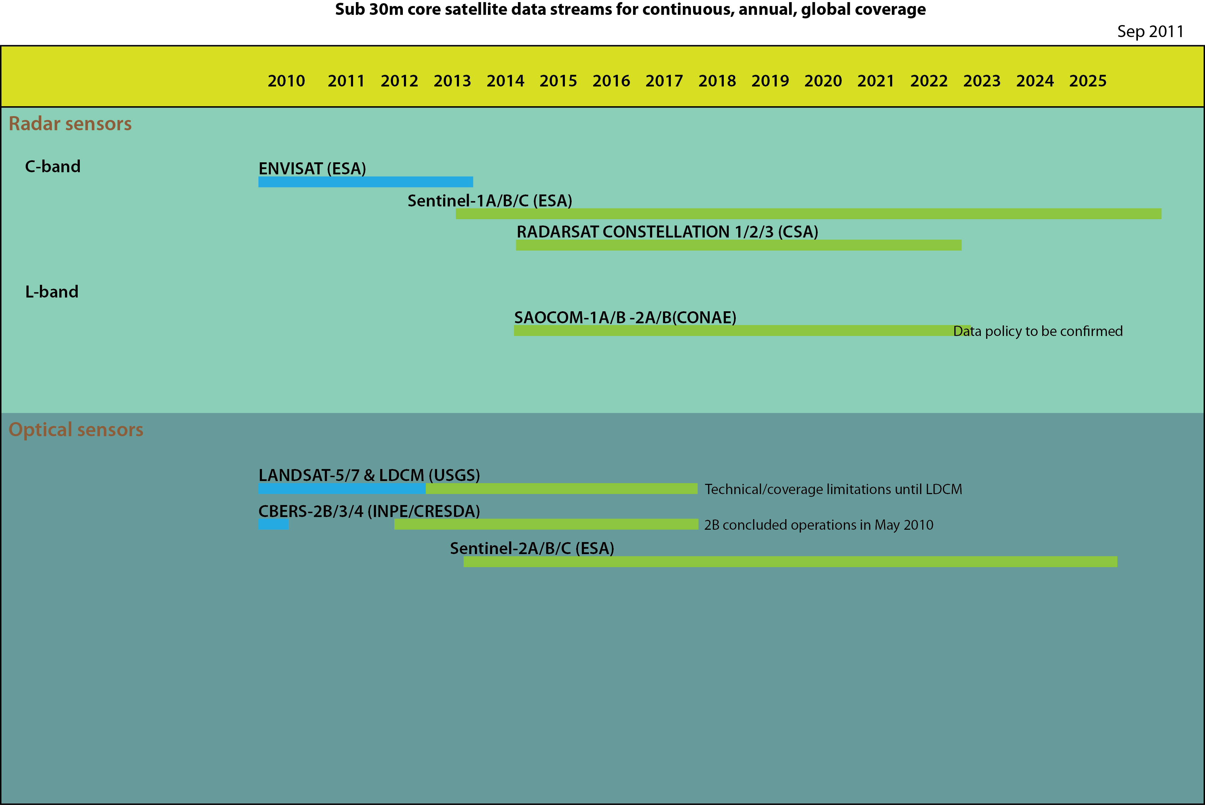
Figure 1: GFOI Core Data Streams
Further Data Streams of Interest
Whilst few CEOS agency missions may satisfy the criteria to be classified as a GFOI Core Data Stream, there are many more which will be able to contribute to systematic national, regional, and global coverage - and thereby to the three elements of the CEOS Data Strategy. These include optical high-resolution missions, as well as X-band and L-band radar missions. The data from these further missions can also support validation and technical studies. They may well be needed to satisfy reporting requirements in terms of detection thresholds, frequency of (cloud-free) coverage, and reliability.
Coordination of the national data acquisition strategy for GFOI and of the data supply in support of the FCT activities (and potentially the baseline global data acquisition strategy - particularly in the early years of GFOI operations) will necessarily involve participation of a larger number of CEOS agencies, and possibly engagement of some commercial suppliers – recognising the many existing and expected intergovernmental arrangements for supply of data in support of REDD+ and GFOI objectives.
The CEOS Data Strategy encourages non-core data streams to contribute to the long-term building of consistent wall-to-wall time series archives on scales from national to global – even if an explicit commitment to free-of-charge data provision cannot be guaranteed. Uninterrupted time-series archives of wall-to-wall data are fundamental to the success of GFOI and all interested agencies are encouraged to participate in the GFOI coordinated acquisition strategies, even if future data policies (and indeed national reporting requirements in frameworks such as UNFCCC) are not yet fully defined.
Figure 2 summarises further data streams of interest below:
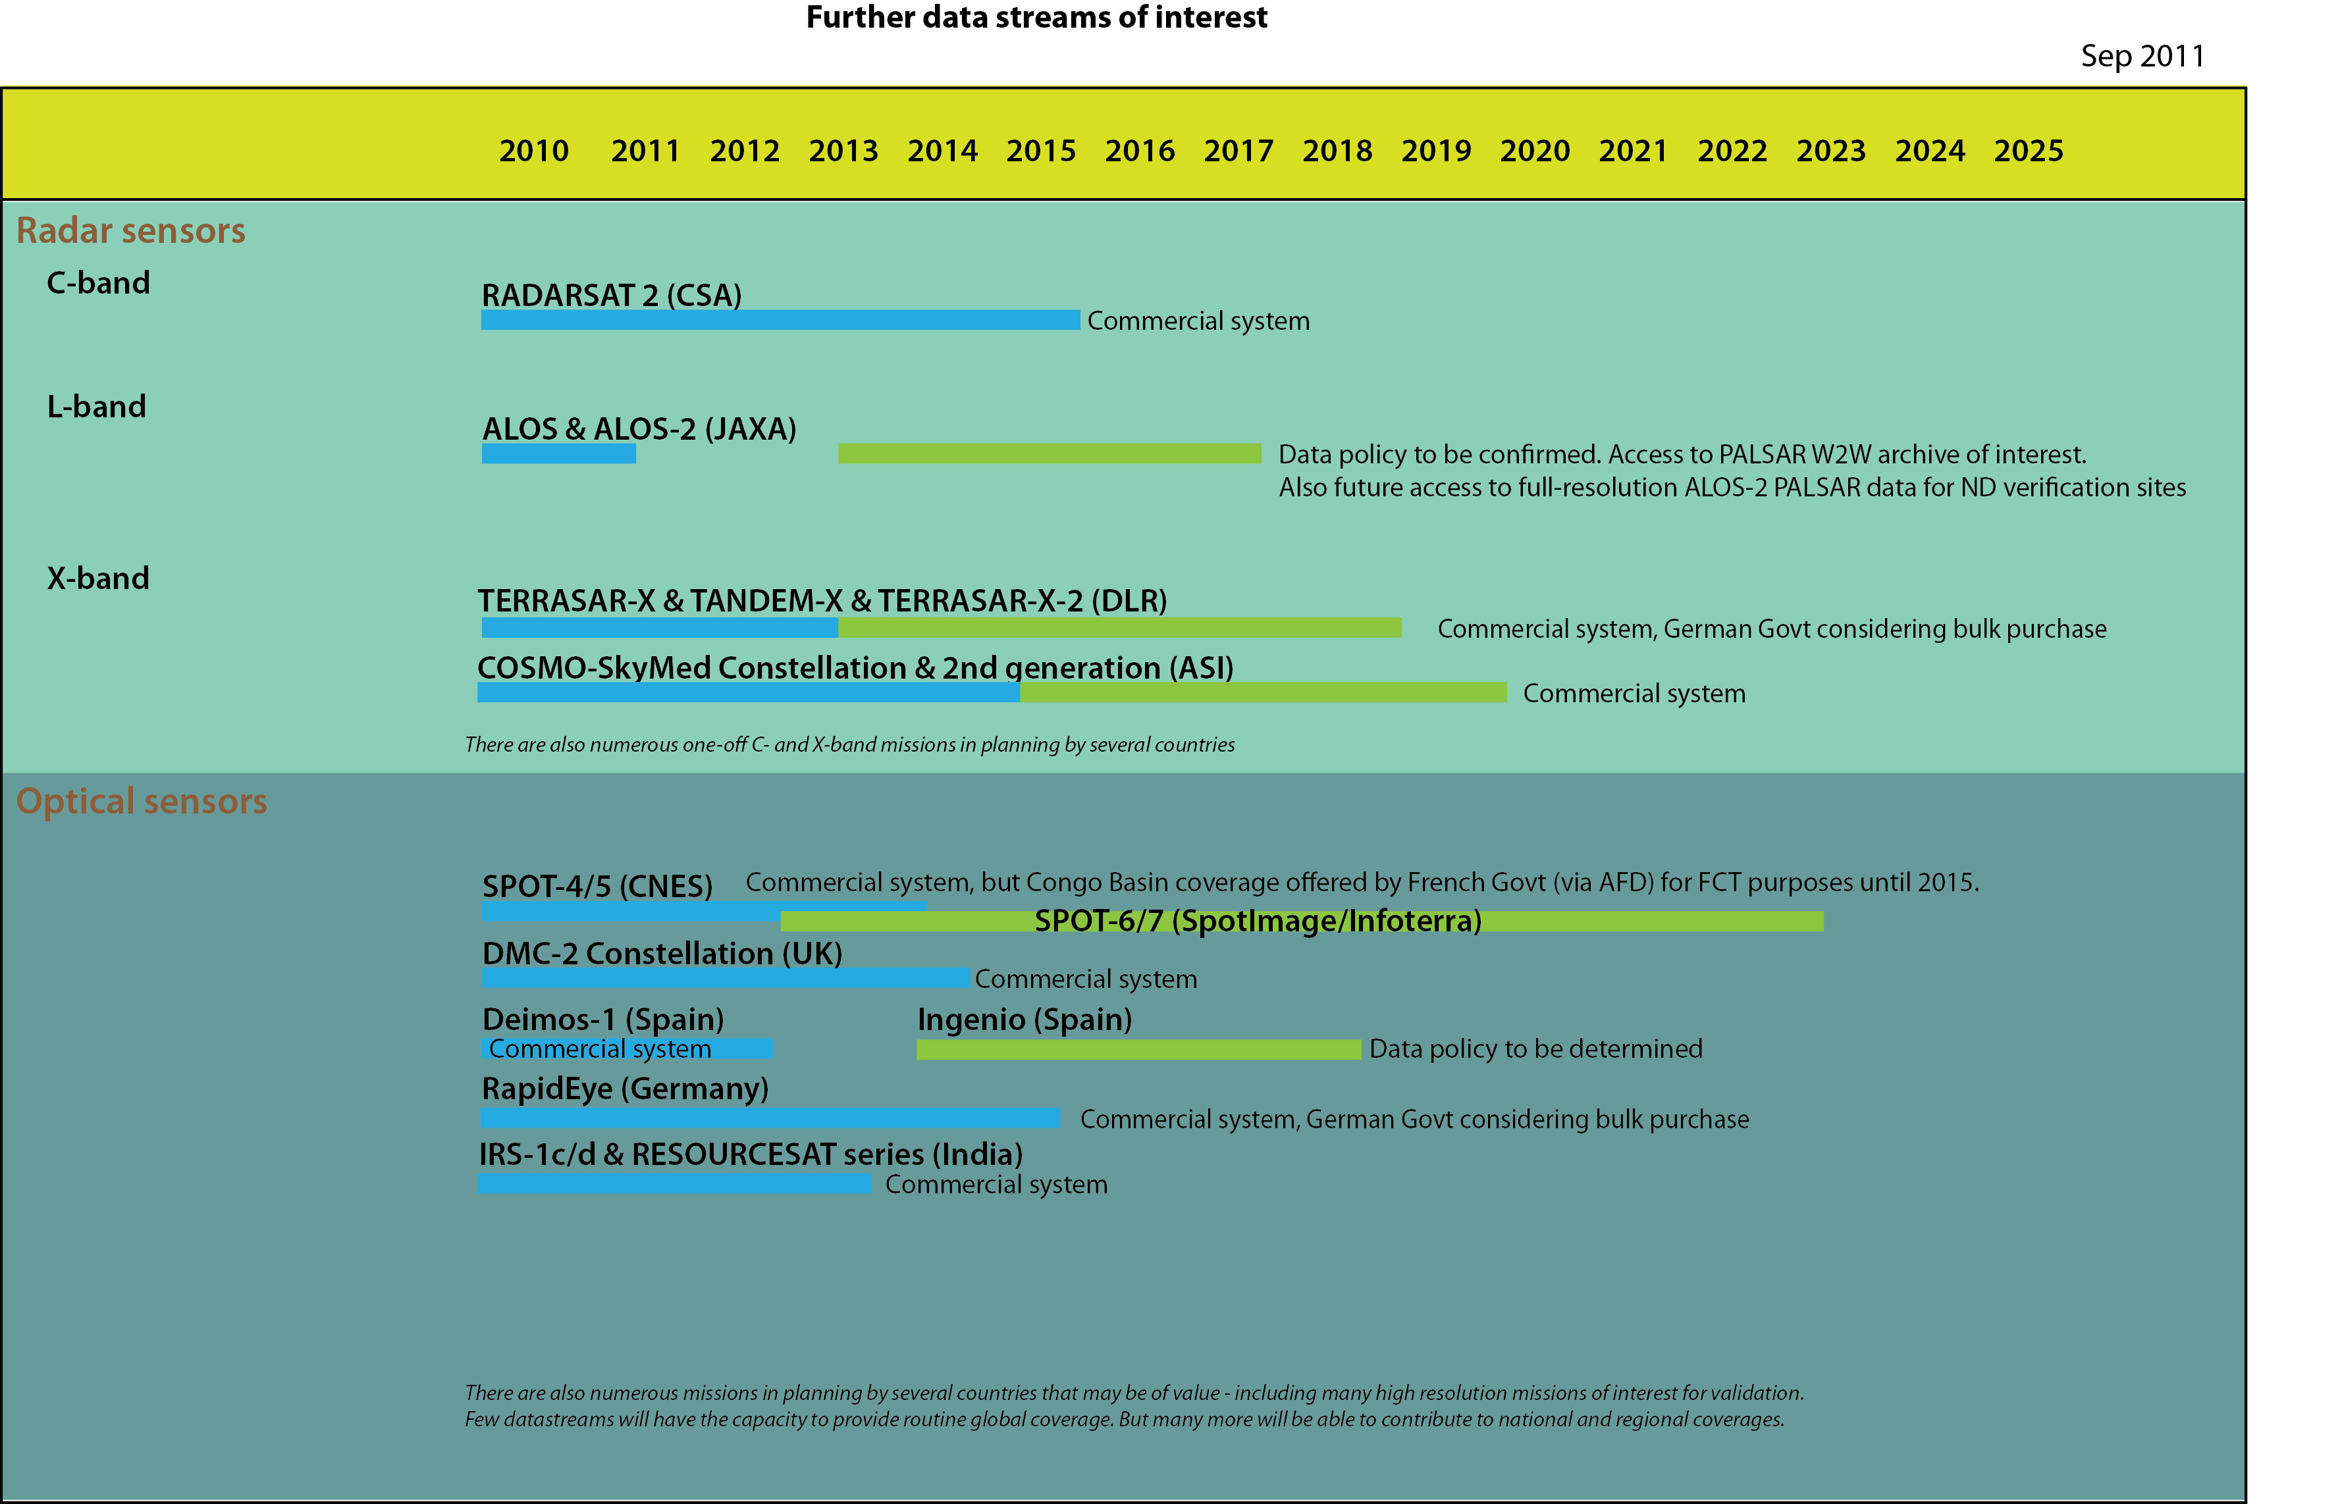
Figure 2: Further Data Streams of interest for GFOI and FCT

Timing of the CEOS Data Strategy
The GFOI Implementation Plan calls for the key components (including Observations & Measurement) to be operational by 2014. 2013 is described as a ‘building year’ with the aim of moving the GFOI components towards operational scale and status. The GFOI Linkages Forum in 2012 will have a key role in determining priorities for national coverage as observations move towards a global, operational status and will help broker connections between potential data suppliers and individual national needs.
As far as possible, timing of the CEOS data strategy should reflect and support the schedule indicated in the GFOI Implementation Plan. In practical terms, the limited number of core data stream missions until 2013 will limit the overall acquisition capacity which CEOS agencies are able to provide.
Enough is known of expected reporting requirements for a provisional definition of the first element of the CEOS Data Strategy – the baseline, coordinated global data acquisition strategy. The need for early coordination to ensure that GFOI requirements are reflected in the background missions of the core data streams suggests that this element should be an immediate priority.
The schedule of the second element - a coordinated national data acquisition strategy – will be determined by the GFOI Linkages Forum and the national needs assessments which are undertaken in support of it. The GFOI Implementation Plan draft suggests that the Linkages Forum will be in Q2 of 2012. The GFOI Linkages Forum will bring together the various users and suppliers around the proposed GFOI framework, and will confirm and record arrangements for how the support and services framework would be underpinned and supplied to nations. The CEOS coordinated national data acquisition strategy will have its beginnings in this activity.
The third element of the Data Strategy - Data supply in support of the FCT activities – is assumed to continue uninterrupted but with arrangements transitioning to become part of the broader GFOI activity within CEOS and the GFOI Project Office.
The table below suggests a timetable for CEOS Data Strategy reflecting the GFOI Implementation Plan and the existing FCT ambitions for progressive satellite coverage of UN-REDD countries (starting with pilot countries) - being those most likely to be among the first governments to consider seeking GFOI “services” in relation to systematic and continuous observations.
Year | GFOI Phase | CEOS GFOI-FCT Data Strategy
2011 | Planning phase | Baseline Global Data Acquisition: Planning initiated via formalised Space Data Coordination Group, including all core data stream providers and leveraging existing inter-agency coordination efforts.  National Data Acquisition: National needs assessments expected to commence late 2011 in support of GFOI Linkages Forum and CEOS will support.  FCT Data Supply: Continuation of the FCT ND wall-to-wall coverage. Ongoing data needs for technical development, validation etc.
2012 | Start-up phase | Baseline Global Data Acquisition: Definition of long-term acquisition strategy, identifying roles for core and other data streams.  National Data Acquisition: GFOI Linkages Forum provides basis for initial definition of the national data acquisition strategy. Priority to UN-REDD pilot countries.  FCT Data Supply: Continuation of the FCT ND wall-to-wall coverage. Ongoing data needs for technical development, validation etc.
2013 | Commencement of Operations | Baseline Global Data Acquisition: Initial operational capability in support of global strategy – as core and other data stream availability allows.  National Data Acquisition: Implement 2013 requirements as identified by Linkages Forum and captured in CEOS strategy. Priority to UN-REDD pilot countries.  FCT Data Supply: Continuation of the FCT ND wall-to-wall coverage. Ongoing data needs for technical development, validation etc.
2014 & beyond | Operations | Baseline Global Data Acquisition: Operational global acquisitions in line with strategy.  National Data Acquisition: Implement 2014 requirements as identified by Linkages Forum and captured in CEOS strategy.  FCT Data Supply: Routine wall-to-wall coverage will be addressed by the other elements. Ongoing data needs for technical development, validation etc.

In practice, the scheduling of the core data streams will have a bearing on the pace at which the baseline global data acquisition strategy can be implemented. The current generation of systems is at or beyond their design life, and the next generation will be available from mid-2012, but full capacity will not be realised until 2013/2014 with the launch of Landsat-8 and Sentinel-1 and -2 and RCM. In the interim, only Envisat and Landsat missions from the core data streams remain operating in support of continuity of the National Demonstrators and the possible addition of UN-REDD countries. Ensuring the necessary continuity of coverage, and planning of increased coverage and a transition to a global scale operation in support of GFOI will need careful coordination by CEOS.
Annex A provides a year-by-year proposal for the implementation of the CEOS Data Strategy from 2011 (GFOI Planning Phase), 2012 (GFOI Start-up Phase), 2013 (GFOI Commencement of Operations), 2014 & 2015 (GFOI Operations). This covers the 3 elements of the CEOS Data Strategy and all related CEOS agency data streams.
Institutional Arrangements
Management by CEOS of the satellite part of the Observations and Measurement component of the GFOI will be a subset of, and necessarily consistent with, the broader overall institutional arrangements for the GFOI. Proposals for these arrangements are currently under definition within the GFOI Implementation Plan development and will naturally be dependent on support at GEO-VIII and subsequent funding. The assumption is that a GFOI Project Office will be established in 2012, ultimately with a full complement of staff by the time Operations Phase commences in 2014. Since space data coordination is a significant proportion of the overall operational activity for GFOI, CEOS can be expected to have good representation within and/or links to the GFOI Project Office.
The foundations of the mechanism for coordination of CEOS data strategy already exist informally among the CEOS participants within the FCT task, supplemented by the optical data coordination efforts of the LSI Virtual Constellation Team. It is proposed that a reinforced and formal coordination group – the GFOI Space Data Coordination Group (SDCG) - be established by CEOS in 2011 in anticipation of an immediate requirement for its functions in support of the GFOI.
Reflecting the schedule set by the GFOI Implementation Plan, the SDCG will initially prioritise the definition of the baseline global data acquisition strategy, and ensuring that the planning of the next generation systems of the agencies contributing core data streams (currently anticipated to be (CONAE), CSA, ESA, INPE/CRESDA and USGS) are as supportive as possible of the baseline global data strategy for GFOI. The global data acquisition strategy should be completed by end 2012 and should indicate a credible plan for transition to global coverage in the few years ahead as GFOI reaches operational status.
The core data stream agencies should be joined in the SDCG by those agencies supporting the national data acquisition strategy and data supply in support of FCT (this may include a broad range of agencies – eg ASI, CNES, DLR, JAXA etc). The SDCG will be responsible for producing an annual satellite data acquisition plan in support of the three data strategy elements and this can be the mechanism for brokering gap-filling, comparing national needs with data donor offers, and for communicating possible priorities to the commercial sector – anticipating that multiple systems will need to be applied in support of the various needs.
The SDCG will immediately assume the responsibilities of the existing FCT data coordination group, including coordination of the data supply in support of FCT activities, the National Demonstrators and supply to the PD teams.
The way forward
The following way forward is proposed (as of September 2011):
- CEOS stakeholders are invited to review and endorse this document at CEOS Plenary in November 2011 – with the aim of demonstrating readiness for the Space Data Coordination role in GFOI during the discussion at GEO-VIII.
- Stakeholder agencies should explore management and operation arrangements for a GFOI Space Data Coordination Group (SDCG - being a reinforced grouping of the informal coordination arrangements within CEOS FCT participants and including the agencies responsible for the core data streams - namely CONAE, CSA, ESA, INPE/CRESDA and USGS, as well as other CEOS agencies with interest in contributing data to GFOI/FCT). This is to allow for a more systematic and formal planning of the design of the baseline global data acquisition strategy for GFOI to start in 2011.
- The SDCG will commence formally following the GEO-VIII Plenary in November. The Group will be responsible for all elements of the CEOS GFOI Data Strategy – including in relation to the FCT.
- CEOS should stay aware of developments in arrangements within GEO for GFOI implementation and institutional arrangements and ensure that adequate representation and connections exist between CEOS efforts and the anticipated GFOI Project Office.

ANNEX A: CEOS Strategy Timetable

The table attached summarises the timetable against which CEOS will implement its data strategy for GFOI and FCT. This is driven by the ambitions and schedule expressed in the GFOI Implementation Plan, as well as by the existing ambitions expressed by the GEO FCT task, which anticipate the requirements of the REDD+ process and those of countries participating therein.

