Space Data Coordination Group Meeting (SDCG-2)
U.S. Geological Survey
13-14 September 2012

Venue:

U.S. Geological Survey
12201 Sunrise Valley Drive
Reston, Virginia, USA 57198
Phone: 703-648-5953
John Faundeen mobile: 605-759-4558
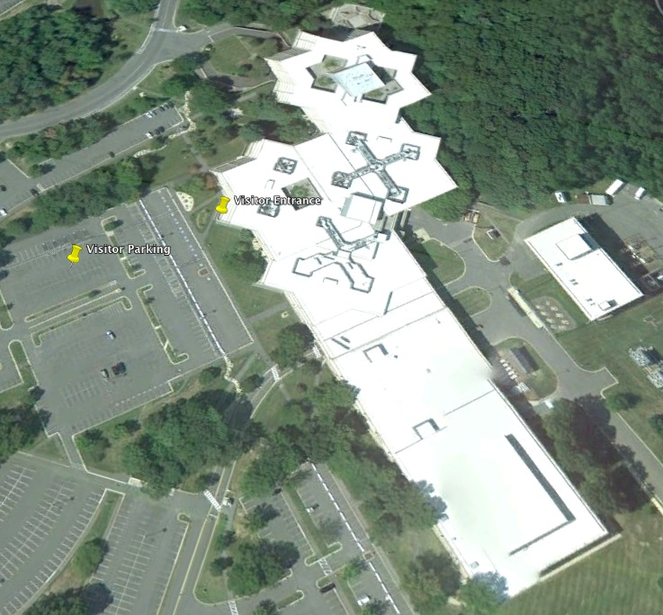

Meeting Objectives:

The proposed objectives for SDCG-2 are:

- To review the inputs to the GFOI Baseline Global Data Strategy
- To refine the draft GFOI Baseline Global Data Strategy
- To characterize the data gaps and strategize means of mitigation
- To assess sensor programming proposals
- To establish a timetable to finish the GFOI Baseline Global Data Strategy
Space Data Coordination Group Meeting (SDCG-2)
U.S. Geological Survey
13-14 September 2012

Thursday, 13 September 2012
Room 2A-405

Time | Session | Lead
07:30-08:00 | Registration
08:00-08:30 | Welcome, Introductions, Meeting Objectives | Tom Clines and Co-Chairs
08:30-09:15 | GFOI Context, Status and Information Requirements | Giovanni Rum & Ake Rosenqvist, Stephen Ward
09:15-09:45 | Review of SDCG-1 Actions | SDCG Sec (Stephen Ward, George Dyke)
09:45-10:15 | Break
10:15-10:40 | GFOI Baseline Global Data Strategy  Overview  Current Status | Frank-Martin Seifert
10:40-11:00 | Mission Planning Tables  Intent  Status | Ake Rosenqvist
11:00-11:20 | Phased Implementation Approach  2013  2014-2015  2015-Beyond | John Faundeen
11:20-12:00 | Brief Mission Updates | Roundtable
12:00-13:00 | Lunch
13:00-14:00 | Near-Launch Mission Updates  INPE/CRESDA – CBERS-3  USGS – LDCM/LTAP  JAXA – ALOS-2  ESA – Sentinels | John F. on behalf of INPE/CRESDA  Tim Newman & John Faundeen  Osamu Ochiai  Frank-Martin Seifert
14:00-15:00 | Level 1 Baseline Strategy  Results of Gap Analysis and Near-Term  Mitigation Plan  - Critical Spatial / Regional Needs  - Essential Space Mission Needs | Co-Chairs (John Faundeen)
15:00-15:30 | Break
15:30-17:00 | Level 1 Baseline Strategy  Programming proposals - sensor by sensor | Co-Chairs (Ake Rosenqvist)
17:00-17:15 | No-Host Dinner Logistics and Adjournment | John Faundeen

Space Data Coordination Group Meeting (SDCG-2)
U.S. Geological Survey
13-14 September 2012

Friday, 14 September 2012
Room 2A-405

Time | Session | Lead
08:00-08:30 | Confirmation of Level 1 Baseline Strategy | Co-Chairs
08:30-10:00 | GFOI Baseline Global Data Strategy document  Section-by-Section Review and Updating | SDCG Sec
10:00-10:30 | Break
10:30-11:00 | Writing Assignments  Dash to the Plenary  Timetable | SDCG Sec
11:00-12:00 | GEOGLAM  Objectives  User Requirements Workshop at CSA  Next Steps with SDCG Discussion | Yves Crevier
12:00-13:00 | Lunch
13:00-13:30 | Engaging Commercial Operators Discussion | Co-Chairs (FM Seifert)
13:30-14:15 | COVE Update  Features Added Since February 2012 | Brian Killough
14:15-14:30 | Land Surface Imaging Status  Cross-Catalog Query  Web Page Evolution | John Faundeen
14:30-15:15 | Summary, Action Item Review, Plenary Plan | Co-Chairs, SDCG Sec
15:00-15:15 | Next Steps, SDCG-3 | Co-Chairs, SDCG Sec
15:15 | Adjournment of Main Meeting | John Faundeen

15:30 - 17:30
SDCG Executive Group Meeting

