MINUTES OF THE 4th SDCG MEETING (SDCG-4)

4th-6th September 2013
Caltech, Pasadena, USA

Welcome and Opening Remarks
Ake Rosenqvist welcomed participants to the SDCG-4 meeting on behalf of the SDCG Executive, and reviewed the objectives of the meeting:
- Confirm progress in implementing the Global Baseline Acquisition Strategy;
- Progress the GFOI Space Data Services definition & development;
- Confirm schedule & responsibilities for delivery of the strategy to SIT-29;
- Define a way forward with the pilot countries;
- Develop a standing procedure for managing non-core data stream requests and activity; and
- Review the impact of GEOGLAM acquisition requests on the GFOI strategy and develop appropriate adjustments as relevant, and plan for liaison.
Simon Eggleston provided an update on the status of GFOI, noting that it is structured into four components:
- Methods and Guidance (M&G) Documentation;
- Coordination of satellite data supply (SDCG);
- R&D on technical challenges (FCT); and
- Capacity Building.

Review of SDCG-3 Actions
George Dyke reviewed the status of SDCG-3 actions, and an updated status of these actions is included as an appendix. He pointed out that most actions from SDCG-3 have been closed, and were linked to inputs to the Element 1 strategy. He noted that two items remain in progress which are of ongoing interest.
SDCG-3-10 | Ake to confirm the cost and terms for ISRO’s offer to provide AWiFS data. (Understanding is free of cost.) | IN PROGRESS  ISRO, “working on the modality of supporting the GFOI activities with AWIFS data supply”
SDCG-3-18 | Evie to coordinate the SDCG plan for 1-2 data delivery pilots starting in 2013, and provide potential candidates and a summary of the way forward to be reported at SIT-28. | IN PROGRESS  To be discussed at SDCG-4 Session 5 and 6.
Stephen Briggs asked about action SDCG-3-18, and what the difference was between this and the GEO Forest Carbon Tracing (FCT) activity. Stephen Ward noted that FCT was mostly about acquisitions, and Stephen Briggs stressed that it is important to ensure that the effort made to FCT isn’t lost – this data was a GEO deliverable.

GFOI Baseline Global Data Strategy - 2013 Implementation Plan
Ake Rosenqvist provided a background on the Element 1 Strategy - the Global Baseline Acquisition Strategy. The objective of the baseline strategy is to ensure the availability of time series data over the global forest cover. The focus is on core data streams (i.e. free and open), and at present we only have two core data streams (Landsat-7 and Landsat-8) in operation. Ake reviewed the target products from the Element 1 Strategy.
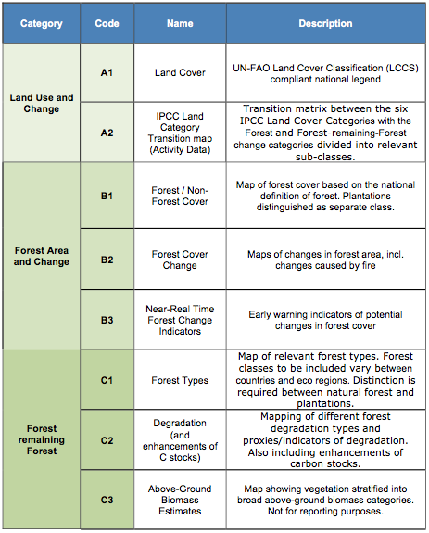
Stephen Briggs raised the issue of what is possible now, in 1-year, 3-years, 5-years, etc. There is a general incoherence in what products are available, and what is possible today. He noted that this is a general GFOI issue, rather then a specific issue for SDCG. This consistency is also an issue in the GFOI M&G documents. There is a need to ensure consistency between the SDCG (space data) and GFOI M&G pillars and documents.
Ake reviewed the phased implementation approach, including the table of country coverage.
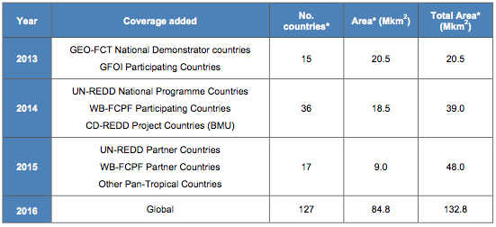
Tom Cecere noted that Landsat-8 is currently collecting about 550 scenes a day, which is near global coverage – though maintaining this pace will depend on how the satellite continues to operate. With Landsat-7 and Landsat-8 in operation, scaling up to the 2014 coverage requirements could be feasible, but capacity needs to be reviewed.
Landsat-7 and Landsat-8 Implementation Status
Eugene (Gene) Fosnight reviewed the status of Landsat-7 and Landsat-8 activities.
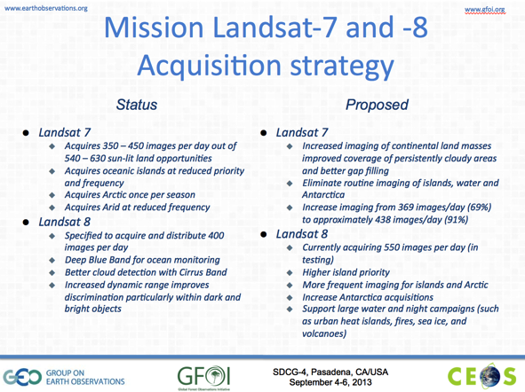
Gene noted that the LTAP is being tuned assuming an acquisition rate of 550 scenes per day, however, there are some potential constraints that could reduce this rate, for example engineering and duty cycle constraints, and contractual issues around ground stations. At present these constraints aren’t expected to impact the acquisition rate, but with Landsat-9 funding still being sought, lifecycle constraints could become a factor.

GFOI Baseline Global Data Strategy - 2014 Implementation Plan
Core Data Streams
ESA - Frank Martin Seifert reviewed the status of the Sentinel missions, noting the current planned launch dates.
Sentinel-1A | March-May 2014
Sentinel-1B | Late September 2015
Sentinel-2A | September 2014
Sentinel-2B | Q2 2015
Sentinel-3A | Late 2014
The high level strategy for full Sentinel-1 operations capacity calls for 25 minutes of acquisitions per orbit per satellite. The most challenging region for Sentinel-1 acquisitions will be Africa, as this may conflict with acquisitions over Europe.
Frank Martin reviewed the status of Copernicus (GMES) ground segment, noting that at present three of the four ground stations have been confirmed (Alaska still being coordinated).
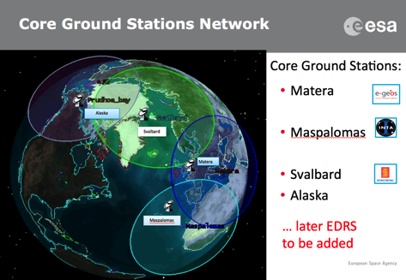
Frank Martin reviewed the status of the Copernicus data policy, noting that, “users shall have free, full and open access to Copernicus/GMES dedicated data and Copernicus service information.”
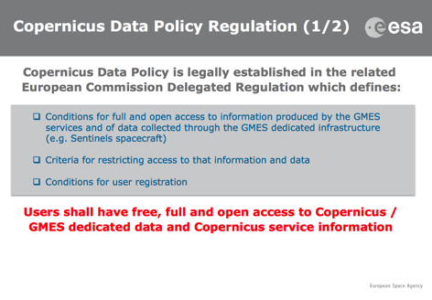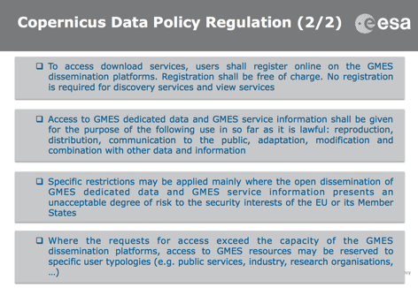
Frank Martin noted that there is ongoing collaboration between USA and USGS on the cross-calibration of Landsat and Sentinel-2 data. Brian Killough asked about the tailing scheme for Sentinel-2, and Frank Martin will provide further details of the product granularity.
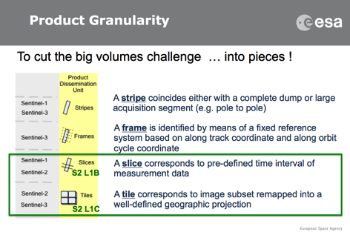
INPE/CRESDA - Ake Rosenqvist presented on behalf of Julio D’alge (INPE) and Chaohui Guo (CRESDA). The CBERS-2B expected launch date is December 27th, 2013. The CBERS data policy is free and open, and data is available for download from the web.
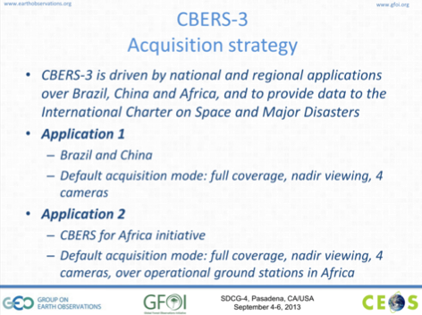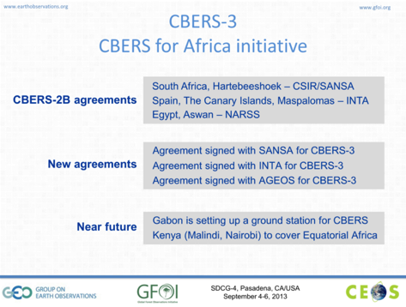
The CBERS for Africa initiative is working to get ground stations build and agreements in place, though the ground station network is still under development. Downlink to these ground stations is not currently possible. Given the expected availability of Landsat and Sentinel, the optimal role of CBERS is likely to focus on Brazil and China, as well as potentially gap coverage for cloudy areas.
CONAE/ASI - Ake presented on behalf of Laura Frulla (CONAE), noting that the planned launch year for SAOCOM-1A is 2015, and SAOCOM-1B 2016.
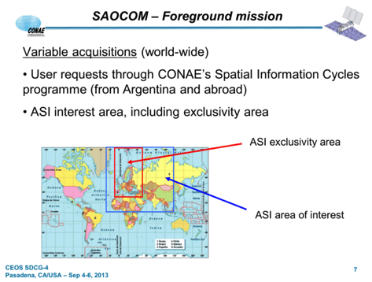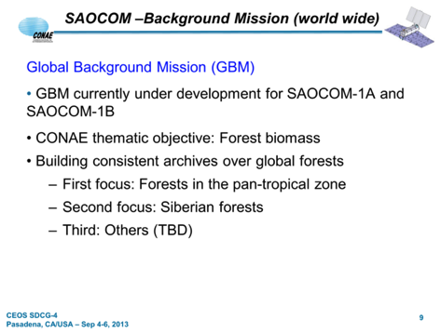
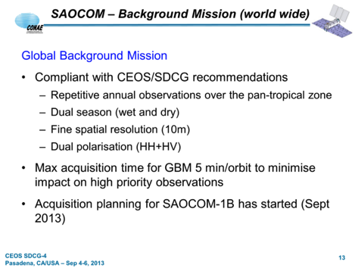
Stephen Ward asked about the data policy for SAOCOM for GFOI, and Ake noted that this hasn’t been discussed yet and that CONAE has been cautious in the past. Stephen suggested asking CONAE whether they could make a data policy statement on the background mission data in support of GFOI. Per-Erik noted that securing access for Svalbard for SAOCOM in exchange for access to SAOCOM GBM data for GFOI is one of the options currently being discussed. There was a suggestion that the timing could bring this together at CEOS Plenary to be hosted in Norway in October 2014.
CSA – Yves Crevier reported, noting that CSA has reviewed the Element 1 Strategy, and has confirmed that it represents the situation with respect to RADARSAT-2. He also noted that while RADARSAT ceased operations last year, its archive covering 17 years is available. The launch of RCM is currently planned for July 2018, and returns to the government owned and operated model. The main users of RCM are planned to be Environment Canada (ship navigation, oil spill, wind vectors), and Department of Defence.
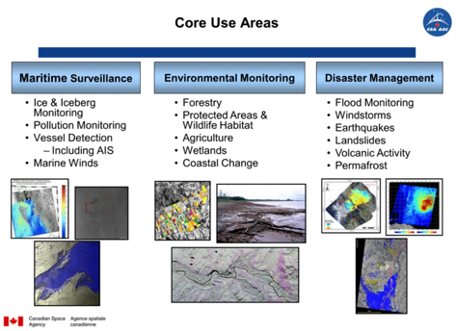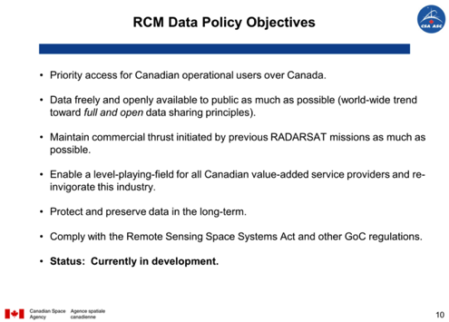
The operational guidelines for RCM are being developed in line with GEO’s “free and open” data policy guidance. CSA has requested SDCG to communicate its requirements officially to the RADARSAT mission manager. Yves noted that access to RADARSAT-2 data remains open for R&D-related activities, and added that there is excess capacity available in RADARSAT-2.
Contributing Data Streams
JAXA - Masanobu Shimada noting that the launch of ALOS-2 is not confirmed, but is expected within the next six months. Ake noted that the Basic Observation Scenario for ALOS-2 (BOS-2) is fully compliant with SDCG requirements.
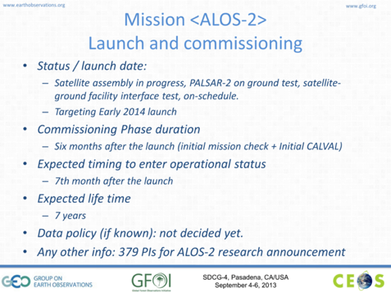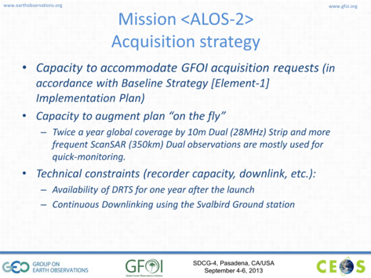
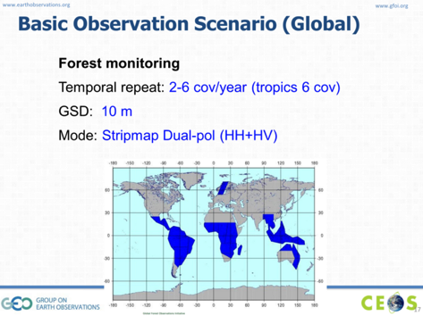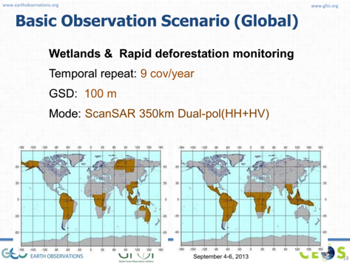
DLR - Frank Martin presented on behalf of Helmut Staudenrausch (DLR), noting that TerraSAR-X has provided support starting with the GEO-FCT Technical Demonstration sites. He also reviewed the status of the TanDEM-X mission, and current open opportunities.
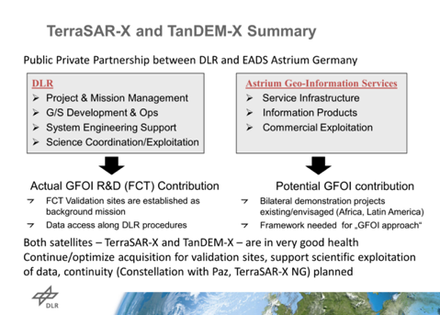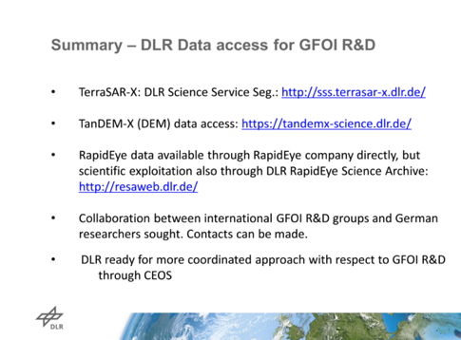
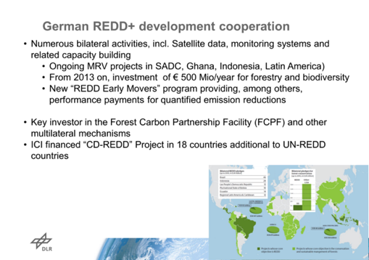
NSC - Evie Merethe Hagen reported, noting that NSC has been focused on the R&D and space data coordination pillars of GFOI. They have been asked by their ministry to work even closer with FAO to help ensure country access to satellite data. Brian asked if NSC has a priorities list of countries for data access, and Evie confirmed that this list has been developed.
Stephen Briggs noted that there is a need to ensure consistency between the M&G documents and the SDCG documentation and description of space data.
CNES – Steven Hosford presented a summary of an agreement on SPOT data over the Congo Basin. The reference year is 2010 +/- 2 years, and a repeat for 2015 +/- 2 years is being discussed. The 2015 dataset would be based on SPOT-6, and potential SPOT-7, using 6m multispectral data. Five national authorities have signed up to the scheme to date, and several research institutes have also been granted access. Steven also noted that there is an effort to get the SPOT 1-4 archive open for data five years and older at 10m.
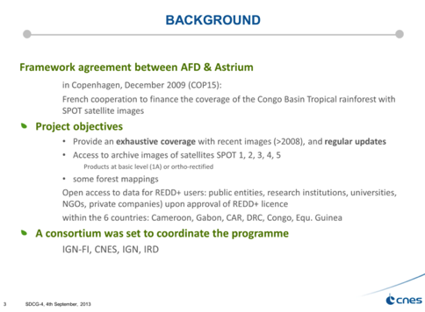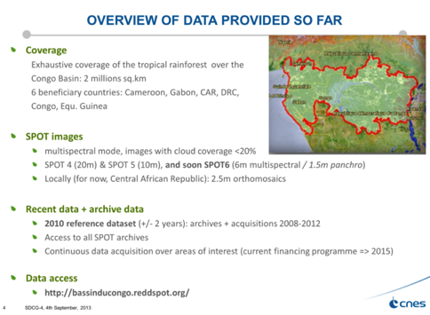

Element 1 Coverage and Future Plans
Brian Killough presented a summary of how the CEOS Systems Engineering Office (SEO) will support GFOI. He summarised a recent analysis of Landsat-7 coverage for 2013 performed by the SEO, as well as a summary of 2014 performance to date for Landsat-8.
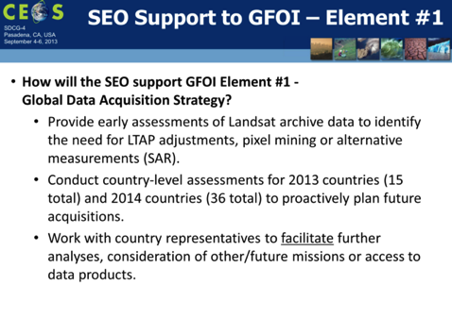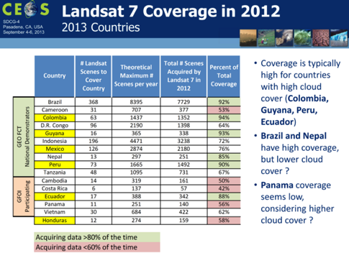
The SEO has prepared a country package for each of the countries participating in SDCG-4. These packages include background information on clouds and precipitation, Landsat historical coverage information, and coverage analysis.
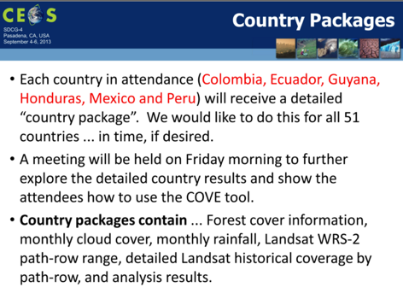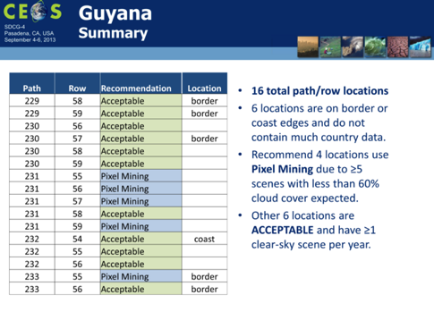
Tom Cecere noted that certain path-row combinations close the water boundaries are difficult to translate to L1T, and so for these scenes if pixel-mining techniques are the proposed solution, then some manual processing to L1T might be required. An analysis of the metadata should show which path-row combinations are worst impacted. It was suggested that ideally there would be 100% coverage (i.e. always on) over GFOI regions, or perhaps at least over cloudy regions.
Brian gave a summary of recent enhancements to the COVE tool.
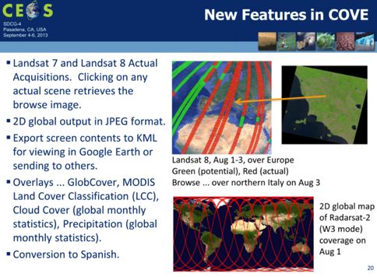
Brian asked about who would need to be contacted to further discuss WELD, and Tom noted that the eventual goal of the WELD group is a global composite product. He noted that prior to 2013, there really hasn’t been enough coverage of countries to generate composite WELD products globally.

2013-2014 Global Baseline Implementation Plans (Element 1)
Ake summarized the current status of missions that may potentially be able to contribute to the 2013-2014 Global Baseline implementation plan.
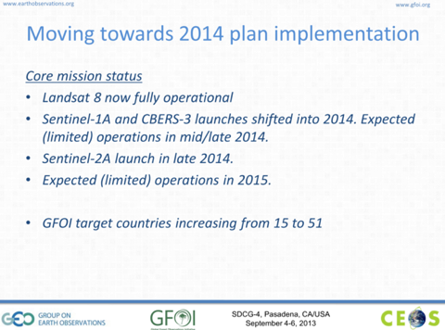
Ake reviewed the recommendations in the Element 1 Strategy for 2013:
SDCG-2013-1: Boosting the number of Landsat-7 and Landsat-8 acquisition opportunities over the priority countries. Based on the performance of Landsat-7 and Landsat-8, it is not really possible further boost the coverage – with Landsat-8 all possible acquisition opportunities are being taken. Gene Fosnight noted that while acquisitions are maxed out, they would welcome suggestions to address anomalies in the acquisition strategy.
SDCG-2013-2: Modify the LTAP in support of pixel mining. This is addressed in the same way as SDCG-2013-1.
SDCG-2013-3: Work with NASA/USGS on the implementation of global WELD.
SDCG-2013-4: Supported by key CEOS implementation partners, define a pixel mining service for GFOI.
SDCG-2013-5: Work with INPE/CRESDA on CBERS-3 acquisitions. A regional focus and gap-filling role has been defined for CBERS-3, but we will need to wait until the satellite is up before this item can be progressed.
SDCG-2013-6: Focus Sentinel-1 acquisitions in support of GFOI on the selected national wall-to-wall coverage role. This item will need to be rephrased, and reworked to identify the countries that can use national wall-to-wall C-band data. Stephen Briggs noted that we shouldn’t only consider the capacity of the countries, but also what guidance the M&G documents provide on the utilization of the data. There are simple things you can do with radar data that can improve the estimates of forest density. It was noted that the Sentinel-1 recommendation is framed by the ramp-up phase for operations, and that it would need to be revised to reflect full operations.
Ake outlined several 2014 Implementation Plan actions.
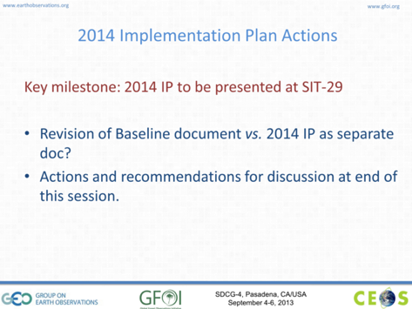
There are a few key points that will need to be reflected in the updated Element 1 strategy:
- Include a report on 2013 results and outcomes (including development of COVE reporting tools);
- Further detail the 2014 and 2015 implementation plans, and add a 2016+ plan;
- Revisit and update on the status of SAOCOM as a potential core data stream; and
- Work with the Sentinel-2 mission manager to ensure that acquisition planning is consistent with the Element 1 acquisition strategy.
It was agreed that the 2013 implementation results and outcomes report would be a separate document to the updated Global Baseline Strategy.

Data Supply for R&D Activities (Element 3)
Ake Rosenqvist presented a summary of data supply for GFOI R&D activities.
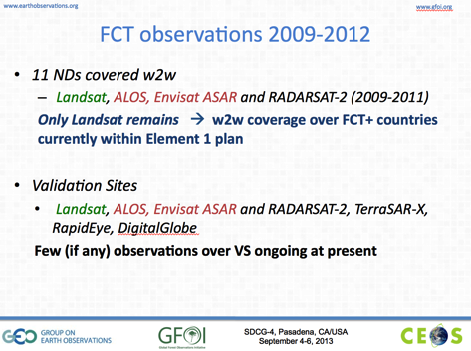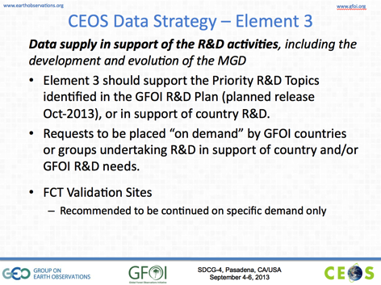
Yves Crevier noted that RADARSAT-2 could continue observations over validation sites if the details were communicated. However, it was agreed that in general such acquisition requests would only be made with a request from the country.
There was a discussion on the procedures to communicate R&D data requests.
- Landsat: Inline with the Global Baseline Strategy.
- Envisat: To be coordinated through Frank Martin Seifert.
- ALOS: 50 scenes per year per country at full res for GFOI, Ake is currently coordinating for Ecuador, Tanzania, Peru, Colombia.
- RADARSAT-2: Yves noted that the SOAR framework is in place for forests. He would like to see a pre-approval process of the projects within GFOI/SDCG, and based on that process RADARSAT-2 accounts could be opened. This could include early warning projects. He noted that the GFOI R&D plan could be attached to the SOAR to facilitate approval. He also noted that an AO between ASI and CSA has just been released focused on X-band and C-band interoperability. Responses can be submitted via a Canadian or Italian stakeholder – Yves could possible submit one, though they have never tried an internal submission.
- SPOT: Contact Steven Hosford. Frank Martin noted that with the de-orbit of SPOT-4, CNES have acquired dense high-resolution time series (every 5 days to simulate Sentinel-2 acquisition frequency) over many sites with different thematic purpose between February and June 2013. For forest degradation two sites in Gabon and the Republic of Congo have been monitored. ESA triggered as additional sensors RapidEye as Third Party Mission and Landsat-8. All EO data will be made available for non commercial use.
- RapidEye: Contact Axel Penndorf <penndorf@rapideye.com>.
- DLR: Contact Helmut Staudenrausch

GFOI Operational Scenario
Frank Martin Seifert introduced the discussion of the space data services and national data acquisitions.
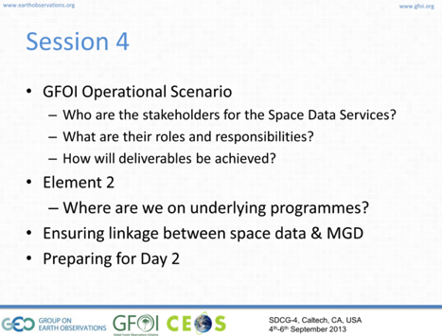
Stephen Ward introduced the topic of GFOI Space Data Services. Element 1 was aimed at demonstrating and stating the capacity of satellites to address the requirements for global forest monitoring. Element 2 is focused on defining data services on a country level. It was noted that while Element 1 focused on global acquisitions (i.e. all countries), Element 2 is focused on providing services to countries by request. There is a need for systematic communication with countries, including informing them that data acquisitions are underway, and ensuring they are engaged. It is also important to ensure that GFOI is well aligned with other efforts, including activities within the UN system (i.e. FAO).
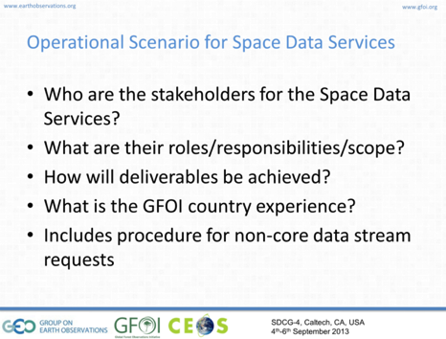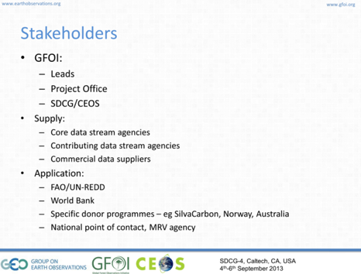
There is a need to ensure a good interface between the M&G documents process, and the space data strategy. Stephen Briggs noted that GFOI is working in support of countries, and that this support needs to be integrated across the pillars of GFOI – an end-to-end logic is required in order to ensure the processes and services being discussed are coherent. He also noted that the M&G documents don’t currently related or link well to the efforts of SDCG on the data coordination site.
Simon Eggleston presented a summary of the GFOI Operational Scenario, noting that there are a number of other actors working in the forest emissions and monitoring area.
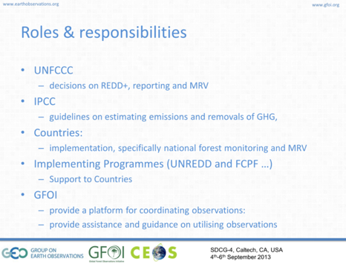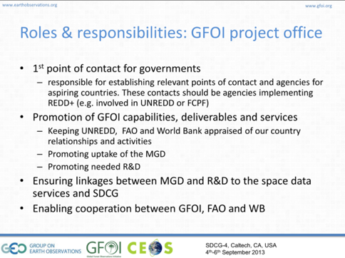
Stephen Briggs raised the issue of the need for the GFOI Office to rank implementation of activities outside the GFOI framework. Unless GFOI takes account of all the activities that are relevant, it will always have a partial/incomplete outlook.
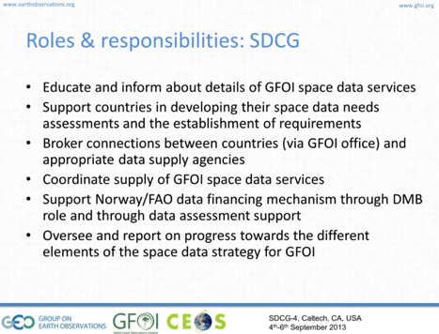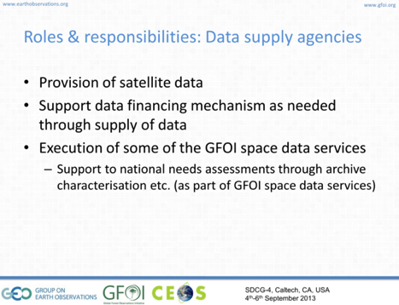
Ake Rosenqvist noted that in the past the SDCG has limited its scope to the missions of CEOS agencies, and that the topic of the interface to commercial providers needs to be discussed. Stephen Briggs noted that non-commercial and commercial providers should be coordinated, and that it would make sense if SDCG was involved in this coordination effort. GFOI should be providing a coherent suite of advice, and this group may be capable of advising on potential commercial data streams.
Yves Crevier suggested that any advice should be in terms of classes of instruments, rather than specific missions in order to avoid being seen to advocate on behalf of particular commercial solutions.
Stephen Briggs noted that the M&G documents are missing advice on what might be possible with higher resolution data, complementing the classes of data that are being coordinated by the SDCG. Stephen Ward noted that the SDCG should be central to the process of advising countries on all data streams – commercial and non-commercial.
Pontus Olofsson noted that it is important for the M&G documents team to get this kind of feedback. He also noted it would be useful to have a table of what satellite data is available and where. Ake noted that we can provide this for future acquisitions once the Element 1 strategy is implemented. The topic of a historical archive search is a separate one –the past archive is somewhat patchy due to the lack of coordinated acquisitions.
Pontus noted that the reason that the M&G documents don’t feature the use of radar data is because there aren’t currently examples of using radar to do large scale forest change mapping. If and when this capacity has been developed, the M&G document authors will be very happy to include it. Ake noted that in the past, there wasn’t radar data over large areas, and creating these larger-area data sets is a part of the purpose of the acquisition coordination being done by SDCG. Yves noted that past radar data was also single polarisation, single frequency – modern radar sensors can produce much more information rich data products.
Simon reviewed the GFOI deliverables. He noted that inputs on the GFOI Implementation Plan have been requested, but have only been received from the M&G documents group.
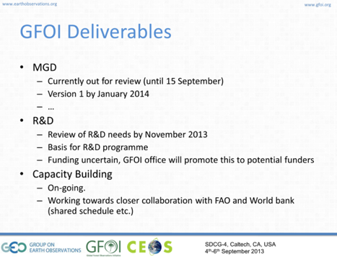
There is a need to discuss how SDCG and GFOI should address requests for non-core data. This involves a financial mechanism, as well as being able to justify non-core data purchases as returning value and improvement.
Stephen Briggs noted that in the past SDCG has relied on existing services, and end up with solutions that are not necessarily coherent – there is a need to start from exactly what’s needed, and then to devise a coherent set of solutions and services.
Sylvia Wilson noted that the countries expect to receive data streams, and are happy to convert this data into products. Frank Martin noted the gap between the data the countries have received, and what they expected, mainly due to the reduced number of satellites in orbit and restricted data policy.

GFOI Space Data Services (Element 2)
Stephen Ward summarised the GFOI Space Data Services, presented in the draft Element 2 paper which has been circulated.
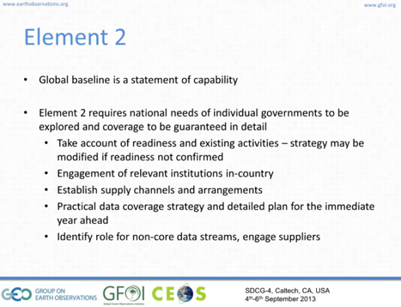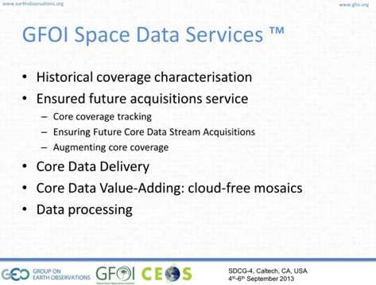
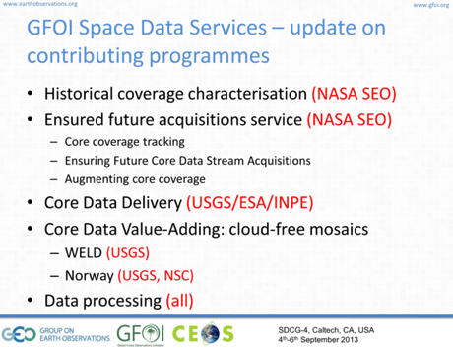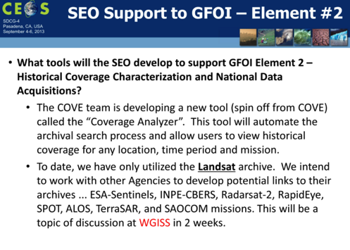
Brian provided a brief update on historical coverage, and service concepts that the SEO has been working on related to ensuring future acquisitions based on COVE. Brian noted that to date, the COVE team has leveraged Landsat metadata, and is discussing access to metadata from other missions. Stephen Briggs suggested initially focusing on historical data archives like RADARSAT, ERS-2, Envisat, rather than future missions like the Sentinels – whose metadata format is still in flux.
Stephen Briggs suggested that for the historical coverage analyser, we shouldn’t assume a priori that users will be able to indicate which instruments they want to see the data from. The tool should list all the data sources available for a given region and time period. He suggested looking at how ESA’s EOLI tool is organised.
Sylvia Wilson noted that a SilvaCarbon capacity building workshop is being planned for Bangkok, Thailand, likely in January 2014, which may be of interest.
Tom Cecere noted that all Landsat data acquired through December 2013 will be shipped via hard disk to the 16 countries on the GFOI list, as it has in the past. However, this activity is being phased out in general, and with 30+ more countries coming online the GFOI data shipping effort will not scale. He noted that the SilvaCarbon countries will continue to receive these data deliveries, but if this effort is to be extended, further resources would need to be identified.
Frank Martin confirmed that Sentinel data from the Copernicus Ground Segment will only be available via download from the internet. Sylvia noted that this download process is slow, and represents a significant issue for countries. Per-Erik Skrovseth noted that space agencies are not currently setup for the long-term provision of satellite data, and this discussion needs to take place – the word provision implies a commitment and resources by the data provider agencies. Ake suggested that the concept of regional data hubs may need to be revisited, serving a function as central data packaging and delivery facilities.
Stephen Ward asked what countries are likely to ask for, and Sylvia indicated that what they are going to want to hear is how to secure the provision of space data. SilvaCarbon can provision Landsat for one more year for SilvaCarbon countries, but after that there is no plan for the provision of Landsat data. Per-Erik noted that this again brings up the point about what the objectives of GFOI are, relative to all the other initiatives that are out there – especially when it comes to delivering data to countries. There is a need to ensure that countries understand that GFOI is not just a data provider, who will deliver data upon request. Sylvia asked what GFOI is providing if not data, and Per-Erik pointed to the M&G documents.
Tom presented a summary of core data value adding activities, including a global WELD prototype of several five year composites, centred on 2010.
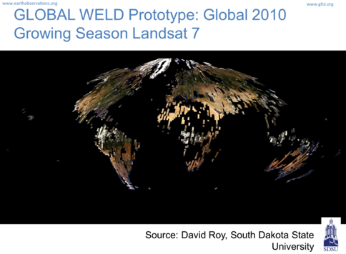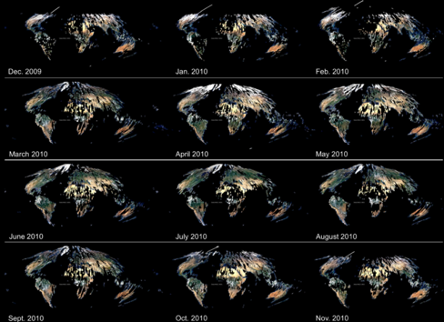
Frank Martin asked about the assessment of Earth Engine as a potential tool, and George Dyke indicated that based on what he’s seeing it should be considered as a potential platform for a “virtual processing hub”. Though a number of issues relating to data access and data policy need to be addressed to make best use of cloud-based data storage and analysis tools.
Steven Hosford asked about an exploitation platform for the Sentinels along the forest thematic, and Frank Martin replied that currently ESA prepares for an ITT on thematic exploitation platforms where forestry could be one of the themes.

National MRV Welcome and Introductions
Sylvia Wilson welcomed participants from the countries in attendance: Colombia; Peru; Ecuador; Mexico; Guyana; and, Honduras.
Simon Eggleston provided an overview of the background of GFOI, including the GEO-FCT activity.
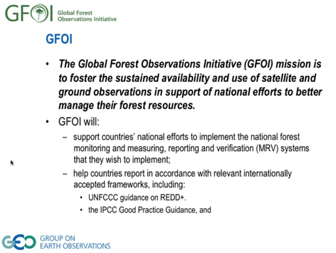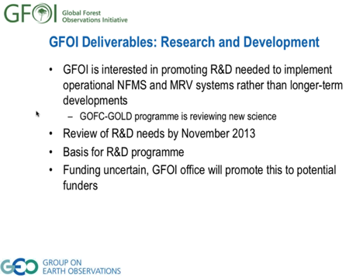
The issue of Core Data Streams was raised, and it was confirmed that in addition to Landsat-7 and Landsat-8, CBERS, and Sentinel-1 and Sentinel-2 are being considered in the near term. As well as SAOCOM and RCM subject confirmation of the data policy. The Core Data Streams are those which are useful for GFOI and are distributed free of charge.

SDCG role and GFOI Space Data Services
Stephen Ward presented an overview of the background and role of the SDCG.
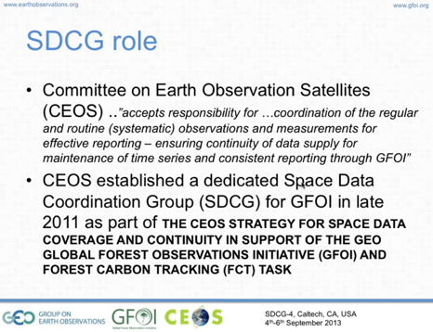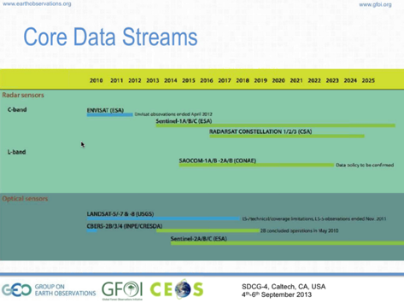
The objective of GFOI is to foster comparable and interoperable forest information products - starting with the use of common data and processing methods (i.e. GFOI Methods and Guidance documents). Stephen reviewed the GFOI space data services being considered, noting that the SDCG has drafted a paper summarising these services, and feedback and comment from SDCG-4 participants is being requested.
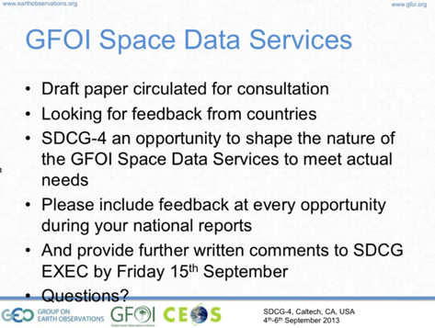

Country Presentations
Colombia – Edersson Cabrera presented, summarising the role of The Hydrological, Meteorological and Environmental Studies Institute of Colombia (IDEAM) in forest and carbon monitoring systems.
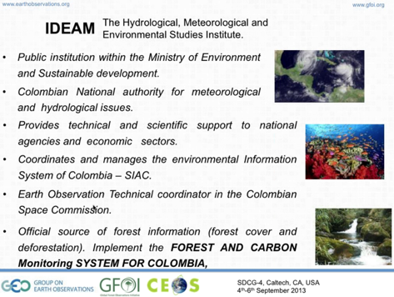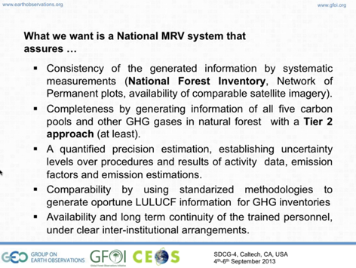
He noted that two years ago, the Colombian government took the decision to focus on forests and carbon emissions, and is pursing the development of a national MRV system.
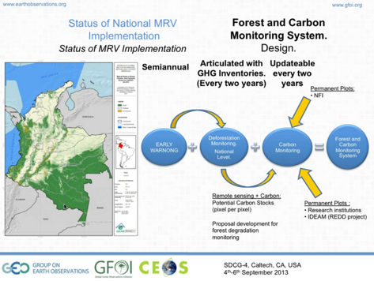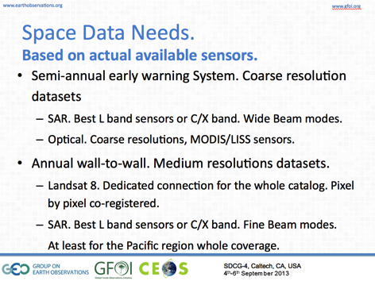
Edersson reviewed the space data needs for Colombia, as well as some additional data streams of interest.
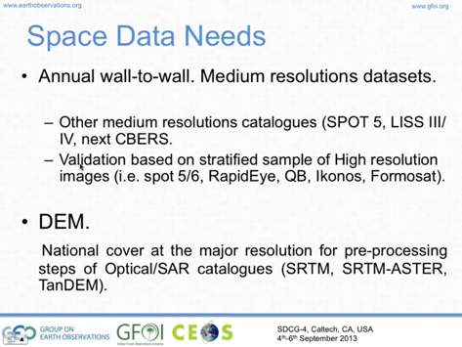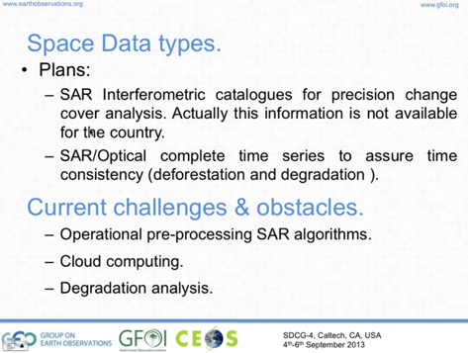
A discussion followed:
- Frank Martin Seifert asked if a reference year has been decided, and Edersson noted that 2000-2012 has been chosen. The Pacific and Amazon regions will be the initial focus, and these areas contain 80% of Colombian forests.
- Ake Rosenqvist asked about the accuracy requirement for the deforestation early warning system. Gustavo Galindo noted that the resolution will be similar to the Brazilian system, and the key is quick detection enabling detailed follow-up with high resolution data and in situ investigation.
- Gene Fosnight asked about the derivation of carbon stock information from the satellite data, and Edersson noted that a combination of methods (e.g. LiDAR, radar, in situ, etc.) is used. Currently the official carbon stock data is derived only from in situ data.
- Per-Erik Skrovseth asked about progress on implementation of the national forest inventory. Edersson noted that Colombia doesn’t have an official forest inventory, but does have historical information based on research plots. A national forest inventory has been designed based on FAO recommendations, and resources are currently being sought for implementation.
- Per-Erik noted that a number of the topics presented by Edersson (e.g. LiDAR) are in the R&D domain, and that feedback on R&D needs would be quite helpful for SDCG and GFOI.
- Stephen Ward asked about the space data needs, and the frequency of semi-annual information needs, and Edersson noted that data was required at least as every six months, or more frequently if possible.
- Stephen asked about which of the data needs have been addressed, and which have not. Edersson noted that their system is Landsat based, but that they need support in accessing the data – they are able to download scenes from the web, but internet capacity constraints limit this approach.
- Tom Cecere noted that a push-type system for Landsat images could be useful (though they don’t have the resources to implement), and asked if Colombia would be able to ingest this information. Sylvia noted that they probably couldn’t handle this, though Edersson noted that Colombia is considering a national system of catalogues which could help the ingestion.
- Sylvia noted that the countries have put together a consolidated set of space data requirements, which they can share.
- Ake noted that Colombia’s request for SAR data underscores the need to address SAR data processing in the GFOI M&G documents.
Peru – Renzo Giudice presented a summary of Peru’s experience in the development of their national MRV system, their reporting status, and space data needs. They are currently evaluating forest monitoring methodologies, and are in the initial phase of trying to design and implement a national MRV system.
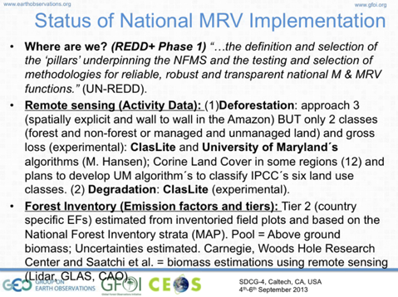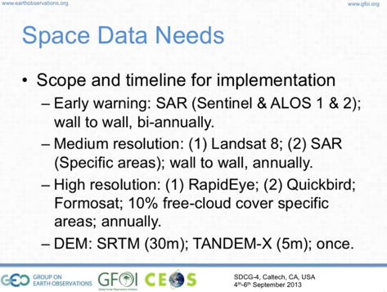
Renzo reviewed Peru’s space data needs, and a discussion followed:
- Tom asked about plans for the utilisation of LiDAR data, and Renzo noted this would be used for the preparation of emissions factors.
- Frank Martin asked where in the country SAR data would be useful for the purposes of coordinating possible Sentinel-1 acquisitions, and Renzo agreed to follow-up with Frank Martin, sending KML/shape file details of the regions within Peru where radar data would be useful.
- Stephen asked about whether Peru is considering using MODIS data for early warning, and Renzo confirmed that they are interested in using MODIS.
- Per-Erik noted that consistent terminology around the required resolution, for example medium resolution has different meanings for different groups and agencies.
- Per-Erik asked about the utilisation of SAR for early warning and what resolution might be required. Ake suggested this idea needs to be discussed in some detail - that early warning has been mentioned by both Colombia and Peru, and this appears to be a common theme.
- Frank Martin asked about whether Peru had considered a baseline, and Renzo indicated the planned period would be 2000-2010.
Ecuador – Mario Jijón presented a summary of Ecuador’s national MRV implementation. He reviewed their space data needs, noting that they need to submit their reporting by December each year.
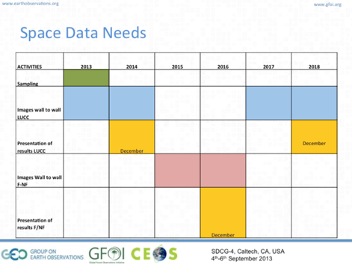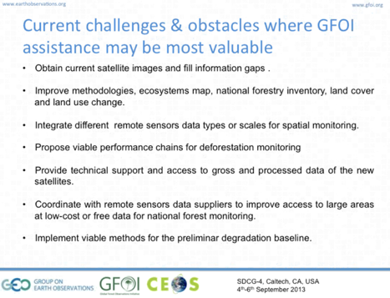
A discussion followed:
- Per-Erik asked about the monitoring unit and in particular the role of the measurement plots, and Mario noted that these are principally used for validation of modelling done with satellite data.
- It was noted that no early warning system need is currently identified.
- Frank Martin asked about establishing a historical baseline, and Mario noted that 2008-2012 will be used as the historical baseline.
Mexico – Alberto Sandoval presented the current status of Mexico’s national MRV implementation. He described a Norwegian-backed activity focused on the development of new methodologies for MRV.
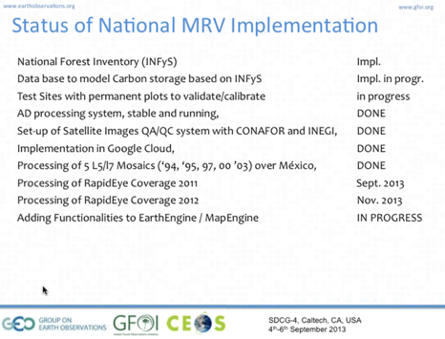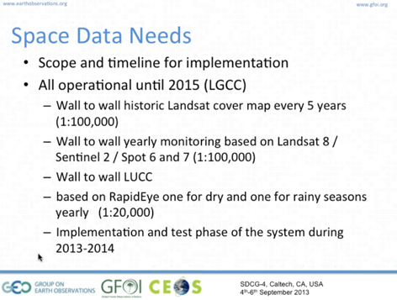
Alberto noted that there are 66 classes of land cover approved within Mexico, and its biodiversity represents a significant challenge for the MRV development. Mexico is using RapidEye wall-to-wall, with the need for high resolution data driven more broadly by a desire for the Mexican government to empower local authorities to use remote sensing data for natural resource management, and also by the diversity of land cover classes.
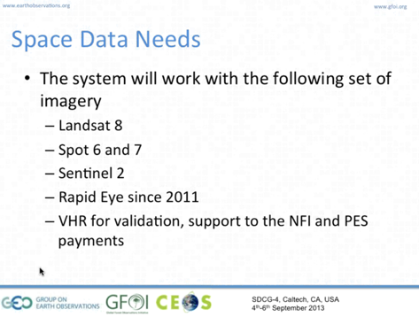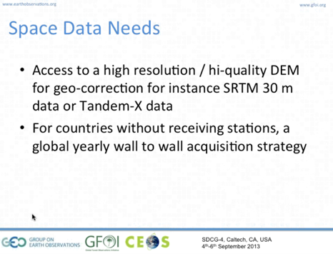
Alberto noted that the monitoring requirement for Mexico is in both the wet and dry seasons – meaning two complete coverages per year.
A discussion followed:
- Frank Martin asked about plans or discussion on the release of the SRTM dataset with 30 m resolution worldwide, and Tom noted that it is a US Government (NGA) decision. He noted that the process has been held up by internal discussions and questions, and its not clear when a global release might happen. There have been some past successes to have limited SRTM data sets released for regions in Africa based on the efforts of CEOS WGCapD.
- Frank Martin noted that a 90m resolution DEM from TanDEM-X will be freely available for research purposes, while the 12m resolution DEM is still available only on commercial terms.
- Ake asked whether Mexico would consider becoming a data node for Central American countries, and Alberto noted that while no decision has been made, this has been discussed.
- Alberto noted that their main concern isn’t the acquisition of initial images, but rather ensuring that the rate at which acquisitions are available will meet the needs of the MRV system.
- Yves asked about whether there were plans for future annual RapidEye acquisitions, and whether they had discussed mission continuity. Alberto noted that RapidEye has been quite responsive but currently there is no clear plan for continuity – though discussions are ongoing, including on alternate data streams.
Guyana – Pete Watt presented a summary of Guyana’s MRV, reporting status, and related space data needs on behalf of Guyana.
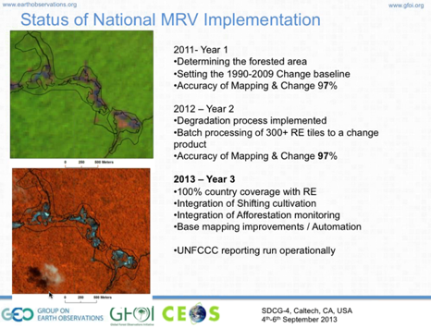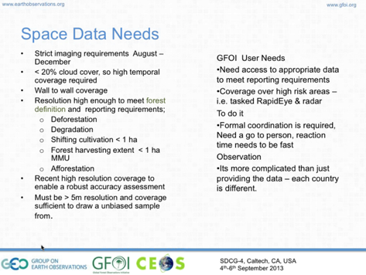
The cloud cover in Guyana meant that Landsat is not sufficient in order to meet reporting requirements (which include degradation), which drove them towards using RapidEye in order to ensure continuity of coverage across the country. For areas where they are unable to secure data in a given year, the reporting is done in the next year. Because they used RapidEye, they needed something higher resolution to do the accuracy assessment of the data – this year, they collected 25cm aerial data which cost $8000 for the country.
A discussion followed:
- Brian Killough asked why they are restricted to August-December, and Pete noted that this was a requirement from Norway.
- Brian asked what drove Guyana to use RapidEye data, and Pete noted this is driven by the requirement to generate degradation products as well.
- Ake asked how they ensure that the Landsat and RapidEye data are interoperable, and Pete noted that this is picked up in the manual data processing.
- Pete noted that they have worked with Dirk Hoekman in the past on radar data, but availability was a challenge. They haven’t found any radar data streams to date that they are interested in working with.
- Frank Martin asked whether Sentinel-2 would provide sufficient resolution to derive degradation, and Pete indicated it would likely meet the requirement.
- Yves asked about capacity issues in Guyana, and Pete noted that they are engaged on a contractual basis, which represents value for money if the country passes the national assessment process. He also noted that keeping expertise and capacity from year to year is a challenge as about half the local experts tend to leave after a reporting season.
- Per-Erik asked about the GEO-FCT efforts to test radar data in Guyana. Pete was familiar with this effort, but it was mostly post-graduate studies work.
- Frank Martin asked about the baseline, which for Guyana was 1994 as a year where a NFI took place. They are currently in the process of improving the base forest/non-forest layer using RapidEye.
Honduras - Efraín Duarte presented a summary of Honduras’ MRV implementation status, and summarised the space data needs for Honduras.
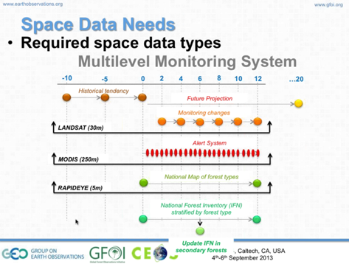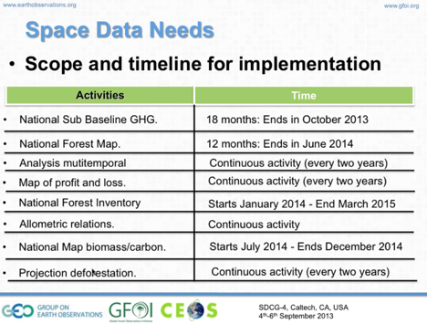
A discussion followed:
- Per-Erik asked about the second round of plots, and the frequency of revisit planned for these plots. Efraín noted that 2005 was the first set of plots, and the repeat will be targeted for 10 years later (e.g. 2015).

Practical Solutions and Actions on Data Supply
Gustavo Galindo presented a summary table of the regional space data data needs across the six countries.
Early Warning | High and Medium Resolution
SAR (Sentinel, TerraSAR, COSMO-SkyMed, ALOS I and II) | Landsat 8 (co-registered) - wall-to-wall
MODIS (continuity) | SAR - specific areas (C/X bands)
 | LISS III/IV
Very High Resolution  for use in validation; 10% of country area (annual & free of clouds) | DEM
RapidEye (5) - most important | SRTM - need 30m
IKONOS (1) | TanDEM-X - need 5m
QuickBird (2) - 2nd most important | Other options?
SPOT6 (3)
Worldview2 (1)
Nigersat II (1)
FORMOSAT (2) - 3rd most important
Gustavo noted the need to facilitate interpretation of medium resolution for training data development. He also noted that data distribution solutions were needed for specific areas – in many cases this means hard copies on hard drives delivered directly to country. For wall-to-wall data sets, FTP/internet speed is inconsistent, and even in the capitals connectivity is spotty. Another alternative would be to have all the data compiled in one place (e.g. active in-country, Woods Hole, etc.). A discussion followed:
- Ake asked about whether one of the countries would serve as a hub for the other countries in South America, and Gustavo noted this would be an option – but at present none of the countries have the capacity.
- Per-Erik noted that Sentinel-3 is a potential continuity option for MODIS.
Gustavo noted that L-band SAR should be added under the high and medium resolution data streams.
SDCG Response
Stephen Ward summarised the key points that SDCG will need to consider responding to.
- Early Warning and MODIS continuity. The first choice as a follow-on for MODIS is VIIRS, though it may not be ideal. Other options include Sentinel-3, GCOM-C (if it gets funded), and for early warning itself perhaps ScanSAR will be an option. It looks like ALOS and ALOS-2 will both be made freely available above 50m, which may make ALOS-2 a potential candidate for early warning.
- Wall-to-wall coverage needs. The combination of Landsat and Sentinel-2 is assumed to be the global solution for GFOI. Sentinel-2B will follow Sentinel-2A by 18 months, and they are expected to overlap by six years.
- Historical data coverage. There may be an opportunity for SDCG (via the CEOS SEO) to build some of the connections required to bridge space agency databases and the user systems – through efforts like WGISS and CWIC, and the LSI Explorer. It was noted that country-by-country guidance is required to start off the historical archive search, for example feedback on existing data sets, existing requirements, desired baseline year, etc.
- DEM data. Exploring the possibility of releasing a 30m DEM with TanDEM-X or SRTM.
- Data support. Including assembly and delivery of datasets in light of internet bandwidth restrictions.
Stephen noted that the countries are being asked to review the GFOI M&G documents, which have been under development for more then a year by a wide range of experts. The plan is to have these documents finalised by the GEO Plenary in January 2014.
Stephen ask that the countries provide feedback on the GFOI Space Data Services paper, and encouraged countries to let us know if any of the services specified are not useful, or if any services are missing. The paper is being used as a tool to develop the dialogue, and communicate requirements to the CEOS agencies.

Institutionalization of Capacity
Evie Merethe Hagen gave an overview of a proposed fast-track delivery mechanism for REDD+.
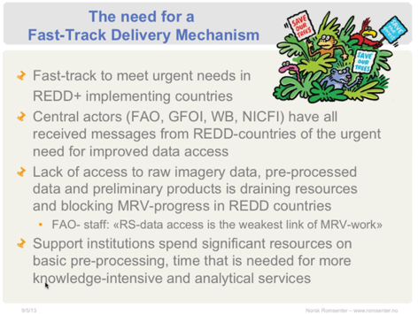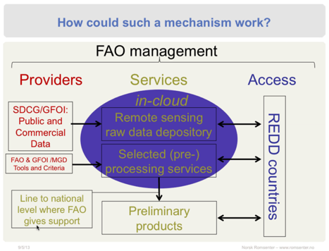
She is working to develop a two-page concept note that they hope to circulate for comment by the end of September, including a list of initial target countries. A full proposal will follow before the end of the year. The objective of the proposal is to provide rapid support to those countries that are in need of data and capacity in order to progress their MRV systems. Frank Martin asked whether the DEM data sets discussed could be in the scope of this activity, given that many of the countries presenting here today were interested in these data sets, and Evie indicated this could be in scope.
It was agreed to that is a need ensure that this effort is well coordinated with ongoing GFOI and SDCG efforts.

GFOI Country Relationship Management
Simon Eggleston presented a summary of plans for GFOI country relationship management, noting that GFOI is aiming at practical support to countries implementing REDD+/National Forest Monitoring Systems/MRV Systems – this requires a link to those in countries directly involved in these activities. He stressed that this is a country led process, and that the systems must meet individual country needs, requirements and circumstances while also complying with UNFCCC decisions and IPCC Guidelines. GFOI aims to complement exiting support from FAO, World Bank etc., and is not an alternative to them. This support is provided around the provision of, and guidance on the utilisation of earth observation data.
He outlined plans for national needs assessments, and future plans for the development of GFOI country involvement.
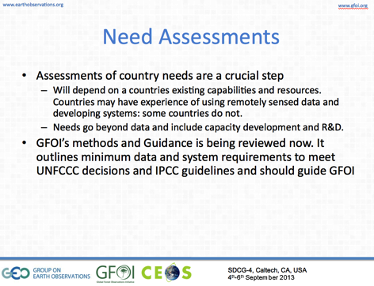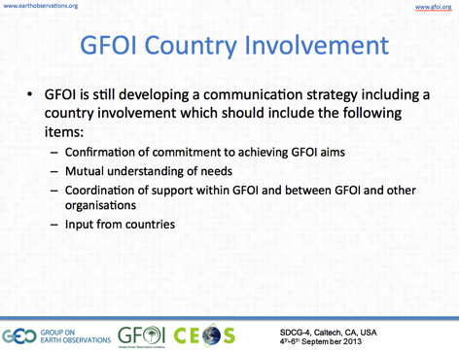

Indonesian MRV Activities
Nikki Fitzgerald presented on behalf of Indonesia, noting that Australian has been working with Indonesia on building the remote sensing side of a carbon accounting system since July 2008. She reviewed the basic principals of the design of the system.
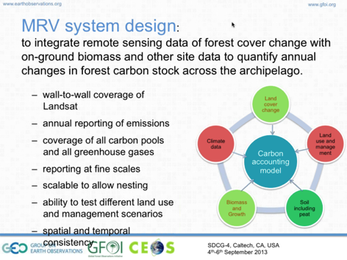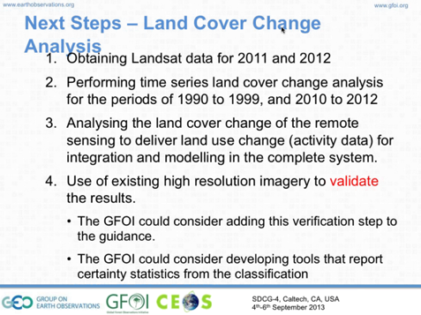
A discussion followed:
- It was noted that MODIS continuity, as well as other approaches on rapid detection have been discussed here today, and some follow-up actions have been identified.
- Pontus Olofsson noted that the GFOI M&G document currently doesn’t recommend MODIS data for change detection because a lot of disparate observations get binned into a single pixel. This means you see a lot of change, even when no change is present, and the result is that you have a large number of errors of commission.
- Ake noted that this is a MODIS unique issue, and Pontus noted that VIIRS will also have the issue, as it is a wide scanning whisk broom instrument issue. Sentinel-3 is a push broom scanner and so it will not have this issue.
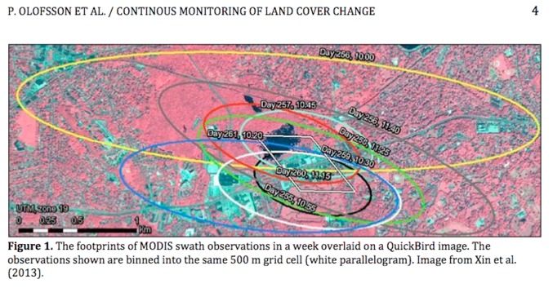
- Pete Watt asked if there’s any timeframe for the consideration of degradation for Indonesia. Nikki noted that they are awaiting a methodology for degradation to be released, and also focusing on completing the forest change detection. She noted that the key is that it is operational, and it doesn’t necessarily have to be based on Landsat.
- Masanobu Shimada asked how Nikki they address the cloud problem. She noted that the scene selection process looks for imagery that is cloud free over forest areas, and that there are only 5-6 years out of the 20-year period where clouds have been a challenge. In those cases, they have used a statistical model whereby if a pixel is forest one year, cloud the next, and then forest again – the assumption is that the cloudy pixel was forest.

Follow up on National MRV Support Discussion
There was a general wrap-up discussion, reviewing a number of the key points from SDCG-4, and looking ahead to SDCG-5 and deliverables for SIT-29, as well as follow-up with the countries who participated in SDCG-4.
Country Follow-ups, SilvaCarbon, and Scaling
- It was agreed that there is a need for a broader discussion between the GFOI leads, SDCG, and GFOI office to discuss country relationships and how to scale that effort. Two things need to be ensured: consistency of the country contacts and responsibilities; and, a consistent approach to what the technical products should be and therefore what the remote sensing data is required.
- It was agreed that SDCG needs a plan for which countries can be supported year-by-year, and it is clear that we can’t directly support all countries.
- Countries have diverse, heterogeneous interfaces, sponsors, and levels of maturity. This implies the need for some sort of intelligent process, and work with the countries on data selection.
- It was also agreed that there was a bottom-up need for SDCG to follow-up on the country needs expressed at SDCG-4. Sylvia Wilson took an action to summarise these needs, and the SDCG took an action to follow-up point-by-point, and possibly with dedicated GoToMeeting sessions if appropriate.
- The possibility of a GEO Ministerial outcome showing GFOI providing data and services to a country for Mexico and/or Colombia was raised.
- It was agreed that a plan is needed for SDCG to engage countries in Asia at the SilvaCarbon workshop being considered for January 2014 in Bangkok.
- The topic of DEM data was raised by most of the countries, and it may be that the SRTM DEM release will require case-by-case agreements with the countries. Kerry Sawyer noted that for the WGCapD workshops, they were only able to secure the release of South Sudan and Somalia.
Updating the Global Baseline Strategy (Element 1)
- It was agreed that SDCG should focus on data streams supporting the target products in the Element 1 document, and that if additional target products are identified, appropriate data streams should also be added to support.
- There was a discussion about the need to need to add reference to early warning inputs like MODIS, VIIRS, Sentinel-3, etc. However, these “early warning” products are already included in the Element 1 strategy (product B3, Near-Real Time Forest Change Indicators). However, the supporting data streams are not addressed explicitly in the implementation of the acquisition strategy as there are no acquisition decisions to be made. However, it was agreed that SDCG should address continuity of MODIS-class data streams in the Element 1 strategy.
- It was noted that using SAR for early warning, monthly acquisitions are likely sufficient as you can be assured you’re going to get an acquisition. Yves noted that RADARSAT-2 uses tropical forests as part of its calibration inputs, and it might be possible to use these data sets as a trial.
Links Between Across GFOI: SDCG and the M&G Documents
- It was agreed that SDCG should submit a set of comments on the M&G documents by the 15th September deadline, and Stephen Ward and Stephen Briggs are coordinating these.
- Stephen Briggs noted that the front end of the M&G documents need to provide more practical guidance to countries, in terms of decisions to make in designing their MRV systems. He also noted that the back end does a good job of describing how you get from the higher level products to an emissions report, but doesn't describe how you get this high level products from remotely sensed data
- It was noted that the M&G documents do need to address SAR data sets more comprehensively, especially based on country feedback at SDCG-4. Though it was noted that the M&G documents work hard to stay focused on operational products, and SAR is not yet in that domain. It was acknowledged that SAR has a bit of a “chicken and the egg” problem now in the sense that without operational methodologies, it is hard to include them in guidance to countries. However, it was agreed that a more middle ground would be sought.
- For example, some countries may wish to use SAR as an early warning data stream, and advice on this needs to be added.
- There is a need to ensure consistency between the terminology and data streams included in the SDCG Global Baseline Strategy, and the M&G documents.
Developing the GFOI Space Data Services Strategy (Element 2)
- It was agreed that the next steps in developing the Space Data Services Strategy are to: develop consultation plan based around feedback from the countries, and the next update of the Element 2 paper; broader circulation of the Strategy paper; an outline of the Strategy document; and, then writing assignments and activities.
- Stephen Briggs suggested the following re-organisation of the GFOI Space Data Services as follows: Core Data Delivery; Core Data Products; and, Information Products and Services.
- Two additional services were discussed: a series of Space Data Workshop; and, a space data needs assessment support service.
- It was agreed that the Strategy should leverage existing activities (e.g. SilvaCarbon, FAO, etc.), and to target identifying initiatives in Latin America, Asia, and then Africa.
Fast Track Proposal
- Evie summarised a proposal to fast track services and data to countries that she has been discussing with a number of actors, including within Norway and at UN-FAO. It is built around the mandate that FAO has to support countries directly.
- The group is seeking GFOI and SDCG feedback and engagement in the development of this proposal. She noted that this will be discussed at a meeting at FAO at the beginning of October.
- It was noted that this proposal needs to be formally routed through the GFOI leads so that the effort is well coordinated with other GFOI efforts.
- Stephen Briggs stressed that the GFOI partnership should draw on the strengths of its partners – incluiding CEOS, FAO, Norway, Australia, World Bank, etc.
- Gene Fosnight asked if hosting someone at EROS to support data delivery to countries could be useful, and that this could be done through the UN office at EROS. It was agreed that this could be a useful step.
- Actions were agreed for Evie to liaise with the GFOI Co-Leads on the proposal, and to circulate a summary of the proposal to the SDCG EXEC for comment. And for Ake to coordinate SDCG involvement and input in the proposal.
Progress towards SDCG-5 and SIT-29
- It was agreed that Frank Martin Seifert would draft one page summary of SDCG-5, including location, consideration of a country day at/in coordination with FAO, and objectives of the meeting.
- Frank Martin confirmed that he has blocked rooms at ESRIN for the week of 24th February for SDCG-5.
- It was agreed that an effort would be made by Stephen Ward and Stephen Briggs to hold a GFOI leads meeting during the same week, allowing for participation in both meetings, in order to make best use of travel resources.
- It was noted that the December GFOI leads meeting is also being held at FAO.
Other Items
- Per-Erik Skrovseth was given an action to work on a potential SAOCOM outcome to be delivered at CEOS Plenary 2014 in Norway based on making a pan-tropical L-band data set available to GFOI. He should provide a status update at SDCG-5.
- It was noted that ALOS-2 is looking like a possible core data stream (i.e. 25m data) based on changes in JAXA’s approach.
- It was agreed that Ake and Stephen Briggs would handle reporting at the SIT Technical Workshop, and that a presenter and materials still need to be identified for CEOS Plenary in November.
Work Streams
The following main work streams were agreed for follow-up from SDCG-4, and towards SDCG-5 and SIT-29 – with the leads as noted. Leads are responsible for defining outcomes from these work steams, and ensuring their delivery.
- Element 2 paper consultation and revision (Lead: George, Contributing: SDCG EXEC)
- South American requirements (Lead: Sylvia Wilson, Contributing: Simon Eggleston, CEOS SEO)
- Fast Track Paper (Lead: Ake Rosenqvist, Contributing: Steve Briggs, Stephen Ward)
- 2013 Implementation Report (Lead: Gene Fosnight, Contributing: CEOS SEO)
- 2014 Strategy Update (Lead: George, Contributing: SDCG EXEC)
- M&G Document Interoperability within GFOI with SDCG and Better Reflect Countries (Lead: Stephen Ward, Contributing: Stephen Briggs)
- MODIS Continuity and Early Warning (Optical Lead: Gene, Radar Lead: Ake)
- Sentinel Mission Links (Lead: Frank Martin)
- DEM Thread (Lead: Frank Martin, Contributing: Helmut Staudenrausch)
- SCDG-5 (Lead: Frank Martin, Contributing: SDCG EXEC)
- Commercial providers (Lead: Ake, Contributing: Evie)
- Three Year Vision for SDCG (Lead: Stephen Ward)

GEOGLAM Update and Possible Synergies with GEOGLAM
George Dyke and Brian Killough provided a brief overview of the current activities of the CEOS ad hoc Working Group for GEOGLAM. This includes the development of a CEOS Acquisition Strategy for GEOGLAM Phase 1 (2013-2015) to be presented at CEOS Pleanry. A discussion followed:
- Ake Rosenqvist noted that in the case of optical data streams, overlapping requirements mean synergy, but in the case of SAR data streams, overlaps could mean mode conflicts.
- Stephen Briggs noted that agriculture is a high priority for ESA, and they expected to be able to support the GEOGLAM Phase 1 Acquisition Strategy at CEOS Plenary.
- Brian Killough noted that the real challenge of GEOGLAM is the temporal revisit. He also noted that the CEOS SEO would welcome feedback on how it can best support GFOI and GEOGLAM, and the coordination between the two. For example, by way of the COVE tool or other analysis support.
- Yves Crevier noted that optimising land cover resources is a general issue for CEOS, and there is an open question as to whether CEOS keeps its efforts ad hoc, or works towards true coordination.
- The importance of coordination between GFOI and GEOGLAM from the very start was stressed.
- Brian reviewed what he expects GEOGLAM will be asking CEOS Plenary for this year: Support GEOGLAM acquisition planning with appropriate agencies; adjustment of acquisition plans for GEOGLAM countries if not already covered; facilitation of the acquisition of evaluation data where possible (e.g, JECAM, and GEOGLAM applications development); and, any known agriculture-related projects they are aware within their agencies and/or countries that could contribute to GEOGLAM.

SDCG-4 Attendees
Organisation | Participant | Organisation | Participant
CEOS DCEO (NOAA) | Kerry Sawyer | FAO(/Mexico) | Alberto Sandoval
CEOS SEO (NASA) | Brian Killough | GEOSEC | Osamu Ochai
CEOS SEO (NASA) | Paul Kessler | GFOI Office | Simon Eggleston
CEOS SEO (NASA) | Kim Keith | GFOI MGD | Pontus Olofsson
CNES | Steven Hosford | Honduras | Efraín Duarte
Colombia | Edersson Cabrera | Indufor(/Guyana) | Pete Watt
Colombia | Gustavo Galindo | JAXA | Masanobu Shimada
CSA | Yves Crevier | NSC | Per-Erik Skrovseth
DCCEE/Australia | Nikki Fitzgerald (GTM) | NSC | Ake Rosenqvist
DCCEE/Australia | Kim Moore (GTM) | NSC | Evie Merethe Hagen
DCCEE/Australia | Stephen Ward | Peru | Renzo Giudice
DCCEE/Australia | George Dyke | USGS | Tom Cecere
Ecuador | Mario Jijón | USGS | Eugene (Gene) Fosnight
ESA | Stephen Briggs | USGS (SilvaCarbon) | Sylvia Wilson
ESA | Frank Martin Seifert

SDCG-3 Action Item Status Table
No. | Action | Due date
SDCG-3-1 | Helmut Staudenrausch to research and summarise the various options for access to global and/or national DEM information for consideration by SDCG. (This is partially a data access issue – we know a number of acquisitions and archives exist.) Kerry to help link with ongoing DEM-related activities within WGCapD, WGISS, and WGCV. | COMPLETE  Helmut circulated a comparison of available DEMs in July 2013. Kerry suggested contacting CEOS WGCV, WGCapD, and WGISS – follow-up remains to be done.
SDCG-3-2 | SDCG EXEC to follow-up with CONAE and NSC to confirm the status of plans for downlinking SAOCOM data to Svalbard – in particular on when this capability might extend SAOCOM’s coverage and capacity to deliver pan-tropical data sets for GFOI. | COMPLETE  Capacity not yet established. Ake pursuing follow-up with Norwegian MoE.
SDCG-3-3 | Frank Martin to provide a table of countries that are active in C-band SAR usage with a view to element 2 engagement and coordination of Sentinel-1 national wall-to-wall data sets. | 28 February 2013
SDCG-3-4 | Frank Martin to work with Inge Jonckheere to identify which countries from the top-20 cloudy countries in the element 1 strategy that she feels may have the capacity to use C-band SAR, with a view to element 2 engagement and coordination of Sentinel-1 national wall-to-wall data sets | 28 February 2013
SDCG-3-5 | Julio to provide a summary and any details available on the expected expansion of CBERS coverage under the CBERS for Africa program. Julio to ensure that references to CBERS in the element 1 strategy reflect the increasingly global nature of its coverage. | 28 February 2013
SDCG-3-6 | Ake to work with Helmut to revise the phasing table (3.1 in v28) to reflect the new German Ministry of Environment program (International Climate Initiative, http://www.bmu-klimaschutzinitiative.de/en/home_i) which is expanding the number of UN-REDD+ countries through funding to FAO. | COMPLETE
SDCG-3-7 | Helmut to confirm the nature of the link between the German Ministry of Environment International Climate Initiative and UN-REDD+. | COMPLETE  The link between BMU/ICI and REDD+ is the CD-REDD project, see: www.cdredd.org.
SDCG-3-8 | SEO to advise on what is possible in terms of visualising on going acquisitions, starting with Landsat, considering several options including COVE and Earth Engine. | COMPLETE  SEO to report during SDCG-4 Session 2.
SDCG-3-9 | Ake to update v28 Table 4.4 to reflect that CBERS-3 can contribute to the generation of the C2 product. (Adding a delta, for contributing, rather then sole source.) Should also check consistency for other sensors listed in these tables | COMPLETE  in v29
SDCG-3-10 | Ake to confirm the cost and terms for ISRO’s offer to provide AWiFS data. (Understanding is free of cost.) | IN PROGRESS  ISRO, “working on the modality of supporting the GFOI activities with AWIFS data supply”
SDCG-3-11 | Frank Martin to confirm the status and capacity of ESA Landsat ground stations for both Landsat-7 and Landsat-8. | 28 February 2013
SDCG-3-12 | Ake should update the LTAP recommendation in the element 1 strategy to optimise coverage with respect to pixel mining approaches to specify only over the pan-tropical region, rather then globally. | COMPLETE  Reflected in the global strategy (Element 1).
SDCG-3-13 | Ake to confirm the preferred Sentinel-1 beam mode for GFOI (interferometric dual-pol mode?), and ensure that it is reflected in the element 1 strategy. | COMPLETE  Interferometric wide swath dual-pol mode
SDCG-3-14 | Ake to add the expected 2016 global coverage figure to the element 1 strategy. Also update to include the South African ground station for CBERS-3/-4. | COMPLETE  Reflected in the global strategy (Element 1).
SDCG-3-15 | SEO to update its analysis for DRC and Guyana to include 2011 and 2012 (currently ends at 2010) to see if there is a bump in the number of acquisitions after these countries became FCT National Demonstrators. | COMPLETE  A bump in Landsat-7 acquisitions was found.
SDCG-3-16 | Stephen to share a mature draft of the GFOI country paper once it is ready for circulation. | COMPLETE  Draft Element 2 (data services) paper has been circulated a number of times for comment.
SDCG-3-17 | John and Frank Martin to create a draft 0 of a table of country specific satellite archive data availability for Guyana based on the list of sensors suggested by Stephen Briggs. SEO/Brian to provide significant inputs for Guyana based on his analysis to date. Helmut to provide inputs for RapidEye and TerraSAR-X and TanDEM-X, and Ake for ALOS and JERS-1. The draft table will be presented at SIT-28 as an example of a service that SDCG could provide under its element 2 strategy. The draft table will also be provided to the MGD community to provide feedback and suggestions for how this SDCG service could be implemented and improved. | COMPLETE  Draft table was sent to Stephen Briggs for feedback from the MGD group. Feedback pending.
SDCG-3-18 | Evie to coordinate the SDCG plan for 1-2 data delivery pilots starting in 2013, and provide potential candidates and a summary of the way forward to be reported at SIT-28. | IN PROGRESS  To be discussed at SDCG-4 Session 5 and 6.
SDCG-3-19 | Helmut to provide Ake and Julio with details of a new Brazilian R&D activity funded by DLR, starting in May 2013, as an input to the GFOI R&D plan. | COMPLETE  PoC is Patrick Hostert (patrick.hostert@geo.hu-berlin.de), Humboldt-Uni Berlin, and a contact has been established between him and Julio as well as with Dalton Valeriano.
SDCG-3-20 | Helmut to review and advise on relationship between core and contributing data streams (section 5.2). | COMPLETE  Reflected in the global strategy (Element 1).
SDCG-3-21 | Ake to provide Brian with a list of ground stations to implement in COVE and provide an export to KML. | COMPLETE
SDCG-3-22 | SDCG EXEC to formulate a list of feasible date-location combinations for SDCG-4. | COMPLETE
SDCG-3-23 | SDCG EXEC to confirm the date and location for SDCG-4. | COMPLETE
SDCG-3-24 | Ake to contact Inbal Becker-Reshef to provide the details of the ongoing LDCM/Sentinel-2 interoperability R&D activity, including the names of those involved from NASA, CNES, and ESA. | COMPLETE  The main European contributors (for now) are: Olivier Hagolle and Gerard Dedieu from CESBIO, and Richard Santer (Calibration) from University of Littoral in Wimereux. From the US, the contacts are Eric Vermote and Jeff Masek from NASA GSFC, and Chris Justice and Martin Claverie from UMD.
SDCG-3-25 | Ake to circulate the next revision (v29) of the SDCG element 1 strategy as the new baseline for writing pushing towards SIT-28. | COMPLETE
SDCG-3-26 | SDCG agencies to review v29 of the baseline strategy and review, revise, update, and confirm agency specific content and sub-sections. | COMPLETE
SDCG-3-27 | Brian/CEOS SEO to recommend potential web services that could be developed to streamline the ability of countries to perform an archive search, starting with Landsat, but also considering other core and then non-core satellite data archives. | COMPLETE  SEO to report during SDCG-4 Session 2.

