Data Acquisition Analyses for the
Global Forest Observation Initiative (GFOI)

Philippines

CEOS Systems Engineering Office (SEO)
Brian Killough, Kim Holloway, Paul Kessler, Shaun Deacon
October, 2014

Introduction

This report summarizes country-specific information and Landsat data acquisition information in support of GFOI. It is anticipated regional teams will use the contents of this report to plan future data acquisitions in support of GFOI objectives. The CEOS Systems Engineering Office (SEO) welcomes feedback from country representatives to confirm the contents of this report and explore how this data can be best used to support the needs of countries as they assess forest cover for GFOI.

Section 1: Country Background Information

Total Area: 30 Mha Forested Area: 7.7 Mha (25.7%)
Reference: Mongabay Environmental Science and Conservation website (www.mongabay.com)
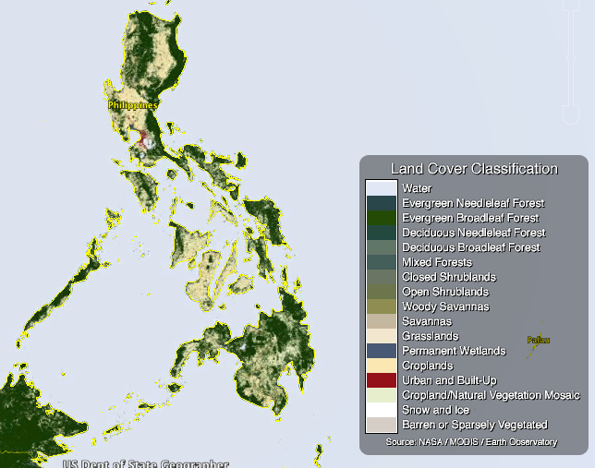

Figure 1. MODIS Land Cover Classification (LCC) product. Green colors represent different types of forests and tan colors represent grasslands/croplands.

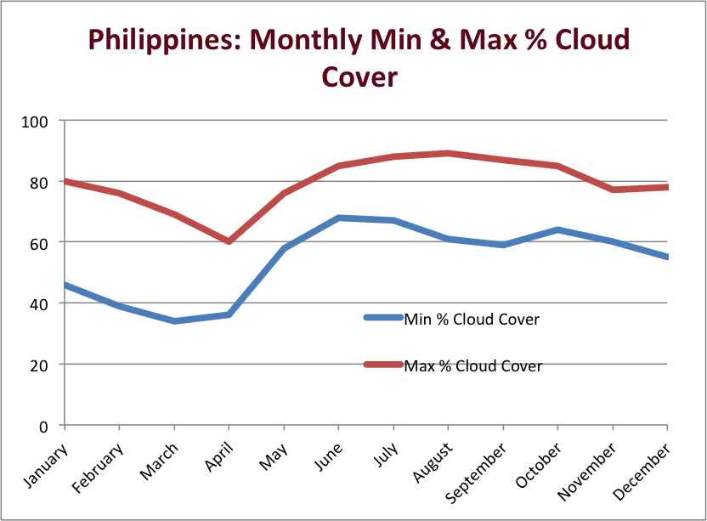

Figure 2. Monthly Minimum and Maximum Cloud Cover. Data from the NASA International Satellite Cloud Climatology Project (ISCCP) dataset (D2 product, 25 years, 280-km pixels, 3-hour sampling, monthly averages).

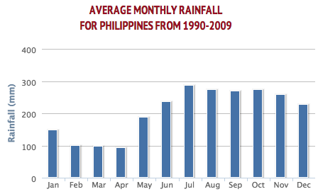

Figure 3. Average Monthly Rainfall. Data from the World Bank website (http://data.worldbank.org)
Section 2: Landsat Data Acquisition Background Information

Philippines
Landsat WRS-2 and Data Summary
Pass | Duration (min) | Path | Row(s) | Scenes | Data Volume (GB)
1 | 0.76 | 118 | 54-55 | 2 | 0.9
2 | 3.40 | 117 | 47-55 | 9 | 4.2
3 | 2.64 | 116 | 47-53 | 7 | 3.3
4 | 3.40 | 115 | 48-56 | 9 | 4.2
5 | 2.64 | 114 | 50-56 | 7 | 3.3
6 | 2.27 | 113 | 51-56 | 6 | 2.8
7 | 1.51 | 112 | 53-56 | 4 | 1.9
8 | 0.38 | 111 | 55 | 1 | 0.5
 | 17.00 |  |  | 45 | 20.9

Table 1. Landsat WRS-2 Path-Row Summary Table (Pass 1 = West, Pass 5 = East)

The Landsat scene area is 183km x 170km, or 31,110 km². Data volume was based on the number of scenes and an average scene size of 465 MB. Refer to Figures 5-8 for scene borders in Google Earth.

The minimum number of Landsat scenes required to cover the total area of a country was determined by visual inspection of COVE (www.ceos-cove.org) instrument ground tracks. Each country only has one mission swath per day. Complete coverage of a country takes the entire revisit period (16 days), since orbits are typically designed for global coverage over this repeat period.

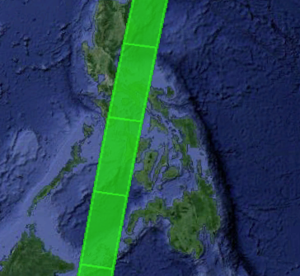

Figure 4. COVE Tool visualization of the Landsat 8 swath over a region on October 14, 2014.

Section 3: Landsat Historical Coverage Summary

Path | Row | Landsat 7 (2012) |  |  |  | Landsat 7 (2013) |  |  |  | Landsat 8 (2013)
 |  | Avg. Cloud Cover | Total # scenes acquired | # scenes <10% | # scenes <60% | Avg. Cloud Cover | Total # scenes acquired | # scenes <10% | # scenes <60% | Avg. Cloud Cover | Total # scenes acquired | # scenes <10% | # scenes <60%
111 | 55 | 50% | 14 | 3 | 8 | 29% | 7 | 0 | 7 | 36% | 2 | 0 | 2
112 | 53 | 37% | 10 | 1 | 8 | 68% | 2 | 0 | 0 | 29% | 6 | 1 | 5
112 | 54 | 54% | 13 | 0 | 6 | 62% | 6 | 0 | 2 | 37% | 5 | 0 | 4
112 | 55 | 58% | 14 | 0 | 7 | 40% | 5 | 1 | 3 | 35% | 5 | 0 | 4
112 | 56 | 54% | 15 | 0 | 8 | 38% | 8 | 2 | 6 | 46% | 5 | 0 | 4
113 | 51 | 33% | 9 | 0 | 9 | 28% | 7 | 1 | 7 | 20% | 5 | 2 | 5
113 | 52 | 45% | 11 | 0 | 8 | 44% | 7 | 0 | 5 | 19% | 5 | 1 | 5
113 | 53 | 48% | 10 | 1 | 7 | 40% | 8 | 1 | 6 | 27% | 5 | 1 | 4
113 | 54 | 56% | 10 | 0 | 5 | 35% | 8 | 1 | 7 | 24% | 5 | 0 | 5
113 | 55 | 55% | 13 | 0 | 7 | 34% | 9 | 2 | 6 | 28% | 5 | 0 | 4
113 | 56 | 53% | 12 | 2 | 6 | 37% | 9 | 1 | 8 | 47% | 5 | 0 | 4
114 | 50 | 36% | 9 | 1 | 7 | 34% | 7 | 1 | 6 | 27% | 6 | 0 | 6
114 | 51 | 47% | 10 | 0 | 7 | 28% | 9 | 2 | 8 | 26% | 6 | 0 | 6
114 | 52 | 30% | 11 | 0 | 11 | 32% | 9 | 2 | 8 | 41% | 6 | 0 | 5
114 | 53 | 46% | 13 | 0 | 9 | 29% | 11 | 2 | 11 | 47% | 6 | 0 | 5
114 | 54 | 41% | 13 | 2 | 10 | 23% | 11 | 3 | 11 | 46% | 6 | 0 | 5
114 | 55 | 43% | 13 | 1 | 9 | 27% | 11 | 2 | 10 | 53% | 6 | 0 | 4
114 | 56 | 43% | 12 | 1 | 9 | 20% | 11 | 3 | 11 | 59% | 5 | 0 | 3
115 | 48 | 49% | 15 | 3 | 8 | 51% | 7 | 0 | 5 | 53% | 3 | 1 | 1
115 | 49 | 47% | 14 | 4 | 8 | 65% | 6 | 0 | 1 | 57% | 3 | 0 | 1
115 | 50 | 42% | 12 | 3 | 8 | 65% | 5 | 0 | 3 | 47% | 3 | 0 | 2
115 | 51 | 32% | 12 | 3 | 10 | 55% | 6 | 0 | 3 | 56% | 4 | 0 | 2
115 | 52 | 37% | 13 | 1 | 11 | 56% | 6 | 0 | 3 | 55% | 4 | 0 | 2
115 | 53 | 31% | 13 | 4 | 11 | 56% | 6 | 1 | 2 | 55% | 4 | 0 | 4
115 | 56 | 28% | 4 | 2 | 3 | 49% | 7 | 1 | 4 | 25% | 1 | 0 | 1
116 | 47 | 44% | 7 | 0 | 7 | 25% | 8 | 3 | 8 | 38% | 6 | 1 | 4
116 | 48 | 51% | 11 | 0 | 6 | 43% | 11 | 1 | 8 | 55% | 6 | 0 | 3
116 | 49 | 44% | 14 | 1 | 10 | 41% | 11 | 0 | 9 | 42% | 5 | 0 | 3
116 | 50 | 39% | 13 | 1 | 10 | 41% | 9 | 1 | 7 | 37% | 5 | 0 | 3
116 | 51 | 37% | 10 | 3 | 7 | 23% | 9 | 2 | 9 | 41% | 5 | 1 | 4
116 | 52 | 38% | 9 | 3 | 6 | 20% | 9 | 4 | 9 | 35% | 4 | 1 | 4
116 | 53 | 35% | 9 | 3 | 6 | 25% | 9 | 3 | 8 | 35% | 4 | 1 | 4
117 | 47 | 23% | 14 | 4 | 13 | 17% | 12 | 6 | 11 | 37% | 6 | 2 | 4
117 | 48 | 20% | 12 | 6 | 11 | 19% | 12 | 7 | 11 | 32% | 6 | 1 | 4
117 | 49 | 28% | 13 | 6 | 12 | 35% | 12 | 5 | 9 | 35% | 6 | 0 | 5
117 | 53 | 36% | 11 | 4 | 8 | 39% | 12 | 3 | 9 | 28% | 5 | 1 | 4
117 | 54 | 31% | 9 | 3 | 7 | 49% | 12 | 1 | 7 | 38% | 4 | 1 | 3
117 | 55 | 35% | 10 | 2 | 7 | 52% | 12 | 0 | 7 | 44% | 5 | 0 | 4
118 | 54 | 41% | 15 | 2 | 10 | 33% | 7 | 1 | 6 | 28% | 5 | 2 | 4
118 | 55 | 51% | 17 | 3 | 10 | 38% | 10 | 1 | 7 | 32% | 5 | 2 | 4

Path | Row | Landsat 7 (2014) |  |  |  | Landsat 8 (2014)
 |  | Avg. Cloud Cover | Total # scenes acquired | # scenes <10% | # scenes <60% | Avg. Cloud Cover | Total # scenes acquired | # scenes <10% | # scenes <60%
111 | 55 | 83% | 2 | 0 | 0 | 46% | 14 | 0 | 8
112 | 53 | 44% | 4 | 2 | 2 | 45% | 14 | 1 | 11
112 | 54 | 59% | 4 | 1 | 2 | 45% | 13 | 0 | 9
112 | 55 | 49% | 4 | 1 | 3 | 43% | 13 | 0 | 9
112 | 56 | 39% | 5 | 1 | 5 | 33% | 13 | 1 | 11
113 | 51 | 57% | 3 | 0 | 2 | 38% | 10 | 3 | 7
113 | 52 | 41% | 3 | 0 | 2 | 39% | 12 | 1 | 9
113 | 53 | 51% | 4 | 0 | 3 | 31% | 12 | 1 | 11
113 | 54 | 69% | 4 | 0 | 2 | 37% | 12 | 1 | 9
113 | 55 | 44% | 5 | 0 | 4 | 40% | 14 | 3 | 11
113 | 56 | 29% | 6 | 0 | 5 | 45% | 13 | 2 | 9
114 | 50 | 0% | 0 | 0 | 0 | 38% | 11 | 5 | 8
114 | 51 | 95% | 1 | 0 | 0 | 44% | 11 | 2 | 7
114 | 52 | 95% | 1 | 0 | 0 | 44% | 11 | 2 | 7
114 | 53 | 69% | 1 | 0 | 0 | 47% | 11 | 1 | 7
114 | 54 | 33% | 1 | 0 | 1 | 52% | 14 | 1 | 8
114 | 55 | 30% | 2 | 0 | 2 | 53% | 13 | 0 | 8
114 | 56 | 37% | 2 | 0 | 2 | 47% | 12 | 0 | 7
115 | 48 | 37% | 3 | 0 | 2 | 31% | 9 | 3 | 6
115 | 49 | 40% | 4 | 1 | 3 | 28% | 14 | 5 | 11
115 | 50 | 48% | 4 | 0 | 2 | 34% | 15 | 1 | 13
115 | 51 | 50% | 4 | 0 | 2 | 20% | 13 | 5 | 13
115 | 52 | 45% | 4 | 0 | 3 | 27% | 12 | 4 | 11
115 | 53 | 40% | 4 | 0 | 3 | 29% | 12 | 6 | 10
115 | 56 | 70% | 4 | 0 | 1 | 28% | 13 | 5 | 11
116 | 47 | 0% | 0 | 0 | 0 | 40% | 15 | 3 | 11
116 | 48 | 60% | 4 | 0 | 2 | 44% | 15 | 3 | 9
116 | 49 | 52% | 4 | 0 | 2 | 45% | 15 | 1 | 10
116 | 50 | 52% | 4 | 0 | 2 | 45% | 15 | 1 | 11
116 | 51 | 23% | 4 | 2 | 3 | 36% | 15 | 3 | 11
116 | 52 | 21% | 4 | 3 | 3 | 39% | 14 | 5 | 9
116 | 53 | 36% | 4 | 1 | 3 | 44% | 14 | 1 | 8
117 | 47 | 0% | 0 | 0 | 0 | 32% | 15 | 5 | 12
117 | 48 | 26% | 12 | 6 | 10 | 28% | 14 | 8 | 12
117 | 49 | 29% | 12 | 4 | 10 | 25% | 14 | 7 | 12
117 | 53 | 45% | 14 | 2 | 8 | 24% | 13 | 3 | 12
117 | 54 | 42% | 14 | 2 | 9 | 27% | 13 | 3 | 11
117 | 55 | 0% | 0 | 0 | 0 | 30% | 13 | 3 | 12
118 | 54 | 0% | 0 | 0 | 0 | 39% | 14 | 4 | 11
118 | 55 | 0% | 0 | 0 | 0 | 36% | 15 | 4 | 12

Table 2-3. Landsat 7 and 8 Historical Coverage Over Region.

A detailed analysis (Tables 2 and 3) was completed for the Philippines to summarize Landsat 7 and Landsat 8 historical acquisitions for years 2012-2014. This information will help users understand the expected availability of core data and to assess alternatives to ensure core data coverage over very cloudy regions.

Tables 2 and 3 show the average cloud cover for all acquired scenes, the total number of scenes acquired, the number of nearly cloud-free scenes (<10% cloud cover) and the number of scenes where pixel mining (mosaics) may be feasible (<60% cloud cover). The maximum theoretical number of acquired scenes for any single path-row location in a full year is 23, considering a 16-day mission repeat cycle and only one of the Landsat missions. In the case of Landsat 8 in 2014, the duration of acquisitions is January 1, 2014 thourhg September 30, 2014 (9 months) with a maximum number of acquired scenes of 17. RED text in Tables 2 and 3 indicates there were NO clear-sky (<10% cloudy) scenes acquired for a given path/row that year. Since the minimum requirement for GFOI is one clear-sky scene per year, these highlighted locations will require more Landsat acquisitions, supplemental acquisitions by similar missions, pixel mining of scenes with <60% cloud cover to create cloud-free mosaics, or supplemental radar measurements to penetrate cloud cover. An assessment of these results is found in Section 4 of this document.

The current Landsat Long-Term Acquisition Plan (LTAP) for Landsat-7 and -8 acquires constant data over the U.S. but only acquires a minimum of one scene per Path-Row region over other areas of the world. In addition, the Landsat-7 instrument had a scan line corrector error in 2003 that introduces a 22% data loss in imagery such that additional swaths are required to achieve complete coverage of an area. In general, Landsat 8 is acquiring more scenes than Landsat 7 over the world, but the combination of these two missions often acquires more than one cloud-free scene of a given area of the world.
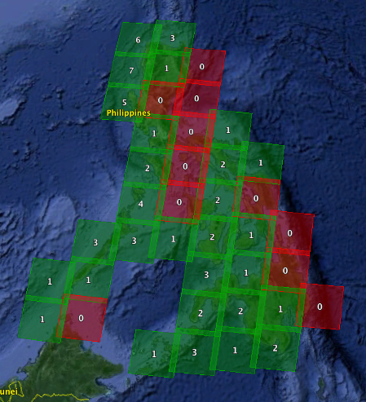
Figure 5. Number of nearly clear-sky scenes (<10% cloud cover) acquired by Landsat 7 in 2013. Results are shown in Google Earth.

Section 4: Analyses and Conclusions

Path-Row scenes for the Philippines were evaluated based on the criteria defined below. These evaluations are completed in ascending order (1,2,3) using the criteria below to determine the recommendation for handling Landsat scenes over specific regions to meet the GFOI requirements.

1. Acceptable: There is a minimum requirement of ONE clear-sky scene per year for baseline assessments and a goal of AT LEAST TWO clear-sky scenes per year for improved classification and change detection. For these analyses, it is assumed that ONE clear-sky scene per year is acceptable. If the archive data had ONE clear-sky scene in each year, the location is considered “acceptable” for GFOI.

2. Pixel Mining: These locations have a sufficient number (≥ 5 per year) of existing archived scenes with less than 60% cloud cover that could be used for pixel mining (e.g.. via Web-Enabled Landsat Data, WELD) to produce at least ONE or more clear-sky composited or mosaic scenes.

3. Extreme Cloudiness. These locations do not have a sufficient number (< 5 per year) of existing archived scenes with less than 60% cloud cover for pixel mining. Due to persistent cloudiness, these locations should pursue alternative optical or non-optical measurements for cloud penetration.

Conclusions:

The Philippines has cloud problems in several regions of the country, but many do meet the minimum acceptable requirement of one nearly cloud-free scene (<10%) per year. The table below highlights the recommendations for each path-row region. While Landsat coverage is acceptable for generating an annual cloud-free mosaic from acquired scenes, many regions (18 total) would require Pixel Mining to generate a cloud-free mosaic. In addition, there is ONE regions that show Extreme Cloudiness and will likely need to consider alternative measurement options, such as SAR imagery to penetrate clouds.

Path | Row | Recommendations
111 | 55 | Pixel Mining
112 | 53 | Acceptable
112 | 54 | Pixel Mining
112 | 55 | Pixel Mining
112 | 56 | Pixel Mining
113 | 51 | Pixel Mining
113 | 52 | Pixel Mining
113 | 53 | Acceptable
113 | 54 | Pixel Mining
113 | 55 | Pixel Mining
113 | 56 | Acceptable
114 | 50 | Acceptable
114 | 51 | Pixel Mining
114 | 52 | Pixel Mining
114 | 53 | Pixel Mining
114 | 54 | Acceptable
114 | 55 | Acceptable
114 | 56 | Acceptable
115 | 48 | Acceptable
115 | 49 | Extreme Cloudiness
115 | 50 | Pixel Mining
115 | 51 | Pixel Mining
115 | 52 | Pixel Mining
115 | 53 | Acceptable
115 | 56 | Acceptable
116 | 47 | Pixel Mining
116 | 48 | Pixel Mining
116 | 49 | Pixel Mining
116 | 50 | Acceptable
116 | 51 | Acceptable
116 | 52 | Acceptable
116 | 53 | Acceptable
117 | 47 | Acceptable
117 | 48 | Acceptable
117 | 49 | Acceptable
117 | 53 | Acceptable
117 | 54 | Acceptable
117 | 55 | Pixel Mining
118 | 54 | Acceptable
118 | 55 | Acceptable

Table 4. Landsat Path-Row coverage analysis results.

