MINUTES OF THE 6th SDCG MEETING (SDCG-6)

22nd-24th October 2014
Oslo, Norway

Welcome and Opening Remarks
Evie Merethe Hagen welcomed the group to Norway. Ake Rosenqvist welcomed participants to SDCG-6 on behalf of the SDCG Executive, and reviewed the objectives and agenda:
- Confirm progress in implementing the 2014 global baseline and ensure upcoming core missions are optimised in support of GFOI. Prepare 2015 implementation plan (Element 1).
- Confirm progress in implementing the CEOS Space Data Services (Element 2), including the pilot activities and secure feedback.
- Continue the promotion and expansion of Element 2 to interested countries, in cooperation with the GFOI Capacity Building component.
- Review the status of the contacts database and consider the future size and scope of SDCG country engagement. Confirm the role of World Bank and FAO relating to Element 2.
- Progress the R&D Data Support Strategy (Element 3) definition towards submission at SIT-30 for endorsement.
- Finalise the SDCG 3-Year Work Plan and confirm the detailed outcomes and paths and contributions for their realisation – including specific technical systems and capabilities.
- Define and action the coordination required with the Methods and Guidance Component so that space data is being applied consistent with GFOI principles.
- Review the impact of GEOGLAM acquisition requests on the GFOI strategy and develop appropriate adjustments as relevant, and plan for liaison.

Review of SDCG-5 Actions
George Dyke reviewed the status of SDCG-5 actions, and an updated status of these actions is included as an appendix. He noted that there were 24 actions agreed at SDCG-5, that 13 are complete, seven have a deadline of SDCG-6, and four are in progress. He reviewed the status of items with a deadline of SDCG-6.
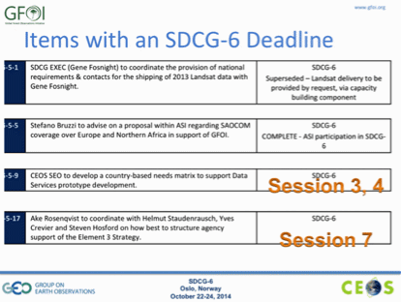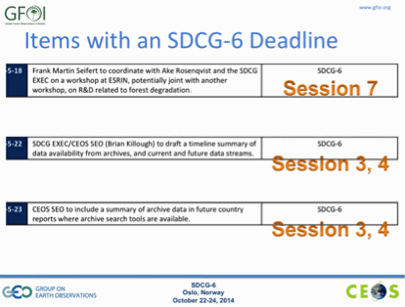

GFOI Leads Meeting and Components Update
Stephen Briggs highlighted the main outcomes from Monday’s GFOI Leads meeting:
- During the meeting, the draft GFOI Strategy was reviewed, and will be presented at the GFOI Leads meeting in February for endorsement. The Strategy represents a codification of how things have been organised in the past, and doesn’t represent a radical departure.
- During the meeting, members from the Norwegian policymakers expressed support for GFOI’s approach to supporting UN-REDD. They confirmed that when they support initiatives, they will include GFOI as a part of a suite of options for the implementation of their national MRV programs.
- It was noted that a number of other countries are also involved in funding the development of national MRV programs through their aid programs, including Australia and Germany. The UK and others are also expressing an interest in this area.
- There has been a discussion about the future of the GFOI Office, which as been funded (by Australia and Norway) for the past two years co-located at the GEO Secretariat as a temporary home. It has always been thought that it would be better hosted within a service delivery agency (i.e. FAO). The process of developing the requirements for the office is ongoing, and is expected to conclude at the Leads meeting in February.
- It was decided that there will be a one-year rotating chair for the GFOI Leads meeting, and Stephen Briggs was nominated to chair the meetings for 2015. (February in Australia, and likely October in Rome but this remains to be confirmed).
- Simon Eggleston noted that the UNFCCC has a program in West Africa helping countries to develop national carbon accounting systems. They will be using satellite data for land use, and will be getting Landsat data from USGS. However they have asked about support in getting higher resolution data, and there may be a role to play for SDCG in that process. Brian Killough asked if FAO would be involved in the delivery of this program, and Simon noted that in this case probably not.
- Stephen Ward noted that the main message from SDCG to the GFOI Leads is to get clarity on how the relationship with FAO around service delivery, including specific discussion around the roles and service delivery. Stephen Briggs noted that this discussion is independent of the location of the GFOI Office.
- Evie Merethe Hagen noted that she expects FAO to work with GFOI and SDCG, as they work with other partners, to try and advance their activities and initiatives.

Space Data Services Strategy (Element 2) Overview and Implementation
Stephen Ward presented an overview of the space data strategy for GFOI (Element 2), which features a call for the development of program Space Data Services for GFOI.
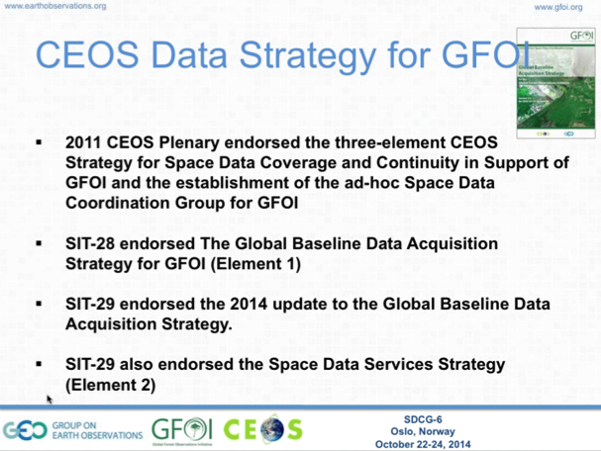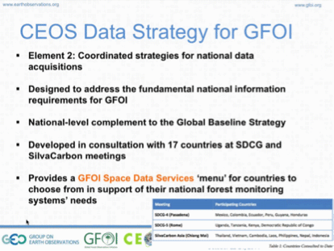
Jim Baker asked which countries have received services to date, and Brian Killough noted (for example) the four countries present at the country day this week (Indonesia, Philippines, Nepal, and Bangladesh) have received a country data supply assessment package. He also noted that Kenya has identified data needs, and SDCG is working to help facilitate access to SPOT data as a supplement to Landsat coverage.
Gene Fosnight noted that Landsat-8 was the breaking point in terms of data volume as we look toward Sentinel-2 data access and distribution. The necessary and sufficient data requirements needed to create GFOI forest products in support of UN-REDD should be prioritized to ensure those data can be delivered.
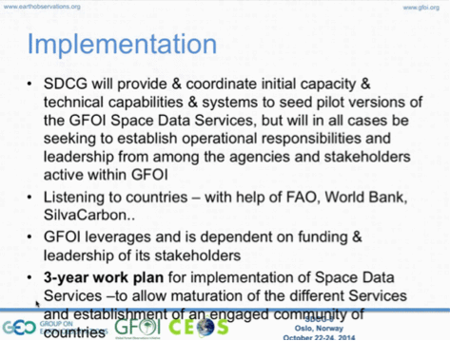
Space Data Services
Brian presented a status update on the development of Space Data Services.
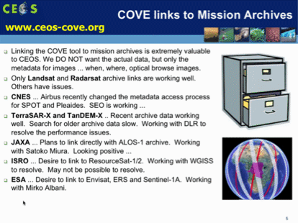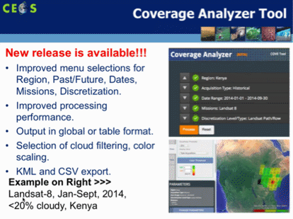
Brian noted that JAXA has provide access to the ALOS archive via an API, which should enable metadata search for the full ALOS mission. He reviewed the current data services prototypes under development.
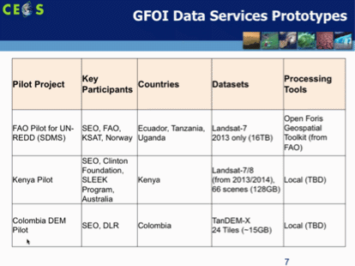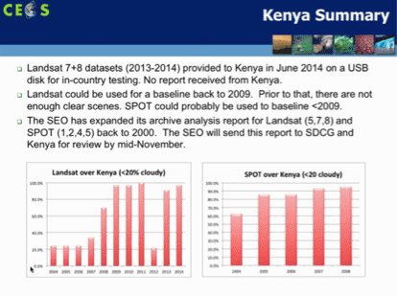
Brian noted that there is good potential to use the Kenyan activities as a test bed for the development of future services. Doug Muchoney asked if the Kenyan Landsat coverage assessment included data from African archives, and Gene confirmed that it should. He noted that the main outstanding data missing from the USGS archive is from ESA and this is in the process of being ingested. Stephen Briggs noted that the ESA Landsat archive contains millions of scenes, which makes it a logistical challenge – however it covers mostly Europe. Ake noted there is a JERS-1 coverage of Kenya in 1996, though there may be technical limitations to their ability to process.
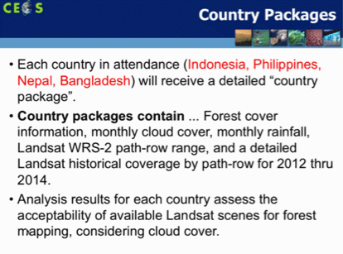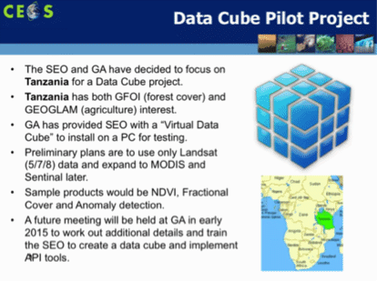
Brian noted that the SEO is working with Geoscience Australia to develop a data cube for Tanzania, and Stephen Ward noted that this could be a potential solution to the challenge of data distribution. Brian noted that once the data cube is built, countries could leverage it via an API.
Yves Crevier noted that this will allow users and agencies to rethink how they use data, changing from scene-oriented to pixel-oriented access. Gene noted that this is also a likely path forward for integration between Landsat and Sentinel-2.
CEOS Systems Engineering Toolset (CSET)
Sanjay Gowda presented a summary of the SDMS, as well as the CEOS System Engineering Toolset (CSET).
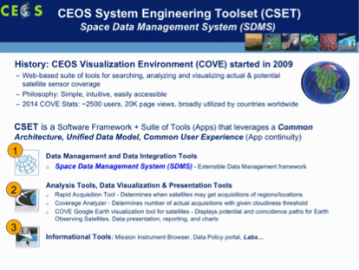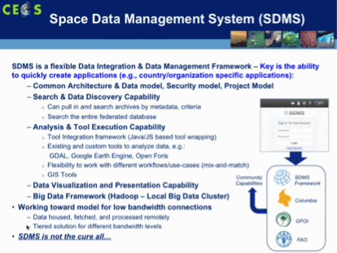
He noted that the CSET portal is expected to go live in November 2014, and that it has been under development for about a year now.
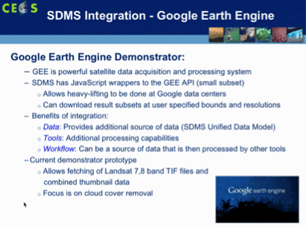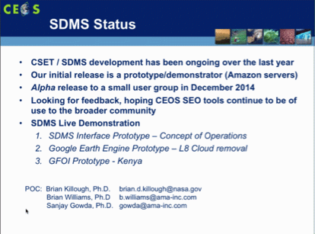
Brian Williams presented a live demonstration of the CSET tools, which can be found at ceos-tools.org and ceos-sdms.org.
Inge Jonckheere noted that the FAO SDMS is a small scale project. She noted she was quite impressed this toolset, but stressed the need for a coordinated approach in order to avoid confusion around “SDMS”. Brian Killough agreed, noting that he also wants to avoid confusion around the naming.
Regional Space Data Workshops
Doug Muchoney presented a summary of regional space data workshop activities.
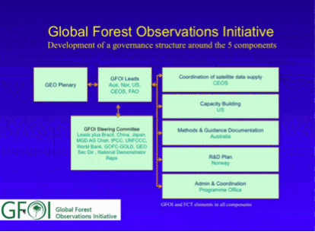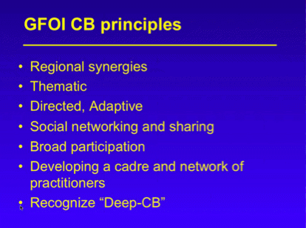
Inge noted that she just returned from the SilvaCarbon workshop in Hanoi, and suggested that we have reached the limit of what can be accomplished by regional workshops – and that now national engagement is required, and Doug agreed there is a need to have more directed national-level treatment. Inge noted that the coordination between FAO and SilvaCarbon is going quite well.
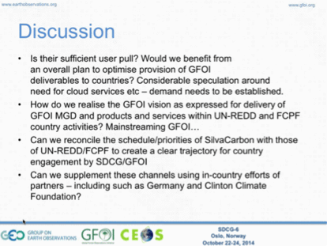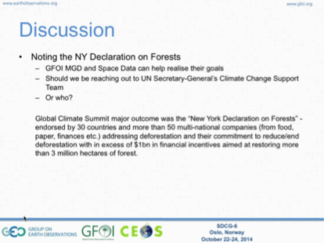
A brief discussion followed:
- Stephen Ward raised the question of a strategic framework for SilvaCarbon. It was suggested in the Leads meeting that the components of GFOI coalesce around the MGD 2.0, which could be helpful in working out how the space data will fit in to that effort.
- Stephen Ward raised the issue of using other channels, for example the Clinton Foundation or German aid efforts, to promote capacity building activities. Jim Baker and Helmut Staudenrausch both noted that there may be opportunities in the near future to do this.
- The need to integrate the MGD into the likes of the CSET tool was stressed.
- Stephen Briggs noted that GFOI is not only about acquiring satellite data, but is also about supporting the delivery of forest products.
- Doug asked about the definition of a “GFOI country”, and Stephen Ward noted that SDCG does have a country table, which was established with the objective of trying to improve contact management. Inge noted that the country table needs to be improved to make it more workable. It was agreed that the spread sheet should be focused more on the country interface, rather than cataloguing all national activities.
- It was agreed that the MGD (and MGD 2.0, once it is established) can provide a simple vehicle to organise the other GFOI components.
- Inge stressed that in-country support and training is vital to delivering tools like CSET, and information like the MGD.
- Anthony Bennie stressed that the Kenya efforts doesn’t just end with delivering the data, but also include support to the full development process for national MRV.
- Evie asked what information FAO might be able to provide to SDCG. Stephen Briggs stressed the need to know from those engaged in-country what it is they need in terms of data, and Gene added the need to understand what it required to deliver data.

SDCG 3-Year Work Plan
George Dyke noted that discussion around the 3-Year Work Plan was one of the key outcomes of the SDCG-6 meeting: “Finalise the SDCG 3-Year Work Plan and confirm the detailed outcomes and paths and contributions for their realisation – including specific technical systems and capabilities.”
Objective of the 3-Year Work Plan
Stephen Ward presented the rational behind the development of the SDCG 3-Year Work Plan, and the main points of the 3-Year vision for GFOI.
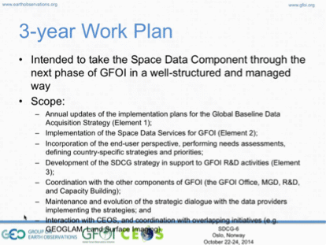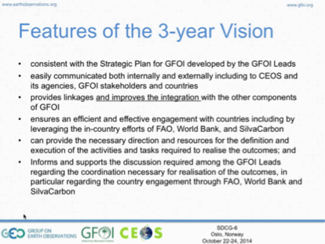
George presented a summary of the current draft of the 3-Year Work Plan.
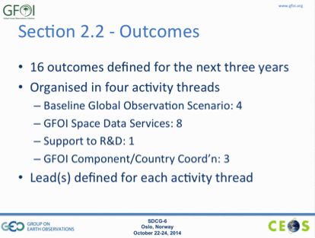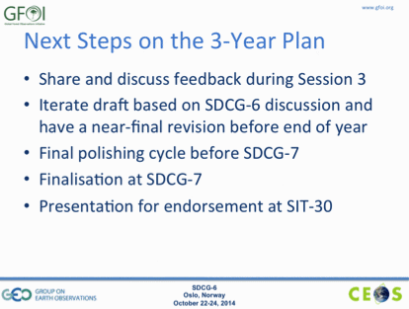
A brief discussion followed:
- There was a suggestion to revise baseline coverage outcome to indicate global coverage by 2016, consistent with the Element 1 strategy.
- Helmut Staudenrausch asked about the inclusion of cooperation with the private sector in the vision for GFOI. Not just in terms of data supply, but also the generation of products and services. He noted that CEOS agencies are generally more focused on R&D, but that the sustainability of services needs to be considered. Brian Killough agreed that the sustainability solution for some of these services may be to deliver them on a commercial basis.
- Brian noted that based on the cloud cover assessments they have been doing that there are some really cloudy areas where optical data won’t provider coverage no matter how many systems are available – and that SAR will be required.
- Yves supported the idea that the commercial sector may be able to make a contribution, but stressed that the space agencies should remain focused on the coordination of data acquisitions. He also suggested that if we have outcomes in the Work Plan, then we should also have indicators to measure if the outcomes have been achieved.
Baseline Global Observation Scenario for Sentinel-1A
Frank Martin Seifert presented a brief update on acquisitions by Sentinel-1A.
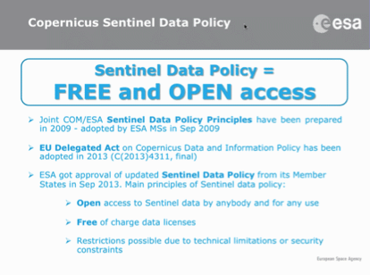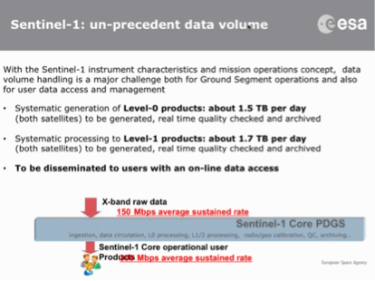
A brief discussion followed:
- There was a question about the two-month rolling scientific archive. At present, this is the main way for non-Copernicus services to access Sentinel-1A data, and Frank Martin suggested that while another solution may eventually be identified, users who want to use the data should download it within the two month posting period online.
- Frank Martin noted that he will look at whether ESA may be able to setup a download service for Sentinel-1A data over GFOI priority countries.
Global Baseline Coverage Activity Thread
Gene Fosnight presented a summary of the global baseline acquisition activity thread and related 3-year outcomes.
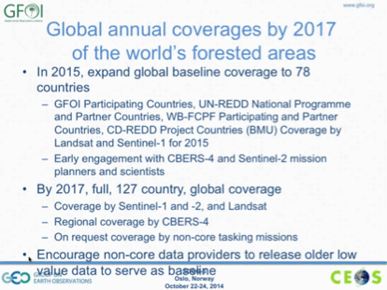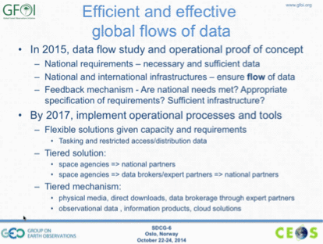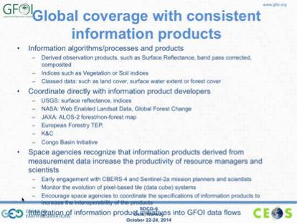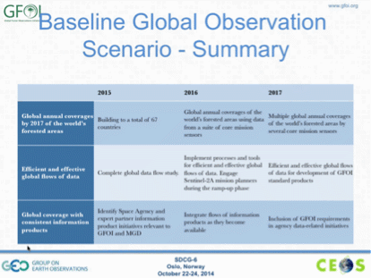
Gene noted that USGS/NASA and ESA are currently discussing creating a mirror archive of the global Sentinel-2 dataset at EROS.
A brief discussion followed:
- Stephen Ward noted that if Sentinel-2A is going to be used, then the data volume issue is going to have to be addressed, and that it is likely to be first addressed by the group who has the most to gain from addressing the data volume challenge. Frank Martin suggested that it will likely be the Copernicus services that will solve the problem first.
- Yves asked about the meaning of the “efficient and effective data flows” outcome. Stephen Ward noted that this is about trying to focus less on moving data, and more on moving information, and noted that this outcome can be revised.
- It was agreed that there is a need to ensure GFOI needs are woven into ESA’s Forest Thematic Exploitation Platform (TEP). Frank Martin noted that GFOI is one of the service cases requested within the ITT.
- Einar-Arne Herland noted that when it comes to Sentinel data distribution, ESA are playing their role. He noted that the Copernicus users have full access to all products, and that each member state receives a copy. He noted that access to science data is limited to the previous two months, and access speed is not guaranteed. Stephen Briggs added that the EC is still coming to terms with the scale of their challenge to archive and distribute the data, and that ESA has no resources to support the use of the data.
GFOI Space Data Services Activity Thread
Brian Killough presented a summary of the GFOI Space Data Services and related outcomes.
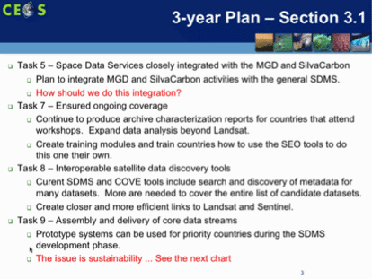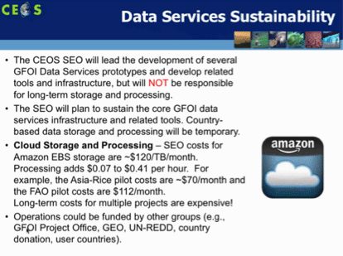
Brian noted the linkages between the Services and the MGD, and that he is planning to include references within the SDMS and CSET. He is also looking at building links back from the MGD to space data, for example possibly to the coverage analyser.
A brief discussion followed:
- Inge noted that it may be possible that the Global Forest Watch Products (from Matt Hansen) are consistent with the MGD so long as it is used in line with the guidelines prescribed by Pontus. Evie Merethe Hagen noted that SilvaCarbon is making the training materials outlining this process. There was a request to circulate the guidelines as there are have been significant doubts about the suitability of global-scale map products, such as the Global Forest Products, as a basis for national MRV.
- Sylvia Wilson asked if any countries have been consulted by the SEO in the development of the SDMS, and Brian noted that these tools have been tested with Kenya and Colombia.
- Yves noted that the GEOGLAM community is quite interested in tools space data management tools like the SDMS.
R&D Activity Thread and Commercial Support
Ake Rosenqvist presented a summary of the R&D activity thread, including on the potential for support from the commercial sector.
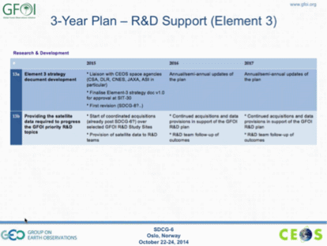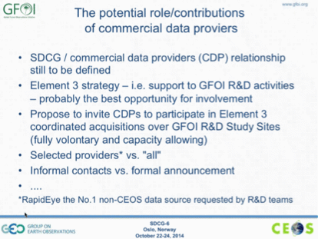
Ake noted that he is proposing a split of the R&D outcomes, and also adding an outcome about the provision of satellite data required to progress GFOI priority R&D topics. He noted that currently there are about 30 GFOI sites, but not all sites use all sensors.
- Yves noted that a few years ago, JECAM invited private sector participation in one of their meetings. They invited 10-12 commercial data providers, and about 6 attended the meeting with proposals to make to the group. Ake noted that a commercial provider event could be coupled with an upcoming event like the GFOI Science Summit in 2015, or sooner if possible. Helmut noted that industry may generate a number of good ideas for SDCG and GFOI.
- It was suggested to host the meeting in Europe or North America to make it accessible, and Yves mentioned CSA could also host.
Component Coordination and Country Engagement
Simon Eggelston presented a summary of component coordination and country engagement activity thread.
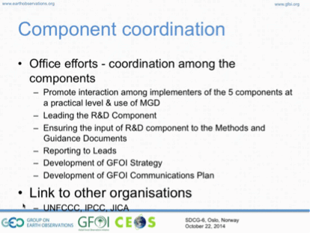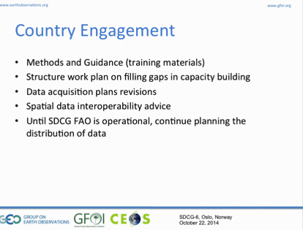
Simon noted that the GFOI Office is working to promote the MGD to IPCC, and aid agencies like JICA. Sylvia Wilson presented some additional detail on the country engagement activities via SilvaCarbon.
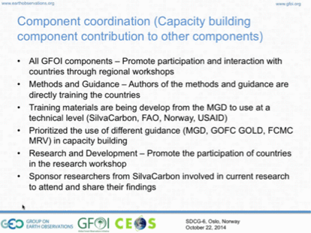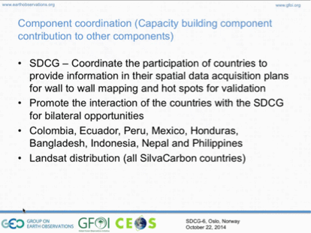
Simon confirmed that it made sense to list the GFOI Office as the lead of the component coordination and country engagement activity thread.
A brief discussion followed:
- Stephen Ward suggested building this activity thread around the MGD.
- Stephen Briggs suggested that the biggest problem we have is engagement with the end user countries.

Joint Country Session with SilvaCarbon
Frank Martin Seifert welcomed the country day participants, and Sylvia Wilson reviewed the objectives for the country day.
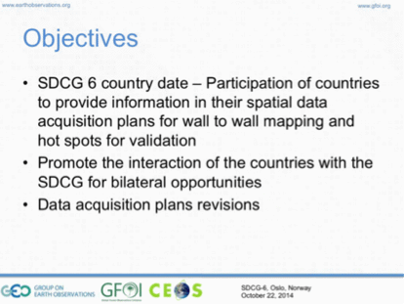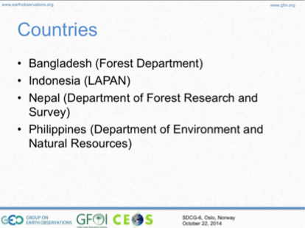
Stephen Briggs briefly reviewed the CEOS vision for support to GFOI. He noted that CEOS represents the world’s civil space agencies, that GFOI comes via GEO, and CEOS members see GEO as an important vehicle to communicate with the wider world on a variety of application areas. Support for data delivery comes through initiatives like Brian Killough and the CEOS Systems Engineering Office.
Stephen Ward presented a summary of the Space Data Services for GFOI.
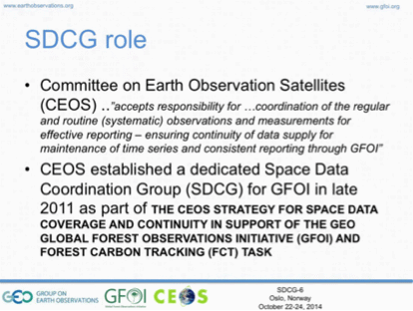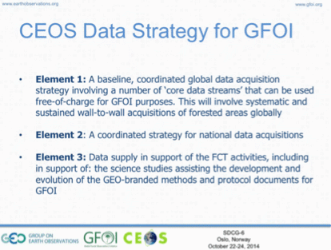
Stephen Ward reviewed the plan for global baseline coverage.
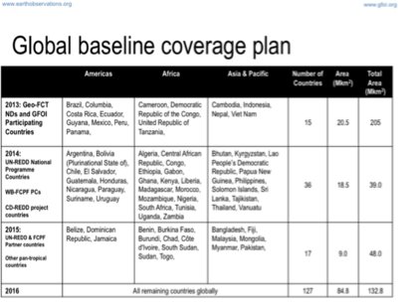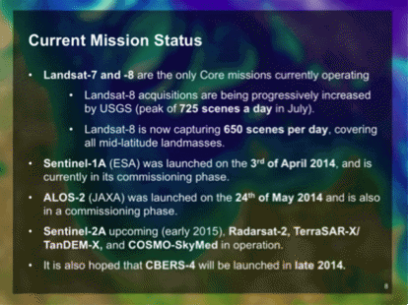
And he reviewed the nationally targeted GFOI Space Data Services.
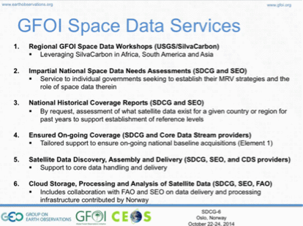
A brief discussion followed:
- Sylvia Wilson asked about the relationship between commercial providers and the SDCG. It was noted that SDCG is focused on the coordination of core missions (which are available on free and open conditions), and that SDCG can’t provide access to commercial data – in particular for operational use. Ake noted that the reason for this is that GFOI doesn’t want to build in a dependency on commercial data that you have to pay for – for the majority of national MRV reporting activities, the core data streams are sufficient.
- Ake noted that within the GFOI R&D component, and the supporting Element 3 Strategy from SDCG, access to commercial data providers has and can be facilitated.
- Inge Jonckheere noted that some countries do use commercial data for their national monitoring, but generally speaking it is not cost effective.
- Jenny Hewson noted that for applications like model training, the high-resolution data (i.e. commercial) is needed.
UN-FAO
Inge presented a summary of the activities of UN-FAO, noting that they have worked a lot with Brazil who are world leaders in this area and who are working to train other countries to develop and implement their own programs.
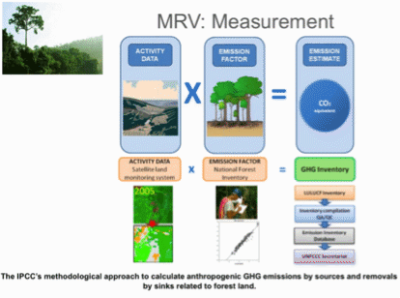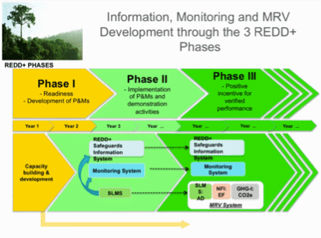
Inge noted that most countries are in the readiness phase (Phase I), and starting onto the implementation phase (Phase II).
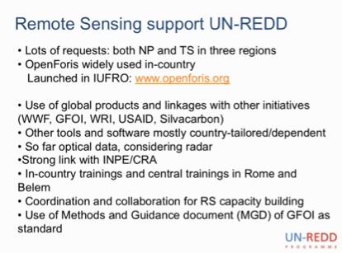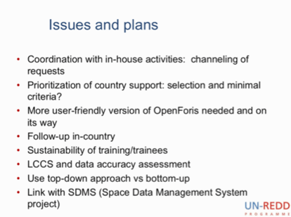
She shared a few lessons learned through working with countries.
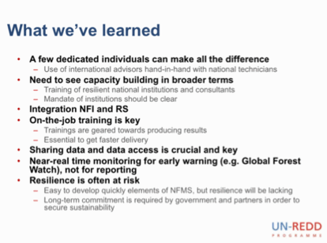
A brief discussion followed:
- Stephen Ward asked how many countries are using OpenForis, and Inge noted there are 12 (mostly in South America).
- Inge noted that the current platform is based on Linux, but that a Windows version is required and that should be released in the next few months.
Country Packages
Brian Killough presented a summary of the country packages that the SEO has developed for each of the countries.
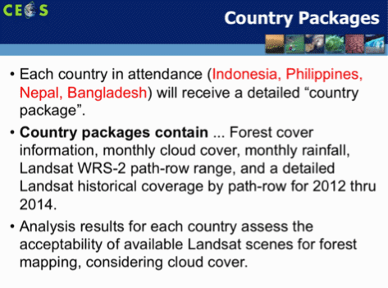
Bangladesh
Miriam Ahkter reviewed the status of national MRV implementation in Bangladesh.
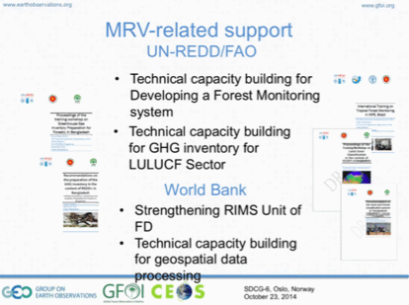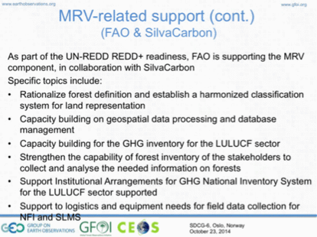
Mariam noted that Bangladesh is aiming for an IPCC Approach 3 implementation.
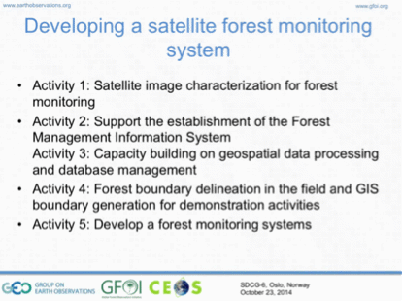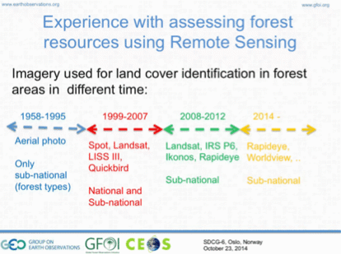
Mariam summarised the remote sensing data needs for Bangadesh, noting that they would like to integrate 30m (or better) DEM data, but need capacity support on how to use the data.
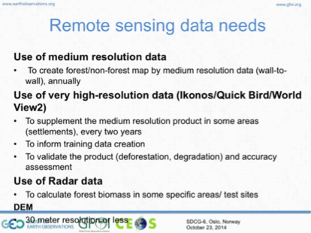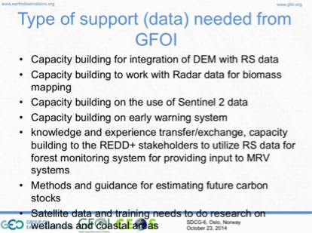
A brief discussion followed:
- Ake asked about the DEM data request, noting that Bangladesh is quite flat. Miriam noted that because of this much of the country is exposed to flood risks and the availability of a high-accuracy DEM is considered of high importance.
- Brian noted that the 25m ALOS mosaics may be of interest for Bangladesh, and that the TanDEM-X DEM may also be of interest. Helmut note that he can help in putting together a proposal for DEM data in Bangladesh, and he expects that the that the full global dataset will be available soon at which time a call for proposals will be launched.
- Ake suggested that above-ground biomass estimation may be better done using airborne Lidar. Mariam noted that Bangladesh would need capacity building support to make use of Lidar. For monitoring of forest changes, Ake noted that JAXA’s K&C Global Mangrove Watch project may be of interest.
- Jennifer asked if 25m ALOS mosaic data is available, and Ake confirmed that the 50m mosaic data is currently available now, and the expectation is that it will be available from next week at 25m [25m PALSAR mosaic data were released on Oct. 31, 2014].
- Stephen Ward asked if FAO is working to prepare for Sentinel-2A data flows, and Inge noted that they are not, and need to look at preparations. Jennifer stressed that it would be great if this kind of training can be provided, so it is not just having the data available, but also having accompanying utilisation support.
- Frank Martin noted that ESA will setup a series of Thematic Exploitation Platforms (TEPs) with a focus on Sentinel-2 – the TEPs will allow data and algorithms to be brought together. There are currently six TEPs being setup for different thematic areas, including Forests. Frank Martin noted that for the Forest TEP, support and engagement with FAO will be a key feature.
- Mariam noted that the for Bangladesh, the internet infrastructure is a limitation.
Nepal
Shree Krishna Gautam summarised national REDD+ readiness activities within Nepal, including a summary of national space data needs.
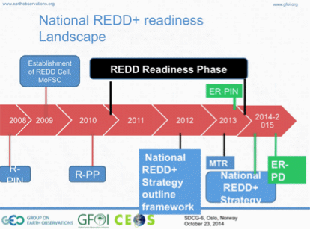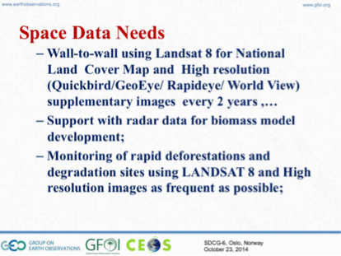
Shree Krishna stressed that support from GFOI on securing high resolution data would be useful.
- Jim Baker asked how Nepal’s community forestry program fits within their national program. Shree Krishna confirmed that more than 18,000 people are working in forestry management.
- Inge noted that the request for Sentinel data from countries is clear.
- Ake noted that radar data for aboveground biomass mapping is an R&D topic. Inge asked how this request could be channelled, and Ake suggested that it fits well within the GFOI R&D plan.
Philippines
Nelissa Maria Rocas presented an overview of the REDD+ strategy for the Philippines.
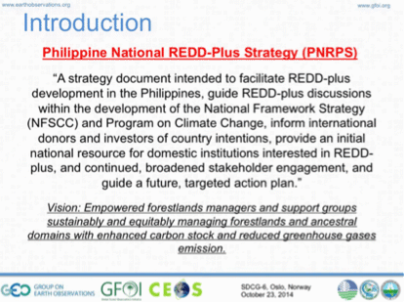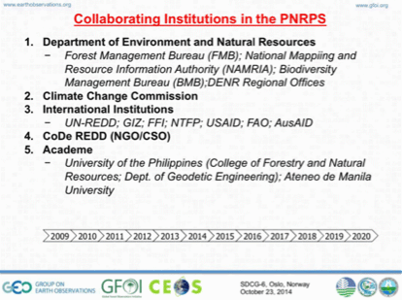
She reviewed the status of national MRV implementation, as well as a summary of space data needs.
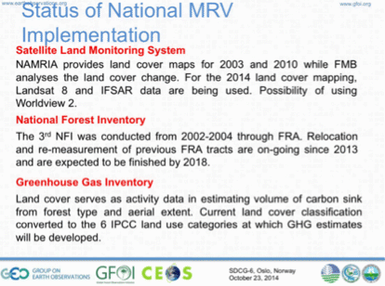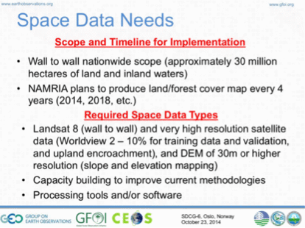
She reviewed some of the challenges and obstacles that the Philippines is facing with respect to space data, including a number of tools and capacity building topics.
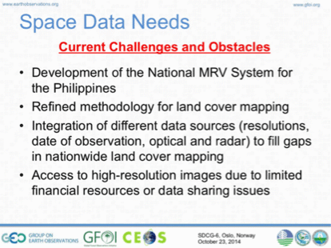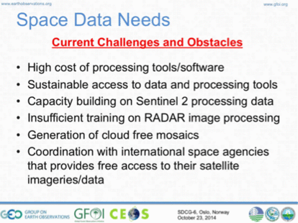
A brief discussion followed:
- Ake noted the need for Sentinel-2 training was raised again, but asked what specific training would be required in addition to the capability that countries already have for processing Landsat data. Frank Martin noted that ESA is currently developing tool boxes for the Sentinel missions (1, 2 and 3) which could be the subject of training.
- Nelissa noted that even an introduction to the differences between Landsat and Sentinel, and that perhaps the relative capability and complementarity between the two systems.
- Jennifer suggested that training on Sentinel-2 wouldn’t have to be extensive, but could include things like data access, data format, the process for ingesting and handling, and information on bands.
- Yves Crevier asked if there is a lot of overlap with rice crop growing areas, noting that there is a lot of SAR data being collected for rice crop monitoring – and this could be a source of images to be accessed for R&D activities.
Indonesia
Orbita Roswintiarti presented a summary of Indonesia’s national MRV program. Indonesia has worked for a number of years now, and in 2013 it established a national REDD+ Implementation Agency.
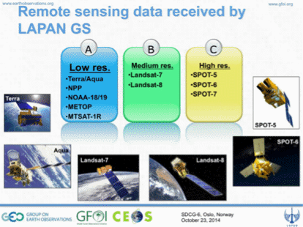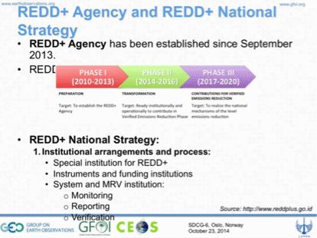
She presented a status of the implementation of national MRV, noting that Indonesia has devleoped a national strategy to guide the process.
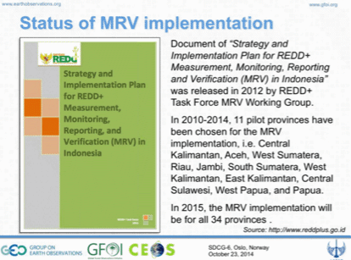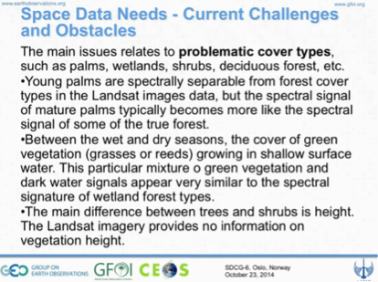
Orbita noted some space data needs, including on Sentinel-1 and -2 data handling and processing.
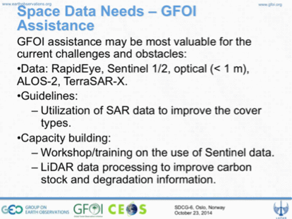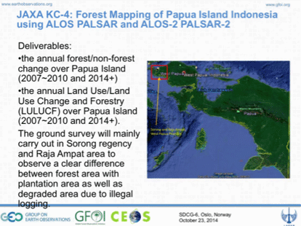
Summary of Space Data Needs from Countries
Orbita presented a summary of the current data needs discussed by the countries during their country session.
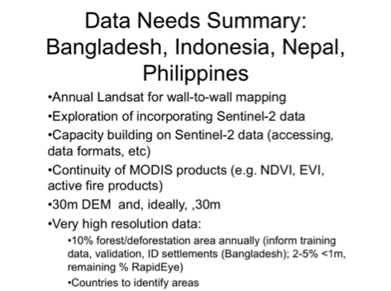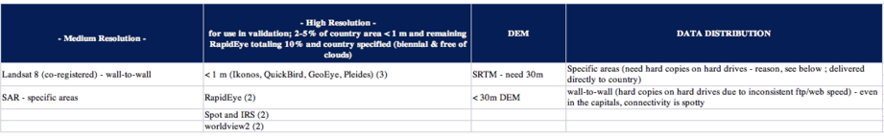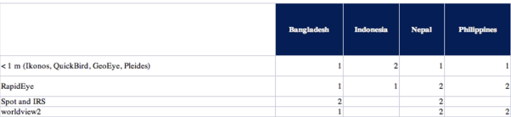
A brief discussion followed:
- Sylvia asked Kerry Sawyer about the release of the SRTM DEM. Kerry noted that it is being released on a regional basis. Gene noted that the released product will not be gap filled, so the SPOT data will not be released. He noted that we can expect that the release of NASA/SRTM+ will quickly follow the NGA products and they will be gap filled.
- Kerry noted that the CEOS WGCapD will be holding workshops on the data, with the first to be held in Africa.
- Frank Martin noted that SAR sensors have been demonstrated to be useful for early warning, though there are no currently know operational systems based on SAR.
- Ake noted that an ALOS/PRISM DEM is under development by JAXA, and is expected to be completed by March 2016, with a 30m version anticipated to be freely available.
A brief Session summary discussion followed:
- Sylvia noted that the use of high-resolution data for hot-spot monitoring and selected areas (i.e. not wall-to-wall) was a common issue across all the countries, and that information on plans to engage these providers would be of interest. Jennifer suggested that countries are quite dependant on this data. Ake noted that the SDCG Strategy is built around the core data streams (free and open), but message taken that the commercial data providers need to be better taken into account.
- Frank Martin noted that there is no budget within GFOI to buy high-resolution data. Ake added that in the context of R&D and the Element 3 strategy, commercial data providers will be invited to engage.
- Gene agreed that while the data might be required to the job, within SDCG there isn’t much capacity to provide this data. He suggested that the GFOI capacity building component may be able to provide support.
- Stephen Briggs asked about high resolution SAR, and Jennifer noted that the optical is what is needed – specifically RapidEye. Frank Martin noted that the RapidEye data available through SDCG would only be in support of R&D. He noted that he spoke with Axel Penndorf (Blackbridge) about the possibility of RapidEye coverage over the GFOI R&D sites. Once established Blackbridge will select some R&D sites to support.
- Helmut noted that it may not be that hard to find a donor for RapidEye data, if the case is convincing. Ake suggested this could be an issue for the GFOI Office to coordinate.
- Sylvia noted that the need in this case would be limited to those countries engaged with SilvaCarbon.
- Evie noted that Norway has been buying RapidEye data for Tanzania.
- Inge noted that in the FAO SDMS, they have budgeted up to 10% RapidEye-like data.
- Sylvia suggested that SDCG could pay a coordinating role, noting that countries often have budget for data, but it is not always sufficient.
Data Accessibility
Brian presented on a summary of the GFOI Space Data Management System (SDMS), and the CEOS Systems Engineering Toolset (CSET).
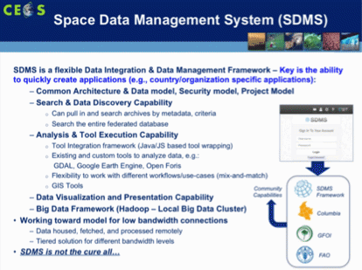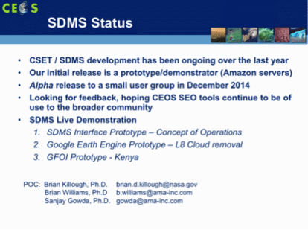
He noted that the GFOI SDMS, and the CSET are supersets of the capability the SEO has developed for the FAO SDMS.
A brief discussion followed:
- Brian noted that the TanDEM-X data for Colombia will be delivered in the next few weeks.
- Sylvia asked if data can be downloaded locally, and Brian confirmed they can. He also noted that tools can be uploaded so they run in the cloud with the satellite data.
- Sylvia noted that currently the data distribution process takes place by hand at various FAO and SilvaCarbon workshops, and that this remains an issue which she hopes that the FAO and/or CEOS SDMS.
- Stephen Ward asked about the latest on MODIS continuity, and Gene confirmed that VIIRS and Sentinel-3 are currently the plan. But that as of now MODIS is expected to be operational until 2020.

Roles and Responsibilities Within GFOI
Role of the GFOI Office
Stephen Briggs presented summarised the role of the GFOI Office, noting that it has been located alongside GEO Secretariat in Geneva since February 2013. Arrangements to host the Office within FAO are currently being discussed. Any transfer would take place after February 2015, but the exact timing remains to be confirmed – best efforts will be made to try and assure that there is no gap.
SE Asia Capacity Building
Jennifer Hewson provided a summary of a REDD+ MRV Manual being put together for SE Asia by Conservation International as a part of the Forest Carbon, Markets and Communities (FCMC) Program.
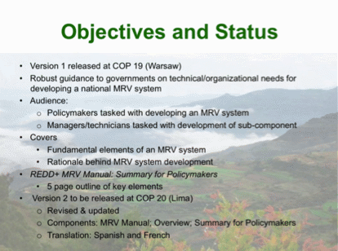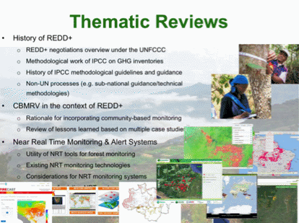
The manual includes chapters on Institutional Arrangements, Estimating GHG Emissions & Removals, Field-based Inventories, Remote Sensing of Land Cover Change, and Reporting and Verification. She reviewed synergies between the GOFC-GOLD Sourcebook and the GFOI MGD.
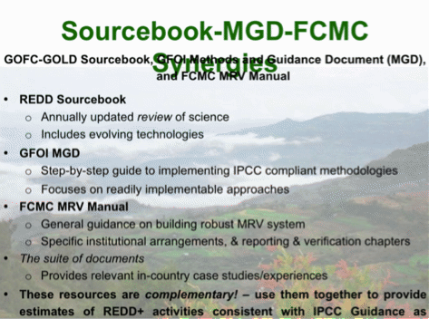
Jenny noted that the FCMC manual is an umbrella document that doesn’t dig as deeply into the remote sensing side of things. She also noted that she would expect to see information on Landsat and Sentinel interoperability in the GOFC-GOLD sourcebook.
A brief discussion followed:
- Inge Jonckheere noted that the UN-REDD documentation should also be included, and that when it was adopted, it was endorsed by the 58 UN-REDD countries.
- It was noted that the MGD is being translated into Spanish, and this is expected to be completed before the end of the year.
- Jenny noted that there is an issue that has to be addressed about how to use the various documents. Sylvia agreed, noting SilvaCarbon would also like to have some kind of explanation of the various resources for their own use.
UN-FAO SDMS
Inge presented the National Forest Monitoring System (NFMS), which is an open data portal.
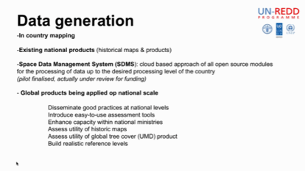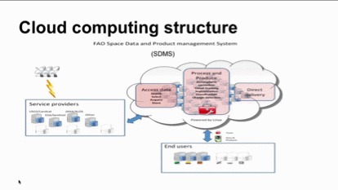
She reviewed the functionality and audience of OpenForis (openforis.org).
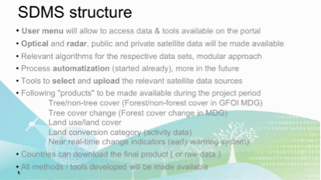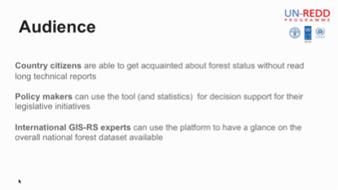
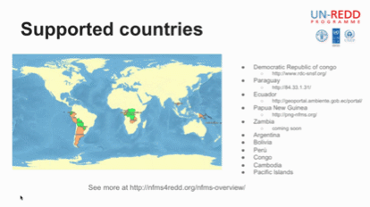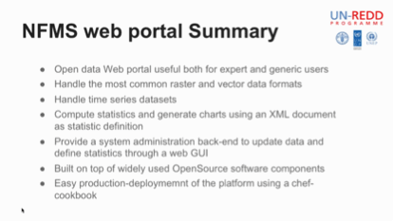
Inge noted that the provision of high-speed internet access for countries is included in the budget.
A brief discussion followed:
- Doug Muchoney noted that there is confusion between how the components fit together (e.g. SDMS, SDCG, Terra-Congo, etc.), and that it is important that a coordinating body like GFOI help clarify the message.
- Inge noted that Terra-Amazon is a platform for visual interpretation of the data, that it originates with the Brazilian system, and that complementary to OpenForis. She also noted that if you have paid tools like ArcGIS and Incognition, then you don’t need OpenForis.
- Inge noted that the main overlap between the FAO and GFOI SDMS systems is naming. Brian agreed, noting that at present the FAO SDMS is a three country pilot project, and is expected to expand to 18.
- Gene noted that FAO, SilvaCarbon and DOTE/Australia have worked well in partnership on capacity building. FAO has the science expertise to interpret and implement the MGD methodologies required to produce Forest product maps. Space agencies know their data and should be encouraged to develop the information products needed to support the MDG methodologies. The primary role of SEO and CEOS should be as data brokers to discover and bundle data from many sources including data with access and distribution restrictions. The delivery of the data should be in close partnership with expert partners, such as FAO USGS SilvaCarbon, and DOTE/Australia.
- Inge noted that funding for the FAO REDD helpdesk is through 2020, and that funding for data varies by national program. She noted the example of Guyana as one to consider looking at more closely.
- Stephen Ward suggested that everyone is playing their roles – FAO on implementation; the CEOS SEO on developing new tools and capabilities; and, the space agencies on data delivery.
- Ake asked about countries that are not involved in the FCPF or UN-FAO countries, and Inge suggested that these countries are generally not institutionally mature.
SilvaCarbon
Sylvia Wilson presented a summary of their SE Asian activities, noting that they are currently considering future workshops based on their 2014 activities in Thailand and Nepal. This will likely include workshops on:
- Radar data processing;
- Cost-effective biomass mapping and carbon estimation; and
- Accuracy assessment and uncertainty analysis for GHG-reporting from the forestry sector.
She also noted that three study tours are being considered:
- Option 1 - Radar data processing;
- Option 2 - Working with time series; and
- Option 3 - Indonesia National Carbon Accounting System.
USGS / Landsat-8
Gene Fosnight presented a summary of current Landsat acquisitions. [Post meeting note: the new daily limit was set to 725 images/day.]
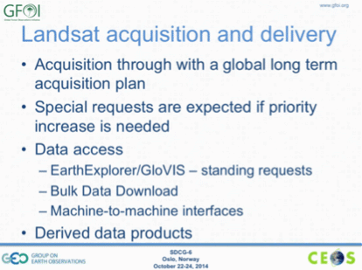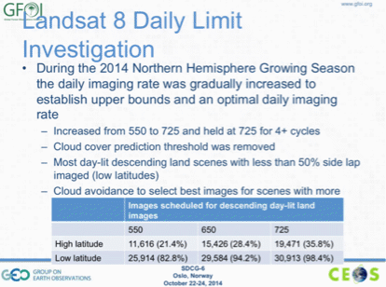
He reviewed the various data access methods for Landsat.
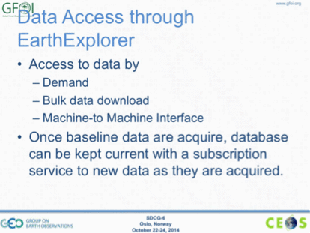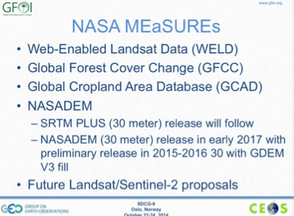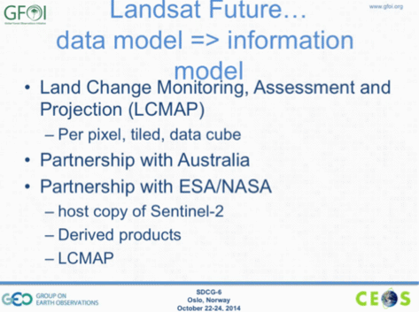
A brief discussion followed:
- Brian asked about the status of the updated LEDAPS software, and Gene noted that software required to produce the surface reflectance product for Landsat 8, which is a stand alone system rather than LEDAPS, is expected to be released in December 2015.
- Brian noted that he will make some internal inquiries at NASA regarding the data cube.
ESA / Sentinel-1 and Sentinel-2
Frank Martin Seifert presented a summary of the Sentinel-1 and Sentinel-2 programs.
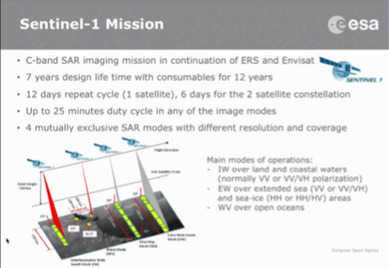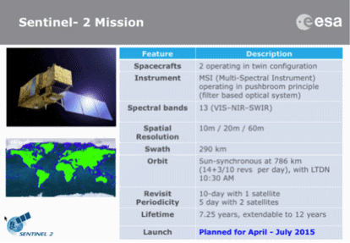
He noted that funding for systematic processing of Sentinel 2 data to level 2A is under discussion with the EC – currently level 2A processing is foreseen with the dedicated Sentinel-2 toolbox by the user. He summarised the status of the two-month rolling science archive for Sentinel-1, and suggested that countries should download any Sentinel-1 data they desire before it is removed from the archive, as there is still some uncertainty around long-term access to the archive for non-Copernicus services. Though the underlying principal is that the data are and will remain free and open.
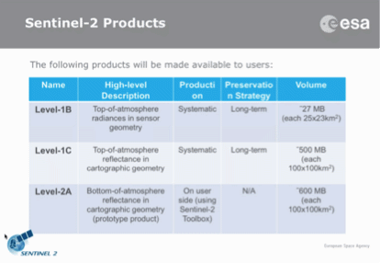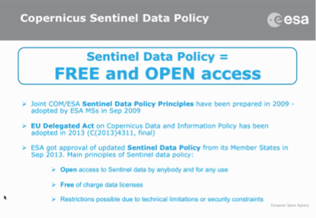
A brief discussion followed:
- Brian noted that there is an open question about how to access Sentinel-1 data older than two months.
- Frank Martin noted that the Copernicus data access is still evolving, and currently GFOI could consider downloading the data for all the GFOI sites.
- Helmut noted that the budget for the 3rd and 4th flight models is secured, which means that prospects for continuity of service are strong.

Baseline Strategy Update
Gene Fosnight presented a summary of plans for the baseline strategy update for SIT-30.
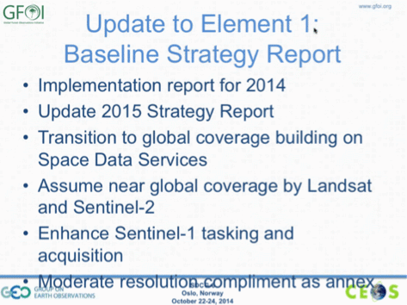
There was a brief discussion about whether the baseline strategy needs to be updated every year, and while it was agreed that the revisions would likely be small, it is important to update the strategy. Examples of the changes for 2015 would include updating the country tables, reflecting the changing status of CBERS-4 and Sentinel-2A, and also updating the reporting appendix for 2014.
Gene presented a brief status update on Landsat-7 and -8.
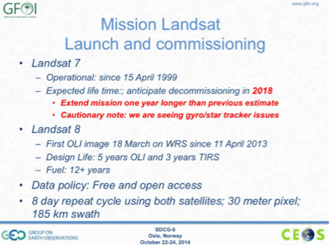
Evie Merethe Hagen asked about the status of Landsat-9 and Landsat-10, and Gene noted that as far as he is aware plans are on track.
Sentinel-1A Commissioning
Frank Martin Seifert provided a brief update on the commissioning of Sentinel-1A, noting that it reached its nominal orbit reached on 7 August, and completed commissioning on 23 September. Data flow opened to all users on 3rd October, and the Operational Qualification phase is on-going with satellite and ground segment status and performance nominal. The Sentinel-1A Routine Operations phase is expected to begin in April-May 2015, and Sentinel-1B is under procurement, with launch foreseen in early 2016.
ALOS-2 Commissioning and Expected Data Flow
Ake Rosenqvist presented a summary of the ALOS-2 Checkout Phase and Basic Observation Scenario on behalf of Masanobu Shimada, JAXA. ALOS-2 is currently in the Cal/Val phase, with the operational phase expected to commence in late November.
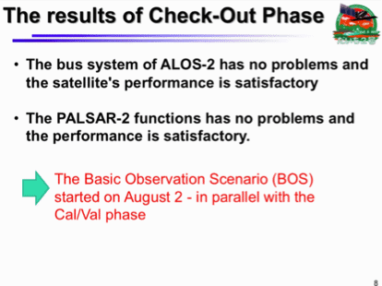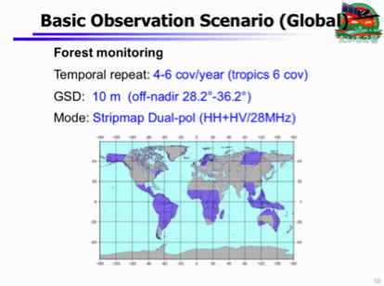
Ake also presented a brief overview of JAXA’s global PALSAR mosaics products and noted that the 25m resolution versions of the mosaics were to be released free and open by JAXA the last week of October [released October 31]. JAXA plans to add PALSAR-2 25m mosaics on the fly as they are produced, with about one year delay.
A brief discussion followed:
- Brian Killough asked about how the 25m ALOS mosaics could be made available to countries, and Ake responded that the SAR mosaics are available for download (in 1°x1° tiles) online at http://www.eorc.jaxa.jp/ALOS/en/palsar_fnf/fnf_index.htm. In the event that countries have problems downloading the large files, Ake noted he can work with Brian and SEO to make them available through the SDMS.
- Inge Jonckheere asked if it would be appropriate to do a data accuracy assessment on the forest/non-forest mosaic released by JAXA. Ake noted that the forest/non-forest mosaics also have been released and could be evaluated, however he encouraged waiting for a future update. Recalling the discussion earlier about the Global Forest Watch map products, Ake again cautioned against using global-scale map products for national-scale mapping.
- Inge noted she is considering hiring someone to assess the use of radar operationally in a country, and after a brief discussion it was agreed that Vietnam may be suitable.
SAOCOM Status
Ake presented on a brief status update on SAOCOM on behalf of Laura Frulla, CONAE.
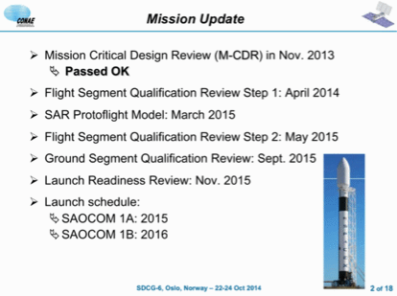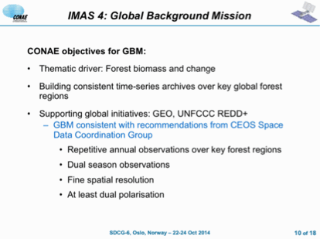
He noted that the Global Background Mission comprises two wall-to-wall observations over all tropical countries per year with each of SAOCOM-1A and -1B.
CBERS-4 Status
Hilcea Ferreira presented the latest status of CBERS-4, noting that its launch date is holding for 7th December.
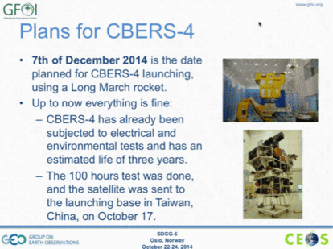
A brief discussion followed:
- Ake asked if the ResourceSat-2 data includes the LISS-3 Sensor, and Hilcea confirmed that it is included. The data catalogue can be found here: http://www.dgi.inpe.br/CDSR/.
- Brian asked if the AWIFS archive only over Brazil, or globally, and Hilcea confirmed the data available was only for Brazil.
- Brian asked about CBERS-4 coverage. Hilcea noted that Brazil will have the archive for their South American footprint, and will distribute that free of charge. But in the case of the Chinese ground stations, their Chinese partners will decide how the data will be distributed.
- Gene asked when data from CBERS for Africa is expected to be available, and Hilcea noted that China manages the CBERS ground station in Africa and so the timing was up to them.
COSMO-SkyMed Status
Ana Rita Pisani presented the ASI perspective and potential contributions to SDCG.
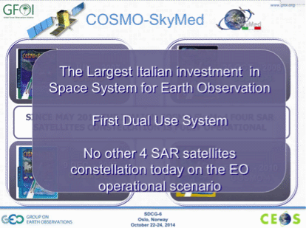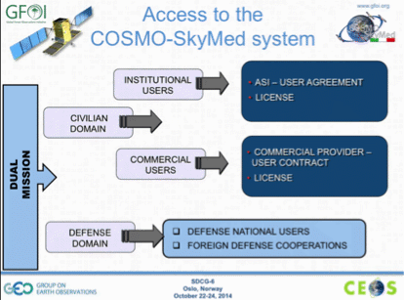
Ana Rita noted that the first next generation COSMOS satellite is expected to launch in 2017. She noted that ASI is making significant contributions to the GEO Geohazard Supersites and Natural Laboratories (GSNL) initiative. She noted that ASI is quite interested in supporting R&D activities involving X-Band – in particular integration with C-band and L-band. Ake welcomed this and noted that this fits in very well with the Element-3 strategy in support of the GFOI R&D data plan.
TerraSAR-X/TanDEM-X Status
Helmut Staudenrausch presented a brief summary of the TerraSAR-X and TanDEM-X missions.
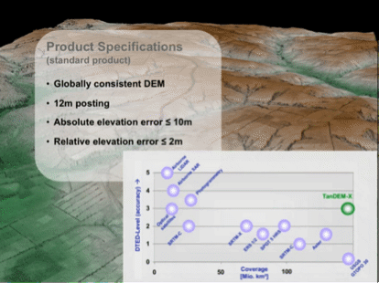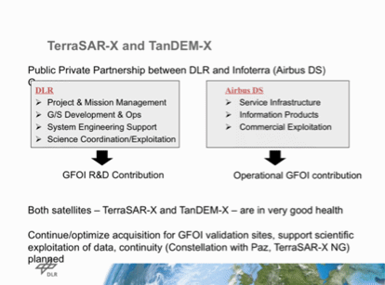

Space Data Support to GFOI R&D
GFOI R&D Plan
Simon Eggelston introduced the GFOI R&D Plan, stressing that the purpose of the Plan is to advance the development of products in support of the MGD, aiming to bring them into operations. Ake Rosenqvist noted that the Element 3 Strategy is intended to support the GFOI R&D plan, and therefore is more focused on the contributing data streams rather than the core data streams.
Element 3 Strategy Overview
Ake presented an overview of the Element 3 Strategy, noting that he and Anthea Mitchell have been working to progress the Strategy.
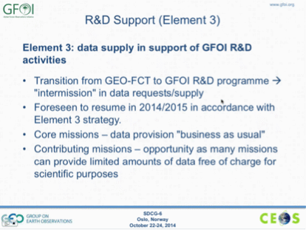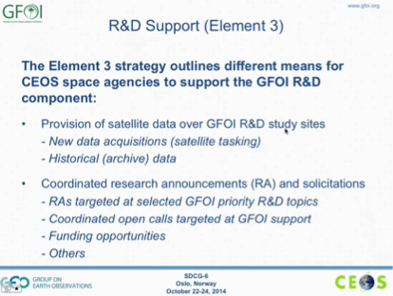
Ake gave an overview of the structure of the Element 3 Strategy draft.
- Introduction
- The GFOI R&D Component
- Collection of User Requirements
- Coordinated Strategy for satellite observations in support of GFOI R&D
- The Way Forward
- Annexes on contributing agencies and missions, and archive data
He noted that the Element 3 strategy is planned to be a simple and robust plan.
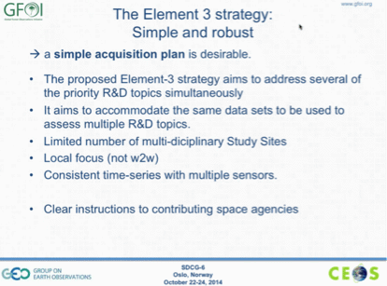
A brief discussion followed:
- Yves Crevier asked about the inclusion of northern countries like Finland, Iceland and Russia, and Ake confirmed that their inclusion was as a result of discussion at the recent degradation R&D workshop.
- Gene Fosnight asked if we are tracking links between the expert workshops, acquisitions, outcomes on the ground, and progress towards operational applications. Ake noted that they are trying to track this, but in many cases the researchers involved have their own drivers and schedules. However in some cases, providing data streams can help to push the research along.
- Yves noted that having the program in place provides the potential for a much more coherent series of R&D activities, and makes it easier for agencies like CSA to define and justify their contributions.
- Doug Muchoney noted that the results from the GEO-FCT National Demonstrators are important and welcomed that they were highlighted in the report. He noted that it would be good to be able to track outcomes (papers) from these sites, and note the continuation of these sites under the GFOI R&D component provide ongoing returns. He stressed that there is a need to ensure clarity between R&D and operational activities – specifically how the R&D projects and activities support countries in developing a robust national MRV system.
- Per-Erik Skrovseth asked who the audience for the Element 3 Strategy and whether the front matter was requried, and Ake noted that it was primarily aimed at the CEOS audience. Per-Erik suggested that in this case, the front matter should be kept to a minimum, and focus in reporting on what had been achieved with previous data provided. Ake and Doug both agreed that including some front matter in the plan is important in order to provide some background.
- Helmut Staudenrausch asked about the role of the GFOI Office in the development of the Element 3 Strategy, and Ake noted that the science activities are to be managed within the GFOI R&D Plan, and Element 3 Strategy is focused on coordinating space data acquisitions support. The Strategy is closely linked to the GFOI R&D Plan, but Ake sees these as distinct.
- Helmut noted that it is important ensure a clear boundary between the R&D Plan and the space data Strategy in order to help clarify the R&D funding process.
- Yves noted that the Element 3 Strategy is a part of the solution, but cannot address issues like modelling and product generation.
- Simon confirmed that the GFOI Office will continue to manage the GFOI R&D component, though the ToR for the Office are currently under review as a part of formulating the move to FAO.
CSA
Yves presented a summary of CSA engagement with GFOI and the SDCG, including ongoing support to acquisitions over the GFOI R&D sites.
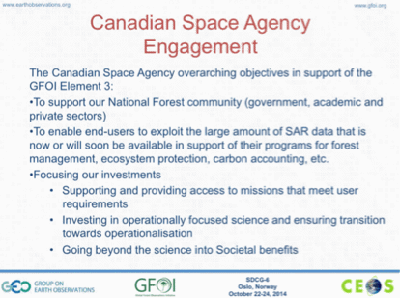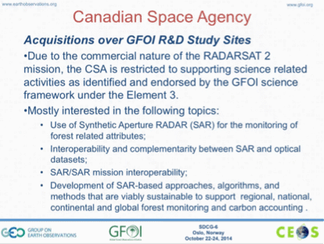
Yves noted the unprocessed RADARSAT-1 archive could be made available to GFOI, but the data is likely of limited use as it was not acquired in a systematic manner for forests.
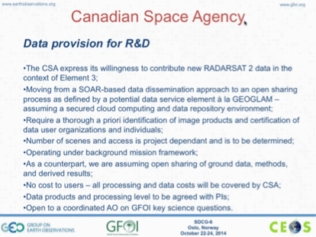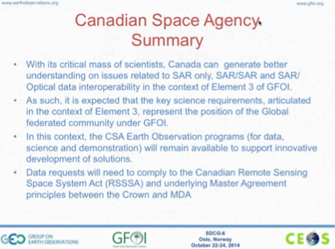
Yves stressed that the only way that Canada can currently contribute data to GFOI (with RADARSAT-2) is via R&D and in support of the science strategy. He noted that the contribution of RCM as a core mission is still foreseen, and this means there’s a more urgent need to address science issues related to SAR and forests so the data can be used in an operational fashion.
Yves summarised his presentation noted that CSA acknowledges the work on the GFOI R&D Plan, and the Element 3 Strategy, and he expressed CSA’s willingness to support.
A brief discussion followed:
- Yves noted that RADARSAT-2 data can be stored and disseminated in the SDMS for R&D purposes so long as the imager is clearly identified, and the users of the data are clear. Brian Killough noted that this is currently being coordinated.
- Steven Hosford noted that within the context of the International Charter on Disasters there was an attempt to bring all data into one place and distributed by one entity, and it proved challenging to implement. Yves noted that CSA is very close to finding a solution to this issue within the context of JECAM, and so this may help to progress the issue.
- Yves noted that CSA does not want to set a “quota” for data contributions, but would rather measure the contribution in terms of what is necessary to answer the relevant science questions.
DLR
Helmut Staudenrausch presented a summary of acquisitions over GFOI R&D sites by DLR missions. He also summarised the Sense Carbon project within the national EO program.
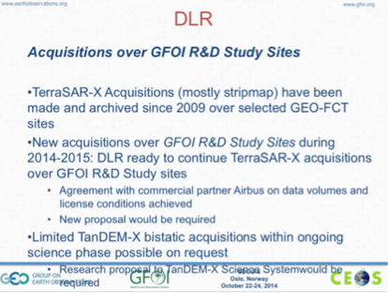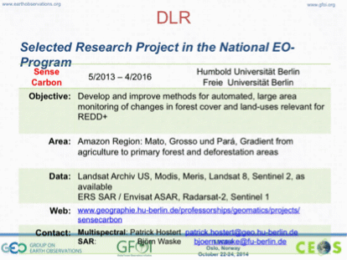
Helmut summarised some upcoming research opportunities of relevance to the GFOI R&D Plan.
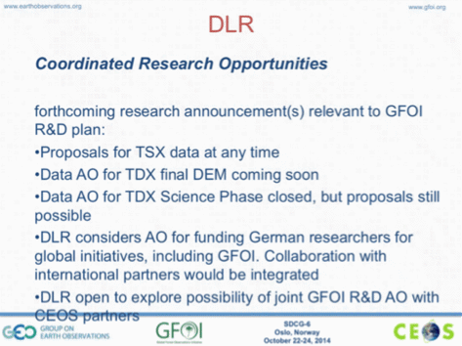
A brief discussion followed:
- Per-Erik noted that Airbus is quite support of R&D, and it might be worth making an approach.
- Steven asked if DLR would provide access to TerraSAR-X data through a portal / website operated by another organisation. Helmut noted that a discussion has started along these lines in the context of the Geohazard Supersites activity, but he does not know the latest status. He noted that DLR is interested in sharing more openly, but question will be whether it is compliant with the arrangements they have with Airbus, and data security act in Germany. It is also a matter of funding, but generally if it can be demonstrated that the data is secure then distribution arrangements can be considered.
- Steven noted that generally the person / organisation that signs the licence agreement is responsible, but in the case of the SDMS, it may be less clear who takes legal responsibility, and that this discussion has been difficulty on the French side.
- Brian noted that the SEO will know more on data policy implications in a few more months as their activities evolve.
CNES
Steven presented a summary of acquisitions over GFOI R&D sites by CNES missions, including archive data.
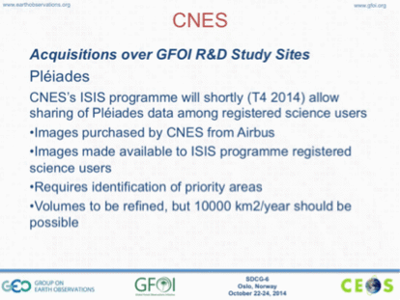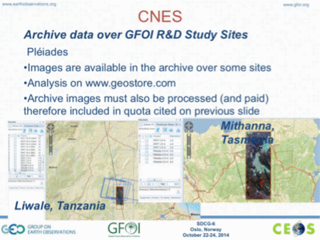
Steven noted that Pléiades data requests are possible, however there are limited resources, and so a priorities list of GFOI sites would need to be provide, and geospatially explicit information (e.g. shape / KML files) would be needed to assess. He stressed that the limited budget would not be able to provide observations over all GFOI sites.
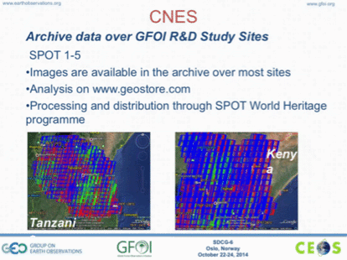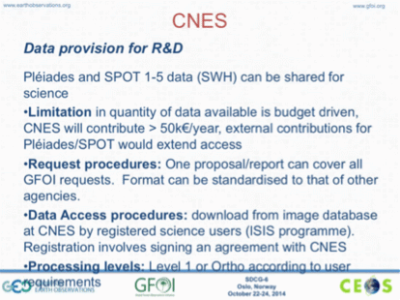
A brief discussion followed:
- Ake asked if the data over the GFOI sites could be processed with a higher priority when the processing of the next 100,000 images from the SPOT World Heritage Program takes place. Steven noted that to date they have taken a broad brush approach to processing, but it may be possible to bump the priority of a small group. He noted that if the location and prioritisation of these sites could be shared explicitly, then some higher priority may be able to be applied to these sites.
- Ake asked whether SPOT-6 and -7 are included in the World Heritage Program, and Steven confirmed that they are not currently included, CNES does have an agreement with Airbus.
- Ake asked how many Pléiades scenes might be able to be processed based on the available budget. Steven noted the budget was 50,000 EUR per year, which equates to about 25 scenes.
JAXA
Ake presented on behalf of Masanobu Shimada of JAXA on their acquisitions and archive over GFOI R&D study sites.
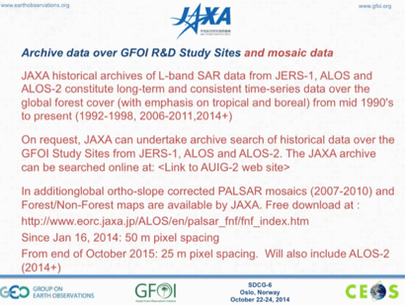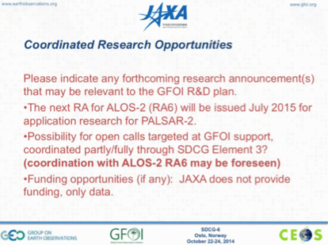
A brief discussion followed:
- Anna Rita noted that ASI is currently evaluating options to contribute to the GFOI R&D activities. She noted that COSMO-SkyMed data are not free, but there is the possibility to provide the data free of charge for R&D activities.
Frank Martin presented a summary of a couple of activities in the ESA pipeline.
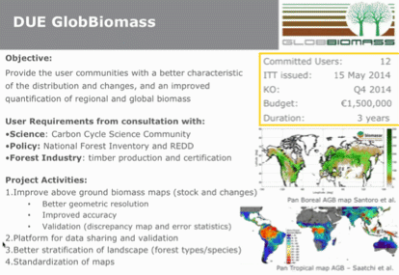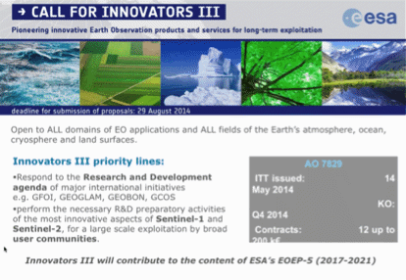
He reported that while the Innovator-III program proposals are still under evaluation, a couple of proposals related to GFOI seem likely to be supported. He provided a summary of the EO Thematic Exploitation Platform for forests, as well as the SPOT-5 Take-5 experiment, noting that this experiment is being lead by CNES and ESA.
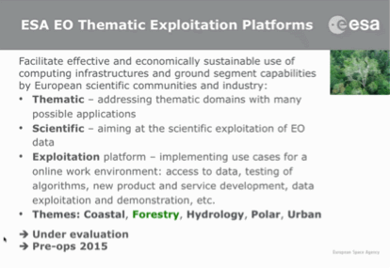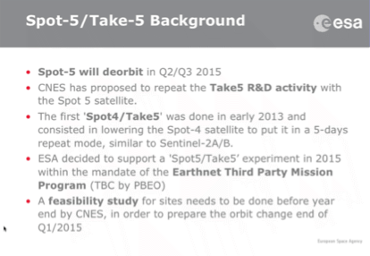
Frank Martin noted that it would be good to encourage other agencies to engage with the SPOT-5 Take 5 initiative by making acquisitions with their sensors, in modes that support the GFOI R&D Plan. Ake confirmed that several of the GFOI R&D sites are reflected in the SPOT-5 Take 5 list.
Ake noted that this will be his last meeting as an SDCG co-chair, and the GFOI R&D funding is also under evaluation. He noted that the SDCG EXEC will need to identify a new lead for R&D and for the development of the Element 3 strategy. The other two co-chairs and SDCG secretariat thanked Ake for his outstanding engagement and dedication as co-chair.

Coordination with External Groups
Space Data Support to the Methods and Guidance Component
Stephen Ward presented an update on activities in the MGD component of GFOI, noting that they are developing a new MGD portal. He encouraged members of the SDCG to read the MGD, noting that there may be a strong case for closer alignment of space data support with the MGD.
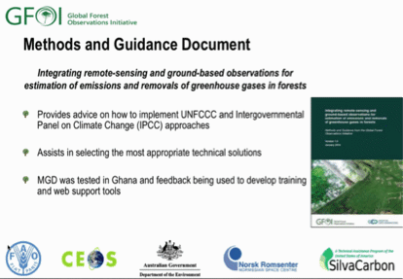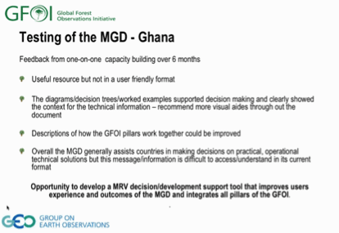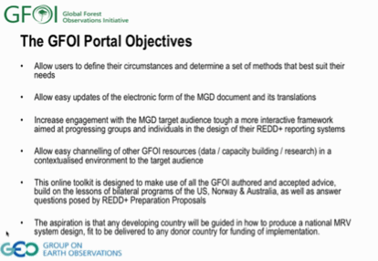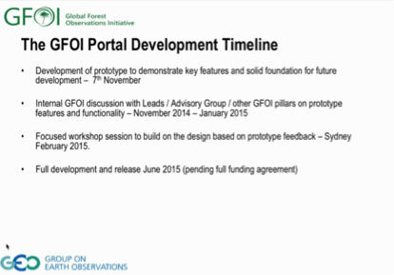
He noted that Carly Green (the MGD component director) has asked that SDCG provide a representative to the design team of the new MGD portal. It is expected that the portal (aka MGD 2.0) will be much more interactive, which may open up opportunities for the incorporation of space data tools (e.g. COVE).
A brief discussion followed:
- Brian asked about the role of FAO within the MGD, and it was noted that Carly and Inge Jonckheere are working strongly together on the MGD.
- Gene asked about links to OpenForis. Brian noted that he plans to try and incorporate OpenForis better into the tools he is developing.
- Stephen Ward suggested that Brian could be the best SDCG representative to the MGD portal design team.
Status of GEOGLAM and Impacts for GFOI and SDCG
George Dyke presented a brief summary of the main topics for coordination between the GFOI Space Data component and GEOGLAM.
He noted that the CEOS Acquisition Strategy for GEOGLAM will be presented at CEOS Plenary for endorsement, and suggested that SDCG review the strategy and produce a brief assessment of potential impacts on SDCG activities.
George reported that discussion at the SIT Workshop had suggested an update to the naming of the CEOS ad hoc Working Group for GEOGLAM, and that while in the end there was not official proposal to make a change, one of the alternatives considered was the Space Data Coordination Group for GEOGLAM. Ake Rosenqvist noted that he opposed the co-naming of the SDCG for GFOI and the SDCG for GEOGLAM without proper, formal coordination between the two groups.
Interactions with SilvaCarbon
There was a brief discussion about the need to interact with SilvaCarbon in order to push forward the implementation of the space data strategy. Brian suggested that the GFOI Office should be the coordinating body for this interaction. Doug Muchoney suggested that one area for coordination between SilvaCarbon and the SDCG would be on the prioritisation of countries based on current activities.
GEO Plenary
Doug raised the issue of the GFOI side event at GEO Plenary, and it was noted that there would likely not be a side event given the uncertainty around GEO Plneary.
Helmut Staudenrausch noted that there are no official documents submitted to GEO Plenary for GFOI and GEOGLAM, and that without these documents being submitted on an annual basis, there is no official basis to evaluate progress. He noted that the German GEO delegation, and other colleagues in the German government have queried him on the absence of these documents. Per-Erik noted that the leads agreed that annual GFOI reports would not be submitted to GEO Plenary in order to reduce reporting burden. Kerry noted that if there is a strong reference to GFOI in the CEOS statement to GEO Plenary, this could help to raise the profile.

Wrap-up Discussions
Stephen Ward summarised the major discussion points from the meeting, including the development of the 3-Year Work Plan, and around the country interface.
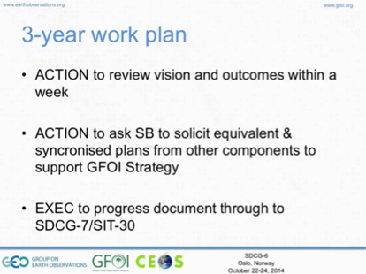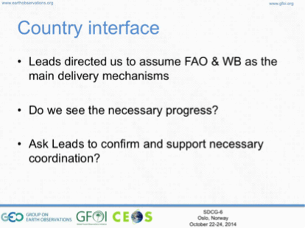
He noted that the MGD is having success in cutting through into the country engagement dialogue, and so the SDCG should consider how to best collaborate with that GFOI component. He also noted that Jim Baker suggested that we get reference to GFOI into the World Bank RPP documents, and this will be pursued.
He also noted that there is concern about making GFOI, the Space Data Component, and SDCG tools visible and relevant to the countries, and that FAO’s role here as a GFOI contributor should be to provide country feedback.
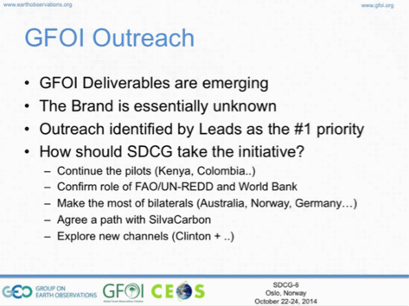
Helmut Staudenrausch agreed that it is important to address GFOI branding, but it has to be conceived as a partnership with FAO as integral implementing partner. Stephen Ward noted that Jim Baker is also going to help make connections across the community to try and help identifying further channel partners for GFOI.
It was agreed that for SDCG-7, SDCG should focus on the strategic approach to SilvaCarbon interaction, and interaction with the MGD component.
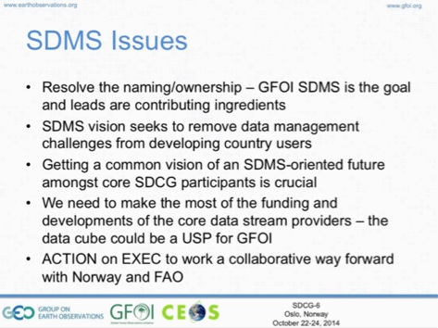
Gene noted that there is no clear, defining statement for the SDMS, which would help in understanding the role it could play. He stressed that one useful function could be data packaging and distribution. Stephen Ward also noted the absence of feedback from users to date.
Sylvia noted that SilvaCarbon is in a difficult situation because of the lack of coordination between the FAO SDMS and the GFOI SDMS. It was agreed that SilvaCarbon should be used as a forum to solicit country and user feedback on the GFOI SDMS.
Brian noted that in an ideal world, the GFOI SDMS would be developed in response to requirements from FAO and GFOI. However, the only actual requirement has been for a simple prototype from FAO, which they have addressed. The rest of the requirements are being harvested from Brian’s interactions with countries and various pilot projects on going. Brian also noted the need to clarify FAO’s plans for their broader 3-Year SDMS project.
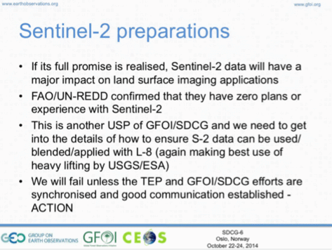
The need for support and coordination on the utilisation of Sentinel-2 was raised a number of times during the meeting, and this is an area where SDCG should be able to provide resources, including through initiatives like the Thematic Exploitation Platforms.
Stephen Ward noted that with the retirement of the NSC Co-Chair as of 31st December this year, SDCG should consider options for leadership continuity.
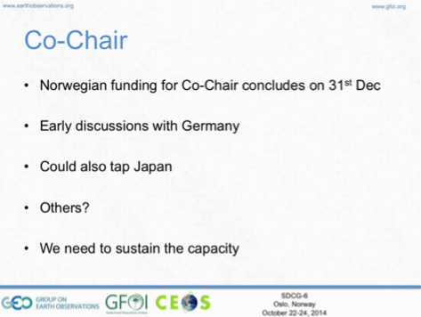
It was also noted that CSA could be considered, and has a good heritage of supporting the SDCG, hosting the first meeting.
SDCG Reporting to Plenary
Stephen Ward briefly reviewed the main topics to be covered during the SDCG presentation to CEOS Plenary.
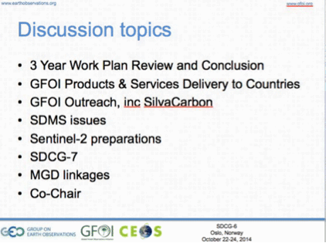
SDCG-7
Stephen Ward presented a preview of the SDCG-7 meeting, noting the Australian offer to host.
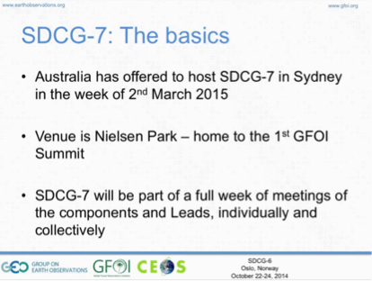
In particular, the linkage to the MGD component should be discussed at SDCG-7, given the Australian leadership of this component.
Closing Remarks
Ake thanked all participants on behalf of the host, NSC, and also thanked NSC for their generous hosting of SDCG-6.

SDCG-6 Attendees
Organisation | Participant | Organisation | Participant
ASI | Anna Rita Pisani | FAO | Inge Jonckheere
Bangladesh | Miriam Ahkter | GEOSEC | Osamu Ochai (GTM)
CEOS CEO (NOAA) | Kerry Sawyer | GFOI Office | Simon Eggleston
CEOS SEO (NASA) | Brian Killough | Indonesia | Orbita Roswintiarti
CEOS SEO (NASA) | Paul Kessler | INPE | Hilcéa Ferreira
CEOS SEO (NASA) | Brian Williams | Nepal | Basanta Gautam
CEOS SEO (NASA) | Sanjay Gowda | Norway MoE | Oystein Nesije
Clinton Foundation | James (Jim) Baker | NSC | Evie Merethe Hagen
Conservation International | Jennifer Hewson | NSC | Einar-Arne Herland
CNES | Steven Hosford (GTM) | NSC | Ake Rosenqvist
CSA | Yves Crevier | NSC | Per-Erik Skrovseth
DLR | Helmut Staudenrausch | Philippines | Maria Nelissa Rocas
DOTE/Australia | Anthony Bennie | SilvaCarbon | Sylvia Wilson
DOTE/Australia | Stephen Ward | SilvaCarbon | Marija Kono Spirovska
DOTE/Australia | George Dyke | SilvaCarbon | Alicia Peduzzi
ESA | Stephen Briggs | USGS | Douglas Muchoney
ESA | Frank Martin Seifert | USGS | Eugene (Gene) Fosnight

SDCG-5 Actions Status Update

V1.2 – SDCG-6 Update, 14 November 2014

No. | Action | Due date
SDCG-5-1 | SDCG EXEC (Gene Fosnight) to coordinate the provision of national requirements & contacts for the shipping of 2013 Landsat data with Gene Fosnight. | SDCG-6  Superseded – Landsat delivery to be provided by request, via capacity building component
SDCG-5-2 | Brian Killough to follow-up with Johannes Roeder on the Sentinel-2 global grid system, including a draft KML (not final – subject to change) for evaluation. | COMPLETE  Will be released
SDCG-5-3 | CEOS SEO to work with Ake and Shimada to test the upload of the 50m ALOS PALSAR mosaics into the CEOS Google Maps Engine account for evaluation in Earth Engine. | June 2014  In progress
SDCG-5-4 | Masanobu Shimada to provide SDCG with an update on the availability of the 25m ALOS PALSAR mosaics as GFOI Core Data | COMPLETE  Release of 25m mosaics confirmed
SDCG-5-5 | Stefano Bruzzi to advise on a proposal within ASI regarding SAOCOM coverage over Europe and Northern Africa in support of GFOI. | COMPLETE  ASI participated at SDCG-6
SDCG-5-6 | Helmut Staudenrausch to provide an update on the potential DLR workshop on satellite data monitoring systems for REDD implementation. | COMPLETE  R&D Workshop program in progress
SDCG-5-7 | SDCG EXEC to review the latest draft of the Global Baseline Strategy, including writing assignments noted by Ake, and provide comments and required inputs. | COMPLETE
SDCG-5-8 | Sylva Wilson to provide inputs into the Element 2 Space Data Services Strategy to ensure that the efforts of SilvaCarbon are accurately characterised. | COMPLETE
SDCG-5-9 | CEOS SEO to develop a country-based needs matrix to support Data Services prototype development. | COMPLETE
SDCG-5-10 | SCDG EXEC to work with Sylvia Wilson and Simon Eggleston on the creation and rationalisation of a country contact table for GFOI based on current interactions. | COMPLETE
SDCG-5-11 | Stephen Briggs to raise at the GFOI Leads meeting the issue of coordination of GFOI service delivery (i.e. GFOI Space Data Services) between FAO, World Bank, and GFOI. | COMPLETE
SDCG-5-12 | SDCG EXEC to provide Stephen with Word redline comments on the Element 2 (GFOI Space Data Services) strategy. Stephen will take these comments and send the next revision to SDCG, within a week. | COMPLETE
SDCG-5-13 | SDCG to provide Gene final feedback on the draft 2013 Global Baseline Strategy results report. | COMPLETE
SDCG-5-14 | Stephen Ward, Gene Fosnight, and Ake Rosenqvist to deliver the Element 2 strategy, 2013 Global Baseline Strategy results report, and the 2014 update of the Global Baseline Strategy and Implementation Plan respectively for CEOS Principal review and endorsement at SIT-29 | COMPLETE
SDCG-5-15 | Stephen Briggs and Stephen Ward to develop and deliver the GFOI and SDCG presentation materials for the SIT-29 meeting. | COMPLETE
SDCG-5-16 | Ake Rosenqvist to work with Steven Hosford and the SDCG EXEC to coordinate a follow-up action from SIT-29 calling for the presentation of an Element 3 Strategy for endorsement at SIT-30. | COMPLETE
SDCG-5-17 | Ake Rosenqvist to coordinate with Helmut Staudenrausch, Yves Crevier and Steven Hosford on how best to structure agency support of the Element 3 Strategy. | COMPLETE  Discussed at SDCG-6 and to be reflected in the E2 strategy
SDCG-5-18 | Frank Martin Seifert to coordinate with Ake Rosenqvist and the SDCG EXEC on a workshop at ESRIN, potentially joint with another workshop, on R&D related to forest degradation. | COMPLETE  Workshop held at Uni. Wageningen
SDCG-5-19 | Kerry Sawyer to provide an update on the SRTM-2 availability after the determination of the NGA process. | COMPLETE  SRTM data being released over the next year
SDCG-5-20 | SDCG EXEC (Ake Rosenqvist), in consultation with SDCG agencies, to propose an approach to the commercial providers by SDCG in general, including a recommendation on plans for SDCG-6 | COMPLETE  Discussion and actions defined from SCDG-6 for a commercial provider meeting
SDCG-5-21 | SDCG EXEC (Ake Rosenqvist) to work with Ake and Evie/NSC on the coordination of SDCG-6 in Oslo week of 20th October 2014. | COMPLETE
SDCG-5-22 | SDCG EXEC/CEOS SEO (Brian Killough) to draft a timeline summary of data availability from archives, and current and future data streams. | COMPLETE  Being provided by the Coverage Analyser tool
SDCG-5-23 | CEOS SEO to include a summary of archive data in future country reports where archive search tools are available. | COMPLETE
SDCG-5-24 | CEOS SEO to work with Helmut Staudenrausch and DLR to respond to the TanDEM-X DEM Announcement of Opportunity with a view to evaluating the data set for application to GFOI. | COMPLETE  A.O. open until 12th March 2014

