MINUTES OF THE 8th SDCG MEETING (SDCG-8)

23rd-25th September 2015
DLR, Bonn, Germany

Welcome and Opening Remarks – Commercial Provider Day
Rolf Densing (Program Director Space Administration, DLR) welcomed the group to Germany, noting that Earth observations are a highlight in DLR’s space programme. Helmut Staudenrausch (DLR) added his welcome to the meeting and to DLR, noting that this first Commercial Provider Day was an important milestone for the SDCG and for the GFOI Space Data Component.
The participants introduced themselves in a Tour de Table.

Introductions and Objectives
Eugene (Gene) Fosnight (USGS) reviewed the objectives of the day, including:
- exchange of views and information between CEOS Space Data Coordination Group in support of GFOI and commercial EO data providers;
- informing commercial data providers on the GFOI global baseline data strategy and related opportunities for commercial data providers;
- engaging commercial data providers in contributing to GFOI key science questions (R&D Plan) and service demonstration and pilot activities; and,
- exploration of a collaborative and open contribution framework with commercial data providers, aiming at providing data streams complementary to the CEOS portfolio to support GFOI SDCG strategy elements 2 & 3.
Gene noted that the main objective is to identify opportunities and synergies between the activities of the SDCG and the commercial sector. He contrasted the relative strengths of medium resolution global survey missions, with the generally more responsive, finer resolution commercial missions, and identified several potential opportunities for synergy and collaboration:
- multi-resolution analysis;
- multi-stage sample designs;
- absolute and cross calibration; and,
- coordination of access to commercial archive data that is no longer commercially viable.
He briefly reviewed the role of SDCG:
- To ensure country access to core data provided by the CEOS space agencies;
- To understand the GFOI data needs of the national forest agencies; and,
- To support R&D requirements needed to continue to evolve forest monitoring methodologies.
Overview of GFOI
Frank Martin Seifert (ESA) presented an overview of GFOI, reviewing its four components: Space Data, Methods and Guidance, Capacity Building, and Research and Development. The principles of GFOI are to support and be consistent with REDD+, to support wall-to-wall monitoring, to offer affordable and practical solutions, and to encourage other international partners such as FAO, World Bank, IPCC/UNFCCC, and others. GFOI supports a variety of in-country delivery arrangements, including via its own capacity building component (SilvaCarbon).
Frank Martin reviewed the core data streams, identified by the SDCG as providing global coverage for GFOI, including Landsat, Sentinel-1, and soon to be joined by Sentinel-2 which is in its on-orbit commissioning phase. He also noted that annual ALOS and ALOS-2 global mosaics are being provided, leveraging ALOS’s Baseline Observation Strategy (BOS). He stressed that one of the main requirements of the climate community is for systematic and repeated observations.
Frank Martin noted that SDCG, supported by the CEOS Systems Engineering Office (SEO), is working on data management solutions leveraging cloud computing models (e.g. Data Cube), and is also working on a Space Data Access Guide and accompanying Space Data Portal (website) for GFOI.
CEOS Space Data Strategy for GFOI
Stephen Ward (SDCG Secretariat) reviewed the CEOS approach to data for GFOI, which focuses on three elements – free and open Global Baseline data (Element 1), Space Data Services (Element 2), and support to R&D (Element 3).
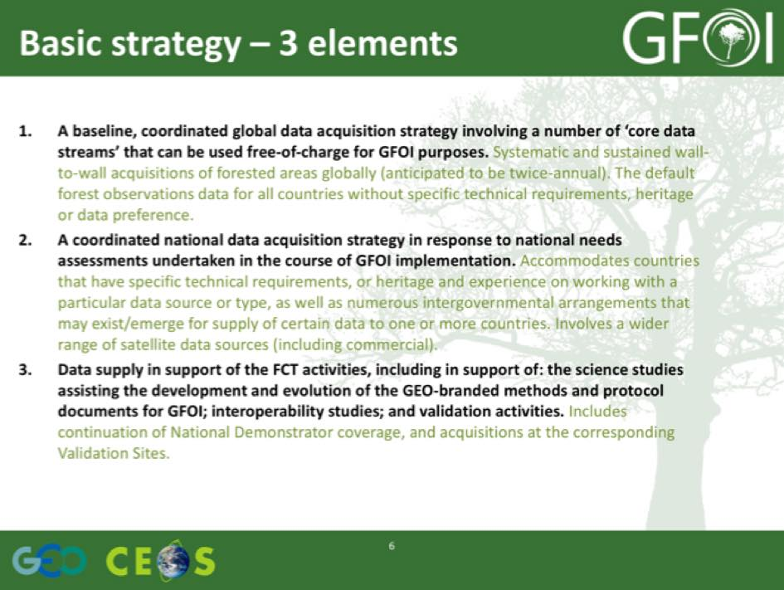
Stephen reviewed the core data streams and candidates:
- Landsat-5/7/8 (optical) – USGS;
- ENVISAT (C-band SAR) – ESA;
- Sentinel-1 series (C-band SAR) – ESA/EC;
- Sentinel-2 series (optical) – ESA;
- CBERS-3 & -4 (optical) – INPE/CRESDA;
- RADARSAT Constellation Mission (C-band SAR) – CSA; and,
- SAOCOM series a candidate.
He also reviewed a number of other data streams which have been identified as being of interest, including a number of commercial data sources.
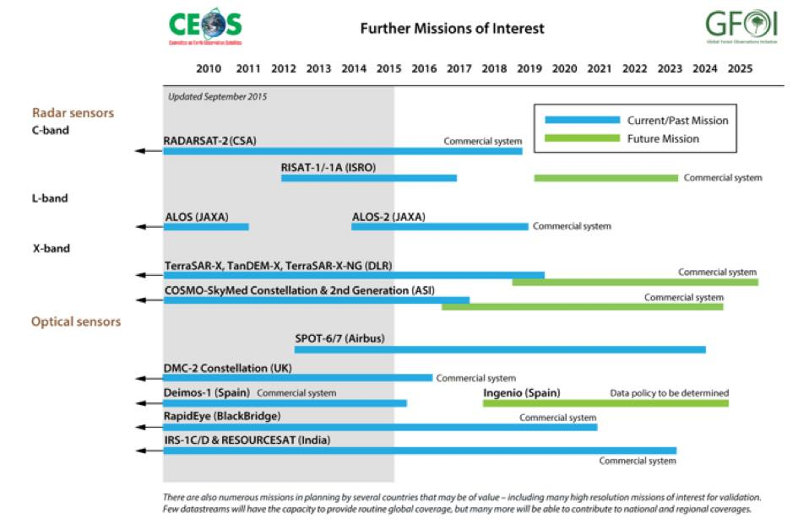
Stephen reviewed the institutional arrangements that lead CEOS to create the Space Data Coordination Group, noting that this is a small step by CEOS closer to the user interface.
Element 1 - Global Baseline Data Acquisition
Stephen reviewed the Global Baseline Acquisition Strategy, including the expected outcomes for 2015 and the plan to achieve them. He noted that a major part of the strategy will be to leverage developments in cloud computing and storage, including via the Data Cube being worked on by the CEOS Systems Engineering Office (SEO) in collaboration with Geoscience Australia.
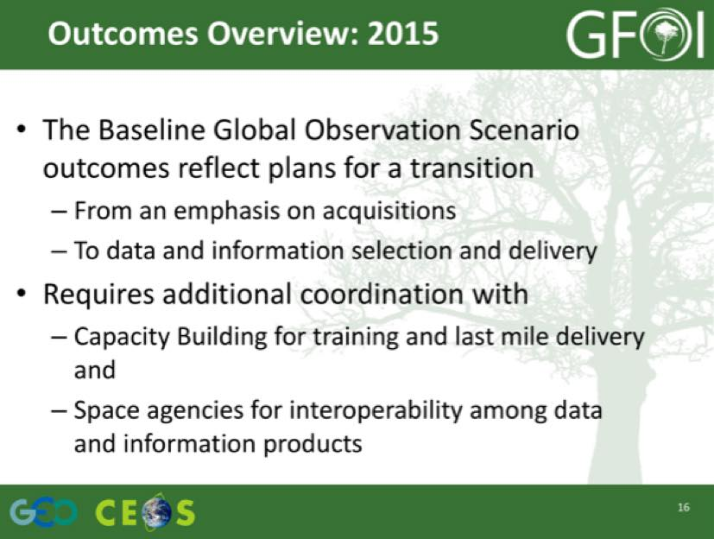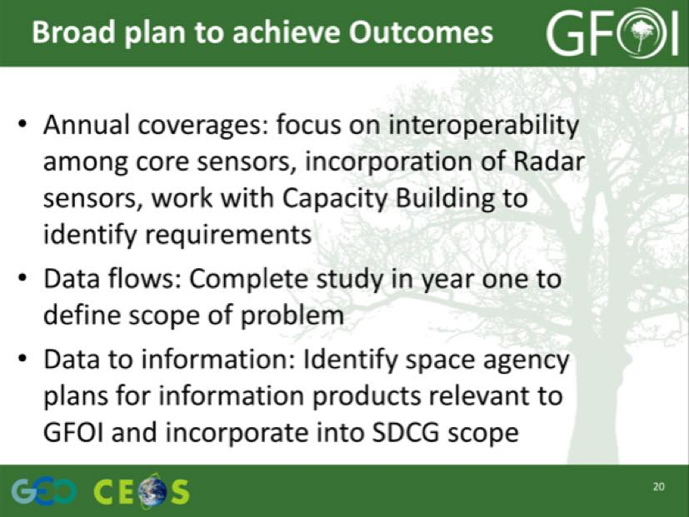
A brief discussion followed:
- Brice Mora (GOFC-GOLD) asked about data flows for applications beyond REDD+ (e.g. biodiversity), noting that these needs are overlapping, and asked whether there is a group focused on this theme. Brian Killough (NASA) noted there are a couple of other groups within CEOS working on coordinating land cover observations, but none are presently focused on biodiversity. Yves Crevier (CSA) noted that many of the requirements overlap, that many of the observations would be common, and that it is a challenge for CEOS to balance the many and varied user requirements.
- It was noted that the Land Surface Imaging Virtual Constellation (LSI-VC) is currently in the process of being re-animated, and is a promising venue to address the diversity of user requirements. Gene cautioned that SDCG has remained focused on GFOI which has ensured it has stayed strong, but if the focus becomes more diffuse, there is a risk of losing touch with the constituency.
Element 2 - Country Specific Space Data Services
Brian presented a summary of the Space Data Services (Element 2) that the CEOS SEO are developing in support of GFOI.
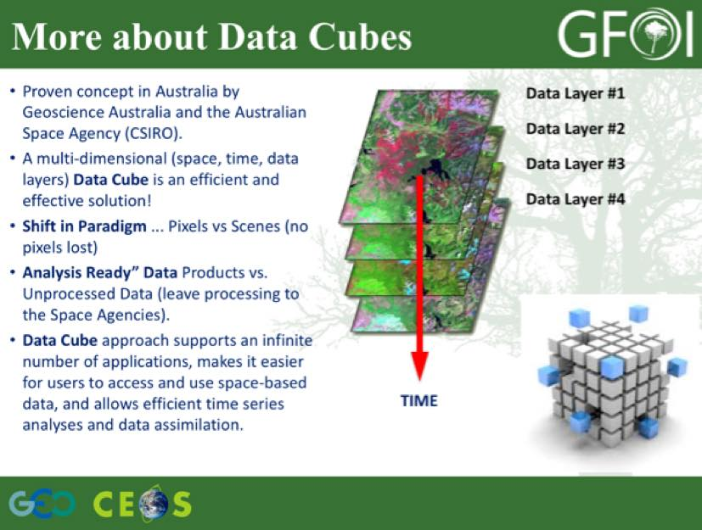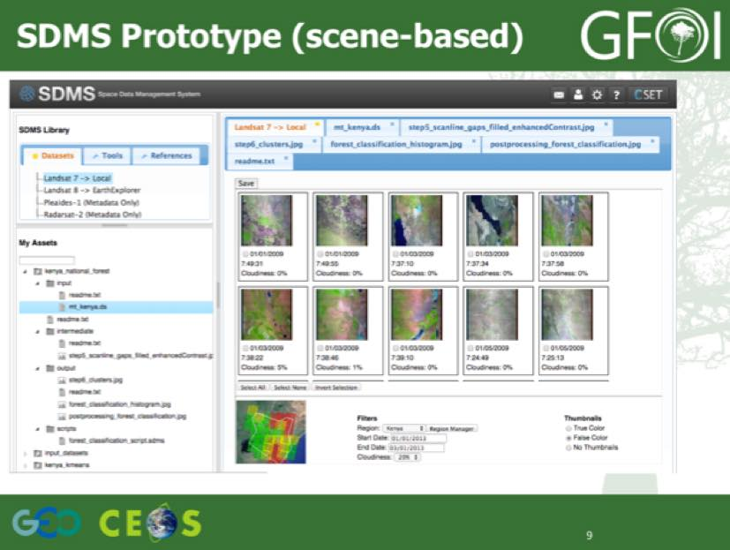
Brian reviewed some of the technical details of the Space Data Management System (SDMS), noting that a variety of data streams and data types can be ingested, and that the tool will be available via open source. He stressed that they are planning to be able to accommodate commercial data, and would like to try and test with some sample data. He noted that addressing requirements arising from data restrictions is an administrative challenge, and so would prefer test data be free and open. He also noted progress on multi-site program-oriented user agreements, developed by CSA in collaboration with MDA.
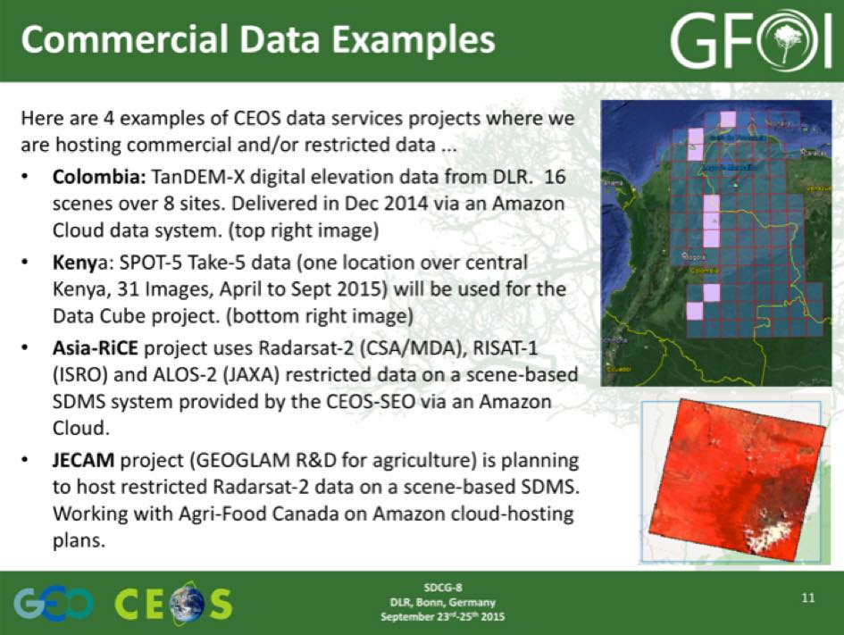
A brief discussion followed:
- The issue of how much data will be stored in the data cube was raised, and Brian confirmed that the Data Cubes will be specific to countries (rather than global). Cubes are being developed on a pilot basis, and the objective is to have countries ingest their own data via an open source tool. It is envisioned that this tool will be able to handle a number of data streams, and that data providers could possibly add accommodation for their own data streams via the open source project.
- Yves asked if the derived products would be ingested back into the Data Cube, and Brian noted that they could be re-ingested, but products from the Data Cube are intended to be incorporated into the user’s regular work flow. He noted that currently the focus is on producing cloud free mosaics.
- Inge Jonckheere (FAO) asked about why the Cube prototype is focused on countries, given that the forest products are not currently integrated, and she suggested that the country focus complicates the process.
- Gene noted that the Data Cube is a reorganisation of the data archive optimised for time series analysis, and cautioned that algorithms are run against the archive need to be well understood. He noted that within GFOI and SDCG, we have capacity building and technology together, and we need to ensure that these efforts are linked.
- Marcus Apel (RapidEye) noted that the Data Cube approach fits well with their approach, and that they are also ingesting Landsat data (and plan the same with Sentinel-2) in order to make access easier for their users. He also noted that free and open RapidEye data that was acquired along with the Spot 5 Take 5 data which could be used to test.
- Jonathan Ross (Geoscience Australia) stressed that we need to move to a model where the data is not moved around as it is too big. And that data systems should be interoperable behind the scenes, with the ability to share processing capacity and products directly between data centres.
- It was noted that commercial providers generally agree that Cube-like distribution and processing models are the future, though there are relevant national regulations which providers have to comply with. In addition, licencing arrangements need to be adjusted to accommodate these new models.
Element 3 - Research & Development
Ake Rosenqvist (SDCG Executive) presented a summary of SDCG support to the GFOI R&D Component, noting that the Component is now lead by GOFC-GOLD and supported by a CEOS Acquisition Strategy (Element 3). He noted that the GFOI R&D plan focuses on areas where products are not yet operationally generated – for example degradation, and interoperability between data streams.
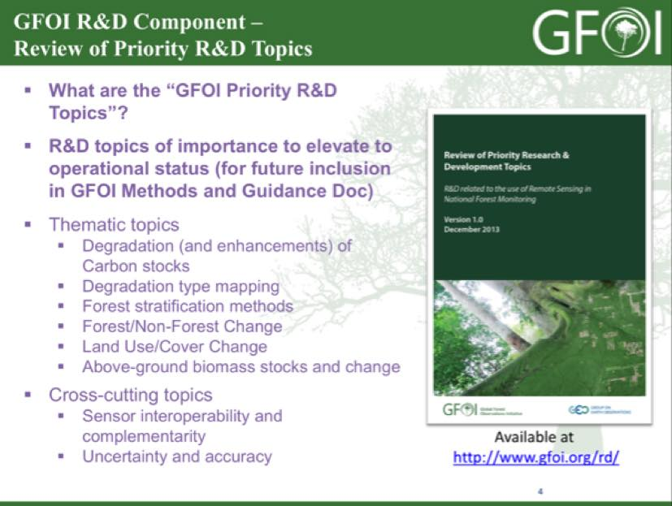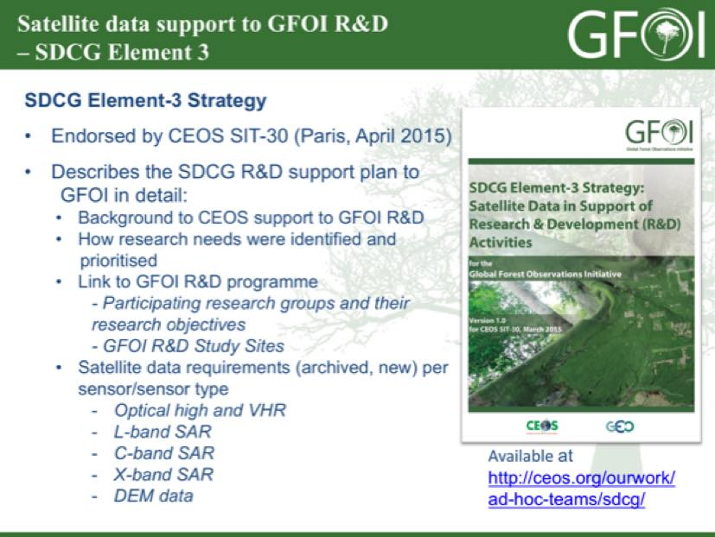
A brief discussion followed:
- Marcus asked about the benefit of working through the GFOI R&D program, noting that satellite data is normally only available from a wide range of providers. Ake noted that working through the program can provide greater visibility, and may also provide access to data that would normally not be accessible without a cost. He also noted that there is a focused effort to acquire time series over the GFOI R&D sites in order to help support the development of sensor synergy.
- Brice noted that the coordination of joint acquisitions (including airborne acquisitions) is another one of the attractions of the GFOI activity.
- Yves noted that one of key outcomes could be the integration of data streams or types into the GFOI Methods and Guidance documents, which are used by countries to generate their forest products.
- Doug Muchoney (USGS) noted that data is valuable across a number of GEO initiatives, and a number of these activities have research funding attached which may be of interest for commercial providers.

Commercial EO Data Provider Activities Relevant to GFOI
Airbus Defence and Space Germany: Felicitas Poncet TBA from slides.
Airbus Defence and Space France: Patrick Houdry TBA from slides.
Steven Hosford provided an update on the SPOT World Heritage program, noting that the production of 200,000 images has started – including 10,000 historical images of Kenya.
A brief discussion followed:
- Brian asked about licence arrangement, and the circulation of derived products, and Patrick Houdry (Airbus Defence and Space France) confirmed that derived products can be redistributed so long as the original product cannot be re-extracted.
BlackBridge: Marcus Apel presented a summary of RapidEye activities, noting that they are active across the value chain. He reviewed some of the challenges which BlackBridge views as important for forest monitoring, including speed of response, narrow time windows, and clouds. He noted that RapidEye provides daily revisit, and possibly twice daily by request. They expect that the current satellites will run full capacity until 2020, and is expected to last (with reduced battery capacity) until 2025.
Marcus summarised a number of campaigns that have been run by BlackBridge over the past few years, noting that all of the UN-REDD partner countries are covered by the archive. He summarised some existing and planned forest-related activities, including monitoring illegal logging.
A brief discussion followed:
- Brian asked about the data archives, noting that it appears there is significant coverage of a number of countries. Marcus noted that the background mission is always acquiring data, though it is focused on supporting potential business opportunities. There are some examples where high priority tasking has taken place without a user request (e.g. Indonesia), and those data are then made available at a later time.
- Doug Muchoney noted that the red edge band is important for forest applications, and the early detection of stress and damage.
- Doug asked how well RapidEye can normalise the reflectance for topology. Pablo Rosso noted that customer requirements are considered when selecting the nadir viewing angle, but that there isn’t a comprehensive response globally and it varies on a case-by-case basis. Pablo also noted that most of their experience is based on imaging of flat areas.
- Doug asked about cloud and phonological windows, and whether these are programmed or based on customer orders, and Marcus confirmed this was based on customer orders.
GAF: Jörn Reike presented a summary of GAF activities, noting that they have European distribution rights for a number of satellites including the Indian IRS series. GAF develops solutions derived from multiple sensors, and combining them to generate value added products. This includes a number of activities related to forest in both Europe and Africa.
A brief discussion followed:
- Frank Martin Seifert asked about the scope of the European distributorship, and Jörn confirmed that if you are situated in Europe, then GAF can provide you with data globally. But if you are based outside of Europe, then you are outside the scope of the GAF distributorship.
- Helmut asked if GAF has any special pricing for scientific usage, and Jörn confirmed this was possible, and that in addition demonstration products are possible.
A brief discussion followed on potential support to the three GFOI Space Data Strategy Elements:
- Doug raised the possibility of a larger test site (possibly cross boarders) to investigate an R&D topic like degradation, and suggested that it may even be possible to secure funding. Gabon was suggested as a potential area of interest, given the problems with clouds. Brice confirmed that this is something that the R&D component of GFOI could help coordinate.
- The sharing of ground / field data is frequently a challenge, and somewhere where GFOI might be able to contribute.
- The community – space agencies, industry, and GFOI – appear to be willing to cooperate, but one of the barriers stopping progress are resources to evaluate the value-added of new activities. This is a common issue across a number of activities in the remote sensing community.
- Yves noted that the activities of the commercial providers is impressive, and demonstrate a direct connection to real users and real world problems. He noted that the commercial providers need to be an integral part of the solution, but that we need to understand how to engage. Frank Martin noted that the performance based payments for REDD+ may be part of the solution.
- It was noted that the commercial providers are not selling data, but they are selling a reliable and quality service including acquisition planning, and contracted results delivery.

Follow-up Discussion from Commercial Providers Day
Helmut opened the discussion, noting that the commercial provider session was a useful exchange of information between the groups. A brief discussion followed:
- It was agreed to keep the points of contact from the Commercial Provider Day informed about future GFOI workshops and events.
- It was agreed that following-up with BlackBridge on the incorporation of some sample RapidEye data in the Data Cube should be pursued. RapidEye data was acquired in conjunction with the SPOT 5 Take 5 initiative, and is available freely and openly.
- The commercial providers require specific requests, consistent with the GFOI R&D plan, for example requests for SPOT-6 and SPOT-7 data.
- Helmut suggested that it may be worth following-up on a TanDEM-X 3D Forest Product for Kenya and Uganda. This would be a demonstration activity, and would fit under the responsibility of DLR.
- It is important to ensure the relationship with the commercial providers is clear, both in terms of research opportunities and also when the data is purchased operationally.
- Frank Martin noted that part of the mandate of SDCG is to provide neutral advice to countries on the usage of space data.
- The mixing of data from a number of providers to generate inter-comparable surface reflectance products is going to be a significant challenge. Brice noted that they are planning a second workshop on sensor interoperability where these topics will be discussed.
- Helmut noted that we need to avoid the impression that we are competing with the commercial providers, and that any eventual solution will not be operated by CEOS, but will likely be implemented by industry and national partners.
SDCG-8-1 | Brian to prepare a brief (1-2 page) position paper to guide the process of the pilot incorporation of RapidEye data into the Colombia Data Cube in order to provide some context for the activity, and follow-up with BlackBridge about the incorporation of sample data | October 2015
SDCG-8-2 | Brian to follow-up with Colombia on identifying some sites for sample RapidEye data to be incorporated into the Colombia Data Cube | October 2015
SDCG-8-3 | Brice and Ake to formulate the follow-up on the topic of commercial provider space data support for the GFOI R&D Plan | October 2015
SDCG-8-4 | Ake and Michael Bock to formulate a recommendation on TerraSAR-X / TanDEM-X on the collection of data in support of GFOI R&D via a potential Forest 3D product | October 2015
SDCG-8-5 | Yves to report back on the discussion at the JECAM science meeting of a GEOGLAM commercial provider day to be hosted by Agriculture Canada | November 2015

Review of SDCG 3-Year Work Plan
George Dyke reviewed the 2015 Work Plan Outcomes and gave a brief status overview as of the start of SDCG-8.
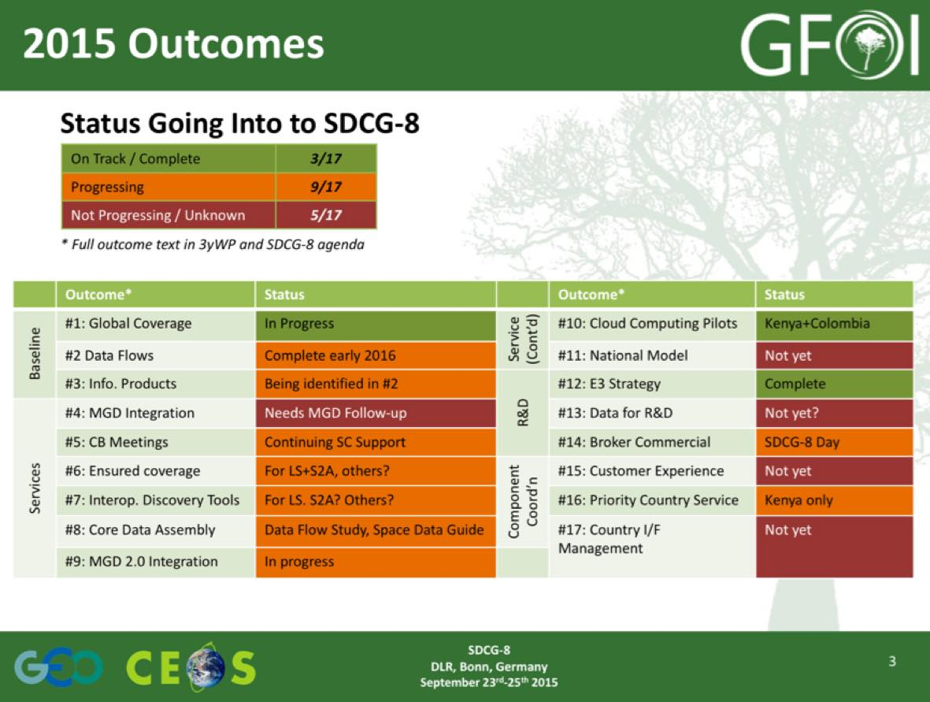
He reviewed the status of SDCG-7 and the GFOI Component meeting actions as of the start of SDCG-8.
SDCG-7 29 actions agreed:
  - 16 COMPLETE or CLOSED;
  - 5 DUE at SDCG-8; and,
  - 8 ONGOING.
GFOI Component meeting 29 overall GFOI actions, with 13 Space Data Component-related:
  - 5/13 COMPLETED or CLOSED;
  - 5/13 DUE September 2015;
  - 2/13 ONGOING; and,
  - 1/13 OVERDUE.

Baseline Global Observation Scenario (Element 1)
Status of 3-Year Work Plan Outcomes Gene Fosnight (USGS) reviewed the status of the global baseline outcomes.
- Outcome 1 - Acquire Data: three optical data streams (Landsat, Sentinel-2, and CBERS-4), and one radar data stream (Sentinel-1) is currently operating.
- Outcome 2 – Global Data Flows: Global Data Flows Study currently in progress.
- Outcome 3 – Data to Information: Identification of Space Agency and expert partner information product initiatives relevant to GFOI and MDG (e.g. GA Data Cubes, ESA Thematic Exploitation Platforms (TEP), USGS Land Change, Monitoring, Assessment and Prediction (LCMAP), and FAO SEPAL), and inter-calibration and interoperability studies underway.
Gene reviewed the status of Landsat-7 and Landsat-8 acquisitions.
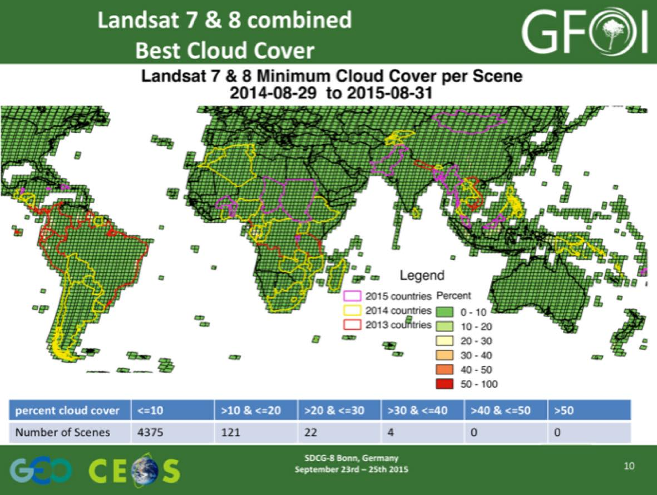
He summarised the EROS Land-Change System, noting that the objective is to remove as many of the barriers possible to the utilisation of Landsat data. The system will also focus on bring the analysis capability to the data, rather than moving the data around, with plans for a web-based analysis portal being considered.
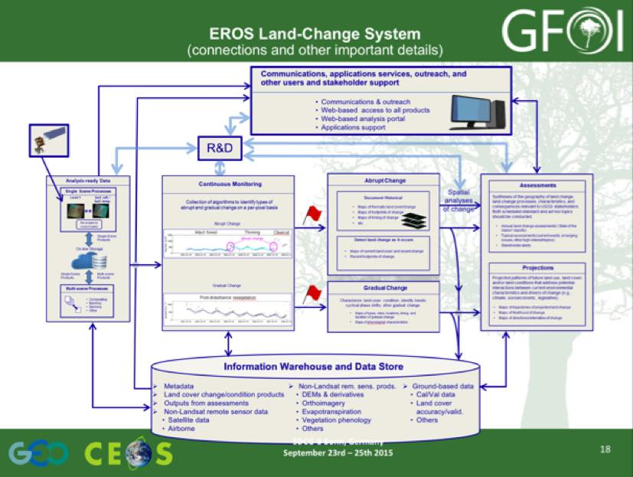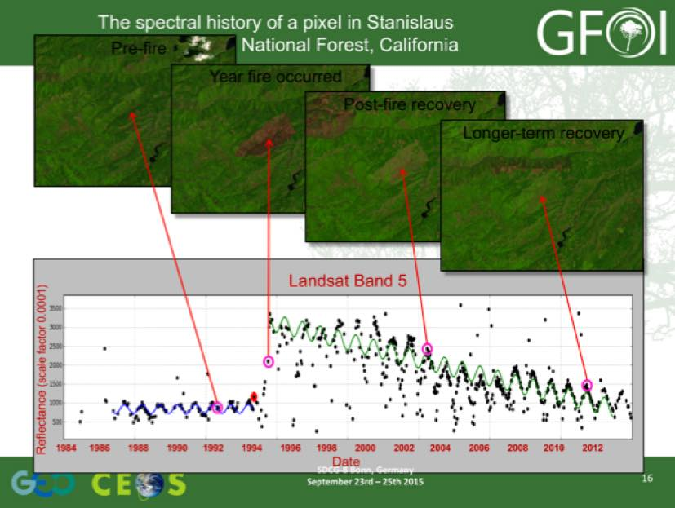
Gene reviewed some of the potential benefits of the EROS Land-Change System:
- Gains economies of scale for data processing, storage, and analysis while removing burden (and redundancies) of data preparation from individual science projects;
- Helps clarify interconnections and interdependencies among Center components;
- Provides a framework to strategize and prioritize R&D activities throughout EROS;
- Provides data infrastructure that enables USGS to produce cyclical reports on land change and be more agile and responsive to interests in land-change assessments related to current events and emerging issues;
- Provides a framework to understand the value of external inputs (partnerships, R&D, data, etc.) to the overall system; and,
- Provides foundation for a more cohesive and aggressive strategy for outreach, communications, and user-support that draws upon shared responsibilities across the Center.
A brief discussion followed:
- Gene noted that an example CONUS instance of the Land-Change system is being developed in cooperation with Geoscience Australia (GA).
SDCG-8-6 | Brian to follow-up with USGS and Geoscience Australia on the work being done there on the example instance of the CCDC algorithm | October 2015

Sentinel-1 and Sentinel-2 Update since SDCG-7 Frank Martin provided an update on Sentinel-1A, noting that it has recently entered its second year of activity. It has imaged a number of GFOI priority areas in its first year, with several thousand scenes acquired to date. The launch of Sentinel-1B is currently planned for the first half of 2016.
Frank Martin noted that Sentinel-2A is currently undergoing commissioning, and once ramp-up is completed it is on track for systematic global coverage.
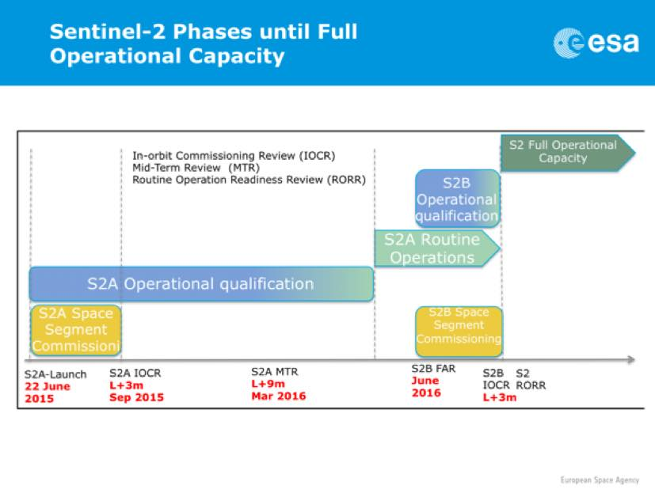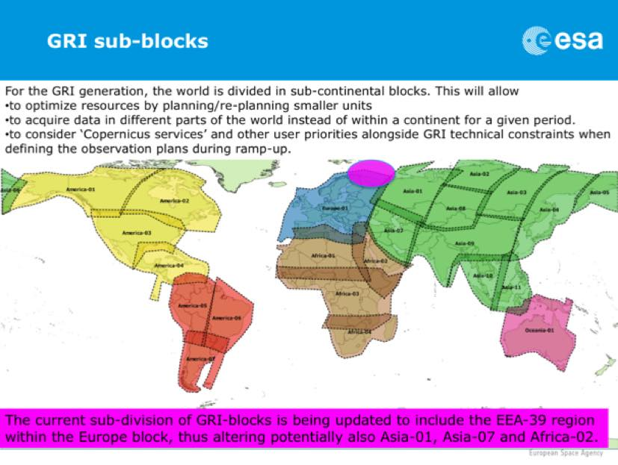
It is expected that the generation of a Global Reference Image (GRI) will take about a year, with most of the acquisitions during the commissioning phase taking place over Europe in support of Copernicus Services. The GRI will be used as a base map for future acquisitions, and serve as a baseline for pixel temporal analysis. Like Sentinel-1A, Sentinel-2A data is available on the Sentinel Data Hub (scihub.esa.int), and the archive data is not expected to roll off until a permanent data distribution solution is found.
A brief discussion followed:
- Yves asked who is harvesting the Sentinel-1 data for GFOI, and Frank Martin noted that the archive has not started rolling yet, and won’t start rolling until a permanent data access solution is put in place. Brian noted that the NASA archive at the Alaska Science Facility will be accessible once the final agreement is in place with the European Comission (expected in October). Helmut and Steven noted that there are plans for French and German mirrors of the archive as well.
- Brian noted that USGS will be hosting the US mirror of Sentinel-2, and NASA will host Sentinel-1, -3, and -5.
- Frank Martin noted that there is one atmospheric correction module in the Sentinel-2 toolbox, though there are plans underway to make atmospherically corrected products available from the ground segment.
- There has been some discussion about the format of the Sentinel-2 data in the US mirror site, and it appears that it may be made available in Landsat format.
- Frank Martin noted that there will likely be a reprocessing of the early Sentinel-2 images at some stage.
- Helmut asked about Sentinel-1A coverage of tropical forests, and Frank Martin noted that he felt coverage could be improved, and added that when Sentinel-1B is operational, coverage is expected improve further.
- Ake asked whether there will be separate acquisition plans for Sentinel-1A and -1B, and Frank Martin noted this will be dictated by the needs of the Copernicus services. Ake suggested that SDCG could provide input on the respective acquisition plans of the mission to try and optimise coverage. Frank Martin noted that a REDD service had been considered by the EC, but this is not currently being pursued.
SDCG-8-7 | Frank Martin to clarify the Sentinel-1B acquisition strategy (whether it will be a direct copy of 1A, and whether there will be an attempt to optimise acquisitions between 1A and 1B by shifting the timing of acquisitions) | October 2015

Global Data Flows Study
Status of the Global Data Flows Study Gene presented a summary of the Global Data Flows Study, stressing that the overall goal of the study is to ensure that user requirements are being met by the proposed solutions. The opportunity is to leverage the increased number of satellites to provide a dense time series, and in turn to improve change detection and classification of global forest cover.
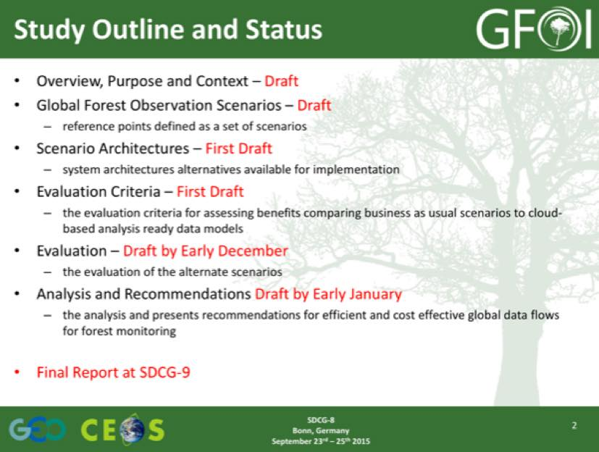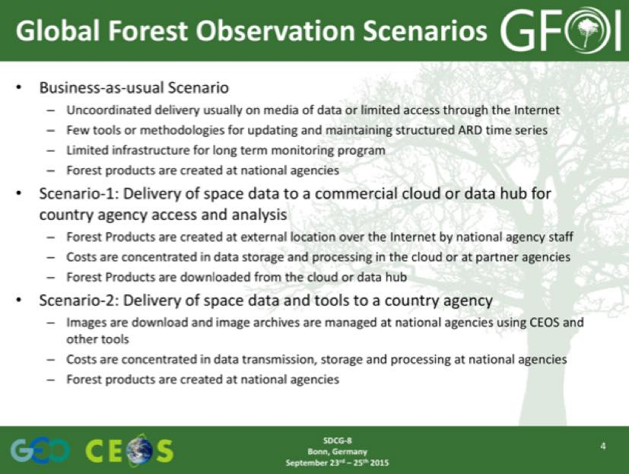
The objective is to have a mature draft of the Study by SDCG-9, and to be discussing the results of at that stage. Gene reviewed a number of the problems and options to be considered:
- Higher data volume increases processing, storage and delivery costs;
- Multiple sensors increase the importance of georegistered, cross-calibrated, surface reflectance, and reformatted Analysis Ready Data;
- Additional choices adds complexity to data discover and selection; and
- New methodologies and algorithms are needed to benefit from more data.
Brian presented a summary of an analysis that used internet speed and storage requirements for the first three groups of GFOI countries (total 70). The analysis calculated the annual data flow for Landsat-7, Landsat-8, and Sentinel-2A, and arrived at a rate of 200TB per year. This kind of macro picture will help to inform implementation decisions by countries. It is also important to recognise that countries requirements may differ, and that the study considers what’s required to provision a full data cube for a country.
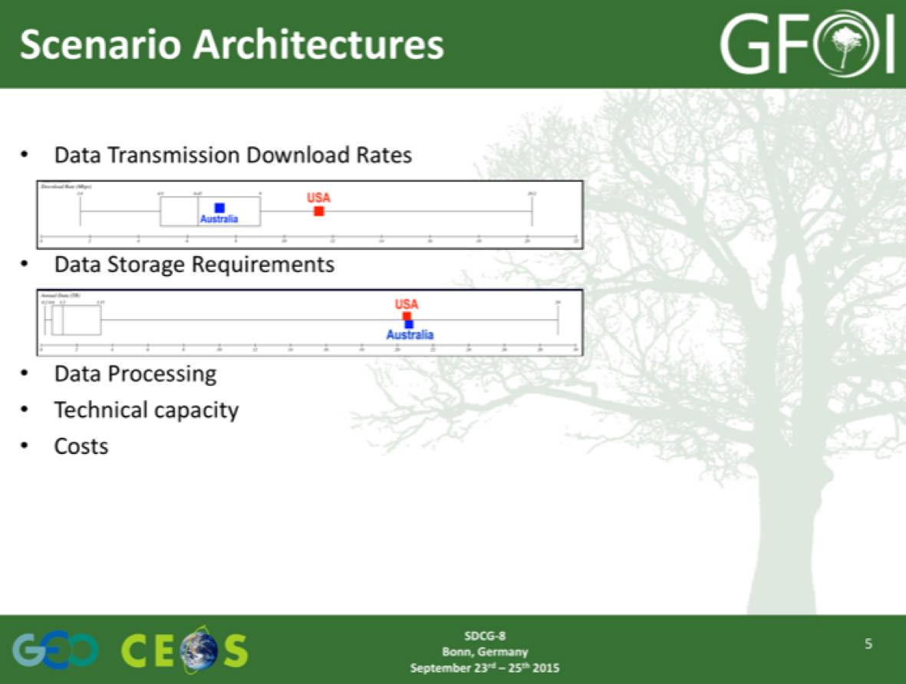
Gene introduced the idea of the evaluation criteria for the solutions being proposed in the Data Flows Study.
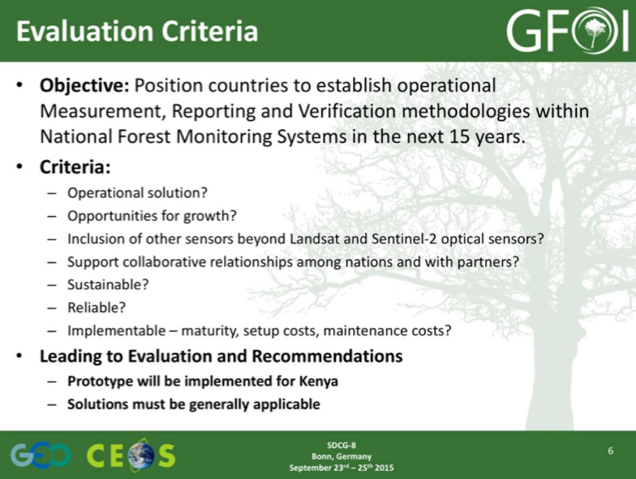
A brief discussion followed:
- The scope of the study was discussed, and whether it should be focused on REDD+, global forests, or other forest applications (e.g. biodiversity). For the purposes of this study, the application is less important than identifying the scale of the requirements and informing prospective solutions. Though once implementation is being formulated, the details will help to scope the problem.
- Doug noted that there has been a lot of discussion amongst the GFOI Leads about the variety of forest applications, and that the decision was taken that GFOI will remain focused on REDD+.
- Brian noted that the key issue is that the business as usual scenario of moving data around is not feasible, and the Study should illustrate the alternatives – though it is just seeding the process, and it is expected that it will evolve over time.
- Brian noted that the business as usual scenario is to provide unprocessed data, where Scenarios 1 and 2 are focused on analysis ready data. Doug noted that Scenario 1 is cloud based, where Scenario 2 is about bringing data to countries to process in country.
- Helmut noted that there are two user groups to consider – the REDD+ countries, and the donors. And both perspectives should be considered by the study. A consistent and coherent approach is important for donor countries. Scenario 1 delivers a much more consistent approach, while Scenario 2 is likely to be more attractive for countries.
- The cost of delivery of Scenario 1 is likely to be less, and the macro scale cost of the Scenarios should be addressed by the Study. Doug noted is likely cheaper to address internet bottlenecks to provide access to cloud computing than to deliver data and servers to countries.
- The intent of the report is to display the problem and describe potential solutions for implementation, but the details will remain to be coordinated. The likely implementation bodies are the likes of USGS and the EC. Existing activities like NASA SERVIR should also be considered.
- Carley Green noted that both Scenario 1 and 2 came up at the SilvaCarbon workshop last week in Vietnam (for both forests and agriculture), and the three scenarios being considered are realistic and will be helpful for countries. There was concern around the initial costs associated with Scenario 2 in procuring infrastructure, and also around the uncertainty around the availability and cost of cloud services in Scenario 1.
- Stephen noted that while space agency efficiencies are important, the focus is about removing the barriers to access to the data.
- The question of how to engage users like FAO in this process was raised, and Gene suggested that we can engage by being successful. Where success means providing a business model that better addresses their requirements.
- Helmut suggested that there may be some additional parameters of interest for the study – scalability and co-application, and data security and commercial data. They are not easy to tackle, but they should be considered.
- It is likely that one of the key elements of the approach to these scenarios will be the need to co-locate the data, and that there will be co-location of the Landsat and Sentinel datasets.
- There was a discussion on the role of Global Forest Products (e.g. Hansen), and it was noted that while these products can provide a good ancillary layer, they cannot currently be used to derive the classes required for national MRV. Brice noted that the upcoming R&D workshop will address this topic, and also noted that there is an emerging global biomass product which may be of interest.
- Helmut stressed that from the perspective of Germany as a prospective donor to REDD+, the most important aspect of solutions to the data handling issues raised by the Global Data Flows is consistency.
Gene noted that the next steps should involve engagement with capacity building groups (e.g. SilvaCarbon, FAO) and countries, and donors (e.g. ADB, The World Bank, Norway, Germany).
SDCG-8-8 | Global Data Flows Study team to reflect the user perspective and requirements in their Study, in consultation with the MGD component, SilvaCarbon, FAO, and priority countries where possible | SDCG-9
SDCG-8-9 | Global Data Flows Study team to reflect the donor perspective and requirements in their Study, in consultation with donors like ADB, The World Bank, Norway, and Germany | SDCG-9
SDCG-8-10 | GFOI Office to contact the GFOI Leads for suggested organisations and countries to canvass regarding user and donor perspectives on the Global Data Flows Study | October 2015
SDCG-8-11 | Helmut to provide a German donor perspective on the requirements for the Global Data Flows Study | November 2015

GFOI Space Data Services
Status of 3-Year Work Plan Outcomes Brian reviewed the status of the Space Data Services-related Outcomes from the SDCG 3-Year Work Plan. He reported that he generated reports for Peru and Vietnam in support of this week’s GIZ MRV conference.
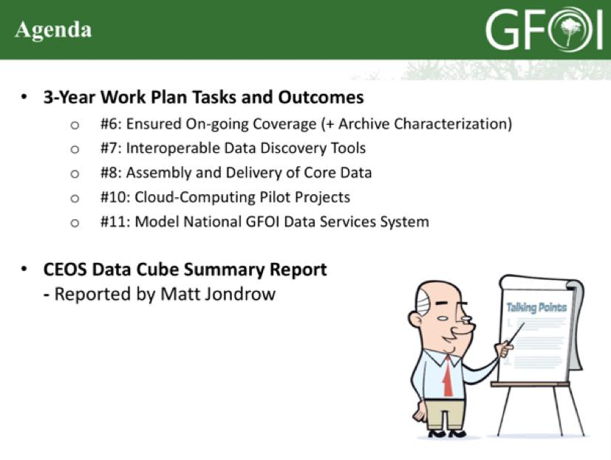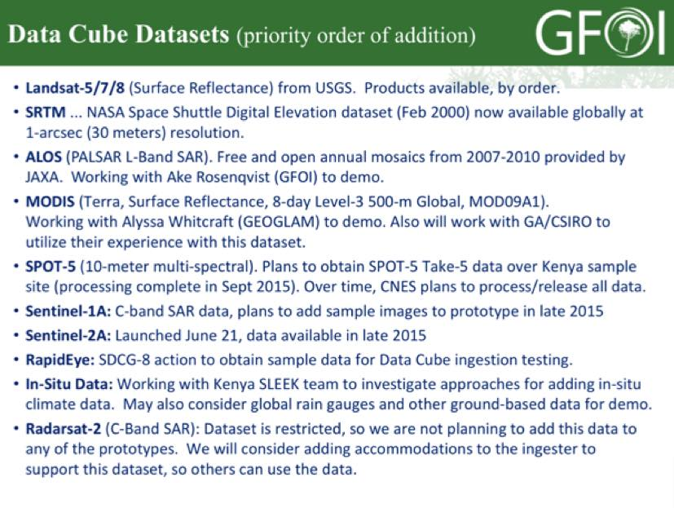
Brian reviewed how Data Cubes might interact with the Scenarios being considered by the Global Data Flows Study.
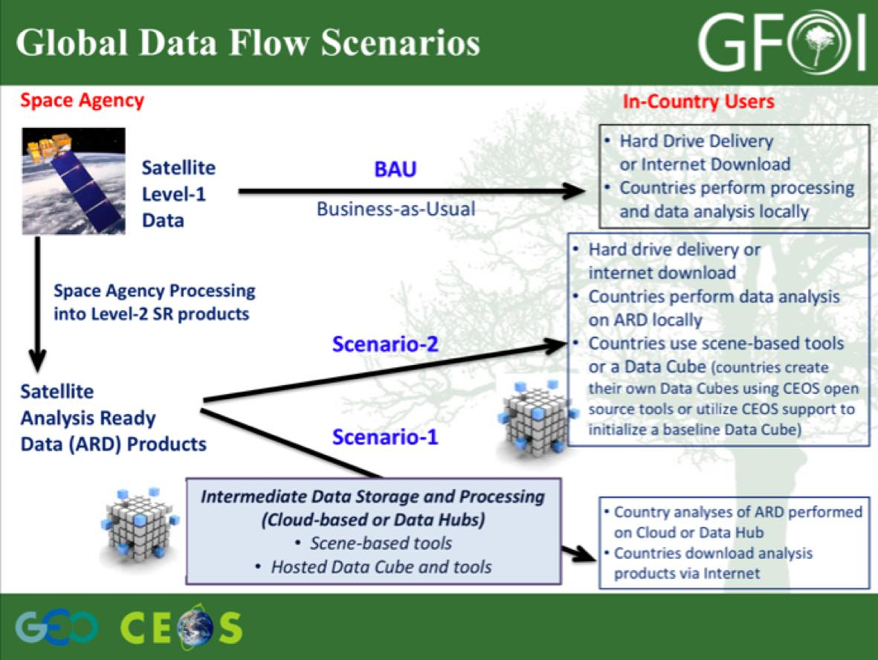
Matthew Jondrow gave a demonstration of the pilot Kenya Data Cube, and Sanjay Gowda noted that this system is an alpha version, but that it can be shared with Kenya at this stage. He noted that another iteration is expected to be completed by the end of the year.
A brief discussion followed:
- There was a discussion about which stage re-projection is applied, and it was noted that the design decision has been made to use the native projection of the data.
- It was noted that because data from different instruments is not reprocessed to a common grid, a true ‘Data Cube’ is not being created. However, this re-gridding is being done on the fly (computationally intensive), which does in principal allow data from different instruments to be overlayed and used together in analysis.
- It was stressed that the overall error budget during processing needs to be well understood and optimised as a part of the design process.
- Analysis ready data should not require any additional processing before its ready to be analysed, and this includes re-projection. The products can be re-projected once the analysis is completed.
- Yves asked if it is possible to discover the provenance of the pixel and Brian noted that this is not currently possible, but this is a requirement they are working to address.
- Brian noted that he is working with Ake to try and pull in ALOS annual mosaics for four years. Gene noted that multiple datasets could be used to validate results between them.
- Sanjay noted that all of this progress has been made since the last SDCG meeting, and it was agreed this needs to be shared. And for this, a short promotional video would be useful.
- Gene asked about the automation of ingesting new datasets, and Matthew noted that currently ingestion is manual, but there are plans to automate it in the future.
- Gene asked about the role of commercial and open source software tools, and Brian noted that they are developing a couple of simple reference / pilot implementations to show the system. It was noted that optimisation of the API will be one of the main computational challenges.
- The source will be open and available on Github shortly, with the pilot will being delivered to Kenya by the end of the year.
- Gene noted that there is a need to consider how the Data Cube could be sustained. And if the model is open source development, then how that is supported needs to be addressed.
- Gene suggested that the Data Cube team should work with Geoscience Australia on some of these issues.
The group thanked AMA Team for their strong efforts in progressing the Data Cube since SDCG-7.
SDCG-8-12 | Brian to investigate whether the country reports the SEO generates could be automated or semi-automated and provided via the GFOI Space Data Portal | November 2015
SDCG-8-13 | Brian to share current progress on the Space Data Access guide in support of the development of the GFOI Space Data Portal | COMPLETE  Brian shared his most recent status – will follow-up after CEOS Plenary
SDCG-8-14 | Yves to make the circulate information from CCMEO (Canada Centre for Mapping and Earth Observation) on their Data Cube development activities, including technical and implementation details as possible | October 2015
SDCG-8-15 | Brian to prepare a set of definitions on the Data Cube approach to map projections to be circulated to canvass broad opinion across the GFOI constituency | October 2015
SDCG-8-16 | Brian to prepare a short (15 minute) summary video of the Kenya Cube to be circulated amongst the GFOI constituency | October 2015
SDCG-8-17 | SDCG Secretariat to work with Brian to setup the first in a series of SDCG-All Data Cube update telecons to provide status updates between SDCG-8 and SDCG-9 | COMPLETE  First call held 21 October

Support to GFOI R&D
Status of 3-Year Work Plan Outcomes Ake presented a status update on SDCG support to GFOI R&D. He noted that funding for the GFOI R&D component has been secured through the end of December 2016.
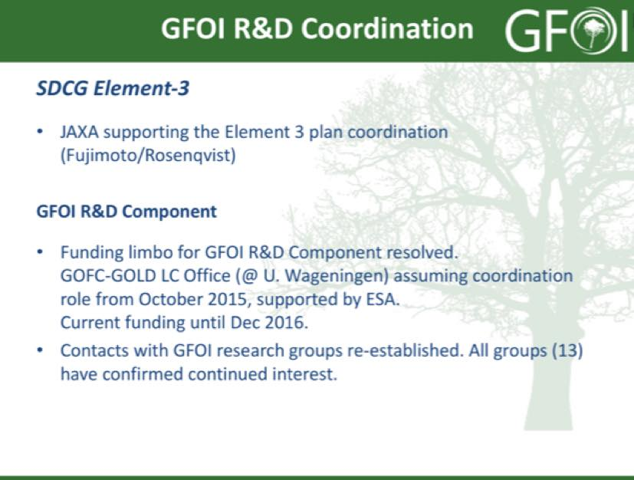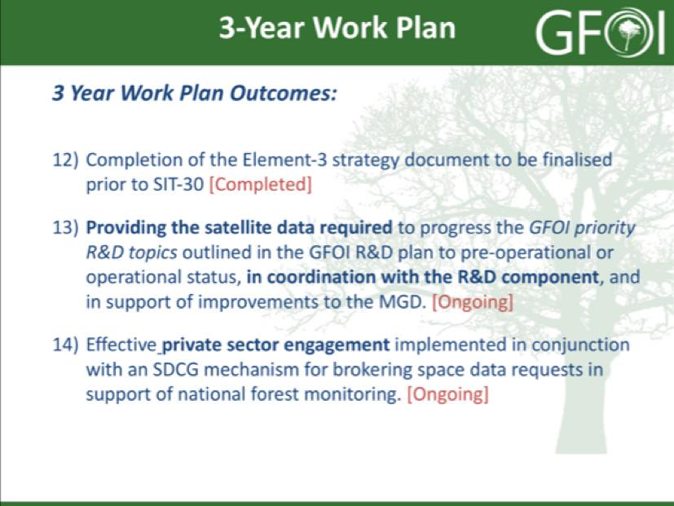
Ake presented a summary of the way forward and proposed actions for several areas.
Acquisitions and data distribution:
- GFOI R&C Component funding and new lead resolved;
- Confirmed continued interest from all current (13) GFOI research groups;
- Confirmed continued interest from SDCG agencies; and,
- Interest from commercial providers.
Proposed action SDCG Exec to assist agencies (e.g. through facilitating contacts with R&D groups etc.) - to commence/resume acquisitions over R&D Study Sites, and commence/resume distribution of archive data to R&D groups, and clarify process.
Commercial data providers
- Confirmed initial interest from providers to participate/contribute. Details and level of engagement to be hammered out.
Proposed action SDCG Exec (together with G-G) to follow-up with direct contacts with BlackBridge/PL, GAF, and Airbus DS/France (Spot 6/7) (DLR and CNES, remain PoC for TSX, TDX and Pléiades).
Accommodating GFOI R&D Component evolution
- Under the coordination of GOFC-GOLD, the GFOI R&D Component will continue to progress during 2015/2016.
Proposed action SDCG agencies, in collaboration with GOFC-GOLD, to agree on a mechanism (and boundary conditions) to accommodate new research groups and Study Sites.
Coordinated Research Announcements:
Agencies interested in coordinating RAs (ASI, CSA, CNES, DLR) to agree on:
- Schedule for coordinated calls;
- Select R&D topics of common interest (e.g. sensor synergy); and,
- Common preamble text.
It was noted that an updated Element 3 Strategy would be prepared, and it was agreed that it should be presented for endorsement at the CEOS SIT-31 meeting.
Agency Update since SDCG-7
ASI Anna Rita Pisani presented an update on ASI contributions in support of the GFOI R&D Plan.
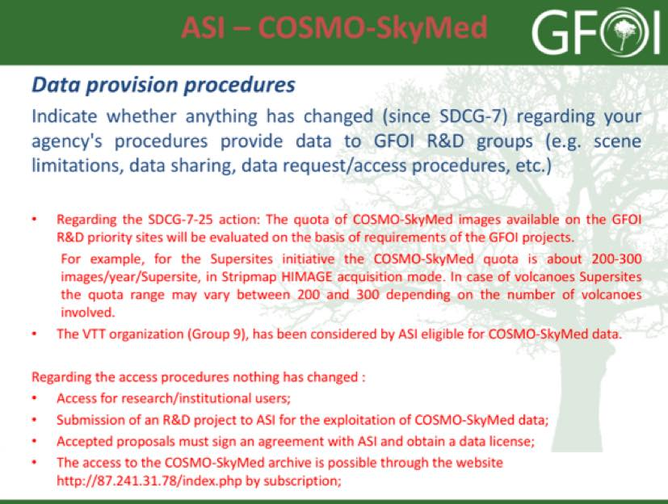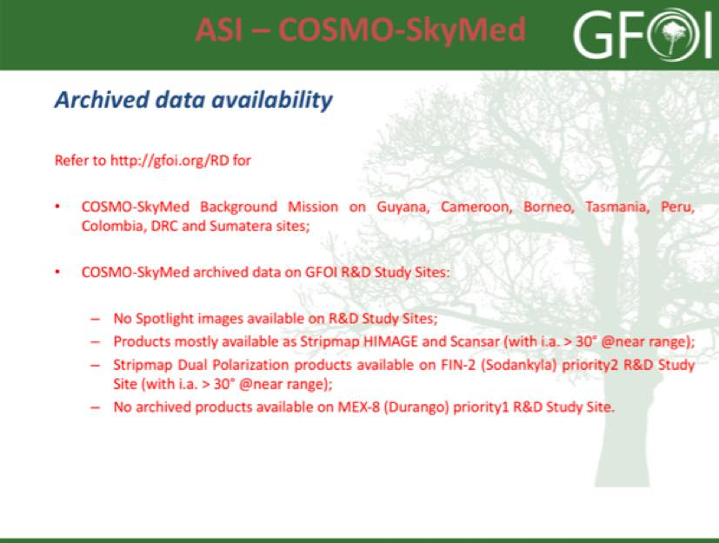
A brief discussion followed.
- The quota for COSMO-SkyMed data available for GFOI projects will be evaluated based on the basic project requirements.
- There is an “Open Call for Science” which opened in February, and more information is available here: http://www.asi.it/en/agency/bandi_en/calls/cosmoskymed_open_call_for_science.
CNES Steven Hosford presented an update on CNES contributions in support of the GFOI R&D Plan.
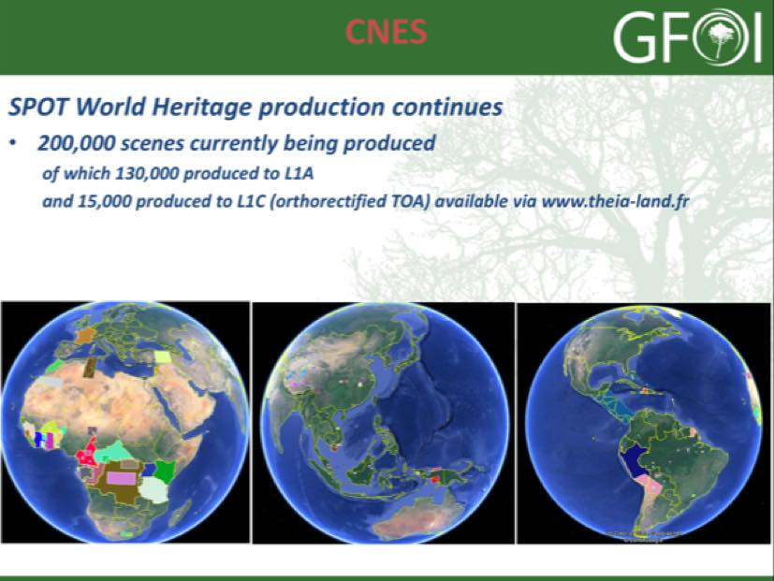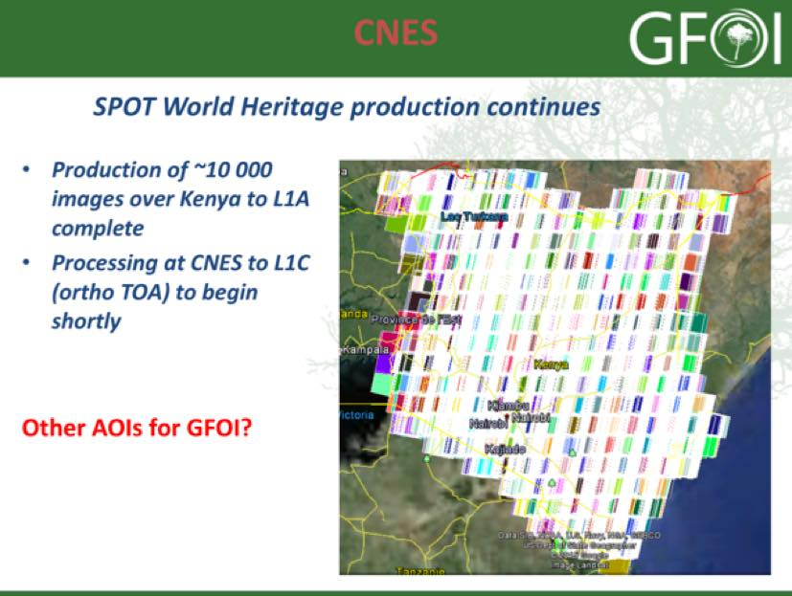
Steven noted that:
- Pleiades data is available to be processed over three GFOI study sites, but CNES is awaiting feedback from the users on format and processing options. At the same time, the data licence be resolved shortly which will enable the release of the data.
- The ISIS program (http://www.isis-cnes.fr) is an open call for research proposals for European researchers, though the data can be shared with anyone.
- Production of the SPOT World Heritage products continues and the data is available at www.theia-land.fr. 10,000 images over Kenya have been processed to Level 1A, and processing to Level 1C will commence shortly. Steven noted that they are accepting inputs for the next priority areas for processing.
A brief discussion followed:
- Brian asked what would be required to process the Kenyan SPOT images to Level 2, and the response is that there is no common processing methodology like USGS does. Gene noted that without some of the key bands, processing to Level 2 is challenging.
CSA Yves Crevier presented an update on CSA contributions in support of the GFOI R&D Plan.
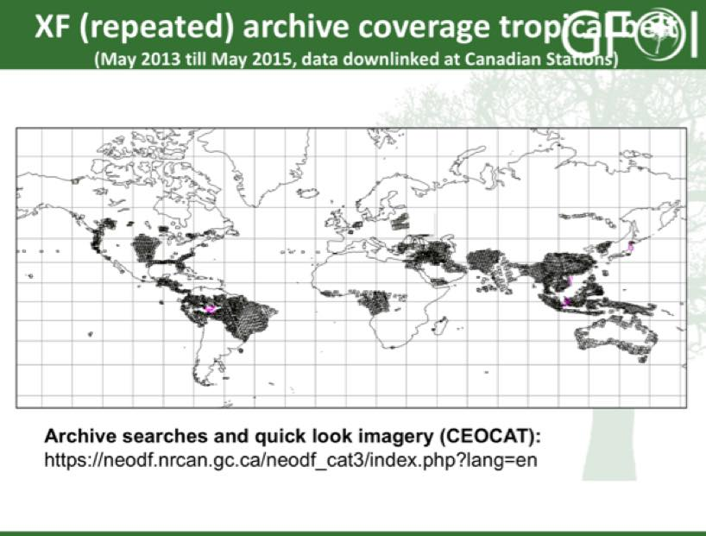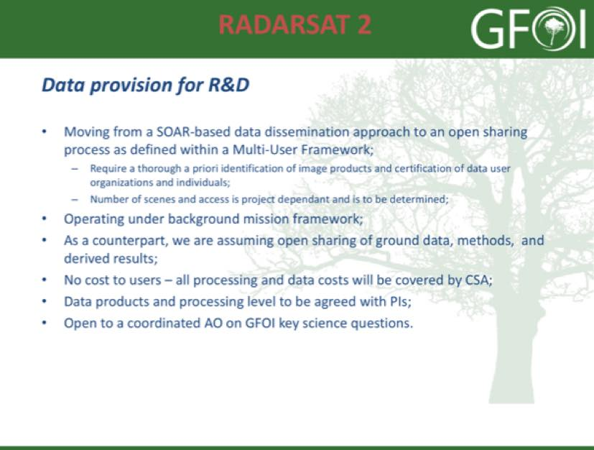
Yves noted that:
- Yves suggested that any calls should also be opened to industry (i.e. the value added sector), who may be able to support the objectives of SDCG and GFOI.
- CSA would like to focus on the potential contribution of C-band SAR to forest monitoring, considering the large number of data streams that are expected to come online. He noted that CSA is willing to support the monitoring of study site as well as “demonstrating” C-Band capabilities for coherent national monitoring using dense time series in the context of Element 3 (Science only).
- Yves noted that since the first SDCG meeting, RADARSAT-2 has been acquiring data over a pan tropical range, and this data could be made available if a framework that identifies reportable outcomes, derived products, and sharing of ground data and methodology can be arranged. Research funds may be available from CSA for Canadians and Canadian companies.
DLR Michael Bock presented an update on DLR contributions in support of the GFOI R&D Plan.
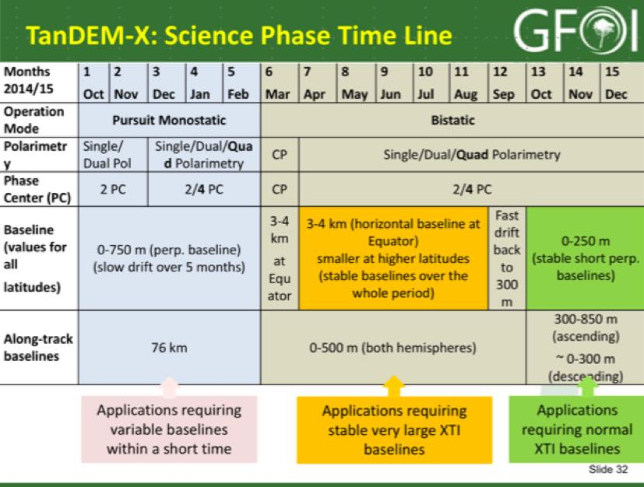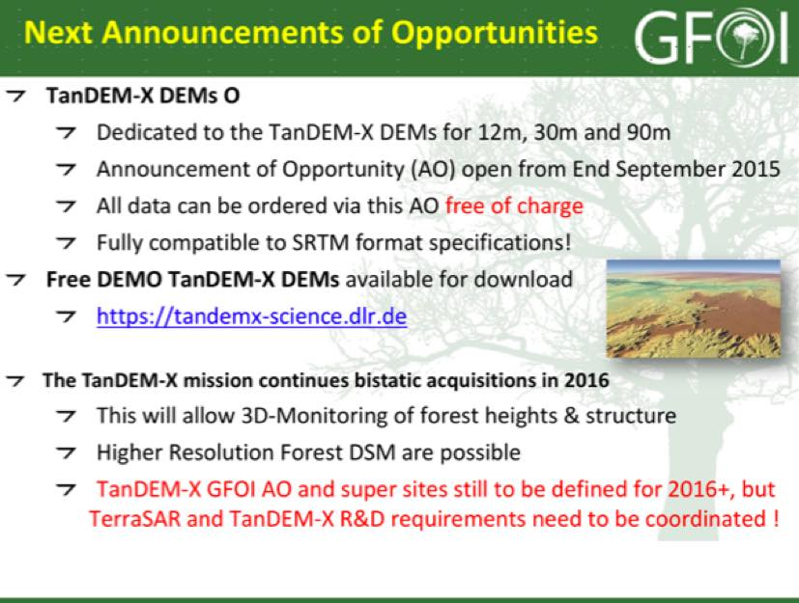
Michael noted that:
- TanDEM-X is planning a series of activities supporting forest science, including looking at forest height, forest structure, and forest mapping. These activities will be taking place globally in Europe, North and South America, Africa and Asia.
- There will be a dedicated AO for TanDEM-X 12m, 30m, and 90m DEMs which will open soon, and will make data available free of charge. There are free demonstration DEM datasets available at tandemx-science.dlr.de.
JAXA Nobuyoshi Fujimoto presented an update on JAXA contributions in support of the GFOI R&D Plan.
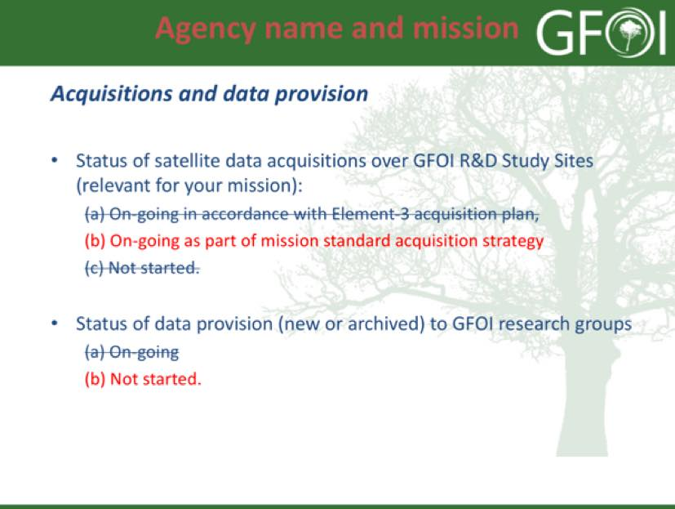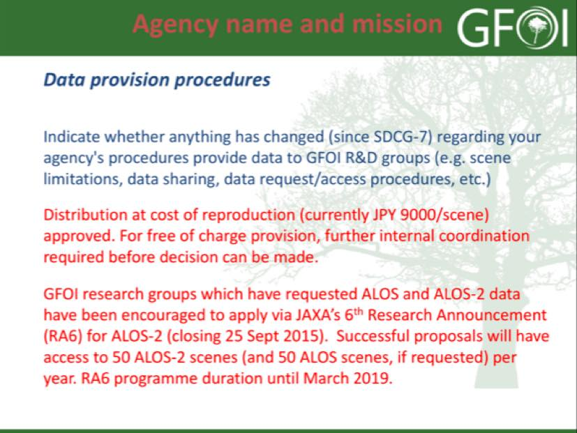
It was noted that ALOS-2 acquisitions are ongoing as a part of the Basic Observations Scenario (BOS), and that data is made available for GFOI at the nominal reproduction cost.
INPE Ake presented a summary of support to GFOI on behalf of INPE.
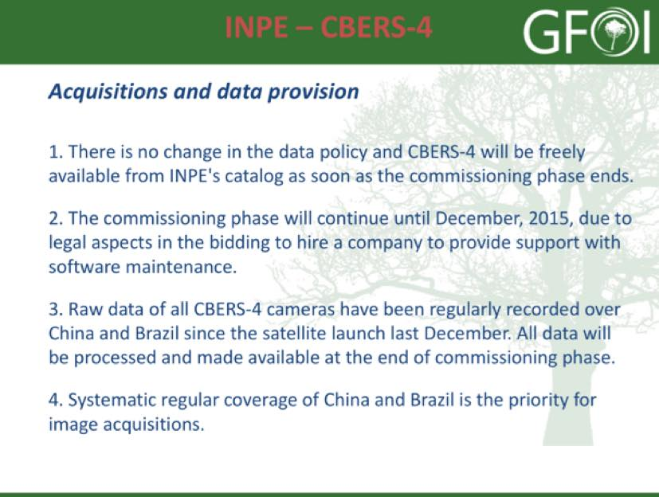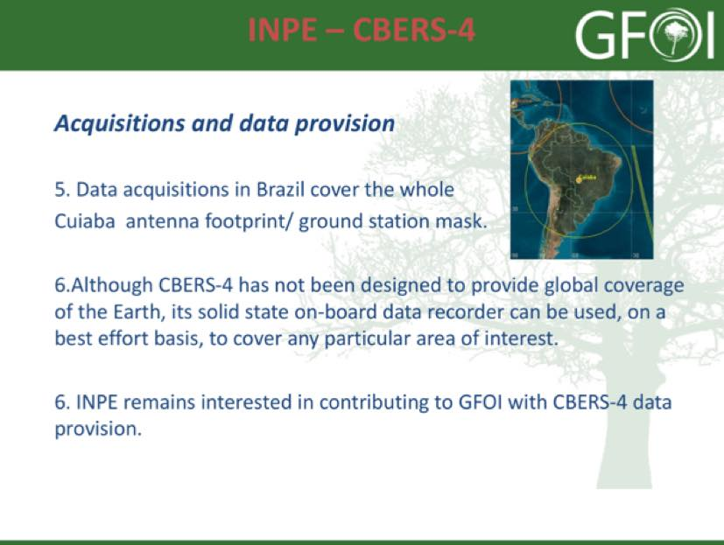
He noted that while CBERS-4 was not intended to provide global coverage, with an appropriate ground segment coverage could be expanded beyond the Chinese and Brazilian coverage areas.
A brief discussion on support to the GFOI R&D Plan followed:
- Brice asked if agencies present regularly monitor the scientific literature to see how their data is used. Steven noted that participants in the CNES science programme are asked to provide any papers published as a result of the data provided. It was agreed that it would be useful to have some summary of the results from the GFOI R&D sites where data was collected.
- Helmut suggested that it would be useful to have a better description of the relationships and processes between the GFOI R&D component, the SDCG Element 3 coordination, and the other R&D-related functions. Ake agreed, and noted a summary will be included in the updated Element 3 Strategy.
- The topic of a second commercial provider meeting was raised. Yves noted that GEOGLAM has expressed an interest in having a commercial provider meeting, and planning for a North America meeting will be discussed the JECAM science meeting in November. This meeting would be solely focused on the relationship between science and the commercial providers, and will be hosted by Agriculture Canada. Yves indicated that there may be an opportunity for GFOI to be involved with this meeting.
- Ake raised a number of issues to be discussed in relation to coordinated research Announcement of Opportunity (AO) calls for GFOI. He noted that ASI, CSA, CNES and DLR have all expressed interested. The schedule depends on how much the AO can be coordinated with existing calls, but the November – December timeframe seems possible. Interested agencies agreed to have an offline discussion on the topic.
- The question of whether a researcher will need to submit an application to each agency’s AO, and the evaluation of the proposals would also need to be discussed.
SDCG-8-18 | Helmut to circulate the details of GFOI-relevant DLR research announcements of opportunity | Result of the evaluations/negotiations of the 2016 AO expected by end of 2015
SDCG-8-19 | Brice and Ake to prepare a brief summary (a couple of slides) of GFOI R&D activities to circulate to the GFOI community once the program is officially reactivated | Before end December 2015
SDCG-8-20 | Ake and Nobuyoshi to assist agencies to commence/resume acquisitions over GFOI R&D Study Sites, and to commence/resume distribution of archive data to research groups | October 2015
SDCG-8-21 | Yves to share the data set template (quad sheet) that the Polar Space Task Group uses | October 2015
SDCG-8-22 | Ake and GOFC-GOLD to follow-up with BlackBridge/PL, GAF, and Airbus DS/France (SPOT 6/7) on their potential to contribute to Element 3 | October 2015  In progress – Ake has reached out
SDCG-8-23 | Ake to follow-up with science groups who have requested Pléiades data, advising to get in contact with CNES regarding product formatting and production details | October 2015
SDCG-8-24 | Ake to update the Element 3 Strategy, in coordination with SDCG agencies and GOFC-GOLD, to reflect a new mechanism (and boundary conditions) for the collection of requests and the selection process to accommodate new research groups and GFOI Study Sites | SDCG-9
SDCG-8-25 | Ake to prepare the an update to the Element 3 Strategy to be presented for endorsement at SIT-31 | SIT-31
SDCG-8-26 | Ake to circulate an update on the outcome of discussions amongst interested SDCG agencies in coordinated research Announcement of Opportunity (AO) calls for GFOI | November 2015

GFOI Component Coordination and Country Engagement
Status of SDCG 3-Year Work Plan Component Stephen Ward (SDCG SEC) presented a summary of the - GFOI Office Status and a quick Status on Other GFOI Components, noting that there are three outcomes in the Work Plan related to this thread.
- 15: Delivery of a coherent customer experience for GFOI countries;
- 16: Space data support and services provided to all priority countries; and
- 17: Effective management of country interfaces.
Stephen noted that the development of an MGD Portal is underway and will be a clear deliverable available as basis for country engagement with GFOI. There has been a proposal to develop a corresponding Space Data Portal, which would contain information and tools to facilitate access to space data. A brief discussion followed:
- It was agreed that the portal needs to remain small or else it won’t be easily maintained.
- It was suggested that we include some ‘success stories’ outlining where remote sensing data has been successfully applied to national MRV development.
Stephen noted that while the Sydney GFOI component meetings appeared to have agreed on the need for a coordinated country engagement strategy, the idea hasn’t progressed.
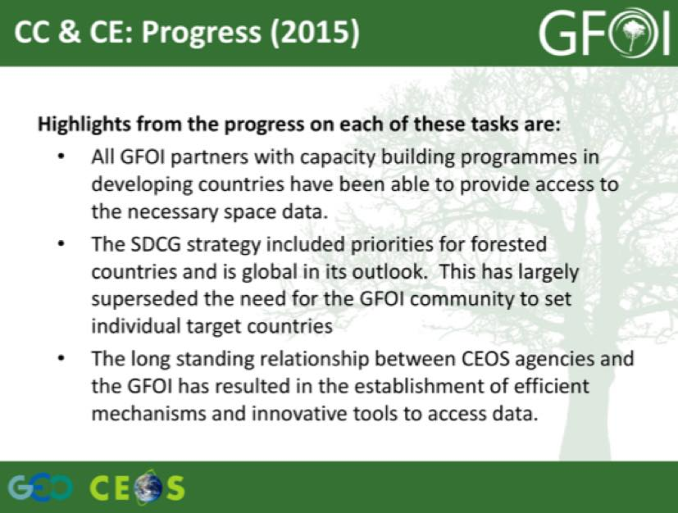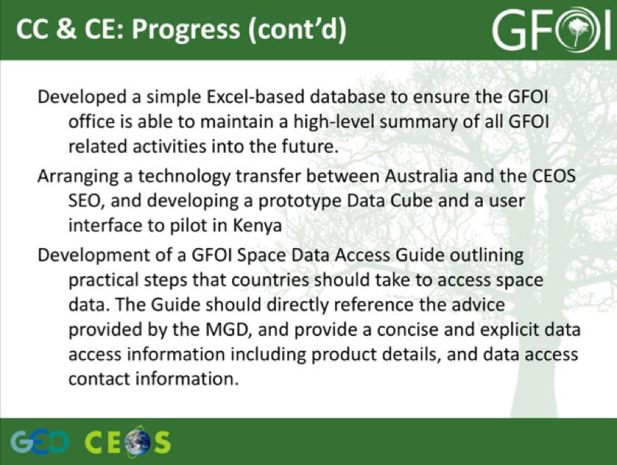
It was noted that the GFOI Plenary and Open Forum (February 2016 at ESRIN) will be a large gathering of countries and stakeholders, and this may present an opportunity to progress the issues of both GFOI Component Coordination and Country Engagement.
SDCG-8-27 | Stephen and George to circulate a draft outline of the GFOI Space Data Portal for comment | October 2015
Progress Towards MGD 2.0 Carly Green presented a summary of the MGD development to date, and the planned review process. She summarised the current status:
- MGD Version 1.0 pdf is available for download from the GFOI website in English/Spanish/French;
- More than 200 printed versions of the document have been distributed in developing countries;
- Rapid response modules have been developed related to global map products and reference emission levels; and,
- Cross referencing with other GFOI partner resources has been a focus.
Currently version 2.0 of the MGD is being developed, and is expected to be released in June 2016. The lead authors are Lead authors are Jim Penman, Curtis Woodcock, Pontus Olofsson, John Raison, and Carly. One of the main sections to be updated will be on activity data, with updates expanding guidance on the use of global data sets, including options for managing large datasets, covering any tools that have been released since publication of version 1.0, and reviewing and updating satellite data table.
Carly reviewed the schedule for the development of version 2.0:
- Engage with willing contributing authors to fill gaps (October-January 2016);
- Lead authors collate and edit material to generate first draft of Version 2.0 (February 2016);
- External review of Version 2.0 (March 2016);
- Integration of review comments (April 2016);
- Copy edit process of Version 2.0 (May 2016); and,
- Publication of Version 2.0 (June 2016).
She gave a brief summary of the MGD web application, noting that it is being developed with MGD 1.0 materials. She noted that the target audience is groups like FAO, but it is also hoped that countries will be able to use the portal directly themselves. The draft portal will be tested with several countries in the coming weeks and months, with the first opportunity coming in Indonesia, and also via several upcoming SilvaCarbon workshops. The plan is to release the web portal with MGD 1.0 materials in April, and then integrated the MGD 2.0 materials once they are ready. But it is possible that the release could be delayed until June and released with MGD 2.0 materials integrated.
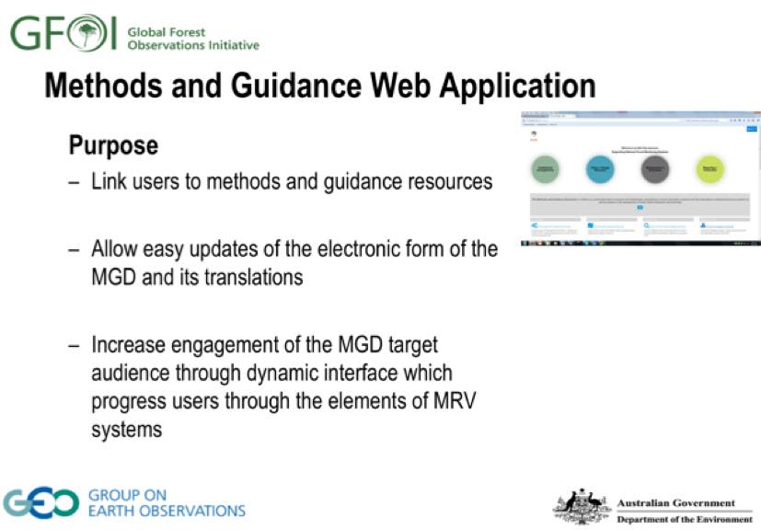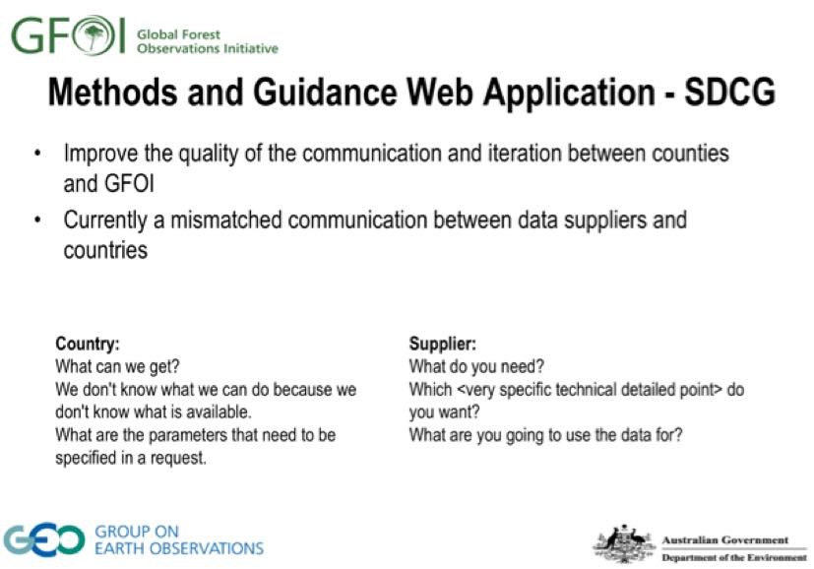
Carly noted that if a protocol can be defined or better structured, data needs can be more readily identified and justified and further effort can be focused efficiently on interested/active countries need. The portal is capable of collecting and storing information related to design decisions which can be sent with data requests to SDCG.
A brief discussion followed:
- Helmut asked about getting input on the MGD from the donor perspective, in particular for ensuring consistent reporting. Carly noted that the document will be put out to the GFOI community, including The World Bank, and she noted that there are UNFCCC and IPCC members are on the panel. Helmut noted that there is a gap between the IPCC guidance and the expectations of donors on a transparent and consistent report – and that this is also a political question. Carly would like to follow-up, and understand this perspective from Helmut.
- Frank Martin asked about communications and outreach, and how advanced the prototype will be by COP21 and whether it might be available to display at a booth there. Carly confirmed that both of those sound achievable.
- Frank Martin asked about the release in time for the June 2016 SBSTA meeting, and Carly confirmed this seemed feasible.
- Gene noted that there is a need to ensure that Carly is engaged with the Global Data Flows study, and Carly agreed noting that she is busy with the MGD portal now, but will do what she can to engage.
- Ake noted that the R&D component should also be engaged to ensure that methodologies are integrated. Carly noted that there could be links from the website to research papers and materials.
SDCG-8-28 | Frank Martin to follow-up with Carly regarding the display of the MGD web portal at ESA’s COP21 booth | December 2015
Country Engagement Inge Jonckheere (FAO) presented a summary of SEPAL, noting that it is fully in-use in Ecuador, Uganda, and Paraguay, and in partial use in Zambia and Guyana. She noted that they are working on building internal capacity with these countries, and that for each of, Uganda, Paraguay, Ecuador, and Zambia there is at least one full time FAO staff (or consultant) engaged. She noted that they continue to develop the system, with two full-time developers, and one full-time LTO.
Inge noted that there is coordination ongoing with the likes of Wageningen University on topics such as the processing of Landsat time series, and how to include this in the FAO processes.
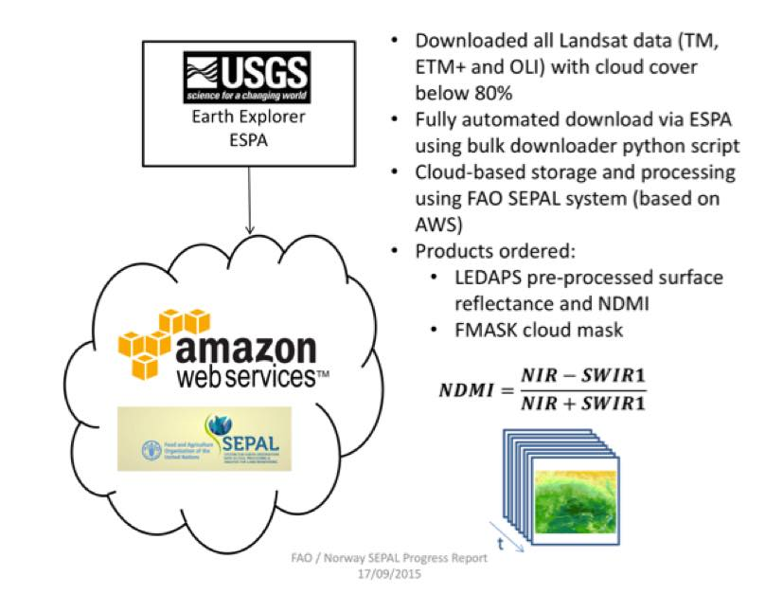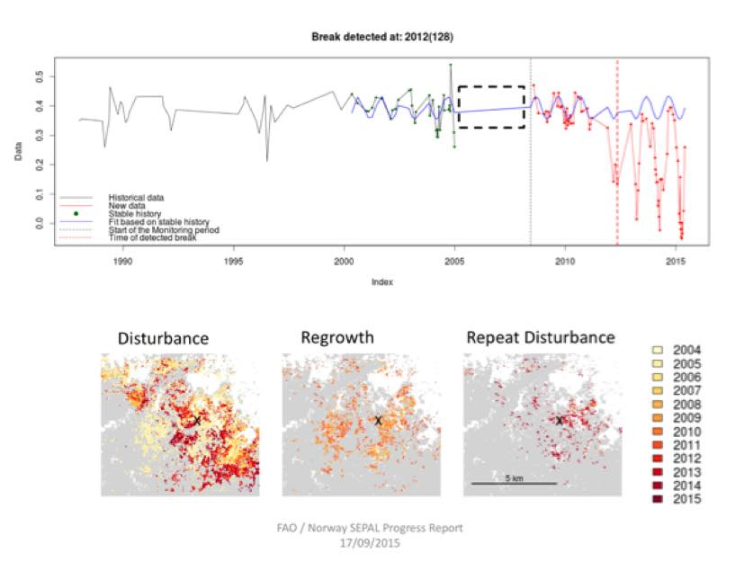
Inge noted that they are working to evalute the added value of pre-processed SAR data, and they are utilising OpenSARKit, which provides command line tools for quasi-fully automatic preprocessing of nationwide SAR mosaics. They are using ALOS Palsar Fine Beam Double Polarisation (FBD) data, and producing 30m output products.
The aim is to perform a cost-benefit analysis of the utility of SAR data, noting the main advantages are seen to be the lack of interference from clouds, day and night coverage (i.e. active sensor), and sensitivity to biomass (especially L-Band like ALOS Palsar). She highlighted the example of Zambia, where ~ 400 scenes (750,000 km²) were collected, and processed within 5 days. She reviewed a number of example countries where they are looking at RADAR, including: Ecuador, Tanzania, Bangladesh, Bhutan, Congo, Uganda, and Sri Lanka.
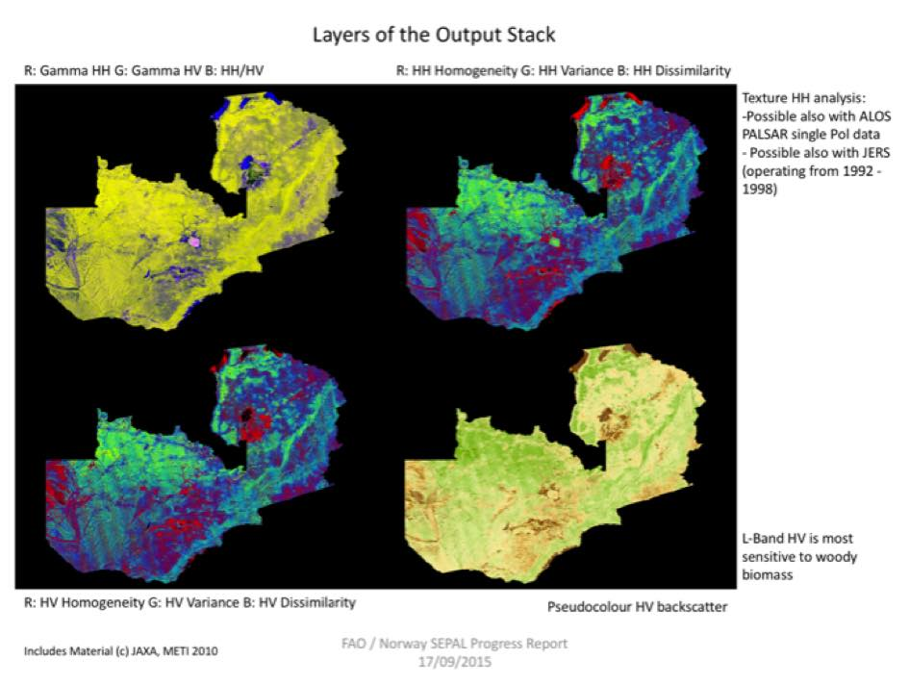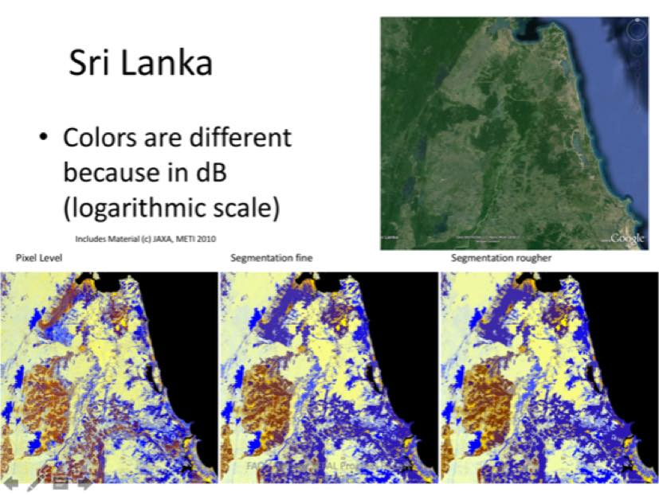
Inge reviewed some of the immediate next steps in the development of SEPAL:
- Holding an Advisory Group / Practitioners Summit;
- Looking at high spatial resolution data processing;
- Interface improvements, moving on from command line tools; and,
- Expanding focus from data distribution to also include methodology dissemination and processing capacity.
A brief discussion followed:
- Stephen noted that Henrik advised the Leads that he has taken the lead of the SEPAL Steering Committee, and Erik confirmed that invitations for the group are expected to go out by the end of October.
- Ake noted that he was happy to see SAR data, and Inge confirmed they are using scene data from Alaska Satellite Facility (ASF). Ake asked if they were using OpenForis, and Inge noted they are using the OpenSARKit toolkit, based on internal code, and they have a radar expert working with them. OpenSARKit will be available on the OpenForis website in a few weeks once finalised. Ake noted that he is working with Brian on SAR tools for the Data Cube, and would like to look at OpenSARKit.
- Ake asked about mosaic data, noting that it is radiometrically and topographically corrected. Inge noted this is an R&D project, and that they are trying to ensure that there are free products, and Ake noted that the mosaics are available for free.
- Frank Martin asked whether they derived biomass, and Inge confirmed that this is currently just a composite. Biomass detection is well beyond what most countries are interested in – they are mostly interested in forest/non-forest.
- Gene asked if he could find out more about the Landsat time series work. Erik confirmed it is developed in R, and that he will send Gene a copy of the publication.
- Michael noted that DLR has produced a series of free SAR training materials (https://saredu.dlr.de).
SDCG-8-29 | Ake to follow-up with Inge on the trial use of SAR data by FAO | October 2015  Ake has been in touch with FAO on OpenSARKit
SDCG-8-30 | Gene to follow-up with Erik on publications (i.e. papers) related to the time series analysis of Landsat being performed by FAO (e.g. in cooperation with Wageningen University) | October 2015
SDCG-8-31 | Brian to consult with Erik and FAO on their specific in-country processing tools (e.g. OpenForis), processing chain, and data flows to assess the feasibility and utility of supporting them in the Data Cube | November 2015  Brian has been coordinating with Erik on meeting opportunities
SDCG-8-32 | Michael Bock to send the link to the DLR SAR training materials | COMPLETE  https://saredu.dlr.de

Update to SDCG 3-Year Work Plan
Stephen presented a summary of the SDCG 3-Year Work Plan, as well as some recent changes made at the request of DLR at SIT-30.
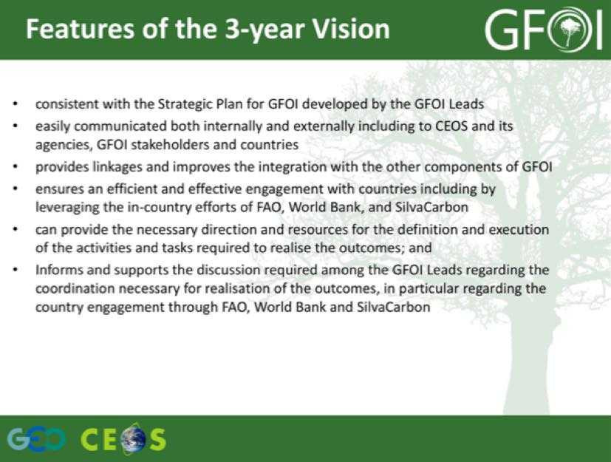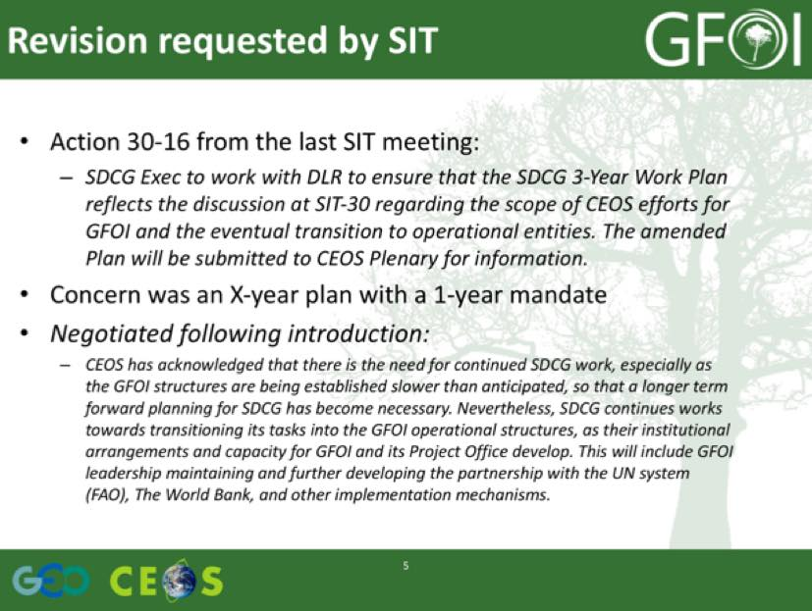
Stephen raised the issue of reporting against the SDCG 3-Year Work Plan, and it was agreed that it would be useful to maintain a simple progress matrix to report status. There was a discussion about the time scope of the SDCG 3-Year Work Plan, and it was agreed that the next update would be prepared to follow the cycle of the CEOS 3-Year Work Plan, covering roughly the calendar years.
SDCG-8-33 | SDCG Secretariat to circulate a first revision of a SDCG 3-Year Work Plan outcome and task status matrix | October 2015
SDCG-8-34 | SDCG Secretariat to propose an update cycle and plan for the SDCG 3-Year Work Plan, culminating in an update at SDCG-9 | October 2015

SDCG Reporting to CEOS Plenary
Stephen presented a summary of SDCG reporting requirements for CEOS Plenary, noting that SDCG will need to request a renewal of its mandate for another year. He also noted that Stephen Briggs will be stepping down as the CEOS Lead for GFOI as of the GFOI meetings at ESRIN in February 2016, and reviewed some of the criteria that have been discussed for a successor.
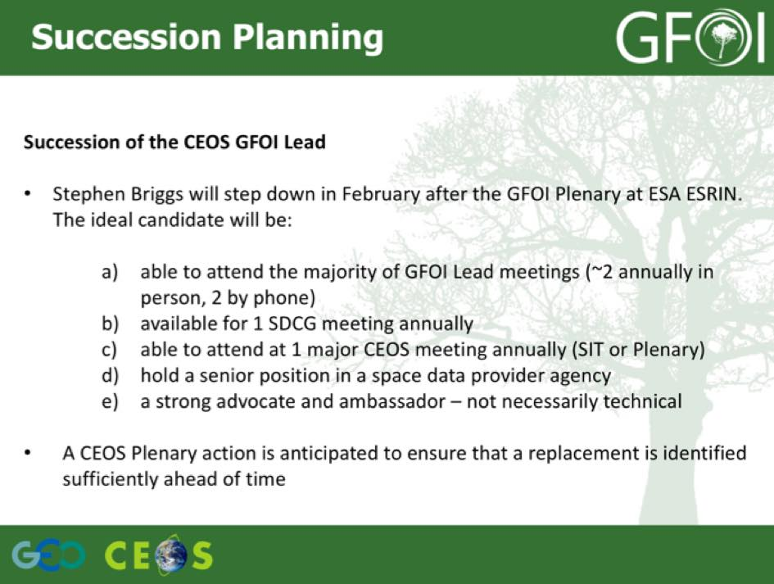
Stephen noted that the Australian funding for the GFOI support appears to be ending end June 2016, and that there is currently no continuity for SDCG Secretariat support.
A brief discussion followed:
- Doug asked about the Australian position on funding for GFOI, and it was agreed that this needs to be clarified. He noted that there are a number of potential vacancies within GFOI, including the Space Data Lead, SDCG Secretariat, MGD Lead, and the GFOI Office. He also noted that GFOI is missing a higher level advocate to work on issues around funding and fundraising.
- Yves noted that CSA is concerned about some of the uncertainty around GFOI, given the resources being invested, and other CEOS agencies share that concern. He noted that this makes it difficult to convince management to continue support.
- Frank Martin noted that there are a number of opportunities coming up (e.g. performance based payments for REDD+) that space agencies should doing as much as possible to be involved.
- Yves noted that regardless of the progress of GFOI, there has been quite a bit of momentum built that can be advanced upon.
- Ake noted that the newly revamped LSI-VC might be a potential home for this activity, but Yves added that LSI-VC is not structured to accommodate the work of SDCG at present.

2016 GFOI Open Forum
Stephen reported that the GFOI Open Forum will be held at ESA ESRIN 22nd-26th February 2016, and the proposal is that this will include SDCG-9. This meeting will bring all the GFOI Components together, including the Space Data component. Stephen noted that the GFOI Leads are considering who should be invited, and there are a number of current and new participants are being contemplated. He noted that in future, they will try and have the meeting closer to some of the user countries to see if that might encourage engagement.
A brief discussion followed:
- Frank Martin asked about the transition of the GFOI Office to FAO, and whether either Australia or Norway could take on the role directly.
- Helmut suggested that donors should be well represented at the Open Forum.
- Frank Martin confirmed that the rooms at ESRIN are booked for these dates.
Stephen raised the issue of SDCG-10, noting that in the past we have tried to synchronise SDCG meetings with other CEOS meetings. The SIT Technical Workshop is the week of 11th September at Harwell, U.K., and so SDCG-10 is being proposed for the week of 5th September. A brief discussion followed:
- It was noted that we have had a lot of meetings in Europe. It was also noted that this may be an opportunity to engage with the UK.
- Yves noted that CSA is willing to organise a future SDCG / GFOI meeting.
- Helmut noted that it is unusual to plan an SDCG meeting in the U.K. without a representative from the U.K. or the UKSA participating in SDCG.
SDCG-8-35 | Stephen to circulate the draft list of invitees to the GFOI Open Forum for comment | October 2015
SDCG-8-36 | Frank Martin to work with Stephen Briggs and SDCG EXEC to develop an outline of the week of SDCG-9 | October 2015
SDCG-8-37 | Stephen Briggs to provide some suggestions on potential hosts for SDCG-10 in the UK in September 2016 | October 2015

Closing
Review of Actions
George Dyke reviewed the draft actions from the meeting. These actions are presented in a table attached to these minutes.
Frank Martin noted that GFOI has secured a joint COP21 Side Event with ESA, Australia, Cameroon, and RESTEC. The Event will take place 3rd December 2015 from 16:45-18:15, will be chaired by Stephen Briggs, and will feature four country cases and a panel discussion.
Frank Martin noted that he is expecting a decision from UNFCCC on an ESA Stand at COP21. He invited suggestions from the group for other items to be displayed at the booth. Brice note that he can provide electronic copies of the GOFC-GOLD sourcebook and training materials, which should be available in English, French and Spanish by that time.
Closing Remarks
Frank Martin summarised the week, noting that the interaction with donors and countries on Monday-Tuesday 21st-22nd at the International Conference on MRV of REDD hosted by the German Federal Ministry for Economic Cooperation and Development (BMZ) and the German Aerospace Center (DLR), and organised by the Deutsche Gesellschaft für Internationale Zusammenarbeit (GIZ) GmbH was useful. He noted that we should do more work to promote the work of this coordination group within GFOI, in particular in the lead up to the GFOI Open Forum in February.
He thanked Helmut and DLR for the generous hosting this week’s meetings and associated activities.

SDCG-8 Attendees
Organisation | Participant | Organisation | Participant
Airbus-Geo France | Patrick Houdry | DOTE/Australia | Stephen Ward
Airbus-Geo Germany | Felicitas von Poncet | DOTE/Australia | George Dyke
Airbus-Geo Germany | Oliver Lang | ESA | Frank Martin Seifert
ASI | Anna Rita Pisani | FAO | Inge Jonckheere (1 day + GTM)
BlackBridge | Marcus Apel | FAO | Erik Lindquist (GTM)
BlackBridge | Philippe Campenon | GAF | Jörn Reike
BlackBridge | Pablo Rosso | GOFC-GOLD | Brice Mora
CEOS DCEO (GA) | Jonathon Ross | JAXA | Nobuyoshi Fujimoto
CEOS SEO (NASA) | Brian Killough | JAXA | Ake Rosenqvist
CEOS SEO (NASA) | Shaun Deacon | MGD Component | Carly Green (GTM)
CEOS SEO (NASA) | Matthew Jondrow | USGS | Douglas Muchoney
CEOS SEO (NASA) | Sanjay Gowda | USGS | Eugene (Gene) Fosnight
CNES | Steven Hosford (GTM)
CSA | Yves Crevier
DLR | Helmut Staudenrausch
DLR | Michael Bock
DLR | Joern Hoffmann
DLR | Godela Rossner
DLR | Albrecht von Bargen
GTM = Participation on the phone via GoToMeeting.

SDCG-7 Actions Status Update for SDCG-8
SDCG-7 Actions

No. | Action | Due Date
SDCG-7-1 | CEOS SEO to coordinate with ESA, USGS and GA on the planning, definition, and progressing of the initial implementation steps of Outcomes 11 and 12 (cloud computing pilots) in the SDCG 3-Year Work Plan. | SDCG-8  The SEO is leading monthly telecons with the Data Cube team to develop requirements and a Kenya demo. Other cloud-computing pilots are progressing and have been delivered (FAO and Colombia). A summary of these projects will be presented at SDCG-8.
SDCG-7-2 | Stephen Ward to confirm the content of outcomes 3 (around standard products) and 9 (integration of space data within the MGD) from the SDCG 3-Year Work Plan with the MGD component manager, including around the objective of the SDCG Data Cube to focus on standard surface reflectance products. | ONGOING  Carly Green has said that the MGD doesn’t infer requirements for standard products and as such will have no bearing on outcome #3. We await the MGD Portal before significant progress.
SDCG-7-3 | Stephen Ward and George Dyke to define additional milestones for the advancement of Kenya as a national model implementation of the Space Data Services for outcome 11 in the 3-Year Work Plan. | ONGOING
SDCG-7-4 | SDCG EXEC to include an SDCG 3-Year Work Plan task to propose a mechanism to address the coordination and collection of forest-related R&D space data requests. | Task defined by SIT-30, mechanism definition by SDCG-8  To be added to the 2016-2018 Work Plan revision.
SDCG-7-5 | SDCG EXEC to finalise the SDCG 3-Year Work Plan based on discussion at SDCG-7, and submit to the SIT-30 document approval process. | COMPLETE
SDCG-7-6 | SDCG EXEC, in collaboration with the MGD component manager, to draft a 1-2 page assessment of the potential roles and interactions between the GFOI Space Data Component and the GFW. | SDCG-8  No progress – check MGD references to GFW.
SDCG-7-7 | SDCG EXEC to collaborate with GA & the SEO to achieve the 2015 paper on future efficient global data flows (SDCG 3-Year Work Plan Outcome 2) – starting by agreeing the scope and objectives with SDCG. | Draft for discussion at SDCG-8  Ongoing. The Global Data Flows Study Team is working on the study paper and holding regular coordination teleconferences.
SDCG-7-8 | Steven Hosford to confirm some details of the SPOT archive processing including approximate schedule, number of scenes being handled, and current expected completion date. | ONGOING  Steven reported:  “We are currently processing the 2nd set of 100000 images. We had hoped to focus these on forested regions and use this to promote the SWH programme and GFOI at COP21, as time progresses and no specific areas of processing are identified, the likelihood of this happening is evaporating. An internal programme review is being organized for the 26th June and after this date we should have more information on the schedule for opening the data server. As stated in all the presentations on the subject, access to the images already processed will be free for non-commercial use.”  25/8/2015 – Matt has asked Steven for an update on the outcomes of the June 26th programme review meeting.
SDCG-7-9 | Gene Fosnight to engage with CEOS WGCV (and its Land Cover Validation subgroup) on analysis ready surface reflectance products and USGS activities to see whether their work might be complementary. | CLOSED  Gene: CEOS WGCV and its Land Product Validation subgroup is aware of the importance of the cross validation of derived data products. However there is not a focused activity to address this requirement. With the launch of Sentinel-2 it is acknowledged that this requirement becomes increasingly important. SDCG should increase its awareness of WGCV activities as we pursue analysis ready data in support of GFOI.
SDCG-7-10 | Brian Killough to confirm with Andy Mitchell whether the NASA mirror of the Sentinel-1A rolling archive can be shared with GFOI and other CEOS users. | ONGOING  Brian confirmed with Andy Mitchell that Sentinel-1A mirroring is taking place at the Alaska Science Facility (ASF). NASA is still working with ESA/EC to get the approval to open the archive publicly and for CEOS use. An MOU is expected to be signed within one month.
SDCG-7-11 | Brian Killough and Frank Martin Seifert to confirm the linkages between the ESA TEP and the SDMS. | COMPLETE  ESA’s Thematic Area Program (TEP) includes products from Sentinel-1 and Sentinel-2. At this point, there does not appear to be any specific data products that could be used for the SDMS and Data Cube. The SEO will continue to monitor the ESA Sentinel site for relevant data products.
SDCG-7-12 | Steven Hosford to coordinate with SDCG EXEC on potential SDCG and GFOI outcomes to include in any CEOS presence at COP-21. | SDCG-8  Stephen Ward reached out to Steven on the possibility of CNES contributing multiple years of SPOT data for Kenya in support of developing a model national system for forest MRV applications, thus providing a good demonstration for COP.  Steven reported that he has had no further discussions around this. He is working on the assumption we would process the available Kenya archive and this could be integrated into the Data Cube that the SEO is developing.  As discussed in Sydney, as this is a small contribution on the French side, it is unlikely that the French delegation will be able to promote it at COP21. CNES continue to look for contributions that could promote SWH and GFOI at COP21 via the French delegation.
SDCG-7-13 | SDCG, in consultation with the Capacity Building component and Kenya to advise CNES on priority locations and dates for SPOT reprocessing. | ONGOING  Sylvia has sent a listing/map of HR monitoring and verification SilvaCarbon sites to the SDCG Sec.  Steven Hosford has had no communications from anyone on requirements of zones in Kenya or elsewhere.
SDCG-7-14 | Erik Lindquist to confirm with Brian Killough whether FAO would be able to host a Kenya data cube on their AWS infrastructure in the event that Kenya wishes to use the prototype Brian is developing operationally. | ONGOING  The SEO sent a request to FAO via email on May 9th. No response has been received.
SDCG-7-15 | Brian Killough to confirm whether an updated RapidEye API is available. | COMPLETE  Not ready until late 2015.
SDCG-7-16 | Ake Rosenqvist to work with Brian Killough on including the ALOS archive in the country coverage assessment and COVE tools. | COMPLETE
SDCG-7-17 | Yves Crevier to work with Brian Killough on including the RADARSAT-1 archive in the country coverage assessment and COVE tools. | COMPLETE
SDCG-7-18 | Brian Killough to follow up Erik Lindquist for feedback on the archive assessment tools his group are developing. | COMPLETE
SDCG-7-19 | CEOS SEO to perform a Kenyan archive analysis back to 1990 for SPOT and Landsat (including MSS) data. | COMPLETE
SDCG-7-20 | Brian Killough to share information with Sar Sophyra (Cambodia) on forest fire early detection using MODIS, including Australia’s Sentinel Hotspot system (in coordination with Alex Held). | COMPLETE  Email sent on June 4th.
SDCG-7-21 | Sylvia Wilson to confer with SDCG EXEC to specify sites in SilvaCarbon countries with high-resolution data requirements that might be addressed by SDCG brokerage. | ONGOING  Sylvia has sent a listing/map of HR monitoring and verification SilvaCarbon sites to the SDCG Sec.  Yves Crevier is communicating directly with the Cambodian representatives to see if some CSA/MDA consultants that work in Cambodia could provide data/research, and potentially build some capacity.
SDCG-7-22 | Helmut Staudenrausch and Frank Martin Seifert to approach Airbus regarding the cost and availability of a 30m TanDEM-X DEM product for Colombia. | ONGOING  Frank Martin will follow up with Helmut. He expects to have more information by ISRSE-36.
SDCG-7-23 | R&D space agency representatives to read the GFOI R&D Component Plan and the Element 3 (R&D) Acquisition Strategy and provide feedback to Ake by Wednesday 11th March, and indicate their agency’s support for the presentation of the Strategy for endorsement at SIT-30. | COMPLETE  The Element 3 strategy was endorsed at SIT-30.
SDCG-7-24 | Brian Killough to circulate the details of the pilot data services the SEO have put in place for JECAM, including the MURF and other data licence mechanisms. | CLOSED  Details are unable to be shared.
SDCG-7-25 | Anna Rita Pisani to confirm the COSMO-SkyMed quotas that will be available for GFOI projects. | COMPLETE  The number of COSMO-SkyMed images available for GFOI R&D priority sites will be evaluated based on their individual requirements.
SDCG-7-26 | Helmut Staudenrausch to confirm the TerraSAR-X quotas that will be available for GFOI projects. | COMPLETE  Collectively 500 scenes per year will be available for GFOI.
SDCG-7-27 | Frank Martin Seifert to assume responsibility as the POC for Element-3 (R&D). | COMPLETE
SDCG-7-28 | Helmut Staudenrausch to coordinate with SDCG EXEC to confirm the details of the SDCG-8 meeting alongside the international workshop on MRV of REDD+ planned for 21-22 September 2015 in Bonn, Germany. | COMPLETE
SDCG-7-29 | SDCG EXEC to investigate the constraints, and draft a brief proposal for a commercial provider session in conjunction with SDCG-8. | COMPLETE

GFOI Component Meeting Actions (SDCG-related only)

No. | Action | Due Date
GFOI-2 | MGD and Space Data components to ensure sufficient linkages between their respective tools and services. | September 2015
GFOI-3 | SDCG (CEOS SEO) to investigate and report on the availability of core and contributing archive data (Landsat and other) for Kenya from 1990-2000. | COMPLETE
GFOI-4 | All to provide feedback to Gene Fosnight on what standard Landsat products are the most useful as part of USGS’s systematic offerings. | May 2015
GFOI-5 | Kenyan SLEEK team to provide SDCG with a list of sites where they require high-resolution data. | COMPLETE
GFOI-7 | Helmut Staudenrausch to share details of the DLR open solicitation for research projects once available. | September 2015
GFOI-8 | Component Leads, with support from the GFOI Office, to collaborate to define a process and practical plan addressing deliverable availability, meetings, country engagement and follow up – with a view to understanding the process of working and meeting together for the next 1 to 2 years. | ONGOING
GFOI-14 | Helmut Staudenrausch to work with SDCG, in coordination with the GFOI Lead Team, to establish the scope and purpose of the proposed September meetings in Germany, which will include SDCG-8. | COMPLETE
GFOI-17 | Richard Tipper and SDCG to share information and experiences on cloud-based EO data distribution and processing solutions for national forest MRV. | September 2015
GFOI-21 | Alex Held to follow up with the Kenya SLEEK team on potential Kenyan interest in agricultural monitoring and GEOGLAM RAPP. | September 2015
GFOI-22 | FAO and SilvaCarbon, in consultation with the MGD component manager, and utilising their GFOI Capacity Building meeting in April, to produce a brief report on the state of play with regards to partner engagement; requirements; and national MRV in different countries, and to make recommendations as to which countries might be the priorities for uptake of the GFOI deliverables of MGD and Space Data. | CLOSED
GFOI-23 | SDCG to produce a GFOI Space Data Access Guide for the reference of countries and for incorporation into the MGD Online Portal, which will identify data sources, data/mission specifications, and relevant points of contact for follow up. | September 2015
GFOI-24 | SDCG, with support from the GFOI Office, to work with Norway and FAO to determine optimal representation of the Space Data Component on the FAO SDMS Advisory Group. | ONGOING
GFOI-28 | SDCG to continue working to engage commercial space data providers in GFOI, in particular in support of the Element-3 R&D Acquisition Strategy. | COMPLETE  Commercial provider session to be held at SDCG-8.

