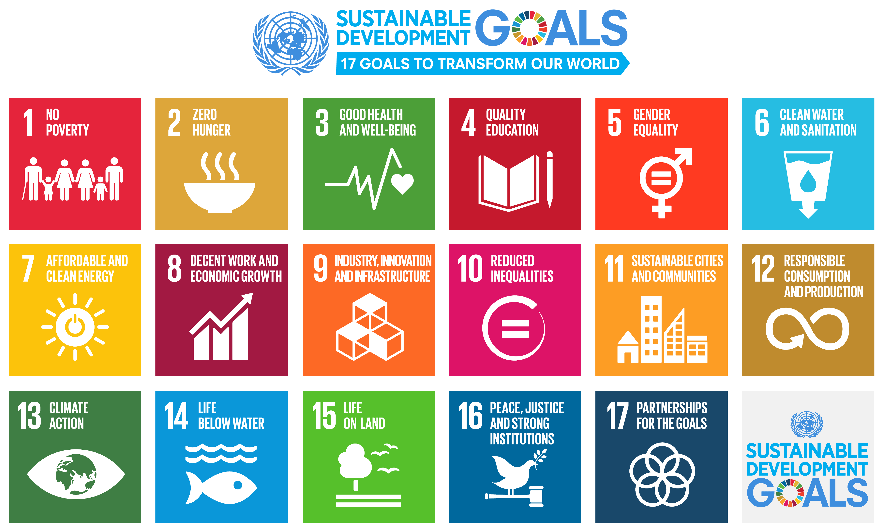
CEOS Agency Support to the United Nations Sustainable Development Goal Process

At the 31st Meeting of the CEOS Strategic Implementation Team (SIT-31), CEOS emphasized its role in supporting the United Nations Sustainable Development Goals (UNSDG) process:

Decision 3: The CEOS way forward on the UNSDGs will be undertaken in conjunction with GEO & UN-GGIM, supplemented by a top-down dialogue with relevant UN Agencies and with individual CEOS Agencies making connections within their governments.

CEOS also discussed the creation of communications materials and content that could help communicate that role.

To facilitate this process, we are asking CEOS Agencies to provide a non-technical snapshot of the ways you currently are or plan to support the UNSDG process, specifically (i.e. the nature of the project(s), pertaining to which goals/targets/indicators, in what country/region, etc).

We will use the information CEOS Agencies provide to generate communications materials and content for a wide, non-technical audience (meaning easily readable formats such as executive summaries and fact-sheets, with clear, jargon-free language, and using as many visuals such as graphs, charts, illustrations as possible).

In the following tables, we request the following kinds of information:

- at least one goal, target, or indicator on which your Agency is currently focused or will focus
- the specific satellites and sensors from your Agency that support the specified goal, target, or indicator
- several relevant images/photos of people doing/affected by the related work, application-focused images, images of satellites and sensors, etc.
- the country or countries/geographic region where this activity is taking or will tak place
Please fill out the following tables and return the information to Kim Holloway (CEOS Systems Engineering Office, SEO) and copy Flora Kerblat (CEOS Chair team), by August 26th, 2016.
Thank you in advance for your cooperation.

1. UNSD Goals, Targets, & Indicators

In the table below, please specify up to three Goals, Targets, and/or Indicators from the latest list of “Provisional Proposed Tiers for SDGs” (March, 2016) and the satellite/sensor from your Agency that can help monitor or achieve them.

Being able to get specific enough to provide examples of how your Agency’s satellites and sensors are or can support the UNSDGs all the way down to the Indicator level is helpful, but not necessary. If you are only able to identify examples at the Target or even at the broad Goal level, that information is helpful as well.

Note: We would also like to showcase how satellite Earth Observations can support some of the less obvious UNSDGs (i.e. Goals other than Goals 2, 6, and 15), so please be sure to let us know if any of your satellites/sensors can do so.

- Goal Example: Goal 2: Zero Hunger
- Target Example: Target 15.3: Land Degradation Neutrality
- Indicator Example: Indicator 15.3.1: Proportion of Degraded Land

Please replace the sample text in the table with your own example(s):

 | 1 | 2 | 3
Goal | 2: Zero Hunger | 15: Life on Land
Target | -- | 15.3: Land Degradation Neutrality
Indicator | -- | 15.3.1: Proportion of Degraded Land
Satellite | Satellite X | Satellite Z
Sensor | Instrument XYZ | Etc.
Product to be Measured | NDVI
Country/Region Monitored
Operational Duration (Launch Year – End Year) | 2015-2020
Major Characteristics (optical/radar, frequency, etc.) | Optical, 8-day Repeat, 400 m resolution, etc.

2. Agency Applications/Services

Does your Agency have a relevant application or service it is willing to promote in support of the UNSDG Process? (Joint or collaborative activities involving contributions from multiple CEOS Agencies are also applicable here.) If so, please let us know in the table below:

Application/Service Name

Country/Region Supported

Department/Business Unit

Description
(up to 50 words)

Point of Contact Name

Point of Contact Email

Application/Service Website

3. Images/Photos

Please email several examples of relevant images/photos to Kim Holloway (jpeg/png preferred, high enough resolution for quality printing).

Please also make sure to send caption information such as geographical area, dates, satellites/sensors, agencies, and any necessary credit/copyright information.

Examples of relevant images/photos might include:
- photos that show people working on these activities/problems
- photos of people who will benefit from these activities (users, communities, etc.),
- application-focused images depicting problems or solutions,
- images of actual satellites and sensors
- satellite imagery/products
- high resolution logos
Thank you kindly for your time and effort.
For your information, the following is an example of the kinds of communications or outreach material we’d like to generate using the information you provide (with additional information about relevant CEOS Agency satellites/sensors):

