Indicator | 15.3.1 Proportion of land that is degraded over total land area.
Target | 15.3 By 2030, combat desertification, restore degraded land and soil, including land affected by desertification, drought and floods, and strive to achieve a land degradation-neutral world.
Custodian | United Nations Convention to Combat Desertification (UNCCD) | Tier | II
Current approach and challenges | UNCCD has defined these components of the SDG indicator 15.3.1– To Improve the conditions of affected ecosystems – including i) trends in land cover (SO 1-1), trends in land productivity of functioning of the land (SO 1-2) and iii) trends in carbon stocks above and below ground (SO 1-3). With the Good Practice Guidance (GPG, Version 1.0, 2017), the UNCCD has established a universal methodology for reporting on SDG 15.3.1.  Approach:  The indicator aims at measuring and monitoring land degradation by calculating the ratio between the degraded land area and the total land area of a country. Land degradation is defined as “the reduction or loss of the biological or economic productivity and complexity of rain fed cropland, irrigated cropland, or range, pasture, forest and woodlands resulting from a combination of pressures, including land use and management practices” (GPG, Version 1.0).The total proportion of land that is degraded over total land area is given by:  $$P_{n}= \frac{{A(degraded)}_{n}}{\sum_{i}^{m}{A(Total)}}$$  where 𝑃n is the proportion of land that is degraded over total land area; 𝐴(𝐷𝑒𝑔𝑟𝑎𝑑𝑒𝑑)n is the total area degraded in the year of monitoring n (ha) and A(Total) is the total area within the national boundary (ha).  The indicator is a binary - degraded/not degraded - quantification based on the assessment of three sub-indicators (Land cover and land cover changes, land productivity changes and carbon stock changes above and below ground), which were adopted by the UNCCD’s governing body in 2013 as part of its monitoring and evaluation approach. They represent proxies that ought to reflect the capacity of the land to deliver ecosystem services. The changes have to be assessed and depicted as (i) positive or improving, (ii) negative or declining, or (iii) stable or unchanging. Based on the evaluation of the changes, the proportion of land that is degraded over total land area (%) is calculated following a “One out all out” (1OAO) principle. That is, if one of the sub-indicators is negative (or stable when degraded in the baseline or previous monitoring year) for a particular land unit, the particular area is considered as degraded.  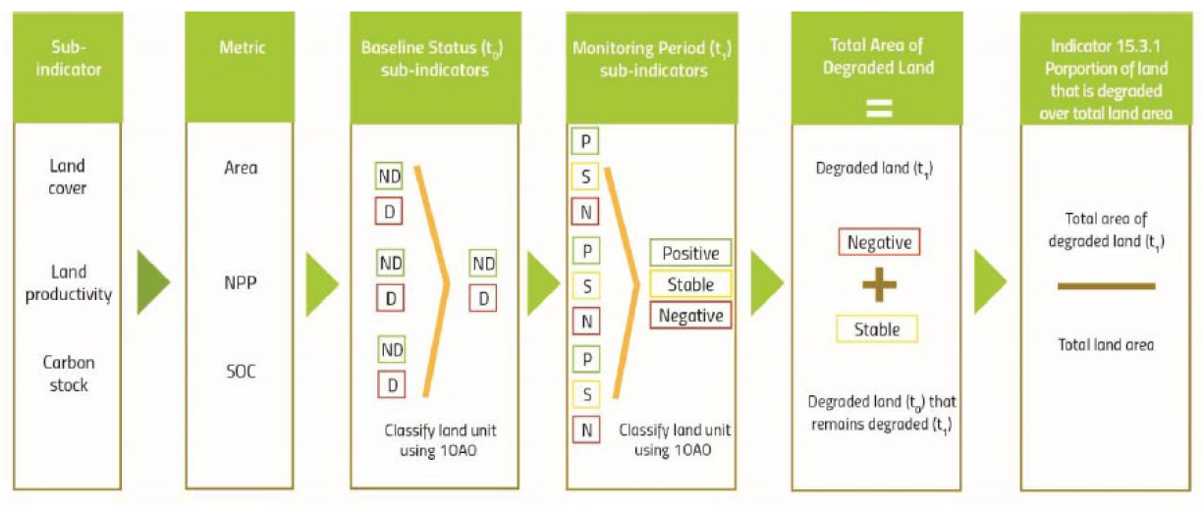  Land Cover:  The sub-indicator describes the changes in the distribution of vegetation types, and human-impacted infrastructure, and reflects the use of land resources (i.e., soil, water and biodiversity) for agriculture, forestry, human settlements and other purposes. The land cover classes should be exhaustive and mutually exclusive, with the entire country’s land area being attributed to a set of land cover classes.  There is an international standard for land cover which includes the Land Cover Meta Language (LCML), a common reference structure (statistical standard) for the comparison and integration of data for any generic land cover classification system. LCML is also used for defining land cover and ecosystem functional units used in the System of Environmental-Economic Accounting (SEEA), and closely linked to the Intergovernmental Panel on Climate Change (IPCC) classification on land cover/land use. The IPCC land use change legend suggests six main classes (forest land, grassland, cropland, wetlands, settlements and other lands, like bare soil, snow and glaciers and water bodies) which should be considered as a minimum set. To classify the changes and decide whether or not land degradation occurs from a land cover change perspective, a change matrix approach is applied (see below).  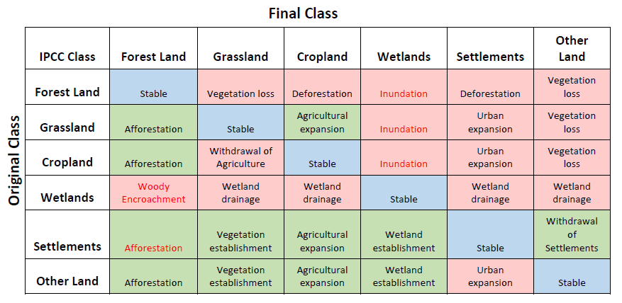  Note: This sub-indicator is also expected to be used for reporting on SDG indicators 6.6.1, 11.3.1 and 15.1.1 to guarantee a consistency among the reporting (e.g. forest changes).  Land productivity:  The sub-indicator refers to the total above-ground net primary production (NPP) defined as the energy fixated by plants minus their respiration which translates into the rate of biomass accumulation that delivers ecosystem services. The international standard for calculating NPP (gC/m²/day) from remotely sensed, multi-temporal surface reflectance data, accounting for the global range of climate and vegetation types, was established in 1999 by NASA for the MODIS sensor. The Land Productivity Dynamics (LPD) methodology and dataset, developed by the Joint Research Centre (JRC) of the European Commission (EC) and used in the UNCCD LDN Target Setting programme, employs this international standard to calculate NPP time series trends and change analyses. The LPD dataset is based on a timeseries analysis of long-term changes and current efficiency levels of vegetative or standing biomass, providing 5 qualitative classes of land productivity trends over the time period 1999-2013.  Carbon Stock:  In UNCCD decision 22/COP.11, soil organic carbon (SOC) stock was adopted as the metric to be used with the understanding that this metric will be replaced by total terrestrial system carbon stocks, once operational. SOC is an indicator of overall soil quality associated with nutrient cycling and its aggregate stability and structure with direct implications for water infiltration, soil biodiversity, vulnerability to erosion, and ultimately the productivity of vegetation, and in agricultural contexts, yields. For carbon stocks, IPCC (2006) contains the most relevant definitions and standards related to soil infrastructure, and data transfer.  Baseline and reporting period:  The baseline is established over the period 2000 to 2015, with the base year being 2015. All changes are assessed relative to the baseline value with a reporting interval of 4 years, starting in the year 2018. Countries are responsible for submitting national reports to UNCCD. According to the reporting platform prais³ of the UNCCD a total of 149 countries have reported in 2018.  Challenges:  The indicator has been classified as TIER-II meaning that the indicator is conceptually clear, and an established methodology exists but data on many countries is not yet available. Challenges and issues are related to the fact that the sub-indicators cannot fully capture the complexity of land degradation (e.g., its degree and drivers). Countries are strongly encouraged to use other relevant national or sub-national indicators, data and information to strengthen their interpretation. Further, the rather coarse spatial resolution (>100m) of the existing EO products prevent detailed land degradation mapping including the monitoring of its triggers. Other challenges include the combination of coarse or/and medium resolution data with high resolution (HR) EO imagery, the validation of national EO-based data products as well as the uncertainty in the continuity of global datasets currently used as default data. With respect to carbon stocks, more research is needed on how to complement and update it with EO data.  Consideration of EO:  The GPG deeply integrates EO into the methodology by using global default EO datasets such as the ESA CCI Land Cover and the JRC LPD. Further, Conservation International (CI) together with Lund University, and NASA have developed a platform for monitoring land degradation using EO in a desktop and cloud-based system financed by the Global Environment Facility (GEF). The Trends.Earth tool box draws on a variety of different data sources including the Normalized Difference Vegetation Index (NDVI), soil moisture, precipitation, evapotranspiration, land cover, soil carbon, agro-ecological zones as well as administrative boundaries. The toolbox is able to estimate the three sub-indicators for monitoring the achievements towards Land Degradation Neutrality (LDN) and can be used by countries to analyse the data as well as to report to UNCCD. The methodology is detailed on the Trends.Earth website.
Opportunities for Earth Observation
Opportunities for EO | Coarse resolution satellite EO has already been proven to be an ideal tool to monitor land degradation on a larger scale. With ESA’s Copernicus Sentinel-2 constellation being operational the ability for near-real-time monitoring of land use and land use changes as well as land productivity at high temporal and spatial resolution has significantly increased. HR regional and global datasets derived from EO and geospatial information can play an important role to enhance national data sources and complement the results of Trends.Earth. These datasets can help validate and improve national statistics for greater accuracy by ensuring that the data are spatially explicit. While access to HR remote sensing imagery has improved dramatically in recent years, there is still a need for essential historical time series that are currently only available at coarse to medium resolution. The expectation is that the availability of HR, locally-calibrated datasets will increase rapidly in the near future due to among others the Copernicus Sentinels. National capacities to process, interpret and validate geospatial data still need to be enhanced in many countries.  For the derivation of the baseline period and the baseline year 2015 it is possible to exploit the Landsat 5 to 8 archive to derive the land cover change sub-indicators on a higher spatial resolution. While for land productivity the same data can be used to estimate land productivity changes, this process is more challenging due to the need of capturing vegetation phenology. In some instances, the temporal resolution of historical Landsat data might not be enough for certain places (e.g. tropics) or time periods. For SOC changes the application of high-resolution satellite EO imagery is rather limited and needs to be further explored.
EO Data availability | There is a range of satellite data sources and global data products which could be used within the indicator reporting. In addition, there are several online platforms and tools that provide options and support for accessing or deriving various inputs for computation of indicator 15.3.1.  Satellite Data  Raw satellite imagery for assessing land cover as well as land productivity changes can be obtained from public and freely accessible data collections. A summary of the available options is provided in the table below:  Sensor Type Spatial resolution Revisit time Temporal coverage Data policy Comment  Sentinel-2 Multi-spectral 10 m 5 days From 2015 Free and open Limited historical data but the long-term continuity is secured under the Copernicus program  Landsat Multi-spectral 30 m 16 days Since 1984 Free and open The 30-meter resolution is a drawback compared to Sentinels but the long temporal coverage is invaluable for historic mapping.  Sentinel-3 OLCI Colour instrument 300 m At least every 2 days globally Since 2016 Free and open OLCI instrument Long-term continuity is secured under the Copernicus program  MODIS Multi-spectral 250m,500m and 1km At least every 2 days globally Since 2002 Free and open Moderate Resolution Imaging Spectroradiometer on-board AQUA and TERRA satellites  MERIS Colour instrument 300m and 1.2km At least every 3 days globally 2002-2011 Free and open As for Sentinel-3 but discontinued  VIIRS Multi-spectral 375m, 750m Sub-daily, e.g. 3-4 times per day at mid-latitudes Since 2012 Free and open Similar to MODIS in terms of specifications and to provide continuity  SPOT VEGETATION 4 bands (B,R,NIR, SWIR) 1km 1 day 1998-2015 Free and Open VGT-1 on board SPOT-4 (1998) and VGT-2 on board SPOT-5 (2002)  PROBA-V 4 bands (B,R,NIR,SWIR) 300m and 1km 1 day Since 2013 Free and Open Continuity of SPOT Vegetation  Commercial SAR and Multi-spectral 0,5 to 2.5 meters n/a Since ~2000 From 2.5 to 20 €/km² Provides the highest level of detail but at expense of cost Commercial  Sentinel data can be accessed through the Data and Information Access Services (DIAS) or the Conventional Data Hubs (https://www.copernicus.eu/en/access-data) while Landsat data is available via the EarthExplorer (https://earthexplorer.usgs.gov/ ). Commercial satellite data can be purchased through data providers and their reseller network.  EO-based global datasets  Land cover datasets:  - ESA Climate Change Initiative Land Cover dataset: Annual global land cover maps are available at 300m spatial resolution from 1992 to 2015. Land cover information is provided for 22 classes following the Land Cover Classification System (LCCS). Further regional classes are implemented allowing for a higher level of detail in the legend  https://www.esa-landcover-cci.org/  - Copernicus Dynamic Land Cover: The dynamic land cover map provides a yearly global land cover map at 100m spatial resolution with an overall accuracy of higher than 85%.  https://land.copernicus.eu/global/products/lc  - Pan-European Copernicus High resolution Layers (HRL): HRL maps are available for imperviousness, forest, grasslands, water and wetness as well as small woody features for the year 2015 at 20m resolution  https://land.copernicus.eu/pan-european/high-resolution-layers  - A Summary of additional existing global, regional as well as national land cover data available is provided in the GPG (2017, Version 1.0). The GPG further states the accuracy, geographical coverage, spatial resolution, time periods available as well as thematic resolution.  Land productivity datasets:  - JRC’s Land Productivity Dynamics (LPD) dataset: The LPD dataset is based on an analysis of long-term changes and current efficiency levels of vegetative or standing biomass. The LPD dataset was derived from a 15-year time series (1999 to 2013) of global NDVI observations composited in 10-day intervals at a spatial resolution of 1 km. http://publications.jrc.ec.europa.eu/repository/handle/JRC80541  - Copernicus Global Land Service products: Several global datasets are available that allow for the assessment of vegetation condition including Fraction of Absorbed Photosynthetically Active Radiation (FAPAR), Fraction of green Vegetation Cover (FCover), Leaf Area Index (LAI), Normalized Difference Vegetation Index (NDVI), Vegetation Condition Index (VCI), and Vegetation Productivity Index (VPI)  https://land.copernicus.eu/global/  - An overview for low or no-cost satellite sensors and data streams (e.g. PROBA-V, Vegetation, MODIS, etc.) utilized for land surface phenology studies is provided in the GPG (2017, version 1.0).  Soil Organic Carbon datasets:  - Harmonized World Soil Database (HWSD), Version 1.2: The HWSD was produced by FAO, IIASA, ISRIC-World Soil Information, Institute of Soil Science, Chinese Academy of Sciences (ISSCAS), and the JRC. It is a 30 arc-second raster database that provides information on over 15000 different soil mapping units.  http://www.fao.org/soils-portal/soil-survey/soil-maps-and-databases/harmonized-world-soil-database-v12/en/  - ISRIC’s SoilGrids250m: SoilGrids is a system for automated soil mapping based on state-of-the-art spatial predictions methods. It provides soil property and class maps of the world at 1 km / 250 m spatial resolutions produced using automated soil mapping based on machine learning algorithms. https://www.isric.org/explore/soilgrids  - Global Soil Organic Carbon Map v1.0: The GSOC map was produced by the Global Soil Partnership (GSP) and the Intergovernmental Technical Panel on Soils (ITPS) in a consultative and participatory process involving 110 countries. It allows for SOC stock estimations from 0 to 30 cm, providing information to monitor soil condition, identify degraded areas, set restoration targets, explore SOC sequestration potentials, etc. http://www.fao.org/3/i8195en/I8195EN.pdf  Platforms and Tools:  - Trends.Earth represents a platform for monitoring land change using EO in a desktop and cloud-based system. The tool is providing land degradation estimations at 1km spatial resolution.  - Swiss Data Cube (SDC): UN Environment/GRID-Geneva and the University of Geneva are currently building the SDC. The SDC has started to implement algorithms for monitoring land cover and land productivity changes using the Trends.Earth algorithms on Sentinel data streams.
International Initiatives | GEO LDN initiative: The GEO Land Degradation Neutrality Initiative promotes the collaborative development, and support the provision and use, of EO datasets, quality standards, analytical tools and capacity building to avoid, reduce, and reverse land degradation with the aim of achieving LDN in all countries by 2030 (SDG 15.3). The Initiative will help connect data providers to data users, including researchers, decision-makers, land use planners, commercial sector, donors/investors and other stakeholders in order to optimize the use of EO datasets for LDN assessment, planning, implementation, monitoring and reporting.
Proposed Methodology
Step-by-Step guide for EO integration into SDG indicator framework | - The GPG (Version 1.0, 2017) already outlines the current approach in detail and explicitly states how EO can be incorporated into the reporting framework.  - Further information regarding the methodology is outlined in Reporting manual for the 2017-2018 UNCCD reporting process.  - A guidance document to assist Parties to the UNCCD in preparing their national reports for the 2018 reporting process is available: https://prais.unccd.int/sites/default/files/helper_documents/3-DD_guidance_EN.pdf
Recommendations for implementation
Activities | Tentative, not necessarily in sequential order  - Consistent time series of HR optical satellite imagery is an issue in cloud-prone areas, hampering the delineation of productivity proxies like the start of the season and the end of the season as well as the delineation of land cover changes. A systematic approach should be developed to overcome this issue.  - Precipitation-data is only available in a very low resolution for detrending the productivity data  - Sentinel-2 data is only available on a short time series (2016 to present) prohibiting the use for trend analysis.
Timeframe | Current indicator timeframe considerations:  - According to the latest metadata It is anticipated that countries can report consistently after 2-3 years (relative to 2018) and hereafter repeated regularly in 4-year intervals, allowing for three reporting points until the year 2030.
References | Indicator background  - 15.3.1: four main documents: 1. Glossary; 2. Manual; 3. DD_Guidance (technical note on use and interpretation of default data made available to parties); 4. Good Practice Guidance (on methods to assess the three land-based indicators). All available at: https://prais.unccd.int/node/7  - 15.3.1 PRAIS3 reporting platform https://prais.unccd.int  - 15.3.1 UNSD metadata January 2018, https://unstats.un.org/sdgs/metadata/files/Metadata-15-03-01.pdf  - UNCCD reporting process overview: https://www.unccd.int/convention/2017-2018-unccd-reporting-process  - UNCCD Reporting Manual for 2017-2018 UNCCD reporting Process: https://prais.unccd.int/sites/default/files/helper_documents/2-Manual_EN_1.pdf  - Default data: methods and interpretation. A guidance document for the 2018 UNCCD  Reporting https://prais.unccd.int/sites/default/files/helper_documents/3-DD_guidance_EN.pdf  Publications  - Neil C. Sims, Jacqueline R. England, Glenn J. Newnham, Sasha Alexander, Carly Green, Sara Minelli, Alex Held, 2019: Developing good practice guidance for estimating land degradation in the context of the United Nations Sustainable Development Goals, Environmental Science & Policy, Volume 92, Pages 349-355, https://doi.org/10.1016/j.envsci.2018.10.014.  - Note: Please also refer to the GPG list of references.  EO Technical sites  - Trends.Earth hosted by Conservation International (CI), with partners: Lund University, NASA, and the GEF.  - ESA Climate Change Initiative Land Cover dataset v. 2.0.7: https://www.esa-landcover-cci.org/  Copernicus Dynamic Land Cover: https://land.copernicus.eu/global/products/lc  Copernicus Global Land Service products: https://land.copernicus.eu/global/  Harmonized World Soil Database (HWSD), Version 1.2: http://www.fao.org/soils-portal/soil-survey/soil-maps-and-databases/harmonized-world-soil-database-v12/en/  - ISRIC’s SoilGrids250m: https://www.isric.org/explore/soilgrids  - Global Soil Organic Carbon Map v1.0: http://www.fao.org/3/i8195en/I8195EN.pdf  - EarthExplorer: https://earthexplorer.usgs.gov/  - Sentinel Open Access Hub” https://scihub.copernicus.eu/

https://prais.unccd.int/node/7
Trends.Earth was produced as part of the project “Enabling the use of global data sources to assess and monitor land degradation at multiple scales”, funded by GEF.

