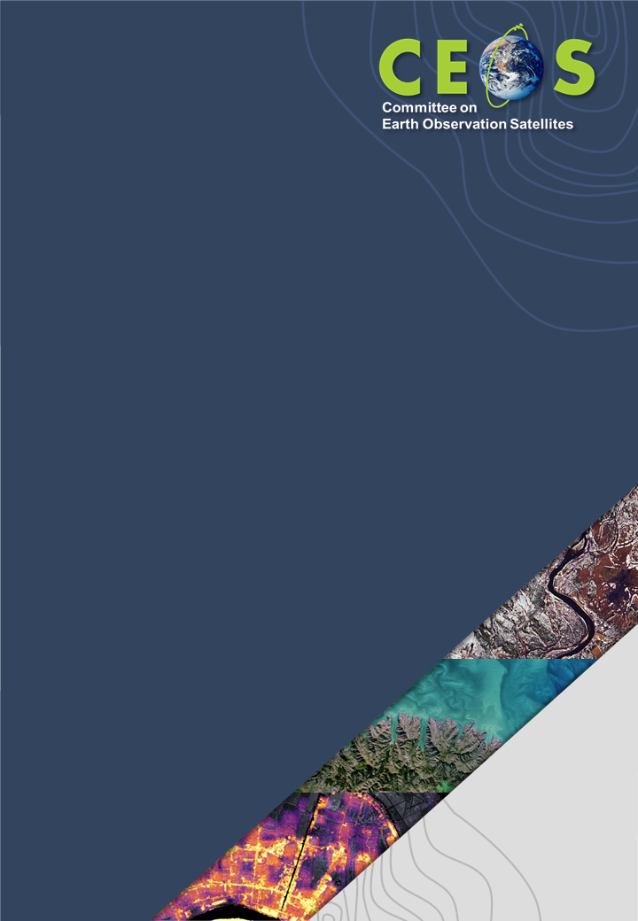

Communications Strategy

Version 1
November 1, 2021

Background and Introduction
This document outlines the CEOS Communications strategy: the specific internal/external communications tactics we will implement to achieve specific goals that align with our organizational mission.

CEOS Mission:
CEOS ensures international coordination of civil space-based Earth observation programs and promotes exchange of data to optimize societal benefit and inform decision making for securing a prosperous and sustainable future for humankind.

CEOS Communications Objectives
Use established CEOS Communications channels and tactics to:
- convey how CEOS supports and optimizes the effective use and impact of satellite Earth observations
- increase awareness around how satellite Earth observations help inform critical decisions and benefit society

Audiences: Goals and Outcomes
CEOS is the unique organization where all of the world’s space-based Earth observing agencies/organizations come together to collaborate for the greater good. So naturally, CEOS has more than one type of audience with different needs:

Audience 1 – The EO Bubble
The first key CEOS Communications Audience is what we call the “EO Bubble”, made up of CEOS Agencies and other EO-involved organizations. For this audience, it is important that we educate and raise awareness about CEOS activities, showcase their involvement/contributions, and amplify/celebrate their EO-related achievements both within and outside CEOS. In addition, it’s important that our communications systems enable and streamline coordination across these Agencies and organizations in support of their collaborative efforts and contributions. Accomplishing these Audience 1 goals will help facilitate two key outcomes for CEOS: increased CEOS Agency contribution, collaboration, and engagement; and furthering awareness and impact of CEOS work.

Audience 2 – Active Users
The second main CEOS Communications audience consists of “Active Users”: researchers/scientists/government employees and all other potential users of satellite Earth observation data, products, and related resources. For this audience, it is important that we educate and raise awareness about CEOS and CEOS Agency data, tools, resources, and opportunities for EO-related training and capacity building. Accomplishing these goals ensures that the actual people using EO data to solve real problems in the world are aware of and able to use and benefit from CEOS work.

Audience 3 – The Supporters
The third main CEOS Communications audience are “The Supporters”: people who aren’t directly involved in the field but who have a strong interest in satellite EO, science, education, and societal benefit in diverse thematic areas. We want to educate/raise awareness within this audience about the potential, value, and possible applications of satellite Earth observations for the good of the world. This will increase widespread support for our work by echoing and amplifying our message across audiences we may generally not interact or communicate with, which helps ensure future support for satellite Earth observations and our work.

Content Types/Formats
CEOS must create high quality content that helps build trust with our audiences and drives traffic to more information and potential for action/involvement. A few ideal formats for doing this include:
- Original blog posts, news stories, case studies, and/or opinion pieces that establish CEOS as a reliable resource for EO information and drive traffic to our website
- Webinars/videos/podcasts that help users learn, showcase our work, and raise awareness
- Infographics that convey what we do, why it's important, who its for, and drive traffic to our website (e.g. one each on the scope and roles of each CEOS WG, VC, AHT, released over a time period)
And all of these content types should generally flow according to our planned/scheduled communications focus at any given time.

Channels
The content types/formats above should be published to a variety of channels, and modified to be most effective for that channel. CEOS communications channels currently include:
- CEOS website news stories and pages
- CEOS YouTube Channel
- Facebook
- Twitter
- LinkedIn

Content Creation & Publication
Implementation of the CEOS Communications Strategy depends on an organized, structured, and well-planned approach for content creation that outlines who should create various kinds of content and when that content will go live. This is made possible through the collaborative use of an Editorial Content Calendar, which allows us to plan, assign, and schedule the content we intend to publish over the course of the year.
It will be the aim of the CEOS Communications team to plan out each month’s content at least one month in advance, even if the team is still polishing the content itself. Similarly, a rough idea of what’s coming in the next quarter should be planned by the first day of the last month of the previous quarter. (These are arbitrary deadlines to help the team make decisions well enough in advance to ask the CEOS community for inputs and feedback for content creation.)
Creating/finalizing content in advance allows us to schedule it to post/publish in advance, facilitating timely publishing/posting, regardless of individual team member work schedules, etc.

Content
Much of our CEOS content may be evergreen — content that is just as relevant months from now as it is today. Some of our content will be timely – related to current events or things happening now (like meetings, events, or launches). Evergreen content can be saved and used again in the future at regular intervals. Timely content can spike audience interest around specific events/opportunities, which could include focusing on particular themes (e.g. landslides, a new sensor or datacube) two to four times per year to provide opportunity for some more in-depth focus on specific areas of interest. Both evergreen and timely content are important.
We can also plan to create content around various holidays, in particular, niche holidays that appeal to our audience (like Earth day!). For example, we could create an awesome blog post in advance to share on “World Water Day”, which is March 22nd annually, showcasing all the various CEOS activities and projects that help us understand our planet’s water bodies/resources and why those are important, etc.
Though we have yet to propose and agree upon a specific set of topical areas (and, potentially, a set of associated icons) within to categorize content, we also hope to help CEOS assert our expertise in various topical areas, minimize clutter, and maximize SEO by managing our content by topic area, tagging and labeling content accordingly to facilitate relevant content discoverability and quick user recognition.

Roles/Responsibilities: Who makes up the Communications Team?
- CEOS Executive Officer (CEO)
- SEO Communications Team
- CEOS Chair Secretariat Team

Work Flow & Responsibilities:
While the whole team is meant to co-create and collaborate on all content, relying on feedback from each other to ensure a consistent CEOS voice and alignment with our Communications vision and organizational Mission, certain role and responsibility assignments help delineate the work flow. For example:
- The CEO checks content for external relations and political/international sensitivity concerns. Also, given his/her constant interaction with the entire CEOS and global EO community, s/he notes current and future activities and events for which we may agree to create content.
- The SEO Communications Team helps maintain/manage existing content, creates new media in collaboration with the CEOS Chair Secretariat Team, maintains/manages the social media content calendar and content publication across all channels (with help, as needed/requested/agreed upon), and proposes new content (e.g. blog post/video/webpage ideas). The SEO Comms Team also offers proofreading and branding consistency checks for all CEOS content prior to publication.
- The CEOS Chair Secretariat Team provides ideas for and contributes to timely content about current, relevant EO-related activities, both internal and external (e.g. blog post/video/social post/web content ideas).
There is naturally some overlap in skill, interest, involvement, and availability across the entire team, so the team must work together to coordinate, communicate, and decide who will take primary responsibility for authoring, sourcing images, recording video/voice-over, publishing, etc. for all content. The Communications team plans to meet quarterly, at a minimum, to facilitate coordination across the team.

A Few Dos / Don’ts to Help Guide the Team
- Do get creative.
- Don’t try totally new approaches without team inputs.
- Do adjust voice/tone for channel appropriateness.
- Don’t be unprofessional.
- Do plan things and ask for community support in advance.
- Don’t be afraid to do something on the fly, if it aligns with the overall Communications strategy

Future Communications Strategy Efforts for Consideration
- Most of the above is about external comms/outreach. What internal communication problems do we need to address? e.g. System for improving CEOS publication/document discoverability, system for notifying CEOS Communications Team about news-worthy events/achievements
- Are there other external communication problems we need to address?
- Metrics: Can we implement a routine tracking of performance analytics/metrics, e.g. track of how various content pieces perform for the sake of future content creation decisions/plans, or perhaps a quarterly review.
- Can CEOS agree upon a consistent set of “thematic areas” and associated icons (similar to what was produced by the WGCapD for CEOS Webinars) for tagging CEOS content?

