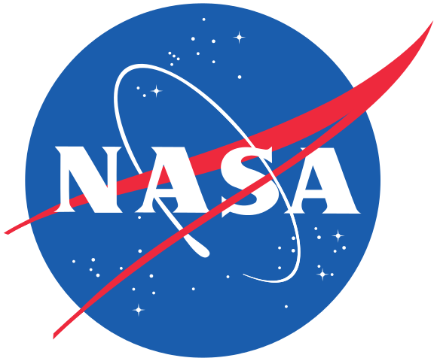
CEOS Chair 2021
Karen St-Germain
NASA
Karen St. Germain
karen.m.stgermain@nasa.gov

CEOS SIT Co-Chairs 2020-2021
Alex Held, Adam Lewis
CSIRO, GA
Alex.Held@csiro.au
Adam.Lewis@ga.gov.au

CEOS Executive Officer
Marie-Claire Greening
Tel: +44 7980 488231
marie-claire@greeningconsulting.co.uk

CEOS Secretariat Contacts

ESA
Ivan Petiteville
Italy
Tel: +33 06941 80567
ivan.petiteville@esa.int

EUMETSAT
Paul Counet
Germany
Tel: +49 6151 807 60 30
paul.counet@eumetsat.int

NASA
Christine M. Bognar
United States of America
Tel: +1 202 358 2066
christine.mcmahonbognar@nasa.gov

NOAA

Kerry Sawyer
United States of America
Tel: +1 202 309 0399
kerry.sawyer@noaa.gov

MEXT/JAXA
Osamu Ochiai
Japan
ochiai.osamu@jaxa.jp
Date

Dear [Recipient],

Sincerely,

Karen St. Germain
2021 CEOS Chair
National Aeronautics and Space Administration

