CEOS: Building the Space Segment of GEOSS

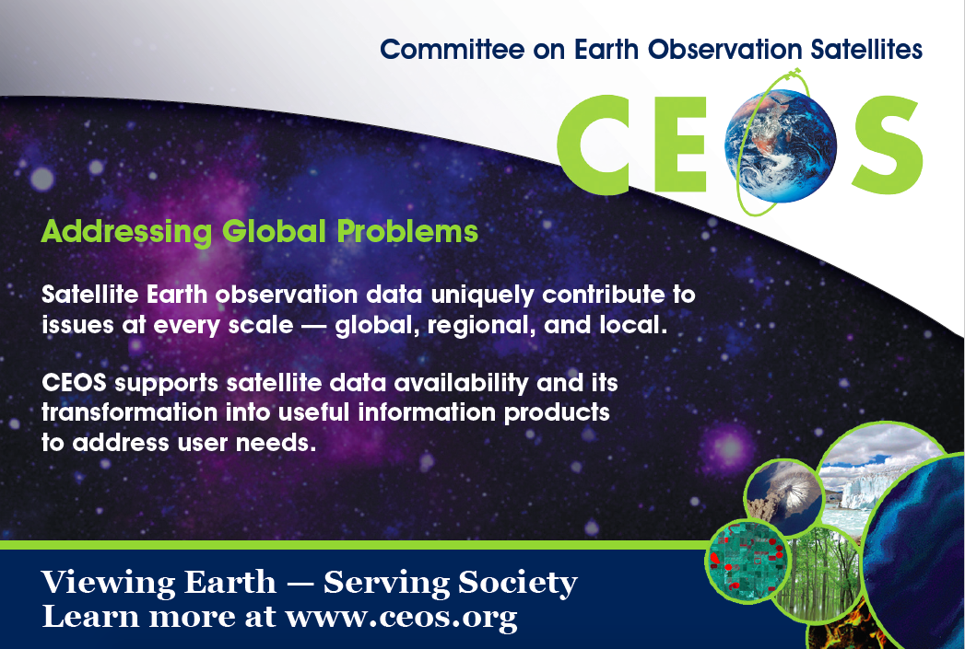

The CEOS Data Cube

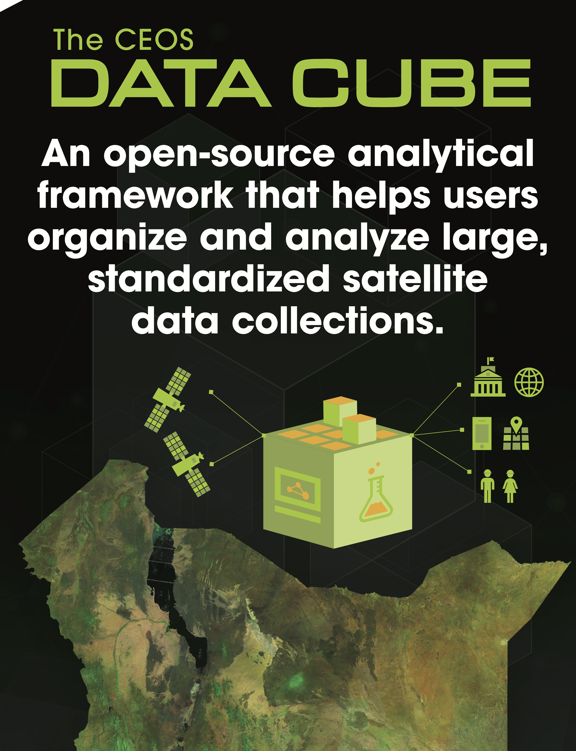
The CEOS Systems Engineering Office and the Commonwealth Scientific and Industrial Research Organisation (CSIRO, Australia) have conducted three data cube workshops in 2015 and 2016 with the Colombia government (IDEAM) to enhance their use of satellite data for national applications and decision-making. Colombia has demonstrated a new capacity for managing large time-series datasets with the use of a new CEOS Data Cube platform. This initiative has demonstrated significant improvements in data preparation and analysis and has been adopted by Colombia as the preferred approach for future data management supporting national applications.

The Global Forest Observation Initiative (GFOI)

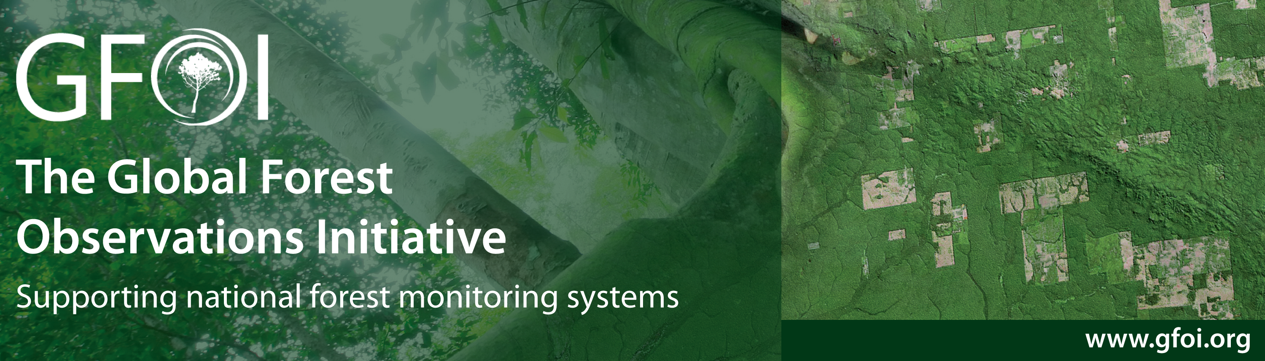

“GFOI promotes a globally integrated approach to measuring forest emissions using satellite-based data. This work is already making a tangible difference in supporting countries in our region to measure the emissions from their forest resources. These are great practical initiatives that Australia is proud of.”
- Josh Frydenberg, Australian Minister for the Environment and Energy

CEOS in Support of GEOGLAM

"GEOGLAM acknowledges the critical support from CEOS with respect to evaluating our data requirements, to coordinating data for the JECAM research and development site network, and to confronting critical issues related to data access, dissemination, and continuity via the Space Data Management System and the forthcoming Data Cube. We particularly recognize the efforts of the Systems Engineering Office, who have collaborated with the GEOGLAM Secretariat toward advancing the state of the art of agricultural monitoring using space-based EO."
- GEOGLAM Secretariat

The CEOS Working Group on Information Systems & Services

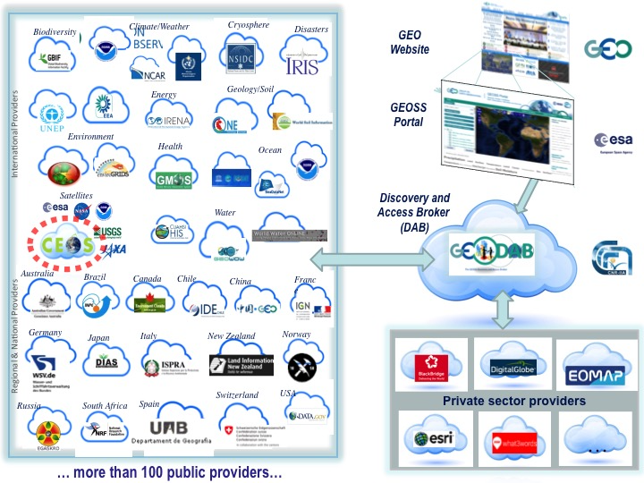

As a brokered data provider, CEOS provides access to more than 260 million (more than 250 million GEOSS Data Core) potentially discoverable and accessible resources (mix of data collections, datasets, and individual images) as contributions to the GEOSS Common Infrastructure (GCI).

