CEOS Social Media Toolkit for COP21 (#cop21ceos)

The CEOS COP21 social media campaign is a coordinated effort to raise awareness (of the public and other organizations) about the CEOS coordination of climate information from space and to host a live Twitter event (TweetChat) on this topic. The campaign (#cop21ceos) will run on Twitter from November 25 – December 11, 2015, during which we will advertise and host two live TweetChats.

For this campaign to be successful, we will rely on CEOS Agencies and individuals to engage in this effort. This toolkit provides everything you need to participate in the #cop21ceos social media campaign, so please join us in this critical online conversation throughout COP21.

Note: You or your organization will need a personal or organizational Twitter profile to actively participate in this campaign (even if you only intend to watch the conversation). Once you create a profile, you can do a search for the CEOS Twitter handle (@ceosdotorg) to find us and Follow us on Twitter.

The TweetChats

A TweetChat is a live conversation on Twitter (where each thing you say must be written in 140 characters or less). You can think of Twitter as a room full of millions of people, all talking (very concisely) at once (while showing you pictures, videos, and giving you links to various websites). To differentiate our COP21 TweetChat conversation from all the other noise in this big room, participants will include a hashtagged phrase in their tweets (#cop21ceos). This allows us to do a Twitter search for “#cop21ceos” and view only the tweets of our participants.

We will hold two, one-hour TweetChats during COP21. I propose to hold them on Thursday, December 3rd and Thursday, December 10th so that each of them gives participants the opportunity to reflect on what they’ve seen/heard/learned at COP21 throughout the previous week. However, should there be more ideal dates/times to host our TweetChats – perhaps based on the dates/times that CEOS representatives will make statements or when there will be significant discussion on EO contributions to climate science/decisions – please propose them!

- TweetChat 1: Thursday, December 3rd, 2015 at 2pm CET (8am EST)
- TweetChat 2: Thursday, December 10th, 2015 at 2pm CET (8am EST)

Advertising the TweetChats

Sometime between November 25th and 27th, the CEOS home page banner image will change to a climate-themed banner that links to our CEOS COP-21 webpage containing general information and links to resources about CEOS climate activities. That banner will show the CEOS COP21 hashtag (#cop21ceos), which will be a first indication to CEOS website visitors that they can follow this conversation on Twitter. (No need to explain it. Hashtagged phrases or prolific now. I may put a little Twitter icon next to it.)

At this point, we will begin tweeting about and inviting our Twitter followers to participate in our upcoming TweetChats, to include images that show the agenda for each of those events. We will also private message our CEOS Agency followers to help us advertise (and participate in) these events, which will extend our advertisements to all of their Twitter followers.

Sample Tweets to Advertise the TweetChats

TweetChat Ad:
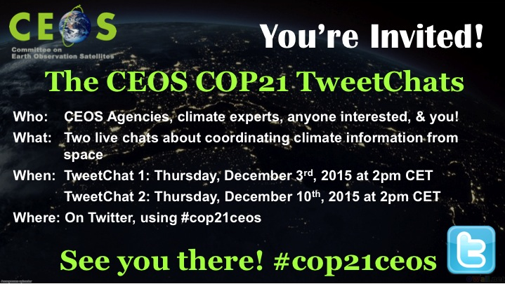

TweetChat Agenda 1 (see details in next section below):
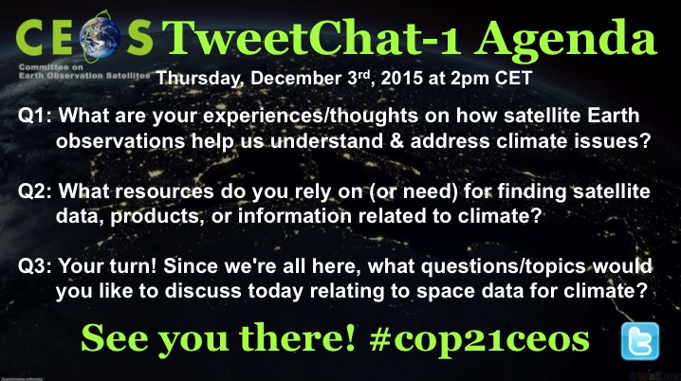
TweetChat Agenda 2 (see details in next section below):
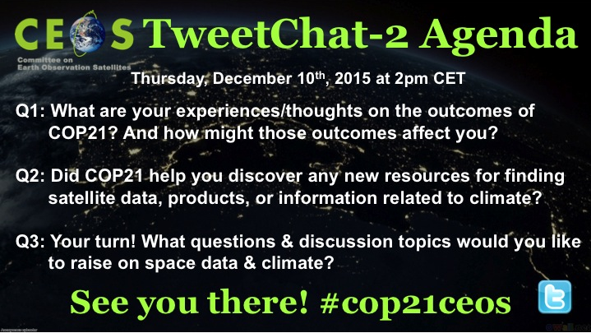

TweetChat 1 Agenda & Sample Tweets

2pm Welcome Tweet:

- Welcome to our 1st #cop21ceos TweetChat. Please introduce yourself: Where are you from & what is your profession? Please include #cop21ceos. [Attach image of TweetChat 1 Agenda]

2:10pm: Get started. Two tips and then Q1 (15 min)

- Great to have you all with us! Feel free to interact w/each other & with us. Remember to include #cop21ceos. Let's get started!

- We'll use a Q/A format to organize the conversation. e.g. If your tweet pertains to Q1, feel free to lead your tweet with A1. #cop21ceos

- Q1: What are your experiences/thoughts on how satellite Earth observations help us understand & address climate issues? #cop21ceos

2:25pm: Wrap up Q1. Introduce Q2 (15 min)

- Q1: Really great dialogue. Feel free to continue discussing amongst yourselves as we move on to Q2. #cop21ceos

- Q2: What resources do you rely on (or need) for finding satellite data, products, or information related to climate? #cop21ceos

2:40pm: Close Q2. Introduce Q3 (15 min).

- Q2: Hopefully, we’ve all learned about some new resources available to us today. Let’s move on to the next question. #cop21ceos

- Q3: Your turn! Since we're all here, what questions/topics would you like to discuss today relating to space data for climate? #cop21ceos [This is a kind of open discussion time.]

2:55pm: Close Q3. Point people to COP-21 page for information & resources pertaining to CEOS climate activities. Advertise TweetChat-2.

- We're out of time for today. Thanks for joining us! In case we didn't get a chance to reply to you today, let's stay connected. #cop21ceos

- Help yourselves to the many resources available at http://www.ceos.org/cop21 & feel free to join our next TweetChat Dec 10th! #cop21ceos [Attach image of TweetChat-2 Agenda]

TweetChat 2 Agenda & Sample Tweets

2pm Welcome Tweet:

- Welcome to our 2nd #cop21ceos TweetChat. Please introduce yourself: Where are you from & what is your profession? Please include #cop21ceos. [Attach image of TweetChat 2 Agenda]

2:10pm: Get started. Two tips and then Q1 (15 min)

- Great to have you all with us! Feel free to interact w/each other & with us. Remember to include #cop21ceos. Let's get started.

- We'll use a Q/A format to organize the conversation. e.g. If your tweet pertains to Q1, feel free to lead your tweet with A1. #cop21ceos

- Q1: What are your experiences/thoughts on the outcomes of COP21? And how might those outcomes affect you? #cop21ceos

2:25pm: Wrap up Q1. Introduce Q2 (15 min)

- Q1: Very interesting discussions here. Feel free to continue amongst yourselves as we move on to Q2. #cop21ceos

- Q2: Did #COP21 help you discover any new resources for finding satellite data, products, or information related to climate? #cop21ceos

2:40pm: Close Q2. Introduce Q3 (15 min).

- Q2: Hopefully, we’ve all learned about some resources available to us. Check out http://www.ceos.org/cop21 for more. Let’s move on. #cop21ceos

- Q3: Your turn! What questions & discussion topics would you like to raise on space data & climate? #cop21ceos [This is a kind of open discussion time.]

2:55pm: Close Q3. Point people to COP-21 page for information & resources pertaining to CEOS climate activities.

- We're out of time today. Thanks for joining us! In case we didn't get a chance to reply to you today, let's stay connected. #cop21ceos

- Help yourselves to the many resources available at http://www.ceos.org/cop21 & please feel free to stay in touch. Thank you! #cop21ceos

Example Response Tweets

TweetChats can get pretty hectic, and we want to respond to as many people as possible, even if it’s just to thank them for their thoughts. Having a few canned responses to the questions above can really help us stay on top of the conversation, so that’s where your participation would be extremely helpful (to tweet informative, expert responses to some of the things people are saying or asking during this event).

If there are any particular statements, comments or resources that you’d like for me to mention if/when the opportunity arises, please list them as bullets below. (I may need to edit for grammar, clarity, or to fit the 140 character limit.] Of course, you could always tweet these things yourself, if that suits you.

- something you’d like for me to tweet about
- something you’d like for me to tweet about
- something you’d like for me to tweet about

Since we may have one or two people on the TweetChat that want to nay-say, distract, or make negative comments, it’s best to just respond to those people politely (or, if the chat is busy, not at all):

- There is a wealth of information on the web that addresses your comments. Here's one great resource: http://climate.nasa.gov/evidence/ #cop21ceos

- Thanks for your comments. It looks like we may have to agree to disagree on this particular issue. #cop21ceos

Also, retweeting positive, relevant tweets from others can help keep the conversation on-track and moving forward.

After the TweetChats

After the TweetChats, Kim will compile some information on how many people/organizations participated, re-capture (via screenshots) some key parts of the conversations to share with our community, and report on lessons learned, in case we decide to do this again someday.

