Record of the European Commission GHG Workshop:
Interfaces Between CEOS Agencies and the GHG Monitoring System

18-19 June 2018
Ispra, Italy

Monday June 18
Introductions and Round Table
Mark Dowell (COM) welcomed everyone to the meeting. He welcomed Mauro Facchini and Greet Maenhout to say a few words. Mauro recalled that this area of the world is the birthplace of the Copernicus programme, and he noted the upcoming 20-year anniversary of Copernicus.
The European Commission’s CEOS Chair priority on greenhouse gases was noted as the driver for this workshop, and the outcomes of this workshop will be a key deliverable.
Everyone introduced themselves in a tour de table.
Objectives of the Meeting and the European Commission Priority on GHG Monitoring
Mark noted that COM is the chair of CEOS for 2018, and one of their identified priorities for the year is around greenhouse gas monitoring. The priority is strictly from the space agency perspective, and doesn’t seek to disrupt any of the various ongoing international initiatives in this area. COM has sought to bring all of these groups together here to make the most of past and ongoing efforts.
There are three components to the COM GHG priority:
- Facilitate the completion, and follow-on activities, of the CEOS AC-VC whitepaper;
- Review how CGMS and CEOS could work together in a more structured way for the operational implementation of GHG monitoring; and,
- Place the space segment in the broader context of a sustained CO₂ monitoring system – i.e., looking at how space agencies could contribute to the necessary system approach (e.g. extracting and documenting best practices, identifying open issues and recommendations, build upon existing efforts, etc.).
The objective of this workshop is to prepare a brief report for the SIT Technical Workshop and CEOS Plenary that documents best practices for interacting in this more general system context with these other communities (in situ, modelling, inventory) – based on the past experiences of both CEOS Members and Associates.
Mark presented an early version of the following diagram, which proposes a set of common elements and language for the broad system that integrates atmospheric GHG measurements. The diagram below is the final version resulting from refinements agreed during the meeting.
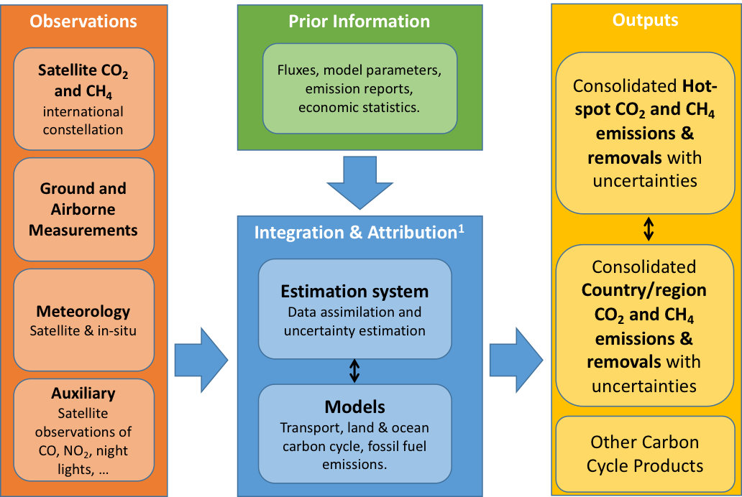
Mark noted a number of excerpts from the COP 23/SBSTA 47 proceedings that show the link between GCOS and space agencies, in particular Conclusion #12 from SBSTA 47, which refers to SBSTA acknowledging the ability of satellite observations of greenhouse gases to support the Paris Agreement. There is increasing recognition at the policy and international levels on the applicability of space-based measurements – a result of communication work done by CEOS.
Mark reviewed the workshop agenda. He noted that while Chinese agencies were unable to attend, the Commission will present something on their behalf. Following a recent productive bilateral meeting. Albrecht von Bargen (DLR) requested a TCCON presentation be added to the agenda.
The importance of a clearly defined scope for the objectives of the system (e.g. which species are included within the scope of the GHG monitoring system) and associated terminology, was noted. This will be discussed and confirmed during the course of the meeting.
Kevin Bowman (NASA) asked whether land use change is considered a part of this activity. Mark noted that Agriculture, Forestry and Other Land Use (AFOLU) was considered in the definition of this workshop, but it was decided that it would detract from the main purpose (atmospheric GHG). However, AFOLU will of course be a part of the overall system, and additional modules will be needed for this.
Relevant International Programmes
WMO (WIGOS-2040/Physical Architecture for Climate Monitoring from Space and IG³IS)
Werner Balogh (WMO) presented the WMO Integrated Global Observing System (WIGOS) and Physical Architecture for Climate Monitoring from Space.
WIGOS
Werner noted WMO’s World Weather Watch (WWW) and stated that WIGOS is the evolution of the WWW and incorporates various elements, including those of WWW:
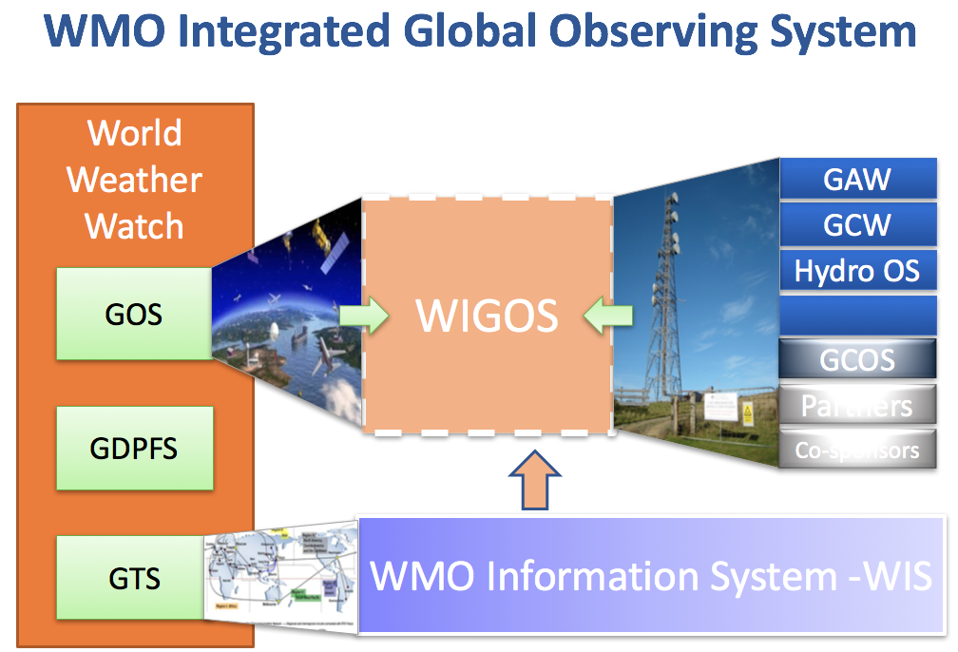
WIGOS was needed due to the expanding mandates of National Meteorology and Hydrology Services (NHMS), and has both technical and financial advantages. WIGOS has been designed with user requirements in mind from the very beginning, and is making use of synergies wherever possible to improve efficiency of observations. WIGOS has 14 application areas, including climate, and has integration across many layers, disciplines, networks, geographies, etc. A rolling review of requirements (RRR) keeps WIGOS up to date with evolutions in the space. Werner noted the OSCAR database and its role in the RRR.
The WIGOS Vision 2040 includes space-based considerations in its tiered structure (core and additional capabilities). The first draft of this vision was presented to CGMS-46, and the WMO Congress is expected to consider endorsement in 2019.
Physical Architecture for Climate Monitoring from Space
The 2013 Strategy Towards an Architecture for Climate Monitoring from Space presents terminology, the logical view, and an implementation roadmap. The logical view is based on four pillars:
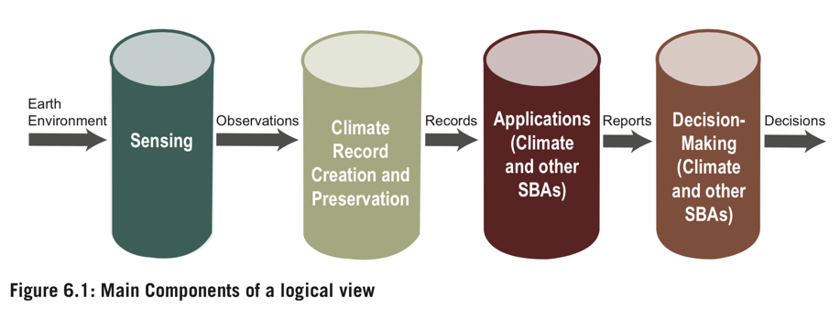
A physical view of the architecture is now needed to add specificity to the plan. WMO has proposed a physical view, however after review by CGMS and others, it’s clear that there was no consensus on this subject. Defining and reaching consensus on the physical view will be important for efficient and effective climate monitoring from space. Having a consensus on the description of the physical view is a high priority. WMO proposes a small task group, perhaps including participants from this group, to prepare a view to present to the WMO Congress in 2019.
Integrated Global GHG Information System (IG³IS)
Phil DeCola (UMD/WMO) presented some background and context. He noted the possibility of using atmospheric measurements and models to verify inventories, which is an evolution from simply providing long-term data records. He noted that there has been a shift in UNFCCC thinking between COP15 and COP21 regarding verifying and validating Nationally Determined Contributions (NDCs) and the need to avoid policing submissions.
Phil summarised the IG³IS principles:
- Combine (in a unified approach) atmospheric measurements with socioeconomic inventory data to better quantify and attribute greenhouse gas emissions.
- Success criteria are that the information guides additional and valuable emission-reduction actions.
- Stakeholders are entrained from the beginning to ensure that information products meet user priorities and deliver on the foreseen value proposition.
- IG³IS will serve as an international coordinating mechanism and establish and propagate consistent methods and standards (BIPM/GAW partnership).
- IG³IS must mature in concert with the evolution of policy and technology.
Phil noted that the commercial sector and others are marching ahead in their support of NDC activities, and a unified voice for our community is a necessity. Phil presented a number of IG³IS products and objectives – please see the slides for details. Phil reported that he is attending this workshop to understand how IG³IS can link to this effort.
GCOS (IP 2016 , Action T71, and Paris Follow-on Paper)
Stephen Briggs (GCOS) presented the background of GCOS. The GCOS vision is a world where users have free access to the climate-related information they need, and it aims to ensure the availability and quality of observations necessary to monitor, understand and predict the global climate system so that communities and nations can live successfully with climate variability and change.
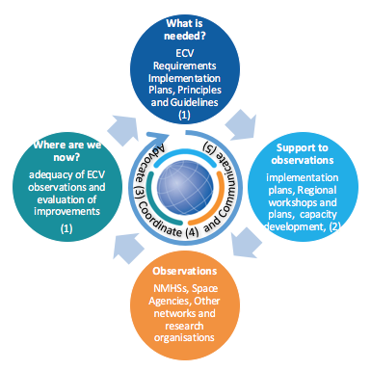

The GCOS status report delivered to COP 21 in Paris showed that there has been improvement in the adequacy of the existing observing networks since 2010, but for the next decade we have to look into:
1. Adaptation & Mitigation
2. Water, Energy and Carbon cycles
3. Additional Essential Climate Variables
4. Emphasis on more help for networks in developing countries
GCOS defines the Essential Climate Variables (ECVs) and these are evolving slightly based on capability evolution. ECVs need to be feasible as well as desirable. The new GCOS IP also presents a suite of climate indicators, and tries to move debate away from a focus on surface temperature to other variables, namely: mean temperature, ocean acidity, atmospheric CO₂, glacier mass balance, ocean heat content, sea level change, and sea ice extent. It is thought that these provide more context and broaden the debate on historical climate change. The new GCOS IP also addresses how the ECVs contribute to the understanding of the water, carbon, and energy cycles of the climate system.
Stephen noted the importance of the GCOS-UNFCCC relationship:
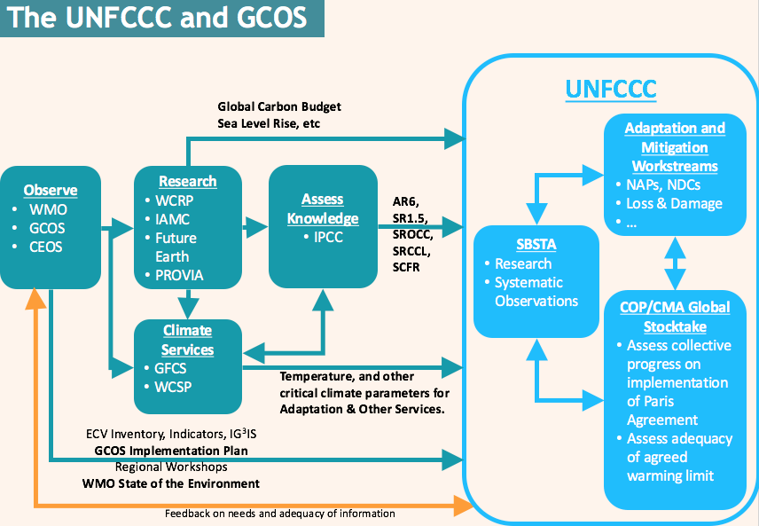
Stephen noted that there has been good progress on the research and systematic observation aspects within UNFCCC, and GCOS, along with CEOS and WMO, have been key to this. Stephen recalled a special climate observation day held during COP21, which is expected to be repeated in 2018.
Stephen presented the road to the global stocktakes. A suite of observations are needed, and these are covered by the GCOS Implementation Plan. He noted action T-71 and its focus on atmospheric carbon (despite the name) and suggested that the cost is likely to be a factor of 10 lower than quoted. Stephen covered the scope of all required observations – see the slides for details.
GEO (GEO-C, In-situ Coordination Mechanism, Paris Workshop)
Andre Obregon (GEO SEC) presented some background on GEO. GEO’s priorities include supporting the UN 2030 Agenda for Sustainable Development, the Paris Agreement on Climate Change, and the Sendai Framework for Disaster Risk Reduction. Andre noted the 2010 GEO Carbon Strategy, and the responses to this from CEOS, COM, and others.
The GEO Carbon Initiative (GEO-C, chaired by Han Dohlman) aims to integrate carbon cycle observations across ocean, land and atmosphere; and to provide coherence to the numerous ongoing efforts, with a focus on observations for decisions. Andre spoke about the governance, the secretariat in place at ICOS – supported by Italy and Japan – and the Steering Council established to bring on board all key players.
Andre noted the lack of an equivalent group to CEOS for the in situ component of the GEO structure, but there are numerous groups at the domain level. The loss of GTOS leaves a gap for the land domain, despite some of its components continuing to exist. This is also reflected in the GCOS IP, which has an action (T1) around improving the coordination of terrestrial observations. GEO is identified as a key contributor to this action. There is an active effort within GEO to improve in situ coordination in response to GCOS.
Andre also spoke about the GEO Symposium Workshop on Climate, which addressed how GEO should address the Paris Agreement – refer to the slides for the outcomes.
Review and Discussion
Phil DeCola (UMD/WMO) noted that historically, WMO has invested in GAW to enable members to make more observations, and the focus has been on global background measurements. Source regions are now the focus. He stressed the need to be specific with requirements for these source measurements. He added that IG³IS (depending on the application) will drive the need for improved prior information as well. High-resolution optical imagery is needed to meet the needs. WMO embraces the need to provide improved prior information. Mark Dowell responded, noting that he hopes we can identify during the breakout sessions areas that should be prioritised, as well as what type of in situ data will be most advantageous.
Kevin Bowman (NASA) noted Stephen Briggs’ slide on meeting the needs of those responding to the Paris Agreement and asked about the maturity of the systems for dissemination of this data and how this is tracked. There were no specific answers. Philip stated that this is country specific in the context of NDCs.
Stephen Briggs (GCOS) recalled that anthropogenic emissions are the only focus for the UNFCCC agreements. A complete overview is needed to look at trends (e.g., in cities 40% of emissions are from the soil).
Richard Engelen gave a summary of relevant activities in the Copernicus Climate Change Service (C3S).
Recent and Ongoing Activities
CEOS AC-VC Whitepaper
David Crisp (NASA) gave an overview of the CEOS AC-VC white paper, past, current and planned GHG monitoring missions.
David noted the large number of scientific missions already on the roadmap (already launched and planned) well before the first global stocktake. Integrating these satellites into a virtual constellation would be a very effective way of having something in place for the first global stocktake. Meeting the 2023 deadline would serve as a great shake-down test of a system, leading to a better understanding for what follows.
There is also a proposal for a purpose-built constellation in the document, which represents a longer term effort (mid-2020s for starting implementation). The Copernicus Sentinel and Tansat-2 constellations could be key components. David outlined the candidate GHG (CO₂, CH₄) constellation architecture, noting that the accuracy, precision, resolution, and coverage requirements (from the GCOS IP) could be achieved with a constellation that incorporates:
- A constellation of three (or more) satellites in LEO with:
  - A broad (> 200) km swath with a mean footprint size < 4 km²;
  - A single sounding random error near 0.5 ppm, and vanishing small regional scale bias (< 0.1 ppm) over > 80% of the sunlit hemisphere; and,
  - One (or more) satellites carrying ancillary sensors (CO, NO₂, CO₂ and/or CH₄ Lidar).
- A constellation with three (or more) GEO satellites:
  - Monitoring diurnally varying processes (e.g., rush hours, diurnal variations in the biosphere);
  - Stationed over Europe/Africa, North/South America, and East Asia.
- This constellation could be augmented with one or more HEO satellites to monitor carbon cycle changes in the high arctic.
Phil DeCola (UMD/WMO) and David agreed on the need to think carefully about the future needs of the policy and inventory communities. David is planning to include some example statements in the report for consideration.
Ken Holmlund (EUMETSAT) noted the rapid pace of development of missions in China. It is currently not clear what sensors will be used for an operational constellation.
Copernicus CO₂ Task Force Report
Bernard Pinty (COM) presented the context and state of play of the Copernicus anthropogenic CO₂ emissions initiative. The global CO₂ budget is needed as input to the 5-yearly global stocktake exercise starting from 2023 established under the Paris Agreement. Analysis at local/regional level may help countries in evaluating the effectiveness of their CO₂ emission reduction strategies and possibly in defining revised Nationally Determined Contributions of the UNFCCC Parties. There is a need to provide independent evidence on and verification of nationally reported anthropogenic CO₂ emissions, and to help assess the uncertainties and gaps associated with the emission inventories.
Bernard outlined this expansion of the Copernicus programme, which aims to significantly increase the density of high quality relevant observations, with an emphasis on having an operational system underpinned by strong user requirements and based on international commitments and corresponding EU Policy implementation. International cooperation is also crucial to help address the breadth of requirements.
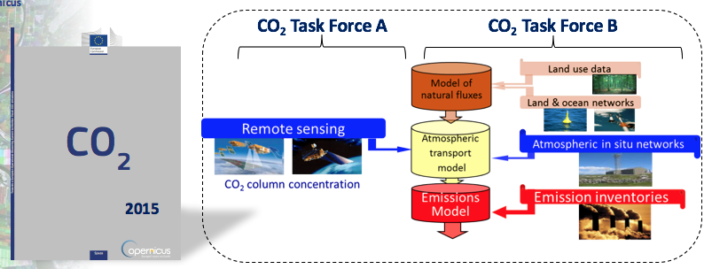
Bernard reviewed the objectives, requirements, open questions, and way forward for the space component and Task Forces – see slides for all the details.
Japanese MOE/NIES Guidebook and IPCC TFI Update
Tsuneo Matsunaga (NIES) reviewed the aim of the Guidebook on the Use of Satellite Greenhouse Gases Observation Data to Evaluate and Improve Greenhouse Gas Emission Inventories: to promote the use of satellite GHG data in national GHG inventory verifications and contribute to the 2019 refinement of the 2006 IPCC Guidelines for National Greenhouse Gas Inventories. The first edition of the Guidebook can be downloaded here.
The Guidebook will be used at the 16th Workshop on GHG Inventories in Asia in India, July 10-12, 2018 (WGIA-16). This will be a good opportunity to promote the guidebook to Asian countries.
Matsunaga-san noted the literature cut-off date for the 2019 refinement of the 2006 IPCC Guidelines for National Greenhouse Gas Inventories is June 25, and May 2019 is the target for completion/adoption. A number of refinements have already been made in relation to satellite data:
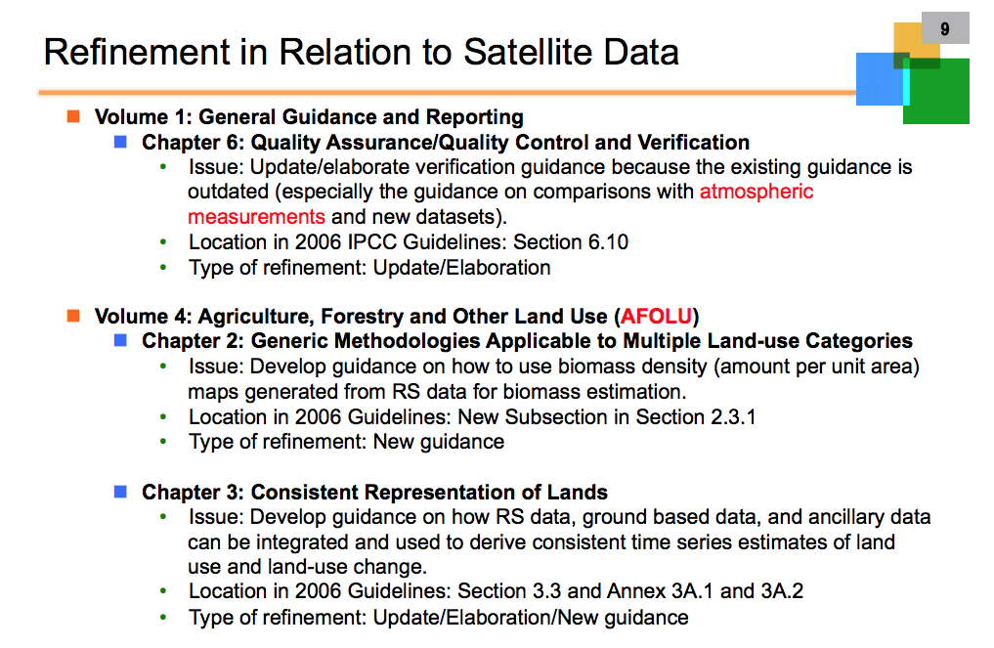
Simon Eggleston (WMO/GCOS) noted that while the IPCC TFI Guidelines will include references to satellite data, they will not be a mandatory instruction. He added that the cost of labour needed to integrate these satellite sources into inventory work is significant, so that is a hurdle. Another hurdle is concern about the sustainability of the satellite data. Simon also highlighted the importance of the Second Order Draft review from July to September; this is really the final opportunity for input.
Report from IWGGMS Toronto
Ray Nassar provided an overview of highlights from the 14th International Workshop on Greenhouse Gas Measurements from Space. The objective of the workshop was to exchange information on the state of the art of CO₂, CH₄, and other GHG measurements, and to foster international collaboration. The focus was on existing and ongoing missions, retrievals and validation, use of data for flux/source estimation, and future missions.
Ray has observed a change in focus over the course of the 14 IWGGMS meetings to include a greater focus on more policy relevant science aspects, including major progress on the quantification of anthropogenic CO₂ and CH₄ emissions.
Ray provided summaries and thoughts on a number of projects and programmes presented at the workshop – see the slides for details. IWGGMS-15 will be held in Sapporo, Japan in early June 2019 – a few months after the scheduled launch of GOSAT-2.
Individual Agency Perspectives
CNES
Carole Deniel (CNES) presented the CNES agency perspective. She noted both the MERLIN (CH₄, with DLR) and MicroCarb (CO₂, with UKSA) missions. These are in addition to IASI and IASI-NG, on which CNES cooperates with EUMETSAT and UKSA. MERLIN aims to derive a global methane budget and to reconcile top-down and bottom-up approaches using a new active mission which offers lower biases, day and night observations, at all latitudes, for all seasons. MicroCarb will be used to better characterise CO₂ sources, sinks and fluxes, including at city scale.
Carole also summarised ongoing CNES activities with the modelling and in situ communities:
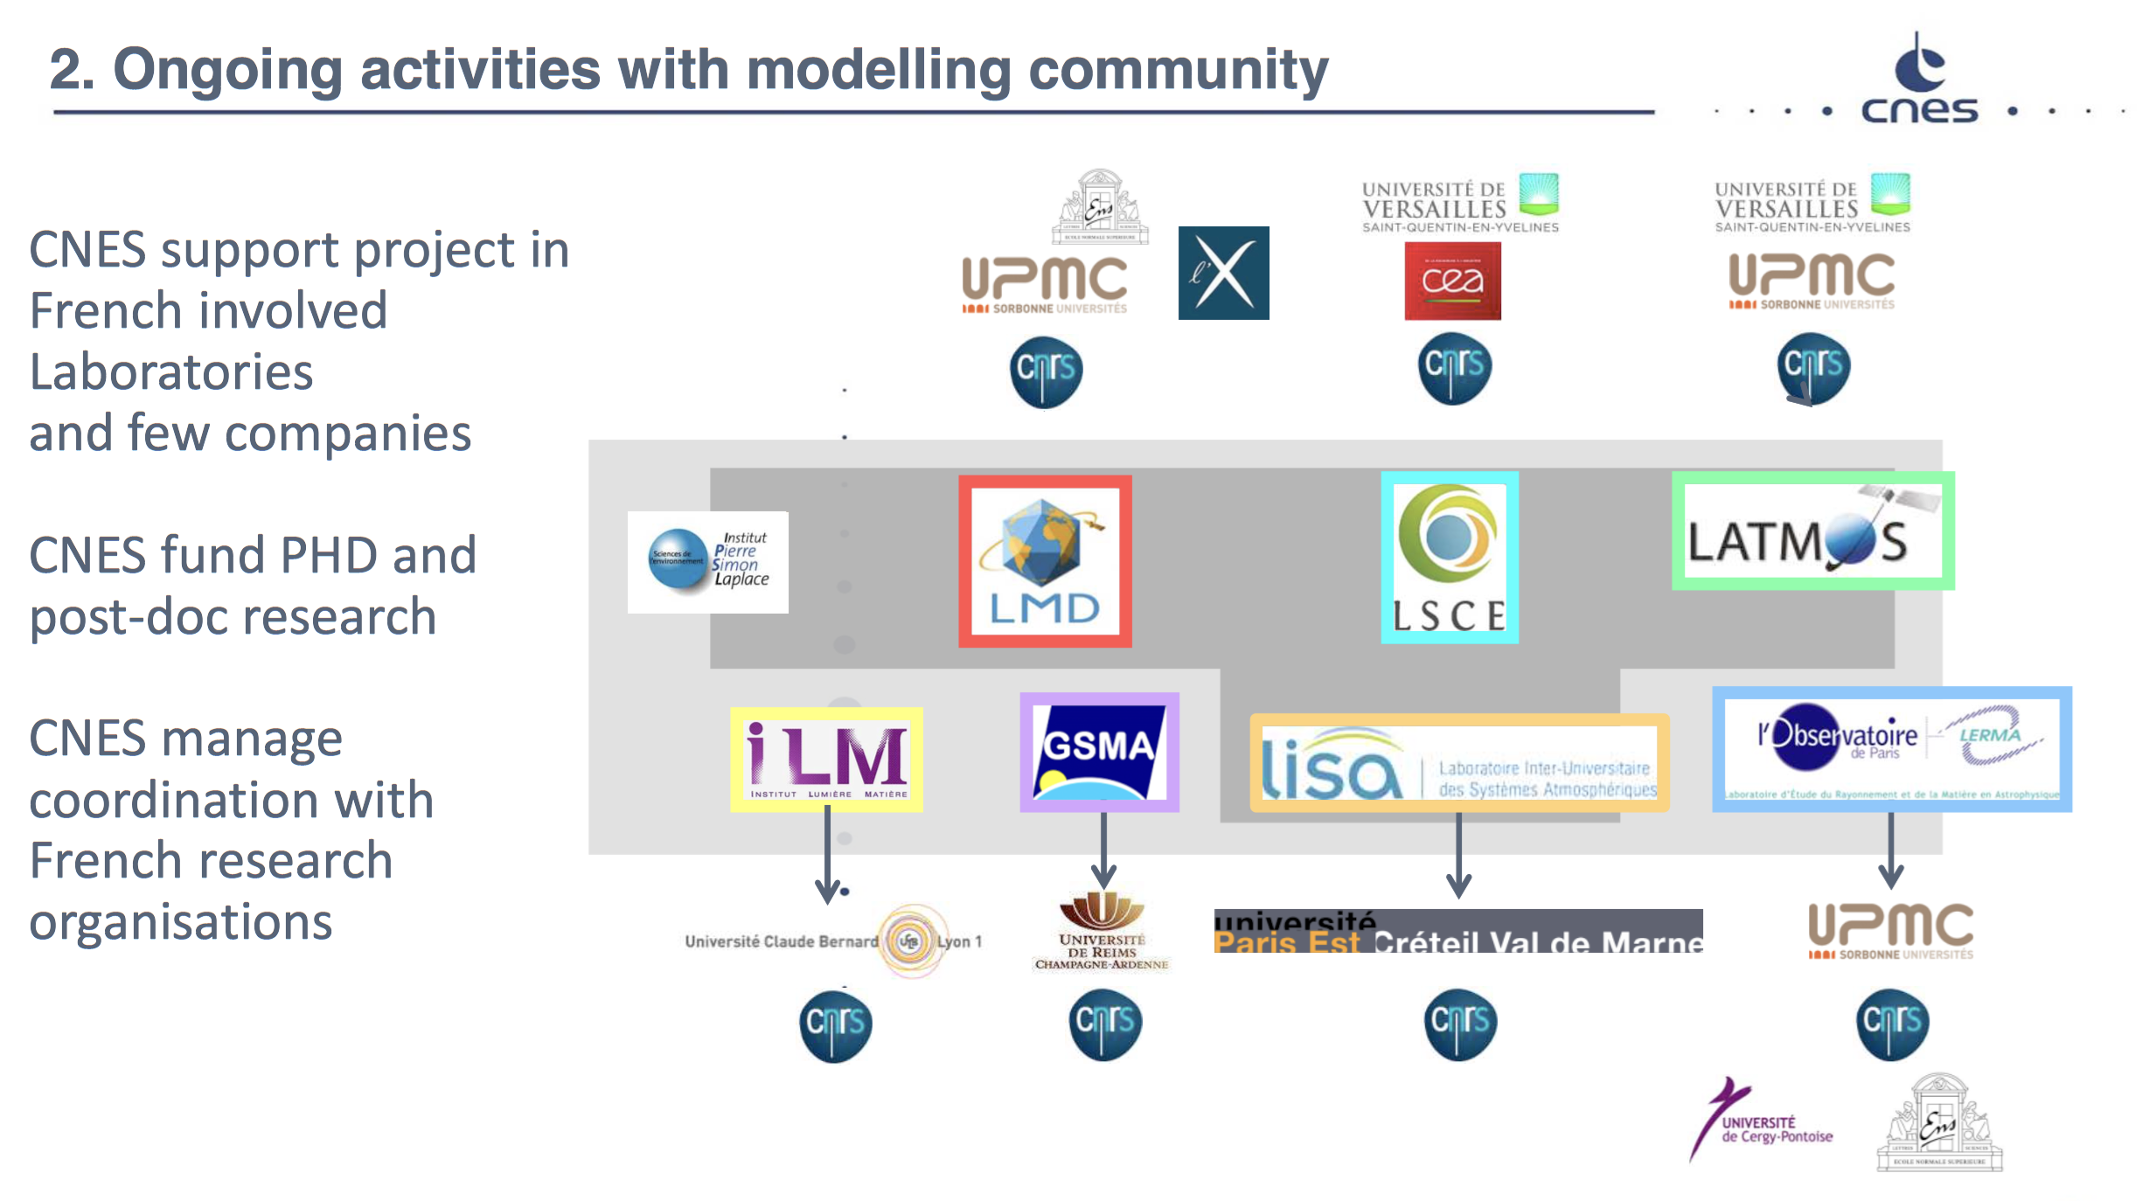
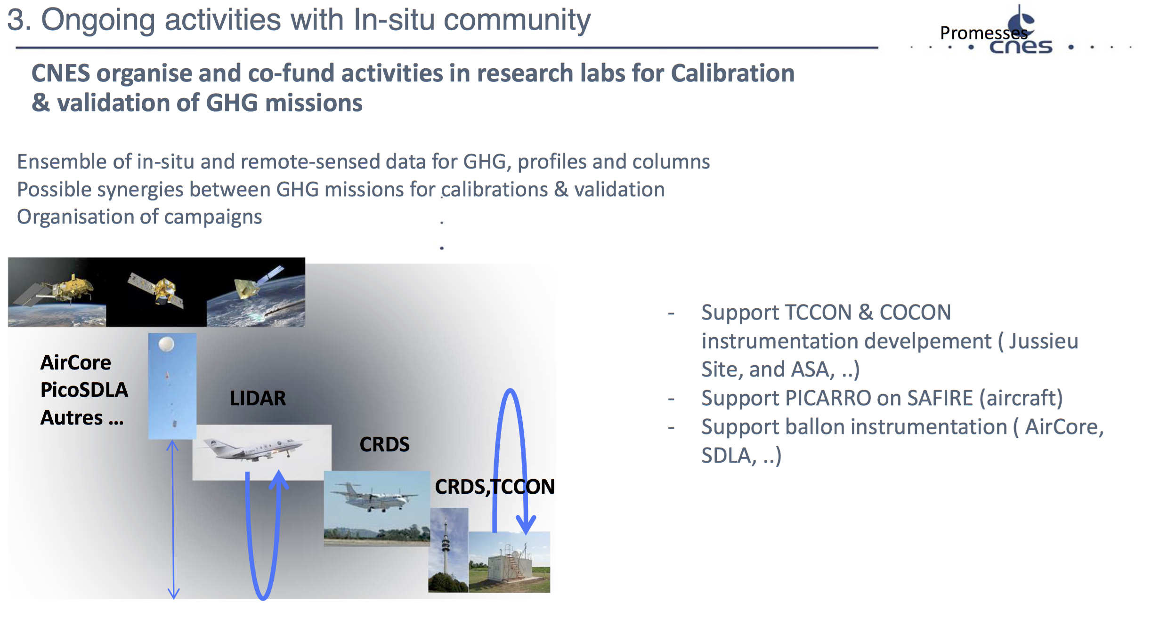
Examples of in situ cooperations were presented, including AirCore and MAGIC-CoMet (also with DLR). CNES is also supporting atmospheric observations from the ground like TCCON, and France is strongly involved in ICOS infrastructure.
Carole reported that there is not a lot of existing dialogue with the inventory community.
Carole noted that government funds were received for MicroCarb based on the expected socio-economic impacts (through the Future Investment Plan). CNES have received some requests to investigate applications with the commercial sector (e.g., GHGSat, Bluefield). At an institutional level, CNES now has some contact with the Ministry of Environment (in charge of inventory, etc.) regarding the use of space-based measurements for verification, however the main focus is research rather than inventory work. CNES works with both CEOS (AC-VC) and many other agencies bilaterally for inter-calibration activities.
In addition to the benefits of the MERLIN measurement approach (high latitude, better calibration) already mentioned, Phil DeCola (UMD/WMO) noted the potential contributions to the understanding of clear-sky bias. Philip asked if there has been any study into whether better data can be retrieved for often cloudy areas. Carole noted that some preliminary work has been done with CALIPSO, but this has not been published.
CSA
Marcus Dejmek (CSA) noted some active Canadian space assets, including RADARSAT-2, SCISAT, CloudSat, OSIRIS on Odin, and MOPITT on Terra. Natural Resources Canada is using RADARSAT-2 to monitor permafrost, among many other applications. SCISAT has been in continuous spaceflight operation since 2003. It now measures over sixty atmospheric species at still one of the world’s highest vertical resolutions possible, and includes ozone, methane, carbon dioxide and multiple CFCs. Many of these species are measured by no other instrument or satellite world-wide, making Canada the sole provider of these datasets globally. SCISAT contributes to the monitoring of many ECVs. Potential future missions: the Chemical and Aerosol Sounding Satellite (CASS) and AIM-North (a HEO mission for atmospheric imaging of greenhouse gases, air quality and SIF in northern regions) were also noted.
The following connections with other communities (modelling, in situ) were presented:
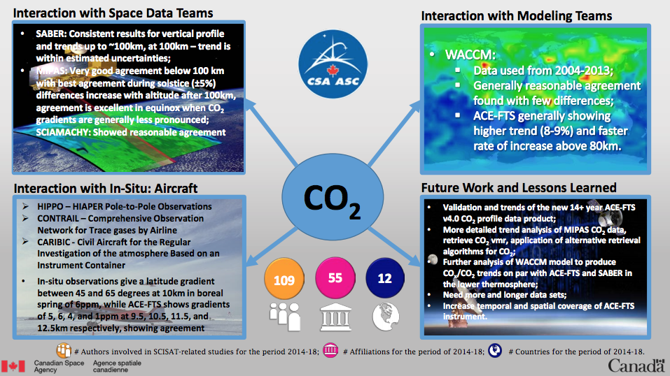
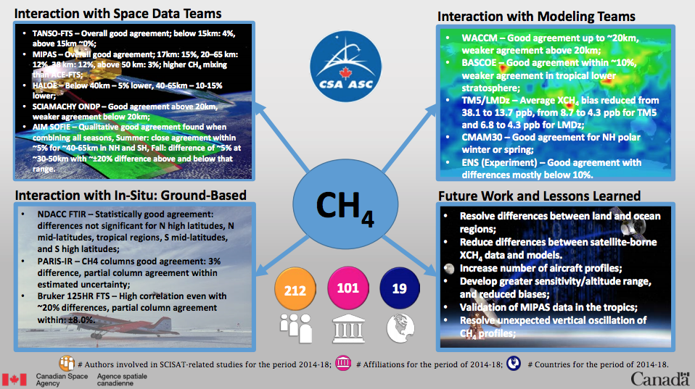
Marcus presented a logic model that connects Canadian government priorities down to data and modelling needs (see slide 11 here).
Marcus noted the numerous climate research activities related to GHGs that Environment and Climate Change Canada (ECCC) undertakes, as well as other satellite validation activities that take place in the country. ECCC also develops Canada’s National Inventory Report (NIR) each year. Marcus identified that federal departments (including CSA) could play a role in the Peer Review element of the annual NIR (not currently the case, but is a target, and could be followed up).
DLR
Albrecht von Bargen (DLR) presented some relevant German missions, noting the SCIAMACHY heritage and the CarbonMon national mission study (aimed at measuring both CO₂ and CH₄ passively and actively), which in 2010 resulted in the selection of MERLIN (as a Germany-France collaborative mission). Albrecht presented the MERLIN mission specifications.
Regarding in situ measurements, Albrecht noted the COMET campaign, which included aircraft and ground-based means to simultaneously measure CO₂ and CH₄ using lidar, passive remote sensing and in situ techniques. COMET is a collaboration between DLR and various government agencies including partners from Poland and CNES. Numerous German agencies also contribute to ICOS.
Policy in Germany is driven by the classical approach of the inventory compilation (regulations), led in Germany by the Federal Office for the Environment, which coordinates input from the state-level offices. Input generation is based on the EU ETS regulations and on the 2006 IPCC guidelines, using reported emissions as input. The Federal Office for the Environment is studying approaches including Earth observation data. At the DWD Climate Workshop 2017, an agreement was made to use top-down emissions from atmospheric observations (ICOS) and inverse modelling (STILT) from the 2019 NIR. Furthermore, Germany intends to include satellite (Sentinel-5P, GOSAT, OCO-2) and in situ data with inverse modelling, coordinated by DWD.
The German space programme reflects the high and sustained multi-level commitment of Germany:
National level (mission and data exploitation)
- Coherent R&D on GHG measurements from space;
- Concepts of integration of current and future missions (TanDEM, EnMAP, MERLIN) including in situ and modelling;
- Supporting mission success through on-ground cal/val activities and coordination of the German user community.
European level
- EC COPERNICUS programme including services, e.g., Sentinel-4, Sentinel-5, and Sentinel-NG;
- ESA Earth observation programme;
- EUMETSAT programme.
International level
- Bilateral efforts (mission implementations, agreements, etc.)
- Multilateral coordination of space agencies’ activities (CEOS) and support to GEO initiatives;
- Inclusion of space-based measurements in international efforts for the evaluation of GHGs.
ESA
Yasjka Meijer (ESA) noted the Copernicus programme – specifically the applications of Sentinel-5P and TROPOMI. The potential of the virtual constellation of Sentinel-4, Sentinel-5, and Sentinel-5P was highlighted. The Copernicus CO₂ expansion mission was presented, including its objectives, target specifications, auxiliary products, and expected timeline. Yasjka suggested some possible CEOS collaborations to support the Copernicus CO₂ mission:
- Add CO₂ imagers in constellation for increased coverage;
- Add CO₂ lidar in constellation to calibrate imagers;
- Contribute with in situ measurements;
- Contribute to radiometric calibration;
- Exploitation of data.
EUMETSAT
Paul Counet (EUMETSAT) recalled EUMETSAT’s mission:
- The primary objective is to establish, maintain and exploit European operational meteorological satellite systems, taking into account as far as possible the recommendations of the WMO.
- A further objective is to contribute to operational climate monitoring and detection of global climatic changes.
- Through fulfilling these objectives, contribute to environmental monitoring, where interactions with the ocean and the atmosphere are involved.
Paul presented a coverage/daily revisit analysis that looked at various satellite combinations and highlighted the need for coordination among observing systems. Following the model developed by the operational meteorological satellite constellation, any future GHG constellation will need to focus on orbit and mission coordination, data distribution, data exchange, and data format requirements. To fully exploit the information collected by future GHG constellations, the missions will also have to invest in training and capacity building as well as public outreach. Paul suggested that CEOS should exploit the experience of CGMS and other organizations to foster the development of these capabilities.
Paul also presented the following outcomes from CGMS-46 (June 2018):
- CGMS reconfirmed its commitment to support the establishment of an operational greenhouse gas monitoring system and its space based component.
- CGMS brings experience from building meteorological systems, in particular on mission coordination, data exchange, training, and outreach.
- CGMS interacts with WMO for the inclusion of a space-based carbon monitoring system in Tier 1 of WIGOS2040.
- CGMS is part of the CEOS AC-VC writing team for the GHG white paper.
- CGMS is working towards establishing a joint team with CEOS to support current activities towards an operational space-based carbon monitoring system targeting provision of systematic data supporting the activities of UNFCCC and other bodies.
The contribution of Satellite Application Facilities (SAFs) was noted, in particular the existing SAF on atmospheric composition monitoring. Paul suggested something similar could be done for CO₂ (or built into the existing structure).
JAXA
2019 IPCC TFI Guidelines Revision
JAXA have led, on behalf of CEOS, engagement with NIES and the UNFCCC/IPCC to input to the 2019 IPCC TFI Guidelines revision. Osamu Ochiai (JAXA) presented the process to date, noting in particular the events organised around COP23, as well as the comments contributed by JAXA on behalf of CEOS. The revision is now entering the Second Order Draft (SOD) phase, and there is the potential for further CEOS feedback during this phase if necessary. JAXA will continue to lead this effort on behalf of CEOS until its conclusion.
GOSAT
Masakatsu Nakajima (JAXA) reviewed the GOSAT programme – a collaboration between the Japanese Ministry of Environment, NIES, and JAXA to advance the monitoring of GHG from space. The programme has also seen a number of collaborations with other space agencies, science teams, etc. Nakajima-san reviewed the specifications and status of the two GOSAT missions. He noted that according to the Japanese Basic Space Plan, GOSAT-3 is scheduled for launch in 2022, but this will likely be delayed.
NOAA
Alisa Young (NOAA) presented a NOAA line office priorities chart, and noted that OAR, NESDIS, and NWS all have climate as a priority. The Office of Oceanic and Atmospheric Research (OAR) and the National Environmental Satellite, Data, and Information Service (NESDIS) will be the focus here.
Oceanic and Atmospheric Research (OAR)
OAR has the responsibility of performing global monitoring of atmospheric constituents by:
- Measuring climate forcing agents in the atmosphere at 269 sites around the world for up to 40 different chemicals.
- Running the GHG Reference Network of air sampling sites (55 active sites that precisely measure CO₂, methane (CH₄), nitrous oxide (N₂O), sulfur hexafluoride (SF₆), carbon monoxide (CO), and hydrogen (H₂).
- Undertaking in situ observations at surface, on towers, buoys, via aircraft, etc.
OAR also performs independent verification of emissions reductions; runs the NOAA Annual GHG Index (AGGI), Carbon Tracker (modeling), and North American Carbon Program; and performs satellite cal/val and GHG research.
National Environmental Satellite, Data, and Information Service (NESDIS)
The primary function of NESDIS is to support other NOAA line offices. NESDIS core capabilities are for real-time regional weather imagery and global near real-time soundings. Observations of global atmospheric composition have not been a high-level priority, however, some capabilities for global GHG monitoring do exist.
Instruments
Chris Barnet (NOAA) noted a variety of relevant missions, as well as operational and experimental retrieval products available through NOAA. He noted Aqua; Metop-A and B; Suomi-NPP, and NOAA-20. While GHGs are not the primary design criteria of the modern NOAA satellite suite, they do offer some useful information. Chris noted two different CO₂ retrieval algorithms: NUCAPS and CLIMCAPS (see slides). These two algorithms can contribute to the weather, composition and climate communities. Uses include monitoring GHGs, air quality, climate processes, etc. Chris noted NOAA’s support of the FIREX field campaign, and reported that working together with the in situ community has been very beneficial, providing feedback from experts on the value of retrievals and in situ data products.
NSMC-CMA & Europe Bilateral Workshop
Mark Dowell (COM) reported on this workshop, which was organised to discuss all components of a GHG monitoring system. Specific discussions were held on the space-based, in situ, and modelling components. The following conclusions were reached:
- Having a GHG monitoring system is essential.
- Any system should be a series of systems that are coordinated at an international level.
- China and Europe are open to coordination.
- Agreed to work on cal/val for existing missions, and also coordinate on planning and deployment of future missions (e.g., intelligent orbit choices)
- There is a need for standardisation in this community. Agreed to address this.
- Collaboration and workshops on modelling are also needed.
A follow up meeting is planned for a year’s time. Overall there was an acknowledgement that while approaches are different in China and Europe, coordination is welcome.
NASA
David Crisp (NASA) presented NASA’s EO portfolio, in particular past constellations such as GPM and the A-train, and noted that NASA are exploring new ideas around cubesat constellations and geostationary platforms. David recalled the 2017 Decadal Survey recommendations, which were grouped as follows:
- 5 ‘Designated Observables’ – highest priority, but doesn’t include GHG missions.
- ‘Explorer’ class missions – 350M cost constraint, includes GHG; 3 of 6 missions will be selected for implementation.
David noted that NASA is looking for international partnerships to help fill the portfolio. CEOS and international collaborations are key to meeting all desired objectives.
David also presented results and specifications of NASA’s GHG missions including OCO-2, OCO-3 (flying on the ISS; rapidly precessing orbit for alternate time measurements), and GeoCarb (geostationary; 7km per footprint – similar to Sentinel-5P).
In addition to missions, NASA is also undertaking significant data processing, analysis, etc. Priorities include remote sensing retrieval algorithms for XCO₂ and XCH₄; support for vicarious calibration and validation (ground based TCCON sites, vicarious calibration campaigns; solar and lunar standards); and the carbon cycle Observing System Simulation Experiment (OSSE) initiative to advance modeling and data assimilation used in coordinated OSSEs.
UKSA
Rob Parker (NCEO) presented on behalf of UKSA. He reported that the UK is committed to satellite systems for GHG monitoring, and this is evidenced through its investment in MicroCarb with CNES, among other activities. The UK is also strongly involved with GOSAT and OCO-2; contribute to the GHG-CCI, and are international partners on Tansat with China. NCEO provides UK sustained infrastructure and people as a contribution to activities with NERC, ESA, EC, etc.
Rob spoke about the use of tall towers to provide top-down verifications of UK emissions, which can achieve a high-degree of accuracy with only a few towers. These tall tower measurements can be used to constrain the UK inventory reporting.
Rob acknowledged the importance of TCCON, and also spoke about the COCCON network, which are portable stations useful for filling validation gaps and urban deployments. The UK is also involved in airborne measurements, specifically GHOST – an airborne SWIR spectrometer for CO₂, CH₄ and CO measurements. SIF is another interest area for NCEO, and NCEO delivers this data operationally for Copernicus.
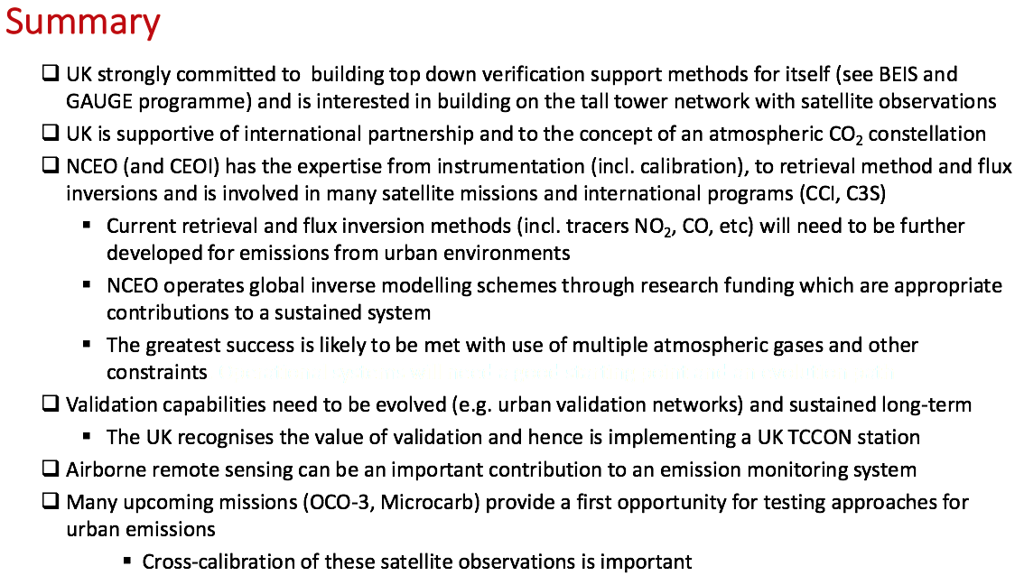
Phil DeCola (UMD/WMO) noted that the UK’s tall towers do a great job for the UK inventory. In the past a single tower was able to provide 3 year averages, but now with 5 towers, 1 year averages are possible.
Rob noted that the UK TCCON station is operating on an ad hoc basis due to staffing constraints, however this is expected to be rectified shortly with the hiring of a new post graduate to do the required analysis. Rob expects a lot more engagement in international TCCON meetings in the future once this new capacity is realised.
Summary
Agency representatives were asked to address the following in their presentations:
- Agency programmatic state-of-play on GHG missions and plans.
- Ongoing activities with the modelling community.
- Ongoing activities with the in situ community.
- Existing dialogue with the inventory community.
- Engagement/involvement at the international level (bilateral/multilateral).
- Target/focus of any relevant research funding.
The following table was constructed by distilling information from the presentations for each of these points.
Agency | GHG Missions  & Plans | Modelling Community  Activities | In situ Community Activities | Inventory Community  Dialogue | International Engagement | Research Funding Focus
CSA | OSIRIS on Odin (O₃), SCISAT, MOPITT (CO) on Terra, RADARSAT-2 (permafrost); CASS (proposed), AIM-North (proposed) | CMAM30, EC-CAS, Plume model analyses. | NDACC FTIR, PARIS-IR, 2 Bruker 125HR FTS sites in TCCON (Eureka and East Trout Lake) | Essentially none, but ECCC highlighted as target. | CEOS, UN/WMO CMIP6, UN/WMO Ozone, GAW, ECCC’s AQHI, IPCC
CNES | MERLIN (CH₄), MicroCarb (CO₂), IASI, IASI-NG | See slide 7. CNRS, UPMC, UVSQ, LSCE, LATMOS, lisa, GSMA, iLM, IPSL, etc.  Tools: LMDz et CHIMERE for atmospheric modeling , ORCHIDEE for Land interface, NEMO-PISCES for OCEAN & PYVAR for flux inversion | Calibration & validation of GHG missions.  AirCore, PicoSDLA, Autres, LIDAR, CRDS, TCCON, COCCON, PICARRO on SAFIRE, MAGIC-CoMet | Some contact just started with Ministry of Environment (in charge of inventory).  Negotiating to promote use of space data for verification. | Working in the frame of CEOS AC-VC and bilateral MOUs (JAXA, NASA, UKSA, DLR) for inter-calibration mainly. | Radiative transfer, dynamic transport models, adaptation of global and local assimilation schemes.
DLR | TanDEM, EnMAP, MERLIN |  | COMET |  | European level:  EC Copernicus programme,  ESA Earth observation programme,  EUMETSAT programme;  International level: Bilateral efforts, CEOS, support to GEO initiatives
ESA | Sentinel-5P/5  Candidate Copernicus Expansion Mission for CO₂ Monitoring |  |  |  | CEOS, Copernicus | GHG Climate Change Initiative.  Performance assessment studies.  Validation and demonstration campaigns.
EUMETSAT | Sentinel-5/Copernicus Sentinels CO₂ initiative |  |  |  | CEOS, CGMS, Copernicus
JAXA | GOSAT, GOSAT-2 |  |  | IPCC & TFI Guidelines revision, Japanese MOE | Japanese MOE, NIES, GEO, UNEP, WMO, CGMS; ESA, CNES, DLR, NASA; CEOS AC-VC
NOAA | Aqua; Metop-A and B; Suomi-NPP, and NOAA-20 |  |  |  |  | NUCAPS: developing weather and air quality applications.  CLIMCAPS: developing a long-term (2002-2040’s and beyond) climate record for Aqua/AIRS and S-NPP/JPSS CrIS to support scientific research in process studies, and climate & composition.  Also exploring future LEO and GEO instrument concepts for weather, air quality, and climate.
NASA | OCO-2, OCO-3, GeoCarb | Carbon Management System (CMS)  OCO-2 Flux Multi-model Intercomparison Project  Carbon OSSE Initiative | Support for vicarious calibration and validation,  and solar & lunar standards.  NASA’s ground based TCCON validation sites. |  |  | Improved remote sensing retrieval algorithms for XCO₂ and XCH₄.  Carbon Cycle Observing System Simulation Experiment (OSSE) initiative: Advanced modeling and data assimilation used in coordinated OSSEs to:  - Assess/improve spatial resolution and accuracy of horizontal & vertical transport.  - Improve methods for assimilation of ground-based, aircraft, and space based data.  - Develop methods to validate fluxes on local, national, and regional scales.  - Assess performance requirements and observing strategies of GHG satellites.  - Improve understanding of CO₂ interannual variability through assimilation of biomass and atmospheric carbon (OCO-2, MOPITT) leveraging CMS-Flux.
UKSA | MicroCarb, Copernicus Sentinels CO₂ initiative |  | GAUGE, BEIS tall towers, NCEO funding UK TCCON station, contributing to COCCON network, GHOST: GreenHouse gas Observations in the Stratosphere and Troposphere |  | NERC, ESA, EC  Involvement in JAXA (GOSAT) and NASA (OCO) missions  NCEO contributes CO₂ & CH₄ to both the ESA GHG-CCI and Copernicus C3S  UoL is one of the TANSAT international partners  European CO₂ Emission Monitoring System
Cross-cutting Issues and Best Practices
Mark Dowell (COM, CEOS Chair Team) presented slides on cross-cutting issues and best practices.
Kevin Bowman (NASA) suggested also covering measurement reconciliation approaches in the discussions tomorrow. With an international community, groups will use their own modelling processes, and there will be a need for a reconciliation element in a holistic system. It was agreed to discuss this in the satellite-modelling session tomorrow to capture what should be done from a space agency perspective.
Ken Holmlund (EUMETSAT) noted the various ongoing intercomparison activities, which are contributing to an iterative improvement process. A dialogue needs to be established between all of these independent activities.
A number of activities related to understanding the discrepancies of inversion modelling approaches were noted, including Alex Vermeulen’s workshop and components of IG³IS (including the September workshop in Lunde, Sweden) and the VERIFY project.
Greet Maenhout (COM) noted that the air quality community is also going through similar coordination issues, and we could draw on their past experience.
Sources of requirements were discussed, and Osamu Ochiai (JAXA) wondered if the GEO Carbon Strategy would be a useful source of requirements in addition to those from the GCOS Implementation Plan. Mark noted that the GCOS requirements are very clear, whereas the GEO Carbon Strategy requirements are vague in many cases. No matter the source, traceable, well-justified, clear requirements are a necessity. Initiating a dialogue with the UNFCCC is a key point, and an iterative process should be established to reach agreed requirements.
Stephen Briggs (GCOS) suggested the use of multiple numbers for requirements (e.g., threshold, target) might be helpful. He also noted that there will be different values and scales for different foci.
Phil DeCola (UMD/WMO) suggested that it would be very helpful to have end-users engaged in these discussions. Mark agreed, but noted that their perspectives are being gathered through other fora (e.g., via OSSEs, etc.).
It was agreed that capabilities should be socialised with the community well ahead of time to get them using the data early, so that they become a source of demand in the future.
Terminology Discussion
Mark Dowell (COM, CEOS Chair Team) clarified that the intent here is to clarify the terminology we use in a multilateral context when describing a GHG monitoring system.
Stephen Briggs (GCOS) stressed that the word ‘verification’ should be avoided in any description of a GHG monitoring system due to the negative and ‘policing’ connotations. He suggested that validation is a better word to use. Stephen noted there is a large distinction between becoming a formal contributor to the IPCC verification process and an independent validation body.
Kevin Bowman (NASA) agreed that the focus is on validation. He noted the balance between natural and anthropogenic sources, stressing that space-based systems will give you the complete picture. Providing a means to link policies and results is very important. There is a unique role for space-based measurements to aid countries in understanding the link between their actions and the resulting impact on atmospheric GHG emissions/removals.

Tuesday June 19
Joint Research Centre Inversion Modelling Workshop
Peter Bergamaschi (COM) reviewed the workshop and resulting report. The objectives were to review current capabilities, potential, and further perspectives to use atmospheric monitoring and inverse modelling to improve estimates of greenhouse gas emissions in support of the Paris Agreement; and to provide recommendations for the further development of top-down verification capabilities.
The main challenge is to separate the fossil fuel CO₂ component from the ecosystem CO₂ fluxes. The most promising approaches are to use additional measurements of radiocarbon and tracers co-emitted with fossil fuels. Non-CO₂ GHGs (CH₄, N₂O, halogenated gases) generally have much larger uncertainties in their bottom-up inventories than fossil fuel CO₂ and require independent quantification of emissions by atmospheric measurements and inverse modelling.
A large number of scientific studies have demonstrated the potential to quantify GHG emissions using top-down methods (inverse modelling). The top-down approach provides estimates of total emissions, but does not provide any information about specific source sectors. Quantification of anthropogenic emissions depends on the magnitude of natural sources and sinks, and the capability to quantify them. Accuracy of derived emissions and the spatial scales at which emissions can be estimated depend on the quality and density of measurements and the quality of the atmospheric models. The current observation network is sparse, which presently limits the capability to quantify GHG emissions at country or regional scale. Significant further developments of the global observations system and the top-down methods would be required, in order to support the implementation of the Paris Agreement.
Peter presented a number of recommendations for ground based measurements, satellite measurements, inverse atmospheric modelling, and bottom-up emission inventories:
Ground Based Measurements
- Significantly expand ground based measurement networks.
- Further extend the ICOS network over Europe, especially in southern and eastern Europe.
- Global scale: set up monitoring stations in areas that are currently not well covered, especially Central and South America, Asia, and Africa.
- Quantification of fossil fuel CO₂ emissions: increase the spatial and temporal resolution of ¹⁴CO₂ observations / further develop use of tracers co-emitted with fossil CO₂ (CO, NO_{x}).
- Monitoring of GHG emissions from cities and large point sources: local networks should be set up close to emission hot spots.
- Maintain / further expand the European in situ network for halocarbons or build up an infrastructure for frequent flask sampling and centralizing the analysis (as demonstrated by NOAA for the U.S.).
Satellite Measurements
- Future satellite instruments are expected to significantly enhance the capabilities to monitor CO₂ and CH₄ emissions from space. Particularly promising are new satellite missions with high spatial resolution and imaging capabilities, which allow quantification of emissions from hotspots (as demonstrated for selected cases by recent OCO-2 studies).
- However, the accuracy requirements for the spaceborne measurements remain demanding. Special attention should be paid to avoid systematic biases in satellite retrievals, which could otherwise introduce large systematic errors in the estimated emissions.
- Validation of the satellite retrievals is essential, including through ground based remote sensing (FTS), airborne, and balloon in situ measurements.
- The space-based and ground-based elements required for a European operational capacity in support of the monitoring and verification of anthropogenic CO₂ emissions are currently being elaborated by the Copernicus CO₂ Monitoring Task Force.
Inverse Atmospheric Modelling
- Providing top-down emission estimates, e.g., at national scale, with low uncertainties as required for the international climate agreements remains very challenging.
- It will be essential to further improve the transport models, especially the representation of boundary layer dynamics, vertical mixing, and horizontal and vertical resolution.
- The largest concern is transport model errors resulting in biases in the derived top-down emission estimates.
- Therefore, atmospheric transport models need to be thoroughly evaluated against independent observations in order to identify/quantify potential biases and to support the further development of models. Evaluation of the simulated 3-dimensional concentration fields in the whole model domain, e.g., by validation against aircraft measurements, is needed.
Bottom-up Emission Inventories
- Spatially and temporally resolved emissions (emission maps) are required.
- Improved uncertainty estimates (including uncertainties in the spatial / temporal distribution) are required.
- Facility scale measurements (using airborne instruments or mobile labs in vehicles) will be very helpful in providing more representative emission factors and to bridge the gap between top-down and bottom-up estimates.
- Improved estimates of natural emissions are needed.
A discussion followed:
- It was noted that methane profiles in the stratosphere are still poorly modelled, and better measurements would be useful for improving these models.
- Transport model errors are mitigated by increasing the time length (3-year averages vs 1-year average). The required accuracy for boundary layer and turbulent mixing models is dependent on averaging time scale.
- There is the possibility for bias in derived trends from adding additional in situ measurements.
- Richard Engelen (ECMWF) suggested reaching out to other communities, for example those looking at hydroxyl radicals or transport modelling, which are both very active.
- Mark Dowell (COM) asked if there are long term, specific, inverse and transport modelling dialogues at the international level. It was noted that WMO have ongoing activities in these areas.

Discussion
Mark Dowell (COM) recapped the previous days’ outcomes and initiated a continuation of yesterday afternoon’s discussion session.
Requirements
- Acknowledged that the GCOS requirements are a good starting point.
- It was recognised that partitioning of requirements might be necessary, based on the subject and scale.
- Ensuring that requirements are traceable is key.
- There is a need to make use of OSSE experiments for the purpose of feeding back to and refining requirements.
- A cross-check with the needs of the inventory community should be carried out.
- It would help to have a dialogue with users in the requirement setting process (OSSEs can be a source of inspiration).
Terminology
Following a discussion on the need for a clear position and terminology in an international multilateral context, the following were agreed as acceptable statements of the goals of the GHG monitoring system:
- Help countries improve their estimates of CO₂ and CH₄ emissions and removals in support of their Nationally Determined Contributions (NDCs) under the Paris Agreement; and,
- Provide an additional mechanism for validating the consistency between reported emissions and atmospheric observations.
Mark recalled the following diagram of the system and its components, and a discussion took place. The diagram below is the final version resulting from the refinements noted throughout the meeting.
Richard Engelen (ECMWF) noted that the Copernicus CO₂ Task Force report includes more context for this diagram. He directed everyone to slide 7 from Bernard Pinty’s presentation for a supplementary figure that goes into detail on what the individual observations are for each of the components.
Scope
Initially, there was a general agreement that the scope should be broader than just CO₂, however a discussion was necessary to determine where the line should be drawn.
David Crisp (NASA) suggested specifically saying that the system focus is CO₂ and CH₄. These are the most policy relevant, and being specific avoids confusion with the minor greenhouse gases.
Simon Eggleston (GCOS) pointed out that the inventory community highlights CH₄ and N₂O as having the largest uncertainties. Simon also suggested against the use of the term ‘fossil fuel’ in the system description, and Mark agreed that this will be toned down.
David acknowledged that N₂O is the third most important GHG, but noted the need to draw a line somewhere. Phil DeCola (UMD/WMO) agreed, suggesting that we also need to be realistic about satellite capabilities and that the focus should be on long-lived GHGs. He supported a CO₂ and CH₄ focus.
Peter Bergamaschi (COM) suggested that the inventory community is interested in halocarbons and non-CO₂ GHGs.
Mark noted that Agriculture, Forestry and Other Land Use (AFOLU) is not considered here, and auxiliary measurements are covered in the system diagram.
Identifying Critical Elements for Sustainability of the Space Segment
Mark noted that both the WIGOS 2040 Vision and CEOS AC-VC white paper present two observation options, however they each have different scopes, with WIGOS 2040 looking also at the supporting elements in addition to the core elements of the space segment. David Crisp (NASA) highlighted that the AC-VC white paper outlines today’s requirements, unlike the WIGOS 2040 Vision. Mark will provide David a couple of paragraphs explaining the ‘two step approach’ – regarding the AC-VC paper’s focus on current requirements, whereas the WIGOS 2040 Vision is an extrapolated, fully sustained system.
Ken Holmlund (EUMETSAT) noted that despite this slightly different scope, there are no large discrepancies in the observation requirements. Three to four LEO satellites is the minimum requirement for resiliency, etc. Both reports include additional components such as lidar and HEO missions.
Ken stressed the need to be cautious when using the term ‘operational’. This is a word that has a defined meaning in CGMS and CEOS, but it is not necessarily the right terminology in this context. Operational in this context means sustained observations.
Centralised Repository of Quality Assured Data – Emphasis of this point is the QC’ing of data
Mark Dowell (COM, CEOS Chair Team) asked whether a centralised repository of quality assured data is a necessary part of the system. He clarified that ‘centralised’ does not necessarily refer to location, but rather the organisational aspects and QC, etc. It was agreed that the data should be in the hands of community.
Robert Parker (NCEO/UKSA) requested more information on the scope of the data. Mark suggested that the scope is Level-2 products, but not necessarily just output products.
David Crisp (NASA) sees the greatest benefit in compiling all products, noting that users often wish to go back into calibration data archives, etc. A fairly complete data set all the way up to Level-3 was suggested as necessary. David agreed that it would be nice to have a uniform set of criteria for each of these levels of product, with consistent headers, etc. and a single entity that took responsibility for maintaining this capability and its accessibility.
Mark summarised that satellite data and data required for the quality control process (e.g., matching TCCON data) should all be within scope. In situ is out of scope, except for that which is used in quality control, cal/val, etc.
Ken Holmlund (EUMETSAT) suggested ensuring that FDAs are considered.
It was noted that other communities are already doing quality control for many products, and these resources should be drawn upon as much as possible to avoid duplication of effort.
It might be better to focus on standardisation of QC methodologies, procedures, etc. and data accessibility and curation. Level-1 should be the responsibility of space agencies; Level-2+ becomes more open.
Simon Eggleston (GCOS) recalled that UNFCCC inventories must be transparent; this could be an important consideration. There needs to be, at least in principle, the ability to review what data has been used for an inventory.
Mark closed this discussion with a summary: we will advocate for standards and procedures that are common and consistent, that space agencies can use to systematically process and verify data. Space agencies should continue to consider how they can work together to do intercomparison activities, harmonise products, etc.

The following discussions were held to address the questions posed in this presentation (slides 12-14)
Space-Modelling Interaction
Observing System Simulation Experiments (OSSEs)
- It was acknowledged that OSSEs are a fundamental tool, and will be increasingly important in a virtual constellation context and for the associated cost-benefit and mission design analyses.
- Open questions are fairly well defined at the global scale. Nevertheless, there is not so much at point-scale and estimating emissions from plume inversions. There is also limited experience in exploiting the proposed attribution tracer species (e.g. NO₂ for plume identification).
- It was agreed to ask CEOS Principals to continue supporting these activities, to provide mechanisms through AC-VC to make the best use of resources in a coordinated manner, and to make resources available for under represented OSSEs.
- A message of support from CEOS regarding the OSSEs would be welcomed.
- CO₂ and CH₄ are very different from an OSSE standpoint. They need to be thought about differently.
- CEOS Agencies should support AC-VC in holding a workshop to identify the issues and research priorities that need to be addressed via OSSEs. Q1 2019 would be the target for the workshop, with outcomes presented at the 2019 SIT Technical Workshop.
Some potentially useful OSSE topics/questions were also identified, including: NO₂ for plume inversion modelling, and the ancillary data assimilation systems that might be necessary for the attribution of sources and sinks; usage and synthesis of ancillary sources; more characteristics on point source locations; transport uncertainties; how decadal trajectories imprint on signatures – how well can we establish these change trajectories for NDCs, and are these as expected (need a bottom-up process that captures this).
Ray Nassar noted that we need to start with a list of questions that we are trying to answer in these OSSEs, and then assess the scale (global, regional, point, time). Once the scale is established, we can achieve a better understanding of the status.
Ken Holmlund (EUMETSAT) noted a 2016 atmospheric composition workshop organised at ESA (the second in a series) and while the focus was very much on air quality and GEO instruments, there was also an interest in that group around requirements for inverse modelling of GHG fluxes. Ken suggested we might follow this up to see if there is a plan for another workshop that could be leveraged.
Generic Issues on Joint Assimilation of Satellite and in situ Observations
- Boundary layer dynamics and stratosphere details are key areas where more research is needed.
- It was agreed that a broad monitoring overview of the natural carbon cycle is a necessity.
- It could be useful to use the atmospheric field as a boundary condition to derive more accurate forest emission factor maps – for the extrapolation of source and sink information. Surface biomass estimations could also be used in combination.
- Limb sounding capability needs to be raised with CEOS (should be reflected in VC discussions).
Peter Bergamaschi (COM) directed everyone to his slides for his recommendations. Boundary layer dynamics and stratospheric details are areas where more research is needed. Understanding the stratosphere is critical for the methane budget, as it is a methane sink.
Issues Relating to Distinguishing Natural and Anthropogenic Sources and Sinks
Mark requested recommendations for specific infrastructure that would help make the distinction between natural and anthropogenic sources and sinks. A discussion followed and the following key points were noted:
- Improved prior information for natural sources would be of great benefit.
- Carbon 14 has great potential for constraining models, at large scales in particular.
- Carbon 14 is only one way to separate natural and anthropogenic sources – another is Sun Induced Fluorescence (SIF) since they can help to quantify the GPP component. GEO (and HEO) SIF measurements could be a great help due to coverage of the daytime diurnal cycle, and this is another potential OSSE topic. SIF was recommended as a dedicated standard product, in particular for Sentinel-4/5/5P but also from other future missions.
- In a system context, consideration needs to be given to how to adapt the in situ network to better fill the gaps in satellite measurement capabilities and coverage. There is a need to be more synergistic with what space-based measurements cannot achieve.
- In situ networks need to be expanded in the northern polar region and the tropics in particular.
- Having more in situ measurements in close proximity to known sources is key to making accurate distinctions.
- Maintaining current in situ networks is critical for the global background measurement.
- Need to be specific with in situ requirements (e.g., identify what type of data is needed and what will make the most impact).
Ancillary Data Requirements (Satellite)
Mark asked for suggestions on what satellite-based ancillary data is needed in sustained production and also which should be produced in a systematic manner (i.e., with common/consistent processing). The following suggestions were noted:
- Clouds, aerosols, hyperspectral measurements, natural background, SIF, wetland models for the water table, CO, NO₂, the NOAA night lights product, and biomass measurements (yet to be integrated into models, but will be in 5-10 years) were all noted. These will be added to the system diagram also.
- Hyperspectral measurements could be useful, but it is unclear how they fit at the moment. The modelling community should be consulted on this.
- A common SIF product specification would be very helpful.
- Cloud and aerosol data is critical for both screening and bias identification and control.
Phil DeCola (UMD/WMO) suggested that there would be good value in communicating annual variations of the biosphere to countries that are already doing an excellent job with their inventories (using Tier 3 TFI approaches).
Mark noted that the report will emphasise the importance of ancillary data and encourage agencies to continue producing these valuable data sets.
Dependency on Transport Models & Mitigating the Impact of Uncertainty
Mark noted that these questions are scale related. He asked what general points and comments should be made on this in the report, and asked whether we need to incentivise work in a specific area. The following responses were noted:
- Need to make it very clear that concentration gradients in the atmosphere are useless without wind information. Priority should be given to achieving the best possible wind profiles. Taking advantage of the existing work and experience from the NWP community will be key. Plume dispersal, turbulence, and atmospheric stability are aspects that are particularly worthwhile exploring with the NWP community.
- It was suggested that agencies could run localised transport models.
- ECMWF think it might be a good idea if the use of the NWP fields in the transport models were further investigated to see if they are used in an optimal manner.
- Constraining the dynamics of the boundary layer (particularly vertical transport/mixing) with measurements would be very helpful.
- Uncertainties from transport models can be reduced by increasing the satellite temporal sampling through orbit planning, whilst also reducing dependency on the models. This provides additional justification for geostationary platforms.
ICOS Presentation
Alex Vermeulen presented a quick background on the Integrated Carbon Observation System (ICOS). The Integrated Carbon Observation System Research Infrastructure (ICOS RI) integrates atmosphere, ecosystem and ocean greenhouse gas observations to provide timely and reliable data for research, policy making, and the general public. ICOS RI has more than 100 measurement stations in twelve European countries. These stations measure greenhouse gas concentrations in the atmosphere and fluxes over the terrestrial and marine ecosystems. The ICOS stations are run and funded by national funding agencies, institutes and universities.
Alex reported that inversions have already been done using processed ICOS data.
Finance and finding contributors was identified as a challenge.
Alex noted that member countries are usually committed for 20 years, but can leave the network any time, with one year advance notice requested.
TCCON Presentation
Dietrich Feist (TCCON Deputy Chair Europe & Africa) presented a quick overview of the Total Carbon Column Observing Network (TCCON). The presentation is available here. He noted that discussions around integrating some TCCON stations into ICOS are ongoing, with official negotiations starting in October 2018. Dietrich summarised in conclusion:
- TCCON is the cal/val reference for all current satellite GHG missions.
- This reference cannot be provided by ground-based in situ observations readily.
- Important regions like Africa and South America are currently not covered.
- Very few TCCON stations have stable long-term funding.
- All future satellite GHG missions at least plan to use TCCON data.
At least one aircraft profile is a requirement for each TCCON station. Mark asked if there are coordinated aircraft campaigns organised through TCCON. Dietrich noted that this has been done in the past, and could be repeated in the future, but there are discussions around removing this requirement for the initiation of a station.
It was noted that it would be very valuable if TCCON measurements were validated with AirCore. Dietrich would like to see more intercomparisons with AirCore data. David Crisp (NASA) suggested that CEOS could perhaps help with arranging more AirCore coverage over TCCON sites.
Space-In Situ Interaction
Mark noted the distinction between in situ data for cal/val and for flux estimation.
It was strongly agreed TCCON is critical infrastructure for the space agencies, especially in the context of this integrated CO₂ and CH₄ system, and the stations should be resourced appropriately.
Access to In Situ Data on Operational Time Scales
Mark asked if space agencies should be investing in this capability. The following points were noted during the discussion that followed:
- There was some concern around the governance and sustainability of these in situ systems if they are going to be relied upon for an integrated system.
- Space agencies should do whatever they can within their means to support these networks. It was noted however that this might not be in the mandates of some agencies, so requests via CEOS might not be enacted.
- Operational time scales need to be considered (1 month time scale at a minimum).
- The Copernicus Atmosphere Monitoring Service has a budget to support these networks in order to meet certain requirements.
- It was noted that as long as NASA has a mission that requires the data, support should be possible. However, it must be noted that there is no plan for a NASA operational capacity for carbon, and so it cannot be relied upon for support long-term.
- Funding could come through mission budgets if the measurements are required for cal/val and operation, but this is likely to be for short time periods only – not ongoing and operationally.
- Mechanisms that allow funding of in situ measurement capabilities outside of the usual mission budgets are needed to provide capacity on a sustained basis.
- Essentially all existing interfaces to the in situ community for cal/val and flux inversion are through individual relationships.
- Common methods, standards, and processing chains should be established and made available so cross-calibrations are possible. Coincident measurements and vicarious calibration sites are a necessity for a system that relies on multiple spacecraft to correct for biases and drift.
- The ICOS governance structure is a good example that could be referenced – for Europe in particular.
Additional In Situ Requirements from a System Perspective
- Little analysis has been done on the role of in situ measurements for the validation of inversion systems. An open question is: what would the design of the in situ network be to best validate inversions? This is an area that could be studied with support from CEOS.
- Lab measurements and work are required to improve spectroscopy. This was noted as an additional ‘in situ’ requirement. It was noted that the expert community is ageing and expertise is being lost.
Need for Additional International Standards
- Traceable standards are necessary to allow traceable calibration, and should be consistent with meteorological standards.
- There is work to be done to understand how to transfer standards for gas metrology calibration to lower cost, modern precision sensors. It was noted that the WMO Global Atmosphere Watch (GAW), NOAA, and CSIRO all have unique gas metrology standards. The report should propose an action for CEOS WGCV to consider organising discussions with these metrology groups.
Space-Inventory Interaction
Inventory Community Interactions – What Has Been Successful and What Hasn’t?
- Switzerland and the UK are good examples of successful relationship building.
- Key for space data uptake is building the relationships between and with the government agencies responsible for UNFCCC inventory reporting. This is the IG³IS approach.
- Need to make it clear that EO provides additional information only.
- We need to take note of the requirements of the inventory community and tailor products to meet their needs (making inputs as appealing as possible).
- We could consider approaches for making the inventory community more interested in spatially explicit results, and could look at how to influence the policy/requirements side to create demand.
- The report should promote the continued production of synthesised datasets.
Links Between CEOS Agencies
- Mark noted the ongoing activity in CEOS around engaging in the IPCC TFI Guidelines revision process. He also noted the continued dialogue with GCOS, SBSTA, etc.
- The proposed supplement to the IPCC TFI Guidelines was rejected. The 2019 Refinement is itself optional, and a supplement would have to follow the strict processes of the IPCC. It was noted that uptake of the 2019 Guidelines is expected to be minimal at this stage.
- The need for an AFOLU / LULUCF component for the operational system was acknowledged. This will be covered in the report as previously noted.
- It is necessary to be very clear what we are trying to provide, and to be careful to avoid the idea that we are providing independent verification of NDCs.
- The report needs to be clear that we are discussing a broad, holistic system, and it should promote all aspects, not just the space-based components.
- The usual WMO interface is with NHMS contacts, and they’re not always able to make the necessary connection to those in charge of the inventories. WMO has established a UNFCCC MOU to try and improve these connections. The less rigid governance structure of organisations such as GEO and CEOS might be a more effective conduit to the country contacts.
- A framework for reaching out to all of the relevant institutions and contacts is needed.
- The driver for this workshop is to establish common elements and messages, so that we can communicate in a consistent way to agencies and ministries – hopefully improving effectiveness.
- Inventory groups are usually resource limited and are looking for ways to improve the efficiency of their work. Increasing efficiency could be a good angle to promote uptake.
- We must remain aware that space-based measurements of atmospheric GHGs are still a research activity, and we must be careful not to establish partnerships with oversold performance promises.
Decision Support Systems
- It was agreed that it is premature to consider this. It might be more appropriate in around two years time.
- Existing work under the VERIFY project was noted.
Need for Standards/Formats on How Inventory Information is Used to Establish Priors
- Peter Bergamaschi (COM) reported that there is no strong need.
- Kevin Bowman (NASA) felt otherwise, noting that there is a need for consistent information on the temporal variations of sources. Secondly, as we start to consider using multiple trace gases, it will be increasingly important to know more sectoral information.
- Scale was noted as the reason for these discrepancies.
- Point sources should be described in terms of their longitude and latitude.
Closing Remarks
Mark Dowell (COM, CEOS Chair Team) presented the revised system diagram, and a few additional changes were requested (already reflected in the system diagrams presented earlier in these minutes).
Mark thanked everyone for their attendance and valuable inputs. He reminded everyone that the intention is to take the lessons learned during the workshop and prepare a report for consideration by the CEOS SIT Technical Workshop in September.
Mark closed the meeting and wished everyone safe onward travel.
APPENDIX A
Attendees

Affiliation | Name
CNES | Carole Deniel
CNES | Mathilde Dupre
COM | Astrid-Christina Koch
COM | Bernard Pinty
COM | Greet Janssens-Maenhout
COM | Hugo Zunker
COM | Mark Dowell
COM | Matthew Steventon
COM | Mauro Facchini
COM/EUMETSAT | Robert Husband
CSA | Marcus Dejmek
DLR | Albrecht von Bargen
ECMWF | Richard Engelen
ECCC | Ray Nassar
ESA/ECSAT | Pascal Lecomte
ESA/ESTEC | Yasjka Meijer
EUMETSAT | Ken Holmlund
EUMETSAT | Paul Counet
EUMETSAT | Ruediger Lang
GCOS | Simon Eggleston
GCOS | Stephen Briggs
GEO | Andre Obregon
ICOS | Alex Vermeulen
JAXA | Akiko Suzuki
JAXA | Masakatsu Nakajima
JAXA | Osamu Ochiai
MPI Jena | Julia Marshall
NASA/JPL | David Crisp
NASA/JPL | Kevin Bowman
NCEO | John Remedios
NCEO | Robert Parker
NIES | Tsuneo Matsunaga
NOAA | Alisa Young
NOAA | Chris Barnet
TCCON | Dietrich Feist
TNO | Hugo Denier van der Gon
UMD/WMO | Phil DeCola
WMO/OBS | Werner Balogh

