The Kyoto Statement

We, the assembled participants of the 29th Plenary meeting of the Committee on Earth Observation Satellites (CEOS), taking place in Kyoto, Japan, on 5 and 6 November, 2015:
Building upon our collective commitments to coordinate our Earth observation satellite missions in response to needs expressed by the United Nations (UN) Framework Convention on Climate Change (UNFCCC), the UN International Strategy for Disaster Reduction (UNISDR), the UN 2030 Agenda for Sustainable Development, the intergovernmental Group on Earth Observations (GEO), the Global Climate Observing System (GCOS), the World Meteorological Organization (WMO), the Food and Agriculture Organization (FAO) of the UN, and other external stakeholders;
Confirming our primary Mission to ensure international coordination of civil space-based Earth observation programs and promote exchange of data to optimize societal benefit and inform decision making in support of a prosperous and sustainable future for humankind;
Recognizing that the successful development of the space segment of the Global Earth Observation System of Systems, and of global observing systems and programmes operated under the auspices of U.N agencies, is the result of significant and sustained investments made by CEOS Agencies; and
Recognizing significant progress worldwide in the use and application of the data supplied by CEOS Agency satellites and subsequent diverse societal benefits as highlighted by the CEOS Data Applications report released at this Plenary meeting;
Declare that we have agreed to continue to enhance our international cooperation and partnerships in support of CEOS objectives and have affirmed our intent to:
- ensure that the climate observation requirements identified by the Global Climate Observing System (GCOS) in response to the needs of the UNFCCC – including implications of any agreements emerging from the COP21 meeting — are addressed through space agency planning processes, with CEOS reporting on progress to UNFCCC, as requested.;
- ensure, in the context of the Sendai Framework for Disaster Risk Reduction 2015-2030, adopted in March 2015, that CEOS Agency data are made available in support of disaster risk reduction activities and promote continued engagement with relevant UN agencies and authorities to ensure the full societal benefit potential of the data is realized in all phases of disaster risk management;
- continue to enhance the provision of space-based Earth observations for GEO in the framework of the new GEO 10-year strategic plan while also stepping up to participate in GEO governance arrangements to reflect widespread CEOS contributions to GEO success, including GFOI, GEOGLAM, AfriGEOSS, Blue Planet, and the GEO Carbon and Water Strategies; and
- proactively engage in global discussions on the critical challenges that face our modern society, such as achievement of the Global Goals for Sustainable Development unanimously adopted by the United Nations General Assembly, and ensure continuity in and delivery of Earth observations from space play their part in global, regional, and local solutions.
CEOS will accomplish these activities through contributions from its Virtual Constellations, Working Groups, and Ad-Hoc Teams, as well as the program coordination mandate of its Strategic Implementation Team. CEOS will continue to address user needs for data quality, data discovery and access, and capacity building.
CEOS ensures international coordination of civil space-based Earth observation programs and promotes exchange of data to optimize societal benefit and inform decision making for securing a prosperous and sustainable future for humankind.

CEOS Agencies

Agencia Espacial Mexicana (AEM), Mexico
Agence Gabonaise d'Études et d'Observations Spatiales (AGEOS), Gabon
Agenzia Spaziale Italiana (ASI), Italy
Agensi Angkasa Negara (ANGKASA), Malaysia
Australian Bureau of Meteorology (BoM)
Belgian Federal Science Policy Office (BELSPO)
Canada Centre for Mapping and Earth Observation (CCMEO)
Canadian Space Agency (CSA)
Centre National d’Etudes Spatiales (CNES), France
Centro para Desarrollo Tecnólogico Industrial (CDTI),
Spain
China Center for Resources Satellite Data and
Applications (CRESDA)
Chinese Academy of Space Technology (CAST)
Comisión Nacional de Actividades Espaciales (CONAE), Argentina
Commonwealth Scientific and Industrial Research Organisation (CSIRO), Australia
Crown Research Institute (CRI), New Zealand
Council for Scientific and Industrial Research (CSIR)
Satellite Applications Center (SAC), South Africa
Deutsches Zentrum fürLuft-und Raumfahrt (DLR),
Germany
Earth System Science Organisation (ESSO), India
European Commission (EC)
European Organisation for the Exploitation of Meteorological Satellites (EUMETSAT)
European Space Agency (ESA)
Geo-Informatics and Space Technology Development Agency (GISTDA), Thailand
Geoscience Australia (GA)
Global Climate Observing System (GCOS)
Global Geodetic Observing System (GGOS)
Global Ocean Observing System (GOOS)
Global Terrestrial Observing System (GTOS)
Indian Space Research Organisation (ISRO)
Instituto Nacional de Pesquisas Espaciais (INPE), Brazil Intergovernmental Oceanographic Commission (IOC)
http://www.ceos.org

International Council for Science (ICSU)
International Geosphere-Biosphere Programme (IGBP)
International Ocean Colour Coordinating Group (IOCCG)
International Society of Photogrammetry and Remote Sensing (ISPRS)
MEXT (Ministry of Education, Culture, Sports, Science, and Technology/Japan Aerospace Exploration Agency (JAXA)
Korea Aerospace Research Institute (KARI)
National Aeronautics and Space Administration (NASA), USA
National Oceanic and Atmospheric Administration (NOAA), USA
National Remote Sensing Center of China (NRSCC)
National Satellite Meteorological Center/China Meteorological Administration (NSMC/CMA)
National Space Agency of Ukraine (NSAU)
National Space Research Agency of Nigeria (NASRDA)
Netherlands Space Office (NSO)
Norwegian Space Centre (NSC)
Russian Federal Space Agency (ROSCOSMOS)
Russian Federal Service for Hydrometeorology and Environmental Monitoring (ROSHYDROMET)
Scientific and Technological Research Council of Turkey (TÜBITAK-Uzay)
South African National Space Agency (SANSA)
Swedish National Space Board (SNSB)
United Kingdom Space Agency (UKSA)
United Nations Economic and Social Commission for Asia and the Pacific (ESCAP)
United Nations Educational, Scientific and Cultural Organization (UNESCO)
United Nations Environment Programme (UNEP)
United Nations Food and Agriculture Organization (FAO)
United Nations Office for Outer Space Affairs (UNOOSA)
United States Geological Survey (USGS)
Vietnam Academy of Science and Technology (VAST)
World Climate Research Programme (WCRP)
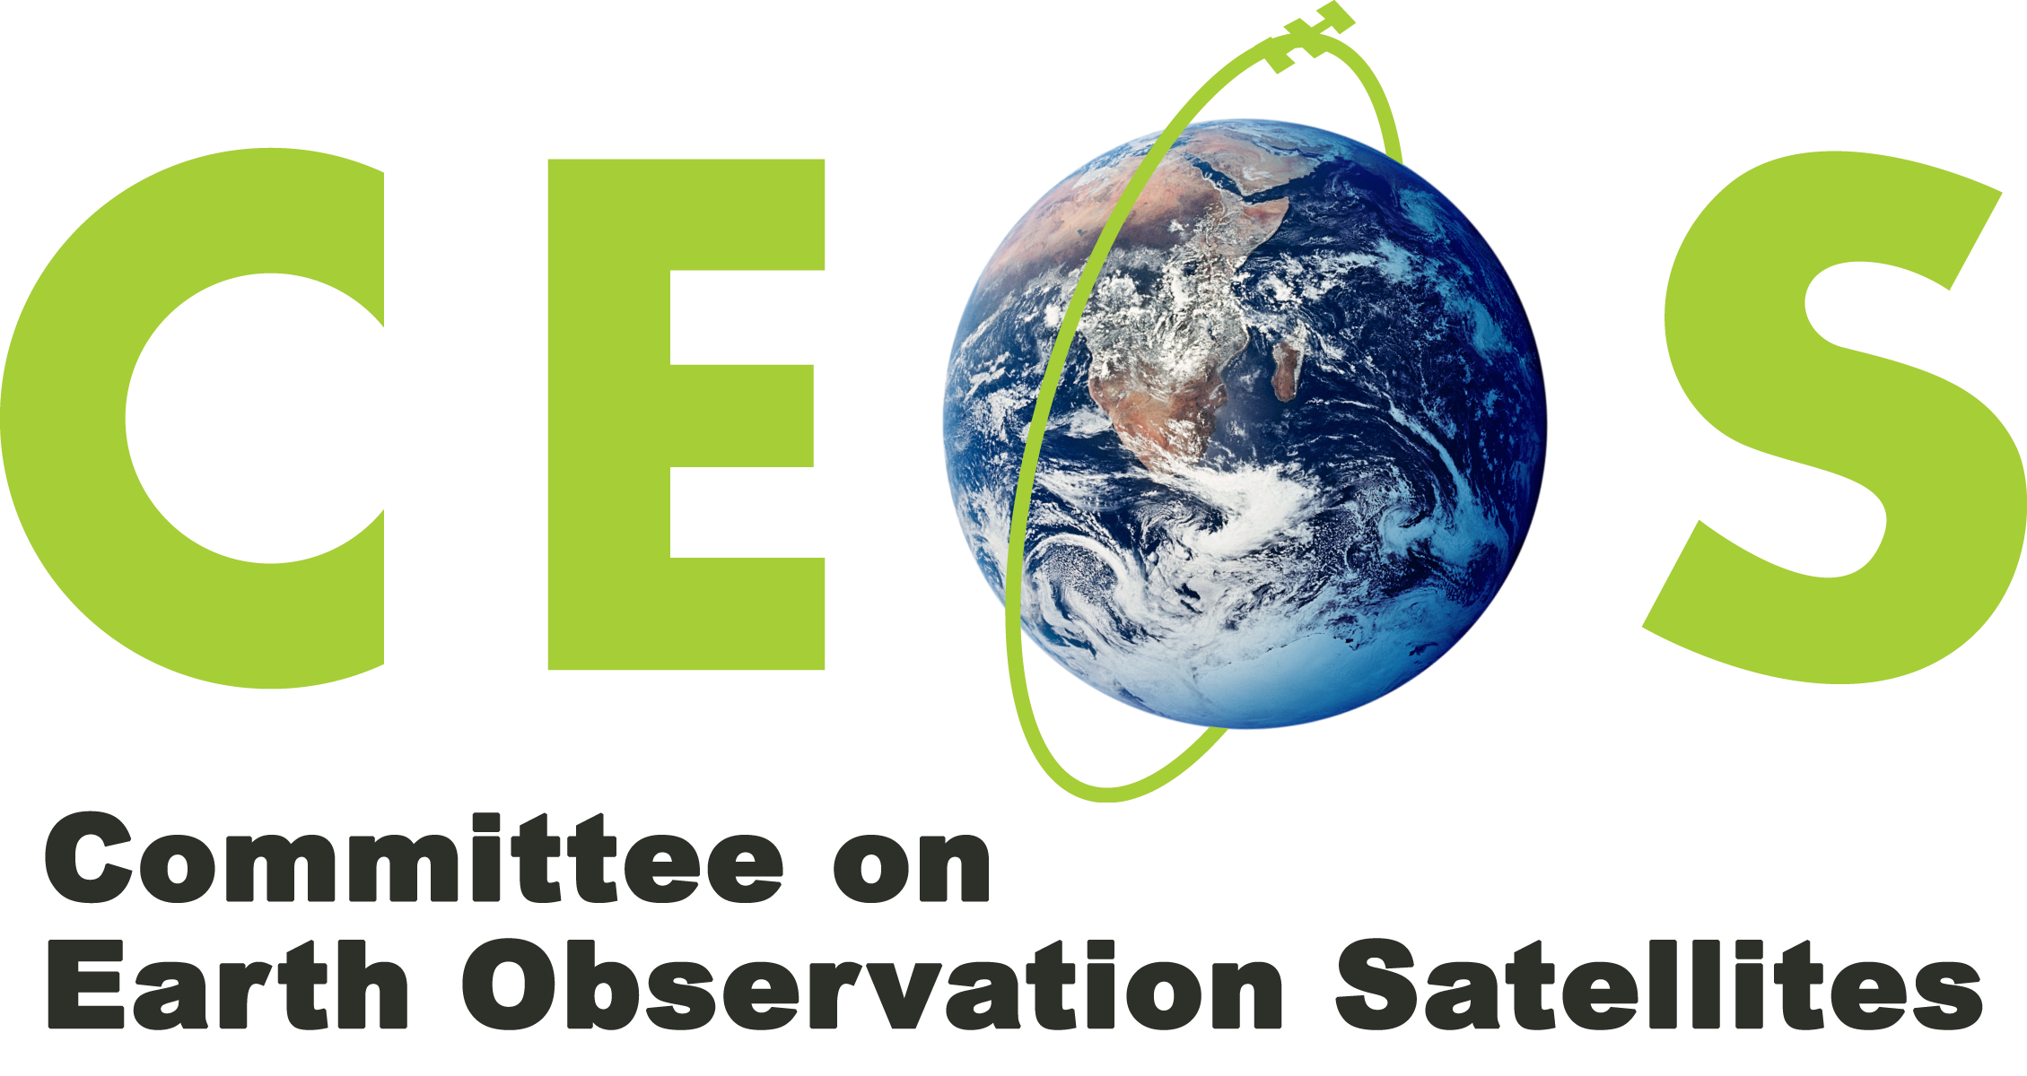
World Meteorological Organization (WMO)

