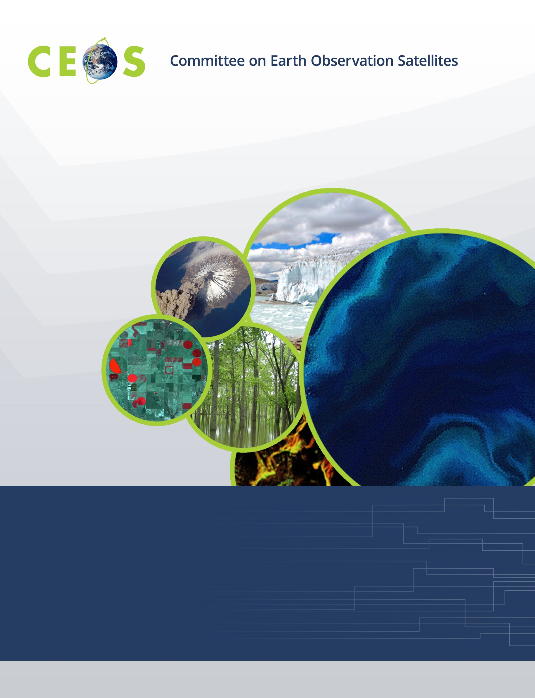
Meeting Prospectus
The 29th CEOS Plenary
5-6 November 2015
Meeting Prospectus
The 29th CEOS Plenary
5-6 November 2015

Meeting Participation
The Japan Aerospace Exploration Agency (JAXA) is pleased to invite you to participate in the 29th Plenary of the Committee on Earth Observation Satellites (CEOS) on 5-6 November 2015 in Kyoto, Japan. A number of side meetings and preparatory meetings will also be held on 4 November.
This meeting is open to invited participants only, such as
- CEOS Agency Principals (Members and Associates)
- CEOS Agency Contacts (Members and Associates)
- CEOS Chair & Chair Team
- CEOS Strategic Implementation Team (SIT) Chair & SIT Chair Team
- CEOS Working Group Chairs & Members
- CEOS Virtual Constellation Leads & Members
- CEOS Ad Hoc Team Leads & Members
- CEOS Executive Officer and Deputy
- CEOS Systems Engineering Office (SEO) representatives
- Group on Earth Observations (GEO) representatives

Accessing the Meeting Venue
This meeting will take place at Kyoto International Conference Center (http://www.icckyoto.or.jp/en/index.html) in Kyoto, Japan (ICC Kyoto). Since Kyoto is located more or less at the center of Japan, it enjoys a strategic position in the transport network and excellent accessibility from all over the world and anywhere in Japan.
From the Airport to Kyoto Station
Kyoto’s central railway station can be reached from Kansai International Airport in 75 minutes via the “Haruka” airport express service. It can be reached from Osaka International Airport in Itami in 55 minutes by limousine bus.
From Tokyo to Kyoto Station
From the Tokyo metropolitan area, Kyoto can be reached in about two and a half hours via Shinkansen (Bullet Train; http://english.jr-central.co.jp/index.html) with easy transfer to the subway at JR Kyoto station. Those who intend to participate in the JAXA Symposium for Data Applications of Earth Observing Satellites 2015 in Tokyo are recommended to take Shinkansen for transfer from Tokyo to Kyoto.
From Kyoto Station to ICC Kyoto
To get from the Kyoto Station to ICC Kyoto, take the Karasuma subway line to the “Kokusaikaikan” station (about 20 minutes).
Tips for using the subway & tips for foreign visitors (http://www2.city.kyoto.lg.jp/koho/eng/access/transport.html#sub)
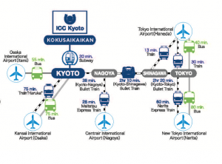
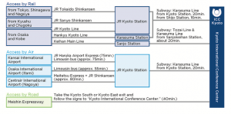
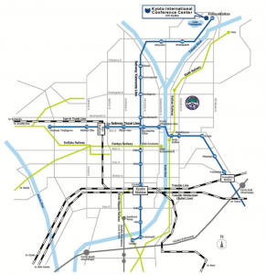

Accommodations
There is a block of rooms available for a special rate at the Grand Prince Hotel Kyoto from 2-7 November. Please complete the Hotel Reservation Request Form (http://ceos.org/document_management/Meetings/Plenary/29/Plenary-29_Hotel-Reservation-Request-Form_Aug2015.docx) and e-mail it to our local organizer (E-ceosplenary2015@restec.or.jp) to make your reservations.
Grand Prince Hotel Kyoto*
- One room (for one person) including breakfast: JPY22,000/night
- One room (for two people) including breakfast: JPY14,000/night each
*Cancellation Charges
- 72 hours prior notice: 30%
- Previous day: 50%
- Same day: 100%
You can find more information about the Grand Prince Hotel Kyoto on the hotel website (http://www.princehotels.com/en/kyoto/).
For those of you making your own accommodation at other hotels, we’ve listed several options below (We have not arranged a special rate at the hotels listed below.):
- Hotel Nikko Princess Kyoto (http://www.jalhotels.com/domestic/kansai/kyoto/)
- Kyoto Royal Hotel & Spa (http://www.ishinhotels.com/kyoto-royal/en/)
- Kyoto Tokyu Hotel (http://www.kyoto-h.tokyuhotels.co.jp/en/)
- New Miyako Hotel (http://www.miyakohotels.ne.jp/newmiyako/english/index.html/)
- Hotel Granvia Kyoto (http://www.granviakyoto.com/)
- Rihga Royal Hotel Kyoto (http://www.rihga.com/kyoto)

Visa Applications
Please contact our local organizer (E-ceosplenary2015@restec.or.jp) if you need visa support. The Ministry of Foreign Affairs of Japan Website (http://www.mofa.go.jp/j_info/visit/visa/index.html) also provides information on visa requirements for entering Japan.

Local Area
The City of Kyoto
Kyoto is a city located in the Kansai region, famous for its natural scenery, temples, shrines, towns and homes intermingled with a poignant historical beauty. Also known as the City of Ten Thousand Shrines, the cityscape is dominated by 2000 temples and shrines, and 17 traditional locations in Kyoto were inscribed on The United Nations Educational, Scientific and Cultural Organization’s (UNESCO) World Heritage List in 1994.
A Mixture of Ancient & Modern
Formerly the imperial capital of Japan for more than 1,000 years, the city is now home to 1.5 million people and a major part of the Kyoto-Osaka-Kobe metropolitan area. The city limits contain opportunities to experience leading modern technology and architecture, neon lights, deafening gaming parlors, graceful geisha (known as Geiko and Maiko in Kyoto), serene Buddha, a formidable castle, secluded temples, and even lush green rice paddies.
There is a great deal to see and experience in this city during free time in the business schedule and for accompanying persons who want to venture off-site. The city also offers visitors endless opportunities to gain meaningful hands-on experiences of rich Kyoto culture through Tea Ceremony, sake brewing, kimono wearing, swordsmanship, and more. Each season brings festival and event highlights that date back to the foundation of Kyoto in the eighth century.
Kyoto’s rich heritage is reflected in modern technical advances. Kyoto is packed with opportunities to rub shoulders with new frontier industries and top Japanese scholars. Kyoto is one of the academic centers in Japan and home to around 40 institutions of higher education, and, in fact, half of all Japanese Nobel Prize winners have been Kyoto University researchers.
Kyoto is a Pleasure During All Seasons & Weather
Kyoto has a temperate northern hemisphere climate with clearly defined seasons and predictable weather patterns. April heralds a warm spring full of excitement for celebrating the much cherished cherry blossoms. Innumerable green hues in temple areas offer respite from summer heat. Autumn brings bright reds and yellows that harmonize with the historic monuments from October to December. The silence brought by an occasional dusting of snow is said to be the best way to appreciate Kyoto during winter.
Also, Kyoto residents are renowned for their hospitality—the city takes pride in its outstanding service. Therefore, rest assured that wherever you go, be it meeting venues, hotels, restaurants or enchanting cobbled lanes, you will be welcomed with all the warmth of the culture heart of Japan.
Sights of Kyoto
In Kyoto, there are 17 castles, temples and shrines registered as World Heritage Sites. The years in which they were built vastly range from before 794 CE, when the capital of Japan was transferred to Heian-kyo (currently Kyoto-city), to the Edo period of 1603-1868 CE.
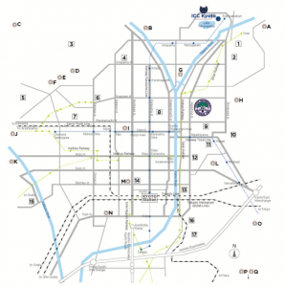

Social Events
The following events and lunch will be hosted by JAXA. Details for these hosted dinners will be provided in due course.
- Icebreaker 4 November 2015
- Dinner Reception 5 November 2015

Useful Information
Weather in Kyoto
- The average temperature in November is 13°C (55°F), and the average rainfall in November is 80mm.
- August is the hottest month in Kyoto with an average temperature of 29°C (83°F)
- January is the coldest month in Kyoto with an average temperature of 5°C (40°F)

For more information, please visit: http://www.holiday-weather.com/kyoto/averages/

Currency
- The unit of currency is the Yen (\)
- USD 1 = about JPY 121

For more information, please visit: http://www.xe.com/currency/jpy-japanese-yen

Electricity
- Voltage: 100V
- Frequency: 50/60 Hz
- Power sockets: Type A/B

For more information, please visit: http://www.japan-guide.com/e/e2225.html

Time Zone
- UTC/GMT + 9 hours

Contact
If you have any questions regarding the meeting logistics, please do not hesitate to email the local organizer:

E-ceosplenary2015@restec.or.jp
(CEOS Plenary 2015 Secretariat)

