CONFERENCE GUIDE BOOK

Committee on Earth Observation Satellites
The 33rd CEOS Plenary

Hanoi, October 14th - 16th, 2019
www.ceos.org

TABLE OF CONTENTS
Contents
HOST OF 33rd CEOS PLENARY 1
ARRIVAL & TRANSPORTATION 2
ACCOMMODATION 3
MEETING VENUE 4
ICEBREAKER VENUE 5
THINGS TO DO IN HANOI 6
TOUR TO HALONG BAY (Tentative) 8
USEFUL NUMBERS 9

HOST OF 33rd CEOS PLENARY
VIETNAM ACADEMY OF SCIENCE AND TECHNOLOGY
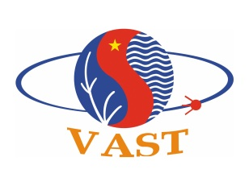
The Vietnam Academy of Science and Technology (VAST) is a government agency, earlier known as Vietnam Academy of Science, established in 1975 and issued by the former Council of the Vietnam Government. The VAST is committed to carrying out basic research in natural sciences and technology development; providing objective grounds for science and technology management, for shaping policies, strategies and plans for socio-economic development; and training high quality human resources for science and technology.
The Vietnam Academy of Science and Technology has 51 subordinate units located mainly in Hanoi, Phutho, Haiphong, Ho Chi Minh City, Nhatrang, Dalat, and Hue, including: 33 research units, 6 administrative units, 4 self-financing units, 1 state enterprise, and 7 other units.
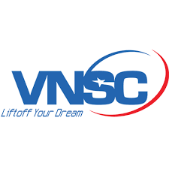
VIETNAM NATIONAL SPACE CENTER
Vietnam National Space Center (VNSC), under the Vietnam Academy of Science and Technology was established on September 16, 2011. The functions of VNSC are to manage and implement the Vietnam Space Center Project. Currently, VNSC has about 150 staff members and has headquarters at 18 Hoang Quoc Viet, Hanoi; a center in Ho Chi Minh City named the Vietnam Southern Satellite Technology Application Center; an observatory in Nha Trang; and an observatory in Hoa Lac High-tech Park.
VNSC has successfully developed and launched 2 satellites, the 1kg PicoDragon satellite launched in 2013 and the 50kg MicroDragon satellite launched in 2019.

ARRIVAL & TRANSPORTATION
Noi Bai International Airport (HAN) is just 30km away from central Hanoi, as well as our meeting venue, Hanoi Pan Pacific Hotel.
Taxis are easily accessible from the 1st floor, terminal T2 (international terminal) of the airport. It costs about 15 USD to travel from the airport to the hotel.
Weather in Hanoi
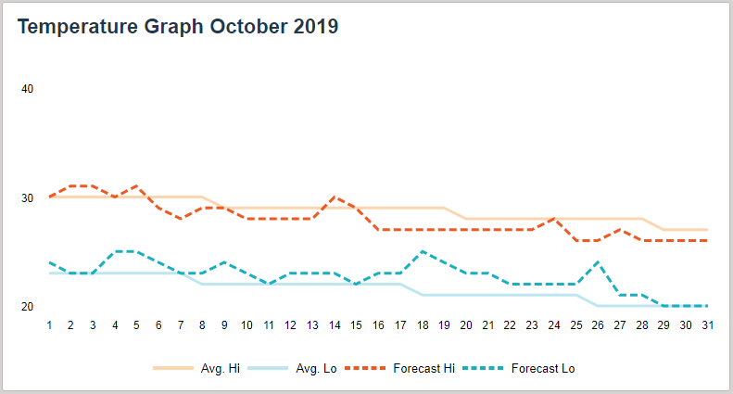
If you visit Hanoi in October, beautiful autumn days will be waiting for you. The weather is quite pleasant compared with other seasons. The average temperature is about 23 - 28 degrees Celsius.

ACCOMMODATION
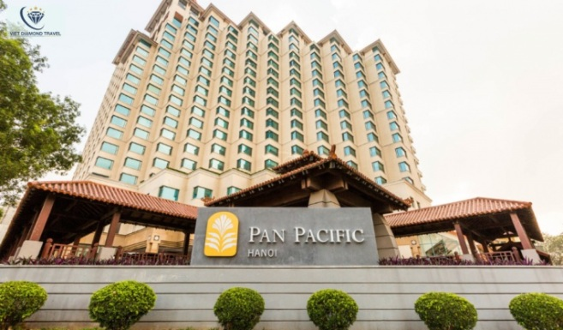
Pan Pacific Hanoi Hotel
Address: 1 Thanh Nien Road, Ba Dinh District, Hanoi, Vietnam
Telephone: +84 24 3823 8888

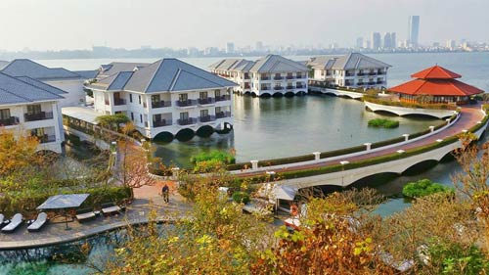
Intercontinental Hanoi Westlake:
About 2km from the Pan Pacific Hanoi Hotel
Address: 5 Tu Hoa street, Tay Ho district, Hanoi, Vietnam
Telephone: +84 24 6270 8888

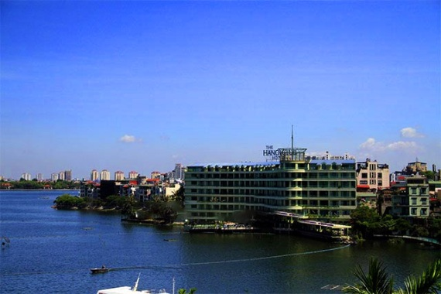
The Hanoi Club Hotel & Lake Palais Residences:
About 500m from the Pan Pacific Hanoi Hotel
Address: 76 Yen Phu street, Tay Ho district, Hanoi, Vietnam
Telephone: +84 24 3823 8115

MEETING VENUE
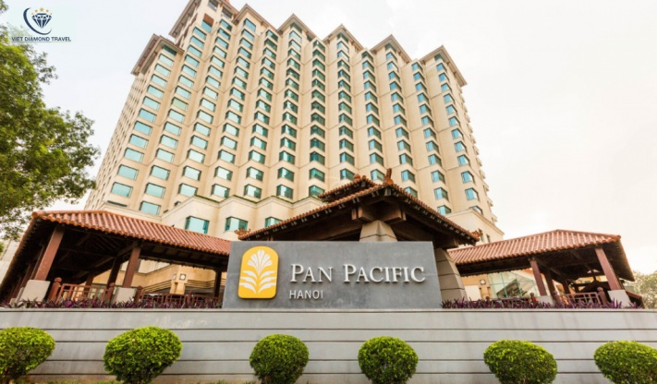
Pan Pacific Hanoi Hotel
Address: 1 Thanh Nien Road, Ba Dinh District, 10000 Hanoi Vietnam
Telephone: +84 24 3823 8888
Email: enquiry.pphan@panpacific.com
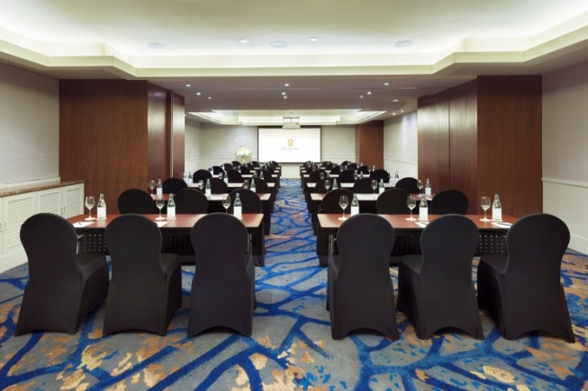

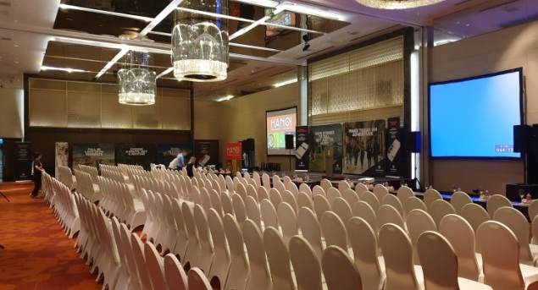

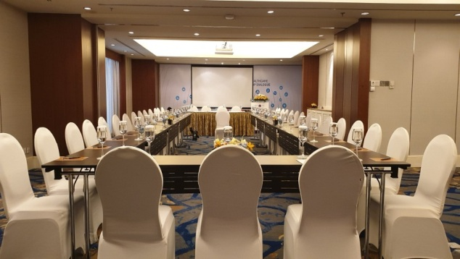
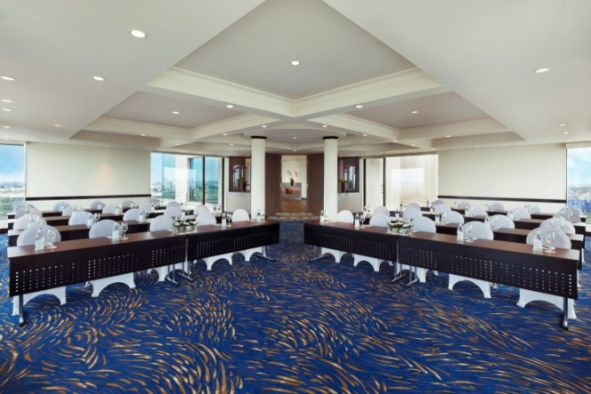
Saigon - Danang Room: Side Meeting (Oct 14, 2019)
Ballroom Theatre: Plenary room (Oct 15-16, 2019)

Hanoi - Haiphong Room: Side Meeting (Oct. 14);
Secretary room (Oct 15-16, 2019);
Westlake Meeting Room: Side Meeting (Oct 14, 2019)

ICEBREAKER VENUE
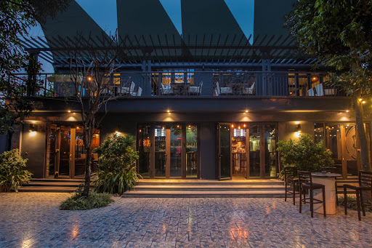
18:00-20:00, Monday, October 14
TURTLE LAKE BREWING COMPANY
Address: 105 Quang Khanh street, Tay Ho district, Hanoi
Tel: 024.66.505.187
About 3.6km away from the Pan Pacific Hotel.
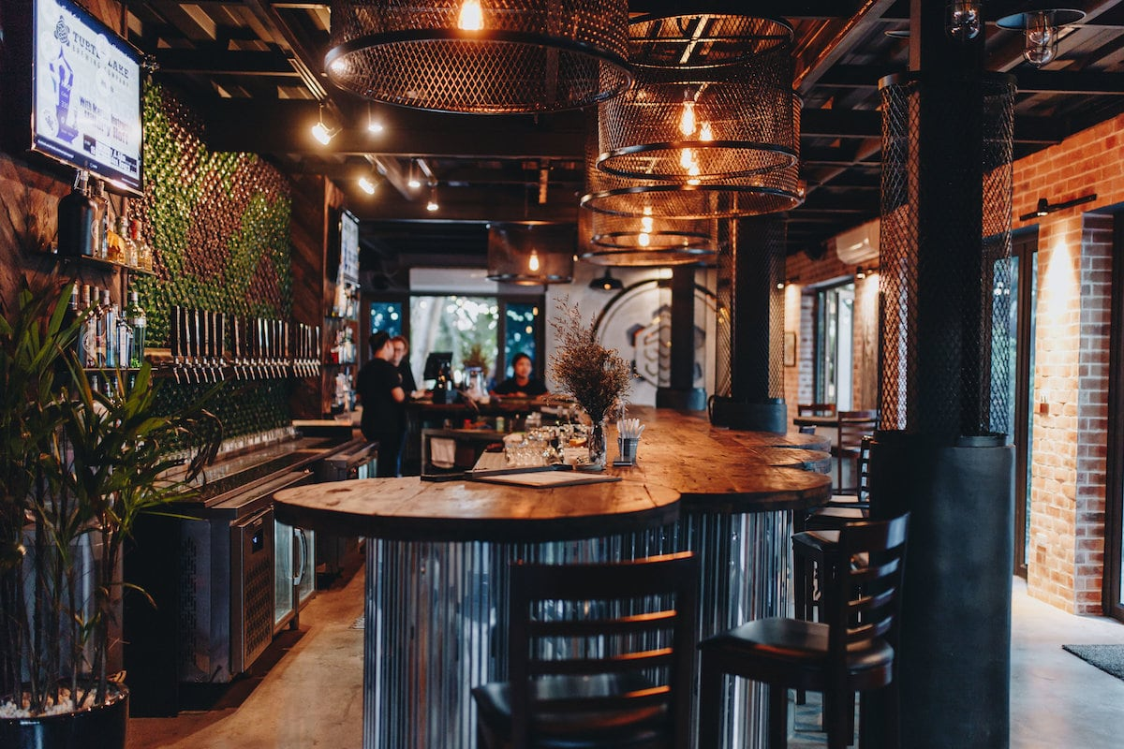

THINGS TO DO IN HANOI
Must-visit Attractions in Hanoi

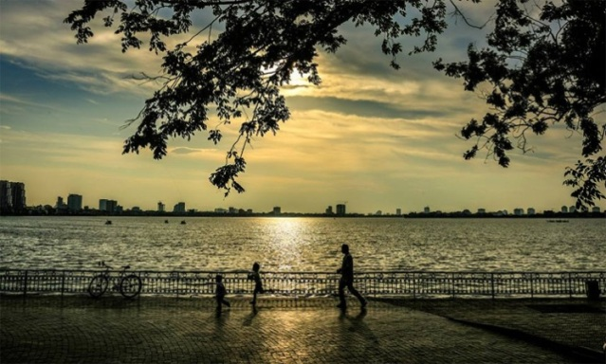
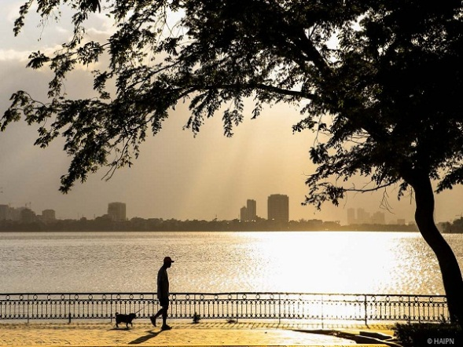
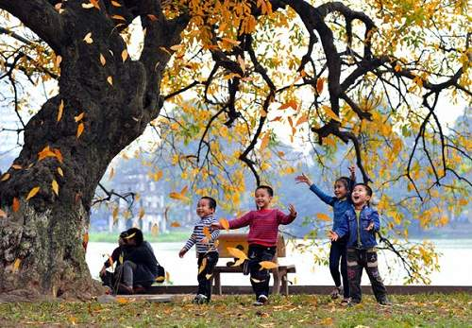
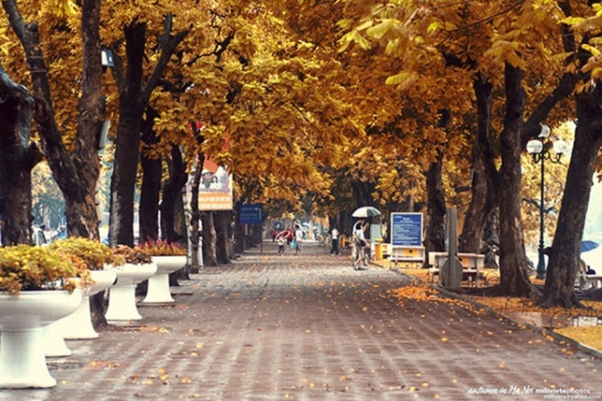
Hoan Kiem Lake in the city center, Ngoc Son Temple and Huc Bridge: You may take a walk around the lake or walk over the The Huc Bridge and visit the Ngoc Son Temple lying in the middle of the lake.

West Lake, Tran Quoc Pagoda, Tran Vu Temple, Vong Thi Pagoda, West Lake Temple (Phủ Tây hồ), and many others: You can take an 18km tour around the West Lake by electric bus. The bus station is located in Tran Quoc Pagoda, about 200m from the Pan Pacific Hotel. The ticket price is about 4USD. You may also hire the whole bus for about 20USD/hour.
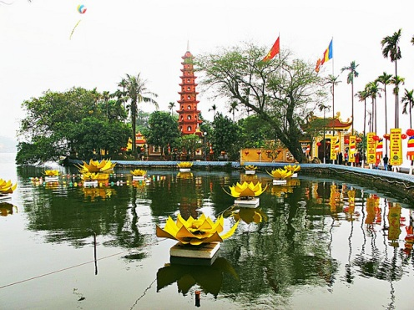
Tran Quoc Pagoda: It is the oldest temple in Hanoi, located in the southeastern shore of the West Lake, constructed from 544 to 548 with the original name “Khai Quoc” (National Founding). Over the years, the pagoda has also been named “An Quoc” (Pacification of the Realm), “Tran Bac” (Guardian of the North), and “Tran Quoc” (Guardian of the Country).
Tran Vu Temple (or Quan Thanh Temple): located on Thanh Nien road, near the West Lake. It was established in the 11th century and was one of 4 sacred temples built in 4 directions to protect the capital. The Quan Thanh protects from the North, Bach Ma Temple from the East, Kim Lien Temple from the South, and Voi Phuc Temple from the West.
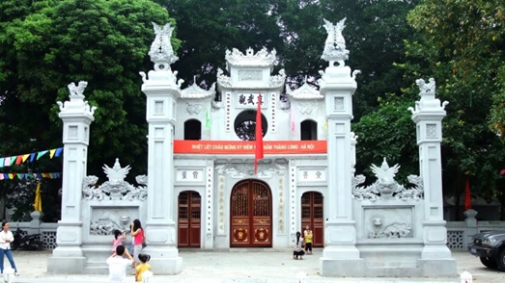
Old Quarter
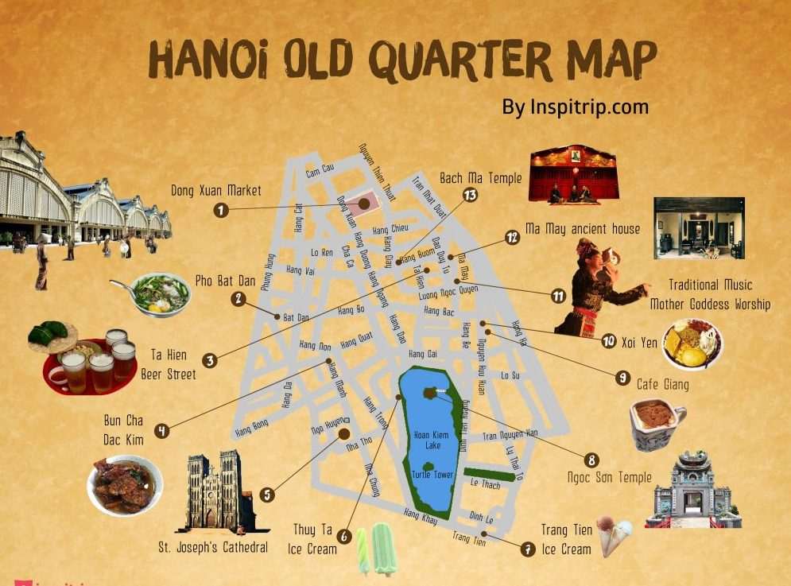
You may enjoy coffee, Hanoi’s Bia Hơi beer, Hanoi Phở, etc. or enjoy shopping for made-in-Vietnam things such as silk, silver jewelry, handmade craft gifts, etc. in little streets around the old quarter of Hanoi.

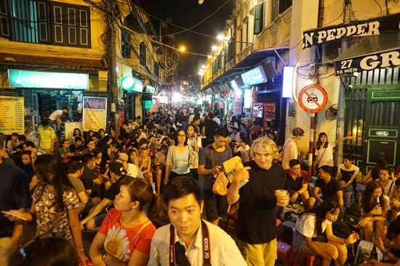
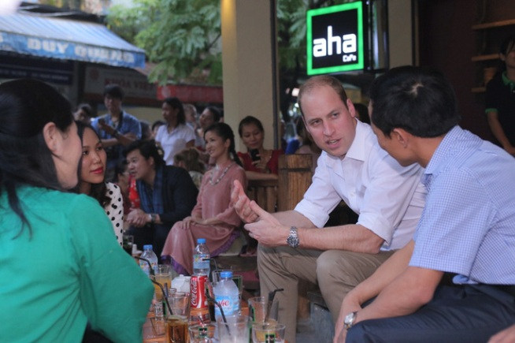

TOUR TO HALONG BAY (Tentative)
Time: 8am, October 17, 2019
Depart: 1st floor, Pan Pacific Hanoi Hotel.
8.00 – 8.30: Pick up guests at the Pan Pacific Hotel.
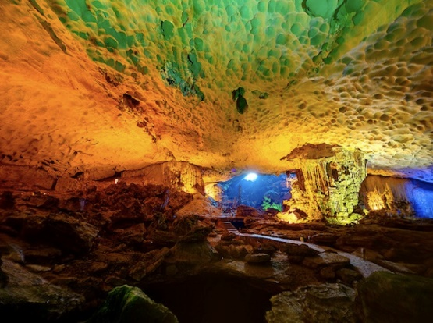
10.00: Have a short break (about 20 min).
12.30: Arrive at Tuan Chau, Halong Tourism Harbour.
12.45: Start cruising to visit Ha Long Bay – one of the New Seven Wonders of the World, UNESCO World Heritage Site. Have lunch on the cruise.
13.15: Visit Thien Cung Grotto – one of the largest and most beautiful grottoes in Halong Bay.
16.15: Back to the Pan Pacific Hotel in Hanoi.

(Final program will be defined and informed during CEOS Plenary)

USEFUL NUMBERS
CEOS Chair Team:
Ms. Linh Phan: (84) 903.511.818
Ms. Ngoc Pham: (84) 328.997.997
Emergency Numbers
Police: 113
Fire: 114
Ambulance: 115
Vietnam Country Code: +84
Taxi Numbers
Mai Linh Taxi: 024.38.333.333
Group Taxi: 024.38.535.353
Noi Bai Airport Taxi: 024.66.873.000 / 024.66.873.368

