MINUTES OF THE 33RD CEOS PLENARY
15-16 October 2019
Hanoi, Vietnam

Executive Summary
- NOAA formally offered to nominate Kerry Sawyer as interim CEOS Executive Officer for 2020.
- A dedicated discussion will be planned for the September 2020 SIT Technical Workshop among relevant CEOS entities, GCOS, and the UNFCCC Secretariat on Climate Change Convention engagement by space agencies.
- CEOS accepted the Greenhouse Gas Roadmap approach that was proposed. The project plan will be presented at the CEOS SIT-35 meeting (March 2020). The estimation of resources needed should give agencies enough information to assess their support for activities envisioned for the CEOS 2020-2022 Work Plan.
- Plenary approved the removal of two entities from the list of CEOS Associates: the International Geosphere-Biosphere Program (IGBP) and Global Terrestrial Observing System (GTOS), due to them no longer functioning.
- Plenary endorsed JAXA nominee, Makoto Natsuisaka as WGISS Vice Chair for 2020-2021 and WGISS Chair for 2022-2023.
- Plenary endorsed the CEOS Analysis Ready Data Strategy.
- ESA nominated Philippe Goryl as the next WGCV Vice Chair. A formal nomination letter is forthcoming.
- Plenary endorsed Pierric Ferrier of CNES as WGDisasters Vice Chair for 2020-2021 and WGDisasters Chair for 2022-2023.
- Plenary endorsed the CEOS Response to GEOGLAM Requirements 2019.
- Plenary endorsed the AC-VC Geostationary Satellite Constellation for Observing Global Air Quality: Geophysical Validation Needs white paper.
- The CEOS Coastal Observations and Applications Study Team (CEOS-COAST) was established – with an initial term of 12 months and Work Plan to be submitted by December 2019 for virtual endorsement by SIT, and a progress report at SIT-35.
- Plenary approved the proposed language changes to the Virtual Constellations Process Paper and endorsed Virtual Constellations Process Paper rev1 2019.
- Plenary approved the proposed language changes to the Virtual Constellation, Ad Hoc Team, and Working Group sections of the CEOS Governance and Processes Document and endorsed CEOS Governance and Processes rev1 2019.
- Plenary accepted the recommendation of the Working Group Study Team report to continue to utilise existing CEOS leadership and technical group channels (e.g., CEOS Chair, SIT Chair, SEC, CEO, SEO, VCs, WGs) to address new external requests, rather than establish a new Working Group.
- Plenary accepted the recommendation of the Ocean Virtual Constellation Merger Study Team to keep the four CEOS Ocean Virtual Constellations rather than merging them into one Ocean Virtual Constellation.
- Plenary endorsed the transition of the Ad Hoc Space Data Coordination Group for GFOI to become a thematic subgroup on Forests & Biomass within LSI-VC.
- Plenary endorsed the transition of the Ad Hoc CEOS Working Group on GEOGLAM to become a thematic subgroup on GEOGLAM within LSI-VC.
- Plenary approved a one-year extension for the Ad Hoc Team on Sustainable Development Goals (AHT-SDG) after which CEOS will consider whether it will transition its activities to a permanent CEOS mechanism or disband it.
- Plenary endorsed NASA for the role of 2021 CEOS Chair.
- Plenary endorsed Pham Thi Mai Thy of VAST-VNSC as WGCapD Vice Chair for 2020-2021 and WGCapD Chair for 2022-2023.
- Plenary welcomed CSIRO/GA (Alex Held and Adam Lewis) as SIT Chair for the two-year term of 2020-2021.
- The Indian Space Research Organisation (ISRO) assumed the role of 2020 CEOS Chair.

Tuesday October 15th
Session 1: CEOS Core Business
1.1: CEOS Chair Introduction
Pham Anh Tuan (VAST-VNSC, CEOS Chair) welcomed participants to the 33rd CEOS Plenary meeting and to Vietnam, on behalf of VAST-VNSC.
Participants introduced themselves, their affiliations and CEOS roles in a tour de table.
1.2: Vietnam Academy of Science and Technology (VAST) Welcome
Prof. Tran Tuan Anh (VAST) added the welcome of VAST to the Plenary and to Vietnam and expressed appreciation for the work of CEOS and the benefits of Earth observation for Vietnam.
1.3: Review of the Status of Actions [PPT]
Presenter: Steven Hosford (ESA/CNES, CEOS Executive Officer (CEO))
Main points:
- Steven reviewed the status of the Actions from the previous CEOS Plenary (Oct. 2018) and the SIT Technical Workshop (Sept. 2019). Steven reviewed the status of open Actions and identified which items on the 2019 CEOS Plenary meeting agenda address them.
Main discussion points:
- Ivan Petiteville (ESA) suggested the Action to develop an External Request Process Paper (SIT TW-2019-04) be slightly reworded to indicate the responsible party is the collective team and not only the Systems Engineering Office (SEO). Kerry Sawyer (NOAA, SIT Chair Team) said the meeting minutes of the Sept. 2019 SIT Technical Workshop provide context explaining that the Action is on both the SEO and a small task team.
1.4: CEOS Three-Year Work Plan Annual Update Schedule & CEOS Work Plan Progress Report [PPT] [Document]
Presenter: Steven Hosford (ESA/CNES, CEO)
Main points:
- The annual maintenance of the comprehensive CEOS Work Plan is agreed to be essential for effective organisation and process in CEOS.
- The 2019-2021 CEOS Work Plan incorporates a number of changes to improve accountability, resource estimation, descriptions and timelines, and links it to the GEO Work Programme where possible.
- A detailed report is available here.
- Updates are needed for WAT-4 (CEOS Strategy for Water Observations) and BP-4 (Blue Planet).
- There is a continued tendency for deliverables to be assigned due dates that are later pushed back. Contributors to the Work Plan are encouraged to give more consideration to the due dates they propose in order to improve the relevance of these estimates. Steven noted this has improved since it was first flagged a year or so ago.
- Steven outlined the process for the next Work Plan update, which is expected to commence on November 7 and conclude in March 2020.
Main discussion points:
- Steve Volz (NOAA, SIT Chair) thanked CEOS for providing inputs and updates to the CEOS Work Plan Tasks/Deliverables. He suggested that the shorter-term due dates are likely due to people submitting interim tasks that make up longer-term objectives. Alex Held (CSIRO, SIT Vice Chair) suggested finding some way to reflect the context of these longer-term objectives in the Work Plan and these summary presentations to Plenary.
- Gilberto Camara (GEO Secretariat Director) thanked CEOS for making a strong effort to consider linkages between CEOS Tasks/Deliverables and the GEO Work Programme.
- Ivan Petiteville (ESA) suggested it would be helpful to have a summary of trends/lessons learned regarding Task delays.
1.5: Contingency Plan in the Absence of a New CEOS Executive Officer [PPT-1] [PPT-2]
Presenters: Steven Hosford (ESA/CNES, CEO) & PG Diwakar (ISRO)
Main points:
- Steven reviewed the main functions of the CEOS Executive Officer (CEO), which are: Work Plan planning and monitoring; managing the flow of internal information; being the interface for external contacts (GEO, UN, others); and CEOS administrative management (website updates, email list maintenance, etc.).
- The CEO role is a significant commitment in terms of hours and meeting participation. The role is crucial in ensuring the efficient functioning of CEOS.
- Steven suggested that CEOS needs to make it easier for external people to get in contact with the CEO – perhaps a dedicated CEO@ceos.org email address would address this need.
- The recent struggle to find a new CEO has highlighted the need for better forward planning for both CEOs and Deputy CEOs (DCEOs). Increased agency representation is desired. A geographic rotation was one of the ideas suggested as a way to compel agencies to propose candidates and ensure a queue of successive CEOs in the pipeline. Other ideas include lessening the financial burden an agency must cover as a way to open the role up to qualified candidates from a greater number of CEOS Agencies. Having a DCEO is also important, as it allows for mentoring opportunities and because the DCEO assists the CEO in the lead up to serving in the CEO role for a two-year term.
- SANSA and UKSA are possible candidates following the stop-gap solution proposed by NOAA to cover 2020 (January 1st to December, Kerry Sawyer). CEOS has a window between now and SIT-35 to identify two DCEO candidates for the next two vacancies.
Main discussion points:
- Simonetta Cheli (ESA) supported the temporary solution proposed by NOAA for 2020 but stressed the need to find permanent solutions for the following terms as soon as possible. She is not supportive of a fully commercial solution.
- Steve Volz (NOAA, SIT Chair) formally offered to nominate Kerry Sawyer (NOAA) as a stop-gap solution as the CEO for 2020. He agreed the need to find a sustainable solution, starting with identification of DCEOs to maximise mentoring opportunities.
- Sandra Cauffman (NASA) thanked NOAA for their offer and suggested that the proposal be further discussed in the CEOS SEC to allow proper consideration given the short notice.
- Bertie Archer (UKSA) reported that UKSA can no longer nominate a candidate for the CEO position.
1.6: 2019 CEOS Chair Initiative [PPT]
Presenter: Lam Dao Nguyen (VAST-VNSC)
Main points:
- In 2019, CEOS Chair activities have focused on two specific applications utilising Open Data Cube software:
  - Carbon observations, including forested regions;
  - Observations for agriculture.
- The focus has been on the Mekong basin, which is a cross-border region strongly affected by climate change and human activities.
- The Vietnam Data Cube contains the following data contributed by CEOS Agencies: Landsat from 1986 to present; ALOS-2 (from JAXA) from November 2016 to present; and, Sentinel-1 (from ESA, processed to Analysis Ready Data by CESBIO/CNES) from October 2014 to present.
- Forest cover change monitoring in Vietnam has been achieved with a focus on monthly forest loss estimates – developed by VNSC and CNES/CESBIO (validation is in progress).
- Rice application outputs include crop maps (developed by VNSC, CNES/CESBIO, and JAXA) and production/yield estimates.
- Capacity building events (with WGCapD) focused on the use of SAR for rice, forest, and flood monitoring, as well as ground motion detection and LCLUC. These activities have supported Vietnamese capacity to use SAR and other Earth observation data, which has also helped grow technical capabilities around the Vietnam Data Cube.
Main discussion points:
- Kazuo Tachi (JAXA) reported that JAXA will continue to support the Vietnam Data Cube through bilateral activities.
- Sandra Cauffman (NASA) congratulated the VAST-VNSC team for their progress, noting that this is a perfect example of what can be achieved through CEOS collaboration.
- PG Diwakar (ISRO) asked if VAST-VNSC will continue Vietnam Data Cube and application development in the future; Lam Dao Nguyen confirmed that they will.
Session 2: Climate & Carbon
2.1: Update: Global Climate Observing System (GCOS) [PPT]
Presenter: Carolin Richter (GCOS)
Main points:
- The GCOS Status Report will be updated in 2021 and the Implementation Plan updated in 2022; typically, these are timed to coincide with the IPCC Assessment Reports.
- GCOS has been consulting with WGClimate to ensure effective cooperation with space agencies, including on homogeneity and format of requirements – with new mappings of ECV product names within the OSCAR/Requirements database and aligning definitions of ECV products with definitions in OSCAR/Requirements.
- GCOS seeks to formalise and better structure the overall process for updating requirements (as recognised in Action G10 of the 2016 GCOS IP).
- Key milestones for GCOS are shown below:
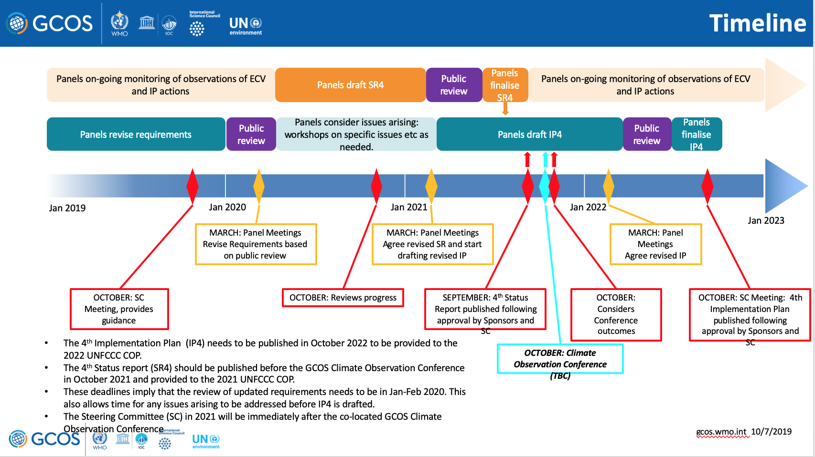
Main discussion points:
- Steve Volz (NOAA, SIT Chair) asked about the level of WMO resources committed to updating and maintaining the OSCAR Database. Carolin reported that one expert is assigned to each observation type, which represents a significant effort. She added that one staff member is fully committed to reflecting the GCOS IP in the database.
2.2: CEOS/CGMS Joint Working Group on Climate [PPT]
Presenter: Jörg Schulz (EUMETSAT, WGClimate Chair)
Main points:
- The Essential Climate Variable (ECV) Inventory fully describes current and planned implementation arrangements (ECV-by-ECV) within the Architecture, with content fully verified and updated annually with approval from CEOS and CGMS. This informs space agency planning and improves availability and interoperability of climate data records. Contributions to the Inventory are welcomed at any point in the year.
- The Inventory covers contributions to 35 out of 54 GCOS ECVs (37 being accessible by satellite). 2019 saw the inclusion of a significant number of newly planned Climate Data Records (CDRs) from ESA’s CCI+ and EC-Copernicus Climate Change Service, and from KMA, JMA and JAXA, filling previous gaps on lightning, sea-surface salinity, above-ground biomass, and permafrost, the latter two having significance for the study and analysis of the Earth’s carbon cycle.
- WGClimate is seeking endorsement for the gap analysis report and updated coordinated action plan for the current ECV Inventory by end 2019 so that they can progress onto Version 4.
- Jörg flagged the resources needed/requested for the ECV CDR Inventory and gap analysis. Agencies were asked to continue/enhance their support to the ECV Inventory and to award full appreciation to engaged contributors within their agencies.
- COP 25 will take place from 2-13 December 2019 in Madrid, Spain. CEOS will be represented by various people including Jörg, Mark Dowell (COM), and David Crisp (NASA/JPL). The CEOS/CGMS Space Agency Statement to SBSTA-51 was presented and requires endorsement before it is submitted (by November 22). Due to the need for incorporation of editorial comments by agencies, virtual endorsement shortly after the Plenary is the suggested approach.
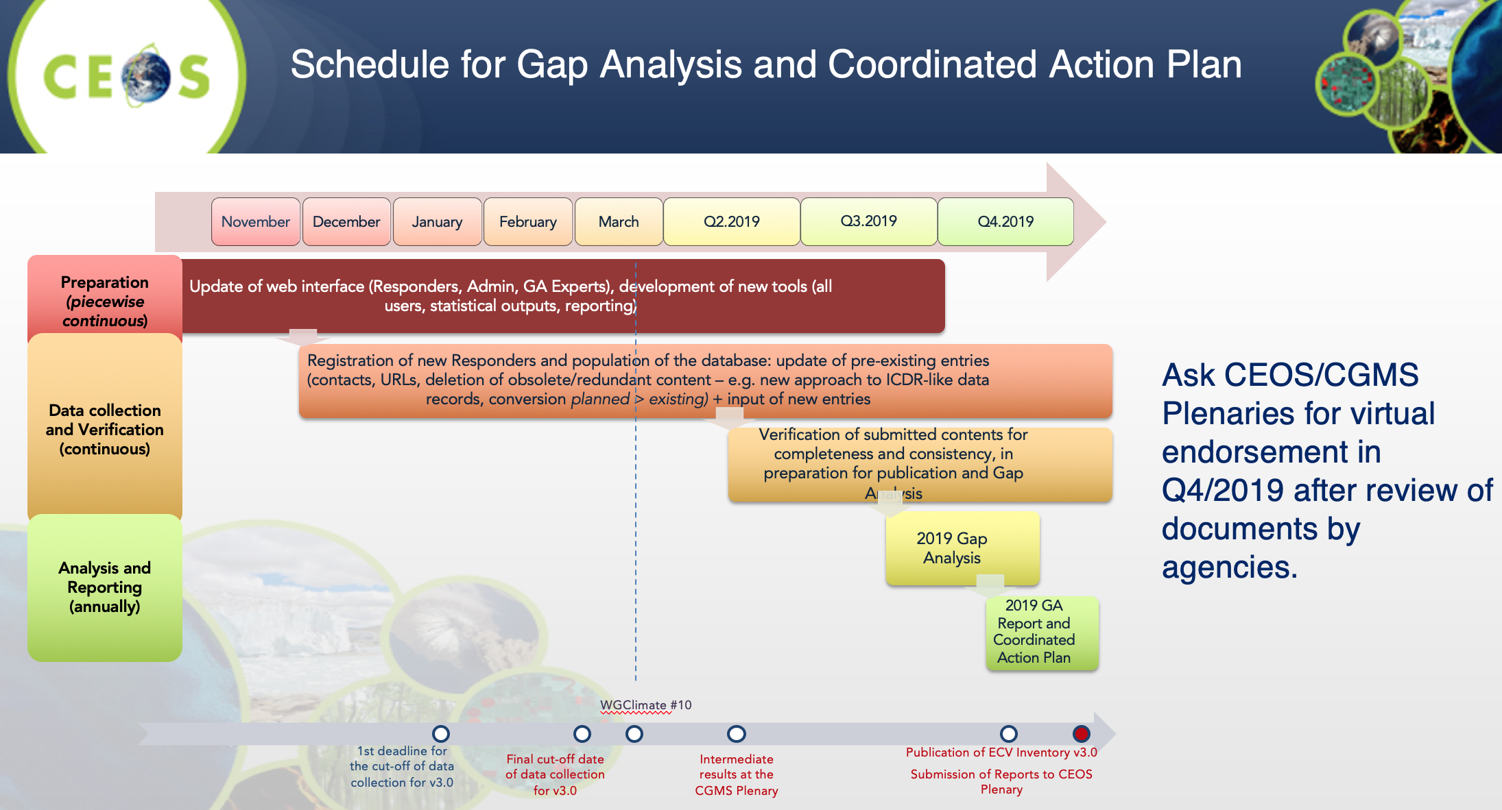
Main discussion points:
- Simonetta Cheli (ESA) supported the draft SBSTA-51 statement. ESA will also be present at COP-25 and will hold a joint side event with JAXA on greenhouse gas (GHG) monitoring.
- Sandra Cauffman (NASA) encouraged agencies to consider additional contributions to the ECV Inventory and thanked agencies for their recent contributions. She also expressed support for the draft statement to SBSTA-51.
- Paul Counet (EUMETSAT) also supported the SBSTA-51 statement.
- Steve Volz (NOAA, SIT Chair) suggested including references in the response to WMO regarding OSCAR that stress the importance of the GCOS interface and resourcing of the OSCAR database.
CEOS-33-01 | WGClimate Chair to integrate agency comments and issue a final draft of the CEOS/CGMS Space Agency Statement for SBSTA-51 for virtual endorsement by CEOS Principals. | 20 October 2019
CEOS-33-02 | SIT Chair to prepare and broaden the response to WMO’s letter on enhancing collaboration with CEOS and providing focal points for the OSCAR/Space Database to include references to the following points:  - the importance of a strong GCOS programme to space agencies;  - for WMO to more fully resource the OSCAR system. | November 2019

Decision 01 | Endorsement of the CEOS/CGMS Statement to SBSTA-51 will be accomplished virtually after the 2019 CEOS Plenary.
2.3: CEOS Carbon Strategy [PPT]
Presenter: Mark Dowell (COM)
Main points:
- It is time to reassess the actions to be taken on from the 2014 CEOS Carbon Strategy. 42 actions were originally identified, with five initiatives being actioned so far by various CEOS entities. Mark reviewed the actions undertaken to date: WGISS Carbon Portal, review of the IPCC TFI guidelines, AC-VC GHG Constellation white paper, the addition of carbon-relevant ECVs to the ECV Inventory, an assessment by LSI-VC on medium to coarse resolution optical sensors for carbon variables, and the WGCV LPV Biomass Protocol.
- Mark proposes CEOS now identify new actions to take forward from the 2014 Strategy, before an update to the Strategy is considered. Mark presented initial ideas for new actions and related responsibilities:
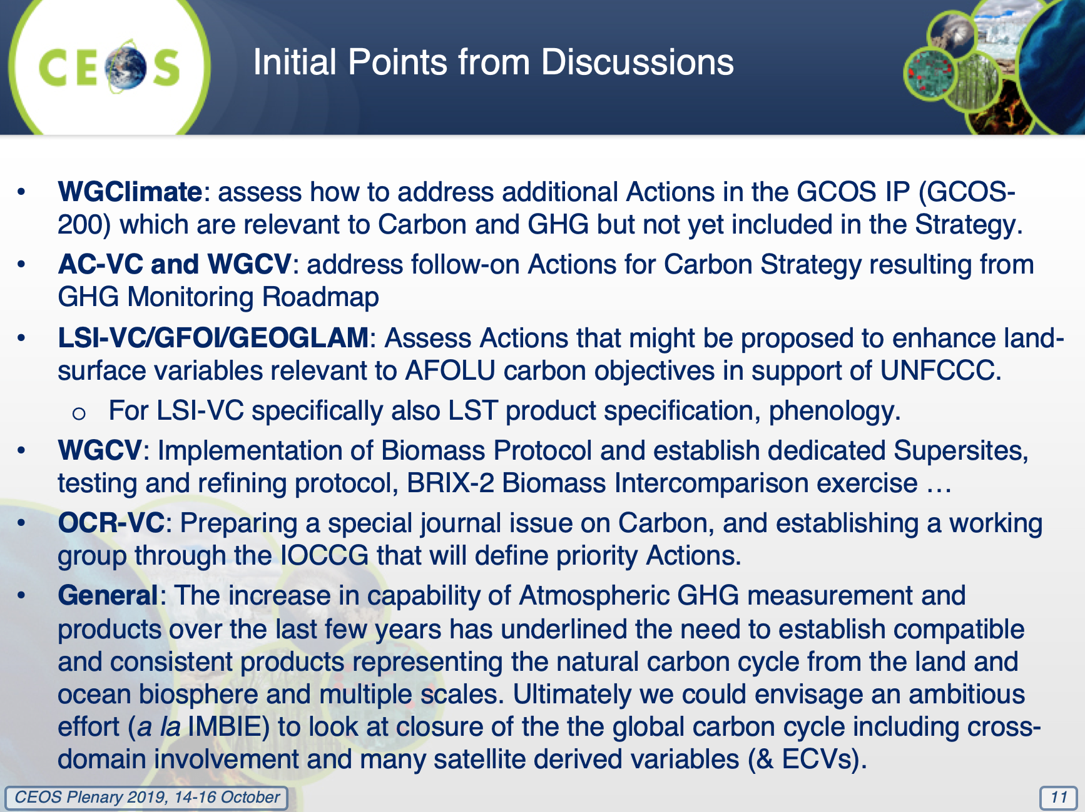
Broadening and Consolidating UNFCCC Engagement
- CEOS has established a positive and proactive dialogue with UNFCCC/SBSTA and GCOS, mainly through close engagement of the joint CEOS/CGMS WGClimate. It is now worth stepping back and considering how we can more systematically contribute to the Convention.
- CEOS needs to adopt a longer-term strategy accounting for the multitude of contributions CEOS, and space agencies more generally, can make to the Convention. We need to maintain the effective focal point established through WGClimate, but also increase communication on contributions from other parts of CEOS (in statements, SBSTA briefings, etc.), including:
  - reinforcing the CEOS Carbon Strategy as the framework for carbon-relevant aspects;
  - giving greater visibility to GFOI/biomass aspects as well as agriculture, not only through REDD+ but also the SBSTA Research and Systematic Observation (RSO) subgroup.
- In the short/mid-term CEOS should: build on the priorities of the incoming SIT Chair (CSIRO/GA) on carbon and biomass, as well as the current visibility on GHG monitoring; initiate dialogue between the GHG and Agriculture, Forestry and Other Land Use (AFOLU) communities (a workshop hosted by the European Commission in June 2020 is planned); and, hold a dedicated discussion at the SIT Technical Workshop (Zagreb, Croatia; September 2020) with all CEOS entities, GCOS, and the UNFCCC Secretariat.
- Mark noted the hope to hold a broader discussion during the course of 2020 on an IMBIE-type closure effort for the carbon cycle (bringing competencies from all domains and all VCs, WGs, and AHTs).
Main discussion points:
- Ivan Petiteville (ESA) asked about the original CEOS Carbon Strategy and its lack of actions related to the ocean VCs. He asked whether we should wait for ocean VCs to suggest actions or instead be proactive in expressing some top-down requirements related to ocean carbon and asking them to respond. Mark acknowledged the lack of ocean-related actions but noted that OCR-VC will be stepping up in the next round. Mark suggested a shared action that combines all VCs and domains around closing the carbon cycle could be a good way forward.
CEOS-33-03 | European Commission to plan a workshop at the Joint Research Centre to support dialogue among the Greenhouse Gas and Agriculture, Forestry and Other Land Use (AFOLU) communities. | June 2020
CEOS-33-04 | Mark Dowell and SIT Chair Team to plan for a dedicated discussion at the 2020 SIT Technical Workshop (Zagreb, Croatia, September 2020) among relevant CEOS entities, GCOS, and the UNFCCC Secretariat on Climate Change Convention engagement by space agencies. | September 2020
CEOS-33-05 | Mark Dowell to progress the definition of another round of actions from the CEOS Carbon Strategy and their inclusion in the CEOS 2020-2022 Work Plan, focusing on those entities that did not participate in the first round of actions (i.e., OCR-VC and SST-VC). | January 2020

Decision 02 | Plenary endorsed the definition of another round of actions from the CEOS Carbon Strategy and their inclusion in the CEOS 2020-2022 Work Plan.
2.4: Architecture for Monitoring Carbon Dioxide and Methane from Space [PPT] [Document]
Presenter: David Crisp (NASA)
Main points:
- The CEOS AC-VC GHG white paper recommends the following approach: refine requirements for atmospheric flux inventories; produce a prototype atmospheric CO₂ and CH₄ flux inventory that is available in time to inform the bottom-up inventories for the 2023 global stocktake; use lessons learned from the prototype flux inventory to refine requirements.
- The first step was to develop a Roadmap for the implementation of recommendations including a justification for the resource request. This will evolve over time as the more detailed project plan is developed, within the constraints of the available resources.
- Three broad categories of resources are envisaged and requested for consideration by CEOS Agencies: human resources; support for travel and hosting of workshops; support for research, development, and infrastructure.
- The GHG Roadmap is not being presented for endorsement at CEOS Plenary. Rather the team is seeking acceptance/acknowledgement of the approach. The subsequent project plan will be presented by SIT-35.
Main discussion points:
- Osamu Ochiai (JAXA) reported that JAXA will certainly contribute, but the exact nature and scope will be confirmed later. Osamu asked that the team try to accommodate a meeting at AGU in December 2019.
- Mark Dowell (COM) highlighted the tight time constraint for the first global stocktake. Whilst a number of documents will be finalised over the course of the next year, the estimation of resources currently provided should give agencies enough information to make initial contribution assessments and not delay progress, which should start immediately.
- Paul Counet (EUMETSAT) emphasised the importance of consistency and coherence between the Roadmap and the Project Plan.
- Ivan Petiteville (ESA) suggested that the CEOS best efforts approach needs to be put aside for this task, due to the extreme importance and very tight time constraints. ESA will support with the participation of Yasjka Meijer in the GHG Task Team.
- Kerry Sawyer (NOAA, SIT Chair Team) reported that NOAA agrees with the proposal to defer the endorsement of the GHG Roadmap and accepts the approach suggested.
- Selma Cherchali (CNES) strongly supported the plan.
2.5: Refinement of the IPCC Guidelines for GHG Inventories [PPT]
Presenter: Kazuo Tachi (JAXA)
Main points:
- Kazuo reported on the activities conducted by CEOS towards refinement of the guidelines. The final draft was adopted during the 49th Session of the IPCC in May 2019 in Kyoto, Japan. Kazuo reported a summary of the changes made in the 2019 update related to satellite contributions.
- Kazuo thanked CEOS Agencies for their efforts in the update. Going forward, demonstration of these capabilities by CEOS Agencies is key. JAXA will take actions along these lines and Kazuo encouraged other agencies to do the same.
2.6: Update on CEOS Contributions to Forest Carbon Monitoring (GFOI/SDCG) [PPT]
Presenters: Osamu Ochiai (CEOS Lead for GFOI, JAXA) & Stephen Ward (SDCG Sec)
Main points:
- Reviewed the overall status of GFOI. Phase 2 has a renewed focus on capacity building and country engagement to develop National Forest Monitoring Systems (NFMS) for Measurement, Reporting and Verification (MRV).
- GFOI and UNFCCC representatives met in Bonn, Germany on September 24-25, 2019, to discuss the “policy mandates” associated with the Paris Agreement (i.e., nationally determined contributions (NDCs), global stocktakes). CEOS engaged with the UNFCCC on the global stocktake process and key contacts.
- GFOI Plenary will be held at FAO in Rome, Italy on 9-13 March 2020, and CEOS is one of the organising members.
- The SDCG Work Plan has been updated to reflect the SDCG’s slimmer profile – due to strong baseline data supply and reduced agency attendance. SDCG’s focus has moved to data use and value adding activities, including: support to LSI-VC on ARD pilots and data access; linking FAO’s SEPAL platform to an Open Data Cube (ODC) back-end; and, working through the new USGS Co-Chair (Chris Barber) to establish stronger linkages to SilvaCarbon’s capacity building activities.
- Biomass is also a priority for SDCG going forward. The goal is to help accelerate the policy relevance of these new missions and datasets. It was suggested that CEOS consider how the CEOS structure should incorporate biomass.
- Plenary will be asked to endorse the transitioning of the SDCG Ad Hoc Team into an LSI-VC subgroup. This decision will be revisited under item 5.10.

Main discussion points:
- Prakash Chauhan (ISRO, WGCapD Chair) suggested stronger connections be established between WGCapD and SDCG/GFOI capacity building efforts – for biomass in particular.
Session 3: Agency & Partner Updates
3.1: Update: Group on Earth Observations [PPT]
Presenter: Gilberto Camara (GEO Secretariat Director)
Main points:
- Gilberto recommended the development of a common Application Programming Interface (API) for Earth observation (EO) Data Cubes and challenged CEOS and GEO to organise EO data as Data Cubes openly available in cloud platforms.
- He presented two requests from GEO to CEOS:
  - Work together to find a way to produce Data Cubes as organised sets of cloud-optimised files with accompanying catalogues (e.g., STAC);
  - Engage with the Open Geospatial Consortium (OGC) and GEO to conceive and develop web services for Data Cubes.
- Gilberto congratulated VAST-VNSC on the development of the Vietnam Data Cube.
Main discussion points:
- Adam Lewis (GA, SIT Vice Chair) noted the CEOS ARD Strategy is being presented for endorsement tomorrow and suggested that this might go some way toward addressing the points raised by Gilberto. Adam noted in particular the ARD Strategy tasks around machine readability, STAC, etc. Gilberto responded that CARD4L is not necessarily Data Cube-ready.
3.2: Continuity of CEOS Representation on the GEO Programme Board and ExCom [PPT]
Presenter: Kerry Sawyer (NOAA, SIT Chair Team)
Main points:
- CEOS submitted the following names to the GEO Secretariat as GEO Programme Board (PB) representatives: Andreia Siqueira (GA, principal) and Jonathon Ross (GA, alternate). A late proposal was received from CSIRO: Amy Parker (CSIRO) will serve as a second alternate.
- CEOS has been an Observer to the GEO ExCom for the last three years. Pending a favourable outcome of the ExCom approval for PB membership 2020-2022, CEOS needs to decide whether to re-nominate for ExCom Observer status (request expected from the GEO Secretariat in late November).
Main discussion points:
- Trevor Dhu (GA, SIT Vice Chair Team) asked if the decision regarding the ExCom Observer status re-nomination is to be made by CEOS SEC. Kerry confirmed this to be the case.
- Gilberto Camara (GEO Secretariat Director) acknowledged the involvement of CEOS on the PB and ExCom, noting that it is important to GEO to have CEOS at the table. He thanked CEOS representatives for their involvement.
3.3: GEO Programme Board Report [PPT]
Presenter: Kerry Sawyer (NOAA, SIT Chair Team)
Main points:
- Kerry Sawyer (NOAA, SIT Chair Team) and Steven Hosford (ESA/CNES, CEO) served as the CEOS representatives to the GEO Programme Board (PB) in 2019.
- Major work for the PB in 2019 was the preparation of the 2020-2022 GEO Work Programme, which was approved by the PB for presentation to GEO-XVI Plenary for endorsement.
  - The PB was responsible for reviewing the GEO Flagship and Initiative Implementation Plans (IPs) and providing feedback and engaging with Leads to improve language and content of the IPs for inclusion in the new GEO Work Programme.
- The PB Paris Agreement Subgroup was instrumental in creating the Climate Working Group under the GEO Foundational Task on Engagement Priorities.
3.4: GEO ExCom Report
Presenter: Alex Held (CSIRO, SIT Vice Chair)
Main points:
- CEOS has been an Observer to the GEO ExCom for the last three years, providing the opportunity to input on and listen in on: development of the GEO Knowledge Hub concept and related community efforts; GEO Week 2019 and Ministerial preparation; the new concept of operations for the GEO Secretariat; new GEO Associates; and, the GEO mid-term evaluation.
3.5: CEOS Statement to the GEO-XVI Plenary [PPT]
Presenter: Steven Hosford (ESA/CNES, CEO)
Main points:
- The draft statement is available on the CEOS Plenary website. Feedback is due by COB on the second day of CEOS Plenary. The statement will be submitted at the close of CEOS Plenary.
3.6: Agency & Partner Updates – Brief Notes
NOAA  Chuck Wooldridge  [PPT] | Noted COSMIC-2 launch in July 2019. Early results show COSMIC-2 occultations are exceeding baseline requirements. The dynamic landscape in which NOAA is considering its space architecture includes an increasingly diverse pool of users, demand for data, and higher expectations. NOAA recently put out a call for proposals on new instrument technology and concepts for future evolution of the programme. Chuck also noted the commercial weather data pilot, for which initial results are expected in early 2020.
ESA  Simonetta Cheli  [PPT] | Reviewed ESA-developed Earth observation missions. Showed Copernicus usage statistics. Demonstration products from Sentinel-5P and deforestation images from Sentinel-2. Reviewed proposed new Copernicus missions up for discussion at the ESA Ministerial in November. These new missions cover anthropogenic CO₂ monitoring, LST, passive microwave, L-band SAR, hyperspectral for food security, and polar ice and snow topography. Also noted Earth Explorer 9: FORUM.
USGS  Jenn Lacey  [PPT] | Presented a Landsat 7 & 8 mission status review. 20 years of Landsat 7 operations; fuel is the limiting factor. Landsat 9 planned to replace Landsat 7 around mid-2020. Sustainable Land Imaging (SLI) programme looking at the future evolution of the Landsat programme (2026-2041). The Landsat Advisory Group (LAG) report is now available; the conclusion was that Landsat data should remain free and open. Landsat is leading the way on CEOS Analysis Ready Data for Land (CARD4L), with products being assessed now by WGCV. Update on EROS Cal/Val Center of Excellence (ECCOE).
EUMETSAT  Paul Counet  [PPT] | Ten satellites currently operating. Jason-2/OSTM was decommissioned on October 10. Metop-C launched 7 November 2018; operating since July 3 as part of the Metop constellation. Routine operations of Sentinel-3B commenced March 2019. Next Gen MTG launch Q4 2021. New generation satellite programmes are being designed with Big Data concepts and operational data access in mind.
Roshydromet  Zoya Andreeva  [PPT] | Reviewed Roshydromet missions. Ground segment distributed across Russia: European, Siberian and Far East. ELECTRO-L geostationary meteorological satellite review. A common Data Collection System (DCS) is used across all satellite programmes. Meteor-M programme recently had a new launch. Arctica-M HEO mission planned for launch next year. Kanopus-V has a disaster monitoring focus – in particular for forest fires. Roshydromet implements an integrated cal/val system for all missions and in situ data.
JAXA  Kazuo Tachi  [PPT] | Current portfolio of missions: GOSAT (GHG), GCOM-C (climate), GCOM-W (water), GPM (precipitation), ALOS-2 (disaster and forest focus). Showed GHG trend from GOSAT. Global rainfall watch GSMaP is now covering the whole globe (since June 2019) thanks to the integration of Meteosat and GOES. Future JAXA missions: ALOS-3, ALOS-4, EarthCARE, GOSAT-2 Follow-on/AMSR3.
UKSA  Bertie Archer  [PPT] | Noted UKSA policy focus. Presented on NovaSAR-1 and offered acquisitions for CEOS purposes – Bertie is the contact point. Presented the proposed TRUTHS mission. Noted various international collaborations and missions. UKSA is engaged in CEOS ARD trials and WGCV.
NASA  Sandra Cauffman  [PPT] | Covered NASA Earth Science missions and objectives. NASA's Earth Science Division (ESD) combines flight, technology, applied science, research, and analysis. Reviewed Earth fleet including international cooperation missions. Innovating through constellations, hosted payloads, and commercial hosts for instruments. Investigating the utility of commercial data sources for science and research. Covered Decadal Survey. Gilberto Camara (GEO Secretariat Director) thanked NASA for their contributions to GEO activities – particularly GEOGLAM.
NIER  Jaehoon Jeong  [PPT] | GEMS: Geostationary Environmental Monitoring Spectrometer. Plan to produce and distribute 20 different products from GEMS. Data from GEMS will be available within 30-60 minutes from time of acquisition. GEMS is planned to launch in Q3 2020, with an 8-month pre-operational phase to follow.
KMA  Geun-Hyeok Ryu  [PPT] | GK-2A was launched December 4, 2018; 7 geophysical products released. Reviewed some of the products and the satellite data broadcasting system.
VAST-VNSC  Vu Anh Tuan  [PPT] | Reviewed history of VNSC, their satellite development timeline, and roadmap for the future. VAST/VNSC is an official member of GEO, CEOS, IAF, IAA, and APRSAF, and will host the 27th APRSAF meeting in Hanoi in 2020.
GA/CSIRO  Trevor Dhu  [PPT] | Covered the Australian Space Agency and related programmes. AusCalVal (a coordinated cal/val facility for satellite operators) was presented. Digital Earth Australia was presented and a soon to be released water availability and history map function was shown. Now investing in Digital Earth Africa, which uses ARD, Open Data Cube, and the cloud (AWS), and leverages the work of the CEOS SEO on the African Regional Data Cube and various initiatives already ongoing in Africa.
CNES  Selma Cherchali  [PPT] | Showed CNES EO missions in development and operation. The outcomes of the Science Prospective Seminar (Le Havre, 8-10 October 2019) will provide Earth Science orientation for future CNES programmes and activities. Numerous priorities for Earth observations from space were shown, including international collaboration missions. Various recommendations were presented relating to data and data processing, ground-based and airborne infrastructure, and cal/val activities.
Roscosmos  Andrey Kuklin  [PPT] | Showed EO missions and instruments of Russia. Kondor-FKA has been pushed back to 2020/2021. Showed ground segment details and initiatives on geoinformation services and access portals. The Russian Digital Earth service will provide a unified information space of EO data and products in the cloud. The BRICS constellation was shown. Roscosmos participates in the Disasters Charter and various CEOS WGs.
ISRO  PG Diwakar  [PPT] | Reported details of operational and upcoming ISRO EO missions. New missions include: Cartosat-3, HRSAT-1, Oceansat-3/3A, Resourcesat Sampler-3S/3SA, RS-3/3A, RISAT-1A, GISAT-1, NISAR, and TRISHNA. ISRO has recently made efforts to increase EO data availability through cooperations with USGS and Copernicus. Noted ISRO ground segment, data platforms, and cal/val activities.
SANSA  Andiswa Mlisa | SANSA supports the fight against poverty, inequality, and unemployment. Fostering application development in the ocean, mining, and agriculture sectors. Looking to upgrade space weather centre. Increasing investment for cubesat constellations, with a focus on the oceans. Noted the Earth Observation Open Innovation Challenge. SANSA will host SpaceOps 2020. Continue to support AfriGEO. SANSA are active participants in Digital Earth Africa – expressed appreciation of GA, CEOS SEO, and USGS for their support. Also working with GA on South Africa Data Cube.
COM  Mauro Facchini  [PPT] | Reviewed Sentinel programme and schedule, as well as its future evolution. The key priority is an anthropogenic CO₂ mission. Noted 23.6-24 GHz passive satellite observation band concerns and asked for CEOS support at/around WRC-19.
WMO  Carolin Richter  [PPT] | In support of the OSCAR Database update process, CEOS Members are asked to designate focal points to WMO to provide updated information on Earth observation satellites. A letter has been sent to CEOS from WMO regarding this matter.
23.6-24 GHz Passive Satellite Observation Spectrum Issue
Kerry Sawyer (NOAA, SIT Chair Team) asked for clarification on the action required, and whether such an issue necessitates resumption of a dedicated CEOS effort around spectrum issues. Mauro Facchini (COM) suggested that a statement from CEOS and also from CEOS Agencies and their countries individually would strengthen the messages already communicated by the European Commission and others. Alex Held (CSIRO, SIT Vice Chair) and PG Diwakar (ISRO) supported the need for action. Mark Dowell (COM) suggested that CEOS voice its concerns to the ITU through WMO. Simonetta Cheli (ESA), Gilberto Camara (GEO Secretariat Director) and Sandra Cauffman (NASA) also supported taking action.
CEOS-33-06 | CEOS Chair and leadership to consider an intervention or a letter for the World Radiocommunication Conference (WRC-19, 28 October – 22 November) regarding the protection of bands above 24.25 GHz, and to encourage CEOS Agencies to take action both individually and through national representatives. | 28 October 2019
3.7: CEOS Membership [PPT]
Steven Hosford (ESA/CNES, CEO) raised some issues associated with the continued eligibility of some CEOS Agencies: IGBP and GTOS (no longer functioning); CSIR/SAC (South Africa) and CRI (New Zealand) (no up-to-date contacts). Actions were agreed to address the issues. It was suggested that an assessment of WGs/VCs/AHTs could be undertaken to get a better picture of the current level of activity of CEOS Members and Associates.
CEOS-33-07 | CEOS Executive Officer to remove the International Geosphere-Biosphere Program (IGBP) and Global Terrestrial Observing System (GTOS) from the list of CEOS Associates, due to them no longer functioning. | 20 October 2019
CEOS-33-08 | SANSA and CSIRO/GA to reach out to CSIR/SAC and CRI respectively to ascertain whether they are still active and interested in continuing to be identified as CEOS Associates. | November 2019
Wednesday October 16th
Session 4: EO Data Access, Delivery, and Interoperability
4.1: Report: Working Group on Information Systems & Services (WGISS) [PPT]
Presenter: Mirko Albani (ESA, WGISS Chair)
Main points:
- An updated version of the WGISS Data Management and Stewardship Maturity Matrix document will be released next year, along with a self-assessment questionnaire.
- CEOS Work Plan Task DATA-2: full representation and accessibility of CEOS Agency datasets through WGISS Standards and Connected Data Assets Infrastructure (i.e., IDN, CWIC, FEDEO) is on track.
- Work is underway to make WGISS Connected Data Assets (CDA) harmonised/consistent and to incorporate map-based search in IDN re-using the NASA OSS EarthDATA client.
- Implementation of ECV/CDR discovery and access through WGISS systems is in progress, but delayed.
- The effort to have CEOS data holdings reported and accessible through GEOSS and other international contexts is on-track for completion by Q4 2019.
- FDA activities in WGISS are proceeding along several lines: making FDA services/tools/elements discoverable through WGISS CDA; pursuing interoperability between FDA elements (Data Cube interoperability; standardisation activities in OGC (e.g., OGC APIs, STAC); showcasing FDA elements and how they can support CEOS/GEO initiatives (Data Cube for WGCV, GEOhazards Thematic Exploitation Platform (TEP), WGISS Carbon Portal); outreach and awareness of FDA in cooperation with WGCapD.
- Plenary was asked to endorse Dr. Makoto Natsuisaka of JAXA as the new WGISS Vice Chair and to welcome Dr. Robert Woodcock of CSIRO as the new WGISS Chair.
Main discussion points:
- Kerry Sawyer (NOAA, SIT Chair Team) on behalf of Steve Volz (NOAA, SIT Chair) thanked Mirko for leading WGISS, welcomed Rob Woodcock as the new WGISS Chair, and supported the nomination of Makoto Natsuisaka of JAXA as the new WGISS Vice Chair.
- Kazuo Tachi (JAXA) strongly supported the nomination of Dr. Natsuisaka.
Decision 03 | Plenary endorsed Makoto Natsuisaka of JAXA as the WGISS Vice Chair for 2020-2021 and WGISS Chair for 2022-2023.
4.2: Status Report: CEOS Analysis Ready Data for Land (CARD4L) [PPT]
Presenter: Steve Labahn (USGS)
Main points:
- CEOS Analysis Ready Data for Land (CARD4L) are satellite data that have been processed to a minimum set of requirements and organised into a form that allows immediate analysis with a minimum of additional user effort and interoperability both through time and with other datasets.
- CARD4L promotion and pilots are being discussed with CEOS thematic groups (SDCG for GFOI and the CEOS Ad Hoc Working Group on GEOGLAM).
- LSI-VC has initiated discussions around its potential contributions to the SIT Chair 2020-2021 CEOS ARD priorities, including a CEOS-Industry ARD Workshop.
- LSI-VC plans to undertake two actions from the WGClimate Coordinated Action Plan – on LST CDRs and continuity.
- LSI-VC has been discussing biomass measurements as a priority across CEOS (SDCG, GHG, etc.) and is exploring a CARD4Lidar concept in response.
Main discussion points:
- Gilberto Camara (GEO Secretariat Director) suggested the CARD4L definition should perhaps be clearer in explaining the full depth of the work. He also asked about the reproducibility of CARD4L across users of different capacity.
- Steve responded that LSI-VC can consider the wording. On reproducibility, it will need work with WGISS and WGCV to ensure effective end-to-end operation.
- Gilberto stressed the importance of open source software and processing.
4.3: A Broader CEOS ARD Strategy [PPT] [Document]
Presenter: Adam Lewis (GA, SIT Vice Chair)
Main points:
- The SIT Vice Chair proposes CEOS adopt a strategy to expand work on CEOS Analysis Ready Data (ARD) beyond the LSI-VC’s CARD4L foundation, with the following key outcomes: demonstrated real world benefits of CEOS ARD for both data providers and data users; a variety of CEOS ARD products being actively produced by numerous CEOS missions; data hosts/aggregators hosting and promoting CEOS ARD on their platforms; engagement with standards organisations; additional CEOS ARD Specifications for new applications, greatly increasing the user base for and impact of CEOS Agency data.
- The main objectives of the proposed strategy are to: ensure effective engagement of the three key stakeholder groups (EO data providers (both public and private), Big Data hosts and aggregators who stage increasing amounts of CEOS Agency free and open data, and data users); manage expectations of all stakeholders as to the status and outlook for ARD availability – so that all might plan and invest with confidence; establish priorities for which products and applications might follow on from the current CARD4L Product Family Specifications (PFS) – forming a rational and orderly queue for future efforts; and, to ensure appropriate organisational responsibilities across the CEOS structure for the definition and execution of the way forward on CEOS ARD.
- The Strategy is foreseen as an informal collection of ongoing and resourced pieces of CEOS ARD-related work across the CEOS structure, with light oversight and coordinated reporting supported by the SIT Chair.
- The four pillars of the Strategy are: CEOS ARD User Needs & Specifications; Assured Production & Access; Pilots & Feedback; Communication & Promotion.
- Agency contributions to tasks and other inputs are welcomed.
- Plenary was asked to endorse the CEOS Analysis Ready Data Strategy.
Main discussion points:
- Vu Anh Tuan (VAST-VNSC, CEOS Chair Team) welcomed the inclusion of tasks related to broadening the scope of CEOS ARD.
- Gilberto Camara (GEO Secretariat Director) volunteered GEO support for the Strategy as needed. He hoped that the Strategy would support stakeholders such as VNSC in compiling the likes of the Vietnam Data Cube.
- Gilberto encouraged further engagement with OGC, and in particular urged CEOS to review recently released documents related to Data Cube standardisation. Ivan Petiteville (ESA) also urged attention to OGC efforts.
- Steve Volz (NOAA, SIT Chair) encouraged continuous user engagement across all thematic areas.
- Sandra Cauffman (NASA) asked for further information on the requested agency involvement/resources. Adam noted that most tasks and engagements (e.g., with WGISS, WGCV, etc.) are already underway. Further resources would be welcomed but are not required.
With no objections, Plenary endorsed the CEOS Analysis Ready Data Strategy and thanked the SIT Vice Chair and contributors for developing the initiative.
Decision 04 | Plenary endorsed the CEOS Analysis Ready Data Strategy.
Session 5: Working Groups, Virtual Constellations and Ad Hoc Teams
5.1: Report: Working Group on Calibration & Validation (WGCV) [PPT]
Presenter: Cindy Ong (CSIRO, WGCV Chair)
Main points:
- New WGCV CEOS Work Plan Tasks have an emphasis on cross-CEOS work, for example, the engagement of WGCV in the GHG Roadmap (the Atmospheric Composition Subgroup in particular will look at pre-launch calibration for CO₂ and CH₄ instruments and best practices for onboard calibration).
- The field surface reflectance intercomparison exercise and development of surface reflectance validation protocols are planned to conclude by the end of 2021.
- The second Biomass Retrieval algorithm Inter-comparison eXercise (BRIX-2) will take place over 2020-2021.
- Investigating a new SAR supersite for multi-mission SAR radiometric and geometric calibration, cross-calibration, and validation. The criteria, characteristics, and requirements are currently being defined.
- A new Digital Elevation Model Intercomparison eXercise (DEMIX) will be taken up by the renewed WGCV Terrain Mapping Subgroup.
- Work on ocean surface vector wind standards and metrics will be undertaken through a collaboration between the WGCV Microwave Subgroup and the OSVW-VC. They aim to define standards and metrics to enable cross-calibration and comparison between scatterometers and wind retrieval approaches.
- WGCV is contributing to the SIT Chair 2020-2021 priorities, in particular the biomass thread with the LPV Biomass Validation Protocol. Cindy noted the planned CEOS Biomass Validation Workshop, March 2020, Canberra, Australia.
- WGCV is looking for a new Vice Chair. Europe is the next region for the leadership geographic rotation.
Main discussion points:
- Simonetta Cheli (ESA) nominated Philippe Goryl (ESA) as the next WGCV Vice Chair. Kerry Sawyer (NOAA, SIT Chair Team) noted that a formal nomination letter is required.
- Cindy reaffirmed WGCV’s commitment to the CARD4L peer review process.
CEOS-33-09 | ESA to send the WGCV Chair a formal letter nominating Philippe Goryl for the role of WGCV Vice Chair, in accordance with procedures in the Working Group Process Paper. | November 2019
5.2: Report: Working Group on Capacity Building & Data Democracy (WGCapD) [PPT]
Presenter: Prakash Chauhan (ISRO, WGCapD Chair)
Main points:
- Carried out numerous webinars and massive open online courses (MOOCs), including on: the use of space-based EO to meet the data challenges of the 2030 Agenda for Sustainable Development; FDA awareness building and outreach; introduction to radar remote sensing; and geospatial technology for wildfire management.
- Supported various training events: SAR and other EO data training in support of the VNSC CEOS Chair Initiative; hands-on training on forest monitoring and the Orfeo Toolbox; regional hands-on training on LULCC topics in GEOSS regions; capacity building support to AmeriGEO Week 2019 and AfriGEO Symposium 2019; hands-on training for flood monitoring for the Vietnam School of Earth Observation; and hands-on training for disaster applications, including for land subsidence in Vietnam.
- CEOS Training Calendar established: https://training.ceos.org
- CB-37: white paper describing approaches for capacity building networks supported by others, e.g., UN, completed and submitted to SIT. The paper has also been approved for inclusion in the peer-reviewed Journal of Space Policy.
- Roscosmos has sent a letter to formally join WGCapD and it has identified members.
- Plenary was asked to endorse Dr. Pham Thi Mai Thy of VAST-VNSC as the new WGCapD Vice Chair and to welcome Dr. Nancy Searby of NASA as the new WGCapD Chair.
Main discussion points:
- Vu Anh Tuan (VAST-VNSC, CEOS Chair Team) commended the WGCapD team and noted that VAST-VNSC has seen numerous benefits as a result of being engaged in the group.
- The formal letter nominating Dr Pham Thi Mai Thy as Vice Chair of WGCapD requires a minor adjustment to reflect that the duration of the commitment is four years (two years as WGCapD Vice Chair, followed by two years as WGCapD Chair). The letter will be updated and circulated before the end of CEOS Plenary. Formal endorsement will be postponed until the end of the meeting.
- Sandra Cauffman (NASA) thanked Prakash and ISRO for their leadership of WGCapD over the past two years.
5.3: Report: Working Group on Disasters (WGDisasters) [PPT] [Document]
Presenter: Simona Zoffoli (ASI, WGDisasters Chair)
Main points:
- Reviewed the supersite network as of 2019, including the Wolf Volcano, Icelandic, and Virunga supersites.
- GEO-DARMA (DIS-15): the regional assessments for Asia and Africa were completed in 2018. The regional assessment for Latin America and the Caribbean has been prepared and was presented at the AmeriGEO meeting in Lima, Peru, August 2019. Project proposals are being developed in each of the regions in line with the regional assessments.
- Recovery Observatory (RO) (DIS-12): seeks to demonstrate the value of using satellite Earth observations to support recovery after a major disaster. RO thematic products are: building maps, terrain motion change detection, flood, agriculture, environmental impact, and land use. An RO survey found that the three most useful products were: damage to built structures, land cover, and environmental impact.
- Landslide Pilot: The launch of https://landslides.nasa.gov and work with the GEP have greatly expanded the potential for inventories to be shared across geographic areas.
- GEO/LEO Progress: GEO/LEO participants and members of the WGDisasters team have met virtually in a series of conference calls following SIT-34. Discussions have focused on how to explore the integration of SAR as a LEO contribution for new products and applications. Targeting areas of intensive flood risk such as coastal and urban areas.
- Plenary was asked to endorse the updated WGDisasters Terms of Reference, to endorse Dr. Pierric Ferrier of CNES as the new WGDisasters Vice Chair, and to welcome Dr. David Green of NASA as the new WGDisasters Chair.
Main discussion points:
- Kazuo Tachi (JAXA) noted the typhoon that recently hit Japan and the response of Sentinel Asia and the Disasters Charter. He thanked agencies for their contributions to these services and stressed the importance of timely data. He asked WGDisasters to consider the timeline of data provision to meet the needs.
- Gilberto Camara (GEO Secretariat Director) thanked Simona and the WGDisasters team for working with GEO activities (e.g., GSNL, GEO-DARMA) – which would not be possible without this support from CEOS. GSNL has enabled communities to access datasets that are not currently open and to understand the impact of these datasets.
- Simonetta Cheli (ESA) thanked WGDisasters and Simona for their efforts. She welcomed David Green (NASA) as the new WGDisasters Chair and supported the endorsement of the updated Terms of Reference and the nomination of Dr. Pierric Ferrier of CNES as the new WGDisasters Vice Chair.
- Mauro Facchini (COM) supported the requested endorsements. He also noted the new European Ground Motion Service (EGMS), which uses Sentinel-1 observations and interferometry. He suggested WGDisasters connect with this initiative.
- Alex Held (CSIRO, SIT Vice Chair) thanked Simona for her leadership of WGDisasters and welcomed David Green as the new Chair. Alex noted that Amy Parker (CSIRO) is participating in the WGDisasters team. CSIRO is interested in improving the latency of data for disaster response, and is looking at possible contributions from NovaSAR.
Decision 05 | Plenary endorsed the updated WGDisasters Terms of Reference.
Decision 06 | Plenary endorsed Pierric Ferrier of CNES as the WGDisasters Vice Chair for 2020-2021 and WGDisasters Chair for 2022-2023.
5.4: Report: CEOS Ad Hoc Working Group on GEOGLAM [PPT] [Document]
Presenter: Ian Jarvis (GEOGLAM)
Main points:
- The policy landscape has shifted since 2011, and GEOGLAM is evolving and evaluating linkages to the SDGs, the Sendai Framework, and Paris Accords, though the annually renewed G20 mandate is still the core of the programme.
- AMIS formally requested GEOGLAM observe countries where there is high uncertainty in production forecast. NASA Harvest, in its capacity as host to the Crop Monitor Coordination Team, will be working on this topic.
- A new Capacity Development Coordination Team has been established and is already working with WGCapD.
- An Essential Agricultural Variables for GEOGLAM Working Group has been established, and a white paper of the framework and initial variables has been written. EAVs for GEOGLAM are coming and collaboration with the WGCV LPV Subgroup is foreseen.
- The 2019 GEOGLAM Requirements Reboot is now complete. The requirements are holistic, user-driven, and research-substantiated. The requirements consider all aspects including acquisition, access, and adoption.
- Plenary was asked to endorse the updated CEOS Response to GEOGLAM Requirements and the evolution of the Ad Hoc CEOS Working Group on GEOGLAM to become a thematic subgroup on GEOGLAM within LSI-VC. The latter will be revisited under item 5.10.
Main discussion points:
- ESA endorsed the CEOS Response to GEOGLAM Requirements 2019 and noted the agriculture priority of the Copernicus programme.
Decision 07 | Plenary endorsed the CEOS Response to GEOGLAM Requirements 2019.
5.5: Report: Sustainable Development Goals (SDG) Ad Hoc Team [PPT] [Information Note] [Work Plan]
Presenter: Alex Held (CSIRO)
Main points:
- Seeking endorsement for a final year of SDG-AHT operation and contributions to/feedback on the SDG-AHT Work Plan.
- Reviewed status of the SDG-AHT Deliverables in the CEOS Work Plan 2019-2021.
- The approach proposed is to streamline CEOS efforts on the SDGs to three primary Indicators: 6.6.1, 11.3.1, and 15.3.1, which all have agreed methodologies with clear connections to EO.
- The SDG-AHT Work Plan 2019-2021 considers further contributions to GEO and IAEG-SDGs, and ensures the activities of CEOS are coordinated with these.
- Requested CEOS Agency support and individual nominations for the sub-teams identified in the Work Plan for the three specific work areas.
- Open call for Co-Lead positions of the SDG-AHT, consistent with the SDG-AHT Terms of Reference, to succeed the existing Co-Leads (Alex Held, CSIRO; Marc Paganini, ESA).
- If extended for another year, the SDG-AHT will: update its Tasks in the next CEOS Work Plan; coordinate agency participation and commitment to the SDG Work Plan; fully engage with CEOS groups (VCs, WGs, and SEO) listed in the Work Plan and plan a coordinated and effective way forward with designated sub-teams; and, continue investigating options for the way forward on SDGs for CEOS.
Main discussion points:
- Steve Volz (NOAA, SIT Chair) noted the potential contribution of Aquawatch and OCR-VC to the water Indicator (6.6.1). Alex noted the offer of engagement received from Paul DiGiacomo (NOAA) regarding the water sub-team.
- Gilberto Camara (GEO Secretariat Director) is pleased with the approach of the SDG-AHT and encouraged CEOS to continue along the lines outlined. Working with trusted institutions in-country (those that are tasked with official reporting) is key. He urged that development of any good practice guidelines be developed in close coordination with these institutions to ensure the work is valid.
- Ivan Petiteville (ESA) agreed the need to connect with institutions responsible for the reporting. He commended the SDG-AHT for the well-considered Work Plan with concrete deliverables and their good progress. ESA endorses the continuation of the SDG-AHT on this basis. Ivan appealed for agencies to commit to the tasks in the SDG-AHT Work Plan, as described in the following slide:
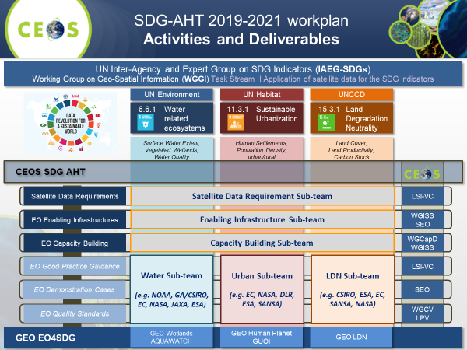
- Sandra Cauffman (NASA) also endorsed the continuation of the SDG-AHT for another year and asked about the plan after this final year, noting that a number of people are contributing to both the CEOS and GEO teams on the SDGs. Alex confirmed that the specifics of the continuation of SDG tasks in CEOS beyond that year are to be decided.
- Trevor Dhu (GA) asked about the SDG-AHT’s relation to EO4SDG in GEO and noted the good work done to have Custodian Agencies acknowledge where satellite EO can fit in the official methodologies. Alex noted that the two activities are connected, and technical experts from CEOS Agencies have been involved in the development of methodologies with the Custodian Agencies, and this will continue.
- Selma Cherchali (CNES) supported the continuation of the SDG-AHT and noted that CNES will contribute to certain tasks in the Work Plan.
- Osamu Ochiai (JAXA) asked if GEO or CEOS is in charge of coordinating the space agency response to the SDGs. Gilberto remarked that it is GEO’s mandate to engage with the UN and connect Custodian Agencies to space agencies. Steve Volz objected, stressing the need for GEO and CEOS to work together, as CEOS is the ‘space arm’ of GEO. Alex noted that there are also direct links through governments, and the SDG-AHT is doing its best to connect all sides.
- Mark Dowell (COM) reported that UNEP has established a World Water Quality Alliance, which will support water quality reporting for SDG 6. This was recently launched at a workshop at the JRC in Ispra. They may be contacting CEOS in the new year requesting support in a number of areas, but specifically for intercomparison exercises between the different water quality products available from different agencies.
- The decision regarding endorsement for a final year of SDG-AHT operation will be revisited under item 5.10.
5.6: AC-VC Air Quality Constellation Validation Needs and Recommendations for Implementation [PPT] [Document]
Presenter: David Crisp (NASA)
Main points:
- Several countries and space agencies are currently preparing geostationary satellites with a strong focus on Air Quality (AQ). Responding to the CEOS Work Plan Action VC-3, AC-VC prepared a white paper ‘Geostationary Satellite Constellation for Observing Global Air Quality: Geophysical Validation Needs’.
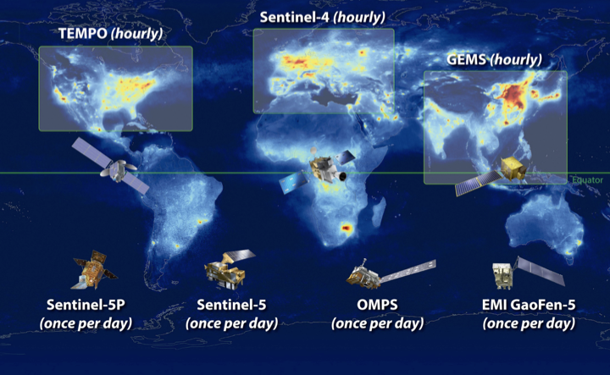
- The white paper elaborates the validation needs of the constellation; identifies ‘Constellation Products’ common to the missions; sets quantitative inter-mission consistency targets for the Constellation Products, and identifies activities needed to assess and establish this consistency; and, makes specific and actionable recommendations.
- The strategy is cost efficient by: building on core validation activities of each individual mission needed anyway, irrespective of the constellation; identifying and leveraging existing activities when possible; and, exploiting existing assets (LEO sensors as travelling standards, networks of inter-calibrated ground-based sensors).
- Implementation should begin immediately, given the planned launch of the GEMS mission in early 2020. The VC-03 CEOS Work Plan Deliverable will be evolved to address implementation.
- Plenary was asked to endorse the Geostationary Satellite Constellation for Observing Global Air Quality: Geophysical Validation Needs white paper.
Main discussion points:
- Whilst signalling general support for the white paper, EUMETSAT noted in its intervention that it has an issue with Recommendation 8. EUMETSAT noted there is no need for the creation of a new entity – Level 1 should be handled in the frame of GSICS and Level 2 is handled in the frame of the CEOS WGCV/ACSG. Paul Counet (EUMETSAT) also noted that Recommendations 5 and 7 make a call for extensive resources. In general, Paul urged that existing solutions be used wherever possible. The AC-VC Leads confirmed that the intent for implementing all recommendations is to leverage existing capabilities as much as possible.
- Simonetta Cheli (ESA) supported the endorsement, again noting that existing ESA infrastructure should be used wherever possible.
- ISRO noted their geostationary satellites for aerosols and reported that they are keen to contribute. David confirmed the focus is on both GHGs and aerosols.
- Steve Volz (NOAA, SIT Chair) supported the endorsement.
Decision 08 | Plenary endorsed the AC-VC Geostationary Satellite Constellation for Observing Global Air Quality: Geophysical Validation Needs white paper.
5.7: Virtual Constellations [PPT]
Presenter: Steve Volz (NOAA, SIT Chair)
Main points:
- SIT-34 produced actions to look at potential changes to CEOS governance, processes, and organisation resulting from discussions on Virtual Constellations (VCs) and Ad Hoc Teams (AHTs) and the formal processes CEOS will mandate for them.
- There have been significant changes in VC leadership recently, as summarised in the chart below.
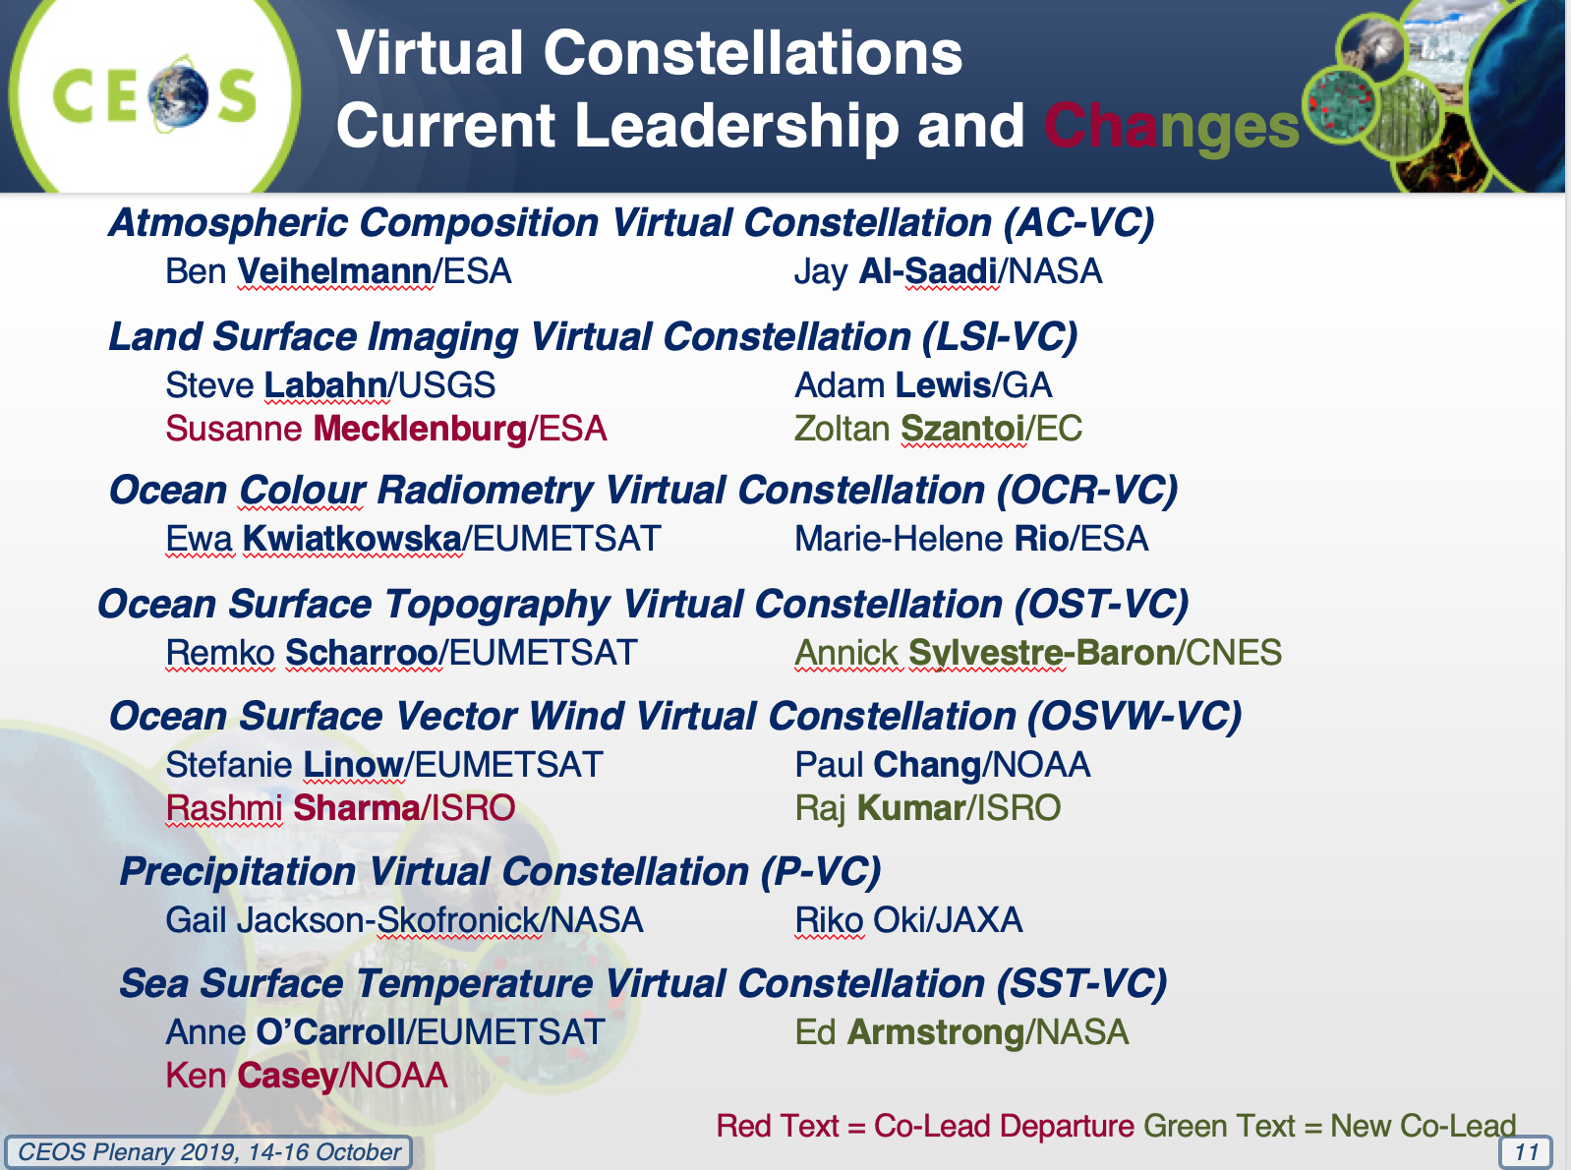
- Notable outputs from the VCs for the last year include:
  - AC-VC: CEOS Architecture for Monitoring Atmospheric CO₂ and CH₄ Concentrations, Greenhouse Gases Roadmap white paper;
  - LSI-VC: Progress on CEOS Analysis Ready Data for Land (CARD4L);
  - OCR-VC: Implementation of the INSITU-OCR white paper;
  - OST-VC: Contributing to the OceanObs ‘19 white paper: Requirements for a Coastal Zone Observing System, and planning the update of the User Requirements Document (URD) in 2020;
  - OSVW-VC: Looking at new technologies for the future of the constellation; refresh of the constellation planned for next year, with a consultation workshop in early 2020.
  - SST-VC: Focusing on contributions to the science community; constellation refresh white paper being prepared for the 2020 CEOS Plenary; preparing a summary of radio-frequency interference (RFI) impacts on SST measurements.
- GEO-LEO: The NOAA SIT Chair Team activity demonstrated utility and significant interest. The SIT Chair does not recommend continuation of a focused activity for GEO-LEO coordination, rather suggesting that continuing work be done within existing CEOS structures and processes. In particular, WGDisasters is working on next steps toward implementing the need for a GEO-LEO-SAR Flood-Risk Pilot Project targeting flood risk areas such as coastal and urban areas.
- Proposal for a CEOS Coastal Observations and Applications Study Team (COAST): NOAA proposes to form a Study Team to do a scoping assessment of CEOS contributions to coastal observations, perhaps around a specific objective or regional scope. The key objective is to move from multi-sensor observations through the value chain to extract information which users can exploit.
- Steve asked Plenary to decide on the creation of the CEOS Coastal Observations and Applications Study Team (CEOS-COAST) (not a formal AHT) with an initial term of 12 months and Work Plan to be submitted by December 2019 for virtual endorsement by SIT, and a progress report at SIT-35. Agency nominations to the Study Team were also requested.
Main discussion points:
- ESA, ISRO, COM, and VNSC supported the creation of the CEOS Coastal Observations and Applications Study Team (CEOS-COAST). ESA and ISRO also offered to participate in the Study Team.
- Adam Lewis (GA, SIT Vice Chair) asked that the multidisciplinary nature of this topic be kept in mind. Emmi Mikedakis (GA) confirmed GA’s support and confirmed they will provide a representative to the Study Team.
- Jenn Lacey (USGS) supported the proposal and noted that USGS will participate on land aspects.
- Selma Cherchali (CNES) supported the proposal and confirmed CNES will participate.
- Alex Held (CSIRO, SIT Vice Chair) supported the proposal, but noted the need to control scope and structure.
- Paula Bontempi (NASA) asked what sort of structure this group will be operating under. Kerry Sawyer (NOAA, SIT Chair Team) confirmed it will use the same Study Team structure as the Working Group Study Team and Ocean Virtual Constellation Merger Study Team. The process will be presented at SIT-35.
Decision 09 | Plenary endorsed the establishment of a study team to consider formulation of a CEOS coastal observations initiative over the next year (CEOS-COAST).

CEOS-33-10 | Paul DiGiacomo and the CEOS Coastal Observations and Applications Study Team (CEOS-COAST) to develop a draft Work Plan for CEOS Agency review and potential virtual endorsement. | December 2019
CEOS-33-11 | CEOS Agencies to identify participants with appropriate expertise and interest in participating in CEOS-COAST. | November 2019
CEOS Virtual Constellation Leadership Succession Proposal and Language Changes
Main points:
- Proposed wording for leadership changes shared for review here: [Document] [Track-changes Version] [Summary Document].
- Plenary was asked to endorse the Virtual Constellations Process Paper rev1 2019, which includes the proposed language changes, and to approve the proposed language changes to the Virtual Constellations Section of the CEOS Governance and Processes Document. Endorsement of the CEOS Governance and Processes rev1 2019 document will be requested during item 5.9, after the AHT life cycle language changes are also presented.
Main discussion points:
- Jenn Lacey (USGS) supported the updates and suggested that an action be given to the VCs to review their own Terms of Reference in response to these changes.
Decision 10 | Plenary approved the proposed changes to the text of the CEOS Virtual Constellations Process Paper and endorsed the CEOS Virtual Constellations Process Paper rev1 2019.
5.8: Results of Study Teams Considering a New Working Group and a Merged Virtual Constellation for the Oceans [PPT]
Presenter: Steve Volz (NOAA, SIT Chair)
Working Group Study Team (WGST) [WGST Document]
Main points:
- The WGST was tasked with evaluating whether there is interest in and feasibility for a new Working Group to provide a single interface to user communities and to filter observation requirements.
- The WGST proposes:
  - To use existing CEOS leadership and technical groups (e.g., CEOS Chair, SIT Chair, SEC, CEO, SEO, VCs, WGs) to address new external data user community requests;
  - That the CEOS organisation formalise the process to streamline and improve the CEOS response to such external requests;
  - The WGST terminate its work with the delivery of its report to the 2019 CEOS Plenary;
- CEOS Plenary is asked to approve the approach proposed above.
- A task team, led by the SEO, will develop a CEOS “External Request Process Paper” (ref: SIT-TW-2019-04).
- The SIT Chair Team also proposes the creation of a separate task team to conduct an assessment of the potential user community needs and external demand for CEOS observations to help CEOS understand the potential workload to CEOS from these external requests (a “market analysis”; ref: SIT-TW-2019-05).
Main discussion points:
- Ivan Petiteville (ESA) clarified that ESA does not support the “market analysis” task. Performing a comprehensive assessment of all user requirements is a very large and difficult task. Similar Copernicus efforts have taken many years and resources.
- Brian Killough (NASA, SEO) confirmed the participants and timeline suggested for the "External Request Process Paper" task team are acceptable.
- Adam Lewis (GA, SIT Vice Chair) urged that the task teams be open and inclusive.
- Osamu Ochiai (JAXA) asked for clarification of the “market analysis” task and how this is related to the “External Request Process Paper” task team.
- Mauro Facchini (COM) supported the "External Request Process Paper" task team but suggested that the “market analysis” task is lacking clarity around the definition of ‘user community’ in particular.
- Gilberto Camara (GEO Secretariat Director) offered GEO Secretariat support for such a ‘market analysis’, provided the scope is reasonably constrained.
- Mark Dowell (COM) noted protocols and processes will be put into place as outcomes of the "External Request Process Paper", and this will aid any future ‘market analysis’ task.
Decision 11 | Plenary decided to utilise existing CEOS leadership and technical group channels (e.g., CEOS Chair, SIT Chair, SEC, CEO, SEO, VCs, WGs) to address new external requests. CEOS needs to consider formalising and codifying the process to streamline and improve the CEOS response to such external requests and an External Request Process Paper is under development by a Task Team created under SIT Technical Workshop 2019 action SIT TW-2019-04, led by the SEO. Plenary agreed not to open a new Plenary action since an action is already open.
Decision 12 | Plenary decided not to establish a Task Team to conduct a ‘market analysis’ assessment of the potential user community needs and external demand for CEOS observations because CEOS is not currently resourced to conduct such a broad-scope analysis.
Ocean Virtual Constellation Merger Study Team (OVCMST) [OVCMST Document]
Main points:
- The Ocean Virtual Constellation Merger Study Team (OVCMST) objective was to assess the feasibility of merging the current four oceans Virtual Constellations – Ocean Colour Radiometry (OCR-VC), Ocean Surface Topography (OST-VC), Ocean Surface Vector Wind (OSVW-VC), and Sea Surface Temperature (SST-VC) – into one Ocean Virtual Constellation and to identify any issues and opportunities that may arise from the merger.
- The OVCMST does not recommend the merger of the four CEOS Ocean VCs into one Ocean VC. The team believed the potential negatives (disrupt current strong connections between VCs and their international science teams; risk weakening the different ocean community voices in CEOS; some issues still require dedicated, domain-specific CEOS-level exposure to support proper coordination and advancement; broad and diverse ranges of data users and applications that require specific expertise) outweighed the potential positives (reduction in the workforce; mechanism to facilitate the harmonisation of multivariate observations into consolidated products; reduced administrative burden; cross-domain harmonised data management practices; and, integrated product development). The proposed merger also did not appear to directly address the fundamental concern of lack of engagement or improve on the delivery of cross-domain, integrated products.
- Plenary was asked to decide on the results of the OVCMST Assessment Report, specifically the recommendation to not merge the four Oceans VCs into one Ocean VC; and, to consider three recommendations to reinforce and reinvigorate VC activity within CEOS, namely: cross-VC collaboration, VC and Working Group coordination, and Ocean VC communication with CEOS overall.

Main discussion points:
- Ivan Petiteville (ESA) noted similarity to a past situation regarding WG reporting to CEOS leadership. He supported the suggestions related to reinvigorating VC engagement with CEOS leadership and suggested inviting reports at the major CEOS meetings.
- Paula Bontempi (NASA) noted that the level of VC representation on SIT agendas has fluctuated over the years and SIT Chair terms. Paula suggested consistency and giving VCs clear direction, roles, and representation at key meetings.
- Ivan Petiteville concluded by noting the usefulness of the streamlining exercise triggered by the SIT Chair. It has revealed two important weaknesses in the CEOS structure and organisation: the lack of process and organisation for handling requests for support coming from major external stakeholders, and the gap and lack of communication between CEOS management and the Ocean VCs.
Decision 13 | Plenary concurred on the recommendation of the Ocean Virtual Constellation Merger Study Team to not merge the four CEOS Ocean Virtual Constellations into one Ocean VC.
Decision 14 | Plenary agreed to consider the three recommendations presented to reinvigorate CEOS Virtual Constellations:  - More crosscutting collaboration among Virtual Constellations.  - More integral coordination among Virtual Constellations and Working Groups.  - Optimise bottom-up and top-down communications overall with the Ocean Virtual Constellations.

CEOS-33-12 | SIT Chair to consider implementation of the three recommendations presented to reinvigorate CEOS Virtual Constellations:  - More crosscutting collaboration among Virtual Constellations.  - More integral coordination among Virtual Constellations and Working Groups.  - CEOS to optimise bottom-up and top-down communications overall with the Ocean Virtual Constellations. | SIT-35
CEOS-33-13 | All Virtual Constellations to review, update, and revise their respective Terms of Reference, as appropriate. | SIT-35
5.9: Ad Hoc Team Initiation Cycle [PPT]
Presenter: Steve Volz (NOAA, SIT Chair)
Main points:
- Proposed wording changes regarding Ad Hoc Team life cycles were shared for review here: [Document] [Track-changes Version] [Summary Document].
- Plenary was asked to endorse the CEOS Governance and Processes rev1 2019, which includes language changes discussed previously in item 5.7 on Virtual Constellations and AHT life cycle language just presented.
Decision 15 | Plenary approved the proposed text changes to the Virtual Constellation, Ad Hoc Team, and Working Group sections of the CEOS Governance and Processes Document and endorsed the CEOS Governance and Processes rev1 2019.
5.10: Ad Hoc Team Continuity Decisions [PPT]
Presenter: Steven Hosford (ESA/CNES, CEO)
Main points:
- Plenary decisions are required on the continuity of the Space Data Coordination Group for GFOI, the Ad Hoc Working Group on GEOGLAM, and the SDG Ad Hoc Team. Steven reviewed each of the proposals from the AHTs and called for decisions from CEOS Plenary – with the results summarised in the decisions below.
Decision 16 | Plenary endorsed the transition of the Ad Hoc Space Data Coordination Group for GFOI to become a thematic subgroup on Forests & Biomass within LSI-VC.
Decision 17 | Plenary endorsed the transition of the Ad Hoc CEOS Working Group on GEOGLAM to become a thematic subgroup on GEOGLAM within LSI-VC.
Decision 18 | Plenary approved a one-year extension for the Ad Hoc Team on Sustainable Development Goals (AHT-SDG) so the AHT can conclude activities and determine if the AHT will transition to a permanent CEOS mechanism or disband.
Main discussion points:
- Jenn Lacey (USGS) noted that LSI-VC will revise its Terms of Reference to reflect the addition of the Forests & Biomass and GEOGLAM subgroups.
CEOS-33-14 | LSI-VC to update its Terms of Reference to incorporate the integration of the thematic subgroups: Forests & Biomass and GEOGLAM. | SIT-35
Session 6: Other CEOS Business
6.1: Report: CEOS Missions, Instruments, and Measurements (MIM) Database [PPT]
Presenter: Ivan Petiteville (ESA)
Main points:
- 28 of 38 agencies responded to the 2019 MIM Database survey.
- Ivan highlighted the significant time investment in the annual updates – both for the CEOS MIM team and the agencies that are involved.
- Recent updates to the MIM Database include: the inclusion of NORAD catalogue numbers for missions, integration with and links to WGISS systems, and featured datasets.
- Multiple past efforts have been made to coordinate with and support WMO’s OSCAR/Space Database. The MIM Database team has supplied WMO with copies of the full MIM Database and a MIM-OSCAR mapping several times in the past ten years, however these inputs from CEOS have not been properly reflected in OSCAR nor have these efforts been reciprocated. The level of detail requested by OSCAR is much higher than the MIM survey requests and is beyond the effort tolerance of CEOS Agency MIM contacts. It is not sustainable for annual updates. Ongoing support to OSCAR and the ECV Inventory will be provided by the MIM Database team.
- The MIM API is under development. Demand has been articulated by several CEOS communities/groups, including LSI-VC, CEOS SEO, ECV Inventory, and WGISS. Pilot activities have demonstrated good benefits.
Main discussion points:
- Steve Labahn (USGS) thanked ESA for the work on the Database, noting it has been particularly useful for the U.S. Sustainable Land Imaging Study. LSI-VC will work with the MIM Database team to reflect CARD4L datasets in the Database.
- Paula Bontempi (NASA) also thanked ESA for the database maintenance and development of new capabilities.
- Astrid-Christina Koch (COM) thanked ESA and encouraged all CEOS Agencies to follow up with agencies that have not responded to the annual MIM survey.
CEOS-33-15 | CEOS MIM team to assess measures for consistency with GCOS IP and OSCAR ECVs and measurements. | CEOS-34
6.2: Report: CEOS Systems Engineering Office (SEO) [PPT]
Presenter: Brian Killough (NASA, SEO)
Main points:
- Key SEO accomplishments for 2019 include: progressing the Open Data Cube initiative through the Partners Forum (strategic) and Steering Council (code contributions); ODC prototype support; Africa Regional Data Cube (testing and training); GEO-AWS project support to Ukraine, Mexico, and Kenya; LSI-VC CARD4L Specifications, advertisement and prototype testing; Sentinel Data Flows working with ESA and Albrecht Schmidt; MIM Database support and testing of an API and gap analysis tools; support to GFOI and GEOGLAM data acquisition planning; maintaining and improving the COVE Tool and the Data Policy Portal; update of the CEOS Deliverables Tool; the WGCapD Training Database; and, the WGISS Open Source Software Inventory Tool.
- The SEO also maintains CEOS website (over 28,000 visits in the last year) and social media content (1674 Twitter followers, 1467 Facebook likes), supports meeting logistics across many CEOS groups, prepares outreach materials for GEO and IGARSS meetings, and maintains the CEOS mailing lists and server software.
- Brian thanked ESA for their support to the SEO, with Albrecht Schmidt in particular, in the domain of ARD.
- The latest ‘Faces of CEOS’ video, starring John Dwyer of USGS, was shown to the Plenary.
Main discussion points:
- Pham Anh Tuan (VAST-VNSC, CEOS Chair) thanked Brian and the SEO for their support to both CEOS and the Vietnam Data Cube/Mekong CEOS Chair Initiative.
- Adam Lewis (GA, SIT Vice Chair) thanked Brian and the SEO for their support to the African Regional Data Cube.
- Mirko Albani (ESA, WGISS Chair) thanked the SEO for their support on the Open Source Software Inventory and various other pieces of WGISS work.
Session 7: Closing Business
7.1: Overview of CEOS Leadership
Presenter: Pham Anh Tuan (VAST-VNSC, CEOS Chair)
Main points:
- NASA has provided a letter formally nominating as Chair of CEOS for 2021 and this was confirmed by Plenary.
Decision 19 | CEOS endorsed NASA as the 2021 CEOS Chair.
- Sandra Cauffman (NASA) thanked CEOS Agencies for their encouragement and endorsement.
- UKSA is considering a nomination for CEOS Chair 2022.
- PG Diwakar (ISRO) noted again the ongoing issue of CEOS Executive Officer continuity. Steven Hosford (ESA/CNES, CEO) noted the interim offer of NOAA (Kerry Sawyer) and the opportunity to find a longer-term solution over the next year or so. Sandra Cauffman noted the need for a process to improve continuity. She also thanked Steven Hosford for serving as CEO, and ESA and CNES for providing the resources for his term.
WGCapD Vice Chair Endorsement
Steven Hosford (ESA/CNES, CEO) reported that a corrected WGCapD Vice Chair nomination letter has been received from VAST-VNSC and shared with CEOS via email. He asked that Plenary now consider the endorsement of Dr Pham Thi Mai Thy (VAST-VNSC) as WGCapD Vice Chair.
Decision 20 | Plenary endorsed Pham Thi Mai Thy of VAST-VNSC as the WGCapD Vice Chair for 2020-2021 and WGCapD Chair for 2022-2023.
7.2: SIT Chair Handover
The transfer of the SIT Chair role from NOAA (Steve Volz) to CSIRO/GA (Alex Held and Adam Lewis) was formalised. ESA also commenced its SIT Vice Chair role for the next two years.
Agencies expressed their gratitude to Steve Volz and the whole NOAA SIT Chair Team for their service to CEOS over the past four years, and welcomed the CSIRO/GA SIT Co-Chairs and their teams.
Steve Volz thanked CEOS for the opportunity to serve as SIT Chair. He thanked the NOAA team who supported him in this role: Kerry Sawyer, Chuck Wooldridge, and Albert DeGarmo.
7.3: CSIRO/GA SIT Chair 2020-2021 Prospectus [PPT]
Presenter: Adam Lewis (GA)
Main points:
- CSIRO/GA plan to evoke the original vision for SIT – making best use of Principals’ time in SIT meetings to address significant challenges to be addressed by coordination and observing system harmonisation across space agencies.
- They are focused on a few priorities – reflecting the major thrusts across civil EO programmes and priority needs:
  - Analysis Ready Data: supporting the effectiveness of public EO programmes with a broad CEOS ARD Strategy – with evolution of CARD4L, new thematic areas, and exploring industry engagement.
  - Carbon and Biomass: prototype GHG products for the first global stocktake in 2023; new relationships with Convention and inventory communities; accelerated policy relevance of new above-ground biomass observing capabilities, including with GFOI; support to the GCOS documents update.
  - Sustainable Development Goals (SDGs): CEOS organisational clarity, and a few focused demonstrations for good practices/methods; establishing a longer-term strategy for CEOS support to the SDGs.
- Priorities reflect existing important CEOS Work Plan activities that will benefit from being escalated, elevated and expedited. Most activities have leadership and plans already. The priorities are intended to be best efforts in nature, as usual.
- Looking into more effective use of the different CEOS meetings. SIT meetings will focus on significant debate and decision by Principals; SIT Technical Workshop will be focused on working teams (reporting, interaction, and preparation for CEOS Plenary). All meetings cannot accommodate reporting of all CEOS business. The SIT Chair will aim to ensure an effective intersection between CEOS management and the working teams.
- SIT-35 will be held in Hobart, Australia, on the 25th and 26th of March 2020 (with side meetings on Tuesday the 24th of March).
- SIT Technical Workshop 2020 will be held in Zagreb, Croatia in the week of September 7.
7.4: CEOS Chair Handover
Pham Anh Tuan (VAST-VNSC, 2019 CEOS Chair) and PG Diwakar (ISRO, 2020 CEOS Chair Team) exchanged the CEOS flag and gavel, signifying the transfer of the CEOS Chair role from VAST-VNSC to ISRO.
PG Diwakar thanked CEOS for the opportunity to serve in this role and thanked Pham Anh Tuan and VAST-VNSC for their strong leadership in 2019.
7.5: Presentation by the 2020 CEOS Chair, ISRO [PPT]
Presenter: PG Diwakar (ISRO, 2020 CEOS Chair Team)
Main points:
- ISRO will pursue the following initiatives as its CEOS Chair priorities. Requests and opportunities for CEOS Agency contributions were detailed in the presentation.
  - Virtual Constellation gap analyses for priority measurements, including global studies of continuity (e.g., many scatterometers are in orbit or planned, but gaps exist with regard to temporal coverage).
  - Applications focus on SDGs for the BIMSTEC (Bay of Bengal Initiative for Multi-Sectoral Technical and Economic Cooperation) Region (e.g., vegetation, LULC, water) incorporating Data Cube technology and CEOS ARD.
  - Renewable energy assessments (solar and wind) from space (e.g., monthly/annual digital energy atlas, solar and wind energy calculator, site selection tool for solar energy).
  - New tools for disaster management – including GEO-LEO based solutions.
- The 34th CEOS Plenary will be held on October 19-21, 2020, in Ahmedabad, India.
Main discussion points:
- Paul Counet (EUMETSAT) reported that EUMETSAT would be particularly interested in a scatterometer coordination priority and noted the CGMS linkage, suggesting that this CEOS Chair priority could also be raised at the next CGMS Plenary.
7.6: Review: 2019 CEOS Plenary Actions
Stephen Ward (2019 CEOS Chair Team) reviewed the Actions and Decisions of the 33rd CEOS Plenary (see Appendix B for the summary).
7.7: Closing Remarks
Pham Anh Tuan (VAST-VNSC, 2019 CEOS Chair) thanked everyone for coming to Hanoi. He thanked the VAST-VNSC CEOS Chair Team for their support throughout 2019, as well as Steven Hosford (ESA/CNES) for his assistance as CEOS Executive Officer. He wished ISRO all the best for their 2020 CEOS Chair year and wished all participants safe onward travel.
The 2019 CEOS Plenary was adjourned.

APPENDIX A
Attendees
Organisation | Name | Organisation | Name
ASI | Laura Candela | NASA | Christine Bognar
ASI | Simona Zoffoli | NASA | David Crisp
CAST | Jun Dai | NASA | David Green
CNES | Selma Cherchali | NASA | David Jarrett
CNES | Thuy Le Toan | NASA | Kimberly Hurst
CSIRO | Alex Held | NASA | Lauren Childs-Gleason
CSIRO | Amy Parker | NASA | Paula Bontempi
CSIRO | Cindy Ong | NASA | Sandra Cauffman
CSIRO | Flora Kerblat | NIER | Jaehoon Jeong
CSIRO | Robert Woodcock | NOAA | Charles Wooldridge
DLR | Klaus Schmidt | NOAA | Kerry Sawyer
ESA | Ivan Petiteville | NOAA | Mitchell Goldberg
ESA | Mirko Albani | NOAA | Stephen Volz
ESA | Simonetta Cheli | NSO | Joost Carpay
ESA/CNES | Steven Hosford | Roscosmos | Andrey Kuklin
EUMETSAT | Jörg Schulz | Roscosmos | Tamara Ganina
EUMETSAT | Paul Counet | Roshydromet | Zoya Andreeva
EUMETSAT | Robert Husband | SANSA | Andiswa Mlisa
European Commission | Astrid-Christina Koch | SANSA | Imraan Saloojee
European Commission | Mauro Facchini | UKSA | Bertie Archer
GA | Adam Lewis | USGS | Christopher Barnes
GA | Andreia Siqueira | USGS | Jenn Lacey
GA | Emmi Mikedakis | USGS | Steve Labahn
GA | Trevor Dhu | USGS | Timothy Stryker
GEO | Gilberto Camara | VAST-VNSC | Kien Nguyen
GEOGLAM | Ian Jarvis | VAST-VNSC | Linh Phan Ngoc Phuong
GGOS | Richard Gross | VAST-VNSC | Matthew Steventon
ISRO | PG Diwakar | VAST-VNSC | Ngoc Pham Diem
ISRO | Prakash Chauhan | VAST-VNSC | Nguyen Lam Dao
JAXA | Hitoshi Tsuruma | VAST-VNSC | Nguyen Tien Cong
JAXA | Kazuo Tachi | VAST-VNSC | Sean Lam
JAXA | Osamu Ochiai | VAST-VNSC | Stephen Ward
JAXA | Tsugito Nagano | VAST-VNSC | Thi Mai Thy Pham
KMA | Geun-Hyeok Ryu | VAST-VNSC | Tuan Pham Anh
KMA | Jae-Dong Jang | VAST-VNSC | Tuan Vu Anh
NASA | Andrew Mitchell | VAST-VNSC | Vance Hum
NASA | Brian Killough | WMO/GCOS | Carolin Richter

APPENDIX B
Actions and Decisions Record
No. | Action | Due Date
CEOS-33-01 | WGClimate Chair to integrate agency comments and issue a final draft of the CEOS/CGMS Space Agency Statement for SBSTA-51 for virtual endorsement by CEOS Principals. | 20 October 2019
CEOS-33-02 | SIT Chair to prepare and broaden the response to WMO’s letter on enhancing collaboration with CEOS and providing focal points for the OSCAR/Space Database to include references to the following points:  - the importance of a strong GCOS programme to space agencies;  - for WMO to more fully resource the OSCAR system. | November 2019
CEOS-33-03 | European Commission to plan a workshop at the Joint Research Centre to support dialogue among the Greenhouse Gas and Agriculture, Forestry and Other Land Use (AFOLU) communities. | June 2020
CEOS-33-04 | Mark Dowell and SIT Chair Team to plan for a dedicated discussion at the 2020 SIT Technical Workshop (Zagreb, Croatia, September 2020) among relevant CEOS entities, GCOS, and the UNFCCC Secretariat on Climate Change Convention engagement by space agencies. | September 2020
CEOS-33-05 | Mark Dowell to progress the definition of another round of actions from the CEOS Carbon Strategy and their inclusion in the CEOS 2020-2022 Work Plan, focusing on those entities that did not participate in the first round of actions (i.e., OCR-VC and SST-VC). | January 2020
CEOS-33-06 | CEOS Chair and leadership to consider an intervention or a letter for the World Radiocommunication Conference (WRC-19, 28 October – 22 November) regarding the protection of bands above 24.25 GHz, and to encourage CEOS Agencies to take action both individually and through national representatives. | 28 October 2019
CEOS-33-07 | CEOS Executive Officer to remove the International Geosphere-Biosphere Program (IGBP) and Global Terrestrial Observing System (GTOS) from the list of CEOS Associates, due to them no longer functioning. | 20 October 2019
CEOS-33-08 | SANSA and CSIRO/GA to reach out to CSIR/SAC and CRI respectively to ascertain whether they are still active and interested in continuing to be identified as CEOS Associates. | November 2019
CEOS-33-09 | ESA to send the WGCV Chair a formal letter nominating Philippe Goryl for the role of WGCV Vice Chair, in accordance with procedures in the Working Group Process Paper. | November 2019
CEOS-33-10 | Paul DiGiacomo and the CEOS Coastal Observations and Applications Study Team (CEOS-COAST) to develop a draft Work Plan for CEOS Agency review and potential virtual endorsement. | December 2019
CEOS-33-11 | CEOS Agencies to identify participants with appropriate expertise and interest in participating in CEOS-COAST. | November 2019
CEOS-33-12 | SIT Chair to consider implementation of the three recommendations presented to reinvigorate CEOS Virtual Constellations:  - More crosscutting collaboration among Virtual Constellations.  - More integral coordination among Virtual Constellations and Working Groups.  - CEOS to optimise bottom-up and top-down communications overall with the Ocean Virtual Constellations. | SIT-35
CEOS-33-13 | All Virtual Constellations to review, update, and revise their respective Terms of Reference, as appropriate. | SIT-35
CEOS-33-14 | LSI-VC to update its Terms of Reference to incorporate the integration of the thematic subgroups: Forests & Biomass and GEOGLAM. | SIT-35
CEOS-33-15 | CEOS MIM team to assess measures for consistency with GCOS IP and OSCAR ECVs and measurements. | CEOS-34

Decision 01 | Endorsement of the CEOS/CGMS Statement to SBSTA-51 will be accomplished virtually after the 2019 CEOS Plenary.
Decision 02 | Plenary endorsed the definition of another round of actions from the CEOS Carbon Strategy and their inclusion in the CEOS 2020-2022 Work Plan.
Decision 03 | Plenary endorsed Makoto Natsuisaka of JAXA as the WGISS Vice Chair for 2020-2021 and WGISS Chair for 2022-2023.
Decision 04 | Plenary endorsed the CEOS Analysis Ready Data Strategy.
Decision 05 | Plenary endorsed the updated WGDisasters Terms of Reference.
Decision 06 | Plenary endorsed Pierric Ferrier of CNES as the WGDisasters Vice Chair for 2020-2021 and WGDisasters Chair for 2022-2023.
Decision 07 | Plenary endorsed the CEOS Response to GEOGLAM Requirements 2019.
Decision 08 | Plenary endorsed the AC-VC Geostationary Satellite Constellation for Observing Global Air Quality: Geophysical Validation Needs white paper.
Decision 09 | Plenary endorsed the establishment of a study team to consider formulation of a CEOS coastal observations initiative over the next year (CEOS-COAST).
Decision 10 | Plenary approved the proposed changes to the text of the CEOS Virtual Constellations Process Paper and endorsed the CEOS Virtual Constellations Process Paper rev1 2019.
Decision 11 | Plenary decided to utilise existing CEOS leadership and technical group channels (e.g., CEOS Chair, SIT Chair, SEC, CEO, SEO, VCs, WGs) to address new external requests. CEOS needs to consider formalising and codifying the process to streamline and improve the CEOS response to such external requests and an External Request Process Paper is under development by a Task Team created under SIT Technical Workshop 2019 action SIT TW-2019-04, led by the SEO. Plenary agreed not to open a new Plenary action since an action is already open.
Decision 12 | Plenary decided not to establish a Task Team to conduct a ‘market analysis’ assessment of the potential user community needs and external demand for CEOS observations because CEOS is not currently resourced to conduct such a broad-scope analysis.
Decision 13 | Plenary concurred on the recommendation of the Ocean Virtual Constellation Merger Study Team to not merge the four CEOS Ocean Virtual Constellations into one Ocean VC.
Decision 14 | Plenary agreed to consider the three recommendations presented to reinvigorate CEOS Virtual Constellations:  - More crosscutting collaboration among Virtual Constellations.  - More integral coordination among Virtual Constellations and Working Groups.  - Optimise bottom-up and top-down communications overall with the Ocean Virtual Constellations.
Decision 15 | Plenary approved the proposed text changes to the Virtual Constellation, Ad Hoc Team, and Working Group sections of the CEOS Governance and Processes Document and endorsed the CEOS Governance and Processes rev1 2019.
Decision 16 | Plenary endorsed the transition of the Ad Hoc Space Data Coordination Group for GFOI to become a thematic subgroup on Forests & Biomass within LSI-VC.
Decision 17 | Plenary endorsed the transition of the Ad Hoc CEOS Working Group on GEOGLAM to become a thematic subgroup on GEOGLAM within LSI-VC.
Decision 18 | Plenary approved a one-year extension for the Ad Hoc Team on Sustainable Development Goals (AHT-SDG) so the AHT can conclude activities and determine if the AHT will transition to a permanent CEOS mechanism or disband.
Decision 19 | CEOS endorsed NASA as the 2021 CEOS Chair.
Decision 20 | Plenary endorsed Pham Thi Mai Thy of VAST-VNSC as the WGCapD Vice Chair for 2020-2021 and WGCapD Chair for 2022-2023.

