CEOS Analysis Ready Data Governance Framework
18 October 2021
The purpose of this document is to present all aspects of the governance of CEOS Analysis Ready Data (ARD), including the high-level definition, processes for defining certain types of CEOS ARD (via Product Family Specifications, PFS), and the process by which datasets meet the requirements to be classified as CEOS ARD.
1: CEOS ARD Framework
1.1: Overview
The CEOS ARD Framework covers:
- Generalised CEOS ARD definition
- The role of the Product Family Specifications (PFS)
- PFS core elements
- Development process for new PFS
- Self-assessments and CEOS roles in the process
- General process for peer review of self-assessments and approval of CEOS ARD datasets
- Classification and promotion of CEOS ARD datasets
- The role of Advisory Notes in providing guidance on aspects like file formats, etc. which are not part of the core Framework.
2: CEOS ARD Definition
“CEOS Analysis Ready Data are satellite data that have been processed to a minimum set of requirements and organized into a form that allows immediate analysis with a minimum of additional user effort and interoperability both through time and with other datasets.”
The definition of CEOS ARD reflects the attributes of fundamental measurement products for the majority of global remote sensing users, and are the minimum level required to support time series analysis and data interoperability.
3: CEOS ARD Coordination and Oversight
The development of CEOS ARD, including the framework, governance processes, strategy, and implementation will be coordinated between the CEOS Executive Officer, SIT Chair, and nominated representatives from each of the CEOS Virtual Constellations, the Working Group on Calibration and Validation (WGCV), and the Working Group on Information Systems and Services (WGISS).
CEOS ARD (CARD) coordination meetings including the above participants and others as appropriate will be held annually in the wings of the SIT and SIT Technical Workshop meetings to consider approvals, cross-cutting matters and other leadership matters related to CEOS ARD.
Where CEOS endorsement is required for anything emerging from the coordination meetings, the relevant VC(s) will elevate the matter through the SIT Chair in accordance with existing reporting arrangements.
4: Product Family Specifications
4.1: Purpose
Product Family Specifications (PFS) are the core component of the CEOS ARD concept and describe Analysis Ready Data specifications for a measurement type. PFS are a flexible and extensible framework to detail specific requirements that a dataset must satisfy in order to be classified as CEOS ARD. Each PFS has the following core elements:
- General Metadata: allowing the user to assess the overall suitability of the dataset;
- Per-pixel Metadata: allowing users to choose which observations (e.g., pixels) to use or discard;
- Requirements for Radiometric Corrections and Accuracy: specifying any corrections that must be made to the data to reach a measurement, and accuracy requirements for the data to be analysis-ready;
- Requirements for Geometric Corrections and Accuracy: specifying the geometric corrections that must be made and geometric accuracy that is required for the data to be analysis-ready.
All PFS will address the core elements above. However, it is worth noting that the exact form of the Specification (i.e., which items / parameters appear in the documents’ tables) will differ from one product family to the next, because the measurement, instrumentation, mode of observation, levels of maturity, expectation of the user community, etc. will differ between product types.
The Specifications detail two levels of requirements – 'Threshold' and 'Target'. The Threshold level is the minimum level to meet the requirement, whereas the Target level will represent the leading edge and may not be achievable by all data providers at the time of setting the specification. Target levels could be interpreted as aspirational requirements, which might become the Threshold requirement in future revisions of the PFS, or interpreted as desirable but not necessary characteristics.
The PFS are intended to be self-contained documents, which allow data providers to complete their self-assessments by including fields for detailing how their products meet the specifications, as well as fields to record feedback on the specifications themselves. This feedback is vital input to the annual review of each PFS.
The template PFS (the ‘bare bones’) can be found here.
4.2: Development of Product Family Specifications (PFS)
Given the thematic nature of the PFS, CEOS Virtual Constellations (VC) will serve as the fora in which new PFS are proposed and developed. The open nature of VCs, able to include CEOS-external representatives, potentially including end users, makes them the perfect structure in CEOS to define the PFS.
- Product family specifications will be developed by and through the virtual constellation (VC) teams, ensuring that each PFS has a clear owner in CEOS and that the leadership includes the key stakeholders and expertise needed for the product.
Requirement (Demand)
- PFS will be developed when producers, experts and users perceive that there is a benefit and are prepared to invest in the effort to develop PFS, manage the process, and undertake to produce the data.

Resources
- CEOS ARD is demand-driven. A PFS will be developed only when the relevant VC is committed to the development and support of the PFS, recognising that development of a PFS requires significant and sustained effort, including convening of meetings with interest groups to develop shared understanding, gather input, and agree on and communicate the specification.
- A point of contact (POC) will be identified for each PFS. Each PFS requires a clear owner in the VC and the leadership also needs to include key stakeholders and the expertise necessary for the definition of the product.
- To facilitate the development of a new PFS, information and experience will be freely shared within CEOS through the POCs.
Consultation
- The development of PFS must consider both the user needs and the ability of data providers to produce data to the threshold level specifications. The teams formed to develop PFS should therefore seek to include data providers, users, and experts. Participation should be sought from CEOS thematic working groups as well as GEO, as these groups bring application perspectives.
Consistency
- A template PFS has been developed to provide a starting point for future PFS, to ensure commonality in layout, general structure, interpretation and approach. The template will be maintained at ceos.org/ard
- While there is high-level commonality between PFS and there are some core requirements, the requirements will vary for each thematic domain. The PFS are intended to be flexible in this regard (e.g., a radar PFS may include requirements that are not applicable to an optical sensor PFS).
Acceptance of a New PFS
- A new PFS requires endorsement by the relevant VC, which will consult with the other VCs to ensure consistency.
- The lead VC will elevate the draft PFS for CEOS approval through the coordination mechanism identified above.
Review Process
Once approved and in use, PFS need to be reviewed and updated periodically to ensure they are evolving in line with technological trends and user needs, as well as to address oversights or community concerns. Reviews are particularly important in the early years of the PFS, as feedback begins to be gathered from data providers and users. The lead VC will manage the revision.
Review includes processes for:
- Gathering stakeholder feedback on a Specification;
- Considering the feedback received and revising the PFS;
- Agreeing and approving the revised PFS;
- Providing advice and guidance on the implications of the review for existing CARD products, e.g., will CARD products automatically meet the new specification, or require partial re-assessment;
- Considering whether the feedback received might also have implications for other PFS – necessitating communication with other VCs, perhaps via the CEOS ARD (CARD) coordination meetings
Communication
- Endorsed PFS documents are added to ceos.org/ard for reference and use.
5: CEOS ARD Products
CEOS ARD Products are products that have been assessed to determine that they meet the requirements of CEOS ARD, as detailed in the PFS. The assessment process consists of:
- Self-assessment by the data provider; and,
- Peer review by CEOS experts.
5.1: Self-Assessments
Self-assessment is the process in which data providers review each item in a PFS and assess whether their product satisfies either the ‘Threshold’, ‘Target’, or both of the requirements. PFS are written as a form that can be completed by data providers in the self-assessment phase – keeping the process and guidance self-contained for ease of use.
- Data providers use self-assessments to put forward their product as compliant with CEOS ARD Specifications.
- Data providers complete the self assessment columns of the PFS form and compile necessary supporting information
- The columns of the Product Family Specification form help the data provider to assess how well the specific product complies with each of the criteria in the Product Family Specification. This includes providing a description of how the dataset complies with each element.
The VC responsible for overseeing the specific PFS appoints a POC to serve as point of contact for any questions.
5.2: Peer Review
Following completion of the self-assessment, a peer review is undertaken to independently confirm that the specification is met.
Key principles of the peer review are:
- independence, including that the data provider is not involved in the review;
- expertise-based, ensuring that experts in the data products are used in the peer review;
- timeliness and efficiency, ensuring that the work-load is manageable and that data providers receive feedback in a reasonable period of time.
Submission
- For peer review, the data provider submits a complete package that will consist of the self-assessment PFS form, sample data, associated metadata, and any other necessary references to the designated POC of the VC responsible for overseeing the specific PFS.
- The VC POC does a first pass to ensure the submitted package is complete, and if not, they work with the data provider to resolve any issues.
Peer Review
- The relevant CEOS entity (normally the VC with carriage of the PFS) provides a review including:
  - a rapid first pass to confirm all necessary info is present;
  - confirming the data provider’s self-assessment;
  - working with the data provider to address any issues.
Acceptance
- The relevant CEOS entity (normally the VC with carriage of the PFS) determines if the data product meets the specification.
- Products that meet the specification will be accepted as Compliant with CEOS ARD and classified as either fully meeting the ‘Threshold’ level plus some degree of the ‘Target’ level – or perhaps fully compliant for both.
Notification
- The POC will promptly notify the data provider in writing of the outcome of the peer review.
Communication
- Datasets submitted for Peer Review will be listed on ceos.org/ard – specifically the ‘Under Assessment’ dataset table.
- A dataset that has been accepted as compliant will be listed on ceos.org/ard – specifically the ‘CEOS Analysis-Ready Datasets’ table.
6: Classification and Promotion
6.1: Specifications
Endorsed Product Family Specifications will be openly available on ceos.org/ard
6.2: Dataset Register
Once confirmed as meeting the requirements of CEOS ARD, satellite EO datasets are added to the CEOS ARD Website table. DOI links are provided for access, along with links to further information (e.g., the data provider’s website, CEOS MIM Database records), sample products, and the completed CEOS ARD self-assessment and peer review outcome documents.
CEOS ARD Datasets are also promoted via the CEOS MIM Database.
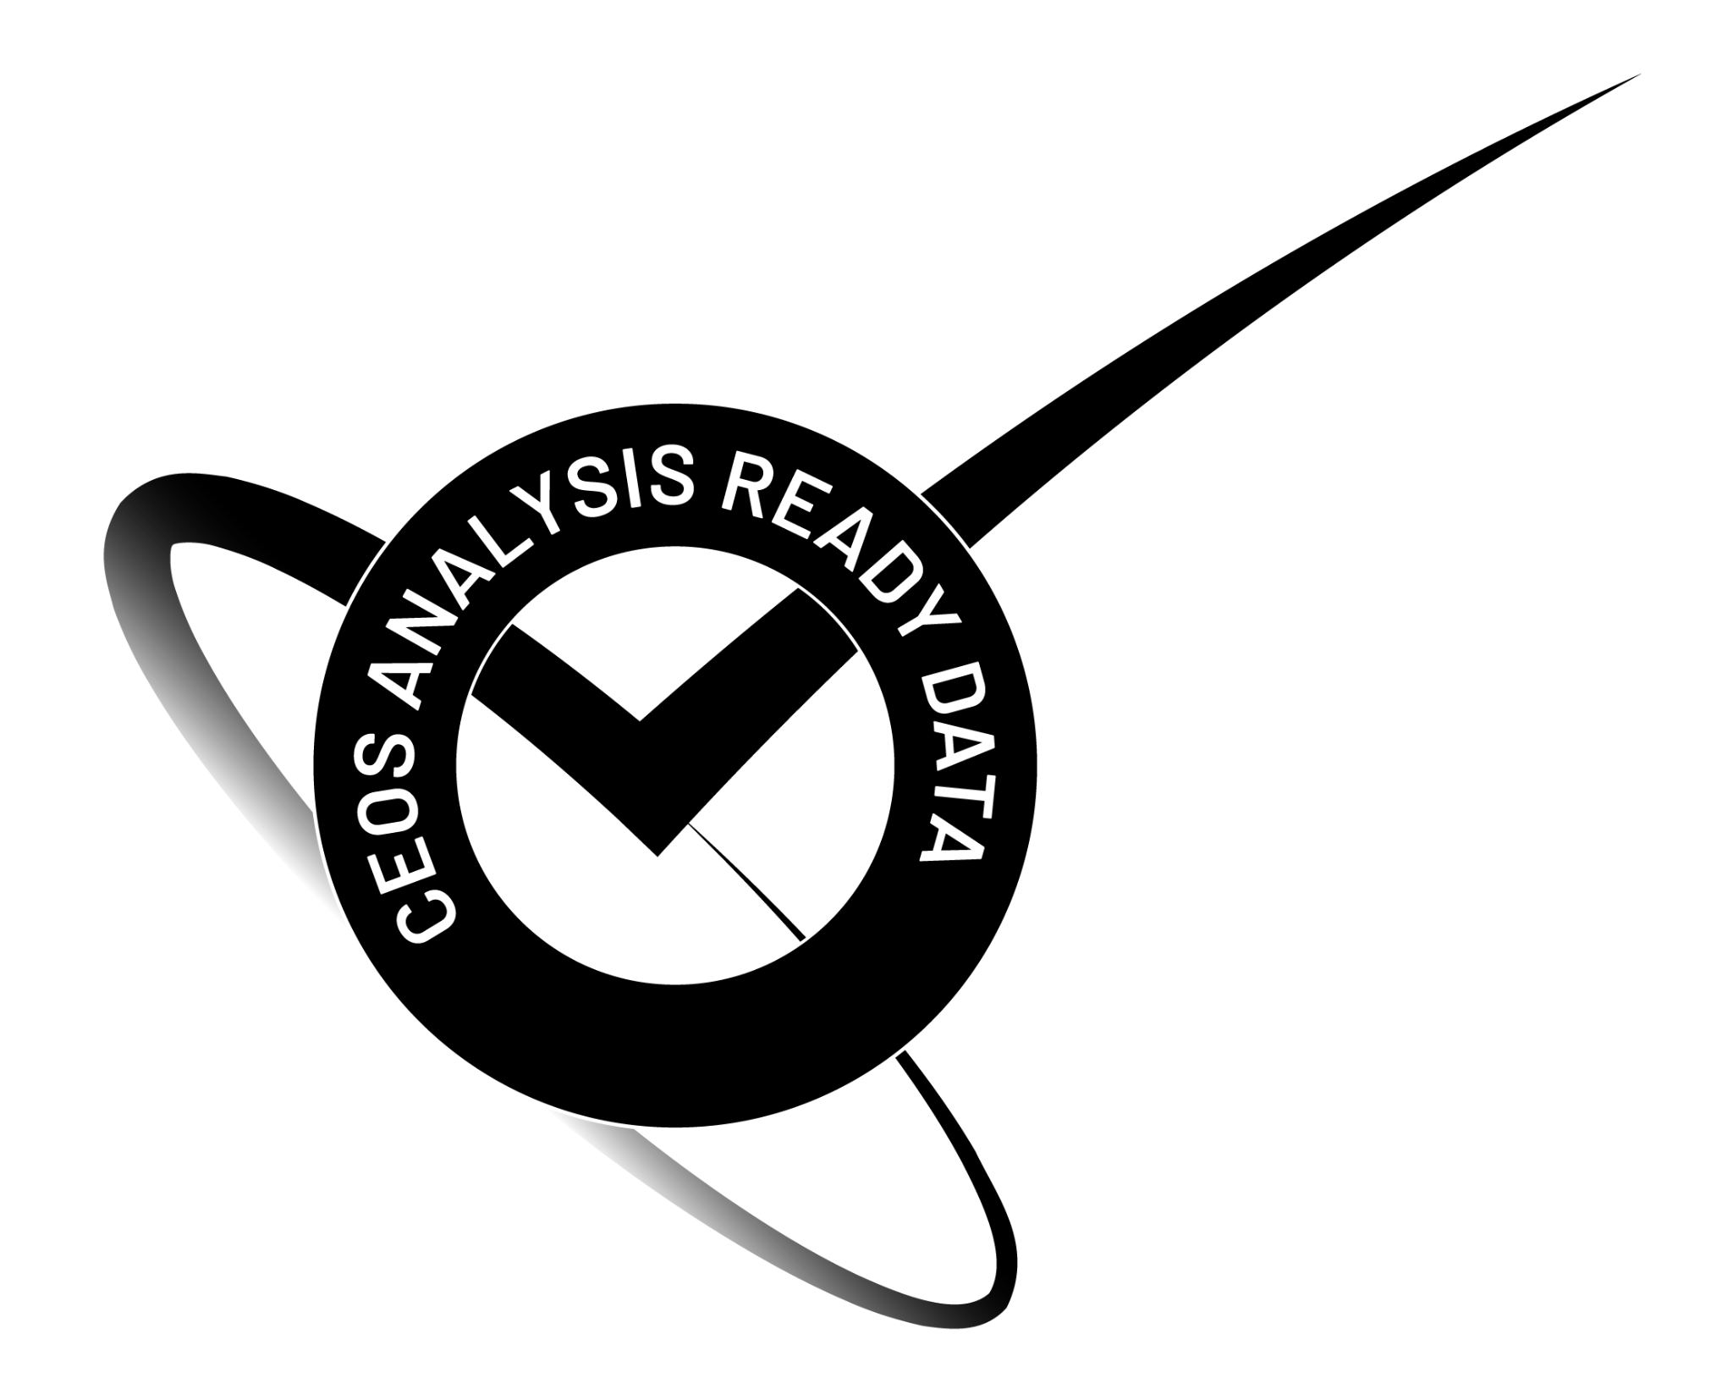
6.3: CEOS ARD Logo
The CEOS ARD Logo (shown on the right) is the property of the CEOS organization and has been created to allow:
- Data Providers to highlight which of their datasets have been assessed and approved against the CEOS ARD Product Family Specifications (PFS).
- Data Users to easily identify which datasets have been assessed and approved against the CEOS ARD Product Family Specifications (PFS).
The CEOS ARD Logo may only be used in accordance with these conditions. Complying with these conditions grants all users non-exclusive license to use the CEOS ARD Logo on printed and digital materials. The following conditions apply:
- CEOS Agencies may use the logo to promote their general support for the CEOS ARD Strategy and its framework, and to promote ARD datasets that have been assessed and approved against the CEOS ARD Product Family Specifications (PFS).
- Data Providers, including CEOS Agencies and external organizations (e.g., commercial data providers or cloud data distributors), may use the logo to highlight specific datasets that have been assessed against and found to comply with the CEOS ARD Product Family Specifications (PFS).
7: Advisory Notes
CEOS ARD Advisory Notes are intended to provide guidance on aspects such as file formats, etc. which are not part of the core Framework. Advisory Notes will be found on the CEOS ARD website and will be developed by CEOS entities as needed in response to an identified need.

