CEOS Coastal Observations, Applications, Services and Tools (COAST) Ad Hoc Team (AHT) Information Note to CEOS Principals for 36th CEOS Plenary
20 October 2022

For CEOS Principals Decision
The CEOS Coastal Observations, Applications, Services and Tools Ad Hoc Team (COAST AHT) invites the CEOS Principals at the 36th CEOS Plenary to approve an extension of the CEOS COAST AHT for one year, in accordance with the CEOS Governance and Processes.

Context:
Creation of the CEOS Coastal Observations and Applications Study Team (CEOS-COAST) was approved at the 33rd CEOS Plenary in October 2019. In 2020, the CEOS-COAST coordinated and prepared COAST Phase 1 deliverables which identified the specific scope and priorities of the COAST effort moving forward, focusing on the transboundary and transdisciplinary nature of the coastal zone. These included three scoping whitepapers for COAST Phase 2 pilot activities in 2021, a compilation of relevant international projects, and an annotated bibliography (see https://ceos.org/ourwork/ad-hoc-teams/ceos-coast/). In response to these COAST Phase 1 activities and deliverables, the request to transition COAST from a Study Team into CEOS Coastal Observations, Applications, Services and Tools Ad Hoc Team (COAST AHT) was approved at the 34th Plenary in October 2020, with the Indian Space Research Organisation (ISRO) and the National Oceanic and Atmospheric Administration (NOAA) as identified Co-Leads.
There is a broad spectrum of coastal needs, issues and challenges, with a diverse ecosystem of stakeholders that can potentially be engaged in Phase 2. Specifically, sea impacts on land – including coastal hazards such as flooding and inundation, at continental as well as for small island states – as well as land impacts on the sea, including water quality issues such as coastal eutrophication and sediment loading, affecting the ability of the coastal ecosystem to deliver valuable goods and services. Within this framework, the specific objectives of the CEOS COAST AHT are to:
- Identify and analyze opportunities for new and emerging satellite-based observations and derived capabilities to support coastal needs, challenges and opportunities (e.g., new methods, new data, new products).
- Implement COAST priority pilots & supporting infrastructure identified in Phase 1.
- Engage with GEO, UN entities and other relevant authoritative stakeholders on coastal needs and issues, working together on pilot project implementation, and building partnerships to transfer and sustain COAST deliverables after Phase 2.
- Provide a forum for sharing/communicating best practices and approaches across CEOS and the broader international community in support of COAST activities and priorities, providing easy access to methodological development, tools and platforms, and ready discovery and accessibility to high priority global/regional data sets.
- Strategically utilize CEOS assets and bodies to engage with users and advance capabilities for COAST pilot project implementation, and also generally for future COAST planning and activities.

Highlights of COAST AHT Activities:
- Successful outreach and stakeholder engagement events - introducing COAST to new audiences and demonstrating regional data products and the COAST Application Knowledge Hub to regional pilot stakeholders (Bay of Bengal, Chesapeake Bay).
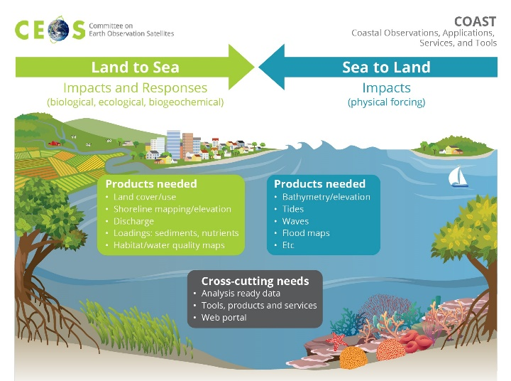
- Exceptional strides to train the internal CEOS teams and to work on product development in the CEOS Earth Analytics Interoperability Lab (EAIL).
- Continued work advancing thematic products in project areas such as flooding, coastline mapping, coastal eutrophication, especially in the Chesapeake Bay, Bay of Bengal and West Coast Africa.
- Emerging opportunities to pursue product development in La Plata Estuary for Turbidity and coastal bathymetry.
- COAST was formally endorsed by the IOC as a UN Ocean Decade Contribution on June 8, 2021.
- Observing Our Coasts Article in ECO Magazine, May 2021 Special Issue on the UN Decade of Ocean Science for Sustainable Development.
- Recently submitted two manuscripts on the COAST AHT and proceedings from the COAST Workshop at Oceans 22 Meeting for consideration in peer-reviewed publications for December release.

Future Plans for COAST AHT:
- Complete Phase 2 work building products and engaging stakeholders in all pilot regions (i.e., La Plata Estuary and Small Island Nations).
- Blue Carbon (with Marine Biodiversity Observation Network-MBON and GEO Biodiversity Initiative-GEOBON): Evaluate nature-based solutions to coastal resilience; take the USGS-led Ecological Coastal Units to the next level; advance habitat mapping/monitoring (e.g., seagrasses/mangroves) with GEO Blue Planet.
- Engage additional Pilot Regions in Polar (Arctic focus) and Asia; explore using data from new missions (e.g., SWOT) in support of COAST objectives.
- Increased emphasis on utilizing CEOS EAIL, which will require further sustainment and development support to expand capabilities and data offerings.
- Continued discussions with the Ocean Coordination Group, led by the Strategic Implementation Team (SIT) Chair, on how to converge the activities of the COAST AHT and the Ocean Coordination Group.

Recommendation:
The success of the COAST AHT Phase 1 and Phase 2 activities over the past two years, and the linkage to biodiversity, and the proposed Phase 3 activities support a one-year extension of the COAST AHT in accordance with CEOS Governance and Processes, which states that an “Ad Hoc Team will have an initial two-year term…if it is clear the objective of the Ad Hoc Team will exceed the initial two-year term, the Ad Hoc Team will either identify an existing permanent mechanism for the activities of the Ad Hoc Team; recommend Plenary consider the creation of a new permanent mechanism; or request that Plenary grant a one-year extension of the Ad Hoc Team.”
CEOS 36th Plenary participants are requested to approve a one-year extension of the COAST AHT.

