CEOS Land Surface Imaging Interoperability Framework
Discussion Paper
3 August 2022

The CEOS Analysis-Ready Data (CEOS-ARD) framework is a first step towards increasing the interoperability of Earth observation datasets. The CEOS-ARD Product Family Specifications (PFS) define a series of parameters which facilitate interoperability both through time and with other datasets. CEOS-ARD is a first step on the interoperability spectrum:
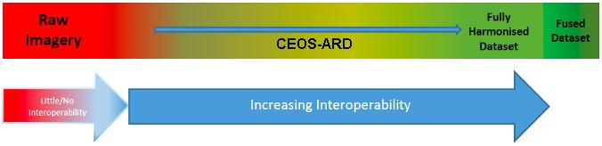
Parameters currently covered by the PFS are only a subset of what needs to be considered when trying to achieve full interoperability of datasets. Addressing the full scope of interoperability requires a larger framework that captures all aspects of the problem. The following (non-exhaustive list) are all important factors to consider, and each have a number of component pieces:
- Structural / Data Architecture
- Accessibility / System / Data Presentation
- Formats / Syntactic / Data Language
- Terminology / Semantics / Data Context
Given the scope of the EO data interoperability problem, each of these factors and their components are distributed across many CEOS groups (e.g., LSI-VC, WGISS, WGCV, etc.), and therefore a robust framework and coordination mechanisms are needed to address all of the necessary pieces. Complex issues are best tackled by breaking them down to simpler and related sub-parts to:
- help to treat the issue comprehensively (no gaps) and efficiently (no overlaps)
- be as much as possible independent from each other and with clear delineations and interfaces
- have the right granularity to distribute the effort equally and assemble enough contributors
The concept of ‘interoperability’ is of course much broader than satellite EO and is a major common concern in all modern societies. Interoperability has been extensively studied in areas ranging from public administration, to transportation, supply chains, health care, and of course IT-systems. Hierarchical models exist side by side with sequential and transversal approaches; certain elements are common; others differ.
It is proposed that any CEOS effort should be built upon and derived from one of these existing, broad, well considered, and well defined frameworks. Some examples are the European Interoperability Framework, the European Open Science Cloud Interoperability Framework, and the Knowledge Organisation (KO) Interoperability Framework.
Once an appropriate framework has been agreed, the next step will be to apply it to the specific problem of Earth observation dataset interoperability, and allow us to effectively structure future work and define responsibilities across the CEOS organisation.
Proposal for LSI-VC-12 Discussion
Assuming that the goal of LSI-VC is to move CEOS agency and other data providers' land surface imaging datasets along the interoperability spectrum, with a view to a future of sensor agnostic land surface data from all missions, it is proposed that an interoperability framework is required to tackle this comprehensively and in a coordinated fashion.
While this discussion has emerged in the LSI-VC, the concept is broadly applicable across CEOS and could result in a broad CEOS Interoperability Framework.
A substantial discussion will be planned for LSI-VC-12 around the following questions:
- Do we need a CEOS Interoperability Framework (CEOS-IF)?
  - Should it focus on LSI or should it encompass all CEOS work?
  - Do you know of some particularly well-suited frameworks for our purpose?
  - Which one is, or could be, suitable for your agency?
- How many and which components should a CEOS-IF have?
  - Which of the shown examples would you follow?
  - What should be adapted?
  - Where do you see your own expertise best represented?
- Which components would LSI-VC lead?
  - Where could you lead or contribute?
- Which components would LSI-VC contribute to?
  - In which of these areas are you already active and in which frame (agency / national / international)?
  - Which layers are you interested in and willing to discuss?
- Who should deal with the other components?
  - Which topics should be addressed within CEOS and by whom?
  - What is out of scope for CEOS and do you have suggestions whom we might need to cooperate with?
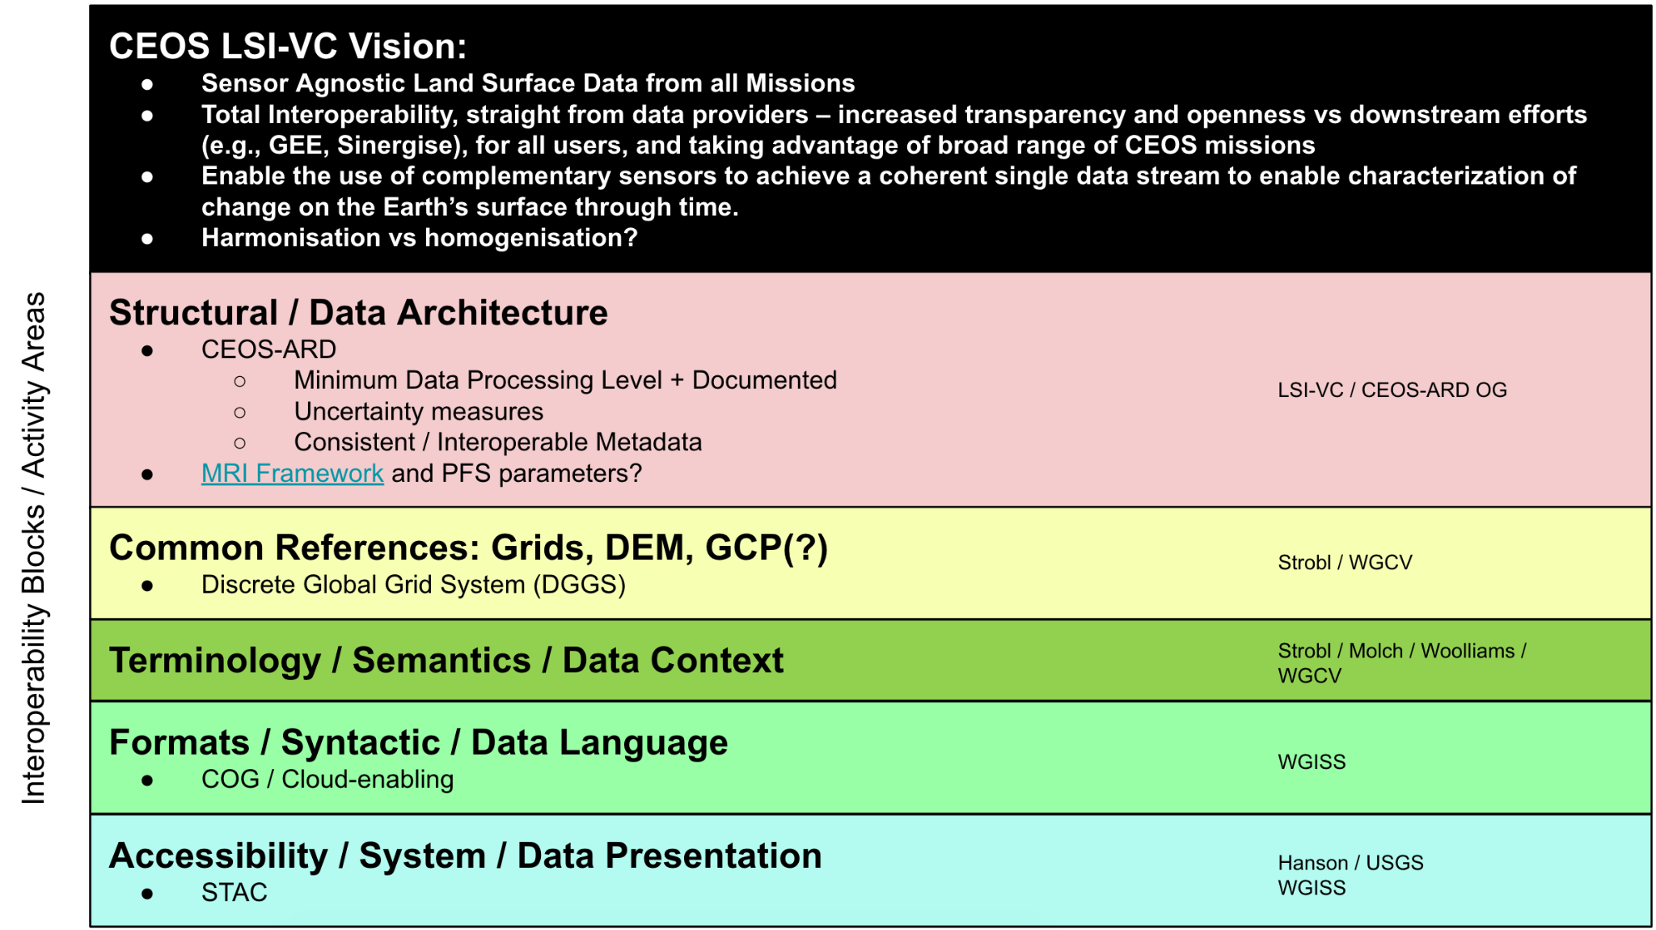

From the endorsed definition of CEOS Analysis-Ready Data: “CEOS Analysis Ready Data (CEOS-ARD) are satellite data that have been processed to a minimum set of requirements and organized into a form that allows immediate analysis with a minimum of additional user effort and interoperability both through time and with other datasets.”

