GISTDA - SilvaCarbon 2023 CEOS Workshop on
Uptaking Global AFOLU Datasets
23 February to 03 March
Chanthaburi Province, and Khao Yai National Park
Under the banner of its CEOS Chair year in 2023, GISTDA will hold a workshop in collaboration with Silvacarbon with the objectives of:
  - Better connecting South-East Asian national forest inventory agencies with CEOS space agencies and their datasets – seeking to improve the uptake of EO datasets in national inventory and reporting processes (e.g., Nationally Determined Contributions (NDCs) for the Global Stocktake (GST) of the UNFCCC Paris Agreement, Reducing Emissions from Deforestation and Forest Degradation (REDD+)).
  - Exploring opportunities for country-level calibration and validation of global CEOS land cover products (e.g., harmonised above-ground biomass product, Global Mangrove Watch global dataset, others as listed on ceos.org/gst) – building on the experience of SilvaCarbon's pilot work being undertaken as part of the CEOS Strategy to Support the Global Stocktake of the UNFCCC Paris Agreement.
  - Ensuring countries’ data and requirements are included in the calibration process, which is key to the uptake of global products.
  - Carrying out assessments of global products against local-scale data.
  - Exploring the specifics of the application of space-based Earth observation data to mangrove forest, and lower mountain rain forest carbon storage inventories.
  - Undertaking capacity building related to inventory techniques specifically for mangrove forests.
  - Exploring opportunities to improve emission factors using space-based LiDAR data.
This workshop will support the headline priority of CEOS support to the Global Stocktake of the UNFCCC Paris Agreement and complements the ongoing work of CEOS Agencies, including JAXA’s support of the Global Mangrove Watch (GMW) dataset.
The workshop also responds to feedback from regional national forest inventory and research communities regarding the need for training specifically on inventory techniques for mangrove forest.
Field Trip
GISTDA is making significant contributions to ground data collection, compiling its own mangrove and below-ground Carbon inventories and installing numerous GHG flux towers. The workshop will include a field trip to a nearby mangrove forest to conduct hands-on activities and survey the environment and some of this equipment.
CEOS Agency Participation
CEOS Agencies are asked to flag their interest in participating and contributing datasets, tools, and expertise to support the objectives of the workshop.

Field Data Collection
During the workshop, there will be two exercises of data collection, one at the mountain rain forest at Khao Yai National Park. Here we will collect data using the same Thailand National Forest Inventory methodology in one plot. The plot data biomass will be compared to biomass from a GEDI model-based biomass estimation. The second field data collection exercise will occur at the Khung Kraben Bay Mangrove Forest mangroves. The group will collect core data to calculate below and above-ground biomass and compare it to global products. These two exercises will also collect data and information for calibrating global products.
The workshop will include a field trip to a nearby mangrove forest to conduct hands-on activities and survey the environment and GISTDA ground data collection activities: mangrove and below-ground Carbon inventories, numerous GHG flux towers.

(a)
(b)
(c)
Fig 1 Field Trip (a), Khao Yai National Park (b) and Kung Krabaen Bay Royal Development Study Centre (c)

Khao Yai National Park
Khao Yai National Park (KYNP), a seasonal evergreen forest in Nakhon Ratchasima Province, Thailand (14°26'31" N, 101°22'55" E, 700–800 m asl), is where the study is taking place. Based on data from 1994 to 2018, the average annual temperature at the site is about 22.4°C, and the average annual rainfall is about 2,100 mm. Most of the time, the rainy season is from May to October, and the dry season is from November to April, when the average monthly rainfall is less than 100 mm. KYNP is a patchwork of different kinds of forests, such as old-growth (primary) forests and secondary forests that have grown back from old fields in the last 42 years. For the tower installation, we chose two plots that show very different stages of development. The first plot is part of the 30-ha Mo Singto forest dynamic plot (Brockelman et al., 2017), which is a ForestGEO plot in the Smithsonian Tropical Research Institute's Centre for Tropical Forest Science (CTFS) network. The ForestGEO plots were set up using a standard method (Condit, 1998) in which every woody stem with a diameter of less than 1 cm at breast height (DBH) is mapped and measured every five years. Our land was in the old-growth (hereafter OF) stage, which means it was more than 200 years old.
The main canopy height of the OF is 20–30 m, but some new trees are taller than 50 m. The leaf area index (LAI) is 5 and there are 1,112 trees per hectare. We set up a 2-ha plot in a 4-year-old early successional forest about 3 km away from the OF plot (hereafter YF). Its average canopy height is 15 meters, and there are 1,226 trees per hectare. Even though there are no LAI data available, it is clear that the YF canopy is not as full as the other stages. "stand initiation stage" is the term for the YF plot.
In 2019-2020, one tower was established in each of the sites. In OF, a 50-m tall tower was elected in a gap of the Mo Singto plot. In YF, the tower is 20 m tall. Both towers are equipped with standard meteorological sensors as follows (one set per site):
1. Temperature & RH: E+E Temperature/RH probe (EE181-PT, Campbell Scientific)
2. Photosynthetically Active Radiation: Quantum sensor (LI190R-PT, Campbell Scientific)
3. Rainfall: Texas Elect. Rain gauge 9.6in 0.1mm TIP (TE525MM-PT, Campbell Scientific)
4. Wind speed and direction: Metone 034B Wind Set (034B-PT, Campbell Scientific)
5. Soil moisture at 5, 10, 15 and 30 cm depth: Water content reflectometer (CS616-PT-U, Campbell Scientific).
In late 2020, thermal dissipation probes were installed in 10 and 12 trees in OF and YF, respectively, covering the size distribution within the plot. Data from the weather and sap flux sensors are being logged at 30-minute intervals by a data logger (CR1000X, Campbell Scientific) and can be checked and downloaded remotely. Electric fences were also built to prevent large animals, such as wild elephants, from attacking the towers. The following figures show some pictures of both towers.
Two Eddy Covariance system will be installed in 2023 to measure evapotranspiration and carbon exchange between ecosystem and atmosphere in terms of gas, energy, and momentum
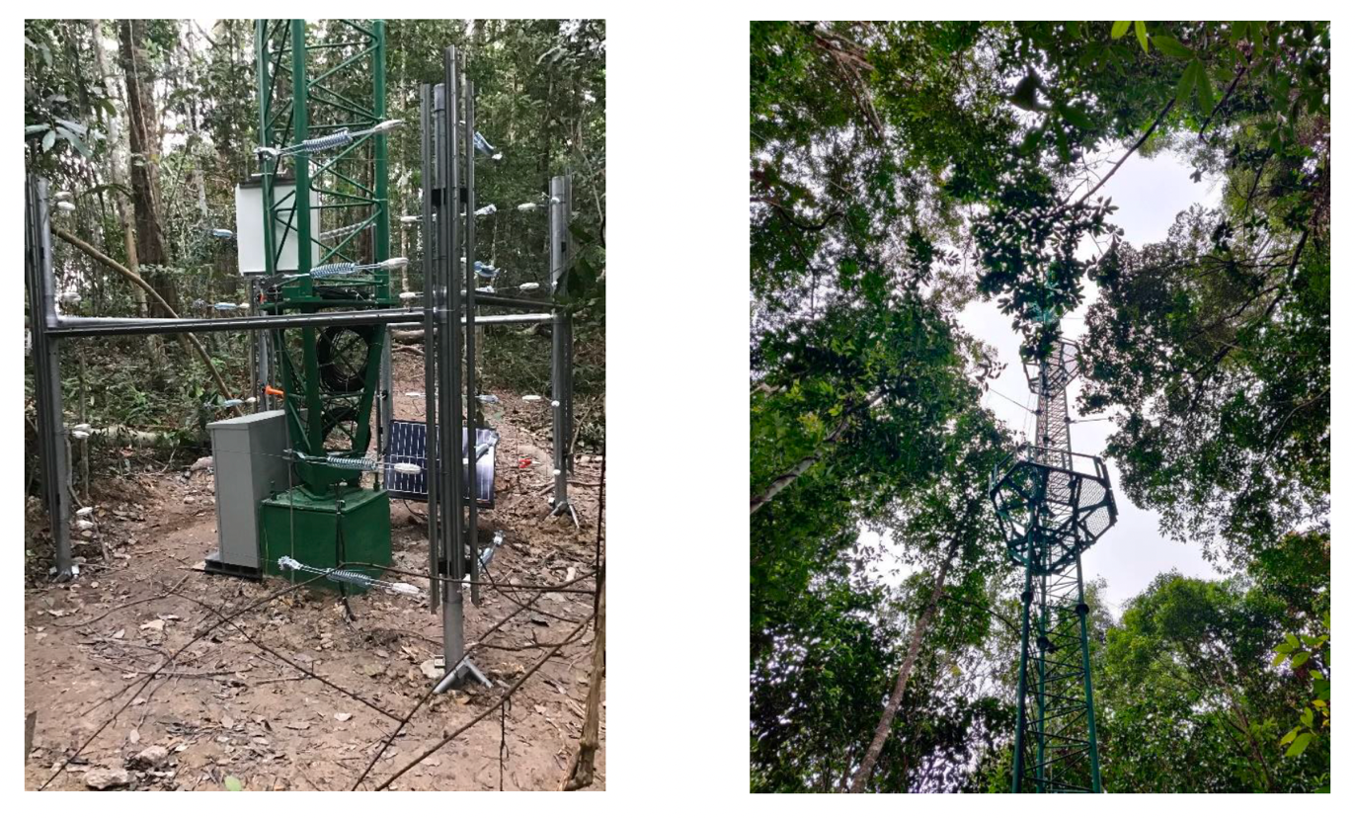
(a)
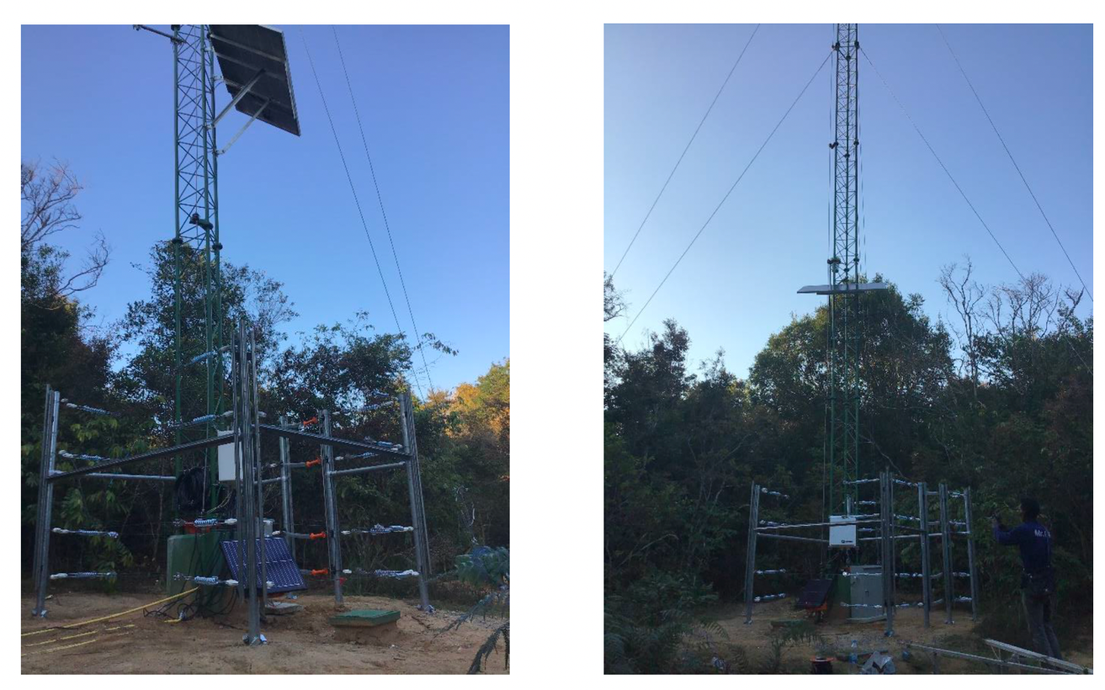
(b)
Fig 2 The 20-m (a) tower at the young forest plot and 50-m (b) tower at the old growth forest plot in Khao Yai National Park

Kung Krabaen Bay Royal Development Study Center
On December 28, 1981, the Kung Krabaen Bay Royal Development Study Center was established in Tha Mai District, Chanthaburi Province, on Thailand's eastern coast. The locals were unable to engage in any fishing operations due to the salty soil in this section of the shore and the issue of the mangrove forest's decline. As a result, the Centre concentrates its efforts on conducting research and studies on the growth and development of coastal fisheries, the reproduction of marine species, and integrated agricultural techniques.
The Center's operations include enhancing the protection and use of coastal natural resources to promote ecological harmony. The goal is to provide farmers the tools they need to boost productivity and eventually become self-sufficient. The coordinating effort is handled by the Department of Fisheries. There are already 23 nearby communities acting as role models for other local farmers looking to further their careers and increase the production of their properties.

1 To support the growth of the eastern coastline's agricultural and occupational sectors as well as appropriate management of the coastal fisheries.
2 To provide the efficient environmental conservation program and to investigate issues with mangrove damage in the coastal environment and identify solutions using an integrated strategy.
3 To raise the level of life and boost the income of the local farmers and communities.

Through the use of "demonstration projects" and the provision of training based on the study, research, and experimentation work conducted at the Centre, the Center aims to promote the dissemination of knowledge, skills, and appropriate techniques on aquaculture, coastal environmental protection and conservation, agriculture, and animal husbandry.The Department of Fisheries is in charge of overseeing the Center's project execution as a whole.
Since the Kung Krabaen Bay Royal Development Study Centre was founded in 1981, study, research, and development activities have improved the well-being and standard of living of the local farmers and villagers while also acting as a "successful demonstration model" for the management of coastal resources and the environment. The Center has contributed significantly to restoring the coastal zone's ecological balance, which is essential for the survival of the coastal natural resource base, as well as the previously devastated mangrove forest.
Aquaculture and crop farming have both been effectively steered toward sustainability in agricultural growth. The farmers' land has been used for mixed farming and farming in accordance with the New Theory, an activity that encourages optimum land usage and permits year-round output.
The Center allocates 1,040 rai (166.4 hectares) of shrimp farms in the project's degraded region to 104 families of impoverished farmers in addition to encouraging farmers in the nearby communities to pursue ecologically friendly, intensive shrimp farming. This has been successful in a decent manner. The Center has also been successful in spreading awareness of the advantages of group formation and inspiring farmers to create a shrimp farming cooperative, which in 1995 won the prize for the best fishing cooperative in the country.
The standard of living and income of farmers has increased, particularly for those who raise shrimp. Shrimp producers earned an average of 150,000 Baht per family per year in 1995, which is almost three times what they made in 1994.
In general, farmers' economic circumstances have improved and are now above the poverty level. Since introducing development-oriented tourism, which gives tourists both technical information and methods for professional growth while they are there, the Center has seen an increase in visitors of up to 200,000 per year. As a result, the Centre received the Tourism Authority of Thailand's "Excellence" Tourism Award in 2000 and "Distinguished" Tourism Award in 2002.

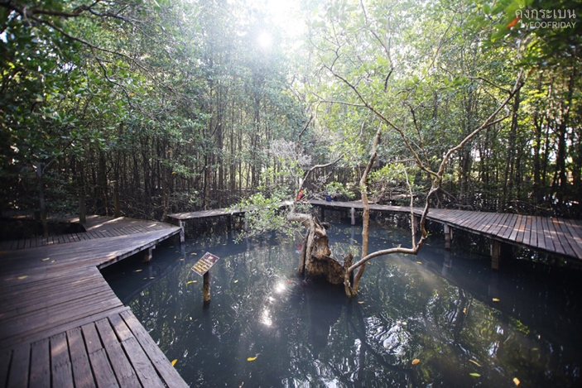 | 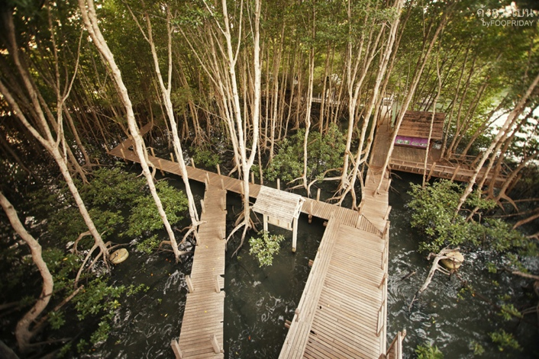
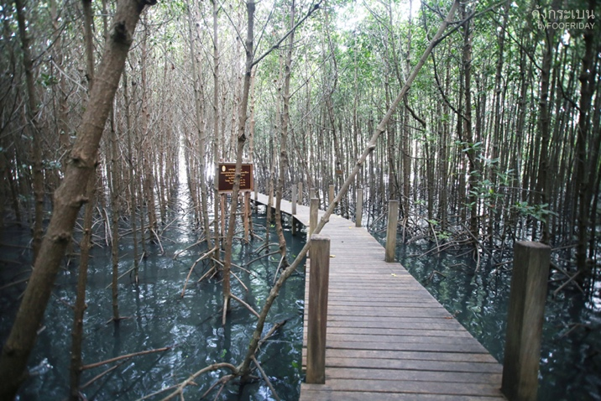 | 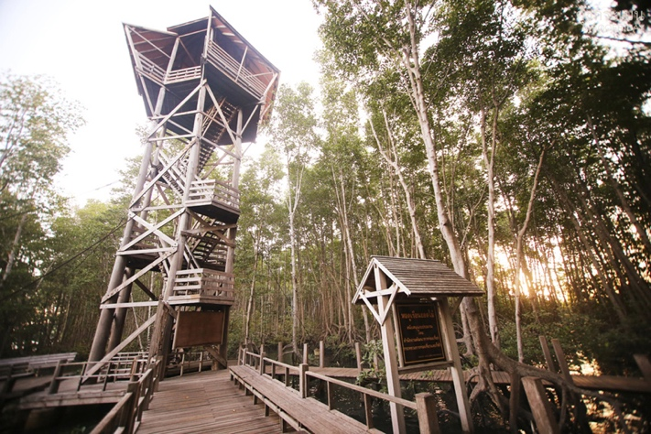
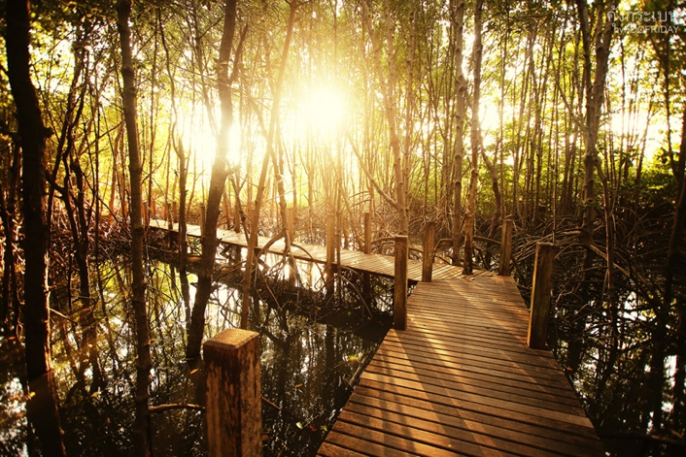 | 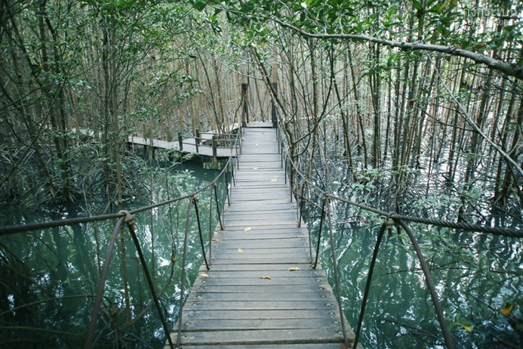
Fig 2 Kung Krabaen Bay Royal Development Study Center

Proposed Agenda

February 22: Travel from Bangkok to Khao Yai National Park
Feb 23 at Khao Yai National Park - Hotel near Khao Yai
Time
09:00 am | Welcome and introductions  Framing of the workshop | GISTDA  USGS SilvaCarbon  USAID
09:30 am | GISTDA CEOS Chair program
10:00 am | USGS CEOS | (EROS - USGS)
10:44 am | Coffee Break
11:15 am | CEOS Uptake of Global Datasets | Sylvia Wilson (USGS)
12:00 pm | LUNCH
02:00 pm | CCI Biomass | Osamu Ochau/ Ake? (Jaxa)
03:00 pm | GEDI model to calculate biomass | Sean Healey (USFS)
04:00 pm | Coffee Break
04:30 pm | Google Earth Engine tool for Obiwan model | Eric Bullock (USFS)
05:30 pm | Closing and preparations for the field
07:00 pm | Dinner
Feb 24 at Khao Yai National Park - Field day
07:00 am | Departure for the field
Feb 25 at Khao Yai National Park - Hotel
09:00 am | Data processing and examples | Eric Bullock (USFS)
10:30 am | Coffee Break
11:00 am | Calculating uncertainties | Pontus Olofsson (NASA)
12:00 pm | Lunch and departing for the mangroves
Feb 26 at Mangroves - Hotel
09:00 am | Intro to carbon accounting mangroves  Mangroves and sea levels rise | Rich Mackenzie (USFS)  Ken Krauss
11:00 am | Global Mangrove Mapping, mangrove extend and heights | Lola Fatoyinbo, Marc Simard
12:00 pm | Lunch
02:00 pm | Global Mangrove watch | Ake Resenqvist
02:30 pm | CCDC Mapping for mangroves | Eric Bullock
03:30 pm | IPCC guidance for Mangroves | Carly Green
04:00 pm | Coffee Break
04:15 pm | Break out groups for field exercise | Rich Mckenzie
Feb 27 at Mangroves - Field Visit
09:00 am |  | Rich Mackenzie (USFS), Ken Krauss
Feb 28 at Mangroves - Hotel
09:00 am | Data Processing | Rich Mckenzie, Kristin Jayd, Ken Krausse, Maybeleene
10:30 am | Coffee Break
11:00 am | Lab biomass calculation
12:00 pm | Lunch
02:00 pm | Uncertainty calculation
03:00 pm | Introduction to Mangroves mapping | Lola Fatoyimbo and Marc Simard
05:00 pm | Closing
March 01 at Mangroves - Hotel
09:00 am | Integration Remote Sensing and emission factors | Eric Bullock
10:30 am | Accuracy calculations | Pontus Olofsson
11:00 am | Exercise of Integration with collected data and GEE apps | Eric Bullock, Rich Mckenzie, Marc Simard
12:00 pm | Lunch
02:00 pm | Comparison with global estimates | Osamu Ochau, Lola Fatoyimbo
05:00 pm | Closing of the workshop
March 02 at Mangroves - Hotel
09:00 am | Drive back to Bangkok

